Fishing patterns on the Ayamé 1 dam lake, 17 years after its reopening

.
ABSTRACT
Aims: Closed in 1998 following continuous and uncontrolled exploitation of fishery resources and recurring conflicts between indigenous and non-indigenous actors, the Ayamé 1 dam lake is now experiencing an increase in the number of non-national fishermen and a decline in the size of fishery resources caught. This study aims to assess fishing activity on the Ayamé 1 dam lake.
Methodology: The study was conducted from July 2017 to June 2018. The data was collected using a questionnair survey, an interview guide, and direct observation of events in the field.
Results: The results of the study show a predominance of non-national fishermen (61.80%). Fishing is practiced by adults aged between 30 and 45 (53.07%). Most fishermen are educated (55.80%), although this rate is low among non-nationals (42.82%). The fishermen, most of whom are married (62.89%), are mostly occasional fishermen. To carry out their activities, fishermen use two types of boats, nailed plank canoes (56.09%) and dugout canoes (46.91%), with six types of fishing gear (gillnets, traps, seines, cast nets, bamboo traps, and handlines).
Conclusion: The uncontrolled increase in the number of non-national fishermen and their low level of education remain a major problem for the management and stability of this activity in this region.

.

Keywords: fishing, dam lake, national, fishing gear, Ivory Coast
1. INTRODUCTION
Fishing plays a major socio-economic role in Ivory Coast. Indeed, this sector contributes to the food security of the Ivorian population, provides jobs and foreign exchange to the state by contributing to the national GDP. Inland fishing in Côte d'Ivoire is mainly artisanal and relies on a number of lake fisheries, the main ones being Lakes Kossou, Buyo, Ayamé 1, Taabo, and Faé [1]. These fisheries are also characterized by a mix of indigenous and foreign fishing communities. However, the lack of control over fishing practices and excessive production efforts are believed to be the cause of the collapse of fish stocks and the source of conflict in many fisheries. This is the case of Lake Ayamé 1, which, following uncontrolled exploitation of resources and recurring conflicts between non-indigenous and indigenous fishermen, was closed in 1998, with the permanent expulsion of non-national actors from the lake. Five years after its reopening, [2] research conducted on the lake between 2004 and 2005 noted the absence of non-indigenous fishermen (Bozo) and a return to equilibrium in the lake. However, the work of [3] confirmed a significant return of non-indigenous fishermen (Bozo) to the lake. These authors also reported a conflict between indigenous and non-indigenous people in Ebikro-N'dakro, a village located 30 km from Ayamé. If this is the case, a new conflict at the Ayamé 1 dam lake could have consequences for the economy of this area, which is heavily dependent on fishery resources. The aim of this study is to deepen knowledge about fishing on Lake Ayamé 1, highlighting the organization of the actors involved and the equipment used, in order to improve fisheries management on this body of water.
2. material and methods

2.1 Study Area
Located 130.7 km from Abidjan in southeastern Ivory Coast between longitudes 3 and 3.5° West and latitudes 5.3 and 6° North (Figure 1). The Ayamé 1 dam lake was built on the Bia River in 1959 [2]. It has an average surface area of 9,320 ha [4] and measures approximately 80 km long and 27 km wide, with a maximum depth of 30 m [5]. The lake enjoys an Attian climate characterized by four distinct seasons (two dry seasons and two rainy seasons) [6]. Three stations were visited on this lake: Ayamé landing stage, Bakro (Temin landing stage), and Ebikro (Danga).
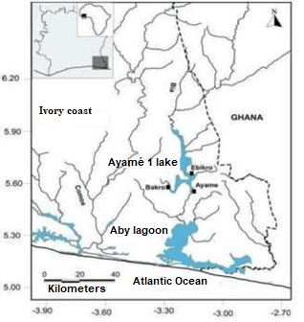
Fig. 1. Geographic location of sampling stations on Lake Ayamé 1
2.2 Sampling
Data collection took place between July 2017 and June 2018 on the Ayamé 1 dam lake, mainly at the Ayamé, Bakro (Temin), and Ebikro landing stages. This data collection on fishing activity was carried out using a questionnaire survey, an interview guide, and direct observation of the facts. The survey covered the population living directly or indirectly from fishing, in particular Ivorian and non-Ivorian fishermen, traditional authorities, fisheries managers, and local administrative officials. The information collected from fishermen included the following: date, location, ethnicity, nationality, marital status, type and number of fishing gear, number of children, type and number of boats, main activity, taxes, and possession of a fishing license.
2.3 Statistical analysis
The chi-square test was used to compare the distribution of fishermen in pairs according to the level of education of the age group and marital status.
3. results and discussion

3.1 Results
3.1.1 Fisheries managers
Fishing management at the Ayamé 1 dam lake is controlled by the fisheries department, which is under the supervision of the Aboisso Departmental Directorate of Animal and Fisheries Resources. This fisheries department is divided into three units. The first unit, in Ayamé, has four fisheries officers who are responsible for the landing sites at Ayamé, Track 2, Track 4, and Akressi. The second is the Bakro unit, which has a single fisheries officer who manages the Temin landing site. Finally, the last unit responsible for Ebikro has two (02) fisheries officers in charge of the landing sites at Danga, Kétésso, and Yaou. These officers are tasked with regulating fishing activity in the area. To this end, they identify the various stakeholders, collect various taxes, weigh the different catches, issue administrative documents, remove illegal fishermen, resolve any conflicts between stakeholders, and compile fishing statistics.
3.1.2 Fishermen's organization
3.1.2.1 Distribution of fishermen by nationality and ethnicity
A total of 733 fishermen were counted during this study. The majority of these fishermen are non-nationals, accounting for 61.80% of the population surveyed (Table 1). They are from Mali, Burkina Faso, Niger, Guinea, Togo, and Ghana. On the lake, the Ivorian community is made up of 16 ethnic groups. The Malian and Burkinabe communities comprise 12 and 11 ethnic groups respectively. The other communities are represented by few ethnic groups. These include the Togolese, comprising three ethnic groups, followed by the Nigeriens and Guineans, each represented by two ethnic groups. The Ghanaian community is represented by a single ethnic group. In terms of ethnicity, the Agni (18.96%) are the most dominant. They are followed by the Troukan (9.55%), the Bambara (8.05%), the Corôborô (7.64%), the Bozo and the Attié (5.73% each) and the Mossi (5.59%). The other ethnic groups each represent less than 5% of the population surveyed.
Table 1. Distribution of fishermen by ethnicity and nationality at the Ayamé 1 dam lake from July 2017 to June 2018
Nationalities/Ethnicities | Workforce | %
Ivorians
Agni | 139 | 18.96
Baoulé | 24 | 3.27
Yacouba | 4 | 0.54
Attié | 42 | 5.37
Lobi | 20 | 2.73
Adjoukrou | 1 | 0.14
Bété | 5 | 0.64
Djimini | 1 | 0.14
Guéré | 13 | 1.77
Kroumen | 1 | 0.14
Sénoufo | 18 | 2.46
Tagbana | 1 | 0.14
Abron | 3 | 0.41
Gouro | 2 | 0.27
Koyaka | 1 | 0.14
Malinké | 5 | 0.68
Total Ivorians | 280 | 38.2
Malians
Sénoufo | 15 | 2.05
Bozo | 42 | 5.73
Bambara | 59 | 8.05
Corôborô | 56 | 7.64
Dongonon | 3 | 0.41
Somonon | 26 | 3.55
Maraka | 18 | 2.46
Peul | 7 | 0.95
Bougounika | 1 | 0.14
Mianka | 18 | 2.46
Bêla | 2 | 0.27
Kadô | 5 | 0.68
Total Malians | 252 | 34.38
Burkinabe
Mossi | 41 | 5.59
Troukan | 70 | 9.56
Daffi | 11 | 1.5
Sénoufo | 10 | 1.36
Samôgô | 10 | 1.36
Bissa | 5 | 0.68
Lobi | 22 | 3
Karabôrô | 8 | 1.09
Sonraille | 1 | 0.14
Brifor | 1 | 0.14
Bôbô | 1 | 0.14
Total Burkinabe | 180 | 24.55
Togolesen
Momba | 3 | 0.41
Tabière | 1 | 0.14
Aïgbeu | 1 | 0.14
Total Togolesen | 5 | 0.68
Nigeriens
Zamalaman | 6 | 0.82
Peul | 3 | 0.41
Total Nigeriens | 9 | 1.23
Guineans
Kogninaka | 3 | 0.41
Maniga | 3 | 0.41
Total Guineans | 6 | 0.82
Ghanaians
Ashanti | 1 | 0.14
Total Ghanaians | 1 | 0.14
Total nationals | 280 | 38.2
Total non-nationals | 453 | 61.8
Total fishermen | 733 | 100
3.1.2.2 Distribution of fishermen according to their level of education
On the lake, fishermen who have attended school are the most numerous (55.80%). This school enrollment rate is higher among the Ivorian community (76.78%) than among the foreign community (42.82%). In the Ivorian community, those who have completed primary school are the most represented, accounting for 43.21% of registered fishermen in this community. In contrast, in the foreign community, those with no education are the most prevalent (57.18%) (Figure 2).

Fig. 2. Distribution of fishermen according to their level of education on the Ayamé 1 dam lake from July 2017 to June 2018
3.1.2.3 Distribution of fishermen by age group
The age of fishermen surveyed on the Ayamé 1 dam lake ranges from 15 to 69 years old. Fishing activity is dominated by adults aged between 30 and 45 (53.07%). This age group is equally well represented among Ivorians (51.07%) and non-nationals (54.30%). The adult age group over 45 is less represented among nationals (12.14%) than among non-nationals (14.35%) (Figure 3).

Fig. 3. Distribution of fishermen by age group on the Ayamé dam lake from July 2017 to June 2018
2.1.2.4 Distribution of fishermen according to marital status and family responsibilities
Of all the fishermen surveyed, 62.89% are married. Among nationals, 53.57% of fishermen are married, compared to 68.67% among non-nationals (Figure 4). Each fisherman is responsible for between 1 and 17 people. The average number of dependents is 6 among Ivorians and 3 among foreigners. Furthermore, the χ² test shows that there is no significant difference between the marriage rates of nationals and non-nationals (χ² = 1.14; ddl = 1; P = 0.2867).

Fig. 4. Marital status of fishermen by nationality on Lake Ayamé Dam from July 2017 to June 2018
2.1.2.5 Distribution of fishermen by occupational category
Two (02) groups of fishermen share the fishery resources of the Ayamé 1 dam lake. These are professional fishermen, who represent 36.97% of registered actors. This group includes 47.14% of national actors and 30.68% of non-national actors. The second group consists of occasional fishermen, with 52.86% national fishermen and 69.32% non-national fishermen. Occasional fishermen remain the most numerous, combining fishing with activities such as agriculture, transport, fish farming, hairdressing, schooling, trade (1.36%), masonry assistance (0.27%), veterinary medicine, mechanics, electricity, surveying, sawing, tiling, carpentry, teaching, sewing, and livestock farming (Table 2).
Table 2. Alternative activities to fishing on the Ayamé dam lake from July 1, 2017 to June 2018
 | Nationals |  | Non-nationals |  | Total
Activities | Workforce | % | Workforce | % | Workforce | %
Fishing only | 132 | 47.14 | 139 | 30.68 | 271 | 36.97
Fishing + agriculture | 108 | 38.57 | 290 | 64.03 | 398 | 54.3
Fishing + trade | 6 | 2.14 | 5 | 1.1 | 11 | 1.5
Fishing + hairdressing | 1 | 0.36 | 0 | 0 | 1 | 0.14
Fishing + transportation | 5 | 1.78 | 0 | 0 | 5 | 0.68
Fishing + fish farming | 1 | 0.36 | 0 | 0 | 1 | 0.14
Fishing + school study | 18 | 6.43 | 0 | 0 | 18 | 2.44
Fishing + masonry assistant | 2 | 0,71 | 0 | 0 | 2 | 0.27
Fishing + farming | 1 | 0.36 | 2 | 0.44 | 3 | 0.41
Fishing + mechanics | 0 | 0 | 3 | 0.66 | 3 | 0.41
Fishing + veterinary officer | 1 | 0.36 | 0 | 0 | 1 | 0,14
Fishing + electrician | 0 | 0 | 2 | 0.44 | 2 | 0.27
Fishing + topography | 1 | 0.36 | 0 | 0 | 1 | 0.14
Fishing + sawing | 0 | 0 | 11 | 2.43 | 11 | 1.5
Fishing + tiling | 1 | 0.36 | 0 | 0 | 1 | 0.14
Fishing + carpentry | 2 | 0.71 | 0 | 0 | 2 | 0.27
Fishing + teaching | 1 | 0.36 | 0 | 0 | 1 | 0.14
Fishing + sewing | 0 | 0 | 1 | 0.22 | 1 | 0.14
Total actors | 280 | 100 | 453 | 100 | 733 | 100
Total actors engaged solely in fishing | 132 | 47.14 | 139 | 30.68 | 271 | 36.97
Total actors engaged in other activities + fishing | 148 | 52.86 | 314 | 69.32 | 462 | 63.03

2.1.2.6 Types of fishing vessels
Two types of boats are used for fishing (Figure 5). These boats are not motorized. They are dugout canoes carved from a single tree trunk (46.91%) and canoes made from nailed planks (53.09%). The first type of boat is typical of nationals, and the second is attributed to non-nationals.
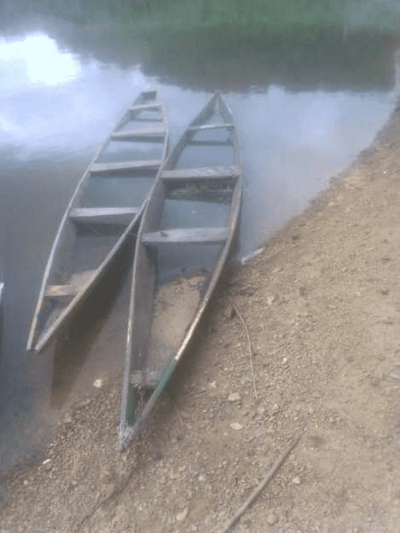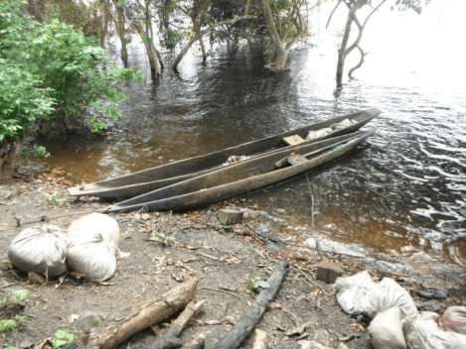
a
b
Fig. 6. Different types of boats encountered on the Ayamé dam lake from July 2017 to June 2018 a: nailed plank canoes, b: dugout canoes
2.1.2.7 Fishing gear
Six types of gear are used on the Ayamé 1 dam lake. These are gillnets, shore seines, longlines, cast nets, traps, and bamboo traps. Gillnets are divided into two groups (Figure 7). The first group refers to simple gillnets with mesh sizes ranging from 5 mm to 45 mm. These are individual gear types used in accordance with the fixed net method. They are found in all types of boats. The second group corresponds to complex gillnets (trammel nets). This type of net has two pockets (one at each end). The length of the net can vary from 200 m to 400 m. The mesh size of the pockets (10 mm) is different from that of the body or central part of the net (20 mm). The “trawl” net is a collective device operated by a team of two people. To set this type of net, one of the edges (top or bottom) is attached to stones so that it can sink into the water. To remove the net, the two operators stand on the canoe and perform synchronized movements, lifting the net in the direction of one pocket and then in the other direction toward the second pocket.
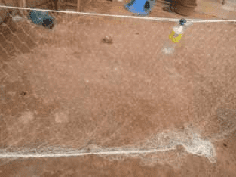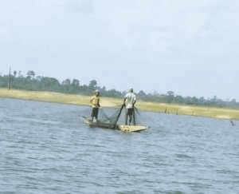
a
b
Fig. 7. Gillnets used to catch fish in the Ayamé dam lake from July 2017 to June 2018 a: Gillnet in a fishing camp, b: Fishermen working with a cast net
The shore seine is a collective gear operated by a team of 4 to 5 people (Figure 8). This gear is made from multi-filament nets with meshes ranging from 10 to 15 mm from one knot to another. It does not have a true pocket and its length varies between 250 m and 400 m. The drop of these nets varies from 2 to 3 m.
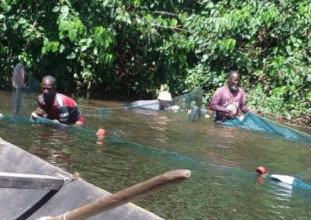
Fig. 8. Beach seine used to catch fish at the Ayamé dam lake from July 2017 to June 2018
Longlines are made from multiple hooks. The number of hooks varies from 100 to 300. The distance between hooks depends on the species being targeted (Figure 9).
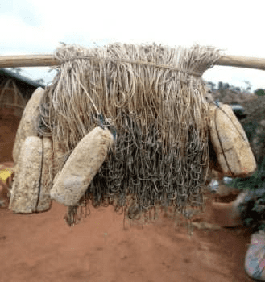
Fig. 9. Longline used to catch fish in the Ayamé dam lake from July 2017 to June 2018
The sparrowhawk is an active fishing gear. It is conical in shape and is generally used in shallow water (Figure 10). This gear consists of a circular multi-filament nylon net, equipped with weights around the perimeter. On the lake, the mesh size of this gear ranges from 10 to 30 mm.
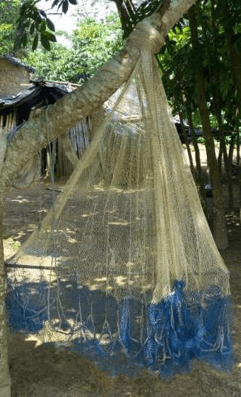
Fig. 10. Sparrowhawk used to catch fish at the Ayamé dam lake from July 2017 to June 2018
Fish traps belong to the category of passive gear. There are four types on the Ayamé 1 dam lake: (1) Wire mesh traps that do not have a specific shape and have a single opening. They can measure 1.5 m long and 1 m wide with an average mesh size of 25 mm (Figure 11 a). (2) Net traps have a frame made of sticks and vines that may or may not meet at the top. These traps are covered with multifilament netting with a mesh size ranging from 10 to 50 mm. The base diameter of these traps is between 45 and 85 cm. Small traps (diameter < 55 cm) have two clearly marked funnel-shaped openings. These traps are usually baited with corn or rice bran or pieces of rotten cassava. However, large traps (diameter > 55 cm) have a single funnel-shaped opening at the base. These traps are usually placed in the water lying on one side and are never baited (Figure 11 b). (3) Can traps are made from empty 20- to 25-liter oil cans. They have a funnel-shaped opening made with a net at the base. These traps are specialized for catching species of the genus Chrysichthys. These traps work in a unique way. The traps are baited with a mature female that will emit calls to attract males into the trap (Figure 11 c). (4) Plant fiber (raffia) traps have a diameter ranging from 20 to 30 cm. They are not baited and are often used as storage after catches (Figure 11 d).
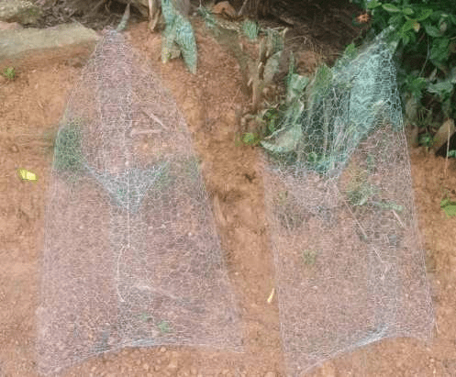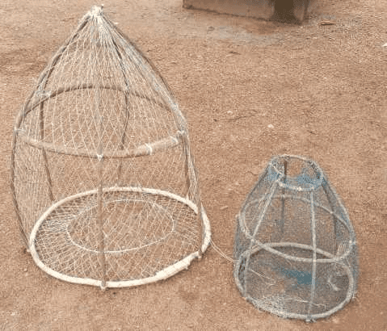
b
a
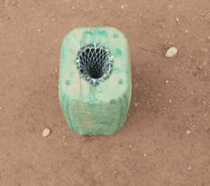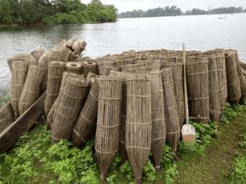
d
c
Fig. 11. Different types of traps used to catch fish on the Ayamé dam lake from July 2017 to June 2018 a: metal mesh trap, b: net or papolo traps, c: can trap, d: palm fiber traps
Bamboo traps (Figure 12) are hollow bamboo tubes with an opening at one end and a closed end at the other. They are placed in the water and are all connected to a pole by a rope. They are not baited and are specifically designed to catch species of the genus Chrysichthys.
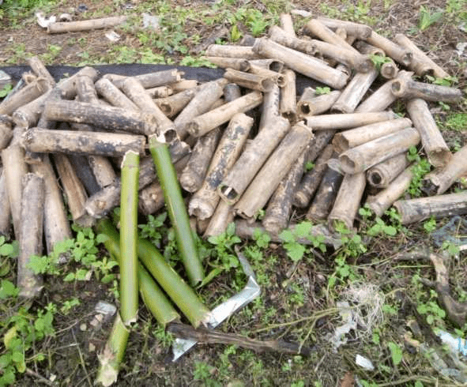
Fig. 12. Bamboo traps used to catch fish in the Ayamé dam lake from July 2017 to June 2018
3.2 Discussion
The presence of a fisheries office at the Ayamé 1 dam lake demonstrates the political will of the Ivorian authorities to sustainably manage the fishery resources in this area. These results corroborate those of [7] on the same lake. The same observation was made by [8] on the lower reaches of the Bandama River. However, the reduced number of fisheries officers on the lake makes this task difficult.
At the lake level, the exploitation of fishery resources is dominated by non-national fishermen. This dominance is due to various reasons. These include the demotivation of national fishermen, who find fishing exhausting and unprofitable, in favor of informal activities [9]. There is also an influx of non-nationals to fishing areas following the WAEMU agreements on the free movement of its nationals and the freedom to engage in any activity within the WAEMU zone [10]. These results differ from those obtained by [11] and [2] on the same lake. This difference could be explained by the fact that the work of these authors took place after the expulsion of non-natives from the fishing zone.
The low presence of young people in fishing activities at the Ayamé 1 dam lake, to the detriment of adults aged between 30 and 45, could be linked, on the one hand, to rural exodus and, on the other hand, the fact that young people have turned to other informal activities, particularly transportation (apprentice drivers or drivers), which they find easier. These results corroborate those of [12] and [13], who reported a strong presence of adults on the lower reaches of the Bandama River. According to [14], fishing is physically demanding and often dangerous, with the survival of fishermen depending on their courage, the quality of their equipment, and their professional skills. However, these results differ from those of [15] and [2], who reported a strong presence of young people in this sector.
Analysis of educational attainment levels showed that fishermen with formal education are the most numerous. The very high rate of formal education among nationals is thought to be due to the fact that many young people who dropped out of school took up fishing after the expulsion of Bozo fishermen from the lake in 1998. This situation is also thought to be due to the lack of employment in this region. On the other hand, the very low rate of schooling observed among non-nationals can be explained by the fact that they place more emphasis on their cultural knowledge, which they pass on to their descendants, rather than on education. Furthermore, the results of this study corroborate those of [16] on Lake Songori, [12] and [13] on the Bandama River, who reported a predominance of educated fishermen on these bodies of water. On the other hand, [17] reported a predominance of illiterate fishermen on Lake Bolodon.
Most of the registered fishermen on the Ayamé 1 dam lake are married. The large number of married fishermen on the Ayamé 1 dam lake can be explained by the advantages of this situation. Indeed, their wives assist them in their work. The women are responsible for processing and selling the fish. The same observation was made by [8] and [18]. The former author asserts that their traditional role as housewives not only allows their spouses to eat well and recover after hard work on the river, but also to live in a well-maintained environment.
With regard to the classification of fishermen by professional category, the fishermen of the Ayamé 1 dam lake are mainly occasional fishermen, whether national or non-national. This situation can be explained by the fact that fishing is practiced by many nationals to meet the food needs of households, to have financial resources to solve specific problems, and to pay for labor to maintain fields, on the one hand. On the other hand, it is believed to be the result of the closure of the Ayamé 1 dam lake to fishing in 1998.
With regard to boat types, nailed plank canoes are the most common. This dominance is thought to be related to the growing number of non-national fishermen. Indeed, these types of boats are not used by the latter. On the other hand, it is thought to be related to the decrease in tree trunks due to the destruction of forests for the benefit of export crops.
Six (06) types of equipment are used on the lake, as in most national reservoirs. This situation could be explained by the ease with which this equipment can be acquired and its ease of use.
4. Conclusion
The management of the Ayamé 1 dam lake is carried out by an administrative body. Most of the fishermen of this lake are non-nationals. They are mainly adults with a high level of education among nationals. It should be noted that two types of fishing gear are used on the lake, each type being characteristic of a particular community. Although several types of fishing gear are used on the lake, they can be grouped into six (06) types. The growing number of non-national fishermen should prompt our decision-makers to regulate these sectors in order to avoid potential conflict.

References

1. Da Costa, K. S., & Dietoa, Y. M. (2007). Typology of fishing on Lake Faé (Côte d’Ivoire) and implications for rational management of fishery resources. French Bulletin for Fishing and Fish Farming, 384, 1-14.
2. Tah, L. (2012). Exploitation of Lake Ayamé I (Côte d’Ivoire) after the departure of the “Bozo” fishermen in 1998 and impact on the demographic structures of fish populations. Doctoral thesis, Félix Houphouet-Boigny University, Côte d’Ivoire, 177 p.
3. Kouamé, K. P., & Touré M. S. (2012). Ayamé Report - Fisheries Conflicts, Abidjan, Côte d’Ivoire, 44 p.
4. Laë, R., Lek, S., & Moreau J. (1999). Predicting fish yield of African lakes using neural networks. Ecological Modelling, 120, 325-335.
5. Ouattarra, N. I. (2004). Study of the aquaculture potential of a population of the estuarine Coptodon Sarotherodon melanotheron (Rüppell, 1852) isolated from the Ayamé Dam Lake (Côte d’Ivoire). Doctoral thesis, University of Liège, Belgium, 288 p.
6. Savané, I., & Konaré A. (2010). Climate in Biodiversity Atlas of West Africa, Volume III. Edited by S. Konaté and D. Kampmann (eds.), Abidjan & Frankfurt/Main, Côte d’Ivoire, 124-125.
7. Koudou, D., Koulaï, D., Zran, G. M., & Anoh, K. P. (2019). Radioscopy of a recurring fishing conflict on the Ayamé I hydroelectric dam lake (Côte d'Ivoire). Revue Espace Géographique et Société Marocaine, 27, 231-246.
8. Kien, K. B. (2016). Fishing activities on the Bandama River (Côte d'Ivoire): Impact on the organization of fish populations in the lower reaches and socioeconomic consequences. Doctoral thesis, Félix HOUPHOUËT BOIGNY University, Côte d'Ivoire, 228 p.
9. Sédia, N. A. G. (2000). Access to the resource space of small dams in northern Ivory Coast and the modalities of local sharing of exploitation benefits: the case of fishing. Master's Thesis, University of Bouaké, Côte d'Ivoire, 75 p.
10. UEMOA (2016). 2016 Annual Report on the Operation and Development of the Union. UEMOA Commission, 94 p.
11. Vanga, A. F. (2001). Socioeconomic Consequences of Natural Resource Management: The Case of Fisheries in Lakes Ayamé and Buyo (Côte d'Ivoire). Doctoral Thesis, University of Abobo-Adjamé, Côte d'Ivoire, 210 p.
12. Boguhé, G. F. D. H., Goore Bi, G., N'Zi, K. G., Yao, S. S., Kouamelan E. P., & Kouassi, N. J. (2011). First data on the shrimp fishery in the Bandama River (Côte d’Ivoire): actors and fishing gear. Sciences et Nature, 8(1), 107-118.
13. Kien, K. B., Yao, S. S., Vanga, A. F., & Kouamelan, E. P. (2015). Typology of fishing on the lower reaches of the Bandama River (Côte d’Ivoire, West Africa). International Journal of Innovation and Applied Studies, 13(1), 66-77.
14. Koffi, B. C. (1997). Artisanal maritime fishing in Côte d’Ivoire: A geographical study. Doctoral thesis, University of Nantes, France, 324 p.
15. Vanga, A. F. (2011). Evolution of fishing in Lake Ayamé since the expulsion of non-national fishermen (Côte d’Ivoire). Tropicultura, 29(1), 8-13.
16. N’dri, K. M. (2018). Fisheries and fish farming management in the Ivorian continental environment: current status and socio-economic aspects. Doctoral thesis, Nangui Abrogoua University, Côte d’Ivoire, 155 p.
17. N’dri, K. M. (2019). Fishing typology and level of exploited biomass in Lake Bolondo (Bagoué region; northern Côte d’Ivoire). African Agronomy, 31(1), 1-14.
18. Blahoua, K. G., Adou, Y. E., Kouame, K. A., & N’Douba, V. (2018). Fishing typology on the Ayamé 2 dam lake (Côte d’Ivoire, West Africa). International Journal of Innovation and Scientific Research, 36(2), 178-185.

