Short Research Article
Morphological, Genetic And Phytochemical Characterization Of black ginger (Kaempferia parviflora Wall. ex Baker) Accessions

.
ABSTRACT

This study aimed to evaluate the morphological, genetic, and phytochemical diversity of Kaempferia parviflora accessions to identify potential elite genotypes for conservation and commercial applications. Twenty-one accessions, collected from multiple locations were cultivated under uniform conditions and assessed for 14 morphological traits. Cluster analysis using Gower’s General Similarity Coefficient and UPGMA revealed distinct phenotypic groupings, with variation in leaf shape, size, and margin color suggesting underlying genetic divergence. Genetic characterization using 10 ISSR primers produced 33 polymorphic bands, with a mean Shannon diversity index of 1.70, indicating a narrow genetic base. Jaccard’s similarity coefficients ranged from 0.61 to 0.98, and UPGMA clustering separated accessions into three main groups, with KH-MJ emerging as a genetically distinct outlier. Phytochemical profiling of 10 selected accessions showed significant variation in total phenolic content (TPC), total flavonoid content (TFC), and 4,5,7-trimethoxyflavone (TMF) levels. KH-THA 10 consistently exhibited the highest TPC (47.534 mg GAE/g), TFC (7.887 mg RE/g), and TMF (42.95 µg/mg), identifying it as an elite accession for pharmaceutical and nutraceutical potential. The integration of morphological, molecular, and phytochemical data provides a robust framework for germplasm management, breeding, and the development of high-value K. parviflora cultivars. Future work should focus on broadening the genetic base and validating genotype–environment interactions affecting bioactive compound production.

Keywords: Kaempferia parviflora, germplasm characterization, ISSR markers, phytochemical profiling, genetic diversity

1. INTRODUCTION

Kaempferia parviflora Wall. ex Baker, commonly known as black ginger or “Krachai Dam” in Thailand, is a perennial herbaceous plant belonging to the family Zingiberaceae. It is native to Southeast Asia, particularly Thailand, Laos, and Malaysia, where it has been traditionally used for its medicinal properties, including antioxidant, anti-inflammatory, vasodilatory, and aphrodisiac effects [2,21]. The plant’s bioactive potential is attributed mainly to its polymethoxyflavones, such as 4,5,7-trimethoxyflavone (TMF), which exhibit significant pharmacological activities [20,22].

As global demand for herbal and nutraceutical products increases, interest in K. parviflora cultivation and commercialization has grown rapidly. However, sustainable utilization of this high-value medicinal crop requires comprehensive characterization of existing germplasm to identify superior accessions for breeding, cultivation, and conservation. Germplasm characterization plays a critical role in detecting genetic variability, which is essential for crop improvement and adaptation to changing environments [7,18].

Previous studies in Curcuma longa varieties have revealed morphological diversity within its populations, with variation in traits such as leaf shape, pigmentation, and floral morphology, which may be influenced by both genetic factors and environmental conditions [23]. Molecular markers provide a robust tool for assessing genetic diversity, detecting polymorphisms, and establishing phylogenetic relationships in Zingiberaceae crops [11,12]. Integrating molecular analysis with morphological characterization enables a more accurate assessment of diversity and facilitates the identification of genetically distinct and potentially elite accessions.

In addition to morphological and molecular traits, phytochemical profiling is vital for identifying accessions with high levels of bioactive compounds. TMF, in particular, is a key marker compound for quality evaluation due to its potent biological activity [20]. Despite its economic and medicinal importance, there is limited integrated research combining morphological, molecular, and phytochemical data for K. parviflora germplasm. Therefore, this study aimed to evaluate 21 accessions of K. parviflora using morphological traits, ISSR markers, and phytochemical profiling to assess the extent of phenotypic and genetic diversity, identify genetically distinct and phytochemically superior accessions, and also provide baseline data to support breeding, conservation, and commercialization strategies for this valuable medicinal crop.

2. material and methods

2.1 Morphological Characterization

Twenty-one accessions of K. parviflora (Table 1) were collected from various locations and suppliers were cultivated under uniform conditions at MARDI Jerangau. Morphological evaluation was conducted at the mature stage based on 14 traits: plant height, number of leaves, leaf length, leaf width, petiole length, petiole width, leaf sheath length, leaf sheath width, flower length, inflorescence length, peduncle length, leaf shape, leaf sheath color, and leaf margin color. Quantitative traits were measured using standard tools, while qualitative traits were assessed visually.

Morphological data, comprising both qualitative and quantitative variables, were analyzed using Gower’s General Similarity Coefficient. Cluster analysis was performed using the unweighted pair-group method with arithmetic mean (UPGMA), and a dendrogram was generated with MVSP software to determine relationships among accessions.

Table 1. Commercial K. parviflora rhizomes collected from suppliers and commercial cultivation

No. | Accession code | Commercial cultivated supplier/ location | Date collected
1 | KH-THA-1 | Thailand - Aliran Sepakat Enterprise | 14/4/2021
2 | KH-LAO-1 | Laos - Aliran Sepakat Enterprise | 14/4/2021
3 | KH-THA-2 | Thailand - Easyherb | 24/5/2021
4 | KH-VIE-1 | Vietnam - Aman Ubi House | 30/8/2021
5 | KH-LAO-2 | Laos - Boifresh Wellness Trading | 20/9/2021
6 | KH-THA-3 | Thailand - Aman Ubi House | 30/9/2021
7 | KH-THA-4 | Thailand - Yusri Tijarah Group Ent. | 3/10/2021
8 | KH-THA-5 | Thailand - Global Element Enterprise | 17/10/2021
9 | KH-THA-6 | Thailand - Global Element Enterprise | 17/10/2021
10 | KH-THA-7 | Thailand - Vma Empire | 16/12/21
11 | KH-THA 8 | Thailand - Microgreen Shop | 19/1/2022
12 | KHA-THA 9 | Thailand - Khatijah herbs traditional | 23/1/2022
13 | KH-THA 10 | Thailand - Yusri Tijarah Group Ent. | 22/3/2022
14 | KH-MJ | Malaysia - MARDI Jerangau, Terengganu | 2015
15 | KH-LGK | Malaysia - Langkawi, Kedah | 2015
16 | KH-BI | Malaysia - Bukit Ibam, Pahang | 2015
17 | KH-MT | Malaysia - Melaka Tengah, Melaka | 8/9/2020
18 | KH-DN | Malaysia - Terengganu - Kg. Sura, Dungun | 4/10/2020
19 | KH-KB | Malaysia - Kg. Perih, Kuala Berang,Terengganu | 5/10/2020
20 | KH-PR | Malaysia - Parit Raja, Johor | 23/3/2021
21 | KH-PB | Malaysia - Permatang Badak, Pahang | 2015

2.2 Molecular Characterization

Genetic characterization was conducted on 21 K. parviflora accessions using DNA extracted from young leaf tissue. DNA isolation followed the cetyltrimethylammonium bromide (CTAB) protocol of [5] with minor modifications. DNA quality and quantity were assessed using a spectrophotometer, and concentrations ranged from 20 to 120 ng µL⁻¹. Polymerase chain reaction (PCR) amplification was performed using ten inter-simple sequence repeat (ISSR) primers: 807, 808, 811, 827, 829, 836, 854, ISSRa, ISSRb, and ISSR6. Cluster analysis was carried out using NTSYSpc version 2.11 software, based on Jaccard’s similarity coefficient, to evaluate genetic relationships among accessions. The resulting dendrogram illustrated the grouping patterns of the 21 accessions.

2.3 Phytochemical study

Ten K. parviflora accessions (KH-THA 1, KH-THA 2, KH-THA 4, KH-THA 5, KH-THA 7, KH-THA 10, KH-LAO 1, KH-LAO 2, KH-VIE 1, and KH-MJ), representing different clusters based on morphological and molecular evaluations, were harvested at optimum maturity (8 months) from MARDI Jerangau. Rhizomes were washed, sliced, oven-dried at 60 °C for 48 h to 8–10% moisture, and ground to 0.25 mm powder. Samples (1 g) were extracted via sonication in 10 mL of 70% methanol at 40–50 °C for 1 h, centrifuged at 10,000 rpm for 15 min (repeated twice), combined, filtered (0.22 µm), and analyzed by HPLC. Total phenolic content (TPC) was determined as mg gallic acid equivalent (GAE)/g sample, and total flavonoid content (TFC) as mg rutin equivalent (RE)/g sample. Quantification of 5,7,4′-trimethoxyflavone (TMF) was performed using a TMF standard. HPLC was used to separate and determine 4,5,7-trimethoxyflavone content. Data were analyzed by ANOVA and Tukey’s post hoc test using SPSS v20 (SPSS Inc., Chicago, IL, USA).

- results and discussion

3.1 Morphological Characterization

Morphological characterization of the 21 K. parviflora accessions revealed notable phenotypic variation across 14 vegetative and floral traits. A cluster analysis using Gower’s General Similarity Coefficient and UPGMA produced two major groupings of accessions (Figure 1). Cluster I (overall similarity index = 0.592) comprised six accessions collected from Thailand (KH-THA 2–5), Laos (KH-LAO 2), Vietnam (KH-VIE 1), and two from Terengganu, Malaysia (KH-DN and KH-KB). These accessions displayed ovate leaves that were broader than long, with long petioles, long floral peduncles, short inflorescences, and green leaf margins.

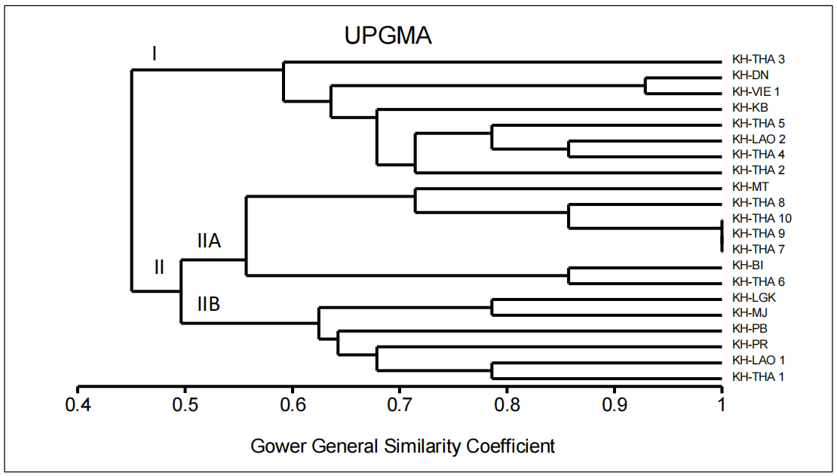

Figure 1. Phylogenetic tree of K. parviflora accessions based on Gower General Similarity Coefficient

Cluster II (similarity index = 0.497) was further subdivided into two subclusters. Cluster IIA (similarity index = 0.557) contained KH-THA 6–10 and KH-BI, characterized by ovate leaves longer than wide, short petioles and short peduncles, long inflorescences, and reddish leaf margins. Cluster IIB (similarity index = 0.625) comprised KH-THA 1, KH-LAO 1, KH-LGK, KH-MJ, KH-PB, and KH-PR, which exhibited ovate to lanceolate leaves, long petioles and peduncles, and similarly reddish margins. This observed variation in leaf shape, size, and pigmentation aligns with previous reports of significant morphological diversity in K. parviflora and related Zingiberaceae species [13].

The analytical methods applied were appropriate for the mixed data types of the morphological traits. Gower’s coefficient, which accommodates both qualitative and quantitative data, proved suitable for assessing overall similarity [8]. The UPGMA clustering method effectively grouped phenotypically similar accessions into coherent clusters. Similar phenetic clustering approaches have been successfully applied in turmeric (Curcuma longa) and ginger (Zingiber officinale) germplasm research to classify accessions by trait similarity [11,12]. Unique morphological variants identified in this collection should be prioritized for germplasm conservation to maintain rare or desirable traits [6,18]. This morphological diversity assessment provides a baseline that can be integrated with molecular data for a more comprehensive understanding of diversity and for guiding targeted breeding strategies.

3.2 Molecular Characterization

Molecular characterization of the 21 K. parviflora accessions using 10 ISSR primers revealed relatively low genetic diversity within the collection. The ISSR analysis yielded a total of 33 polymorphic bands. The mean Shannon diversity index (H′) was 1.70, which is indicative of limited genetic variation among these accessions. This suggests that the accessions are largely clonal or closely related, a pattern observed in other vegetatively propagated Zingiberaceae crops where limited seed-based reproduction and frequent exchange of planting material lead to a narrow genetic base [4,1]. Jaccard’s genetic similarity coefficients ranged from 0.61 (between KH-THA 1 and KH-THA 2) to 0.98 (between KH-KB and KH-LGK), demonstrating that while most accession pairs are very closely related, a few pairs exhibit moderate genetic divergence. The UPGMA dendrogram based on ISSR data clustered the accessions into three major groups, designated Cluster A, B, and C (Figure 2). Cluster A included eight accessions (KH-THA 1, KH-THA 2, KH-THA 3, KH-THA 4, KH-DN, KH-LAO 1, KH-VIE 1, and KH-KB). Cluster B encompassed twelve accessions: the Thai clones KH-THA 5 through KH-THA 10, together with KH-LAO 2 and the Malaysian accessions KH-PR, KH-BI, KH-MT, KH-PB, and KH-LGK. Cluster C consisted of a single outlier, KH-MJ, which was genetically distinct from all other accessions.

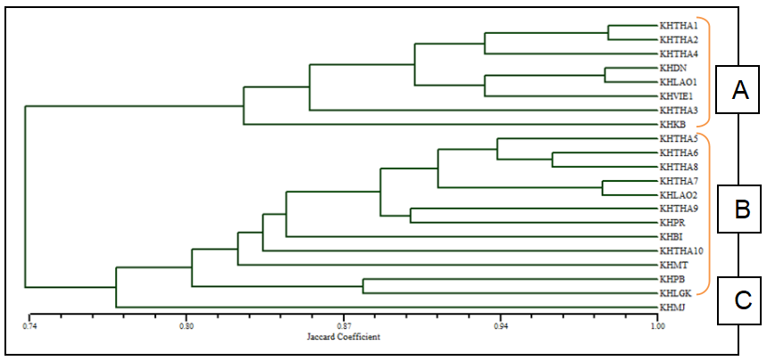

Figure 2. UPGMA dendrogram showing genetic relationships among 21 K. parviflora accessions based on ISSR marker profiles

Interestingly, two K. parviflora accessions from Terengganu (KH-DN and KH-KB) grouped within Cluster A alongside accessions from Thailand, Vietnam, and Laos.In contrast, Cluster B was composed predominantly of accessions from Peninsular Malaysia (Johor, Pahang, Melaka, Kedah), alongside a single Thai clone (KH-THA 10), indicating particularly close genetic relationships among geographically proximate materials. The overall high genetic similarity across the collection supports the hypothesis of a narrow genetic base in cultivated K. parviflora, likely resulting from its predominantly vegetative propagation and limited introduction of novel genetic material. This pattern similarly in other studies for instance, ISSR and RAPD analysis of various Kaempferia species showed high polymorphism levels, ranging from approximately 49 % to 93 % similarity, indicating both genetic differentiation and redundancy within the genus [19]. Additionally, recent morphological assessments have found surprisingly low phenotypic variation among cultivated K. parviflora accessions, supporting the idea of a narrow genetic base [17].

From a conservation perspective, the identification of a genetically unique accession (KH-MJ) is particularly important. Such an outlier genotype can contribute disproportionately to the species’ adaptive potential and should be conserved as a priority [9]. Incorporating this and other divergent genotypes into breeding programs will help increase the genetic variability in progeny, a critical factor for improving resilience to pests, diseases, and environmental changes [14]. Overall, ISSR markers proved to be effective for elucidating genetic relationships among K. parviflora accessions. The molecular data complement the morphological findings, and together these tools can inform more effective germplasm management, breeding, and conservation strategies for black ginger.

3.3 Phytochemical Variation and Methoxyflavone Content

Phytochemical profiling of 10 selected K. parviflora accessions revealed significant variability in their total phenolic content (TPC), total flavonoid content (TFC), and levels of the bioactive compound 4,5,7-trimethoxyflavone (TMF). The results (Table 2 and Figure 3) showed that these phytochemical parameters differed markedly among accessions. Notably, accession KH-THA 10 consistently exhibited the highest concentrations across all measures, with a TPC of 47.534 mg GAE/g, a TFC of 7.887 mg RE/g, and a TMF content of 42.95 µg/mg. In contrast, several other accessions – including KH-THA 4, KH-THA 5, KH-LAO 2, KH-VIE 1, and KH-MJ showed substantially lower values for all three phytochemical parameters.

Table 2. Variation in total phenolic content (TPC), total flavonoid content (TFC), and 4,5,7-trimethoxyflavone (TMF) levels among 10 K. parviflora accessions.

No. | Sample/ accessions | Total phenol content  (mg GAE/g) | Total flavonoid content  (mg RE/g) | 4,5,7-trimethoxyflavone (μg/mg)
1 | KH-THA 1 | 28.281 b | 9.008 a | 30.363 b
2 | KH-THA 2 | 33.679 b | 3.841 c | 27.714 b
3 | KH-THA 4 | 4.885 d | 3.069 c | 14.912 c
4 | KH-THA 5 | 4.885 d | 3.218 c | 16.252 c
5 | KH-THA 7 | 12.762 c | 7.602 a | 15.179 c
6 | KH-THA 10 | 47.534 a | 7.887 a | 42.950 a
7 | KH-LAO 1 | 16.484 c | 3.411 c | 25.224 b
8 | KH-LAO 2 | 4.114 d | 3.044 c | 14.705 c
9 | KH-VIE 1 | 5.205 d | 3.373 c | 18.876 c
10 | KH-MJ | 5.313 d | 3.603 c | 19.118 c
*Min yang dilabel dengan huruf yang sama adalah tidak signifikan pada P<0.05.

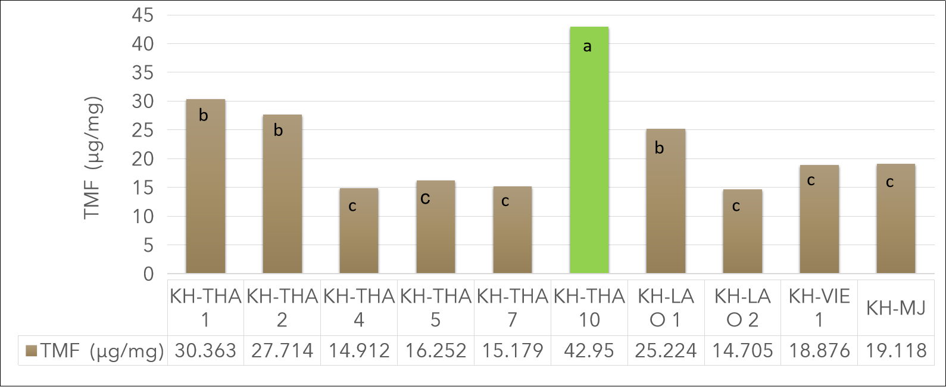

Figure 3. TMF content in extracts from various K. parviflora accessions

The wide variation observed in TPC and TFC among genotypes is consistent with previous studies indicating strong genotypic influence on phenolic and flavonoid accumulation in K. parviflora and other Zingiberaceae species [3,16]. Likewise, the differences detected in TMF content are particularly noteworthy because TMF is a key polymethoxyflavone linked to antioxidant, anti-inflammatory, and other pharmacological activities of black ginger [15,24]. The identification of KH-THA 10 as a top-performing genotype across multiple phytochemical traits underscores the importance of integrating phytochemical data with the morphological and molecular characterization of germplasm. This holistic approach enables more effective selection and utilization of superior accessions for breeding and cultivation. By combining phenotypic, genetic, and phytochemical evaluations, breeders and conservationists can ensure that valuable traits – such as high bioactive compound content – are preserved and exploited in future cultivar development [10].

4. Conclusion

This study provides a comprehensive characterization of 21 K. parviflora accessions using morphological, molecular, and phytochemical assessments. Morphological evaluation revealed clear phenotypic variation, particularly in leaf shape, size, and pigmentation, resulting in distinct clusters that may reflect underlying genetic divergence. ISSR marker analysis demonstrated a relatively narrow genetic base, consistent with the crop’s predominant vegetative propagation and limited introduction of novel genetic material. Nevertheless, the detection of a genetically distinct accession (KH-MJ) underscores the importance of conserving unique genotypes to safeguard adaptive potential.

Phytochemical profiling of 10 representative accessions highlighted significant variability in total phenolic content, total flavonoid content, and 4,5,7-trimethoxyflavone levels, with KH-THA 10 emerging as an elite accession for its consistently high concentrations of bioactive compounds. The integration of phenotypic, genetic, and phytochemical datasets provides a robust foundation for targeted germplasm conservation, breeding programs, and potential commercialization. Future research should focus on expanding the genetic base of K. parviflora collections, validating genotype-by-environment interactions influencing phytochemical profiles, and developing elite cultivars with superior agronomic and pharmacological traits. By strategically combining molecular tools with traditional breeding, the potential of K. parviflora as a high-value medicinal crop can be more fully realized.
References

- Akshitha, H.J., Prasath, D., Umesha, K., Mohammed Faisal, P. and Venkataravanappa, V. (2022). Molecular characterization of ginger genotypes using RAPD and SSR markers. Hortl. Sci. 17 (1) : 95 - 102.

- Chaisuwan, V., Dajanta, K., and Srikaeo, K. (2022). Effects of extraction methods on antioxidants and methoxyflavones of Kaempferia parviflora. Food Research. 6 (3): 374 - 381. DOI: https://doi.org/10.26656/fr.2017.6(3).408.

- Chumroenphat, T., Somboonwatthanakul, I., Saensouk, S. and Siriamornpun, S. (2019). The Diversity of Biologically Active Compounds in the Rhizomes of Recently Discovered Zingiberaceae Plants Native to North Eastern Thailand. Pharmacog J. 11 (5): 1014-1022.

- Dev, H. and Sharma, V. (2020). Int.J.Curr.Microbiol.App.Sci (2020). Genetic Divergence in Ginger (Zingiber officinale Rosc). International Journal of Current Microbiology and Applied Sciences. 9 (8): 3072 - 3076. DOI: https://doi.org/10.20546/ijcmas.2020.908.347

- Doyle, J. J., and Doyle, J. L. (1990). Isolation of plant DNA from fresh tissue. Focus. 12: 13 - 15.

- Engels, J.M.M. & Visser, L. (2003). A guide to effective management of germplasm collections. IPGRI.

- Govindaraj, M., Vetriventhan, M., & Srinivasan, M. (2015). Importance of genetic diversity assessment in crop plants and its recent advances: An overview of its analytical perspectives. Genetics Research International. 431487. https://doi.org/10.1155/2015/431487

- Gower, J.C. (1971). A general coefficient of similarity and some of its properties. Biometrics. 27 (4): 857 - 874.

- Hughes, A.R., Inouye, B.D., Johnson, M.T.J., Underwood, N., & Vellend, M. (2008). Ecological consequences of genetic diversity. Ecology Letters. 11 (6): 609–623. https://doi.org/10.1111/j.1461-0248.2008.01179.x

- Hyun, D.Y., Gi, G.Y., Sebastin, R., Cho, G.T., Kim, S.H., Yoo, E. et al. (2020). Utilization of Phytochemical and Molecular Diversity to Develop a Target-Oriented Core Collection in Tea Germplasm. Agronomy. 10: 1667. https://doi.org/10.3390/agronomy10111667

- Jaleel, K. and Sasikumar, B. (2010). Genetic diversity analysis of ginger (Zingiber officinale Rosc.) germplasm based on RAPD and ISSR markers. Scientia Horticulturae. 125 (1): 73 - 76. DOI:10.1016/j.scienta.2010.02.024

- Kamran, A., Altaf, A., Syed Adnan, A.S. and Mujeeb, M. (2017). Genetic diversity in accessions of indian turmeric (Curcuma longa l.) using rapd markers.International journal of pharmacy and pharmaceutical sciences. 9 (10): 288 - 291.

- Labrooy, C.D., Thohirah, L.A., and Johnson, S. (2018). Identification of ethnomedicinally important Kaempferia L. (Zingiberaceae) species based on morphological traits and suitable DNA region. Current Plant Biology. 14: 50 - 55. https://doi.org/10.1016/j.cpb.2018.09.004.

- McCouch, S. (2004). Diversifying selection in plant breeding. PLoS Biology. 2 (10): e347. https://doi.org/10.1371/journal.pbio.0020347

- Mohammad Aidiel, M.R., Maisarah, A.M., Khalisanni,K., Nik Ramli, N.N., Tang, S.G.H. and Adam, S.H. (2024). Polymethoxyflavones transcends expectation, a prominent flavonoid subclass from Kaempferia parviflora: A critical review .Arabian Journal of Chemistry. 17: 105364. DOI:10.1016/j.arabjc.2023.105364

- Rahman, Z.A., Shukor, S.A., Abbas, H., Machap, C.A.L., Alias, M.S.B., Mirad, R. et al. (2018) Optimization of Extraction Conditions for Total Phenolics and Total Flavonoids from Kaempferia parviflora Rhizomes. Advances in Bioscience and Biotechnology. 9: 205 - 214. https://doi.org/10.4236/abb.2018.95014

- Rahmawati, A., Widiyastuti, Y., & Purwanto, E. (2025). Qualitative morphology of Kaempferia parviflora rhizomes in various regions in Indonesia: Indications of low morphological diversity. IOP Conference Series: Earth and Environmental Science. 1490: 012051.

- Rao, V.R., & Hodgkin, T. (2002). Genetic diversity and conservation and utilization of plant genetic resources. Plant Cell, Tissue and Organ Culture. 68 (1): 1–19. https://doi.org/10.1023/A:1013359015812

- Singh, A., Singh. N., Singh. S., Srivastava, R.P., Singh. L., Praveen, C. et al. (2023). The industrially important genus Kaempferia: An ethnopharmacological review. Front. Pharmacol. 14:1099523. DOI: 10.3389/fphar.2023.1099523

- Sutthanut, K., Sripanidkulchai, B., Yenjai, C.,and Jay, M. (2007). Simultaneous identification and quantitation of 11 flavonoid constituents in Kaempferia parviflora by gas chromatography. Journal of Chromatography A.1143 (1-2): 227 - 233. https://doi.org/10.1016/j.chroma.2007.01.033.

- Tan, T.Y.C., Lim, X.Y., Krishnan, P., Muhamad Rosli, S.H., Chan, J.S.W., Voon, Y.L., et al. (2024). Application of Kaempferia parviflora: A Perspective Review. Natural Product Communications. 19 (10). DOI:10.1177/1934578X241281615.
- Tewtrakul, S., Subhadhirasakul, S., Karalai, C., Ponglimanont, C. and Cheenpracha,S. (2009). Anti-inflammatory effects of compounds from Kaempferia parviflora and Boesenbergia pandurata. Food Chemistry. 115 (2): 534-538. https://doi.org/10.1016/j.foodchem.2008.12.057.

- Vaishali and Singh, N.P. (2017). Morphological characterization of turmeric (Curcuma longa L.) varieties. Bhartiya Krishi Anusandhan Patrika. 32: 27-28.

- Wattanapitayakul, S. K., Chularojmontri, L., Herunsalee, A., Charuchongkolwongse, S., Niumsakul, S., & Bauer, J. A. (2007). Vasorelaxation and antioxidant activity of Kaempferia parviflora. Journal of Ethnopharmacology. 110 (3): 559 - 562. https://doi.org/10.1016/j.jep.2006.10.011

