IMPACT OF PANAMA DISEASE OF BANANA CAUSED BY Fusarium oxysporum f. sp. cubense TR4 ON BANANA GROWERS

Abstract
This study explores the socio-economic impact of Panama disease (Fusarium oxysporum f. sp. cubense TR4) on small-scale banana growers in Davao del Norte using a quantitative research design. A total of 372 farmers from Tagum, Panabo, Asuncion, and Kapalong were surveyed through stratified random sampling. The results reveal that 55% of the farmers are aged 51 and above, and 84% are male. Most have secondary-level education (52%), with only 5% having completed college. Regarding land tenure, 50% own their land, while 47% are lessees. The majority (78%) operate farms between 1 to 5 hectares. Although banana production is export-driven, effective disease control remains lacking. Only 25% use both organic and inorganic inputs, and just 2% practice crop rotation. Awareness of Panama disease is widespread; however, only 33% of respondents have received formal training, exposing a major gap in extension services. The disease has impacted all surveyed farmers, with 57% experiencing at least a 50% drop in income and yield. As a result, 95% have reduced spending on basic needs, and 96% sought alternative income sources. Despite these challenges, 98% of farmers are willing to adopt disease-resistant varieties, and 91% already implement disease control strategies. However, only 43% have received government assistance. The study emphasizes the urgent need for improved training, financial support, and stronger government intervention to sustain banana farming in the region.

Keywords: Panama disease, Fusarium oxysporum f. sp. cubense TR4, banana farming, socio-economic impact, small-scale farmers, disease management, financial hardship, agricultural sustainability, and government intervention

Introduction

Panama disease, caused by the soil-borne fungus Fusarium oxysporum f. sp. cubense (Foc), is a destructive disease affecting banana crops worldwide. The Tropical Race 4 (TR4) strain is the most virulent and damaging, infecting the vascular system of banana plants, leading to yellowing, wilting, and plant death. This pathogen can persist in the soil for decades, making it extremely difficult to eradicate once it is established in an area (Ploetz, 2015).

Globally, the disease poses a severe threat to banana production, especially the Cavendish variety, which accounts for almost half of all bananas traded internationally. Its high susceptibility to TR4 has made the banana industry increasingly vulnerable to outbreaks. The spread of Panama disease has caused significant economic losses, reduced production, and disrupted the livelihoods of small-scale farmers who depend on banana farming for their income (Dita et al., 2018).

In the Philippines, a major global exporter of bananas, the effects of TR4 have been particularly concerning. The disease has resulted in decreased yields, higher production costs, and a potential loss of export markets. Ordoñez et al. (2015) reported that the incursion of TR4 in Mindanao has threatened the country’s position in the global banana trade and placed small-scale farmers under intense financial pressure.

Davao del Norte, one of the top banana-producing provinces in the Philippines, illustrates the localized impact of TR4. Farmers in the region have experienced reduced incomes due to lower yields and the rising cost of disease management. Many smallholders lack the resources to implement effective control measures, increasing the risk of abandonment of affected farms or shifts to less profitable crops (Mostert et al., 2017).

Assessing the economic impact of Panama disease in areas like Davao del Norte is crucial for informing government policies and support interventions. It also highlights the importance of continued investment in research, particularly in developing TR4-resistant banana cultivars and promoting sustainable disease management practices.

Statement of the Problem

This study investigates the economic impact of Panama disease, caused by Fusarium oxysporum f. sp. cubense Tropical Race 4 (TR4), on small-scale banana growers in Davao del Norte. It examines how the disease affects farmers’ socio-demographic profiles, farming practices, productivity, income, and long-term farm sustainability. The research also explores farmers’ coping mechanisms—such as intercropping and crop shifting—as well as their level of disease awareness, optimism for the future, and the precautionary measures they adopt. Additionally, the study evaluates the extent of government support received by affected growers.

The findings offer practical benefits for multiple stakeholders. Farmers can use the insights to adopt better disease management strategies, while government agencies may develop targeted policies and support programs. Agricultural extension workers can improve technical assistance delivery, and industry associations can advocate for increased research funding. Ultimately, the study supports a deeper understanding of Panama disease's effects and highlights actionable strategies for sustaining banana farming in the region.

Methodology

This study utilized a quantitative research approach to examine the socio-economic impact of Panama disease, caused by Fusarium oxysporum f. sp. cubense Tropical Race 4 (TR4), on small-scale banana growers in Davao del Norte. The primary instrument for data collection was a structured survey questionnaire, which was designed to gather information on the farmers’ socio-demographic profile, farming practices, awareness of Panama disease, its effects on production and income, coping strategies, and access to institutional support. The questionnaire was reviewed and validated by agricultural experts, local government representatives, and banana industry stakeholders to ensure content validity and reliability.

Stratified random sampling was used to select 372 banana growers from the municipalities of Tagum City, Panabo City, Asuncion, and Kapalong. These areas were chosen due to their high concentration of banana production and significant exposure to TR4. Respondents were proportionally selected to represent a broad spectrum of age, farm size, land tenure, and farming experiences.

Prior to data collection, the researcher obtained informed consent from all participants, ensuring ethical compliance with research standards and the Data Privacy Act of 2012. Data collection was conducted during the third quarter of 2024 with the assistance of local agricultural officers and farmer associations.

Descriptive statistical tools—primarily frequency counts and percentage distribution—were used to analyze the responses. These methods allowed for a clear understanding of the patterns and severity of Panama disease’s effects. The data served as the foundation for drawing meaningful conclusions and providing practical, evidence-based recommendations for policy and intervention.

Result and Discussion

- Socio-Demographic Profile of Banana Growers in Davao del Norte (Figure 1)
This chapter discusses the socio-demographic profile of banana growers in Davao del Norte, offering insights into their age, gender, educational background, land tenure status, and farm lot sizes. These characteristics are essential for understanding the factors that influence farming decisions, access to agricultural support, and responses to challenges such as Panama disease.
1.1 Age Distribution
A majority of banana growers (55%) are 51 years old and above, followed by those aged 41–50 (23%). Only 2% of respondents are under 30 years old. This indicates an aging agricultural workforce, consistent with national trends. According to the Philippine Statistics Authority (PSA, 2022), the average age of Filipino farmers is 53 years, raising concerns about succession and sustainability in agriculture. International studies reflect similar patterns. For instance, Smith et al. (2018) and Zhang et al. (2016) found aging trends in U.S. and Chinese agriculture, respectively, warning that this shift could reduce innovation and adaptability. The lack of youth in farming suggests the need for policies that attract younger generations through incentives, education, and modernization of the sector.
1.2 Gender Distribution
The study shows that 84% of banana growers are male, while only 16% are female. This male dominance in banana farming aligns with national data, which indicates that women represent only 25% of the agricultural workforce (PSA, 2020). Vallejo et al. (2022) and Manfre and Rubin (2012) emphasized that farming is often considered a male occupation due to its labor-intensive nature, limiting women’s roles to supporting or informal tasks. Gender inequality in agriculture hinders equitable access to resources, training, and decision-making. Addressing this imbalance requires gender-sensitive policies and the promotion of inclusive agricultural development programs.
1.3 Educational Attainment
Educational data reveal that 52% of respondents completed secondary education, while only 5% finished college. A significant portion—20%—attained only elementary education or less. These findings point to limited access to higher education among banana growers. Dizon et al. (2022) attribute this trend to economic constraints that force farming families to prioritize agricultural inputs over educational expenses. Reyes and Salazar (2021) also noted that low educational attainment limits farmers' ability to adopt modern technologies and benefit from extension services. Therefore, providing targeted educational support and technical training is essential to empower farmers and improve productivity.
1.4 Land Tenure Status
Land ownership among respondents was fairly balanced, with 50% being landowners and 47% lessees, while only 3% were tenants. Land tenure significantly impacts farmers’ willingness to invest in long-term improvements and sustainable practices. Ballesteros et al. (2021) found that landowners are more likely to access loans and government programs due to secure ownership. Conversely, Peña and Valerio (2022) argue that lessees and tenants face uncertainty that discourages investment and innovation. The Philippine Institute for Development Studies (2023) recommends formalizing lease agreements and offering tenure protection to support inclusive rural development. Given that nearly half of the banana farmers are lessees, enhancing tenure security is vital for agricultural resilience in Davao del Norte.
1.5 Farm Lot Size
Regarding farm size, 78% of banana growers manage farms ranging from 1 to 5 hectares, 8% operate between 6 to 10 hectares, and only 6% own farms larger than 10 hectares. These figures indicate that most farmers are smallholders, reflecting the national average of 3 hectares or less (Vallejo et al., 2022). While medium-sized lots offer better income potential, smaller farms may struggle with economies of scale and market competitiveness. This limitation underscores the importance of collective action through cooperatives and support from agricultural extension services to improve efficiency and profitability.

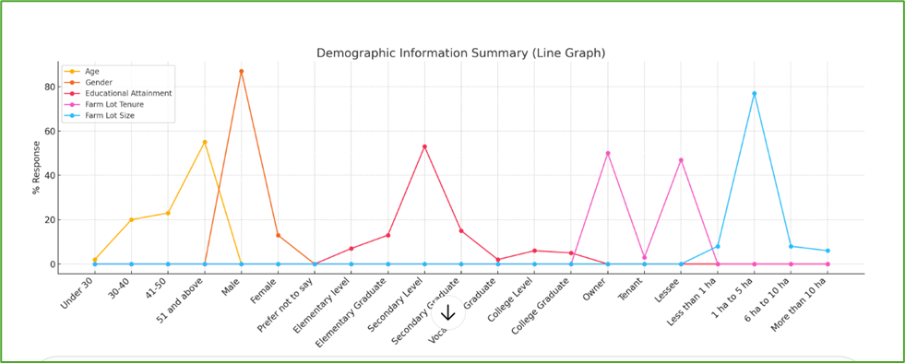
Figure 1. Liner Graph Representation of Respondents’ Demographic Information Including Age, Gender, Educational Attainment, Farm Lot Tenure, and Farm Lot Size.

- Farming Practices of Panama Disease on Banana Growers in Davao del Norte (Figure 2)
Farming practices play a pivotal role in disease and pest management in banana plantations, especially in regions like Davao del Norte, known as the "Banana Capital of the Philippines." According to a survey of 372 farmers, 100% of respondents grow export-oriented banana varieties, underscoring the region's global market focus. However, farming methods vary. While 75% of respondents depend solely on inorganic inputs, 25% incorporate organic fertilizers, such as vermicompost and farmyard manure, which have been shown to improve plant health and yield (Marak et al., 2017).
Despite the importance of crop rotation in managing soil-borne diseases like Fusarium wilt, only 2% of respondents practice rotation every five years. Research by Fan et al. (2020) supports crop rotation’s effectiveness in reducing Fusarium wilt incidence and enhancing banana yield, emphasizing its potential for sustainable disease management.
Knowledge and awareness of Panama disease—caused by Fusarium oxysporum f. sp. cubense Tropical Race 4 (TR4)—is widespread among banana growers in the region. All survey participants were aware of its presence, highlighting high local awareness. However, only 33% reported receiving formal training on disease management. This discrepancy points to a significant gap between general awareness and technical knowledge. Effective management of Panama disease requires an understanding of symptoms, transmission, and preventive practices, which can be enhanced through targeted education (Ploetz, 2015; Ordonez et al., 2015).
The lack of sufficient training underscores the urgent need for enhanced extension services and expert-led workshops. Blomme et al. (2017) emphasize that building farmer capacity through training is essential for effective, long-term management strategies. Thus, improving both farming practices and farmer education is critical to sustaining banana production in Davao del Norte.
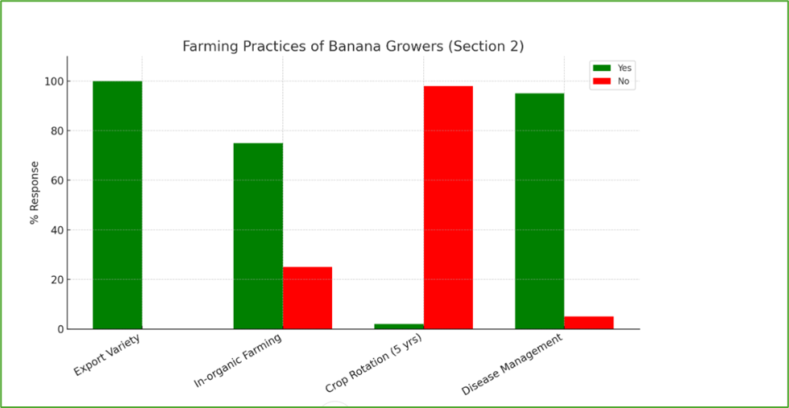
Figure 2. Cluster Bar Graph Showing Percentage Distribution of Farming Practices Adopted by Banana Growers in Davao del Norte.
- Knowledge and Awareness of Panama Disease on Banana Growers in Davao del Norte (Figure 3)
Knowledge and awareness are essential components in effectively managing plant diseases, especially soil-borne threats like Panama disease, caused by Fusarium oxysporum f. sp. cubense Tropical Race 4 (TR4). In Davao del Norte, 100% of banana growers surveyed acknowledged the presence of Panama disease on their farms, reflecting a high level of awareness likely influenced by the visible impact of the disease in the region (Figure 3).
However, while general awareness is widespread, in-depth knowledge and practical training remain limited. Only 33% of respondents reported having received formal training on disease prevention and control measures (Figure 3). This discrepancy between awareness and technical capability reveals a critical gap in disease management efforts. As Ploetz (2015) noted, understanding disease symptoms, transmission pathways, and appropriate control strategies is key to limiting the spread of Panama disease.
Ordonez et al. (2015) emphasized that farmer education is vital for implementing effective biosecurity measures, crop rotation, and the use of resistant cultivars. Without proper training, farmers may be aware of the threat but lack the tools to respond effectively. This was confirmed in the current study, where a lack of structured training opportunities hindered more comprehensive disease control among banana growers.
Blomme et al. (2017) further stressed the importance of capacity-building efforts through expert-led workshops and extension programs. These initiatives not only equip farmers with necessary skills but also enhance their long-term adaptability and resilience to future outbreaks.
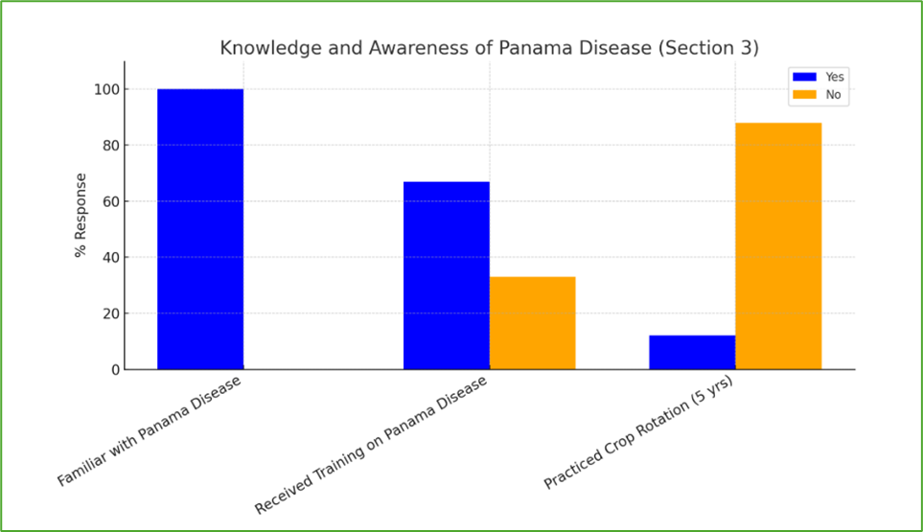
Figure 3. Cluster Bar Graph Showing Percentage Distribution of Banana Growers’ Knowledge and Awareness of Panama Disease in Davao del Norte.

- Disease Impact of Panama Disease on Banana Growers in Davao del Norte (Figure 4)
Panama disease, caused by Fusarium oxysporum f. sp. cubense Tropical Race 4 (TR4), is a severe and rapidly spreading threat to banana production across Southeast Asia (Cook et al., 2015). In Davao del Norte, survey results show that 100% of banana farmers have experienced Panama disease on their farms. More than half (57%) reported a reduction in income and yield by up to 50%, while 43% have responded by implementing strict biosecurity protocols and utilizing biological control agents (Figure 4). This demonstrates the critical need for improved disease management practices to safeguard the livelihoods of affected farmers.
Despite these challenges, a high percentage of farmers (91%) actively implement disease management strategies to curb further damage (Figure 4). These practices include biosecurity measures, crop sanitation, and the use of integrated disease management (IDM) approaches. Gaunt (1995) originally proposed a correlation between disease severity and crop yield loss, and recent studies continue to support this model, emphasizing the importance of proactive intervention.
Aquino et al. (2021) advocate for IDM strategies that incorporate early detection, use of resistant cultivars, and fungicide applications to combat Fusarium wilt and other banana diseases like Sigatoka. Additionally, Torres and Manalo (2022) found that Filipino farmers who adopted farm-level biosecurity protocols were more successful in minimizing the spread of TR4. The Food and Agriculture Organization (FAO, 2023) further supports this by emphasizing that farmer education and real-time access to disease surveillance information are key to effective disease response.
Panama disease has significantly impacted banana farmers in Davao del Norte, many are taking proactive steps to mitigate its effects. Continued investment in farmer training, biosecurity, and science-based interventions is essential to maintaining banana productivity and protecting vulnerable farming communities.
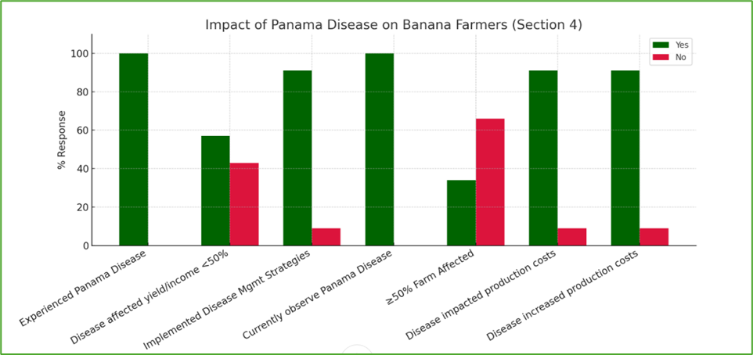
Figure 4. Cluster Bar Graph Showing Percentage Distribution of Banana Growers’ Responses on the Impact of Panama Disease in Davao del Norte.

- Financial Impact of Panama Disease on Banana Growers in Davao del Norte (Figure 5)
Panama disease, caused by Fusarium oxysporum f. sp. cubense TR4, has had a severe financial impact on banana farmers in Davao del Norte. Survey results revealed that 57% of farmers experienced a 50% decline in both yield and income, with 95% reporting financial instability as a direct consequence of the disease. This economic distress has forced many farmers to reduce spending on essential items such as food, education, and healthcare—affecting 96% of the respondents. The widespread income loss has compelled 96% of farmers to seek alternative sources of livelihood to survive, underscoring their resilience amid the crisis (Mostafiz et al., 2022).
The economic toll has also limited farmers' ability to invest in necessary farm improvements, with 97% stating they cannot afford upgrades such as improved drainage, disease-resistant planting materials, or irrigation systems. This lack of reinvestment not only diminishes current productivity but also contributes to the continued spread of the disease. According to Mendoza et al. (2020), this pattern is consistent across Mindanao, where smallholder farmers affected by Fusarium wilt struggle to implement basic maintenance and containment practices.
Moreover, the inability to respond adequately to the disease may lead to a long-term agricultural shift, as some farmers consider abandoning banana cultivation entirely (Lorenzo et al., 2021). Saludes and Ortega (2022) emphasize that recovery is hindered by a lack of access to crop insurance and affordable credit. The Department of Agriculture (2023) has acknowledged the urgency of scaling up support systems, including financial assistance and disease monitoring, to prevent further economic and agricultural decline in the region.
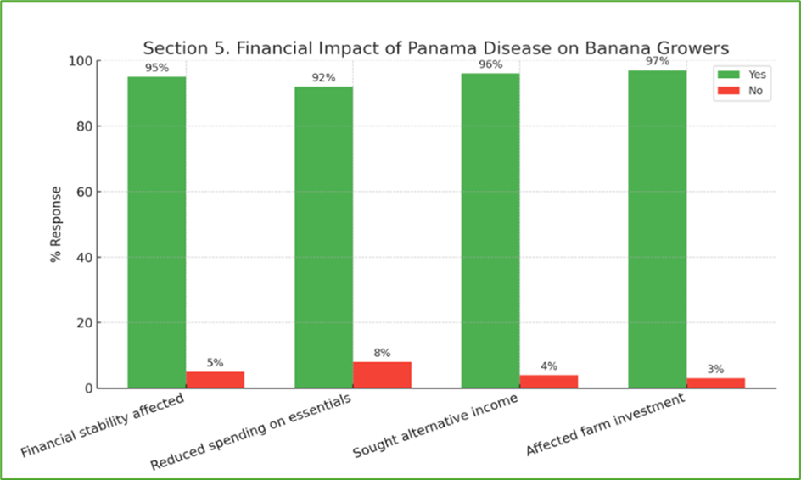
Figure 5. Cluster Bar Graph Showing the Financial Impact of Panama Disease on Banana Growers in Davao del Norte.
- Coping Mechanism of Panama Disease on Banana Growers in Davao del Norte (Figure 6)
Coping with Panama Disease requires both individual initiative and institutional support to safeguard farmers’ livelihoods and national production. In Davao del Norte, 56% of surveyed growers reported having personal strategies—chiefly seeking alternative income sources—to mitigate the economic fallout of Fusarium wilt (Mostafiz et al., 2022). Despite these efforts, robust government intervention remains critical: programs such as crop insurance, targeted financial aid, and technical training can strengthen resilience and prevent long‐term decline.
Biotechnological advances offer promising solutions. Dale et al. (2017) highlighted the successful development of genetically modified Cavendish bananas resistant to Tropical Race 4 (TR4), with field trials demonstrating sustained disease resistance over three years. Reflecting this potential, 98% of Davao farmers expressed willingness to adopt such resistant varieties if available—an urgent call for authorities to facilitate technology transfer and subsidize adoption (Zheng et al., 2023). In the interim, 55% of respondents employ soil fumigation with fungicides, although 45% refrain due to cost and environmental concerns.
Universal adoption of biosecurity measures (100% of respondents) underscores farmers’ recognition that preventing pathogen spread is vital. However, biosecurity alone cannot replace investments in resistant genetics, diversified livelihoods, and supportive policies. Comparative studies reinforce these findings: Mostafiz et al. (2022) documented Bangladeshi banana growers diversifying into livestock and off‐farm work, yet emphasized that without financial backing and extension services, such adaptations are unsustainable.
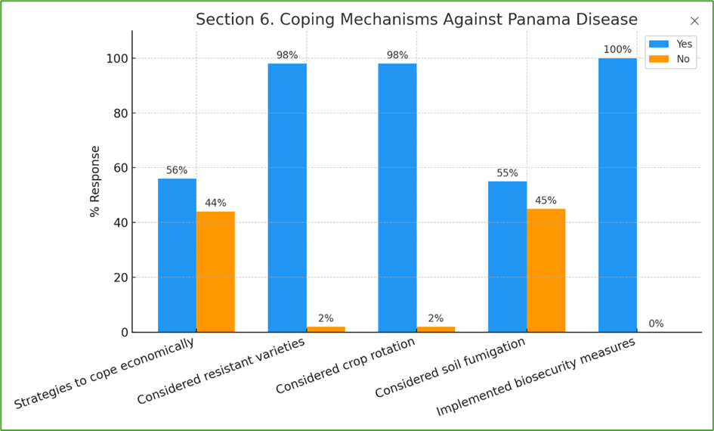
Figure 6. Cluster Bar Graph of Coping Mechanisms Employed by Banana Growers in Response to Panama Disease.

- Support, Resources, and Future Outlook of Banana Growers in Davao del Norte (Figure 7)
Support and access to resources are essential for smallholder banana farmers coping with Panama disease in the Philippines. This study revealed that only 43% of farmers in Davao del Norte received assistance from government or agricultural agencies, while 57% are still waiting for any form of aid. This aligns with findings by Lantican et al. (2021), who reported that delayed and insufficient government support hindered farmers' capacity to manage disease outbreaks. Similarly, the Food and Agriculture Organization (FAO, 2020) stressed that timely, equitable support is crucial for mitigating the impacts of agricultural disruptions, especially in vulnerable communities.
Comprehensive and integrated aid—including financial support, technical training, and input provision—is critical for building resilience against plant disease. Blomme et al. (2017) emphasized that financial assistance must be paired with infrastructure development and disease management education to be effective.
Despite these challenges, optimism remains high among banana farmers in Davao del Norte. This study found that 96% of respondents are confident in the future of banana farming, expressing hope that authorities will eventually provide adequate support. This is consistent with findings by Islam et al. (2022), who reported that farmers affected by Fusarium wilt in Bangladesh remained hopeful and resilient despite substantial losses.
Furthermore, nearly one-third of Davao respondents indicated a willingness to adopt new farming strategies or shift to alternative practices. According to Altieri et al. (2015) and Lybbert & Sumner (2012), resilience and innovation—driven by personal outlook and institutional support—are vital for overcoming agricultural crises. These findings suggest that Davao banana growers are prepared to adjust and survive, provided appropriate support mechanisms are put in place.
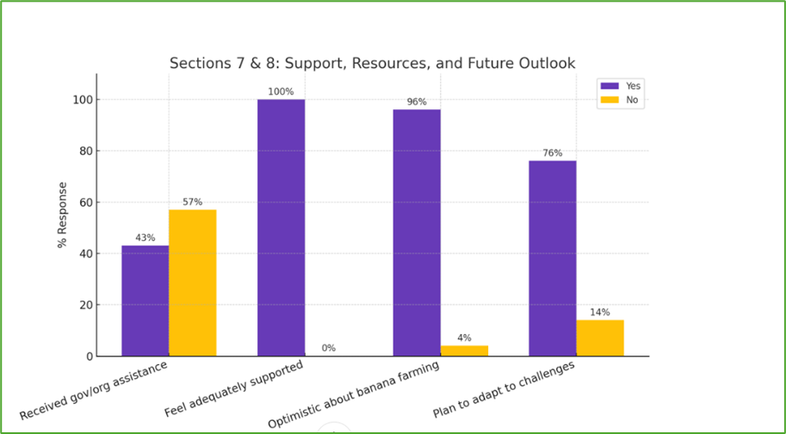
Figure 7. Cluster Bar Graph of Support, Resources, and Future Outlook Among Banana Growers Affected by Panama Disease in Davao del Norte.

Conclusion
This study highlights the severe socio-economic toll of Panama disease (TR4) on banana growers in Davao del Norte, exposing critical challenges in agricultural sustainability. While farmers exhibit resilience and awareness, their ability to combat the disease is hindered by inadequate training, insecure land tenure, and limited financial and institutional support. The aging farming population, low youth and female involvement, and minimal use of sustainable practices further compound these issues. Despite widespread adoption of biosecurity measures, high costs and insufficient aid limit the implementation of effective disease control strategies. Encouragingly, most farmers express readiness to adopt resistant banana varieties and adapt their practices. To ensure the region’s banana industry survives and thrives, immediate action is needed. Strengthened extension services, access to resistant cultivars, secure land tenure, and financial assistance must be prioritized. Coordinated government and stakeholder support is vital to empower farmers, enhance resilience, and secure the long-term future of banana farming in Davao del Norte.
Summary
This study evaluated the socio-economic impact of Panama disease (Fusarium oxysporum f. sp. cubense TR4) on banana farmers in Davao del Norte, focusing on demographics, farming practices, disease awareness, financial effects, coping strategies, and support systems. Findings show that most farmers are aging (55% over 51), predominantly male (84%), and have limited educational attainment. Land tenure is split, with 50% owning and 47% leasing land, and most managing small farms (1–5 hectares). While all grow export bananas, only 25% use mixed farming inputs and just 2% practice crop rotation. Though awareness of TR4 is high, only 33% have received formal training. All farmers have been affected, with 57% reporting income losses of up to 50% and 96% reducing essential spending. Despite limited government aid (43%), 91% use disease control methods and 98% are open to resistant varieties. Stronger institutional support and access to training and resistant cultivars are urgently needed.

Recommendations
This chapter outlines targeted recommendations to address the socio-economic challenges posed by Panama disease (TR4) among banana growers in Davao del Norte. To respond to the aging farming population and limited educational background, the government should provide free or subsidized training, strengthen land tenure, and promote cooperative farming. Financial support through grants and low-interest loans will help farmers afford inputs and farm improvements. Sustainable practices—such as crop rotation, integrated disease management, and balanced input use—must be promoted through farmer field schools and digital training. To reduce financial strain, emergency aid, subsidies, and credit access should be expanded. Encouraging livelihood diversification and accelerating the distribution of disease-resistant banana varieties are vital for long-term resilience. Improving market access, forming cooperatives, and ensuring efficient aid delivery will help stabilize farmer incomes. Lastly, future research should broaden geographic scope and address market and climate dynamics. Strong institutional collaboration is key to industry recovery and sustainability.

References
- Altieri, M. A., Nicholls, C. I., Henao, A., & Lana, M. A. (2015). Agroecology and the design of climate change-resilient farming systems. Agronomy for Sustainable Development, 35(3), 869–890. https://doi.org/10.1007/s13593-015-0285-2
- Aquino, V. D., et al. (2021). Integrated management strategies for banana diseases. Philippine Journal of Crop Science, 46(2), 45–52.
- Ballesteros, M. M., Llanto, G. M., & Ramos, T. (2021). Land tenure and rural development in the Philippines. Philippine Institute for Development Studies.
- Blomme, G., et al. (2017). Addressing the impact of Fusarium wilt on banana productivity and livelihoods in Sub-Saharan Africa. Acta Horticulturae, 1179, 307–316. https://doi.org/10.17660/ActaHortic.2017.1179.39
- Blomme, G., Ploetz, R., Jones, D. R., De Langhe, E., & Price, N. (2017). A historical overview of the appearance and spread of Fusarium wilt of banana in Asia. Acta Horticulturae, 828, 155–164. https://doi.org/10.17660/ActaHortic.2009.828.18
- Cook, D. C., et al. (2015). Strategic planning for managing the spread of Panama disease TR4 in bananas. Crop Protection, 73, 132–142. https://doi.org/10.1016/j.cropro.2015.03.003
- Creswell, J. W., & Creswell, J. D. (2018). Research design: Qualitative, quantitative, and mixed methods approaches (5th ed.). SAGE Publications.
- Dale, J. L., et al. (2017). Development of genetically modified Cavendish bananas resistant to Fusarium wilt TR4: A field trial in Northern Australia. Plant Biotechnology Journal, 15(2), 142–152. https://doi.org/10.1111/pbi.12616
- Department of Agriculture. (2023). Banana industry recovery program highlights Fusarium wilt response.
- Dita, M., Barquero, M., Heck, D., Mizubuti, E. S. G., & Staver, C. P. (2018). Fusarium wilt of banana: Current knowledge on epidemiology and research needs toward sustainable disease management. Frontiers in Plant Science, 9, 1468. https://doi.org/10.3389/fpls.2018.01468
- Dizon, J. M., Garcia, A. L., & Cruz, R. M. (2022). Barriers to higher education among smallholder farmers in rural Philippines. Journal of Rural Studies, 87, 101–112. https://doi.org/10.1016/j.jrurstud.2021.10.011
- Fan, H., et al. (2020). Crop rotation and soil microbiota in controlling Fusarium wilt of banana. Frontiers in Microbiology, 11, 575643. https://doi.org/10.3389/fmicb.2020.575643
- FAO. (2020). COVID-19 and the role of local food production in building more resilient food systems. Food and Agriculture Organization of the United Nations.
- Food and Agriculture Organization. (2023). Building resilience to Fusarium wilt in banana-producing regions. FAO Brief No. 24.
- Gaunt, R. E. (1995). Modeling the relationship between disease and crop loss. Annual Review of Phytopathology, 33, 119–144. https://doi.org/10.1146/annurev.py.33.090195.001003
- Islam, M. S., Mostafiz, I., Kabir, M. H., & Hossain, M. (2022). Farmers’ resilience to Fusarium wilt: A case from Bangladesh. Journal of Plant Pathology, 104(2), 389–397. https://doi.org/10.1007/s42161-021-00929-5
- Lantican, F. A., Alviar, K. P., & Espino, R. R. (2021). Government support mechanisms for banana farmers affected by Fusarium wilt in Southern Philippines. Philippine Journal of Crop Science, 46(1), 23–31.
- Lorenzo, R., Dela Cruz, J., & Santos, M. (2021). Economic resilience of banana farmers to Fusarium wilt in Southeast Asia. Journal of Rural Studies, 87, 144–152. https://doi.org/10.1016/j.jrurstud.2021.09.015
- Lybbert, T. J., & Sumner, D. A. (2012). Agricultural technologies for climate change mitigation and adaptation in developing countries: Policy options for innovation and technology diffusion. Food Policy, 37(1), 114–123. https://doi.org/10.1016/j.foodpol.2011.11.001
- Manfre, C., & Rubin, D. (2012). Integrating gender into agricultural development projects: A toolkit for practitioners. USAID.
- Marak, T., et al. (2017). Effect of organic and inorganic fertilizers on banana productivity and soil health. International Journal of Agricultural Science and Research, 7(1), 95–102.
- Mendoza, D., Garcia, P., & Alviar, K. (2020). Constraints to disease management among smallholder banana growers in Mindanao. Philippine Agricultural Scientist, 103(3), 245–252.
- Mostafiz, I., Kabir, M. H., & Rahman, M. (2022). Livelihood transitions among banana farmers affected by Fusarium wilt in Bangladesh. Agronomy for Sustainable Development, 42(1), 1–12. https://doi.org/10.1007/s13593-022-00765-2
- Mostert, D., Molina, A. B., Daniells, J., Fourie, G., Hermanto, C., Chao, C. P., & Viljoen, A. (2017). The distribution and host range of the banana Fusarium wilt fungus, Fusarium oxysporum f. sp. cubense, in Asia. PLoS ONE, 12(7), e0181630. https://doi.org/10.1371/journal.pone.0181630
- Ngidlo, R. T. (2014). Sustainable farm practices and infrastructure in Philippine agriculture. Asian Journal of Agriculture and Development, 11(2), 75–91.
- Ordoñez, N., Seidl, M. F., Waalwijk, C., Drenth, A., Kilian, A., Thomma, B. P. H. J., ... & Kema, G. H. J. (2015). Worse comes to worst: Bananas and Panama disease – when plant and pathogen clones meet. PLoS Pathogens, 11(11), e1005197. https://doi.org/10.1371/journal.ppat.1005197
- Ordonez, N., et al. (2015). Lessons learned from managing Panama disease. PLoS Pathogens, 11(8), e1005190. https://doi.org/10.1371/journal.ppat.1005190
- Peña, R. V., & Valerio, G. L. (2022). Tenure insecurity and investment behavior among Filipino farmers. Asian Journal of Agriculture and Development, 19(1), 67–83. https://doi.org/10.37801/ajad2022.19.1.5
- Philippine Institute for Development Studies. (2023). Improving land tenure systems in rural communities. https://www.pids.gov.ph
- Philippine Statistics Authority. (2020). Women in agriculture and the rural economy. https://psa.gov.ph
- Philippine Statistics Authority. (2022). Average age of Filipino farmers. https://psa.gov.ph
- Ploetz, R. C. (2015). Fusarium wilt of banana. Phytopathology, 105(12), 1512–1521. https://doi.org/10.1094/PHYTO-04-15-0101-RVW
- Reyes, E. A., & Salazar, A. V. (2021). Digital divide in rural farming communities in the Philippines. International Journal of Agricultural Extension, 9(2), 55–65.
- Saludes, R., & Ortega, V. (2022). Financial vulnerability of smallholder banana growers to Fusarium wilt and credit accessibility. Agricultural Economics Review, 14(2), 101–117.
- Smith, R. L., Johnson, T., & Carter, B. (2018). Aging farmers and the future of U.S. agriculture. Rural Sociology Review, 83(3), 210–229.
- Torres, R. J., & Manalo, L. M. (2022). Biosecurity adoption and disease control among banana farmers in the Philippines. Journal of Agricultural Sustainability, 9(1), 33–40.
- Vallejo, A. M., Santos, M. C., & Navarro, J. L. (2022). Status of Filipino smallholder farmers: Demographics and productivity challenges. Philippine Journal of Agricultural Economics, 44(2), 120–138.
- Zhang, Y., Chen, Q., & Li, M. (2016). Demographic trends in China's rural farming population. China Agricultural Review, 12(1), 55–72.

