Prevalence of malaria among children less than five years old and socio-economic factors of mothers/caregivers in Awka South LGA, Anambra State, Nigeria.
ABSTRACT
Malaria is a life-threatening disease caused by protozoan parasite belonging to the genus Plasmodium. Children less than five years old are one of (remove) the most vulnerable groups affected by the disease. This study was carried out to determine the prevalence and intensity of malaria among children less than five years old in five major health facilities in Awka Metropolis. A total of 678 blood samples were obtained from children that attended these health facilities from January to July, 2025. The samples were processed and examined microscopically for the presence of malaria parasites. Of the 678 blood samples examined, 576 (85.0%) were positive however, most of the positive cases 492(85.4%) had a mild infection. The prevalence was highest (87.0%) in Primary Health Centre, Okpuno. Female children were more infected (87.7%) than their male counterpart (82.1%). Malaria was highest (96.9%) among children between 13-24 months old. On the mothers/caregivers level of literacy, the highest prevalence (92.3%) was observed among children whose mothers/caregivers had primary school. Similarly, children whose mothers/caregivers were housewives had the highest prevalence of malaria (97.5%). Based on marital status, children whose mothers/caregivers were married had the highest prevalence of malaria (91.0%). This study showed that a substantial number of children in Awka still have malaria, and it calls for a re-evaluation of the control/elimination strategies that have been adopted until now.
Key Words: prevalence, malaria, children, socio-economic factors, Awka-South LGA.
INTRODUCTION
Malaria is a life-threatening disease caused by protozoan parasites belonging to the genus Plasmodium, and is transmitted to humans through the bites of infected female Anopheles mosquitoes (WHO, 2021). It is among the most endemic parasitic diseases in the tropics (Nwaneli et al., 2020; Abdullahi et al., 2009). It is an important public health disease, not just in the tropics, but also in sub-tropical countries of the world where poverty and ignorance, including unsuitable environmental factors exist (Debash et al., 2022; Kalu et al., 2012; Onyido et al., 2014; Irikannu and Chukwuekezie, 2015; Onyido et al., 2016).
The disease causes widespread premature death, suffering and financial hardship especially among the less privileged (RBM, 2005). Despite recent efforts at malaria control, it still infects over 200 million people and kills up to 800,000 worldwide, with over 90% of the death still in sub-Saharan Africa (WHO, 2022). The region(Sub-Saharan Africa) carries a disproportionately high share of the global malaria burden. In 2021, the Region was home to 95% of malaria cases and 96% of malaria deaths. Children under 5 accounted for about 80% of all malaria deaths in this region.
Nigeria has the greatest burden of malaria globally accounting for 31.3% of global malaria burden. The risk of transmission exists throughout the country all year round. It accounts for more cases and deaths than in any other country in the world (Debash et al., 2022; WHO, 2022). According to the Federal Ministry of Health (2018), the highest case fatality ratio due to malaria in Nigeria was recorded in Sahel Savannah region of Northeastern Nigeria. The disease is responsible for 60% outpatient visits to health facilities, 30% hospitalizations and 11% maternal deaths. The financial loss due to malaria annually is estimated to be about 132 billion Naira in the form of treatment costs, prevention and loss of man-power (FMOH, 2018).
Children less than five years of age are one of the most vulnerable groups affected by malaria. There was an estimated 438, 000 malaria deaths around the world, of which approximately 69% were children under 5 years of age (Debash et al., 2022; Opara et al., 2011; Onyido et al., 2016; WHO, 2021). Also, it is estimated that about one out of five children in Nigerian dies of malaria before the age of five years (WHO, 2021). Large numbers of children miss schools thus their educational development is affected (Ughasoro and Okafor, 2015).
Following massive deployment of malaria interventions in Nigeria with the ambition (replace with aim) to eliminate the disease in the country, periodic studies on malaria epidemiology is a necessity to provide an up-to-date knowledge on the status of the disease and to evaluate progress made. With this goal in mind, this study was aimed at determining the prevalence of malaria among children less than five years old in Awka, Anambra State.
MATERIALS AND METHODS
Study Area
The study was carried out in Awka South Local Government Area (Fig 1). Awka South LGA is situated between Longitude 7⁰04’East and Latitude 6⁰10’ North of the Equator. Awka South LGA consist of nine communities namely: Awka, Amawbia, Nibo, Nise, Umuawulu, Mbaukwu, Okpuno, Isiagu and Ezinato. Located in the tropical rainforest zone of Nigeria, the region experiences two distinct seasons which are rainy or dry seasons. The rainy season occur between April and October. This is followed by four months of dryness (November - March). The temperature in Awka is generally 27-30˚C between April and October but rises to 32-34˚C between November and March, with the last few months of the dry season marked by intense heat. The relative humidity of the area is about 70% in the dry season reaching 80% during the wet season. The annual rainfall is between 2000-3000mm. The community is about 150m above sea level. Awka South has a population of 189,654 (NPC, 2006).The inhabitants of the area are predominantly farmers, civil servants, students, traders, and blacksmiths.
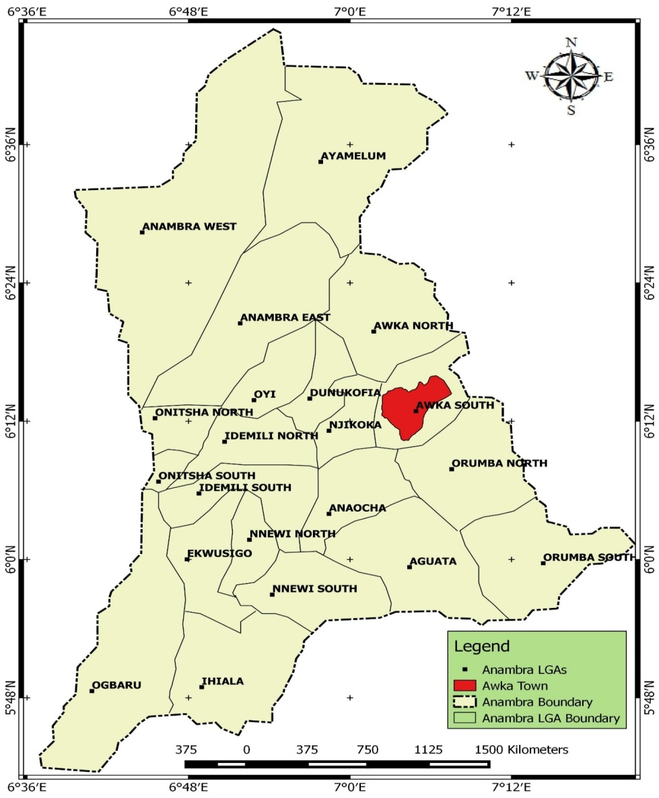
Source: GIS and Cartography Lab, Department of Geography and Meteorology, Nnamdi Azikiwe University, Awka.
Figure 1: Map of Anambra State Showing Awka South Local Government Area

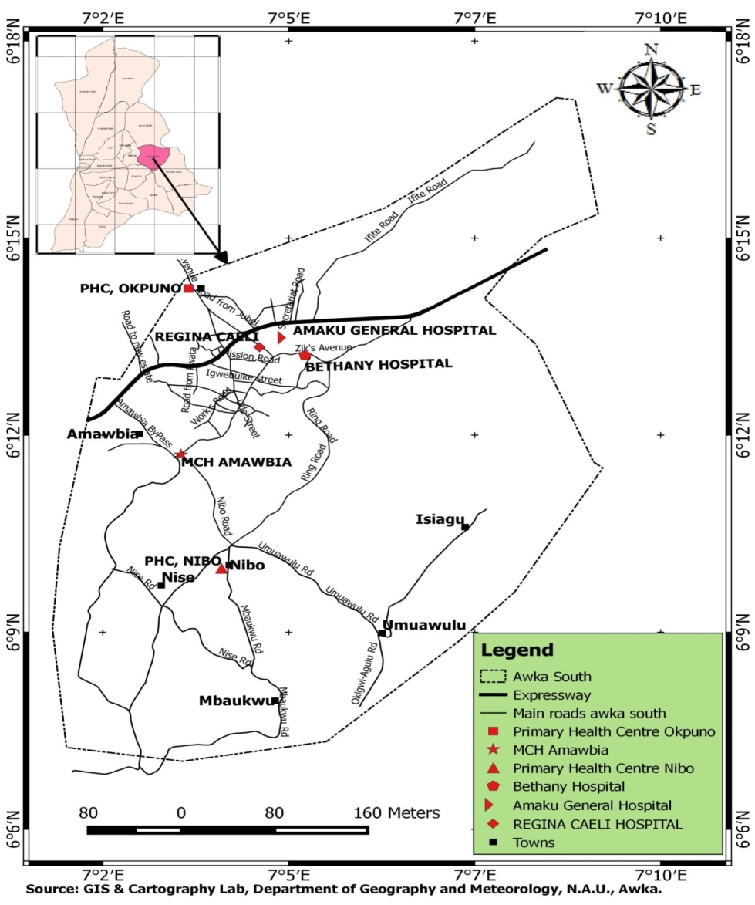
Source: GIS and Cartography Lab, Department of Geography and Meteorology, Nnamdi Azikiwe University, Awka.
Figure 2: Map of Awka South Local Government Area Showing the Study Locations.
Study Design
The study was a hospital based survey of under five year old children in four major health facilities in Awka within a period of 6 months from March to September, 2023. This covered both wet and dry seasons.

Ethical Consideration
The study was approved by the ethical committee of Anambra State Ministry of Health, Awka. Advocacy visit to the State Ministry of Health with Advocacy visits with a copy of the approval letter from the Ministry of Health to the Medical Directors of the Health facilities used for the study, was used to get the support and co-operation of the institutions and their staff. The informed consent of the mothers and caregivers to the children was obtained through careful explanation of the project intent and gains to them.
Selection of the Health Facilities
Four health facilities were chosen based on their location and attendance by the people. The selected Health facilities were (1) Chukwuemeka Odimegwu Ojukwu University Teaching Hospital Awka, (2) Regina Caeli Hospital, Awka, (3)Primary Health Centre, Okpuno, (4) Primary Health Centre, Nibo, and (5) Maternal and Child Health Centre, Amawbia.
Sample Size Determination
A formular for sample size determination as described by Yaman (1964) was used thus
n=N/1+N(e)²
where n=sample size
N=population size
e=error limit
1=constant
The total sample size was 600 but was made up to 678.

Collection of Blood Samples
Blood was collected from the participating children by trained nurses (blood collection for laboratory analysis should be by lab scientists or technicians) in the health facilities. A total of 678 samples were collected in this study. about 1ml of venous blood of each participant was transferred into an EDTA (anticoagulant) bottle.
Diagnosis of Malaria
Thick and thin Blood Films were made from the participant’s blood witha well-labeled grease-free microscope slide. Both films were stained with Leishman’s stain. Preparation and staining of the blood films was done according to Cheesbrough (2005). The slides were examined under the microscope with 100 X (oil immersion) objective lens. The presence of malaria parasites in the blood film was indicated by a positive sign (+) while the absence of malaria parasite was indicated by a negative sign (-).
Determination of Intensity of Malaria
The intensity of malaria parasites in the blood films was indicated with one or more positive signs as follows: Mild infection (+) for 1-10 parasites per 100 high power fields, Moderate infection (++) for 11-100 parasites per 100 high power fields, Heavy infection (+++) for 1-10 parasites per high power fields (Cheesbrough, 2005).
Socio-economic factors of mothers/caregivers
Data on socio-economic factors of mothers/caregivers were generated using questionnaire.
Data Analysis
All the data obtained were analyzed using Statistical Package for Social Sciences (SPSS) software version 17.0. The relationship between the prevalence and intensity of the infection were analyzed. Chi-square test (χ²-test) was used to compare the parameters. P-value less than 0.05, (P<0.05) was considered significant.
RESULTS
Overall prevalence of malaria among the children
The result of 678 blood samples collected for malaria diagnosis from children less than five years old from four different health facilities in the study area was presented in table 1. Of the 678 children tested for malaria in the study area, 576(85.0%) were positive for malaria parasite. Of all the children infected with malaria, 492(85.4%) had mild malaria infection, 72(12.5%) had moderate infection, and 12(2.1%) had heavy (replace with severe) infection. There was no significant association (P>0.05) between the intensity of malaria and the health facility sampled. However comparing the prevalence across the community health facilities, revealed a significant difference (χ²=12.265, df=3P-value=0.007).
Table 1: Prevalence and intensity of malaria in relation to health facility.
Health facility | No. Examined | No. Positive (%) | Mild Inf. (+) (%) | Moderate Inf. (++) (%) | Heavy Inf. (+++) (%)
COOUTH, Awka | 188 | 158(84.0) | 135(85.4) | 20(12.7) | 3(1.9)
RCH, Awka | 170 | 145(85.3) | 123(84.8) | 20(13.8) | 2(1.4)
PHC, Okpuno | 100 | 87(87.0) | 75(86.2) | 10(11.5) | 2(2.3)
PHC, Nibo | 100 | 84(84.0) | 71(84.5) | 10(11.9) | 3(3.6)
MCH, Amawbia | 120 | 102(85.0) | 85(83.3) | 12(11.8) | 2(2.0)
Total | 678 | 576(85.0) | 492(85.4) | 72(12.5) | 12(2.1)
*COOUTH is Chukwuemeka Odimegwu Ojukwu University Teaching Hospital; RCH is Regina Caeli Hospital; PHC is Primary Health Centre; and MCH is Maternal and Child Health Centre.** Inf. is a short form for infection; No. is short form for number.
Sex-related prevalence and intensity of malaria
Of all 678 children, 336 (49.6%) were male and 342 (50.4%) were female. Male children positive for malaria were 276(82.1%) while female children positive for malaria were 300(87.7%).No significant association was found between the intensity of malaria and sex of the children (χ²=2.586; P-value=0.460).See table 2.
Table 2:Prevalence and intensity of malaria in relation to sex.
Sex | No. Examined | No. Positive (%) | Mild Inf. (+) (%) | Moderate Inf. (++) (%) | Heavy Inf. (+++) (%)
Male | 336 | 276(82.1) | 228(82.6) | 42(15.2) | 6(2.2)
Female | 342 | 300(87.7) | 264(88.0) | 30(10.0) | 6 (2.0)
Total | 678 | 576(85.0) | 492 (85.4) | 72 (12.5) | 12(2.1)
* Inf. is a short form for infection; No. is short form for number.

Age-related prevalence and intensity of malaria
Table 3 shows the prevalence of malaria in relation to the age groups of the children, which was highest 192(96.9%) among 13 – 24 months old and least 132 (73.3%) among children less than 12 months old. A significant difference was found in the intensity of malaria infection in relation to age (χ²=42.946; P-value=0.000).
Table 3: Prevalence and intensity of malaria in relation to age
Age (months) | No. Examined | No. Positive (%) | Mild Inf. (+) (%) | Moderate Inf. (++) (%) | Heavy Inf. (+++) (%)
<12 | 180 | 132 (73.3) | 126(95.5) | 6 (4.6) | 0 (0.0)
13-24 | 198 | 192(96.9) | 168 (87.5) | 24 (12.5) | 0 (0.0)
25-36 | 96 | 90 (93.8) | 78 (86.7) | 6 (6.7) | 6 (6.7)
37-48 | 114 | 84 (73.7) | 54(64.2) | 24 (28.6) | 6 (7.1)
49-60 | 84 | 78 (92.8) | 66(84.6) | 12 (15.4) | 0 (0.0)
Total | 672 | 576 (85.0) | 492(85.4) | 72 (12.5) | 12 (2.1)
* Inf. is a short form for infection; No. is short form for number.
Prevalence and intensity of malaria among children in relation to literacy level of mother/caregivers.
The prevalence and intensity of malaria infection by risk factors is shown in Table 4. Based on mothers/caregivers’ literacy level, the highest malaria prevalence (92.3%) was observed among children whose mothers/caregivers had primary education and the least prevalence of (83.8%) was recorded among children whose mothers/caregivers had tertiary education. Children whose parents had secondary education had a prevalence of 85.0%. There was a significant difference in the prevalence and intensity of malaria infection by risk factors in relation to caregivers education (P<0.05) (X²=37.617; p-value=0.000) (Appendix 1).
The highest prevalence of mild malaria was recorded among children whose mothers/caregivers had tertiary education (89.6%), and moderate malaria was recorded highest among children whose mothers/caregivers had primary education. No case of heavy infection was found among those whose mothers/caregivers had secondary and tertiary education.
Table 4: Prevalence and intensity of malaria in relation to literacy level of mothers/caregivers.
Literacy level of mothers/caregivers | No. Examined | No. Positive (%) | Mild Inf. (+) (%) | Moderate Inf. (++) (%) | Heavy Inf. (+++) (%)
Primary | 78(11.6) | 72(92.3) | 42(58.3) | 18(23.1) | 12(16.7)
Secondary | 120(17.7) | 102(85.0) | 90(88.2) | 12(11.8) | 0(0.0)
Tertiary | 480(70.8) | 402(83.8) | 360(89.6) | 42(10.4) | 0(0.0)
Total | 678(100) | 576(84.9) | 492(85.4) | 72(12.5) | 12(2.1)

Prevalence and intensity of malaria among children in relation to occupation of mothers/caregivers.
From the prevalence and intensity of malaria infection by risk factors based on mothers/care givers’ occupation, children whose parents were housewives had the highest prevalence 234(97.5%), while children of civil servants had the least (76.6%).The children of traders had a prevalence of 80.7%. The observed difference in the prevalence and intensity of malaria infection by risk factors in relation to mothers/caregivers’ occupation was not significant (P>0.05) (X²=41.535; P-value=0.000) (Appendix 2).
The highest prevalence of mild infection (89.7%) was recorded among housewives and the least prevalence among traders (80.9%). The highest prevalence of moderate infection was found among civil servants (16.7%). However, no case of heavy infection was recorded among civil servants and traders.
Table 5: Prevalence and intensity of malaria by occupation in relation to mothers/caregivers.
Occupation | Total Examined (%) | Total infect. (%) | Mild Inf. (%) | Mod. Inf. (%) | Heavy Inf. (%)
Civil serv. | 282(41.6) | 216(76.6) | 180(83.3) | 36(16.7) | 0(0.0)
Traders | 156(23.0) | 126(80.7) | 102(80.9) | 24(10.5) | 0(0.0)
Housewives | 240(35.4) | 234(97.5) | 210(89.7) | 12(5.1) | 12(5.1)
Total | 678(100.0) | 576(84.9) | 492(85.4) | 72(12.5) | 12(2.1)

Prevalence and intensity of malaria among children in relation to marital status of mother/caregivers.
From the prevalence and intensity of malaria infection by risk factors based on mothers/care givers’ marital status, children of married caregivers had the highest prevalence 486(91.0%) while children of single parents had the least 18(37.5%). The children of widows had a prevalence of 72(75.0%). The observed difference in the prevalence and intensity of malaria infection by risk factors in relation to mothers/caregivers’ marital status was not significant (P>0.05) (X²=3.423; P-value=0.0490).

Table 6: Prevalence and intensity of malaria among children in relation to marital status of mother/caregivers.

Marital status | Total Examined (%) | Total infect. (%) | Mild Inf. (%) | Mod. Inf. (%) | Heavy Inf. (%)
Married | 534(78.8) | 486(91.0) | 444(91.4) | 42(8.6) | 0(0.0)
Single | 48(7.1) | 18(37.5) | 0(0.0) | 12(66.7) | 6(33.3)
Widowed | 96(14.2) | 72(75.0) | 48(66.7) | 18(25.0) | 6(8.3)
Total | 678(100.0) | 576(84.9) | 492(85.4) | 72(12.5) | 12(2.1)

DISCUSSION
An overall prevalence of malaria in this study, using microscopy technique was 85.0%. This is higher than the overall malaria prevalence of 58.2% observed in children of same age in Awka North Local Government Area by Nwaorgu and Orajiaka, (2011); 49.2% observed by Ughasoro and Okafor (2015) in a survey of malaria prevalence in paediatric patients in South Eastern Nigeria; 34.8% obtained by Okeke et al. (2021) in Dunukofia, Anambra State; 62% obtained by Onyido et al. (2011) in the study on malaria prevalence and vector abundance in Uli, Anambra State; 79.1% by Opara et al. (2011) in Ebonyi State and 80.4% by Kalu et al. (2012) in Abia State; 43.1% by Uzochukwu et al. (2008) in Enugu-East Local Government Area (L.G.A) of Enugu State; all in the same geographical (southeast) zone of Nigeria. It is also lower than 50% reported by Ajayi et al. (2015) in Ibadan, Southwest Nigeria; 17.0% in Eastern Nigeria by Anumudu et al. (2006); and 27.3% by Abdullahi et al. (2009) in Sokoto State. This could partly be explained by the variation in parasite– vector–human transmission dynamics that favour or limit the transmission of malaria infection and partly by the associated risk of disease and death (Okeke et al., 2021). The wide range of differences in malaria prevalence may be attributed to differences in climatic factors and behavioural patterns of people in the area which promote mosquito breeding and susceptibility of the people to mosquito bites. Awka has an annual rainfall which supports the life of malaria vectors more than northeast and northwest zones of Nigeria which appear drier with lesser amount of annual rainfall. The high prevalence of malaria in this study could also be due to some factors such as higher seasonalrelative humidity, temperature, urbanization, and availability of breeding sites for malaria vectors.Thus, Awka may be described as highly endemic for malaria despite the fact that the participants were healthy individuals who showed no sign and symptoms of malaria parasite.
Of all the children positive for malaria, 85.4% had mild malaria infection, 12.5% had moderate infection and 2.1% had heavy (use severe) infection with malaria parasites. In this study, the highest occurrence of mild infection of malaria parasite (95.5%) was in the age group less than 12 months. This has further demonstrated the vulnerability of the children in this age group to malaria infection (Aliyu, 2022). This might also suggest that malaria infection occur more in children less than 5 years old as a moderate infection than a mild or severe form of the disease. Estimating malaria parasite intensity is necessary for patients’ management especially when parasite resistance to available therapy is on the increase (Adu-Gyasi et al. 2012). The low percentage of moderate (12.5%) and heavy (2.1%) infections obtained in this study could be indicating a high immunity to malaria in the community; hence all the participants were apparently healthy.
Plasmodium falciparum was the only malaria species encountered. Falciparum malaria is almost entirely confined to the tropics and subtropics (Oguoma et al., 2021) and it is therefore not surprising that P. falciparum was the only species seen. Similarly, Mboera et al. (2006) indicated that P. falcparum was predominant malaria parasite in their study in Tanzania. Also Ogundipe et al. (2022) recorded only P. falciparum in Ondo State. P. falciparum accounts for most of the infections in Africa and over one third of the infection in the rest of the world (Nwaneli et al., 2020). Malaria is holoendemic in Nigeria with P. falciparum as the dominant species (Gaston et al., 2020).
Mild parasitaemia was higher in females (88.0%) than males (79.2%) while moderate intensity of malaria was higher in males (14.6%) than in females (10.0%), although there was no significant difference in both prevalence and intensity (P>0.05). This contrasts sharply with the works of Kalu et al. (2012) and Okonko et al. (2010) who recorded higher intensity of malaria in females than males in Aba and Umuahia(Abia State) and Ibadan (Oyo State) respectively. The result agrees with the findings of Aliyu (2001) in Jigawa State and Ezeigbo et al. (2014) in Aba, Abia State where significantly higher malaria intensity in males than in females were obtained. Although there is no concrete explanation for higher ‘moderate intensity’ in males but higher prevalence of malaria in females, we may (remove) attributed this to some physiological changes in them that tend to lower their immunity thus predisposing them to malaria and other diseases. However, there is no scientific evidence to support the higher prevalence and intensity being related to gender as susceptibility to malaria infection is not influenced by gender (Okonko et al., 2010). The higher prevalence in females and higher intensity in males may just be by chance as both sexes are equally affected by malaria parasite.
Children are considered the high risk group in malaria transmission and the consequence of this could be enormous. In this study, the highest prevalence of malaria parasite (96.9%) was observed in the age group 13-24 months. This contrasts with the findings of Nwaorgu and Orajiaka (2011) who reported that children less than one year old had low prevalence for Plasmodium infection. They attributed this to maternal derived antibodies. The deviation in this study may be as a result of “chance or eventuality” that the children 0-9 months of age with malaria infection attending the health facilities within the period of this study were significant in number than other age groups. Although it has been established that residual immunity derived from mothers could be very effective in younger children but environmental condition and inability of children of this age in the study area to ward-off environmental induced mosquito attack predisposed them to malaria attack (Nwaorgu and Orajiaka, 2011).
High infection rate in the younger age group recorded in this work may also be attributed to low transferred maternal immunity or inadequate protection. Children within this age bracket may not know how to protect themselves with mosquito nets unless they are taken care of by their parents. Generally, there is slow acquisition of active immunity to malaria. Children born to immune mothers are protected against the disease during their first year of life by maternal antibodies (add reference). As they grow older, after continuous exposure to multiple infections with malaria parasite over time they build up an acquired immunity and become relatively protected against disease and blood stage parasites.
The prevalence and intensity of malaria infection by mothers/caregivers level of education showed that the highest prevalence 72 (92.3%) was observed among the children whose parents had primary education while the least prevalence 67 (83.7%) was observed in children whose parents had tertiary education. This agrees with the findings of Onyido et al. (2016) where the primary education group had the highest malaria prevalence 21(21.21%) and no malaria parasite was observed among the children of caregivers or mothers with tertiary education. The tertiary education group had the least prevalence of (83.8%). Gaston et al. (2020) observed that it could be that those with tertiary education have proper knowledge about the mode of infection of malaria and also the ways to prevent and control the disease as a result of their educational exposure. They take care of themselves properly. The high malaria prevalence among the primary (add-educational level)could be attributed to poverty and lack of knowledge about malaria prevention and control, abundant mosquito breeding sites, ignorance, unsanitary conditions, and poor behavioral attitudes and inadequately planned socio-economic projects. Education improves general awareness and protection against diseases including malaria. Education invariably affects peoples’ perceptions about causes of certain diseases of which malaria is not an exception. Lack of knowledge about the consequences of undue exposure to mosquito bites will account for high prevalence of malaria infection. Education improves general awareness and could be that those who have tertiary education had better understanding on how to protect themselves against mosquito bites and malaria transmission. This may be part of the reason why those with tertiary education had the lowest prevalence and intensity of malaria in the present study, having acquired more knowledge on malaria transmission and ways of protecting and taking care of their health should the need arise.
By occupation, children of those who were housewives had highest prevalence of 234 (97.5%) while those of civil servants had the least prevalence of 216(76.6%).This agrees with Irikannu and Chukwuekezie (2015) who also observed least prevalence among civil servants but contrasts with their findings where they observed highest prevalence among traders. Least malaria prevalence in civil servants has also been reported in Abagana (Ugha et al., 2013). Tsegaye et al. (2021) the relationship between occupation and malaria infection and observed a significantly higher prevalence of the Plasmodium parasite in low paid, unskilled workers and the unemployed than the civil servants. The variation of malaria prevalence and intensity in different occupational groups could be due to the nature of individual occupation which exposes them to the bites of the vectors of malaria. It could also be due to the low socio-economic status as some are not employed or underemployed and as a result of financial constraint, they are unable to engage in malaria preventive and control measures.
By marital status, children of married mothers/caregivers had the highest prevalence of 486(91.0%) while those of single parents had the least 18(37.5%), followed by children of widows 72(75.0%) The variation here may be by chance as the malaria diseases can affect anyone, irrespective of the person’s marital status.
CONCLUSION
Malaria is a major cause of illness and death especially among children under 5years old. A prevalence of 85% recorded in the current study clearly showed that disease still poses a great (please rephrase) problem in Awka South Local Government Area of Anambra State. These findings call for a re-evaluation of the control/elimination strategies that have been adopted until now. An improved drainage system might reduce vector breeding sites and early treatment of malaria cases with appropriate drugs is important to alleviate the burden.

REFERENCES
Abdullahi, K., Abubakar, U., Adamu, T., Daneji, A.I., Aliyu, R.U., Jiya, N., Ibraheem, M.T.O. and Nata’ala, S.U. (2009). Malaria in Sokoto, North Western Nigeria. African Journal of Biotechnology 8 (24): 7101-7105.
AduGyasi, D., Adams, M., Amoako, S., MahamaE. ,Nsoh, M., AmengaEtego, S., Baiden, F., Asante,K.P., Newton, S. and Owusu-AgyeiS. (2012). Estimating malaria parasite density: assumed white blood cell count of 10,000/μl of blood is appropriate measure in Central Ghana. Malaria Journal,11: 238.

Anumudu, C.I., Adepoju, A., Adeniran, M., Adeoye, O., Kassim, A., Oyewole, I. and Nwuba, R.I. (2006). Malaria prevalence and treatment seekingbehaviour of young Nigerian adults. Annals of African Medicine, 15: 82-88.
Ajayi, I.O., Afonne, C., Dada-Adegbola, H.O., Falade, C.O. (2015). Prevalence of asymptomatic malaria and intestinal helminthiasis coinfections among children living in selected rural communities on Ibadan, Nigeria. American Journal of Epidemiology and Infectious Diseases 3(1): 15-20.

Aliyu, I.A. (2022). Geospatial analysis of malaria prevalence among children under five years in Jigawa State Northwest Nigeria. https://orcid.org/0000-0001-9539-365 doi.org/10:21203.rs-1506 321/vi

Cheesbrough, M. (2005). Test for Malaria Parasites. Laboratory Practices In Tropical Countries, Second Edition, Part I. Cambridge University Press UK. P191.
Debash, H., Bisetegn, H., Ebrahim, H., Feleke, D.G., Gedefie, A. and Tilahun, M. (2022) Prevalence and associated risk factors of malaria among febrile under-five children visiting health facilities in Ziquala district, Northeast Ethiopia: A multicenter cross- sectional study.PLoS One 17(10):e0276899https://doi.org/10.1371/journal.pone.0276899
Ezeigbo, O., Ibegbulam, Z. and Kalu, S. (2014). Malaria patrasitaemia in children aged 1-5 years in Aba, Southeastern Nigeria.
Federal Ministry of Health (2018). National Malaria Control Programme, Vector Control. www.nmcpnigeria.org.
Gaston, R.T., and Ramroop, S. (2020). Prevalence associated with malaria in children under five years of age in Malawi using malaria indicator survey data. Haliyon 6(2020) e03946.
Irikannu K.C and Chukwuekezie O.C (2015). Malaria and man-biting mosquitoes in tropical Africa. Lambert Academic Publishing, 37:56-60.
Kalu, K. M., Obasi, N.A.,Nduka, F.O. and Otu, G.C. (2012). A Comparative Study of the Prevalence of Malaria in Aba and Umuahia Urban Areas of Abia State, Nigeria. Science Alert 17 (24).

Mabaso, M.L.H., Sharp, B. and Lengeler, C. (2004). Historical review of malaria control in southern Africa with an emphasis on the use of indoor residual house-spraying. Tropical Medicine and International Health, 9:846–856.
Mbohou, C.N., Foko, L.P.K. and Nyabeyeu, H. N. (2019). Malaria screening at the workplace in Cameroon, PLoS One, vol. 14, no. 12, article e0225219.

Nwaneli, E., Eguonu I., Ebenebe J., Osuorah C., Ofiaeli., Nri-Ezedi C. (2020) Malaria prevalence and its sociodemographic determinants in febrile children - a hospital-based study in a developing community in South-East Nigeria. Journal of Preventive Medicine and Hygiene, 61: 173-180
Nwaorgu, O.C and Orajaka, B.N. (2011) Prevalence of malaria among children 1-10 years old in communities in Awka North Local Government Area, Anambra State, South East Nigeria.African Research Review, 5(5)22:264-268.

Ogundipe, A.M., Ekundayo, L., Olajumoke, K., Akinbinu, B.J. and Aribasoye, M.R. (2022). Prevalence of malaria among children under the age of five. A case study of Ondo State, southwest, Nigeria. The Internatural Journal of Innovative Research and Development, 11(9)https//doi.org/10.24940/ijrd/2022/v.
Oguoma, V.M., Anyasodor, E.A., Adeleye, A.O., Eneanya, O.A. and Mbanefo, E.C. (2021). Multilevel modeling of the risks of malaria among children aged under five years in Nigeria. Transactions of the Royal Society of Tropical Medicines and Hygiene, 115(5):482-492.
Okeke, O.A., Igboka, C.C., Udeh, P.K., Nnatuanya, I.O., Elosiuba, V.N., Nwadike, C.C., Imakwu, C.A., Afoemezie, P.I. and Egwuagu, C.C. (2021). Prevalence of malaria infection and malaria density among under five children: A case study of Dunukofia rural communities in Anambra State, Nigeria. International Journal of Tropical Diseases and Health, 42(18) doi:10.9734/ijtdh/2021/v42i18305 34 23-29.

Onyido, A.E., Agbata, V.O., Umeanaeto, P.N and Obiukwu, M.O (2011). Ecology of Malaria Vectors in a Rainforest Sub-Urban Community of Nigeria. African Research Review5(2): 293-305.
Onyido, A.E., Ifeadi, C.P., Umeanaeto, P.U., Irikannu, K.C., Aribodor, D.N., Ezeanya, L.C, Ugha, C.N. and Obiechina, I.O. (2014). CoInfection of Malaria and Typhoid Fever in Ekwulumili Community Anambra State, Southeastern Nigeria, New York Science Journal; 7(7): 18-27.
Onyido, A.E., Ughaelu, C.A., Irikannu, K.C., Umeanaeto, P.U., Iwueze M.O., Ezeani, A.C and Okafor, C.N (2016). Knowledge and Management practices against malaria in Isulo community, Orumba South L.G.A Anambra State, Nigeria. Journal of Advance Research in Biology & Pharmacy Research1(4)35-43.
Opara, A. U., Nnodim, J. K. and Dike, J. (2011). Prevalence of malaria among rural farmers of North Central Area of Ebonyi State, Nigeria. International Science Research Journal, 3: 29-33.

Roll Back Malaria (2005). Global Strategic Plan: Roll Back Malaria 2005-2015. Geneva: Roll Back Malaria Partnership, World Health Organization (WHO), Switerland. 23-24.
Tsegaye, A.T., Ayele, A and Birhami, S. (2021). Prevalence and associated risk factors of malaria in children under the age of five years in Wogena District, Northwest Ethiopia: A cross-sectional study. PLoS One 16(10):e0257944 doi:10.1371/journal.pone.0257944.
Ugha, C.N., Onyido, A.E., Obiukwu, M.O., Umeanaeto, P.U., Egbuche, M.C. and Obiechina, I.O. (2013) Stable endemic malaria in a rainforest community of Southeastern Nigeria. IOSR- Journal of Pharmacy and Biological Sciences. 6(3):6-15.
Ughasoro, M.D and Okafor, H.U (2015). Prevalence and risk factors of anaemia in paediatrics patients in South East Nigeria. South African Journal of Research9(1):14-17.
Uzochukwu, B.S.C., Onwujekwe, E.O., Onoka, C.A. and Ughasoro, M.D. (2008). Rural-urban differences in maternal responses to childhood fever in South East Nigeria. Pubilc Library of Science,3:1788-1797
WHO (2021). Guidelines for malaria, Geneva: World Health Organization; 2021. https://cdn.who.int/media/docs/default-source/malaria/who-ucn-gmp-2021.01- eng.pdf?sfvrsn=bd30cd9b_10&download=true.
World Health Organization (2022). World Malaria Report 2022’ Geneva, Switzerland

