Review Article

Effects of Climate Change on Plant Nutrition and Soil Fertility

Abstract
Climate change profoundly affects the interactions among soil, plants, and the atmosphere through rising temperatures, altered rainfall patterns, and extreme weather events. These changes lead to soil degradation, erosion, and nutrient losses, thereby reducing fertility and intensifying soil acidity and salinity problems. Plant physiology and microbial communities are also negatively influenced, disrupting photosynthesis, nutrient uptake, and carbon cycling processes, which in turn put pressure on agricultural productivity and ecosystem services. The soil–plant–atmosphere system further amplifies these impacts through climate-induced feedback loops. Therefore, the implementation of adaptation and mitigation strategies, the protection of natural carbon sinks, and the promotion of climate-smart agricultural practices are crucial for sustainable farming and food security.

Keywords: Climate change, Soil fertility, Plant physiology, Soil nutrient cycling, Soil salinity, Sustainable agriculture

- Introduction

Climate change, by driving long-term alterations in temperature, precipitation, and atmospheric conditions, profoundly affects the integrated processes known as the soil–plant–atmosphere interactions, which play a vital role in ecosystem functioning (Hassan et al., 2022). Since, this system is crucial for agricultural productivity, climate regulation, and ecological balance, disturbances in soil, plants, and the atmosphere threaten ecosystem stability on a global scale (Abbass et al., 2022). While soils provide essential ecosystem services, plants link soils with the atmosphere through processes such as photosynthesis, water cycling, and carbon flux (Silva & Lambers, 2020). The atmosphere, in turn, governs the climatic conditions that shape these processes.

Extreme climate events cause severe disruptions in the soil–plant–atmosphere system. Prolonged drought increases soil water deficiency, heightening the risk of desertification and limiting root nutrient uptake (Zia et al., 2021). Plant physiological processes such as photosynthesis, carbon assimilation, and ATP production are negatively affected (Muhammad et al., 2021). Elevated temperatures accelerate microbial activity in the rhizosphere, enhancing the release of stored carbon into the atmosphere (Ferdush et al., 2023); this triggers feedback loops that intensify greenhouse gas effects.

In terms of climate change mitigation, the application of resource-conserving technologies represents an effective strategy to enhance carbon sequestration, reduce greenhouse gas emissions, promote environmental restoration, and support food security (Chatterjee et al., 2024). However, the long-term impacts of extreme weather on soil structure, porosity, and microbial interactions in different soil types remain insufficiently understood (Mondal, 2021). The effects of nutrient cycling disruptions, soil acidity and salinity on productivity, the resilience of soil biodiversity to stress, and its role in carbon sequestration are also not yet fully clarified (Nazir et al., 2023). Furthermore, research gaps persist regarding plant–microbe interactions and plant responses in aquatic ecosystems (Anbleyth-Evans et al., 2024).

This review examines how rising temperatures, shifting rainfall regimes, and extreme weather events affect soil nutrient cycles, plant physiology, and atmospheric conditions. It also explores the reciprocal feedback mechanisms within the soil–plant–atmosphere system and their implications for agriculture and the economy. By focusing particularly on soil degradation and plant adaptation to atmospheric changes, the study offers recommendations for adaptation and mitigation strategies against climate change.

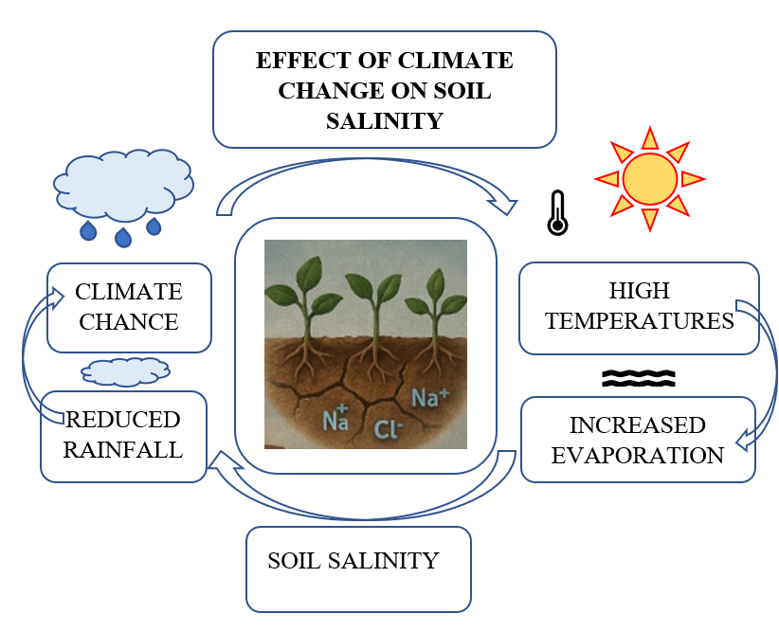
Figure 1. Effect of climate change on soil salinity

Figure 1 summarizes the mechanism by which climate change increases soil salinity. Decreased rainfall limits the leaching of salts, while higher temperatures and increased evaporation cause salts to accumulate in the top soil. Consequently, climate change exacerbates salinity problems in agricultural areas.

- Climate Change and Soil Dynamics
  - Physical Health and Fertility of Soil
Climate change significantly alters soil structure, moisture content, compaction, and erosion rates, ultimately reducing soil fertility. For instance, an 11-year warming experiment in China’s Henan region revealed a reduction in soil aggregate size, increased compaction, and a 10.6% decline in total soil organic carbon, which was linked to a 30% reduction in maize yield (Shah et al., 2017; Ma et al., 2024). Irregularities in soil moisture negatively affect microbial activities and nutrient cycling, thereby weakening soil functions (Furtak & Wolinska, 2023). Excessive rainfall and drainage problems cause oxygen deficiency, leading to increased emissions of greenhouse gases such as nitrous oxide (N₂O), creating feedback loops that intensify climate change (Hui et al., 2024; Topali et al., 2024). Additionally, accelerated erosion results in the loss of topsoil, further reducing fertility (Kundzewicz et al., 2019).

  - Chemical Properties of Soil
Climate change exacerbates soil acidity and salinity issues, thereby undermining fertility. Rising temperatures and elevated CO₂ concentrations stimulate organic acid production, reducing soil pH (Ferdush et al., 2023; Barros et al., 2021). Altered rainfall regimes cause leaching of essential cations (Ca²⁺, Mg²⁺), while increasing H⁺ and Al³⁺ concentrations, which intensifies acidity (Gelybo et al., 2018). During drought periods, salt accumulation increases, leading to salinity problems (Ishfaq et al., 2020). Acidic soils restrict the uptake of essential nutrients such as phosphorus and molybdenum, induce aluminum toxicity, and reduce crop yields (Rahman et al., 2023). Salinity, on the other hand, particularly in arid and semi-arid regions with poor irrigation practices, hampers water uptake by plants and limits growth (Shrivastava & Kumar, 2014; Miah et al., 2020). In coastal regions with seawater intrusion, the salinity problem becomes even more severe (Miah et al., 2020). Therefore, managing both acidity and salinity requires integrated and sustainable soil management strategies.

- Impact of Climate Change on Soil Nutrient Cycling
The cycling of essential nutrients such as calcium, nitrogen, and phosphorus in soil is profoundly affected by climate change. Elevated atmospheric CO₂ and nitrogen fertilization alter the distribution of mineral-associated organic carbon and particulate organic carbon fractions, which are the two main components of soil organic carbon. Variations in plant inputs and microbial activities lead to different responses of these fractions (Rocci et al., 2021; Yue et al., 2017).

Drought periods restrict the mobility of nutrients in soils, resulting in deficiencies of nitrogen, potassium, and other elements. Excessive rainfall, on the other hand, enhances leaching, particularly of calcium and magnesium (Mehra et al., 2018; Yao et al., 2021). Moreover, increased temperatures accelerate nitrification and denitrification processes, raising nitrous oxide emissions and intensifying soil acidification (Kumar et al., 2022; Hui et al., 2024). These nutrient imbalances negatively impact soil fertility and ecosystem health.

  - Impact of Climate Change on Soil Biodiversity
Soil microorganisms play a critical role in organic matter decomposition and nutrient cycling (Fu et al., 2023). Climate change, through variations in temperature and moisture, affects the structure and functionality of microbial communities. While moderate warming may stimulate microbial activity, excessive warming reduces ecosystem resilience (Liu et al., 2023).

Changes in rainfall and soil acidification alter the distribution of microbial species, leading to declines in acid-sensitive organisms (Jin et al., 2022). Extreme climate events also negatively affect soil fauna, reducing biodiversity (Barreto & Lindo, 2022). In forest ecosystems, fungal and bacterial communities may become disrupted, adversely affecting plant health (Sharmah & Jha, 2014).

Shifts in rainfall regimes trigger erosion and nutrient losses, decreasing soil fertility, while structural degradation enhances compaction, hindering root growth and the circulation of water and air. Altogether, these processes reduce soil health and fertility, threatening agricultural production and ecosystem services. In short, climate change directly and indirectly diminishes soil fertility through multiple mechanisms, placing increasing pressure on sustainable agriculture (Figure 2).

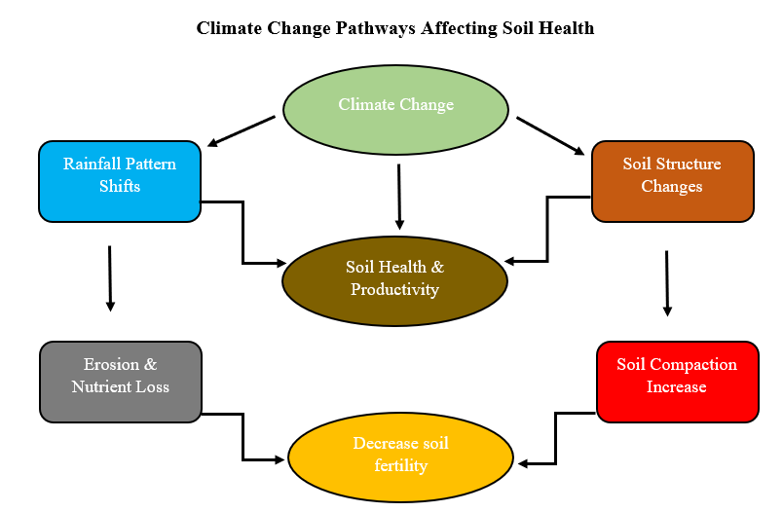
Figüre 2. Climate Change Pathways Affecting Soil Health

- Plant Responses to Climate Change
4.1. Impacts on Plants and Agriculture
Climate change affects plant physiology through rising temperatures, increasing CO₂ levels, altered precipitation patterns, and more frequent extreme weather events (Rocha et al., 2022). High temperatures negatively impact photosynthesis, thereby restricting plant growth (Muhammad et al., 2021). Moreover, elevated temperatures cause stomatal closure and increase respiration rates, reducing net carbon gain (Dusenge et al., 2018). Pests and diseases also become more widespread with rising temperatures (Skendzic et al., 2021).
Changes in precipitation affect water and nutrient uptake; drought reduces photosynthesis and crop yields, while excessive rainfall leads to flooding and soil erosion (Jackson et al., 2023). Rising CO₂ can enhance photosynthesis, but nutrient limitations constrain this effect (Van Der Kooi et al., 2016). Increasing pest pressure and extreme weather events further threaten agriculture (Farooq et al., 2022). With climate change driving higher temperatures and altered rainfall regimes, the role of irrigation methods in influencing pest population dynamics has become increasingly critical. In this context, Topal et al. (2024) noted that drip irrigation creates unfavorable conditions for pest populations by reducing surface and air humidity, whereas furrow irrigation increases pest densities due to higher humidity levels (Topal et al., 2024).

4.2. Aquatic Plants and Impacts on the Blue Economy
The Blue Economy refers to ocean-based economic activities and is highly sensitive to climate change. Sea level rise, ocean acidification, and increasing temperatures negatively impact fisheries and aquaculture (Nazarnia et al., 2020). Coastal infrastructure and communities face growing risks from flooding and erosion (Becker et al., 2018).

Ocean acidification threatens shell-forming organisms and disrupts food webs (Çelekli & Zariç, 2024). Marine heatwaves cause damage to ecosystems (Fuentes et al., 2023). More frequent cyclones and storms further endanger coastal economies and livelihoods (Tregarot et al., 2023). Mitigation of these impacts requires reducing greenhouse gas emissions and adopting sustainable marine resource management strategies (Hoque et al., 2019).

- Soil–Plant–Atmosphere Interactions
5.1. Relationship Between Soil and Atmosphere
Soil and atmosphere are interconnected, and this linkage triggers climate change feedback loops (Huang et al., 2024). Global warming raises soil temperature, which enhances carbon release through heterotrophic respiration; this increases atmospheric CO₂ and accelerates warming (Nissan et al., 2023). Permafrost thaw releases large amounts of carbon and metals, though the exact processes and impacts remain poorly understood (Schuur et al., 2022).

Excessive rainfall increases soil saturation and erosion, stimulating greenhouse gas emissions (Zeppetello et al., 2024). While higher CO₂ supports photosynthesis and plant growth, rising temperatures can reduce soil moisture (Mandal & Roy, 2024). Temperature shifts also affect the nitrogen cycle, raising N₂O emissions; however, methods such as biochar application may help mitigate these emissions (Hui et al., 2024).

Rising CO₂ and heat stress disrupt soil–plant interactions, intensifying drought stress and influencing plant hormones and root development (Kirby & Hawk, 2023). Plant adaptation, in turn, alters carbon and nutrient cycling, completing the feedback loop and further intensifying climate change (Sardans & Penuelas, 2013).

Soil microorganisms, particularly mycorrhizal fungi, undergo changes in abundance and function under climate change (Hu et al., 2021). Heat stress and nutrient shifts affect their carbon storage capacity. Understanding these dynamics is critical for addressing climate change.

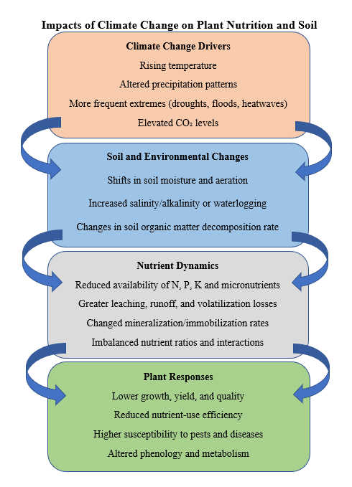
Figure 3. Effects of climate change on soil and plants

- Mitigation and Adaptation Methods
As the world stands on the brink of a climate crisis, shifting rainfall regimes are intensifying erosion and nutrient losses, thereby reducing soil fertility. Soil structure degradation increases compaction, negatively affecting root growth as well as water and air circulation, which in turn places pressure on agricultural production and ecosystem services. In short, climate change threatens soil health and productivity both directly and indirectly. To alleviate these problems and adapt to their impacts, we must change our daily habits. Food production accounts for a significant share of global greenhouse gas emissions, and even if fossil fuel use were eliminated, emissions from the food system would remain high throughout the next century. In this struggle, climate-friendly agricultural practices implemented by local communities play a vital role.

Moreover, the preservation of natural carbon sinks such as forests, wetlands, and oceans is critical for reducing atmospheric carbon. Reducing fossil fuel consumption and investing in renewable energy are also key to a sustainable future. Increasing green spaces in cities helps lower temperatures and enhances carbon sequestration. Finally, the ability of certain insects to digest plastics offers nature-based solutions against environmental pollution. To mitigate the impacts of climate change, swift and comprehensive action is essential.

- Conclusions
Climate plays a crucial role in maintaining the balance among the atmosphere, soil, plants, and microorganisms. However, rising temperatures, altered precipitation patterns, and extreme weather events disrupt this balance, negatively affecting soil properties, the nitrogen cycle, salinity, and biodiversity. These changes threaten agricultural productivity and ecosystem health. Interactions among soil, plants, and the atmosphere create feedback loops that intensify the impacts of climate change. Current research often focuses on only one part of the system, whereas an integrated examination of all interactions is needed. In addition to soil organic carbon, the role of inorganic carbon in climate processes has not been sufficiently studied. Future research should focus on adaptation strategies such as regional impact assessments, resilient plant species, and sustainable water management. In this way, the effects of climate change on the soil–plant–atmosphere system can be better understood and mitigated.

REFERENCES
Abbass, K., Qasim, M.Z., Song, H., Murshed, M., Mahmood, H., Younis, I., 2022. A review of the global climate change impacts, adaptation, and sustainable mitigation measures. Environ. Sci. Pollut. Control Ser. 29 (28), 42539–42559. https://doi.org/ 10.1007/s11356-022-19718-6.
Anbleyth-Evans, J., Leiva, F.A., Gaymer, C.F., Abel, R.R.A., Campos, L., Hidalgo, C., 2024. From a Brown to a blue economy in Chile. Environ. Challeng. 14, 100846. https:// doi.org/10.1016/j.envc.2024.100846.
Barreto, C., Lindo, Z., 2022. Response of soil biodiversity to global change. Pedobiologia 90, 150792. https://doi.org/10.1016/j.pedobi.2022.150792.
Barros, N., Rodríguez-A~non, J.A., Proupín, J., Perez-Cruzado, C., 2021. The effect of extreme temperatures on soil organic matter decomposition from Atlantic oak forest ecosystems. iScience 24 (12), 103527. https://doi.org/10.1016/j.isci.2021.103527.
Becker, A., Ng, A.K., McEvoy, D., Mullett, J., 2018. Implications of climate change for shipping: ports and supply chains. Wiley Interdis. Rev. Clim. Change 9 (2). https:// doi.org/10.1002/wcc.508.
Chatterjee, D., Das, S.R.,Saha, S.,Sarkar, A.,Pathak,H., 2024.Impactsofclimatechangeon soil processes. In: Pathak, H., Chatterjee, D., Saha, S., Das, B. (Eds.), Climate Chang.
Çelekli, A., Zariç, € O.E., 2024. Rising tide of ocean acidification. Environ. Res. Tech. 7 (4), 605–613. https://doi.org/10.35208/ert.1407588.
Dusenge, M.E., Duarte, A.G., Way, D.A., 2018. Plant carbon metabolism and climate change: elevated CO2 and temperature impacts on photosynthesis, photorespiration and respiration. New Phytol. 221 (1), 32–49. https://doi.org/10.1111/nph.15283.
Ferdush, J., Paul, V., Varco, J., Jones, K., Sasidharan, S.M., 2023. Consequences of elevated CO2 on soil acidification, cation depletion, and inorganic carbon: a column based experimental investigation. Soil Tillage Res. 234, 105839. https://doi.org/ 10.1016/j.still.2023.105839.
Furtak, K., Wolinska, A., 2023. The impact of extreme weather events as a consequence of climate change on the soil moisture and on the quality of the soil environment and agriculture– a review. Catena 231, 107378. https://doi.org/10.1016/ j.catena.2023.107378.
Ferdush, J., Paul, V., Varco, J., Jones, K., Sasidharan, S.M., 2023. Consequences of elevated CO2 on soil acidification, cation depletion, and inorganic carbon: a column based experimental investigation. Soil Tillage Res. 234, 105839. https://doi.org/ 10.1016/j.still.2023.105839.
Fu, F., Li, J., Li, Y., Chen, W., Ding, H., Xiao, S., 2023. Simulating the effect of climate change on soil microbial community in an Abies georgei var. smithii forest. Front. Microbiol. 14. https://doi.org/10.3389/fmicb.2023.1189859.
Farooq, M.S., Uzair, M., Raza, A., Habib, M., Xu, Y., Yousuf, M., Yang, S.H., Khan, M.R., 2022. Uncovering the research gaps to alleviate the negative impacts of climate change on food security: a review. Front. Plant Sci. 13. https://doi.org/10.3389/ fpls.2022.927535.
Fuentes, M., McMichael, E., Kot, C., Silver-Gorges, I., Wallace, B., Godley, B., Brooks, A., Ceriani, S., Cortes-Gomez, A., Dawson, T., Dodge, K., Flint, M., Jensen, M., Komoroske, L., Kophamel, S., Lettrich, M., Long, C., Nelms, S., Patrício, A., Hays, G., 2023. Key issues in assessing threats to sea turtles: knowledge gaps and future directions. Endanger. Species Res. 52, 303–341. https://doi.org/10.3354/esr01278.
Hassan, K., Dastogeer, K.M.G., Carrillo, Y., Nielsen, U.N., 2022. Climate change-driven shifts in plant–soil feedbacks: a meta-analysis. Ecolog. Proc. 11 (1). https://doi.org/ 10.1186/s13717-022-00410-z.
Hui, D., Ray, A., Kasrija, L., Christian, J., 2024. Impacts of climate change and agricultural practices on nitrogen processes, genes, and soil nitrous oxide emissions: a Quantitative Review of Meta-Analyses. Agriculture 14 (2), 240. https://doi.org/ 10.3390/agriculture14020240.
Hoque, M.Z., Cui, S., Lilai, X., Islam, I., Ali, G., Tang, J., 2019. Resilience of coastal communities to climate change in Bangladesh: research gaps and future directions. Watershed Ecol. Environ. 1, 42–56. https://doi.org/10.1016/j.wsee.2019.10.001.
Huang, T., Hu, Q., Shen, Y., Angles, A., Fernandez-Remolar, D.C., 2024. Biogeochemical cycles. In: Elsevier eBooks, pp. 393–407. https://doi.org/10.1016/b978-0-12 822562-2.00347-9.
Hu, H., He, L., Ma, H., Wang, J., Li, Y., Wang, J., Guo, Y., Ren, C., Bai, H., Zhao, F., 2021. Responses of AM fungal abundance to the drivers of global climate change: a meta analysis. Sci. Total Environ. 805, 150362. https://doi.org/10.1016/ j.scitotenv.2021.150362.
Liu, G., Sun, J., Xie, P., Guo, C., Zhu, K., Tian, K., 2023. Climate warming enhances microbial network complexity by increasing bacterial diversity and fungal interaction strength in litter decomposition. Sci. Total Environ. 908, 168444. https://doi.org/ 10.1016/j.scitotenv.2023.168444.
Jin, J., Krohn, C., Franks, A.E., Wang, X., Wood, J.L., Petrovski, S., McCaskill, M., Batinovic, S., Xie, Z., Tang, C., 2022. Elevated atmospheric CO2 alters the microbial community composition and metabolic potential to mineralize organic phosphorus in the rhizosphere of wheat. Microbiome 10 (1). https://doi.org/10.1186/s40168-021 01203-w.
Gelybo, G., Toth, E., Farkas, C., Horel, A., Kasa, I., Bakacsi, Z., 2018. Potential impacts of climate change on soil properties. Agrokemia Es Talajtan 67 (1), 121–141. https:// doi.org/10.1556/0088.2018.67.1.9.
Ma, R., Kou, T., Cheng, X., Yu, N., 2024. Long-term warming altered soil physical structure and soil organic carbon pools in wheatland field. Exp. Agric. 60. https:// doi.org/10.1017/s0014479723000236.
Mandal, D., Roy, T., 2024. Climate change impact on soil erosion and land degradation. In: Advances in Global Change Research, pp. 139–161. https://doi.org/10.1007/978 981-99-7935-6_5.
Mehra, P., Singh, B.P., Kunhikrishnan, A., Cowie, A.L., Bolan, N., 2018. Soil health and climate change: a critical nexus. In: Burleigh Dodds Series in Agricultural Science, pp. 39–68. https://doi.org/10.19103/as.2017.0033.04.
Miah, M.Y., Zia, M., Kamal, U., Salam, M., Islam, M., 2020. Impact of salinity intrusion on agriculture of Southwest Bangladesh-A Review. Int. J. Agric. Pol. Res. 8 (2). https:// doi.org/10.15739/ijapr.20.005.
Muhammad, I., Shalmani, A., Ali, M., Yang, Q., Ahmad, H., Li, F.B., 2021. Mechanisms regulating the dynamics of photosynthesis under abiotic stresses. Front. Plant Sci. 11. https://doi.org/10.3389/fpls.2020.615942.
Mondal, S., 2021. Impact of climate change on soil fertility. In: Soil Biology, pp. 551–569. https://doi.org/10.1007/978-3-030-76863-8_28.
Nazir, M.J., Li, G., Nazir, M.M., Zulfiqar, F., Siddique, K.H., Iqbal, B., Du, D., 2023. Harnessing soil carbon sequestration to address climate change challenges in agriculture. Soil Tillage Res. 237, 105959. https://doi.org/10.1016/ j.still.2023.105959.
Nazarnia, H., Nazarnia, M., Sarmasti, H., Wills, W.O., 2020. A Systematic review of civil and environmental infrastructures for coastal adaptation to sea level rise. Civil Eng.J. 6 (7), 1375–1399. https://doi.org/10.28991/cej-2020-03091555.
Nissan, A., Alcolombri, U., Peleg, N., Galili, N., Jimenez-Martinez, J., Molnar, P., Holzner, M., 2023. Global warming accelerates soil heterotrophic respiration. Nat. Commun. 14 (1). https://doi.org/10.1038/s41467-023-38981-w.
Silva, L.C.R., Lambers, H., 2020. Soil-plant-atmosphere interactions: structure, function, and predictive scaling for climate change mitigation. Plant Soil 461 (1–2), 5–27. https://doi.org/10.1007/s11104-020-04427-1.
Shah, A.N., Tanveer, M., Shahzad, B., Yang, G., Fahad, S., Ali, S., Bukhari, M.A., Tung, S.A., Hafeez, A., Souliyanonh, B., 2017. Soil compaction effects on soil health and crop productivity: an overview. Environ. Sci. Pollut. Control Ser. 24 (11), 10056–10067. https://doi.org/10.1007/s11356-017-8421-y.
Shrivastava, P., Kumar, R., 2014. Soil salinity: a serious environmental issue and plant growth promoting bacteria as one of the tools for its alleviation. Saudi J. Biol. Sci. 22 (2), 123–131. https://doi.org/10.1016/j.sjbs.2014.12.001.
Skendzic, S., Zovko, M., Zivkovic, I.P., Lesic, V., Lemic, D., 2021. The impact of climate change on agricultural insect pests. Insects 12 (5), 440. https://doi.org/10.3390/ insects12050440.
Sharmah, D., Jha, D.K., 2014. Diversity of arbuscular mycorrhizal fungi in disturbed and undisturbed forests of Karbi Anglong Hills of Assam, India. Agric. Res. 3 (3), 229–238. https://doi.org/10.1007/s40003-014-0110-1.
Sardans, J., Penuelas, J., 2013. Plant-soil interactions in Mediterranean forest and shrublands: impacts of climatic change. Plant Soil 365 (1–2), 1–33. https://doi.org/ 10.1007/s11104-013-1591-6.
Schuur, E.A., Abbott, B.W., Commane, R., Ernakovich, J., Euskirchen, E., Hugelius, G., Grosse, G., Jones, M., Koven, C., Leshyk, V., Lawrence, D., Loranty, M.M., Mauritz, M., Olefeldt, D., Natali, S., Rodenhizer, H., Salmon, V., Sch€ adel, C., Strauss, J., Turetsky, M., 2022. Permafrost and climate Change: carbon cycle feedbacks from the Warming Arctic. Annu. Rev. Environ. Resour. 47 (1), 343–371. https://doi.org/10.1146/annurev-environ-012220-011847.
Kumar, A., Bhattacharya, T., Mukherjee, S., Sarkar, B., 2022. A perspective on biochar for repairing damages in the soil–plant system caused by climate change-driven extreme weather events. Biochar 4 (1). https://doi.org/10.1007/s42773-022-00148-z.
Kundzewicz, Z.W., Su, B., Wang, Y., Wang, G., Wang, G., Huang, J., Jiang, T., 2019. Flood risk in a range of spatial perspectives– from global to local scales. Nat. Hazards Earth Syst. Sci. 19 (7), 1319–1328. https://doi.org/10.5194/nhess-19-1319-2019.
Kirby, R., Hawk, S., 2023. Plant-soil feedback mechanisms: understanding biotic and abiotic influences. J. Plant Ecol. 16 (6), 1092–1105. https://doi.org/10.1093/jpe/ rtad021.
Ishfaq, M., Farooq, M., Zulfiqar, U., Hussain, S., Akbar, N., Nawaz, A., Anjum, S.A., 2020. Alternate wetting and drying: a water-saving and ecofriendly rice production system. Agric. Water Manag. 241, 106363. https://doi.org/10.1016/j.agwat.2020.106363.
Tregarot, E., D'Olivo, J.P., Botelho, A.Z., Cabrito, A., Cardoso, G.O., Casal, G., Cornet, C.C., Cragg, S.M., Degia, A.K., Fredriksen, S., Furlan, E., Heiss, G., Kersting, D.K., Marechal, J., Meesters, E., O'Leary, B.C., Perez, G., Seijo-Nú~nez, C., Simide, R., De Juan, S., 2023. Effects of climate change on marine coastal ecosystems– a review to guide research and management. Biol. Conserv. 289, 110394. https:// doi.org/10.1016/j.biocon.2023.110394.
Topal, R., Beyyavaş, V., & Mutlu, Ç. (2024). Impact of irrigation methods and two cotton varieties on sucking pest populations in Şanlıurfa, Türkiye. International Journal of Entomology Research, 9(12), 179–188.
Topali, C., Antonopoulou, C., Chatzissavvidis, C., 2024. Effect of waterlogging on growth and productivity of fruit crops. Horticulturae 10 (6), 623. https://doi.org/10.3390/ horticulturae10060623.
Rahman,S.U.,Han,J.,Ahmad,M.,Ashraf,M.N.,Khaliq,M.A.,Yousaf,M.,Wang,Y.,Yasin,G., Nawaz,M.F.,Khan,K.A.,Du,Z.,2023.Aluminumphytotoxicityinacidicenvironments:a comprehensive review of plant tolerance and adaptation strategies. Ecotoxicol. Environ. Saf. 269, 115791. https://doi.org/10.1016/j.ecoenv.2023.115791.
Rocci, K.S., Lavallee, J.M., Stewart, C.E., Cotrufo, M.F., 2021. Soil organic carbon response to global environmental change depends on its distribution between mineral-associated and particulate organic matter: a meta-analysis. Sci. Total Environ. 793, 148569. https://doi.org/10.1016/j.scitotenv.2021.148569.
Rocha, J., Oliveira, S., Viana, C.M., Ribeiro, A.I., 2022. Climate change and its impacts on health, environment and economy. Elsevier eBooks 253–279. https://doi.org/ 10.1016/b978-0-12-822794-7.00009-5.
Van Der Kooi, C.J., Reich, M., L€ ow, M., De Kok, L.J., Tausz, M., 2016. Growth and yield stimulation under elevated CO2 and drought: a meta-analysis on crops. Environ. Exp. Bot. 122, 150–157. https://doi.org/10.1016/j.envexpbot.2015.10.004.
Yue, K., Fornara, D.A., Yang, W., Peng, Y., Peng, C., Liu, Z., Wu, F., 2017. Influence of multiple global change drivers on terrestrial carbon storage: additive effects are common. Ecol. Lett. 20 (5), 663–672. https://doi.org/10.1111/ele.12767.
Yao, Y., Dai, Q., Gao, R., Gan, Y., Yi, X., 2021. Effects of rainfall intensity on runoff and nutrient loss of gently sloping farmland in a karst area of SW China. PLoS One 16 (3), e0246505. https://doi.org/10.1371/journal.pone.0246505.
Zia, R., Nawaz, M.S., Siddique, M.J., Hakim, S., Imran, A., 2021. Plant survival under drought stress: implications, adaptive responses, and integrated rhizosphere management strategy for stress mitigation. Microbiol. Res. 242, 126626. https:// doi.org/10.1016/j.micres.2020.126626.
Zeppetello, L.R.V., Trevino, A.M., Huybers, P., 2024. Disentangling contributions to past and future trends in US surface soil moisture. Nature Water 2 (2), 127–138. https:// doi.org/10.1038/s44221-024-00193-x.

