Case Report

Coffin-Siris Syndrome Confirmed by an ARID1B Mutation: A Case Report

Abstract

Introduction :Coffin-Siris syndrome (CSS) is a rare genetic disorder belonging to the group of SWI/SNF-related intellectual disability disorders. It is characterized by global developmental delay, variable intellectual disability, distinctive facial dysmorphism, and hypoplasia/aplasia of the distal phalanges, particularly of the fifth digit. Among the genes involved, ARID1B is the most frequently mutated, representing the majority of genetically confirmed cases.

Case presentation: We report the case of a 14-year-old boy presenting with global developmental delay, moderate intellectual disability, characteristic dysmorphic features, bilateral hypoplasia of the fifth digits, dorsolumbar scoliosis, and a history of bilateral cryptorchidism. Additional findings included café-au-lait macules, rarely reported in CSS. Complementary investigations were unremarkable, including a normal karyotype. Exome sequencing identified a novel heterozygous deletion in the ARID1B gene (NM_001374828.1:c.2964del; NP_001361757.1:p.Ser989ValfsTer20), leading to a frameshift predicted to cause protein truncation. This variant, absent from population databases and previously unreported in the literature, was classified as likely pathogenic, confirming the diagnosis of Coffin-Siris syndrome type 1 (OMIM:135900).

Conclusion: This case illustrates a typical ARID1B-related Coffin-Siris phenotype while reporting a novel variant, thereby contributing to the expansion of the molecular spectrum of CSS. It underscores the pivotal role of next-generation sequencing in confirming the diagnosis of complex malformation syndromes, facilitating appropriate multidisciplinary care and genetic counseling.

Keywords
Coffin-Siris syndrome; ARID1B; exome sequencing; intellectual disability; dysmorphic features; next-generation sequencing.

Introduction
Coffin-Siris syndrome (CSS) is a rare and complex genetic disorder, belonging to the group of SWI/SNF-related intellectual disability disorders. It is characterized by global developmental delay, variable intellectual disability, distinctive dysmorphic features, and hypoplasia/aplasia of the distal phalanges, particularly of the fifth digit. Since its first description in 1970, the clinical and genetic spectrum has expanded considerably, largely due to the advent of next-generation sequencing (NGS) technologies [1–3].
Among the implicated genes, ARID1B is by far the most frequently mutated and accounts for the majority of genetically confirmed cases [4–6]. The ARID1B phenotype is characterized by moderate intellectual disability, speech delay, progressive dysmorphic features, and overall preserved survival. However, significant interindividual variability has been reported, making clinical diagnosis sometimes challenging.
We report a case of CSS confirmed by a pathogenic mutation in ARID1B, highlighting the importance of molecular diagnosis in the evaluation of complex malformative syndromes, and discussing the role of this gene within the Coffin-Siris spectrum.

Case Report
Ilyass is a 14-year-old boy, the second of five siblings, born to non-consanguineous parents. The pregnancy was uneventful and well monitored. Delivery was by cesarean section, with immediate crying at birth, and a birth weight of 3000 g. Family history did not reveal similar conditions or neurodevelopmental disorders.
Psychomotor development was notably delayed: independent walking was only achieved after the age of two and a half years, and intelligible speech emerged around the age of three. Academically, the child experienced persistent difficulties, requiring specialized support and referral to child psychiatry for moderate intellectual disability.
Clinical examination revealed characteristic facial dysmorphism: a triangular face, low anterior hairline, prominent ears, thick lips, long eyelashes, and microcrania. Additional findings included café-au-lait spots, a broad intermammary distance, and flat feet. Musculoskeletal examination revealed a dorsolumbar scoliosis, radiologically confirmed. Examination of the extremities showed bilateral hypoplasia of the distal phalanges of the fifth fingers, considered a cardinal sign of the syndrome. Past medical history included bilateral cryptorchidism surgically corrected at age three.
Complementary investigations were globally unremarkable: standard karyotype was normal, ENT and ophthalmological evaluations showed no abnormalities, and both cardiac and abdominopelvic ultrasounds were normal. Skeletal X-rays confirmed moderate dorsolumbar scoliosis.
Molecular analysis by exome sequencing identified a heterozygous deletion in the ARID1B gene (NM_001374828.1:c.2964del; NP_001361757.1:p.Ser989ValfsTer20). This variant causes a frameshift leading to protein truncation or nonsense-mediated mRNA decay. It is absent from population databases (gnomAD v4.1.0), has never been reported in the literature, and was classified as likely pathogenic, thereby confirming the diagnosis of Coffin-Siris syndrome type 1 (OMIM:135900) (Figure 1).

Discussion
Coffin-Siris syndrome (CSS) is a rare genetic condition first described in 1970 by Coffin and Siris in three female patients presenting with intellectual disability, digital anomalies, and recognizable facial dysmorphism [7]. It is now classified within the spectrum of SWI/SNF-related intellectual disability disorders, a group of syndromes caused by mutations in genes encoding subunits of the SWI/SNF chromatin-remodeling complex, which plays a key role in transcriptional regulation [1,8].

Prevalence and Epidemiology
CSS is considered ultra-rare, with only a few hundred cases described worldwide. Its exact prevalence remains unknown, but international databases (Orphanet, OMIM) estimate its frequency at <1/100,000 live births. With the introduction of NGS technologies, the number of confirmed diagnoses has markedly increased [9].

Clinical Description and Phenotypic Variability
The classic phenotype of CSS includes:
- global developmental delay and intellectual disability, present in over 90% of cases [5,6],
- characteristic facial dysmorphism: wide mouth, thick lips, long eyelashes, low hairline, prominent ears, and flat or upturned nose [10],
- hypoplasia/aplasia of the distal phalanges of the fifth fingers or toes, considered almost pathognomonic [11].
Additional anomalies often include skeletal abnormalities (scoliosis, joint laxity, flat feet), urogenital defects (cryptorchidism, renal malformations), neurological features (hypotonia, seizures, white matter abnormalities), and cutaneous manifestations (hirsutism, hypertrichosis, pigmentary lesions) [12,13].
In our patient, all these major features were present: global developmental delay, intellectual disability, triangular face with microcrania, bilateral fifth finger hypoplasia, dorsolumbar scoliosis, and a history of bilateral cryptorchidism. The originality of our case lies in the presence of café-au-lait macules, rarely reported, suggesting a possible extension of the cutaneous phenotype associated with ARID1B.

Genotype-Phenotype Correlations
Several genes of the SWI/SNF complex have been implicated in CSS (ARID1A, ARID1B, SMARCA4, SMARCB1, SMARCE1, DPF2). Among them, ARID1B is the most frequently mutated, accounting for approximately 65–70% of genetically confirmed cases [5,6].
Patients with ARID1B mutations usually present with a moderate to typical phenotype: language and cognitive delay, progressive facial anomalies, digital hypoplasia, but without major life-threatening visceral malformations [4,9]. This contrasts with mutations in ARID1A or SMARCA4, often associated with severe or even neonatal lethal forms [8].
Our observation is of particular interest because the identified variant (c.2964del; p.Ser989ValfsTer20) is novel, absent from population databases, and never previously reported in the literature. This finding expands the known molecular spectrum of ARID1B mutations and reinforces its association with the classic Coffin-Siris phenotype.

Complementary Investigations and the Role of NGS
Karyotype and CGH-array are most often normal in CSS [10]. Only next-generation sequencing, particularly exome sequencing, can provide definitive diagnosis. Identification of the causal mutation is crucial both for diagnostic confirmation and for ruling out close differential diagnoses such as Nicolaides-Baraitser, Cornelia de Lange, or Rubinstein-Taybi syndromes [3,14].
In our case, with a normal karyotype, exome sequencing was decisive in confirming the pathogenic ARID1B mutation.

Therapeutic Management
There is no curative treatment. Management is multidisciplinary and individualized, including neurodevelopmental follow-up (speech therapy, psychomotor therapy, special education), orthopedic monitoring (scoliosis, joint laxity), urological surgery (cryptorchidism, renal anomalies), endocrinological and metabolic follow-up, as well as psychiatric and social support [15].

Prognosis and Evolution
Prognosis is variable but generally favorable for survival in patients with ARID1B mutations. Intellectual disability remains the main functional handicap, ranging from moderate to severe, and largely determines the level of autonomy in adulthood [6,9]. Dysmorphic features tend to become more pronounced with age, making diagnosis more evident in adolescents and adults.
In our case, the evolution was marked by stable intellectual disability, requiring specialized educational support, but without major visceral complications.

Perspectives
Future directions in CSS research include:
- better understanding of genotype-phenotype correlations, including borderline forms between CSS and nonspecific intellectual disability,
- identification of additional SWI/SNF genes involved,
- development of targeted epigenetic therapies, still experimental at this stage [8,9].

Conclusion
Coffin-Siris syndrome is a rare but recognizable entity when global developmental delay, typical facial dysmorphism, and digital anomalies are associated. The ARID1B gene is the most frequently implicated. The contribution of next-generation sequencing is essential for diagnostic confirmation, particularly when karyotype is normal. This case illustrates the importance of molecular diagnosis in rare syndromes, enabling tailored multidisciplinary care and providing valuable genetic counseling, while contributing to the expansion of the molecular spectrum of Coffin-Siris syndrome.

References
- Tsurusaki Y, et al. Mutations affecting components of the SWI/SNF complex cause Coffin-Siris syndrome. Nat Genet. 2012;44(4):376–80.
- Kosho T, Miyake N. Coffin-Siris syndrome and related disorders involving components of the SWI/SNF complex. Congenit Anom (Kyoto). 2014;54(3):114–25.
- Santen GW, et al. The role of exome sequencing in Coffin-Siris syndrome diagnosis. Clin Genet. 2019;95(3):399–407.
- Halgren C, et al. ARID1B is a frequent cause of intellectual disability: mutational and clinical spectrum. Eur J Hum Genet. 2012;20(7):701–7.
- Bramswig NC, et al. Genetic and clinical spectrum of ARID1B mutations: expanding Coffin-Siris syndrome. Hum Mutat. 2017;38(11):1374–85.
- Santen GW, et al. ARID1B-related disorder: review and case series. Am J Med Genet A. 2014;164A(7):1761–71.
- Coffin GS, Siris E. Mental retardation with absent fifth fingernail and terminal phalanx. Am J Dis Child. 1970;119(5):433–9.
- Parenti I, et al. Mutations in SWI/SNF genes: expanding the Coffin-Siris and Nicolaides-Baraitser phenotypes. J Med Genet. 2020;57(5):339–46.
- Hoyer J, et al. Phenotypic spectrum of ARID1B mutations: from Coffin-Siris to nonspecific intellectual disability. Clin Genet. 2021;99(2):187–200.
- Wieczorek D. Cell adhesion and developmental pathways in Coffin-Siris syndrome. Am J Med Genet C Semin Med Genet. 2013;163C(4):249–56.
- Vergano SA, et al. Clinical features of Coffin-Siris syndrome in 23 individuals. Am J Med Genet C Semin Med Genet. 2014;166C(3):250–6.
- Schrier SA, et al. The Coffin-Siris syndrome: phenotype-genotype correlations. Am J Med Genet A. 2012;158A(11):2646–55.
- Miyake N, et al. Genotype-phenotype correlations in Coffin-Siris syndrome caused by mutations in SMARCB1, SMARCA4, and ARID1B. J Hum Genet. 2017;62(5):481–9.
- Kline AD, et al. Diagnosis and management of Cornelia de Lange syndrome: 2018 consensus guidelines. Am J Med Genet A. 2018;176(4):865–77.
- Vergano SA, Santen G. ARID1B-related disorder. In: GeneReviews® [Internet]. Seattle (WA): University of Washington; updated 2023.
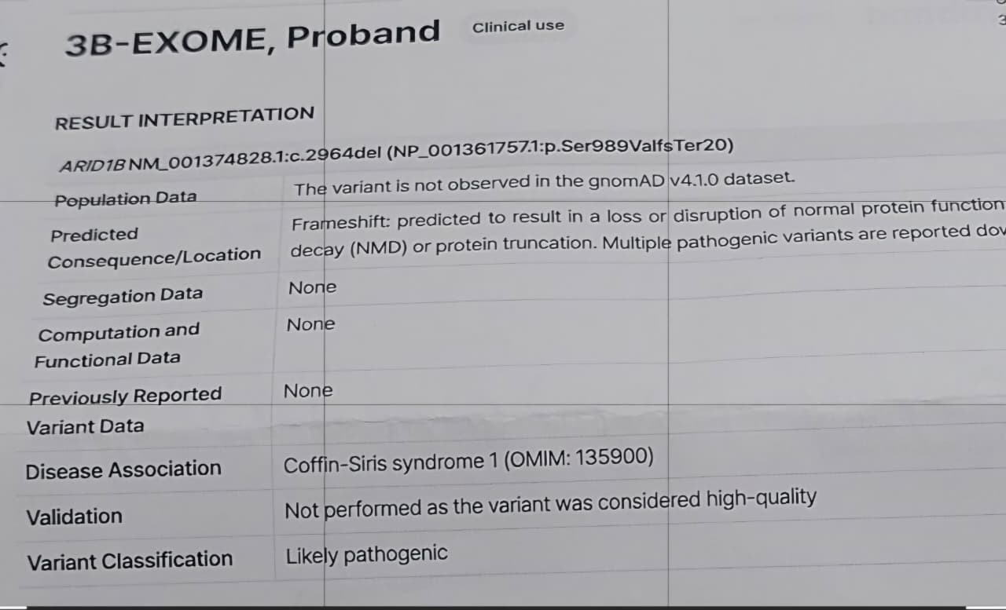
Figure 1. Molecular analysis by exome sequencing identified a heterozygous deletion in the ARID1B gene

