Case study

Pediatric Behçet’s Disease: Experience of the Children’s Hospital of Rabat (35 Cases)

ABSTRACT
Aims: To describe the epidemiological, clinical, paraclinical and therapeutic profile of pediatric Behçet’s disease (BD) in a Moroccan cohort.
Study design: Retrospective descriptive and analytical study.
Place and Duration of Study: Department of Pediatric Rheumatology, Cardiology and Nephrology (P4), Children’s Hospital of Rabat, Ibn Sina University Hospital, from January 2012 to December 2024.
Methodology: Thirty-five patients aged ≤15 years diagnosed with BD according to Mason & Barnes and ISG criteria were included. Data were collected from medical records and analyzed using descriptive statistics.
Results: The cohort included 16 boys and 19 girls (sex ratio 0.84). The mean age at diagnosis was 11.5 years, while the mean age at first symptom onset was 8.7 years. Clinical findings included recurrent oral ulcers (100%), genital ulcers (34%), pseudofolliculitis (45%), erythema nodosum (5%), positive pathergy test (14%), articular involvement (57%), ocular involvement (42%), neurological manifestations (11.4%), vascular involvement (5%), digestive manifestations (14%), fever (22%), cardiac involvement (5%), and renal involvement (2%). An inflammatory syndrome was detected in 62% of patients. HLA-B5 was positive in 5 cases. All patients received colchicine; corticosteroids were administered in 18, immunosuppressants in 14, and biologic therapy in 6. The mean follow-up was 32 months. Outcomes included complete remission in 8 cases, relapses in 6, clinical improvement in 16, 4 lost to follow-up, and 1 death from pulmonary embolism.
Conclusion: Pediatric BD is rare but likely underdiagnosed. Our findings confirm the similarity to adult forms with specific pediatric features such as a balanced sex ratio, more frequent neurological complications, and strong familial background.

Keywords:
Pediatric Behçet’s disease; Oral ulcers; Vasculitis; Morocco; Rheumatology

1. INTRODUCTION
Behçet’s disease (BD) is a chronic, multisystem inflammatory vasculitis affecting vessels of all sizes, with a predominance for venous involvement. First described in 1937 by Hulusi Behçet as a triad of recurrent oral and genital ulcers and ocular inflammation, it is characterized by relapsing–remitting evolution. Although more frequent in adults, pediatric cases remain rare and diagnostically challenging due to their insidious or atypical onset. Its pathophysiology is multifactorial, involving genetic susceptibility, environmental factors, and dysregulated immune response. Pediatric BD has been reported globally, with higher prevalence in Mediterranean, Middle Eastern, and East Asian populations. This study aimed to describe the epidemiological, clinical, paraclinical, and therapeutic features of pediatric BD in Morocco.

2. MATERIALS AND METHODS
Study design: Retrospective descriptive and analytical study.
Setting: Pediatric Rheumatology, Cardiology and Nephrology Department (P4), Children’s Hospital of Rabat.
Duration: January 2012 – December 2024.
Inclusion criteria: Patients aged ≤15 years diagnosed with BD according to Mason & Barnes and ISG criteria.
Exclusion criteria: Incomplete records or unconfirmed diagnosis.
Data collection: Data were extracted from medical files using a standardized sheet covering epidemiological, clinical, paraclinical, therapeutic, and outcome variables.
Statistical analysis: Descriptive analysis was performed with Microsoft Excel 2013.

3. RESULTS
The study included 35 patients: 16 males (46%) and 19 females (54%), sex ratio 0.84. Mean age at diagnosis: 11.5 years (range 8–15). Mean age at first symptom: 8.7 years (range 5–14). Family history was noted in 4 patients.
Clinical manifestations included: oral ulcers (100%), genital ulcers (34%), pseudofolliculitis (45%), erythema nodosum (5%), positive pathergy test (14%), ocular involvement (42%), articular involvement (57%), neurological manifestations (11.4%), vascular involvement (5%), digestive manifestations (14%), fever (22%), cardiac involvement (5%), renal involvement (2%).
Biological findings: Inflammatory syndrome in 62% of cases. HLA-B5 positive in 5 cases (20%).
Treatment: All patients received colchicine; 20 received aspirin. Corticosteroids were used in 18 patients, immunosuppressants in 14, anticoagulants in 3, and biologics (adalimumab) in 6 cases.
Outcomes: Average follow-up 32 months. Complete remission in 8 cases, relapses in 6, improvement in 16, 4 lost to follow-up, and 1 death due to pulmonary embolism.

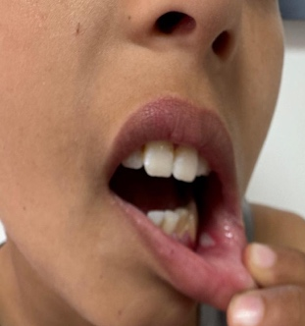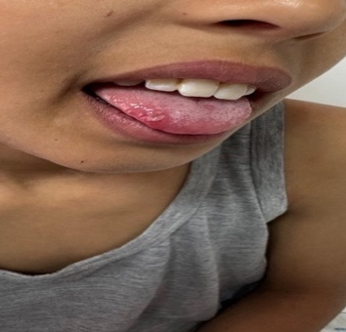
Figure 1: Oral aphthous ulcer

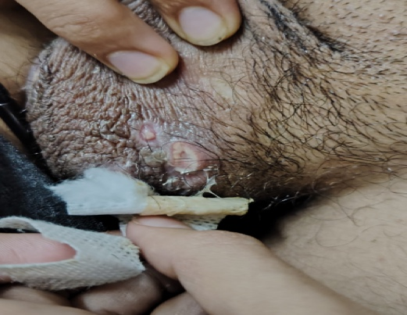
Figure 2: Genital ulcer

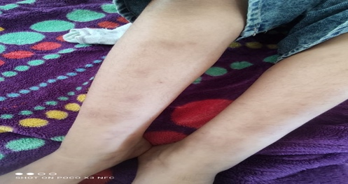
Figure 3: Erythema nodosum

4. DISCUSSION
Our series confirms that pediatric Behçet’s disease (BD) is a rare entity but represents an important cause of morbidity in children, especially in regions along the historic Silk Road[1]. The mean age at diagnosis in our cohort was 11.5 years, similar to reports from France and Italy where pediatric BD is diagnosed around early adolescence [2,10]. The average delay between onset of first symptoms and diagnosis remains substantial, reflecting the diagnostic challenge posed by the nonspecific initial presentation, usually recurrent oral ulcers.
Sex distribution varies across regions. While most adult and pediatric series from Turkey and Jordan show a male predominance [7,9], our study revealed a slight female predominance (sex ratio 0.84), similar to reports from Italy and France [2,10]. This suggests possible geographic or genetic influences on disease expression.
Mucocutaneous involvement was universal, with recurrent oral ulcers present in all patients, consistent with other series [6,7]. Genital ulcers were observed in 34% of our patients, which is lower than the rates reported in Tunisia and Morocco (up to 90%) [6,8], but closer to European pediatric cohorts [10,14]. Cutaneous manifestations such as pseudofolliculitis and erythema nodosum were noted in 45% and 5% of cases, respectively, comparable to frequencies reported in the Mediterranean basin [6].
Ocular involvement was present in 42% of cases, confirming that eye disease is a major morbidity factor. This rate aligns with the French pediatric series (45%) [2] and is higher than Japanese data (12%) [4], but lower than some Moroccan reports where prevalence exceeded 60% [8]. Complications such as optic atrophy and cataract, though rare in our study, highlight the risk of irreversible vision loss [14].
Neurological manifestations occurred in 11.4% of our patients, mainly cerebral venous thrombosis, which is considered one of the most severe pediatric complications. This prevalence is lower than the 20–30% reported in Middle Eastern series [7,9] but still underlines the importance of systematic neurological evaluation [15]. Vascular involvement was observed in 5% of our cases, with one patient dying from pulmonary embolism. This tragic outcome confirms the high mortality risk associated with vascular BD [11].
Articular involvement was frequent (57%), mostly oligoarticular, consistent with data from other Mediterranean cohorts [6,7]. Gastrointestinal manifestations were reported in 14% of patients, which is within the range of 6–50% described in the literature [5]. These features emphasize the systemic nature of pediatric BD.
Therapeutic management followed international practice: colchicine as first-line therapy [5,6], corticosteroids for severe involvement, and immunosuppressants such as azathioprine and methotrexate for refractory cases [11]. In recent years, biologics have emerged as a promising option. In our series, six children with refractory uveitis were treated successfully with adalimumab, echoing recent studies that support anti-TNF agents in resistant pediatric BD [12,15].
Compared with large adult series, pediatric BD appears to present with similar overall manifestations but with notable differences: more balanced sex ratio, earlier age of onset, and a higher frequency of neurological and digestive involvement [2,5,9]. The main limitations of our study are its retrospective design and monocentric nature, which may limit generalizability. Nonetheless, it remains one of the largest pediatric BD series from North Africa.
In conclusion, our findings confirm that pediatric BD shares many features with adult disease but also displays distinct pediatric characteristics. Comparative studies across regions and the development of international registries are needed to better define disease course and optimize management in children.

5. CONCLUSION
Pediatric Behçet’s disease is a rare, underdiagnosed condition in Morocco. Its presentation resembles adult disease but with some pediatric-specific features. Early recognition and tailored treatment are essential to prevent severe complications. Future multicenter registries are needed to better define its epidemiology and optimize management in children.

CONSENT
Written informed consent was obtained from parents or legal guardians of all patients for participation and publication.

ETHICAL APPROVAL
This study was approved by the Institutional Ethics Committee of Ibn Sina University Hospital, Rabat, Morocco, and conducted in accordance with the Declaration of Helsinki.

REFERENCES
1. Behçet H. Über rezidivierende, aphthöse, durch ein Virus verursachte Geschwüre am Mund, am Auge und an den Genitalien. Dermatol Wochenschr. 1937;105:1152-1157.
2. Koné-Paut I. Behçet’s disease in children, an overview. Pediatr Rheumatol. 2016;14:10.
3. Krause I, Uziel Y, Guedj D, et al. Childhood Behçet’s disease: clinical features and comparison with adult-onset disease. Rheumatology. 1999;38:457-462.
4. Fujikawa S, Suemitsu T, Amemiya S, et al. Behçet’s disease in children: clinical features and natural history. Clin Exp Rheumatol. 1990;8:643-649.
5. Koné-Paut I, Shahram F, Darce-Bello M, et al. Consensus classification criteria for pediatric Behçet’s disease. Ann Rheum Dis. 2016;75:958-964.
6. Benamour S, Zeroual B, Alaoui F. Behçet’s disease in Morocco: clinical study of 520 cases. Arch Intern Med. 1992;152:1633-1636.
7. Hamza M, Ayed K. Behçet’s disease in Tunisia: clinical study of 519 cases. Arch Intern Med. 1978;138:434-436.
8. Laghmari M, et al. Pediatric Behçet’s disease in Morocco: ocular manifestations. J Fr Ophtalmol. 2010;33:103-108.
9. Madanat W, et al. Behçet’s disease in Jordanian children. Eur J Pediatr. 1999;158:887-890.
10. Pico G, et al. Behçet’s disease in Italian children: a clinical study of 23 cases. Clin Exp Rheumatol. 1992;10:121-124.
11. O’Duffy JD, Robertson DM, Goldstein NP. Chlorambucil in the treatment of uveitis and meningoencephalitis of Behçet’s disease. Am J Med. 1984;76:75-84.
12. Du-Boutin LTH, Fain O, Wechsler B, Cochereau I. Pediatric Behçet’s disease. Rev Med Interne. 2007;28:424-430.
13. International Study Group for Behçet’s Disease. Criteria for diagnosis of Behçet’s disease. Lancet. 1990;335:1078-1080.
14. Pivetti-Pezzi P, Accorinti M, Abdulaziz S, et al. Behçet’s disease in children: clinical study of 25 cases. Eur J Ophthalmol. 1996;6:23-26.
15. Al-Araji A, Kidd DP. Neuro-Behçet’s disease: epidemiology, clinical characteristics, and management. Lancet Neurol. 2009;8:192-204.

