Case report
Extension Contracture Left 2nd, 3rd & 4th MCP Joint: A Case Report

Abstract
Introduction: Extension contracture of the metacarpophalangeal (MCP) joint is an uncommon condition that impairs hand function, particularly when affecting the 2nd, 3rd & 4th digits. Often under-recognized, it presents diagnostic and therapeutic challenges. Early identification and appropriate management are essential to prevent long-term stiffness and restore functional range of motion in affected joints.
Case Illustration: A 37-year-old male presented with persistent stiffness in the left wrist and the 2nd, 3rd & 4th digits of the left hand, ongoing for five years. He had a history of trauma 20 years ago, resulting in recurrent ulcers, multiple debridements, and chronic stiffness. X-rays and MRI revealed a lunate fracture, soft tissue fibrosis, and joint instability. The patient underwent extensor contracture release with Z-plasty and Kirschner wire stabilization. Postoperatively, he exhibited improved wrist mobility but persistent restricted motion in the third finger, requiring further evaluation.
Discussion: Extension contractures of the metacarpophalangeal (MCP) joints, particularly in the 2nd, 3rd & 4th, are rare but significantly impair hand function. These contractures often result from post-traumatic fibrosis and capsular adhesion, exacerbated by immobilization. Conservative therapies may fail, necessitating surgical intervention such as tendon release and Z-plasty. Postoperative rehabilitation is crucial to prevent recurrence and maintain hand function. This case highlights the importance of early diagnosis and individualized surgical treatment, with positive functional outcomes achieved through extensor tendon release and joint stabilization. Further studies are needed to establish comprehensive treatment protocols for this condition.
Conclusion: This case underscores the significance of early diagnosis, advanced imaging, and personalized surgical planning in managing chronic wrist stiffness and digital contracture, highlighting partial improvement but residual deformity following surgical intervention.

Keywords: Extension contracture, metacarpophalangeal joint, Z-plasty, wrist stiffness.
INTRODUCTION
Extension contracture of the metacarpophalangeal (MCP) joint is an uncommon and often under-recognized clinical condition that can lead to profound functional impairment, particularly when the central digits namely the 2nd, 3rd & 4th fingers are involved. The MCP joint serves as a vital articulation in the kinetic chain of the hand, facilitating coordinated movements necessary for flexion, grasping, object manipulation, and a wide range of fine motor skills. Any disruption to its normal range of motion, especially in extension, may compromise hand function, restrict grip strength, and reduce a patient's ability to perform activities of daily living, thereby significantly diminishing quality of life (1).
Unlike flexion contractures, which are more commonly encountered in clinical practice and are well-documented in orthopedic literature, extension contractures of the MCP joint are rare and less extensively studied. When they do occur, they often present unique diagnostic and therapeutic challenges due to their variable etiology and frequently insidious onset (2). The pathogenesis is multifactorial and may include post-traumatic fibrosis, capsular contracture, chronic synovial inflammation, extensor tendon adhesions, or prolonged immobilization following injury or surgery. In certain cases, biomechanical imbalance or iatrogenic factors, such as overcorrection during splinting or surgical procedures, may also contribute to the development of fixed extension posturing in one or more digits (3).
Central digit involvement, particularly the 2nd, 3rd & 4th MCP joints, is functionally significant due to their key role in power grip and coordinated flexion with the proximal interphalangeal (PIP) and distal interphalangeal (DIP) joints. The presence of an extension contracture in these joints can disrupt the smooth interplay of flexor and extensor forces, leading not only to mechanical limitation of flexion but also to secondary compensatory changes in adjacent joints, tendon imbalance, and eventual joint degeneration if left untreated (4).
Early recognition, accurate diagnosis, and a multidisciplinary approach to management are imperative to prevent the progression of joint stiffness and to restore functional hand use. Conservative interventions, such as physical therapy, dynamic splinting, and corticosteroid injections, may provide benefit in early stages, but established contractures often require surgical intervention. Surgical strategies may include capsulotomy, tendon release, or Z-plasty lengthening techniques, followed by a structured rehabilitation program aimed at regaining range of motion and minimizing recurrence (5).
This case report presents a rare and complex presentation involving both extension contracture of the 2nd, 3rd & 4th metacarpophalangeal (MCP) joints of the left hand and a multifaceted injury to the left wrist, including lunate fracture, carpal bone contusions, palmar subluxation and dislocation, multi-ligamentous damage, and extensor tendon tenosynovitis. We highlight the clinical findings, radiologic features, surgical considerations, and rehabilitative strategies employed in managing this case. Additionally, we review current evidence-based approaches to similar hand and wrist pathologies, emphasizing the challenges posed by chronic instability and the importance of early detection and multidisciplinary management in achieving optimal functional outcomes.

CASE ILLUSTRATION
Patient is a 37 years old male, the patient presented with complaints of persistent stiffness in the left wrist and the 3rd and 4th digits of the left hand, which had been ongoing for the past five years, since 2020. He reported a history of trauma 20 years ago, in 2005, following a fall that resulted in injury to the left wrist. Subsequently, he developed recurring ulcers on the dorsal aspect of the hand, which intermittently discharged pus. In 2014, the infection was reported to have spread proximally to the wrist, necessitating multiple debridement procedures involving both the left wrist and fingers. Despite these interventions, the complaint of stiffness has persisted to the present day. The patient denied any additional symptoms such as redness, swelling, numbness, or tingling sensations in the affected hand. On physical examination of the left hand, a well-healed postoperative scar was noted on the dorsal aspect. There was no evidence of discharge, swelling, bruising, or deformity. Local tenderness was present at the surgical wound site. Vascular assessment revealed a palpable radial artery with a capillary refill time of less than 2 seconds. Oxygen saturation (SpO₂) measured 98%, and sensory examination showed normal sensation throughout the hand. Range of motion assessment showed active wrist movement from 20 to 50 degrees. Active motion of the metacarpophalangeal to interphalangeal joints (MCP–IP) was within a functional range of 0 to 90 degrees.

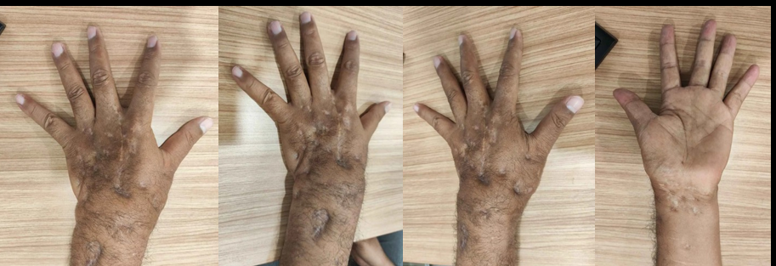
Figures 1. Pre-Operative Left Hand Region

Left Wrist Hand X-ray and MRI performed and found findings demonstrate a lunate fracture with associated bone bruises in the scaphoid, triquetrum, and capitate, accompanied by palmar subluxation and dislocation within the carpal complex. Additional signs of ligamentous injury, soft tissue fibrosis, tenosynovitis, and joint effusion suggest chronic instability and active inflammatory changes in the left wrist. The patient is planned to undergo Release contracture in operating theatere.

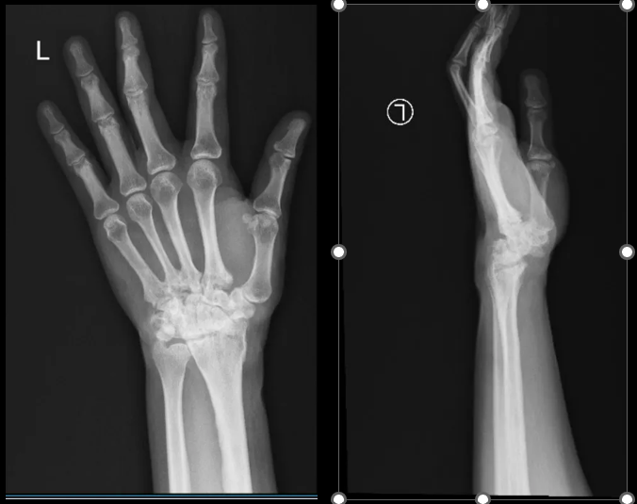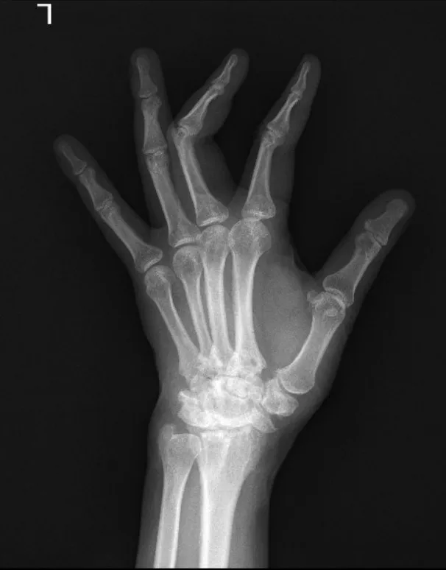
Figures 2. Pre Operative Left Hand X-Ray AP, Oblique and Lateral View

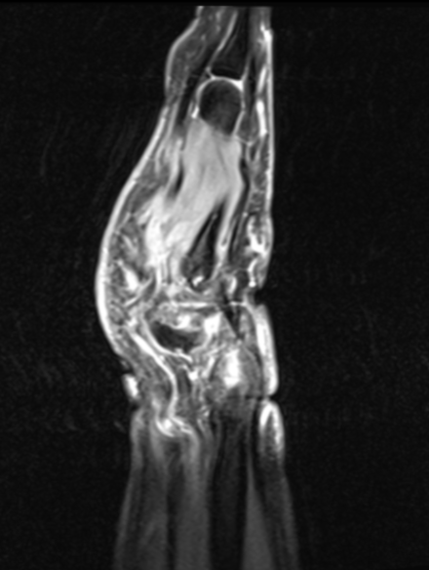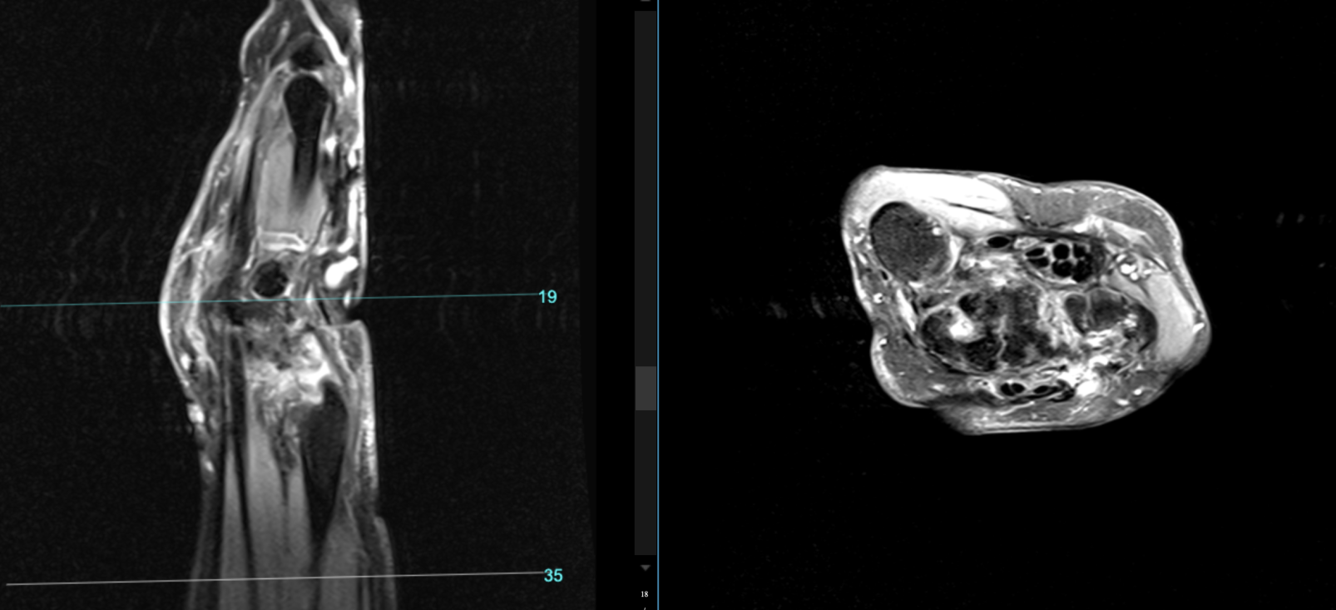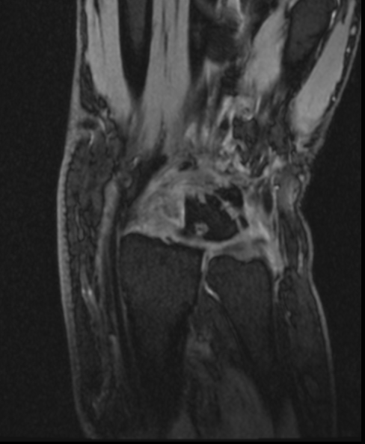
Figures 3. Pr Left Wrist MRI Sagittal, Axial and Coronal View

Intraoperatively
The patient was placed in the supine position under appropriate anesthesia. Standard aseptic preparation and draping of the left upper extremity were carried out. A dorsal longitudinal incision was made over the affected metacarpophalangeal joints, carefully dissecting layer by layer to expose the underlying structures. The Extensor Digitorum Communis (EDC) tendon was identified and released to allow improved joint mobility. Subsequently, sagittal band lengthening was performed using the Z-plasty technique on the 2nd, 3rd & 4th digits to address the extensor mechanism tightness. To maintain joint alignment and stability post-correction, three 1.4 mm Kirschner wires (K-wires) were inserted across the MCP joints. After ensuring adequate positioning and stability, the wound was meticulously closed in anatomical layers. The procedure was completed without complications.


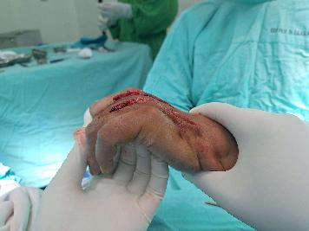
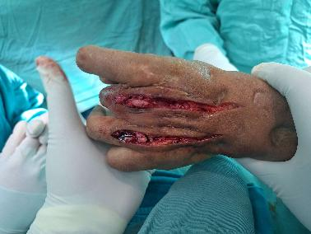
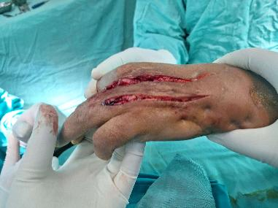

Figure 4. Intraoperative Condition Extensor Contracture Release

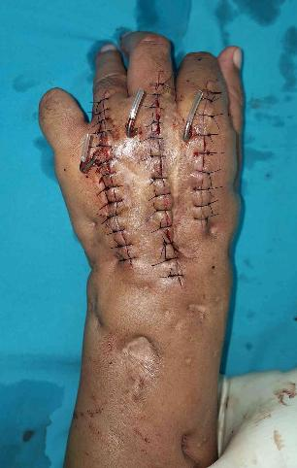
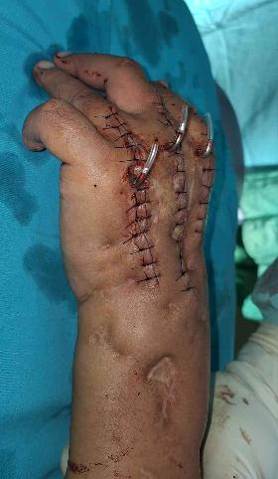
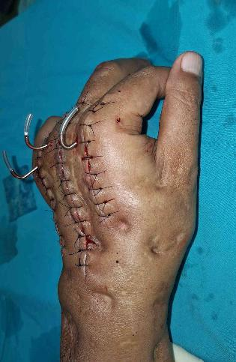

Figures 5. Clinical Post Operative with Kirschner wires

Post operative follow up
One month following the removal of the Kirschner wire, the patient began to complain of persistent pain localized to the third finger of the left hand.
On physical examination of the left hand region, there was a well-healed postoperative scar without signs of swelling or bruising. However, a visible deformity with angulation was noted. Palpation revealed tenderness at the level of the third metacarpophalangeal (MCP) joint. Avascular necrosis (AVN) at the distal phalanx was clinically assessed to be in good condition.
Range of motion (ROM) assessment showed that the active distal ROM of the first, second, fourth, and fifth fingers was within normal limits (0–90 degrees). In contrast, the third finger demonstrated restricted movement with an active distal ROM of only 0–70 degrees.

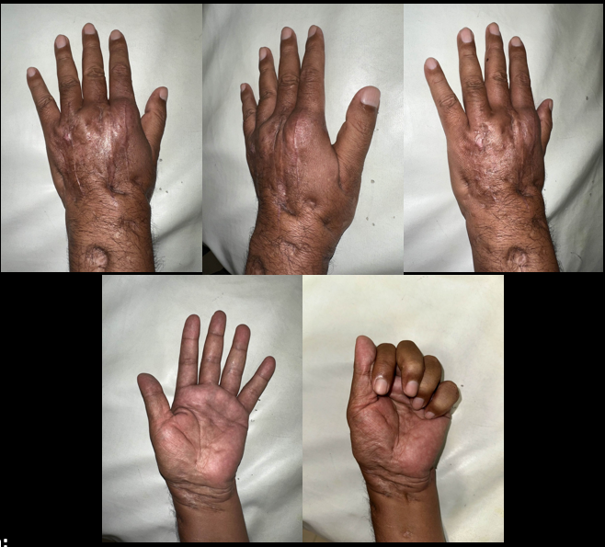
Figure 6. One Months Post-Operative Condition

DISCUSSION
Extension contractures of the metacarpophalangeal (MCP) joints, particularly affecting the 2nd, 3rd & 4th fingers, are an infrequent yet functionally significant condition. These contractures present distinctive challenges in both diagnosis and treatment (6). Compared to flexion contractures which are commonly observed in clinical settings and often linked to conditions such as Dupuytren’s disease or prolonged immobilization—extension contractures are considerably less prevalent and thus receive limited attention in the literature. Nonetheless, their impact on grip function and fine motor coordination can be considerable, especially when the central digits are involved (7).
The development of MCP extension contractures typically involves a combination of contributing factors. In the present case, the contracture likely resulted from post-traumatic soft tissue fibrosis and capsular adhesion, following a period of immobilization. Immobilizing the joint in an extended position—whether due to external devices like splints or casts, or as a result of disuse from pain—can lead to contracture of the joint capsule, shortening of periarticular soft tissues, and adhesion within the extensor mechanism (8). This is particularly detrimental in the MCP joint, where normal function relies on the unimpeded gliding of the extensor tendons and integrity of the sagittal bands (9).
In cases where the contracture becomes chronic or does not respond to conservative therapy, surgical correction is often warranted. In this patient, a dorsal surgical approach was used to access and release the involved structures (10). The Extensor Digitorum Communis (EDC) tendon was carefully released, and Z-plasty techniques were employed to lengthen the sagittal bands of the affected digits. Additionally, 1.4 mm K-wires were inserted to maintain joint positioning during the early postoperative phase. This strategy is well-documented as effective in preventing early recurrence and preserving surgical correction (11).
Postoperative rehabilitation is critical to sustaining functional recovery. Early initiation of therapy under the supervision of an experienced hand therapist can minimize the risk of re-adhesion and joint stiffness. A structured rehabilitation program that includes both active and passive motion exercises promotes soft tissue remodeling and functional reintegration of the hand (12).
Functionally, the restoration of flexion at the 2nd, 3rd & 4th MCP joints leads to a notable improvement in grip strength and manual dexterity. In this case, the patient showed significant improvement in digital flexion and was able to resume functional hand use during daily tasks. Nevertheless, continued follow-up is necessary to detect any recurrence, particularly if underlying factors such as inflammation or tendon imbalance persist (13).
This case emphasizes the importance of timely identification and individualized surgical planning in managing MCP extension contractures. It also demonstrates the effectiveness of combining extensor tendon release with sagittal band Z-plasty for restoring motion in the central digits. Due to the scarcity of such cases in current literature, further reports and clinical studies are needed to guide treatment protocols and standardize outcome expectations in this rare but impactful condition.

CONCLUSION
This case highlights a rare and complex presentation of chronic wrist stiffness and digital contracture following a remote traumatic event complicated by recurrent infection and multiple debridement procedures. Despite extensive prior interventions, the patient continued to experience functional limitations, which were ultimately attributed to extensor mechanism contracture, chronic soft tissue fibrosis, and multi-ligamentous carpal instability as confirmed by imaging. Surgical release of the extensor digitorum communis and sagittal band lengthening with Kirschner wire stabilization provided partial improvement in joint mobility, though postoperative follow-up revealed residual deformity and limited range of motion in the third digit, possibly due to early degenerative changes or soft tissue compromise. This case underscores the importance of timely diagnosis, advanced imaging, and individualized surgical planning in managing longstanding contractures and carpal instability to optimize functional recovery.

References

1. Wyndell H. Merritt MD, Alison L. Wong MD, M.S.E., Donald H. Lalonde MD. Recent Developments Are Changing Extensor Tendon Managemen. 2020;617–28.
2. Al-qattan MM, Rafique A. Type I locking of the metacarpophalangeal joint : A case report. Int J Surg Case Rep [Internet]. 2016;23:120–3. Available from: http://dx.doi.org/10.1016/j.ijscr.2016.04.026
3. Laszlo Dongo MP. Locked metacarpophalangeal joint of long fingers: Clinical presentation, literature review, and a treatment-oriented classification. 2017;
4. Kamnerdnakta S, Huetteman HE, Chung KC, Arbor A, Division P, Surgery P, et al. Complications of Proximal Interphalangeal Joint Injuries: Prevention and Treatment. 2019;34(2):267–88.
5. Bellemère P. Treatment of chronic extensor tendons lesions of the fingers. Chir Main [Internet]. 2015;34(4):155–81. Available from: http://dx.doi.org/10.1016/j.main.2015.05.001
6. Stanley EA, Cavallo A. Dupuytren’s contracture: involvement of the distal interphalangeal joint– a case series and anatomical dissection. 2019;
7. Marshall TG, Sivakumar B. Mechanics of Metacarpophalangeal Joint Extension. 2021;(February 2018).
8. Duzgun S, Duran A, Keskin E, Yigit AK, Buyukdogan H. Chronic Boutonniere Deformity: Cross-Lateral Band Technique Using Palmaris Longus Autograft. J Hand Surg Am [Internet]. 2017;1–5. Available from: http://dx.doi.org/10.1016/j.jhsa.2017.04.010
9. Kim JK, Lim HM. Idiopathic Extension Contracture of the Little. YJHSU [Internet]. 2013;38(1):133–6. Available from: http://dx.doi.org/10.1016/j.jhsa.2012.08.041
10. Burns MC, Derby B, Neumeister MW. Wyndell merritt immediate controlled active motion ( ICAM ) protocol following extensor tendon repairs in zone IV – VII : review of literature , orthosis design , and case study — a multimedia article. 2013;17–22.
11. Saraiya H, Plastic M. Management of An Unusual Extreme Extension Contracture of the Wrist Role of a Custom-Designed Exercise Program in Achieving a Good Range of Movement and Prevention of Recontraction. 2023;378–81.
12. Tuna Z, Sari M, Oskay D. Hand therapy following post-traumatic metacarpophalangeal joint arthroplasty : A case report. 2020;43–8.
13. Eckerdal D, Lauritzson A, Nordenskjöld J, Åkesson A, Atroshi I. Finger Joint Contractures 5 Years After Treatment for Dupuytren Disease: A Comparative Cohort Study of Collagenase Injection Versus Surgical Fasciectomy. J Hand Surg Am [Internet]. 2022;47(9):834–42. Available from: https://doi.org/10.1016/j.jhsa.2022.04.019

