COMPARATIVE STUDY OF THE NUTRIENTS, ANTI-NUTRIENTS AND PHYTOCHEMICAL PROPERTIES OF TWO VARIETIES OF OKRA (Abelmoschus esculentus) CONSUMED IN SOUTHWEST OF NIGERIA

ABSTRACT
AIM: This study presents a comparative analysis of the nutritional, anti-nutritional, and phytochemical properties of long and short varieties of okra commonly consumed in southwestern Nigeria.
STUDY DESIGN: Comparative Experimental Laboratory Study (long vs. short okra varieties).
PLACE AND DURATION OF STUDY: Olabisi Onabanjo University, Sagamu, Ogun State, Nigeria; February to April 2021.
METHODOLOGY: Proximate composition was determined using standard AOAC methods. Mineral composition was quantified by Atomic Absorption Spectrophotometry. Fatty acid composition was analyzed by gas chromatograghy. Standard analytical methods were use to quantify phytochemicals and antinutrients. Antioxidant activity was assessed using the 2, 2-diphenyl-1-picrylhydrazyl (DPPH) radical scavenging assay, and ascorbic acid content was measured using a modified spectrophotometric method based on reduction of 2, 6-dichlorophenolindophenol (DCPIP).
RESULTS: The short variety showed higher moisture (11.20%), protein (17.10%), fat (1.70%), total ash (5.5%) and carbohydrate (63.20%) contents, while the long variety had higher fibre (24.70%) contents. Mineral analysis indicated higher levels of calcium, potassium, zinc, sodium and phosphorus in the short variety, whereas the long variety was slightly richer in iron and cobalt. Phytochemical screening revealed that the long variety contained higher levels of saponins, flavonoids, alkaloids, terpenoids, and phenols, while the short variety had higher cardiac glycoside content. Fatty acid composition varied slightly between the two, with linoleic and oleic acids being predominant in both. Anti-nutrient analysis showed higher oxalate content in the long variety, whereas the short variety had higher levels of tannins and phytates. Additionally, the long variety exhibited greater antioxidant activity (85.43%) and higher ascorbic acid content (0.09 g/100g) compared to the short variety (78.86% and 0.04 g/100g, respectively).
CONCLUSION: The findings highlight distinct variations in the nutritional and phytochemical compositions of both okra varieties, providing useful insights for dietary choices and further nutritional studies.
Keywords: Abelmoschus esculentus; Antinutrients; Phytochemicals; Malvaceae; Nutritional composition; Southwestern Nigeria

INTRODUCTION
Okra (Abelmoschus esculentus), a member of the Malvaceae family, is a globally significant vegetable crop, particularly in tropical and subtropical regions, valued for its nutritional and economic benefits (Naveed et al., 2009). Beyond its immature pods, which are consumed as a vegetable, okra’s mature pods serve as animal fodder or a source of mucilage, while its seeds yield oil or a coffee substitute powder (Calisir et al., 2005). Known as “lady’s finger” in England, “gumbo” in the United States, and by local names like “Ila” (Yoruba), “Kubewe” (Hausa), and “Okwale” (Igbo) in Nigeria, okra is a staple crop (Ndunguru & Rajabu, 2004; Alimi, 2005).
In Nigeria, okra pods are boiled, eaten raw, or used as a thickening agent in soups, contributing vitamins, minerals, calories, and essential amino acids comparable to poultry eggs and soybeans (Schippers, 2000). Its prominence in Nigerian cuisine makes it relatively expensive in local markets (Akinfasoye & Nwanguma, 2005). Okra’s versatility extends to its leaves, buds, flowers, stems, and seeds, which are used in salads, soups, stews, and industrial applications like confectionery (Mihretu et al., 2014; Rubatzky & Yamaguchi, 1997; Adetuyi et al., 2011). This study evaluates the nutritional, anti-nutritional, and phytochemical differences between long and short okra varieties to inform dietary choices and further research.
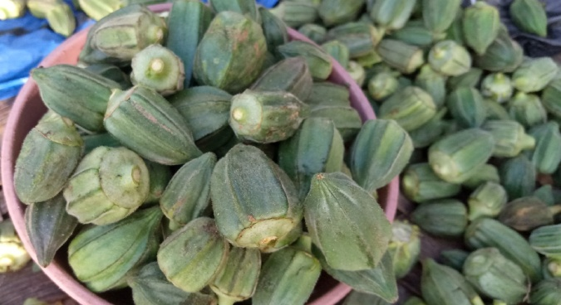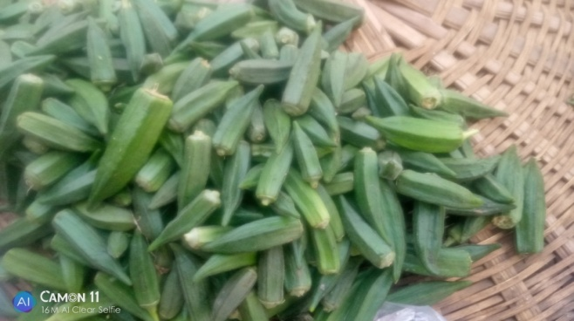
Photograph of Short Okra Photograph of Long Okra
pods eaten in Southwestern Nigeria pods eaten in Southwestern Nigeria
taken from Okun-Owa, Ogun State taken from Okun-Owa, Ogun State

MATERIALS AND METHODS
Plant Materials
Fresh pods of two okra varieties; long (LV) and short (SV) were collected from Okun-Owa, Ogun State, Nigeria. Pods were washed, sliced, oven-dried at 50°C, ground into powder, and stored in sterile flasks for analysis.
Analytical Procedures
Proximate Analysis
Moisture, ash, crude fiber, and fat contents were determined using AOAC (2000) methods. Crude protein was quantified via the Kjeldahl method, with nitrogen converted to protein using a factor of 6.25 (Manzi, 2004). Carbohydrates were calculated by difference:
Carbohydrate (%) = 100 – (Moisture + Ash + Crude Fiber + Crude Fat + Protein).
Metabolizable energy was estimated using Atwater factors: 4 kcal/g (protein and carbohydrates), 9 kcal/g (fat).
Mineral Analysis
Triplicate 0.5 g samples were digested with 10 mL nitric acid (HNO₃) overnight, heated until nitrogen dioxide fumes ceased, cooled, and treated with 2.5 mL 70% perchloric acid until colorless. Digests were diluted to 50 mL with distilled water and analyzed for minerals using an Atomic Absorption Spectrophotometer (ALPHA 4, Fisons Chem-Tech, UK) per Falade et al. (2003).
Tannin Content
A 0.2 g sample was extracted with 10 mL 70% acetone, cooled, shaken for 12–15 minutes, and filtered. From the supernatant, 0.5 mL was mixed with 0.5 mL distilled water, 0.5 mL Folin’s reagent, and 2.5 mL 20% sodium carbonate, vortexed, incubated for 40 minutes, and absorbance measured at 725 nm using tannic acid standards (0.01–1.0 mg/mL) (Adeneye et al., 2006).
Phytate Content
A 4 g sample was soaked in 100 mL 2% hydrochloric acid for 3 hours, filtered, and 25 mL of filtrate mixed with 5 mL 0.3% ammonium thiocyanate and 53.5 mL distilled water. The mixture was titrated with iron (III) chloride until a brownish-yellow color persisted. Phytate was calculated as:
%Phytic Acid = (8.24 × titre value × 100) / (1000 × sample weight) (AOAC, 1990).
Oxalate Content
A 1 g sample was stirred in 75 mL 1.5N sulfuric acid for 1 hour, filtered, and 25 mL of filtrate titrated hot with 0.1N potassium permanganate until a faint pink endpoint. Oxalate was calculated as:
Oxalate (mg/g) = titre value × 0.9004.
Saponin Content
A 20 g sample was extracted with 100 mL 20% ethanol at 55°C for 4 hours, filtered, and re-extracted with 200 mL 20% ethanol. The combined extract was concentrated to 40 mL, purified with diethyl ether and n-butanol, washed with 5% sodium chloride, and dried. Saponin content was calculated as:
%Saponin = (Final extract weight / Initial sample weight) × 100 (Obadoni & Ochuko, 2001).
Total Phenolic Compounds
A 5 g sample was boiled with 50 mL ether for 15 minutes. From the extract, 5 mL was mixed with 10 mL distilled water, 2 mL ammonium hydroxide, and 5 mL amyl alcohol, diluted, and absorbance measured at 505 nm after 30 minutes. Phenolics were calculated as:
%Phenolic Compounds = A_{blank}- A_{sample} × 100.
A_{blank}
Flavonoids
A 10 g sample was extracted with 100 mL 80% methanol, filtered, and evaporated to dryness. Flavonoid content was calculated as:
%Flavonoids = (Residue weight / Sample weight) × 100 (Bohm & Kocipai-Abyazan, 1994).
Alkaloids
A 5 g sample was extracted with 200 mL 10% acetic acid in ethanol for 4 hours, filtered, and concentrated to 50 mL. Alkaloids were precipitated with ammonium hydroxide, filtered, washed, dried, and calculated as:
%Alkaloids = (Alkaloid weight / Sample weight) × 100 (Edeoga et al., 2005).
Cardiac Glycosides
A 1 mL diluted sample was mixed with 10 mL Baljet’s reagent (95 mL 1% picric acid, 5 mL 10% NaOH), incubated for 1 hour, diluted with 20 mL water, and absorbance measured at 495 nm (Solich et al., 1992). Glycosides were calculated as:
%Cardiac Glycosides = A_{blank}-A_{sample} × 100
A_{blank}
Fatty Acid Analysis
Fatty acids were extracted from 150 mg samples using 5 mL n-hexane, transesterified with 0.5 M sodium methoxide in methanol, and separated with 7 mL water. The organic layer was analyzed via gas chromatography (Hewlett-Packard 5890 Series II, FID) using an HP-6890 autosampler and FAME standard mix RM-3 (Sigma-Aldrich) for peak identification.
Ascorbic Acid Determination
The ascorbic acid content of the okra samples was determined using a modified spectrophotometric method based on the reduction of 2, 6-dichlorophenolindophenol (DCPIP) AOAC (2000). Okra samples (Long and Short varieties) were prepared by homogenizing the edible portions. A known weight of the homogenized sample was mixed with a suitable volume of metaphosphoric acid solution to extract ascorbic acid and prevent its oxidation. The extract was then titrated against a standardized solution of 2, 6-dichlorophenolindophenol (DCPIP) until a faint pink color persisted for at least 30 seconds. The volume of DCPIP consumed was recorded. A standard curve was prepared using known concentrations of L-ascorbic acid and titrating them with the same DCPIP solution. This allowed for the quantification of ascorbic acid in the samples
DPPH Radical Scavenging Activity Assay
The antioxidant activity of the okra samples was determined using the 2, 2-diphenyl-1-picrylhydrazyl (DPPH) radical scavenging assay, following a modified version of the method described by Brand-Williams et al. (1995). The two varieties of okra (long and short) were washed, and the edible portions were homogenized to create a fine paste. The extracts were then prepared by solvent extraction using methanol. A 0.1 mM solution of DPPH in methanol was prepared. For the assay, 1 mL of the okra extract was mixed with 3 mL of the DPPH solution. The mixture was shaken vigorously and left to stand in the dark at room temperature for 30 minutes. The absorbance of the resulting solution was measured at 517 nm using a UV-Vis spectrophotometer. A control sample, containing 1 mL of methanol instead of the extract, was also measured. The percentage of DPPH radical scavenging activity was calculated using the following formula:
% Scavenging Activity = [(A_control - A_sample) / A_control] x 100
Where: A_control is the absorbance of the control sample.
A_sample is the absorbance of the sample with the okra extract.
Statistical Analysis
All experiments were performed in triplicate, and the results were presented as the mean ± standard deviation. The data was visualized using a bar chart to compare the results of the two okra varieties.

RESULTS
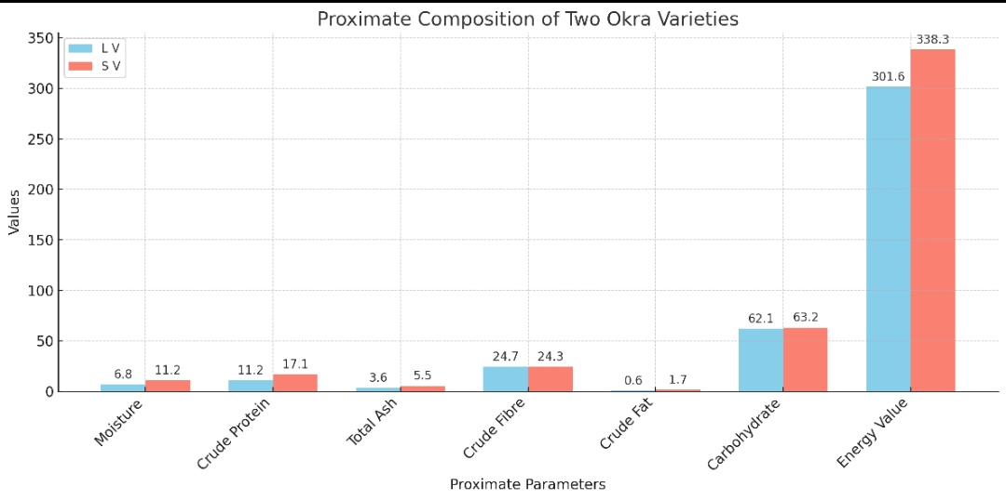
Fig 1: Proximate analysis of long and short okra variety
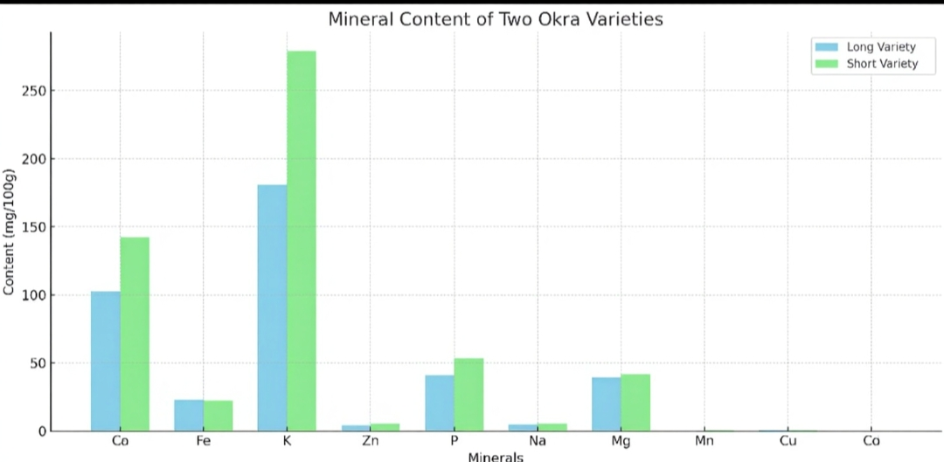
Fig 2: Mineral analysis of long and short okra

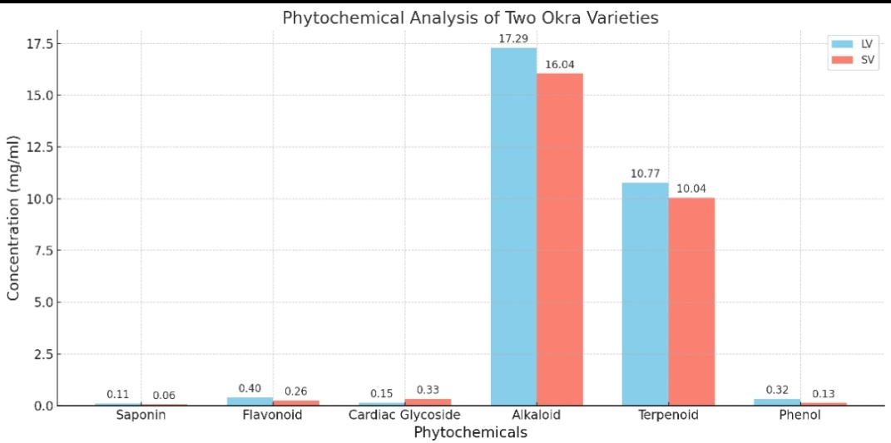
Fig 3: Phytochemical Analysis of Two Okra Varieties
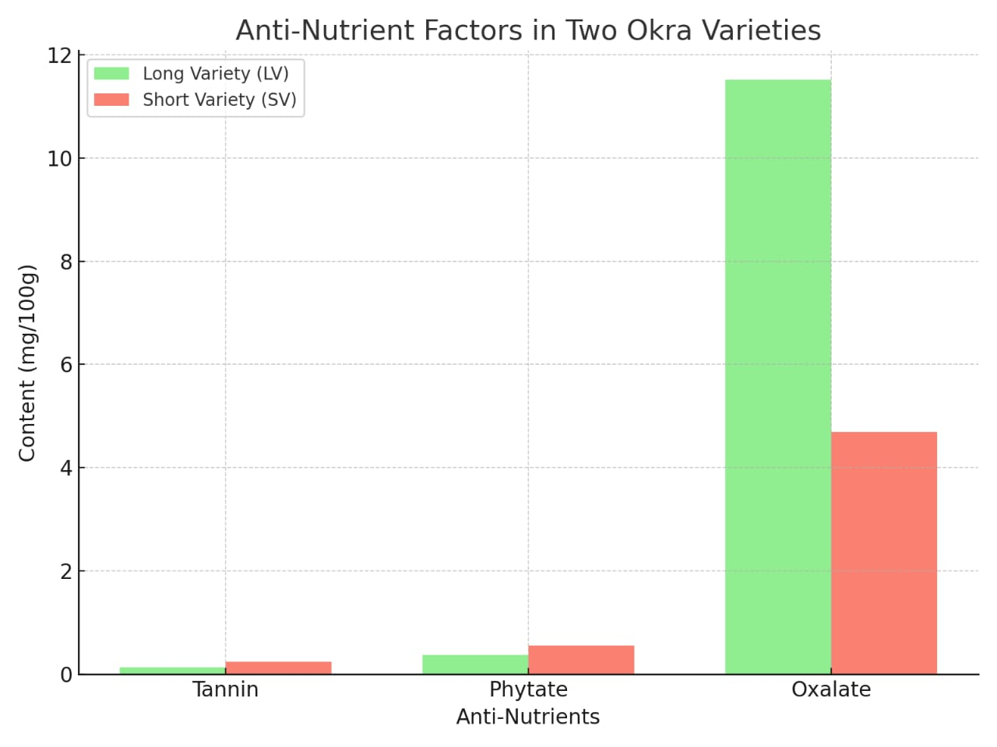
Fig 4: Anti-Nutrient factors in two okra variety
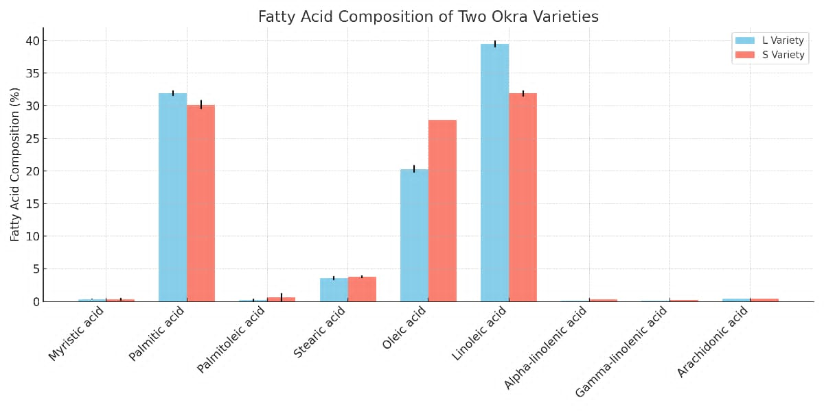
Fig 5: Fatty Acid composition of two okra variety
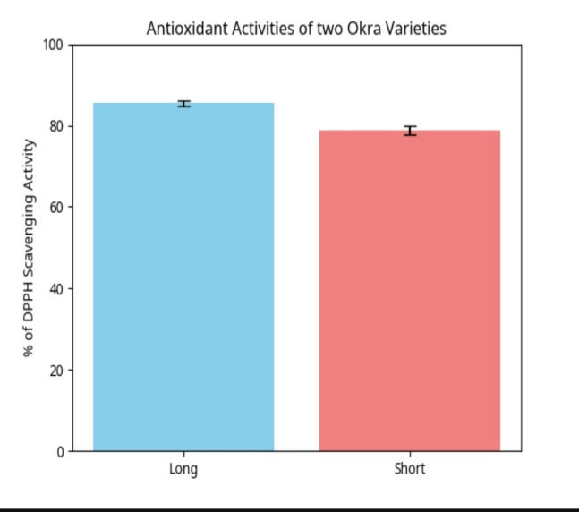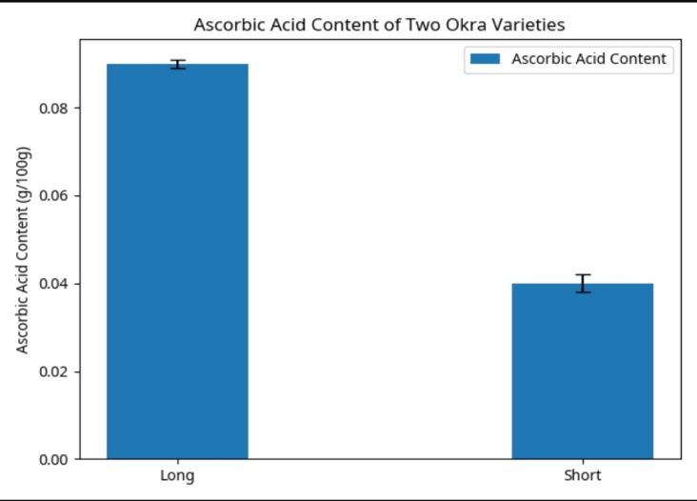
Fig 6: Antioxidant activity of Fig 7: Ascorbic acid content of two okra variety
two okra variety

Discussion
Proximate analysis showed that short variety (SV) had higher moisture (11.20% vs. 6.79%), protein (17.10% vs. 11.17%), fat (1.70% vs. 0.64%), ash (5.52% vs. 3.56%) and carbohydrate (63.20% vs. 62.12%) contents than the long variety (LV), while LV had higher fiber (24.70% vs. 22.43%). High moisture in SV suggests a shorter shelf life due to microbial susceptibility (Adelakun et al., 2009). SV’s elevated protein content (~44% higher than LV) positions it as a valuable protein source (Gemede et al., 2015). Higher ash in SV indicates greater mineral content, supporting metabolic functions (Dhellot et al., 2006). Both varieties are rich in fiber, promoting digestive health (Anderson et al., 2009). SV’s higher fat content aids fat-soluble vitamin absorption, and its energy value (338 kcal/100g vs. 301 kcal/100g) reflects its nutrient density (Akindahunsi & Salawu, 2005; Fasuyi, 2006).
The mineral content revealed that short variety contained more major macrominerals and trace elements like calcium, potassium, zinc, phosphorus, sodium, magnesium, manganese, copper, and cobalt than long Variety, except for iron, which was slightly richer in long variety. This result agrees with Gemede et al. (2021), which noted that mineral content of okra pods was extremely variable in terms of genotype, agroecological site, and post-harvesting treatment. Ijarotimi et al. (2022) indicated extreme variation of mineral content among okra accessions, particularly calcium and potassium levels ranging from 111–312 mg/100 g and 123–318 mg/100 g respectively, depending on varieties and conditions.
These minerals play essential physiological roles. Calcium, for instance, plays a crucial role in bone structure and enzyme activity, magnesium is part of the metabolism of ATP, and potassium is necessary for osmotic balance as well as nerve function (FAO, 2020). Thus, the higher mineral composition observed in short variety would enhance its nutritional appeal, especially among populations prone to micronutrient deficiencies.
Anti-nutrient analysis indicated lower tannins, phytates, and oxalates in long variety compared to short variety. These compounds, at observed levels (<1.0 mg/100g), pose minimal risk to mineral bioavailability, especially in a balanced diet or with processing like cooking (Adeyeye & Adedokun, 2020; Adeleke et al., 2023; Nnam et al., 2021).
Long variety exhibited higher ascorbic acid (0.09 g/100g vs. 0.04 g/100g) and antioxidant activity (85.43% vs. 78.86%), enhancing iron absorption and free radical scavenging (Sarma et al., 2023; Olatunbosun et al., 2021).
Fatty acid profiles showed long variety with higher linoleic (39.5%) and palmitic (32%) acids, while short variety was richer in oleic (~28%) and linolenic acids (31.9%). Unsaturated fatty acids like oleic and linoleic support cardiovascular health, with short variety’s profile favoring oil stability and long variety’s suitable for commercial applications (Adeniyi et al., 2020; Ogunmoyole et al., 2022).
Conclusion
The long variety excels in ascorbic acid, antioxidant activity, and linoleic acid, ideal for functional foods, while the short variety offers superior mineral content, oleic acid, and energy value, enhancing dietary micronutrient intake and oil stability. Both varieties’ moderate anti-nutrient levels support their dietary inclusion. These findings underscore the importance of varietal selection in okra breeding for nutritional and industrial purposes.

References
Adelakun, O. E., Oyelade, O. J., Ade-Omowaye, B. I. O., Adeyemi, I. A., & Van De Venter, M.
(2009). Chemical composition and the antioxidative properties of Nigerian okra seed (Abelmoschus esculentus Moench) flour. Food and Chemical Toxicology, 47(6), 1123–1126.
Adeleke, B. T., Olagunju, O. F., Ijarotimi, O. S., & Ojo, A. T. (2023). Nutritional, anti-
nutritional factors and phytochemical composition of commonly consumed vegetables in Nigeria. Scientific African, 20, e01756.
Adeneye, A. A., Benebo, A. S., & Olagunju, J. A. (2006). Protective effect of the aqueous extract
of the leaves of Treculia africana on acetaminophen-induced liver damage in rats. African Journal of Biomedical Research, 9(3), 165–172.
Adeniyi, P. O., Olagunju, O. F., Ogunmoyole, T., & Ojo, A. T. (2020). Nutritional composition,
functional properties and antioxidant activities of seed flours from three different okra (Abelmoschus esculentus) varieties. Scientific African, 7, e00317.
Adetuyi, F. O., Ibrahim, T. A., & Adetuyi, D. O. (2011). Effect of fermentation time on the
phenolic, flavonoid and vitamin C contents and antioxidant activities of okra (Abelmoschus esculentus) seed flour. Nigerian Food Journal, 29(2), 106–114.
Adeyeye, E. I., & Adedokun, A. I. (2020). Chemical composition and anti-nutritional properties
of lesser-known leafy vegetables in Nigeria. Food Science & Nutrition, 8(12), 6392–6403.
Akinfasoye, J. A., & Nwanguma, E. I. (2005). Effect of weeding regimes on weed infestation
and yield of okra (Abelmoschus esculentus) in a humid environment. Nigerian Journal of Weed Science, 18, 37–44.
Akindahunsi, A. A., & Salawu, S. O. (2005). Phytochemical screening and nutrient–antinutrient
composition of selected tropical green leafy vegetables. African Journal of Biotechnology, 4(6), 497–501.
Anderson, J. W., Baird, P., Davis Jr, R. H., Ferreri, S., Knudtson, M., Koraym, A., &
Williams,C. L. (2009). Health benefits of dietary fiber. Nutrition Reviews, 67(4), 188–205.
AOAC. (1990). Official Methods of Analysis (15th ed.). Association of Official Analytical
Chemists.
AOAC. (2000). Official Methods of Analysis (17th ed.). Association of Official Analytical
Chemists.
Bohm, B. A., & Kocipai-Abyazan, R. (1994). Flavonoids and condensed tannins from leaves of
Hawaiian vaccinium vaticulatum and V. calycinum. Pacific Science, 48(4), 458–463.
Calisir, S., Ozcan, M., Haciseferogullari, H., & Yildiz, M. U. (2005). A study on some
physicochemical properties of Turkey okra (Abelmoschus esculentus) seeds. Journal of Food Engineering, 68(1), 73–78.
Dhellot, J. R., Matouba, E., Maloumbi, M. G., Nzikou, J. M., Safou-Tchoumba, L. C., Linder,
M.,& Desobry, S. (2006). Extraction, chemical composition and nutritional characterization of vegetable oils: Case of Amaranthus hybridus (var 1 and 2) of Congo-Brazzaville. African Journal of Biotechnology, 5(10), 1095–1101.
Edeoga, H. O., Okwu, D. E., & Mbaebie, B. O. (2005). Phytochemical constituents of some
Nigerian medicinal plants. African Journal of Biotechnology, 4(7), 685–688.
FAO. (2020). Human vitamin and mineral requirements. Food and Agriculture Organization of
the United Nations.
Fasuyi, A. O. (2006). Nutritional potentials of some tropical vegetable leaf meals: Chemical
characterization and functional properties. African Journal of Biotechnology, 5(1), 49–53.
Gemede, H. F., Haki, G. D., Woldegiorgis, A. Z., & Beyene, F. (2015). Nutritional quality and
health benefits of okra (Abelmoschus esculentus): A review. Journal of Food Processing and Technology, 6(6), 1–6.
Gemede, H. F., Haki, G. D., Woldegiorgis, A. Z., & Beyene, F. (2021). Comparative study on
the physicochemical properties, functional characteristics and nutrient contents of okra (Abelmoschus esculentus) pods in different harvesting stages. Journal of Food Quality, 2021, Article ID 6695474.
Ijarotimi, O. S., Olagunju, O. F., & Adeniyi, P. O. (2022). Proximate composition, mineral
profile and phytochemical content of Abelmoschus esculentus (okra) from Nigeria. Scientific African, 15, e01133.
Mihretu, M., Wayessa, G., & Adugna, D. (2014). Agro-morphological variability of okra
[Abelmoschus esculentus (L.) Moench] in western Ethiopia. Scientific Research and Essays, 9(25), 1218–1223.
Naveed, A. K., Waqas, M. H., Saifullah, K., & Zahir, Z. A. (2009). Evaluation of plant growth
promoting rhizobacteria and their influence on the growth, yield and nutrient contents of okra (Abelmoschus esculentus L.). Soil & Environment, 28(2), 124–130.
Ndunguru, J., & Rajabu, A. C. (2004). Effect of okra mosaic virus on the yield of okra in
Tanzania. Plant Pathology Journal, 3(1), 50–54.
Nnam, N. M., Asuquo, A., & Ajagu, N. (2021). Effect of processing on antinutritional factors
and nutrient composition of selected underutilized green leafy vegetables in South-East Nigeria. Nigerian Journal of Nutritional Sciences, 42(1), 61–67.
Olatunbosun, O. O., Adenuga, A. A., Akinwande, B. A., & Egharevba, H. O. (2021).
Comparative study on antioxidant and antibacterial activities of selected Nigerian vegetables. Journal of Applied Sciences and Environmental Management, 25(3), 425–429.
Obadoni, B. O., & Ochuko, P. O. (2001). Phytochemical studies and comparative efficacy of the
crude extracts of some homeostatic plants in Edo and Delta States of Nigeria. Global Journal of Pure and Applied Sciences, 8(2), 203–208.
Ogunmoyole, T., Ojo, A. T., & Olagunju, O. F. (2022). Fatty acid profile and antioxidant
potential of seed oil from different okra varieties. Scientific African, 16, e01209.
Rubatzky, V. E., & Yamaguchi, M. (1997). World vegetables: Principles, production, and
nutritive values (2nd ed.). Chapman & Hall.
Sarma, R. K., Saikia, D., & Baruah, D. (2023). Phytochemical screening, antioxidant and
antimicrobial activities of selected medicinal plants from North-East India. Indian Journal of Natural Products and Resources, 14(1), 67–74.
Schippers, R. R. (2000). African indigenous vegetables: An overview of the cultivated species.
Natural Resources Institute/ACP-EU Technical Centre for Agricultural and Rural Cooperation.
Solich, P., Polasek, M., & Vespalec, R. (1992). Spectrophotometric determination of cardiac
glycosides. Journal of Pharmaceutical and Biomedical Analysis, 10(9), 641–645.

