**Original Research Article**

**An Impact Assessment of Pedagogical Interventions to measure the Competency in Practical Geography among Secondary School Teachers**

**Abstract**

The practical applications of geography assist the most effective means to comprehend our duty to safeguard nature. Practical geography is grounded in experiential learning through integrated activities, similar to laboratory as well as field work. Competency is based on 'self-realization and self-regulation', which enable the successful completion of assigned tasks for enhancing the skill. The objective of this study is to evaluate the current knowledge, necessity for teacher training, and various creative activities, improve teachers' competency. Several pedagogical interventions have been incorporated, such as model preparation, demonstrations, and ICT integration. The effectiveness of these interventions is measured using various techniques with the assistance of pre- and post-test assessments. The findings of this training program reveal a significant positive impact on teachers, as indicated by percentage analysis and t-test. Consequently, this study will be highly advantageous for students, teachers, curriculum developers, and stakeholders involved in practical geography.

**Keywords:** Practical geography, pedagogical intervention, experiential learning, analytical thinking, assessment, Secondary School Teachers

**Introduction**

The mechanisms behind natural phenomena such as weather, soil, water, and vegetation, farming, urban development etc. can be easily comprehended through practical applications within the field of geography (Paul, 2013). In this regard, practical geography relies on experiential learning integrated activities, akin to laboratory work (Pearce, 2024), identical to laboratory works in biology, physics and chemistry (Prescott, 1920). The practical applications of geography represent the most effective means of understanding our responsibility to protect nature (Morris, 2019), particularly when it involves experiencing, analysing, and thoroughly evaluating the effects of climate change, environmental degradation, and sustainability (Kahraman, 2016), especially, our connection to nature and our efforts to maintain environmental sustainability (Sheppard, 2004). A very vice-versa relation exist between man and environment. Human beings are deteriorated and destroyed the natural resource due to their uncontrol and reckless demands and desires (D2) and in the same time again face the environmental and ethical (E2) problems like air, water, soil, cultural, ethical pollution (Krakowka, 2012). Therefore, D2 disturbs the E2 but E2 has abundant potential to rejuvenate their homeostatic mechanism in the form of natural (Earthquake, Tsunami, forest fire, drought, flood, climate change etc.) and ethical disaster (crimes in relation, dacottes, stealing, murder, rape, cyber bullying etc.).

However, geography is very involving subject to human being with nature because geography talks from physical world to human world (Roberts, 2023). Geography without practical works looks like a doctor without medical tools. Students gain first-hand, practical experiences that support and reinforce knowledge, skills, and concepts about practical geography in either indoor or outdoor classrooms (NCERT, 2007 and 2022). In this way, learners can integrate concepts from many different areas of science, social science, and the humanities and apply critical thinking to understanding and dealing with current issues of local, national, and international importance (Fargher et al., 2021). Consequently, in modern times, influenced by the National Education Policy 2020 in India, disciplines such as mapping, environmental studies, technology, holistic development, and global citizenship are evaluated and shaped through the lens of experiential learning-based practical activities in geography, which are comprehensively explored through the training programs for teachers and learners (Mier, 2024). Experiential learning, along with integrated ICT, serves as the foundation for geospatial technology, conceptualized as a method for applying the knowledge that learners have acquired, assessed, and analyzed to practical, real-world actions (Adaktylou, 2020; Bikar et al., 2022). By involving students in practical experiences and encouraging reflection, they can more effectively relate the theories and knowledge gained in the classroom to actual situations in the world (Hejmanowska et al., 2002; Di et al., 2022). Pedagogical intervention is a fundamental approach for learners to grasp concepts (Sanchez et al., 2019). The transfer of concepts within the minds of learners, as well as their ability to reflect on the learning outcomes (concepts) after receiving pedagogical interventions, is crucial (Wan et al., 2019). The deliberate actions taken by educators to enhance learning outcomes through structured teaching methods are known as pedagogical interventions (Dejene, 2024). The enhancement of intellectual creativity in practical geography is achieved through the use of low-cost, effective miniatures or models among learners. (Lane et al., 2019). In this way, Competency relies on *‘self-realization and self-regulation’* (emphasis mine), which facilitate the effective execution of assigned tasks. The inherent competency in practical geography involves measuring scale, comprehending direction, ensuring precision in angle bearing, graph plotting, and possessing basic computer knowledge etc. (Braun, 2022) which might enhance the teacher's expertise and accuracy. Therefore, this research investigates a simple and interesting teaching method in the domains of practical works such as data analysis, map projection, remote sensing, scale, toposheets understanding, weather instruments, (DMRSTW) in Geography and their analytical utilization (Ferguson et al., 2021). The fundamentals mechanism of DMRSTW are incorporated into the curriculum by various academic institutions as well as implement in real-life integrated sustaining systems (Pandey, 2018; Sanchez et al., 2019). In this context, the resolution of this study is to assess existing knowledge, need of teacher training, and various creative activities, etc., in the classroom to enhance teachers' competency. In the recent time, the mechanism and pedagogy of the study is needed to realise the study materials through different kinds of hands-on related to practical works in Geography (Bendl et al., 2024; Pandey, 2018). In the meantime, this research examines the impact of this teaching intervention on teachers in states of the western region of India by using the pre-test and post-test methods. A significant progressive effect is observed among selected teachers from the states in their knowledge and competency (Sengupta et al., 2018). This study will be highly beneficial to evaluate the improvement of current knowledge in Key Resource Persons (KRPs), teacher training module, preparation of educational resources for learners, and curriculum development by various stakeholders (Lee, 2025). It will also aid in introducing new examples and incorporating different pedagogical intervention tools such as ICT integrated hands-on, field-based learning, demonstrations, illustrations, etc., across all subjects and regions in schools (Alemu, 2017). In this research paper, the phases (contents) of this training have been analysed through many steps related to the fundamentals of practical geography, critical evaluation, and realization of the daily life-based implementation (Figure 1). Present research work focused on the improvement of knowledge in Practical Geography of 12th standard for Key Resource Persons of western region states (Chhattisgarh, Maharashtra, Madhya Pradesh, Goa, and Gujarat) of India which is related to various mechanisms of practical works in geography with its implications and implementations. A pedagogical intervention was provided to selected teachers for five days in eighteen sessions, and after that, a post-test was administered. The questions/statements were remained same during pre-test and post-test. The objective of this research study is in the way of – a) to assess the self-efficacy among learners in the area of DMRSTW; b) to provide the different pedagogical intervention regrading practical geography; c) to examine the effect of intervention in hands-on based learning in practical geography. The KRPs (who taught to class XI and XII students.) for the study were taken from five states of India and each belonging to a different Government Higher Secondary Schools. The impact of training on teachers-learners was assessed through the pre-test and post-test method, which reflects the earlier knowledge among teachers, interestingly, attentiveness in classroom activity, and grasping aura for content during the sessions (Kunter et al., 2013). In this way, this research study has the potential to increase interest and knowledge by DAY (Doing action by yourself) support and engaging in the learning process which makes it easier for teachers and students to exchange basic knowledge, develop a scientific and ethical mindset, analytical comprehension to address real-world problems (Angeli, 2005).

**Material and methods**

**Study area:** The study area covers five states namely Chhattisgarh, Maharashtra, Madhya Pradesh, Goa, and Gujarat from the Western Region of India **(Figure 1).**

**Data acquisition:** This study is based on the primary data that was collected from 39 PGT (Post Graduate Teacher of class XI and XII standard) teachers from five states of western region such as Chhattisgarh (9), Maharashtra (8), Madhya Pradesh (10), Goa (6), and Gujarat (6) who joined the capacity building training programme. Some instruments (Secchi index, thermometer, wet and dry bulb thermometer, map, orange, wooden cut-piece, balls, white powder, tracing papers, spring, telescope, satellite imageries, toposheets etc.) were used to intervene the KRPs (Jorgensen, et al., 2013) for enhancing the knowledge and real-life application through practical geography. Google Earth Pro, QGIS, MS Office software, etc., were used as tools to understand the fundamental mechanism of practical works in Geography as well as used for data calculation and tabulation as well as mapping (Noesgaard, 2015).

**Pedagogical Interventions and Assessment Tools:** The pedagogical interventions are based on the class XI and XII practical geography textbooks of NCERT, National Education Policy 2020, and National Curriculum framework for School Education, Ministry of Education, Government of India (GOI). The pedagogical interventions include the various methods that are explanation, ICT-integrated hands-on, model preparation and demonstration, ICT-based LTM (learning teaching material), experiential learning, field-based learning and analytical thinking (Evens et al., 2015). Therefore, the level of competency evaluated by some assessment like quick check by MCQs, brain teaser by puzzles, don’t forget the nutshell, map-based puzzle among the states (Angeli, 2005).

**Data analysis:** This research paper explores, elucidate the attractive learning way through different pedagogical intervention of practical works in geography and analyse the competency enhancement among secondary-stage teachers of western region states. Pre and post-test method used to analyse the improving competency after providing the attractive and hands-on based learning assistances within the eighteen sessions (outdoor and indoor session). In this research papers, pre-test, content transact in the brain of KRPs with attractive and easy pedagogical intervention and assessed the competency (Deng, 2018) through numerous way (quick check by MCQs, brain teaser by puzzles, don’t forget the nutshell, map-based puzzle) as well as post-test applied (Bendl et al., 2024.). A pre-test was administered before given pedagogical interventions on all 39 teachers to assess previous knowledge on topic of practical geography (DMRSTW). There are 30 multiple-choice questions were formulated for the both tests (Zarabi, 2019) in the five sections of practical geography. In which, five MCQs given from scale in pre-test and six in post-test; seven MCQs in pre-test and five in post-test from map projection, time zone; six MCQs from weather instruments in pre-test and five in post-test; four MCQs in pre-test and five in post-test from data analysis whereas eight MCQs in pre-test and nine in post-test from remote sensing. It is calculated on the basis of performance of teachers in pre-test and post-test method DMRSTW by the difference sum and mean value of all teachers in a particular state (Di Maio et al., 2002). Both the tests were conducted to evaluate the effect of pedagogical intervention on KRPs for assessing their grasping capacity and attentiveness in the class (Table 2) and as well as examine the earlier competency about the content (Table 1). In this study, Percentage analysis, T-Test (used to check the data significance) used as statistical technique for data analysis (Table 3). MS Office, QGIS software, numerous literatures, etc., are used as tools to understand the impact of attractive pedagogy on teachers in the field of practical geography.

**This research work is done under five phases which are followings:**

* Development of learning materials to make easy through different tools based on NCERT textbook
* Call the KRPs with the help of respective state coordinators
* Pre-test: Question from on scale, map projection, toposheets understanding, weather instruments, data analysis, remote sensing (DMRSTW)
* Intervention: to make easy through analytical hands-on
* Post-test: Same question from on scale, map projection, toposheets understanding, weather instruments, data analysis, remote sensing (DMRSTW)

**Results and Discussion**

**Pedagogical intervention:** Field- based learning (scale, Secchi index), instrumental learning (rain gauge, wind vane, telescope), experimental learning (relative humidity), analytical learning (water quality), demonstration, model making and preparation, map-based learning, ICT integrated learning are the systematic way to acquire the knowledge regarding the content in practical geography after teaching-learning sessions among the teachers (Smit et al. 2023).

1. **Explanation:** In this approach, teachers were trained on the fundamental concept of content pertaining to DMRSTW and its importance. Additionally, it was also addressed that how this concept interconnects and elucidates the core issues related to curriculum development, student dropout rates, engaging pedagogy for better comprehension by learners, and real-time environmental sustainability.
2. **Demonstration:** The identification of any coordinates and latitudinal angles have been demonstrated through the prepared model (Figure 2). Observations of sunspots using a telescope (Figure 3), U-shaped and V-shaped valleys, waterfalls, and relative relief have been analyzed using various wooden cut pieces, each featuring two thickness lines (upper-lower, Figure 4) that represent two contour values. Demonstration method also aids in the interpretation and understanding of wet and dry bulb thermometers, the calculation of relative humidity, and the impact of isobar distance on precipitation and cyclones, among other phenomena (Pandey, 2018).
3. **Model preparation:** Wooden cut pieces were utilized to illustrate anticlines, synclines, valleys, and ridges (Figure 4), along with an orange and a knife to convey the necessity of map projection (Figure 5). A hollow globe, constructed from thin iron wire, was employed to highlight the significance of various types of map projections from the poles to the equator (Figure 6). A rain gauge was used to measure rainfall in centimeters with a real-time database (Figure 7), while cardboard and netting were utilized to comprehend spatial resolution based on pixel size (Figure 8). A spiral ring was employed to demonstrate the inverse relationship between frequency and wavelength in the electromagnetic spectrum (Figure 9), and a 360-degree model was made from cardboard was created to analyze time zones at specific longitudes (Pandey, 2018; Figure 10).
4. **ICT integrated pedagogy:** Data collection, analysis, and interpretation of geographical phenomena, such as spot height on the Indian landmass (Figure 11), have conducted through methods including frequency distribution, tabulation, mean, mean deviation, and standard deviation. Topographical maps were downloaded from the Survey of India (SOI) and the Bhoonidhi portal, followed by geo-referencing the downloaded maps to measure area, perimeter, length, etc., utilizing QGIS software. Virtual river rafting (Supple. Figure 1) was employed to analyze land use and land cover pressures surrounding riverbanks and to assess the status of riverbed encroachment with the assistance of Google Earth Pro software. A Google Form was generated, and the data were compiled into an Excel sheet, providing an informative and efficient system (Lixi, 2014).
5. **Field survey:** This method exemplifies experiential learning, where Earth's phenomena are directly measured using formulas applied on paper (Figure 21). For instance, ground length is measured, and the representative fraction (R.F.) of the scale is calculated, plotting the scale on two-dimensional paper, transitioning from paper to ground (Figure 12; Molina et al., 2018). The level of eutrophication has assessed by measuring the Trophic Status Index (TSI) based on Secchi depth, utilizing the Secchi Index formula (Carlson, 1977) for water bodies, and cross-checked using the colorimetric method.
6. **Instruments:** During this training program, a variety of instruments were utilized. These include observation of sunspots through a telescope, determining the north line with a compass, measuring relative humidity with a wet and dry bulb thermometer, and assessing the level of eutrophication in water bodies, such as ponds, by measuring Secchi depth, among others, using the Secchi Index (Figure 13).
7. **Analytical method:** The influence of humidity and temperature on cloud formation and precipitation was comprehended by teachers. The significance of Remote Sensing and GIS was learnt by the mechanism of Virtual River Rafting (Dannwolf et al., 2020). The utility of VRR was helpful to understand LU/LC analysis and anthropogenic impacts for school-age learners (Supple. Figure 1). A weather map was used which aided learners in grasping the monsoon pattern, among other things. Utilizing a telescope, one can comprehend the Earth's revolution around the sun.
8. **Experiential Learning:** The necessity of map projection was recognized through various activities. For instance, attempt was made to flatten the peel of an orange onto two-dimensional paper and understand the relative relief of any region using a wooden cut-out and the contour interpolation method.
9. **Map-Based Analysis:** The art and science of map reading and creation have become more accessible for learners to grasp. Various maps are employed to elucidate the mechanisms and status of geographical phenomena, such as the monsoon status by observing isobars and isotherms on a map. Weather maps are instrumental in understanding different features such as wind direction, wind speed, and temperature. Furthermore, spatio-temporal maps illustrated LU/LC features and population data using choropleth, chorochromatic, choroschematic, flow maps, etc. (Nunez et al., 2020). The construction of maps using QGIS and Google Earth Pro software is highly beneficial for creating land use/land cover (LU/LC) maps (Dziob et al., 2020).
10. **Data Game:** Methods of data collection were taught. It was taught that data collection is conducted through primary (household) surveys utilizing open and closed-ended questionnaires and interview schedules, followed by classification and tabulation of the gathered data, which is validated with secondary survey-based data. Data representation is achieved through bar diagrams, pie charts, line graphs, etc. (Jang, 2020)

**Assessment:** It was a very serious part of the entire training programme because how much gain by learners was essential to measure the success of this kind of teaching-learning based practices (Lee, 2025). Therefore, the assessment was made by quick check of MCQs, brain teaser by puzzles, don’t forget to look on nutshell, map-based puzzle, ICT integrated assessment. These were the best way to analyse the effectiveness of provided pedagogical intervention on learners (Kristiani, 2019).

1. **Quick check by MCQs:** A series of multiple-choice questions were posed to educators over a specified timeframe. This was used to assess their understanding and attentiveness, which was related to their prior knowledge and the lessons provided. Rapid-fire questions concerning DMRSTW were directed to teachers grouped by state, with a response time of 10 seconds.
2. **Brain Teaser by Puzzles:** A selection of oranges was given to the teachers, who were instructed to remove the outer layer and flatten them onto two-dimensional plain paper. This exercise was meant to assist in comprehending the necessity of projection to display the actual position of any coordinate and various scale-based maps on the Earth's surface (Figure 5). However, this was not feasible because both the orange and the Earth are perceived as spheres (three-dimensional), and the orange exhibits several bulges at the upper (north pole) and lower (south pole) regions (Brooks, 2016). The identification of toposheets according to their scale and number represents a distinctive form of assessment. In this process, participants accurately determined the correct number and sequence based on the scale within a span of 10 seconds (Figure 14; Molina et al., 2018).
3. **Don’t forget to look on nutshell:** Numerous facts were presented in a concise manner to facilitate learning and improve competency. There existed an inverse relationship between frequency and wavelength, which aided in comprehending the electromagnetic spectrum in Remote Sensing; the scale for radius to represent the reduced Earth in map projections; one centimetre is equivalent to one lakh kilometres; weather symbols on weather charts; the utilization of weather instruments; primary colours in Remote Sensing, and so forth. This assessment method simplifies the learning of fundamental facts for students.
4. **Map-based puzzle:** It was beneficial to recall the locations of states, countries, cities, and similar entities on the Earth's surface, making it easier to relate them to the physiography of the region and subsequently predict various geographical aspects such as climate, forests, water bodies, coasts, deserts, mountains, demographics, local requirements, minerals, and more. In this exercise, a forex sheet containing cut-out pieces of the states of India was distributed to teachers, grouped by subject, with the instructions to arrange these pieces according to their actual positions on Earth within a two-minute timeframe. This assessment method could aid in exploring competencies related to real-life connections with environmental issues and their solutions, as it has the potential to impart knowledge about geographical phenomena.
5. **ICT integrated assessment:** Comparative analysis was done by drawing longitudinal profile of northern and southern India’s rivers like Narmada and Ganga rivers with the help of Virtual River Rafting within 3 minutes (Supple. Figure 1). Learners could measure the area, perimeter of school and home and their distance through the length and width of roads within a certain time frame. Moreover, reduction in area of waterbodies, forest etc. and impact of anthropogenic interferences (Simerska, 2023) measured by using the historical analysis within 3 minutes test (Hodam et al., 2020).
6. **Let us Explores:** In this assessment procedures we could get the answer of what, why, when, which, where questions. Because it explored the reason behind the reasons of their location, further, it was also explained the space and time and other determinants. It is understood by an example: Hang a thermometer in classroom and take reading three times during first session, launch and last session. Assessed the average, maximum and minimum temperature.

**Effect of pedagogical interventions on teachers**

In this study teachers got many attractive interventions in the area of *Map projection, Remote Sensing, Scale, Toposheets, Weather Maps and Weather instruments and Data*. The effectiveness of pedagogical interventions in each dimension have been analysed by percentage analysis of state teacher’s response during pre-test and post-test. In the data journey section (Table 1 and Figure 16), which encompasses collection to analysis, the state teacher’s responses are recorded differently. For instance, among the five states, teachers in Maharashtra exhibited the most significant improvement due to their previously limited knowledge. They demonstrated the highest interest in the learning approach during classroom teaching and learning. Consequently, there was a 31.07 percent increase in marks in the post-test (64.04 percent) compared to the pre-test (33.33 percent). Teachers in Madhya Pradesh scored 50 percent in the pre-test and 73.4 percent in the post-test, resulting in a 46.8 percent increase attributed to their prior knowledge and attentiveness in class. In contrast, teachers in Chhattisgarh achieved 50 percent in the pre-test and 66.16 percent in the post-test, reflecting a 33.2 percent improvement. Additionally, teachers from Gujarat and Goa displayed moderate knowledge and interest in classroom interaction, however they also observed notable improvement. Specifically, teachers in Goa scored 16% improvement in the post-test (56 percent) compared to the pre-test (40 percent), while teachers in Gujarat improved by11.73 percent in the post-test (57.4 percent) relative to the pre-test (45.67 percent).

In the section concerning the scale and toposheet (Table 2 and Figure 17), the response of all five state teachers is shown differently. For example, out of the five states, educators in Gujarat and Maharashtra showed the most notable enhancement owing to their prior limited understanding. They displayed the greatest enthusiasm for the learning methodology during classroom instruction and learning. As a result, there was a 30 percent rise in scores in the post-test (90 percent) when compared to the pre-test (60 percent). As well as the teachers of Maharashtra obtained 29 percent more in post-test (93.4 percent) than pre-test (64.4 percent). However, Goa and Madhya Pradesh gain moderate marks due to earlier knowledge and good interest in classroom interaction. For instance, there was an increase of 12.88 percent marks in the post-test (78 percent marks) than the per-test (66 percent) by the teachers of Gujarat. While in the Madhya Pradesh state teachers are obtained 93.4 percent marks in post-test and 76.6 percent in pre-test. 16.8 percent marks more recorded due to moderate performance of teachers in both tests, attributed to a moderate level of prior knowledge regarding the content and commendable efforts in class interaction. However, the teachers of Chhattisgarh gain 6.6 marks more in post-test (86 percent) than the pre-test (80 percent) due to earlier better knowledge in the content.

In the section addressing the Map Projection (Table 3 and Figure 18), the responses from all five state teachers are presented differently. For instance, among the five states, teachers in Madhya Pradesh exhibited the most significant improvement due to their previously limited understanding. They demonstrated the highest enthusiasm for the learning methodology during classroom instruction and learning. Consequently, there was a 45.75 percent increase in scores in the post-test (76.6 percent) compared to the pre-test (30.85 percent). Additionally, the teachers of Maharashtra achieved 39.57 percent lesser scores in the pre-test than in the post-test (64.4 percent) due to moderate level of previous understanding about the content. Moreover, Goa, Chhattisgarh and Gujarat's teachers received moderate improvement in scores due to their least prior knowledge and moderate interest in classroom interaction. For example, teachers in Gujarat had obtained a 23.83 percent increase in marks in the post-test (52.4 percent) compared to the pre-test (28.57 percent). Whereas, the Goa’s teachers gain 24.86 percent more marks in post-test (52 percent) than pre-test (27.14 percent). Meanwhile, teachers in Chhattisgarh scored 60 percent in the post-test and 33.28 percent in the pre-test, reflecting a 26.72 percent increase attributed to their moderate performance in both assessments, which is linked to a moderate level of prior knowledge regarding the content and commendable efforts in class interaction.

In the section regarding the weather instruments and weather maps (Table 4 and Figure 19), the responses from all five state teachers are presented differently. For instance, among the five states, educators in Madhya Pradesh exhibited the most significant improvement due to their previously moderate understanding but shown highest enthusiasm for the learning methodology during classroom instruction and learning. Consequently, there was a 31.38 percent increase in scores in the post-test (75.88 percent) compared to the pre-test (44.5 percent). Conversely, Maharashtra and Gujarat received modest scores due to their moderate level of prior knowledge and reasonable interest in classroom interaction. For example, the teachers in Maharashtra’ teachers have gotten a 9.33 percent increase in marks in the post-test (50 percent) compared to the pre-test (40.67 percent). While the teachers of Gujarat obtained 6.33 percent marks more in post-test (45.83 percent) compared to pre-test (39.5 percent). Meanwhile, the teachers in Chhattisgarh scored 61 percent marks in the post-test and 41.67 percent in the pre-test, reflecting a 19.33 percent marks increase attributed to their moderate performance in both tests, which is linked to a moderate level of prior knowledge regarding the content and commendable efforts in class interaction. However, the teachers in Chhattisgarh achieved 26.67 marks more in the post-test (65 percent) than in the pre-test (38.33 percent) due to their earlier least understanding regarding the content.

The effectiveness of pedagogical interventions in the section of Remote Sensing is evaluated (Table 5 and Figure 20). Among the five states, Chhattisgarh's teachers demonstrated the most significant improvement, attributed to their initially limited knowledge. They exhibited the highest interest in the learning approach during classroom teaching and learning. Consequently, they achieved a post-test score of 82.86 percent, reflecting a gain of 48.11 percent compared to their pre-test score of 34.55 percent. Teachers in Maharashtra scored 48.11 percent in the pre-test and 79.55 percent in the post-test, resulting in a gain of 31.44 percent, which can be attributed to their technical proficiency and attentiveness in class. In Gujarat, teachers recorded 40.22 percent in the pre-test and 80.55 percent in the post-test, indicating a gain of 40.33 percent, which is linked to the absence of a syllabus for Remote Sensing content in the practical geography curriculum for classes XI and XII. Thus, notable improvement was observed in Gujarat following effective classroom activities and enhanced knowledge in ICT. Teachers in Goa performed well in the pre-test, achieving 63 percent due to their prior knowledge and exposure to Remote Sensing. They recorded an increase of 12.88 percent in the post-test, reaching a total of 75.88 percent. In Madhya Pradesh, there was an increase of 28.29 percent from the pre-test score of 50 percent to a post-test score of 78.89 percent, with moderate performance noted among teachers during both assessments, attributed to a moderate level of prior knowledge about the content and commendable efforts in class interaction (Table 3 and Figure 9).

An independent sample t-test was conducted to compare pre-test and post test scores of PGT teachers from all five western region states of India. There was significant difference in scores for pre-test (M=13.62, SD=2.53) and post-test (M=19.85, SD=2.815). Whereas the t (76 df) value is -10.281 and P value is 0.000. It is conducted to analyse the impact of before and after pedagogical interventions on teachers. As p value is less than the 0.05 significance level (Table 7). So, the t-test analysis data have sufficient evidence to say that the two data set’s (pre-test and post-test) means are different (Table 6) and as well as significant. In this way, the importance of these kinds of effective pedagogical interventions is recommendable for enhancing the teacher’s competency in the field of practical geography.

**Conclusion**

Practical applications of geography serve as the most effective means to comprehend our involvement in environmental sustainability. The study incorporates various pedagogical interventions, including explanations, model preparation, demonstrations, ICT-integrated learning materials, experiential learning, hands-on ICT integration, and analytical thinking. Numerous assessment techniques, such as brain teasers through puzzles, quick checks via multiple-choice questions, and map-based puzzles, were employed to evaluate the effectiveness of the intervention on teachers regarding content. The objective of this study was to evaluate existing knowledge, the necessity for teacher training, and numerous creative tasks, activities, demonstrations etc., within the classroom to enhance teachers' competency. A pre- and post-training assessment was conducted to measure the self-realization and self-regulated directives during the classroom interaction. The results of this training program indicate a significant progressive impact on teachers through t-test analysis. In which P value (0.000) is less than the 0.05 significance level. As a result, these findings suggest that the study will be highly beneficial for students, curriculum developers, and stakeholders involved in the practical application of Geography in educational settings as well as in real-life integrated activities.

COMPETING INTERESTS DISCLAIMER:

Authors have declared that they have no known competing financial interests OR non-financial interests OR personal relationships that could have appeared to influence the work reported in this paper.

**References**

Adaktylou, N. (2020). Remote Sensing as a Tool for Phenomenon-Based Teaching and Learning at the Elementary School Level: A Case Study for the Urban Heat Island Effect. International Journal of Educational Methodology, 6(3), 517-531.

Alemu, B. M. (2017). Transforming Educational Practices of Ethiopia into Development and the Knowledge Society through Information and Communication Technology. *African Educational Research Journal*, *5*(1), 1-17.

Angeli, C. (2005). Transforming a teacher education method course through technology: Effects on preservice teachers’ technology competency. *Computers & Education*, *45*(4), 383-398.

Bendl, T., Krajňáková, L., Marada, M., & Řezníčková, D. (2024). Geographical thinking in geography education: a systematic review. *International Research in Geographical and Environmental Education*, 1-19.

Bikar, S. S., Rathakrishnan, B., Rabe, Z., Mahat, H., Sharif, S., & Talin, R. (2022). The impact of geography information system integrated teaching on underachieving students’ intrinsic motivation. International Research in Geographical and Environmental Education, 31(4), 304-319.

Brooks, C. 2016. *Teacher subject identity in professional practice: Teaching with a professional compass*. London: Routledge.

Dannwolf, L., Matusch, T., Keller, J., Redlich, R., & Siegmund, A. (2020). Bringing earth observation to classrooms—the importance of out-of-school learning places and e-learning. Remote Sensing, 12(19), 3117. <https://doi.org/10.3390/rs12193117>.

Dejene, W., & Tilahun, D. (2024). How ready are our students for e-learning? Evidence from Ethiopia. *Discover Education*, *3*(1), 283.

Deng, Z. 2018. Pedagogical content knowledge reconceived: Bringing curriculum thinking into the conversation on teachers’ content knowledge. *Teaching and Teacher Education* 72:155–64. doi: 10.1016/j.tate.2017.11.021.

Dziob, D., Krupinski, M., Wozniak, E., & Gabryszewski, R. (2020). Interdisciplinary teaching using satellite images as a way to introduce remote sensing in secondary school. *Remote Sensing*, *12*(18), 2868.<https://doi.org/10.3390/rs12182868>

Evens, M., J. Elen, and F. Depaepe. 2015. Developing pedagogical content knowledge: Lessons learned from intervention studies. *Education Research International* 2015:1–23. doi: 10.1155/2015/790417.

Fargher, M., Mitchell, D., & Till, E. (Eds.). (2021). Recontextualising geography in education. Springer International Publishing.

Ferguson, T., Roofe, C., & Cook, L. D. (2021). Teachers’ perspectives on sustainable development: the implications for education for sustainable development. *Environmental Education Research*, *27*(9), 1343-1359.

Hejmanowska, B., Kaminski, W., Przyborski, M., Pyka, K., & Pyrchla, J. (2015). Modern remote sensing and the challenges facing education systems in terms of its teaching. In EDULEARN15 Proceedings (pp. 6549-6558). IATED.

Hodam, H., Rienow, A., & Jürgens, C. (2020). Bringing earth observation to schools with digital integrated learning environments. Remote Sensing, 12(3), 345.

Jang, I. C. (2020). *Teachers’ beliefs and practices of ICT use in Secondary schools in Addis Ababa, Ethiopia* (Doctoral dissertation, University of East Anglia).

Kahraman, C. (2016). Role of geography in environmental education. *International Journal of Humanities, Arts and Social Sciences*, *2*(4), 121.

Ketema, T., & Nirmala, M. (2015). The impact of E-learning to enhance quality of education: The case of Adama science and technology university. Afr. J. Comput, 8(1), 155-162.

Krakowka, A. R. (2012). Field trips as valuable learning experiences in geography courses. *Journal of Geography*, *111*(6), 236-244.

Kristiani, T., & Suriansyah, A. (2019). Instructional leadership, Progressive Professional Development, Work Motivation, and the Assessment Results of Elementary School Teacher Competency. *Journal of K6 Education and Management*, *2*(3), 234-241.

Kunter, M., Klusmann, U., Baumert, J., Richter, D., Voss, T., & Hachfeld, A. (2013). Professional competence of teachers: effects on instructional quality and student development. *Journal of educational psychology*, *105*(3), 805.

Lane, R., and T. Bourke. 2019. Assessment in geography education: a systematic review. *International Research in Geographical and Environmental Education* 28 (1):22–36. doi: 10.1080/10382046.2017.1385348.

Lee, S. J., & Kriewaldt, J. (2025). Where powerful knowledge and pedagogical content knowledge intersect: The case of knowledge and beliefs for teaching school geography through inquiry. *International Research in Geographical and Environmental Education*, *34*(1), 79-94.

Lixi, M., & Dahan, M. (2014). ICT as an enabler of transformation in Ethiopia.

Meir, A. (2024). Ethnogeomorphology and landscape-as-place: bridging physical, human, and GIS geographies in higher education. Journal of Geography in Higher Education, 1-18.

Molina, E., Pushparatnam, A., Rimm-Kaufman, S. E., & Wong, K. K. Y. (2018). Evidence-based teaching: Effective teaching practices in primary school classrooms. World Bank Policy Research Working Paper, (8656).

Noesgaard, S. S., & Ørngreen, R. (2015). The Effectiveness of E-Learning: An Explorative and Integrative Review of the Definitions, Methodologies and Factors that Promote e-Learning Effectiveness. *Electronic Journal of E-learning*, *13*(4), 278-290.

Nunez, J. A. L., Belmonte, J. L., Guerrero, A. J. M., & Sanchez, S. P. (2020). Effectiveness of innovate educational practices with flipped learning and remote sensing in earth and environmental sciences—an exploratory case study. *Remote Sensing*, *12*(5), 897.

Pandey, A. (2018). India: global understanding in geography education. Geography Education for Global Understanding, 215-221.

Paul, S. K. (2013). Vulnerability concepts and its application in various fields: a review on geographical perspective. *Journal of Life and Earth Science*, *8*, 63-81.

Pearce, R. H., Chadwick, M. A., & Francis, R. (2024). Experiential learning in physical geography using arduino low-cost environmental sensors. *Journal of Geography in Higher Education*, *48*(1), 54-73.

Practical work in Geography, Part II. (2007, 2022). Textbook in Geography for Class X, National Council of Educational Research and Training, New Delhi, India.

Braun, V., & Clarke, V. (2022). Toward good practice in thematic analysis: Avoiding common problems and be(com)ing a *knowing* researcher. *International Journal of Transgender Health*, *24*(1), 1–6. https://doi.org/10.1080/26895269.2022.2129597

Morris, T. H. (2019). Experiential learning – a systematic review and revision of Kolb’s model. *Interactive Learning Environments*, *28*(8), 1064–1077. https://doi.org/10.1080/10494820.2019.1570279

Prescott, G. P. (1920). Practical Work in Geography. *South African Geographical Journal*, *4*(1), 41–50. https://doi.org/10.1080/03736245.1920.11882217

Roberts, M. (2023). Powerful pedagogies for the school geography curriculum. *International Research in Geographical and Environmental Education*, *32*(1), 69-84.

Roberts, M. (2023). Powerful pedagogies for the school geography curriculum. *International Research in Geographical and Environmental Education*, *32*(1), 69-84.

Sanchez, P. K. M., Lopez, C. G. N., Lopez, M. M. L., & Figueroa, Y. G. M. (2019). Learning problems: pedagogical intervention. International Research Journal of Engineering, IT and Scientific Research, 5(6), 25-32.

Sengupta, P., Hazra, K. K., & Chel, M. M. (2018). A COMPARATIVE STUDY ON THETEACHER COMPETENCY OF PROSPECTIVE TEACHERS IN TEACHERS EDUCATION INSTITUTES.

Sheppard, E. (2004). Practicing Geography. *Annals of the Association of American Geographers*, *94*(4), 744–747. https://doi.org/10.1111/j.1467-8306.2004.00430.x

Simerska, D. (2023). The importance of remote sensing in geography education. *GEOGRAFIE*, *128*(4), 419-435.

Smit, E., Tuithof, H., Savelsbergh, E., & Béneker, T. (2023). Geography teachers’ pedagogical content knowledge: A systematic review. *Journal of geography*, *122*(1), 20-29.

Wan, H., Liu, K., Yu, Q., & Gao, X. (2019). Pedagogical intervention practices: Improving learning engagement based on early prediction. IEEE Transactions on Learning Technologies, 12(2), 278-289.

Woreta, S. A., Kebede, Y., & Zegeye, D. T. (2013). Knowledge and utilization of information communication technology (ICT) among health science students at the University of Gondar, North Western Ethiopia. *BMC medical informatics and decision making*, *13*, 1-7.

Zarabi, P. S. D. (2019). Self-regulated strategy: Effect on self-efficacy and wellbeing of students with learning disability. International Journal of Human Resource Management and Research (IJHRMR), 9, 29-38.

**Declaration for ethical standard**

Models are prepared by using low-cost materials with the help learners in this research work.

**Disclosure statement**

No potential conflict of interest was reported by the authors.

**Data availability statement**

Data will be made available if asked and required.

**Figure Captions**

**Figure 1:** Study site (Western Region states in India)

**Figure 2:** Identification of a latitudinal angle and latitude

**Figure 3:** Observe the sun spot by telescope

**Figure 4:** Identification of a valley, relative relief and contour lines

**Figure 5:** Representation of the Earth from 3-D to 2-D and understanding the need of map projection

**Figure 6:** Hollow Globe (made by iron thin wire) to identify the significance of various kinds of map projection from Polar cases to equatorial cases

**Figure 7:** Rain Gauge to measure rainfall in cm in open ground to reduce the impact of raindrop which is again enter into the bottle

**Figure 8:** Model of Spatial resolution

**Figure 9:** Miniature of wavelength of EMR

**Figure 10:** 360-degree model on card board made to analyze the time zone on a particular longitude

**Figure 11:** Data analysis from the geographical phenomena like spot height on Indian landmass through frequency distribution, tabulation, mean, mean deviation, standard deviation are calculated

**Figure 12:** measure the ground length and calculate the R.F. of scale and plot the scale on two-dimensional paper such as from paper to ground in real manner

**Figure 13:** level of eutrophication in waterbodies like pond by Secchi Depth etc. by using Secchi Index

**Figure 14:** Identify the correct toposheets number and sequence based on the scale (million sheet, degree sheet, quarter sheet) within a span of 10 seconds

**Figure 15:** Cut-out pieces of the states of India are arranged according to their actual positions on Earth within a two-minute timeframe by the groups of each state

**Figure 16:** Effect of pedagogical intervention about Data analysis on teachers through pre-test and post-test assessment Data analysis

**Figure 17:** Effect of pedagogical intervention about scale and toposheets on teachers through pre-test and post-test assessment

**Figure 18:** Effect of pedagogical intervention about Map Projection on teachers through pre-test and post-test assessment

**Figure 19:** Effect of pedagogical intervention about Weather instrument and Weather map on teachers through pre-test and post-test assessment

**Figure 20:** Effect of pedagogical intervention about Remote Sensing on teachers through pre-test and post-test assessment

**Figure 21:** Enlargement and reduction (one fourth) of graphical scale while zoom in and zoom out imagery (Digital Content)

**Table Captions**

**Table 1:** Growth of competency among teachers through the pedagogical interventions regarding Weather instruments and weather maps

**Table 2:** Growth of competency among teachers through the pedagogical interventions regarding Map projection

**Table 3:** Growth of competency among teachers through the pedagogical interventions regarding Data analysis

**Table 4:** Growth of competency among teachers through the pedagogical interventions regarding scale and toposheets

**Table 5:** Growth of competency among teachers through the pedagogical interventions regarding Remote Sensing

**Table 6:** Group Statistics

**Table 7:** Independent Samples Test

**Figure**

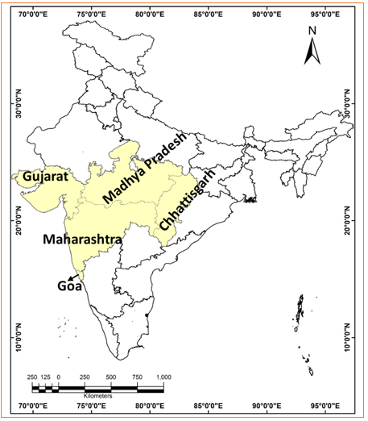

**Figure 1:** Study site (Western Region State of India)

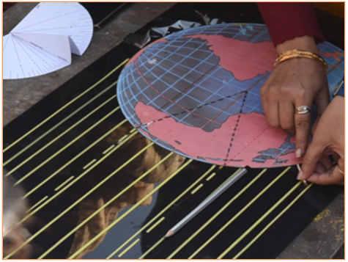

**Figure 2.** Identification of a latitudinal angle and latitude

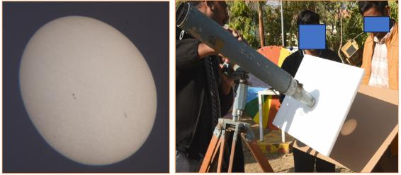

**Figure 3.** Observe the sun spot by telescope

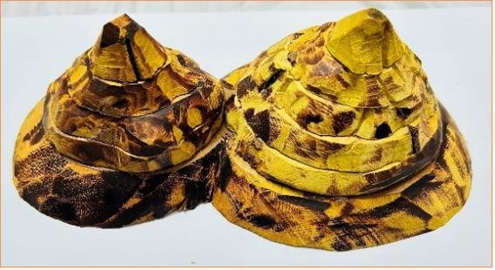

**Figure 4.** Identification of a valley, relative relief and contour lines

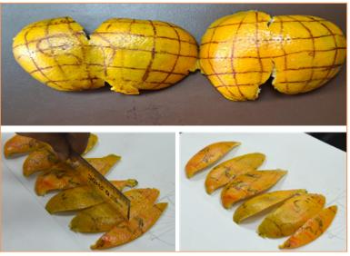

**Figure 5.** Represent earth from 3-D to 2-D and understanding the need of map projection

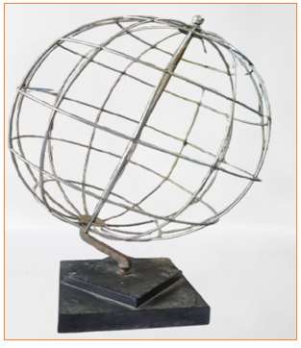

**Figure 6.** Hollow Globe (made by iron thin wire) to identify the significance of various kind of map projection from pole to equator

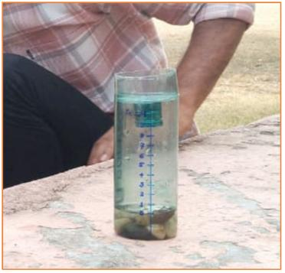

**Figure 7.** Rain Gauge to measure rainfall in cm in open ground to reduce the impact of raindrop which is again enter into the bottle

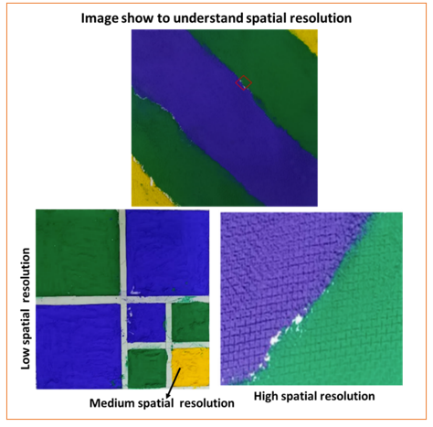

**Figure 8:** Model of Spatial resolution

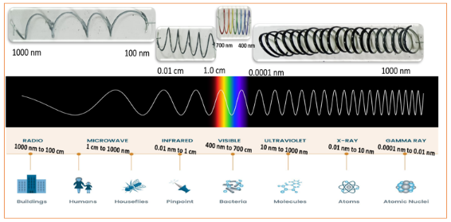

**Figure 9:** Miniature of wavelength of EMR

Source: Fundamental of Remote Sensing, CCRS/CCT

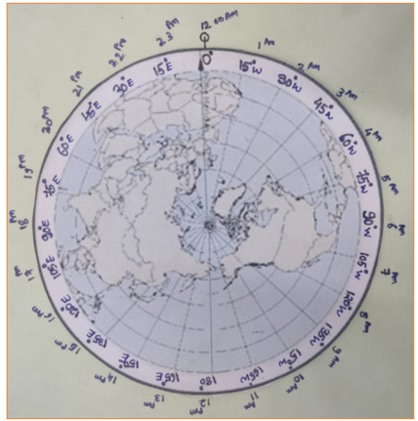

**Figure 10.** 360-degree model on card board made to analyze the time zone on a particular longitude

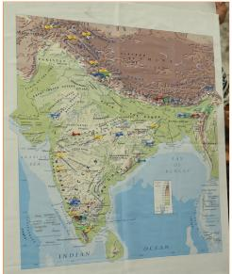

**F****igure 11.** Data analysis from the geographical phenomena like spot height on Indian landmass through frequency distribution, tabulation, mean, mean deviation, standard deviation are calculated

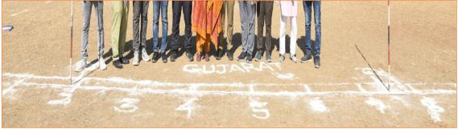

**F****igure 12.** measure the ground length and calculate the R.F. of scale and plot the scale on two-dimensional paper such as from paper to ground in real manner

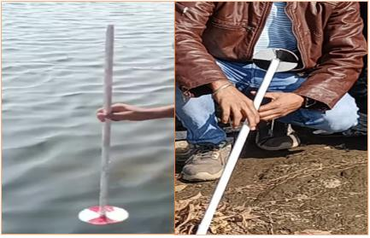

**Figure 13.** level of eutrophication in waterbodies like pond by Secchi Depth etc. by using Secchi Index

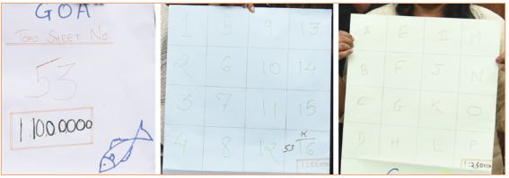

**Figure 14.** Identify the correct toposheets number and sequence based on the scale (million sheet, degree sheet, quarter sheet) within a span of 10 seconds

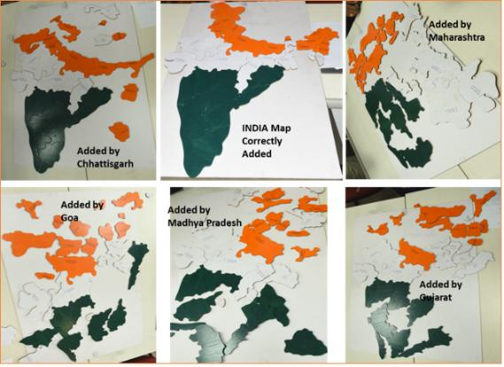

**Figure 15.** Cut-out pieces of the states of India are arranged according to their actual positions on Earth within a two-minute timeframe by the groups of each state

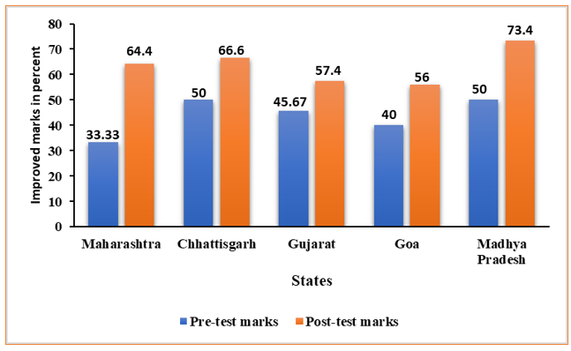

**Figure 16.** Effect of pedagogical intervention about Data analysis on teachers through pre-test and post-test assessment Data analysis

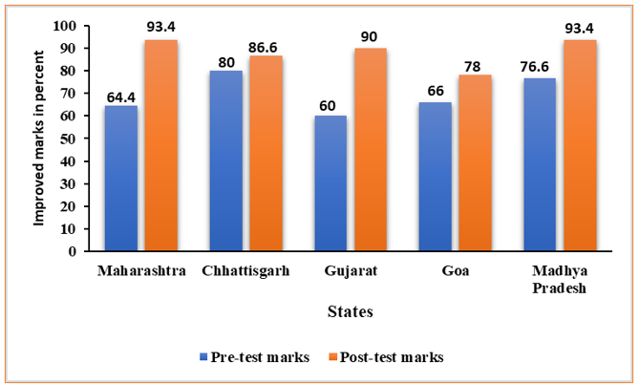

**Figure 17.** Effect of pedagogical intervention about scale and toposheets on teachers through pre-test and post-test assessment

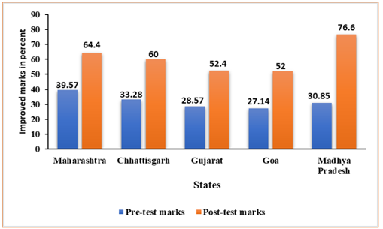

**Figure 18.** Effect of pedagogical intervention about Map Projection on teachers through pre-test and post-test assessment

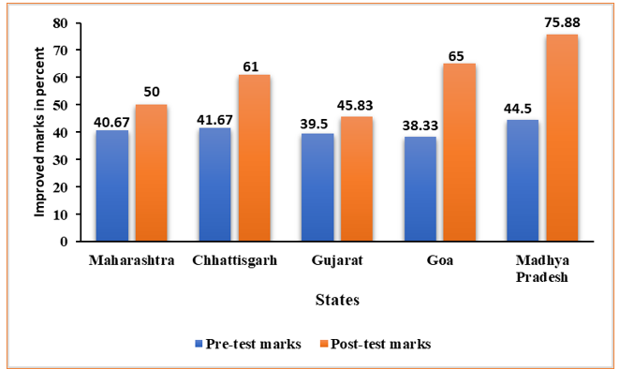

**F****igure 19.** Effect of pedagogical intervention about Weather instrument and Weather map on teachers through pre-test and post-test assessment

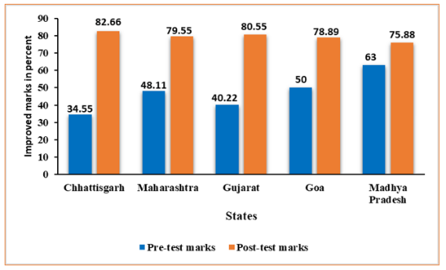

**Figure 20.** Effect of pedagogical intervention about Remote Sensing on teachers through pre-test and post-test assessment

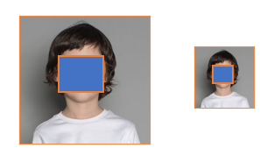

**Figure 21.** Enlargement and reduction (one fourth) of graphical scale while zoom in and zoom out imagery (Digital Content)

**Table**

**Table 1: Growth of competency among teachers through the pedagogical interventions regarding Data analysis**

|  |  |  |  |  |  |
| --- | --- | --- | --- | --- | --- |
| **Marks in percent (data)** | **States of Western Region, India** | | | | |
| **Maharashtra** | **Chhattisgarh** | **Gujarat** | **Goa** | **Madhya Pradesh** |
| **Pre-test marks** | 33.33 | 50 | 45.67 | 40 | 50 |
| **Post-test marks** | 64.4 | 66.6 | 57.4 | 56 | 73.4 |
| **Growth** | 31.07 | 16.6 | 11.73 | 16 | 23.4 |

**Source:** Measured the effectiveness of pedagogical intervention in percent through tools

**Table 2: Growth of competency among teachers through the pedagogical interventions regarding scale and toposheets**

|  |  |  |  |  |  |
| --- | --- | --- | --- | --- | --- |
| **Marks in percent (Toposheet)** | **States of Western Region, India** | | | | |
| **Maharashtra** | **Chhattisgarh** | **Gujarat** | **Goa** | **Madhya Pradesh** |
| **Pre-test marks** | 64.4 | 80 | 60 | 66 | 76.6 |
| **Post-test marks** | 93.4 | 86.6 | 90 | 78 | 93.4 |
| **Growth** | 29 | 6.6 | 30 | 12 | 12.88 |

**Source:** Measured the effectiveness of pedagogical intervention in percent through tools

**Table 3: Growth of competency among teachers through the pedagogical interventions regarding Map projection**

|  |  |  |  |  |  |
| --- | --- | --- | --- | --- | --- |
| **Marks in percent (Map projection)** | **States of Western Region, India** | | | | |
| **Maharashtra** | **Chhattisgarh** | **Gujarat** | **Goa** | **Madhya Pradesh** |
| **Pre-test marks** | 39.57 | 33.28 | 28.57 | 27.14 | 30.85 |
| **Post-test marks** | 64.4 | 60 | 52.4 | 52 | 76.6 |
| **Growth** | 24.83 | 26.72 | 23.83 | 24.86 | 45.75 |

**Source:** Measured the effectiveness of pedagogical intervention in percent through tools

**Table 4: Growth of competency among teachers through the pedagogical interventions regarding Weather instruments and weather maps**

|  |  |  |  |  |  |
| --- | --- | --- | --- | --- | --- |
| **Marks in percent (Weather)** | **States of Western Region, India** | | | | |
| **Maharashtra** | **Chhattisgarh** | **Gujarat** | **Goa** | **Madhya Pradesh** |
| **Pre-test marks** | 40.67 | 41.67 | 39.5 | 38.33 | 44.5 |
| **Post-test marks** | 50 | 61 | 45.83 | 65 | 75.88 |
| **Growth** | 9.33 | 19.33 | 6.33 | 26.67 | 31.38 |

**Source:** Measured the effectiveness of pedagogical intervention in percent through tools

**Table 5: Growth of competency among teachers through the pedagogical interventions regarding Remote Sensing**

|  |  |  |  |  |  |
| --- | --- | --- | --- | --- | --- |
| **Marks in percent (Remote Sensing)** | **States of Western Region, India** | | | | |
| **Chhattisgarh** | **Maharashtra** | **Gujarat** | **Madhya Pradesh** | **Goa** |
| **Pre-test marks** | 34.55 | 48.11 | 40.22 | 50 | 63 |
| **Post-test marks** | 82.66 | 79.55 | 80.55 | 78.89 | 75.88 |
| **Growth** | 48.11 | 31.44 | 40.33 | 28.89 | 12.88 |

**Source:** Measured the effectiveness of pedagogical intervention in percent through tools

|  |  |  |  |  |  |
| --- | --- | --- | --- | --- | --- |
| **Table 6: Group Statistics** | | | | | |
|  | Pre-Post Test | N | Mean | Std. Deviation | Std. Error Mean |
| Scores | 1 | 39 | 13.62 | 2.530 | .405 |
| 2 | 39 | 19.85 | 2.815 | .451 |

**Table 7: Independent Samples Test**

|  |  |  |  |  |  |  |  |  |  |
| --- | --- | --- | --- | --- | --- | --- | --- | --- | --- |
|  | **Levene's Test for Equality of Variances** | | **t-test for Equality of Means** | | | | | | |
| **Score** | F | Sig. | t | df | Sig. (2-tailed) | Mean Difference | Std. Error Difference | 95% Confidence Interval of the Difference | |
| Lower | Upper |
| **Equal variances assumed** | 0.281 | 0.598 | -10.281 | 76 | 0.000 | -6.231 | 0.606 | -7.438 | -5.024 |
| **Equal variances assumed** | -10.281 | 75.151 | 0.000 | -6.231 | 0.606 | -7.438 | -5.024 |