ELT Methods Used at the Aliya Madrasahs in Bangladesh: Urban-Rural Divide

Abstract: This study investigates the ELT methods used in Rural and Urban Aliya Madrasahs and evaluates the impact of those methods on the student's learning outcomes. The study used a triangulation method for collecting data: questionnaires, semi-structured interviews, and observation. The researchers collected data from two Aliya madrasahs- one rural and one from urban areas. Besides, two teachers and 120 students participated in the study, and two consecutive classes of the Madrasah in both areas were analyzed through the researchers’ observation. The study's findings revealed many differences in Madrasah's English language teaching-learning process in both areas. Teachers in rural areas needed to be better qualified and more competent compared to urban teachers. Students in urban areas were very active and engaged in different group tasks to practice all four English language skills. In contrast, students from rural areas only received the lecture and practiced the reading and writing skills to pass the examination. The current study intends to enhance Madrasah education by identifying effective ELT methods to improve student learning outcomes.
Keywords: ELT method, aliya madrasah, English

1. Introduction
Language is a system of communication through which we communicate with others. According to Chowdhury (2020), “Any foreign language, including English, is difficult to learn if the learners are not exposed to the language in everyday life.” Nowadays, every educational setting focuses on learning the English language, as it is not only a foreign language but also used as a lingua franca. However, “the aim of the Madrasah is to educate students in religious knowledge by using Arabic and Urdu as the medium of instruction, adopts a traditional system of teaching and learning based on text memorization and oral transition” (Chowdhury, 2020). According to Ruman (2021), “English is a foreign language but it is taught here as an optional course or a course to pass the examination besides Bangla, Urdu, Farshi; this subject is given less importance either by the students or the teachers, or both in the Madrasah.”
The methods that Madrasah teachers follow for English language teaching vary significantly. Some teachers with a master’s degree in English may apply trained methods of ELT, while others teach only enough to help students pass exams. As a result, the proficiency level in basic English skills differs among Madrasah students depending on location and teacher expertise.
Although English is promoted as a second language in mainstream Bangladeshi education, the Madrasah curriculum treats it as a lower-priority subject. Chowdhury (2020) stated that “the main concern of every Madrasah is to teach students the Quran, the Hadith and Tafsir. Subjects like Bangla, English, Mathematics and Science are included in the curriculum, they are considered as worldly knowledge and are often seen as a barrier to the spiritual path.” Consequently, Madrasah students often fall behind their peers in general education. Moreover, Madrasahs in rural and urban areas use different teaching methods, leading to disparities in students’ English proficiency. Generally, urban Madrasah students demonstrate better English language production than those in rural areas. The instructional methods used play a critical role in shaping these outcomes. To succeed globally, Madrasah students must develop all four language skills equally, just like their peers in other educational systems.
The objectives of this study were to investigate the ELT methods commonly employed in rural Madrasahs, to compare and contrast the differences in ELT methods between rural and urban Madrasahs, to evaluate the impact of ELT methods on English language learning outcomes in both rural and urban Madrasahs, and to explore the scope for developing a more effective and inclusive ELT method suitable for both rural and urban Madrasahs in Bangladesh.
Language teaching methods are central to the success of English language instruction, rooted in various language learning theories. These methods, ranging from rigid approaches like Grammar Translation to more flexible ones such as Communicative Language Teaching (CLT), are influenced by the teacher's philosophy and the needs of the students (Nunan, 2003). Over the years, several methods have come in and out of favor, including the Grammar-Translation Method, Direct Method, Audio-Lingual Method, and Total Physical Response (TPR), each reflecting different educational philosophies (Brett, 2020). More contemporary methods such as CLT, Task-Based Language Teaching (TBLT), and Content-Based Instruction (CBI) emphasize learner-centered approaches, communicative competence, and real-world relevance (Bhuiyan, 2019). Teachers are seen as facilitators, role models, and motivators, while students are encouraged to be active, autonomous, and reflective learners (Larsen-Freeman, Krashen, Richards; Harmer, Nunan). Error correction techniques and engaging activities such as role-plays and critical thinking tasks also play vital roles in fostering a conducive learning environment that supports interaction, participation, and language acquisition (Krashen, Harmer; Wright, Johnson & Johnson).
2. Literature Review
English is considered the lingua franca of globalization (Rahman et al., 2021; Wulyani et al., 2019). Despite learning English for 12 years, students’ proficiency remains poor (Haque, 2017; Kabir, 2017). This issue is more severe in Madrasahs, where students lack access to higher education and employment due to their low proficiency (Rahman et al., 2021). Rahman’s research indicates some improvement in ELT conditions, but many teachers still rely on outdated GTM methods.
Hayati et al. (2021) found that teachers employed strategies like direct instruction, group work, and role play, which foster communication. Linda (2022) explored challenges in Islamic boarding schools: students' unfamiliarity with English, academic overload, lack of facilities, and low teacher confidence. Strategies included emphasizing English’s significance, offering extra lessons, and creating engaging environments.
Hoque (2008) identified problems in Alim-level ELT: irrelevant syllabi, unengaging textbooks, avoidance of listening and speaking, and poor teaching aids. Akhter et al. (2022) showed that students are extrinsically motivated (e.g., watching TV or passing exams), but teachers perceive motivation as exam-driven only.
Uddin (2019) observed that even after training, teachers mostly use GTM and rely on textbooks. Haque (2019) confirmed these findings, noting minimal use of communicative practices in Aliya Madrasahs. Hussain and Masum (2016) emphasized the potential of CLT to develop all four skills, but highlighted contextual barriers like large class sizes, traditional exams, and untrained teachers.
Golam and Kusalabe (2018) called for urgent reforms in teacher recruitment, curriculum focus, and administration. Rahman et al. (2021) found students have positive attitudes towards English, influenced by their parents’ education levels.
Golam (2020) revealed that Qawmi Madrasahs lack a supportive English-learning environment compared to Aliya ones. Ruman (2021) found that Qawmi Madrasahs prioritize reading and writing while neglecting listening and speaking. Uddin (2000) criticized the inadequacy of INSET programs due to logistical and institutional weaknesses.
Golam and Kusakabe (2020) found that Qawmi students are only exposed to traditional grammar. Teachers lack training, and textbooks are poorly implemented. Amin (2020), using Krashen’s affective filter theory, found high anxiety and low confidence among Madrasah students, worsened by grammar-heavy, non-interactive classes.
Negi (2022) studied Madrasahs in Delhi and reported issues like undertrained teachers, student disinterest, Urdu medium instruction, and poor basic skills. Salma and Nehal (2017) observed that West Bengal Madrasahs emphasized only reading, writing, and grammar. GTM dominated, and speaking or conversational skills were absent.

While many studies have investigated English teaching in Madrasahs—exploring challenges, attitudes, and teacher preparation—none have compared ELT methods between rural and urban Madrasahs in Bangladesh. This study addresses that gap, examining their impacts on students’ outcomes and offering recommendations for more effective English learning across both contexts.
3. Research Methodology
This section outlines the research design and methodology used in the study. A mixed-method approach, combining both qualitative and quantitative methods, was employed to offer a fuller understanding of the research problem (Rehman et al., 2021). A descriptive survey design was employed to examine and compare ELT methods used in rural and urban Aliya Madrasahs in Bangladesh. Data were collected through close-ended questionnaires, semi-structured interviews, and classroom observations using an observation checklist. Primary data sources included students and teachers from two Madrasahs—one urban and one rural—while secondary data were gathered from journals, books, websites, and reports. Approximately 120 students and 2 teachers participated, selected using simple random sampling. A close-ended questionnaire was used for students, while interviews and questionnaires were administered to teachers. Class observations were conducted, and the researcher acted as a non-participant observer. Quantitative data were analyzed using tables, pie charts, and graphs, while qualitative data from interviews and observations were analyzed through transcription and thematic analysis (Green & Thorogood, 2004).
To ensure triangulation, semi-structured interviews were conducted with two EFL teachers—one from each Madrasah. The interviews provided deeper insights into ELT practices and challenges in both contexts. Observation data from two consecutive classes of each Madrasah were also documented. Questionnaire responses were analyzed using descriptive and inferential statistics, while interview data were simplified and synthesized to identify themes and patterns. Verbal consent was obtained before conducting the interviews. The survey included Likert-scale questions and other close-ended items. The research population consisted of class-nine students aged 14–16 and teachers with 15–20 years of experience. The conclusion reiterates that a well-chosen methodology directly affects research outcomes. The mixed-methods approach ensured comprehensive and valid findings for this comparative study of ELT methods in urban and rural Madrasahs.
Table 1. Sample Size
SL. | Name of Institution | Area | No. of Students | No. of Teachers
01 | Quaderia Taiyabiya Alia (Kamil) Madrasah, Dhaka | Urban | 85 | 1
02 | Khalla Darus Sunnah Imim Mahedi (a) Dakhil Madrasah, Brahmanbaria | Rural | 35 | 1
Total |  |  | 120 | 2

4. Findings and Discussion
English Language Teaching (ELT) practices across Madrasahs in Bangladesh vary significantly, shaped by institutional setting, teacher training, access to resources, and students’ language exposure. A comparative analysis between rural and urban madrasahs reveals not only divergent pedagogical approaches but also differing impacts on learners’ proficiency, engagement, and motivation.
4.1 Divergence in Teaching Practices
In many rural madrasahs, teaching practices were heavily dependent on the Grammar Translation Method (GTM), where the native language dominated classroom instruction. Teachers prioritized literal translation, rule memorization, and rote vocabulary acquisition, with minimal exposure to interactive or communicative techniques. Quantitative data reinforced this trend: 83% of rural students reported learning grammar deductively, and 95% relied on memorization.
Figure 1: Preferred instructional approach (inductive vs. deductive) for teaching language form and function in urban and rural madrasahs.
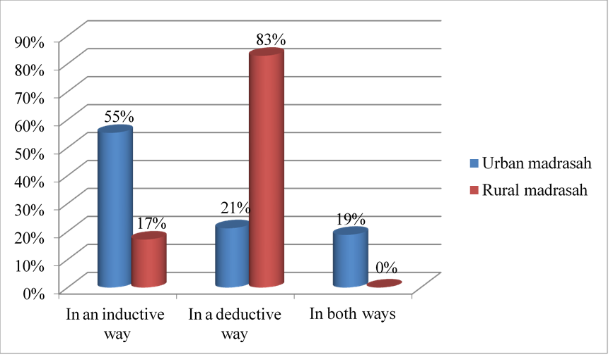
Figure 2: Students’ preferred methods for learning grammatical rules and vocabulary
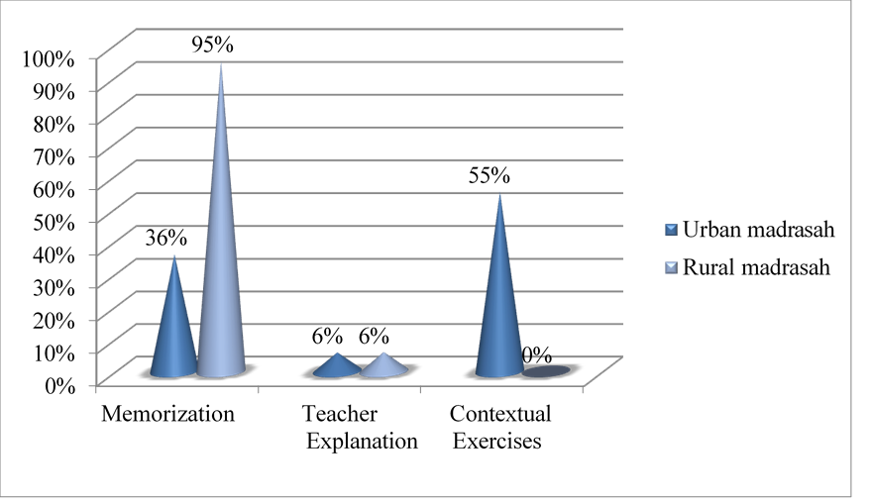
In contrast, urban madrasahs demonstrated a more dynamic blend of methods. Teachers employed a combination of Communicative Language Teaching (CLT) and task-based approaches, integrating multimedia, group activities, and interactive exercises. This was supported by student responses: over 55% reported inductive grammar learning, and 69% acknowledged frequent group or pair work.
Figure 3: Students’ responses on teacher engagement in group and pair work activities
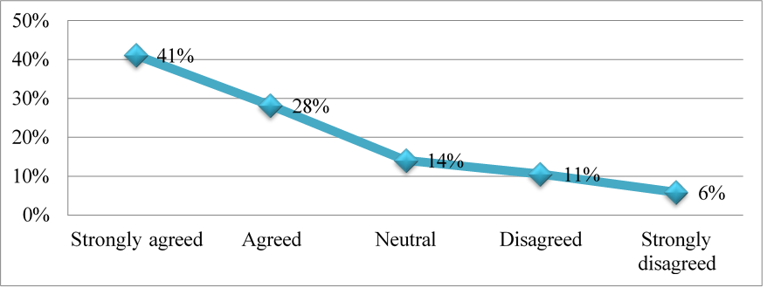
4.2 Classroom Dynamics and Teacher Roles
The teacher’s role differed markedly across settings. In urban classrooms, instructors acted as facilitators, encouraging peer collaboration, self-correction, and oral practice. They routinely balanced fluency and accuracy, adjusting correction styles depending on the activity observations confirmed that teachers gave space for self-expression and employed visuals, speech prompts, and real-life scenarios to make lessons engaging.
Meanwhile, rural instructors operated more as authoritative figures, directing all classroom activity and placing overwhelming emphasis on exam preparation. Immediate error correction, limited student talk time, and minimal peer interaction were routine. As classroom observation and interviews noted, fluency was often undervalued in favor of grammatical precision.
Figure 4: Students' responses on learning grammatical rules and vocabulary through contextualized, engaging methods such as picture cues, spoken prompts, and real-life situations.
4.3 Student Motivation and Learning Outcomes
Learners’ motivation and experiences also diverged notably. In urban madrasahs, students showed a stronger interest in learning English as a tool for communication and career advancement. A significant number of students expressed that they found tasks enjoyable, felt encouraged by teachers, and practiced all four language skills with regularity.
Figure 5: Students’ interest in learning English language
By contrast, rural students tended to view English more as an academic hurdle than a communicative tool. Their motivation was closely tied to exam performance, and classroom interactions were often limited to reading and writing tasks. Even though many rural students believed their madrasahs provided a “suitable environment,” the absence of technology and exposure undermined opportunities for skill development.
Figure 6: Emphasis on reading and writing over speaking and listening skills.

4.4 Infrastructure and Access Disparities
One of the clearest distinctions lay in the material and infrastructural resources available. Urban classrooms benefited from projectors, audio-visual aids, and internet access, which enabled teachers to use authentic materials and interactive content. Rural institutions, however, were constrained by the absence of such tools. Even basic items such as cue cards or visual posters were often lacking.
Interviews highlighted that even when the textbook offered potential, rural teachers lacked the training or confidence to go beyond its contents. In contrast, urban teachers supplemented lessons with personalized materials and tasks, enriching students’ exposure.
4.5 Bridging the Pedagogical Gap
While both rural and urban madrasahs follow the same national syllabus, their implementation strategies differ significantly. Teachers in rural areas largely defaulted to traditional approaches due to limited professional development, while their urban counterparts had attended seminars and workshops on ELT and CLT strategies.
Despite these gaps, there are indications of progress. Some rural students are developing core skills and improving performance over time. Interviews suggest that even within current limitations, student outcomes improve when teachers creatively adapt to their learners’ needs.
To reduce the rural-urban gap, a multi-pronged strategy is required:
- Context-sensitive training for rural teachers in communicative and inductive techniques;
- Equitable access to classroom technologies;
- A shift in assessment orientation away from rote-based grading to skills-based evaluation.
Only then can ELT in Bangladesh evolve toward a more inclusive, student-centered, and communicative model of language learning.
5. Conclusion
The study aimed to investigate the English language teaching methods used in both rural and urban Madrasahs, assess their impact on students' learning outcomes, and identify differences between the two settings. A mixed-method approach was adopted to collect data. Quantitative data were gathered through questionnaires distributed to Class Nine students and English teachers, while qualitative data were obtained via semi-structured interviews with EFL teachers from both rural and urban Madrasahs.
Findings suggest that rural Madrasah teachers were generally less qualified and less competent compared to their urban counterparts. Teachers in rural Madrasahs predominantly relied on the Grammar-Translation Method (GTM), whereas teachers in urban Madrasahs employed a variety of approaches, including Communicative Language Teaching (CLT), Task-Based Language Teaching (TBLT), Content-Based Instruction (CBI), Suggestopedia, the Direct Method, and the Silent Way.
Moreover, students in rural Madrasahs were often unaware of the actual objectives of learning English, unlike students in urban Madrasahs who had a clearer understanding. Urban students were more active participants in class, while rural students tended to be passive. As a result, urban Madrasah students generally demonstrated higher levels of English proficiency.
The study recommends that the government take necessary steps to ensure equal educational facilities and environments for both rural and urban Madrasahs. In particular, targeted teacher training programs should be implemented to improve the use of effective English language teaching methods. Since English is a global language, Madrasahs in Bangladesh should focus on teaching it not merely as a subject but as a means of communication.

COMPETING INTERESTS DISCLAIMER:
Authors have declared that they have no known competing financial interests OR non-financial interests OR personal relationships that could have appeared to influence the work reported in this paper.
References
Bhuiyan, M. F. U. (2019). Methodologies and approaches in ELT: A search for more effective ways of teaching second/foreign languages. International Journal of English, Literature and Social Science (IJELS), 4(5), 58–67. https://doi.org/10.22161/ijels.45.58
Brett, T. (2020). Principled eclecticism in the classroom: Exploring the use of alternative methodologies in ELT. Arab World English Journal (AWEJ): Proceedings of the 2nd MEC TESOL Conference 2020, 212–228. https://doi.org/10.24093/awej/MEC2.15
Chowdhury, T. (2020, September 21). English language teaching in Qawmi girls' madrasas in Bangladesh: Problems, challenges and prospects.
Golam, A. M. (2020). A critical investigation of English subject teaching at two types of madrasas in Bangladesh. TARBIYA: Journal of Education in Muslim Society, 7(1), 1–15. https://doi.org/10.15408/tjems.v7i1.13041
Golam, A. M., & Kusakabe, T. (2018). A qualitative study of English teaching in Bangladesh: A case study of Madrasa education. US-China Education Review, 8(3), 106–122. https://doi.org/10.17265/2161-623x/2018.03.003
Green, J., & Thorogood, N. (2004). Qualitative methods for health research. SAGE Publications. https://doi.org/10.7748/nr.13.2.91.s14
Haque, S. (2019). An exploratory study of English teaching and learning in three Alia Madrasahs of Bangladesh (Doctoral dissertation, Brac University).
Harmer, J. (2007). The practice of English language teaching. Pearson Longman. https://doi.org/10.1177/003368820103200109
Hoque, M. E. (2008). M. Phil. in English Language (Applied Linguistics and ELT) (Doctoral dissertation, Jahangirnagar University).
Johnson, D. W., & Johnson, R. T. (1999). Learning together and alone: Cooperative, competitive, and individualistic learning. Prentice Hall. https://doi.org/10.1037/027279
Krashen, S. D. (1982). Principles and practice in second language acquisition. Pergamon Press. https://doi.org/10.2307/328293
Larsen-Freeman, D. (2000). Techniques and principles in language teaching (2nd ed.). Oxford University Press. https://doi.org/10.18172/jes.83
Negi, H. K. (2022). Issues in English language teaching in madrasas in Delhi. Journal of Positive School Psychology, 6(2), 1183–1189.
Nunan, D. (1991). Language teaching methodology: A textbook for teachers. Prentice Hall. https://doi.org/10.5785/11-1-234
Rahman, A. R. M. M., Jalaluddin, I., Mohd Kasim, Z., & Darmi, R. (2021). Aliya madrasah students’ motivation for learning English in Bangladesh. Journal of Language and Linguistic Studies, 17(1), 70–84. https://doi.org/10.52462/jlls.5
Rehman, K. U., Iqbal, Z., Azam, M., Iram, S., & Javed, A. U. (2021). A study of perception of madrassa’s students regarding the trends and challenges of ELT in Pakistan. PalArch’s Journal of Archaeology of Egypt/Egyptology, 18(8), 489–512.
Richards, J. C., & Rodgers, T. S. (2014). Approaches and methods in language teaching (3rd ed.). Cambridge University Press. https://doi.org/10.1017/9781009024532
Ruman, M. A. K. (2021). Challenges of teaching English listening, speaking, reading and writing skills at Qawmi Madrasas under BEFAQ in Bangladesh. International Journal of Linguistics, Literature and Translation, 4(7), 125–138. https://doi.org/10.32996/ijllt.2021.4.7.14
Salma, U., & Nehal, R. (2017). Analyzing the status of English language teaching in madrasas for local and global employment: Some evidences from Murshidabad district of West Bengal. IOSR Journal of Humanities and Social Science, 22(9), 83–87.
Uddin, M. R. (2019). English language pedagogy in Bangladeshi madrasahs: Findings from classroom observation. The International Journal of Humanities & Social Studies. https://doi.org/10.24940/theijhss/2019/v7/i12/hs1912-076
Uddin, M. R. (2020). In-service training for secondary English teachers of Bangladeshi madrasahs: Investigating adequacy and effectiveness. PAROLE: Journal of Linguistics and Education, 10(1), 36–45. https://doi.org/10.14710/parole.v10i1.36-45
Wulyani, A. N., Elgort, I., & Coxhead, A. (2019). Exploring EFL teachers’ English language proficiency: Lessons from Indonesia. Indonesian Journal of Applied Linguistics, 9(2), 263–274. https://doi.org/10.17509/ijal.v9i2.20235

