Review Article
Revisiting the Technology Acceptance Models: A Critical Evaluation and Their Educational Applications

Abstract
This paper comprehensively reviewed four important technology acceptance models, including the Technology Acceptance Model (TAM) (Davis et al., 1989), the Extended Technology Acceptance Model (TAM2) (Venkatesh & Davis, 2000), the Model of the Determinants of Perceived Ease of Use (Venkatesh, 2000), and the Technology Acceptance Model 3 (TAM3) (Venkatesh & Bala, 2008), and deeply analyzed their different strengths and limitations. It also analyzed and discussed recent applications of TAM and TAM3 in educational empirical studies. This review contributes to the existing literature by clarifying different theoretical models in the field of technology adoption and use and guiding future researchers to find research gaps and directions.
Keywords: TAM, TAM2, TAM3, technology adoption and use, educational empirical studies

- Introduction
The tremendous development of Information and Communication Technology (ICT) provides technical support for integrating modern technology into educational development. Educational technologies, such as e-learning technologies, AI-powered learning systems, and VR technologies, have been created for educational purposes. Many benefits of applying these intelligent technologies in education have been studied, such as improving the instructional efficiency in the learning process, increasing learning productivity, promoting interactive communication, and reducing misunderstanding (Roy et al., 2022). However, despite the significant advances and increasing investment in technologies, the precondition of leveraging the advantages of educational technologies is that users are willing to adopt these technologies. If these technologies remain underutilized, they may cause many adverse effects, such as financial losses and user dissatisfaction (Venkatesh, 2000). Thus, users’ willingness to accept and use technology has attracted the attention of many researchers and practitioners. Currently, numerous studies have concentrated on exploring possible factors that could motivate individuals’ willingness to use technology and proposing suggestions to improve users’ adoption of emerging educational technology and help them adapt to the changes caused by it. Therefore, this paper conducts a literature review on different technology acceptance models and their applications in educational empirical studies.

This study overviewed various technology acceptance models, including the Technology Acceptance Model (TAM) (Davis et al., 1989), the Extended Technology Acceptance Model (TAM2) (Venkatesh & Davis, 2000), the Model of the Determinants of Perceived Ease of Use (Venkatesh, 2000), and the Technology Acceptance Model 3 (TAM3) (Venkatesh & Bala, 2008), and deeply analyzed their latest practical applications in the educational empirical studies. This review could help future researchers clarify different technology acceptance models, better understand their practical applications in education and provide guidance to help find research gaps and directions in the future.

2. Review of Technology Acceptance Models
2.1 Technology Acceptance Model (TAM)
There have been numerous frameworks proposed to investigate individuals’ intention and behavior in adopting and using new technology (Venkatesh, 2000). Among the existing studies, the Technology Acceptance Model (TAM) is considered the most extensively used framework in technology adoption research (Venkatesh, 2000). Given it as a "robust, powerful, and parsimonious" framework, TAM has been used to investigate how individuals’ technology adoption could be determined in various research contexts (Venkatesh & Davis, 2000; Lai, 2017). Initially building upon the Theory of Reasoned Action established by Fishbein and Ajzen (1975), Davis (1986) proposed TAM to explain the intention and behavior of individuals’ adoption of specific technology. According to the TAM, perceived usefulness (PU) and perceived ease of use (PEOU) play crucial roles in determining users’ attitudes and behavioral intention (BI). Meanwhile, individuals’ BI predicts their actual use behavior. In addition, both PU and PEOU were argued to mediate the relationship between external predictors and users’ BI; for the convenience of understanding, their hypothesized relationships are illustrated in Figure 1.

However, due to the limits of the TAM in the lack of detailed explanation regarding external variables that may affect PU and PEOU (Samar et al., 2020), limited variance in some studies (Legris et al., 2003), absence of practical guidance for implementation (Lee et al., 2003), and ineffectiveness in promoting users to adopt new technology (Faqih & Jaradat, 2015), numerous efforts have been invested to develop a more comprehensive model and supplement intervention experiments.
Figure 1 The Technology Acceptance Model (Davis et al., 1989, p. 984)
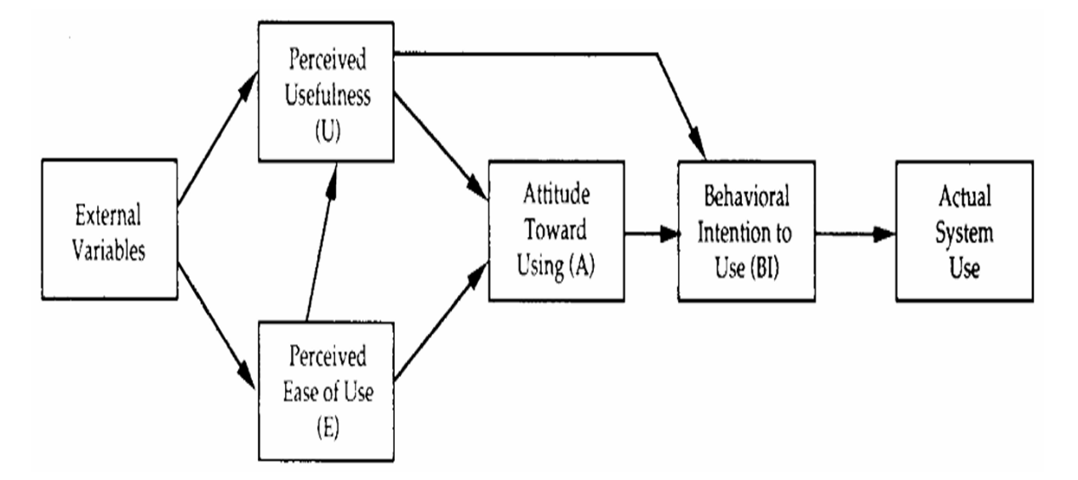

2.2 Extended Technology Acceptance Model (TAM2)
The conventional TAM was extended with a few more predictors to enhance its capacity to explain an individual’s PU, as Venkatesh and Davis (2000) described in TAM 2. It elaborates on how these determinants shape users' perceptions of PU and BI through social influence and cognitive instrumental processes. In the process of social influence, concepts such as compliance, internalization, and identification play pivotal roles. Cognitive instrumental processes involve users evaluating PU by comparing a technology’s capabilities to their needs. The extended model also incorporates two moderating factors—experience and voluntariness. Notably, the variable attitude was excluded from TAM2, as it was found not to fully mediate among PU, PEOU, and BI (Davis, 1989). Figure 2 shows the predictive relationships between the critical factors within the TAM2 framework. Although TAM2 explains why users perceive technology as useful in detail (Chuttur, 2009), it is criticized as an incomplete model for not elaborating on the determinants of PEOU (Samar et al., 2020).
Figure 2 Extended Technology Acceptance Model (TAM2) (Venkatesh & Davis, 2000, p. 197)

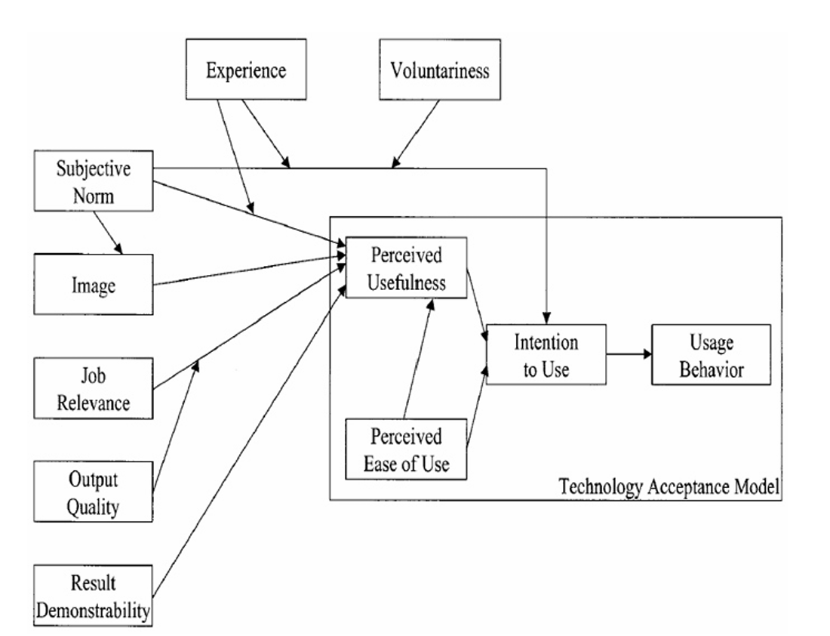

2.3 Model of the Determinants of Perceived Ease of Use
Venkatesh (2000) proposed a model explaining how individuals form perceptions of perceived ease of use (PEOU). According to this model, users develop initial PEOU through various predictors, including computer self-efficacy, playfulness, anxiety, and perceived external control. Although these factors form users' early judgments toward PEOU, these judgments will change with continued technology usage. This process is called adjustments (Venkatesh, 2000). In this regard, two significant adjustments, namely, perceived enjoyment and objective usability, were introduced. Figure 3 presents the interconnected relationships within this model. However, it only identifies the antecedents of PEOU (Chuttur, 2009), which is also considered non-complete.
Figure 3 Model of the Determinants of PEOU (Venkatesh, 2000, p. 346)

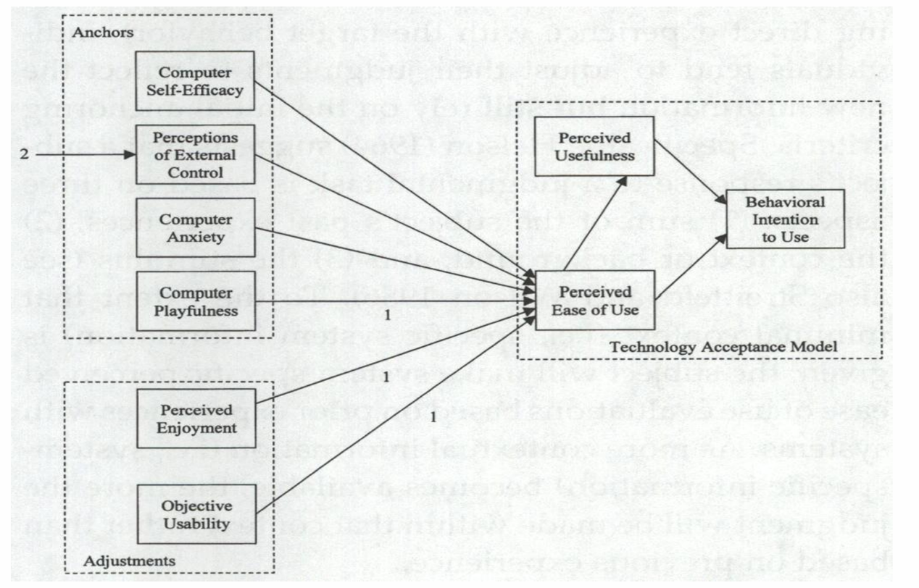

2.4 Technology Acceptance Model 3 (TAM3)
Venkatesh and Bala (2008) integrated the model of PEOU predictors into TAM2 and developed TAM3, a more comprehensive model covering determinants of both PU and PEOU. TAM3 has made four significant theoretical contributions. First, it presents a complete model covering PU and PEOU determinants. Second, it indicates no cross-over effects between PU's and PEOU's determinants. Third, it tests new moderating effects of experience on essential relationships. Finally, it suggests interventions and explains their association with the predictors of PU and PEOU.

Based on previous TAM research, TAM3 demonstrates four groups of external factors, including individual differences, social influence, system characteristics, and facilitating conditions, that affect PU and PEOU. Both PU and PEOU mediate between these external factors and BI, and BI finally predicts the actual use behavior. In TAM3, the four external variables are subdivided into several specific determinants of PU and PEOU. Figure 4 depicts the predictive relationships within the framework of TAM3.
Figure 4 Technology Acceptance Model 3 (Venkatesh & Bala, 2008, p. 280)
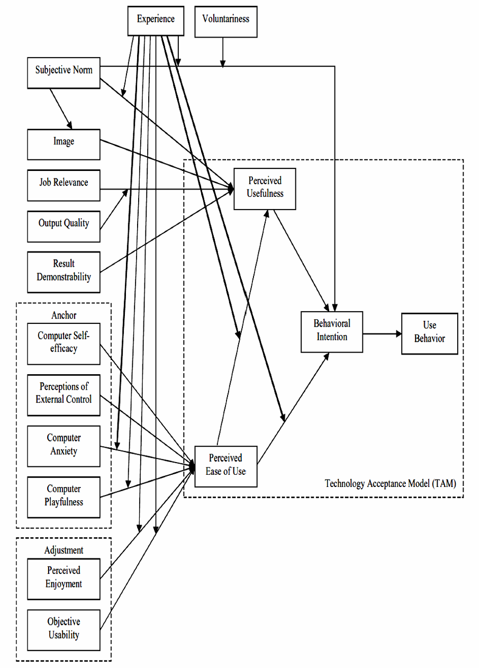
In TAM3, experience and voluntariness are also identified as essential moderating factors. Specifically, the experience could impact the relationships between a) PEOU and PU, b) computer anxiety and PEOU, and c) PEOU and BI. It further explains that as individuals obtain more experience in adopting technology, the impact of PEOU on PU strengthens; in the meantime, the negative impact of computer anxiety over PEOU decreases; additionally, the effect of PEOU on BI also diminishes. Similarly, voluntariness could moderate the predictive power of subjective norms onto BI. When technology use is voluntary, users’ BI will be less influenced by subjective norm as more practical experience gains. In contrast, when technology use is mandatory or required, the predictive power of subjective norm over BI becomes more substantial.

Moreover, Venkatesh and Bala (2008) suggested pre- and post-implementation interventions to promote users’ technology adoption. Pre-implementation interventions refer to activities in developing and deploying technology, such as designing safe and user-friendly systems, encouraging users to participate in the system development and implementation process, ensuring management support, and aligning system features with users’ needs. These interventions are designed to help individuals better understand the features and functions of specific technologies. As a result, it is believed that the user’s initial resistance can be reduced. Moreover, post-implementation interventions, such as training and support from organizations and peers, can help users become more adaptive to the new technology.

Through significant efforts invested in enhancing previous models, Venkatesh and Bala (2008) eventually proposed TAM 3 to improve our understanding of the factors that were likely to impact individuals’ technology adoption. In particular, two imperative aspects are identified as critical advantages for this model. First, from the perspective of theoretical contribution, it incorporates a range of valuable theoretical factors in this framework. Specifically, it identifies predictors of PU and PEOU, making it a more comprehensive model for studying the complex dynamics of technology acceptance and use in practical situations (Faqih & Jaradat, 2015). Second, from the perspective of practical contribution, it provides useful and actionable guidance on developing instructional intervention schemes to facilitate users to accept certain technology (Faqih & Jaradat, 2015). Moreover, the intervention schemes are believed to help users employ certain technology more effectively; additionally, it can also facilitate the decision-making process in terms of allocation of resources (Venkatesh & Bala, 2008).

Although TAM3 has many new contributions and advantages, it has been challenged for the following reasons:
- TAM3’s extremely complicated model poses a challenge to its practical application (Samar et al., 2020).
- Relevant research applying TAM3 in different contexts and fields remains limited. As a result, the generalizability of TAM3 with different technologies in various research settings is under-explored (Faqih & Jaradat, 2015). In this regard, Venkatesh and Bala (2008) also called for continuous exploration of TAM3 in different research domains to enhance its comprehensiveness and power.

To sum up, researchers have proposed various models to investigate individuals’ adoption and usage of new technology, such as TAM, TAM2, the model of determinants of PEOU, and TAM3. These models have their strengths and limitations. However, among the four models, the TAM was argued to be the most widely used framework in technology adoption research, while the TAM3 was considered a more comprehensive technology acceptance model containing various determinants of both PU and PEOU. Because of the broad application of the TAM and the comprehensiveness of the TAM3, the following chapter reviewed the recent literature works that applied the TAM-based models, especially the TAM and the TAM3, to explore individuals’ intentions and actual use of novel technologies in educational contexts in the current study.

- Review of TAM-based Models in Educational Empirical Studies
As technology has been widely applied in educational contexts, increasing numbers of researchers have noticed the crucial role in technology acceptance and use. Many have used TAM-based models to examine teachers’ and students’ attitudes towards technology in education. Several representative empirical studies based on technology acceptance models, especially TAM and TAM3, are reviewed in this part to gain insight into TAM-based models and practical guidance in teaching and learning to elicit future research directions. Table 1 summarizes recent empirical studies employing TAM-based models in education.

Table 1 Review of TAM-based Models in Educational Context.
 | Authors | Sample | Educational Level | Learning Artefacts | Context |  | Theoretical Model
 | - (Wang et al., 2022) | Students | Higher Education | CCtalk-aided EFL course | L2 learning |  | Extended TAM
 | - (Zheng & Li, 2020) | Students | Middle school | Tablet computers |  | Education | Extended TAM
 | - (Zhang et al., 2023) | Students | Higher Education | Mobile dictionaries | L2 learning |  | Extended TAM
 | - (Yu, 2024) | Students | Higher Education | New-generation information technology | L2 learning |  | Extended TAM
 | - (Rafiee & Abbasian-Naghneh, 2021) | Students | Higher Education | E-learning technologies | L2 learning |  | Extended TAM
 | - (Ortiz-López et al., 2023) | Students | Higher Education | Mobile assessment devices | Assessment |  | Extended TAM
- (De la Vall & Faundez, 2024) |  | Teachers | Higher Education | Pre-made language learning system | Language teaching |  | Extended TAM
 | - (AlGerafi et al., 2023) | Students | Higher Education | AI-based robots | Education |  | Modified TAM3
 | - (Han et al., 2024) | Students | Secondary school | AI-powered adaptive learning systems | Rural education |  | Modified TAM3
 | - (Chang et al., 2024) | Students | Elementary school | VR technologies | L2 learning |  | Modified TAM3

3.1 TAM-based Research
Wang et al. (2022) included personal investment, self-efficacy, relevance, and perceived security as external variables in the TAM to explore the factors affecting university students’ intentions to adopt CCtalk-aided EFL courses. This study collected 771 participants’ questionnaires and found that all constructs except perceived security could significantly predict learners’ intention to use the courses. It argued that personal investment could be added to the TAM as a new construct since this factor could positively affect PU and BI in this research.

Aiming to comprehensively understand the factors that influence school students’ intentions to use tablet computers, Zheng and Li (2020) added self-efficacy, technology anxiety, and family support into the original TAM model. After analyzing the questionnaire data from 347 middle school students in China, they found that this extended TAM model could better explain K12 students’ adoption of tablet computers. The results showed that 1) self-efficacy could predict K12 students’ PU and PEOU; 2) technology anxiety could negatively affect both PU and PEOU; and 3) family support could positively influence PEOU, PU, attitude, and BI. Based on the findings, researchers of this study called for more attention to students’ emotions and family support to facilitate students’ adoption of tablet computers at school. However, this study extended TAM by only adding three predictors, suggesting that more empirical research should be conducted to break through the dilemma of investigating various possible predictors or selecting appropriate contextual factors in this field.

As an increasing number of Chinese students use mobile dictionaries to learn English, Zhang et al. (2023) conducted a study to explore EFL learners’ adoption of three different types of mobile dictionaries (i.e., monolingual, bilingualized, and bilingual mobile dictionaries) in China based on TAM and the framework of mobile technology evaluation. After analyzing 125 undergraduate students’ questionnaires, they found that participants preferred to use a bilingual mobile dictionary compared with the other two types. In contrast, students who used the bilingual mobile dictionary had the least positive perceptions. The results also showed that learners’ attitudes toward PU, PEOU, and BI of mobile dictionaries were consistent. This proves that the TAM is efficient in explaining students’ intentions to adopt technology in language learning.

Yu (2024) proposed an extended TAM model to investigate the factors that could predict students’ intention to use new-generation information technology, like AI, in intelligent foreign language learning. Construction of foreign language intelligence classroom and computer self-efficacy were added as two external variables to predict PU and PEOU. The author collected data from 237 students in a Chinese university and found that the added two external variables, PU and PEOU, positively influenced students’ BI. The research presented several suggestions to teachers, such as adjusting their teaching techniques according to students’ learning performance, deploying educational technologies in language teaching, and improve own skills to integrate new emerging technology into language learning. The results also proved the efficiency of the TAM in explaining influential factors of students’ adoption of new technologies in intelligent foreign language learning. However, the author indicated that more predictors should be added to improve its capacity to predict students’ intentions and use.

Rafiee & Abbasian-Naghneh (2021) also extended the TAM by including e-learning motivation, online communication self-efficacy, and perceived enjoyment as three determinants of PU and PEOU to evaluate students’ attitudes towards e-learning in learning a foreign language. After collecting 181 valid questionnaires of Iranian university students, the authors found that e-learning motivation and online communication self-efficacy significantly affected both PU and PEOU, while perceived enjoyment only affected students’ PEOU.

Ortiz-López et al. (2023) conducted a descriptive study to investigate the intention of 262 university pre-service teachers to use mobile assessment devices based on the extended TAM with two additional determinants of PU and PEOU (i.e., autonomy and computer self-efficacy). This research found that participants highly intended to accept mobile devices in the assessment process. The result also showed that science students were more willing to adopt mobile devices in assessment processes than Arts and Humanities students. However, male and female students had no significant difference in technology adoption in this research.

De la Vall and Faundez (2024) used mixed methods to explore Chilean university language teachers’ intention to use a pre-designed language learning system (PLLS) that contained various AI-based resources about developing language skills through a TAM-based survey and individual interviews. They found that teachers generally had a neutral to negative attitude towards the pre-designed system. Teachers rated low in PU, PEOU, and perceived enjoyment, which indicated that they found it challenging to use the system to support their teaching. The interviews also revealed teachers’ concerns about using the system. The results verified the effectiveness of the TAM in analyzing the influential factors of individuals’ attitudes toward a new technology in language teaching.

3.2 TAM3-based Research
AlGerafi et al. (2023) conducted an empirical study on Chinese university students and proposed a modified research model based on the TAM3 to examine learners’ acceptance of AI-based robots for learning. They collected 348 data through online questionnaires from universities in mainland China to measure the effects of different predictors on BI. They found that 12 out of 14 hypotheses from TAM3 were accepted. The result proved the effectiveness of TAM3 in the context of AI-based robots for learning purposes in higher education. It also indicated that students were willing to adopt AI technologies in learning processes. Moreover, this research has proposed several suggestions to encourage students to adopt AI technologies in education. For example, policymakers and universities need to understand the market, students, and education, thereby developing and integrating appropriate AI-related educational content into the curriculum. Teachers then further emphasize and promote the practical application of the content in teaching and learning. The selected technologies should be simple to operate, have user-friendly characteristics, and satisfy students' needs. However, this study only focused on assessing the BI of students who majored in engineering and information technology without investigating the relationship between BI and the actual use of AI-based robots.

Also, based on the TAM3, Han et al. (2024) examined what factors may influence Chinese rural middle school students’ continuous intention to use AI-powered adaptive learning systems, aiming to understand AI deployment in education and improve rural education outcomes. Given the unique features of AI learning systems, a modified TAM3 model was proposed and included computer self-efficacy, self-regulation skill, perceived enjoyment, system quality, and perception of external control as determinants of PU and PEOU, which then affected learners’ continuous intention to use the AI systems. After analyzing the data from 231 questionnaires, the study found that PU was the most crucial factor influencing continuous usage intention, perceived enjoyment was the second, and PEOU was the third. In addition, strong self-regulation skills could enhance students’ continuous intention. System quality and computer self-efficacy were significant predictors of PEOU. Perception of external control factors, including support from teachers, peers, and technicians, could also improve students’ continuous usage intention.

Since virtual reality (VR) technologies have been proven to benefit learners by providing more interactive and exciting learning experiences to enhance their creativity, cooperation, and abilities to solve problems as well as actively build knowledge, Chang et al. (2024) proposed a TAM3-based model by including eight constructs related to VR in language education to explore reasons why students continuously use VR to learn English and also investigate the impact of VR on young learners’ abilities in English learning compared with conventional teaching methods. The authors conducted two studies. One was to examine 120 Korean elementary school students’ continuous intention to use VR, while the other was to explore the influence of VR on 300 school students’ English learning capacities. The first study found that all constructs except image significantly affected BI. This indicates that the TAM3 can be applied to explain the influential factors of students’ intention to use VR in English education. However, students did not feel prestige when they used VR since this technology was not unique to them. In addition, the second study revealed that VR technologies could better benefit students’ English learning abilities by offering a more immersive learning experience than traditional English teaching methods.

3.3 Discussion
Based on the above literature review of empirical studies in the recent five years, a detailed discussion regarding the theoretical models, contexts, research subjects, and practical guidance is presented in the following.

3.3.1 Theoretical models and contexts
From the ten representative empirical studies mentioned above, we can find that seven literature works presented various extended TAM models, indicating that most researchers tend to use the TAM to evaluate individuals’ attitudes toward technology in educational settings. Although the TAM has been the most widely used model in technology adoption and use (Venkatesh, 2000), it has been criticized for shortcomings, such as inadequate elaboration of external variables (Samar et al., 2020). Accordingly, scholars usually extend the TAM by adding appropriate contextual constructs to enhance its predictive capacity. In contrast, few studies applied the TAM3 to explore users’ acceptance and use of technology. Generally, researchers select several suitable constructs from the TAM3 due to its complexity. In addition, among all the ten works of literature, researchers have only studied the factors that could influence individuals’ BI without exploring the relationship between BI and actual use behavior. Hence, some scholars called for further studying the gap between BI and use behavior in education. Also, many scholars have used the TAM-based models, including the TAM and TAM3, to predict individuals’ adoption of technology in education, particularly in L2 learning. This proves the practical application of TAM-based models in foreign language learning.

3.3.2 Research subjects
Most of the above studies examined students' intentions, including those of university and school students. Researchers paid more attention to studying students’ attitudes towards a given technology because learners are the target users of educational technologies, and their willingness to use technology in learning could determine the success or failure of the technology. As for the learning artifacts, scholars have explored individuals’ attitudes toward various new emerging information technologies in education, like AI-powered learning systems. This indicates that researchers have noticed the importance of AI-assisted learning. However, integrating AI into universities is still inadequate (AlGerafi et al., 2023).

3.3.3 Practical guidance
After figuring out the factors influencing students’ acceptance of technology, some researchers proposed several practical suggestions to promote learners’ adoption of a given technology in learning. For example, AlGerafi et al. (2023) provided specific suggestions to policymakers, universities, teachers, and the selected technologies. This offers practical guidance for the effective implementation of technology in education.

To summarize, numerous empirical studies have used TAM-based models to examine students’ acceptance of educational technology for learning purposes, such as improving L2 learning. This proves the effectiveness of TAM-based models in explaining students’ adoption of technology in learning. Meanwhile, most previous studies applied the TAM model extending with various constructs, but the research employing TAM3 is still limited. Considering the complexities in education with various technologies, individuals, and contexts or settings, it is inadequate for TAM to investigate the adoption and use of educational technology, so a more integrated TAM model is needed (Wang et al., 2022). In addition, few literature studies examine the relationship between students’ intentions and the actual use of technology in education. Moreover, although the crucial role of AI in education has attracted the attention of many scholars and practitioners, and some progress has been made, studies about integrating AI in higher education are still insufficient. Therefore, to fill these research gaps, future studies could develop a more comprehensive model to examine students’ intentions and actual use behavior of AI-powered technology for learning purposes.

- Conclusion
The above literature reviews encompass a detailed analysis and discussion of four important technology acceptance models and the practical applications of TAM and TAM3 in recent empirical studies in educational contexts. Each theoretical model has its strengths and shortcomings, so researchers need to consider their research problems, objectives, contexts, and subjects when choosing suitable theoretical frameworks. Moreover, this study found several research gaps by analyzing the latest educational empirical research and provided research directions for future studies. This review will contribute to helping future researchers clarify and comprehend different technology acceptance models and their practical applications in education, as well as providing guidance for finding research gaps and future research directions.

Reference
AlGerafi, M. A., Zhou, Y., Alfadda, H., & Wijaya, T. T. (2023). Understanding the factors influencing higher education students’ intention to adopt artificial intelligence-based robots. IEEE Access.
Chang, H., Park, J., & Suh, J. (2024). Virtual reality as a pedagogical tool: An experimental study of English learner in lower elementary grades. Education and Information Technologies, 29(4), 4809–4842. https://doi.org/10.1007/s10639-023-11988-y
Chuttur, M. Y. (2009). Overview of the technology acceptance model: Origins, developments, and future directions. Working Papers on Information Systems, 9(37), 9-37.
Dai, H. M., Teo, T., Rappa, N. A., & Huang, F. (2020). Explaining Chinese university students’ continuance learning intention in the MOOC setting: A modified expectation confirmation model perspective. Computers & Education, p. 150. https://doi.org/10.1016/j.compedu.2020.103850.
Davis, F. D. (1986). A technology acceptance model for empirically testing new end-user information systems: Theory and results. Cambridge MA: Sloan School of Management Massachusetts Institute of Technology.
Davis, F. D. (1989). Perceived usefulness, perceived ease of use, and user acceptance of information technology. MIS Quarterly, pp. 13, 319–340. https://doi.org/10.2307/249008
Davis, F. D., Bagozzi, R. P., & Warshaw, P. R. (1989). User acceptance of computer technology: A comparison of two theoretical models. Management Science, pp. 35, 982–1002. https://doi.org/10.1287/mnsc.35.8.982.
De la Vall, R. R. F., & Faundez, C. V. (2024). Foreign Language Teacher's Attitudes towards a Pre-Designed Language Learning System. Digital Education Review, pp. 45, 222–231.
Faqih, K. M., & Jaradat, M. I. R. M. (2015). Assessing the moderating effect of gender differences and individualism-collectivism at individual-level on the adoption of mobile commerce technology: TAM3 perspective. Journal of Retailing and Consumer Services, 22, 37-52. https://doi.org/10.1016/j.jretconser.2014.08.003.
Fishbein, M., & Ajzen, I. (1975). Belief, attitude, intention, and behavior: An introduction to theory and research. Reading, MA: Addison-Wesley.
Han, J., Liu, G., Liu, X., Yang, Y., Quan, W., & Chen, Y. (2024). Continue Using or Gathering Dust? A Mixed Method Research on the Factors Influencing the Continuous Use Intention for an AI-powered Adaptive Learning System for Rural Middle School Students. Heliyon. https://doi.org/10.1016/j.heliyon.2024.e01223.
Hsu, H. T., & Lin, C. C. (2021). Extending the technology acceptance model of college learners’ mobile assisted language learning by incorporating psychological constructs. British Journal of Educational Technology. https://doi.org/10.1111/bjet.13165
José Carlos Sánchez-Prieto, Juan Cruz-Benito, Roberto Therón and Francisco J. García-Peñalvo. (2019). How to Measure Teachers’ Acceptance of AI-driven Assessment in eLearning: A TAM-based Proposal. In Proceedings of the Seventh International Conference on Technological Ecosystems for Enhancing Multiculturality (TEEM 2019) (León, Spain, October 16-18, 2019), ACM, New York, NY, USA, 6 pages. https://doi.org/10.1145/3362789.3362918.
Lai, P.C. (2017). The Literature Review of Technology Adoption Models and Theories for the Novelty Technology. Journal of Information Systems and Technology Management, (14)1, 21–38. DOI: 10.4301/S1807- 17752017000100002.
Lee, Y., Kozar, K.A. & Larsen, K.R.T. (2003). The technology acceptance model: past, present, and future. Communications of the AIS, 12(50),752-80.
Legris, P., Ingham, J., & Collerette, P. (2003). Why do people use information technology? A critical review of the technology acceptance model. Information & Management, 40(3), 191-204. https://doi.org/10.1016/S0378-7206(01)00143-4.
Ortiz-López, A., Migueláñez, S. O., & Sánchez-Prieto, J. C. (2023, October). Behavioral Intention to Use Mobile Devices for Assessment in Pre-service Teachers: A Gender or an Initial Training Issue?. In International conference on technological ecosystems for enhancing multiculturality (pp. 1135-1146). Singapore: Springer Nature Singapore.
Rafiee, M., & Abbasian-Naghneh, S. (2021). E-learning: development of a model to assess the acceptance and readiness of technology among language learners. Computer Assisted Language Learning, 34(5-6), 730-750. https://doi.org/10.1080/09588221.2020.1793099.
Roy, R., Babakerkhell, M. D., Mukherjee, S., Pal, D., & Funilkul, S. (2022). Evaluating the intention for the adoption of artificial intelligence-based robots in the university to educate the students. IEEE Access, 10, 125666-125678.
Samar Zaineldeen, Li Hongbo, Aka Lucien Koffi, Bilal Mohammed Abdallah Hassan (2020). Technology Acceptance Model' Concepts, Contribution, Limitation, and Adoption in Education. Universal Journal of Educational Research, 8(11), 5061-5071. DOI: 10.13189/ujer.2020.081106.
Yu, S. (2024). A Research on University Students’ Behavioral Intention to Use New-Generation Information Technology in Intelligent Foreign Language Learning. Transactions on Asian and Low-Resource Language Information Processing, 23(5), 1-15. https://doi.org/10.1145/3445944.
Yu, Z. G. (2020). Extending the learning technology acceptance model of WeChat by adding new psychological constructs. Journal of Educational Computing Research, 58(6), 1121–1143. https://doi.org/10. 1177/0735633120923772
Venkatesh, V. (2000). Determinants of Perceived Ease of Use: Integrating Control, Intrinsic Motivation, and Emotion into the Technology Acceptance Model. Information Systems Research. https://doi.org/10.1287/isre.11.4.342.11872.
Venkatesh, V., & Davis, F. D. (2000). A theoretical extension of the technology acceptance model: Four longitudinal ﬁeld studies. Management Science, 46, 186–204. https://doi.org/10.1287/mnsc.46.2.186.11926.
Venkatesh, V. & Bala, H. 2008. Technology Acceptance Model 3 and a Research Agenda on Interventions. Decision Science, (39)2, 273-315. https://doi.org/10.1111/j.1540- 5915.2008.00192.
Wang, Y., Yu, L., & Yu, Z. (2022). An extended CCtalk technology acceptance model in EFL education. Education and Information Technologies, 27(5), 6621-6640. https://doi.org/10.1007/s10639-022-10909-9.
Zhang, D., Hennessy, S., & Pérez-Paredes, P. (2023). An investigation of Chinese EFL learners’ acceptance of mobile dictionaries in English language learning. Computer Assisted Language Learning, 1-25. https://doi.org/10.1080/09588221.2023.2119045.
Zheng, J., & Li, S. (2020). What drives students’ intention to use tablet computers: An extended technology acceptance model. International Journal of Educational Research, 102, 101612. https://doi.org/10.1016/j.ijer.2020.101612.

