Original Research Article

Comparative Analysis of Carbon Sequestration Potential and Phytolith-Occluded Carbon in Two Bamboo Species from Coimbatore, India

.
ABSTRACT

The alarming rise in atmospheric CO₂ levels is a major driver of global warming and climate change. Bamboo, a fast-growing and renewable resource, has emerged as a promising solution due to its high carbon sequestration capacity. This study investigates the carbon storage potential, phytolith content, and phytolith-occluded carbon in different plant parts of two bamboo species Bambusa balcooa and Bambusa vulgaris grown in Coimbatore, India. The organic carbon content in the leaves of B. balcooa and B. vulgaris was 44.52% and 50.11%, respectively, while in the branches it was 49.10% and 50.94%. Phytolith content in the leaves was recorded at 174.43 mg g⁻¹ for B. balcooa and 113.03 mg g⁻¹ for B. vulgaris; in branches, the values were 105.03 mg g⁻¹ and 79.06 mg g⁻¹, respectively. Five morphotypes of phytoliths were identified in the leaves and branches of both species: (1) dumbbell or bilobate, (2) globular granulate or spherical rugose, (3) saddle-shaped, (4) elongated, and (5) square short cells. These morphotypes varied in distribution and abundance between the species and plant parts. The findings indicate that B. vulgaris has a higher organic carbon content and greater potential for PhytOC formation compared to B. balcooa, despite the latter exhibiting higher phytolith content. This suggests that B. vulgaris may be more effective in long-term carbon sequestration through PhytOC mechanisms. Given the significant role of bamboo in the global carbon cycle, promoting the cultivation of high PhytOC-producing species like B. vulgaris could serve as an effective nature-based strategy for climate change mitigation.

Keywords: Carbon sequestration, Phytolith-occluded carbon (PhytOC), Bamboo species, Bambusa balcooa, Bambusa vulgaris, Climate change mitigation

1. INTRODUCTION

The continuous rise in atmospheric carbon dioxide (CO₂) levels is a major contributor to global warming and climate change (Selin, 2017). Among the various greenhouse gases, CO₂ is considered the most critical factor driving climate instability worldwide (Song et al., 2017). Effective mitigation of climate change requires reducing atmospheric CO₂ concentrations, and enhancing terrestrial carbon sequestration through sustainable land-use practices and forest management has been identified as a key strategy (Selin, 2017; Li, 2013). The Intergovernmental Panel on Climate Change (IPCC) supports both mitigation and adaptation strategies, including afforestation and reforestation, to address the global climate crisis (Sohel et al., 2015).
Terrestrial ecosystems play a pivotal role in the global carbon cycle, acting as major carbon sinks by storing carbon in vegetation, litter, and soils (Lal, 2008). Forest ecosystems alone sequester approximately 14.9 petagrams (Pg) of atmospheric CO₂ annually, holding nearly 90% of all living terrestrial biomass carbon (Yang et al., 2018). However, anthropogenic activities have disrupted nearly half of the terrestrial biological carbon cycle, further intensifying the need for effective carbon sink management (Farrelly et al., 2013; Sheikh et al., 2014).
In this context, bamboo is emerging as a highly promising species due to its exceptionally rapid growth rate, extensive biomass production, and significant long-term carbon storage capacity (Nath et al., 2015). Belonging to the subfamily Bambusoideae of the Poaceae family, bamboo is a woody grass that thrives across tropical and subtropical regions and covers approximately 31.5 million hectares globally around 0.8% of the world’s forest area (Montti et al., 2009; Yuen et al., 2017). Notably, bamboo holds the Guinness World Record for the fastest-growing plant, capable of growing up to 1.2 meters per day (Abutu, 2010), and has been identified as an effective carbon sink through its aboveground biomass and leaf structure (Nath et al., 2015; Giri et al., 2015).
In addition to carbon sequestration in biomass, bamboo also contributes to long-term carbon storage through phytolith-occluded carbon (PhytOC). Phytoliths, microscopic silica structures formed in plant tissues can entrap small amounts of organic carbon during their formation, resulting in stable carbon that persists in soils long after plant decay (Abdul et al., 2014; Yang et al., 2018). The proportion of carbon occluded in phytoliths ranges from 0.1% to 6% (Song et al., 2014; Ru et al., 2018; Pan et al., 2017). Bamboo is particularly rich in phytoliths, and its PhytOC content significantly enhances its role in long-term atmospheric CO₂ reduction (Li et al., 2014; Tao et al., 2020).
Despite the growing interest in carbon sequestration, most research has traditionally focused on large forest trees, with limited studies addressing the potential of phytoliths and PhytOC particularly in India (Montti et al., 2009; Parr & Sullivan, 2014; Yang et al., 2018). Therefore, the present study aims to investigate the carbon storage potential, phytolith content, and PhytOC concentration in different parts (leaves and branches) of two bamboo species Bambusa balcooa and Bambusa vulgaris, cultivated in Coimbatore, India. This research contributes to a better understanding of bamboo’s role in carbon sequestration and highlights its potential in climate change mitigation strategies.
2. materials and methods

2.1 Study Site
The present study was carried out in Coimbatore, a major city located in the western part of Tamil Nadu, India (Figure 1). The region lies within the tropical semi-arid zone and is characterized by moderate climatic conditions, making it suitable for the growth of various bamboo species.
Samples were collected from two different locations within Coimbatore, specifically at the geographic coordinates N 11°02′01″ E 77°00′40″ and N 11°02′45″ E 76°52′80″. These sites were selected based on the natural occurrence and accessibility of the two bamboo species under study Bambusa balcooa and Bambusa vulgaris.
To assess the carbon sequestration potential of these species, leaf and branch samples were collected from mature, healthy plants at both locations. The collected samples were analyzed for moisture content, organic carbon content, phytolith concentration, and phytolith-occluded carbon (PhytOC) using standard analytical procedures.
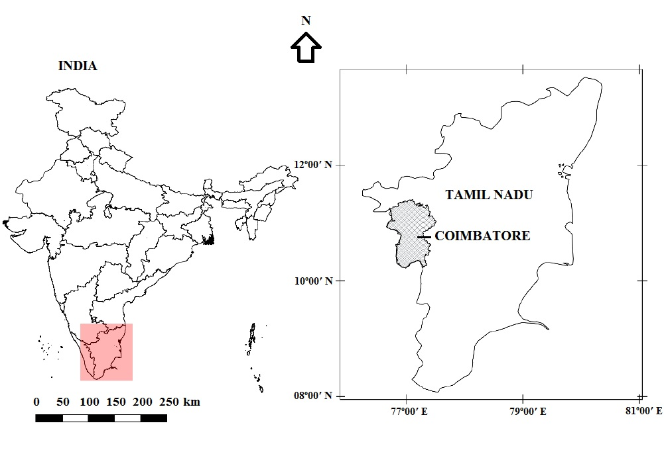
Fig. 1. Map showing the location of Coimbatore in Tamil Nadu state of India.

2.2 Moisture Content Determination
Above-ground plant parts, specifically leaves and branches, were collected from the same individual plants of Bambusa balcooa and Bambusa vulgaris. The fresh weight of each sample was immediately recorded using a digital electronic balance. The samples were then oven-dried at 105°C for 24 hours to ensure complete removal of moisture. After drying, the samples were weighed again to obtain their dry weight.
The moisture content of each sample was calculated by taking the difference between the fresh weight and dry weight, using the following formula:
$$Fresh weight−Dry weight=Water content or weight of moisture$$
$$\frac{Weight of moisture}{Fresh weight of plant material} ×100=Moisture content$$

This method allowed for accurate determination of water content in both leaves and branches, which is essential for standardizing further analyses related to carbon and phytolith content.
2.3 Determination of Organic Carbon content
Freshly collected leaf and branch samples from Bambusa balcooa and Bambusa vulgaris were first weighed to record their fresh weight. These samples were then oven-dried at 105°C for 24 hours to obtain the dry weight. Once completely dried, the samples were ground into a fine powder using a mechanical grinder to ensure uniformity.
Measured quantities of the powdered samples (1 g, 2 g, and 3 g) were transferred into pre-weighed crucibles. The crucibles containing the samples were then placed in a muffle furnace at 550°C for 2 hours to allow complete combustion of organic matter. After combustion, the crucibles were allowed to cool gradually to room temperature inside the furnace to prevent thermal shock.
The weight of the remaining ash was measured, and the organic carbon content was calculated using the following formula, as described by Allen et al. (1986):
$$Ash\%=\left(\frac{W3−W1}{W2−W1}\right)×100$$
Where,
W1 the weight of crucibles,
W2 the weight of oven dried grind samples + Crucibles,
W3 is the weight of ash + Crucibles.
$$C \left(\%\right)=\left(100−Ash\%\right) ×0.58$$
(Considering 0.58% carbon in ash free stem, branch and foliage materials)
Where, C is the organic carbon.
This method enables accurate estimation of the organic carbon present in the plant tissues by quantifying the loss of mass due to the combustion of organic material.
2.4 Extraction of Phytolith and Phytolith-Occluded Carbon from Plant Material
The dry ashing and acid extraction method was employed to isolate phytoliths from the leaf and branch samples of Bambusa balcooa and Bambusa vulgaris. The procedure followed was based on the protocol outlined by Rajendiran et al. (2016), with slight modifications.
Initially, powdered plant samples were subjected to dry ashing to remove the bulk of organic matter. The resulting ash was then treated with 10% hydrochloric acid (HCl) to eliminate carbonates, followed by 15% hydrogen peroxide (H₂O₂) to remove any remaining organic residues.
After purification, the phytolith-rich residue was treated with 1 mol/L hydrofluoric acid (HF) at 55°C for 60 minutes to dissolve the silica structure of the phytoliths and release the occluded organic carbon. The released organic matter was then dried at 45°C, and the phytolith-occluded carbon (PhytOC) content was quantified using the potassium dichromate oxidation method, as described by Li et al. (2013).
Further, the phytolith morphotypes present in the samples were identified and categorized under a light microscope following the classification criteria established by Madella et al. (2005). This allowed for the morphological characterization of phytolith types across different plant parts and species.
2.5 Data Analysis
All experimental data were statistically analyzed using one-way analysis of variance (ANOVA) to assess significant differences among the measured parameters. Mean comparisons were performed using Duncan’s Multiple Range Test (DMRT) at a significance level of P < 0.05 to determine statistically significant differences between groups.
The analyses were carried out using SPSS software (Version 21, SPSS Inc., Wacker Drive, Chicago, USA). Results are presented as the mean ± standard deviation (SD) of three independent replicates (n = 3) for each treatment or measurement.
3. results

3.1 Organic Carbon Content
The organic carbon content varied between the leaves and branches of the two bamboo species studied (Bambusa balcooa and Bambusa vulgaris). In B. balcooa, the carbon content was 44.52% in leaves and 50.11% in branches. In B. vulgaris, the values were slightly higher, with 49.10% in leaves and 50.94% in branches (Table 1). In both species, branches exhibited a higher carbon content than leaves. Among all samples, the highest carbon content was recorded in the branches of B. vulgaris. Overall, when combining leaf and branch values, B. vulgaris showed a greater total carbon storage potential compared to B. balcooa.
Table 1. Carbon content and phytolith content of leaves and branches of the two study species.
Species | Plant part | Carbon%  Mean±S.D. | Phytolith (mg/g)  Mean±S.D. | PhytOC%  Mean±S.D.
B.balcooa | Leaf | 44.52^{d}±0.202 | 174.43ª±14.846 | 0.0199±0.020
B.balcooa | Branch | 50.11^{b}±0.264 | 105.03^{b}±11.888 | 0.0133±0.012
B.vulgaris | Leaf | 49.10^{c}±0.016 | 113.03^{b}±4.605 | 0.0398±0.020
B.vulgaris | Branch | 50.94ª±0.104 | 79.06^{c}±1.530 | 0.0265±0.030
Values are means ±standard deviation (N=3). Mean values followed by different superscript in the same column are significantly (P < 0.05) different (One way ANOVA).

3.2 Phytolith Content
Phytolith content also differed across plant parts and species. In B. balcooa, phytolith concentrations were 174.43 mg g⁻¹ in leaves and 105.03 mg g⁻¹ in branches. In B. vulgaris, phytolith content was 113.03 mg g⁻¹ in leaves and 79.06 mg g⁻¹ in branches (Table 1). In both species, leaves contained higher phytolith levels than branches. The highest phytolith content was observed in the leaves of B. balcooa. The leaf-to-branch phytolith content ratio was 1.66:1 for B. balcooa and 1.43:1 for B. vulgaris. When leaf and branch values were combined, B. balcooa had a significantly higher total phytolith content than B. vulgaris.
A total of five distinct phytolith morphotypes were identified in both species: Dumbbell or bilobate, Globular granulate or spherical rugose, Saddle-shaped, Elongated, and Square short cell.
Morphotype distribution varied across species and plant parts. In B. balcooa, dumbbell-shaped phytoliths were prominent in leaves, while globular granulate types were observed in branches. In B. vulgaris, saddle-shaped forms were predominant in leaves, whereas elongated, saddle-shaped, and square short cell types were present in branches.
3.3 Phytolith-Occluded Carbon (PhytOC) Content
PhytOC content followed a similar trend to phytolith content. In B. balcooa, the PhytOC content was 0.0199% in leaves and 0.0134% in branches. In B. vulgaris, higher values were observed, with 0.0398% in leaves and 0.0265% in branches (Table 1). As with phytoliths, leaves had higher PhytOC content than branches in both species. Summed across both organs, B. vulgaris demonstrated a significantly greater capacity for long-term carbon sequestration via PhytOC than B. balcooa.
3.4 Morphology of Bamboo Phytoliths
Phytolith morphology was examined using Scanning Electron Microscopy (SEM) (Figure 2) and light microscopy at 100× magnification (Figure 3). A total of five morphotypes were identified across both species and plant parts (Table 2). Among these, dumbbell or bilobate forms were found exclusively in leaf tissues, highlighting a part-specific occurrence of certain morphotypes.
3.5 Moisture Content
The average moisture content also showed notable variation between species and plant parts. In B. balcooa, moisture content was 77.49% in leaves and 73.52% in branches. In B. vulgaris, higher values were observed: 80.57% in leaves and 85.36% in branches (Figure 4). Branches of B. vulgaris exhibited the highest moisture content among all samples. Overall, both leaves and branches of B. vulgaris had higher moisture levels than those of B. balcooa.

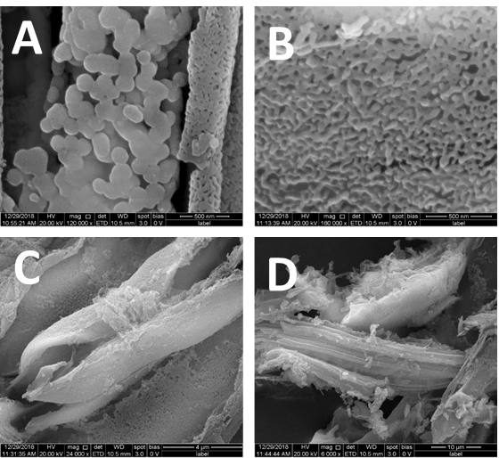
Fig. 2. Scanning electron microscope (SEM) image of phytolith: A- Phytolith in leaves of B. balcooa. B- Phytolith in branches of B. balcooa. C- Phytolith in leaves of B. vulgaris. D- Phytolith in branches of B. vulgaris. Phytolith of leaves and branches of two different bamboo varieties isolated and prepared by the method described above.

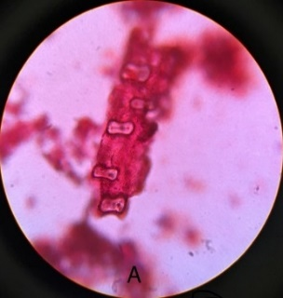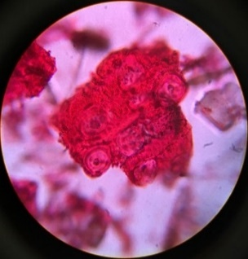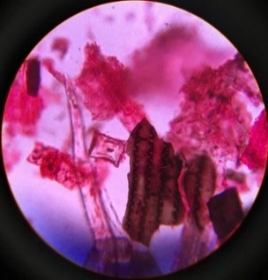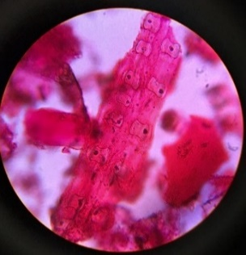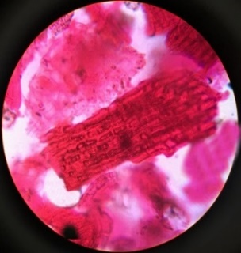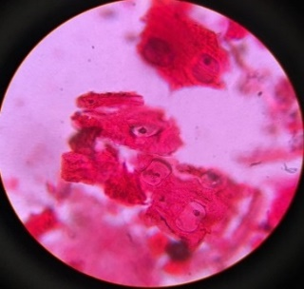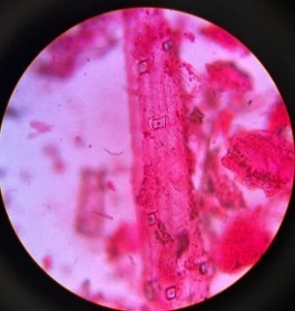
A
C
D
B
Fig. 3. Microscopic image of phytolith in 100x magnification: A- dumbbell shape phytolith in leaves of B. balcooa. B- Globular granulate and bulliform phytolith in branches of B. balcooa. C- Saddle shape phytolith in leaves of B. vulgaris. D- Elongated, saddle and square (or rectangle) or trapeziform short cell Phytolith in branches of B. vulgaris.

Table 2. Phytolith morphotypes in this study was determined according to the Madella et al. (2005).
Species | Parts | Phytolith shapes
B. balcooa | Leaves | Dumbbell or bilobate
 | Branches | Globular granulate or spherical rugose and bulliform
B. vulgaris | Leaves | Saddle shape
 | Branches | Elongated, saddle and square short cell

Fig. 4. Moisture content in leaves and branches of B. balcooa and B. vulgaris bamboo varieties. A- Leaves of B. balcooa, B- Branches of B. balcooa, C- Leaves of B. vulgaris and D- Branches of B. vulgaris.
4. discussion

4.1 Carbon Content and Sequestration Potential
Plant-based carbon sequestration has gained significant attention as a strategy to mitigate rising atmospheric CO₂ levels (Sheikh et al., 2014). In this study, we observed clear differences in carbon content between the two bamboo species, Bambusa balcooa and Bambusa vulgaris, as well as between their different plant parts. Overall, B. vulgaris showed a higher total organic carbon content (leaf + branch) than B. balcooa, with the branches of B. vulgaris recording the highest individual carbon percentage.
These findings align with previous research by Sohel et al. (2015), who reported that B. vulgaris stands in the Lawachara Forest Reserve of Bangladesh stored approximately 50.44 t C ha⁻¹ in above-ground biomass (culms, branches, and leaves), emphasizing its considerable potential for carbon storage and climate change mitigation. They also suggested that B. vulgaris could be effectively utilized in Clean Development Mechanism (CDM) projects due to its fast growth and high carbon sequestration capacity.
In contrast, Pathak et al. (2015) found higher biomass in B. balcooa (104.7 t ha⁻¹) than in B. vulgaris (53.42 t ha⁻¹), indicating that biomass alone does not necessarily equate to higher carbon content, highlighting the importance of assessing carbon density in different plant parts. A study by Teng et al. (2015) on eight sympodial bamboo species in China reported organ-specific carbon densities in the order: culms > belowground > branches > leaves, which is consistent with our findings showing lower carbon content in leaves compared to branches.
Similarly, Zhang et al. (2014) reported 40.45 t C ha⁻¹ in a Moso bamboo forest using modeling approaches, showing variability based on age, diameter at breast height (DBH), and environmental conditions. Yuen et al. (2017) emphasized that site-specific factors such as soil type, rainfall, and species selection also significantly influence carbon accumulation rates in bamboo stands. In light of the Kyoto Protocol’s recognition of forests as critical carbon sinks, the role of fast-growing bamboos in climate change mitigation strategies is increasingly evident (Sohel et al., 2015).
4.2 Phytolith and PhytOC Content
Unlike woody trees, bamboo has a unique advantage due to its high silica accumulation, particularly in leaf tissues (Montti et al., 2009). This silica forms phytoliths, amorphous, rigid structures within and between cells that not only enhance mechanical support but also occlude carbon (PhytOC) during their formation (Abdul et al., 2014).
In the current study, phytolith content was consistently higher in B. balcooa than in B. vulgaris. The highest content was observed in the leaves of B. balcooa (174.43 mg g⁻¹), suggesting that leaves are the primary sites for silica deposition. This supports previous findings that silica concentrations are typically highest in leaf tissues due to transpiration-driven uptake (Montti et al., 2009; Abdul et al., 2014).
The PhytOC content also followed a similar trend, with B. vulgaris showing higher overall values than B. balcooa. Specifically, PhytOC in the leaves of B. vulgaris reached 0.0398%, nearly double that of B. balcooa. This indicates that despite lower phytolith concentration, B. vulgaris may occlude more carbon per unit of phytolith, possibly due to species-specific differences in phytolith formation and carbon entrapment efficiency.
Several global studies have explored PhytOC sequestration in bamboo. Parr et al. (2010) and Li et al. (2014) estimated PhytOC sequestration at the national and global scales, though their estimates were primarily based on leaf litter, thereby underrepresenting the substantial PhytOC present in branches and culms, which make up a larger proportion of bamboo biomass. Yang et al. (2015) found a significant correlation between silicon content and phytolith formation (R² = 0.47, p < 0.01) but observed no consistent relationships between silicon and PhytOC content, indicating complex and variable factors influencing carbon occlusion.
Qi et al. (2017) further demonstrated that PhytOC concentration varies significantly among plant organs and species, ranging from 0.08 to1.52 g kg⁻¹, and found a positive correlation between phytolith and PhytOC content across multiple bamboo species.
Given the long-term stability of phytoliths in soils, PhytOC represents a durable and resistant carbon pool, potentially remaining stable over millennia. Therefore, bamboo, with its high silica and phytolith production, offers a dual benefit: short-term carbon capture through biomass and long-term sequestration through PhytOC, making it a highly effective nature-based solution for climate change mitigation.
4.3 Phytolith Morphology and Taxonomic Relevance
Phytolith morphology varied among species and plant parts in this study, consistent with previous research. Using light microscopy and scanning electron microscopy (SEM), five morphotypes were identified: Dumbbell or bilobate (leaves of B. balcooa), Globular granulate or spherical rugose (branches of B. balcooa), Saddle-shaped (leaves of B. vulgaris), Elongated, saddle-shaped, and square short cell (branches of B. vulgaris). These morphotypes are characteristic of grasses and align with observations by Madella et al. (2005), Montti et al. (2009), and Piperno and Pearsall (1998). Morphological diversity of phytoliths is not only useful for identifying plant taxa but also for reconstructing paleoenvironments and ancient vegetation.
Phytolith deposition is governed by silica uptake through the transpiration stream, and species-specific differences in transpiration rates and root absorption efficiency likely explain the observed variation. Moreover, genetic origin and ecological adaptations may influence silica accumulation patterns across bamboo genera (Li et al., 2014).
4.4 Implications for Climate Change Mitigation
Overall, this study highlights the multifaceted role of bamboo in carbon sequestration. Through high biomass production, efficient carbon capture, silica accumulation, and stable PhytOC storage, bamboo offers an integrated approach to combatting climate change. As noted by Yuen et al. (2017), such ecosystem services also support biodiversity, soil health, and rural livelihoods, making bamboo plantations valuable for both environmental conservation and sustainable development.
5. Conclusion

Bamboos are highly adaptable plants capable of thriving under diverse and adverse site conditions, making them integral components of many tropical forest ecosystems. They play a vital role in sequestering atmospheric carbon and preventing carbon loss due to forest degradation. This study demonstrates that bamboo species contribute significantly to carbon sequestration and climate change mitigation through the long-term storage of organic carbon.
The research focused on measuring organic carbon and phytolith content in the leaves and branches of two bamboo species, Bambusa vulgaris and Bambusa balcooa. Results revealed that B. vulgaris had higher organic carbon content, while B. balcooa exhibited greater phytolith accumulation. No significant correlation was found between organic carbon and phytolith content. Further, distinct phytolith morphotypes were observed between leaves and branches, as well as between the two species, reflecting variation within and among species of the Bambusoideae subfamily.
While this study provides valuable insights into phytolith content and morphotypes, it is limited to above-ground leaves and branches. Other important factors such as above- and below-ground biomass, culm carbon storage, and phytolith content in litterfall remain unexplored. Estimating organic carbon is a labor-intensive process but essential for developing accurate methodologies to assess carbon stock potential in bamboo species.
Considering bamboo’s rapid growth, high productivity, and diverse ecological and economic benefits, its role in the global carbon cycle deserves further attention. In particular, more extensive studies in India are needed to evaluate carbon storage and phytolith variation across different species and plant parts, which will deepen our understanding of bamboo’s potential in climate change mitigation.

References

Abutu, A. 2010. Bamboo can capture carbon fast, says report. SciDev. net-Environment.
Chen, W. J., Black, T. A., Yang, P. C., Barr, A. G., Neumann, H. H., Nesic, Z., ... & Cuenca, R. 1999. Effects of climatic variability on the annual carbon sequestration by a boreal aspen forest. Global Change Biology, 5(1): 41-53.
Farrelly, D. J., Everard, C. D., Fagan, C. C., & McDonnell, K. P. 2013. Carbon sequestration and the role of biological carbon mitigation: a review. Renewable and sustainable energy reviews, 21: 712-727.
Giri, K., Mishra, G., Kumar, R., & Pandey, S. 2015. Role of Bamboo Forests in Carbon Sequestration and Climate Change Mitigation.
Lal, R. 2008. Carbon sequestration. Philosophical Transactions of the Royal Society B: Biological Sciences, 363(1492), 815-830.
Li, B., Song, Z., Li, Z., Wang, H., Gui, R., & Song, R. 2014. Phylogenetic variation of phytolith carbon sequestration in bamboos. Scientific reports, 4(1): 4710.
Li, T. 2013. What Can Bamboo Do About CO2. Ecology Global Network.
Li, Z., Song, Z., & Jiang, P. 2013. Biogeochemical sequestration of carbon within phytoliths of wetland plants: a case study of Xixi wetland, China. Chinese Science Bulletin, 58(20): 2480-2487.
Lisztes_Szabo, Z. S. U. Z. S. A., Kovacs, S., & PETÖ, Á. 2014. Phytolith analysis of Poa pratensis (Poaceae) leaves. Turkish Journal of Botany, 38(5): 851-863.
Madella, M., Alexandre, A., & Ball, T. 2005. International code for phytolith nomenclature 1.0. Annals of botany, 96(2): 253-260.
Monson, R. K., Turnipseed, A. A., Sparks, J. P., Harley, P. C., Scott‐Denton, L. E., Sparks, K., & Huxman, T. E. 2002. Carbon sequestration in a high‐elevation, subalpine forest. Global Change Biology, 8(5): 459-478.
Montti, L., Honaine, M. F., Osterrieth, M., & Ribeiro, D. G. 2009. Phytolith analysis of Chusquea ramosissima Lindm.(Poaceae: Bambusoideae) and associated soils. Quaternary International, 193(1-2): 80-89.
Nath, A. J., Lal, R., & Das, A. K. 2015. Managing woody bamboos for carbon farming and carbon trading. Global Ecology and Conservation, 3: 654-663.
Pan, W., Song, Z., Liu, H., Van Zwieten, L., Li, Y., Yang, X., ... & Wang, H. 2017. The accumulation of phytolith-occluded carbon in soils of different grasslands. Journal of Soils and Sediments, 17(10): 2420-2427.
Parr, J. F., & Sullivan, L. A. 2014. Comparison of two methods for the isolation of phytolith occluded carbon from plant material. Plant and soil, 374(1): 45-53.
Pathak, P. K., Kumar, H., Kumari, G., & Bilyaminu, H. 2015. Biomass production potential in different species of bamboo in Central Uttar Pradesh. The Ecoscan, 10(1): 41-43.
Piperno, D. R., & Pearsall, D. M. 1998. The silica bodies of tropical American grasses: morphology, taxonomy, and implications for grass systematics and fossil phytolith identification (Vol. 85). Washington, DC: Smithsonian institution press.
Qi, L., Li, F. Y., Huang, Z., Jiang, P., Baoyin, T., & Wang, H. 2017. Phytolith-occluded organic carbon as a mechanism for long-term carbon sequestration in a typical steppe: The predominant role of belowground productivity. Science of the Total Environment, 577: 413-417.
Prajapati, K., Rajendiran, S., Coumar, V., Dotaniya, M. L., Kumar, A., & Kundu, S. 2016. Carbon occlusion potential of rice phytoliths: implications for global carbon cycle and climate change mitigation. Appl Ecol Environ Res, 14(2): 265-281.
Ru, N., Yang, X., Song, Z., Liu, H., Hao, Q., Liu, X., & Wu, X. 2018. Phytoliths and phytolith carbon occlusion in aboveground vegetation of sandy grasslands in eastern Inner Mongolia, China. Science of the Total Environment, 625: 1283-1289.
Selin, N. E. 2017. Carbon sequestration. In Encyclopaedia Britanica.
Abdul, S., Bhat, M. A., & Mir, S. H. 2014. Phytoliths in Plants: A Review. Research & Reviews: Journal of Botanical Sciences.
Sheikh, A. Q., Skinder, B. M., Pandit, A. K., & Ganai, B. A. 2014. Terrestrial carbon sequestration as a climate change mitigation activity. J Pollut Eff Control, 2(1).
Sohel, M. S. I., Alamgir, M., Akhter, S., & Rahman, M. 2015. Carbon storage in a bamboo (Bambusa vulgaris) plantation in the degraded tropical forests: Implications for policy development. Land Use Policy, 49: 142-151.
Song, X., Chen, X., Zhou, G., Jiang, H., & Peng, C. 2017. Observed high and persistent carbon uptake by Moso bamboo forests and its response to environmental drivers. Agricultural and Forest Meteorology, 247: 467-475.
Song, Z., Wang, H., Strong, P. J., & Guo, F. 2014. Phytolith carbon sequestration in China's croplands. European Journal of Agronomy, 53: 10-15.
Tao, X., Wen, M., Li, R., Vachula, R. S., Pang, L., Li, C., ... & Jiang, N. 2020. Phytolith sizes and assemblages differentiate genera and ecotypes of woody bamboos in subtropical Southwest China. Review of Palaeobotany and Palynology, 272: 104129.
Teng, J., Xiang, T., Huang, Z., Wu, J., Jiang, P., Meng, C., ... & Fuhrmann, J. J. 2016. Spatial distribution and variability of carbon storage in different sympodial bamboo species in China. Journal of Environmental Management, 168: 46-52.
Theunissen, J. D. 1994. A method for isolating and preparing silica bodies in grasses for scanning electron microscopy. Biotechnic & Histochemistry, 69(5): 291-294.
Yang, J., Wu, J., Jiang, P., Xu, Q., Zhao, P., & He, S. 2015. A study of phytolith-occluded carbon stock in monopodial bamboo in China. Scientific Reports, 5(1): 13292.
Yang, X., Song, Z., Liu, H., Van Zwieten, L., Song, A., Li, Z., ... & Wang, H. 2018. Phytolith accumulation in broadleaf and conifer forests of northern China: implications for phytolith carbon sequestration. Geoderma, 312: 36-44.
Yuen, J. Q., Fung, T., & Ziegler, A. D. 2017. Carbon stocks in bamboo ecosystems worldwide: Estimates and uncertainties. Forest Ecology and Management, 393: 113-138.
Zhang, H., Zhuang, S., Sun, B., Ji, H., Li, C., & Zhou, S. 2014. Estimation of biomass and carbon storage of moso bamboo (Phyllostachys pubescens Mazel ex Houz.) in southern China using a diameter–age bivariate distribution model. Forestry: An International Journal of Forest Research, 87(5): 674-682.
Zhang, X. Q., & Xu, D. 2003. Potential carbon sequestration in China’s forests. Environmental Science & Policy, 6(5): 421-432.

