Comparative Assessment of Intertidal Macrofaunal Assemblages between Rocky and Muddy Shores in the Gulf of Khambhat, Gujarat, India.
Original Research Article

ABSTRACT

The dynamic intertidal zones of the Gulf of Khambhat, Gujarat present a mosaic of habitats shaped by pronounced tidal regimes and varied substrate compositions. This study provides a comprehensive comparative analysis of macrofaunal assemblages across two ecologically distinct intertidal coasts, one rocky coast at Gopnath and second is muddy flats at Koliyak. Using standardized quadrat-based sampling across five assemblages (three at Gopnath coast and two at Koliyak coast), a total of 55 species of macrofauna spanning six phyla Mollusca, Arthropoda, Annelida, Nemertea, Cnidaria, and Chordata were documented. Rocky intertidal habitats at Gopnath supported higher species richness and taxonomic diversity, particularly among mollusks and crustaceans, in contrast to the relatively less diverse communities at Koliyak. To assess the ecological health and community structure of intertidal macrofaunal assemblages, biodiversity indices such as the Sorenson‘s index (QS) of similarity, Shannon-Wiener Index (H'), Simpson’s Diversity Index (D), and Pielou's evenness index (J’) were applied. Furthermore, Hierarchical cluster analysis was conducted to group assemblages based on species composition, revealing clear distinctions between rocky and muddy habitats and highlighting substrate-driven ecological segregation. These findings underscore the ecological significance of habitat heterogeneity in

coastal biodiversity and provide critical baseline data for future monitoring, conservation planning, and habitat-specific management strategies in this region of Gulf of Khambhat.

Keywords: Intertidal macrofauna, Gulf of Khambhat, Gopnath, Koliyak, species richness, rocky shore, muddy shore, benthic diversity, habitat heterogeneity.

INTRODUCTION
The intertidal zone represents one of the most dynamic marine ecosystems, subjected to regular fluctuations in environmental conditions. Macrofaunal communities in these zones play essential roles in ecosystem functioning, contributing to bioturbation, nutrient cycling, and food web dynamics (Snelgrove, 1998; Kristensen et al., 2012). The diversity and structure of these communities are heavily influenced by environmental variables such as substrate type, hydrodynamics, and sediment characteristics (Gray, 2002).

Macrofauna comprise various taxonomic groups, including molluscs, hydrozoans, echinoderms, and polychaetes (Snelgrove, 1999; Eleftherioo & McIntyre, 2005). When all taxa are observed together to observe specimens, they usually from distinguished assemblages. Macrofaunal assemblages have been increasingly considered as dependable indicators to monitor the responses of the aquatic environment to various stressors because of their sensitivity to a wide range of environmental disturbances and their important roles in ecosystem functioning (van der Linden et al., 2017, Hu et al., 2019). The composition and structure of biotic assemblages
emphasizes a mechanical understanding of regional biological interactions and their effects, with a focus on current species assemblages (National research council, 2005).

A prominent example of such biodiversity- rich intertidal zones can be found along the Gujarat coast, which hosts some of India's most ecologically important and diverse marine habitats. Gujarat has the longest coastline of any Indian state approximately 1,600 kilometers and features a mosaic of coastal ecosystems including extensive mudflats, sandy beaches, coral reefs (in the Gulf of Kachchh), and some of the country's most expansive mangrove forests. The Gulf of Kachchh, in particular, is renowned for its wide intertidal range and supports a variety of benthic communities, sea grasses, and reef-building corals, making it one of the richest marine biodiversity zones in the region (Nair et al., 2015). These intertidal habitats not only sustain marine life but also support local economies through fisheries, salt production, and tourism. The coastline of Gujarat is geologically diverse, composed predominantly of Tertiary sedimentary formations overlying the Deccan Traps, as well as Pleistocene-age miliolite limestone deposits that are particularly prominent along the Saurashtra coast. In addition,

recent alluvial sediments, often calcareous in nature, are found in various parts of the coastal zone. Notably, the Gulf of Khambhat has experienced significant recent alluvial deposition, contributing to its dynamic sedimentary environment (Jha et al., 2009).

Among the various coastal habitats, intertidal rocky shores have been extensively studied within marine ecological research due to their accessibility and the well-documented spatial and temporal variability of their biotic communities, particularly macroalgae and benthic invertebrates. These ecosystems offer valuable insights into ecological processes such as succession, competition, and environmental stress responses (Underwood & Chapman, 1996; Menconi et al., 1999; Benedetti-Cecchi, 2001; Blanchette et al., 2006; Martins et al., 2008; Burrows et al., 2009; Dal Bello et al., 2017a). Their structural complexity and the pronounced environmental gradients they exhibit make them ideal natural laboratories for examining patterns of biodiversity, species distribution, and ecosystem functioning.

The Gulf of Khambhat, located along the western coast of India in Gujarat, features high tidal amplitudes and complex hydrological conditions, creating varied
intertidal habitats. Despite extensive research on its geomorphology and tidal dynamics, few studies have focused on macrofaunal diversity within this system. This study compares macrofaunal assemblages between the rocky intertidal zone of Gopnath and the muddy intertidal flat of Koliyak, aiming to assess how substrate heterogeneity influences community structure.

MATERIALS AND METHODS
Study area: Gopnath and Koliyak are situated in Gujarat, western India, along the Gulf of Khambhat, which is situated between latitudes 21°00'N and 22°18'N and longitudes 72°15'E and 72°45'E. The shoreline of Koliyak (Latitude: 21°35′51.226″N, Longitude: 72°17′33.259″E) is murky with sporadic rocky spots. The intertidal zone here exposes roughly 600 to 900 meters at low tide, which makes it appropriate for long-term transect sampling. Gopnath, which is primarily a rocky shore with few muddy deposits, is located at latitude 21°21′10.56 N and longitude 72°10′62.53 E. Puddles and tide pools of all sizes and forms are scattered across the rocky substratum, each displaying distinct ecological traits. The 350–450 m of intertidal area that is exposed at low tide at this location for in-depth investigation of several microhabitat.

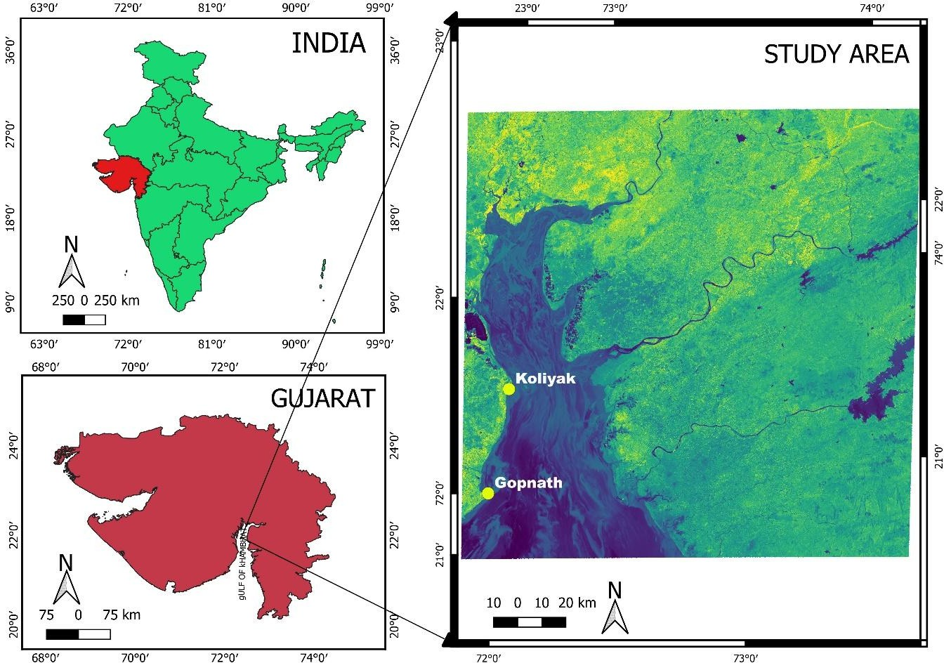
Fig. 1. Location of study sites. (Map generated using QGIS 3.34 with spatial data obtained from DIVA-GIS (https://www.diva-gis.org/)).

Sampling Method: The study investigated five distinct macrofaunal assemblage zones: GA1, GA2, and GA3 at Gopnath, and KA1 and KA2 at Koliyak. All sampling sites were situated within the middle to lower intertidal zones. Field surveys were conducted monthly during low tide, when approximately 350 to 450 meters of the intertidal area were exposed, allowing systematic sampling across the shore profile.
Macrofaunal specimens were recorded and collected using a standard quadrat method (0.25 m²) placed randomly along transects. Species identification was carried out through direct field observation and manual collection, followed by taxonomic
classification using standard identification keys. Species names were further cross- verified using the World Register of Marine Species (WoRMS) database to ensure taxonomic accuracy.
Data analysis: The collected data were analysed for species richness, overall abundance, and phylum-level distribution. A presence–absence checklist of recorded species was prepared to support comparative assessment. To evaluate the ecological condition and community structure of intertidal macrofaunal assemblages, standard biodiversity indices were employed, including the Shannon- Wiener Diversity Index (H'), Simpson’s

Dominance Index (D), and Evenness. In addition, hierarchical cluster analysis was conducted to group assemblages based on species composition, revealing clear distinctions between rocky and muddy habitats and highlighting substrate-driven ecological segregation.

RESULT

A total of 55 macrofaunal species were recorded across all five sampling sites GA1, GA2, GA3 (Gopnath rocky coast) and KA1, KA2 (Koliyak muddy coast) belonging to six phyla: Cnidaria, Nemertea, Annelida,
Mollusca, Arthropoda, and Chordata (Table: 1). The species-level data reveal significant spatial variation in diversity and distribution influenced by habitat type (rocky vs muddy). The phylum-level analysis of intertidal macrofauna across the five sampling assemblages: GA1, GA2, and GA3 (located at Gopnath rocky coast) and KA1 and KA2 (situated at Koliyak muddy coast) revealed notable spatial variations in species richness and community composition. A total of six phyla were recorded across all sites: Mollusca, Arthropoda, Annelida, Nemertea, Cnidaria, and Chordata.

Table: 1. Detailed Checklist of Macrofaunal Species at observed assemblages.

Sr. No |  | GA1 | GA2 | GA3 | KA1 | KA2
Phylum- Cnidaria
1. | Anthopleura thallia (Gosse,1854) | + | - | - | - | -
Phylum- Nemertea
2. | Emplectonema sp. | + | + | + | + | +
Phylum- Annelida
3. | Diopatra cuprea (Bosc, 1802) | + | + | + | + | +
4. | Nereis sp. 1 | + | + | - | + | +
5. | Nereis sp. 2 | - | - | - | + | +
6. | Unidentified | + | + | + | - | -
Phylum- Mollusca
7. | Agaronia gibbosa (Born,1778) | - | + | + | + | +
8. | Agaronia nebulosa (Born,1778) | - | + | + | + | +

9. | Aliculastrum cylindricum (Helbling, 1779) | + | + | + | - | -
10. | Amaea minor (Sowerby II,1873) | - | - | - | + | +
11. | Amphicyclotulus dominicensis (Bartsch,1942) | + | + | + | - | -
12. | Assiminea brevicula (Pfeiffer,1855) | + | - | - | + | +
13. | Astralium semicostatum (Kiener,1850) | + | + | + | + | +
14. | Astralium stellare (Gmelin,1795) | - | + | + | - | -
15. | Calliostoma tranquebaricum (Roding, 1798) | + | + | + | + | +
16. | Cantharus spiralis (Gray,1839) | + | + | - | + | +
17. | Cellana karachiensis (Winckworth, 1930) | + | + | + | - | -
18. | Chiton peregrines (Sowerby in Broderip & Sowerby, 1832) | + | + | + | - | -
19. | Clypeomorus batillariaeformis (Habe & Kosuge,1966) | + | + | + | + | +
20. | Clypeomorus bifasciata (G. B. Sowerby II, 1855) | + | + | + | + | +
21. | Echinolittorina malaccana (Philippi, 1847) | - | + | - | + | -
22. | Gyrineum natator (Roding,1798) | - | + | - | - | -
23. | Lataxiena bombayana (Melvill, 1893) | + | + | - | - | -
24. | Laternula anatine (Linnaeus, 1758) | + | + | + | + | +
25. | Littoraria intermedia (Philippi, 1846) | + | + | - | + | -
26. | Littoraria scabra (Linnaeus, 1758) | + | + | - | + | -
27. | Nerita oryzarum (Recluz, 1841) | - | - | + | - | -
28. | Nerita undata Linnaeus (1758) | - | + | + | - | -
29. | Nassarius dorsatus (Röding, 1798) | + | + | + | + | +
30. | Nassarius reeveanus (Dunker,1847) | + | + | - | + | -
31. | Nassarius stolatus (gmelin,1791) | + | + | + | + | +
32. | Octopus vulgaris (Cuvier,1797) | - | - | + | - | -

33. | Peronia verruculata (Cuvier,1830) | + | + | + | + | +
34. | Pirenella cingulata (Gmelin,1791) | + | + | - | - | -
35. | Planaxis sulcatus (Born,1778) | + | + | + | + | +
36. | Saccostrea cucullata (Born,1778) | + | + | + | - | -
37. | Semiricinula tissoti (Petit de la Saussye,1852) | + | - | + | + | +
38. | Serratina capsoides (Lamarck, 1818) | + | + | + | + | +
39. | Tectus tentorium (Gmelin, 1791) | + | + | + | - | -
40. | Trochus radiates (Gmelin,1791) | + | + | + | + | +
41. | Turbo bruneus (Röding, 1798) | + | + | + | + | -
42. | Turris clausifossata (Kilburn,Fedosov & Olivera,2012) | + | + | + | - | -
43. | Umbonium vestiarium (Linnaeus,1758) | + | + | + | + | +
Phylum- Arthropoda
44. | Amphibalanus amphitrite (Darwin, 1854) | + | + | + | - | -
45. | Clibanarius infraspinatus (Hilgendorf, 1869) | + | + | + | + | +
46. | Clibanarius longitarsus (De Haan,1849) | + | + | + | + | +
47. | Diogenes avarus (Heller, 1865) | + | + | + | + | -
48. | Eriphia smithii (Macleay,1838) | + | + | - | - | -
49. | Euraphia withersi (Pilsbry,1916) | + | + | + | - | -
50. | Macrophthalmus laevis A. (Milne Edwards,1867) | + | - | + | + | +
51. | Matuta victor (Fabricius,1781) | + | + | + | + | +
52. | Metopograpsus thukuhar (Owen,1839) | + | + | - | - | -
53. | Scylla serrata (Forsskal, 1775) | - | - | + | + | -
54. | Scopimera globosa (De haan, 1835) | + | + | + | + | +
Phylum – Chordate

55. | Boleophthalmus dussumieri (Valenciennes, 1837) | + | + | + | + | +
The table below shows species presence (+) in each assemblage: GA1, GA2, GA3 (Gopnath); KA1, KA2 (Koliyak).
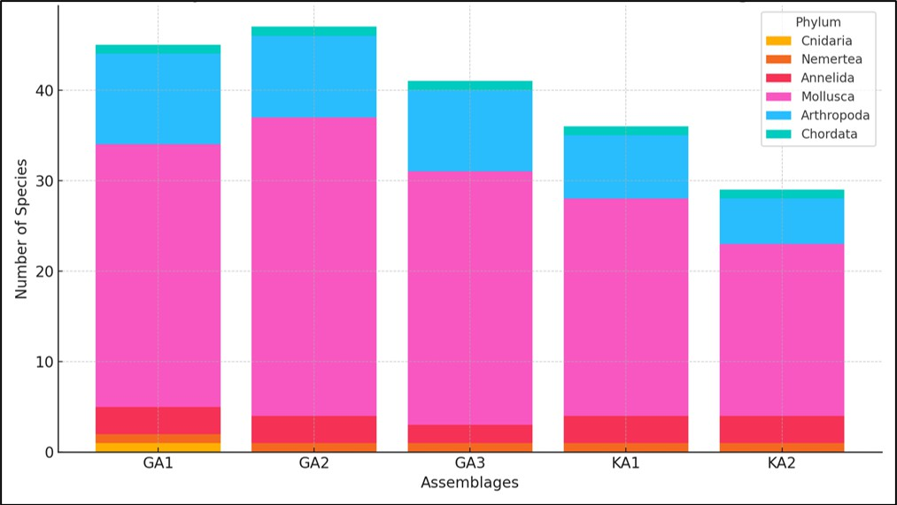

Fig. 2. Phylum-wise Distribution of Macrofauna in different assemblages.

The highest overall species richness was observed at GA2 (47 species), followed by GA1 (45 species), and GA3 (41 species). In contrast, the Koliyak sites showed relatively lower richness, with KA1 and KA2 supporting 36 and 29 species respectively. (Fig.2)
The dendrogram illustrates the results of a hierarchical cluster analysis based on species composition across five intertidal assemblages: GA1, GA2, GA3, KA1, and KA2. (Fig. 3)
GA2 and GA3, both located along the rocky intertidal zone of Gopnath, show the highest similarity, clustering together at the lowest linkage distance. This suggests that these two
assemblages share a closely related macrofaunal community structure, likely due to comparable substrate types, tidal exposure, and microhabitat complexity.
KA2, one of the muddy shore assemblages from Koliyak, forms the next closest linkage with the GA2–GA3 cluster, indicating some degree of overlap in species composition. This may reflect the presence of generalist or eurytopic species capable of inhabiting both muddy and rocky substrates.
KA1, the other Koliyak assemblage, clusters separately at a slightly higher distance, pointing to greater dissimilarity in its species

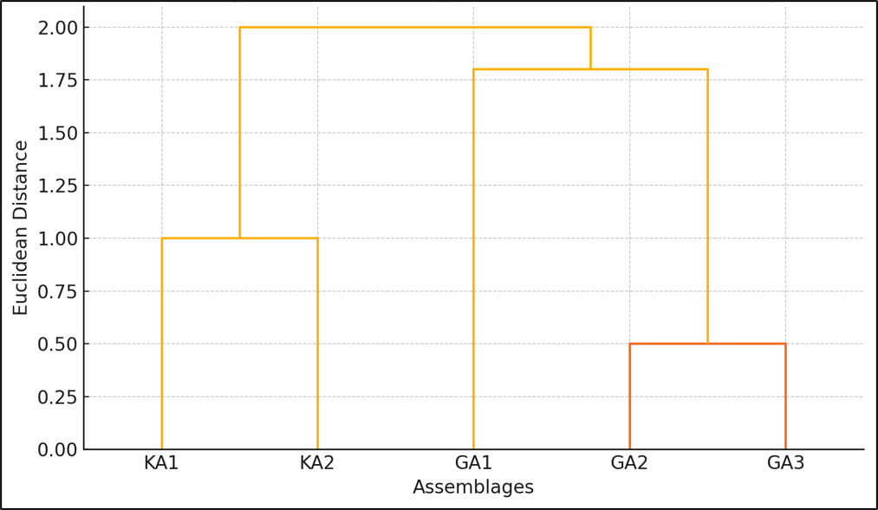

Fig. 3. Cluster analysis of Assemblages Based on Species Composition.

composition possibly due to localized environmental variation such as sediment characteristics or tidal inundation patterns.
GA1, although part of the rocky shore, stands out as the most distinct assemblage, joining the cluster at the highest Euclidean distance. This separation may reflect unique biotic or abiotic conditions at that particular site, such as the presence of Cnidaria (not found at other locations), unique tide pool features, or species exclusivity.
To assess the ecological structure and health of the intertidal macrofaunal communities, three standard biodiversity indices Shannon- Wiener Index (H'), Simpson’s Dominance Index (D), and Evenness were calculated for each assemblage.The Shannon-Wiener Index (H'), which accounts for both species richness and evenness, revealed that GA1 (1.0517)
and KA2 (1.0470) had the highest diversity among the five assemblages. In contrast, GA2 exhibited the lowest diversity (H' = 0.9043), indicating a community potentially dominated by fewer phyla. The Simpson’s Index (D), which reflects dominance patterns, showed that GA2 (0.5346) had the highest dominance (and thus the lowest diversity), while GA1 (0.4706) and KA2 (0.4721) displayed lower dominance, suggesting a more even representation of species. The Evenness index showed that species were more uniformly distributed at KA2 (0.6506) and KA1 (0.6182), while GA2 again recorded the lowest value (0.5619), reflecting an imbalanced phylum distribution. These index values collectively indicate that KA2 (muddy coast) and GA1 (rocky coast) support more balanced and diverse macrofaunal

Table: 2 diversity indexes for different assemblages.

Assemblages | Shannon-Wiener  Index (H') | Simpson’s  Dominance Index (D) | Evenness
GA1 | 1.0517 | 0.4706 | 0.5870
GA2 | 0.9043 | 0.5346 | 0.5619
GA3 | 0.9218 | 0.5181 | 0.5727
KA1 | 0.9949 | 0.4907 | 0.6182
KA2 | 1.0470 | 0.4721 | 0.6502
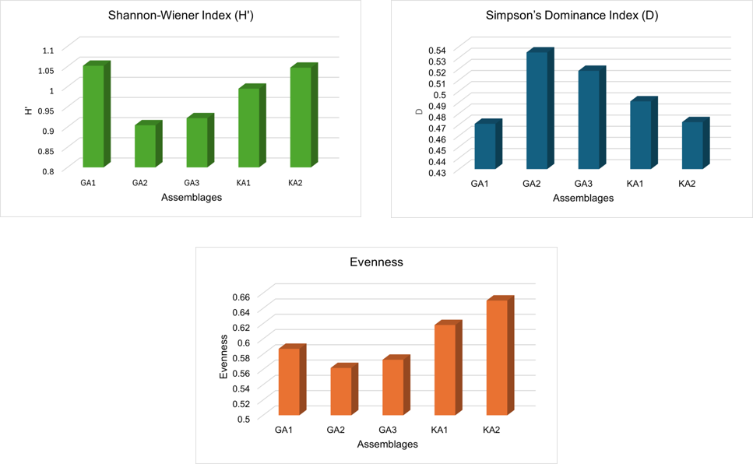

Fig. 4. Bar charts displaying the biodiversity indices for each assemblage.

communities, while GA2 appears to be comparatively less diverse and more taxonomically skewed.

DISCUSSION

This study demonstrates how the composition, richness, and distribution of macrofaunal assemblages along the Gulf of Khambhat are
significantly influenced by the type of substrate and the structure of the intertidal habitat. Fifty- five macrofaunal species from six phyla were recorded from five different assemblages in two different coastal habitats: the muddy flats at Koliyak and the rocky coasts at Gopnath.
Compared to the muddy intertidal flats of Koliyak (KA1 and KA2), the rocky intertidal

zones of Gopnath (GA1, GA2, and GA3) consistently had better species richness and taxonomic diversity. Previous studies have shown that structurally complex environments, such as rocky coastlines, tend to maintain more diverse and stable communities due to the abundance of microhabitats and niches available (Underwood & Chapman, 1996; Benedetti-Cecchi, 2001; Martins et al., 2008). Rock substrates sustain species including gastropods, barnacles, and polychaetes that require hard surfaces for attachment or protection from desiccation during tidal cycles (Blanchet al., 2006).
The most prevalent phylum in all assemblages was Mollusca, which was more prevalent in Gopnath sites. The presence of algae, biofilm, and microhabitats in tidal pools and fissures is responsible for the abundance of molluscs, particularly grazing gastropods and filter feeders. The concept of habitat-specific species sorting, in which environmental filters like sediment type, water retention, and exposure control community assembly, is supported by the presence of several species from Clypeomorus, Nassarius, and Trochus in both habitats, albeit in differing numbers (Gray, 2002; Hu et al., 2019).
Additionally, rocky places had a greater diversity of Arthropoda, particularly brachyuran and hermit crabs (e.g., Clibanarius, Scopimera). This could be because rocky crevices provide security and there are empty shells to hide in (Burrows et al., 2009). On the other hand, Koliyak's muddy intertidal habitat was home to a greater number of infaunal and
burrowing species, such as Scylla serrata and polychaetes. This is consistent with patterns observed in soft-sediment ecosystems, where deposit feeders and burrowers typically dominate the fauna (Snelgrove, 1998; Kristensen et al., 2012).
From an ecological point of view, the combined use of Simpson's Dominance Index (D), Shannon-Wiener Index (H'), and Evenness provides valuable insights into species distribution patterns and community structure. The higher H' values observed in Assemblages GA1 and KA2 indicate ecologically stable and heterogeneous environments that support a greater variety of ecological niches, promoting species richness and balanced abundance (Magurran, 2004; Gray, 2000). In contrast, GA2 showed the highest dominance (D) and the lowest H' and evenness, indicating ecological stress, possibly due to habitat simplification, environmental disturbance, or microhabitat homogeneity. Such patterns suggest that a few stress-tolerant or opportunistic species dominate these areas, suppressing overall community diversity (Warwick & Clarke, 1993; Pearson & Rosenberg, 1978). This dominance-driven skewness can result from natural factors like sediment type or tidal exposure, as well as anthropogenic pressures such as pollution or habitat alteration (Alongi, 1990; Thrush et al., 2001).
Different grouping patterns according to species composition were found using cluster analysis. Due to similar rocky habitat structure and environmental circumstances that support

similar species assemblages, GA2 and GA3 formed the closest cluster, representing similar faunal communities (Warwick & Clarke, 1991; McCune & Grace, 2002). The presence of eurytopic (generalist) species, which can colonize both stony and muddy substrata and endure a wide variety of circumstances, may be the reason for the intriguing resemblance between KA2 and the Gopnath sites (Gray, 1981; Alongi, 1990). GA1, on the other hand, was the most unique assembly. Localized topography, salinity gradients, or the exclusive occurrence of Anthopleura thallia (Cnidaria), a species frequently linked to tidal pools and specialized microhabitats, could be the cause of its separation (Branch et al., 2008; Raffaelli & Hawkins, 1996). These results highlight how structural complexity and microhabitat variety influence the organization of benthic communities throughout varied intertidal zones (Little & Kitching, 1996). These results highlight the critical role of habitat heterogeneity in shaping coastal biodiversity. The differential community structure between the rocky and muddy zones emphasizes how substrate type, hydrodynamic forces, and microtopography jointly influence ecological patterns (Martins et al., 2008; van der Linden et al., 2017).
Furthermore, the macrofaunal diversity found in this study provides a crucial starting point for upcoming biomonitoring initiatives. Long- term research is required to monitor changes in biodiversity and inform conservation planning in the Gulf of Khambhat due to the increasing anthropogenic pressures of
industrialization, sedimentation, and coastal erosion.

CONCLUSION

This comparison of macrofaunal assemblages in rocky and muddy intertidal zones along the Gulf of Khambhat highlights the critical role that substrate type plays in determining species richness, biodiversity, and community structure from an ecological point of view. Molluscs and crustaceans, in particular, dominated the larger and more varied macrofaunal population that was sustained by the rocky intertidal substrate at Gopnath. This is probably because rocky substrates, which offer a range of biological niches, stable attachment surfaces, and protective microhabitats, are structurally complicated. The muddy flats of Koliyak, on the other hand, were home to fewer species but also specialized taxa that were suited to the unstable sediments, reduced oxygen supply, and changing salinity. These variations are a reflection of habitat filtering processes, in which species composition is directly influenced by sediment characteristics and physical conditions. These ecological patterns were further supported by the application of biodiversity indices, which showed that GA1 and KA2 had higher levels of diversity and evenness, indicating ecosystems that were both generally stable and varied. The dominance of a small number of tolerant species is suggested by the decreased diversity at GA2, which may be a sign of habitat homogeneity or environmental stress. By identifying clear groupings between habitat

categories and pointing out minor variations among sites with comparable substrates, cluster analysis validated these views. This implies that macrofaunal distribution can be strongly impacted by even little changes in environmental characteristics, such as tidal exposure, substrate texture, or water retention. The study's overall findings underscore the ecological significance of habitat complexity in sustaining resilient and varied intertidal communities. In ecologically sensitive coastal areas like the Gulf of Khambhat, where growing human pressure may jeopardize the integrity of these dynamic ecosystems, it also offers a basis for site-specific conservation and monitoring initiatives.

DISCLAIMER (ARTIFICIAL INTELLIGENCE)

Author here by declared that no generative AI technologies have be used during writing or editing of this manuscript.

COMPETING INTERESTS

Authors have declared that no competing interests exist.

REFERENCES:

- Alongi, D. M. (1990). The ecology of tropical soft-bottom benthic ecosystems. Oceanography and Marine Biology: An Annual Review, 28, 381–496.
- Benedetti-Cecchi, L. (2001). Beyond competition: Incorporating positive interactions between species to predict ecosystem invasibility. PLOS Biology, 2(4), e39. (Note: please confirm the correct article as Benedetti-Cecchi has many works in 2001—this one might differ.)
- Benedetti-Cecchi, L. (2001). Variability in abundance of algae and invertebrates at different spatial scales on rocky sea shores. Marine Ecology Progress Series, 215, 79–92. https://doi.org/10.3354/meps215079
- Blanchette, C. A., Miner, C. M., Raimondi, P. T., Lohse, D., Heady, K. E., & Broitman, B. R. (2006). Biogeographical patterns of rocky intertidal communities along the Pacific coast of North America. Journal of Biogeography, 35(9), 1593–
1607. https://doi.org/10.1111/j.1365- 2699.2008.01913.x
- Branch, G. M., Griffiths, C. L., Branch,
M. L., & Beckley, L. E. (2008). Two oceans: A guide to the marine life of southern Africa (3rd ed.). Struik Nature.
- Burrows, M. T., Harvey, R., & Robb, L. (2009). Wave exposure indices from

digital coastlines and the prediction of rocky shore community structure. Marine Ecology Progress Series, 379, 1–12.
https://doi.org/10.3354/meps07856
- Dal Bello, M., Galzin, R., & Claudet, J. (2017a). Effects of local and regional processes on reef fish assemblages in a marine protected area. Marine Ecology Progress Series, 567, 171–
183.
https://doi.org/10.3354/meps12050
- Eleftheriou, A., & McIntyre, A. (2005). Methods for the study of marine benthos (3rd ed.). Blackwell Science.
- Gray, J. S. (1981). The ecology of marine sediments: An introduction to the structure and function of benthic communities. Cambridge University Press.
- Gray, J. S. (2000). The measurement of marine species diversity, with an application to the benthic fauna of the Norwegian continental shelf. Journal of Experimental Marine Biology and Ecology, 250(1–2), 23–49.
https://doi.org/10.1016/S0022- 0981(00)00178-7
- Gray, J. S. (2002). Biomagnification in marine systems: The perspective of an ecologist. Marine Pollution Bulletin, 45(1–12), 46–52.
https://doi.org/10.1016/S0025- 326X(02)00187-1
- Hu, Z., Li, Q., Fang, J., & Zhang, J. (2019). Macrofaunal community structure and its response to
environmental gradients in an estuarine intertidal zone. Marine Pollution Bulletin, 138, 241–249. https://doi.org/10.1016/j.marpolbul.201 8.11.041
- Jha, P. K., Sinha, R., & Tiwari, M. (2009). Holocene alluvial stratigraphy and pedogenesis in the coastal plain of the Gulf of Khambhat, western India. Quaternary International, 206(1–2), 64–75.
https://doi.org/10.1016/j.quaint.2008.1 1.001
- Kristensen, E., Bouillon, S., Dittmar, T., & Marchand, C. (2012). Organic carbon dynamics in mangrove ecosystems: A review. Aquatic Botany, 97(1), 1–22.
https://doi.org/10.1016/j.aquabot.2011. 08.007
- Little, C., & Kitching, J. A. (1996). The biology of rocky shores. Oxford University Press.
- Magurran, A. E. (2004). Measuring biological diversity. Blackwell Science Ltd.
- Martins, G. M., Neto, A. I., Cacabelos, E., & Thompson, R. C. (2008). Insights into the functional role of non- indigenous species on urbanized rocky shores. Marine Ecology Progress Series, 358, 303–306. https://doi.org/10.3354/meps07366
- McCune, B., & Grace, J. B. (2002).
Analysis of ecological communities. MjM Software Design.

- Menconi, M., Benedetti-Cecchi, L., & Cinelli, F. (1999). Spatial and temporal variability in the distribution of algae and invertebrates on rocky shores in the northwest Mediterranean. Marine Ecology Progress Series, 188, 75–85. https://doi.org/10.3354/meps188075
- Nair, K. R., Desai, D. V., & Ingole, B.
S. (2015). Benthic biodiversity of the Gulf of Kachchh: Status and future research needs. In Essays on Marine Biodiversity (pp. 137–156). National Institute of Oceanography, Goa.
- Pearson, T. H., & Rosenberg, R. (1978). Macrobenthic succession in relation to organic enrichment and pollution of the marine environment. Oceanography and Marine Biology: An Annual Review, 16, 229–311.
- Raffaelli, D., & Hawkins, S. (1996).
Intertidal ecology. Chapman & Hall.
- Snelgrove, P. V. R. (1998). The biodiversity of macrofaunal organisms in marine sediments. Biodiversity and Conservation, 7(9), 1123–1132. https://doi.org/10.1023/A:1008867313 340
- Snelgrove, P. V. R. (1999). Getting to the bottom of marine biodiversity: Sedimentary habitats. BioScience, 49(2), 129–138.
https://doi.org/10.2307/1313538

- Thrush, S. F., Hewitt, J. E., Cummings, V. J., & Dayton, P. K. (2001). The influence of habitat heterogeneity on the biodiversity–
ecosystem function relationship in seafloor communities. Ecological Monographs, 71(3), 355–375. https://doi.org/10.1890/0012- 9615(2001)071[0355:TIOHHO]2.0.CO
;2
- Underwood, A. J., & Chapman, M. G. (1996). Subtidal assemblages on rocky reefs at a cliff-face and two outcrops on the coast of New South Wales. Marine and Freshwater Research, 47(3), 351–368. https://doi.org/10.1071/MF9960351
- van der Linden, P., Paterson, D. M., & Piersma, T. (2017). The influence of macrofauna functional traits on benthic ecosystem functioning. Journal of Sea Research, 123, 33–42. https://doi.org/10.1016/j.seares.2016.0 3.005
- Warwick, R. M., & Clarke, K. R. (1991). A comparison of some methods for analysing changes in benthic community structure. Journal of the Marine Biological Association of the United Kingdom, 71(1), 225–244. https://doi.org/10.1017/S00253154000 37528
- Warwick, R. M., & Clarke, K. R. (1993). Increased variability as a symptom of stress in marine communities. Journal of Experimental Marine Biology and Ecology, 172(1– 2), 215–226.
https://doi.org/10.1016/0022- 0981(93)90098-9

