Identification of naturally occurring bioflavonoids as potential BCL-2 inhibitor: a computational approach

Abstract
B-cell lymphoma 2 (BCL-2) is a protein that enhances malignant cell survival in the pathophysiology of cancer. Biflavonoids are naturally occurring phytochemicals with diverse therapeutic benefits. This study investigated the BCL-2 inhibitory potential of C-O-C linked biflavonoids using computational approach. A library of C-O-C linked biflavonoids was constructed and docked against BCL-2 target. Quantum chemical calculation was performed on the hit molecule and its monoflavonoid unit. The molecular docking studies identified lanaroflavone as the hit molecule with a binding affinity of -10.2 kcal/mol. The electrophilicity index and other electronic parameters showed that the compound has good druggable potentials. Further in vitro BCL-2 inhibitory studies are recommended.
Keywords: B-cell lymphoma 2; Biflavonoids; Molecular docking; Density functional theory calculations
Introduction
Cancer is one of the major causes of death all over the world; every year millions of people are diagnosed with oncological pathologies (Siegel et al., 2019). The ability of cancer cells to evade apoptosis during oncogenesis or in response to therapy is an essential mechanism of tumour maintenance; B-cell lymphoma 2 (BCL-2) family proteins (anti-apoptotic and pro-apoptotic proteins) are key regulators of this process (Kutuk and Letai, 2008; Hatok and Racay, 2016)
Cancerous cells have been reported to be frequently associated with an imbalance in the expression of this family of proteins in favour of the anti-apoptotic members (Yip and Red, 2008; Ola et al., 2011; Knight et al., 2019). Specifically, BCL-2 proteins expression blocks the morphologic features of apoptosis including DNA cleavage, nuclear condensation and plasma membrane blebbing, more so, they oppose various chemotherapeutic measures against cancer (Ola et al., 2011). Hence, effective inhibitors of Bcl-2 enzymes which are capable of targeting their structurally defined multi-domains thereby restoring the delicate balance in pro-apoptotic and anti-apoptotic BCL-2 proteins are desirable as therapeutic agent against cancer development. Despite the existence of various anticancer agents, their high level of toxicity has limited their usage. Plant-derived phytochemicals are notable sources of novel anticancer drugs as studies have shown that they target multiple dysregulated pathways in cancer (Fakhri et al., 2021)
Biflavonoids are dimers of flavonoid units linked by a C-C or C-O-C bond via an ether linkage (Goossens et al., 2021). Natural biflavonoids with C-O-C bonds have been reported to elicit promising therapeutic effects on various diseases including cancer, their therapeutic effect on cancer have been reported to be as a result of their inhibitory activity on Bcl-2 proteins via p53 signaling pathway, up-regulation of caspase-3/cleaved-caspase-3, inhibition of metabolism-related pathways and other apoptosis induction mechanisms (Goossens et al., 2021; Kang et al., 2021).
Computational chemistry plays fundamental roles in drug screening and drug discovery (Lin et al., 2020). It helps to determine drug binding sites on the target macromolecules thereby elucidating the drug action mechanism, provides more efficient means of probing for lead compounds among massive data bases and alternative way of drug design using building blocks from the scratch (Birkinshaw et al., 2019; Faloye et al., 2021). Therefore, this study evaluates the inhibitory effect of biflavonoids with C-O-C linkage on BCL-2 using molecular docking studies. It also used density functional theory calculations to estimate the quantum chemical properties of the hit molecule and its monoflavonoid unit.
Materials and method
Protein and ligand preparation
The 3D crystallographic structure of BCL-2 (PDBID : 60OK) (Birkinshaw et al., 2019) was retrieved from the protein data bank (www.rcsb.org) and loaded on PyMol software in order to remove the water molecules, co-factors and ions. The co-crystallized ligand (venetoclax) was also identified on PyMol software and the residues within 5 Å residents at the binding site of the protein were selected. Later on, the native ligand was removed to obtain a bare protein. The protein was saved in PDB format for docking purpose.
The chemical structures of 19 naturally occurring C-O-C bioflavonoids (see supplementary material) was built with Spartan 14 software, while the reference compound (venetoclax) were downloaded from the PubChem database (https://pub-chem.ncbi.nlm.nih.gov/). All the chemical structures were saved in SDF format and loaded into Open Babel for energy minimization. Then the energy-minimized ligands were saved as PDBQT file.
Molecular docking studies
The molecular docking studies of the C-O-C linked bioflavonoids against BCL-2 were carried out by converting the clean protein’s PDB file to PDBQT using the MGL software. Thereafter, the protein was loaded into the Autodock Vina interface of PyRx 0.8 software (Trott and Olson, 2010) and amino acid residues resident within 5 Å was selected. Then the grid box of the protein was adjusted to center_x = 14.6217, center_y = 20.8817, center_z = -13.2697 and size_x = 28.9674, size_y = 22.8650, size_z = 21.4296. The PDBQT file of the chemical compounds and venetoclax were loaded and molecular docking was carried out against BCL-2 at an exhaustiveness of 100. After successfully completing the docking procedure, the binding poses of the ligand was retrieved and those with the lowest RMSD value were selected for hydrogen bonding, hydrophobic and pi-interactions analysis using the Discovery Studio Visualizer software.
Density functional theory calculations
Density Functional Theory (DFT) analysis of the top-ranked molecule was carried out using the Spartan 14 programme containing functional B3LYP with a 6-31G basis set (Becke, 1993). During the calculations, the values of the frontier orbital energies and parameters like energy gap (ΔE), hardness (η), chemical reactivity (µ), electrophilicity index (ω), softness (S), electronegativity (Ɛ), ionization potential (I) and electron affinity (A) were computed.
ΔE = E_{LUMO} – E_{HOMO} (1)
(E_{LUMO} – E_{HOMO}) (2)
(E_{HOMO} + E_{LUMO}) (3)
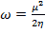 (4)
(5)
(6)
χ = - µ (7)
A = -E_{LUMO} (8)
I = - E_{HOMO} (9)
Results and discussion
Molecular docking analysis
In this study, the binding affinity of venetoclax (-10.0 kcal/mol) was used as the cut-off point for the phytochemicals screened against BCL-2. Lanaroflavone was identified as the potential hit molecule amongst the naturally occurring C-O-C bioflavonoids with a binding affinity of -10.2 kcal/mol. The hit molecule elicited better binding affinity than apigenin (-8.7 kcal/mol) indicating that two moles of apigenin may produce better inhibitory potential against the target receptor that the apigenin moiety. The oxygen atoms of the lanaroflavone moiety established good hydrogen bond interactions with Gln11 at 2.88, Asn101 at 2.75, Gly146 at 2.50, Asn206 at 2.14 and Asn228 at 1.97 as compared to apigenin that participated in hydrogen bond interactions with Ser140 at 2.21, Gly142 at 2.54 and Thr145 at 2.79. Also, lanaroflavone formed hydrophobic and pi-interactions with Gln11, Ala12 and Tyr224, compared to apigenin which had none of such interactions. The important interactions observed between the amino acid residues of BCL-2 and lanaroflavone moiety contributed to its good binding affinity and stability.
Lanaroflavone is a secondary metabolite that has a structural feature typical of a biflavonoid with a C-O-C linkage. While apigenin is a known flavonoid with various pharmacological properties, lanaroflavone with two moles of apigenin has also exhibited good antiplasmodial, leishmanicidal and antitrypanosomal activities (Weniger et al., 2006). Hence, the biflavonoid could possess anticancer activity since phytochemicals like hinokiflavone and delicaflavone that has similar structural features with lanaroflavone exhibit anticancer activity.

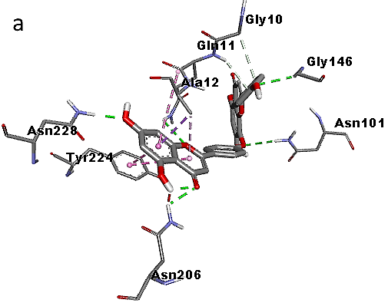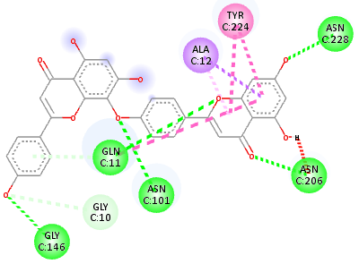
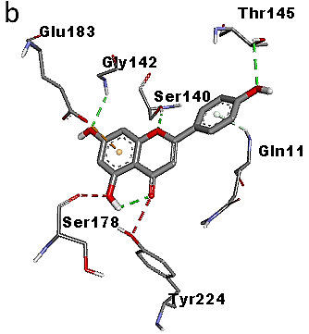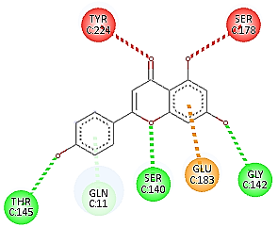
Figure 1: Interaction analysis of 4O2B-lanaroflavone (a) and 4O2B-apigenin (b) complexes
Frontier Molecular Orbitals and reactivity descriptors analysis
The reactivity descriptors calculated for the lanaroflavone and apigenin molecules are shown in Table 2.
Table 1: Calculated reactivity descriptors values of Lanaroflavone and Apigenin by B3LYP/6-31 (d,p) method
Quantum reactivity descriptor | Apigenin | Lanaroflavone
E_{HOMO} (eV) | -5.91 | -5.91
E_{LUMO} (eV) | -1.73 | -2.25
n E_{Gap} (eV) | 4.18 | 3.66
I (eV) | 5.91 | 5.91
A (eV) | 1.73 | 2.25
χ (eV) | 3.82 | 4.08
µ (eV) | -3.82 | -4.08
η (eV) | 2.09 | 1.83
S (eV⁻¹) | 0.48 | 0.54
ω (eV) | 3.49 | 4.54
Ɛ (eV⁻¹) | 0.28 | 0.22

The apigenin's HOMO orbital has energy value (E_{HOMO} = -5.91 eV) which is same as lanaroflavone HOMO energy value (E_{HOMO} = -5.91 eV) suggesting that the valence electron density distribution for lanaroflavone and apigenin is both available to be donated. Nonetheless, the lanaroflavone's LUMO orbital has energy value (E_{LUMO} = -2.25 eV) lower than the apigenin's LUMO orbital (E_{LUMO} = -1.73 eV), indicating that lanaroflavone is more susceptible to accept electronic density since the additional electron will be described by a lower energy molecular orbital (Figure 2). Therefore, the lanaroflavone molecule could be predicted to be more reactive than apigenin. This tendency can be observed using the HOMO-LUMO energy gap (ΔE_{Gap}) since the reactivity of a chemical species is related directly to the lower energy difference (lower energy gap).
The lanaroflavone's energy gap (ΔE_{Gap} = 3.66 eV) is lower than the apigenin's energy gap (ΔE_{Gap} = 4.18 eV), which implies more chemical reactivity to the lanaroflavone. Lanaroflavone molecule has a higher electron affinity (A = 2.25 eV) than apigenin (A = 1.73 eV) due to the lower energy value of the LUMO as it was described above. Both molecules demonstrated chemical stability due to the negative value of chemical potential. In terms of the relationship of hardness and softness to the formation of a molecule from two reactants, a favourable interaction between two compounds occurs when both are hard or soft molecules (Faloye et al., 2023). Thus, apigenin is considered hard due to the value of global hardness (η = 2.09 eV) or low value of global softness (S = 0.48 eV⁻¹) and the reaction between them, in consequence, the formation of lanaroflavone, is favourable. Both reactivity descriptors electronegativity and electrophilicity index for lanaroflavone (χ = 4.08 eV and ω = 4.54 eV) has higher values than those calculated for apigenin (χ = 3.82 eV and ω = 3.49 eV). Therefore, the lanaroflavone molecule is more susceptible to accept electronic density, which can be classified as a good electrophilic species, in comparison to apigenin molecule, which has higher value of nucleophilicity index (ε = 0:28 eV⁻¹). Also, a high electrophilicity index value for a phytochemical directly corresponds to its ability to elicit high binding affinity at the binding pocket of a target receptor (Olajubutu et al., 2022; Marinho et al., 2021). Lanaroflavone with high electrophilicity index exhibits better tendency to give higher binding affinity than apigenin.
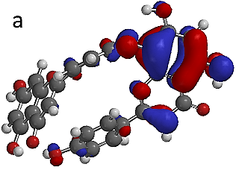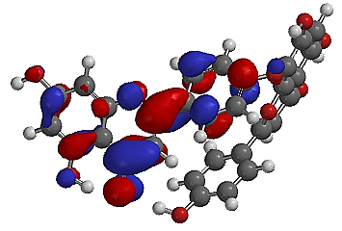
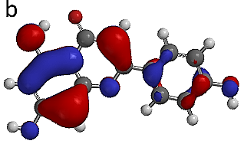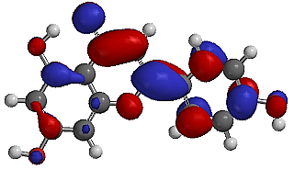
Figure 2: HOMO (lettered) and LUMO (unlettered) plots of lanaroflavone (a) and apigenin (b)
Conclusion
The study investigated the anticancer property of C-O-C linked biflavonoids by targeting BCL-2 enzyme using molecular docking and also evaluated the quantum chemical properties of the hit molecule. Lanaroflavone was identified as the top-ranked BCL-2 inhibitor from the molecular docking studies. Its binding affinity and quantum chemical properties were compared with that of apigenin. The quantum chemical properties such as electrophilicity index of the compound revealed its bioactivity properties and also showed may elicit better BCL-2 inhibitory activity compared to apigenin. The in vitro BCL-2 inhibitory property of the hit molecule can be explored in future studies.
Declaration of conflicting interest
The author(s) declared no potential conflicts of interest

References
- Siegel RL, Miller KD, Jemal A. Cancer statistics, 2019. CA: a cancer journal for clinicians, 2019; 69(1), 7-34.
- Kutuk O, Letai A. Regulation of Bcl-2 family proteins by posttranslational modifications. Current Molecular Medicine 2008; 8, 102-118.
- Hatok J, Racay P. Bcl-2 family proteins: master regulators of cell survival. Biomol Concepts 2016; 7(4): 259-270.
- Knight T, Luedtke D, Edwards H, Taub JW. A delicate balance - The Bcl-2 family and its role in apoptosis, oncogenesis and cancer therapeutics Biochemical Pharmacology 2019; 162: 250-261.
- Ola MS, Nawaz, M, Ahsan H. Role of Bcl-2 family proteins and caspases in the regulation of apoptosis. Molecular and cellular biochemistry, 2011; 351, 41-58.
- Yip KW, Reed JC. Bcl-2 family proteins and cancer. Oncogene 2008; 27: 6398-6406.
- Fakhri S, Abbaszadeh F, Jorjani M, Pourgholami MH. The effects of anticancer medicinal herbs on vascular endothelial growth factor based onpharmacological aspects: A review study. Nutr. Cancer. 2021; 73: 1-15.
- Goossens JF, Goossens L, Bailly C. Hinokiflavone and related C-O-C-type biflavonoids as anti-cancer compounds: Properties and mechanism of action. Nat. Prod. Bioprospect. 2021; 11, 365-377.
- Kang F, Zhang S, Chen D et al. Biflavonoids from Selaginella doederleinii as Potential Antitumor Agents for Intervention of Non-Small Cell Lung Cancer. Molecules 2021; 26, 401.
- Lin X, Li X, Lin X. A review on application of computational methods in drug screening and design. Molecules 2020; 25, 1375.
- Faloye KO, Bekono BD, Fakola EG et al. Elucidating the glucokinase activating potentials of naturally occurring prenylated flavonoids: An explicit computational approach. Molecules, 2021; 26(23), 7211.
- Birkinshaw RW, Gong JN, Luo CS et al. Structures of BCL-2 in complex with venetoclax reveal the molecular basis of resistance mutations. Nature communications, 2019; 10(1), p.2385.
- Trott O, Olson AJ. AutoDock Vina: improving the speed and accuracy of docking with a new scoring function, efficient optimization, and multithreading. Journal of Computational Chemistry, 2010; 31(2), 455–461.
- Becke AD. A new mixing of Hartree–Fock and local densityfunctional theories. The Journal of Chemical Physics, 1993; 98(2), 137
- Weniger B, Vonthron-Sénécheau C, Kaiser M, et al. Comparative antiplasmodial, leishmanicidal and antitrypanosomal activities of several biflavonoids. Phytomedicine, 2006; 13(3), 176-180.
- Faloye KO, Tripathi MK, Adesida SA, et al. Antimalarial potential, LC–MS secondary metabolite profiling and computational studies of Zingiber officinale. Journal of Biomolecular Structure and Dynamics, 2023; 1-16.
- Olajubutu OG, Ogunremi BI, Adewole AH, et al. (). Topical anti-inflammatory activity of Petiveria alliacea, chemical profiling and computational investigation of phytoconstituents identified from its active fraction. Chemistry Africa, 2022; 5(3), 557–565.
- Marinho MM, Almeida-Neto FWQ, Marinho EM, et al. Quantum computational investigations and molecular docking studies on amentoflavone. Heliyon, 2021; 7(1).

