Screening of chickpea genotypes for source of resistance against dry root rot caused by Macrophomina phaseolina (Tassi.) Goid)

.
ABSTRACT

Screening of chickpea genotypes was carried out under natural field & artificial conditions during Rabi 2022 and 2023 at research farm of BSP, AICRP on Chickpea, JNKVV, Jabalpur Madhya Pradesh. Twenty six chickpea genotypes were tested against R. bataticola under natural conditions. Result of this study nine genotypes viz. JG 2020-1614, JG 52, JG 11 x JG 14, JG 18, JG 2020-12-16-8, ICCV 211204, JG 315, JG 2016-9651 and ICCV 191257 exhibited resistant reaction, seven were moderately resistant, six were moderately susceptible, three were susceptible and only one (L550) showed highly susceptible reaction. Screening of twenty six genotypes using blotter paper technique (artificial conditions). Result of this study two genotypes viz. ICCV 211204 and JG 2016-9651 showed resistant reaction, six had moderately resistance, thirteen were moderately susceptible reaction, two showed susceptible reaction, and three namely L 550, JAKI 9218 and JG 62 were showing highly susceptible reaction.

Keywords: [Chickpea, Macrophomina phaseolina, Screening, Genotypes, Resistance, Dry root rot}

1. INTRODUCTION

Chickpea (Cicer arietinum L.) is a popular pulse crop farmed in over 50 countries. It originated from Southwest Asia and has been cultivated for centuries throughout Asia and Europe. It is the world's second most significant food legume, followed by common bean. Asia accounts for 89.20% of chickpea acreage and 84.47% of production. India (67.4%), Australia (6.21%), Pakistan (5.73%), Turkey (3.86%), Myanmar (3.74%), and Iran (2.25%) are the top chickpea producing countries, accounting for more than 90% of global production. Chickpea cultivation in India covers 10.91 million hectare. Total production is 13.75 million tones with productivity of 1260 kg/ha of which the state of Madhya Pradesh contributes 2.03 million hectare area with 3.03 million tonnes production and 1492 kg/ha productivity (Anon., 2023). States of India viz., Madhya Pradesh, Chhattisgarh, Rajasthan, Maharashtra, Uttar Pradesh, Andhra Pradesh, and Karnataka account for 95.71% of total production and 90% of area in the country. Chickpea, a member of the Leguminaceae family, is typically grown in the tropics during the rainy season on moist soil and in temperate as well as Mediterranean regions throughout the spring. Chickpea cultivation is often subjected to significant yield losses due to insects and diseases ranging from 5-10% in temperate and 50-100% in tropical regions (Van Emden et al., 1988). Dry root rot is the most damaging disease of chickpea that limits the productivity and production significantly. It is more common during hot temperatures (30-35°C) and poor soil moisture conditions (Taya et al., 1988; Pande and Sharma, 2010). Rhizoctonia bataticola (Taub.) Butler [Pycnidial stage: Macrophomina phaseolina (Tassi) Goid], the causal organism of dry root rot is a necrotrophic fungal pathogen that infects over 284 plant species, including monocots and dicots (Farr et al., 1995). In a chickpea field, the disease manifests as patchy drying of the plants. Affected plants often seem straw-colored, but lower leaves and stems may have dark discoloration. Better understanding the role of temperature and soil moisture help in standardization of dry root rot resistance screening techniques which will assist in developing crop breeding strategy for dry root rot resistance over broader geographical areas.
2. material and methods

Screening of twenty six chickpea genotypes was carried out under natural field & artificial conditions during Rabi 2022 and 2023 at research farm of BSP, AICRP on Chickpea, JNKVV, Jabalpur.

Table 1: Rating scale for scoring of dry root rot of chickpea (1-9 scale)

Disease Reaction | Scale | Per cent Disease incidence (%)
Resistance | 1 | 0-10%
Moderately Resistance | 3 | 11-20%
Moderately Susceptible | 5 | 21-30%
Susceptible | 7 | 31-50%
Highly Susceptible | 9 | 51-100%
Plant Pathology technical programme of AICRP on Chickpea (2022-23)

  - Artificial screening through blotter paper method
Twenty six chickpea genotypes procured from AICRP on Chickpea, JNKVV, Jabalpur were screened in the laboratory condition using Blotter Paper Technique to study the reaction of lines to Rhizoctonia bataticola infection and to identify the resistance sources for the disease. Potato Dextrose Broth (PDB) was used for culturing the fungus. 250 ml of PDB was poured into 500 ml conical flasks and steam sterilized in autoclave at 15 PSI for 15 minutes. The flasks were then inoculated with the fungus and incubated at 35C for seven days. The mycelial mat formed in the flask was removed and macerated in a waring blender along with distilled water for a minute. The inoculum was later collected in a beaker. In the mean time, chickpea seedlings were raised in earthen pots containing sterilized sandy soil. One week old ten seedlings were uprooted and the roots were immersed in sterile water in order to remove the adhered soil particles. The seedlings were then immersed completely in the inoculum placed in a beaker for 60 seconds. The seedlings particularly the root portion were then placed side by side on a blotter paper (45 cm x 25 cm with one fold) in such a way that only the cotyledons and roots were covered and the green portion of seedlings remained outside and then blotter paper were folded. One folder blotter paper contained the seedlings of one test line. The folded blotter papers were then placed in trays and trays were placed in an incubator at 35C for eight days. During the incubation period, twelve hour artificial light was provided and the blotters were moistened with sterile water every day. At the end of the incubation period, seedlings were examined for the extent of root damage and scored for the disease severity on 1- 9 rating scale (Nene et al., 1981).
Table 2: Description of the rating scale for scoring
Scale | Category | Symptoms
1 | Resistance | No infection on roots
3 | Moderately Resistance | Very few small lesions on roots
5 | Moderately Susceptible | Lesions on roots clear but small and new roots free from infection
7 | Susceptible | More lesion on roots; many new roots generally free from lesions
9 | Highly Susceptible | Roots infected and completely discolored

3. results and discussion

  - Screening of chickpea genotypes against dry root rot disease
Under natural field conditions
.
Breeding for resistance and screening of genotypes under both natural field conditions and artificial environments is an inexpensive and environmentally sustainable method for addressing the issue of dry root rot. Resistant varieties defend themselves against disease and save time, energy, and money spent on other forms of control. The level of resistance for 26 chickpea elites genotype were evaluated under natural field conditions for two years. Since the disease is soil borne, exploitation of host plant resistance is the most economical way to manage the disease. Host plant resistance serves as a cornerstone of integrated pest management systems, offering farmers a self-contained defense mechanism that requires no additional inputs once established. Unlike chemical treatments that demand repeated applications throughout the growing season, resistant varieties provide continuous protection from planting to harvest. This inherent protection translates directly into reduced production costs, as farmers can decrease their expenditure on fungicides, application equipment, and labor associated with disease management activities. The environmental benefits of this approach extend far beyond individual farm operations. By reducing reliance on chemical pesticides, resistant varieties contribute to the preservation of beneficial soil microorganisms, protect non-target species including pollinators and natural enemies of pests, and prevent contamination of water resources through reduced chemical runoff. Additionally, this approach helps maintain the long-term effectiveness of chemical control options by reducing selection pressure for pesticide-resistant pathogen strains. The level of resistance in 26 chickpea elite genotype were evaluated under natural field conditions during Rabi 2022 and 2023. Data are presented in Table 3 significant difference in dry root rot (DRR) incidence among the screened genotypes of Chickpea was observed in both the years. In first year (2022-23), the incidence of DRR was ranged between 6.3% (JG 52) to 51.8% (L 50). Twelve genotypes namely ICCV 191257, ICCV 15104, JG 2020-
1614, JG 52, JG 2016-9651, JG 2021-67, JG 11 x JG 14, JG 18, JG 2018-51, JG 2020-12-16-8, ICCV 211204 and JG 315 were shown resistant reaction. In second year, it was ranged between 8.5% (JG 2020-1614) to 59.5% (L 550). Eight genotypes i.e.; JG 2020-1614, JG 52, JG 2016-9651, JG 11 x JG 14, JG 18, JG 2020-12-16-8, ICCV 211204 and JG 315 shown resistant reaction against the dry root rot. Whereas, seven genotypes namely ICCV 191257, JG 36, JG 74 x JG 315, JG 24, JG 16 x JG 17, JG 14 and JG 12 x ICC 4958
showed moderate resistance. The highest incidence was recorded in susceptible checks in both the years. Average incidence of dry root rot was maximum in L 550 (55.7%), followed by JAKI 9218 (44.9%), ICCV 221110 (31.5%), JG 62 (31.1), JG 16 (29.8%), JG 2016-14-16-11 (23.2%), JG 12 (21.6%), JG 12 x JG 14 (21.5%) and ICCV 15104 (21.0%). Where as
minimum incidence was recorded in JG 2020-1614 (6.8%), followed by ICCV 211204 (7.4%), JG 52 (7.8%), JG 2016-9651 (7.9%), JG 18 (8.0%), JG 2020- 12-16-8 (8.3%), JG 315 (9.5%), JG 11 x JG 14 (9.7%) and ICCV 191257 (9.9%).
Chickpea genotypes were grouped in different categories of reaction against dry root rot and result are presented in Table 4 ang Fig. 1. Out of 26, nine genotyeps i.e.; JG 2020-1614, JG 52, JG 11 x JG 14, JG 18, JG 2020-12-16-8, ICCV 211204, JG 315, JG 2016-9651 and ICCV 191257 were shown resistant reaction against the dry root rot disease. Whereas, seven genotypes i.e.; JG 36, JG 74 x JG 315, JG 24, JG 16 x JG 17, JG 14, JG 12 x ICC 4958, JG 2021-67 showed moderate resistance, six namely JG 12, ICCV 15104, JG 16, JG 2016-14-16-11, JG 2018-51, JG 12 x JG 14 were moderate susceptible. Three genotypes ICCV 221110, JAKI 9218, JG 62 were susceptible and one genotype L 550 was highly susceptible to dry root rot. It is evident from the data that 34.62% genotypes were from resistant, 26.92% moderate resistant, 23.08% moderate susceptible, 11.54% susceptible and 3.85% highly susceptible to dry root rot. Similar to our work, Jayalaxmi et al. (2008), Jagre et al. (2018), Patidar et al. (2019), Talekar et al. (2021) were carried out field evaluation of chickpea genotypes and identified genotypes with different category of resistance againt dry root rot disease. Pancheshwar et al. (2016) also screened different genotypes of soybean against YMV and found that 40 genotypes showed highly resistant reaction, 16 genotypes were showing moderate resistant reaction among 72 soybean germplasm line.

Table 3: DRR incidence and differential reactions in chickpea genotypes under natural field conditions during 2022-23 and 2023-24

S.  No. | Genotypes | Per cent disease Incidence |  |  | Reaction
S.  No. | Genotypes | 2022-23 | 2023-24 | Average | Reaction
1 | ICCV 191257 | 08.5  (16.9) | 11.3  (19.6) | 09.9 | R
2 | JG 12 | 19.7  (26.3) | 23.6  (29.0) | 21.6 | MS
3 | ICCV 15104 | 09.6  (18.0) | 32.5  (34.7) | 21.0 | MS
4 | JG 36 | 10.1  (18.4) | 14.3  (22.2) | 12.2 | MR
5 | JG 12 x JG 14 | 19.6  (26.2) | 23.4  (28.9) | 21.5 | MS
6 | JAKI 9218 | 41.5  (40.0) | 48.3  (44.0) | 44.9 | S
7 | JG 2020-1614 | 05.1  (13.0) | 08.5  (16.9) | 06.8 | R
8 | JG 2016-14-16-11 | 13.2  (21.2) | 33.3  (35.2) | 23.2 | MS
9 | JG 74 x JG 315 | 13.2  (21.2) | 16.1  (23.6) | 14.6 | MR
10 | JG 24 | 11.9  (20.1) | 13.7  (21.6) | 12.8 | MR
11 | JG 52 | 06.3  (14.4) | 09.4  (17.8) | 07.8 | R
12 | ICCV 221110 | 19.7  (26.3) | 43.3  (41.1) | 31.5 | S
13 | JG 16 | 31.6  (34.1) | 28.1  (31.9) | 29.8 | MS
14 | JG 62 | 27.4  (31.5) | 34.8  (36.1) | 31.1 | S
15 | JG 2016-9651 | 07.3  (15.6) | 08.5  (16.9) | 07.9 | R

S.  No. | Genotypes | Per cent disease Incidence |  |  | Reaction
S.  No. | Genotypes | 2022-23 | 2023-24 | Average | Reaction
16 | JG 16 x JG 17 | 17.5  (24.7) | 20.0  (26.5) | 18.7 | MR
17 | JG 14 | 11.3  (19.6) | 13.5  (21.5) | 12.4 | MR
18 | JG 2021-67 | 08.1  (16.5) | 26.7  (31.0) | 17.4 | MR
19 | JG 11 x JG 14 | 09.5  (17.9) | 10.0  (18.4) | 09.7 | R
20 | JG 12 x ICC 4958 | 11.8  (20.0) | 13.4  (21.4) | 12.6 | MR
21 | JG 18 | 06.4  (14.6) | 09.7  (18.1) | 08.0 | R
22 | JG 2018-51 | 09.1  (17.5) | 24.3  (29.5) | 16.7 | MS
23 | JG 2020-12-16-8 | 07.1  (15.4) | 09.6  (18.0) | 08.3 | R
24 | ICCV 211204 | 06.1  (14.2) | 08.7  (17.0) | 07.4 | R
25 | JG 315 (Resistant) | 09.1  (17.5) | 09.8  (18.1) | 09.5 | R
26 | L 550 (Susceptible) | 51.8  (45.9) | 59.5  (50.4) | 55.7 | S
SEm+ |  | 0.46 | 0.49
CD (P=0.05) |  | 1.32 | 1.40
*R= Resistance, MR= Moderately resistance, MS= Moderately susceptible, S= Susceptible, HS= Highly susceptible
Table 4: Categorization of chickpea genotypes against dry root rot under artificial inoculation

Rating Scale | Symptoms | No. of genotypes | Genotypes | Reaction
1 | No infection on roots | 02 | ICCV 211204, JG 2016-  9651 | R
3 | Very few small lesions on roots | 06 | JG 12 x ICC 4958, JG  2020-12-16-8, ICCV  191257, JG 2020-1614, JG  52, JG 18 | MR
5 | Lesions on roots clear but small and new roots free from infection | 13 | JG 14, JG 16 x JG 17, JG  36, JG 24, JG 11 x JG 14,  JG 2021-67, JG 315, JG  12 x JG 14, JG 74 x JG  315, ICCV 221110, ICCV  15104, JG 2016-14-16-11,  JG 2018-51 | MS
7 | More lesion on roots; many new roots generally free  from lesions | 02 | JG 12, JG 16 | S
9 | Roots infected and completely discolored | 03 | L 550, JAKI 9218, JG 62 | HS

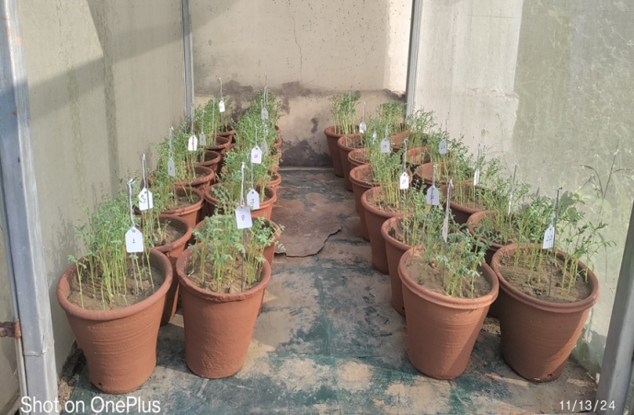

Plate 1: Chickpea genotypes grown in pot for study of artificial screening against dry root rot

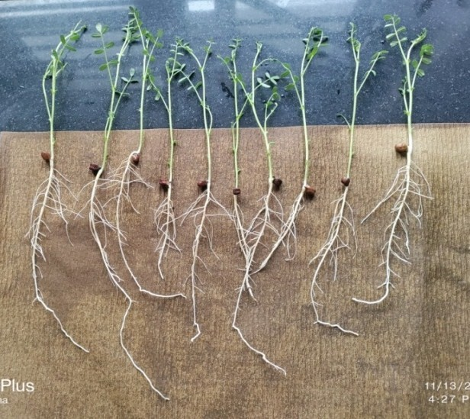 | 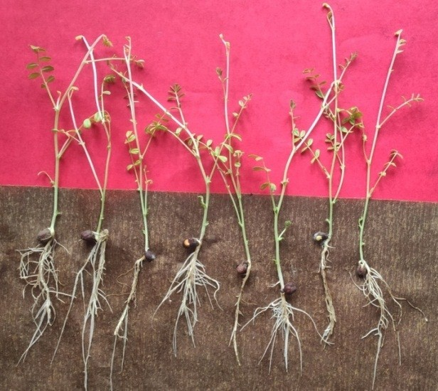
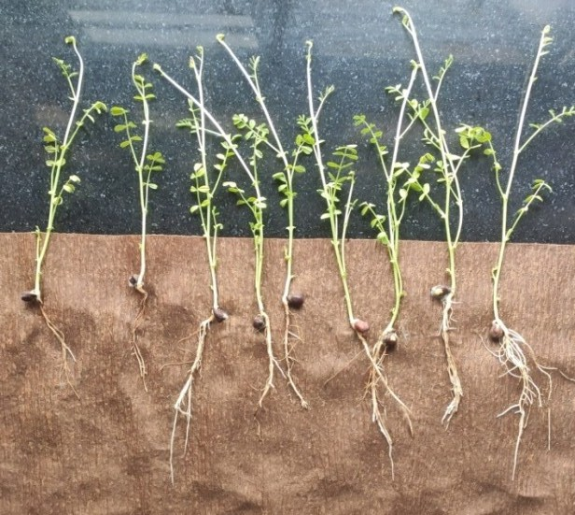 | 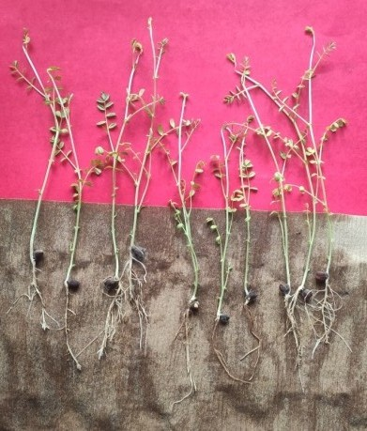
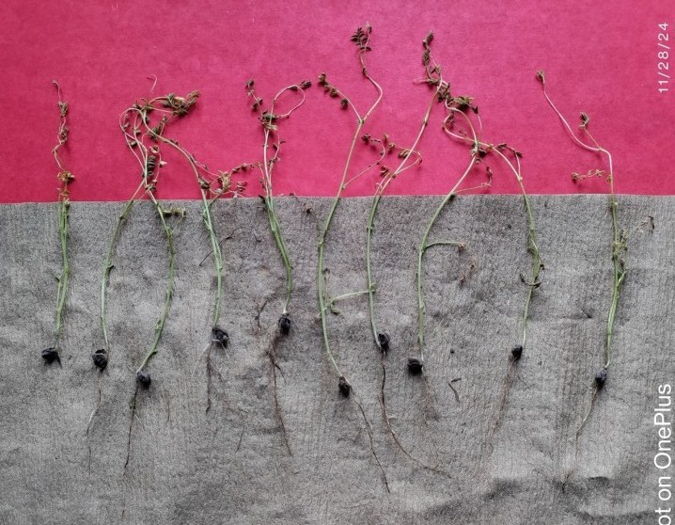
A-(Resistance); B- (Moderately resistance); C- (Moderately susceptible); D- (Susceptible); E- (Highly susceptible)
Plate 2- Seedlings showing varying disease responses for resistance grading (A–E)
4. Conclusion

The development of crop varieties with inherent disease resistance represents one of the most economically viable and environmentally conscious approaches to agricultural disease management. In the context of chickpea cultivation, dry root rot poses a significant threat to crop productivity and farmer livelihoods. Rather than relying heavily on chemical interventions or other costly management strategies, plant breeders have increasingly focused on developing resistant cultivars that can naturally defend against this devastating pathogen. The strategy of breeding for resistance offers multiple advantages over conventional disease control methods. It provides a cost-effective solution that reduces the financial burden on farmers while simultaneously minimizing the environmental impact associated with chemical pesticide applications. This approach aligns with the principles of sustainable agriculture by promoting ecological balance and reducing the risk of pesticide resistance development in target organisms. The comprehensive evaluation of chickpea genotypes for dry root rot resistance under natural field conditions represents a scientifically sound and economically practical approach to addressing one of the most challenging diseases in chickpea production. This methodology combines the rigor of scientific evaluation with the practical realities of commercial agriculture, ensuring that resulting varieties will provide meaningful benefits to farmers while contributing to more sustainable and environmentally responsible crop production systems. The following conclusion can be drawn from the present study. Out of twenty six chickpea genotypes nine genotypes namely JG 2020- 1614, JG 52, JG 11 x JG 14, JG 18, JG 2020-12-16-8, ICCV 211204, JG 315, JG 2016-9651 and ICCV 191257 were shown resistant reaction under natural field conditions. Furthermore, resistant varieties contribute to food security by ensuring more consistent chickpea production, which is crucial given the crop's importance as a protein source in many developing countries. The multiplication and distribution of resistant varieties can have far-reaching impacts on rural livelihoods and nutritional security.

References
Anonymous. 2023. Directorate of Economics and Statistics (DES). https://desagari.gov.in.
Farr DF, Bills GF, Chamuris GP and Rossman AY. 1995. Fungi on plants and plant products in the United States. 2nd ed. St Paul, MN: APS Press.
Gupta O, Manisha R and Mishra M. 2012. Screening for resistance against Rhizoctonia bataticola causing dry root rot in chickpea. Journal of Food legumes 25(2): 139-141.
Jagre A, Nagar GP and Gupta O. 2018. Screening of chickpea (Cicer arietinum L.) genotype against dry root rot through Blotter Paper Technique In-vitro Condition. International Journal of Current Microbiology and Applied Sciences Special Issue 7: 30-34.
Jayalaxmi SK, Usharani S, Benagi VI and Mannur DM. 2008. Sources of resistance to dry root rot of chickpea caused by Rhizoctonia bataticola. Agricultural Science Digest 28(2): 147-148.
Nene YL, Reddy MV, Haware MP, Ghanekar AM and Amin KS. 1981. Field diagnosis of chickpea diseases and their control. ICRISAT Information Bulletin 28:52.
Pancheshwar DK, Mishra S, Kumar S and Singh G. (2016). Screening of resistance soybean [Glycine max (L.) Merr.] genotypes against the yellow mosaic virus (YMV) disease. International Journal of Agriculture Sciences 8(20): 1362-1363.
Pande S and Sharma M. 2010. Climate change: potential impact on chickpea and pigeonpea diseases in the rainfed semi-arid tropics (SAT). In: 5th International Food Legumes Research Conference (IFLRC V) & 7th European Conference on Grain Legumes (AEP VII) April 26-30, 2010.
Patidar JK, Singh R, Singh PK and Fatehpuria PK. 2019. Screening of chickpea lines against dry root rot of chickpea caused by Rhizoctonia bataticola (Taub.) butler. Journal of Pharmacognosy and Phytochemistry 8(1): 1030-1032.
Pandey AK, Burlakoti RR, Rathore A and Nair RM. 2020. Morphological and molecular characterization of Macrophomina phaseolina isolated from three legume crops and evaluation of mungbean genotypes for resistance to dry root rot. Crop Protection 127: 104962.
Taya RS, Tripathi NN and Panwar MS. 1988. Influence of soil type, soil moisture and fertilizers on the severity of chickpea dry root rot caused by Rhizoctonia bataticola (Taub.) Butler. Indian Journal of Mycology and Plant Pathology 18: 133-136.
Talekar SC, Viswanatha KP and Lohithasawa HC. 2021. Screening chickpea genotypes for resistance to Rhizoctonia bataticola in controlled conditions. Legume Research- An International Journal 44(1):101- 108.
Van EHF, Ball SL and Rao MR. 1988. Pest diseases and weed problems in pea, lentil and faba bean and chickpea. In Summer field R.J. (ed.), World crops: cool season food legumes. Dordrecht: Kluwer 519-534.

