Original Research Article

Automatic Family Drip System (FDS) for Increased Vegetable Production in Urban Sector

ABSTRACT

Farm fresh vegetable production is gaining much importance in urban areas. This is a turning point for agriculture in urban and peri-urban areas, to introduce new technology like Drip Irrigation System (DIS). Nowadays, urban people take due care by cultivating vegetables on their roof–top, because of high pesticide residues in market produce. But, urban farming initiatives lack supervision and guidance in whole cultivation practices especially in irrigation. Here comes the role of low-cost drip irrigation system to solve acute water shortage and labor problem

Keeping in view of the above few facts, a field experiment was conducted on automatic drip irrigation for grow bag cultivation to evaluate yield, water-use- efficiency and economic feasibility of a commonly used vegetable, okra. Comparison was done with the manual hose irrigation for grow bags.

A comparative study was conducted to evaluate the performance of time-based automatic drip irrigation system and manual hose irrigation in okra. Irrigation time optimized at 15minutes provided 250 ml of water per plant. Based on the growth stage, crop water requirement of vegetables was estimated to be 0.6 to 2 litre/day. To meet this crop water requirement, irrigation was done at four time intervals viz., morning twice and evening twice in such a manner one litre water was irrigated per grow bag. Thus, drip irrigation conserved 50% water compared to manual hose irrigation. It was found that drip irrigation gave 37.70% higher yield than that obtained with the manual drip irrigation system. Automatic DIS increased irrigation efficiency up to 95% than that of conventional method of irrigation.

Time based Automatic Family Drip System (FDS) is observed to be user-friendly, economical and cost effective as compared to conventional hose irrigation for farming on terraces in cities. Time saving, low energy consumption and low pressure low cost DIS had been widely accepted among urban farmers to promote vegetable cultivation in their own houses.

Keywords - DIS; Water Use Efficiency; Crop yield, Water Savings

1.INTRODUCTION

The world’s population is now increasingly urban, with more than half living in urban areas. Urban population has out-numbered the rural one with the share 54.29% (3.9 billion) globally (2016). In India as well, the urban population escalated to 35% in 2020 from a miniscule 18% in 1960 (Batty, 2015; World Bank, 2017). Besides, the population of urban areas is expected to grow to nearly 60% and 40% in the world and India, respectively by 2030 (First Post, 2014).
The 96% of operational holdings in Kerala is below one hectare. Kerala promotes urban agriculture like roof-top farming and gardening. The majority of urbaner are either senior citizens or part-time workers. The whole agricultural operations to follow found to be difficult for them since the cropping is at roof-top. The major constraint is especially observed for doing irrigation during summer seasons. Minimum of 25 to 200 grow bags were maintained by them. During irrigation they will provide large quantity of water which was not measurable from their end. During summer season, the temperature will be high and thereby, irrigation during morning and evening hours is must. Generally, they lack in irrigating the crops which led to wilting of crops resulting in crop loss too. This conventional method of giving water is very ineffective and inefficient.
Drip irrigation system is the solution for this. Drip irrigation (also known as trickle irrigation or micro-irrigation) is an irrigation method that allows precisely controlled application of water and fertilizer by allowing water to drip near the plant roots through a network of valves, pipes, tubing, and emitters. Here most suitable method is automation.
An automated irrigation system refers to the operation of the system with no or just a minimum of manual intervention beside the surveillance. Almost every system (drip, sprinkler, surface) can be automated with help of timers, sensors or computers or mechanical appliances. It makes the irrigation process more efficient and with this, workers can concentrate on other important farming tasks. On the other hand, such a system can be expensive and very complex in its design and may needs experts to plan and implement it.

2.MATERIALS AND METHODS

In micro irrigation sector, manual interventions are automated to perform all operations, starting from watering to fertigation as per the prescribed schedule. Development of automated system has resulted in lot of developments in crop production like improvement in water saving, increase in crop yield, enhancement in water as well as fertilizer use efficiencies and greater benefit-cost ratio as well, in comparison to general micro irrigation system (Suresh, 2010). Automated timer-based system is comparatively cheaper and hence gaining more popularity than the volume-based system (Rajkumar et al., 2008).
Drip irrigation also gave the highest yield with 319 mm of water use as compared to surface irrigation and drip irrigation system with LLDPE plastic mulch increased yield by 57 % over surface irrigation with same quantity of irrigation water. Similar results have been obtained by Tiwari et al. (1998) for okra crop at Kharagpur, West Bengal. Paul et al. (2013) conducted a study on drip irrigation with plastic mulching; this system increased yield by 57% and net seasonal income by 54%. Sivanappan et al. (1987) conducted a study on drip irrigation for okra and the results revealed that water saved was as high as 84.7% and noted a slight increase in yield by 7.6%. In one study on tomato crop (Carpena et al. 2003), automated irrigation system with feedback from soil moisture sensors resulted in 73% reduction in water use, when compared with standard commercial practices, without any effect on the yield.
Automatic drip irrigation system involves digital timer, submersible pump and drip irrigation materials. For household purpose, we have adopted digital timer rather than volume-based irrigation method. Cost of the equipment also plays a major role to adopt this mechanism at farmers’ level. Hence all the inputs are affordable to them. The advantages are shown in below.
2.1Advantages
- Automation eliminates the manual operation of opening or closing valves.
- Possibility to change frequency of irrigation and fertigation processes and to optimise these processes
- Adoption of advanced crop systems and new technologies, especially new crop systems that are complex and difficult to operate manually
- Increased efficiency in water and fertiliser use
- System can be operated at night, water loss from evaporation is thus minimised
- Irrigation process starts and stops exactly when required, thus optimising energy requirements
2.2Schematic Diagram
Fig. 1 gives the schematic of installation of DIS. Submersible pump must be immersed in water tank and timer connected to the circuit. The main line Φ 16mm LLDPE pipe is directly connected to a 35W pump to lift the water from the tank. The main unit is connected to a screen filter and control valve. The lateral is provided with on line turbokey dripper of 4 ltr/hr discharge capacity. Four-way assembly with four microtubes are fitted on dripper and tubes were inserted into the 4 grow bags. Fifteen drippers can irrigate 60 grow bags with a discharge rate of 1LPH / Poly bag when the grow bags are arranged side by side. If they are arranged 45cm apart, an additional 10m lateral is needed to cover 60 grow bags. Screen filter, filter the water efficiently at the rate of 700 litre per hour. Drip kit will last for more than five years without any fail.
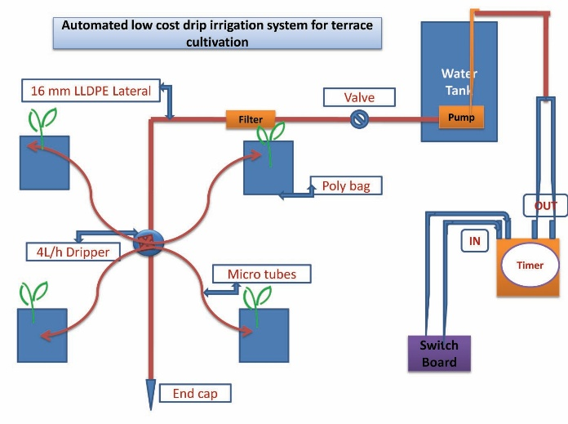
Fig. 1 Schematic diagram of Automated DIS

2.2Operation procedure

Irrigation rate was 250ml of water per plant for 15 minutes. Since the crop water requirement of vegetables is 0.6- 2 ltr/day, irrigation was applied daily for 1 hour. Drip irrigation was applied more frequently in four irrigation intervals due to the slower water delivery rate of the drip system.

2.2.1 Crop yield
The yield was recorded for three crop seasons. Weight of vegetables obtained from 60 grow bags has been measured as the total crop yield.
2.2.2 Water use efficiency

Water use efficiency was determined using Eq. (1),
E_{u} = C/W_{c} (1)
Where C = Crop yield in Kg/ha cm/m²
W_{c} = Water consumed by the crop in ha cm per unit area

Since the drip irrigation was used for grow bag vegetable cultivation; based on the experimental study conducted by Babu et al. (2015), the consumptive water use for okra was fixed as 309.8 mm for drip irrigation and for manual irrigation 535 mm based on the study of Sivanappan et al. (1987).

2.2.3 Irrigation Scheduling

The crop requires adequate moisture during summer months for faster growth. The daily water requirement of okra crop is 2.4 l/day/4 plants during early growth stage and 7.6 l/day/4 plants during the peak growth stage. The irrigation system should be operated daily for 75 minutes during initial growth stage and for 228 minutes during peak growth of the crop with an emitter capacity of 2 lph. Irrigation on each day or on alternate days with on-line type of drippers is preferred (Tiwari, 2015).

2.2.4 Economic analysis

Benefit-cost ratio and net profit were carried out to determine the economic feasibility of the crop using surface and drip irrigation in accordance with Tiwari et al. (1998). The fixed cost of the drip irrigation system was Rs. 3750/unit. The useful life of the drip system was considered to be five years. The system cost was evaluated by distributing the fixed cost of system over life period of drip irrigation set. In addition to this the cost of cultivation includes expenses incurred for grow bags, porting mixture, intercultural operation, fertilizer, crop protection measures, irrigation water and harvesting with labor charge.

3.RESULTS AND DISCUSSIONS

The experimental study was conducted at Thiruvananthapuram on 2018 covering five units. The okra was the identified crop for parameters evaluation. Fig. 2 shows the automated DIS installed at two houses. Water was applied equally in all bags. Germination was highest in grow bags that were irrigated through DIS. Plants responded to DIS so much so that flowering in drip irrigated bags started a month earlier than controlled bags (those being watered manually using hose). The yield was recorded for three crop periods. The yield obtained per plant, for okra, was 215kg in drip compared to hose irrigation.

3.1 Water use efficiency
On an average, water consumption was observed to be 50% less as compared to conventional irrigation. The amount of water required was further less during rainy seasons. Irrigation was programmed for 15 minutes duration at four different timings to meet the per day water requirement of 1 ltr/ plant. Table 1 gives the water use and yield for drip irrigated and control methods for cultivation of okra (average of two-year period).

TABLE I Water use and yield in drip irrigated and control method

Plot No. | Water use efficiency  (t/ha-cm) |  | Yield  (Kg/60 Nos. of Grow bags) |  |  | % increase in yield
Plot No. | Control | Drip | Control | Drip |  | % increase in yield
1 | 2.34 | 6.62 | 125 |  | 205 | 64
2 | 2.30 | 6.29 | 123 |  | 195 | 58.54
3 | 2.06 | 6.08 | 110 |  | 188 | 70.91
4 | 3.08 | 6.94 | 165 |  | 215 | 30.30
5 | 1.77 | 6.10 | 95 |  | 189 | 98.95

It may be observed that maximum water use efficiency was observed to be 6.94 t/ha-cm at plot 4 compared to hose irrigation. The water use efficiency between conventional and drip irrigation is given in Fig. 3.
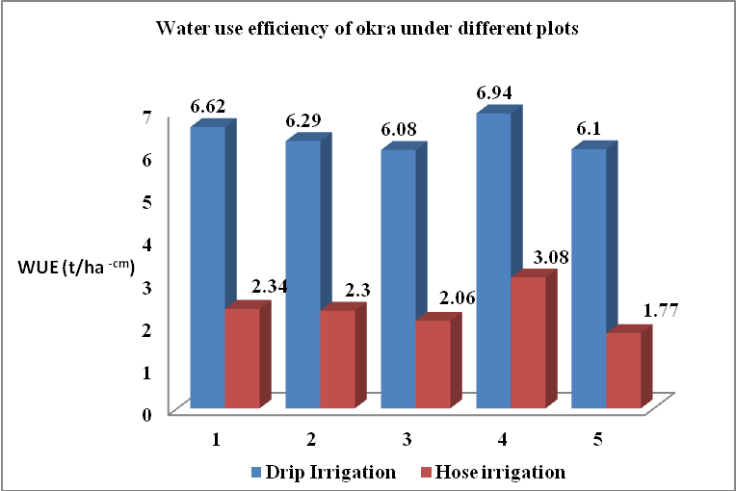
Fig. 3 Water use efficiency of DIS and hose irrigation during cultivation of okra at five terraces

3.2 Irrigation efficiency

During manual hose irrigation, about half the amount of water supplied is lost by leakage, overflow and also thorough evaporation. The irrigation efficiency is only 50%. Using timer-based automated DIS, water saved was as high as 95%. Quantity of water used for four drip irrigations was 1-2 litres/plant against 5 - 10 litres in conventional method.

3.3 Yield
As observed from Table 1, maximum yield obtained was 215kg for 60 numbers of poly bags compared to conventional irrigation for three crop seasons. As the discharge rate increases, crop yield also increases substantially (Fig. 4
). The yield of okra under drip irrigation gave 30-98% more yield as compared to conventional method of irrigation by overcoming severe moisture stress.
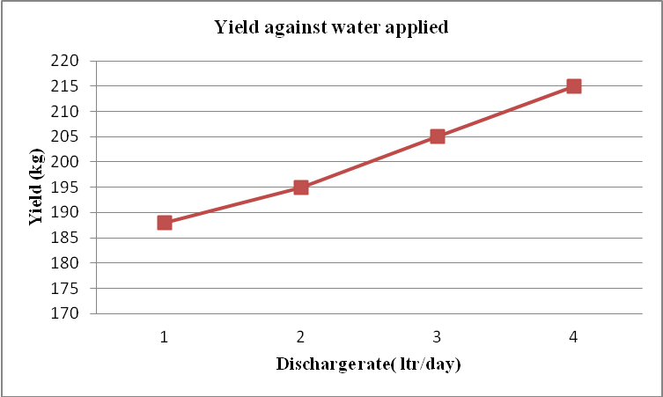
Fig. 4 Crop yield with water discharge

3.4 Water savings
It was observed that there was substantial water saving ranging from 70 to 90% compared to conventional hose irrigation.
3.5 Economic feasibility
Maximum net return of Rs. 3425 for 60 grow bags with B:C ratio of 1.54 was recorded at P4 and lowest net profit of Rs.1845 for 60 grow bags with B:C ratio of 1.25 in P1 (Table 3). At the same time for conventional irrigation, net income varies from Rs. 250 – 575 for 60 grow bags with B: C ratio 1.04 to 1.08. The lower B.C ratio is attributed to lower yield as a result of improper irrigation and thereby low gross income.
TABLE 2 Water use and yield in drip irrigated and control method

Plots | Drip |  |  |  | Control
Plots | Gross cost (Rs.) | Gross income (Rs.) | Net income (Rs.) | BCR | Gross cost (Rs.) | Gross income (Rs.) | Net income (Rs.) | BCR
P1 | 7380 | 9225 | 1845 | 1.25 | 5200 | 5625 | 425 | 1.08
P2 | 6680 | 9750 | 3070 | 1.45 | 6150 | 5800 | 350 | 1.06
P3 | 6000 | 9400 | 3400 | 1.56 | 5500 | 5250 | 250 | 1.04
P4 | 6250 | 9675 | 3425 | 1.54 | 7425 | 6850 | 575 | 1.08
P5 | 6500 | 9450 | 2950 | 1.45 | 4750 | 4500 | 250 | 1.05

4 CONCLUSIONS

Timer-based Automatic Family Drip System (FDS) is observed to be user-friendly, economical and cost effective as compared TO conventional hose irrigation for farming on roof-tops in cities. An average 37.70% increase in yield was obtained against 6.41 t/ha-cm water use efficiency. Water savings to the tune of 50% was observed with drip irrigation by avoiding the wetting of terrace with over-run water loss. Time savings, low energy consumption and low-pressure low cost DIS had been widely accepted among urban farmers to promote vegetable cultivation in their own houses.

REFERENCES
First Post. (2014). India’s urban population to reach 600 mn by 2031: UN-backed report. (Accessed on 9 August, 2017 from http://www.firstpost.com/india/indias-urban-population-reach-600-mn-2031- un-backed-report-1716149.html).
Vincent, A., Saravanan Raj, and Suchiradipa Bhattacharjee. (2018). Urban Farming: Good Practices and Knowledge Management. National Institute of Agricultural Extension Management (MANAGE).
World Bank. (2017). Urban population. Retrieved from https://data.worldbank.org/indicator/sp.urb. totl.in.zs
Batty, M. (2015). Cities in a completely urbanised world. Environment and Planning 42, 381–383. Retrieved from http://journals.sagepub.com/doi/pdf/10.1068/b4203ed
Sudarmaji, A., Sahirman, S., Saparso and Ramadhani, Y. (2019). Time based automatic system of drip and sprinkler irrigation for horticulture cultivation on coastal area. IOP Conf. Series: Earth and Environmental Science 250:012074; 1 -8.
Babu, G. R. Bhaskara Rao, I. Raj Kumar, K. N. (2015). Response of okra to different levels of drip irrigation on growth,yield and water use efficiency. International Journal of Agricultural Engineering, 8(1): 47-53.
Carpena, M. R., Bryan, H. and Klassen, W. (2003). Automatic soil moisture - based drip irrigation for improving tomato production, Proc. Fla. State Hort. Soc. , 116, 0-85.
Paul, J. C. Mishra, J. N. Pradhan, P. L. and Panigrahi, B. (2013). Effect of drip and surface irrigation on yield, water- use -efficiency and economics of capsicum (Capsicum annum L..) grown under mulch and non-mulch conditions in eastern coastal India European Journal of Sustainable Development, 2(1), 99-108.
Rajkumar, D., Raamah,K., Rathika, S. and Thiyagarajan, G. (2008). Automation in Micro irrigation. Science tech Entrepreneur.
Sivanappan, R. K. Padmakumari, O. and Kumar, V. (1987). Drip Irrigation, Keerthi Publishing House (P) Ltd., Coimbatore,
Suresh, R, (2010). Micro Irrigation. First Edition. Standard Publishers Distributors. New Delhi.
Tiwari, K.N, (2015). Technical Bulletin on Okra”, NCPAH(www.ncpahindia.com).
Tiwari, K. N. Mal, P. K., Singh, R. M. and Chattopadhya, A. (1998). Response of Okra to drip irrigation under mulch and non-mulch conditions, Agricultural Water Management, 38: 91-102.

