Determine the Shelf-Life of Brinjal (Solanum melongena) Using A Cold Room condition

Abstract:
Fresh and Firm Brinjal was purchased from Local market from Newasa (MH) and kept them in Cold Storage (10°C and 94% RH) and at room temperature for the evaluation of storage and post-storage life and shelf life at ambient conditions. In Brinjal weight loss was decreased rapidly. There were no chilling injury and disease symptoms observed in all commodities throughout the storage period. Storage life of Brinjal was observed 8 days respectively inside the cold room (10°C and 94% RH). Shelf life at room temperature of Brinjal was observed 2 days respectively.
Keywords: Brinjal, Temperature, Relative Humidity, Cold Storage, Shelf life, Post storage life.
Introduction:
Brinjal (Solanum melongena L.) is an important and indigenous vegetable crop of India. It contributes 9% of the total vegetable production of the country (Sidhu & Dhatt, 2006). Eggplant, brinjal, or aubergine (Solanum melongena L.) is, together with tomato, among the most widely known edible fruits of the Solanaceae family (Daunay M, 2008). Brinjals are thought to be derived from the wild African species, Solanum incanum. The scarlet brinjal (Solanum aethiopicum L.) and the gboma brinjal (Solanum macrocarpon L.) are grown and consumed in Africa and represent an important source of genetic variation (Daunay et al. 2001). Brinjals were already domesticated in Southeast Asia, particularly in Northeast India and Southeast China, more than 2000 years ago (Jadhav PB and Gurav NP, 2018).
Brinjal is a good source of dietary fiber, antioxidants such as nasunin and chlorogenic acid, and important vitamins like Vitamin C, Vitamin K, folate (Vitamin B9), and Vitamin B6. It also provides essential minerals, including potassium, manganese, magnesium, and copper, while being low in calories, fat, and cholesterol (Maurya et al. 2019). Brinjal fruit (unripe) is primarily consumed as cooked vegetable in various ways. India ranks second in the world in terms of brinjal production after China. Maharashtra ranks 9th in brinjal production in all Indian states.
Cold storage is the one widely practiced method for bulk handling of the perishables between the production and marketing processes. It is one of the method of preserving perishable commodities in a fresh and wholesome state for a longer period by controlling temperature and humidity within the storage system. Maintaining an adequately low temperature is critical, as otherwise it will cause chilling injury to the produce. Cold storage is necessary for brinjal to slow down spoilage by decreasing its physiological processes, preventing moisture loss and weight reduction, preserving its texture and flavor, and reducing the risk of infection from harmful microorganisms. By maintaining controlled temperature and humidity, cold storage extends the shelf life of brinjal, helping it stay fresh and suitable for sale much longer than it would under normal room conditions (Gurav & Sharma, 2019). Commodities stored together should be capable of tolerating the same temperature, relative humidity and level of ethylene in the storage environment. High ethylene producers (such as ripe bananas, mangoes, and apples) can stimulate physiological changes in ethylene-sensitive commodities (such as capsicum, lettuce, cucumbers, carrots, bottle gourd, potatoes, and sweet potatoes), leading to often undesirable colour, flavour and texture changes (Krishnakumar and Dayanandakumar 2002). However, the wholesalers, retailers or producers are seldom to afford the above-mentioned practices for increasing the shelf life of eggplants after harvest (Najafi et al. 2021).
Materials and Methods:
Freshly harvested brinjals were collected in the morning from the Newasa vegetable market and transported within 1 hour to the cold storage facility of New Leaf Dynamic Technologies Pvt. Ltd., located in Newasa, Ahilyanagar, Maharashtra. Upon arrival, the produce underwent sorting and grading to remove damaged or unfit samples. The selected brinjals were then placed in cold storage maintained at a temperature of 10°C and 94% relative humidity (RH) to ensure optimal preservation conditions. A 1 kg sample of the fresh produce was kept separately at room temperature to serve as a control for comparison. The rest of the brinjals were stored under cold conditions. During the storage period, the following parameters were monitored under both conditions: Weight loss to determine moisture loss and shrinkage, Visual quality, including: Shriveling percentage, Colour changes, Signs of disease and Chilling injury symptoms. This comparative study aimed to evaluate the effectiveness of cold storage in reducing post-harvest losses and maintaining the quality and shelf life of brinjal under controlled conditions.
Result and Discussion:
- Visual Observations Recorded:

- Shrivelling percentage: Shrivelling percentage was increased with advance storage time in the commodities. Initially less shrivelling was recorded in earlier stage as compared to later stage of storage. From on words 8th day more shrivelling was observed in the Brinjal at cold storage conditions. The relation of Shrivelling is inversely proportional to shelf life. Fruit quality was lost gradually as shrivelling started in both conditions. Shrivelling percentage varies from commodity to commodity (Gurav & Sharma, 2019). The increase in water loss and rapid shrinkage of peel due to physiological disorders during storage are most common adverse effects during storage of eggplants (Jha et al. 2002)
- Colour appearance percentage: In the early days of storage, brinjals maintained a higher colour appearance percentage, with all samples appearing fresh and visually appealing. However, as the storage period progressed, colour deterioration became evident in both cold storage and room temperature conditions, particularly after the brinjals were removed from the cold room. This gradual loss of vibrant colour is associated with the natural degradation of pigments and is a key indicator of declining freshness and market quality. These observations are in line with the findings of Gurav & Sharma (2019).

- Disease development and the chilling injury inside cold storage: During the experimental storage period, no symptoms of disease development or chilling injury were observed in the brinjals stored under cold storage conditions. This indicates that the storage environment, maintained at 10°C and 94% relative humidity, was suitable for preserving the quality of the brinjal without inducing physiological stress or microbial infection. These findings are consistent with previous research by Gurav & Sharma (2019), which also reported the absence of chilling injury and disease symptoms in brinjal under similar storage conditions.
- Actual Observations Recorded:
- Weight loss percentage of Brinjals in cold storage conditions and Room temperature conditions
Table 1 shows the gradual weight loss of brinjal over an 8-day period, likely under cold storage conditions. On Day 0, the initial weight is 1000 grams, considered as 100%. As days progress, the weight of the brinjal decreases due to moisture loss and respiration. By Day 2, the weight drops slightly to 989g (1.10% weight loss), and by Day 8, it decreases to 940g, resulting in a total weight loss of 6.00%. The minimum water loss was observed in cold room condition and maximum water loss was observed at room/ ambient temperature conditions (Jadhav et al. 2018; Fallik et al. 1995).
This steady decline indicates that even under cold storage, brinjal undergoes physiological changes that lead to weight reduction. However, the controlled environment helps slow down this process compared to ambient conditions, thus preserving its market quality for a longer time.
Table 1 : Weight loss percentage of Brinjals in cold storage conditions (10°C & 94% Relative Humidity):
Days | Weight in Gram (g) | Weight in percentage (%) | Weight loss in percentage (%)
0 | 1000 | 100.00 | 0.00
2 | 989 | 98.90 | 1.10
4 | 962 | 96.20 | 3.80
6 | 954 | 95.40 | 4.60
8 | 940 | 94.00 | 6.00

Graph 1: Weight loss percentage of Brinjals in cold storage conditions (10°C & 94% Relative Humidity)

- Weight loss of fresh Brinjals at Room Temperature:
Table 2 presents the weight loss pattern of fresh brinjals stored at room temperature over an 8-day period. The initial weight on Day 0 is 1000 grams, which serves as the baseline (100%). As time progresses, the weight decreases significantly due to faster moisture loss and increased physiological activity in the absence of temperature control. By Day 2, the brinjals lose 5% of their weight. By Day 4, the loss increases to 9%. By Day 8, there is a substantial 15% weight loss, with the brinjal weighing only 850g. The minimum water loss was observed in cold room conditions and maximum water loss was observed at room/ ambient temperature conditions (Jadhav et al. 2018; Fallik et al. 1995).
This data clearly shows that brinjals stored at room temperature deteriorate more rapidly compared to those kept in cold storage. The higher rate of weight loss affects the freshness, texture, and marketability of the produce.

Table 2 : Weight loss of fresh Brinjals at Room Temperature:
Days | Weight in Gram (g) | Weight in percentage (%) | Weight loss in percentage (%)
0 | 1000 | 100.00 | 0.00
2 | 950 | 95.00 | 5.00
4 | 910 | 91.00 | 9.00
6 | 885 | 88.50 | 11.50
8 | 850 | 85.00 | 15.00

Graph 2: Weight loss of fresh Brinjals at Room Temperature

- Weight Loss of Brinjal at Ambient Conditions After taken out of cold room
Table 3 illustrates the weight loss of brinjals after being removed from cold storage and kept under ambient (room temperature) conditions for 2 days. Brinjals initially stored under cold conditions start losing weight rapidly once exposed to room temperature. On Day 2, the weight loss is 4.00%, indicating a quick response to ambient exposure. By Day 6, the loss increases to 7.20%, even though each measurement reflects only 2 days of ambient storage. The maximum water loss and reduce the post storage life of brinjal outside the cold room. Similar results was found in fig storage (Jadhav PB, Gurav NP, 2018).
This data demonstrates that once brinjals are removed from cold storage, their shelf life and quality begin to decline quickly due to accelerated moisture loss and physiological activity. It highlights the importance of maintaining the cold chain until the point of sale or consumption to minimize post-harvest losses.

Table 3 : Weight Loss of Brinjal at Ambient Conditions After taken out of cold room

Cold storage (Fruit taken out from Cold Storage)  Days | Brinjals |  | Weight loss in percentage (%)
Cold storage (Fruit taken out from Cold Storage)  Days | Initial Weight (gm) | Final weight (gm) after 2 days of storage | Weight loss in percentage (%)
2 | 1000 | 960 | 4.00
4 | 1000 | 945 | 5.55
6 | 1000 | 928 | 7.20

- Storage and Post storage life:
Table 4 shows the Storage Life in cold storage (10°C, 93% RH) was observed to be 8 days, during which brinjals maintained quality without signs of disease or chilling injury. After removal from cold storage, the post-storage life at room temperature was 2 days, beyond which noticeable deterioration occurred. When stored directly under ambient conditions, the shelf life of brinjal was only 3 days, indicating a rapid decline in quality without refrigeration. Similar results was found in Capsicum, Eggplant and Bottle Gourd storage (Gurav & Sharma, 2019). Storage of brinjal fruits should not be done with other ethylene producing fruits (Mangal et al. 2001). Eggplants have limited shelf life of 3 days during ambient storage temperature (Singh et al. 2005)
This comparison highlights the effectiveness of cold storage in significantly extending the storage and marketable life of brinjal compared to room temperature conditions.
Table 4: Storage and post-storage life of Commodities Inside Cold Storage (10°C and 93% RH) and Ambient storage life
Commodity | Storage Life (Days) Inside Cold Storage | Post-storage Life (Days) at RT taken out after storage life from cold room | Shelf Life (Days) at Ambient Conditions
Brinjal | 8 | 2 | 3

Graph 3: Storage and post-storage life of Commodities Inside Cold Storage (10°C and 93% RH) and Ambient storage life

Figure 1: Interval Day-wise Photographs
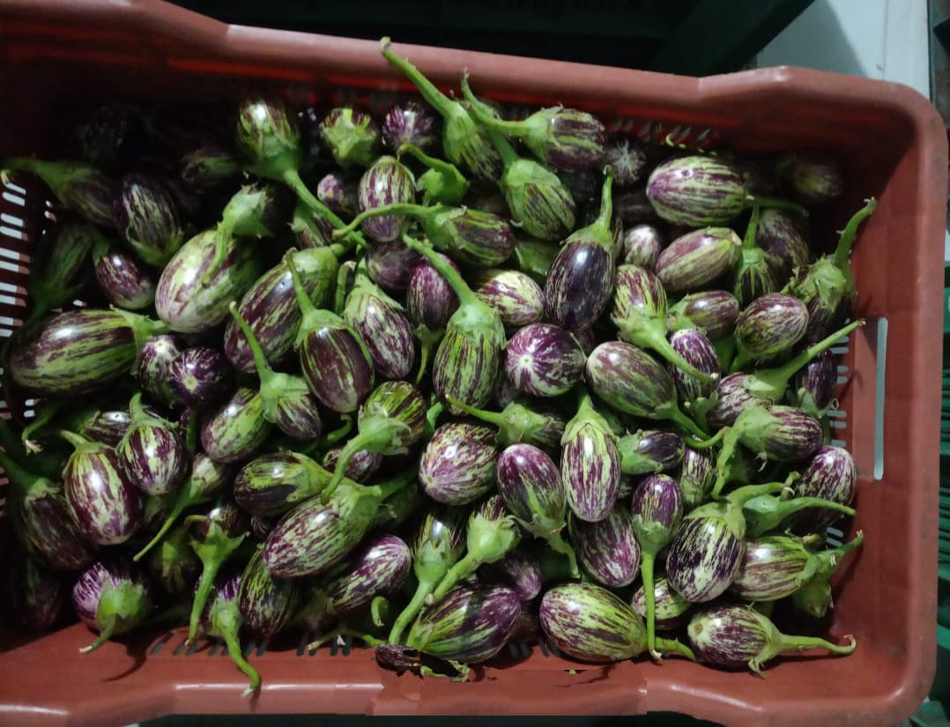 | 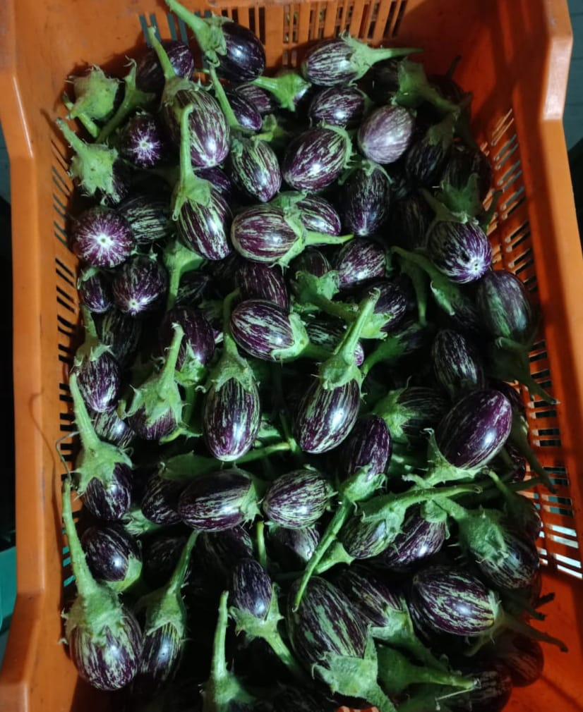
Day-0 (Inside Cold Storage at 13°C & 94% RH)
 | 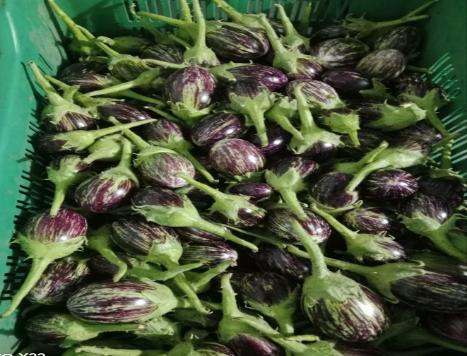
Day-2 (Inside Cold Storage at 13°C & 94% RH)

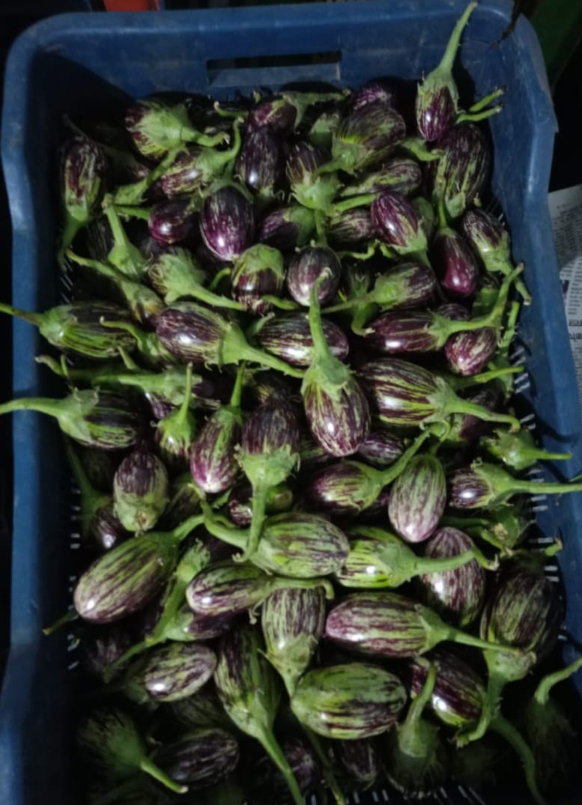 | 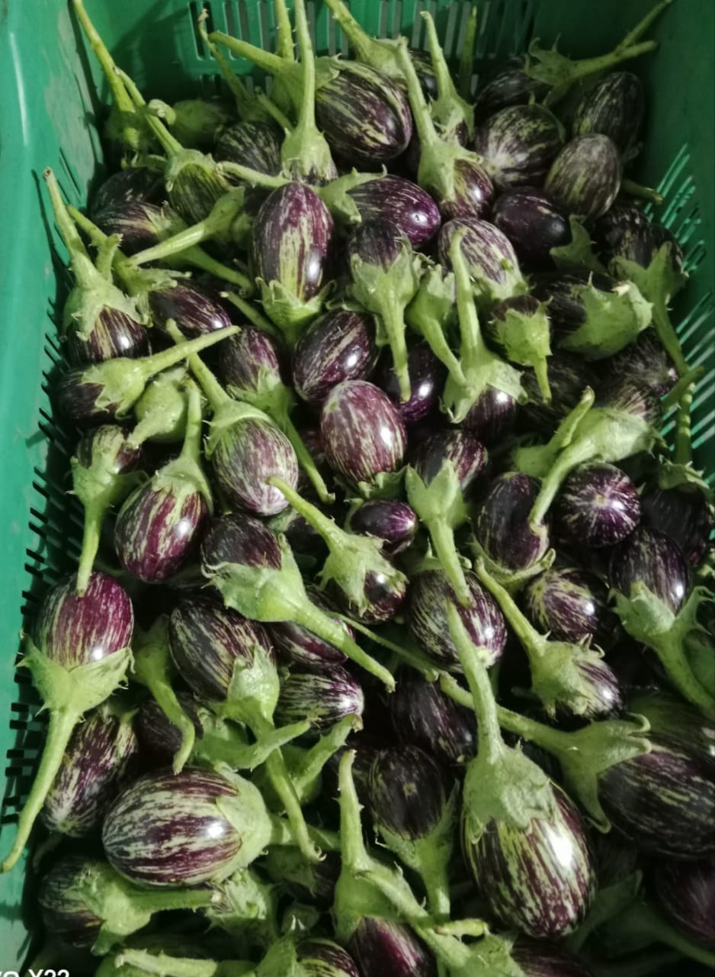
Day-4 (Inside Cold Storage at 13°C & 94% RH)
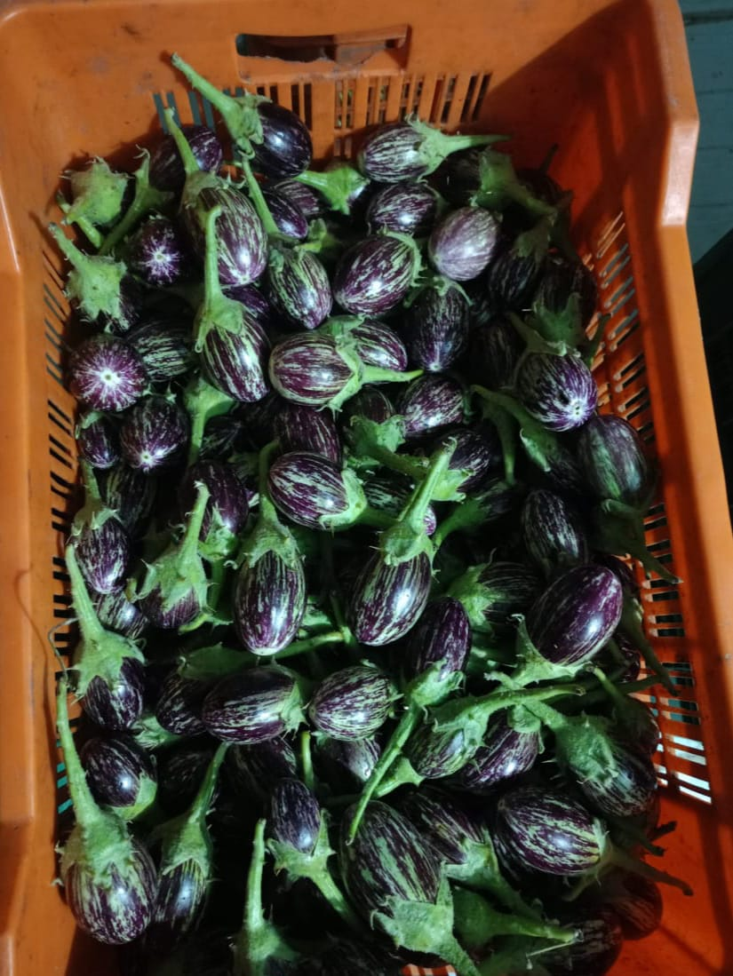 | 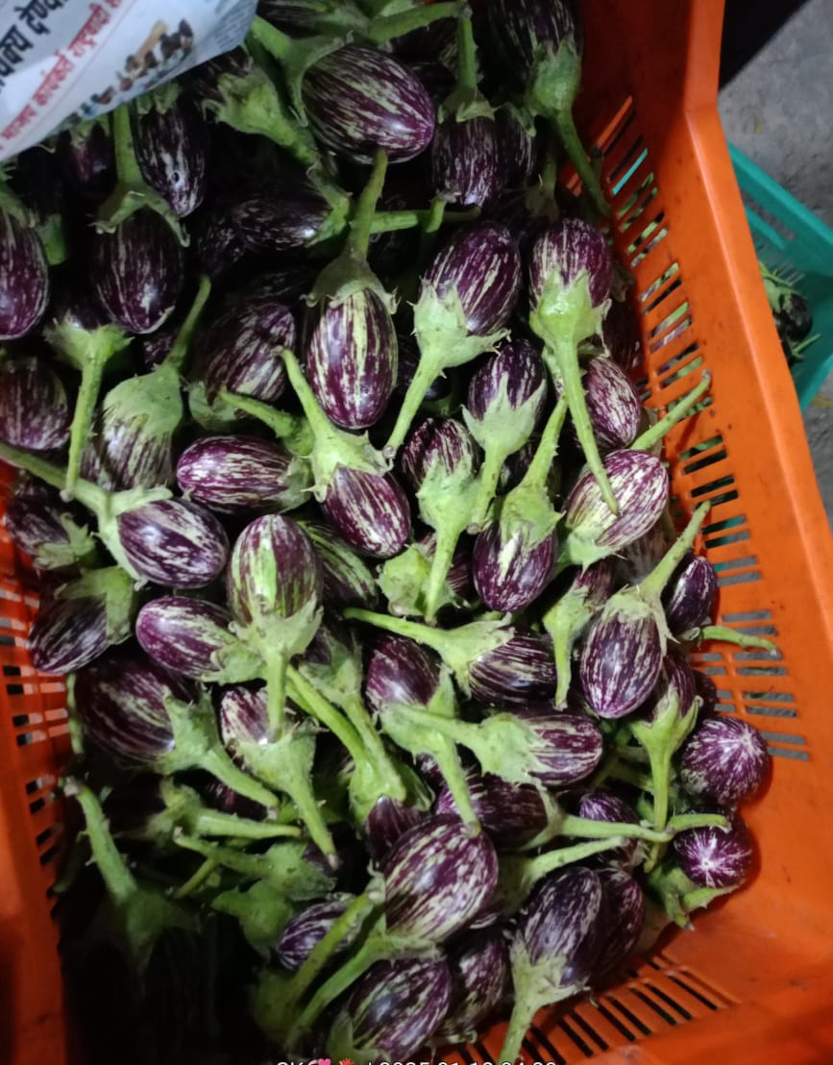
Day-6 (Inside Cold Storage at 13°C & 94% RH)
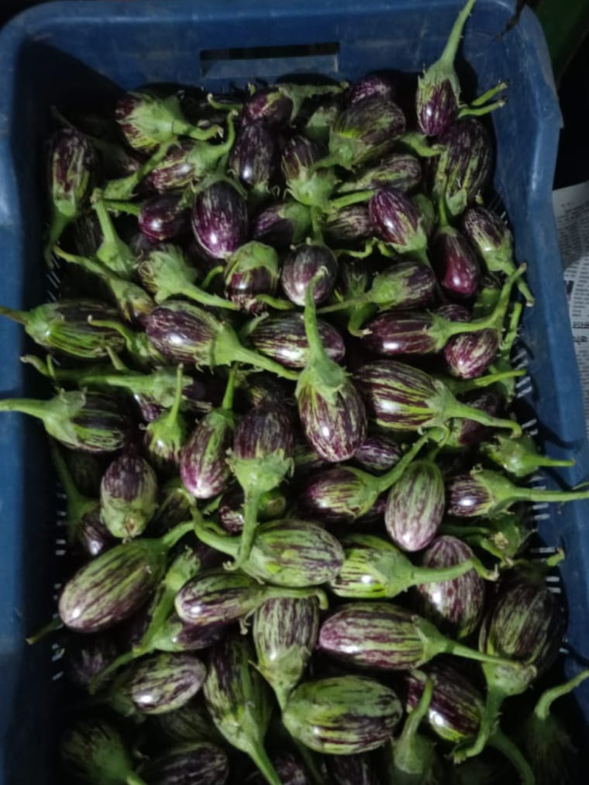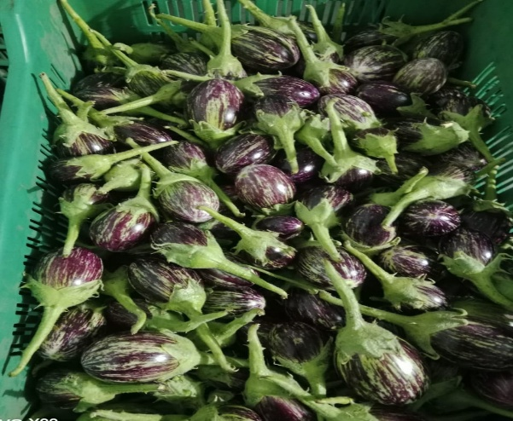

Day-8 (Inside Cold Storage at 13°C & 94% RH)
Figure 2 : Photographs of Stored Brinjal in the cold room
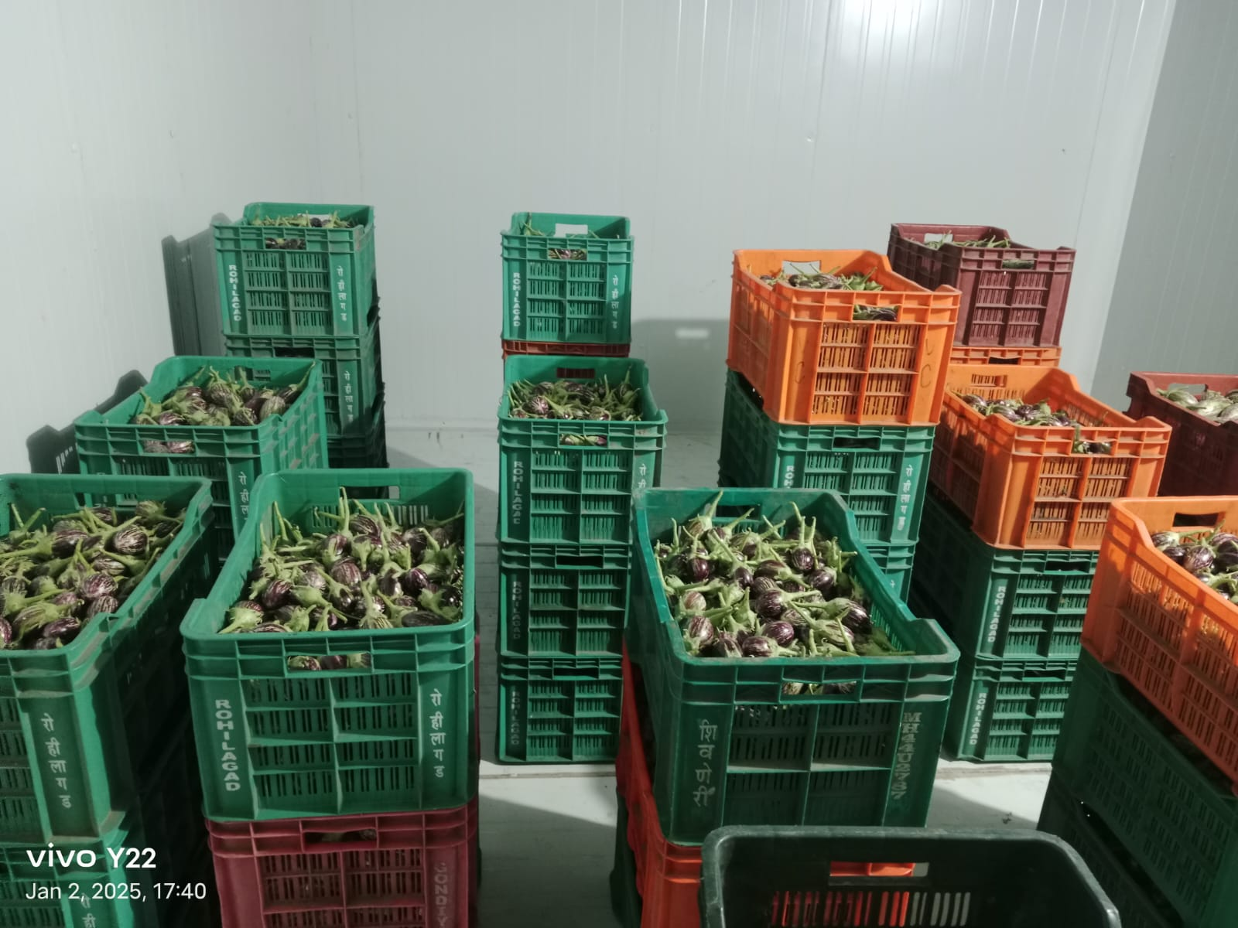

Conclusion:
The storage life of brinjal was observed to be 8 days under cold storage conditions maintained at 10°C temperature and 94% relative humidity (RH). Under these conditions, no signs of chilling injury or disease symptoms were detected throughout the storage period. Brinjals remained in good physical and physiological condition, with minimal weight loss. This indicates that cold storage at 10°C and 94% RH is effective in preserving the freshness, texture, and marketability of brinjal for up to 8 days, making it a suitable post-harvest handling practice.

COMPETING INTERESTS DISCLAIMER:
Authors have declared that they have no known competing financial interests OR non-financial interests OR personal relationships that could have appeared to influence the work reported in this paper.

References:
- Krishnakumar & Dayanandakumar, (2002). Design of cold storage for fruits and vegetables. 10.13140/RG.2.2.14335.82082.
- Daunay, M. 2008. Eggplant. In: Handbook of Plant Breeding: Vegetables II, Prohens, J., Nuez, F. (eds.). Springer, New York. pp. 163–220.
- Daunay, M., Lester, R., Gebhardt, C., Hennart, J., Jahn, M. (2001b). Genetic resources of eggplant (Solanum melongena L.) and allied species: A new challenge for molecular geneticists and eggplant breeders. In: Solanaceae V: Advances in taxonomy and utilization, van den Berg, R.G., Barendse, G.W., van der Weerden, G.M., Mariani, C. (eds.). Nijmegen University Press, Nijmegen, the Netherlands. pp. 251–274.
- Jadhav P.B. and Gurav N.P. (2018) Extend the Storage Life through Cold Conditions in Capsicum cvs. ‘Bachata F1’, ‘Mashelia’, ‘Bombay Green’ and ‘Local Green’. International Journal of Agriculture Sciences, ISSN: 0975-3710 & E-ISSN: 0975-9107, Volume 10, Issue 17, pp.- 7092-7101.
- Jadhav P.B., et al., (2018) Extending the Shelf Life of Broccoli cv. ‘Green Majic’ using a Cold Room (Ecofrost). International Journal of Agriculture Sciences, ISSN: 0975-3710 & E-ISSN: 0975-9107, Volume 10, Issue 17, pp.- 7087-7091.
- Jadhav PB, Gurav NP. Extension of storage and post-storage shelf-life of fig fruit. International Journal of Research and Review. 2018; 5(3):25-34.
- Gurav, N. P., & Sharma, B. (2019). Evaluation Of Compatibility, Storage And Post-Storage Life Of Capsicum, Eggplant And Bottle Gourd With The Help Of Ecofrost Cold Storage.
- Mangal, J.L., Kumar, J., Batra, V.K. and Singh, K. 2001. Effect of cultivars, packing types and waxing on shelf life of brinjal (Solanum melongena L.). Veg. Sci. 28:43-44.
- Fallik, E., Temkin-Gorodeiski, N., Grinberg, S., & Davidson, H. (1995). Prolonged low-temperature storage of eggplants in polyethylene bags. Postharvest biology and technology, 5(1-2), 83-89.
- Sidhu, A. S., & Dhatt, A. S. (2006, December). Current status of brinjal research in India. In I International Conference on Indigenous Vegetables and Legumes. Prospectus for Fighting Poverty, Hunger and Malnutrition 752 (pp. 243-248).
- Maurya, D., Akhtar, S., Tripathi, V., & Pandey, A. K. (2019). Chapter 2 Vegetables for nutritional security and play important role in human diet. Advances in Horticulture, 39, 17-19.
- Singh, S. P., & Rao, D. S. (2005). Effect of modified atmosphere packaging (MAP) on the alleviation of chilling injury and dietary antioxidants levels in ‘Solo’papaya during low temperature storage. European Journal of Horticultural Science, 70(5), 246-252.
- Jha, S. N., T. Matsuoka, and K. Miyauchi. "Surface gloss and weight of eggplant during storage." (2002): 407-412.
- Najafi, R., Barzegar, T., Razavi, F., & Ghahremani, Z. (2021). Effect of postharvest treatments of phenylalanine and hydrogen sulfide on maintaining quality and enhancing shelf life of eggplant (Solanum melongena L.). Journal of Horticultural Science, 34(4), 705-717.

