Original Research Article

The Role of Content Creators in the Promotion of Marine Tourism in Indonesia: A Case Study on Wakatobi Destinations

.

ABSTRACT

|  |
| --- |
| **Aims:** This study aims to examine the role of content creators in promoting marine tourism destinations in Indonesia, focusing on Wakatobi as the case study.  **Study Design:** This research employed a descriptive qualitative study with a case study approach, focusing on the role of content creators in promoting marine tourism in Wakatobi.  **Place and Duration of Study:** Conducted in Wakatobi Regency, Southeast Sulawesi, Indonesia, as a National Tourism Strategic Area, over the period of 2024–2025.  **Methodology:** A descriptive qualitative approach with a case study method was used. Data were collected through non-participatory observation, analysis of national journal literature, and several virtual interviews with local residents and stakeholders. The study analyzed the characteristics of content creators, the types of content produced, and the strategies implemented for digital promotion of marine tourism.  **Results:** The findings reveal that content creators act as effective promotional agents in building destination image through engaging visual content, including cinematic videos, narrative reviews, and personal travel documentation. The greatest impact was observed among millennial and Gen Z audiences, who consume tourism information digitally and respond to authentic narratives. Successful strategies included visual storytelling, use of hashtags and geotags, collaboration with local businesses, interactive engagement with audiences, and the incorporation of local cultural values and conservation messages. These strategies not only increased awareness and visitor intention but also encouraged responsible tourism behavior and strengthened the digital presence of Wakatobi.  **Conclusion:** Content creators have become strategic partners in tourism promotion, bridging the gap between local stakeholders and global audiences. Their role enhances destination visibility, fosters marine conservation awareness, and supports sustainable tourism development. Collaboration among content creators, communities, and tourism authorities is essential to create adaptive, impactful, and long-term promotional strategies for Indonesia’s marine tourism destinations. |

*Keywords: Content Creators; Marine Tourism; Digital Promotion; Wakatobi; Milennial Tourists*

1. INTRODUCTION

Indonesia as an archipelagic country has great potential in the development of marine tourism. With more than 17,000 islands and 95,000 km of coastline, Indonesia holds underwater wealth that attracts domestic and foreign tourists. One of the leading destinations that stands out in this sector is Wakatobi, which is known as the world's coral triangle and is included in the 10 priority National Tourism Strategic Areas (KSPN). However, this huge potential still faces challenges in terms of effective and sustainable promotion. Along with the development of digital technology and the increasing use of social media, a new phenomenon has emerged in the tourism industry, namely the involvement of content creators *as* important actors in shaping tourist perception and interest. Content creators are able to present compelling visual narratives through videos, photos, and personal experience reviews, which are then disseminated to a global audience through platforms such as YouTube, Instagram, and TikTok. This makes them part of a digital tourism marketing strategy that has a direct impact on increasing the visibility and attractiveness of destinations (Kristiani 2023). Wakatobi, located in Southeast Sulawesi Province, is one of the leading marine tourism destinations that has world-recognized marine biodiversity. This area is included in the world's coral triangle and is a major magnet for domestic and foreign tourists (Putra & Maulana, 2020). However, this great potential has not been fully accompanied by a promotional strategy that is adaptive to the times. In the current digital era, tourism information consumption patterns have shifted from conventional media to digital media, especially social media platforms. In the midst of the flow of digitalization, content creators in the form of travel bloggers, vloggers, and influencers are emerging as new actors who are influential in disseminating information, shaping public perception, and directing tourist decisions (Rachman & Nuraini, 2021). They not only present a visualization of the destination, but also build an experiential narrative that is able to create emotional and authentic appeal for potential travelers.

Research by Novanda et al (2022) shows that digital-based promotion through social media has a significant influence on tourists' decision to visit, especially the younger generation who are very responsive to visual content and personal experience testimonials. In the context of Wakatobi, digital promotion has not been consistently maximized by the local government, so the existence of independent content creators is a potential gap that can be used to expand the reach of tourism promotion. However, the role of content creators in the promotion of marine tourism in Wakatobi has not received much attention in academic research. Therefore, this study aims to analyze the role of content creators in supporting the promotion of Wakatobi destinations, focusing on the type of content used, narrative delivery strategies, and its impact on tourist perceptions. With a qualitative approach and case studies, this research is expected to make a practical contribution to the development of regional tourism digital promotion strategies.

2. methodology

This study uses a descriptive qualitative approach with a case study method, which aims to deeply understand the role of content creators in promoting marine tourism in Wakatobi. This approach is considered relevant because it is able to explore the meaning, perception, and content strategies used by creators in the context of digital promotion of tourist destinations (Mustikasari & Widodo, 2021). The case study was chosen because Wakatobi is one of the national priority destinations that has high marine tourism potential, but has not been specifically researched from the perspective of content creators. In addition, the existence of digital creators who produce content about Wakatobi shows a social phenomenon that deserves to be studied contextually and in depth. The location of the research was conducted in Wakatobi Regency, Southeast Sulawesi. The selection of the location was based on Wakatobi's status as a National Tourism Strategic Area (KSPN) and the high potential for marine tourism. The data collection applied in this study was conducted by conducting several interviews with local residents online or virtually. So that the withdrawal of descriptive qualitative data is used to understand the subjective meaning of criticism and suggestions from local residents and the socio-economic dynamics involved in the vicinity. In the end, the author can account for the results of this research.

3. results and discussion

**3.1 Characteristics of Content Creators in Wakatobi**

Most of the creators come from the Southeast Sulawesi region and have backgrounds as photographers, freelance videographers, and local tour guides. They utilize platforms like Instagram, TikTok, and YouTube as the primary means of disseminating visual content. The average content produced focuses on underwater beauty, snorkeling and diving activities, the richness of local culture, and personal experiences while exploring Wakatobi. These creators use interesting visual techniques, such as drone shooting, appropriate music selection, and personalized storytelling. The average content produced focuses on underwater beauty, snorkeling and diving activities, the richness of local culture, and personal experiences while exploring Wakatobi. These creators use interesting visual techniques, such as drone shooting, appropriate music selection, and personalized storytelling. Content creators who produce and disseminate tourism content about Wakatobi consist of two main categories, local creators , namely residents or tourism business actors in Wakatobi who actively create content in between daily activities and external/national creators, namely travelers, bloggers, or videographers from outside the region who make Wakatobi the main object of their content.

Most creators have a general education background, not from the field of communication or tourism, but they are self-taught about shooting, video editing, and content optimization for digital platforms. They use a variety of devices, ranging from mid-range smartphones, mirrorless cameras, to drones to capture the underwater beauty and landscape of Wakatobi. In general, the narrative approach they use is *"experiential storytelling",* which is conveying personal experiences during the trip in Wakatobi, which is visually packaged through vlog, cinematic reels, and interactive stories on Instagram. This style has proven to be preferred by digital audiences because it displays authenticity and emotional closeness (Novanda, Widodo, & Widiastuti, 2022). Observations on 10 active creator accounts show that regular upload frequency, two-way interaction with followers, and honest information delivery and a strong local narrative are key to success in building credibility and engaging audiences. For example, @WakatobiUnderwater and @ExploreWakatobi accounts managed to reach tens of thousands of followers in less than a year thanks to the consistency and originality of the content they presented.

These findings strengthen the theory from Kristiani and Aini (2023) who state that content creators play a role in shaping tourism attraction through personal narratives and visual aesthetics that suit the preferences of the digital generation. These influences are not only informative, but also inspiring—where audiences don't just see, but are encouraged to "experience for themselves" the destination. However, the characteristics of this content creator also show limited resources, especially in terms of production equipment and stable internet access. Some creators admit to having to upload content from outside the village or wait until late at night to get a better connection, which is a challenge in their productivity.

**3.2 Types of Content and Effective Promotional Strategies**

The types of content produced by content creators in promoting Wakatobi destinations have various characteristics, but in general they can be classified into three main types, namely: visual aesthetics (cinematic content), practical information (infotainment travel), and personal experience (storytelling). Aesthetic Visual Content *(Cinematic Content*), This type of content highlights the natural beauty of Wakatobi, especially the underwater world, white sand beaches, and the charming sunset or sunrise atmosphere. Creators utilize technologies such as drones, slow motion, and color grading to produce emotionally captivating visuals. This type of content aims to attract the audience's initial attention with a strong aesthetic impression, while building the image of Wakatobi as an exotic marine paradise (Rizky & Hidayat, 2023). Practical Information Content *(Infotainment Travel)* This type of content contains travel guides such as transportation routes to Wakatobi, estimated vacation costs, lodging recommendations, local culinary, and tips on saving money. This approach is more functional and educational, aimed at assisting potential travelers in planning their trips realistically. This type of content has been proven to have a high engagement rate because it meets the direct information needs of potential visitors (Sutrisno & Sari, 2022). Personal Experience *Content (Storytelling)* carries an experiential narrative style, creators share personal moments while in Wakatobi, ranging from interactions with local people, first-time diving experiences, to unique events experienced. This style of storytelling is effective in creating an emotional connection between creators and audiences, as well as building a more humane and authentic perception of destinations (Rahmawati, 2021). In an effort to maximize the attraction of marine tourism in Wakatobi through social media, content creators not only rely on visual power, but also implement various digital promotion strategies that have proven effective in reaching and influencing audiences. Based on the results of observations and interviews, it was found that one of the main strategies used was the use of popular hashtags and geotags. By adding hashtags such as *#Wakatobi*, *#WisataBahari*, or *#ExploreSultra*, creators increase the likelihood of their content being included in the user's search and exploration algorithms, thus reaching a wider range of potential tourists who have an interest in maritime destinations (Fatimah & Zulfan, 2021).

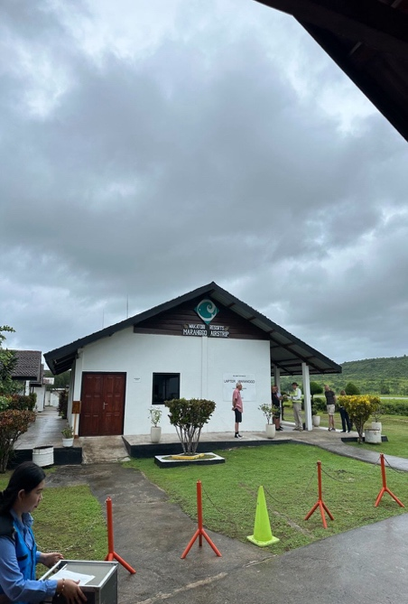

Source: Maranggo Airport by the author (01/8/25)

Fig 1- Maranggo Airport

The next strategy is collaboration with local business actors and communities, such as tour guides, homestay managers, or diving service providers. This collaboration produces more authentic, relevant content, and encourages local economic empowerment. Not only showcasing the exotic side of Wakatobi, the content also provides a real picture of the facilities and services available, which can build the trust of potential tourists (Pratama & Wulandari, 2022). Content interactivity is also an important aspect of digital promotion strategies. Creators actively invite audiences to participate through polls, Q*&A* sessions, or quizzes about the destinations they're visiting. This strategy strengthens the emotional connection between creators and their followers, creating active engagement that impacts increasing the reach of content organically. Positive responses to comments or direct messages from followers are also a supporting factor for audience trust and loyalty (Rahmawati, 2021). In addition, consistency in the upload schedule also has an effect on shaping the perception of professionalism and credibility of creators. Creators who regularly share content, such as once to twice a week, tend to be more memorable and regularly followed by audiences. This regular schedule facilitates information continuity and encourages the creation of *brand persona* creators as trusted tourism sources (Sutrisno & Sari, 2022).

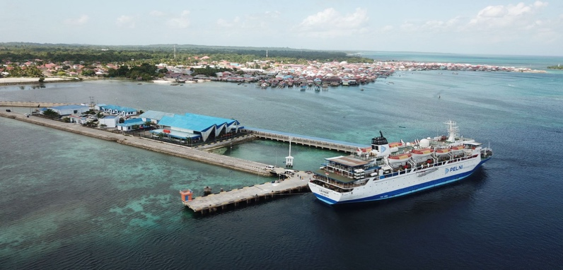

Source: Exeter Port on Wangi-Wangi Island by the author (01/8/25)

Fig 2- : Exeter Port on Wangi-Wangi Island

No less important is the insertion of local values and environmental conservation messages in the uploaded content. Some creators consciously raised the theme of marine ecosystem preservation , waste management, and local culture of the Bajo and Wakatobi people in general. The presentation of content with educational content increases the added value of promotion, because it not only sells visual beauty, but also invites the audience to become more conscious and responsible tourists (Rizky & Hidayat, 2023). The above strategies show that the promotion of marine tourism through social media by content creators is not just a destination visualization activity, but an integrated strategic communication process. The effectiveness of a promotion is not only measured by the number of views *or*  *likes*, but also by the conversion of visitor intent that arises from the audience's emotional involvement (Pratama & Wulandari, 2022).

**3.3 The Impact of Promotion by Content Creators on the Image of the Destination**

The existence of content creators in promoting Wakatobi has a significant influence on the increase in tourist interest, especially among the millennial generation and Gen Z. These two groups are known as digital natives who rely heavily on visual information and social media reviews before deciding on tourist destinations. According to research by Fatmawati and Supriyadi (2023), as many as 76% of young tourists in Indonesia admit to using social media as the main source of travel references, more than conventional brochures or official tourism websites. The content produced by the creators not only presents the panorama of Wakatobi's underwater nature cinematically, but also builds *emotional resonance* through the narrative of personal experiences. This approach has proven to be more effective in influencing the audience's perception and decision to visit Wakatobi. This is in line with the findings of Rahma and Putra (2022) who stated that visual storytelling has a stronger persuasive power than formal information because it creates emotional *engagement*.

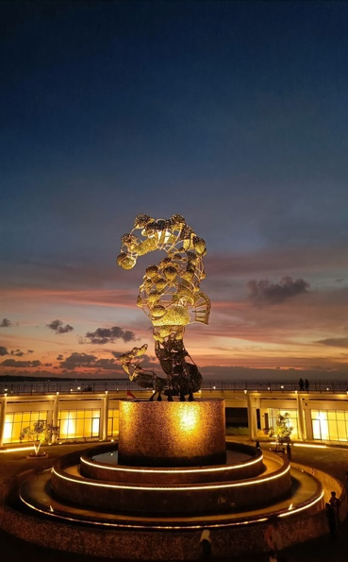

Source: Wakatobi Lestari Coral Statue by the author (01/8/25)

Fig 3- Wakatobi Lestari Coral Statue

In the local context, the increase in the number of tourists to Wakatobi in the last two years has also been attributed to the increased exposure of the destination on social media. Based on data from the Wakatobi Regency Tourism Office, the number of domestic tourist visits increased by 23% in 2023 compared to the previous year, with most visitors claiming to know about the destination from social media, especially Instagram, YouTube, and TikTok. The effectiveness of content creators can also be seen from the increase in digital interaction around Wakatobi, such as Google searches, comments on destination uploads, and re-uploads by large tourism-themed accounts. This creates an echo chamber that strengthens Wakatobi's position in Indonesia's digital tourism ecosystem. However, this influence is not only quantitative in terms of the number of visits, but also qualitative. Many tourists claim to be more informed when they arrive in Wakatobi, having learned about geographical conditions, local culture, and the procedures of maintaining marine ecosystems through the content they consume beforehand. This shows that content creators also play a role in shaping responsible tourism behavior, as stated by Lestari and Wibowo (2021) in their study on sustainable digital tourism.

In addition, the existence of testimonials and honest reviews shared by content creators serves as social proof that increases audience trust in the destination. Content that shows real experiences, both advantages and limitations of tourism services in Wakatobi, actually gives the impression of transparency and builds higher credibility. This phenomenon supports the findings of a study by Amalia and Nurdiansyah (2022) which states that the *trust* factor built through authentic experiences is more effective in driving travel decisions than commercial promotion. Thus, it can be concluded that the presence of content creators has changed the way destination promotion is carried out—from simply delivering information to creating digital experiences that shape perceptions, interests, and real actions of tourists. This is an opportunity as well as a challenge for tourism managers to synergize more with the creator community in order to create sustainable promotions and have a direct impact on marine tourism visits in Wakatobi.

4. Conclusion

This research shows that content creators play a strategic role in promoting marine tourism in Wakatobi. They are not only conveyors of visual information, but also narrative agents who are able to shape the perception and interest of tourists through creative and emotional approaches. The characteristics of content creators, both local and external, show that digital promotion is no longer dependent on formal institutions, but has shifted to individuals with content production skills and an understanding of social media algorithms. The most effective types of content are those that present the beauty of the underwater world, local culture, and authentic experiences in both cinematic and narrative formats. Successful promotional strategies include visual storytelling, collaboration with local actors, and consistency of uploads with an authentic style. The results of this strategy have been proven to be able to increase awareness and desire to visit, especially among the younger generation. The influence on tourist interest is not only seen in the increase in the number of visits, but also in the behavior patterns of tourists who are more informed and more aware of the importance of environmental sustainability. Content creators have become an important part of the tourism promotion ecosystem that not only boosts the existence of destinations, but also instills conservation values and local wisdom in its audience. As such, it is important for tourism stakeholders, including local governments, industry players, and communities, to build active collaboration with content creators as strategic partners in promoting sustainable and impactful tourism.

References

Kristiani, F. D., & Aini, N. (2023). Digital marketing strategies to increase the attractiveness of millennial tourists in Sawarna Tourism Village. Journal of Tourism and Hospitality Management (JMPP), 40–52. <https://ifrelresearch.org/index.php/jmpp-widyakarya/article/view/4542?utm_source=chatgpt.com>

Indonesia Travel. (n.d.). Wakatobi: Marine paradise. Ministry of Tourism and Creative Economy, Republic of Indonesia. Retrieved September 2, 2025, from <https://www.indonesia.travel/gb/en/destinations/sulawesi/wakatobi.html>

Novanda, D., Widodo, S., & Widiastuti, . (2022). Strengthening tourism digitalization through the role of content creators in Adiluhur Tourism Village. Jurnal Abdimas Inspiratif, 1(4), 157–165. <https://jurnal.stikes-ibnusina.ac.id/index.php/jai/article/view/656>

Alvionita, S., Sutanto, E. G., Ayuningtyas, N. D., Wati, N. K., & Dewantara, M. H. (2021). The Influence of Social Media on Generation Z's Travel Decision Efficacy in Choosing Tourist Destinations in Jabodetabek. Tourism Society: Journal of Community Services in Tourism, 2(1), 35–58. <https://doi.org/10.34013/mp.v2i1.372>

Yudha, E., Carli, Z. A. P., Sinaga, R., & Dina, R. A. (2024). Digitalization of tourism in tourist villages: A program utilizing social media in the development of Sukamulya Tourism Village, Pangandaran. Proceedings of the National Seminar. <https://www.researchgate.net/publication/359116496_Digitalisasi_Wisata_di_Desa_Wisata>

Nugraha, N. A. S., Suswandari, S., & Amalia, S. A. (2023). *Improving the capacity of Pokdarwis in implementing digital marketing for the tourist village of Kampung Tudung*. Jember State Polytechnic. <https://publikasi.polije.ac.id/j-dinamika/article/view/3671>

Agustiani, N., Arianto, A., & Mau, M. (2024). The role of social media in promotion and tourism in Wakatobi Regency. Journal of Communication, 15(2), 94–102. <https://doi.org/10.31294/jkom.v15i2.25271>

Sutrisno, S., Lestari, M., & Agus, I. (2022). Designing an information system for a digital marketing strategy using a marketing mix approach. Mulawarman Informatics: Scientific Journal of Computer Science, 7(2), 45–57. <https://doi.org/10.24903/jim.v7i2.8890>

Yuliarti, M. S., Rahmanto, A. N., Priliantini, A., Naini, A. M. I., Anshori, M., & Hendriyani, C. T. (2021). Storytelling of Indonesian tourism marketing in social media: Study of Borobudur and Lake Toba Instagram accounts. Journal of Communication, 13(1), 107–117. <https://doi.org/10.24912/jk.v13i1.9209>

Pratama, I. W. A. (2023). Digital marketing training for marketing tourist villages in the Wakatobi Islands. Indonesian Civil Society Journal, 2(1), 27–32. <https://doi.org/10.59025/js.v2i1.60>

Ayuni, S. (2023). Peningkatan kunjungan wisatawan di Jawa Tengah berbasis e-content marketing dan influencer social media serta e-trust (Studi pada pengunjung destinasi wisata di Jawa Tengah). Jurnal Ekonomi dan Bisnis, 14(1), 45–60. <https://doi.org/10.24912/jeb.v14i1.21993>

Hidayat, R., & Rizqi, R. M. (2021). Tourism marketing communication strategy in Rhee Loka Tourism Village, Sumbawa Regency (Case study of Gelora Beach Tourism Village). Journal of Management and Business, 4(3), 42–54. <https://doi.org/10.37673/jmb.v4i3.1334>

Effsash, F. K., Puspitasari, R., & Setioko, M. D. (2024). The influence of marketing mix on tourists' revisit intention at Wonokitri Edelweiss Park. Tourista Tourism Journal, 4(1), 41–45. <https://doi.org/10.26905/jt.v4i1.13761>

Setiawan, B. (2024). The touch of artificial intelligence in digital promotion in tourist villages in Indonesia. IKRA-ITH Humaniora: Journal of Social and Humanities, 8(3), 90–93. <https://doi.org/10.37817/ikraith-humaniora.v8i3.4186>

Kata, A. M. M. (2024). The role of social media in promoting marine tourism in Wakatobi Regency. Communication: Journal of Communication Studies, 15(2), 101–112. <https://doi.org/10.31294/jkom.v15i2.25271>