Biochar and Cover Crop Integration Enhances Soil Fungal Community Structure and Ecosystem Services in a Perennial Orchard System

Abstract
Sustainable management of perennial orchard soils is critically dependent on strategies that enhance soil fungal diversity and ecosystem services, given their central role in nutrient cycling, soil health, and long-term agricultural productivity. This study evaluated the interactive effects of biochar amendments and cover crop diversification on soil fungal community composition, diversity, and ecosystem service delivery in a mature Japanese apricot (Prunus mume) orchard. Two years of field treatments integrating rice husk biochar (Brh) or bamboo biochar (Bb), individually and in combination with mixed cover crops—bahiagrass (Bg) and white clover (Wc)—were implemented. Amplicon sequencing targeting the ITS region revealed that the Brh + Bg + Wc combination markedly increased the abundance of Mortierellaceae and overall fungal diversity compared to single amendments or control soils. Linear discriminant analysis identified distinct enrichment patterns: Brh + Bg + Wc favored beneficial saprotrophic taxa, while unmanaged controls were enriched in Didymellaceae and Nectriaceae. Although arbuscular mycorrhizal fungal (AMF) community diversity did not show statistically significant changes, trends indicated potential enhancement under combined amendment treatments. Pearson correlation and heatmap analyses demonstrated strong positive associations between key fungal families and soil biochemical traits, including enzyme activities linked to nutrient cycling. The results indicate that the integration of rice husk biochar with diverse cover cropping strategies synergistically promotes soil fungal resilience and functions critical for sustainable orchard management and environmental health. This research advances the understanding of how tailored amendment strategies can optimize ecosystem service delivery in perennial agroecosystems, informing soil management policies aimed at enhancing both productivity and long-term soil health.
Keywords: Arbuscular mycorrhizal fungi; metagenomics; soil enzyme activity; nutrient cycling; perennial agroecosystems.

1. Introduction
Soil ecosystem health and productivity rely on complex microbial interactions, with fungi, particularly arbuscular mycorrhizal fungi (AMF), being keystone taxa in nutrient cycling through symbiosis with plants (Van Der Heijden et al., 2008). Fungi efficiently decompose recalcitrant organic matter, such as lignin and cellulose, via extracellular enzymatic activity, thereby promoting carbon sequestration and humus formation (Baldrian, 2017). AMF establish symbiotic relationships with about 80% of terrestrial plant species, enhancing phosphorus acquisition, drought tolerance, and pathogen resistance (Freire Cruz et al., 2014; Jabborova et al., 2021). In contrast to bacteria, which exhibit rapid but transient responses to environmental changes, fungal communities reflect long-term soil health due to their slower turnover rates and extensive hyphal networks (Dang et al., 2021). This stability makes fungi, particularly AMF, reliable biomarkers for metagenomic assessments in perennial agroecosystems, where soil conditions must remain optimal for decades without tillage (Tedersoo et al., 2014).
In Japanese apricot (Prunus mume) orchards, soil management is crucial for both fruit yield and the preservation of bioactive compounds with antioxidant, anti-inflammatory, and antimicrobial properties (Tian et al., 2023). The high citric acid, β-carotene, and phenolic contents in P. mume fruits contribute to its medicinal value, as evidenced by traditional and modern pharmacopeias (Mitani et al., 2013). However, these phytochemicals are influenced by soil quality, particularly microbial diversity and nutrient availability (Zheng et al., 2019). For example, AMF colonization in P. mume roots enhances secondary metabolite synthesis by improving nutrient acquisition (N, P, K) and stress resilience (Santoyo et al., 2021). Sustainable practices, such as the use of organic amendments and reduced tillage, are essential for sustaining fungal-mediated ecosystem services in these orchards (Guzman et al., 2021).
The application of soil amendments, such as biochar, are recognized as effective strategies for improving soil structure, sequestering carbon, and creating favorable conditions for soil microbial communities (Zheng et al., 2019). The highly porous structure of biochar enhances water retention and nutrient availability while providing microhabitats that favor microbial colonization, particularly of AMF and other soil fungi. Research indicates that biochar promotes AMF hyphal growth and spore production by enhancing soil aggregation and organic matter stability, which improves plant nutrient acquisition (Zhang et al., 2019). Furthermore, the alkaline properties of biochar can neutralize acidic soils, favoring fungal colonization, while its recalcitrant carbon content supports long-term soil fertility. Specific feedstocks, such as wood-derived biochar, support greater fungal diversity due to their substantial surface area and cation exchange capacity.
The integration of cover crops, particularly mixtures of grasses such as bahiagrass (Paspalum notatum) and legumes such as white clover (Trifolium repens), can further enhance fungal activity and soil health (Guzman et al., 2021). Grasses release carbohydrate-rich root exudates that serve as an energy source for AMF, thereby promoting their colonization and symbiotic associations with crops. Legumes contribute to nitrogen fixation through Rhizobium spp. bacteria, reducing reliance on synthetic fertilizers and promoting a balanced soil microbiome. Diverse cover crop mixtures also increase soil organic matter, suppress soil-borne pathogens, and enhance soil structure by mitigating erosion. Research by Vukicevich et al. (2016) demonstrated that cover crops enhance the resilience of fungal networks, supporting nutrient cycling and long-term agricultural productivity.
Despite extensive research on biochar and cover crops as individual soil amendments, their combined effects on soil fungal communities in perennial agroecosystems remain unexplored. Biochar's porous structure and alkaline pH can enhance soil carbon sequestration and water retention (Gul and Whalen, 2016), while cover crops supply organic nitrogen and labile carbon through root exudates (Vukicevich et al., 2016). However, their combined application may induce resource competition, as biochar's high C:N ratio could temporarily immobilize N, potentially reducing AMF colonization in high-nitrogen-demanding fruit crops such as apples or stone fruits (Guzman et al., 2021).
AMF are highly sensitive to changes in soil organic matter and nutrient stoichiometry, making their hyphal density and diversity an indicator of long-term soil health (Van der Heijden et al., 2008). For example, Glomus spp. and Rhizophagus spp. predominate in soils with high organic matter content but decline under sudden nitrogen influx (Guzman et al., 2021). ITS2 sequencing can elucidate these community dynamics by identifying functional genes and keystone taxa (Tedersoo et al., 2014), offering insights that 16S rRNA-based bacterial surveys cannot capture due to bacteria's rapid turnover. In perennial systems, where soil amendments exert cascading effects over years, fungal-focused approaches are essential for predicting carbon storage and crop resilience (Zhang et al., 2019).
This study used a 20-year-old Japanese apricot orchard to evaluate the effects of two years of biochar amendments, applied alone and in combination with cover crops, on soil fungal and AMF communities. The hypothesis was that the combined application of biochar and cover crops enhances soil health parameters more effectively than either treatment alone, as evidenced by favorable changes in fungal community composition and AMF abundance. This targeted approach aligns with the need to enhance soil fertility and tree productivity while providing a nuanced understanding of the long-term ecological benefits associated with these sustainable practices.

2. Materials and methods
2.1. Soil Sampling
Soil samples were collected in June 2022 from an orchard at the Shimogamo Campus of Kyoto Prefectural University. In 2022, Kyoto City had an annual mean temperature of 16.8 °C and annual precipitation of 1459.5 mm (Japan Meteorological Agency). Twelve treatments were established, comprising combinations of biochar (bamboo biochar, rice husk biochar, or no biochar) applied at 2% of soil weight (w w⁻¹) and cover crops (bahiagrass, white clover, bahiagrass and white clover, or no cover crop).
Biochar was applied twice, in May 2021 and May 2022. Cover crops were sown twice, beginning in May 2020. Soil samples were collected at a depth of 10 cm. A total of 36 samples were collected and stored at 4 °C and -18 °C for laboratory analysis. Soil and biochar characteristics were previously described by Gomes and Cruz (2025).
2.2. Amplicon Sequencing Analysis
Amplicon sequencing analysis was conducted using samples stored at -18 °C. DNA extraction and purification were performed as the first step. Initially, 0.2 g of glass beads (diameter = 1 mm) and 0.2 g of soil sample were placed in a 2 mL Eppendorf tube. A master mix, consisting of 80 μL skim milk, 250 μL extraction buffer, and 50 μL 10% SDS, was prepared and 38 μL was added to each tube containing the sample, followed by the addition of benzyl chloride. Samples were vigorously shaken at 4200 rpm for 60 seconds and incubated in a 60 °C water bath for 15 minutes. Subsequently, 150 μL of 3M sodium acetate (NaOAc) was added and gently vortexed. The samples were then centrifuged at 15000 rpm for 10 minutes. After this process, 300 μL of the supernatant, containing unpurified DNA, was collected and cleaned by adding 300 μL of membrane binding solution, transferring it to a specialized tube, incubating for 1 minute, and centrifuging at 15000 rpm for 1 minute. Subsequently, 700 μL of membrane wash solution was added and centrifuged at 15000 rpm for 1 minute (first wash), followed by addition of 500 μL of membrane wash solution and centrifugation at 15000 rpm for 5 minutes (second wash), and an additional centrifugation at the same speed for 1 minute. After transferring the samples to new Eppendorf tubes, 60 μL of nuclease-free water was added, incubated for 1 minute, and centrifuged at 15000 rpm for 1 minute (Kageyama et al., 2003).
Amplicon PCR for the fungal community was conducted using ITS 1 as a forward primer and ITS 2 as a reverse primer (Macrogen Japan Corp.), with a reaction mixture containing 0.5 μL of DNA extract, 10 μL of KOD FX Neo Buffer, 4 μL of dNTPs, 0.4 μL of KOD FX Neo (Toyobo Co. Japan), 1.8 μL of ITS1 primer, 1.8 μL of ITS2 primer, and 1.5 μL of nuclease-free water. PCR was performed using a thermal cycler, with an initial denaturation at 94 °C for 2 minutes, followed by 30 cycles of 98 °C for 10 seconds, 55 °C for 30 seconds, and 68 °C for 1 minute, with a final hold at 12 °C. Index PCR was conducted using S502~S522 as forward primers and N701~N703 (Illumina, Inc.) as reverse primers, with a reaction mixture containing 5 μL of PCR product, 25 μL of KOD FX Neo Buffer, 10 μL of dNTPs, 1 μL of KOD FX Neo (Toyobo Co. Japan), 4 μL of forward primer, 4 μL of reverse primer, and 1 μL of nuclease-free water. Index PCR was performed using a thermal cycler with an initial denaturation at 94 °C for 2 minutes, followed by 12 cycles of 98 °C for 10 seconds, 55 °C for 30 seconds, 68 °C for 1 minute, with a final hold at 12 °C.
Amplicon PCR was conducted for the arbuscular mycorrhizal fungi (AMF) community using FLR2 as the forward primer and FLD3 as the reverse primer (Niwa et al., 2018), with a reaction mixture containing 0.5 μL of DNA extract, 5.9 μL of nuclease-free water, 10 μL of KOD One (Toyobo Co. Japan), 1.8 μL of FLR2 primer, and 1.8 μL of FLD3 primer. PCR was performed using a thermal cycler with an initial denaturation at 94 °C for 2 minutes, followed by 30 cycles of 98 °C for 10 seconds, 55 °C for 30 seconds, 68 °C for 1 minute, with a final hold at 12 °C. Index PCR for AMF community was conducted using S502~S522 as forward primers and N705~N707 (Illumina, Inc.) as reverse primers, with a reaction mixture containing 5 μL of PCR product, 25 μL of KOD One (Toyobo Co. Japan), 4 μL of forward primer, 4 μL of reverse primer, and 12 μL of nuclease-free water. Index PCR was performed using a thermal cycler with an initial denaturation at 94 °C for 2 minutes, followed by 12 cycles of 98 °C for 10 seconds, 55 °C for 30 seconds, 68 °C for 1 minute, with a final hold at 12 °C.
After each amplicon PCR and index PCR for both fungal and AMF communities, PCR products were purified using the following method: PCR products were mixed with Midori Green (approximately 1 μL per 20 μL of PCR product) and loading dye (approximately 1 μL per 20 μL of PCR product) and then subjected to gel electrophoresis for approximately 25 minutes. After electrophoresis, DNA was visualized using a long-wavelength UV transilluminator, and the DNA band of the expected length was excised. The gel slice was transferred to a tube, and 100 μL (for amplicon PCR products) or 150 μL (for index PCR products) of membrane-binding solution was added to each sample. The tube was incubated at 60 °C for 10 minutes or until the gel slice was completely dissolved. Subsequently, the tubes were briefly centrifuged, and 700 μL of membrane wash solution, previously diluted with 95% ethanol, was added to the column to wash the SV Minicolumn. The SV Minicolumn assemblies were centrifuged at 14,000 rpm for 1 minute. Collection tubes were emptied, and the SV Minicolumns were returned to the collection tubes. This washing step was repeated with 500 μL of membrane wash solution, and the SV Minicolumn assemblies were centrifuged at 14,000 rpm for 5 minutes. After centrifugation, the SV Minicolumn assemblies were carefully removed to prevent wetting of the column base. Collection tubes were emptied, and the columns were centrifuged for 1 minute to remove residual ethanol. The SV Minicolumns were transferred to new tubes, and 55 μL of nuclease-free water was added to the column membrane. After incubation at room temperature for 1 minute, the columns were centrifuged at 14,000 rpm for 1 minute to elute DNA (Promega Co., USA). Following amplicon PCR, index PCR, and purification, all index PCR products were sequenced using the Illumina-Miseq platform with 250 bp paired-end reads (Genome Quebec, Canada).
2.3. Soil Enzyme Activities
Protease activity was quantified using the ninhydrin method (Amato and Ladd, 1988). Briefly, 0.5 g of soil, 1.8 mL of 0.1 M Tris-borate buffer, and 2 mL of 2 mM benzyloxycarbonyl-phenylalanyl-leucine (ZFL) were combined in a test tube and agitated. The tubes were incubated at 40 °C with agitation in a water bath for 1 hour and then removed. Subsequently, 0.2 mL of 5M hydrochloric acid was added and mixed thoroughly, and the mixture was filtered through No. 5C filter paper. In a new test tube, 1.5 mL of the filtrate and 0.75 mL of ninhydrin reagent were combined, shaken, and heated in boiling water for 15 minutes. The test tubes were then cooled, 2.25 mL of 50% ethanol was added, shaken thoroughly, and the absorbance of the solution was measured at 570 nm using a spectrophotometer. Data for additional enzyme activities used in this study were obtained from Gomes and Cruz (2025).
2.4. Statistical Analysis
Bioinformatic and statistical analyses were conducted on the collected data using the QIIME2 pipeline (Bolyen et al., 2019), MicrobiomeAnalyst (Lu et al., 2023), and R statistical software. Low-count features were filtered out prior to downstream analysis to reduce the impact of sequencing artifacts and low-level contamination. A minimum count threshold of 8 was applied, and features were retained only if present in at least 20% of the samples. Additionally, low-variance features, which are unlikely to be associated with the experimental conditions due to their near-constant abundance across samples, were excluded. Variance was evaluated using the interquartile range (IQR), and the lowest 10% of features based on IQR were removed. Subsequently, total sum scaling (TSS) normalization was applied.
A Kruskal–Wallis nonparametric test was conducted to assess differences in fungal richness (Shannon index) among treatments, revealing a statistically significant effect (p < 0.05). This test was selected because the Shapiro–Wilk test indicated non-normal distribution of the data.
Linear discriminant analysis effect size (LEfSe) was performed using default parameters with a Kruskal–Wallis test (α = 0.05) to identify features with significant different abundance among treatments. Features meeting the significance threshold were subjected to pairwise Wilcoxon rank-sum tests, followed by linear discriminant analysis (LDA) to determine the effect size of each differentially abundant taxon. An LDA score threshold of 4.0 was applied to identify treatment-specific biomarkers. Separate LEfSe analyses were conducted for the total fungal community and the AMF subset to identify taxonomic groups differentially enriched across biochar and cover crop treatments.
Non-metric multidimensional scaling (NMDS) was used to evaluate relationships between soil fungal and AMF community composition and soil biochemical parameters. NMDS analysis was based on Bray–Curtis dissimilarity matrices derived from the relative abundance data of fungal taxa and the profiles of soil enzyme activities and chemical properties. Data were standardized prior to analysis to minimize differences in magnitude among variables. Ordination was conducted in two dimensions to optimize stress values and enhance interpretability. Vector fitting was applied to assess associations between microbial community structure and environmental variables using the envfit function in the vegan package in R. Only vectors corresponding to statistically significant correlations (p < 0.05) were retained and displayed in the ordination plot.
Pearson correlation heatmap analysis was performed to investigate relationships between fungal and AMF taxa and soil biochemical properties, including enzyme activities, chemical parameters, and predicted metabolic functions. Pearson correlation coefficients (r) were calculated using the cor() function in R, based on the relative abundance of fungal and AMF families and corresponding biochemical variables. A correlation matrix was generated and visualized as a heatmap using the pheatmap package in R. Data were subjected to z-score normalization prior to analysis to standardize values across variables. Significant correlations, determined using the cor.test() function, were denoted with asterisks (*p < 0.05, **p < 0.01). A diverging color scale was applied to emphasize the strength and direction of correlations, with blue indicating negative correlations and red indicating positive correlations. Hierarchical clustering, using Euclidean distance and Ward's linkage method, was performed to group rows and columns with similar patterns.

3. Results

3.1. Fungal Community Composition
Soil fungal community composition at the phylum level varied significantly among treatments, as shown in the stacked bar chart (Fig. 1A). Ascomycota and Mortierellomycota were the dominant phyla, collectively accounting for an average of 69% ± 14.6% of the fungal community across all samples. Mortierellomycota exhibited a significant increase in relative abundance in treatments combining rice husk biochar (Brh) and cover crops. Its relative abundance reached 50% ± 23.7% in the treatment with Brh combined with bahiagrass (Bg) and white clover (Wc) (BrhBgWc), representing a 36% increase compared to Brh alone (14% ± 3.1%) (p < 0.05) and a 12.4% increase compared to BgWc (37.6% ± 2.5%). Ascomycota was more abundant in treatments with bamboo biochar (Bb) (67.8%), the control (57.1%), and BbBg (55.6%). Although less dominant overall (mean 5.2% ± 3.7%), Basidiomycota exhibited variation across treatments, with higher relative abundance in the control (9.5%), Bg (8.1%), Wc (8.8%), and BbBgWc (7.3%). These shifts in relative abundance indicate treatment-driven changes in phylum-level fungal community composition, particularly the increased abundance of Mortierellomycota under co-application strategies.
3.2. AMF Community Composition
The AMF community exhibited compositional variation among treatments, though these differences were less pronounced than those observed for the total fungal community (Fig. 1B). Glomeraceae was the dominant family across all samples, constituting most of the AMF community regardless of treatment. However, treatments incorporating rice husk biochar with cover crops, particularly BrhBgWc and BrhWc, showed a significant increase in the relative abundance of Acaulosporaceae. For example, the relative abundance of Acaulosporaceae increased by 8.8% in BrhBgWc compared to Brh alone, and by 9% compared to the control. Other families, such as Diversisporaceae and Claroideoglomeraceae, exhibited consistently low relative abundances across all treatments, with minor variations.
3.3. Fungal and AMF Diversity Indices
The Shannon diversity index revealed distinct patterns in fungal and AMF community diversity in response to soil treatments (Fig. 2). For the fungal community, the Kruskal–Wallis test indicated a statistically significant difference in Shannon diversity among treatments (p = 0.027), with pairwise comparison revealing that the BrhBgWc treatment exhibited significantly higher diversity than Brh alone. Although no other pairwise differences were statistically significant, the observed trend indicated that the Bb treatment exhibited the highest Shannon index values, while Brh and single cover crop treatments (Bg and Wc) showed comparatively lower fungal diversity. When comparing the mean Shannon index across the four treatment groups (Suppl. Fig. 1)—control, cover crops only, biochar only, and co-application—the control group showed the highest index (1.32 ± 0.09). However, the co-application group (1.26 ± 0.09) demonstrated a higher index than either single application—cover crops only (1.04 ± 0.24) or biochar only (1.17 ± 0.25).
The AMF community showed no statistically significant differences in Shannon index among treatments (p = 0.093); however, the trend observed indicated higher index for treatments combining biochar and cover crops (e.g., BrhBgWc and BbBgWc). In contrast, treatments with single amendments generally exhibited lower AMF diversity. Notably, the control treatments also showed high AMF diversity, indicating a diverse baseline community in the absence of amendments or disturbances.

3.4. Discriminant Fungal Taxa
The linear discriminant analysis (LDA) revealed distinct patterns of fungal family enrichment across treatments (Fig. 3). Mortierellaceae exhibited the highest discriminative power, with significant enrichment in the BrhBgWc treatment (LDA score = 5.3), indicating that the combination of rice husk biochar and mixed cover crops favored this family. Didymellaceae was predominantly enriched in the control treatment (LDA score = 4.7), suggesting that this family is more abundant in unmanaged soil conditions without biochar or cover crop amendments. Chaetomiaceae exhibited strong enrichment in the BgWc treatment (LDA score = 4.5), indicating increased abundance in response to the mixed cover crop system without biochar. Nectriaceae was enriched in the control treatment (LDA score = 4.5), while Sporidiobolaceae showed similar enrichment associated with the control (LDA score = 4.3). Plectosphaerellaceae exhibited the lowest significant enrichment in the BbBgWc treatment (LDA score = 4.2), suggesting a moderate response to Bb combined with mixed cover crops. Ordinations for the AMF community revealed no significantly discriminant taxa (p > 0.05).
3.5. Correlation Analysis Between Fungal Families and Functional Traits
Pearson correlation analysis revealed distinct patterns of association between the most abundant fungal families and both predicted metabolic functions and measured enzymatic activities (Fig. 4). Mortierellaceae exhibited the strongest functional associations, showing significant positive correlations with multiple nitrogen cycling processes, including aerobic nitrite oxidation, nitrification, and various denitrification pathways (all p < 0.05). This family also showed strong positive correlations with hydrocarbon degradation pathways and several enzymatic activities, particularly phosphatase, arylsulfatase, and β-glucosidase activities (all p < 0.05). Chaetomiaceae demonstrated significant associations with fermentation processes and exhibited positive correlations with invertase activity (p < 0.05), indicating involvement in carbohydrate metabolism. In contrast, Didymellaceae exhibited relatively few significant correlations with the examined functional traits, indicating a more specialized or niche-specific role within the soil fungal community. Bullerbasidiaceae exhibited distinct correlation patterns compared to other families, with some negative associations with specific metabolic functions, while Aspergillaceae showed moderate correlations across various enzymatic activities without strong specialization toward specific functional categories.
3.6. NMDS Analysis of AMF Community Structure and Enzymatic Activity
The non-metric multidimensional scaling (NMDS) ordination, depicting patterns in AMF community composition in relation to soil enzymatic activities across treatments with varying cover crops and biochar applications, is presented, as ordinations for the total fungal community showed no significant associations with enzymatic parameters (all p > 0.05). The NMDS plot (Fig. 5) illustrates sample distributions along the first two ordination axes (NMDS1 and NMDS2), with symbols representing cover crop treatments (no cover crop, Bg, Wc, BgWc) and colors indicating biochar types (no biochar, bamboo, rice husk). Only parameters with significant correlations are plotted (p < 0.05). Distinct clustering of samples was observed based on biochar amendment and cover crop treatment, as indicated by different colored circles. Samples with Bb tended to cluster along the negative NMDS1 and NMDS2 axes. This pattern suggests that bamboo biochar influences AMF community structure. Environmental vectors representing enzymatic activities (protease, invertase, arylsulfatase) were fitted onto the ordination. The direction and length of these vectors indicate the strength and direction of correlation between each enzymatic activity and the ordination configuration. The orientation of the vectors suggests that samples with higher enzymatic activity are associated with distinct AMF community assemblages. Protease was more closely associated with the mixed cover crop treatment (BgWc), while invertase activity was more strongly correlated with Brh, and arylsulfatase with Bb. The NMDS ordination indicates that both cover crop and biochar treatments are associated with shifts in AMF community composition, with enzymatic activities serving as significant correlates of these community patterns. These findings highlight the functional relationships among soil management, AMF diversity, and key enzymatic processes involved in nutrient cycling.
The stress value for this ordination was not available, limiting the assessment of the overall fit of the NMDS solution; however, the significant associations between enzymatic activities and AMF community structure provide robust evidence of functional linkages.

4. Discussion
Synergistic Increase in Mortierellomycota Abundance through Combined Rice Husk Biochar and Cover Crop Amendments
The significant increase in Mortierellomycota relative abundance (50% ± 23.7%) in the BrhBgWc treatment compared to Brh alone (14% ± 3.1%) demonstrates synergistic effects of combined soil amendments, supporting the study's primary hypothesis. This finding aligns with established mechanisms whereby biochar's microporous structure creates favorable microhabitats for fungal colonization (Lehmann et al., 2011), while bahiagrass (Bg) and white clover (Wc) root exudates provide labile carbon sources that support microbial metabolism (Erhunmwunse et al., 2023; Wang et al., 2020). The specific responsiveness of Mortierellomycota to combined amendments likely reflects this phylum's opportunistic growth strategy and its ability to utilize both readily available substrates from cover crop rhizodeposition and the stable microsites provided by biochar's porosity. This substantial increase in Mortierellomycota abundance indicates a significant restructuring of the soil fungal community toward decomposer-dominated assemblages, with significant implications for orchard soil health. Mortierellomycota are recognized as decomposers with extensive enzymatic capabilities for organic matter degradation and nutrient mobilization (Baldrian, 2017). Their increased abundance in synergistic treatments suggests increased carbon processing capacity and improved nutrient cycling efficiency, which are critical for long-term soil organic matter accumulation in perennial orchard systems. The shift in dominance from Ascomycota to Mortierellomycota in co-amended treatments indicates that amendment strategies can redirect fungal community composition toward functionally beneficial taxa that support sustainable orchard management.
Biochar Source-Specific Effects and Functional Community Responses
Rice husk biochar (Brh) demonstrated a greater capacity to increase fungal diversity compared to bamboo biochar (Bb), particularly when combined with cover crops. This differential response can be attributed to the distinct physicochemical properties of the biochar types, with Brh possessing higher silica content and surface area that promote hyphal attachment and growth (Nwajiaku et al., 2018). Additionally, the typically lower C:N ratio of Brh compared to wood-derived Bb reduces nitrogen immobilization, creating more favorable conditions for fungal establishment (Gautam et al., 2024). The treatment-specific enrichment patterns identified through LEfSe analysis further support the influence of biochar source on community assembly, with Mortierellaceae exhibiting strong enrichment in Brh treatments compared to a modest response in Bb combinations. Furthermore, the functional implications of Mortierellaceae enrichment extend beyond abundance increases to include improved ecosystem service provision. The strong positive correlations between Mortierellaceae abundance and multiple nitrogen cycling processes (nitrification, denitrification), alongside diverse enzymatic activities (phosphatase, β-glucosidase, arylsulfatase), highlight this family's important role in nutrient mobilization. This functional versatility contrasts with families such as Didymellaceae, which exhibited enrichment in control treatments but limited functional correlations, suggesting that amendment-driven community shifts favor functionally active taxa over ecological generalists.
AMF Community Adaptation and Functional Linkages
Although changes in AMF diversity were not statistically significant, a trend toward higher Shannon indices in co-amended treatments, coupled with increased Acaulosporaceae abundance in BrhBgWc (+8.8% vs. control), suggests functional community adaptation rather than substantial restructuring. The consistent dominance of Glomeraceae across treatments reflects this family's broad host range and ecological stability in perennial systems (Van der Heijden et al., 2008), while Acaulosporaceae enrichment indicates specialization under nutrient-rich conditions driven by amendment synergies. Significant correlations between AMF community composition and enzymatic activities (protease, invertase, arylsulfatase), as revealed by NMDS ordination, demonstrate functional relationships between community structure and soil biogeochemical processes. These relationships suggest that AMF communities respond to, and potentially influence, nutrient cycling intensity, beyond merely reflecting plant host preferences, with implications for understanding mycorrhizal functions in amended orchard systems.
Mechanistic Basis of Amendment Synergies and Ecological Implications
The superior effectiveness of combined Brh and mixed cover crops likely stems from complementary resource provisioning and niche creation mechanisms. Biochar provides stable microsites and water retention capacity, supporting fungal survival during stress periods (Jenkins et al., 2017; Noyce et al., 2016; Wang et al., 2020; Wu et al., 2022), while cover crop root exudates supply readily metabolizable carbon compounds that support microbial growth (Castle et al., 2021; Leite et al., 2021; Vukicevich et al., 2016). The grass–legume mixture offers additional benefits through nitrogen fixation (Wc) and extensive root system development (Bg), creating diverse resource patches that enhance fungal community complexity. Temporal factors also contribute to the observed synergies, as the two-year amendment period allowed sufficient time for biochar aging and cover crop establishment to create favorable conditions for fungal colonization. The enhanced fungal diversity and functional capacity observed under synergistic amendments have significant implications for long-term orchard sustainability. Diverse fungal communities confer greater resilience to environmental stressors and support multiple ecosystem services, including pathogen suppression, nutrient cycling, and soil structure maintenance (Tedersoo et al., 2014). The shift toward decomposer-dominated fungal assemblages may enhance soil organic matter accumulation and nutrient retention, reducing dependence on external inputs while sustaining productivity, thus aligning with sustainable orchard management principles that prioritize biological soil health over chemical interventions.
Study Limitations and Future Research Directions
The two-year study duration may be insufficient to fully capture AMF community responses, as these symbiotic fungi often require extended establishment periods in perennial systems. Additionally, focusing on the 10 cm soil depth may not comprehensively represent fungal community responses throughout the rooting zone, particularly for AMF associations that can extend deeper in orchard soils. Future research should investigate the longer-term effects of amendment combinations on both fungal communities and orchard productivity outcomes, incorporating seasonal sampling to elucidate temporal community dynamics and their relationship with fruit development and quality parameters.
5. Conclusion
This study demonstrates that the strategic integration of rice husk biochar (Brh) with cover crops is an evidence-based approach to enhancing soil and environmental health in orchard systems. The synergistic effects of biochar and cover crop amendments extend beyond improving soil conditions to broader environmental benefits, such as enhanced ecosystem service provision, reduced pollution risk, and improved climate resilience. The findings provide evidence-based support for policy development promoting sustainable soil management practices that address agricultural productivity, environmental protection, and public health objectives. The observed improvements in soil microbial diversity, enzyme activity, and functional capacity translate into measurable environmental outcomes through enhanced nutrient cycling efficiency, reduced reliance on synthetic inputs, and increased ecosystem resilience.
From a global environmental health perspective, these results clarify how local soil management practices influence broader environmental systems and human health outcomes. The methodological framework developed in this study, integrating metagenomic analysis with functional assessment, provides a replicable approach for evaluating soil health interventions across diverse agroecosystems and environmental contexts. This research supports the development of integrated environmental health monitoring systems that link soil biological indicators to ecosystem service provision and environmental quality outcomes. Such linkages are essential for advancing science-based policies that protect soil resources while supporting sustainable food systems and environmental health. Future research should focus on scaling these findings to the landscape level and integrating soil health assessments with broader environmental health monitoring programs. Long-term studies investigating the persistence and transferability of these effects across different geographical and climatic conditions will strengthen the evidence base for global environmental health policy development and support the transition toward sustainable and resilient food systems that safeguard human and environmental health. The implications of this work extend to climate change adaptation strategies, in which enhanced soil biological function contributes to ecosystem resilience and environmental sustainability. By demonstrating clear linkages between soil management practices and environmental health outcomes, this research provides actionable insights for practitioners, policymakers, and stakeholders working to address the interconnected challenges of food security, environmental protection, and public health in the 21st century.

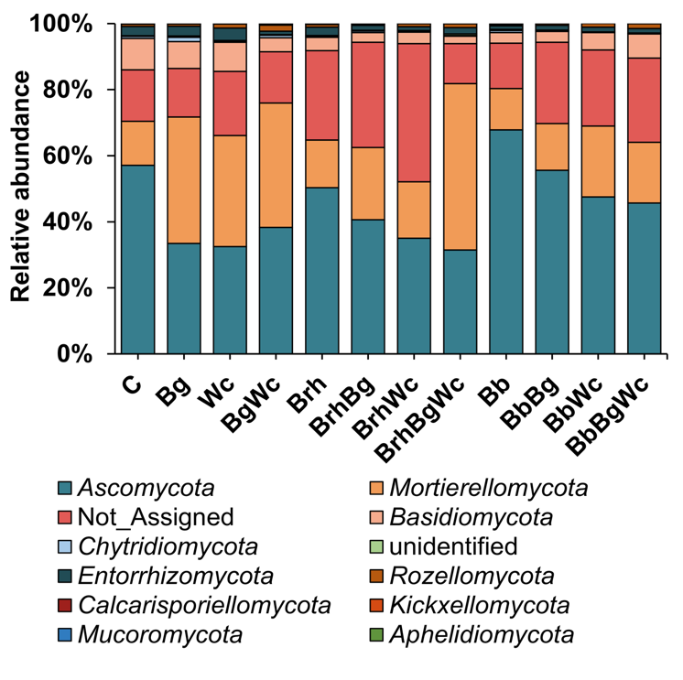
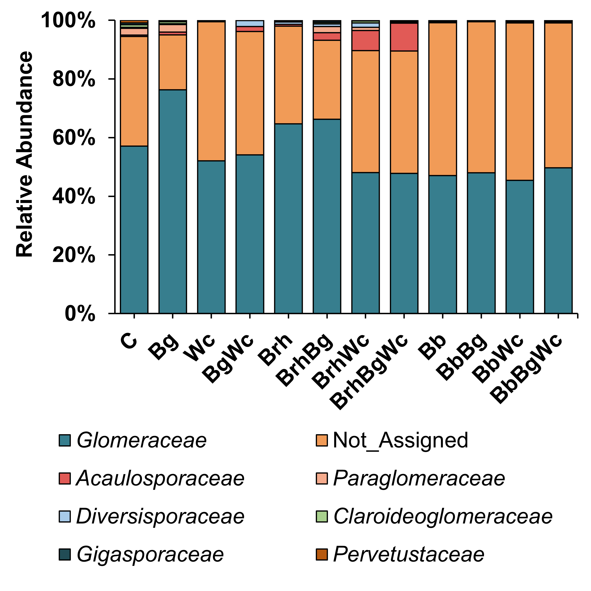
6. Tables and Figures
A
B
A
B
Fig. 1. Relative abundance of fungi at phylum level (A) and of AMF at family level (B).
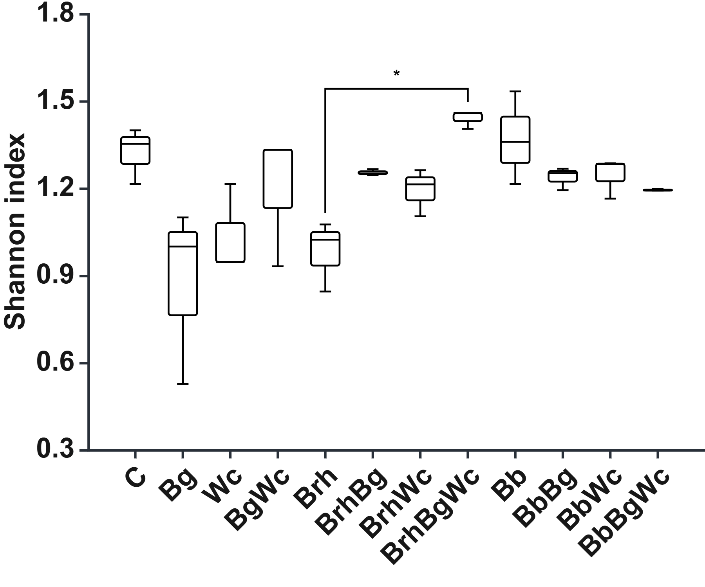
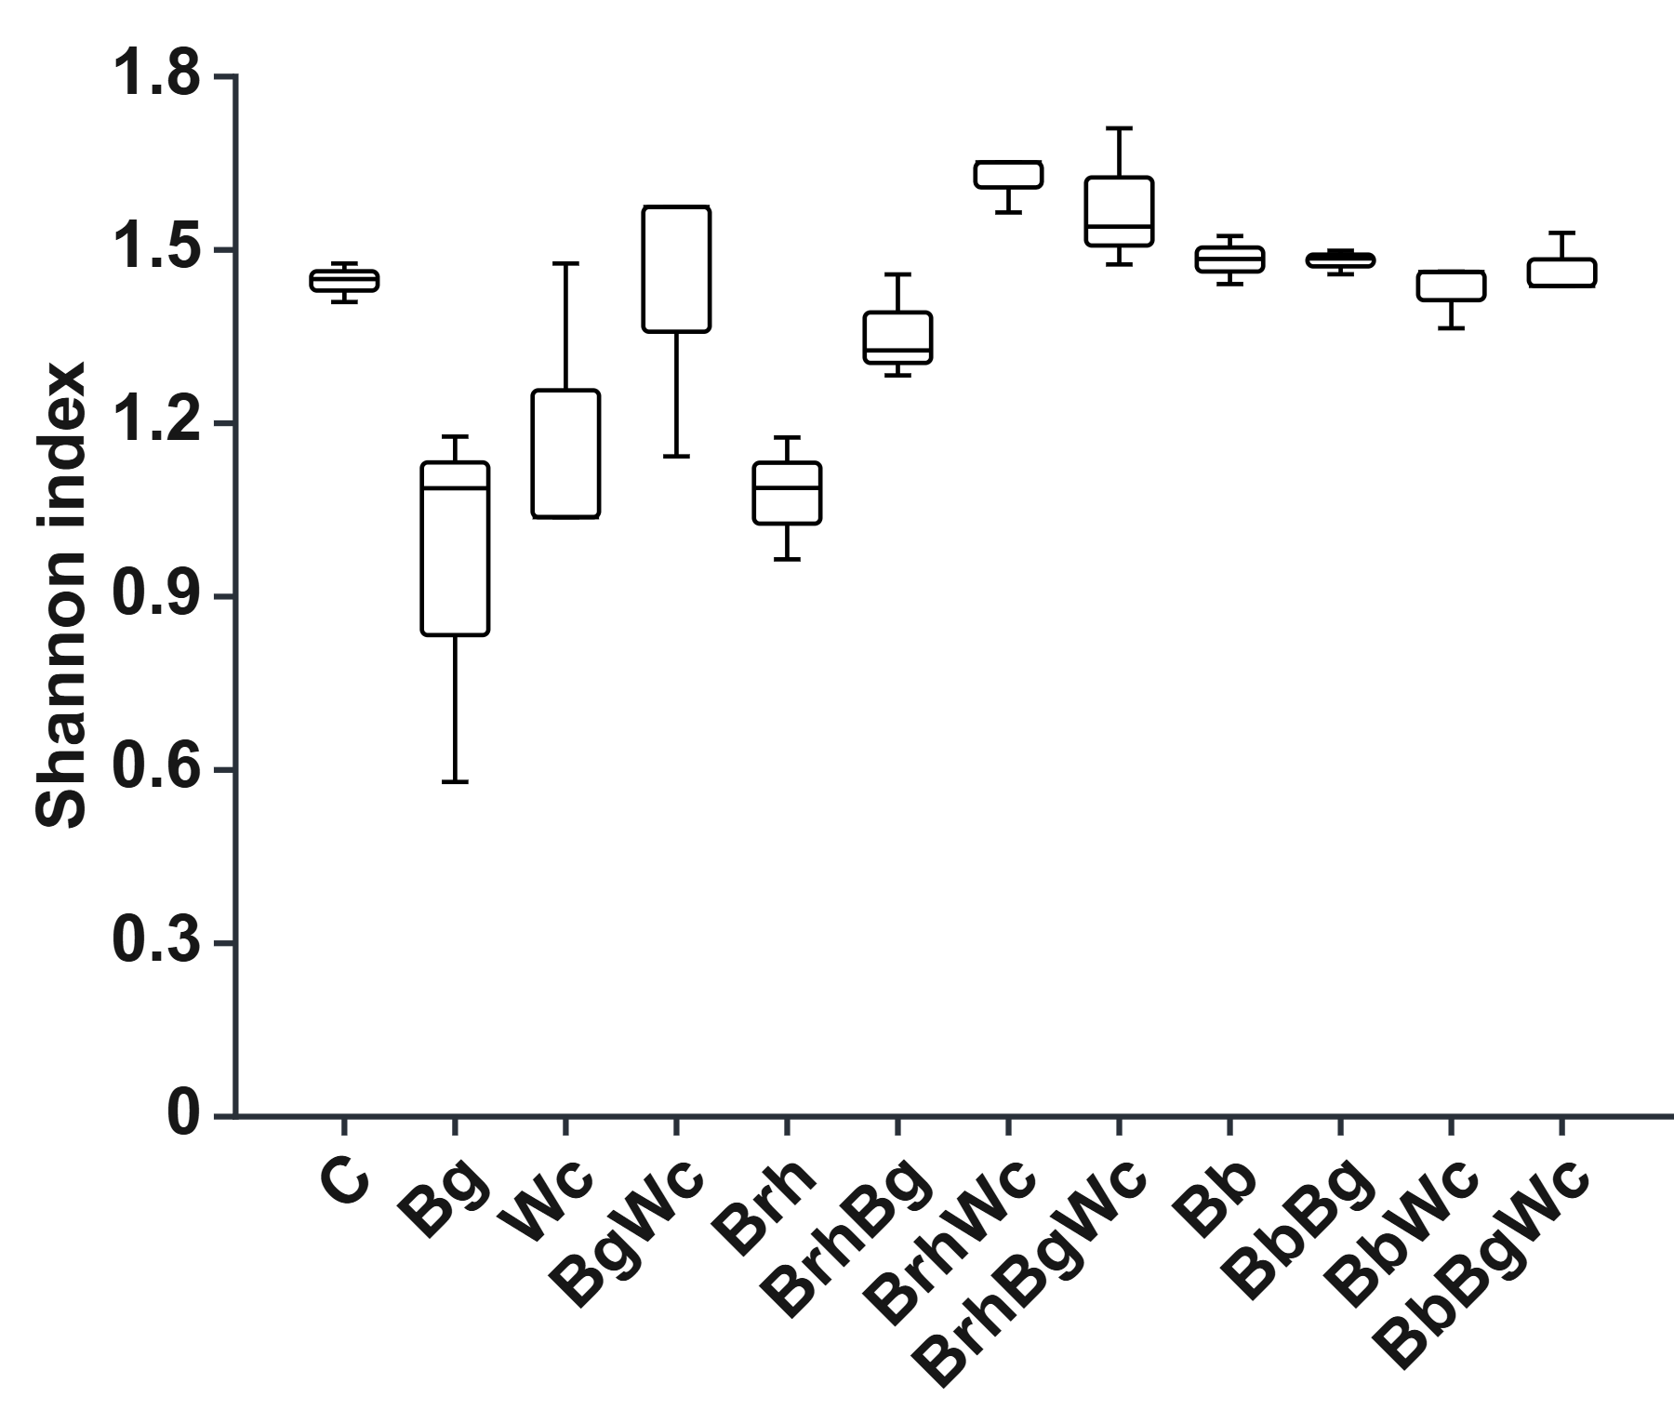
Fig. 2. Bacterial richness, represented by the Shannon index of fungi (A) and of AMF (B).
A
B

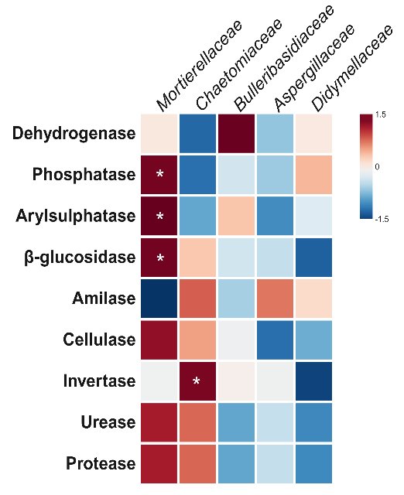
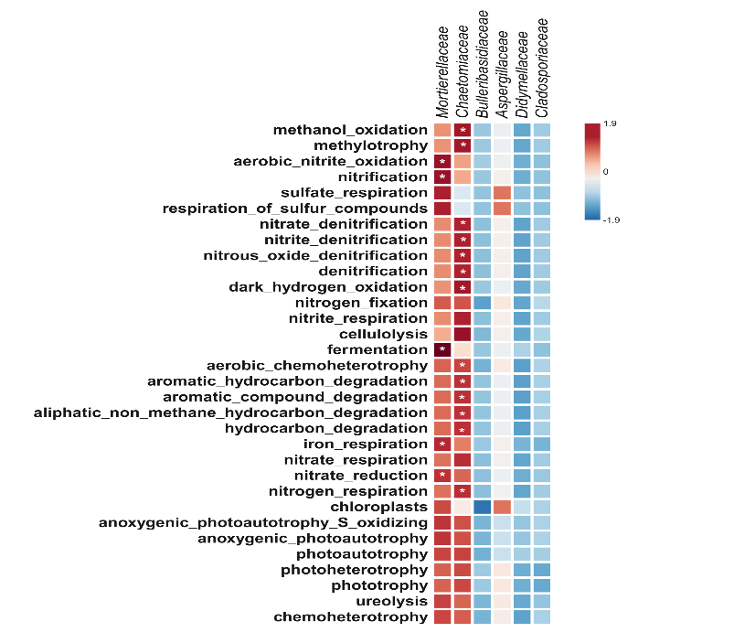
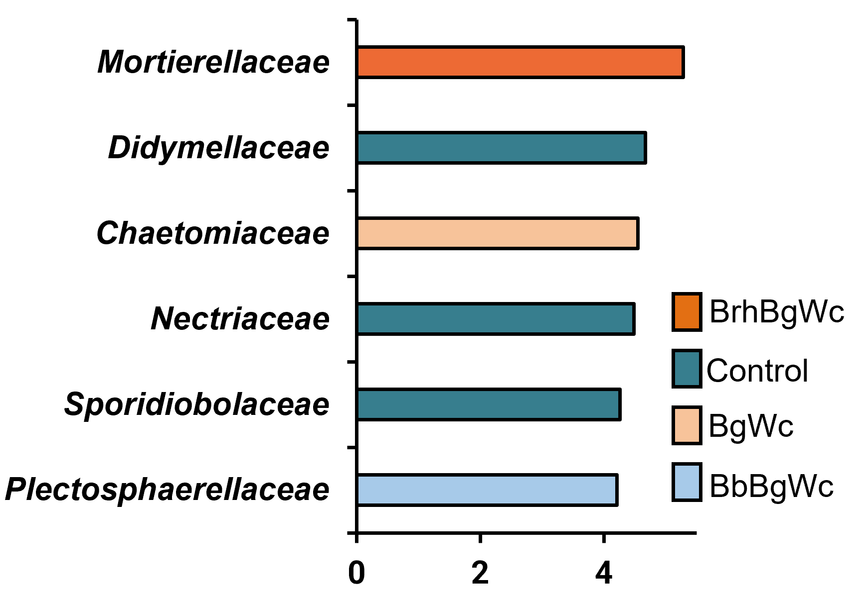
Fig. 4. Heatmaps depicting the Pearson correlation coefficients between the relative abundances of fungal families and measured enzyme activities (A) and predicted metabolic functions (B) across soil samples. Fungal, enzymatic and metabolic data were normalized using z-scores prior to analysis, enabling direct comparison of patterns independent of absolute abundance levels. The color gradient represents the strength and direction of Pearson’s r values, with positive correlations shown in red hues and negative correlations in blue hues. *p < 0.05.
A
B
Fig. 3. Linear Discriminant Analysis (LDA) scores illustrating the separation of fungal families among soil treatments.
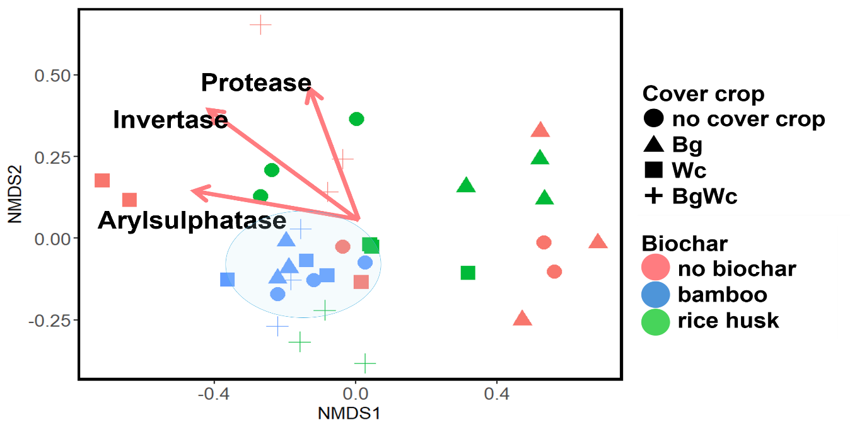
Fig. 5. Non-metric multidimensional scaling (NMDS) ordination highlighting the associations between arbuscular mycorrhizal fungi (AMF) community structure and enzyme activities in soil samples. Only statistically significant correlations between AMF taxa and enzyme activities (p < 0.05) are depicted, as determined by envfit analysis. Vectors represent enzyme activities significantly correlated with AMF community composition, with their direction and length indicating the strength and orientation of the association.

COMPETING INTERESTS DISCLAIMER:
Authors have declared that they have no known competing financial interests OR non-financial interests OR personal relationships that could have appeared to influence the work reported in this paper.

7. References
Amato, M., Ladd, J.N., 1988. Assay for microbial biomass based on ninhydrin-reactive nitrogen in extracts of fumigated soils. Soil Biol Biochem 20, 107–114. https://doi.org/10.1016/0038-0717(88)90134-4
Baldrian, P., 2017. Forest microbiome: Diversity, complexity and dynamics. FEMS Microbiol Rev 41, 109–130. https://doi.org/10.1093/femsre/fuw040
Bolyen, E., Rideout, J.R., Dillon, M.R., Bokulich, N.A., Abnet, C.C., Al-Ghalith, G.A., Alexander, H., Alm, E.J., Arumugam, M., Asnicar, F., Bai, Y., Bisanz, J.E., Bittinger, K., Brejnrod, A., Brislawn, C.J., Brown, C.T., Callahan, B.J., Caraballo-Rodríguez, A.M., Chase, J., Cope, E.K., Da Silva, R., Diener, C., Dorrestein, P.C., Douglas, G.M., Durall, D.M., Duvallet, C., Edwardson, C.F., Ernst, M., Estaki, M., Fouquier, J., Gauglitz, J.M., Gibbons, S.M., Gibson, D.L., Gonzalez, A., Gorlick, K., Guo, J., Hillmann, B., Holmes, S., Holste, H., Huttenhower, C., Huttley, G.A., Janssen, S., Jarmusch, A.K., Jiang, L., Kaehler, B.D., Kang, K. Bin, Keefe, C.R., Keim, P., Kelley, S.T., Knights, D., Koester, I., Kosciolek, T., Kreps, J., Langille, M.G.I., Lee, J., Ley, R., Liu, Y.X., Loftfield, E., Lozupone, C., Maher, M., Marotz, C., Martin, B.D., McDonald, D., McIver, L.J., Melnik, A. V., Metcalf, J.L., Morgan, S.C., Morton, J.T., Naimey, A.T., Navas-Molina, J.A., Nothias, L.F., Orchanian, S.B., Pearson, T., Peoples, S.L., Petras, D., Preuss, M.L., Pruesse, E., Rasmussen, L.B., Rivers, A., Robeson, M.S., Rosenthal, P., Segata, N., Shaffer, M., Shiffer, A., Sinha, R., Song, S.J., Spear, J.R., Swafford, A.D., Thompson, L.R., Torres, P.J., Trinh, P., Tripathi, A., Turnbaugh, P.J., Ul-Hasan, S., van der Hooft, J.J.J., Vargas, F., Vázquez-Baeza, Y., Vogtmann, E., von Hippel, M., Walters, W., Wan, Y., Wang, M., Warren, J., Weber, K.C., Williamson, C.H.D., Willis, A.D., Xu, Z.Z., Zaneveld, J.R., Zhang, Y., Zhu, Q., Knight, R., Caporaso, J.G., 2019. Reproducible, interactive, scalable and extensible microbiome data science using QIIME 2. Nature Biotechnology 2019 37:8 37, 852–857. https://doi.org/10.1038/s41587-019-0209-9
Castle, S.C., Samac, D.A., Gutknecht, J.L., Sadowsky, M.J., Rosen, C.J., Schlatter, D., Kinkel, L.L., 2021. Impacts of cover crops and nitrogen fertilization on agricultural soil fungal and bacterial communities. Plant Soil 466, 139–150. https://doi.org/10.1007/S11104-021-04976-Z/FIGURES/5
Dang, Q., Wang, Y., Xiong, S., Yu, H., Zhao, X., Tan, W., Cui, D., Xi, B., 2021. Untangling the response of fungal community structure, composition and function in soil aggregate fractions to food waste compost addition. Science of The Total Environment 769, 145248. https://doi.org/10.1016/J.SCITOTENV.2021.145248
Erhunmwunse, A.S., Queiroz, L.M.D., Zhang, K., Mackowiak, C.L., Blount, A.R.S., Dubeux, J.C.B., Liao, H.L., 2023. Changes in soil microbial diversity and community composition across bahiagrass and rhizoma peanut pastures. Biol Fertil Soils 59, 285–300. https://doi.org/10.1007/S00374-023-01701-Z/TABLES/2
Freire Cruz, A., Rosa, W., Soares, O., Blum, L.E.B., 2014. Impact of the Arbuscular Mycorrhizal Fungi and Bacteria on Biocontrol of White Root Rot in Fruit Seedlings. a SciTechnol journal Research Article Cruz AF J Plant Physiol Pathol 2, 1. https://doi.org/10.4172/2329-955X.1000114
Gautam, K., Singh, P., Singh, R.P., Singh, A., 2024. Impact of rice-husk biochar on soil attributes, microbiome interaction and functional traits of radish plants: A smart candidate for soil engineering. Plant Stress 14, 100564. https://doi.org/10.1016/J.STRESS.2024.100564
Gomes, M.O., Cruz, A.F., 2025. Synergistic Effects of the Use of Biochar and Cover Crops on Soil Health Parameters. Eurasian Soil Science 58. https://doi.org/10.1134/S1064229324604049
Gul, S., Whalen, J.K., 2016. Biochemical cycling of nitrogen and phosphorus in biochar-amended soils. Soil Biol Biochem. https://doi.org/10.1016/j.soilbio.2016.08.001
Guzman, A., Montes, M., Hutchins, L., DeLaCerda, G., Yang, P., Kakouridis, A., Dahlquist-Willard, R.M., Firestone, M.K., Bowles, T., Kremen, C., 2021. Crop diversity enriches arbuscular mycorrhizal fungal communities in an intensive agricultural landscape. New Phytologist 231, 447–459. https://doi.org/10.1111/nph.17306
Jabborova, D., Annapurna, K., Paul, S., Kumar, S., Saad, H.A., Desouky, S., Ibrahim, M.F.M., Elkelish, A., 2021. Beneficial features of biochar and arbuscular mycorrhiza for improving spinach plant growth, root morphological traits, physiological properties, and soil enzymatic activities. Journal of Fungi 7. https://doi.org/10.3390/jof7070571
Jenkins, J.R., Viger, M., Arnold, E.C., Harris, Z.M., Ventura, M., Miglietta, F., Girardin, C., Edwards, R.J., Rumpel, C., Fornasier, F., Zavalloni, C., Tonon, G., Alberti, G., Taylor, G., 2017. Biochar alters the soil microbiome and soil function: results of next-generation amplicon sequencing across Europe. GCB Bioenergy 9, 591–612. https://doi.org/10.1111/gcbb.12371
Kageyama, K., Komatsu, T., Suga, H., 2003. Refined PCR protocol for detection of plant pathogens in soil. Journal of General Plant Pathology 2003 69:3 69, 153–160. https://doi.org/10.1007/S10327-002-0037-4
Lehmann, J., Rillig, M.C., Thies, J., Masiello, C.A., Hockaday, W.C., Crowley, D., 2011. Biochar effects on soil biota - A review. Soil Biol Biochem. https://doi.org/10.1016/j.soilbio.2011.04.022
Leite, H.M.F., Calonego, J.C., Rosolem, C.A., Mendes, L.W., de Moraes, L.N., Grotto, R.M.T., Araujo, F.F., Pereira, A.P. de A., Melo, V.M.M., Araujo, A.S.F., 2021. Cover crops shape the soil bacterial community in a tropical soil under no-till. Applied Soil Ecology 168, 104166. https://doi.org/10.1016/J.APSOIL.2021.104166
Lu, Y., Zhou, G., Ewald, J., Pang, Z., Shiri, T., Xia, J., 2023. MicrobiomeAnalyst 2.0: Comprehensive statistical, functional and integrative analysis of microbiome data. Nucleic Acids Res 51, W310–W318. https://doi.org/10.1093/nar/gkad407
Mitani, T., Horinishi, A., Kishida, K., Kawabata, T., Yano, F., Mimura, H., Inaba, N., Yamanishi, H., Oe, T., Negoro, K., Mori, H., Miyake, Y., Hosoda, A., Tanaka, Y., Mori, M., Ozaki, Y., 2013. Phenolics profile of mume, Japanese apricot (Prunus mume Sieb. et Zucc.) fruit. Biosci Biotechnol Biochem 77, 1623–1627. https://doi.org/10.1271/bbb.130077
Niwa, R., Koyama, T., Sato, T., Adachi, K., Tawaraya, K., Sato, S., Hirakawa, H., Yoshida, S., Ezawa, T., 2018. Dissection of niche competition between introduced and indigenous arbuscular mycorrhizal fungi with respect to soybean yield responses. Sci Rep 8, 1–11. https://doi.org/10.1038/S41598-018-25701-4;TECHMETA=23,38,47;SUBJMETA=193,2539,2565,326,631,855;KWRD=FUNGAL+ECOLOGY,MICROBIAL+ECOLOGY
Noyce, G.L., Winsborough, C., Fulthorpe, R., Basiliko, N., 2016. The microbiomes and metagenomes of forest biochars. Sci Rep 6. https://doi.org/10.1038/SREP26425
Nwajiaku, I.M., Olanrewaju, J.S., Sato, K., Tokunari, T., Kitano, S., Masunaga, · Tsugiyuki, 2018. Change in nutrient composition of biochar from rice husk and sugarcane bagasse at varying pyrolytic temperatures. International Journal of Recycling of Organic Waste in Agriculture 7, 269–276. https://doi.org/10.1007/s40093-018-0213-y
Santoyo, G., Gamalero, E., Glick, B.R., 2021. Mycorrhizal-Bacterial Amelioration of Plant Abiotic and Biotic Stress. Front Sustain Food Syst. https://doi.org/10.3389/fsufs.2021.672881
Tedersoo, L., Bahram, M., Põlme, S., Kõljalg, U., Yorou, N.S., Wijesundera, R., Ruiz, L.V., Vasco-Palacios, A.M., Thu, P.Q., Suija, A., Smith, M.E., Sharp, C., Saluveer, E., Saitta, A., Rosas, M., Riit, T., Ratkowsky, D., Pritsch, K., Põldmaa, K., Piepenbring, M., Phosri, C., Peterson, M., Parts, K., Pärtel, K., Otsing, E., Nouhra, E., Njouonkou, A.L., Nilsson, R.H., Morgado, L.N., Mayor, J., May, T.W., Majuakim, L., Lodge, D.J., Lee, S., Larsson, K.H., Kohout, P., Hosaka, K., Hiiesalu, I., Henkel, T.W., Harend, H., Guo, L.D., Greslebin, A., Grelet, G., Geml, J., Gates, G., Dunstan, W., Dunk, C., Drenkhan, R., Dearnaley, J., De Kesel, A., Dang, T., Chen, X., Buegger, F., Brearley, F.Q., Bonito, G., Anslan, S., Abell, S., Abarenkov, K., 2014. Global diversity and geography of soil fungi. Science (1979) 346. https://doi.org/10.1126/science.1256688
Tian, T., Cao, H., Farag, M.A., Fan, S., Liu, L., Yang, W., Wang, Y., Zou, L., Cheng, K.W., Wang, M., Ze, X., Simal-Gandara, J., Yang, C., Qin, Z., 2023. Current and potential trends in the bioactive properties and health benefits of Prunus mume Sieb. Et Zucc: a comprehensive review for value maximization. Crit Rev Food Sci Nutr. https://doi.org/10.1080/10408398.2022.2042186
Van Der Heijden, M.G.A., Bardgett, R.D., Van Straalen, N.M., 2008. The unseen majority: Soil microbes as drivers of plant diversity and productivity in terrestrial ecosystems. Ecol Lett. https://doi.org/10.1111/j.1461-0248.2007.01139.x
Vukicevich, E., Lowery, T., Bowen, P., Úrbez-Torres, J.R., Hart, M., 2016. Cover crops to increase soil microbial diversity and mitigate decline in perennial agriculture. A review. Agron Sustain Dev. https://doi.org/10.1007/s13593-016-0385-7
Wang, W., Wang, Z., Yang, K., Wang, P., Wang, H., Guo, L., Zhu, S., Zhu, Y., He, X., 2020. Biochar Application Alleviated Negative Plant-Soil Feedback by Modifying Soil Microbiome. Front Microbiol 11, 537101. https://doi.org/10.3389/FMICB.2020.00799/BIBTEX
Wu, Hongmiao, Wu, Huiming, Jiao, Y., Zhang, Z., Rensing, C., Lin, W., 2022. The combination of biochar and PGPBs stimulates the differentiation in rhizosphere soil microbiome and metabolites to suppress soil-borne pathogens under consecutive monoculture regimes. GCB Bioenergy 14, 84–103. https://doi.org/10.1111/gcbb.12906
Zheng, Y., Han, X., Li, Y., Yang, J., Li, N., An, N., 2019. Effects of Biochar and Straw Application on the Physicochemical and Biological Properties of Paddy Soils in Northeast China. Sci Rep 9. https://doi.org/10.1038/s41598-019-52978-w

