Original Research Article

Genetic Variability of Sulfadoxine-Pyrimethamin Resistant Plasmodium Species among Pregnant Women Attending Antenatal Health Facilities in Nasarawa-South Senatorial Zone, Nigeria

.
ABSTRACT

Aims: This study investigates the genetic variability of sulfadoxine-pyrimethamine resistance genes in Plasmodium species from pregnant women attending Health facilities in Nasarawa-South Senatorial Zone, Nasarawa State, Nigeria.
Study design: Cross sectional study.
Place and Duration of Study: Department of Microbiology, Nasarawa State University, Keffi between October 2024 and July 2025.
Methodology: A total of 45 malaria parasite blood positive samples from our previous studies were used for DNA extraction. The speciation of Plasmodium and detection of dhfr and dhps genes mediating Sulfadoxine-Pyrimethamine resistance were carried out using the polymerase chain reaction method. The polymorphism in dhfr and dhps genes mediating Sulfadoxine-Pyrimethamine were analysed by Sanger DNA sequencing.
Results: The Plasmodium falciparum (P. falciparum) and Plasmodium ovale (P. ovale) were found to be prevalent among the pregnant women of which P. falciparum (33/45; 15.8%) was found to be more prevalent than Plasmodium ovale (12/45; 26.7%). The dhfr gene was detected only in the P. falciparum and the prevalence was (7/33; 21.2%) but none of the P. falciparum and P. ovale carried the dhps gene. The pfdhfr mutation at codon N51I, C59R, and S108N was 100.0% in Sulfadoxine-Pyrimethamine resistant P. falciparum. The Sulfadoxine-Pyrimethamine resistant P. falciparum, due to mutation at codon N51I, C59R, and S108N, were prevalent among the pregnant women in the study centres.
Conclusion: The study highlights that a high prevalence of Plasmodium falciparum parasites with mutations in the dhfr gene (specifically N51I, C59R, and S108N) associated with Sulfadoxine-Pyrimethamine (SP) resistance is rampant among pregnant women in the Nasarawa-South Senatorial Zone, Nigeria. The absence of the dhps gene in the sampled population, does not mitigate the significant threat posed by the established triple dhfr mutations. These findings indicate a concerning level of SP resistance, which could severely compromise the efficacy of this regimen for the intermittent preventive treatment of malaria in pregnancy (IPTp) in this region. Urgent surveillance and a review of current malaria prevention strategies for pregnant women is suggested.

Keywords: Plasmodium, malaria, pregnancy, sulfadoxine-pyrimethamine, resistance

1. INTRODUCTION
Malaria is a significant public health concern in sub-Sahara African countries, and Nigeria accounts for the highest cases [1, 2]. The highest cases of malaria in the Sub- Sahara Africa are found among pregnant women [1], and this contributes to maternal anaemia, leading to spontaneous abortion, still birth, pre-mature birth and low birth weight [1, 3, 4, 5]. To prevent the above problems associated with pregnancy due to Plasmodium infection, malaria endemic countries in Africa are employing Sulfadoxine-Pyrimethamine as intermittent preventive treatment during pregnancy [6].
The continued prophylactic use of sulfadoxine-pyrimethamine (SP) in pregnant women has selected for resistant Plasmodium strains, reducing the drug's efficacy through mutations in the dihydrofolate reductase (dhfr) and dihydropteroate synthase (dhps) genes [6].
Recently, studies had identified mutation in A51I, Ca5R, S1i8N and II64L coding region of DHFR and S4363/F, A437G, K540E, A581G and A613S/T coding region of DHPS to mediate resistance to Sulfadoxine-Pyrimethamine [6].
The genetic variability of sulfadoxine-pyrimethamine (SP) resistance in Plasmodium species is understudied among pregnant women attending antenatal clinics in Nasarawa State, Nigeria. Given SP's role as a standard malaria prophylactic agent during pregnancy, this study focuses on the speciation and genetic characterization of SP-resistant Plasmodium isolates in this population.
2. material and methods
2.1 Blood collections
A total of 45 dried blood spot (DBS) samples, previously collected from malaria-positive pregnant women in the Nasarawa-South senatorial zone [7], were used for this study. Each sample, containing five spots on a DBS card, was air-dried at room temperature, packaged in triple-layered bags with desiccant silica gel, and stored at room temperature prior to DNA extraction.

2.2 DNA Extraction
Genomic DNA was extracted from the dried blood spot (DBS) samples using the quick-DNA Miniprep plus kit (Zymo Research, supplied by Inqaba West Africa) according to the manufacturer's instructions, with the following steps. Punches from the DBS cards were immersed in the provided buffer solution and vortexed. A 400 µL aliquot of this buffer was transferred to a 1.5 mL microcentrifuge tube. Then, 20 µL of Proteinase K and 400 µL of Biofluid (red) solution were added to the tube. The mixture was vortexed and incubated at 55°C for 20 minutes.
Following incubation, 420 µL of Genomic Binding Buffer was added to the lysate and mixed thoroughly by vortexing. The entire mixture was loaded into a Zymo-Spin™ IIC-XLR column seated in a collection tube and centrifuged at 12,000 × *g* for 1 minute. The flow-through was discarded along with the collection tube.
The spin column was placed in a new collection tube, and 400 µL of DNA Pre-Wash Buffer was added. After centrifugation at 12,000 × *g* for 1 minute, the flow-through was discarded. This was followed by the addition of 500 µL of DNA Wash Buffer and another centrifugation step at 12,000 × *g*.
For a final wash, the column was transferred to a clean 1.5 mL microcentrifuge tube, and 200 µL of DNA Wash Buffer was added. The column was centrifuged at 12,000 × *g* for 1 minute. The column was then transferred to a new, labeled 1.5 mL microcentrifuge tube. To elute the purified DNA, 50 µL of DNA Elution Buffer was added directly to the column matrix and centrifuged at maximum speed (>12,000 × *g*) for 1 minute.
The eluted DNA (the harvested product) was stored at -20°C prior to downstream quantification and amplification.

2.3 DNA Quantification
The concentration and purity of the extracted genomic DNA were quantified using a NanoDrop 1000 spectrophotometer. Following instrument calibration with sterile distilled water and blanking with normal saline, 2 µL of each DNA sample was loaded for measurement. The A260/A280 and A260/A230 ratios were recorded to assess protein and salt contamination, respectively.

2.4 Amplification of 18S rRNA of Malaria Parasites
The primary reaction was performed using universal Plasmodium genus-specific primers rPLU5 (5′-CCTGTTGTTGCCTTAAACTTC-3′) and rPLU6 (5′-TTAAAATTGTTGCAGTTAAAACG-3′). Each 25 µL reaction contained 12.5 µL of 2X DreamTaq Master Mix (Inqaba Biotech, South Africa), 0.4 µM of each primer, and 50 ng of template DNA. The thermocycling conditions were: initial denaturation at 95°C for 5 min; 35 cycles of denaturation at 95°C for 30 s, annealing at 56°C for 40 s, and extension at 72°C for 50 s; followed by a final extension at 72°C for 5 min.
The secondary amplification (Nested PCR) used 1 µL of the primary PCR product as template. Species-specific primer sets were used in separate reactions for P. falciparum (rFAL1: 5′-TTTTGAGAGGTTTTGTTACTTTGAGTAA-3′ / rFAL2: 5′-TATTCCATGCTGTAGTATTCAAACAAAA-3′), P. ovale (rOVA1: 5′-TTTTGAAGAATACATTAGGATACAATTAATG-3′ / rOVA2: 5′-CATCGTTCCTCTAAGAAGCTTTACCCT-3′), P. vivax (rVIV1: 5′-ACGCTTCTAGCTTAATCCACATAACT-3′ / rVIV2: 5′-ATTTACTCAAAGTAACAAGGACTTCCAAGC-3′), and P. malariae (rMAL1: 5′-ATAACATAGTTGTACGTTAAGAATAACCGC-3′ / rMAL2: 5′-AAAATTCCCATGCATAAAAAATTATACAAA-3′). Reaction composition was identical to the primary PCR. Annealing temperatures were optimized for each species: 55°C for P. falciparum, 56°C for P. ovale, 57°C for P. vivax, and 52°C for P. malariae. All other thermocycling parameters remained unchanged.
The PCR amplicons were resolved by electrophoresis on a 1.5% agarose gel at 120 V for 25 minutes and visualized under UV light.

2.5 Amplification of the dhfr Gene
The dhfr gene of Plasmodium falciparum was amplified using a semi-nested PCR approach on an ABI 9700 thermal cycler (Applied Biosystems).
The first-round reaction, Primary PCR (Nest 1), was performed in a final volume of 50 µL. The reaction mixture consisted of 25 µL of 2X DreamTaq Master Mix (Inqaba Biotech, South Africa), 0.4 µM of each outer primer (Pfdhfr1F: 5′-TTTATATTTTCTCCTTTTTA-3′ and Pfdhfr1/2R: 5′-CATTTTATTATTCGTTTTCT-3′), and template DNA. The thermocycling conditions were: initial denaturation at 95°C for 5 min; 35 cycles of denaturation at 95°C for 30 s, annealing at 52°C for 30 s, and extension at 72°C for 30 s; followed by a final extension at 72°C for 5 min.
The second-round amplification, Semi-nested PCR (Nest 2), used 1 µL of the primary (Nest 1) PCR product as template. The reaction was identical to the first, except the forward primer was replaced with the internal primer Pfdhfr2F (5′-TGATGGAACAAGTCTGCGAC-3′), and the annealing temperature was lowered to 50°C. All other parameters remained unchanged.
The final PCR amplicon was resolved by electrophoresis on a 1% agarose gel at 120 V for 15 minutes and visualized under UV light.

2.6 Amplification of the dhps Gene
The dhps gene was amplified using a conventional PCR assay. Each 25 µL reaction contained 12.5 µL of 2X DreamTaq Master Mix (Inqaba Biotech, South Africa), 0.4 µM of each primer (Dhps-F: 5’-TTTTGTTGAACCTAAACGTG-3’ and Dhps-R: 5’-AAACGTCATGAACTCTTATTAGAT-3’), and template DNA. Amplification was performed on an ABI 9700 thermal cycler under the following conditions: initial denaturation at 94°C for 5 min; 40 cycles of denaturation at 94°C for 30 s, annealing at 53°C for 30 s, and extension at 72°C for 1 min; with a final extension at 72°C for 5 min.
The resulting PCR amplicons were resolved by electrophoresis on a 1% agarose gel at 120 V for 15 minutes and visualized under UV light.

2.7 DNA Sequencing and Analysis
The amplified dhfr and dhps PCR products were purified and sequenced using the Sanger method. The resulting nucleotide sequences were analyzed using the NCBI BLAST tool (http://blast.ncbi.nlm.nih.gov/) for initial confirmation.
To identify polymorphisms associated with drug resistance, the sequences were aligned with reference strains using the MAFFT algorithm via the CLUSTAL Omega web server (https://www.ebi.ac.uk/Tools/msa/clustalo/). Single nucleotide polymorphisms (SNPs) in the dhfr and dhps genes were identified through multiple sequence alignment analysis.

3. results and discussion
3.1 Plasmodium Species Identification
Plasmodium species in microscopic and seropositive blood samples were identified using a nested PCR assay targeting the 18S rRNA gene. The amplified products were resolved by agarose gel electrophoresis, and species were determined based on the size of the amplicons (Plates 1 and 2).
The prevalence of each species was determined using descriptive statistics (Figure 1). Of the 45 PCR-positive samples, two species were detected: P. falciparum and P. ovale. Plasmodium falciparum was the predominant species, with a prevalence of 73.3% (n=33), while P. ovale was detected in 26.7% (n=12) of the samples.

3.2 Prevalence of Sulfadoxine-Pyrimethamine Resistance Mutations
The prevalence of mutations in the P. falciparum dhfr (pfdhfr) and dhps (pfdhps) genes, associated with sulfadoxine-pyrimethamine (SP) resistance, was investigated.
Among the 33 P. falciparum-positive samples, the pfdhfr gene was successfully amplified in 7 (21.2%). In contrast, the pfdhps gene was not amplified in any of the samples (Figure 2).
The seven pfdhfr amplicons were sequenced using the Sanger method. The sequences were analyzed using the NCBI BLAST tool for initial identification and aligned with reference sequences using the CLUSTAL Omega alignment tool to identify polymorphisms.
Mutations were detected at three codons of the pfdhfr gene in all seven samples (100% prevalence): N51I, C59R, and S108N. The triple mutant haplotype (N51I+C59R+S108N) was therefore present in all SP-resistant isolates identified.

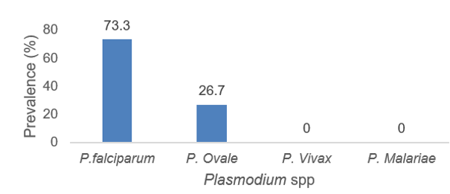
Figure 1: Distribution of different Plasmodium species among pregnant women attending selected Secondary Healthcare facilities, Nasarawa –South Senatorial Zone, Nigeria

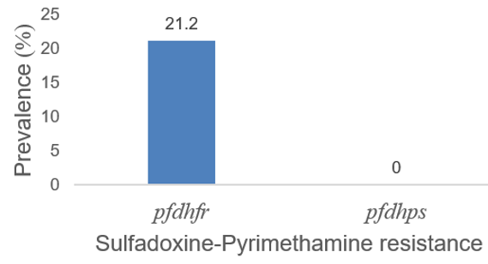
Figure 2: Prevalence of Sulfadoxine-Pyrimethamine resistance gene in Plasmodium falciparum from pregnant women attending selected Secondary Healthcare facilities, Nasarawa –South Senatorial Zone, Nigeria

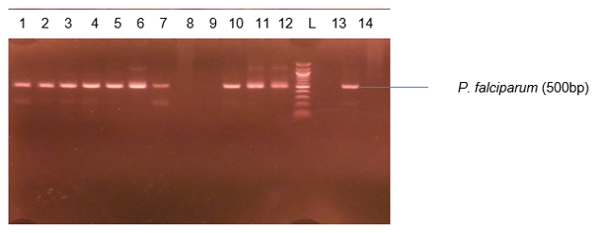
Plate 1: Agarose gel electrophoresis showing the amplified 18srRNA of the P. falciparum at 200bp. Lane 1-7, 10-12 and 14 the represents P. falciparum gene while L represent 100bp molecular ladder
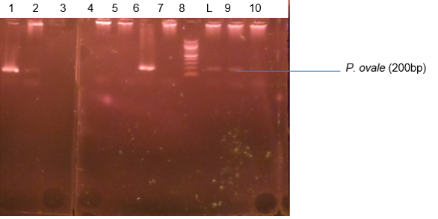
Plate 2: Agarose gel electrophoresis showing the amplified 18srRNA of the P. ovale at 200bp. Lane L 1,7 and 9-10 the represents P. ovale gene while L represent 100bp molecular ladder.

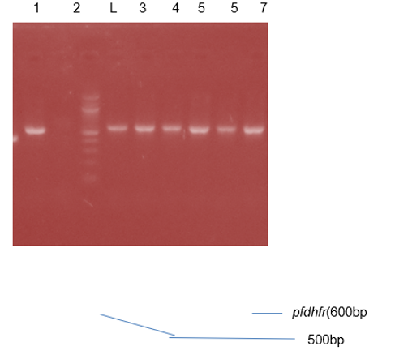
Plate 3: Agarose gel electrophoresis showing the amplified pfdhfr gene bands. Lane 1 and 3-7represent the pfdhfr gene bands at 600bp while lane L represents the 100bp molecular ladder
Our study identified Plasmodium falciparum and Plasmodium ovale as the prevalent species causing malaria in pregnant women within the Nasarawa-South senatorial zone. The predominance of P. falciparum (73.3%) is consistent with its established status as the primary malaria parasite across sub-Saharan Africa [1, 6] and aligns with findings from previous studies in similar Nigerian settings [8]. Notably, the prevalence in our cohort was higher than the 57.1% reported by Dabash et al. (2022) [8] in [their location], potentially reflecting regional variations in transmission intensity.

A key finding was the 21.2% prevalence of mutations in the pfdhfr gene among the P. falciparum isolates. This suggests that SP resistance is a significant concern in the study area. Crucially, all resistant isolates (100%) harbored the triple mutant haplotype (N51I, C59R, S108N) in the pfdhfr gene. This prevalence is markedly higher than the 82.5% reported for the same haplotype in Maiduguri by Balogun et al. (2021) [9], indicating a potentially more advanced state of SP resistance in our study region. The fixation of this triple mutation strongly implies intense selective pressure from sustained SP use, likely driven by its application in intermittent preventive treatment in pregnancy (IPTp).

The absence of pfdhps gene amplification, while requiring further investigation, suggests that the pfdhfr triple mutation alone is a primary driver of SP treatment failure in these cases. These resistant parasites are directly responsible for clinical malaria cases in pregnant women, underscoring a critical failure of current chemo preventive strategies.

4. Conclusion

This study found a high prevalence (21.2%) of dhfr mutations conferring Sulfadoxine-Pyrimethamine (SP) resistance among P. falciparum isolates from pregnant women in Nasarawa State, Nigeria. The fixation of the triple mutant haplotype (N51I, C59R, S108N) in all resistant parasites signifies an established and highly resistant local parasite population. Although the dhps gene was not amplified, the high degree of dhfr mutation alone severely compromises SP efficacy. These findings suggest an urgent need to re-evaluate the continued use of SP for intermittent preventive treatment in pregnancy (IPTp) in this region and to enhance antifolate resistance surveillance.

Ethical approval

Appropriate ethical committee approval was obtained prior to start of the research and is available for review.

Disclaimer (Artificial intelligence)
Author(s) hereby declare that NO generative AI technologies such as Large Language Models (ChatGPT, COPILOT, etc.) and text-to-image generators have been used during the writing or editing of this manuscript

References

1. Gikunju SW, Agola EL, Ondondo RP, Kinyua J, Kimani F, LaBeaud AD, Malhotra I, King C, Thiong’o K and Mutuku F. (2020). Prevalence of pfdhfr and pfdhps mutations in Plasmodium falciparum associated with drug resistance among pregnant women receiving IPTp‑SP at Msambweni County Referral Hospital, Kwale County, Kenya. Malaria Journal, 19:190.
2. Oyerogba OP, Adedapo A, Awokson T, Odukogbe A. and Aderinto N. (2023). Prevalence of malaria parasitaemia among pregnant women at booking in Nigeria. Health Science Report, 1-8.
3. WHO (2013). Lives at risk: malaria in pregnancy. Geneva, World Health Organization.
4. Desai M, Gutman J, Taylor SM, Wiegand RE, Khairallah C, Kayentao K, et al. (2016). Impact of sulfadoxine-pyrimethamine resistance on effectiveness of intermittent preventive therapy for malaria in pregnancy at clearing infections and preventing low birth weight. Clin Infect Dis. 2016;62:323–33.
5. WHO (2018). World Malaria Report 2018. Geneva, World Health Organization, 2018.
6. White NFD, Whitton G, Wasakul V, Amenga-Etego L, Dara A, Andrianaranjaka V, Randrianarivelojosia M, Miotto O, D’Alessandro U, Djimdé A, Ariani CV, Pearson RD and Amambua-Ngwa A (2025). Disparate co-evolution and prevalence of sulfadoxine and pyrimethamine resistance alleles and haplotypes at dhfr and dhps genes across Africa. Scientific Reports,15:13222; https://doi.org/10.1038/s41598-025-98035-7
7. Danjuma, J., Ngwai, Y. B., Nkene, I. H., Bolarinwa, O. F., Ishaleku, D., Agondo, D. I., ... & Tama, S. C. (2025). A Cross-sectional Study on Malaria Prevalence and Associated Risk Factors among Pregnant Women in Nasarawa-South, Nigeria. Microbiology Research Journal International, 35(5), 31-38.
8. Debash H, Bisetegn H, Ebrahim H, Feleke DG, Gedefie A, Tilahun M, Shibabaw A, Ebrahim E, Fiseha M and Abeje G. (2022) Prevalence and associated risk factors of malaria among febrile under-five children visiting health facilities in Ziquala district, Northeast Ethiopia: A multicenter cross-sectional study. PLoS ONE, 17(10): e0276899.
9. Balogun ST, Sandabe UK, Sodipo OA, Okon IO and Akanmu AO (2021). Single Nucleotide Polymorphisms of Pfdhfr and Pfdhps Genes: Implications for Malaria Prophylactic Strategies in Maiduguri, Northeast Nigeria. Journal of Tropical Medicine, 2021:7.

