Hexagonal Shaped 4-Port MIMO Filtering Antenna with High Gain & Low Mutual Coupling for Multiuser Applications

ABSTRACT

A 4-port multiple-input multiple-output (MIMO) antenna exhibiting low mutual coupling and high gain is developed for multiuser applications. The hexagonal-shaped antenna elements are connected with a 50 Ω microstrip feed line that is arranged rotationally to achieve the orthogonal polarization for improving the MIMO system performance.
The antenna is designed and simulated using Ansys HFSS software, and fabricated on FR₄ substrate with dimensions 60 x 60 mm². The antenna parameters are measured using VNA testing Agilent N5247A: A.09.90.02. For EM measurement and characterization, the antenna was tested in anechoic chamber range 1GHz to 20 GHz. The results in the form of S-parameters, omnidirectional radiation patterns, peak gain (7 dBi), Total Active Reflection Coefficient (TARC), Envelope Correlation Coefficient (ECC), Diversity Gain (DG), and Channel Capacity Loss (CCL) are illustrated in paper to validate the suggested antenna performance.
The antenna has a wideband impedance bandwidth of 6.7 GHz with S₁₁ < -20 dB from 17.50GHz to 24.20 GHz and inter-element isolation higher than -20 dB. Time-domain analysis was investigated to demonstrate the operation of the suggested antenna in wideband applications. The simulated and experimental outcomes show excellent inter-element isolation and filtration characteristics making the antenna suitable for its use in MIMO applications.

Keywords: MIMO, UWB, mutual coupling, TARC, ECC, DG, CCL, Filtenna, LHCP, RHCP

INTRODUCTION
Electronics and wireless communication system have developed significantly over past decades. The increasing popularity of wireless connectivity demands integration of mobile devices that operates at different standards evolving towards multi-functionality. This leads to the need of miniaturized, more reliable integrated wireless system. In this context, integration of the entire antenna structure on a single substrate is the vision for future wireless system. Therefore, several planar integrated antennas have been addressed in literature [1]-[9]. Most of these cases include incorporation of several switching components in the antenna structure where, the switching elements such as PIN diodes, varactor diodes and MEMs etc. are basically integrated into the radiating surface of the antenna. However, such integration techniques may affect the radiation behavior of antenna as they lead to extensive care during the design process due to biasing circuit. At the same time, antennas and filters are considered as the largest key component of integrated wireless system [10]-[11]. Owing to such facts, one of the effective solutions for this challenging issue is the implementation of filtenna.
Multiple-input- multiple-output (MIMO) is considered another technology utilized in communication systems. In MIMO systems, several antennas are used in the transmitting and receiving ends to enhance the data rate and signal quality without increasing the bandwidth and the power of the transmission.
Meanwhile, the current wireless technologies have faced the challenges of multipath fading caused by reflection and refraction of the communication link. To mitigate such challenges MIMO configuration system with filtenna have been implemented with good inter port isolation. Such system results very low envelope correlation coefficient, which in turn improves the efficiency and reliability of communication link especially under fading environment. [12]-[16]. The major issue in multiport antenna system is the excellent inter-port isolation, so the antenna element should be placed more than half wavelength. As in typical mobile phone or laptops antennas are distributed around the periphery of device, so maintaining half wavelength does not support always for practical feasibility. In such cases of closely spaced antenna elements, the relative position to each other and ground affects a lot to the radiation behavior. Keeping into eye such issues some recent papers reported in literature in respect of relative distance of different antenna elements [17]-[19].
In [17] a 3D metamaterial structure is employed to achieve an isolation of 18 dB with inter element antenna array spacing of 0.13λ. But the total electrical dimension of the substrate was 60 x 60 mm2 and operated from 2.35 GHz to 2.45 GHz. To mitigate the mutual coupling an antenna interference cancellation chip was proposed in literature [18] operating near 2.4 GHz with isolation more than 15 dB. Similarly, a multilayered EBG is proposed in literature [19] for isolation improvement at operating frequency of 2.55 GHz.
Also, as we know UWB technology is suitable for application scenarios where communication needs to be carried out at a smaller distance because of its weak power and the multipath signal reception problem. So, MIMO technology integrated with filter would help to increase the channel capacity and fix the multipath signal reception problem.
For the above stated problems, this paper suggested a 4-port UWB MIMO filtenna without using decoupling structures. A 50 Ω microstrip feed line is utilized to feed the four hexagonal shape radiator antennas. The isolation is enhanced by adding the elements in a perpendicular arrangement to achieve isolation higher than 20 dB between elements for the desired band of 15.43-23.60 GHz. The simulation of the antenna is carried out using Ansys HFSS software and for VNA testing Agilent N5247A: A.09.90.02 is used. For electromagnetic measurement and characterization, the antenna was tested in anechoic chamber range 1GHz to 20 GHz. The antenna has a size of 60 x 60 mm². The antenna has omnidirectional patterns with a peak gain of >6 dB. The results of the diversity performance of the MIMO are ECC < 0.01, DG >10 within the operating bands. Finally, from the tested results in the form of S-parameters and radiation patterns, it can be claimed that the suggested antenna can be operated in UWB communications.

METHODOLOGY

ANTENNA CONFIGURATION AND DESIGN

Single Port Hexagonal Patch Antenna
The development process of the antenna involves changing the radiator shape and ground length to match the UWB technology requirement, such as wide bandwidth, small size, and simple design as shown in Fig.1 (antenna 1). The S₁₁ simulated results are carried out to obtain the proposed structure, as shown in Fig.2. The antenna has an impedance bandwidth spanning from 9.35-21.09 GHz with S₁₁ lower than -10 dB, as seen in Fig.2. To improve the antenna bandwidth, a hexagonal shaped radiator with slot is utilized as depicted in Fig.3 (antenna 2) with the same length as the ground plane as of antenna 1. The second antenna design has an impedance bandwidth spanning from 9.35-21.26 GHz with S₁₁ lower than -20 dB. But the S₁₁ increases from -22 dB to -44 dB with the insertion of slot in the center of the patch as clear from Fig.2 and Fig.4. On comparison we can see the hexagonal antenna with slot has a better S₁₁ and narrow bandwidth suitable for UWB applications.
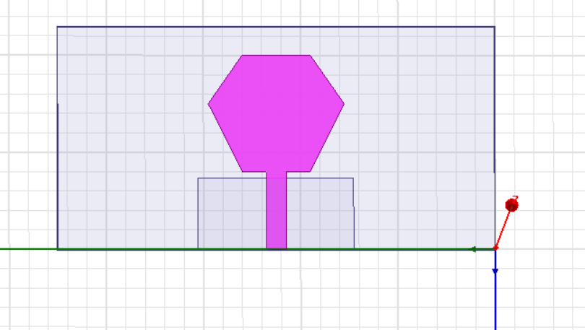
Fig.1. Hexagonal Microstrip Patch Antenna
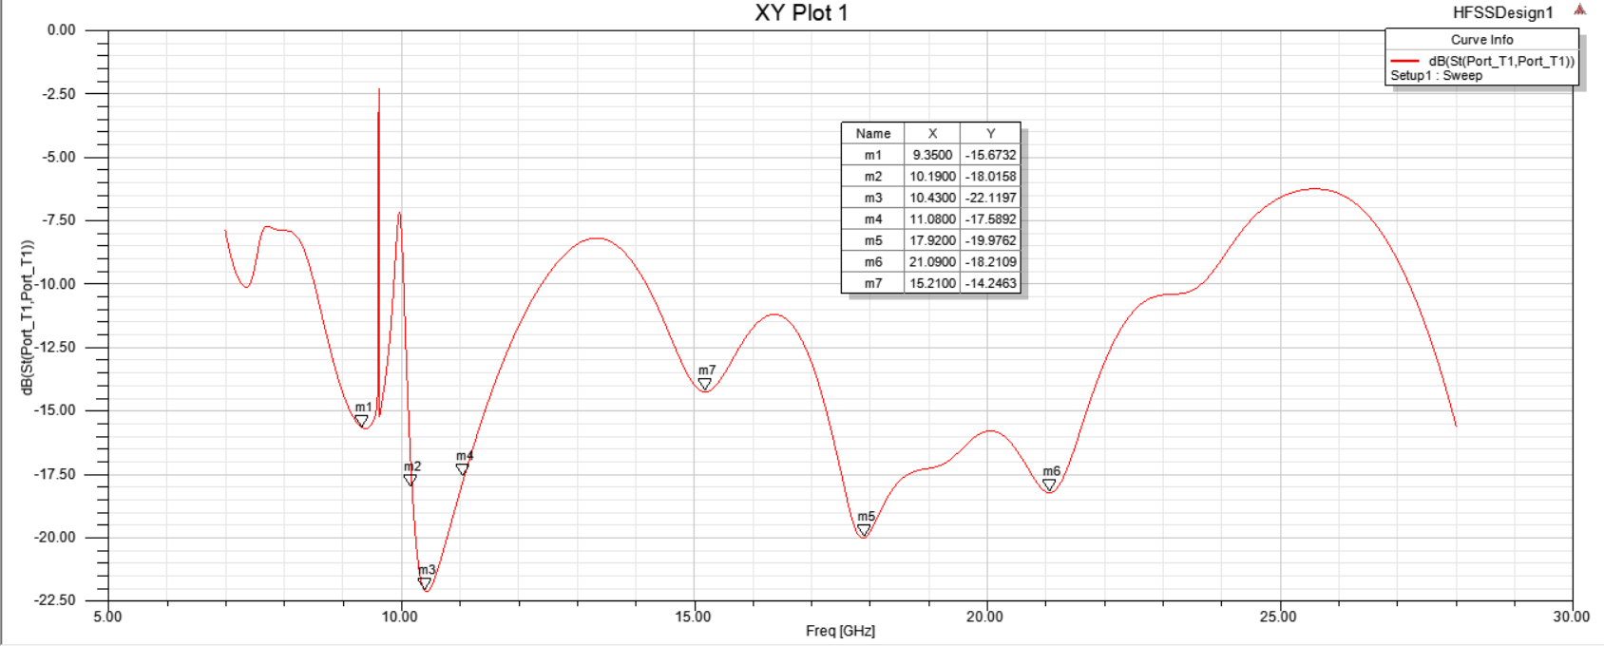
Fig.2. S11 plot for Hexagonal Microstrip Patch Antenna
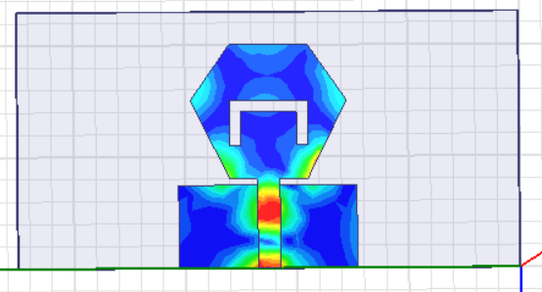
Fig.3. Hexagonal Microstrip Patch Antenna with Slot
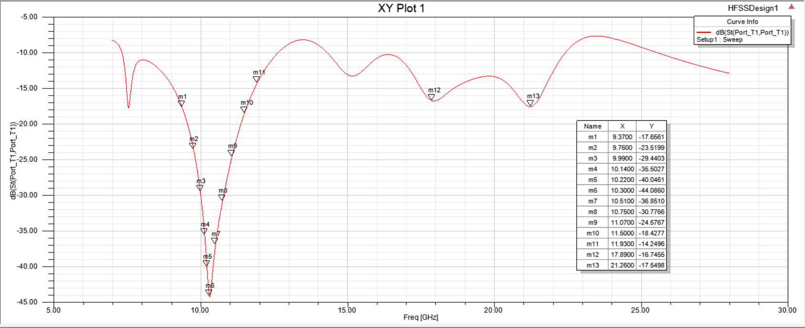
Fig.4. S11 for Hexagonal Microstrip Patch Antenna with Slot
The reason for taking hexagonal shape has been discussed in detailed manner. Table.1 shows five different shapes of polygons unit cell designed in the same substrate of fast Film TM-27 [20]. The simulation results show different bandwidth percentage for each polygon unit cell shape. The hexagon unit cell AMC (with 6-edges) shows the good bandwidth percentage compared to others. Different shapes of patch and its design and performance efficiencies are listed in Table.1, the hexagon shape will be used for further modification. The full patch hexagon AMC is modified by introducing slots into the shape.
Table 1: Bandwidth coverage for different shapes of unit cell polygon
AMC unit cell | Shape | Band Width
Tetragon |  | 77%
Hexagon | 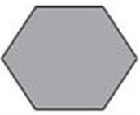 | 104%
Octagon | 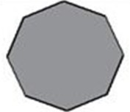 | 121%
Decagon | 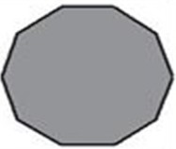 | 98%
Dodecagon | 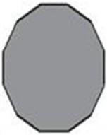 | 97%

To design the antenna to operate at the resonant frequency of 14.25 GHz, the value of the radiator radius is calculated based on the cavity model to excite the dominant mode TM110 as Eq. (1)[20]. Where, fr, εr, and h are the resonant frequency, dielectric constant, and the thickness of the substrate, respectively. Also, to increase the gain, the patch with a slot is employed as shown in Fig.3.
$R= \frac{F}{(1+ \frac{2h}{πFεr}(ln⁡(\frac{πF}{ 2h })+1.7726))}$ (1)

The antenna structure parameters such as hexagonal patch side (s), hexagonal patch diameter (D), ground length (L_{g}), ground width (W_{g}), slot width (W_{s}), slot length (L_{s}), feed length (F_{L}) and feed width (F_{w}) are illustrated below in Table.2 and the design is shown in Fig. 5.
Table.2. Single Hexagonal Patch Antenna parameters
Parameter Name | Parameter value (in mm)
s | 7
D | 14
L_{g} | 7
W_{g} | 8
W_{s} | 1
L_{s} | 4
F_{L} | 8
F_{w} | 2

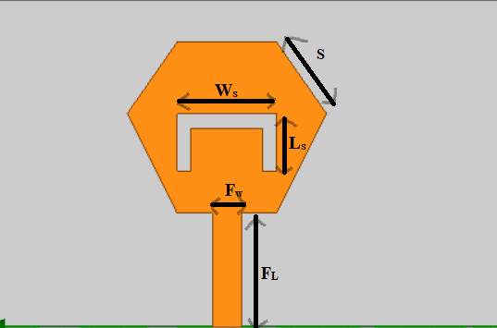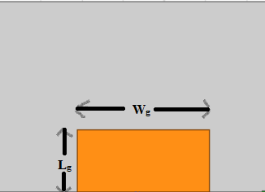
- (b)
Fig.5. (a) Front Layer of Patch Antenna with a slot & (b) Back Layer of Antenna

Dual Port Hexagonal MIMO Patch Antenna
To convert the single port to the two ports, the two ports with two configurations side by side and orthogonal orientations with the same edge-to-edge distance of 7 mm between elements. The side-by-side arrangement is illustrated in Fig.6. The S₁₁ for the side by side 2-port MIMO antenna on simulation exhibited a wide band of 15 GHz ranging from 9.58-24.60 GHz as shown in Fig7. The Radiation pattern for the E-plane of the 2 port MIMO antenna is shown in Fig. 8.
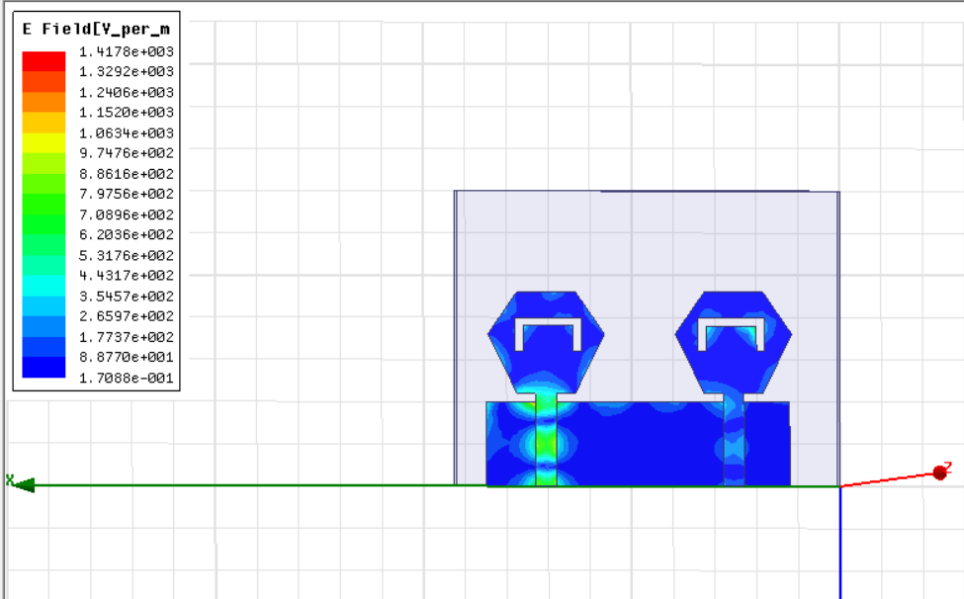
Fig.6. Hexagonal MIMO Patch Antenna places side by side
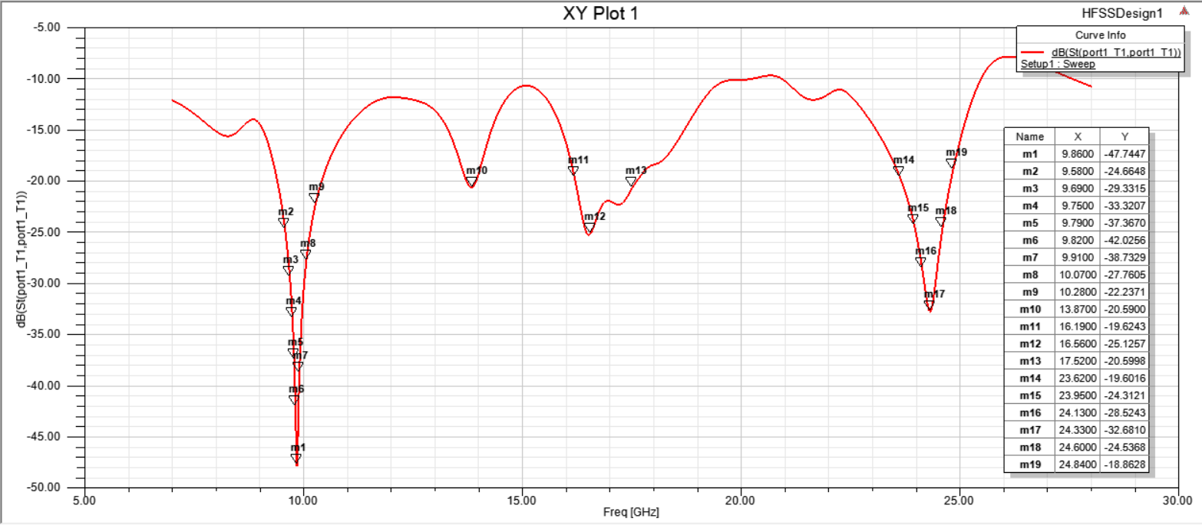
Fig.7. S₁₁ for 2-port MIMO antenna placed side-by-side.
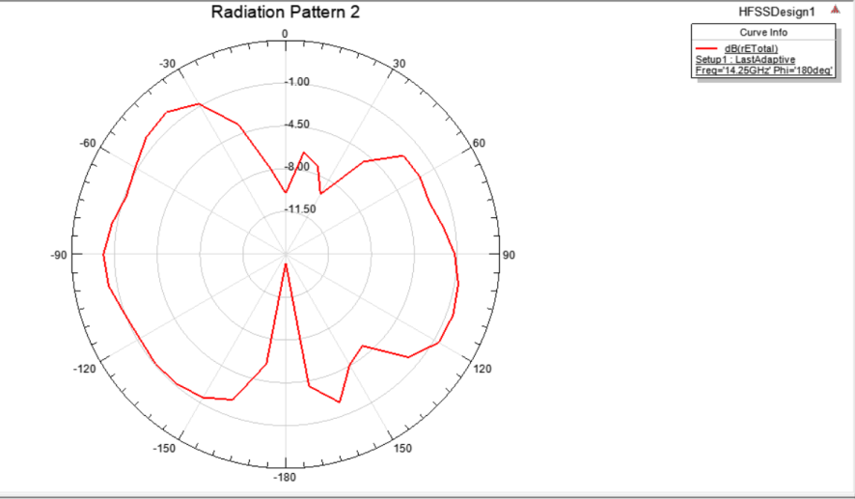
Fig.8. E-plane Radiation pattern for 2-port MIMO antenna placed side-by-side.
The side-by side arrangement although giving a low reflection coefficient had inter-element radiation which reduces the gain. Thus, the orthogonal orientation has been used rather than the side-by-side configuration. The mutual coupling is enhanced by using the orthogonal orientation without adding extra structures. So, the orthogonal orientation is utilized in the final four ports MIMO antenna.

4-Port MIMO Patch Antenna
The single and the two ports MIMO antenna discussed in the previous sections is arranged to achieve and realize the proposed 4 ports MIMO antenna with 60 mm x60 mm as shown in Fig.9. The antenna in port 1 has an orthogonal orientation with the antenna on port 2, and port 4, and has the same orientation but in opposite direction to the antenna in port 3. This arrangement is utilized to produce the polarization diversity which in turn increases the isolation between elements. The antenna is designed and simulated on HFSS software using FR₄ substrate. The simulated result of S11 are extracted using HFSS for port 1 are only presented in Fig.11, because of the symmetry property, the other three ports have the similar results.
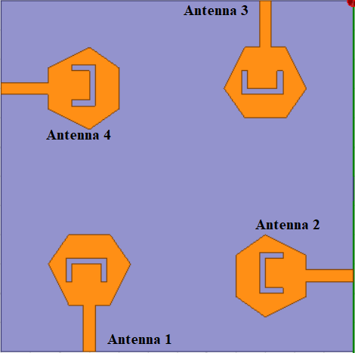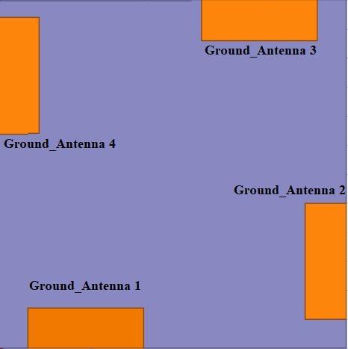
- (b)
Fig.9. 4-Port MIMO Patch Antenna (a) Top layer and (b) Bottom layer
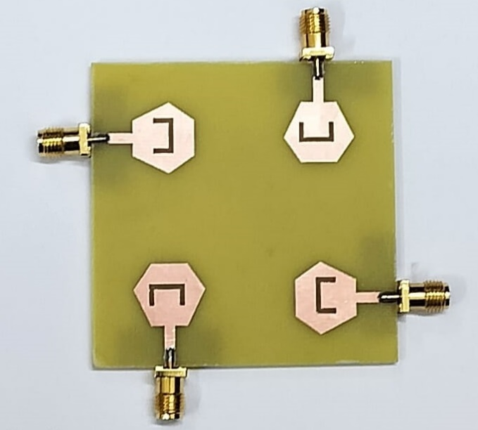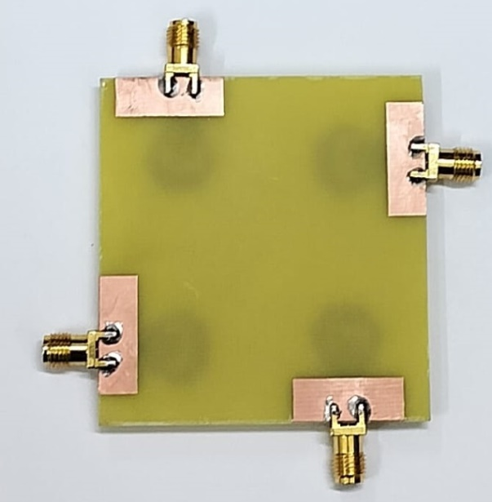
- (b)
Fig.10. Fabricated prototype of 4-Port MIMO Patch Antenna (a) Top layer and (b) Bottom layer
The fabricated prototype of the 4-port MIMO antenna is illustrated in Fig.10. The Patch structure is fabricated on FR₄ substrate.

Results and Discussion
Fig.11. illustrates the proposed 4-port MIMO antenna results at port 1. It is noticed that the simulated results are operated from (103.44%) 15.8–21.5 GHz with S11≤ -20 dB. The antenna is measured using 2 ports Agilent N5247A: A.09.90.02 VNA from port 1 because of the symmetry property, also all the other three ports have similar results. Fig.12 shows the measurement procedure and in Fig.13 the measured S₁₁ is presented. The simulated isolation results at port 1 (S21, S31, S41) are shown in Fig.14, Fig.16 and Fig.17. It is seen that the S21, S31 and S41 have values lower than 20 dB. Also, the results have good matching between them with the small shift.
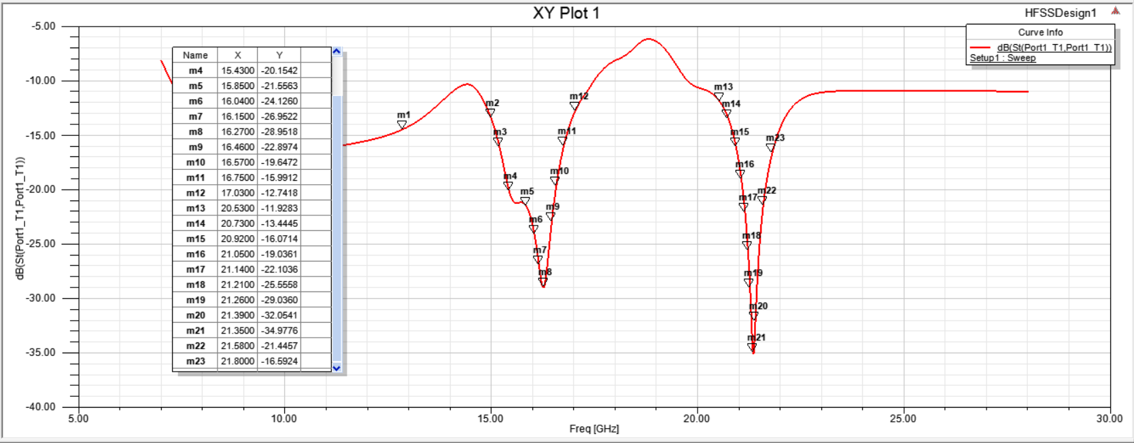
Fig. 11. S₁₁ for 4-port MIMO Patch Antenna
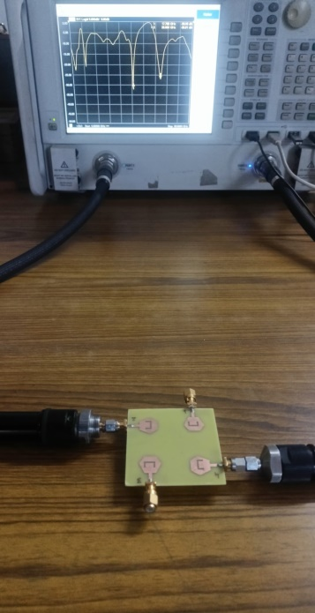
Fig.12. Measurement process using VNA
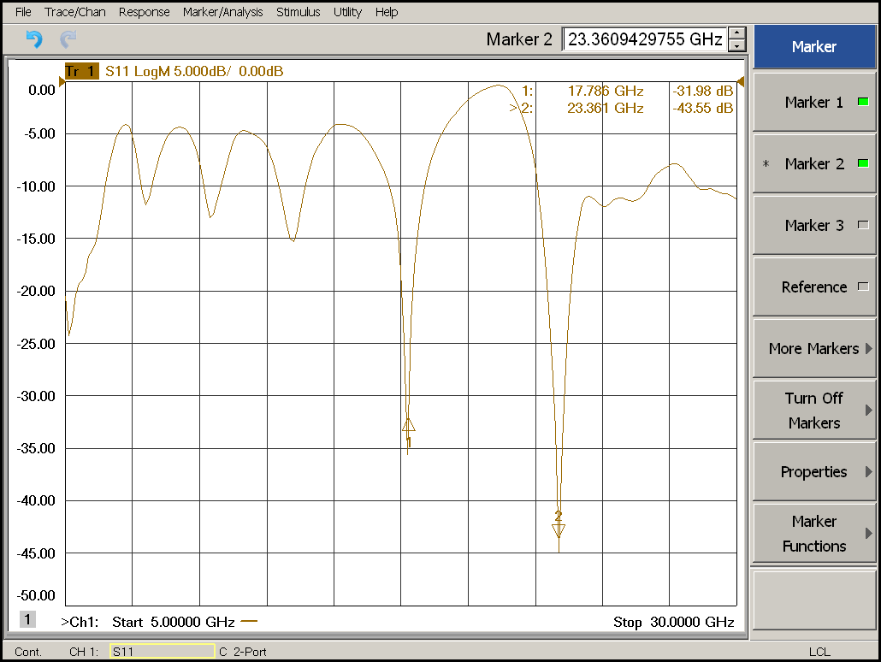
Fig. 13. S₁₁ for 4-port MIMO Patch Antenna obtained through VNA
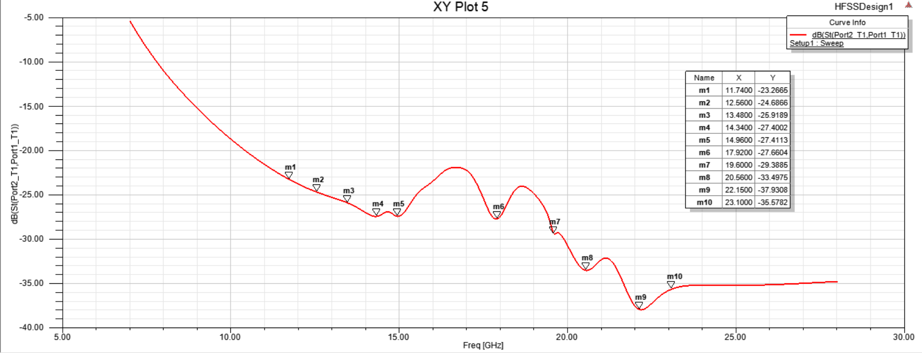
Fig. 14. S₂₁ for 4-port MIMO Patch Antenna
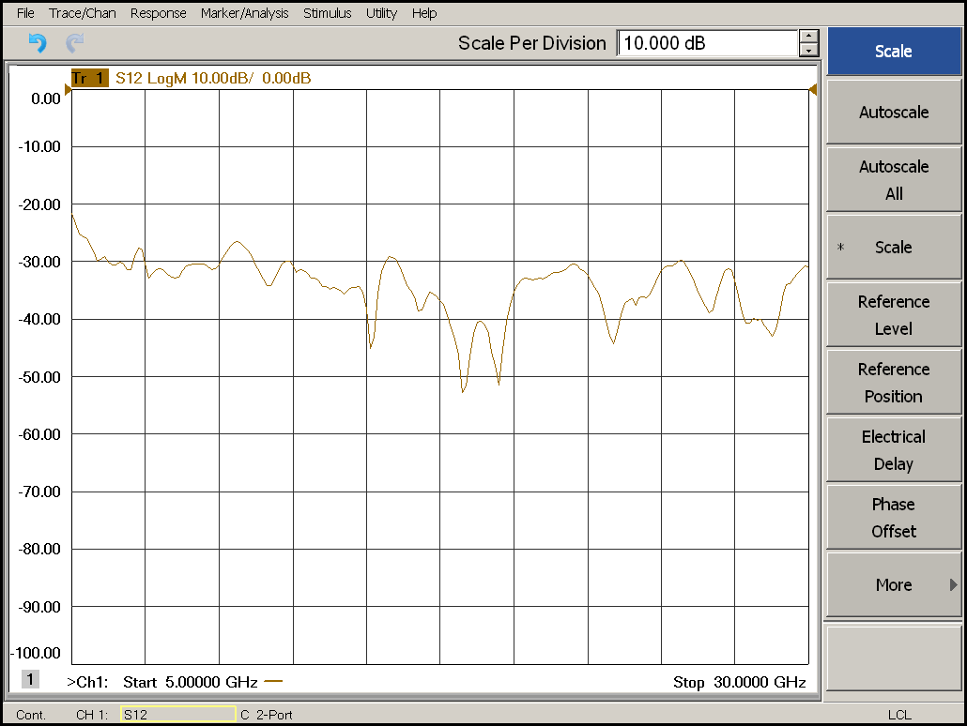
Fig. 15. S₂₁ for 4-port MIMO Patch Antenna
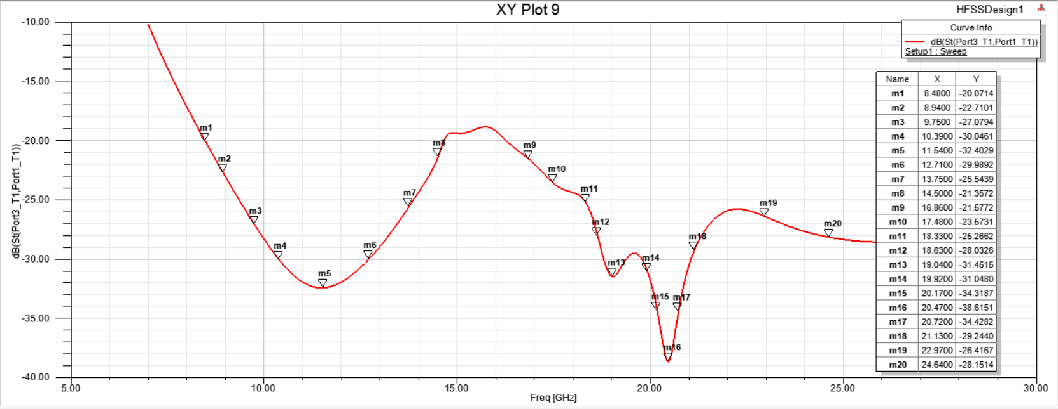
Fig. 16. S₃₁ for 4-port MIMO Patch Antenna
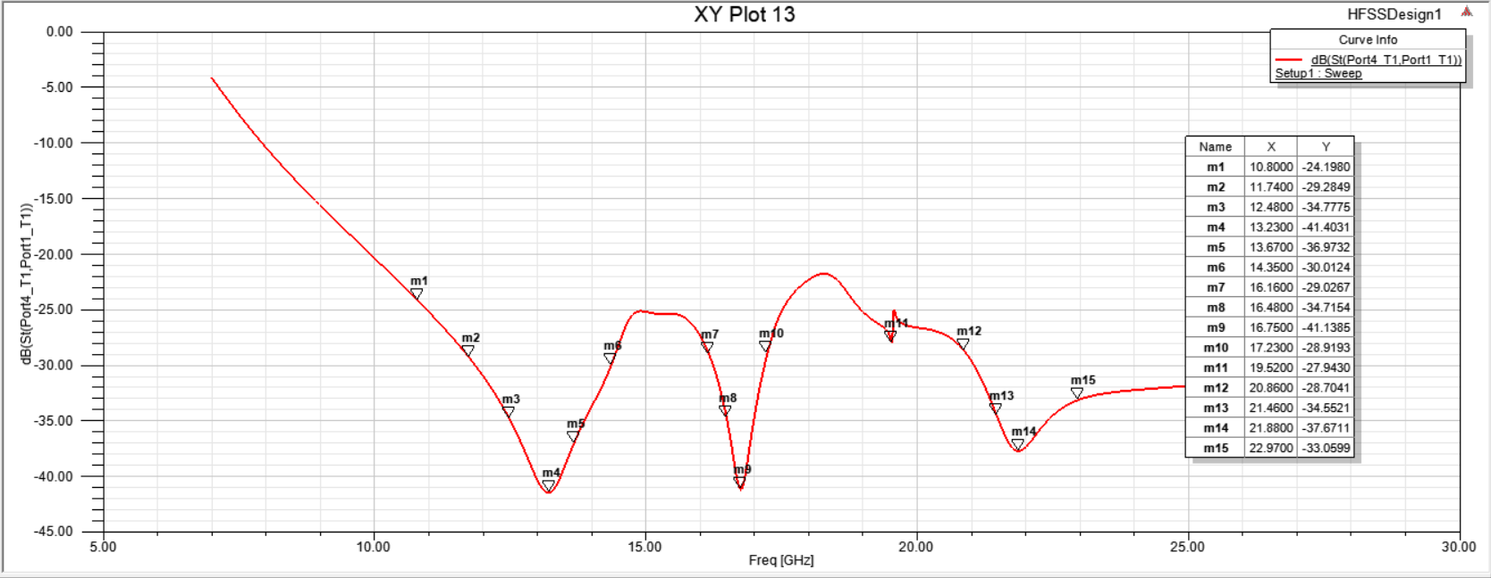
Fig.17. S₄₁ for 4-port MIMO Patch Antenna
The measured outcomes as shown in Fig.13, show that the antenna almost matched the simulated impedance spanning from 17.5 to 24.2 GHz. There is a shift from the resonant frequencies of 16.25GHz and 21.35 GHz to 17.786 GHz and 23.361 GHz respectively due to the fabrication and SMA connector losses. The frequency shift is about 2GHz but the bandwidth range is increased from 5.7 GHz to 6.7GHz. The simulated and measured isolation results at port 1(S12 and S21) are shown in Fig.14 and Fig.15.The results have good matching between them with minor shift, not effecting the overall isolation among the patch arrangements.
The simulated current distributions of the hexagonal MIMO antenna at 16.27 GHz and 21.35 GHz at four ports are shown in Fig.18. The current is concentrated around the hexagonal patch proving that the antenna radiated at these two frequency bands. Also, the current is confined around the antenna with a very small amount of current dissipated to the other ports which confirm the high isolation between ports.
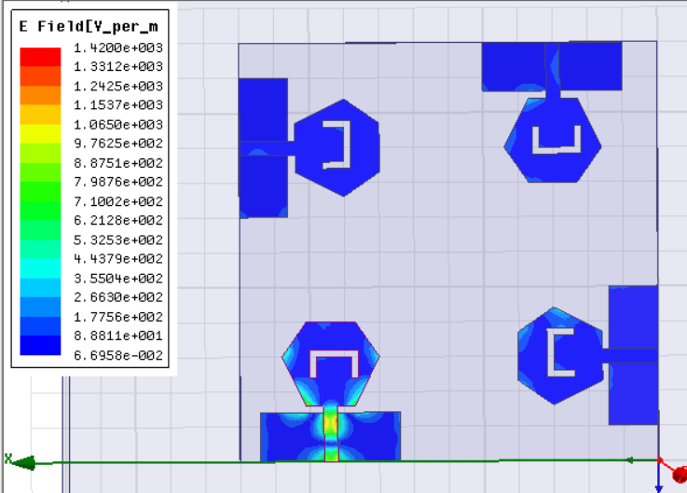
Fig.18. Current distribution of 4-port MIMO Antenna

The radiation pattern simulation results at 16.27 GHz and 21.35 GHz for port1 are illustrated in Fig.19, Fig.20, Fig.22 and Fig.23 to validate the diversity of the patterns. When the suggested port 1 is excited the remaining three ports are connected to 50 Ω loads. Also, from Fig.13 and Fig.15 it is seen that the 90° phase difference between the ports is achieved to confirm the polarization diversity which in turn enhances the MIMO system.
The proposed MIMO antenna simulated radiation patterns and peak gain are depicted in Fig.19 and Fig.20 for 16.27 GHz, the measured peak gains and radiation pattern for 16.27 GHz are illustrated in Fig.21.The simulated and measured results are in agreement.
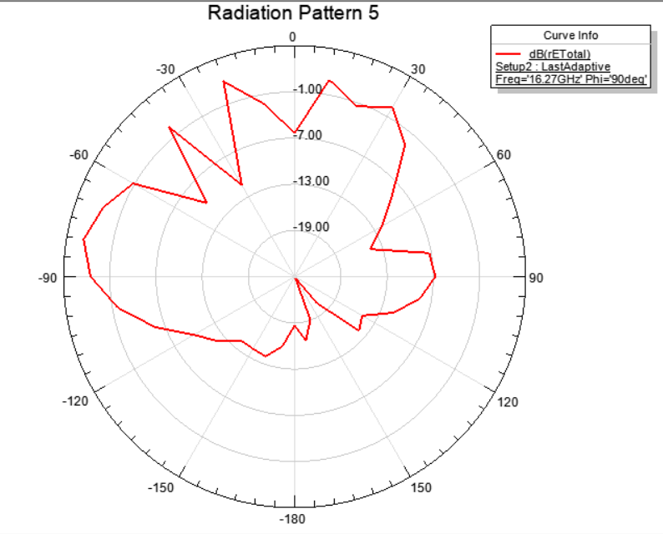
Fig. 19. H-Plane radiation off 4-port MIMO at 16.27 GHz
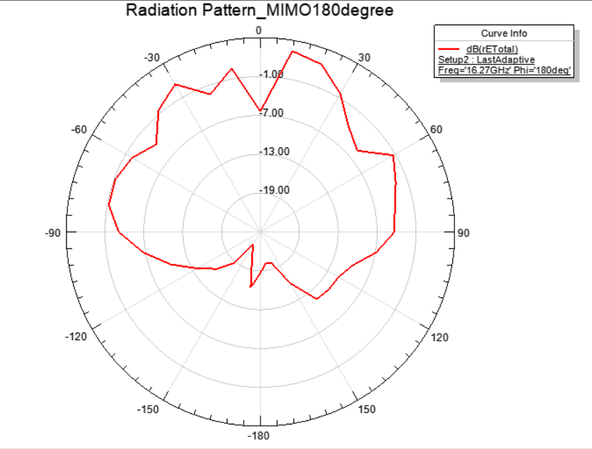
Fig. 20. E-Plane radiation of 4-port MIMO at 16.27 GHz

Fig. 21. Measured E-Plane & H-Plane radiation of 4-port MIMO at 16.27 GHz (co & cross)
The proposed MIMO antenna’s simulated radiation patterns and peak gain are depicted in Fig.22 and Fig.23 for 21.35 GHz, the measured peak gains and radiation pattern for 21.35 GHz are illustrated in Fig.24.The simulated and measured results are in agreement.

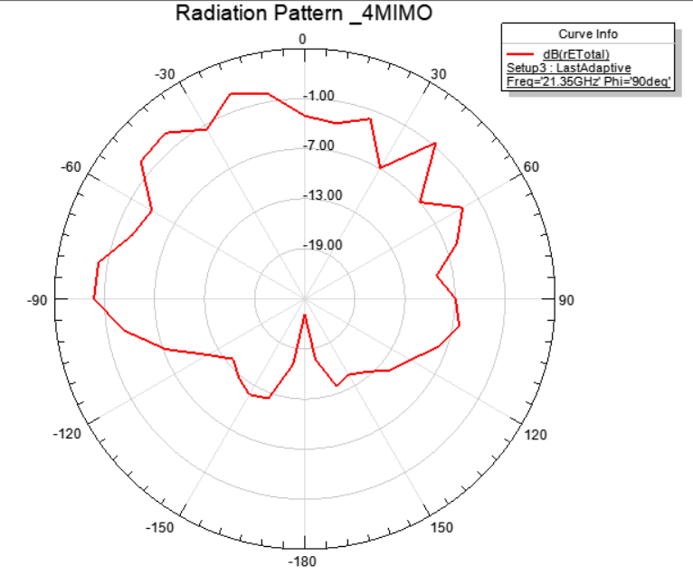
Fig. 22. H-Plane radiation of 4-port MIMO at 21.35 GHz

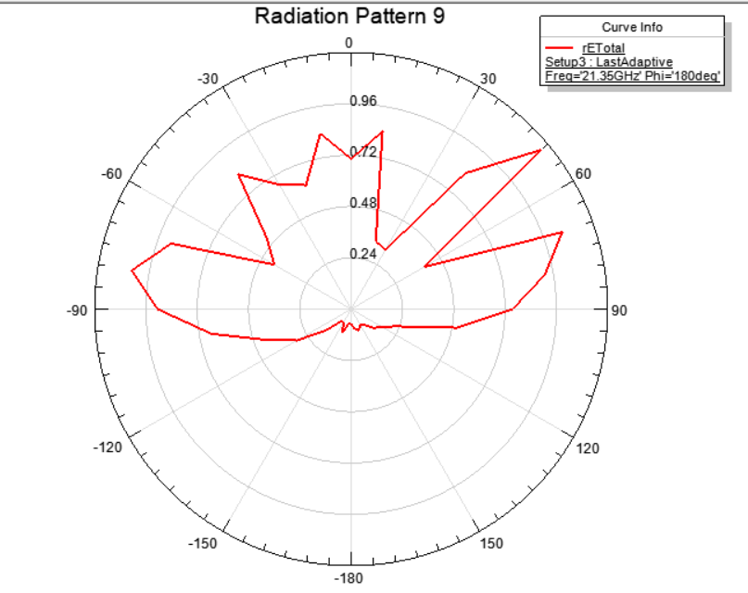
Fig.23. E-Plane radiation of 4-port MIMO at 21.35 GHz

Fig.24. Measured E-Plane & H-Plane radiation of 4-port MIMO at 21.35 GHz (co & cross)
The radiation pattern results of E and H-plane both co and cross at 8.39 GHz for port2 is illustrated in Fig.25 (linear plot) and Fig.26 (polar plot) to validate the diversity of the patterns and multi-output characteristic of MIMO type patch antenna.

Fig.25. Measured E-Plane & H-Plane radiation of 4-port MIMO at 8.39 GHz at Port2 (co & cross)

Fig.26. Measured E-Plane & H-Plane radiation of 4-port MIMO at 8.39 GHz at Port2
The simulated and measured peak gain total of the MIMO antenna at port 1 are presented in Fig.27 and Fig.28. The simulated results show that the antenna has peak gain extended from 2.9 to 7.1 dBi within the operated frequency bands. The measured results show peak gain extends from 1.7 to 9.5 dBi with in the operated frequency band, proving antenna’s utility in UWB applications.
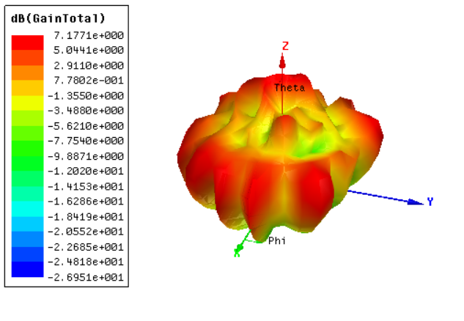
Fig.27. Total Gain of 4-port MIMO Antenna

Fig. 28. 4-port MIMO antenna peak gain results on measurement from Anechoic Chamber
The antenna directivity total, spherical polarization ratio, RHCP and LHCP of the MIMO antenna at port 1 are presented in Fig.29, Fig.30, Fig.31 and Fig.32. While from Fig.29, the results show that the antenna has radiation efficiency extended from 77% to 95% and total efficiency ranging from 70% to 90% within the operated frequency bands. The reduction of the total efficiency especially at higher frequency band is due to the FR4 lossy substrate.
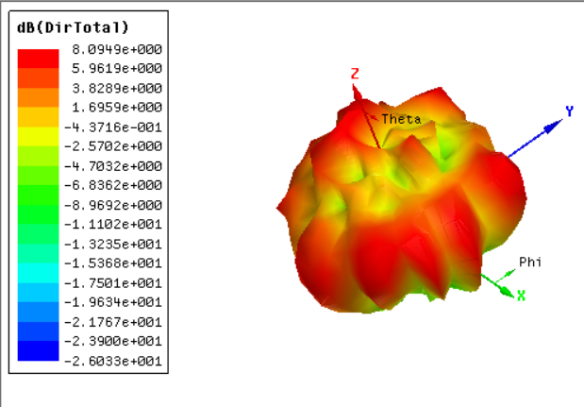
Fig. 29. Radiation Efficiency and Directivity of 4-port MIMO Antenna
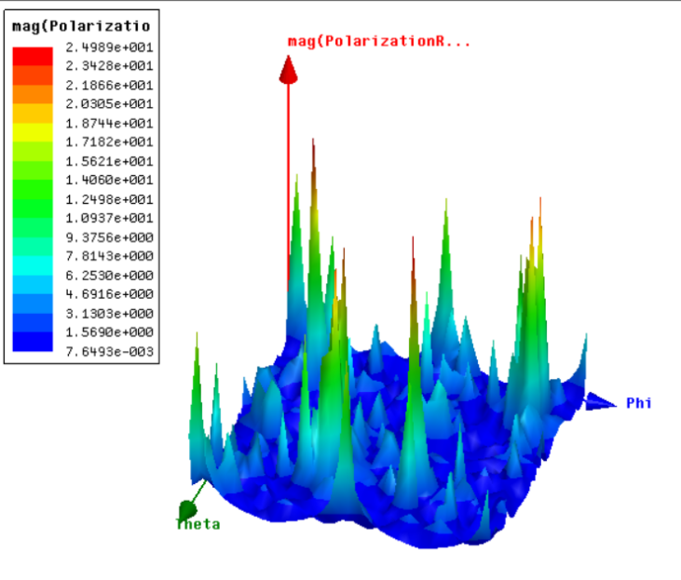
Fig. 30. Spherical Polarization Ratio of the 4-port MIMO Antenna
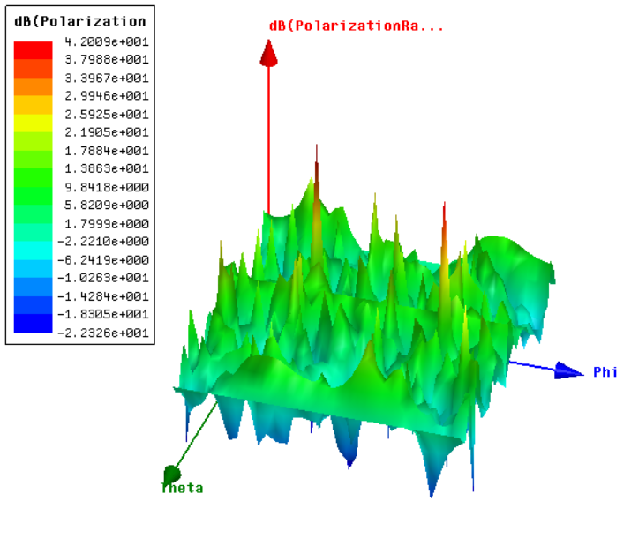
Fig.31. LHCP for 4-port MIMO Antenna
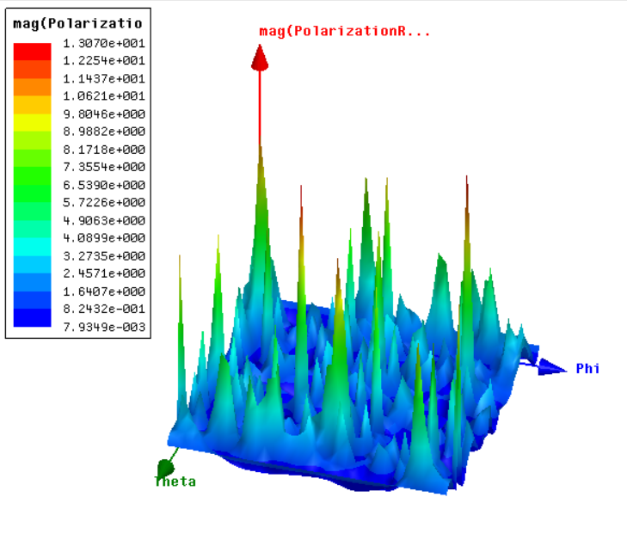
Fig.32. RHCP for 4-port MIMO Antenna
The ECC and DG are two parameters to measure the MIMO performance. The ECC measures the relationship between antenna elements in the MIMO system and its value is recommended to be lower than 0.5 and it can be calculated from Eq.(2) [21]-[23].
ECC = |S₁₁*S₁₂+S₂₁*S₂₂|²/(1-|S₁₁|²-|S₂₁|²) (1-|S₂₂|²-|S₁₂|²) (2)
Fig.33 shows the ECC at port 1. It is noticed that the ECC > 0.01 within the band of interest. As well as the DG is connected with the ECC and is calculated from Eq.(3) [21]-[23].
DG=10$\sqrt{1-{(ECC)}^{2}}$ (3)
Fig.34 illustrates the DG, where for the band of interest, the value of 9.95 dB is achieved. Fig.35. illustrates the TARC for MIMO system which is less than 0dB for the band of interest, as can calculated from Eq.(4).
$Г=\frac{√\sum_{i=1}^{N}{|bi|2}}{√\sum_{i=1}^{N}{|ai|}2}$ (4)
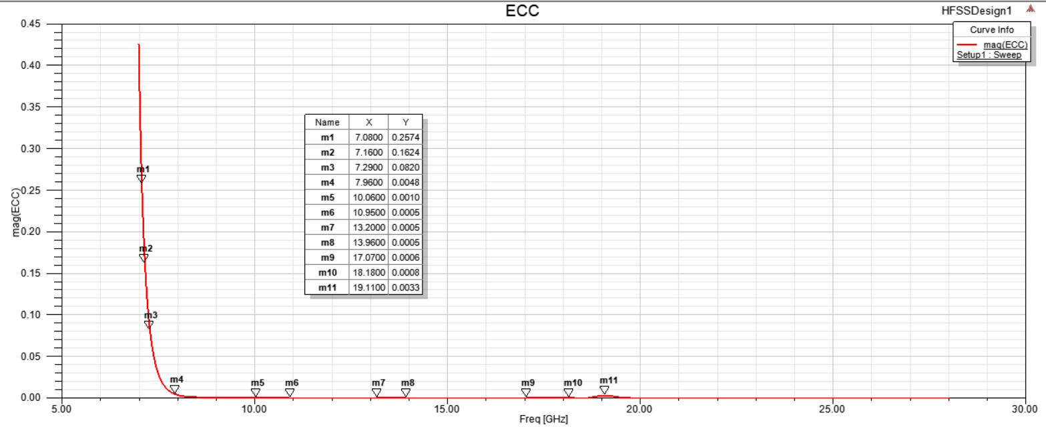
Fig.33. ECC for 4-port MIMO Patch Antenna
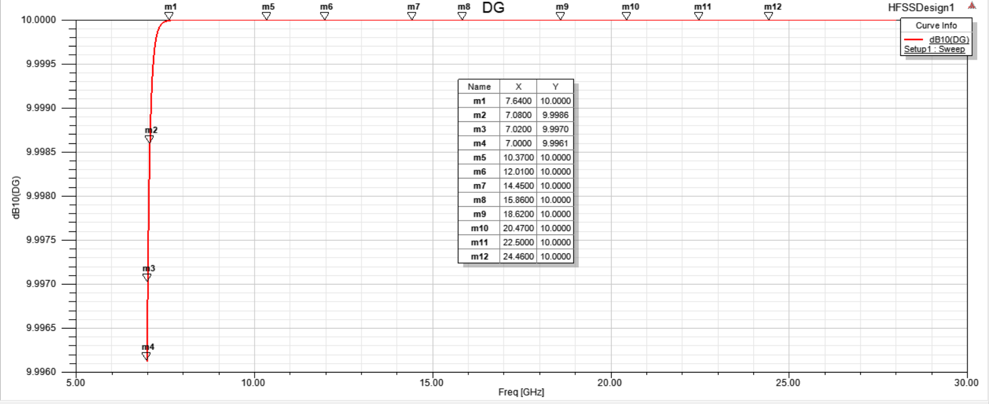
Fig.34. DG for 4-port MIMO Patch Antenna

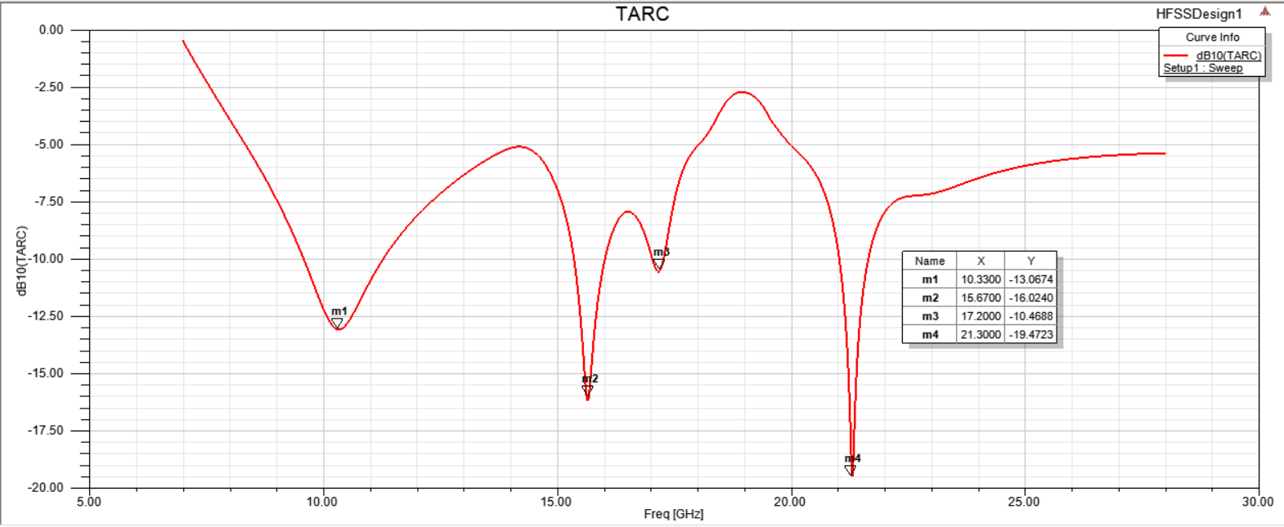
Fig.35. TARC for 4-port MIMO Patch Antenna
From the results in Fig.33 and Fig.34, it is noticed that the proposed antenna has good MIMO results which make our antenna suitable for MIMO for filtration characteristics and diversity systems for UWB communication applications.
The total simulated VSWR for all the 4 ports and VSWR for port 1 is presented in Fig.36 and Fig.37. The standing wave ratio for the all the ports combined in less than 1.5 and for port 1 it is less than 0.9, which is good for a MIMO system. Fig.38 presents the measured VSWR for port 1, the standing wave ratio is less than 1 for all the peak resonating frequencies.
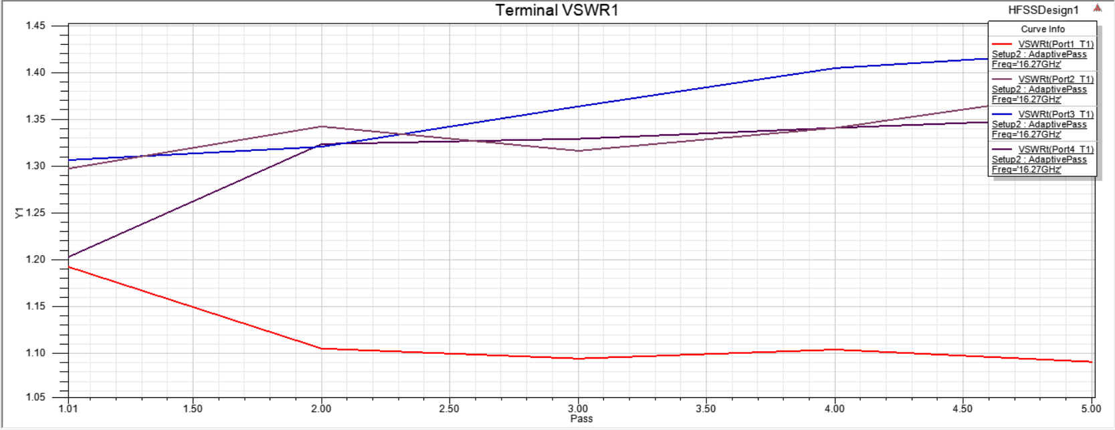
Fig.36. VSWR for all the four ports of the MIMO Antenna
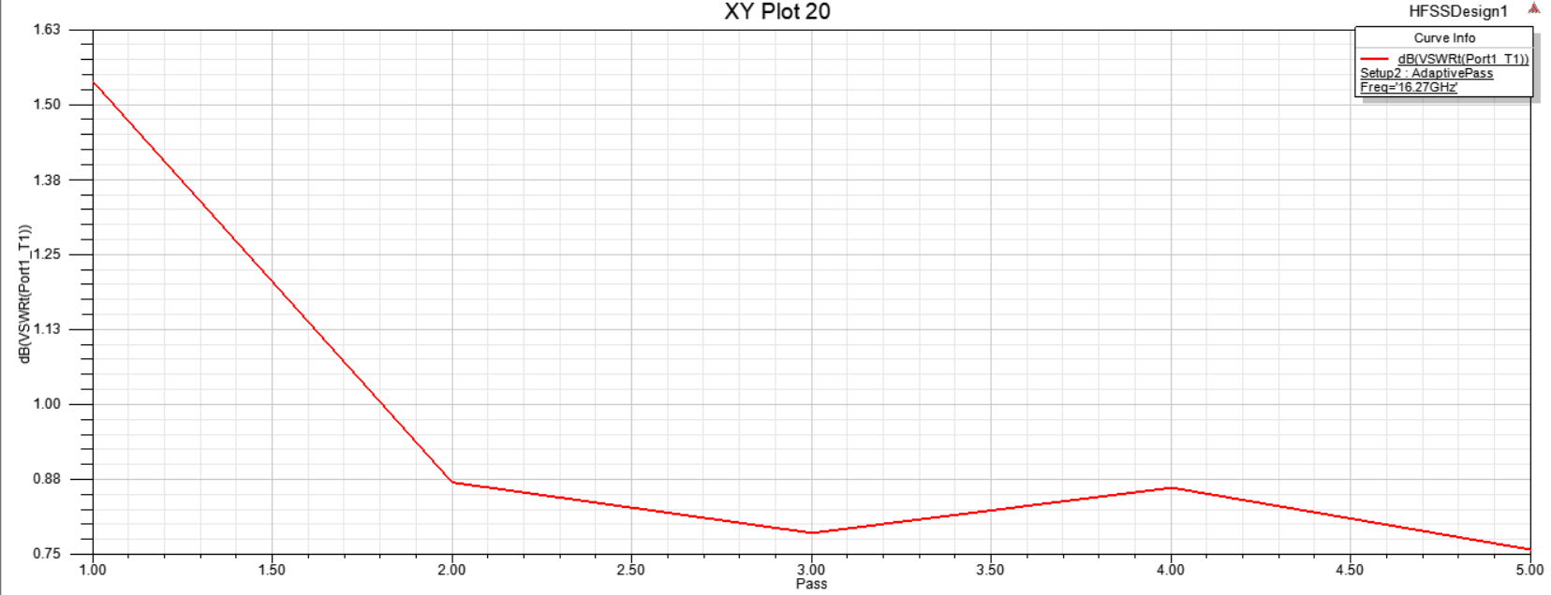
Fig.37. VSWR for port 1 of the MIMO Antenna
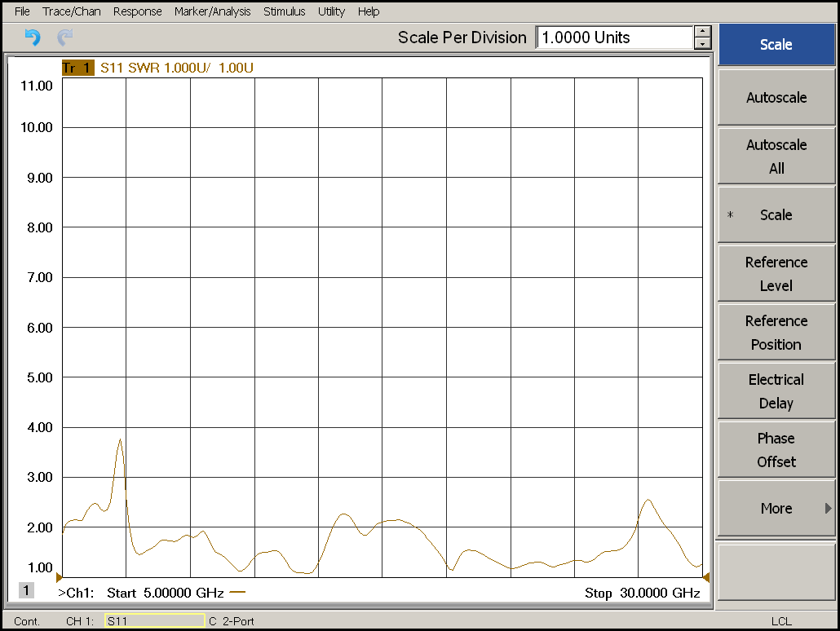
Fig.38. VSWR for port 1 of the MIMO Antenna
The antenna is compared with the existing MIMO antennas from the literature in Table.3. It is observed that the antenna has a low profile, wide bandwidth, 4-port configuration, high gain, low mutual coupling without using a complex decoupling structure, and low ECC value that qualifies the antenna for its use in UWB MIMO Filtenna applications.
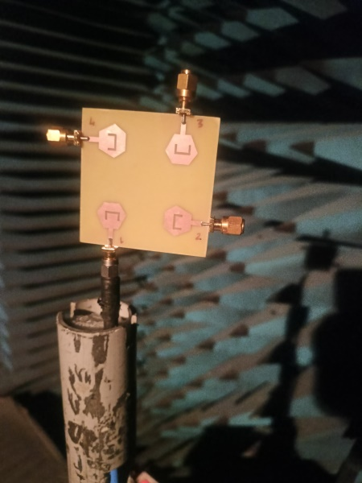
Fig.39. Image of 4-port MIMO being tested in Anechoic Chamber
Table.3: Comparison between our suggested work and other selected designs
S.No. | Reference | Size (mm³) | ε_{r}/thickness (in mm) | B.W (in GHz) | No. of antennas | Gain (dBi) | Efficiency (⁒) | Isolation (dB) | ECC/DG
1 | [6] | 40 x 30 | 4.4/1.6 | 3.20-5.85 | 4 | 3.5 | 85 | >17.5 | <0.15/9.9
2 | [11] | 42 x 42 | 4.4/1.6 | 3.2-12 | 4 | 4 | 80 | ≥17 | 0.01/9.96
3 | [12] | 45.5 x 33 | 3.55/1.5 | 3-12 | 2 | 4 | 75-90 | ≥20 | 0.09/low
4 | [13] | 66 x 36 | 3.38/0.813 | 2.6-12.5 | 2 | 4 | Not mentioned | ≥20 | 0.001/9.97
5 | [15] | 45 x 45 | 4.4/1.6 | 2-10.6 | 4 | 3 | Not mentioned | ≥17 | 0.005/low
6 | [16] | 38 x 38 | 3.2/0.762 | 3-15 | 4 | 3.5 | 65-79 | ≥20 | <0.5/low
7 | [17] | 81 x 87 | 4.4/1.6 | 3.03-10.74 | 4 | 5 | 60-87 | ≥20 | 0.1/low
8 | [19] | 48 x 52 | 4.4/1.6 | 2.7-11 | 4 | 3.5 | 80 | ≥20 | 0.0004/9.85
9 | [20] | 26 x 55 | 4.4/1.6 | 3.1-12.3 | 4 | 2.5 | Not mentioned | >20 | <0.5/low
10 | [24] | 62.5 x 60.5 | 4.4/1.6 | 3.5-11 | 4 | 4 | 70-90 | >20 | <0.01/9.5
11 | My work | 60 x 60 | 4.4/1.6 | 9.35-21.26 | 4 | 7-8 | 85-95 | ≥20 | <0.1/9.9

CONCLUSION
A four-port MIMO antenna for UWB Filtering operation has been presented in this paper. The suggested antenna element, as the initial design, is first designed and simulated using HFSS. After that, 2 ports (both side-by-side and orthogonal arrangement) and 4 ports MIMO antenna with perpendicular arrangement has been designed, simulated and discussed. The radiation patterns, peak gain, and MIMO performance characteristics such as TARC, ECC and DG have been illustrated and discussed. The suggested antenna has been worked at a frequency band extending from 9.35 to 21.26 GHz with S11 more than -20 dB, 4 dBi isolation between ports, and peak gain of upto 9 dBi. The response of the antenna is terms of radiation patterns in E and H-Plane has been discussed to validate the suggested antenna to operate in wideband and filteration applications. Finally, the proposed antenna has been compared with other antennas, and the results show that the suggested antenna can be used in both as Filtenna and in UWB communication.

COMPETING INTERESTS DISCLAIMER:
Authors have declared that they have no known competing financial interests OR non-financial interests OR personal relationships that could have appeared to influence the work reported in this paper.

REFERENCES
- I. Messaoudene, T. A. Denidni, and A. Benghalia, “Experimental investigations of ultra-wide-band antenna integrated with dielectric resonator antenna for cognitive radio applications,” Prog. Electromagnetics. Res., vol. 45, pp. 33–42, 2013.
- S. Pahadsingh and S. Sahu, “A two port UWB-dual narrowband antennas for cognitive radios”, Microwave and Optical Technology Letters, Wiley, Vol, 58, No, 8, August 2016.
- S. Pahadsingh and S. Sahu, “Planar UWB Integrated with Multi narrowband Cylindrical Dielectric Resonator Antenna for Cognitive radio Application”, Int. J. Electron. Commun. AEU, Vol.74, pp.150- 157, 2017.
- A. H. Ramadan, J. Costantine, Y. Tawk, C.G. Christodoulou, and K. Y. Kabalan, “Frequency-tunable and pattern diversity antennas for cognitive radio applications,” Int. J. Antennas Propag., vol. 20, No.14, p. 638-627, 2014.
- E. Erfani, J. Nourinia, C. Ghobadi, M. Niroo-Jazi, and T. A. Denidni, “Design and implementation of an integrated UWB/reconfigurable-slot antenna for cognitive radio applications,” IEEE Antennas wireless Propag. Lett., vol. 11, pp. 77–80, 2012.
- J. F. Li, Q. X. Chu, Z. H. Li, and X. X. Xia, “Compact dual band notched UWB MIMO antenna with high isolation,” IEEE Trans. Antennas Propag., vol. 61, no. 9, pp. 4759–4766, Sep. 2013.
- Y. Li, W. Li, and Q. Ye, “A Reconfigurable Triple-Notch-Band Antenna Integrated with Defected Micro-strip Structure Band-Stop Filter for Ultra-Wideband Cognitive Radio Applications” International Journal of Antennas and Propagation, vol.2013, pp 1-13, 2013.
- Y. Li, W. Li, and Q. Ye, “A Reconfigurable Wide Slot Antenna Integrated With SIRS for UWB/Multiband Communication Applications”, Microwave and Optical Technology Letters, vol. 55, No.1, pp 52-55, 2013.
- Y. Li, W. Li, W. Yu, “A Switchable UWB Slot Antenna using SIS-HSIR and SIS-SIR for Multi-Mode Wireless Communications Applications”, ACES Journal, vol. 27, No.4, pp.340-351, 2012.
- A. Rahman, A. R. Ali, S. Amari, and A. S. Omar, “Design of high frequency RC active filters using passive compensation methods,” IEEE International Symposium on Circuits and Systems, 1988.
- N.S Bhuvana, S.K. Menon, “OLR- Filtenna for WiFi Application” Progress in Electromagnetic Research Symposium (PIERS), pp. 1968-1971, Aug. 2016.
- B. P. Chacko, G. Augustin, T. A. Denidni, “Uniplanar slot antenna for Ultrawideband Polarization Diversity Applications”, IEEE Antennas and Wireless Propag. Lett., vol.12, pp. 88-91, 2013.
- S. F. Rosian, M. R. Kamarudin, M. H. Jamaluddin, “An MIMO F shaped Dielectric Resonator Antenna for 4G Applications”, Microwave and Optical Technology Letters, vol. 57, no.12, pp. 2931- 2936, 2015.
- A. H. Ramdan, K.Y. Kabalan, J. Costantine, Y. Tawk, C. G. Christodoulou, “ A Tunable Filtenna For Cognitive Radio Applications”, 9th European conference on Antennas and Propagation (EuCAP) 2015.
- A. H. Ramadan, J. Costantine, M. Al-Husseini, K. Y. Kabalan, Y. Tawk, and C. G. Christodoulou, “Tunable Filter-Antennas for Cognitive Radio Applications,” Progress In Electromagnetics Research B, vol. 57, pp. 253-265, 2014.
- A. H. Ramadan, J. Costantine, Y. Tawk, M. Al-Husseini, C. G. Christodoulou, and K. Y. Kabalan,“A research vision on cognitive radio filter antennas," , The 8th European Conference on Antennas and Propagation (EuCAP’14), The Hague, The Netherlands, pp. 3654 -3656, 6-1, 2014.
- K. Yu, Y. Li, X. Liu, “Mutual coupling reduction of MIMO antenna array using 3_d Novel metamaterial structure”, ACES Journal, vol. 33, No.7, pp.758-763, 2018.
- Luyu Zhao, Feng Liu, Xiumei Shen, Guodong Jing, Yuanming Cai, and Yingsong Li, “A High Pass Antenna Interference Cancellation Chip for Mutual Coupling Reduction of Antennas in Contagious Frequency Bands”, IEEE ACESS, pp.1-9, 2018.
- Tao Jiang , Tianqi Jiao, Yingsong Li, “A Low Mutual Coupling MIMO Antenna Using Periodic Multi-Layered Electromagnetic Band Gap Structures” ACES Journal, vol.33, No. 3, pp. 305-311, 2018.
- D. Sharmila, M.Puranchandra Rao, P.S.V. Subbarao and S. Nagkishore Bhavanam, “Design, Simulation and Fabrication of Multiband Antenna using HFSS”, IJRTE, vol.8, No. 2, 2019.
- Desai, A., Palandoken, M., Kulkarni, J., Byun, G., Nguyen, T. K. (2021). Wideband flexible/transparent connected-ground MIMO antennas for Sub-6 GHz 5G and WLAN applications. IEEE Access, 9, 147003– 147015. DOI 10.1109/ACCESS.2021.3123366.
- Ibrahim, A. A., Ali, W. A. (2021). High gain, wideband and low mutual coupling AMC-based millimeter wave MIMO antenna for 5G NR networks. AEU-International Journal of Electronics and Communications, 142, 153990. DOI 10.1016/j.aeue.2021.153990.
- Desai, A., Kulkarni, J., Kamruzzaman, M. M., Hubálovský, Sˇ., Hsu, H. T. et al. (2022). Interconnected CPW Fed flexible 4-port MIMO antenna for UWB, X, and Ku band applications. IEEE Access, 10, 57641– 57654. DOI 10.1109/ACCESS.2022.3179005.
- Mahmoud A. Abdelghany, Mohamed Fathy Abo Sree, Arpan Desai and Ahmed A. Ibrahim, “ 4-Port Octagonal Shaped MIMO Antenna with Low Mutual Coupling for UWB Applications”, Computer Modelling in Engineering & Sciences, DOI: 10.32604/cmes.2023.023643, Sept. 2023.

