POLLUTION LEVELS IN THE CAMARON-SABALO LAGOON IN MAZATLAN, SIN. MEXICO AND PUBLIC HEALTH RISKS TO RESIDENTS AND TOURISTS.

ABSTRACT

The Camaron-Sabalo Lagoon is a body water located within of Mazatlán city, NW Mexico. The lagoon's surface area has been significantly reduced by the construction of hotels, boulevards, and the expansion of the aquarium; it also receives illegally wastewater from surrounding quarters. It has result in environmental impact and water pollution of the lagoon, which improve the mosquito’s growth and pathogenic bacteria. Consequently, in a public health risk for residents and tourists; therefore, the aim this work was to know the coliform bacteria levels and Dengue and Chikungunya cases, by the water pollution. Along one year, water and mosquitoes’ samples were taken each three months. The amount of coliform bacteria was quantified by the dilution multiple tubes method; whereas the mosquitoes were captured using an entomological net. The identification and quantification were performing by optical microscopy and the entomologic handbooks of the School National of Biological Sciences and Science Faculty of UNAM. The results indicate that the highest number of coliform bacteria and mosquitoes were recorded during the rainy months (July, August, and September); also, the higher dengue and chikungunya cases, also occurred during these months. This is because during the rainy season, the amount of contaminated water draining to lagoon, increases, exceeding the capacity of the lagoon basin. Therefore, it is possible to conclude that environmental impact caused by construction of hotels and other facilities to enhance tourism, has contributed to increase pollution and public health risks, due the higher proliferation of mosquitoes and fecal coliforms bacteria.

Keywords: (Coastal lagoon, Mazatlan, Mexico, Environmental impact, water pollution, health risk)

1. INTRODUCTION

The coastal lagoons are shallow aquatic environments, that range from freshwater to hypersaline conditions, thus presenting significant ecological gradients. They are ecosystems with a high biodiversity of habitats, suitable for diverse populations of birds, fishes and invertebrates, as well as aquatic plants such as Salicornia spp., reeds, mangroves, etc., Some ones, the deeper, can be used for various recreational activities such as sport fishing, sailing yachts, etc.
Because they are located in the coastal zone, they are places of human settlements and can receive discharges of wastewater and other pollutants, as well as being subject to anthropogenic environmental impact; such as the construction of roads, docks, industries, hotels, which can turn them into infectious and unhealthy focus for human beings and other organisms, such as fish, mollusks, etc. Therefore, it is imperative to assess the anthropogenic impacts, affecting the overall condition and quality of these ecosystems, in order to prevent further deterioration and remediation measures.
The water bodies semi-stagnant, normally are contaminated, and sources of infection for various diseases, such as the Dengue virus, which is transmitted by the bite of the mosquitoes (Aedes aegypti or Aedes albopictus), which also transmits the Chikungunya and other diseases. These mosquitoes belong to the Dipteran order, as they only have two wings, and it is the female that bites, in order to get some sugar which, it is obtained through human blood. Accord to World Health Organization (WHO), the Dengue is a growing global problem. It is estimated that between 100 and 400 million infections occur each year in the world, with the highest incidence in the Americas, Southeast Asia and the Western Pacific countries. Dengue y dengue grave WHO (2025); so in 2024, were reported 14.1 million cases worldwide, with 9,508 deaths, Haider, N., Nayeem, M. H., Onyango, J., Billah, M., et al., (2025). In Mexico, the higher Dengue confirmed cases were 4,593 in 2024. Panorama Epidemiológico de Dengue, Mexican Health Ministry (2024).
In the Americas, the incidence of Dengue has been recorded by the Pan-American Health Organization (PAHO) a branch of WHO; in the Americas the number cases have increase considerately in last decades, summarized in Table 1. The PAHO comment that strategy to control the Dengue disease, comprise several points, such as: vector control, patient care, social communication, environment studies, laboratory standardization, Dengue: data and analysis, (2024).
Table 1. Increase of Dengue cases number, during last decades in the Americas
year | cases | year | cases | year | cases | year | cases | year | cases
1981 | 377,916 | 1998 | 729,423 | 2010 | 1,648,569 | 2016 | 2,891,813 | 2024 | 13,063,434

1.1 Study place

The Camaron-Sabalo lagoon, is located 30 km south of the Cancer Tropic, just in the city of Mazatlán. Due to hotels building, a new aquarium and other municipal facilities, it has become enclosed within the city, resulting in severe pollution problems from multiple anthropological activities and construction projects in the lagoon, which were carried out by previous governments and the private sector, as shown in the Figs.1, 2,3 4, 5 and 6.

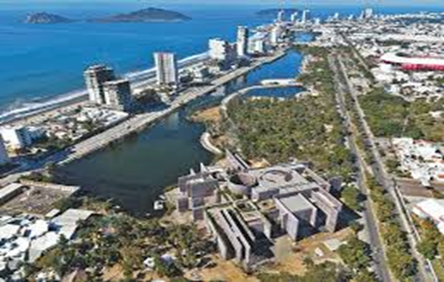

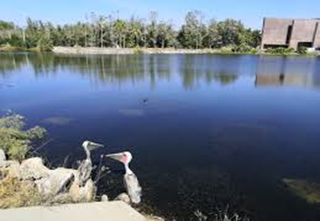

Fig. 1. Environmental impact on flora and fauna in the Camaron-Sabalo lagoon due to volume reduction, by the building of hotels, the new Aquarium and the City Forest, located around the lagoon.

Coordinates and hydrographic features of the Camaron-Sabalo lagoon*
Latitude: 23°14'16"-23° 14´ 05” N
Longitude: 106° 26´ 12”-106° 26´ 37.8” W
Perimeter (km) 7.2
Surface area (ha) 20.4
Depth range (m) 0.7 to 1.9
Annual temperature ranges of (◦C) 19.4- 32.3
Annual mean salinity (‰) 9.1- 40.6
*Data supplied by: Junta Municipal de Agua y Alcantarillado en Mazatlán (JUMAPAM)

1.2 Population growth
The population of Mazatlán, Sinaloa, in 1970* was around 170,000. if the growth rate for the state of Sinaloa was estimated at 0.034 million per year, then, the population in Mazatlán was approximately 501,441 in 2020; that means that the population has been tripled in 50 years; Censo poblacional de Mazatlan (2020);

1.3 Mazatlan boardwalk

According to some historical data, the Mazatlán boardwalk began in 1871, which was a palisade along the coastal street, where the beach dunes ended, and was made to prevent the urban area surrounding the coastal street from flooding and ruining the buildings of the families who lived there. Posteriorly, in 1830, an artificial dike or breakwater was built that "separated" Camaron Lagoon from the coastal area. Later, in 1910, Jorge G. Claussen, during the centennial of Mexico's Independence, arranged for the construction of this section of the seawall, (named by the people as Malecon); which bears his name and extends from the Sanchez Taboada roundabout to the Fisherman's Monument.
Subsequently, the Malecon and particularly the Camaron-Sabalo Lagoon, have undergone changes due to various works, which have caused environmental deterioration of the lagoon. The most significant of these have been: The filling of the eastern part of the lagoon for the construction of the shopping center known as La Gran Plaza; which inauguration was in 1991, making it the city's first "fashion mall." This project has resulted in a reduction of the lagoon basin, which work as regulating reservoir of the lagoon, therefore during the rainy season, it causes flooding in the neighborhoods surrounding the shopping center, because it does not have storm drains, and the sewer water overflows and wastewater sprouts like fountains.

1.4 The “New” Mazatlán aquarium.

The New Mazatlán Aquarium (really an enlargement of the old aquarium) was conceived as a product of national and international impact, with a construction area of at least 12,384 m² in the area called Central Park, adjacent to the current aquarium facilities, which once remodeled will be "dedicated to recreation and rest." Such as:

1. Improve Mazatlán's attractiveness for both tourists and residents.
2. Promote tourism by expanding the city's entertainment, learning, and cultural offerings.
3. Increase the average length of stay of tourists.
4. Increase the annual occupancy rate and average rate through new attraction offerings unique in the country.
5. Generate economic benefits throughout the entire supply chain associated with tourism.
6. Promote the conservation and preservation of endangered species that inhabit aquatic ecosystems.
7. Contribute to social well-being, as the implementation of this project brings economic and social benefits whose positive impact directly affects the local population, investors, and small and medium-sized businesses.

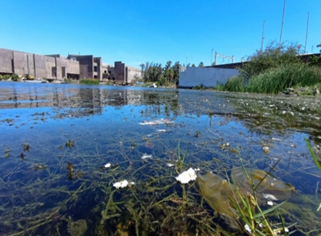

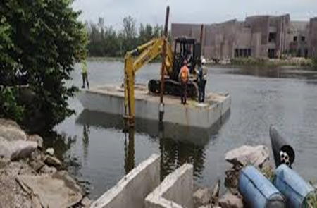

Fig.2 Pollution and destruction of lagoon flora Fig.3 Pipeline for discharge water´s lagoon to the sea

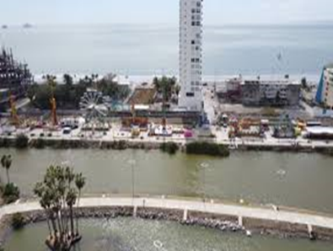

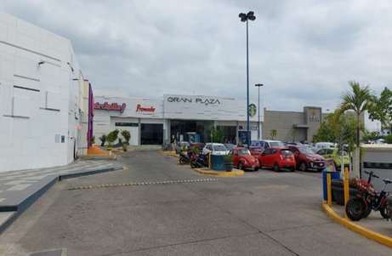

Fig.4 Road construction in the middle of lagoon Fig.5 La Gran Plaza, the commercial center

All of this has been partially achieved. However, what has been evident is the environmental impact on the lagoon, as clearly shown in the previous figures.
Moreover, the aquarium's expansion and the other indicated constructions, have reduced the lagoon area by an estimated percentage, at least 45%. It has also produced an environmental impact on the lagoon and the city forest, now called Central Park, due to significant deforestation and the flora and fauna of the lagoon and the aforementioned city forest.

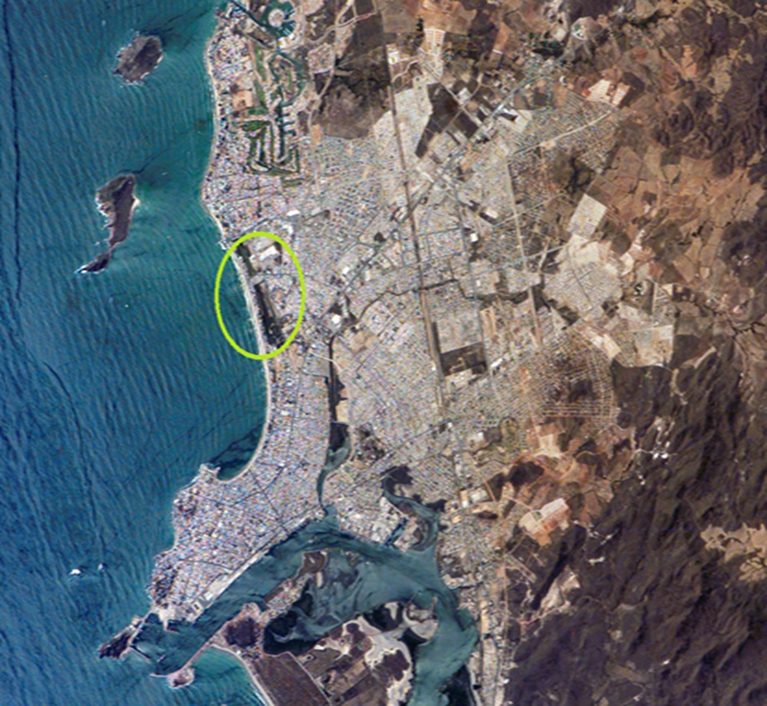

Fig 6. Aerial image of Mazatlán. In this image, can be seen some of the aforementioned landmarks. The lagoon is the circled area in yellow. The shopping center named “la Gran plaza” is located behind the lagoon; also, the New aquarium and Central park are located behind the lagoon. Also, the seawall, closed the natural entrances or mouths to the sea.

2. material and methods

2.1 Public health effects, caused by the pollution of Camaron-Sabalo lagoon: background and justification.

There is not sufficient epidemiological data on diseases directly related to the pollution status of the lagoon; however, some data can be inferred between the lagoon's pollution and some diseases. As previously was mentioned, (Aedes aegypti) is the only mosquito species that can transmit the Dengue, Chikungunya, and yellow fever viruses; however, it has been reported that (Aedes albopictus) could also be a transmitter. For instance, several years ago in 2007, Chikungunya was reported in Africa, Asia, and India, the same source report that the disease transmission was reported for the first time in northeastern of Italy, Chikungunya: data and analysis (2025) PAHO, Disease Outbreak News, Italy (2017), WHO., and for the first time in 2013 was reported in the Americas, the virus was detected in the Saint Martin Island; after, the virus has spread throughout many countries of the region, Chikungunya en las Américas: Preparación, vigilancia y alerta en Chile, Rev. Chil. Infectol, (2014), de Morais Alves Barbosa Oliveira R, Kalline de Almeida Barreto F, Praça Pinto G, Timbó Queiroz I, Montenegro de Carvalho Araújo F, Wanderley Lopes K, et al. (2022), Torales, M., Beeson, A., Grau, L., Galeano, M., Ojeda, A, Martinez, B., et al. (2023).
The Pan American Health Organization (PAHO), a branch of WHO, explains that this type of mosquito is domestic (it is lives in and near houses) and reproduces in any artificial or natural container of water. The Dengue and chikungunya are viral diseases transmitted to humans through the bite of infected (Aedes aegypti) and (Aedes albopictus) mosquitoes; that is, mosquitoes that have bitten an infected person are carriers or vectors of the virus and transmit it by biting another person, Secretaria de Salud del Gobierno de Mexico (2024).
The symptoms of both diseases are similar, however, there are some differences: Both diseases manifest as muscle and joint pain; these are more intense in Chikungunya fever, which affects hands, feet, knees, back and can make it impossible for people to walk. Dengue can cause bleeding and can be complicated by fever, which, if left untreated, can lead to anaphylactic shock. Diagnosis is through a serological test to measure the presence and quantity of IgM and IgG antibodies in the blood, there are four serotypes of the dengue virus. Infection is usually asymptomatic or produces mild symptoms. Most commonly, a high fever (40°C) and flu-like symptoms develop suddenly, 4 to 7 days, after being bitten by an infected mosquito (this is known as the incubation period, and can vary from 3 to 14 days). Other symptoms may include headache, especially behind the eyes, rash, nausea, vomiting, and swollen lymph nodes (lymphadenopathy). Valdivia-Conroy, B., Vasquez-Calderón, J. M., Silva-Caso, W., Martins-Luna, J., et al., (2022).
On the other hand, since wastewater is clandestinely or incidentally discharged into the lagoon, it becomes a hotbed of gastrointestinal diseases such as gastroenteritis, salmonellosis, etc., resulting from the consumption of food or water contaminated by bacteria that cause these diseases; of which public health hospitals in the state and private hospitals have less information on cases than those transmitted by mosquitoes.
2.2 Objectives

Therefore, the objective of this study, was to determine the levels of pollution and environmental impact in the Camaron-Sabalo lagoon and the incidence of Dengue and related diseases, as well as cases of gastrointestinal infections. That is, to determine whether there is a direct relationship between the public health and the levels of pollution and environmental impact of the lagoon; since, based on the information above presented, the lagoon could be the main breeding ground for vectors that transmit these diseases, and also, gastrointestinal illnesses. In other words:

1. Evaluate the levels of coliform microorganisms causing gastrointestinal illness and the contamination level of the lagoon water.

2. Monitoring with major possible certainty, the incidence of diseases of Dengue and Chikungunya, in the Mazatlan population.

3. Establish a program to prevent the aforementioned diseases through workshops and forums in schools, neighborhoods, markets, etc., so that the majority of citizens, to know the results of this study and can raise awareness and demand to the pertinent authorities, address this issue in the best possible way, based on the principle that health is a human right.

2.3 Sampling and processing of samples

Water samples will be taken quarterly to determine the total and fecal coliform bacteria, using the multiple tube dilution method, to get the Most Probable Number (MPN) of bacteria, proposed by Camacho, A., Giles, M., Ortegón, A., Palao, M., Serrano, B. y Velázquez, O. (2009), Lipps W.C., Braun-Howland, E.B., Baxter, T. E., eds. (2023). At same time, water temperature, pH, dissolved oxygen, and salinity will be recorded using a portable thermometer, a field potentiometer, a portable oximeter, and an optical refractometer.
Also, as the water samples are taken, flying insects will be collected at various points in the lagoon, using a hand-held insect net (entomological net). The collected insects, will be transferred to jars with formalin or another preservative. Insects that do not belong to the mosquito taxonomic group will be removed; the mosquitoes, will be fixed on gross paper or cardboard. Mosquitoes of the species (Aedes aegypti), will be identified and quantified by its characteristic white spots on their bodies, heads, and legs, using an optical microscope; and also, using the Entomología, Prácticas de laboratorio. Hernández C. J., García G. A., y Rojas A. A. (2022), UNAM;
Regarding to Dengue and Chikungunya cases, theses will be obtained from the reports of, Mexican Health Ministry (2024) and Chikungunya: analysis by country (2024).

3. RESULTS AND DISCUSSION
During 2024, in Sinaloa the mean values of rains, ranged from 0.0 in May to 209.8 in August mm of water; whereas the temperatures, oscillated from 19.7 to 31.6 ºC, for January and July respectively. Comision Nacional del Agua (CONAGUA, 2024). Summarized in Table 2.
Table 2. Rains and ambient temperatures during 2024 in Sinaloa, Mexico

2024 | Jan | Feb | Marc. | Apr | May | Jun | Jul | Aug | Sep | Oct | Nov | Dec
Rain | 0.9 | 16.4 | 0.9 | 0.2 | 0.0 | 40.3 | 150.2 | 209.9 | 117.3 | 18.3 | 1.5 | 1.0
Tempe. | 19.7 | 20.7 | 21.7 | 24.2 | 27.7 | 29.5 | 31.6 | 30.7 | 30.7 | 30.3 | 23.9 | 21.7

Regarding the captured mosquitoes, the quantity was relatively random, however, the greatest number of mosquitoes occurred in the months of July and October and also with a random distribution, in the different places of lagoon, this can be observed in Table 3. On the other hand, the major amount of (Aedes spp.) mosquitoes was captured around the New Aquarium of Mazatlan; perhaps by in this area, the people concentration is higher and therefore the mosquitoes have more chance to eat. Other authors comment the importance of study to arthropods, as experimental models to interpret the interactions between mosquitoes and humans. Laroche, M., Bérenger, J. M., Delaunay, P., Charrel, R., Pradines, B., Berger, F. et al. (2017).

Table 3. Total and (Aedes spp.) mosquitoes captured in different place of the Camaron-Sabalo lagoon during 2024.

2024 | Jan | Apr | Jul | Oct | Dec
Tot. mosquitoes | 17 | 19 | 16 | 21 | 16
Total (Aedes ssp.)  mosquitoes | 1 | 1 | 2 | 3 | 2
(Aedes spp.)  Close to Aquarium | 1 | 1 | 2 | 1 | 1
(Aedes spp.)  Close to City park | 1 | 0 | 1 | 1 | 0
(Aedes spp.)  Close to middle lagoon road | 0 | 1 | 0 | 1 | 1

On the other hand, the highest values of coliform bacteria, were during the months of July through October, corresponding to the months of higher temperatures and rainfall. Perhaps the elevate temperatures favor the bacterial growth, and the rains, washes the surrounding streets and increases the amount of wastewater discharges to the lagoon. The values of Total and Fecal Coliforms bacteria recorded during 2024 are shown in the Table 4. The values are expressed as Most Probably Number per 100 ml of water (MPN/100 ml.).

Table. 4. Total and Fecal Coliforms bacteria recorded during 2024 in the study place

2024 | Jan | Apr | Jul | Oct | Dec
Tot. Coliforms | 1901 | 2250 | 4502 | 4236 | 1006
Fecal Coliforms. | 190 | 289 | 581 | 520 | 231

As can be observed all the water samples become over maxima permissible for water bodies, such as lakes, lagoons, damps etc. established in their Mexican regulations, (NOM-003-SEMARNAT-1997) which establishes 2000 MPN/100ml., as maximum permissible of coliforms bacteria for residual waters. Therefore, the Camaron–Sabalo lagoon, is polluted by fecal matter.

Regarding to Dengue and Chikungunya cases, some authors reported that from 2008 to 2016 were recorded 128,507 cases of dengue, 4,752 of chikungunya, and 25,755 of Zika in 10 cities in Mexico. Evidence of heterogeneity in disease transmission was recorded in all cities. Also they found hotspots overlap between of 61·7% for dengue and Zika and 53·3% for dengue and chikungunya. The monitored cities were Veracruz, Villahermosa, Campeche, Mérida, Coatzacoalcos, Cancún, Campeche, Tapachula, Acapulco, and Iguala; all of them in southeastern Mexico. Dzul-Manzanilla F., Correa-MoralesF., Che-Mendoza A., Palacio-Vargas J., Sánchez-Tejeda G., González-Roldan J., et al. (2021). The dengue cases are Particularly reported in Panorama Epidemiológico de Dengue en Mexico (2025); a summarized data is shown in the Table 5, which present the presumable and confirmed cases and the deaths of several States of the Mexican Republic; the States who presented the major number of confirmed cases and deaths, were: Oaxaca, Guerrero, Morelos, Nayarit and Sinaloa. This is due to these States, present elevate temperatures, and poverty. Concerning to Sinaloa the confirmed cases were 1,978; This is a “special” case, since however the temperatures are elevated, the poverty is lower, compared with the others States. There is a similar situation for Quintana Roo, Campeche and Yucatan, which also have elevated temperatures, but the poverty is less.

Table 5. Number of dengue cases and deaths by federal entity (States) of the Mexican Republic, during 2024.

STATE PRESUMABLY CASES CONFIRMED CASES DEATHS
Jalisco 90,799 650 6 6
Veracruz 30,565 7,238 1 5
Guerrero 46,882 2,411 6 1
Morelos 31,602 2,920 5 6
Nayarit 34,718 2,459 3 4
Sinaloa 18,850 1,928 3 4
Chiapas 18,891 1,499 1 6
Oaxaca 31,451 1,934 4 4
Tabasco 17,420 2,287 1 7
Quintana Roo 12,698 446 8
Campeche 5,164 246 3
Yucatán 5,642 151 0

The same source declare that the higher number of cases was between the weeks 34 to 46; it is during the summer, when the rains and temperatures are higher.
However, the Mexican Ministry of Health reports zero confirmed cases of Chikungunya and consequently, zero deaths in 2024. Casos Confirmados de Fiebre Chikungunya. Dirección General de Epidemiología, (2024). This is contradictory to the cases reported by the authors above indicated, or the sanitary conditions for Chikungunya improved considerably after 2016, which is unlikely. On the other hand, there is no vaccine for Chikungunya, while for Dengue there are some, Chikungunya key facts (2025) WHO.

4. Conclusion

From the results obtained in this work, can be to conclude that Camaron-Sabalo lagoon, is a body water polluted by coliform bacteria and favorable for mosquitoes’ growth, which is a potential source of gastrointestinal diseases and Dengue, who are affecting such to local and touristic population; these problems, are the results of the anthropogenic impact to lagoon, by the hotels building and other facilities as the “New aquarium” and the reduction of natural forest area for the construction of Central park; given as result, the reduction of lagoon area and the increase of clandestine wastewater discharges. Therefore, is necessary that the local and federal authorities, stop the authorization for building more hotels and other facilities, who have converted a “healthy” body water in an unhealthy place.

References

Camacho A., Giles M., Ortegón A., Palao M., Serrano B. y Velázquez, O. (2009). Técnicas para el Análisis Microbiológico de Alimentos. 2ª ed. Facultad de Química, UNAM. C. U. Coyoacan, México. 04510

Casos Confirmados de Fiebre Chikungunya. Dirección General de Epidemiología. (2024).
https://www.gob.mx/salud/documentos/casos-confirmados-de-fiebre-chikungunya-2024
Censo poblacional en Mazatlan, Sin (2020).
https://www.economia.gob.mx/datamexico/es/profile/geo/mazatlan-992502

Chikungunya: data and analysis (2025), PAHO.
https://www.paho.org/en/arbo-portal/chikungunya-data-and-analysis

Chikungunya en las Américas: Preparación, vigilancia y alerta en Chile, Rev. Chil. Infectol, (2014). Rev. chil. infectol. vol.31 no.6 Santiago dic. 2014
https://scielo.conicyt.cl/pdf/rci/v31n6/art22.pdf

Chikungunya key facts (2025). WHO
https://www.who.int/news-room/fact-sheets/detail/chikungunya

Clinical infectious diseases: an official publication of the Infectious Diseases Society of America, 65(suppl_1), S30–S38.
https://doi.org/10.1093/cid/cix463

CONAGUA, Gob. de Mexico. 2024. Resúmenes Mensuales de Temperaturas y Lluvia
https://smn.conagua.gob.mx/es/climatologia/temperaturas-y-lluvias/resumenes-mensuales-de-temperaturas-y-lluvias

Dengue: data and analysis. (2024), PAHO.
https://www.paho.org/en/arbo-portal/dengue-data-and-analysis

Dengue y dengue grave. (2024), WHO.
https://www.who.int/es/news-room/fact-sheets/detail/dengue-and-severe-dengue

Disease Outbreak News Italy (2017). WHO
https://www.who.int/emergencies/disease-outbreak-news/item/29-september-2017-chikungunya-italy-en

de Morais Alves Barbosa Oliveira R, Kalline de Almeida Barreto F, Praça Pinto G, Timbó Queiroz I, Montenegro de Carvalho Araújo F, Wanderley Lopes K, et al. (2022) Chikungunya Death Risk Factors in Brazil, in 2017: A case-control study. PLoS ONE 17(4): e0260939.
https://doi.org/10.1371/journal.pone.0260939

Dzul-Manzanilla F., Correa-MoralesF., Che-Mendoza A., Palacio-Vargas J., Sánchez-Tejeda G., González-Roldan J., et al. (2021) Identifying urban hotspots of dengue, chikungunya, and Zika transmission in Mexico to support risk stratification efforts: a spatial analysis. The Lancet, Planetary Health Vol 5, Issue 5e 277-285

Entomología, Prácticas de laboratorio. Hernández C. J., García G. A., y Rojas A. A. (2022) 1a edición, Facultad de Ciencias, UNAM. ISBN 9786073060219. C. U. Coyoacán, México. 04510

G. Amagliani, G. Brandi, G.F. Schiavano. 2012, Incidence and role of Salmonella in seafood safety Food Research International. Vol. 45, No 2. 780-788
https://doi.org/10.1016/j.foodres.2011.06.022

Haider N., Nayeem M. H., Onyango J., Billah M., Khan S., Papakonstantinou D., Paudyal P., and Asaduzzaman Md. Global dengue epidemic worsens with record 14 million cases and 9000 deaths reported in 2024. International Journal of Infectious Diseases. (2025) Vol 15. 8107940

Laroche, M., Bérenger, J. M., Delaunay, P., Charrel, R., Pradines, B., Berger, F., Ranque, S., Bitam, I., Davoust, B., Raoult, D., & Parola, P. (2017). Medical Entomology: A Reemerging Field of Research to Better Understand Vector-Borne Infectious Diseases.

Lipps W.C., Braun-Howland, E.B., Baxter, T. E., eds. (2023). Standard Methods for the Examination of Water and Wastewater. 24th ed. Washington DC: APHA Press.
https://doi.org/10.2105/SMWW.2882.002

Mexican regulations, NOM-003-SEMARNAT-1997
https://diariooficial.gob.mx/nota_detalle.php?codigo=4893449&fecha=21/09/1998#gsc.tab=0
National institute of Diabetes and kidney diseases NHI Symptoms & Causes of Viral Gastroenteritis (“Stomach Flu”). (2021).
https://www.niddk.nih.gov/health-information/digestive-diseases/viral-gastroenteritis/symptoms-causes

Panorama Epidemiológico de Dengue, en Mexico. Mexican Health Ministry (2024).
https://www.gob.mx/cms/uploads/attachment/file/979179/PanoDengue__2025_SE06.

Panorama Epidemiológico de Dengue. Gobierno del México, 2024
https://www.gob.mx/salud/documentos/panorama-epidemiologico-de-dengue-2024

Postigo-Hidalgo, I., Jo, W. K., Pedroso, C., Brites, C., & Drexler, J. F. (2023). Introduction of chikungunya virus in coastal northeast Brazil. The Lancet. Microbe, 4(10), e764. https://doi.org/10.1016/S2666-5247(23)00176-3

Torales M, Beeson A, Grau L, Galeano M, Ojeda A, Martinez B, et al. (2023). Notes from the Field: Chikungunya Outbreak — Paraguay, 2022–2023. MMWR Morb Mortal Wkly Rep. 2023;72(23).

Valdivia-Conroy, B., Vasquez-Calderón, J. M., Silva-Caso, W., Martins-Luna, J., Aguilar-Luis, M. A., Del Valle-Mendoza, J., & Puyén, Z. M. (2022). Diagnostic performance of the rapid test for the detection of NS1 antigen and IgM and IgG anti-antibodies against dengue virus. Rendimiento diagnóstico de la prueba rápida para la detección del antígeno NS1 y anticuerpos IgM e IgG contra el virus del dengue. Revista peruana de medicina experimental y salud pública, 39(4), 434–441.
https://doi.org/10.17843/rpmesp.2022.394.11471

Viral gastroenteritis (stomach flu) - Symptoms & causes mayoclinic.org. 2022
https://www.mayoclinic.org/diseases-conditions/viral-gastroenteritis/symptoms-causes/syc-20378847

