Assessment of Vendors’ Knowledge of Hygiene Practices and the Microbiological Quality of Animal-Derived Food at the Togo–Benin Border (Sanvee-Condji and Hillah-Condji)

ABSTRACT
Background and Objective : In a context where consumer health safety is paramount, this study aimed to assess animal product vendors’ knowledge of good hygiene practices and the microbiological quality of these foods at the Togo–Benin border (Sanvée-Condji and Hillah-Condji). Methods : A sociodemographic and behavioral survey was conducted among 70 vendors using a structured questionnaire. Simultaneously, 70 ready-to-eat animal product samples were collected at Sanvée-Condji (Togo) and Hillah-Condji (Benin). Microbiological analyses were performed according to standardized AFNOR methods, targeting fecal coliforms and total aerobic mesophilic flora as indicators of sanitary quality and failures in thermal control. Results : The surveyed population consisted predominantly of women (70 %) with a median age of 45 years (interquartile range: 32–55 years). Over 65 % had no formal schooling, and 80 % were married. Although the 35–49 age group—representing 44.3 % of participants—corresponds to professional maturity, only 10 % of the vendors—all women—demonstrated a good level of knowledge and practice of hygiene measures. This gap was attributed to insufficient on-site sanitary inspection. Microbiologically, 80 % of the samples exceeded recommended limits for indicator organisms, indicating unsatisfactory hygienic quality and breakdowns in cold or heat chains. Conclusion : The findings highlight an urgent need to strengthen training and awareness programs for animal product vendors on good hygiene practices, as well as to reinforce sanitary controls at border transfer points between Togo and Benin.
Keywords : Food safety ; Animal products ; Hygiene practices ; Microbiological quality ; Togo–Benin border
INTRODUCTION
Proteins fulfill multiple indispensable roles within the organism, contributing to cellular structure, function and regulation. Composed of amino acids, they may be derived from either plant or animal sources. Among these, animal‐derived products (meat, fish, seafood, offal, poultry and dairy) occupy a central place in the human diet, with red meat often being the most widely consumed¹.
Global demand for animal proteins continues to rise. According to the FAO, between 2020 and 2021 the production of meat, fish and dairy products increased by 4.2 %, 2 % and 1.5 % respectively, driven by rapid urbanization, demographic growth and the expansion of street‐food culture²,³. In sub‐Saharan Africa, and notably in Togo, this trend is especially pronounced in urban areas: the Maritime Region, which encompasses the commune of Lac 1, concentrates 42 % of the national population on merely 10 % of the country’s territory, exerting considerable pressure on local food supplies⁴.
Ready‐to‐eat street foods meet needs of availability, accessibility and organoleptic variety, yet they pose significant health risks when hygiene standards and cold‐chain protocols are not observed⁵. Meat, as processed muscle tissue, is particularly susceptible to microbial contamination during slaughter, butchering, storage and distribution⁶. Similarly, artisanal processing of fish and dairy products, often carried out without stringent oversight, fosters the proliferation of pathogenic microorganisms⁷,⁸. Such contaminations can give rise to numerous foodborne infections (diarrhoea, septicaemia, and even fatalities) linked to Salmonella, Escherichia coli, Staphylococcus aureus and other indicator organisms⁹⁻¹¹.
In this context, assessing both the sanitary quality of animal‐derived products and vendors’ knowledge of good hygiene practices represents a critical consumer‐protection imperative. The present study focuses on the Sanvée Condji (Togo) and Hillah Condji (Benin) border‐crossing points along the Abidjan–Lagos corridor, where intense movement of people and goods heightens sanitary challenges. Its aim is to contribute to consumer health security by evaluating vendors’ understanding of hygiene practices and analysing the microbiological quality of the animal‐derived foods on sale. By highlighting existing deficiencies, the study seeks to inform targeted interventions to improve vendors’ hygiene practices and ensure the safety of foodstuffs for the benefit of public health.
MATERIAL AND METHODS
Study Area and Material
The study was conducted at the Togo–Benin border, specifically in Sanvée-Condji (Togo) and Hillah-Condji (Benin). This area, located along the Abidjan–Lagos corridor, falls within the municipalities of Lacs 1 (Togo) and Grand-Popo (Benin). Geographically, it lies in southern Togo on the Atlantic coast, about 30 km from Lomé, the capital city.
The survey material consisted mainly of a questionnaire-based form. Samples of animal-based food products were collected under strict hygienic conditions. The samples, transported in sterile coolers, were delivered to the LAMICODA laboratory at the University of Lomé, where daily analyses were carried out. The survey, conducted between May 11 and May 24, 2022, involved interviews based on the questionnaire as well as direct observations of hygiene practices for each participant.
Eligible participants were street or stationary vendors of ready-to-eat animal-based food products located at the Togo–Benin border (Sanvée-Condji/Hillah-Condji). Vendors who did not provide complete information (incomplete questionnaires) were excluded, as were those selling products that required further processing before human consumption. In total, seventy vendors were included in the study.
Microbiological Analyses
Sampling and Types of Animal-Based Food Products Studied
Microbiological analyses were performed on 70 samples. Each sample consisted of a single type of animal protein. The identified products included meats (beef and poultry), seafood (fish, shrimps, mussels), insects (crickets), and processed animal products (cheese, eggs, sausages).
Sampling
Food samples were purchased from vendors and served under the same conditions as for any customer, namely in plastic bags, plates, or various types of paper (cement paper, notebook sheets, or old newspapers). The collected samples were then transferred into sterile laboratory bags and placed in coolers containing ice packs to ensure proper preservation and transport to the laboratory.
Enumeration and Identification of Microorganisms
Microbiological analyses were conducted in accordance with standardized methods of the French Association for Standardization (AFNOR). The microorganisms investigated included: total aerobic mesophilic flora (NF EN ISO 4833-1), total coliforms (NF EN ISO 4832), thermotolerant or fecal coliforms (NF EN ISO 080-060), sulfite-reducing anaerobes (NF EN ISO 15213), yeasts and molds (ISO 21527-2), Escherichia coli, Staphylococcus aureus (NF V 08-057-1), Streptococcus spp., and Salmonella spp. (NF V 08-052).
The microbiological quality of food samples was classified into three categories: satisfactory, acceptable, or unsatisfactory.
- Units with results below the threshold value “m” were considered satisfactory (good microbiological quality).
- Units with results between “m” and “M” were considered acceptable (poor quality).
- Units with results exceeding “M” were considered unsatisfactory (non-compliant).
Here, “m” represents the maximum acceptable concentration of microorganisms (per g or ml), while “M” corresponds to an unacceptable concentration (M = 10 × m). Exceeding this limit indicates uncontrolled sanitary conditions and a potential health risk. The applied microbiological criteria were based on EC Regulation No. 2073/2005, adopted by Togo through Decree No. 86/08/MEAP/CAB/DEP, which establishes microbiological and chemical standards applicable to the production of foodstuffs of animal origin intended for human consumption [61].
RESULTS
Field Survey
Sociodemographic Profile of Animal-Based Food Vendors
At the Togo–Benin border, women predominate among vendors of Animal-Based Food Products, accounting for 70% compared to 30% for men.
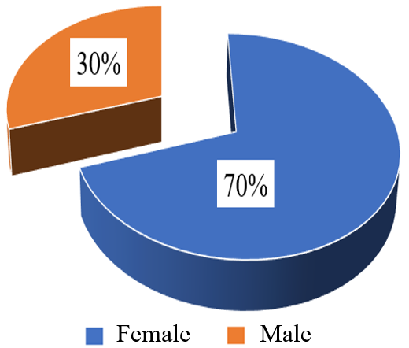
Figure 1. Distribution of Animal-Derived Food Vendors at the Togo–Benin Border (Sanvée-Condji/Hillah-Condji) by Sex, May 2022 (N = 70)
Coastal cities have historically served as major trading hubs since the colonial period. In recent years, street food vending has experienced significant growth. In this study, vendors reported professional experience ranging from 1 to 40 years, with a median of 7 years (interquartile range [3; 17]). The most represented category was 1–3 years of experience (30%), whereas the least represented was 4–7 years (21.42%) (Table 1).
Table 1. Distribution of Animal-Based Food Vendors at the Togo–Benin Border (Sanvée-Condji/Hillah-Condji) in May 2022 by Years of Experience (N = 70)
Professional experience | Number (n) | Proportion (%)
1- 3 years | 21 | 30.00
4 - 7 years | 15 | 21.42
8 - 17 years | 17 | 24.29
18 - 40 years | 17 | 24.29
Total | 70 | 100.00
Respondents were aged between 11 and 65 years, with a mean age of 43.22 years [± 13.24], a median of 45 years [IQR: 32–55]. The most represented group was 40–59 years [44.29%], followed by 18–39 years [38.57%], while vendors under 18 accounted for only 1.43% (Table 2). Overall, 82.86% belonged to the active age group [18–59 years].
Table 2. Age Distribution of Animal-Derived Food Vendors at the Togo–Benin Border (Sanvée-Condji/Hillah-Condji), May 2022 (N = 70)
Age | Number (n) | Proportion (%)
< 18 | 1 | 1.43
[18 - 40[ | 27 | 38.57
[40 - 60[ | 31 | 44.29
≥ 60 | 11 | 15.71
Total | 70 | 100.00
An ethnic diversity was recorded among vendors of animal-derived products, with a predominance of the Guin group (25.71%), related to the study location (Figure 2).
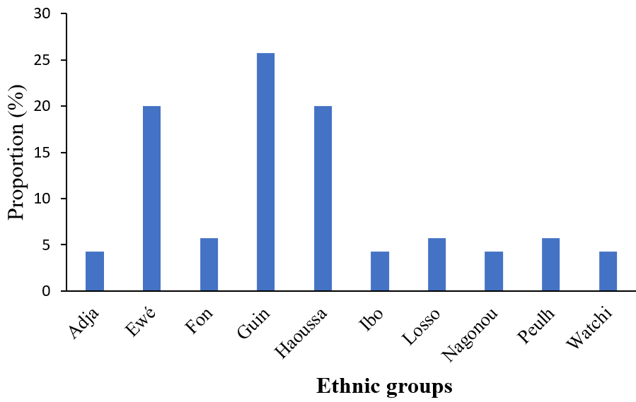
Figure 2. Distribution of Animal-Derived Food Vendors at the Togo–Benin Border (Sanvée-Condji/Hillah-Condji) by Ethnic Group, May 2022 (N = 70)

More than half of the vendors (52.86%) are Togolese nationals (Table 3). This predominance can likely be explained by the fact that the municipalities of Sanvée-Condji and Hillah-Condji are predominantly inhabited by Togolese.

Table 3. Distribution of Animal-Derived Food Vendors at the Togo–Benin Border (Sanvée-Condji/Hillah-Condji) by Nationality, May 2022 (N = 70)
Nationality | Number (n) | Proportion (%)
Beninese | 8 | 11.43
Ghanaian | 4 | 5.71
Nigerian | 14 | 20.00
Nigerien | 7 | 10.00
Togolese | 37 | 52.86
Total | 70 | 100.00
The pursuit of income to secure better living conditions is a central concern within households. In this study, the majority of respondents were married, accounting for 80% of the sample (Table 4).
Table 4. Distribution of Animal-Derived Food Vendors at the Togo–Benin Border (Sanvée-Condji/Hillah-Condji) by Marital Status, May 2022 (N = 70).
Marital Status | Number (n) | Proportion (%)
Single | 14 | 20.00
Married | 56 | 80.00
Total | 70 | 100.00

Figure 3 shows the distribution of vendors according to their educational level. Illiterate vendors accounted for 65.71%, while among those with formal education, only 2.86% had attained university level.
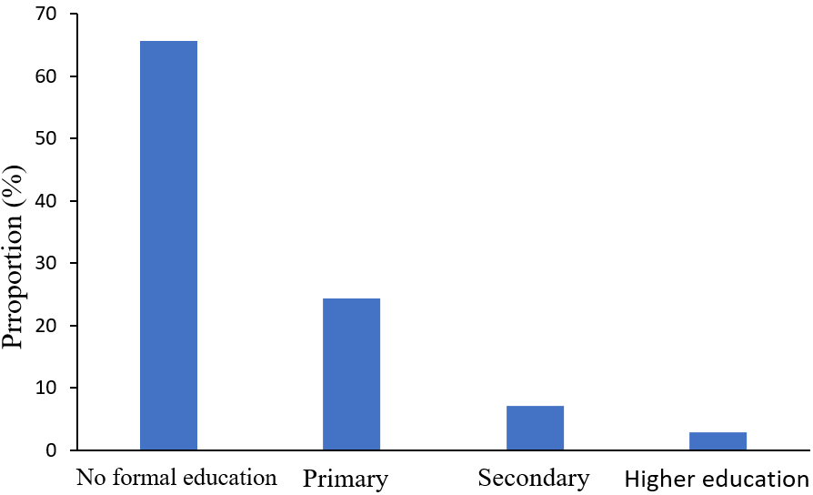
Figure 3. Distribution of Animal-Derived Food Vendors at the Togo–Benin Border (Sanvée-Condji/Hillah-Condji) by Educational Level, May 2022 (N = 70).
In addition, 78.57% of vendors of animal-based products did not possess a professional health card. Regarding vaccines recommended for food handlers, only the tuberculosis vaccine had been administered, with a coverage rate of 77.14%.
Inspections are perceived as a key driver for motivating behavioral change. Their frequency and effectiveness are critical elements that should not be overlooked in ensuring food safety. However, according to the survey, more than six out of ten vendors of animal-based protein products (61.43%) had not received any visit from inspectors or hygiene service officers (Table 5).
Frequency of Controls | Number (n) | Proportion (%)
None | 43 | 61.43
Once | 18 | 25.71
Twice | 8 | 11.43
Three times | 1 | 1.43
Total | 70 | 100.00
Table 5. Distribution of Animal-Derived Food Vendors at the Togo–Benin Border (Sanvée-Condji/Hillah-Condji) by Frequency of Inspectors’ Controls, May 2022 (N = 70)

Knowledge of Hygiene Practices
Immediate Environment of the Selling Site
Slightly more than half of the vendors (54.29%) prepared food in their kitchens, while the others did so directly at the selling sites, often near wastewater or illegal dumpsites. Most of them (84.29%) were located on sidewalks to remain in close contact with passersby, considered as potential buyers to facilitate quick sales. In addition, wastewater and garbage (illegal dumpsites) were reported around 10% of vendors, and the presence of harmful vector agents was observed in 61.43% of cases (Table 6).
Table 6. Environmental hygiene of animal-derived food vending sites at the Togo–Benin border (Sanvée-Condji/Hillah-Condji), May 2022 (N = 70)
 | Presence/Absence
Parameters | Presence | Absence
Wastewater | 7 (10%) | 63 (90%)
Illegal dumpsites | 7 (10%) | 63 (90%)
Disease vectors | 43 (61.43%) | 27 (38.57%)

Hygiene and Hygiene Practices among Vendors
Nearly seven out of ten vendors (68.57%), including 12.5% of men, had short fingernails (p = 0.00). Hair protection was observed in 40% of vendors (p = 0.00), while handwashing before selling food to consumers was reported exclusively by women (10%, p = 0.067) (Tables 7 and 8).
Table 7. Distribution of Animal-Derived Food Vendors by Personal Hygiene at the Togo–Benin Border (Sanvée-Condji/Hillah-Condji), May 2022 (N = 70)
 | Hair covered n (%) | Short fingernails n (%) | Handwashing before food sale n (%)
No | 42 (60) | 22 (31.43) | 63 (90)
Yes | 28 (40) | 48 (68.57) | 7 (10)
Total | 70 (100) | 70 (100.00) | 70 (100)

Table 8. Personal hygiene practices of Animal-Derived Food Vendors at the Togo–Benin Border (Sanvée-Condji/Hillah-Condji) by Sex, May 2022 (N = 70)
 | Hair covered n (%) | Short fingernails n (%) | Handwashing before food sale n (%)
Male | 0 (0) | 6 (8.57) | 0 (0)
Female | 28 (40) | 42 (60) | 7 (10)
Total | 28 (40) | 48(68.57) | 7 (10)

Half of the vendors used well water as their main water source, while potable water supplied by state services was the least used (20%) (Table 9).
Table 9. Distribution of Animal-Derived Food Vendors at the Togo–Benin Border (Sanvée-Condji/Hillah-Condji) by Water Source, May 2022 (N = 70)
Water source | Number (n) | Proportion (%)
Well | 35 | 50
Borehole | 21 | 30
SONEB/TDE | 14 | 20
Total | 70 | 100
The level of hygiene knowledge and its practice was low among nearly one-quarter of the vendors (24.29%). Only 10% of them, all women, demonstrated a good level of hygiene knowledge (p = 0.0052) (Table 10). Nevertheless, the majority of vendors (72.86%) were aware that poor product quality could lead to gastroenteritis symptoms among consumers.

Table 10. Distribution of Animal-Derived Food Vendors at the Togo–Benin Border (Sanvée-Condji/Hillah-Condji) by Level of Hygiene Knowledge and Practices, According to Sex, May 2022 (N = 70)
 |  | Male n (%) | Female n (%) | Total N (%)
 | Poor | 07 (10.00) | 10 (14.29) | 17 (24.29)
Level | Fair | 11 (15.71) | 35 (50.00) | 46 (65.71)
 | Good | 00 (0.00) | 07 (10.00) | 7 (10.00)

Furthermore, Table 11 shows a progressive decline, reaching zero, in the proportion of vendors with low levels of hygiene knowledge and practices from the age of 18 years onward. This regression is statistically significant (p < 0.05). Thus, the older the vendors, the better their level of hygiene knowledge and practices.
Table 11. Distribution of Animal-Derived Food Vendors at the Togo–Benin Border (Sanvée-Condji/Hillah-Condji) by Age Group, According to their Level of Hygiene Knowledge and Practices, May 2022 (N = 70)
 | Level of hygiene knowledge and practices
 |  | Good n (%) | Fair n (%) | Poor n (%)
Age | < 18 | 0 (0.00) | 0 (0.00) | 1 (5.88)
Age | [18 - 40[ | 1 (14.29) | 15 (32.61) | 11 (64.71)
Age | [40 - 60[ | 3 (42.86) | 23 (50.00) | 5 (29.41)
Age | ≥ 60 | 4 (42.86) | 8 (17.39) | 0 (0.00)
Age | Total | 7 (100.00) | 46 (100.00) | 17 (100.00)
Hygienic Quality of Animal-Derived Food According to Different Microbiological Indicators
The analysis revealed that 75% of animal-derived food samples were non-compliant with the criterion of Total Aerobic Mesophilic Flora (TAMF) in food products. Beef meat and processed meat products were entirely non-compliant, while seafood showed a 50% non-compliance rate. Only 10% of the samples demonstrated satisfactory hygienic quality in terms of TAMF, with a maximum colony-forming unit (CFU) count of 8,100.

Table 12. Hygienic Quality of Animal-Origin Food Products with Respect to Total Aerobic Mesophilic Flora (TAMF)
 | TAMF (CE N°2073/2005 ; CFU/g < 100.000)
Types of Animal-Derived Food Products | Unsatisfactory |  | Acceptable |  | Satisfactory
Types of Animal-Derived Food Products | (CFU/g) | % | (CFU/g) | % | (CFU/g) | %
Beef | (540.000 -57.000.000) M16.260.000 | 20.00 | (-) | 0.00 | (-) | 0.00
Poultry meat | (730.000 - 190.000.000) M 66.243.333 | 15.71 | (-) | 0.00 | (3.300) | 4.29
Fishery products | (440.000 - 96.000.000) M 24.860.000 | 20.00 | (12.000 - 61.000) M 29.000 | 14.29 | (8.100) | 5.71
NWFPs | M 8.800.000 | 4.29 | (-) | 0.00 | (-) | 0.00
Processed Meat Derivatives | (180.000 - 4.800.000) M 1.800.000 | 15.71 | (-) | 0.00 | (-) | 0.00
Total | (180.000 - 190.000.000) M 23.592.667 | 75.71 | (12.000 - 61.000) M 29.000 | 14.29 | (3.300 - 8.100) M 5.700 | 10.00
Results are presented as minimum and maximum CFU counts, along with the mean values obtained from 70 samples. (–) denotes no detectable count in accordance with the criterion.
NWFPs = Non-Wood Forest Products ; CFU = Colony Forming Unit

Regarding total coliforms, 80% of the samples showed unsatisfactory hygienic quality, with seafood being predominant (30%). However, seafood also accounted for half (10%) of the compliant samples, with 5% considered to have satisfactory hygienic quality.
Assessment based on thermotolerant coliforms revealed that half of the products were unsatisfactory, with beef meat showing the highest prevalence (15%). Among seafood, which represented 40% of the total sample, 30% were compliant, including 10% with satisfactory hygienic quality.
With respect to fungi, high levels of yeasts and molds were detected, rendering 35% and 30% of the samples, respectively, non-compliant.
Conversely, analysis of sulfite-reducing anaerobes (SRA) showed that almost all samples (95%) were compliant, with 70% of them presenting satisfactory hygienic quality, and no CFU detected. Only processed meat products were found to be unsatisfactory for this parameter (Table 13).

Table 13. Hygienic Quality of Animal-Origin Food Products with Respect to Sulfite-Reducing Bacteria (SRB)
 | Sulfite-Reducing Bacteria (CE N°2073/2005 ; CFU/g < 100)
Types of Animal-Derived Food Products | Unsatisfactory |  |  | Acceptable |  | Satisfactory
Types of Animal-Derived Food Products | (CFU/g) | % |  | (CFU/g) | % | (CFU/g) | %
Beef | (-) | 0.00 | (-) |  | 0.00 | M 0 | 20.00
Poultry meat | (-) | 0.00 |  | M 60 | 4.29 | M 0 | 15.71
Fishery products | (-) | 0.00 |  | (20 - 60) M 40 | 15.71 | M 0 | 24.29
NWFPs | (-) | 0.00 |  | (-) | 0.00 | M 0 | 4.29
Processed Meat Derivatives | M 500 | 4.29 |  | M 40 | 5.71 | M 0 | 5.71
Total | M 500 | 4.29 |  | (20 - 60) M 46.67 | 25.71 | M 0 | 70.00
Results are presented as minimum and maximum CFU counts, along with the mean values obtained from 70 samples. (–) denotes no detectable count in accordance with the criterion.
NWFPs = Non-Wood Forest Products ; SRB = Sulfite-Reducing Bacteria

DISCUSSION

Sociodemographic Profile of Vendors
The findings reveal a predominance of women (70%) among animal-based food vendors at the Togo–Benin border, compared to only 30% of men. This gender imbalance reflects a well-documented division of labor in West African informal trade, where women are primarily responsible for food retail and distribution due to the relatively low entry costs and the possibility of generating daily income to sustain households (Clark, 2010; Yusuff, 2011; Golub, 2015). The overrepresentation of women in this activity also has public health implications, as they constitute the main interface between food and consumers. Their hygiene practices directly affect the microbiological safety of products, underscoring the importance of targeted training programs (FAO, 2017).
The age structure of vendors (mean 43.22 years), with a predominance of those aged 40–59 years (44.29%) followed by 18–39 years (38.57%), indicates that the economically active population sustains informal food trade. Similar age patterns have been reported in other West African contexts, where street food vending provides stable income sources for middle-aged individuals facing limited formal employment opportunities (Steyn et al., 2014; Abrahale et al., 2019). This suggests that informal trade serves as a livelihood strategy for adults with family responsibilities, while only a minority of adolescents engage in this activity.
Marital status also played a role, as the majority of vendors (80%) were married, consistent with findings that household responsibilities push individuals (especially women) toward income-generating activities in informal food markets (Tinker, 1997; Abrahale et al., 2019). These results confirm the embeddedness of food vending in household survival strategies, particularly in urban and peri-urban border communities.

Education, Professional Experience, and Ethnic Diversity
Educational levels were remarkably low: 65.71% of vendors had no formal schooling, and only 2.86% had attended university. This finding is consistent with other studies in Africa showing that street food vending is predominantly practiced by individuals with limited education, which restricts their knowledge of good hygiene practices (Monney et al., 2013; Muyanja et al., 2011). Lack of education often correlates with poor compliance with food safety standards, thereby increasing the risks of microbial contamination (Mensah et al., 2002).
Professional experience ranged from 1 to 40 years, with a median of 7 years. Vendors with fewer than 3 years of experience constituted 30% of the group, suggesting a recent influx into the sector linked to unemployment and urbanization pressures (Skinner, 2008). Interestingly, the analysis showed a progressive decline in the proportion of vendors with poor hygiene knowledge and practices beyond the age of 18 years, suggesting that experience and age contribute positively to improved hygiene performance.
Ethnic diversity was also a defining feature of the vendor population, with the Guin group (25.71%) being predominant. Their concentration in the study site is explained by historical settlement along coastal areas and traditional involvement in fishing and trade (Gayibor, 1997). Border markets, however, also attract multiple ethnic groups, reflecting the intercultural dynamics and interconnectedness of cross-border trade in West Africa (Meagher, 2005; Golub, 2015). Such diversity can enrich market activity but also introduces variability in hygiene practices that may influence food safety (FAO, 2016).

Hygiene Practices and Environmental Conditions
Hygiene practices were found to be inadequate. Nearly 70% of vendors had short fingernails, but only 40% covered their hair, and handwashing before serving food was reported exclusively by 10% of women. Such gaps in personal hygiene contribute to microbial contamination, especially considering that hands and hair are common vectors of pathogens (FAO/WHO, 2009; WHO, 2015). The lack of proper protective measures highlights the need for targeted interventions to raise awareness and provide affordable hygiene equipment.
Environmental conditions at vending sites were precarious. More than half of vendors operated on sidewalks near wastewater or illegal dumpsites, with vectors such as flies and rodents observed in 61.43% of cases. Similar studies in West African cities have shown that such environments are strongly associated with outbreaks of diarrheal diseases (Barro et al., 2002; Abdalla et al., 2009). The absence of designated vending areas exacerbates these risks, as vendors prioritize proximity to consumers over sanitary conditions.
Another major concern is the absence of health cards among 78.57% of vendors and limited vaccination coverage. While tuberculosis vaccination was reported, vaccines against typhoid fever and hepatitis A were not. This situation reflects weak enforcement of regulations and limited access to formal health services (FAO/WHO, 2019; WHO, 2015). Strengthening medical certification and immunization programs for food vendors is essential to reduce risks of foodborne transmission of infectious diseases.

Water Access and Infrastructure
Half of the vendors relied on well water as their main source, while potable water supplied by state services was the least used (20%). In many sub-Saharan contexts, well water is vulnerable to fecal contamination due to inadequate protection and proximity to latrines or dumpsites (Wright et al., 2004). The use of untreated water increases the risk of Escherichia coli and coliform contamination in food, as documented in studies from Ghana and Nigeria (Mensah et al., 2002; Barro et al., 2002). Limited access to potable water is therefore a critical barrier to achieving food safety standards in informal markets (FAO, 2016).

Microbiological Quality of Animal-Derived Foods
The microbiological results confirmed major deficiencies in food hygiene. For total mesophilic aerobic flora (TMAF), 75% of samples were non-compliant, with 100% non-compliance in beef and meat products and 50% in seafood. Elevated TMAF counts reflect poor handling, cleaning, and cold chain maintenance. According to ISO 4833-1, TMAF is a recognized process hygiene indicator, and high levels imply increased risks of spoilage and shorter shelf life (ISO, 2013; Codex Alimentarius Commission, 1997; European Commission, 2005).
For total coliforms, 80% of samples were unsatisfactory, particularly seafood, confirming exposure to unsafe water and inadequate hygiene (Gram & Huss, 1996). Thermotolerant coliforms further revealed that half of the samples were unsatisfactory, with beef showing the highest contamination rates. These microorganisms indicate fecal contamination and a possible presence of enteric pathogens (Guchi, 2015).
Yeasts and molds were detected at concerning levels, rendering 35% and 30% of samples non-compliant, respectively. Such contamination indicates poor storage conditions and potential risks of mycotoxin production (Pitt & Hocking, 2009). Conversely, results for sulfite-reducing anaerobes (SRA) were more favorable: 95% of samples were compliant, with no Clostridium perfringens detected. Only processed meats were unsatisfactory for this parameter, pointing to specific weaknesses in meat processing practices (McClane, 2007).

Implications and Recommendations
Overall, the study demonstrates that food safety risks at the Togo–Benin border are mainly linked to inadequate personal hygiene, unsafe water use, precarious environmental conditions, and insufficient regulatory enforcement. The persistence of high contamination levels in animal proteins highlights the urgent need for a multifaceted approach:
Vendor training on good hygiene practices, particularly handwashing, hair protection, and proper handling.
Improved infrastructure, including access to potable water, designated vending areas, and waste management systems.
Regulatory strengthening, with regular inspections, mandatory health certification, and expanded vaccination coverage.
Microbiological monitoring aligned with international standards (Codex, ISO, EU) to detect risks early and implement corrective measures.
Such interventions would reduce microbial contamination, prevent foodborne diseases, and improve consumer confidence in border markets, which play a crucial role in regional food security and livelihoods.
CONCLUSION
This study highlighted major hygiene and food safety concerns regarding animal-derived products sold at the Togo–Benin border. Women were predominant among vendors, most with low educational levels, and hygiene practices improved only with age and experience. Poor environmental conditions, limited access to potable water, and insufficient personal hygiene were recurrent challenges.
Microbiological analyses confirmed these weaknesses: three-quarters of products were non-compliant for aerobic flora, with high levels of coliforms and fungi, particularly in beef and seafood. Such contamination poses clear risks of foodborne diseases for consumers.
These findings underline the urgent need for interventions focused on training vendors, improving access to clean water, enforcing hygiene regulations, and strengthening microbiological monitoring. Improving food safety at border markets is critical to protect consumer health, sustain livelihoods, and ensure the sustainability of cross-border trade.

REFERENCES
Abdalla, M. A., Suliman, S. E., & Bakhiet, A. O. (2009). Food safety knowledge and practices of street food vendors in Atbara City, Sudan. African Journal of Biotechnology, 8(24), 6967–6971.
Abrahale, K., Sousa, S., Albuquerque, G., Padrão, P., & Damasceno, A. (2019). Street food research worldwide: A scoping review. Journal of Human Nutrition and Dietetics, 32(2), 152–174.
Barro, N., Ouattara, C. A. T., Nikiema, A. P., De Souza, C., & Traoré, A. S. (2002). Street-vended foods: Microbiological quality and risk factors for contamination in Ouagadougou, Burkina Faso. Journal of Food Protection, 65(9), 1541–1545.
Clark, G. (2010). Gender fictions and gender tensions in Ghanaian public markets. Africa, 80(3), 501–523.
Codex Alimentarius Commission. (1997). Principles and guidelines for the establishment and application of microbiological criteria for foods (CAC/GL 21-1997). FAO/WHO.
European Commission. (2005). Regulation (EC) No 2073/2005 on microbiological criteria for foodstuffs. Official Journal of the European Union, L338, 1–26.
FAO. (2016). Street food in urban cities: Food safety and livelihoods. FAO.
FAO. (2017). Women in food safety and food security: Roles and challenges. Rome: FAO.
FAO/WHO. (2009). Principles and guidelines for the conduct of microbiological risk management (MRM). Codex Alimentarius Commission.
FAO/WHO. (2019). Food handlers’ manual: Ensuring food safety through proper training. Rome: FAO/WHO.
Gayibor, N. L. (1997). Histoire des Togolais: Des origines aux années 1960 (Vol. 1). Paris: L’Harmattan.
Golub, S. (2015). Informal cross-border trade and smuggling in Africa. Journal of Borderlands Studies, 30(3), 381–394.
Gram, L., & Huss, H. H. (1996). Microbiological spoilage of fish and fish products. International Journal of Food Microbiology, 33(1), 121–137. https://doi.org/10.1016/0168-1605(96)01134-8
Guchi, E. (2015). Coliform bacteria as indicators of fecal contamination in dairy and water. Food Science and Quality Management, 45, 23–29.
ICMSF. (2002). Microorganisms in foods 7: Microbiological testing in food safety management. Springer.
ISO. (2013). ISO 4833-1:2013 – Microbiology of the food chain: Horizontal method for the enumeration of microorganisms – Part 1: Colony count at 30°C by the pour plate technique. Geneva: International Organization for Standardization.
McClane, B. A. (2007). Clostridium perfringens. In M. P. Doyle & L. R. Beuchat (Eds.), Food microbiology: Fundamentals and frontiers (3rd ed., pp. 423–444). ASM Press.
Meagher, K. (2005). Social capital or analytical liability? Social networks and African informal economies. Global Networks, 5(3), 217–238.
Mensah, P., Yeboah-Manu, D., Owusu-Darko, K., & Ablordey, A. (2002). Street foods in Accra, Ghana: How safe are they? Bulletin of the World Health Organization, 80(7), 546–554.
Monney, I., Agyei, D., & Owusu, W. (2013). Hygienic practices among food vendors in educational institutions in Ghana: The case of Konongo. Food and Nutrition Sciences, 4(3), 165–172.
Muyanja, C., Nayiga, L., Brenda, N., & Nasinyama, G. (2011). Practices, knowledge and risk factors of street food vendors in Uganda. Food Control, 22(10), 1551–1558.
Pitt, J. I., & Hocking, A. D. (2009). Fungi and food spoilage (3rd ed.). Springer.
Skinner, C. (2008). Street trade in Africa: A review. School of Development Studies, University of KwaZulu-Natal.
Steyn, N. P., McHiza, Z., Hill, J., Davids, Y. D., Venter, I., Hinrichsen, E., Opperman, M., Rumbelow, J., & Jacobs, P. (2014). Nutritional contribution of street foods to the diet of people in developing countries: A systematic review. Public Health Nutrition, 17(6), 1363–1374.
Tinker, I. (1997). Street foods: Urban food and employment in developing countries. Oxford University Press.
WHO. (2015). Food safety fact sheet. World Health Organization.
Wright, J., Gundry, S., & Conroy, R. (2004). Household drinking water in developing countries: A systematic review of microbiological contamination between source and point-of-use. Tropical Medicine & International Health, 9(1), 106–117.
Yusuff, O. S. (2011). Gender dimensions of informal cross border trade in West-African sub-region (ECOWAS) borders. International Journal of Sociology and Anthropology, 3(2), 70–79.

