In vitro antibacterial activity of mulberry fruit extracts from different accessions against Salmonella enterica and Bacillus cereus

Abstract

The emergence of antibiotic-resistant foodborne pathogens, particularly Salmonella enterica and Bacillus cereus, highlights the necessity for efficient natural antibacterial alternatives. The present study evaluated the in vitro antibacterial efficacy of aqueous fruit extracts from five mulberry (Morus spp.) accessions (MI-0789, MI-0632, MI-0489, MI-0300 and MI-0783) against these pathogens. Extracts were evaluated at doses ranging from 20 to
100 µL utilizing the agar well diffusion method, with inhibition zones recorded following 24- hour incubation at 37 °C. The results demonstrated significant changes in antibacterial activity that were depending on genotype and concentration. MI-0300 demonstrated enhanced efficacy against both Salmonella enterica (25 mm at100 µL) and Bacillus cereus (38 mm at 100 µL), exhibiting significant activity even at reduced dosages. MI-0783 and MI-0789 exhibited moderate activity, but MI-0632 and MI-0489 shown weak or negligible inhibition. The observed differences are due to variances in phytochemical composition, specifically phenolics, flavonoids and anthocyanins. These findings underscore MI-0300 as a potential
candidate for the development of natural antibacterial agents, functional foods and nutraceutical products.

Key words: Morus spp., mulberry fruit extracts, antibacterial activity, Salmonella enterica,

Bacillus cereus

Introduction

The escalating prevalence of antibiotic-resistant bacterial pathogens poses a significant threat to global public health, necessitating the urgent development of alternative antimicrobial strategies. Foodborne pathogens such as Salmonella enterica and Bacillus cereus are particularly concerning due to their widespread distribution, pathogenicity, and increasing resistance to conventional antibiotics (Helmy et al., 2023). This has prompted extensive research into natural antimicrobial compounds derived from plant sources, which offer promising alternatives with potentially fewer side effects and reduced likelihood of resistance development. Mulberry (Morus spp.) fruits have garnered considerable attention as a rich source of bioactive compounds, including phenolic acids, flavonoids, anthocyanins, and tannins. These secondary metabolites possess well-documented antimicrobial properties through various mechanisms, including bacterial cell membrane disruption, enzyme inhibition, and interference with cellular metabolic pathways. The phytochemical composition of mulberry fruits varies significantly among different genotypes, potentially influencing their antimicrobial efficacy (Özbalci et al., 2023). Despite the recognized therapeutic potential of mulberry fruits, comprehensive comparative studies evaluating the antimicrobial activity of different mulberry accessions against specific foodborne pathogens remain limited. Understanding genotype-specific variations in antimicrobial activity is crucial for identifying superior cultivars that could be developed into natural antimicrobial agents, functional foods, or nutraceuticals. This study aims to evaluate the in vitro antibacterial activity of aqueous fruit extracts from five different mulberry accessions (MI-0789, MI-0632, MI-0489, MI-0300, and MI-0783) against two clinically important bacterial pathogens: Salmonella enterica and Bacillus cereus. The investigation seeks to determine concentration-dependent antimicrobial effects and identify accessions with superior antibacterial potential for future biotechnological applications.
Materials and Methods

The fresh fruits of mulberry (Morus spp.) belonging to five different accessions (MI-

0789, MI-0632, MI-0489, MI-0300 and MI-0783) were harvested from the Mulberry Germplasm Garden, Department of Sericulture, Forest College and Research Institute, Mettupalayam. These accessions were selected to evaluate potential differences in antibacterial properties that may arise from genetic and biochemical variation among the fruit types. The collected fruits were first washed thoroughly with sterile distilled water to remove surface impurities. They were then manually crushed using a sterile pestle and mortar, and the homogenized pulp was filtered through a sterile muslin cloth to obtain a clear aqueous extract. From this crude extract, five different concentrations (20, 40, 60, 80, and 100 µL) were prepared for antibacterial evaluation. For the assay, Mueller-Hinton agar (MHA) medium was used, as it is a standard growth medium recommended for antimicrobial susceptibility testing. The bacterial test organisms, Salmonella enterica (a Gram-negative pathogen associated with foodborne illness) and Bacillus cereus (a Gram-positive bacterium known for food spoilage), were procured from ATCC (American Type Culture Collection) to ensure strain authenticity. These bacterial cultures were grown in nutrient broth and incubated overnight at 37 °C in an orbital shaker at 120 rpm to achieve active growth. The agar well diffusion method was employed to determine antibacterial activity. The actively growing bacterial suspensions were spread uniformly on MHA plates using a sterile L-rod. Sterile wells were made in the agar using a well cutter, into which the prepared mulberry fruit extracts at different concentrations were carefully dispensed. The plates were incubated at 37 °C for 24 hours. Following incubation, the zones of inhibition (clear areas around wells) were measured in millimetres (mm) with a ruler or template, and the mean values were calculated (Seeley and Vandemark,
1962). All experiments were performed in triplicate.

Results and Discussions

Salmonella enterica

Salmonella enterica is a significant cause of infectious illness on a global level, however, the development of antibiotic-resistant strains has restricted the efficacy of conventional remedies. The strong antimicrobial potential has been demonstrated by phytochemicals from medicinal plants, including alkaloids, phenols, flavonoids and terpenes. The efflux pumps, membrane proteins, cell communication and biofilm formation of drug-
resistant Salmonella enterica are disrupted by these compounds (Soni et al., 2025). Therefore, phytochemicals derived from plants offer a promising alternative approach to the treatment of Salmonella enterica infections. The results of antibacterial activity of mulberry fruit extracts against Salmonella enterica is presented in the Table 1 and Figure 1. Mulberry fruit extracts exhibited notable antibacterial activity against Salmonella enterica, with significant genotypic differences. Among the different concentrations (20, 40, 60, 80, 100), 100 µl recorded the highest antibacterial activity. Among the different accessions, MI-0300 showed the highest efficacy, producing a 25 mm inhibition zone at 100 µL and activity even at 20 µL (8 mm), indicating the presence of high levels of phenolics and anthocyanins. MI-0783 followed with strong activity (21 mm), while MI-0789 showed delayed response at higher concentrations, suggesting threshold-dependent effects. MI-0632 and MI-0489 showed least effective, reflecting variation in phytochemical profiles. These results are in align with earlier studies reporting antimicrobial activity of mulberry extracts (Deepa et al., 2022; Suriyaprom et al.,
2021). The lowest zone of inhibition was seen in MI-0632 (7 mm) at 40 µl concentration. There was no zone of inhibition for MI-0489 at 20 to 80 µl concentrations. Similarly, there was zone of inhibition for MI-0789 at 20 to 40 µl and for MI-0632 at 20 µl concentration. Extracts from mulberry fruit, particularly those derived from M. nigra, exhibit significant antibacterial efficacy against Staphylococcus aureus, Staphylococcus epidermidis, Streptococcus pyogenes and Proteus mirabilis (Miljković et al., 2018). Similarly, Edemekong et al. 2025 reported that the ethanolic extracts of Brazilian tea, siam weed, neem and ginger showed significant antibacterial activity against Salmonella enterica serovar Typhimurium, even at the lower concentrations (25 to 100 mg/mL). Salmonella enterica was also inhibited by the gemmotherapy extracts of blackberry, black mulberry, walnut, almond and bilberry, although the primary effect was for suppress growth rather than to kill the bacteria (Hejja et al., 2024). Bioactive compounds such as rutin, chlorogenic acid, and anthocyanins disrupt bacterial membranes and inhibit metabolic pathways (Cowan, 1999) (Alzahrani et al., 2024). The strong efficacy of MI-0300 and MI-0783 highlight their potential for developing natural antimicrobials, functional foods, and nutraceuticals aimed at combating multidrug-resistant foodborne pathogens.
Table 1. In vitro antibacterial activity of mulberry fruit extracts against Salmonella

enterica

S. No | Mulberry  fruit accession number | Zone of inhibition (mm)
S. No | Mulberry  fruit accession number | The concentration of the sample
S. No | Mulberry  fruit accession number | 20µL | 40µL | 60µL | 80µL | 100µL
1. | MI-0789 | - | - | 15 ± 0.47c | 17 ± 0.57c | 20 ± 1.45b
2. | MI-0632 | - | 7 ± 0.47c | 12 ± 0.67d | 14 ± 0.39d | 15 ± 1.07c
3. | MI-0489 | - | - | - | - | 10 ± 0.44d
4. | MI-0300 | 8 ± 0.19b | 20 ± 0.59a | 22 ± 0.51a | 23 ± 1.45a | 25 ± 1.31a
5. | MI-0783 | 13 ± 0.68a | 14 ± 1.03b | 19 ± 1.24b | 19 ± 1.00b | 21 ± 0.79b
SED |  | 0.44 | 0.68 | 0.65 | 0.71 | 0.78
CD (p=0.05) |  | 0.92 | 1.41 | 1.35 | 1.49 | 1.62
Values are expressed in mean ± SD with three replications (n=3)

Means followed by different small superscript in a column are statistically different at p ≤ 0.05

Figure 1. In vitro antibacterial activity of mulberry fruit extracts against Salmonella enterica

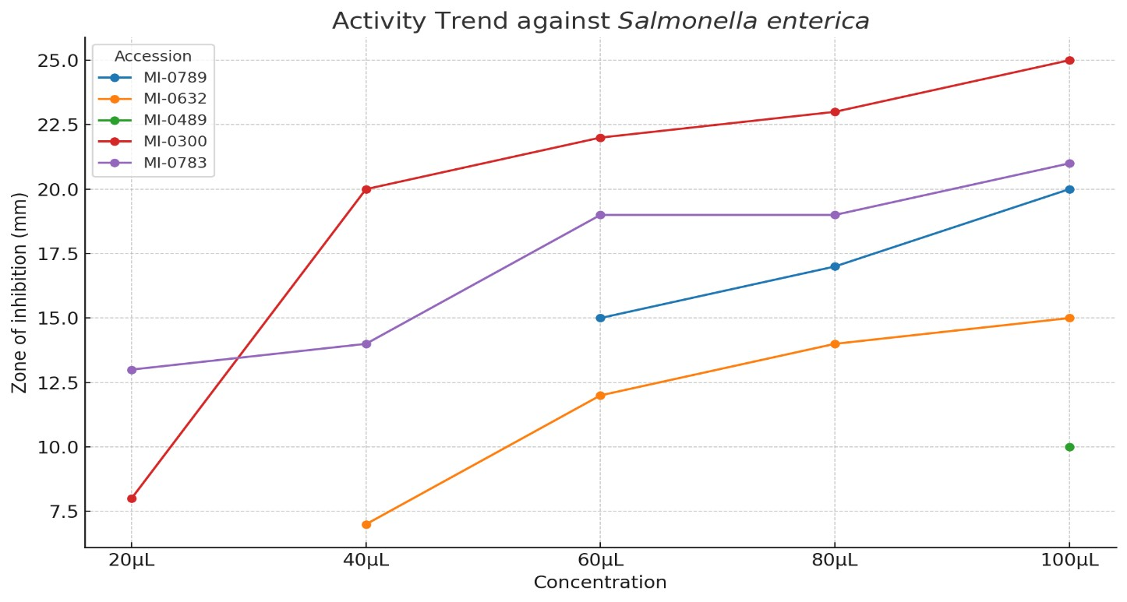
Bacillus cereus

The results of antibacterial activity of mulberry fruit extracts against Bacillus cereus is presented in the Table 2 and Figure 2. Mulberry fruit extracts showed significant antibacterial activity against Bacillus cereus, with clear genotypic differences. Among the different concentrations (20, 40, 60, 80, 100), 100 µl recorded the highest antibacterial activity. Among the accessions, MI-0300 exhibited the highest efficacy, producing inhibition zones from 25 mm (20 µL) to 38 mm (100 µL), indicating strong antibacterial activity even at low concentrations. This potency likely comes from high flavonoid, tannin, and anthocyanin content, which disrupt bacterial cell walls and inhibit enzyme systems. Statistically significant differences confirm MI-0300’s superiority among accessions. MI-0789 demonstrated moderate, concentration- dependent inhibition (10 - 25 mm), while MI-0783 showed intermediate activity (14 - 22 mm), plateauing after 60 µL, possibly due to limited phytochemical availability. MI-0632 and MI-
0489 remained inactive, reflecting a lack of effective antimicrobial constituents against Bacillus cereus. These findings underscore genotype-specific variations in bioactive composition and align with earlier reports on mulberry’s antimicrobial potential (Suriyaprom et al., 2021). There was no zone of inhibition for MI-0632 and mi-0489 at 20 to 100 µl concentrations. Mulberry fruit flavonoids, particularly those derived from black mulberry (Morus nigra), exhibit potent antibacterial properties against Escherichia coli, Pseudomonas aeruginosa, and Staphylococcus aureus. This effect is primarily due to the high content of anthocyanin and flavonols, notably cyanidin-3-O-glucoside, rutin and isoquercetin (Chen et al., 2017). The antibacterial activity of carrot peel extract is primarily attributed to its high content of phenolics, flavonoids, and β-carotene, which function as antimicrobial agents. These compounds have the potential to disrupt membranes, inhibit microbial enzymes, generate oxidative stress, and damage bacterial cell walls, thereby preventing the growth of both Gram- positive (Staphylococcus aureus, Bacillus cereus) and Gram-negative (Salmonella typhi, Escherichia coli) pathogens (Shindia et al., 2024). Morusin, a phenolic extract from mulberry white bark and xylwm showed strong antibacterial activity against Bacillus cereus with a minium inhibitory concentration of 2.25 μg/mL, effectively inhibiting biofilm formation and disrupting cell membrane integrity. It reduced intracellular ATP, caused membrane depolarization, and downregulated genes linked to cell wall synthesis and amino acid metabolism. At 4.5 μg/mL, morusin significantly inhibited B. cereus growth in skimmed milk, highlighting its potential as a natural food preservative (Liao et al., 2024). The pronounced
activity of MI-0300 suggested strong applicability in nutraceutical development and natural food preservatives.

Table 2. In vitro antibacterial activity of mulberry fruit extracts against Bacillus cereus

S. No | Mulberry  fruit accession number | Zone of inhibition (mm)
S. No | Mulberry  fruit accession number | The concentration of the sample
S. No | Mulberry  fruit accession number | 20µL | 40µL | 60µL | 80µL | 100µL
1. | MI-0789 | 10 ± 0.45c | 15 ± 0.56c | 18 ± 0.94c | 20 ± 0.56b | 25 ± 1.36b
2. | MI-0632 | - | - | - | - | -
3. | MI-0489 | - | - | - | - | -
4. | MI-0300 | 25 ± 1.39a | 30 ± 0.28a | 37 ± 2.52a | 37 ± 1.66a | 38 ± 1.19a
5. | MI-0783 | 14 ± 0.14b | 20 ± 1.23b | 20 ± 0.90b | 20 ± 0.41b | 22 ± 1.15c
SED |  | 0.66 | 0.70 | 1.29 | 1.09 | 1.14
CD (p=0.05) |  | 1.39 | 1.47 | 2.68 | 2.27 | 2.37
Values are expressed in mean ± SD with three replications (n=3)

Means followed by different small superscript in a column are statistically different at p ≤ 0.05

Figure 2. In vitro antibacterial activity of mulberry fruit extracts against Bacillus cereus

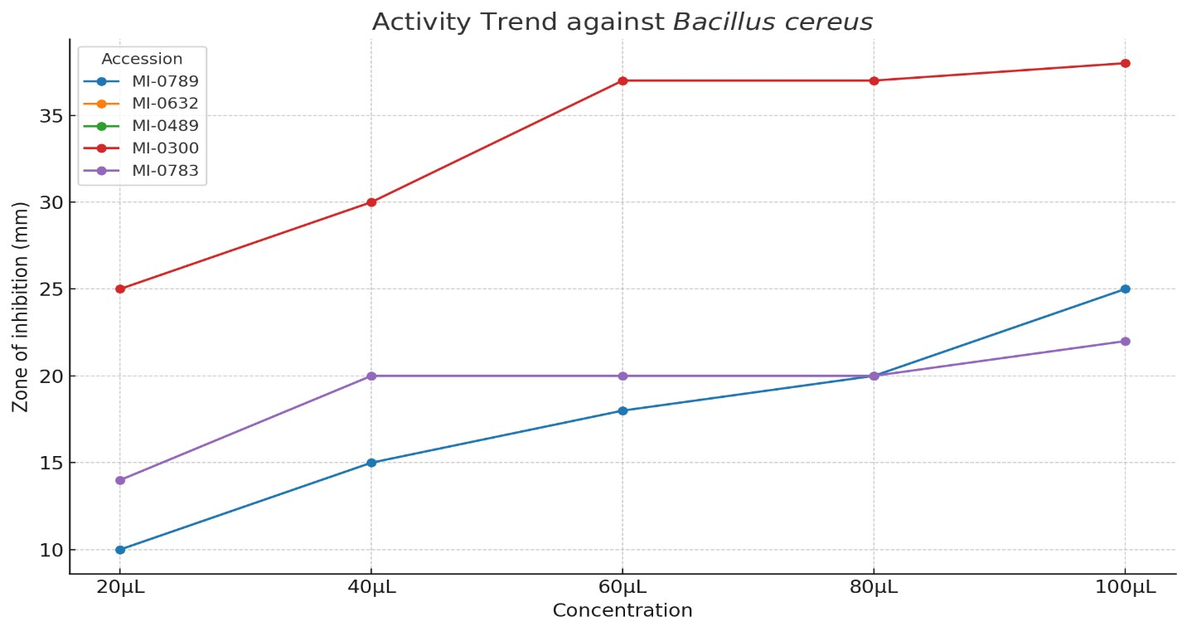

In the Figure 3 the heatmap showed that MI-0300 accession consistently exhibited the strongest antibacterial activity against both Salmonella enterica and Bacillus cereus across all the concentrations, with inhibition zones exceeding 20 mm from 40 µL onward and peaking near 38 mm against Bacillus cereus. In contrast, MI-0632 and MI-0489 displayed weak or no activity, MI-0783 and MI-0789 demonstrated moderate, concentrate -dependent inhibition, with stronger effects against Bacillus cereus than Salmonella enterica. Overall, the dose- response trend is clearly visible and the heatmap highlights the pronounced variation in antibacterial potential among the tested accessions.

Figure 3. Heatmap of Antibacterial Activity of Mulberry Fruit Extracts

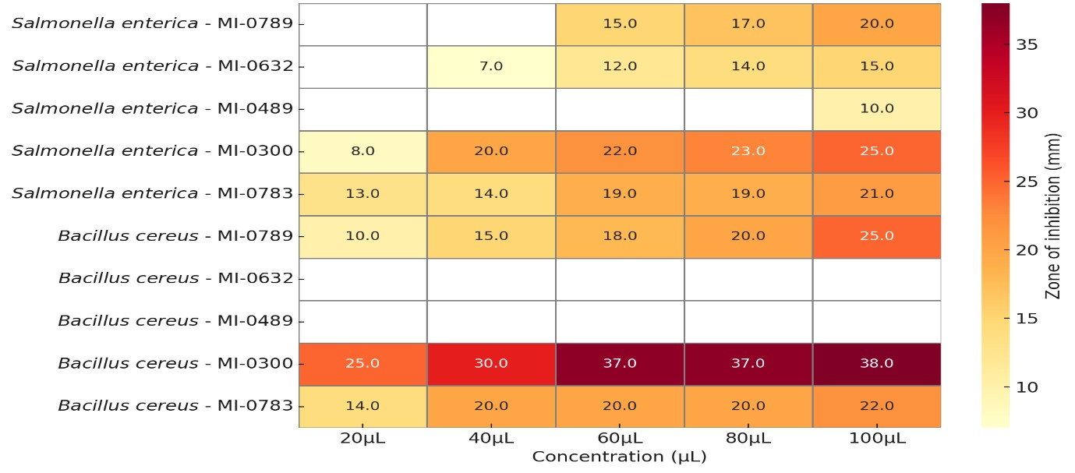
Conclusion

This study successfully demonstrated significant genotype-dependent variations in the antimicrobial activity of mulberry fruit extracts against Salmonella enterica and Bacillus cereus. The findings revealed that mulberry accession MI-0300 exhibited superior antibacterial efficacy against both tested pathogens. The differential antimicrobial responses observed among accessions can be attributed to variations in phytochemical profiles, particularly the content of phenolic compounds, flavonoids and anthocyanins. MI-0783 showed moderate activity, while MI-0789 displayed threshold-dependent effects, suggesting concentration- sensitive antimicrobial mechanisms. These findings have significant implications for the development of natural antimicrobial agents, functional foods and nutraceuticals. The identification of MI-0300 as a superior antimicrobial source provides a foundation for future studies focusing on bioactive compound isolation, mechanism elucidation and scale-up applications. Furthermore, the results support the potential integration of selected mulberry accessions into food preservation systems and therapeutic formulations targeting multidrug- resistant foodborne pathogens. Future research should focus on identifying and quantifying specific bioactive compounds responsible for the observed antimicrobial activity, investigating synergistic effects between different phytochemicals and evaluating the stability and bioavailability of these compounds under various processing conditions.

COMPETING INTERESTS DISCLAIMER:
Authors have declared that they have no known competing financial interests OR non-financial interests OR personal relationships that could have appeared to influence the work reported in this paper.

References

1. Alzahrani, M. Y., Alshaikhi, A. I., Hazzazi, J. S., Kurdi, J. R., & Ramadan, M. F. (2024). Recent insight on nutritional value, active phytochemicals, and health‐ enhancing characteristics of fig (Ficus craica). Food Safety and Health, 2(2), 179-195.
2. Chen, H., Yu, W., Chen, G., Meng, S., Xiang, Z., & He, N. (2017). Antinociceptive and antibacterial properties of anthocyanins and flavonols from fruits of black and non- black mulberries. Molecules, 23(1), 4.
3. Cowan, M. M. (1999). Plant products as antimicrobial agents. Clinical microbiology reviews, 12(4), 564-582.
4. Deepa K, Priyadharshini P, Tilak M, Shanmugam R and Gurumeenakshi G. 2022. "Morphological characteristics and antibacterial activity of mulberry fruit varieties. "The pharma innovation 11(7) (7):219-223.
5. Edemekong, C. I., Chukwujekwu, A. G., Okorie, M. E., Udenweze, E., Obodoechi, I.

F., Ogbonna, I. P., & Livinus, N. P. (2025). Evaluation of Antibacterial Activity of Selected Medicinal Plant on Extended Spectrum β-lactamase Producing Salmonella enterica serovar Typhimurium. UMYU Scientifica, 4(1), 28-36.
6. Héjja, M., Mihok, E., Alaya, A., Jolji, M., György, É., Meszaros, N., ... & Máthé, E. (2024). Specific antimicrobial activities revealed by comparative evaluation of selected gemmotherapy extracts. Antibiotics, 13(2), 181.
7. Helmy, Y. A., Taha-Abdelaziz, K., Hawwas, H. A. E. H., Ghosh, S., AlKafaas, S. S., Moawad, M. M., ... & Mawad, A. M. (2023). Antimicrobial resistance and recent alternatives to antibiotics for the control of bacterial pathogens with an emphasis on foodborne pathogens. Antibiotics, 12(2), 274.
8. Liao, S., Gong, G., Fu, J., Wang, J., Qi, Q., Hu, L., ... & Tian, L. (2024). Antimicrobial mechanism of morusin against Bacillus cereus and its potential as an antimicrobial agent. Food Bioscience, 60, 104378.
9. Miljković, V., Nikolić, G., Mihajlov-Krstev, T. M., & Arsić, B. (2018). Antibacterial activities of fruits extracts of three mulberry species (Morus alba L., Morus rubra L. and Morus nigra L.) and bilberry (Vaccinium myrtillus L.). Acta Medica Medianae, 57(3), 5-12
10. Özbalci, D., Aydin, E., & Özkan, G. (2023). Phytochemical profile and pharmaceutical properties of mulberry fruits.
11. Seeley, H. J., & VanDemark, P. J. (1962). Microbes in action. A laboratory manual of microbiology.
12. Shindia, A., Abdel-Shafi, S., Atef, A., Osman, A., Sitohy, B., & Sitohy, M. (2024).

Antibacterial activity of carrot peel HCl-ethanol extracts and its potential application in meat preservation. LWT, 207, 116638.
13. Soni, S., Gambhir, L., Sharma, G., Sharma, A., & Kapoor, N. (2025). Unraveling the treasure trove of phytochemicals in mitigating the Salmonella enterica infection. Folia Microbiologica, 70(1), 1-17.
14. Suriyaprom, S., Kaewkod, T., Promputtha, I., Desvaux, M., & Tragoolpua, Y. (2021).

Evaluation of antioxidant and antibacterial activities of white mulberry (Morus alba L.)

fruit extracts. Plants, 10 (12), 2736.

