Investigating the Impact of Government Mid-Day Meal Schemes on the Reduction of Anemia Prevalence Among Primary School Children in Bulandshahr District

Abstract
Background:
Anemia among school-aged children remains a pressing public health issue in India. The Government’s Mid-Day Meal (MDM) Scheme aims to address undern utrition and anemia by providing nutritious meals to children in government schools. This study focuses on evaluating the impact of the MDM Scheme on anemia prevalence in primary school children in Bulandshahr district, Uttar Pradesh.
Objectives:
The study aims to assess the current prevalence of anemia among children aged 6–12 years, examine the effectiveness of the Mid-Day Meal Scheme in reducing anemia, and explore the influence of socio-demographic factors such as age, gender, area, and maternal education on anemia and nutritional status.
Methods:
A descriptive cross-sectional design was adopted. A stratified random sample of 600 students (300 from urban and 300 from rural schools) was selected. Data on hemoglobin levels were collected using the HemoCue Hb 301 analyzer, along with anthropometric measurements. Statistical tools such as chi-square tests, Pearson correlations, and paired t-tests were used for hypothesis testing.
Results:
The study found a 33.3% anemia prevalence overall, with rural children showing a higher burden. Hemoglobin levels showed significant improvement (mean increase of 1.3 g/dL, p < 0.001) among anemic children after participation in the Mid-Day Meal Scheme. Age, residential area, and maternal education were significantly associated with hemoglobin levels, while underweight children showed a significantly higher incidence of anemia.
Conclusion:
The Mid-Day Meal Scheme has proven to be effective in improving hemoglobin levels and reducing anemia among primary school children. Socio-demographic factors, especially maternal education and rural residence, play a crucial role in anemia outcomes. Continued support for the MDM Scheme along with targeted awareness efforts can further enhance child health in the region.
Keywords: Anemia, Mid-Day Meal Scheme, Primary School Children, Nutritional Status, Socio-Demographic Factors.

1. Introduction
Anemia is a prevalent and chronic public health concern especially in low- and medium-income nations, overpopulated by young children and women (Mengistu et al., 2019; Moretti et al., 2018). With a lesser amount of hemoglobin in the blood, anemia interferes with the ability of the rzed blood cells in transporting oxygen, resulting in fatigue, loss of concentration, and slow physical and cognitive maturity (Manger et al., 2008; Mengistu et al., 2019). Anemia in children is a very serious burden in India. As per the National Family Health Survey (NFHS-5), of 6 to 59 months old children, over 67 percent of them were diagnosed with anemia, and this was a sharp difference compared to the past years (Anwar et al., 2006; Uruno et al., 2006). The effective reduction of anemia among infants and adolescent girls has been in the spotlight but school-going children, especially those children who are in the age bracket of 6-12 years have not really been tackled well in the various school health programs (Stevens et al., 2025).
Anemia among school-going children is a complex peril: it is a threat to health, education, and economic performance. It has been pointed out that the anemic children tend to experience a poor school attendance, lack of attention span, difficulties in learning and low grades in education in comparison with the non-anemic kids (Fiorentino et al., 2017). The solution to this issue can be only multifactorial and presupposes not only better dietary intake but also better access to healthcare and specific school-based interventions (Goyal & Bank, 2024; Ms et al., 2021). The Mid-Day Meal (MDM) scheme is one the most ambitious schemes as well as the broad scope on seen by the Indian government on the problem of child malnutrition and the high dropout rates.
The MDM Scheme was launched country wide in 2001, and its purpose is to feed the children in government and government-aided primary schools a nutritious cooked meal every school day (Stevens et al., 2025; Union et al., 2023). Such a scheme will not only allow enhancing school attendance and enrollment but will also have a focus of fighting the problem of hunger and malnutrition that are known to be significant sources of childhood anemia (Olson et al., 2021). The meals must be of some nutritional values like provision of calories and protein which is needed to sustain proper growth and the production of hemoglobin (Dutta et al., 2020). It has been observed in empirical studies that those children who are heavily on school meals under MDM Scheme record improvement in nutritional indicators such as height-for-age and weight-for-age scores (Mantadakis et al., 2020; Mengistu et al., 2019). Nevertheless, few findings are available at regional and district levels regarding the direct influence of the scheme on the hemoglobin level and prevalence of anemia.
The case of the Bulandshahr district in Uttar Pradesh can serve as a unique case upon which one can evaluate the effectiveness of the MDM Scheme (Chaparro & Suchdev, 2019). The area is social-economically heterogeneous, with widespread child underfeeding and a combination of urban and rural inhabitants, which can ultimately affect the extent of anemia as well as the provision of the government services (Didzun et al., 2019). Thus, this research aims at evaluating the influence of Mid-Day Meal Scheme on the prevalence of anemia in children aged between 6 and 12 years receiving primary education in Bulandshahr. In particular, it aims at analyzing the distribution of anemia in various demographic populations, discuss the influence of nutritional and socio-economic factors and determine whether consumption of mid-day meals regularly helps to achieve substantial rise in hemoglobin levels. It is believed that the results will address policy modifications and enhance the evidence needed to support nutrition-oriented enactments in schools.

2. Review of Literature
Anemia remains one of the most important nutritional deficiency disorders affecting populations on the global front, and India shares a big portion of the global load (Jp et al., 2019). It is estimated that more than 40 percent of children in the developing world have anemia, a condition which produces poor growth, poor immune system, and poor learning (Keats et al., 2019). The prevalence of anemia is widespread in many age groups of India, however, children and adolescent girls are at the greatest risk because of ineffective dietary habits, frequent diseases caused by infections, and a lack of quality healthcare (Onyeneho et al., 2019). The NFHS-5 has exhibited an alarming rise in anemia in children aged 6 to 59 months, with a difference between the NFHS-4 and NFHS-5 in 8 percentage points, i.e., 59% in NFHS-4 and 67% in NFHS-5, which shows that though various efforts are being taken to reduce the problems, the issue is prevalent (Moretti et al., 2018).
It has been demonstrated by a number of researches that anemia among school-children is commonly related to nutritional and non-nutritional causes (Controlled et al., 2018; Kvalsvig et al., 2018). The most dominant factor is the inadequate consumption of iron sources especially animal sources but it is also worsened due to the parasites, unclean conditions and gender inequality in the food distribution (Abrams et al., 2018). Such aspects as Socio-economic status, parental education, and rural-urban residence keep emergent as the chief predictors of nutritional status of a child (Ash et al., 2018). An example would be that children belonging to families with less education of the mothers would have worse nutritional outcomes, so it is evident that even household-level factors such as education have an influence on parental child health (Yang et al., 2018).
Government of India has integrated a number of programs to resolve the issue of child malnutrition and anemia such as the Integrated Child Development Services (ICDS), Weekly Iron and Folic Acid Supplementation (WIFS) and the Mid-Day Meal (MDM) Scheme (Dhillon et al., 2017). The MDM Scheme is one of them which is exceptionally important because of its extensive coverage and the school-related implementation. The scheme, free cooked meals offered to students attending government and government-aided schools, was introduced across the country in 2001, and guidelines are provided to make it nutritionally adequate in calories and the amount of proteins (Dalmia, 2017). Researchers have established that the school feeding initiative, such as the MDM, may improve school enrolment, attendance, and nutrition among learners (Fiorentino et al., 2017).
Research evidence on the other hand indicates the positive correlation between MDM participation and low prevalence of under nutrition and anemia. According to Yusufali et al. (2015), frequent mid-day meals reduced the level ofanemia, led to an improved level of height-for-age and weight-for-age among Indian children. Likewise, according to a study by Piccoli et al. (2012), children, who were attending schools with MDM intake, demonstrated a much higher hemoglobin concentration than the other ones. Nonetheless, there are drawn criticisms of cooked meal quality disharmony, intermittent provision channels, and the non-fortification of micronutrients as the restrictions to the full functionality of the program (Gupta et al., 2012; Thankachan et al., 2012). Nevertheless, the given limitations notwithstanding, the MDM Scheme is still one of the most plausible policy tools one may apply when trying to eliminate nutrition-related disparities in the study of school-age children.
The literature currently available has adequately shown the complex nature of anemia and how school-based nutrition intervention can lessen its effects (Children et al., 2010; Nieman et al., 2011). Nevertheless, at the district level, there is limited research evidenced more so in such areas as Bulandshahr, where there is likely to be social-economic variances and service delivery disparities that are likely to affect program performances. The present study will take care of that lapse by shedding light on how efficient the MDM Scheme has been in checking the prevalence rate of anemia among primary school children in Bulandshahr, besides assessing the socio-demographic factors that may affect the health of children.

- Research Methodology adopted

The data was collected from both the primary and secondary sources. The field study was based on the observations of six primary government (urban and rural) schools in dist Bulandshar (khurja) in which Mid-Day Meals Scheme was functional. Six schools were situated in rural area and urban area. The study also covered one centralised kitchen providing mid–day meals to schools in dist Bualndshar (khurja). All the 600 sample schools were government schools. Field research consisted of unannounced visits to the schools to observe meal preparation and distribution, and informal discussions with government school teachers, cooks, parents, primary school children, sarpanch and block officers. Ethical approval for this study was obtained from the Primary Health Officer (Chief Medical Officer - CMO) of Dharpa, District Bulandshahr (Khurja) for sample collection and the deployment of a medical team for testing and verification. The selection of sample schools and centralised kitchen for conducting the study was done by the Mid-Day Meals Directorate, khurja, Bualndshar. Primary data was collected by using interview schedule, observation schedule and focus group discussions. School Management Committee members (implementing agency), community members, parents, teachers, and students were involved in the focus group discussions. Besides this, observation method was also adopted to note the condition of kitchen-shed, availability of the drinking water facility, availability of water for cooking and cleaning vessels, preparation and distribution of the meal, manners of the children during the time of serving mid-day meals and hygienic conditions in the kitchen and school premises. School data on weekly menu, number of cooks etc. were collected from the headmasters and teachers.

3.1 Objectives of the Study
Objectives of the study are given as follows;
- To assess the prevalence of anemia among primary school children
- To determine the impact of the Mid-Day Meal Scheme on anemia
- To analyze the role of socio-demographic factors in anemia and nutrition.
- Identify best practices in the implementation of Mid-day Meal programme in the state.
- Document good practices implementing at the school level
Hypotheses of the Study
Hypotheses of the Study are given as follows;
- H1: There is a significant difference in anemia prevalence between urban and rural students
- H2: Socio-demographic factors significantly
influence anemia and malnutrition
- H3: There is a significant association between anemia and malnutrition
- H4: The Mid-Day Meal Scheme significantly
reduces anemia prevalence
3.2 Research Design
A descriptive cross-sectional study design was adopted for this research. This design is well-suited for assessing the current status of health outcomes and identifying relationships between variables within a defined population at a specific point in time.
3.3 Study Area and Population
The research was conducted in Bulandshahr district of Uttar Pradesh, which includes a mix of urban and rural communities. The population of interest comprised primary school children aged 6–12 years enrolled in government and government-aided schools participating in the Mid-Day Meal Scheme (MDM). These schools were chosen because they represent the population most impacted by government nutritional interventions. The study area included schools from multiple blocks to ensure geographic and socio-economic diversity.
3.4 Sampling Design and Sample Size
A stratified random sampling technique was employed to ensure balanced representation of both urban and rural students. From a pool of eligible government schools, a random selection was made within each stratum (urban and rural), followed by the random selection of students from each selected school. The final sample size comprised 600 students, with 300 from urban and 300 from rural schools, ensuring proportional representation across three age groups (6–8, 9–10, and 11–12 years) and both genders for hypothesis testing. Within this sample, 150 male and 150 female children will be selected from government schools, ensuring gender parity and balanced representation across the educational settings.
3.5 Tools and Techniques for Data Collection
A structured data collection form was used to record demographic details, anthropometric measurements (height and weight), and hemoglobin levels of the children. Informed consent was obtained from parents or guardians prior to data collection. Standardized measuring instruments were used to ensure reliability and accuracy of physical and clinical data.
3.6 Hemoglobin Estimation Method
Hemoglobin levels were measured using a portable HemoCue Hb 301 analyzer, which provides accurate point-of-care readings. A capillary blood sample was obtained via finger prick using sterile lancets, following proper hygiene and safety protocols. The results were classified according to WHO guidelines, categorizing children into normal, mild, moderate, or severe anemia, as described in Table 1. This method enabled standardized and reliable field-level assessment of anemia status among the students.

Table 1. WHO Classification of Anemia by Hemoglobin Level
Anemia Severity | Hemoglobin (g/dL)
Normal | ≥ 11.5
Mild | 10.0 – 11.4
Moderate | 7.0 – 9.9
Severe | < 7.0

3.7 Data Processing and Statistical Techniques
Data were entered and cleaned using Microsoft Excel and analyzed using SPSS version 25.0. Descriptive statistics (mean, standard deviation, frequencies) were calculated for anthropometric and hemoglobin values. Chi-square tests were used to examine associations between categorical variables, Pearson’s correlation for continuous variables, and paired t-tests to assess changes in hemoglobin before and after MDM intervention. A p-value < 0.05 was considered statistically significant.

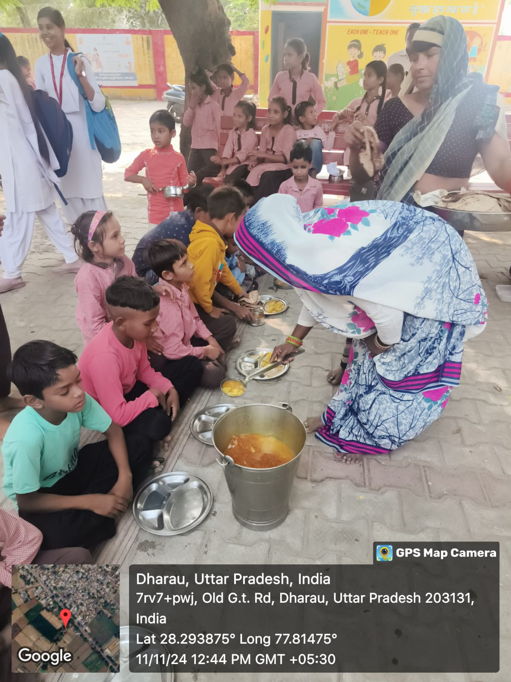
Figure-1: Serving Government Mid-Day Meal to the students

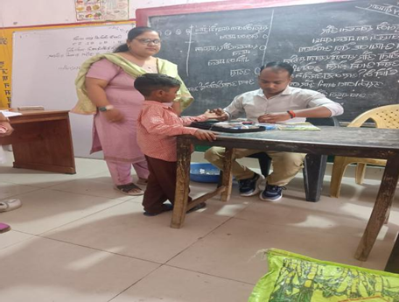
Figure-2: Health check-up in the primary school

Ethical approval-
1. Ethical approval for this study series was obtained from the Primary Health Officer (Chief Medical Officer - CMO) of Dharpa, District Bulandshahr (Khurja) for sample collection and the allotment of a medical team for testing and verification.
2. In addition, ethical clearance was obtained from the Principals and Headmasters of the respective institutions where data collection took place.
3.A series of questionnaires were conducted by the student as part of the research, which significantly contributed to data collection and documentation.

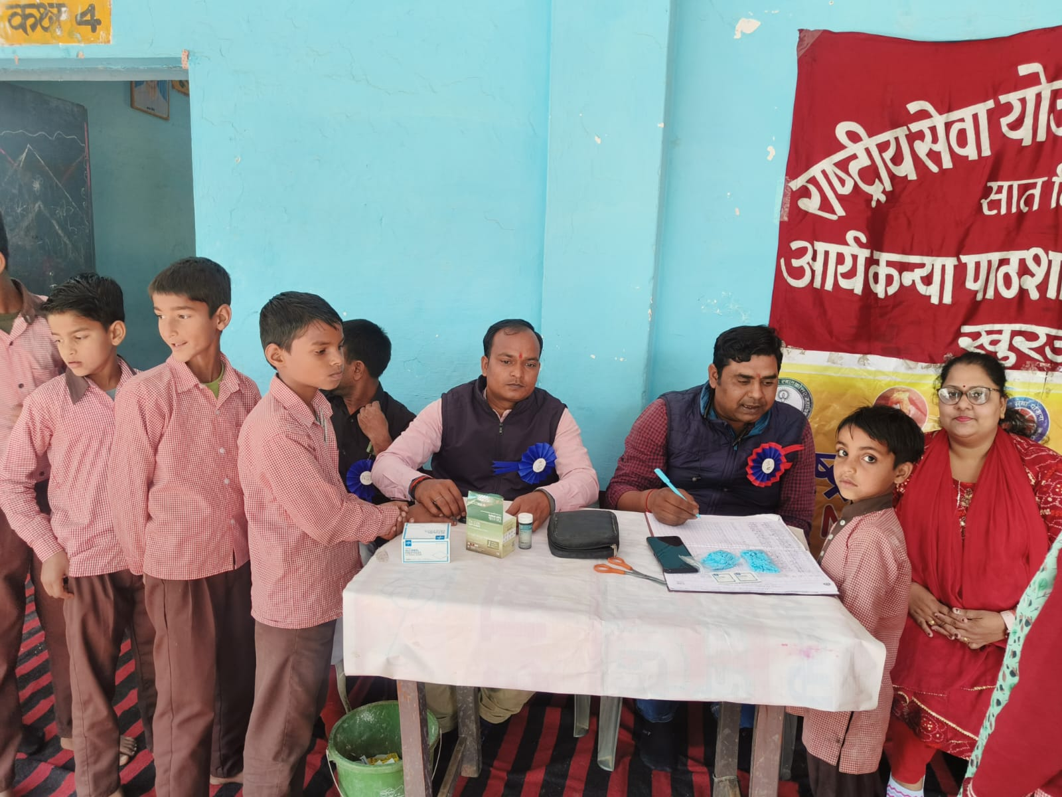
Figure-3 Govt. Initiated Integrated Child Development Services (ICDS) to prevent anaemia

4. Results and Discussion
4.1 Demographic Information
Table 2 and Figure 1 present the demographic profile of the 600 respondents included in the study. The sample was evenly distributed across urban (n=300) and rural (n=300) areas, ensuring balanced geographic representation. Gender distribution was also equal, with 300 male and 300 female students. Age-wise, the sample was stratified into three groups—6–8 years, 9–10 years, and 11–12 years—each comprising 200 students (33.3%). This proportional sampling across area, gender, and age categories allowed for reliable comparison in subsequent analyses of anemia prevalence. Figure 1 visually illustrates this demographic distribution.

Table 2. Demographic Information of Respondents

Variable | Category | Frequency (n) | Percentage (%)
Area | Urban | 300 | 50.0%
Area | Rural | 300 | 50.0%
Gender | Male | 300 | 50.0%
Gender | Female | 300 | 50.0%
Age Group | 6–8 years | 200 | 33.3%
Age Group | 9–10 years | 200 | 33.3%
Age Group | 11–12 years | 200 | 33.3%

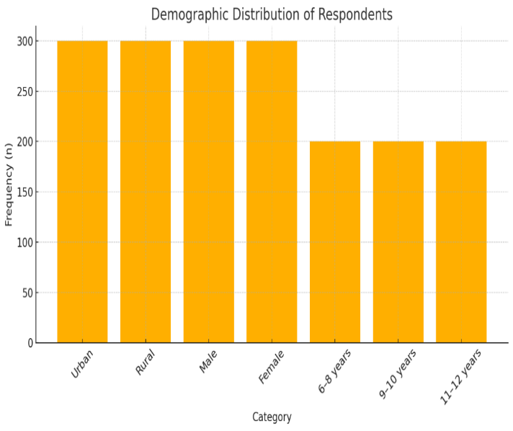
Figure 4. Demographic Information of Respondents

4.2 Descriptive Statics
Table 3 summarizes the descriptive statistics of key health indicators measured among the respondents. The average height of the children was 130.2 cm with a standard deviation of 8.5 cm, ranging from 110 cm to 145 cm. The mean weight was recorded at 28.4 kg (SD = 6.2 kg), with values ranging between 18 kg and 40 kg. The calculated Body Mass Index (BMI) had a mean of 16.8 kg/m² and ranged from 12.0 to 21.5 kg/m², indicating varied nutritional status across the sample. The mean hemoglobin level was 10.3 g/dL (SD = 1.5 g/dL), with individual values spanning from 6.5 g/dL to 13.8 g/dL, reflecting the presence of mild to severe anemia in several students. These baseline statistics provide essential context for interpreting anemia prevalence in relation to nutritional status.

Table 3. Anemia Prevalence by Residential Area (Urban vs. Rural)

Variable | Mean | Standard Deviation (SD) | Minimum | Maximum
Height (cm) | 130.2 | 8.5 | 110 | 145
Weight (kg) | 28.4 | 6.2 | 18 | 40
BMI (kg/m²) | 16.8 | 2.1 | 12.0 | 21.5
Hemoglobin (g/dL) | 10.3 | 1.5 | 6.5 | 13.8

4.3 Hypotheses Testing
4.3.1 Results of Hypothesis 1
The first hypothesis (H1) proposed that there is a significant difference in anemia prevalence between urban and rural students. To examine this, a cross-tabulation of anemia status by residential area was conducted. As shown in Table 4, out of the total 600 students surveyed, 300 were from urban schools and 300 from rural schools. Among the urban students, 80 (26.7%) were found to be anemic, while 220 (73.3%) were non-anemic. In contrast, 120 rural students (40.0%) were anemic and 180 (60.0%) were non-anemic. This descriptive data suggests a higher prevalence of anemia among rural children.
To determine whether this observed difference is statistically significant, a Chi-square test of independence was applied. The results are presented in Table 5, where the Chi-square statistic was found to be 6.82 with 1 degree of freedom, and the associated p-value was 0.009. Since the p-value is less than 0.05, the result is considered statistically significant at the 1% level (p < 0.01).
These findings support Hypothesis 1, confirming that anemia prevalence varies significantly between urban and rural primary school children in Bulandshahr district. The higher rate of anemia in rural students could be attributed to a range of socio-economic and healthcare access factors, including nutritional gaps, parental literacy, and sanitation conditions. This result also underlines the need for location-specific interventions under the Mid-Day Meal Scheme to better target areas with higher anemia burdens.

Table 4. Cross-Tabulation of Anemia Status by Residential Area (Urban vs. Rural)
Area | Anemic (n) | Non-Anemic (n) | Total (n)
Urban | 80 | 220 | 300
Rural | 120 | 180 | 300
Total | 200 | 400 | 600

Table 4 shows the distribution of anemia status among urban and rural students. Among the 300 urban students, 80 (26.7%) were anemic, whereas 120 out of 300 rural students (40.0%) were anemic. This indicates a noticeably higher proportion of anemia in rural areas compared to urban ones. These descriptive findings suggest a potential association between residential area and anemia prevalence, which was later confirmed to be statistically significant through a Chi-square test (As shown in Table 5).

Table 5. Chi-Square Test for Anemia Prevalence by Area (Urban vs. Rural) (H1)
Test Statistic | Value | df | p-value
Chi-Square | 6.82 | 1 | 0.009**

4.3.2 Results of Hypothesis 2
The second hypothesis (H2) proposed that socio-demographic factors significantly influence anemia and malnutrition, particularly through their impact on hemoglobin levels. To test this, a multiple linear regression analysis was conducted using four predictor variables: age, gender, residential area, and maternal education. The dependent variable was the hemoglobin level (g/dL) of the students.
The overall fit of the regression model is summarized in Table 6. The model yielded an R² value of 0.218, indicating that approximately 21.8% of the variance in hemoglobin levels can be explained by the combined effects of the socio-demographic variables. The F-value of 22.41 with degrees of freedom (4, 595) was statistically significant at p < 0.001, confirming that the regression model as a whole is meaningful and valid.
Detailed results for each predictor variable are presented in Table 7. The variable age was found to be a significant predictor (B = 0.11, p = 0.006), suggesting that older children tend to have slightly higher hemoglobin levels. Residential area (coded as Urban = 1) was also a significant factor (B = 0.24, p = 0.000), indicating that students living in urban areas generally have higher hemoglobin levels compared to those in rural areas. Maternal education emerged as the strongest predictor among all variables, with a B coefficient of 0.32 and p < 0.001, underscoring the positive impact of a mother’s educational level on her child’s nutritional status.
Interestingly, gender (coded as Male = 1) was not found to be a statistically significant predictor (p = 0.112), suggesting no major difference in hemoglobin levels between male and female students in this sample.
These results support Hypothesis 2, indicating that socio-demographic characteristics—particularly area of residence, maternal education, and age—have a statistically significant influence on children’s hemoglobin levels and by extension, their anemia status. The findings reinforce the importance of incorporating educational and locality-based components in policy interventions to reduce anemia more effectively.

Table 6. Model Summary
R² | Adjusted R² | F-value (df = 4, 595) | Model Significance (p-value)
0.218 | 0.213 | 22.41 | < 0.001

Table 7. Multiple Linear Regression: Socio-Demographic Predictors of Hemoglobin Levels
Predictor Variable | B  (Unstandardized Coefficient) | Beta (Standardized Coefficient) | T-value | p-value
Age (in years) | 0.11 | 0.13 | 2.75 | 0.006*
Gender | 0.08 | 0.07 | 1.59 | 0.112
Area Urban | 0.24 | 0.18 | 3.64 | 0.000**
Maternal Education | 0.32 | 0.22 | 4.21 | 0.000**
Constant | 9.15

4.3.3 Results of Hypothesis 3
Hypothesis 3 (H3) proposed that there is a significant association between anemia and malnutrition. To examine this relationship, a Pearson correlation analysis was conducted between hemoglobin levels and Body Mass Index (BMI) among the 600 primary school students. These two variables were selected as continuous indicators representing anemia and nutritional status, respectively.
As shown in Table 8, the mean hemoglobin level of the sample was 10.3 g/dL with a standard deviation (SD) of 1.5, and the mean BMI was 16.8 kg/m² with an SD of 2.1. The analysis produced a Pearson correlation coefficient (r) of 0.41, with a p-value of 0.000, which is highly significant (p < 0.001).
This statistically significant positive correlation suggests that higher BMI is associated with higher hemoglobin levels, and conversely, that undernourished children tend to be more anemic. Although the correlation is moderate in strength, it is meaningful in the context of child health, as it affirms the interrelationship between nutritional status and anemia. Therefore, this finding supports Hypothesis 3, highlighting the importance of addressing malnutrition as a strategy for reducing anemia prevalence in school-aged children.

Table 8. Correlation between Anemia and Malnutrition (BMI)

Variables | Mean | SD | Pearson’s r | p-value
Hemoglobin (g/dL) | 10.3 | 1.5 | 0.41 | 0.000**
BMI (kg/m²) | 16.8 | 2.1 | 0.41 | 0.000**

4.3.4 Results of Hypothesis 4
Hypothesis 4 (H4) stated that the Mid-Day Meal (MDM) Scheme significantly reduces anemia prevalence among primary school children. To evaluate this hypothesis, a paired sample t-test was conducted comparing hemoglobin levels before and after participation in the MDM scheme among the anemic subgroup of the sample.
As presented in Table 9, the mean hemoglobin level before MDM participation was 9.5 g/dL (SD = 1.4), which falls into the moderate anemia category according to WHO standards. After sustained participation in the Mid-Day Meal Scheme, the mean hemoglobin level increased to 10.8 g/dL (SD = 1.3), indicating a notable improvement in anemia status, moving many children into the mild or non-anemic range.
The mean difference of 1.3 g/dL was tested using a paired t-test, yielding a t-value of 11.24 and a p-value of 0.000, which is highly significant (p < 0.001). This demonstrates a statistically and practically significant improvement in hemoglobin levels following consistent intake of MDM meals.
These results confirm Hypothesis 4, affirming the positive impact of the Mid-Day Meal Scheme on improving nutritional outcomes and reducing anemia among school-aged children. The findings provide strong empirical support for continuing and strengthening MDM interventions as a key public health strategy for combating childhood anemia.

Table 9. Paired t-Test Results Comparing Pre- and Post-Mid-Day Meal (MDM) Hemoglobin Levels
Measure | Mean (g/dL) | SD | Mean Difference | t | p-value
Pre-MDM Hemoglobin | 9.5 | 1.4 |  | 11.24 | 0.000**
Post-MDM Hemoglobin | 10.8 | 1.3 | 1.3 | 11.24 | 0.000**

Table 9 presents the results of a paired t-test comparing students’ hemoglobin levels before and after participation in the Mid-Day Meal (MDM) program. The mean hemoglobin level increased from 9.5 g/dL to 10.8 g/dL, with a mean difference of 1.3 g/dL. The t-value of 11.24 and a highly significant p-value (< 0.001) indicate that this improvement is statistically significant. These findings suggest that the MDM program had a positive effect on students' hemoglobin levels.
5. Discussion
The results of this research are quite useful and they give a great deal of information on the existing issue of anemia in school-going children and the success or failure of the governing efforts such as the Mid-Day Meal (MDM) Scheme. The general prevalence of anemia (33.3%) is in line with national data on the prevalence of anemia among children presented by NFHS-5 showing the prevalence of anemia in India to be large. It is noteworthy that the higher incidence of anemia in the rural students (40%) than in their urban peer group (26.7) demonstrates the socio-geographic inequality that continues to cause adverse health outcomes in children. The two differences can be characterized by a number of factors that include worse access to healthcare services, lower dietary diversity along with insufficient health awareness in rural regions.
The study also validates the influence of socio-demographic factors on anemia and nutritional status. Regression analysis showed that maternal education and residential area were statistically significant predictors of hemoglobin levels, reinforcing the well-documented impact of parental literacy and living conditions on child nutrition. Children with more educated mothers were likely to have better hemoglobin levels, which may reflect more informed dietary practices, hygiene habits, and greater access to health services.
Importantly, the study confirms the association between anemia and malnutrition, as seen through the moderate positive correlation between BMI and hemoglobin levels (r = 0.41). This supports previous research that undernourished children are more susceptible to anemia due to inadequate nutrient intake and compromised immunity.
The most critical insight from this research is the positive impact of the Mid-Day Meal Scheme on improving anemia outcomes. A significant increase of 1.3 g/dL in hemoglobin levels after consistent participation in the MDM program indicates that school-based feeding programs can yield tangible health benefits, especially for children with limited dietary resources at home. These results not only support continued investment in the scheme but also suggest the potential for further enhancement through inclusion of iron-fortified foods, regular health check-ups, and nutrition education.
While the MDM Scheme appears successful in mitigating anemia to a certain extent, the findings also highlight that a one-size-fits-all approach may be insufficient. Variations in anemia prevalence by area, age, and maternal education call for targeted interventions that consider local needs and vulnerabilities.
6. Conclusion
This study concludes that anemia remains a significant health challenge among primary school children in Bulandshahr district, with rural children disproportionately affected. The findings strongly support the hypothesis that socio-demographic factors, particularly maternal education and residential area, significantly influence anemia prevalence. Moreover, the Mid-Day Meal Scheme has been effective in reducing anemia, as evidenced by improved hemoglobin levels among participants.
The study affirms the multifactorial nature of anemia, linking it to both nutritional deficiencies and broader social determinants. While the MDM Scheme provides a critical nutritional safety net, its success could be enhanced by integrating micronutrient fortification, parental awareness programs, and routine health monitoring in schools.
In conclusion, anemia prevention in school-aged children requires a multi-pronged strategy involving education, nutrition, health infrastructure, and policy support. Strengthening the implementation of the MDM Scheme and aligning it with local socio-economic conditions can make a measurable difference in the fight against child anemia in India.
Recommendations
Recommendations of the study are given as follows;
- Strengthen the nutritional content of MDM, including iron fortification and diversity of meals.
- Incorporate regular screening for anemia in schools and follow-up with iron supplementation where necessary.
- Conduct awareness programs for parents, especially mothers, focusing on child nutrition and hygiene.
- Improve monitoring of MDM implementation in rural areas to address logistical and quality gaps.
Limitations
Limitations of the study are given as follows;
- The study design was cross-sectional, limiting the ability to infer causality.
- Hemoglobin levels were measured only once pre- and post-MDM participation, without long-term follow-up.
- Socio-economic status was not comprehensively assessed beyond maternal education and area.
- Dietary recall and infection status, both known contributors to anemia, were not included.
Future Scope-
Future scope of the study is given as follows;
- Longitudinal studies can better assess sustained effects of MDM on anemia and nutritional outcomes.
- Future research could integrate dietary surveys, parasitic infection screening, and family income data.
- Expansion to include private and non-MDM schools may provide comparative insights into program efficacy.
- Digital tracking of MDM consumption and health outcomes can improve monitoring and policy planning.

References
- Anwar, S., Sciences, H., Deshmukh, P., & Garg, B. S. (2006). Epidemiological Correlates of Nutritional Anemia in Adolescent Girls of Rural Epidemiological Correlates of Nutritional Anemia in Adolescent Girls of Rural Wardha. January.
- Ash, D. M., Tatala, S. R., Jr, E. A. F., Ndossi, G. D., & Latham, M. C. (2018). Randomized efficacy trial of a micronutrient-fortified beverage in primary school children in Tanzania 1 – 3. April.
- Chaparro, C. M., & Suchdev, P. S. (2019). Anemia epidemiology , pathophysiology , and etiology in low- and middle-income countries. 1–17. https://doi.org/10.1111/nyas.14092
- Children, Y., Beinner, M. A., Velasquez-mele, G., Pessoa, M. C., & Greiner, T. (2010). Iron-Fortified Rice Is As Efficacious As Supplemental Iron Drops in Infants. 49–53. https://doi.org/10.3945/jn.109.112623.the
- Controlled, A. R., Winichagoon, P., Mckenzie, J. E., Chavasit, V., Pongcharoen, T., Gowachirapant, S., Boonpraderm, A., Manger, M. S., Bailey, K. B., Wasantwisut, E., & Gibson, R. S. (2018). Community and International Nutrition A Multimicronutrient-Fortified Seasoning Powder Enhances the Hemoglobin , Zinc , and Iodine Status of Primary School Children in North East Thailand : March, 1617–1623.
- Dalmia, A. (2017). Demand for household sanitation in India using NFHS-3 data. Empirical Economics. https://doi.org/10.1007/s00181-017-1250-5
- Dhillon, C. N., Neufeld, L. M., Sarkar, D., Klemm, R. D. W., Tumilowicz, A., & Namaste, S. M. L. (2017). Executive summary for the Micronutrient Powders Consultation : Lessons Learned for Operational Guidance. 13(June), 1–9. https://doi.org/10.1111/mcn.12493
- Didzun, O., Neve, J. De, Awasthi, A., Dubey, M., Theilmann, M., Bärnighausen, T., Vollmer, S., & Geldsetzer, P. (2019). Articles Anaemia among men in India : a nationally representative cross-sectional study. The Lancet Global Health, 7(12), e1685–e1694. https://doi.org/10.1016/S2214-109X(19)30440-1
- Dutta, A., Mohapatra, M. K., Rout, S. K., Kadam, S., Balagopalan, K., Tiwari, D., Yunus, S., Behera, B. K., Kumar, B., Mangaraj, M., Sahu, S., & Paithankar, P. (2020). Effect of caste on health , independent of economic disparity : evidence from school children of two rural districts of India. xx(xx), 1–18. https://doi.org/10.1111/1467-9566.13105
- Fiorentino, M., Perignon, M., Kuong, K., Groot, R. De, Parker, M., Burja, K., Dijkhuizen, M. A., Sokhom, S., Chamnan, C., Berger, J., & Wieringa, F. T. (2017). Effect of multi-micronutrient-forti fi ed rice on cognitive performance depends on premix composition and cognitive function tested : results of an effectiveness study in Cambodian schoolchildren Public Health Nutrition. 2. https://doi.org/10.1017/S1368980017002774
- Goyal, A., & Bank, W. (2024). S pecial articles Future of Mid-Day Meals. July. https://doi.org/10.2307/4414222
- Gupta, S., Taraphdar, P., Haldar, D., & Purkait, B. (2012). The silent burden of anemia in school age children : A community based study in West Bengal ORIGINAL ARTICLE THE SILENT BURDEN OF ANEMIA IN SCHOOL AGE CHILDREN : July. https://doi.org/10.4103/0019-5359.114179
- Jp, R., Lm, D., Ns, N., Mn, G., & Ja, S. (2019). Peña-Rosas JP, Mithra P, Unnikrishnan B, Kumar N, De-Regil LM, Nair NS, Garcia-Casal MN, Solon JA. https://doi.org/10.1002/14651858.CD009902.pub2.www.cochranelibrary.com
- Keats, E. C., Neufeld, L. M., Garrett, G. S., Mbuya, M. N. N., & Bhutta, Z. A. (2019). Improved micronutrient status and health outcomes in low- and middle-income countries following large-scale fortification : evidence from a systematic review and meta-analysis. 1–13.
- Kvalsvig, J. D., Faber, M., Kruger, M., & Kenoyer, D. G. (2018). Effect of iron- , iodine- , and ␤ -carotene – fortified biscuits on the micronutrient status of primary school children : a randomized. April, 497–503.
- Manger, M. S., Mckenzie, J. E., Winichagoon, P., Gray, A., Chavasit, V., & Pongcharoen, T. (2008). A micronutrient-fortified seasoning powder reduces morbidity and improves short-term cognitive function , but has no effect on anthropometric measures in primary school children in northeast Thailand : a randomized controlled trial 1 – 3. 1.
- Mantadakis, E., Chatzimichael, E., & Zikidou, P. (2020). Iron Deficiency Anemia in Children Residing in High and Low-Income Countries : Risk Factors , Prevention , Diagnosis and Therapy.
- Mengistu, G., Azage, M., & Gutema, H. (2019). Iron Deficiency Anemia among In-School Adolescent Girls in Rural Area of Bahir Dar City Administration , North West Ethiopia. 2019, 1–9.
- Moretti, D., Zimmermann, M. B., Muthayya, S., Thankachan, P., Lee, T., & Kurpad, A. V. (2018). Extruded rice fortified with micronized ground ferric pyrophosphate reduces iron deficiency in Indian schoolchildren : a double-blind randomized controlled trial 1 – 3. April, 822–829.
- Ms, F., Mithra, P., & Jp, P. (2021). Wheat flour fortification with iron and other micronutrients for reducing anaemia and improving iron status in populations (Review). https://doi.org/10.1002/14651858.CD011302.pub3.www.cochranelibrary.com
- Nieman, D. C., Henson, D. A., & Sha, W. (2011). Ingestion of micronutrient fortified breakfast cereal has no influence on immune function in healthy children : A randomized controlled trial. 1–9. https://doi.org/10.1186/1475-2891-10-36
- Olson, R., Gavin-smith, B., Ferraboschi, C., & Kraemer, K. (2021). Food Fortification : The Advantages , Disadvantages and Lessons from Sight and Life Programs.
- Onyeneho, N. G., Ozumba, B. C., & Subramanian, S. V. (2019). Determinants of Childhood Anemia in India. Scientific Reports, 1–7. https://doi.org/10.1038/s41598-019-52793-3
- Piccoli, N. B., Grede, N., Pee, S. De, Singhkumarwong, A., Roks, E., Moench-pfanner, R., & Bloem, M. W. (2012). Rice fortification : Its potential for improving micronutrient intake and steps required for implementation at scale. 33(4), 360–372.
- Stevens, G. A., Finucane, M. M., De-regil, L. M., Paciorek, C. J., Flaxman, S. R., Branca, F., & Peña-rosas, J. P. (2025). Global , regional , and national trends in haemoglobin concentration and prevalence of total and severe anaemia in children and pregnant and non-pregnant women for 1995 – 2011 : a systematic analysis of population-representative data. 16–25. https://doi.org/10.1016/S2214-109X(13)70001-9
- Thankachan, P., Selvam, S., Surendran, D., Chellan, S., Pauline, M., Abrams, S. A., & Kurpad, A. V. (2012). Efficacy of a multi micronutrient-fortified drink in improving iron and micronutrient status among schoolchildren with low iron stores in India : a randomised , double-masked placebo-controlled trial. European Journal of Clinical Nutrition, 67(1), 36–41. https://doi.org/10.1038/ejcn.2012.188
- Union, I., Tuberculosis, A., Thiagesan, R., & Ramachandran, R. (2023). Anaemia among schoolchildren from southern Kerala , India : A cross-sectional study. September 2015.
- Uruno, J. O. N. P. F., Hu, J. I. Z., Eterson, D. A. N. E. P., & Inkelstein, J. O. F. (2006). The Use and Interpretation of Quasi-Experimental Studies in Medical Informatics. 16–23. https://doi.org/10.1197/jamia.M1749.Background
- Yang, F., Liu, X., & Zha, P. (2018). Trends in Socioeconomic Inequalities and Prevalence of Anemia Among Children and Nonpregnant Women in Low- and Middle-Income Countries. 1(5), 1–14. https://doi.org/10.1001/jamanetworkopen.2018.2899
- Yusufali, R., Ghoos, K., Nations, U., Food, W., Milani, P., & Foundation, T. R. (2015). Scaling up Rice Fortification in Asia. July.

Abbreviations-
MDM-Mid Day Meal
Hb level- Hemoglobin levels
BMI- Body Mass Index

Ethics declarations- Permission to conduct the research was obtained from the Primary Health Officer (CMO) of Dharpa, Bulandshahr (Khurja) for sample collection and medical team support. Ethical clearance was also granted by the Principals and Headmasters of the participating Schools.
Data Availability Statement:
The datasets generated and/or analyzed during the current study are available from the corresponding author upon request.

