Short Research Article

First record of Vespa basalis feeding directly on Pear (Pyrus communis) fruits in Himachal Pradesh, India

.
ABSTRACT

Wasps are integral to maintaining ecological balance. However, their specific impact as fruit pests in India has not been well documented. This study aimed to investigate the feeding behavior of Vespa basalis (Black bellied hornet) on ripe pears (Pyrus communis) through a field survey conducted in the village of Shahpur in the Kangra district, a mid hill region of Himachal Pradesh, India, during the pear harvest in August 2025. Researchers randomly selected 50 ripe fruits of pears from five trees and observed them at three distinct time intervals: 09:00-11:00 h, 12:00-14:00 h, and 15:00-17:00 h. Feeding indicators, such as puncture marks and tissue scraping, were photographed. The study revealed significant variations in feeding intensity throughout the day, with 24% of the fruits exhibiting damage at midday (12:00-14:00 h), compared to 2% in the morning (09:00-11:00 h) and 6% in the evening (15:00-17:00 h). Observations of two to four wasps per fruit suggests that chemical signals may influence resource utilization. A significant observation was that the wasps initially targeted the ripest portion of the fruit for feeding. As the number of wasps increased and their feeding activity intensified, substantial damage to the fruit ensued. This damage compromises fruit integrity, accelerates microbial decay, and significantly reduces market value, despite its limited occurrence. This study provides the first scientific evidence that V. basalis acts as a direct pest of ripe pears, thereby expanding its ecological role beyond predation. The findings underscore the importance of integrated orchard management strategies, such as attractant-based trapping, sanitation, protective coverings, and timely harvesting, to protect fruit quality and reduce economic losses without over-relying on chemical control.

Keywords: Vespa wasp; pear orchards; fruit feeding; mid hills; Himachal Pradesh; integrated pest management

1. INTRODUCTION

Pear is a major horticultural commercial crop in India, primarily grown in Himachal Pradesh, Jammu and Kashmir, Uttarakhand. India ranks ninth globally in terms of pear production, being the third most cultivated temperate fruit (Singh, 2024; Sawant et al., 2021). Predatory wasps regulate the populations of harmful insects in warm, humid climates (Verma et al., 2023). The genus Vespa, a diverse group within the Vespinae subfamily of the Vespidae family in the Hymenoptera order, encompasses 22 species of eusocial wasps that predominantly thrive in Asia. These predatory insects, known as hornets, are not just inhabitants of their ecosystems; they are vital players in maintaining ecological balance. Adult wasps typically exhibit black or brown coloration, often highlighted by significant yellow or white markings. In the case of Vespa and other social wasps, adult females progressively nourish the larvae with chewed-up insects, although they occasionally rely on glandular secretions. Conversely, in solitary wasp species, larvae generally prey on the caterpillars of other insects (Nguyen et al., 2006 ; Smith-Pardo et al., 2020; Kumar & Sharma, 2014).

In India, more than 12 species of predatory wasps have been recognized for their role in biological pest control. Beyond predation, these wasps consume tree bark to fulfill their nutritional needs, in that way they pose a risk to stone fruit orchards (Sharma et al., 2024). Hornets belonging to the genus Vespa (Hymenoptera: Vespidae) are notable predators that annually establish moderate to large colonies of eusocial insects. This flexibility in resource use, along with several biological characteristics contribute to the successful colonization of non-native environments. In temperate regions, reproductive females initiate nest construction following a period of diapause (Matsuura, 1991). Hornets are excellent predators in their native environment. However, certain species have become well-known for their unintended introduction into non-native ecosystems, where they prey on species that have not developed defenses (Matsuura, 1991; Cappa et al., 2021). In addition to their invasive capacity, the nests of Vespa species are characterized by complex nesting biology. Their colonies can be substantial, accommodating over 1,000 workers, although they typically consist of several hundred (Archer, 2008). These wasps exhibit a range of color patterns that vary by region of the body. Earlier researchers have identified numerous subspecies based solely on these color patterns, yet such traits often transition gradually across different regions, complicating reliable taxonomic classification (Nguyen et al., 2006; Perrard et al., 2014).

Species of the genus Vespa predominantly prey on social Hymenoptera, with a particular emphasis on the Western honey bee, Apis mellifera, thereby posing substantial economic challenges to the apiculture industry (Monceau et al., 2014; Requier et al., 2023). In addition to their ecological importance, wasps have economic value in regions where humans consume insects. For instance, over 2000 insect species, including wasps, are consumed globally by various ethnic groups. In the northeastern states of India, wasps are a traditional dietary staple, offering essential nutrients such as proteins, vitamins, and minerals. However, despite these nutritional advantages, wasp consumption is constrained by challenges related to storage and packaging (FAO, 2021; Thangjam et al., 2020; Mozhui et al., 2020). Given the ecological and economic importance of Vespa species, it is essential to comprehend their interactions with commercial crops, such as pears. These wasps play a pivotal role in regulating pest populations; however, their predatory behavior, nesting practices, and bark-feeding activities can pose a threat to pear orchards. Although their contribution to biological control is acknowledged, there is a paucity of research quantifying their specific impact on pear fruits in the temperate regions of India. This study aimed to address this gap by evaluating the presence, foraging patterns, and potential damage inflicted by predatory wasps on pear fruits in Himachal Pradesh. By elucidating the relationship between Vespa populations and pear fruit health, our findings will support sustainable orchard management and inform the development of broader strategies that integrate ecological wasp control with crop productivity.

2. material and methods

During the pear harvesting season in August, observations were conducted in the villages of Shahpur, located in the Kangra district of Himachal Pradesh (Fig 2), India (32.2197° N, 76.1728° E, altitude 657 m). Local farmers reported the presence of certain wasps on ripe pear fruits. Consequently, a field survey was initiated to investigate and document their direct feeding behavior on ripe pears. A total of 50 ripe fruits were randomly selected from five different trees and arranged in piles to assess feeding damage. This arrangement facilitated thorough monitoring and easy photographic documentation of the wasps as they fed on the fruit. This study primarily focused on the first report of wasps directly feeding on pear fruits, rather than the extent of critical damage caused. Consequently, a single sample was used to examine both feeding behavior and resultant damage. Digital photographs were taken using a mobile camera with a 70 mm focal length, f/5.6 aperture, and a shutter speed of 1/101s. Feeding damage was identified by signs such as fresh puncture marks and tissue scraping, which resulted in bite holes in the fruits (Fig 4a). The number of damaged fruits was documented, and the infestation rate was determined using the following formula:

$$Infestation \left(\%\right)= \frac{Number of damaged fruits }{Total number of fruits examined } ×100$$

The percentage of infestation was quantified by entering the collected data into Microsoft Excel for further analysis.
In August 2025, the survey was conducted in the aforementioned village at three distinct intervals: 9:00-11:00 h, 12:00-14:00 h, and 15:00-17:00 h. Wasps engaged in feeding were captured using a hand net and preserved in 70% ethanol for further analysis. These specimens were subsequently examined under a stereo microscope and identified as Vespa basalis Smith (Fig 3) (Hymenoptera: Vespidae) by analyzing their external morphological characteristics, in accordance with the identification keys of Carpenter and Kojima (1997). Additionally, species identification was corroborated using the NBAIR Vespidae database. Voucher specimens were labeled as SSR-AD-2025-08-CH-01, SSR-AD-2025-08-CH-02, SSR-AD-2025-08-SH-03 and SSR-AD-2025-08-SH-04 (Shahpur) and have been deposited in the insect collections at CSKHPKV, Palampur for future reference upon request.

3. results and discussion

The current investigation is the initial documented instance of wasps directly consuming ripe pear fruits in the mid-hills region of Himachal Pradesh, India. In the northwestern Himalayas, previous research has documented wasps participating in activities such as bark feeding, hive predation, and the exploitation of pre-existing bird-inflicted wounds on fruits. Nevertheless, this investigation demonstrated that these wasps, particularly Vespa basalis, consume ripe pear fruits directly, resulting in discernible puncture marks and scraped tissue areas of the fruit. This damage not only compromises the aesthetic quality of the fruits but also enables microbial entry, resulting in post-harvest spoilage.
As a result, even if the extent of fruit damage is limited, the economic impact on orchardists is significant due to the rapid depreciation in the market value of the affected fruits. The study also demonstrated that wasps have a preference for ripe fruits over unripe ones. Also initial feeding was started from the ripest portion of the fruit. This preference can be attributed to the higher sugar content, aromatic volatiles, and softer skin of mature fruits, all of which serve as attractants for wasps for the purpose of attracting them. In addition to highlighting the originality of these findings, photographic evidence substantiates the claimed behavior. By providing direct evidence, this study fills the critical knowledge gap that was identified in earlier research.
3.1 Direct feeding behaviour of wasps on pear fruits

Field observations indicated that the wasps frequently congregated in groups of two to four individuals per fruit, which suggests that conspecific attraction or chemical cues released during the feeding process may facilitate congregation. Rapid feeding activity was observed during the warm midday hours, particularly from 12:00-14:00 h. Out of 50 fruits (100%) examined, 12 (24%) were damaged during this time period. Also key observation is damaged fruits are most ripen as compared to others. When contrasted with the other two intervals, it is significantly high as compared to 2% in the 9:00-11:00 h and 6% in the 15:00-17:00 h intervals respectively (Fig 1). The timing of this event coincides with hot environmental conditions, such as higher temperatures in the surrounding environment and dry periods. It has been determined that this particular time period is the most destructive time for wasps. Scraping the skin and creating irregular bite holes results in the release of fruit sap. This mechanism facilitates a continuous release of sugary liquid, attracting not one individual, also multiple individuals to feed simultaneously (Fig 4b). This self-reinforcing process implies that once feeding begins, damage can spread quickly due to attacks from more individuals. It is clear from this behavior that wasps are not only opportunistic feeders, but they also have the potential to act as pests in pear orchards when the environmental conditions are particularly favorable. Interestingly, this direct fruit feeding behavior of wasps contradicts previous studies conducted in this mid-hills region. Therefore, the current study broadens the ecological role of Vespa basalis by revealing its potential to act as a pest in commercial pear orchards.
3.2 Implications for Orchard management

This study has two significant implications. First, orchardists must acknowledge Vespa basalis as a pest in pear cultivation because of its direct consumption of vital fruit tissues. Second, there is a need for integrated management strategies to balance the dual roles of wasps as beneficial predators and harmful fruit feeders. Given their ecological benefits and the potential for chemical residues on fruits, reliance on insecticides is neither optimal nor sustainable in the long term. Instead, more selective methods are recommended, such as attractant-based trapping, fermented bait formulations, and habitat manipulation through orchard sanitation, including the removal of fallen or overripe fruits. Harvesting in the morning can also reduce exposure to wasp activity, which peaks in the afternoon. Additional strategies include the use of bait fruits or sugar and honey based traps, along with regionally validated devices, such as the Palampur trap. To minimize direct feeding damage, protective coverings on ripening fruits, such as paper bags, mesh sleeves, and biodegradable wraps, can be utilized. Collectively, these strategies can enhance fruit quality, reduce economic losses, and provide sustainable alternatives to the use of chemical control.

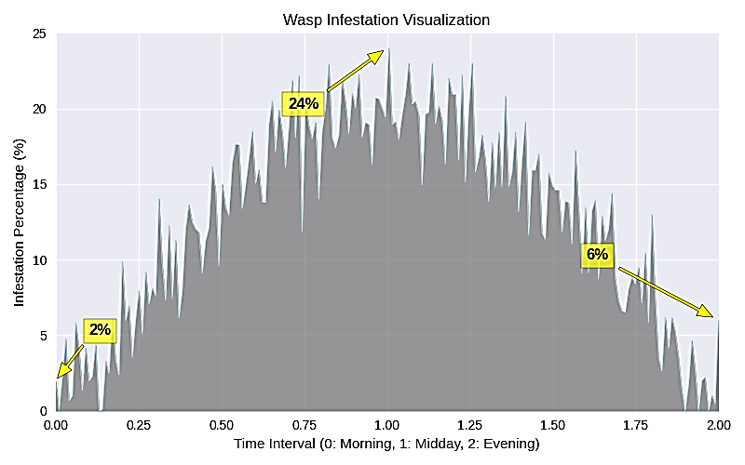
Fig. 1. Percentage of pear fruits damaged by Vespa basalis at different time intervals: morning (09:00–11:00 h) - 2%, midday (12:00–14:00 h) - 24%, and evening (15:00–17:00 h) - 6%.

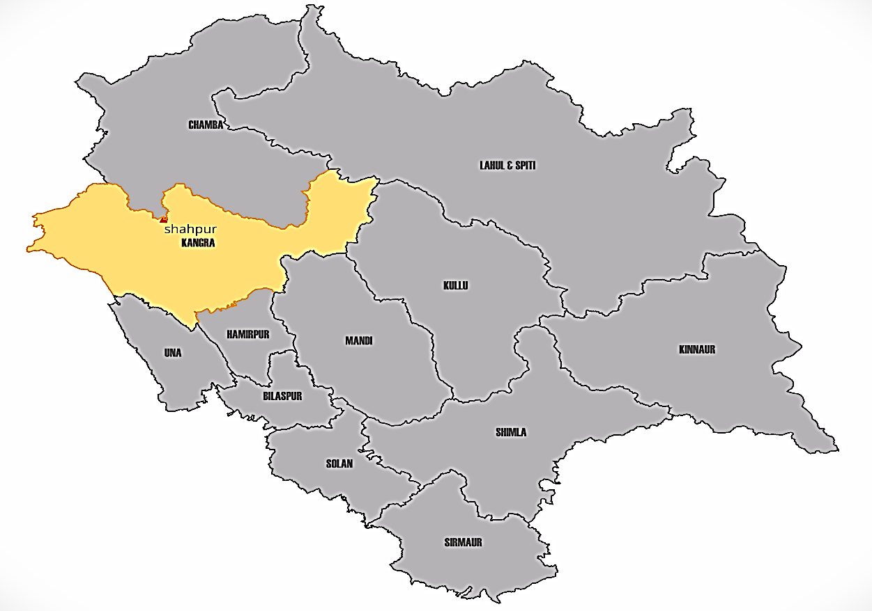
Fig. 2. Geographical location of the study site. Map of Himachal Pradesh highlighting Kangra district and Shahpur village where field observations on Vespa basalis feeding on pear fruits were conducted.
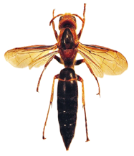
Fig. 3. Adult Vespa basalis (worker)

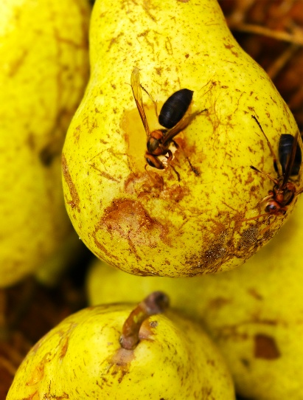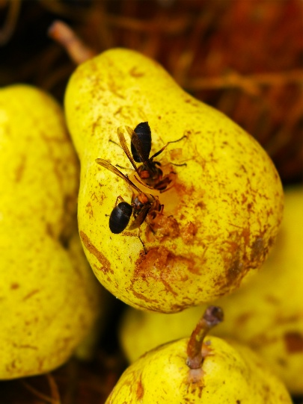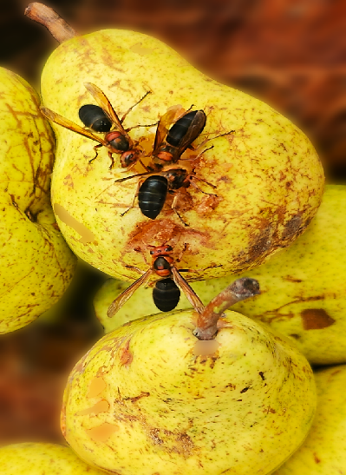
Fig. 4b. Congregation of wasps during feeding
Fig. 4a. Wasps feeding on ripe pear fruits

4. Conclusion

This study documents the first recorded instance of Vespa basalis directly feeding on ripe pear fruits in Himachal Pradesh, India. The peak feeding activity was observed around midday, resulting in 24% of the fruit being damaged, which was significantly higher than the damage observed in the morning and evening. Although the level of damage was moderate, it notably reduced the market value by accelerating spoilage and affecting fruit quality. This study revealed that V. basalis, previously recognized primarily as a beneficial predator, can also function as a direct pest on pear fruits. These findings underscore the necessity of integrated orchard management strategies, such as utilizing attractant-based traps, maintaining orchard cleanliness, employing protective coverings, and ensuring timely harvesting, to minimize economic losses while maintaining ecological balance.

Ethical approval

This study did not involve human participants or vertebrate animals. observations were conducted on insect pests in pear orchards under natural field conditions, and therefore no ethical approval was required.

REFERENCES

Archer, M. E. (2008). Taxonomy, distribution and nesting biology of species of the genera Provespa Ashmead and Vespa Linnaeus (Hymenoptera: Vespidae). Entomologist’s Monthly Magazine, 144(1), 69–101.

Cappa, F., Cini, A., Bortolotti, L., Poidatz, J., & Cervo, R. (2021). Hornets and honey bees: A coevolutionary arms race between ancient adaptations and new invasive threats. Insects, 12(11), 1037. https://doi.org/10.3390/insects12111037

Carpenter, J. M., & Kojima, J. (1997). Checklist of the species in the subfamily Vespinae (Insecta: Hymenoptera: Vespidae). Natural History Bulletin of Ibaraki University, 1, 51–92.
Food and Agriculture Organization. (2021). Looking at edible insects from a food safety perspective: Challenges and opportunities for the sector. FAO. https://doi.org/10.4060/cb4094en

Kumar, P. G., & Sharma, G. (2014). Taxonomic studies on vespid wasps (Vespidae: Vespoidea: Hymenoptera: Insecta) of Rajasthan, India with six new records from the state. Journal on New Biological Reports, 3(3), 240–258.

Matsuura, M. (1991). Vespa and Provespa. In K. G. Ross & R. W. Matthews (Eds.), The social biology of wasps (pp. 232–262). Cornell University Press, NY: Ithaca.

Monceau, K., Bonnard, O., & Thiéry, D. (2014). Vespa velutina: A new invasive predator of honeybees in Europe. Journal of Pest Science, 87(1), 1–16. https://doi.org/10.1007/s10340-013-0537-3

Mozhui, L., Kakati, L. N., Kiewhuo, P., & Changkija, S. (2020). Traditional knowledge of the utilization of edible insects in Nagaland, North-East India. Foods, 9(7), 852. https://doi.org/10.3390/foods9070852
Nguyen, L. T. P., Saito, F., Kojima, J., & Carpenter, J. M. (2006). Vespidae of Viet Nam (Insecta: Hymenoptera) 2. Taxonomic notes on Vespinae. Zoological Science, 23(1), 95–104. https://doi.org/10.2108/zsj.23.95

Perrard, A., Arca, M., Rome, Q., & Carpenter, J. M. (2014). Geographic variation of melanisation patterns in a hornet species: Genetic differences, climatic pressures or aposematic constraints? PLoS ONE, 9(4), e94162. https://doi.org/10.1371/journal.pone.0094162

Requier, F., Fournier, A., Pointeau, S., Rome, Q., & Courchamp, F. (2023). Economic costs of the invasive yellow-legged hornet on honey bees. Science of the Total Environment, 898, 165576. https://doi.org/10.1016/j.scitotenv.2023.165576

Sawant, S., Choi, E., Song, J., & Seo, H.-J. (2021). Pear production trends and characteristics of important pests in India. Journal of the Korean Society of International Agriculture, 33(3), 265–269. https://doi.org/10.12719/KSIA.2021.33.3.265

Sharma, S. K., Chatterjee, D., & Shivani. (2024). First report on the bark feeding wasp species on lowland apple and stone fruit trees of Himachal Pradesh, India. Journal of Scientific Research and Reports, 30(11), 1057–1063. https://doi.org/10.9734/jsrr/2024/v30i112632

Singh, S. (2024). Growth trends and instability in area, production, and productivity of fruit crops in Himachal Pradesh. International Journal for Multidisciplinary Research (IJFMR), 6(4), 1–10.

Smith-Pardo, A. H., Carpenter, J. M., & Kimsey, L. (2020). The diversity of hornets in the genus Vespa (Hymenoptera: Vespidae; Vespinae), their importance and interceptions in the United States. Insect Systematics and Diversity, 4(1), 1–27. https://doi.org/10.1093/isd/ixaa006

Thangjam, R., Kadam, V., Ningthoujam, K., & Sorokhaibam, M. (2020). A review on edible insects and their utilization in Northeastern Himalaya. Journal of Entomology and Zoology Studies, 8(3), 1309–1318.

Verma, R. C., Waseem, M. A., Sharma, N., Bharathi, K., Singh, S., Anto Rashwin, A., et al. (2023). The role of insects in ecosystems, an in-depth review of entomological research. International Journal of Environment and Climate Change, 13(10), 4340–4348.

