Original Research Article
Crop parameters required for the development of a semi-automatic robotic harvester

.
ABSTRACT
Crop characteristics that influence identification and management capacity must be thoroughly understood to develop semi-automatic robotic harvesters. Key plant properties that enable stable gripping during harvesting and reliable automated vision recognition include stem diameter, internode length, fruit position, size, shape, and surface features. While an optimal internode length and fruit setting improve accessibility and reduce obstruction, an appropriate stem diameter provides plant strength while allowing efficient cutting. Similarly, consistent fruit size and shape assist in precise identification and steady handling, whereas surface features affect grip effectiveness and the risk of mechanical damage. The design of automated harvesting devices is significantly affected by the appearance of tomato fruits. Tomato fruits can be protected against deterioration during harvest and processing by considering their physical qualities.

Keywords: Physical properties, Harvesting robot, Plant architecture

1. INTRODUCTION

One of the most popular vegetables in the world (Beed et al., 2021) is the tomato, and its popularity is increasing rapidly as the population grows. Vitamins A and C, as well as potassium, minerals, and fibre, are all present in tomatoes. Most vegetable and fruit products contain lycopene, a phytochemical beneficial ingredient that gives tomatoes their characteristic red colour (Holden et al., 1999). The consumption of tomatoes is growing daily, and a wide range of goods are produced from them, including juice, tomato sauce, paste, syrup, and puree. The physical characteristics and their connections must be understood to develop and operate equipment for carrying, purifying, transporting, sorting, and preserving (Mirzaee et al., 2008). If these characteristics are not taken into consideration when developing such devices, the results could be unsatisfactory.
As a result, evaluating and taking into consideration these features is crucial (Taheri-Garavand et al., 2011). The most crucial elements in measuring systems are the following physical characteristics: length, breadth, thickness, mass, volume, predicted regions, and centre of gravity (Mohsenin, 1986). The tomato fruit type affected the characteristics of size, density, moisture, and force (Viswanathan et al. 1997).
The present pace of growing tomatoes, however, is insufficient to meet requirements in the future, and workforce shortages are impeding efforts to increase output. Due to the lack of interest from youngsters in the physically taxing and repetitive job in the tomato business, the workforce is ageing (Rigg et al., 2020). Automation can replace humans and perform laborious jobs in a tomato environment, like selective plucking and removal of leaves in order to increase productivity and satisfy the growing demand (Van Henten, 2004). Automation can replace humans and perform laborious jobs in a tomato environment, like selective plucking and removal of leaves in order to increase productivity and satisfy the growing demand (Van Henten, 2004).
The goal of this research is to present and illustrate a methodical approach to crop selection and environmental modification for enhanced robotic harvesting. The related crop characteristics, such as crop density, internode length, tomato plant position, peduncle length/thickness, and stem thickness, are determined from these robotic features. Then, strategies for choosing and altering the crop and its surroundings to affect the crop-related characteristics are developed. Every phase is carried out and assessed in a greenhouse (Herck et al., 2020). A summary of the most recent developments in workstation and robot structure was given in this research. Evaluation techniques and a crop layout approach for choosing a crop and adaptation are provided. The outcomes of the assessment are then presented, after which the technique was used for a tomato harvesting automation study.

2. material and methods

The following crop-specific approaches were established to enable an autonomous harvester to operate as efficiently as possible.
2.1 Length of the internodes
A section of the stalk that is between a pair of leaves is called an internode (Herck et al., 2020). There is more area surrounding the fruit to be picked if a plant has lengthy internodes. The region makes it simpler to get close to and hold the fruit, which makes it attractive for simpler fruit plucking. It was measured using a scale. The length of the internodes of the tomato plant is an important morphological feature as it contributes to accurate fruit localisation and optimised harvesting decisions. Internodes are the stem segments between two successive leaves or branches, and their spacing helps determine the spatial arrangement of tomato fruits along the plant. It determines how easily a robot can access the fruits on the stem. Longer internodes provide wider spacing between fruits, which reduces clustering and makes each fruit more accessible to the robotic arm. This spacing also improves visibility for machine vision systems, since fruits are less likely to be hidden by leaves or overlap with one another. With clearer detection, the robot can identify ripe fruits more accurately.
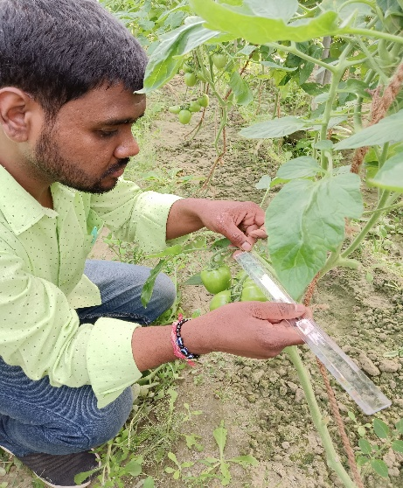
Fig. 1 Length of the internodes
2.2 Diameter of the stem
The diameter of the tomato stem is a crucial structural parameter for visual recognition (Uba et al., 2020). Integrating stem diameter information helps the detection system accurately identify and distinguish between different parts of the plant, particularly when targeting the fruit-bearing sections and planning precise cutting actions. The diameter of the stem is an important factor in robotic harvesting because it affects both the stability of the plant and the efficiency of the cutting mechanism. A stem with sufficient thickness provides the necessary support to hold fruits in position during harvesting, preventing excessive bending or vibration when the robotic arm applies force. At the same time, the stem should not be too thick, as this increases the energy required for cutting and may slow down the harvesting process. On the other hand, very thin stems are more prone to breakage when mechanical tools engage with the fruit. Therefore, an optimal stem diameter ensures a balance between mechanical strength for supporting the plant and ease of cutting for robotic harvesting. The diameter of the stem was measured for the size estimation by a vernier calliper.
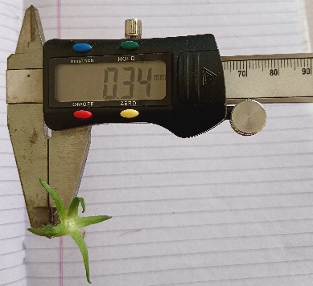
Fig. 2 Diameter of the stem
  - Strength of the stem
TPA (Texture Profile Analysis) was used to calculate the cutting force needed to sever the tomato's stem. A texture analyser (TA-XT plus texture analyser, Stable Micro Systems Ltd.) in the Processing and Food Engineering department at CAET, RPCAU, was utilised to make the assessment in Fig. 3. The texture analyser's requirements are shown in Table 1. A variety of peripherals, including PC-style computers, can be connected to this microprocessor-controlled system. It resembles a universal testing machine and is both user-friendly and adaptable. Two distinct modules make up the texture analyser. The command panel (keyboard) and the experiment platform. by attaching a personal computer running the Texture Exponent software to the texture analyser. To determine the cutting force, the peduncles of the tomato were labelled from the tip. The test was conducted after the samples were positioned beneath the blade set probe on the sturdy platform of the texture analyser. For the test, a Warner Bratzler blade with 30⁰ angles and 2.95 mm of thickness was used. The force required was 0.196N for cutting the stem. So, paper cutter blades were used for cutting the stem. Its bevel angle is 24⁰ and cutting angle 19⁰. The smaller the bevel angle, the greater the sharpness, thus, the greater the cutting ability of the knife. Generally, the bevel angle of the knife varies between 20 to 30º (Persson, 1987). The maximum torque of the MG996R servo at 6 V is 1.08 Nm. The arm length of the robot is 0.32 m. The force required is 3.3 N.

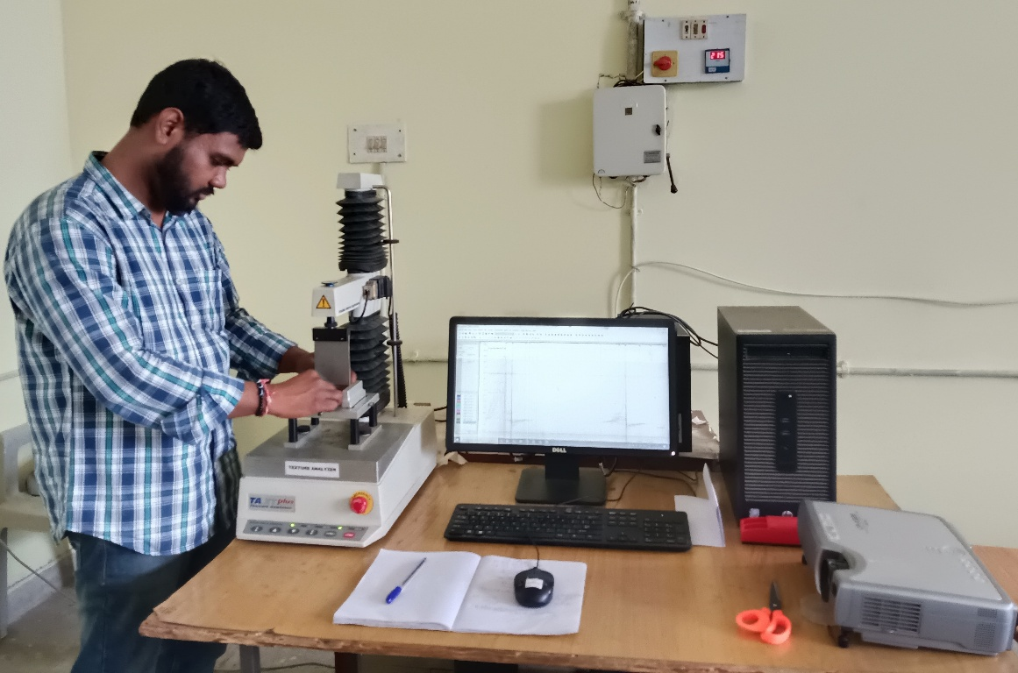
Fig. 3 Texture analyser
Table 1 Texture Profile Analysis (TPA) working procedure
Mode | TPA
Pre-test speed | 1.0 mm/s
Test speed | 1.0 mm/s
Post-test speed | 1.0 mm/s
Distance | 3 mm
Force | 20 g
Time | 150 s
Data acquisition rate | 200 pps
Load cell | 50 kg

2.4 Shape
The shape of a tomato is an important visual feature because it helps accurately identify and classify tomato fruits during detection. Tomatoes can vary in shape depending on the variety, ranging from round and oval to pear-shaped, and recognising these shapes helps the system distinguish tomatoes from similar-colored objects like leaves, stems, or background elements. The shape of the tomato directly influences how effectively robots can detect, grasp, and harvest the fruit. Tomatoes with a more uniform, round, or slightly oval shape are easier for vision systems to recognise because their contours are consistent and less likely to be confused with leaves or stems. A regular shape also allows robotic grippers to establish a stable hold, reducing the chances of slipping or applying uneven pressure that could damage the fruit. In contrast, irregularly shaped tomatoes create challenges in both detection and handling, as the robot must adapt to variable surfaces and orientations. Therefore, the sphericity describes the shape of tomato fruits. Tomatoes are classified based on their outward shape or whether they are meant for manufacturing or immediate use. The variety of tomatoes, nutrients used during growth, and chemical alterations of the seeds to achieve a certain form or substance all influence the tomato's shape. Incorporating shape information into the YOLOv8 model improves object detection accuracy by enabling it to learn the geometric features unique to tomatoes. This is especially important when fruits are partially hidden, overlapping, or growing in dense foliage.
The use of the tomato shape in YOLOv8-based systems leads to more robust, accurate, and context-aware detection, which is essential for efficient and reliable tomato harvesting. The equation was stated by Uba et al. (2020).
Sphericity, Ø$=\sqrt[3]{\frac{LWT}{L}}$ (1)
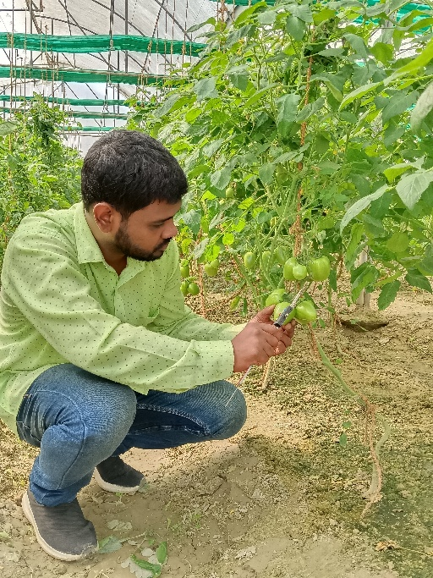
Fig. 4 Shape of the tomato
2.5 Surface area
The surface area of a tomato is a significant feature employed in the YOLOv8-based image detection system for the development of a semi-automatic tomato harvester. Surface area refers to the visible size or the total area occupied by the fruit in the captured image frame. A larger surface area provides better visibility for machine vision systems, allowing the fruit to be distinguished more easily from the surrounding foliage. It also offers more contact points for robotic grippers, which helps in achieving a stable and secure hold during detachment. However, if the surface area is too small, the fruit may be harder to detect and grasp, increasing the chances of missed harvesting or slippage. The surface area of tomatoes is calculated by comparing the surface area of tomatoes to a sphere with the same geometric mean diameter and arithmetic mean diameter (Uba et al., 2020).
Arithmetic mean diameter, D_{a =}$\frac{L+W+T}{3}$ (2)
Geometric mean diameter, D_{g =}$\sqrt[3]{LWT}$ (3)
2.6 Position of the fruit on the stem
The position of the tomato fruit on the stem is an important spatial feature considered (Herck et al., 2020), as it helps the system better understand the plant's structure and accurately locate ripe tomatoes. The relative position of the fruit along the stem allows the detection model to recognise typical fruit-bearing zones, improving the precision and reliability of the harvesting process. Tomatoes typically grow at specific intervals along the stem, often near the leaf nodes or within flower clusters. Fruits that are positioned openly and slightly away from dense foliage are easier for cameras and sensors to identify, which improves detection accuracy. When tomatoes are positioned with adequate spacing along the stem, robotic arms can approach them without obstruction from leaves, branches fruits. Poorly positioned fruits, such as those hidden deep inside the canopy, increase the chances of occlusion and make gripping more difficult, leading to missed harvests or potential damage.
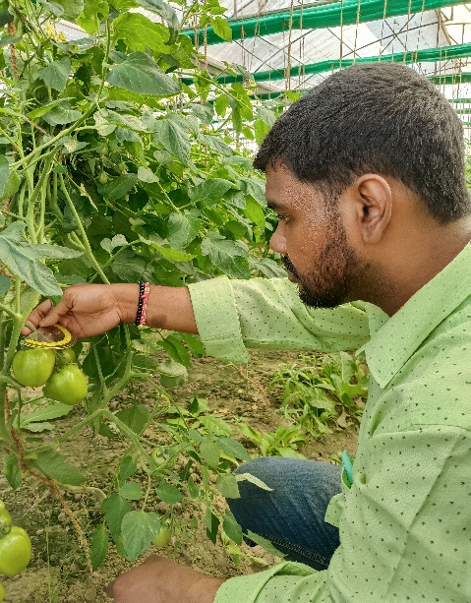
Fig. 5 Position of the tomato
3. Performance indicators of the crop-based harvesting system
Robotic performance criteria specified by Bac et al. (2014) were used to select indicators of success that utilise crop layout; evaluations focusing on the robotic system are excluded. The following outlines each indicator's significance is described below.

3.1 Pickability rate (%)
The pickability rate represents the percentage of fruits that a robotic system can successfully detect, approach, and harvest from the total available fruits on the plant. A higher pickability rate indicates that the crop architecture and fruit placement are favourable for machine vision and robotic manipulation. When fruits are positioned openly with adequate spacing, the robot can achieve a higher success rate in gripping and detachment.
3.2 Harvest success (%)
The harvest success percentage reflects the proportion of fruits that are not only detected and picked by the robot but also removed without causing significant damage. A high harvest success rate indicates that the crop’s physical traits, such as stem strength, fruit position, and surface properties, are well-suited to the design of the robotic harvester. When fruits are accessible, uniformly shaped, and securely gripped, the chances of successful detachment and collection are greatly improved.
3.3 Localisation success (%)
The localisation success percentage indicates how accurately a robotic system can identify the exact position of a fruit on the plant for harvesting. A high localisation rate means that the vision and sensing systems can detect the fruit clearly, estimate its coordinates precisely, and guide the robotic arm to the correct target. Factors such as fruit visibility, color contrast with the background, and spacing on the stem strongly influence this parameter. When fruits are partially hidden by leaves, overlapped by other fruits, or poorly illuminated, localisation errors increase and reduce the overall harvesting efficiency.
3.4 Detachment success (%)
The detachment success percentage refers to the ability of the robotic system to separate the fruit from the plant once it has been detected and grasped. A high detachment rate demonstrates that the end-effector design, cutting mechanism, and gripping force are well-matched with the crop’s stem strength and fruit attachment characteristics. When the stem is of suitable thickness and the fruit is positioned easily, the robot can detach it with minimal effort and without causing damage. However, if the stem is too tough, the grip is unstable, or the fruit is located in a difficult position, detachment failures may occur, leading to incomplete harvesting or fruit loss.
3.5 Damage rate (%)
The damage rate percentage represents the proportion of fruits that are bruised, cut, or otherwise harmed during the harvesting process. A low damage rate is essential for maintaining market quality and ensuring that the harvested fruits remain suitable for storage, transport, and sale. Damage can occur if the robotic gripper applies excessive pressure, if the cutting tool is not well aligned with the stem, or if fruits collide with nearby branches or other fruits during detachment. High damage rates reduce the economic value of the harvest and indicate poor compatibility between the robotic system and the crop’s physical properties

3. results and discussion

A digital vernier calliper was utilised for determining the length (L), width (W), thickness (T), arithmetic mean diameter (D_{a}), and geometric mean diameter (D_{g}) of 100 specimens each to determine the average linear dimensions for the tomato precious F1 hybrid. The results are shown in Table 2 and Fig. 6.
Table 2 Physical properties of tomato
Variable (mm) | Average | Minimum | Maximum | Standard Deviation | Variance | Mean
L | 52.19 | 32.04 | 68.89 | 8.62 | 74.30 | 52.19
T | 47.75 | 28.79 | 63.87 | 9.35 | 87.42 | 47.75
W | 47.03 | 26.52 | 82.87 | 9.69 | 93.90 | 47.03
D_{a} | 48.99 | 30.25 | 61.95 | 8.77 | 76.91 | 48.99
D_{g} | 48.87 | 30.22 | 61.94 | 8.76 | 76.74 | 48.87

Fig. 6 Dimensions of tomato

3.2 Length of the internodes
There is greater space for fruit to be collected from a plant with lengthy internodes. The space makes it easier to approach and handle the fruit, which makes it attractive for simpler fruit harvesting. The length of the internodes was measured in 20 specimens.
The cutting procedure is directly influenced by the length and diameter of the peduncle. It is observed that the fruit's weight, peduncle length, and peduncle diameter all fluctuate separately. The peduncles of tomatoes are smaller. The harvesting process is somewhat hampered by this. For the chosen sample, the peduncle length had the minimum measured value of 63 mm and the longest of 124 mm in Table 3. One inevitable aspect that impacts the cutting section is the length of the peduncle. To separate the fruit from the plant, it chooses where to cut.
Table 3 Average length of the internodes
Sample No. | Tomato weight (g) | Peduncle length (mm) | Average peduncle circumference (mm)
1 | 161 | 105 | 3.05
2 | 42 | 124 | 2.07
3 | 100 | 120 | 1.86
4 | 63 | 95 | 2.6
5 | 108 | 93 | 1.89
6 | 101 | 80 | 1.54
7 | 63.6 | 78 | 1.41
8 | 99.6 | 75 | 1.89
9 | 107.6 | 68 | 1.7
10 | 54.4 | 63 | 1.3

Fig. 7 Peduncle dimensions of tomato
3.3 Cutting force
The cutting force required for cutting the stem of a tomato was obtained from the texture analyser data (Mangat and Niyas, 2017).

Fig. 8 Cutting force of the tomato stem
The information provided makes it evident that the force needed to cut a tomato's stem is independent of the stem's diameter. Regardless of the tomato stem's diameter, the force varies. The force needed to cut a ripe tomato stem was more than that needed for an immature tomato. The tomato stem's cross-sectional image makes it clear why this alteration occurred. The mature stem's cross-section reveals the beginning of secondary growth. Remains of the former primary xylem are visible, and certain secondary tissues, which are made up of tracheids, vessels, xylem fibres, and xylem parenchyma, have developed secondary xylem vessels. The wood structure of the dicot stem, known as the xylem, is what gives the tomato stem its upward conduction and structural assistance for supporting the fruit. The primary reason for an increase in the cutting force needed is the presence of this wood stuff inside a mature tomato peduncle.
3.4 Position of the fruit on the stem
At the initial servo position (180°), the robotic arm was aligned in a straight orientation with the stem, allowing it to reach fruits positioned directly in front of the manipulator. In this position, tomatoes located along the central axis of the stem were more accessible and harvested with minimal adjustment.
When the arm moved to the right rotation (160°), the effective coverage area shifted, enabling the robot to target fruits positioned slightly to the side of the stem. This adjustment improved access to tomatoes growing at an angle but slightly reduced reach to fruits directly aligned with the centre. As a result, the positional change of the servo directly influenced which fruits successfully approached and detached.

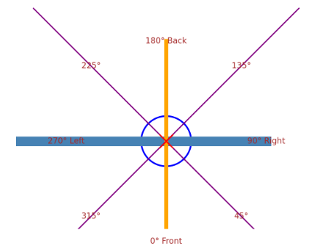
Fig. 9 Position of the fruit

4. Conclusion

The majority of current research on agricultural robotic innovation focuses on improving and modifying the robot rather than crop-adapting the robot. A methodical approach to choosing crops and habitat design is presented in this research to enhance robotic harvesting. Several ideas for the creation of robots were also produced using the methodical approach to crop appearance technique. The capacity of the robot to get to tomatoes lying in accessible places increases with the size of its end effector, enhancing harvesting efficiency.

References

- Bac, C. W., Van Henten, E. J., Hemming, J., & Edan, Y. (2014). Harvesting robots for high-value crops: State-of-the-art review and challenges ahead. Journal of Field Robotics, 31(6), 888-911.
- Beed, F., Taguchi, M., Telemans, B., Kahane, R., Le Bellec, F., Sourisseau, J. M., Mal´ezieux, E., Lesueur-Jannoyer, M., Deberdt, P., Deguine, J.-P., & Faye, E. (2021). Fruit and vegetables: Opportunities and challenges for small-scale sustainable farming. CIRAD: FAO.
- Herck, L.V., Kurtser, P., Wittemans, L., & Edan, Y. (2020). Crop design for improved robotic harvesting: A case study of sweet pepper harvesting. Biosystems Engineering, 192, 294-308.
- Holden, J.M., Eldridge, A.L., Beecher, G.R., Buzzard, I., Marilyn, B., Seema Davis, C.S., Doughlass, L.W., Gebbardt, S.H.D. & Schakel, S. (1999). Carotenoid content of U.S. foods: an update of the database. J. Food Compos., Anal, 12, 169-196.
- Mangat, A. & Niyas, P. (2017). Factors affecting the cutting of peduncle of tomato (Solanum lycopersicum). International journal of agriculture, environment and biotechnology, 10 (3). 345-348.
- Mirzaee, E., Rafiee, S., Keyhani, A., Emam Djom-eh Z. & Kheiralipour, K. (2008). Mass modelling of two varieties of apricot (prunus armenaica L.) with some physical characteristics. Plant Omics J., 1, 37-43.
- Mohsenin, N.N. (1986). Physical properties of plant and animal materials. Gordon and Breach Science Publishers, 20-89.
- Persson, S. (1987). Mechanics of cutting plant material. American society of agricultural engineers. 27−30.
- Rigg, J., Phongsiri, M., Promphakping, B., Salamanca, A., & Sripun, M. (2020). Who will tend the farm? Interrogating the ageing asian farmer. Journal of Peasant Studies, 47 (2), 306–325.
- Taheri-Garavand, A., Rafiee, S. & Keyhani, A. (2011). Study on some morphological and physical characteristics of tomato used in mass models to characterize best post harvesting options. Australian J. of Crop Sci., 5(4), 433-438.
- Uba, F., Esandoh, E.O., Zogho, D. and Anokye, & E.G. (2020). Physical and mechanical properties of locally cultivated tomatoes in Sunyani, Ghana. Scientific African, 10, 1-12.
- Van Henten & E. J. (2004). Greenhouse mechanization: State of the art and future perspective. In International symposium on greenhouses, environmental controls and in- house mechanization for crop production in the tropics,710, 55–70.
- Viswanathan, R., Pandiyarajan, T. & Varadaraju, N. (1997). Physical and mechanical properties of tomato fruits as related to pulping. J. Food Sci. Tech., 34(6): 537- 539.
M. L., & Nelson, S. C. (2002). A study of digit fusion in the mouse embryo. Clinical and Experimental Allergy, 32(4), 489-498.

Saha, M., Adams, M. L., & Nelson, S. C. (2009). Review of digit fusion in the mouse embryo. Journal of Embryology and Experimental Morphology, 49(3), (In press).

Forneau, E., & Bovet, D. (1933). Recherches sur l'action sympathicolytique d'un nouveau dérivé du dioxane. Archives Internationales de Pharmacodynamie, 46, 178-191.

Rang, H. P., Dale, M. M., Ritter, J. M., & Moore, P. K. (2003). Pharmacology (5th ed.). Edinburgh: Churchill Livingstone.

Beers, M. H., Porter, R. S., Jones, T. V., Kaplan, J. L., & Berkwits, M. (Eds.). (2006). The Merck manual of diagnosis and therapy (18th ed.). Merck Research Laboratories.

Glennon, R. A., & Dukat, M. (2002). Serotonin receptors and drugs affecting serotonergic neurotransmission. In D. A. Williams & T. L. Lemke (Eds.), Foye's principles of medicinal chemistry (5th ed., pp. xx-xx). Philadelphia: Lippincott Williams & Wilkins.

Hugo, J. T., & Mondal, S. C. (2006). Parallels between tissue repair and embryo morphogenesis: A conceptual framework. Global Health, 16, 4. https://doi.org/10.1186/1744-8603-1-14

Anonymous. (2006). Parallels between tissue repair and embryo morphogenesis: A conceptual framework. Globalization and Health, 16(4). http://www.globalizationandhealth.com/content/1/1/14

Diabetes Prevention Program Research Group. (2009). A study of digit fusion in the mouse embryo. Journal of Embryology and Experimental Morphology, 49(2), 259–276.

