Development and Evaluation of an IoT-Integrated Solar-Powered Cold Storage System for Post-Harvest Preservation of Perishable Produce

Abstract:
A sustainable, energy-efficient cold storage system was developed using a combination of photovoltaic (PV) solar power and IoT-based real-time environmental monitoring. This research addresses the need for reliable preservation of perishable agricultural commodities, particularly in rural and off-grid regions. Key components included a solar PV panel, DC-powered refrigeration hardware, insulation, sensors, and an IoT platform for continuous temperature and humidity data acquisition. Comprehensive evaluation demonstrated substantial improvements in produce shelf-life and quality, reduction in grid power reliance, and overall operational efficiency. The approach has replicable potential for various perishable supply chains, contributing to both food security and renewable energy adoption in agriculture. Post-harvest losses of fruits and vegetables remain a critical challenge, particularly in rural regions with limited access to reliable electricity. This study presents the design, development, and evaluation of an IoT-based solar powered cold storage system for small-scale agricultural applications. The system utilizes photovoltaic panels to generate renewable energy, coupled with an IoT-enabled monitoring setup for real-time control of temperature and humidity. Components including a compressor, condenser coil, R-134a refrigerant, sensors, and a zero-maintenance battery were integrated into a cold storage prototype. Performance tests conducted with apples, cucumbers, and tomatoes indicated significant improvements in shelf-life and quality compared to ambient storage. The system maintained internal temperatures between 3–5 °C while reducing spoilage, ensuring food safety and quality. This work demonstrates the feasibility of decentralized, sustainable cold storage solutions for smallholder farmers, potentially reducing post-harvest losses and improving farm income.
Keywords: IoT, Solar Energy, Cold Storage, Post-harvest Loss, Smart Agriculture
- Introduction
The agricultural sector plays a pivotal role in food security and livelihoods, especially in developing countries like India, where a large proportion of the population depends on farming. However, one of the persistent challenges in agriculture is post-harvest loss of perishable crops. Fruits and vegetables are highly susceptible to microbial decay, physical damage, and biochemical changes when stored at room temperature. Conventional cold storage facilities help in extending the shelf-life, but these are usually grid-powered, expensive to maintain, and inaccessible to farmers in rural or poorly electrified regions. Solar-powered refrigeration offers an environmentally friendly alternative to fossil fuel-based cold storage systems. Additionally, with the advent of the Internet of Things (IoT), it has become possible to continuously monitor and control storage conditions, ensuring optimal preservation. IoT sensors provide real-time feedback on temperature and humidity, while mobile or web interfaces allow remote management. This study aims to design and evaluate a solar-powered cold storage system integrated with IoT sensors to offer a sustainable and affordable solution. The key objectives are to reduce dependence on conventional electricity, minimize food spoilage, and empower farmers with a smart monitoring system that ensures better quality and safety of stored produce.
- Literature Review
Cold storage has long been recognized as a critical intervention to reduce post-harvest losses, particularly in perishable commodities such as fruits and vegetables. Traditional cold storage facilities, however, remain inaccessible to many smallholder farmers due to their high cost, reliance on grid electricity, and the environmental concerns associated with diesel-powered systems. To address these challenges, researchers have explored renewable energy-based systems and IoT-enabled smart solutions for decentralized storage. IoT-enabled solar-powered cold storage has shown significant benefits for small vendors, as it helps reduce spoilage, ensures food safety, and improves business sustainability (Agarwal, Kumar, Ansari, & Manjunath, 2024). Integration of IoT with solar cold chain systems has also been reported to increase energy efficiency by reducing power consumption up to 60% through intelligent cooling algorithms (Aithal, Dillon, & Grice, 2020). Studies on cloud-controlled cold storage have further shown that IoT can minimize labor requirements while enabling automated monitoring of temperature and humidity, thereby increasing operational efficiency (Alavanthan, Sivakumar, & Prasad, 2023). Extending the application to transportation, IoT-based smart supply chain systems have been found to improve reliability and quality control of perishable goods during logistics operations (Alshdadi, Kamel, Alsolami, Lytras, & Boubaker, 2024). Cold chain management in horticulture has also been a strong focus of research, particularly in Africa. Poor cold chain infrastructure has been identified as a major contributor to post-harvest losses, with estimates ranging from 30–50% in fruits and vegetables (Makule, Dimoso, & Tassou, 2022). Low-cost cooling technologies, such as evaporative coolers and zero-energy cool chambers, have proven useful for smallholder farmers but have limitations in terms of scalability and effectiveness (Makule et al., 2022) (Mishra et al., 2023); (Nagarale et al., 2024); (Ambuko et al., 2016). Research conducted in Rwanda and Burkina Faso has further emphasized that low-cost cold storage technologies can reduce food losses while enhancing farmer incomes and food security (Verploegen, Sharma, Ekka, & Gill, 2021). Other works have explored the technical design and efficiency of solar-powered cold storage systems. Portable micro cold storage units powered by photovoltaic panels have been shown to maintain low internal temperatures effectively in off-grid regions (Hossain & Talukdar, 2019). Energy-efficient solar-powered reefer containers have been suggested as an alternative for transporting perishable crops like tomatoes, reducing both spoilage and nutritional loss (Khan, 2024). Solar-powered fish storage units with integrated temperature control have demonstrated extended storage durations and improved freshness (Setiawan, Ma’ruf, Darmono, & Hermawan, 2024). Smart cold storage for fruit warehouses has also been reported to significantly improve energy efficiency, reduce losses, and enhance overall storage sustainability (Sher, Khan, Rafique, Ikram, & Mazhar, 2024). IoT integration has been a key driver in improving cold storage systems. Smart IoT-based control systems have successfully monitored temperature, humidity, and gases such as CO₂ and ethylene, ensuring stable storage conditions with improved energy efficiency (Alavanthan et al., 2023), (Mohammed, Riad, & Alqahtani, 2022). Similarly, real-time IoT monitoring systems combined with mobile applications have enabled continuous supervision of cold storage environments, reducing risks of spoilage in perishable goods (Islam, Mandal, Hossain, Haque, Saha, & Esha, 2024). Automated IoT frameworks using image processing and solar integration have also been shown to enhance freezer temperature regulation and operational efficiency (Nagarale, Bora, Sonaskar, & Khawashi, 2024). In the broader supply chain, IoT-enabled systems have allowed real-time monitoring of perishable products, optimizing logistics and minimizing losses (Sarkar, Akshatha, Saurabh, Samanvitha, & Sarwar, 2022). Hybrid and advanced solutions have also been proposed to enhance efficiency. Solar-hybrid cold storage with cooling pads has demonstrated stable refrigeration supply while reducing dependency on conventional energy sources (Munir et al., 2021). Artificial intelligence integrated with IoT has been found to optimize cooling systems, further reducing energy use and improving reliability (Dosymbetova et al., 2023). Light-energy-harvested wireless temperature sensors have introduced innovative, battery-free solutions for monitoring food cold storage conditions in real-time (Xiao, Mu, & Cao, 2021). Beyond technical advancements, socio-economic impacts have also been studied. Solar-powered cold storage in Nigerian markets has been shown to reduce post-harvest losses, improve market efficiency, and enhance farmer profitability (Takeshima, Yamauchi, Edeh, & Hernandez, 2023). Additionally, reviews have emphasized that affordable cold storage options are crucial for small and marginal farmers, as they directly improve food security and contribute to increased incomes (Mishra, Pateriya, Ashok, Saxena, Awasthi, & Bibhishan, 2023).

Table.1. General comparison between different gas
S. No. | Chlorofluorocarbon (CFC) | Ammonia  (NH₃ – Cold Storage) | Hydrofluorocarbon (HFC)
1 | High ozone layer depletion | Zero ozone layer depletion | Zero ozone layer depletion
2 | High global warming potential | Low global warming potential | Low global warming potential
3 | Toxic gas | Needs careful handling, can cause skin burns | Provides effective cooling, relatively safer
4 | Low-pressure gas | High-pressure gas | High-pressure gas
5 | Limited availability | Limited availability | Widely available

Table.2. Comparison of Solar Refrigeration Technologies

Technology Type | Mechanism / Principle | Pros | Cons | References
Photovoltaic (PV)-powered systems | PV panels generate electricity to drive conventional vapor-compression units | Mature, flexible, grid-connectable | Lower COP; dependent on electricity; may need batteries/inverters | (Kim & Infante Ferreira, 2008; Alazazmeh & Mokheimer, 2015)
Solar-thermal Absorption systems | Use solar collectors (flat-plate, evacuated-tube) to heat solution; drive absorber cycle | Efficient; relatively low lifecycle cost; no moving parts | Requires high-temperature thermal input; larger collector area | (Syed et al., 2020)
Solar-thermal Adsorption systems | Similar to absorption, but refrigerant is adsorbed on solid material | Can operate at lower temperatures; robust | Bulkier; generally more expensive than absorption systems | (Kim & Infante Ferreira, 2008)
Thermo-mechanical (ejector/Rankine) | Solar-thermal drives mechanical cycles (ejectors or Rankine engines) to compress refrigerant | Higher COP; can integrate with power generation | Complex machinery; high operating temperatures | (Ullah et al., 2013; Curran and Alereza, 1975)
Hybrid Solar (PV + Thermal) | Combine PV with thermal (PVT collectors) to use both electricity and heat | Better spectrum usage; improved system efficiency | Higher investment cost; system complexity | (Agarwal et al., 2024)
Radiative (passive) cooling | Passive cooling by radiating heat to the night sky or space as a heat sink | No power input; works off-grid; maintenance-free | Limited to nighttime or specific conditions; small cooling capacity | (Bihon et al., 2018); (Chen et al., 2022) and (Takeshima et al., 2023).

- Materials and Methods
The IoT-based solar powered cold storage system was designed and fabricated using locally available components, with the dual aim of reducing cost and ensuring functionality. The development process involved the integration of a renewable energy unit, a vapor compression refrigeration system, IoT-based monitoring devices, and a thermally insulated chamber, all brought together into a compact and practical prototype. The primary source of energy was a 15 W photovoltaic solar panel, selected for its affordability, ease of availability, and suitability for powering small-scale systems. The solar panel converted sunlight into direct current electricity, which was then regulated by a solar charge controller. The charge controller was responsible for preventing battery overcharging and deep discharge, thus ensuring both safety and efficiency in energy management. To provide backup power during cloudy weather and nighttime operation, a zero-maintenance premium battery was installed as the energy storage component. This combination of solar panel, controller, and battery allowed the system to function reliably under varying environmental conditions. The refrigeration unit was based on the vapor compression cycle, which is widely regarded as one of the most efficient methods for cooling applications. The unit comprised a compressor, a condenser coil, a capillary tube, and an evaporator connected to the freezer box. The refrigerant used in the system was R-134a (1,1,1,2-tetrafluoroethane), which was chosen due to its zero ozone depletion potential and its proven reliability in small refrigeration applications. In operation, the compressor pressurized the refrigerant, which was then condensed into a high-pressure liquid in the condenser coil. Passing through the expansion device, the refrigerant evaporated inside the evaporator coil, absorbing heat from the storage chamber and thus lowering the temperature (Agarwal et al., 2024). To reduce thermal losses, the chamber was insulated using thermocol sheets due to their low thermal conductivity and effective insulation capacity. These insulation layers were sandwiched between plywood boards for structural support, while the inner surfaces were lined with micro-sheet metal to enhance durability and provide a clean, hygienic surface suitable for storing food. This layered construction was deliberately chosen to balance cost-effectiveness, strength, and thermal performance.

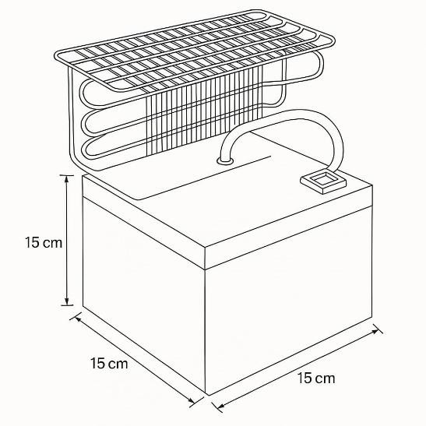
Figure 1. Dimensions of the Cold Storage

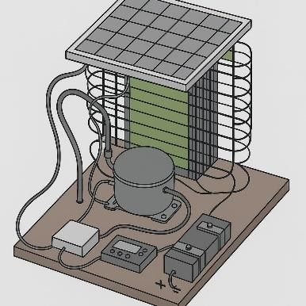
Figure 2. Top view

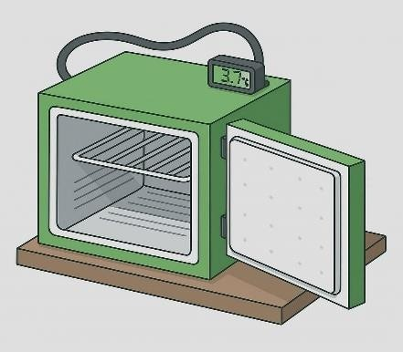
Figure 3. Front view

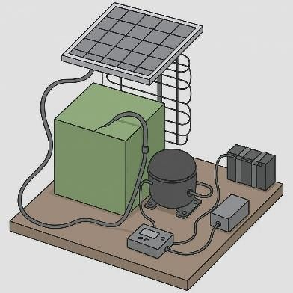

Figure 4. Side view

The unique feature of the system was its integration with Internet of Things (IoT) technology. IoT sensors capable of recording both temperature and humidity were embedded inside the chamber to continuously monitor storage conditions (Verploegen et al., 2021); (Vigneault et al., 2008); (Xiao et al., 2021). These sensors were connected to a microcontroller, specifically an ESP8266-based unit, which acted as the processing hub for sensor data. The microcontroller digitized the sensor readings and transmitted them wirelessly using a Wi-Fi module. A cloud-based platform was used to receive and display the data, allowing users to monitor the conditions inside the cold storage in real time via a mobile phone or web application. In addition to simple monitoring, the system was also configured with threshold-based alerts. If the chamber temperature rose above a pre-set level or if humidity dropped significantly, an automatic notification was sent to the user, thereby reducing the risk of unnoticed spoilage. This IoT framework removed the need for constant physical supervision, enabling proactive management of perishable commodities even from a distance. The fabrication process involved assembling mechanical, electrical, and structural components into a single functional system. The compressor, condenser coil, relay overload protector, filter, and capillary tube were mounted on a plywood frame, which provided the necessary structural foundation. The solar panel was fixed on an adjustable stand to maximize sunlight exposure during the day. The charge controller and battery were installed inside a protective casing to shield them from dust, rain, and mechanical damage. Precise drilling operations were used to mount the components, while welding was employed to fix metallic parts such as the condenser coil and micro-sheet lining. The freezer box, which formed the evaporator compartment, was positioned inside the chamber, surrounded by thermocol insulation panels cut to size and fitted tightly to minimize gaps. The inner micro-sheet lining was fastened using adhesives and bolts, which ensured both mechanical stability and easy cleaning. Copper tubing was used to connect the refrigeration components, which were then charged with R-134a refrigerant and tested for leakages (Islam et al., 2024); (Khan, 2024); (Rajeshwari, 2024); (Sarkar et al., 2022). Electrical wiring was carried out with insulated three-pin cables, ensuring safe connections between the solar panel, charge controller, battery, and compressor. After the electrical and refrigeration subsystems were completed, the IoT sensors were installed, wired to the microcontroller, and calibrated to ensure accurate readings. The final prototype represented a compact, self-sufficient cold storage unit powered entirely by solar energy and enhanced with smart monitoring features. The prototype was tested experimentally to evaluate its performance in preserving the quality of selected fruits and vegetables. Apples, cucumbers, and tomatoes were chosen as test commodities, as they represent common perishable crops that are prone to rapid spoilage under ambient conditions. Fresh samples were divided into two groups: one set stored in the fabricated cold storage unit and the other kept at room temperature as control. The evaluation parameters included internal chamber temperature, weight loss, visual changes in color and texture, and pH of the produce (Alshdadi et al., 2024); (Ambuko et al., 2016). The chamber temperature was continuously recorded by the IoT sensors during the 24-hour storage period, providing a detailed profile of system performance. Weight loss was determined by measuring the samples before and after storage using a digital balance, with reductions attributed to water loss through respiration and transpiration. Visual inspection of color and texture was performed to identify early signs of browning, wrinkling, or softening, while tactile assessment provided information about firmness and freshness (Bihon et al., 2018); (Chen et al., 2022); (Takeshima et al., 2023). The pH levels of fruit and vegetable juice were measured using a digital pH meter to detect changes in acidity, which often correlate with microbial activity and biochemical deterioration. The testing procedure lasted for 24 hours, after which stored samples were compared with control samples (Dosymbetova et al., 2023); (Hossain & Talukdar, 2019); (Setiawan et al., 2024); (Sher et al., 2024). Apples kept at room temperature showed signs of internal browning and softening, whereas apples in the cold storage retained crispness and bright coloration. Cucumbers stored under ambient conditions became soft and yellowish, while those stored in the chamber maintained their green skin and crunchy texture. Tomatoes in the control group lost firmness and developed wrinkles, while refrigerated tomatoes remained firm and fresh. In all three cases, weight loss was lower in the stored samples than in the control group, confirming that the chamber effectively reduced moisture loss. Sensor readings confirmed that the internal temperature of the chamber was maintained between 3–5 °C, demonstrating the efficiency of the refrigeration cycle in conjunction with solar power. The IoT interface provided uninterrupted real-time monitoring throughout the experiment, with the data accessible via mobile devices.
- Results and Discussion
The developed cold storage was able to consistently maintain an internal temperature range of 3–5 °C, even during peak ambient temperatures above 30 °C. This temperature range was found adequate for slowing down respiration and microbial activity in perishable crops. Fruits and vegetables stored in the unit retained freshness, firmness, and natural color (Aithal et al., 2020). Apples remained crisp and red, cucumbers maintained their dark green appearance and crunchiness, and tomatoes remained firm without significant wrinkling (Mohammed et al., 2022); (Nenguwo et al., 2015); (Munir et al., 2021). In contrast, the control samples stored under normal room conditions showed visible deterioration within the same period—apples turned brown inside, cucumbers became soft and yellow, and tomatoes lost firmness with wrinkling. The coefficient of performance (COP) of the system was calculated at 0.8, which is modest but acceptable for small-scale cold storage units. The energy requirement was around 75 Wh/day, which could be sufficiently met by the installed solar panel under normal sunlight conditions. The IoT sensors effectively recorded real-time variations in temperature, which could be monitored remotely. This feature reduced the need for constant human supervision and provided assurance of food safety during storage. The system thus demonstrated both technical feasibility and practical utility for smallholder farmers.
Table.3. Comparison of cold storage on produce quality
Fruit | Parameter | Solar Cold Storage (24h) | Normal RoomTemperature (24h)
Apple | pH | 4.0 | 4.5
 | Weight (g) | 86.4 | 62.4
 | Color | Red | Brown inside
 | Texture | Crunchy, firm | Softer
Cucumber | pH | 5.1 | 5.7
 | Weight (g) | 69.9 | 44.8
 | Color | Dark green | Yellow inside
 | Texture | Crisp | Soft & wrinkled
Tomato | pH | 4.3 | 4.9
 | Weight (g) | 22.4 | 19.7
 | Color | Dark red | Dark red
 | Texture | Firm | Oozing, wrinkled, deteriorated

Results indicated that apples, cucumbers, and tomatoes stored in the solar-powered cold chamber maintained their weight, remained free of spoilage, and retained desirable texture and color attributes. In contrast, produce stored at ambient temperature suffered from weight loss due to dehydration, color change connected to spoilage, and undesirable texture (softening and wrinkling).
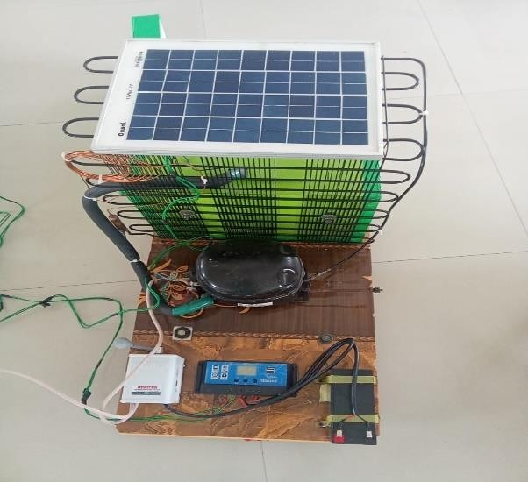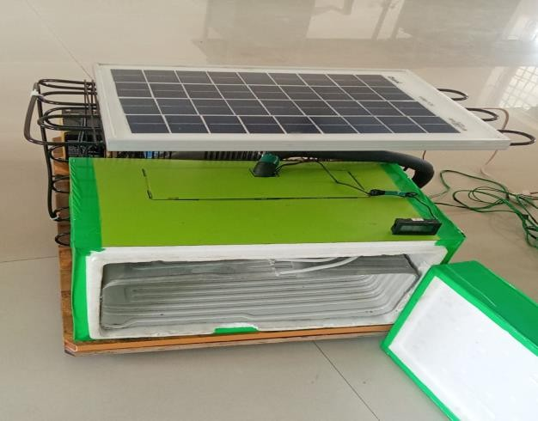
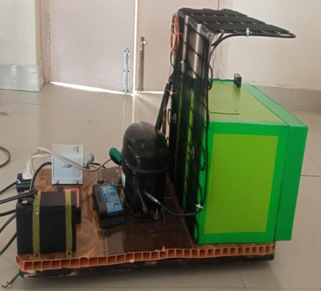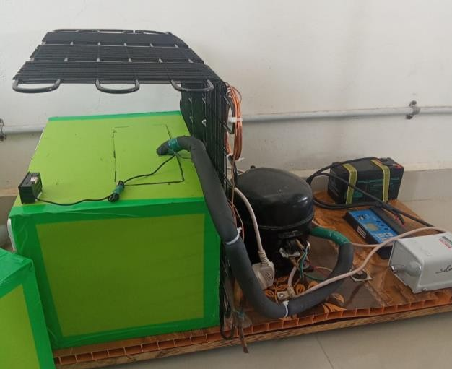
Figure.5. Solar Powered Cold Storage System
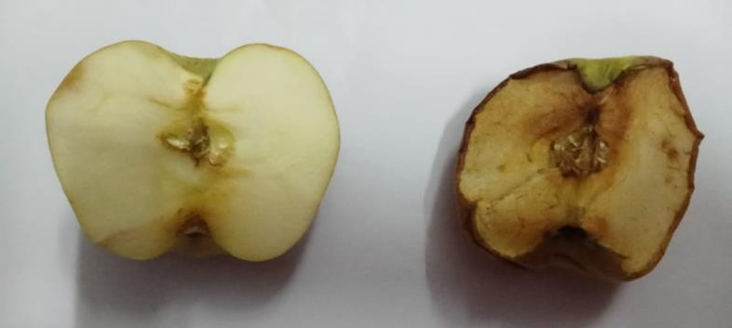

Figure 6. Apple stored in Cold storage Vs Normal temperature

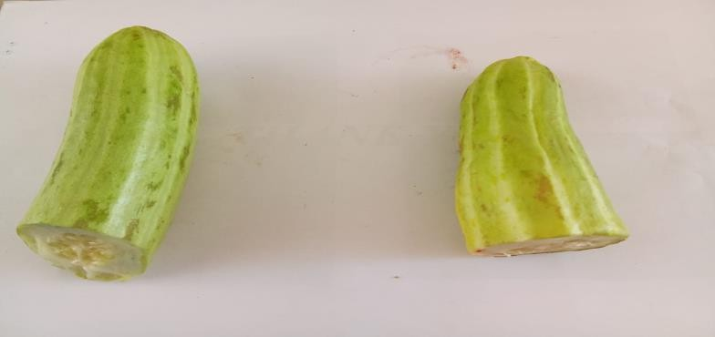

Figure 7. Cucumber stored in Cold storage Vs Normal temperature
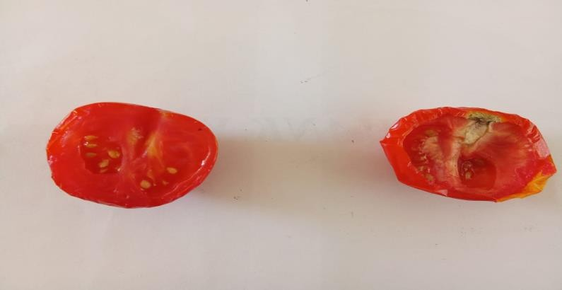
Figure 8. Tomato stored in Cold storage Vs Normal temperature

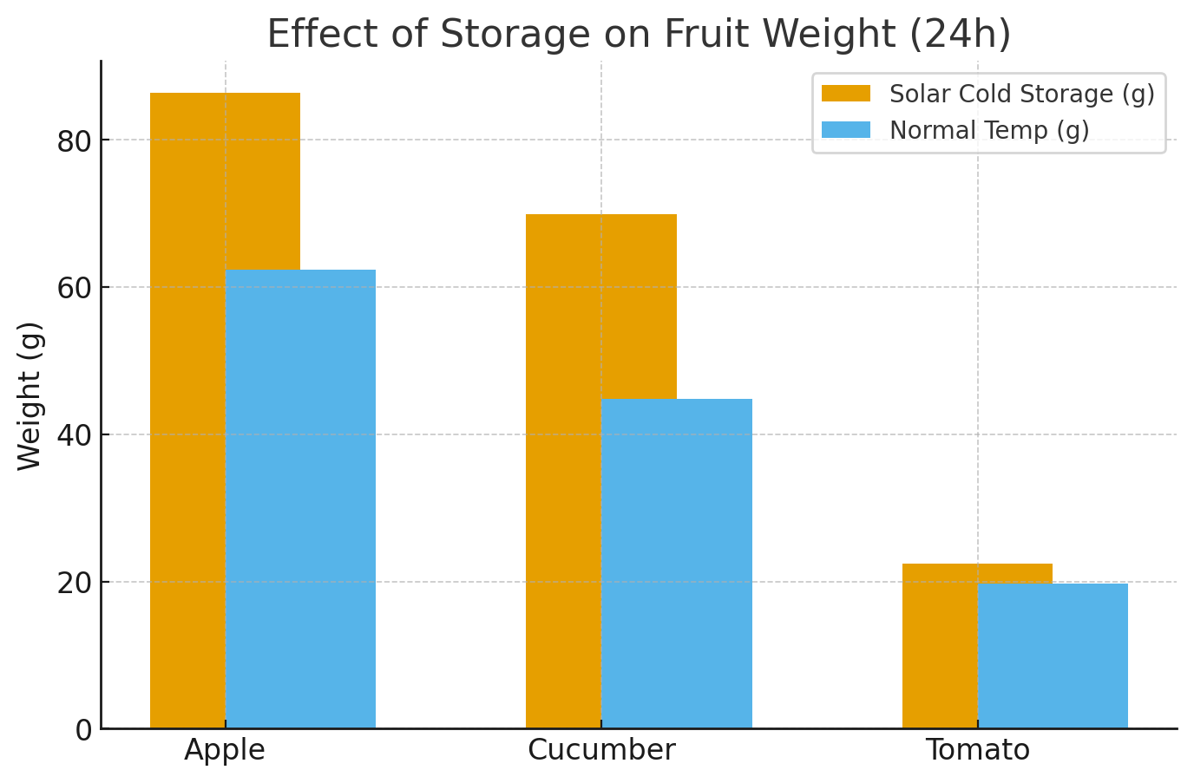
Figure 9. Effect of Storage on Fruit Weight (24h)

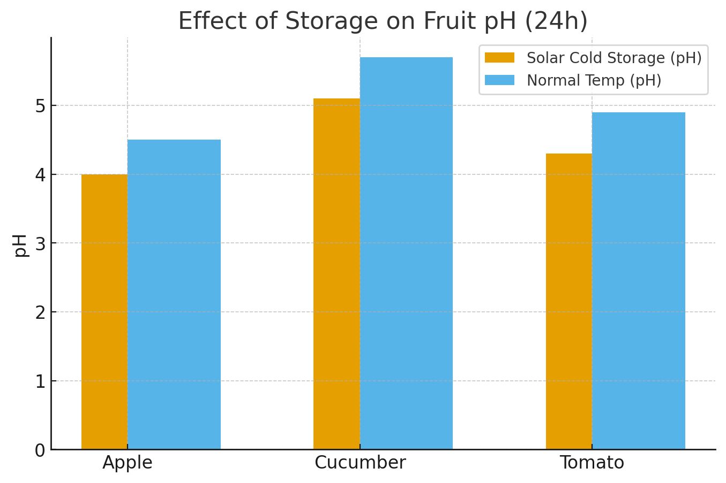
Figure 10. Effect of Storage on Fruit pH (24h)

- Conclusion
This study successfully designed and evaluated an IoT-based solar powered cold storage prototype suitable for small-scale agricultural applications. The system was able to maintain optimal storage conditions for perishable commodities, thereby reducing spoilage and extending shelf-life. The integration of IoT allowed continuous monitoring and control, providing farmers with real-time insights into storage conditions. The technology presents a sustainable, cost-effective, and scalable solution for rural and off-grid areas where access to conventional cold storage is limited. By adopting such systems, farmers can reduce post-harvest losses, improve food quality and safety, and ultimately enhance income. Future work should explore larger-scale implementations, incorporation of advanced data analytics for predictive control, and economic analysis to assess long-term viability for widespread adoption.
- References
- Agarwal, A., Kumar, A., Ansari, A., & Manjunath, T. C. (2024). IoT-enabled solar-powered cold storage solutions for street vendors: Enhancing food preservation and business sustainability. Grenze International Journal of Engineering & Technology.
- Aithal, P. S., Dillon, M., & Grice, R. (2020). Solar cold chain optimization research–An integrated multidisciplinary project agenda. International Journal of Applied Engineering and Management Letters (IJAEML), 4(1), 226–242.
- Alavanthan, R., Sivakumar, P., & Arokiya Prasad, P. (2023). Cloud control cold storage system. In Proceedings of the International Conference on Cognitive and Intelligent Computing: ICCIC 2021. Springer.
- Alazazmeh, A. J., & Mokheimer, E. M. (2015). Review of solar cooling technologies. Journal of Applied Mechanical Engineering.
- Alshdadi, A., Kamel, S., Alsolami, E., Lytras, M. D., & Boubaker, S. (2024). An IoT smart system for cold supply chain storage and transportation management. Engineering, Technology & Applied Science Research, 14(2), 13167–13172.
- Ambuko, J., Wanjiru, F., Karithi, E., Hutchinson, M., Chemining’wa, G., Mwachoni, E., & Nenguwo, N. (2016, August). Cold chain management in horticultural crops value chains: Options for smallholder farmers in Africa. In III All Africa Horticultural Congress (Vol. 1225). ISHS.
- Bihon, W., Coulibaly, A., Chagomoka, T., Sanogo, O., Cisse, F., Ognakossan, K. E., & Diouf, O. (2018). Extending the shelf-life of vegetables using low-cost evaporative cooling systems in Mali. In International Horticultural Congress IHC2018: International Symposium on Strategies and Technologies to Maintain Quality (Vol. 1275, pp. 419–426). ISHS.
- Chen, W., Ye, M., Wei, L., Jie, Z., Donta, P. K., Guangming, C., & Maohua, X. (2022). Design of monitoring system for temperature and humidity of garlic cold storage based on the Internet of Things technology. Journal of Intelligent Agricultural Mechanization, 3(1), 37.
- Curran, H. M., & Alereza, T. (1975). Comparative evaluation of solar cooling concepts. In Application of Solar Energy (Vol. 1975, pp. 305–).
- Dosymbetova, G., Mekhilef, S., Orynbassar, S., Kapparova, A., Saymbetov, A., Nurgaliyev, M., & Koshkarbay, N. (2023). Neural network-based active cooling system with IoT monitoring and control for LCPV silicon solar cells. IEEE Access, 11, 52585–52602.
- Hossain, M. A., & Talukdar, S. (2019). Development and performance evaluation of a solar energy-based portable micro-cold storage. DUET Journal, 5(1), 57–66.
- Islam, H., Mandal, A. K., Hossain, M. S., Haque, D., Saha, H., & Esha, T. (2024, March). Development and implementation of an IoT-enabled real-time cold storage monitoring and notification system. In 2024 International Conference on Advances in Computing, Communication, Electrical, and Smart Systems (iCACCESS). IEEE.
- Khan, M. S. (2024). Refrigeration load calculation of cold storage box used for tomato storage (Doctoral dissertation, School of Mechanical & Manufacturing Engineering, NUST).
- Kim, D. S., & Infante Ferreira, C. A. (2008). Solar refrigeration options: A state-of-the-art review. IIR Solar Refrigeration Review.
- Makule, E., Dimoso, N., & Tassou, S. A. (2022). Precooling and cold storage methods for fruits and vegetables in Sub-Saharan Africa—A review. Horticulturae, 8(9), 776.
- Mishra, A., Pateriya, R. N., Ashok, A., Saxena, A., Awasthi, V. J., & Bibhishan, P. K. (2023). A review—Cold storage system for small and marginal farmers.
- Mohammed, M., Riad, K., & Alqahtani, N. (2022). Design of a smart IoT-based control system for remotely managing cold storage facilities. Sensors, 22(13), 4680.
- Munir, A., Ashraf, T., Amjad, W., Ghafoor, A., Rehman, S., Malik, A. U., ... & Morosuk, T. (2021). Solar-hybrid cold energy storage system coupled with cooling pads backup: A step towards decentralized storage of perishables. Energies, 14(22), 7633.
- Nagarale, S. R., Bora, V., Sonaskar, S., & Khawashi, K. (2024, August). Enhancing cold storage infrastructure efficiency through IoT, image processing and solar panel. In AIP Conference Proceedings (Vol. 3139, No. 1). AIP Publishing.
- Nenguwo, N., Afari-Sefa, V., & Marealle, R. (2015, August). Evaluation of low-cost cooling options for leafy vegetables grown by smallholder farmers in Tanzania. In III Southeast Asia Symposium on Quality Management in Postharvest Systems (Vol. 1179). ISHS.
- Rajeshwari, M. (2024). An integrated solution for solar cold chain portfolio management using Internet of Things.
- Sarkar, S., Akshatha, K. S., Saurabh, A., Samanvitha, B., & Sarwar, M. F. (2022, October). IoT-enabled cold supply chain monitoring system. In 2022 IEEE 3rd Global Conference for Advancement in Technology (GCAT) (pp. 1–6). IEEE.
- Setiawan, R. J., Ma’ruf, K., Darmono, I. S., & Hermawan, A. T. (2024). Design system and performance analysis of fish storage box by utilizing solar energy. International Journal of Power Electronics and Drive Systems (IJPEDS), 15(4), 2591–2602.
- Sher, A., Khan, U., Rafique, M. N., Ikram, M. A., & Mazhar, A. R. (2024). Development and analysis of a smart cold storage system for fruit warehouses. In MATEC Web of Conferences (Vol. 398, p. 01027). EDP Sciences.
- Syed, A., et al. (2020). Thermo-economic comparisons of environmentally friendly solar assisted absorption air conditioning systems. Applied Sciences, 11(5), 2442.
- Takeshima, H., Yamauchi, F., Edeh, H. O., & Hernandez, M. A. (2023). Solar‐powered cold storage and agrifood market modernization in Nigeria. Agricultural Economics, 54(2), 234–255.
- Ullah, K. R., Saidur, R., Ping, H. W., Akikur, R. K., & Shuvo, N. H. (2013). A review of solar thermal refrigeration and cooling methods. Renewable and Sustainable Energy Reviews, 24, 499–513.
- Verploegen, E., Sharma, M., Ekka, R., & Gill, G. (2021). Low-cost cooling technology to reduce postharvest losses in horticulture sectors of Rwanda and Burkina Faso. In Cold chain management for the fresh produce industry in the developing world (pp. 183–210). CRC Press.
- Vigneault, C., Rennie, T. J., & Toussaint, V. (2008). Cooling of freshly cut and freshly harvested fruits and vegetables.
- Xiao, X., Mu, B., & Cao, G. (2021). Light-energy-harvested flexible wireless temperature-sensing patch for food cold storage. ACS Applied Electronic Materials, 3(7), 3015–3022.

