Evaluation of Deep Learning Models for Wheat Spike Segmentation Using Hyperspectral-Derived Pseudo-RGB Images

ABSTRACT
Accurate and automated detection of wheat spikes is essential for high-throughput phenotyping and yield prediction, yet traditional manual counting is labor-intensive and error-prone. This study aimed to evaluate and compare the performance of two deep learning architectures, U-Net and FasterViT, for wheat spike segmentation using pseudo-RGB images derived from hyperspectral data (400–1000 nm). A dataset of 400 wheat plants was collected at physiological maturity, and annotated pseudo-RGB images were used for model training and testing. U-Net achieved a pixel accuracy of 0.893, recall of 0.834, and a Dice score of 0.761. FasterViT outperformed U-Net with a pixel accuracy of 0.922, Intersection over Union (IoU) of 0.836, and a Dice score of 0.860, demonstrating better generalization and sharper segmentation of spikes. In terms of computational efficiency, U-Net required 2.5 seconds per image, whereas FasterViT required 6.85 seconds per image, indicating a trade-off between speed and accuracy. Overall, FasterViT demonstrated higher robustness and suitability for spike segmentation from low-resolution pseudo-RGB imagery, offering a scalable pathway for automated trait extraction and integration into precision agriculture workflows.
Keywords: Wheat, Spike segmentation, Deep learning, U-Net, FasterViT, Hyperspectral imaging, Pseudo-RGB, Image analysis
1. INTRODUCTION
Wheat (Triticum aestivum L.) is one of the world’s most important staple crops, contributing significantly to global food security and providing essential calories and protein for billions of people (Erenstein et al., 2022). Accurate assessment of yield-related traits, particularly spike number per unit area, is critical in breeding programs and agronomic studies (Kumar et al., 2024). Spike number directly influences yield potential, and its reliable estimation enables selection of superior genotypes and better understanding of crop responses under variable environments (Sivapragasam et al., 2025).
Traditionally, spike counting has been carried out manually in field plots or from harvested samples. These approaches, however, are labor-intensive, time-consuming, and prone to human error, creating a significant bottleneck in large-scale breeding pipelines (Kumar et al., 2016). The demand for automated, accurate, and scalable spike segmentation methods has therefore become central to modern high-throughput plant phenotyping (Dagar et al., 2024).
Recent advances in hyperspectral imaging (HSI) provide opportunities to capture fine spectral and spatial details of plant organs across a wide wavelength range (Steinbrener et al. 2019; Herrmann et al., 2013; Pande et al., 2023). While full hyperspectral data analysis can be computationally expensive, pseudo-RGB images, constructed by mapping selected spectral bands to the red, green, and blue channels, offer a practical compromise (Gehan et al., 2017). These images preserve critical structural and spectral cues while being directly compatible with deep learning architectures designed for RGB images. However, pseudo-RGB images are generally of lower spatial resolution compared to high-resolution RGB photographs, which may affect model performance but also reduce computational requirements for training and inference.
Deep learning-based semantic segmentation has shown promise in overcoming these challenges (Misra et al., 2021; Maji et al., 2022). Among the most widely used models is U-Net, introduced by Ronneberger et al. (2015), which employs a symmetric encoder-decoder structure with skip connections to retain fine-grained spatial features. U-Net has been successfully applied in plant phenotyping tasks, including spike segmentation (Zaji et al., 2022). However, its reliance on convolutional operations can limit its ability to capture long-range dependencies, particularly in complex scenes with overlapping spikes and heterogeneous backgrounds (Hasan et al., 2018).
More recently, Vision Transformers (ViTs) have emerged as powerful models for capturing global context in image data (Parez et al., 2023). Yet, their quadratic self-attention mechanisms come with high computational costs, restricting scalability. FasterViT, a hybrid CNN-ViT model, addresses this limitation by incorporating Hierarchical Attention (HAT), enabling efficient global–local feature extraction (Hatamizadeh et al., 2023). This makes FasterViT particularly suitable for tasks requiring a balance between accuracy and efficiency when working with lower-resolution inputs.
In this study, we benchmark U-Net and FasterViT for wheat spike segmentation using pseudo-RGB images derived from hyperspectral data. Our results demonstrate that while U-Net provides a strong baseline, FasterViT achieves superior performance, with higher accuracy, more stable training behavior, and improved boundary delineation of spikes. These findings highlight the potential of hybrid attention-based architectures to overcome the challenges posed by low-resolution imagery and complex field conditions, offering a scalable pathway for accurate, automated spike detection in high-throughput crop phenotyping.

2. MATERIAL AND METHODS
2.1 Dataset
The dataset used in this study was generated from an experiment conducted at the Nanaji Deshmukh Plant Phenomics Centre (NDPPC), ICAR-IARI, Pusa, New Delhi, India, during the winter season of 2023–24. A total of 400 wheat (Triticum aestivum L.) plants were cultivated under controlled environmental conditions, following recommended agronomic practices to ensure uniform and healthy growth. Hyperspectral image acquisition was performed at the physiological maturity stage using a Headwall E-Series VNIR hyperspectral camera. The camera covers the 400–1000 nm spectral range, recording 940 narrow spectral bands. This high spectral resolution enables the precise capture of reflectance signatures associated with wheat spike and canopy traits. The raw hyperspectral data were processed to generate pseudo-RGB images (Fig. 1a) by selecting representative spectral bands for the red, green, and blue channels. These pseudo-RGB images constituted the primary dataset for spike segmentation experiments carried out in this study.
Out of the 400 pseudo-RGB images collected, 320 images were allocated for training the segmentation models, while the remaining 80 images were reserved for independent testing. The wheat spikes in the training and the test dataset were labelled using the polygon available in VGG image annotator tool (Dutta & Zissermann, 2016). To enhance the robustness of model training and reduce the risk of over-fitting, the training dataset was augmented using standard image augmentation techniques, including rotation, brightness adjustment, and horizontal/vertical flipping (Fig. 1b). This augmentation expanded the training dataset to a total of 960 images. For model optimization and performance monitoring, 30% of the augmented dataset was set aside as the validation set, while the remaining 70% was used for training. This partitioning ensured a balanced and reliable evaluation of model generalization during training and inference.
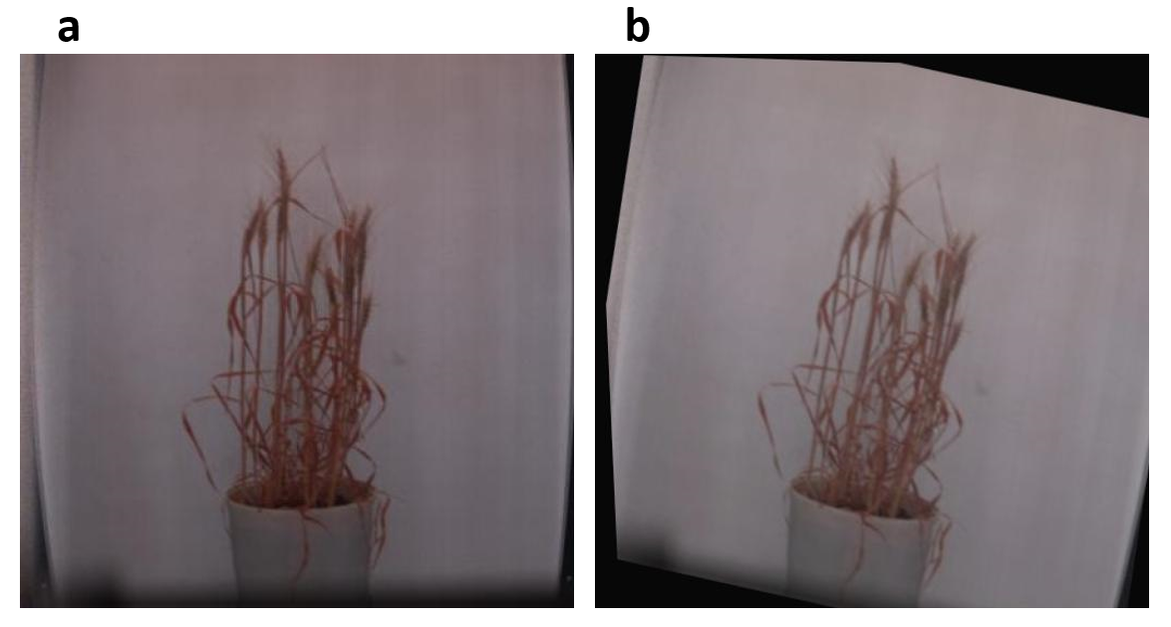
Fig. 1. (a) Pseudo RGB image of wheat plant (b) augmented image
2.2 Models for spike segmentation
2.2.1 U-Net
For baseline segmentation, the U-Net model, originally proposed by Ronneberger et al. (2015) for biomedical image segmentation, was used. U-Net follows a fully convolutional encoder–decoder design. The encoder progressively downsamples the input image through convolutional and pooling layers to extract hierarchical features, while the decoder upsamples the feature maps to reconstruct the segmentation mask. Skip connections between the encoder and decoder preserve fine-grained spatial details that are otherwise lost during downsampling, enabling precise pixel-level predictions. In this study, U-Net was adapted for pseudo-RGB wheat spike images, with modifications in the input layer to accommodate the dataset resolution.
2.2.2 FasterViT
FasterViT is a hybrid convolutional–transformer model that integrates the strengths of convolutional neural networks (CNNs) for local feature extraction and Vision Transformers (ViTs) for modeling global dependencies (Hatamizadeh et al., 2023). It incorporates Hierarchical Attention (HAT), which reduces the computational complexity of traditional self-attention while maintaining global contextual understanding. The architecture employs convolutional stem layers for initial feature extraction and progressively introduces transformer blocks at deeper layers. This design achieves a balance between accuracy and computational efficiency, making it suitable for segmentation tasks on low-resolution pseudo-RGB images. In this study, FasterViT was implemented within a fully convolutional framework to produce dense, pixel-level segmentation of wheat spikes.
2.3 Segmentation Metrics
For pixel-level segmentation tasks such as wheat spike detection, model performance was evaluated based on four fundamental parameters: True Positive (TP), True Negative (TN), False Positive (FP), and False Negative (FN). In this study, TP refers to the number of pixels correctly classified as wheat spikes, while TN corresponds to the number of pixels correctly identified as background (non-spike regions such as leaves, soil, or empty space). Conversely, FP represents background pixels that were incorrectly labeled as spikes, leading to false detections, and FN indicates spike pixels that were misclassified as background, resulting in missed spikes. Based on these four fundamental parameters; the performance of U-Net and FasterViT models was quantitatively evaluated using following standard segmentation metrics:
Pixel Accuracy: The ratio of correctly classified pixels (spike and background) to the total number of pixels.
$$P=\frac{TP+TN}{TP+FP+TN+FN}$$
Precision: Defines the proportion of correctly predicted spike pixels among all pixels classified as spikes. A higher precision indicates fewer false positives.
$$P=\frac{TP}{TP+FP}$$
Recall: Defines the proportion of correctly predicted spike pixels among all actual spike pixels in the ground truth. A higher recall reflects fewer false negatives.
$$R=\frac{TP}{TP+FN}$$
Intersection over Union (IoU): Measures the overlap between predicted and ground-truth spike masks relative to their union, reflecting segmentation accuracy.
$$Jaccard Index=\frac{A∩B}{A∪B}$$
Where A is the set of pixels (or area) in the predicted spike mask. B is the set of pixels (or area) in the ground truth spike mask.
Dice Coefficient (F1-score): Evaluates the harmonic mean of precision and recall at the pixel level, emphasizing correct spike delineation.
$$Dice=\frac{2×\left|A∩B\right|}{\left|A\right|+\left|B\right|}$$
These metrics collectively provide insights into model performance, accounting for both global accuracy and sensitivity to fine structural details in spike segmentation.
3. RESULTS & DISCUSSION
The performance of U-Net and FasterViT architectures was evaluated for wheat spike segmentation using low-resolution pseudo-RGB images. Both models were trained on augmented datasets and validated using an independent test set. Model performance was assessed using pixel accuracy, Dice coefficient, and Intersection over Union (IoU).
3.1 U-Net Performance
The training and validation curves of U-Net (Figure 2) showed that the model converged rapidly within the initial epochs, with the training loss declining to 0.02 and training pixel accuracy reaching 0.98. However, the validation performance stabilized at lower levels, with validation accuracy plateauing at 0.90 and mean IoU at 0.75. This divergence between training and validation trends indicates partial overfitting of U-Net to the training data. On the independent test set, U-Net achieved a pixel accuracy of 0.89, precision of 0.827, recall of 0.834, IoU of 0.830, and a Dice score of 0.761 (Table 1). The comparatively lower Dice score highlights its limitations in delineating the precise boundaries of wheat spikes.
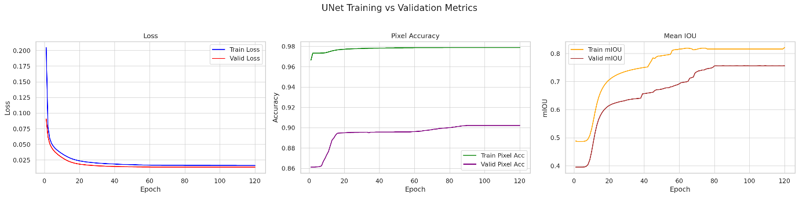
Fig. 2. Training and validation loss curves of the U-Net model for wheat spike segmentation
3.2 FasterViT Performance
In contrast, FasterViT demonstrated more stable and progressive learning behavior across epochs (Figure 2). Training accuracy increased steadily to 0.997, while validation accuracy improved continuously, reaching 0.92 by the end of training. Validation IoU values showed a consistent upward trend, stabilizing at 0.84–0.85, reflecting strong generalization. On the test set, FasterViT achieved higher pixel accuracy (0.92) compared to U-Net, alongside precision of 0.841, recall of 0.832, IoU of 0.836, and a Dice score of 0.860 (Table 1). The high Dice coefficient underscores the model’s superior ability to capture spatial boundaries of wheat spikes under pseudo-RGB imagery.
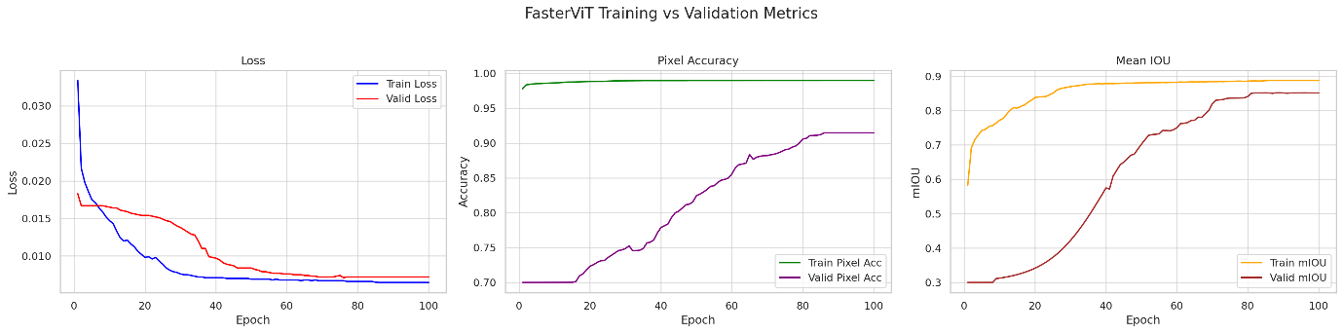
Fig. 3. Training and validation loss curves of the FasterViT model for wheat spike segmentation
3.3 Comparative Assessment
Direct comparison between the two models indicates the clear advantage of FasterViT over U-Net for pseudo-RGB based spike segmentation. While U-Net achieved competitive recall values, its precision, IoU, and Dice scores were consistently lower, pointing to less accurate segmentation boundaries. In terms of computational efficiency, FasterViT required 6.85 seconds per image, whereas U-Net completed the spike segmentation in 2.5 seconds, showing that FasterViT, despite being slower, delivered considerably more accurate results. By effectively combining convolutional and transformer-based representations, FasterViT achieved a better balance of local and global feature extraction, resulting in improved generalization and superior segmentation performance. Overall, FasterViT demonstrated higher robustness and suitability for wheat spike segmentation in low-resolution pseudo-RGB images. Figure 4 presents the spike detection output generated by the FasterViT model, highlighting its robustness in segmenting spikes with sharp boundaries and minimal misclassification.
Table 1. Performance metrics of U-Net and FasterViT models for wheat spike segmentation on the test set
Model | Pixel Accuracy | Precision | Recall | F1 Score | IoU | Dice
FasterViT | 0.922 | 0.841 | 0.832 | 0.836 | 0.86 | 0.925
U-Net | 0.893 | 0.827 | 0.834 | 0.83 | 0.761 | 0.864

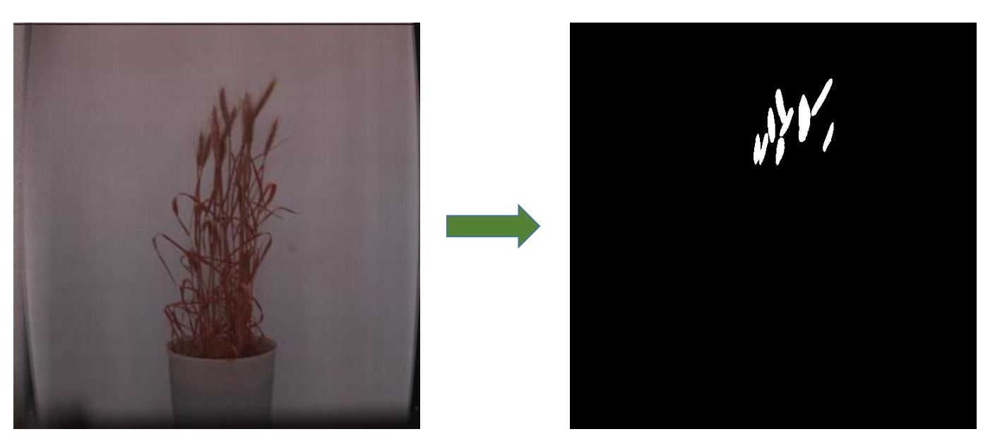
Fig. 4. Spike detection output generated by the FasterViT model, illustrating precise segmentation of wheat spikes under pseudo-RGB imagery
The findings of this study highlight the effectiveness of Vision Transformer-based architectures for crop phenotyping, with FasterViT providing superior segmentation performance compared to U-Net. This improvement can be attributed to FasterViT’s hybrid design, which combines convolutional feature extraction with hierarchical attention to capture both local texture and global contextual information. Such capabilities are particularly important in agricultural imagery, where overlapping structures, occlusions, and varying light conditions often complicate segmentation tasks.
The advantages of hybrid Transformer models observed here are consistent with broader computer vision research, where architectures like FasterViT have demonstrated efficiency and accuracy improvements (Hatamizadeh et al., 2023). Recent agricultural applications further support this trend. For instance, Sunitha et al. (2023) reported that Vision Transformers enhanced wheat head detection across diverse environments. Similarly, Xie et al. (2022) showed that Transformer-based models improved crop classification accuracy from remote sensing imagery. More recently, Zhang et al. (2024) demonstrated that multimodal Transformer networks integrating spectral and meteorological inputs could significantly enhance crop yield prediction. Together, these studies illustrate the increasing relevance of Transformer-based methods in precision agriculture.
The accurate segmentation of wheat spikes achieved by FasterViT has direct implications for trait extraction, including spike count, area, and morphology. These traits are strongly associated with grain yield and are therefore critical for yield prediction pipelines. By enabling reliable quantification of spike traits from pseudo-RGB hyperspectral images, FasterViT can support high-throughput phenotyping workflows while reducing dependence on expensive high-resolution imaging systems. This scalability is particularly valuable for field-based applications, where efficiency and robustness are key to integrating image-based analysis into precision agriculture.
4. CONCLUSION
This study demonstrated the feasibility of using hyperspectral-derived pseudo-RGB images for wheat spike segmentation through deep learning. Both U-Net and FasterViT produced effective results; however, FasterViT consistently achieved higher accuracy, precision, and boundary delineation, highlighting the advantage of hybrid convolution–transformer architectures in capturing both local and global features from low-resolution imagery. The ability of FasterViT to deliver reliable spike segmentation despite the lower spatial resolution of pseudo-RGB images indicates that accurate trait extraction can be achieved without relying on expensive high-resolution RGB imaging systems, thereby enhancing the scalability of phenotyping pipelines.
The robust spike detection achieved in this study provides a foundation for downstream applications such as spike-based yield prediction, trait quantification, and integration into precision agriculture workflows. Nonetheless, the work has some limitations, particularly the use of controlled environment data and a relatively small dataset, which may restrict direct field-level applicability. Future research should focus on validating these models under diverse field conditions, incorporating larger and more heterogeneous datasets, and exploring multimodal data fusion with full hyperspectral bands or thermal and environmental parameters. Such efforts will further strengthen the application of AI-driven phenotyping for yield prediction and sustainable crop management in variable agricultural systems.
DISCLAIMER (ARTIFICIAL INTELLIGENCE)
Author(s) hereby declare that NO generative AI technologies such as Large Language Models (ChatGPT, COPILOT, etc.) and text-to-image generators have been used during the writing or editing of this manuscript.

COMPETING INTERESTS DISCLAIMER:
Authors have declared that they have no known competing financial interests OR non-financial interests OR personal relationships that could have appeared to influence the work reported in this paper.
REFERENCES
Dagar, P., Arora, A., Ray, M., Kumar, S., Chourasia, H., Kumar, M., ... & Chinnusamy, V. (2024). High-resolution reconstruction of images for estimation of plant height in wheat using RGB-D camera and machine learning approaches. Current Science (00113891), 127(12).
Dutta, A., Gupta, A., & Zissermann, A. (2016, January). VGG image annotator (VIA).
Erenstein, O., Jaleta, M., Mottaleb, K. A., Sonder, K., Donovan, J., & Braun, H. J. (2022). Global trends in wheat production, consumption and trade. In Wheat improvement: food security in a changing climate (pp. 47-66). Cham: Springer International Publishing.
Gehan, M. A., Fahlgren, N., Abbasi, A., Berry, J. C., Callen, S. T., Chavez, L., ... & Sax, T. (2017). PlantCV v2: Image analysis software for high-throughput plant phenotyping. PeerJ, 5, e4088.
Hasan, M. M., Chopin, J. P., Laga, H., & Miklavcic, S. J. (2018). Detection and analysis of wheat spikes using convolutional neural networks. Plant Methods, 14(1), 100.
Hatamizadeh, A., Heinrich, G., Yin, H., Tao, A., Alvarez, J. M., Kautz, J., & Molchanov, P. (2023). Fastervit: Fast vision transformers with hierarchical attention. arXiv preprint arXiv:2306.06189.
Herrmann, I., Shapira, U., Kinast, S., Karnieli, A., & Bonfil, D. J. (2013). Ground-level hyperspectral imagery for detecting weeds in wheat fields. Precision agriculture, 14(6), 637-659.
Kumar, M., Arora, A., Marwaha, S., Chinnusamy, V., Kumar, S., Jain, R., & Pal, S. (2024). Machine learning based approach for wheat plant senescence quantification. Plant Physiology Reports, 29(4), 823-835.
Kumar, S., Raju, D., Sahoo, R. N., & Chinnusamy, V. (2016). Phenomics: unlocking the hidden genetic variation for breaking the barriers in yield and stress tolerance. Indian Journal of Plant Physiology, 21(4), 409-419.
Maji, A. K., Marwaha, S., Kumar, S., Arora, A., Chinnusamy, V., & Islam, S. (2022). SlypNet: Spikelet-based yield prediction of wheat using advanced plant phenotyping and computer vision techniques. Frontiers in plant science, 13, 889853.
Misra, T., Arora, A., Marwaha, S., Jha, R. R., Ray, M., Jain, R., ... & Chinnusamy, V. (2021). Web-SpikeSegNet: deep learning framework for recognition and counting of spikes from visual images of wheat plants. IEEE Access, 9, 76235-76247.
Pande, C. B., & Moharir, K. N. (2023). Application of hyperspectral remote sensing role in precision farming and sustainable agriculture under climate change: A review. Climate Change Impacts on Natural Resources, Ecosystems and Agricultural Systems, 503-520.
Parez, S., Dilshad, N., Alghamdi, N. S., Alanazi, T. M., & Lee, J. W. (2023). Visual intelligence in precision agriculture: Exploring plant disease detection via efficient vision transformers. Sensors, 23(15), 6949.
Ronneberger, O., Fischer, P., & Brox, T. (2015, October). U-net: Convolutional networks for biomedical image segmentation. In International Conference on Medical image computing and computer-assisted intervention (pp. 234-241). Cham: Springer international publishing.
Sivapragasam, E., Harika, A., Das, M., Chinnusamy, V., Kumar, M., & Kumar, S. (2025). Imaging Techniques for High-Throughput Phenotyping: Methods and Applications. In Plant High-Throughput Phenotyping and Functional Phenomics (pp. 84-98). CRC Press.
Steinbrener, J., Posch, K., & Leitner, R. (2019). Hyperspectral fruit and vegetable classification using convolutional neural networks. Computers and Electronics in Agriculture, 162, 364-372.
Sunitha, G., Sudeepthi, A., Sreedhar, B., Shaik, A. B., & Farooq, C. (2023, August). RetinaNet and vision transformer-based model for wheat head detection. In 2023 5th International Conference on Inventive Research in Computing Applications (ICIRCA) (pp. 151-156). IEEE.
Xie, J., Hua, J., Chen, S., Wu, P., Gao, P., Sun, D., ... & Lu, J. (2023). HyperSFormer: A transformer-based end-to-end hyperspectral image classification method for crop classification. Remote Sensing, 15(14), 3491.
Zaji, A., Liu, Z., Xiao, G., Bhowmik, P., Sangha, J. S., & Ruan, Y. (2022). Wheat spike localization and counting via hybrid UNet architectures. Computers and Electronics in Agriculture, 203, 107439.

