Integrated Micronutrient Management Enhances Growth, Yield, Quality, and Economic Returns of Napier Hybrid (Pennisetum purpureum Schumach) under Irrigated Conditions in Manipur, India

Abstract
A three-year field experiment (2021 to 2023) was conducted at the experimental farm of CAU, Andro, Manipur, to evaluate the effect of micronutrient management on growth, yield, quality, and economics of Napier hybrid (Pennisetum purpureum Schumach). The study employed a randomized block design consisting of six treatments, replicated three times. Regarding growth attributes such as plant height, leaf-stem ratio, number of leaves and stem girth. Yield parameters were significantly influenced by micronutrient management, with the maximum green fodder yield (728.11q/ha) in T4 (GRDF + soil-applied micronutrients). At the same time, T3 (GRDF + FYM) recorded the highest dry matter yield (140.93 q/ha) and crude protein yield (13.44 q/ha). Economic analysis revealed that the highest net returns (Rs. 121,151/ha) and benefit-cost ratio (3.74) were achieved. Post-harvest soil nutrient analysis showed that integrated nutrient management, particularly with FYM and micronutrient supplementation, resulted in improved N, P, K, and micronutrient status. The research findings support the notion that RDF ensures basic productivity, and the integration of FYM and micronutrients significantly enhances yield, quality, and profitability. T4 (GRDF + soil-applied micronutrients) is the most sustainable practice for Napier hybrid cultivation under irrigated conditions.

Keywords: Napier hybrid, micronutrient management, growth, yield, crude protein, economics, soil fertility

Introduction
Napier hybrid, Pennisetum purpureum Schumach (2n = 28), is a robust perennial grass that has been widely used as a tropical forage, producing a greater dry matter (DM) yield than other tropical grasses (Hanna et al., 2004). Forage production plays a crucial role in supporting livestock productivity, which is vital for ensuring food security and rural livelihoods worldwide. The management of nutrients, including macronutrients and micronutrients, yields superior quality and higher forage yields. The macronutrients, including nitrogen, phosphorus, and potassium, are well-documented. Additionally, micronutrients such as iron, zinc, boron, manganese, and copper are equally important for the optimal growth of plants, development, and improved forage quality (Backiyavathy et al., 2006). Micronutrients play a significant role in chlorophyll synthesis, enzymatic activities, the photosynthesis process, and various biochemical and physiological processes, such as the activation of enzymes and protein formation, which directly affect biomass production and the nutritional value of forage crops (Marscher, 2012). Essential micronutrients, such as Zn, Fe, and Cu, are vital for these processes. Their deficiencies can inhibit plant growth, decrease crude protein content, impair digestibility, and consequently affect the nutritional value of livestock and productivity (Rawashdeh & Sala, 2013). Efficient management of micronutrients through balanced foliar application or fertilization yields increased growth parameters, production, and nutritional levels in various forage species, including maize, sorghum, legumes, and grasses (Asad & Rafique, 2002). Additionally, integrated nutrient management, which involves the use of chemical fertilizers, FYM, and micronutrients, has shown improvements in forage yield, crude protein content, and soil quality (Singh et al., 2022; Tiwari et al., 2024).
Therefore, different practices of micronutrient management are essential to improve and increase the genetic potential of Napier hybrid fodder, thereby enhancing forage quality, promoting sustainability, and enhancing livestock production. Moreover, further research is recommended to optimize the formulation of micronutrients and various methods of application specific to these environments, in order to achieve both agronomic and economic benefits. With this background in view the present investigation was conducted by AICRP on Forage Crops and Utilization, College of Agriculture, Central Agricultural University, Imphal during 2021–2023 to evaluate the Response of Napier hybrid to micronutrient management on growth, quality, yield and economics, and to observe the changes of nutrients status both in soil and plant after harvest.
Materials And Methods
1. Experiment site
The present investigation was conducted at the CAU Experimental Farm in Andro, Manipur, India, located at 24°45'N latitude, 93°56'E longitude, and an altitude of 790 m above mean sea level (Figure 1), spanning the winter seasons of 2021–2022 and 2022–2023. This site falls under the eastern Himalayan region (II) and the sub-tropical zone (NEH-4) of the state of Manipur. The climatic condition of the area is subtropical, and the average annual rainfall is 1212 mm.
2. Soil status
The soil falls under the inceptisols order and is clayey n texture (hyperthermic aerichaplaquept according to U.S. soil taxonomy), acidic in reaction (pH 5.24), medium in available N (287.34 N kg/ha), available phosphorus (16.0 P₂O₅ kg/ha), available potassium (218.0 K₂O kg/ha) and organic carbon (1.4%).2.3.
2.1. Soil Sampling
Representative soil samples were collected randomly prior to the experiment's commencement from several locations at the experimental site, at a depth of 0–15 cm, using a soil auger. The collected samples were composited. The samples were appropriately dried in the shade. After grinding, the soil samples were passed through a 2 mm sieve and stored for chemical analysis of the soil (Tan, 1995).
2.2. Physical Soil Analysis
The soil texture (clay soil) was determined by the international pipette method after treating the soil with hydrogen peroxide (Piper, 1996).
2.3. Soil Chemical Analysis
The pH of the experimental soil was determined using a digital pH meter with a 1:2.5 soil-to-water suspension, as described by Jackson (1973). The oxidizable organic carbon was determined using the wet-oxidation method (Walkey and Black, 1934). The available N content of the soil samples was determined using the alkaline potassium permanganate method (Subbiah and Asija, 1956). The available phosphorus content of the soil was determined by following the Bray and Kurtz method. The available potassium was extracted from the soil using neutral ammonium acetate at a 1:5 soil-to-extract ratio. The concentration of potassium present in the extract was determined using a flame photometer (Jackson, 1973).
3. Treatment details
The experiment was laid out in a Randomized Block Design (RBD) with six treatments, each replicated four times. The plot size was 4 x 5 meters with a planting spacing of 75 x 50 cm. The treatments included: T1, the absolute control with no fertilizer application: T2, the recommended dose of fertilizer (RDF) consisting of 100: 50: 50 kg ha⁻¹ of N:P₂O₅:K₂O based on soil test: T3, GRDF, which comprised RDF combined with farmyard manure (FYM) at 5 t ha⁻¹: T4, GRDF plus soil application of government-notified multi-micronutrient grade I at 25 kg/ha: T5, GRDF plus two foliar sprays of micronutrient grade II at 1% concentration applied at 30 and 60 days after sowing (DAS); and T6, GRDF combined with soil application of grade I at 25 kg/ha plus two foliar sprays of grade II at 1% concentration applied at 30 and 45 DAS.
Data collection and observations
- Plant height (cm): Measure the height of randomly selected plants from the soil surface to the tip of the tallest leaf or the apex of the plant using a measuring tape or ruler. Measurements are taken at different growth stages at regular intervals at 30, 60, and 90 DAS after sowing and at harvest.
- Number of Leaves: Count the total number of fully expanded leaves per plant on selected sample plants in each plot at specified growth stages. This gives an estimate of the plant's vegetative development.
- Leaf Stem Ratio: Collect a plant sample from each plot, separate its leaves and stems, and let them dry in an oven at a constant temperature (65 °C). Then, measure the fresh or dry weights. The leaf-to-stem ratio is calculated as the weight of leaves divided by the weight of stems, which determines forage quality.
- Stem Girth (mm): Randomly select a plant and measure the circumference or diameter of the stem using a vernier caliper or micrometer at a fixed point. Measurements are taken at growth stages to allow stem thickening.
- Green Fodder Yield (q/ha): The plants in the plots are harvested at ground level, and their fresh weight is measured using a weighing scale. The fodder yield is recorded in kilograms and later converted to yield per hectare based on the plot size.
- Dry matter yield (q/ha): Collect the fresh weight of harvested fodder and measure its weight. Let the plant sample be oven-dried (60–70°C) until it achieves a constant weight for about 48–72 hours. The obtained dry weight is the dry matter content of the plant sample. The dry matter yield is calculated by dividing the dry weight of the plant sample by the fresh weight. The dry matter yield per hectare is estimated by multiplying the green fodder yield by the dry matter yield.
- Crude Protein Content (%): It is calculated by multiplying N content (%) in straw by the factor of 6.25.
- viii. Crude Protein Yield (kg ha⁻¹): Crude protein yield is estimated by using the formula.
- Crude Protein Yield (kg ha⁻¹) = (Crude protein content (%) x Fodder yield (kg/ha))/100
4. Economic Analysis
The treatment-wise gross monetary returns were worked out by considering the prevailing market prices of the produce during the year of experimentation. The net return was calculated by subtracting the cultivation cost from the gross return of the respective treatment. This is expressed as the net returns in Rs/ha, and the benefit-cost ratio of each treatment was calculated by dividing the gross return by the cultivation cost for the respective treatments.
5. Statistical Analysis
All the data pertaining to the present investigation were analyzed statistically using Fisher's method of analysis of variance (ANOVA) and interpreted as outlined by Gomez and Gomez. The interpretation of the data, however, was based on 5% probability levels. Critical difference values were calculated wherever the 'F' test was found to be significant. The treatment means were compared following critical differences (CD) at a 5% probability level (Gomez and Gomez, 1984).
Principal Component Analysis and Correlation Analysis
The experimental results were processed using multivariate analysis software, OriginPro (version 2021, OriginLab Corporation, Northampton, MA, USA). Standardization of each dataset to unit variance was performed (Kaiser, 1958). The Pearson correlation analysis verified the presence or absence of a relationship between parameters at a p = 0.05 level of significance, and the results are represented in a graphical form as a color-coded heat map correlation matrix (Friendly, 2002). CA was run through the covariance matrix approach, where components with values over 1.0 were considered in selecting the number to retain (Kaiser, 1960). A biplot presented the results, combining treatment using standard procedures applied in agricultural data analysis (Jolliffe and Cadima, 2016; Gabriel, 1971).
Results and Discussion
- Effect of micronutrient management on growth of Napier hybrid under irrigated situation (pooled mean of 3 years, kharif, 2021, 2022, and 2023)
The pooled data over three years indicated that micronutrient management influenced the growth attributes of Napier hybrid grass. However, the effects were largely non-significant (Table 1). Plant height was highest (228.78 cm) under RDF (T2), showing that an adequate supply of primary nutrients (NPK) ensures optimum vegetative growth. In contrast, the lowest plant height (203.20 cm) was recorded in T4 (GRDF + soil-applied micronutrient), which may be attributed to competitive nutrient partitioning under high micronutrient supply. Earlier studies have also demonstrated that macronutrient balance primarily drives height development in grasses, while micronutrients play a more significant role in leaf physiology and metabolic functions (Nandi et al., 2024; Singh et al., 2025).
T4 recorded the maximum value of the leaf-stem ratio (0.61) due to the enhanced effect of micronutrient supplementation in increasing leafiness, which is a desirable trait for increasing palatability and digestibility of forages. Similar results were found in sorghum and maize fodder, where micronutrient-enhanced fertilization improved leaf production in relation to stem biomass (Singh et al., 2019; Adesh et al., 2021).
The number of leaves per tiller was highest (21) under T6 (GRDF + soil + foliar micronutrients), demonstrating that a combined application strategy supports vigorous tillering and higher leaf production. Foliar sprays provide direct nutrient assimilation, improving leaf initiation and expansion. Stem girth was also maximum under T6 (13.39 mm), reflecting robust tissue growth due to balanced nutrient availability. This finding is in agreement with Golada et al. (2012), who reported that integrated nutrient management resulted in thicker stems in fodder crops.
- Effect of micronutrient management on the yield of Napier hybrid under irrigated situation (pooled mean of 3 years, kharif, 2021, 2022, and 2023)
The different treatment combinations showed significant differences in yield attributes (Table 2). T4 recorded the highest green forage yield (728.11 q/ha), due to enhanced biomass productivity resulting from the use of soil-applied micronutrients. This may be due to improved root proliferation, better nutrient uptake, and enhanced photosynthesis efficiency under balanced macro- and micro-nutrient application. Similar results were reported in 2019 for sorghum (Singh et al., 2022) and in 2021 for pearl millet (Adesh et al., 2021), as well as for maize (Adesh et al., 2021).
The highest dry matter yield was found in T3 (140.93 q/ha), where an integrated application of FYM with fertilizers was used. FYM supplies secondary nutrients and also improves soil organic matter, water retention capacity, and microbial activity, thereby improving dry matter accumulation. These results are supported by Kumar et al. (2024) in forage sorghum and Napier hybrid, who confirmed that the integrated application of organic amendments with mineral fertilizers optimizes structural biomass yield.
T3 recorded significantly higher crude protein yield (13.44 q/ha), followed by T4 and T6, which is due to the synergistic role of FYM and micronutrients in protein synthesis. FYM enhances nitrogen mineralization, and the micronutrients (Zn, Fe) are vital co-factors in protein metabolism (Tandon, 2013). The highest protein content was found in RDF (9.88%), due to efficient nitrogen utilization when applied in balanced proportions, without additional organic matter or excess micronutrients. Similar findings were reported by Singh et al. (2019), who showed that optimized NPK application improved the crude protein percentage in fodder maize and sorghum.
- Effect of micronutrient management on the economics of Napier hybrid under irrigated situation (pooled mean of 3 years, kharif, 2021, 2022, and 2023)
Economic analysis showed significant variation among the treatments (Table 3). T4, GRDF, and soil-applied micronutrients recorded the highest gross return (Rs 158,801/ha), net return (Rs 121,151/ha), and benefit-cost ratio (3.74). T4 recording superior economic performance is primarily due to higher forage yields without substantially increasing input costs. Adesh et al. (2021) reported similar findings in multi-cut sorghum and forage maize, respectively, where micronutrient application resulted in improvements in yield and returns per unit investment. The benefit-cost ratio of the treatment T3 was comparatively lower (2.95). However, it recorded the highest dry matter yield and crude protein yield, which is due to the higher cost associated with FYM application. The result is in agreement with the findings of Kumar et al. (2024), who demonstrated that organic amendments, although beneficial for soil health and productivity, often reduce profitability due to increased labor costs and transportation costs. Meanwhile, the soil application of micronutrients (T4) emerged as a more economically viable strategy, providing a balance between yield improvement and cost efficiency.
- Effect of micronutrient management on soil properties of Napier hybrid under irrigated situation (pooled mean of 3 years, kharif 2021, 2022, and 2023)
Table 4 presents the pooled mean data over three years, indicating variation in soil organic carbon (SOC), pH, and the availability of N, P, and K across the treatments. The values of organic carbon (%) ranged from 1.02 in T1 (Control) to 1.18 in T3 (GRDF + FYM), showing that FYM enhanced soil organic matter. The findings were in agreement with those of Golada et al. (2012), who reported that the incorporation of FYM in soil improves soil organic carbon through slow decomposition and humus formation.
The values of soil pH remained relatively stable (5.09 to 5.21) across the treatments, indicating that nutrient and micronutrient management did not significantly alter the soil reaction in the short term. Similar findings were reported by Singh et al. (2025), who found that micronutrient fertilization had negligible effects on soil pH under forage crops.
T4 recorded the maximum available nitrogen (292.18 to 285.20 kg/ha pooled), which was followed by T3, where the combined benefits of micronutrients in enhancing microbial activity and FYM in improving mineralization were observed. Higher values of available phosphorus were recorded in T4 (15.9 to 14.6 kg/ha) due to reduced phosphorus fixation under micronutrient-rich soil conditions (Tandon, 2013). T4 also recorded the highest available potassium (270.2 kg/ha). In contrast, the control (T1) consistently had lower values, indicating nutrient depletion under unfertilized conditions. Similar findings were reported by Kumar et al. (2015), who found that micronutrient supplementation improved soil nutrient availability through enhanced root exudates and microbial solubilization.
- Effect of micronutrient management on plant micro and macro nutrient parameters after harvest of Napier hybrid under irrigated situation (pooled mean of 3 years, kharif, 2021, 2022, and 2023)
Post-harvest soil micronutrient status showed considerable differences across the treatments (Table 5). Zinc content was markedly higher under T6 (2.61 mg/kg in 2021; 0.598 mg/kg in 2023) compared to the control (0.492 to 0.462 mg/kg), indicating the positive effect of combined soil and foliar micronutrient application. Similar findings were reported by Mousavi et al. (2012), who found that integrated zinc (Zn) application enhanced the residual soil zinc (Zn) status in forage crops. Iron availability varied significantly across the treatments, with the highest value recorded in T3 (up to 89.58 mg/kg in 2022), where the enhanced role of FYM in chelating and mobilizing Fe in the soil was observed (Adesh et al., 2021; Rawashdei et al., 2015). T6 recorded higher copper availability (1.396 to 1, 264 mg/kg), with a residual effect from the combined soil and foliar micronutrient supply. Singh et al. (2019) reported a similar enhancement in Cu availability through integrated management. T6 recorded the highest overall residual Zn and Cu, while T3 recorded a superior Fe status, indicating that organic matter and micronutrient application complement each other in maintaining soil fertility.
Correlation Analysis
A strong positive relationship was found between key productivity parameters in Napier hybrid cultivation using the correlation matrix. Green fodder yield was dramatically positively correlated to dry matter yield (r = 0.97, p≤0.05), crude protein yield (r = 0.96, p≤0.05), gross return (r = 0.98, p≤0.05), and net return (r = 0.96, p≤0.05) (Fig. 1), which means that any treatment that increases biomass production increases overall profitability and protein output. Parameters of soil nutrients depicted interrelationships among them, with a positive correlation between available nitrogen and phosphorus (r = 0.76, p < 0.05), and organic carbon content (r = 0.66, p ≤ 0.05). Significant relationships were observed with micronutrients, particularly between zinc and copper (r = 0.82, p ≤ 0.05), indicating that micronutrient management can be synergistic. It was also interesting that the Crude Protein percentage was largely negatively correlated with the majority of yield traits, implying a phenomenon of dilution, in which as the biomass mass increases, protein concentration decreases. However, the total protein yield can remain or even increase.
Principal Component Analysis
Principal Component Analysis biplot clearly disaggregated the 6-treatments based on their performance attributes, with PC1 (47.6% variance) representing productivity and economic parameters, and PC2 (23.4% variance) representing micronutrients and morphology (Fig. 2; Table 6). Treatment T4 (GRDF soil-applied micronutrients) most vigorously emerged in the positive PC1 direction, correlating with green fodder yield, net and gross return, available nitrogen vectors, which verified its high economic performance. T3 (GRDF + FYM), however, clustered with dry matter yield, crude protein yield, and natural carbon, which confirms its efficiency in improving quality and soil. T6 (GRDF + soil + foliar micronutrients) indicated consonance in copper, number of leaves, and stem girth vectors on the upper right quadrant, as it showed higher growth in terms of morphological development and micronutrient accumulation. The control treatment T1, located in the negative region of PC1, which is primarily related to percent crude protein, exhibits low overall performance compared to other variables due to its low biomass production.
Conclusion
The study revealed that the integrated nutrient management, including the inclusion of micronutrients, significantly improved the growth, yield, and economics of the Napier hybrid. While RDF ensured crop growth and quality, the integrated application of GRDF and soil-applied micronutrients (T4) resulted in the highest green fodder yield and economic returns. The findings inferred that T4 is the most effective and sustainable practice for enhancing both growth and profitability of Napier hybrid under irrigated conditions.

Ethics approval
Not applicable.

AI tool usage declaration
The authors did not use any AI and related tools to write this manuscript. For English language improvement, Grammarly software is used.

List of Tables
Table 1: Pooled mean data on the effect of micronutrient management on the growth of Napier hybrid
Table 2: Pooled mean data on the effect of micronutrient management on the yield and quality of Napier hybrid
Table 3: Pooled mean data on the effect of micronutrient management on growth, yield, quality, and economics of Napier hybrid
Table 4: Pooled mean data on the effect of micronutrients in Napier hybrid on soil parameters after harvest
Table 5: Pooled mean data on the effect of micronutrients in Napier hybrid on soil micronutrient parameters after harvest
Table 6: Principal Component Analysis showing eigenvalues, percentage of variance, and cumulative variance for growth, yield, quality, and soil parameters of Napier hybrid under micronutrient management treatments

List of Figures
Figure 1: Correlation matrix showing relationships between growth, yield, quality, economic, and soil parameters of Napier hybrid under different micronutrient management treatments
Figure 2: Principal Component Analysis (PCA) biplot showing the distribution of treatments (T1-T6) and loading vectors of measured parameters for Napier hybrid under micronutrient management

COMPETING INTERESTS DISCLAIMER:
Authors have declared that they have no known competing financial interests OR non-financial interests OR personal relationships that could have appeared to influence the work reported in this paper.
References
- Adesh, R. P., Singh, S., Pal, R. P., and Verma, D. (2021). Effect of micronutrient application on growth, yield and quality of fodder maize (Ziya maize L.) and fodder sorghum (Sorghum bicolor L.). Pharma Innovation, 10 (10): 2345-2361.
- Asad, A. and Rafique, R. (2002). Identification of micronutrient deficiency of wheat in the Peshawar valley, Pakistan. Communications in Soil Science and Plant Analysis, 33(3-4), 349-364.
- Friendly, M. (2002). Corrgrams: Exploratory displays for correlation matrices. The American Statistician, 56(4), 316-324.
- Gabriel, K.R. (1971). The biplot graphic display of matrices with application to principal component analysis. Biometrika, 58(3), 453-467.
- Golada, S. L., Sharma, G. L., Arvind Verma, A. V. and Jain, H. K. (2012). Effect of FYM, nitrogen and Azospirillum on yield, economics and soil nutrient status of forage pearl millet. Madras Agricultural Journal, 99, 308-310.
- Gomez, K.A.; Gomez, A.A. Statistical Procedure for Agricultural Research, 2nd ed.; John Wiley and Sons: New York, NY, USA, 1984; 680.
- Jackson, M.L. Soil Chemical Analysis; Asia Publication House: Bombay, India, 1973; pp. 165–167.
- Jolliffe, I.T., & Cadima, J. (2016). Principal component analysis: A review and recent developments. Philosophical Transactions of the Royal Society A, 374(2065), 20150202.
- Kaiser, H.F. (1958). The varimax criterion for analytic rotation in factor analysis. Psychometrika, 23(3), 187-200.
- Kaiser, H.F. (1960). The application of electronic computers to factor analysis. Educational and Psychological Measurement, 20(1), 141-151.
- Kumar, A., Pradesh, C. H., Pradesh, H. and Chahal, A (2024). Integrated nutrient management for enhanced fodder production. Futuristic Trends in Agriculture Engineering & Food Sciences, IIP Series, 3 (10).
- Kumar, D. and Chaplot, P. C. (2015). Effect of multi-cut forage sorghum genotypes and fertility levels on nutrient uptake and soil nutrient balance. Forage Research, 41(1), 50-52.
- Mousavi, S. R., Galavi, M. and Rezaei, M. (2012). The interaction of zinc with other elements in plants: a review. International Journal of Agriculture and Crop Sciences, 4(24), 1881-1884.
- Nandi, S., Singh, P.K., Kumar, S. and Jha, A. (2024). Impact of micronutrients on growth and development of fodder crops under water-stress condition: A review. International Journal of Plant & Soil Science, 36(5), 989–999.
- Piper, C.S. Soil and Plant Analysis, 4th ed.; University of Acelicide: Acelicide, Austrilia, 1996; pp. 135-200.
- Rawashdei H. and Sala, F. (2015). Effect of Some Micronutrients on Growth and Yield of Wheat and its Leaves and Grain Content of Iron and Boron. Bulletin of the University of Agricultural Sciences & Veterinary Medicine Cluj-Napoca. Agriculture, 72(2).
- Singh, C., Singh, B. H. A. G. A. T., Satpal, P. K., Ankush, M. A. N. O. J., Gora, K. U. M. A. R. and Kumar, A. N. I. L. (2019). Micronutrient management for enhancing production of major fodder crops: A review. Forage Research, 45(2), 95-102.
- Singh, D. N., Bohra, J. S., Tyagi, V., Singh, T., Banjara, T. R. and Gupta, G. (2022). A review of India’s fodder production status and opportunities. Grass and Forage Science, 77(1), 1-10.
- Singh, S. P. and Malik, J. K. (2025). Nutritional Status of Common Himalayan Pastures and Tree Foliages. In Migratory Small Ruminant Farming System in the Himalayas-Peculiarities, Problems, Prospects, Climate Effects, Nutrition and Health (pp. 185-205). Singapore: Springer Nature Singapore.
- Subbiah, B.V.; Asija, G.L. A rapid procedure for the estimation of available nitrogen in soil. Curr. Sci. 1956, 25, 259–260.
- Tan, K.H. Soil Sampling, Preparation and Analysis; CRC Press: Boca Raton, FL, USA, 1995.
- Tandon, H.L.S. (2013). Fertilizers in Indian Agriculture – From 20th to 21st Century. Fertilizer Development and Consultation Organisation (FDCO), New Delhi.
- Tiwari, H., Bhatt, R., Singh, P. K., Das, D., Vihan, S., Tomar, T. and Kumar, S. (2024). Micronutrients in the Plant-Soil-Environment Continuum: A Comprehensive Review. European Journal of Nutrition & Food Safety, 16(7), 171-178.
- Turano, B., Tiwari, U. P. and Jha, R. (2016). Growth and nutritional evaluation of Napier hybrid hybrids as forage for ruminants. Tropical Grasslands-Forrajes Tropicales, 4(3), 168-178.
- Walkley, A.J.; Black, T.A. Estimation of soil organic carbon by chronic titration method. Soil Sci. 1934, 37, 29–38.

Table 1: Pooled mean data on the effect of micronutrient management on the growth of Napier hybrid

Treatment | Plant height (cm) |  |  |  | Leaf stem ratio |  |  |  | No. of leaves |  |  |  | Stem girth (mm)
 | 2021 | 2022 | 2023 | Pooled mean | 2021 | 2022 | 2023 | Pooled mean | 2021 | 2022 | 2023 | Pooled mean | 2021 | 2022 | 2023 | Pooled mean
T1 | 234.42 | 179.00 | 237.58 | 217.00 | 0.60 | 1.17 | 0.54 | 0.77 | 17 | 19 | 18 | 18 | 14.34 | 10.61 | 10.02 | 11.66
T2 | 246.25 | 196.67 | 243.41 | 228.78 | 0.80 | 1.21 | 0.56 | 0.86 | 16 | 17 | 17 | 17 | 14.46 | 11.66 | 10.55 | 12.22
T3 | 195.92 | 234.25 | 220.92 | 217.03 | 0.80 | 1.03 | 0.69 | 0.84 | 13 | 17 | 21 | 17 | 13.49 | 11.32 | 10.27 | 11.70
T4 | 211.42 | 171.17 | 227.00 | 203.20 | 1.18 | 1.10 | 0.60 | 0.96 | 17 | 15 | 21 | 17 | 15.01 | 11.48 | 9.55 | 12.01
T5 | 239.08 | 201.08 | 229.58 | 223.25 | 0.80 | 1.04 | 0.69 | 0.84 | 17 | 15 | 19 | 17 | 14.71 | 11.25 | 9.41 | 11.79
T6 | 219.75 | 235.50 | 201.83 | 219.03 | 0.73 | 1.06 | 0.52 | 0.77 | 23 | 18 | 21 | 21 | 17.60 | 12.44 | 10.14 | 13.39
SEm+ | 11.53 | 16.52 | 9.37 | 5.84 | 0.10 | 0.09 | 0.02 | 0.05 | 3.00 | 1.26 | 1.39 | 1.44 | 1.99 | 0.78 | 0.73 | 0.81
CD at 5% | 34.76 | 49.80 | 28.24 | NS | 0.31 | NS | 0.06 | 0.15 | NS | NS | NS | NS | NS | NS | NS | NS
CV (%) | 8.90 | 14.10 | 7.16 | 4.64 | 21.85 | 14.60 | 5.48 | 10.32 | 30.13 | 13.00 | 12.39 | 13.94 | 23.11 | 11.77 | 12.68 | 11.58

Table 2: Pooled mean data on the effect of micronutrient management on the yield and quality of Napier hybrid

Treatment | Green fodder yield (q/ha) |  |  |  | Dry matter yield (q/ha) |  |  |  | Crude protein yield (q/ha) |  |  |  | Crude protein (%)
Treatment | 2021 | 2022 | 2023 | Pooled mean | 2021 | 2022 | 2023 | Pooled mean | 2021 | 2022 | 2023 | Pooled mean | 2021 | 2022 | 2023 | Pooled mean
T1 | 472.50 | 342.22 | 380.45 | 419.41 | 100.59 | 67.67 | 75.33 | 85.40 | 9.66 | 6.64 | 7.60 | 8.40 | 9.68 | 9.80 | 10.10 | 9.86
T2 | 524.25 | 613.33 | 662.73 | 605.53 | 84.55 | 135.31 | 127.49 | 116.67 | 7.92 | 13.70 | 12.99 | 11.62 | 9.33 | 10.13 | 10.20 | 9.88
T3 | 635.25 | 650.42 | 711.14 | 680.97 | 125.69 | 140.75 | 147.08 | 140.93 | 11.47 | 13.33 | 14.56 | 13.44 | 9.18 | 9.48 | 9.93 | 9.53
T4 | 736.50 | 657.08 | 718.86 | 728.11 | 118.84 | 143.59 | 142.60 | 139.77 | 10.91 | 13.22 | 13.95 | 13.16 | 9.20 | 9.20 | 9.78 | 9.39
T5 | 556.00 | 637.71 | 701.59 | 655.15 | 89.84 | 122.29 | 144.69 | 123.76 | 8.38 | 11.24 | 14.02 | 11.68 | 9.38 | 9.20 | 9.68 | 9.42
T6 | 555.25 | 625.21 | 690.00 | 646.49 | 121.30 | 135.03 | 130.22 | 133.19 | 10.99 | 12.88 | 13.03 | 12.73 | 9.08 | 9.55 | 10.00 | 9.54
SEm+ | 47.83 | 17.52 | 38.65 | 21.09 | 11.29 | 6.35 | 9.41 | 4.04 | 0.89 | 0.60 | 0.91 | 0.31 | 0.25 | 0.11 | 0.21 | 0.11
CD at 5% | 144.17 | 52.81 | 116.49 | 63.58 | 34.03 | 19.13 | 28.35 | 12.17 | 2.68 | 1.81 | 2.75 | 0.93 | 0.75 | 0.35 | 0.62 | 0.35
CV (%) | 14.28 | 5.16 | 10.39 | 5.87 | 18.31 | 8.86 | 12.74 | 5.67 | 15.57 | 8.81 | 12.47 | 4.53 | 4.64 | 2.07 | 3.61 | 2.07

Table 3: Pooled mean data on the effect of micronutrient management on growth, yield, quality, and economics of Napier hybrid

Treatment | Gross return (Rs./ha) |  |  |  | Net return (Rs./ha) |  |  |  | B:C ratio
 | 2021 | 2022 | 2023 | Pooled mean | 2021 | 2022 | 2023 | Pooled mean | 2021 | 2022 | 2023 | Pooled mean
T1 | 94500 | 68444 | 88700 | 91273 | 68572 | 42516 | 62772 | 65345 | 3.64 | 2.64 | 2.93 | 3.07
T2 | 104850 | 122667 | 135800 | 132422 | 72200 | 90017 | 103150 | 99772 | 3.21 | 3.76 | 4.06 | 3.68
T3 | 127050 | 130083 | 151450 | 148815 | 81900 | 84933 | 106300 | 103665 | 2.81 | 2.88 | 3.15 | 2.95
T4 | 147300 | 131417 | 158150 | 158801 | 109650 | 93767 | 120500 | 121151 | 3.91 | 3.49 | 3.82 | 3.74
T5 | 111200 | 127542 | 154350 | 143893 | 76550 | 92892 | 119700 | 109243 | 3.21 | 3.68 | 4.05 | 3.65
T6 | 111050 | 125042 | 151800 | 141947 | 71400 | 85392 | 112150 | 102297 | 2.80 | 3.15 | 3.48 | 3.15
SEm+ | 9566 | 3504 | 7461 | 4581 | 9566 | 3504 | 7461 | 4581 | 0.25 | 0.11 | 0.24 | 0.13
CD at 5% | 28834 | 10562 | 22490 | 13808 | 28834 | 10562 | 22490 | 13808 | 0.75 | 0.33 | 0.73 | 0.39
CV (%) | 14 | 5 | 9 | 6 | 21 | 7 | 12 | 8 | 13.19 | 5.77 | 11.66 | 6.61
Table 4: Pooled mean data on the effect of micronutrients in Napier hybrid on soil parameters after harvest
Treatment | Soil properties |  |  |  |  |  |  |  | Available nutrient (kg/ha)
 | OC (%) |  |  |  | pH |  |  |  | N |  |  |  | P |  |  |  | K
 | 2021 | 2022 | 2023 | Pooled mean | 2021 | 2022 | 2023 | Pooled mean | 2021 | 2022 | 2023 | Pooled mean | 2021 | 2022 | 2023 | Pooled mean | 2021 | 2022 | 2023 | Pooled mean
T1 | 1.03 | 1.06 | 1.02 | 1.04 | 5.12 | 5.09 | 5.11 | 5.11 | 273.12 | 267.80 | 272.30 | 271.07 | 12.80 | 12.60 | 12.60 | 12.67 | 265.20 | 269.70 | 261.40 | 265.43
T2 | 1.06 | 1.08 | 1.02 | 1.05 | 5.18 | 5.16 | 5.16 | 5.17 | 281.33 | 269.30 | 280.10 | 276.91 | 14.30 | 13.20 | 13.80 | 13.77 | 258.70 | 261.30 | 253.70 | 257.90
T3 | 1.18 | 1.16 | 1.14 | 1.16 | 5.10 | 5.10 | 5.10 | 5.10 | 289.21 | 286.20 | 283.60 | 286.34 | 14.80 | 13.30 | 14.10 | 14.07 | 253.80 | 258.10 | 251.60 | 254.50
T4 | 1.09 | 1.08 | 1.08 | 1.08 | 5.21 | 5.19 | 5.19 | 5.20 | 292.18 | 290.80 | 285.20 | 289.39 | 15.90 | 14.90 | 14.60 | 15.13 | 269.30 | 270.20 | 263.70 | 267.73
T5 | 1.04 | 1.05 | 1.04 | 1.04 | 5.14 | 5.11 | 5.15 | 5.13 | 283.09 | 270.60 | 279.70 | 277.80 | 13.90 | 13.30 | 13.70 | 13.63 | 253.50 | 254.40 | 251.30 | 253.07
T6 | 1.07 | 1.07 | 1.06 | 1.07 | 5.13 | 5.10 | 5.11 | 5.11 | 272.03 | 268.10 | 270.80 | 270.31 | 14.30 | 13.80 | 13.90 | 14.00 | 260.80 | 262.80 | 260.10 | 261.23
Initial | 1.28 | 1.18 | 1.19 | 1.22 | 5.20 | 5.17 | 5.20 | 5.19 | 290.70 | 291.80 | 286.70 | 289.73 | 16.50 | 16.20 | 15.80 | 16.17 | 285.30 | 286.20 | 281.20 | 284.23

Table 5: Pooled mean data on the effect of micronutrients in Napier hybrid on soil micronutrient parameters after harvest

Treatment | Zn (mg/kg) |  |  |  | Fe (mg/kg) |  |  |  | Cu (mg/kg)
 | 2021 | 2022 | 2023 | Pooled mean | 2021 | 2022 | 2023 | Pooled mean | 2021 | 2022 | 2023 | Pooled mean
T1 | 0.49 | 3.90 | 0.46 | 1.62 | 57.75 | 69.84 | 56.21 | 61.27 | 0.74 | 2.23 | 0.69 | 1.22
T2 | 0.36 | 3.85 | 0.33 | 1.51 | 53.04 | 71.90 | 48.86 | 57.93 | 0.59 | 2.44 | 0.60 | 1.21
T3 | 0.31 | 3.39 | 0.30 | 1.34 | 39.78 | 89.58 | 36.71 | 55.36 | 0.48 | 3.31 | 0.48 | 1.42
T4 | 0.30 | 2.06 | 0.30 | 0.89 | 55.28 | 67.52 | 50.63 | 57.81 | 0.67 | 1.85 | 0.64 | 1.05
T5 | 0.29 | 2.85 | 0.28 | 1.14 | 26.78 | 81.70 | 24.78 | 44.42 | 0.43 | 2.74 | 0.41 | 1.19
T6 | 2.61 | 2.89 | 0.59 | 2.03 | 54.14 | 83.24 | 49.82 | 62.40 | 1.40 | 3.20 | 1.26 | 1.95

Table 6: Principal Component Analysis showing eigenvalues, percentage of variance, and cumulative variance for growth, yield, quality, and soil parameters of Napier hybrid under micronutrient management treatments

Principal Component Number | Eigenvalue | Percentage of Variance (%) | Cumulative (%)
1 | 9.05274 | 47.64602 | 47.64602
2 | 4.44524 | 23.39599 | 71.04201
3 | 2.61303 | 13.75278 | 84.79479
4 | 1.99357 | 10.49246 | 95.28724
5 | 0.89542 | 4.71276 | 100
6 | 1.38E-28 | 7.28E-28 | 100

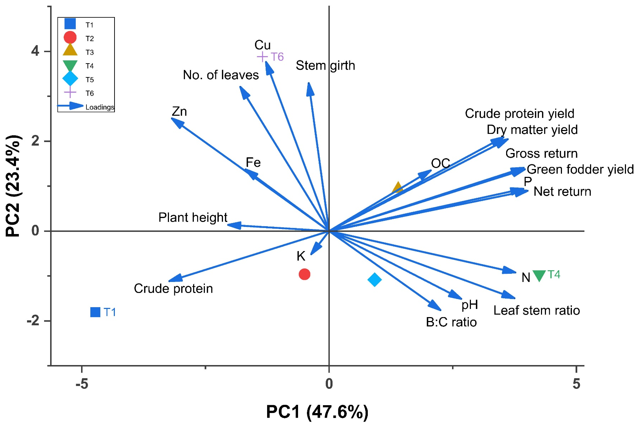
Fig 2. Principal Component Analysis (PCA) biplot showing the distribution of treatments (T1-T6) and loading vectors of measured parameters for Napier hybrid under micronutrient management

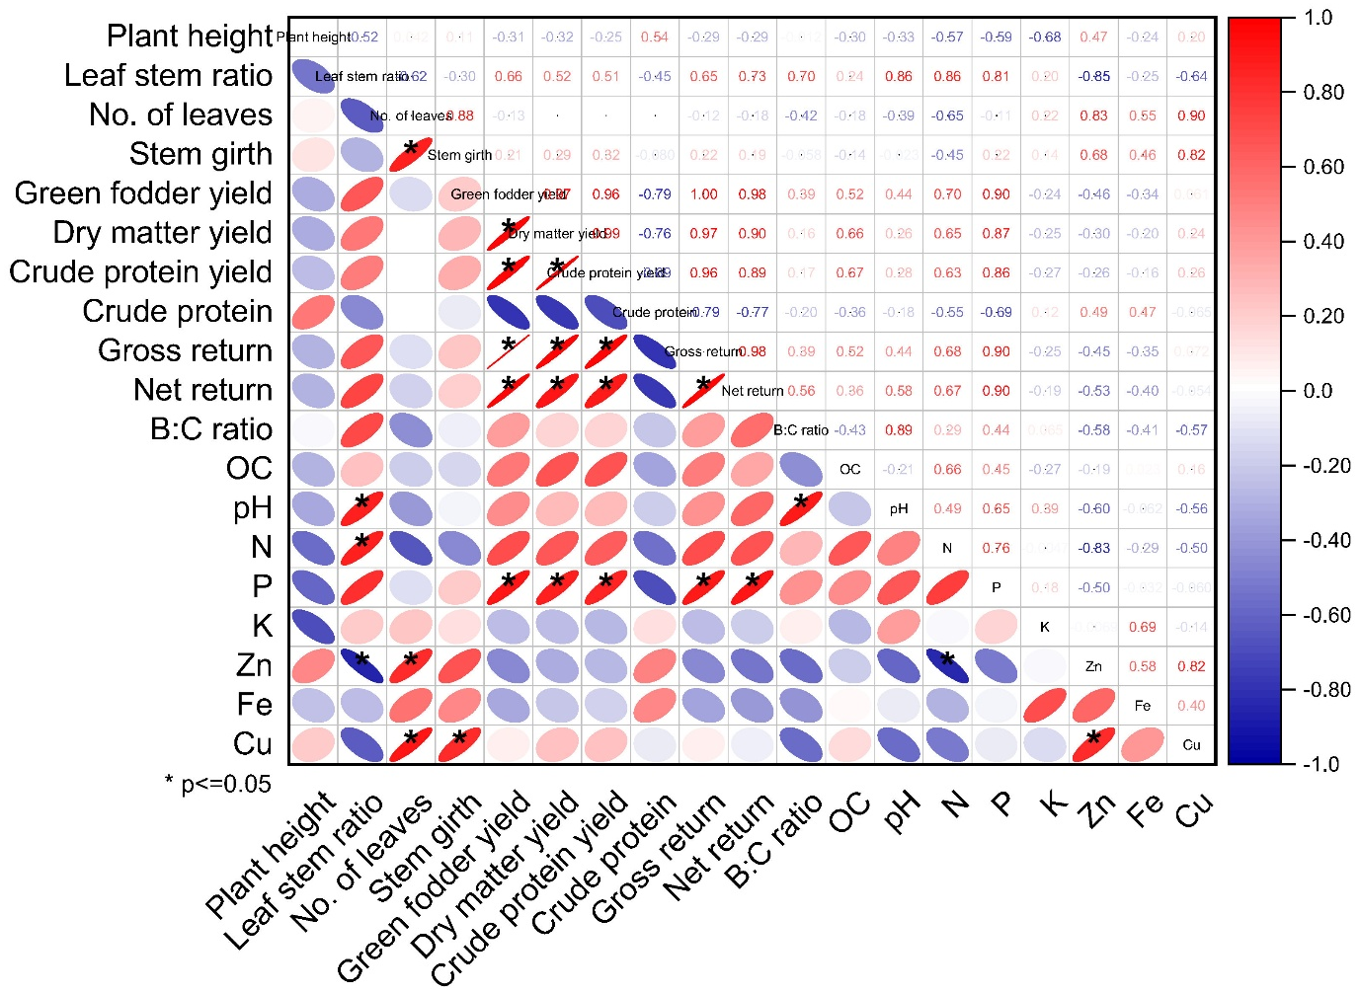
Fig 1. Correlation matrix showing relationships between growth, yield, quality, economic, and soil parameters of Napier hybrid under different micronutrient management treatments

