INCIDENCE AND PATHOLOGICAL CHARACTERIZATION OF LYMPHOID LEUKOSIS IN CROSSBRED NATIVE CHICKEN

ABSTRACT
Lymphoid leukosis (LL), a neoplastic disease caused by avian leukosis virus (ALV), continues to pose a major challenge to the poultry industry by reducing flock productivity and causing economic losses through mortality, reduced growth rate, and compromised egg production. Despite advances in breeding and management, LL remains endemic in many organized poultry farms across India, where crossbreeding programs have been widely adopted. The present study was undertaken to investigate the incidence and histopathological features of LL in crossbred native chickens maintained under organized farming systems. Affected birds presented clinical signs of weakness, reduced feed intake, progressive weight loss, and mortality. Postmortem examination revealed hepatomegaly, splenomegaly, and tumour-like nodular growths in visceral organs. Histopathological analysis confirmed the presence of diffuse lymphocytic infiltrations, obliteration of normal organ architecture, and mitotic figures, which are characteristic hallmarks of lymphoid leukosis. The findings not only establish the continued occurrence of LL in crossbred native chickens but also highlight the importance of histopathology in differentiating LL from Marek’s disease, which presents with overlapping gross lesions. The persistence of LL in crossbred populations emphasizes the urgent need for implementing effective disease control strategies, including strict biosecurity, genetic resistance screening, and the avoidance of vertical transmission through eradication of infected breeding stock. This study underscores the relevance of continuous surveillance, routine diagnostic evaluation, and awareness among poultry farmers to reduce the risk of LL spread. Future research should focus on molecular detection of ALV strains, genetic resistance markers, and the development of effective breeding and management strategies to minimize economic losses associated with LL.
Keywords: Lymphoid leukosis, crossbred native chicken, neoplastic lesions, histopathology
INTRODUCTION
Lymphoid leukosis (LL) is a common neoplastic disease in poultry, caused predominantly by avian leukosis virus (ALV) subgroups A and B. Its pathology is characterized by nodular to diffuse lymphoid infiltrations in visceral organs including the liver, spleen, bursa of Fabricius, kidneys, ovaries, mesentery, lungs and heart (Soujanya et al., 2019). Tumorous involvement of the liver is an important lesion in nearly all cases. Lymphoid leukosis was mostly observed in layer birds over 13 weeks of age and not in any of the tissues from broiler birds (Balachandran.et.al. 2009). Microscopically, LL is characterized by diffuse or coalescing areas of extravascular, immature lymphoid cells. The tumour cells typically resemble large lymphocytes or lymphoblasts, exhibit B-cell markers, and express surface IgM. The disease has an incubation period of over four months and originates in the bursa of Fabricius where lymphoid follicles undergo preneoplastic hyperplasia due to integration of ALV provirus into the c-myc gene, leading to Myc protein overexpression and disrupted B-cell differentiation. While many such lesions regress, some progress to nodular tumours visible by around 14 weeks of age. These neoplastic cells can metastasize to organs such as the liver and spleen, ultimately resulting in mortality (Pattison, Poultry Diseases, 6th Edition).
Infected birds typically show nonspecific clinical signs, including weight loss, anaemia, depression, and decreased productivity, which makes early clinical diagnosis difficult (Payne & Venugopal, 2000). Post-mortem examination reveals tumour nodules in visceral organs, and histopathology remains a gold standard in distinguishing LL from other neoplastic diseases, particularly Marek’s disease (MD), which primarily affects T-cells and involves the sciatic nerve (Zavala & Cheng, 2006: Ezeugwu et al., 2025).
Globally, lymphoid leukosis (LL) continues to challenge both backyard poultry keepers and commercial operations, particularly in regions without comprehensive eradication programs (Payne & Nair, 2012). The coexistence of native and commercial breeds in many developing countries acts as a viral reservoir, complicating control efforts (Elamurugan et al., 2015; Mo et al, 2022;). Additionally, vertical transmission of ALV-J—from hen to chick via the egg—secures viral persistence even under improved biosecurity measures (Li et al., 2017).
The significance of LL in poultry health management lies not only in its economic consequences but also in its potential to interfere with vaccination efficacy against other poultry pathogens, due to virus-induced immunosuppression (Payne & Venugopal, 2000). The continued occurrence of LL, even in crossbred and native chicken populations, highlights the importance of routine monitoring, histopathological confirmation, and policy interventions for effective control.
The present study was undertaken to investigate the occurrence of visceral lymphoid leukosis in crossbred native chickens presented for post-mortem examination. The work focused on gross and histopathological characterization of lesions in different visceral organs, differentiation from Marek’s disease, and assessment of implications for poultry health management under organized farming conditions.
MATERIALS AND METHODS
Sample Collection
Eight representative carcasses of crossbred native chickens of varying ages, which had succumbed to sudden mortality, were collected from organized poultry flocks. Each carcass was subjected to systematic postmortem examination. Tissue samples from grossly affected birds were collected under aseptic conditions for both cytological and histopathological analyses. In total, five out of eight carcasses (62.5%) exhibited tumorous lesions, and samples from these cases were processed further.
Gross Pathological Examination
All carcasses underwent thorough postmortem examination, with detailed recording of gross pathological changes in visceral organs such as the liver, kidneys, spleen, and intestines. Prominent findings included hepatomegaly, splenomegaly, and the presence of grayish-white nodular tumours, predominantly affecting the liver and kidneys. The extent, distribution, and morphological characteristics of the lesions were noted in detail, providing preliminary evidence suggestive of lymphoid leukosis.
Histopathological Examination
Tissue specimens collected from tumorous organs were fixed in 10% neutral buffered formalin immediately after collection to preserve cellular integrity. Fixed tissues were washed under running tap water, dehydrated in ascending grades of alcohol, cleared in xylene, and embedded in paraffin wax. Thin sections of approximately 5 µm thickness were obtained using a rotary microtome and mounted on clean glass slides. The sections were stained with Haematoxylin and Eosin (H&E) following the standard protocol described by Luna (1968). Microscopic examination was carried out using a compound light microscope to evaluate neoplastic changes.
The histological evaluation focused on identifying hallmarks of lymphoid leukosis, including diffuse or nodular infiltration of uniform lymphoblast-like cells, nuclear pleomorphism, and obliteration of normal tissue architecture (Payne & Nair, 2012; Soujanya et al., 2019).
Diagnostic Criteria
Cytological smears were prepared from impression samples of tumorous lesions, fixed with methanol, and stained with Giemsa stain for evaluation of cellular morphology. These smears revealed diagnostic features such as high cellularity, presence of lymphoblasts with vesicular nuclei, prominent nucleoli, and a high nuclear-to-cytoplasmic ratio, consistent with lymphoid leukosis. The combination of gross pathology, histopathology, and cytology provided a reliable diagnostic basis to differentiate lymphoid leukosis from Marek’s disease, as per established avian pathology guidelines (Payne & Venugopal, 2000; Payne & Nair, 2012).
RESULTS AND DISCUSSION
Out of the eight carcasses examined, five (62.5%) were diagnosed with lymphoid leukosis (LL) based on characteristic gross lesions, histopathological changes, and cytological findings. The tumours were observed as either discrete nodules or diffuse proliferations involving multiple visceral organs.
Gross Pathology
The most prominent lesion was hepatomegaly, with the liver markedly enlarged and showing multiple, firm, greyish-white to nodular neoplastic growths scattered across the parenchyma (Fig. 1). The kidneys were pale, markedly enlarged, and contained numerous surface nodules. The heart also exhibited multiple white nodules accompanied by generalized enlargement. These findings are consistent with the gross pathological features of LL reported earlier in native and commercial chickens (Sagarika et al., 2017; Soujanya et al., 2019).
An important diagnostic feature observed in this study was the absence of peripheral nerve enlargement. The sciatic nerves appeared normal, which helped in differentiating lymphoid leukosis from Marek’s disease, as the latter is classically characterized by nerve enlargement and infiltration (Payne and Nair, 2012). Similarly, there were no tumorous growths on the skin or feather follicles, further excluding Marek’s disease as a differential diagnosis. The localization of lesions to visceral organs, particularly the liver, kidneys, and heart, with sparing of peripheral nerves, is a hallmark feature of LL, as also highlighted by previous workers (Balachandran et al., 2009; Xu et al., 2004).
Fig.1. Liver showing nodular growths on the surface
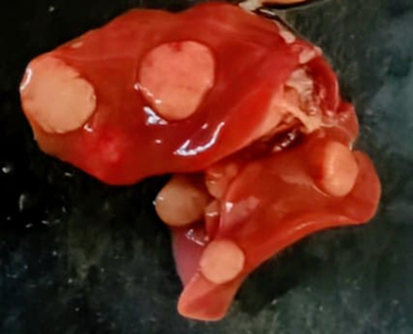 | 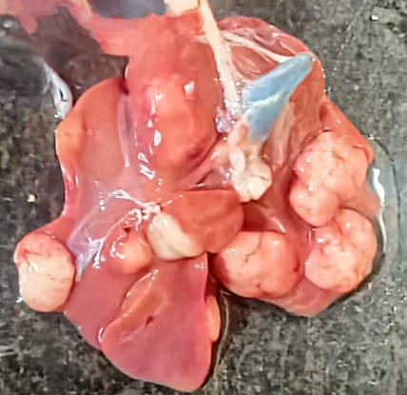
Fig.2. Enlargement of kidneys
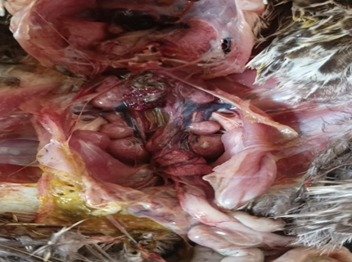
HISTOPATHOLOGY:
Histopathological evaluation provided critical evidence in differentiating lymphoid leukosis from Marek’s disease. The liver revealed multifocal proliferation of uniform neoplastic lymphoid cells consistent with findings reported by Sagarika et al. (2017). Haematoxylin and eosin (H&E, ×10) staining highlighted dense populations of lymphoblasts replacing normal hepatic architecture.
The kidneys were severely affected, exhibiting extensive interstitial infiltration of neoplastic lymphoblasts that almost completely replaced renal tubules (H&E, ×10). Such renal involvement is a characteristic lesion of lymphoid leukosis, as previously documented by Payne & Venugopal (2000).
Cardiac tissues showed severe infiltration of lymphocytes within the myocardium, leading to disruption of myocardial fibres (H&E, ×10). These lesions corroborate the systemic nature of the neoplasm. Importantly, no histological involvement of peripheral nerves was noted, further supporting the diagnosis of lymphoid leukosis over Marek’s disease (Davison & Nair, 2005).
The uniformity of lymphoid cells, lack of mitotic pleomorphism, and absence of intranuclear inclusion bodies served as additional confirmatory criteria for lymphoid leukosis, consistent with earlier comparative pathology reports (Payne & Nair, 2012).
Fig.3. Liver showing uniform neoplastic lymphoid cells | Fig.4. Kidney showing severe interstitial infiltration of lymphoblasts
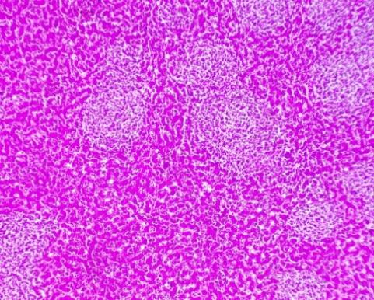 | 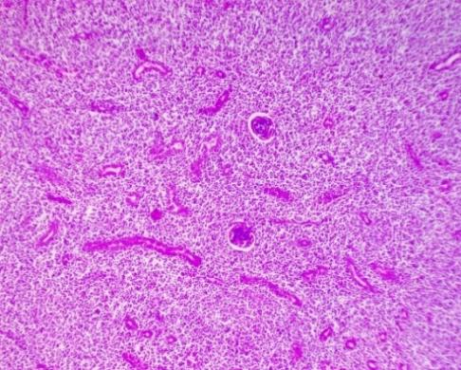
Fig.5. Heart showing infiltration of lymphocytes in myocardium
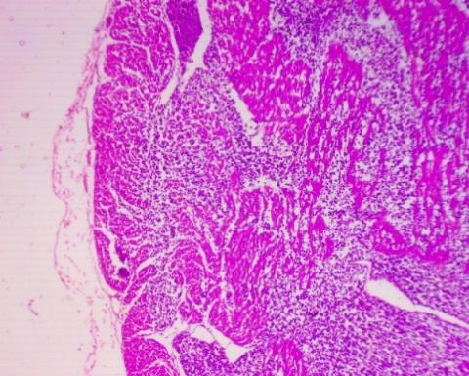
CYTOLOGY
Cytological examination of impression smears from the affected visceral organs revealed high cellularity with a predominance of large, discrete lymphoblasts. These cells exhibited round to oval vesicular nuclei with finely dispersed chromatin, a high nuclear-to-cytoplasmic ratio, and one to multiple prominent nucleoli. The cytoplasm was scant to moderate and basophilic (Giemsa, ×40). These findings are in accordance with previous reports of lymphoid leukosis in poultry, where lymphoblast-like cells were identified as the predominant neoplastic population (Ravikumar et al., 2019; Kishore et al., 2022).
The uniform morphology of the lymphoblasts, along with the absence of marked cellular pleomorphism, served as a distinguishing feature from Marek’s disease, which typically demonstrates pleomorphic lymphoid cells with mitotic activity (Balachandran et al., 2009; Sagarika et al., 2017). Similar cytomorphological patterns of lymphoblast infiltration have also been reported in other avian species, further confirming the diagnostic value of cytology in lymphoid leukosis (Abdelmenem et al., 2024; Ramya et al., 2024).
Thus, cytological evaluation provided a rapid, reliable, and cost-effective diagnostic adjunct to histopathology, supporting earlier observations on the role of cytology in avian leukosis complex diagnosis (Sagarika et al., 2017; Ezeugwu et al., 2025).
Fig.6. Impression smears showing high cellularity with numerous large, discrete lymphoblasts
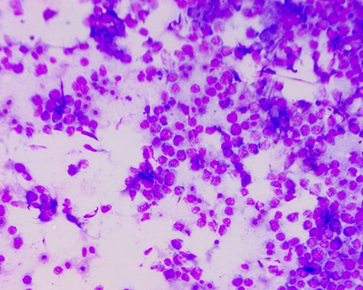
CASE DIAGNOSIS
The overall gross, histopathological, and cytological findings are consistent with visceral lymphoid leukosis (LL) characterized by multisystemic involvement, particularly of the liver, kidneys, and intestine. The neoplastic lymphoblast proliferation in visceral organs without involvement of the sciatic nerve strongly supports the diagnosis of LL and helps to differentiate it from Marek’s disease, which typically shows peripheral nerve enlargement as a key lesion (Payne and Venugopal, 2000; Zavala and Cheng, 2019). The presence of uniform lymphoblasts with scant cytoplasm and prominent nucleoli on cytology, along with multifocal infiltrations in the parenchymal organs, further consolidates the diagnosis. These findings are in close agreement with earlier reports on lymphoid leukosis in poultry, where similar systemic lesions were described (Payne & Nair, 2012; Xu et al., 2004; Ezeugwu et al., 2025).
Table 1. Diagnostic features observed in the present case of visceral lymphoid leukosis in cross bred native chicken.
Organ/System | Histopathological / Cytological Findings | Diagnostic Significance | Reference
Liver | Multifocal proliferation of uniform neoplastic lymphoid cells (H&E ×10) | Consistent with LL tumorigenesis; liver is the most affected organ | Payne & Nair, 2012; Ezeugwu et al., 2025
Kidneys | Severe interstitial infiltration of lymphoblasts replacing renal tubules (H&E ×10) | Indicates systemic infiltration, common in LL cases | Zavala & Cheng, 2006
Heart (Myocardium) | Dense infiltration of neoplastic lymphocytes (H&E ×10) | Multisystemic involvement characteristic of LL | Fadly & Nair, 2008
Peripheral Nerves (sciatic) | No lesions or enlargement detected | Differentiates LL from MD. MD shows nerve enlargement and demyelination | Payne & Nair, 2012
Cytology (Impression Smear) | Numerous large lymphoblasts with round vesicular nuclei, prominent nucleoli, high N:C ratio, basophilic cytoplasm (Giemsa ×40) | Supports malignant lymphoid proliferation; cytology helpful for rapid LL confirmation | Zavala & Cheng, 2006

CONCLUSION
Lymphoid leucosis (LL) continues to pose a major threat to poultry health, leading to tumour development in multiple visceral organs and causing substantial economic losses through mortality and decreased productivity. The present investigation confirmed the occurrence of LL in crossbred native chickens with multisystemic organ involvement, notably the liver, kidneys, and intestines. Importantly, the absence of sciatic nerve lesions allowed clear differentiation from Marek’s disease, reaffirming the diagnostic value of histopathological and cytological examinations. These findings, consistent with earlier reports (Payne & Nair, 2012; Elamurugan et al., 2015; Mo et al., 2022; Ezeugwu et al., 2025), underscore the persistent presence of LL in organized poultry production systems. Strengthening biosecurity, implementing effective breeding and eradication programs, and adopting rigorous diagnostic surveillance remain critical measures to prevent disease spread and minimize its impact on poultry production.
Policy Recommendations, Limitations, and Future Prospects
The persistence of lymphoid leucosis (LL) in organized poultry production systems highlights the urgent need for integrated disease control strategies. Policy initiatives should focus on the implementation of stringent breeding and biosecurity programs, including the selection of resistant genetic lines and routine screening of breeder flocks for avian leukosis virus (ALV) contamination (Payne & Venugopal, 2000; Fadly & Nair, 2008; Elamurugan et al., 2015). Since LL contributes to economic losses through reduced productivity and mortality, government-supported compensation schemes and farmer training modules may help minimize financial impacts and improve adoption of preventive measures (Ezeugwu et al., 2025).
Despite the importance of these findings, this study has certain limitations. The sample size was restricted to a small group of crossbred native chickens, which may not fully represent the broader epidemiological status of LL across different regions and poultry production systems. Furthermore, the study primarily relied on histopathological examination, while advanced molecular diagnostic techniques (PCR, sequencing) were not employed, limiting the ability to confirm viral subgroups or detect latent infections (Zavala & Cheng, 2006).
Future research should prioritize molecular characterization of ALV subgroups in Indian poultry to identify circulating strains and their pathogenic potential. Additionally, exploring host–pathogen interactions through immunogenetic studies may offer new insights into resistance breeding strategies. Long-term prospects include development of marker-assisted selection programs for LL resistance and the integration of omics-based approaches (genomics, transcriptomics, and proteomics) to uncover biomarkers for early disease detection (Fadly & Nair, 2008; Payne & Venugopal, 2000).
By combining policy-driven control programs, farmer awareness initiatives, and advanced research methodologies, the poultry sector can work towards reducing the burden of LL and ensuring sustainable production in the future.

REFERENCES:
- Abdelmenem Ahmed Elmeligy, Ali A. Ghania, Ahmed Fotouh. 2024. Pathological and immunohistochemical studies of lymphoid leukosis in pigeons in Egypt. Open Veterinary Journal, 14(8): 1952–1959.
- Balachandran, C., Pazhanivel, N., Vairamuthu, S., & Murali, M. B. 2009. Marek’s disease and lymphoid leukosis in chicken: A histopathological survey. Tamilnadu Journal of Veterinary and Animal Sciences, 5(4), 167–170.
- Davison, F. & Nair, V. 2005. Use of Marek’s disease vaccines: could they be driving the virus to increasing virulence? Expert review of vaccines, 4(1), 77-88.
- Elamurugan, A., Karthik, K., Badasara, S. K., Hajam, I. A., & Saravanan, M. (2015). Novel insights into identification of shedders and transmitters of avian leukosis virus. Asian Pacific Journal of Tropical Disease, 5(Suppl. 1), S192–S201.
- Ezeugwu C. C., Olanrewaju S. O., Olatunde B. A, Fatima S. 2025. Journal of Veterinary and Applied Sciences, 15(1): 1050 – 1058.
- Kishore, G., Reddy, M.R., Kumar, A.M. and Singh, V. 2022. Prevalence of viral neoplastic diseases with special reference to avian leukosis and their infectious status in different pure line indigenous chickens. Indian J. Vet. Pathology, 46(2): 126-135.
- Li, Y., Cui, S., Li, W., Wang, Y., et al. 2017. Vertical transmission of avian leukosis virus subgroup J (ALV-J) from hens infected through artificial insemination with ALV-J infected semen. BMC Veterinary Research, 13, 204.
- Mo, G., Wei, P., Hu, B., Nie, Q., & Zhang, X. 2022. Advances on genetic and genomic studies of ALV resistance. Journal of Animal Science and Biotechnology, 13, 123.
- Payne, L. N., & Venugopal, K. 2000. Neoplastic diseases: Marek's disease, avian leukosis and reticuloendotheliosis. Revue Scientifique et Technique-Office International des Epizooties, 19(2), 544-560.
- Payne, L. N., & Nair, V. 2012. The long view: 40 years of avian leukosis research. Avian Pathology, 41(1), 11–19.
- Ramya R., Jayanthi N., Kalaiselvi G., et al. 2024. Co-existence of fowl cholera and lymphoid leucosis in Desi chickens. Int. J. Vet. Sci. Anim. Husbandry, 9(2): 687–691.
- Ravikumar, Y., Reddy, B. A. K., Namratha, M. L., Ramesh, G., et al. 2019. Lymphoid Leucosis and Marek’s Disease in Chicken–Gross and Histopathological Studies. Journal of Livestock Research, 9(8), 140-144.
- Sagarika S., Das D., Panda S.K., Das S., et al. 2017. Avian leukosis in chickens: A clinico-pathological survey. J. Entomol. Zool. Stud., 5(6): 1697–1701.
- Soujanya, S., Lakshman, M., & Madhuri, D. 2019. Occurrence of lymphoid leukosis in chicken. The Pharma Innovation Journal, 8(1), 159–162.
- Xu, B., Dong, W., Yu, C. Y., He, Z., et al. 2004. Occurrence of avian leukosis virus subgroup J in commercial layer flocks in China. Avian Pathology, 33(1), 13–17.
- Zavala, G, & Cheng, S. 2006. Detection and Characterization of Avian Leukosis Virus in Marek's Disease Vaccines. Avian Diseases , 50(2): 209-215.
- Luna GLHT (1968). Manual of histological and special staining techniques. Edn 2, the Blakistone Divison McGraw-Hill Book Company, New York, Toronto London. 1-5:9-34.
- Pattison, M., McMullin, P. F., Bradbury, J. M., & Alexander, D. J. (Eds.). (2008). Poultry diseases (6th ed.). Saunders Elsevier.
- Fadly, A.M. and Nair, V. 2008. Leukosis/sarcoma group. In Y.M. Saif, A.M. Fadly, J.R. Glisson, L.R. McDougald, L.K. Nolan and D.E. Swayne (Eds.). In Diseases of Poultry, 12th edition (pp. 514-568). Ames, IA: Blackwell Publishing.

