Performance optimization of happy seeder parameters for wheat sowing under anchored stubble

Abstract
India, second-largest producer of rice and wheat in the world, continues to face perilous challenges in managing rice residues, particularly in the Indo-Gangetic Plains (IGP). In regions such as Punjab and Haryana, the happy seeder has emerged as a promising intervention, offering a partial solution to the widespread practice of rice straw burning. However, its large-scale adoption remains limited beyond northern India, primarily due to high power requirements, excessive fuel consumption, and the prevalence of small landholdings. To address these limitations, this study investigated the field performance of a modified happy seeder (HS2) outfitted with double-disc furrow openers and compared it with the conventional happy seeder (HS1) having inverted T-type openers. Both implements were assessed for direct wheat sowing in combine-harvested, anchored paddy fields across three sowing depths (30, 50, and 70 mm) and three forward speeds (2, 3, and 4 km/h). The findings demonstrated that the draft requirement and fuel consumption were significantly lower for HS2 compared to HS1. Furthermore, HS2 enhanced plant population and grain yield, with both implements performing optimally at a sowing depth of 50 mm. Response Surface Methodology (RSM)-based optimization identified the most favorable operating conditions for HS2 as 4 km/h forward speed and 42 mm sowing depth. Under these operational setting, HS2 recorded fuel consumption of 12.58 l/ha, draft force of 3063 N, plant population of 122 plants/m², and grain yield of 2895 kg/ha. These findings confirm that the modified happy seeder (HS2) not only lowers operational costs but also enhances agronomic performance, thereby presenting a more environmentally sound alternative for wheat establishment under anchored paddy stubble conditions.
Keywords: Happy seeder, Conservation agriculture, Response Surface Methodology (RSM), Double disc opener, Inverted-T opener, Sustainable Agriculture

Introduction
India ranked 2nd in rice and wheat production in the world (ACIAR 2012). Rice (Oryza sativa) is the principal food source as well as the largest exported crop of India. Indo-Gangetic Plains (IGP) is one of the suitable regions for growing of rice and wheat crop in South Asia. In India around 10 million hectares land comes under rice-wheat cropping system [1].The availability of high yield variety rice and wheat crop, various machinery, irrigation water, and chemical fertilizers has changed the overall production of yield as well as crop residues after green revolution. Increase in farm mechanization subsequently reduced the labor and animal power requirements in this region. Most of the farmers now a days uses combine harvester to harvest paddy, leaving the straw on the field. Incorporation of straw before sowing of next crop requires huge number of tillage operation. This led to burning of straw, the easiest solution for the farmers to clean their field in the cheapest[2], [3]. Around 23 million tons of rice straw is produced annually in India, out of which 80% rice straw is directly burnt in the field [4].
Most of the farmers from north western states used to burn the rice residue in field, demoting the capital of India to fifth polluted city in the world [5]. 11.3 Mt of paddy straw was burned by the farmers of Punjab and Haryana in 2018 out of which 88.1 % was contributed by Punjab itself [6]. Burning straw in open fields has a negative impact on the environment, contributing to air pollution and greenhouse gas emissions. Burning of straw releases carbon monoxide (CO), nitrogen oxides (NO_{x}), sulphur dioxide (SO₂) and other harmful gases and particulates into the atmosphere. Open burning of one kilogram of dry rice straw produces about 700–4100 mg of methane (CH4) and 19–57 mg of nitrous oxide (N₂O) [7]. Now a days residue burning becoming a severe threat to human as well as animal health. About 25% of carbon monoxide (CO) and black carbon are released during residue burning, along with approximately 9-13% of carbon dioxide (CO₂) and particulate matter (PM2.5) [8]. Excessive burning of residue not only affecting the global climates, also hampering the natural ecosystem in long term. The presence of GHGs, particle matters and different volatile organic compound forming brown cloud in the atmosphere, deteriorating the air quality index as well the visibility [9].
Open burning of rice residue in the field adversely affects the soil health and plant nutrients. It was recorded that 59,000 t of N, 20,000 t of P, 34,000 t of K and 3.85 Mt of organic carbon were lost due to the burning of rice straw in Punjab[10]. Heat generated during burning of residue not only destroy the soil organic compound but also kills the various microorganism, which are essential for plant growth [6]. Direct residue burning impacts soil biodiversity and hastens soil erosion, both of having a negative effect on the sustaining functions that soils provide [11].
Retention of paddy straw or straw incorporation is a valuable resource for soil to restoring its organic matter and nutrients. Incorporation of fresh rice straw has the ability to retain potassium (35.34 kg/ha), phosphorus (1.86 kg/ha), and nitrogen (14.26 kg/ha) in the soil [12]. On field management of loose rice straw is very difficult prior to tillage operation as well as showing operations. Use of different machinery for managing the rice residue is an energy intensive process while manual management can delay the wheat sowing [13]. Sowing of wheat before 15 November is most economical time for better yield, delay of sowing can result in loss of 1% yield per day [14]. Lack of suitable machinery is one of the major problems for directly sowing of seed into heavy stubble field.
Happy seeder has the ability to directly drilling of wheat into combine harvested rice field. happy seeder can cut the standing rice straw and spread them during the sowing process. Compared to conventional sowing, the combo happy seeder resulted in 50–60% lower operational costs for wheat seeding. Soil moisture conservation, weed control, saving of fertilizer are the key component of happy seeder. However, high power requirement and low germination under heavy straw load is the major constrain for limiting the adaptation of happy seeder [13]. Therefore, this study aimed to compare the performance of conventional and modified happy seeders and optimize their operating parameters for efficient wheat establishment under anchored paddy stubble.

Materials and methods

Experimental site and climatic conditions
The experiment was conducted at Mondouri teaching farm of Bidhan Chandra Krishi Viswavidyalaya, West Bengal, India during 2023-2024. The site is located at a latitude and longitude of 22.56°N and 88.32°E respectively. The average monthly rainfall and temperature of the experimental site is presented in Fig. 1. The soil of the experimental plot was sandy loam with a bulk density of 1.21g/cm³. Fig. 2 shows the average penetration resistance offered by the soil up to 30 cm depth.

Fig. 1. Monthly average rainfall and temperature data of the experimental site during 2023-24

Fig. 2 Cone penetration resistance up to 30 cm depth of soil

Experimental details
Performance of happy seeder was evaluated during cultivation of wheat on the combine harvested paddy field. Existing happy seeder (HS1) was modified by changing the inverted-T furrow openers (Fig. 3b), with double disc (HS2) furrow openers (Fig. 3c). The overall specification of happy seeder is presented in Table 1. Both the happy seeders were operated at three different depth 30, 50, 70 mm (D1, D2 and D3) and speeds 2, 3 and 4 km/h (S1, S2 and S3). The experiment was conducted in accordance with Central Composite Design (CCD). Wheat was sown by the happy seeders (Fig. 3a) on the nine plots having dimensions of 20m × 5m with different combination of speed and depth viz. S1D1, S1D2, S1D3, S2D1, S2D2, S2D3, S3D1, S3D2 and S3D3 during the last week of November.
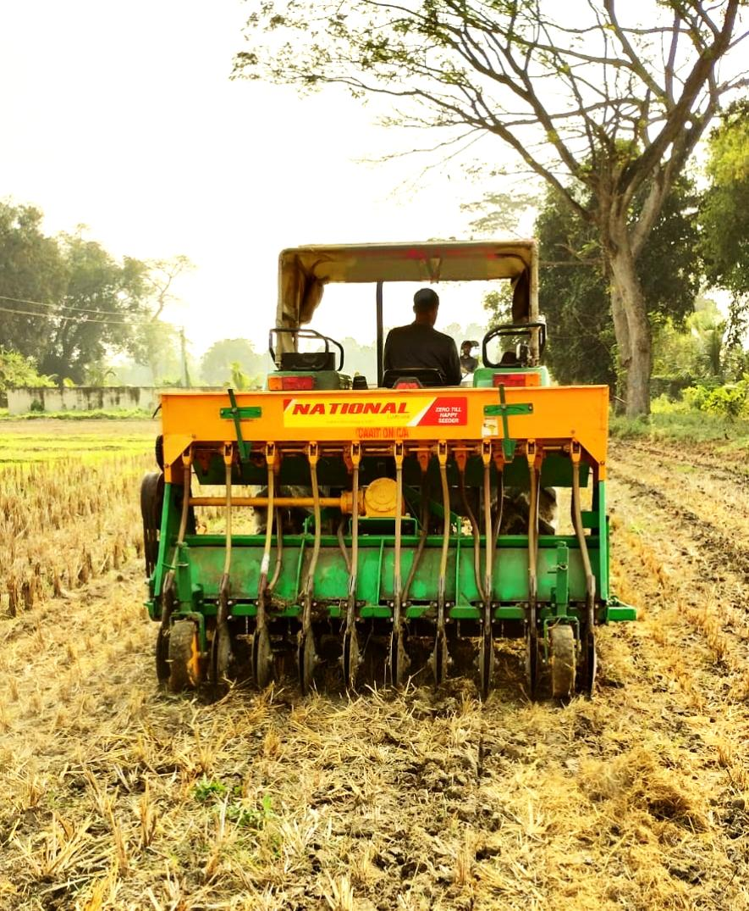
a.
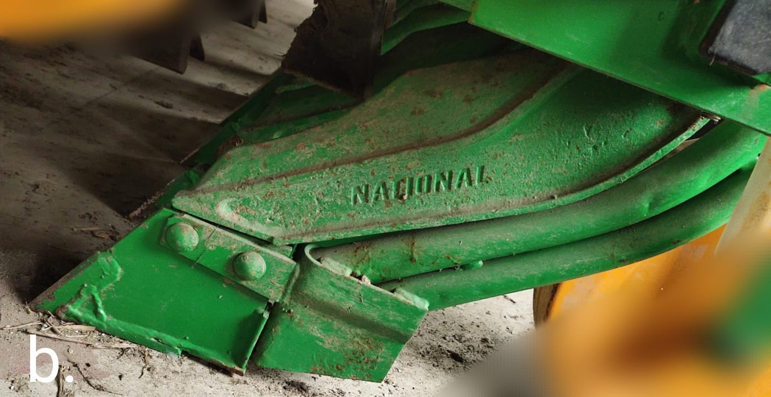 | 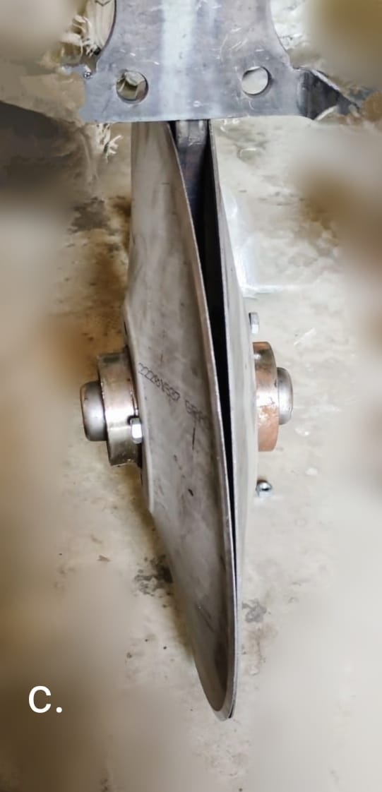
Fig. 3. (a) Evaluation of happy seeder at field (b) inverted-T type furrow opener
(c)double disc furrow opener
Herbicides (Glyphosate @ 5ml/l) was applied 7 days prior to the sowing of wheat to control the weeds. After sowing Pendimethalin was applied at rare of 1.1 kg ai/ha. Recommended dose of fertilizer (NPK) was applied in the each of the plots. Intercultural operations and manual weeding were done according to the requirement. Sowing operation was conducted in the standing stubble field. Whereas, Table 2. shows the properties of stubble and soil conditions of the experimental field. Wheat was harvested in the last week of March.
Table 1. Specification of existing happy seeder
Sl. No. | Particular | Specification
 | Number of rows | 10
 | Mounting type | Tractor mounted
 | Power required, kW | 37.5
 | Transmission system | Tractor PTO (540 rpm)
 | Working width, mm | 2250
 | Machine height, mm | 1480
 | Gear box | Bevel crown wheel and pinion
 | Nos. of depth wheels | 2
 | Ground diameter, mm | 730
 | Weight (kg) | 520
Straw management Unit
 | External diameter, mm | 120
 | Rotor thickness, mm | 5
 | Transmission shaft diameter, mm | 60
 | Drum diameter, mm | 750
 | Working rpm | 1000-1300
 | Number of flails | 20
 | Peripheral flail tip speed (m/s) | 35.1 at 1000 rotor rpm
 | Flail type | inverted ‘γ’
 | Blade overlap with furrow openers, mm | 60
Sowing Unit
 | Number of tool bars | one
 | Number of furrow openers | 10
 | Type of furrow openers | Inverted T-type
 | Row spacing, mm | 225
 | Seed metering device | Fluted feed rollers
 | Fertilizer metering device | Fluted feed rollers
 | Straw placement | In between the two seeded rows
Draft, fuel consumption (FC), and effective field capacity (EFC) were recorded during the sowing of wheat by the happy seeder. A digital three-point hitch dynamometer (monad electronics), which can directly fit in between three-point linkage of tractor and happy seeder, was used to measure the draft force. Fuel consumption was measured by attaching separate measuring cylinder to the engine of the tractor. EFC at different depth and speed was calculated by using the formula given by Kepner et al. (1980). EFC (ha/h) is the actual field covered by the machine per unit time including all the time losses. EFC of a machine mainly depends on the working width, speed of operation, field time loss (turning time loss, refilling of seed, fertilizer, minor maintenance and adjustment etc.)
$EFC=\frac{S×W}{10}×η$ (1)
Where,
S= Forward speed of the machines, km/h
W = working width of machine, m
η = field efficiency, %
η = $\frac{T_{o}}{T_{e}+T_{h}}×100$ (2)
T_{o} = Theoretical time, h/ha
T_{e} = Effective operating time, h/ha
T_{e} = T_{o} ×100 × k
k= portion of implement width actually used. %
T_{h} = Time lost due to turning and minor adjustments etc. h
Table 2. Stubble and soil properties of the field
Particulars | Unit | Amount
Stubble height | cm | 37
Moisture content of stubble | % | 48
Straw load | t/ha | 5
Soil moisture content | % | 15.3
Bulk density | g/cm³ | 1.21

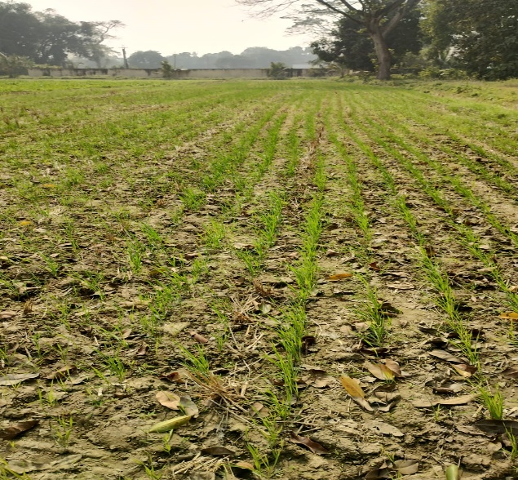 | 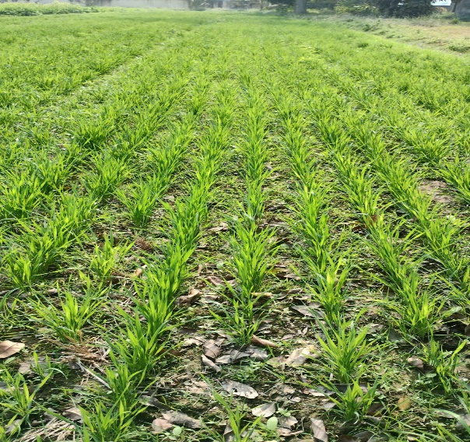
a | b
Fig. 4. Wheat plants after (a) 15 days and (b) 30 days of sowing

Crop husbandry and measurement of yield attribute
DBW-90 variety wheat seed was used in the experiments at a seed rate of 100 kg/ha. Equal amount of fertilizer (NPK) was applied in each of the plot at the ratio of 120:60:50. Intercultural operation was done at a certain interval of time according to the weed density. Approximately 50 mm irrigation water was applied whenever there was a shortage of water in the plots. After 15 days of sowing average plant population data from 1 m² area of each plot was recorded (Fig. 4 a and b). Yield of wheat crop from each and every plot was determined by manually harvesting and threshing them at maturity. Wheat was harvested in the last week of March.

Statistical analysis
ANOVA was used to assess whether the treatments differed significantly in their performance. When the F-test indicated significant variation, the critical difference (CD) at p < 0.05 was calculated to compare treatment means. The F-value, or F-statistic, expresses the ratio of variation between treatment means to the variation within treatments and indicates whether the observed differences are statistically meaningful. To further refine the results, response surface methodology (RSM) was applied which helped to explore how different operating factors influenced machine performance and to determine the most effective combination of settings for maximizing the efficiency of the happy seeder. In a nutshell, the ability of RSM to optimize the best possible solution of the input parameter to get the desirable output was the basis of its implementation in this study.

Results and discussion

Draft requirement
In zero tillage condition the type of furrow opener (shape and size) and its manner of movement inside the soil plays an important role in draft requirements besides the soil conditions. Relation between draft requirement and different operating conditions (depth and speed) is presented in Fig. 5. Maximum draft of 7170 N was exerted by the happy seeder (HS1) with inverted-T furrow opener at a speed and depth of 4 km/h and 70 mm respectively, while 4500 N draft force was recorded during the operation of HS2 at this same operating condition. This might be due to the design of furrow opener, as double disc work on the rolling action while inverted T on the sliding action [15], [16]. For both the scenario HS1 and HS2 highest draft force was observed at maximum speed and depth. HS2 shows lowest draft of 2330 N while operating at 2 km/h speed and a depth of 30mm. Operating HS2 in the combination of S1D3 and S2D3 offered 49.4% and 47.2% less draft than HS1. Inverted T create trench by lifting and displacing the soil, which increases the soil resistance and leads to higher daft force, whereas double disc cuts through the soil by slicing action with minimum soil disturbance reduces the draft requirements [17], [18].
It is clearly indicated that depth of operation and speed of operation has significant effect of draft requirement [19]. For both the scenario HS1 and HS2 draft varies directly with depth and speed of operation. In each operating condition HS1 exert more draft requirement than HS2. At the operating depth of 50mm HS2 exerts only 61, 6.5 and 57.4 % of the total draft exerted by HS1 at the forward speed of 2, 3 and 4 km/h respectively, this is the clear indication of higher soil resistance offered by the inverted T furrow opener due to its larger surface area interaction with soil [19], [20].
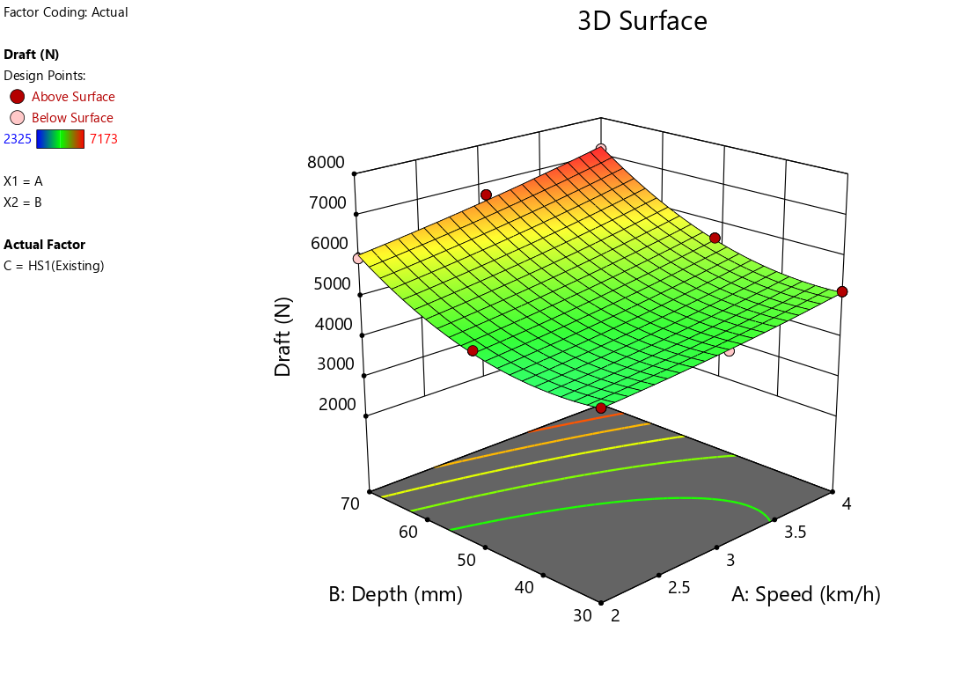 | 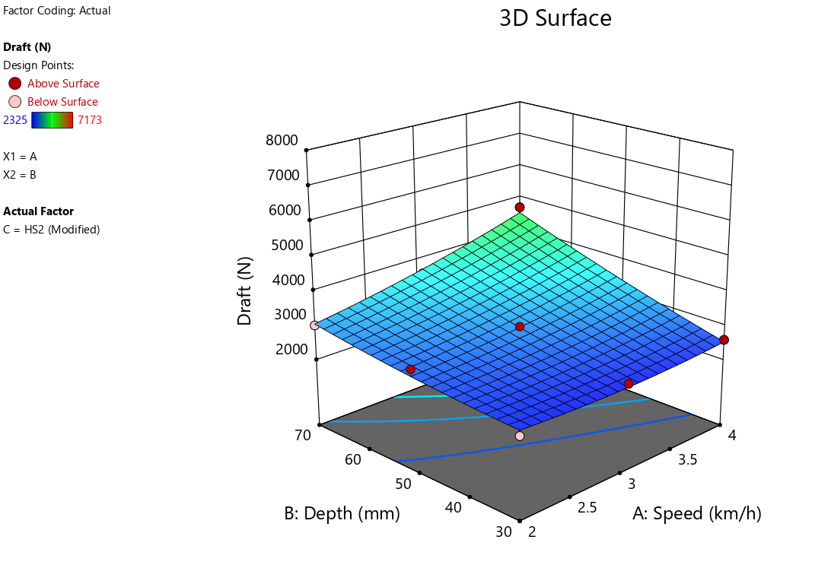
a | b
Fig. 5. Variation of draft requirements with depth and speed of operation (a) HS1 (b) HS2

Fuel consumption
The forward speed and operating depth of zero-till drills additionally influence fuel consumption. The draft force required to run the machinery increases with depth and speed, which raises fuel consumption. Maximum fuel consumption of 17.8 l/ha was recorded during the operation of HS1 at maximum depth and speed (S3D3), whereas HS2 consumed 17.2% (14.74 l/ha) less fuel (Fig. 6). Power requirement is the function of speed and depth of operation, [21] power requirement increases with increase in depth and speed of tillage, leads to higher fuel consumption. HS2 shows minimum fuel consumption of 11.98 l/ha during operating it at minimum speed and depth (S1D1). HS2 consumed 18.7, 18.3 and 16.9% less fuel than HS2 while operating in the combination of S1D2, S2D2 and S3D2. About 9-16% increment in fuel consumption was observed for both the machine, during increasing the depth of operation from 50 mm to 70 mm at different speed.
It was reported that both forward speed and operating depth have an impact on fuel usage in zero-till seed drills. The draft force needed to run the equipment increases with depth and speed, which results in increased fuel consumption [22]. Higher speed increases the soil resistance and tractor wheel slip, thus results in less fuel efficiency. Depth and speed of operation is directly related to the draft force, the higher the draft force greater the power requirement, leading to high fuel consumption [20], [21], [23], [24].
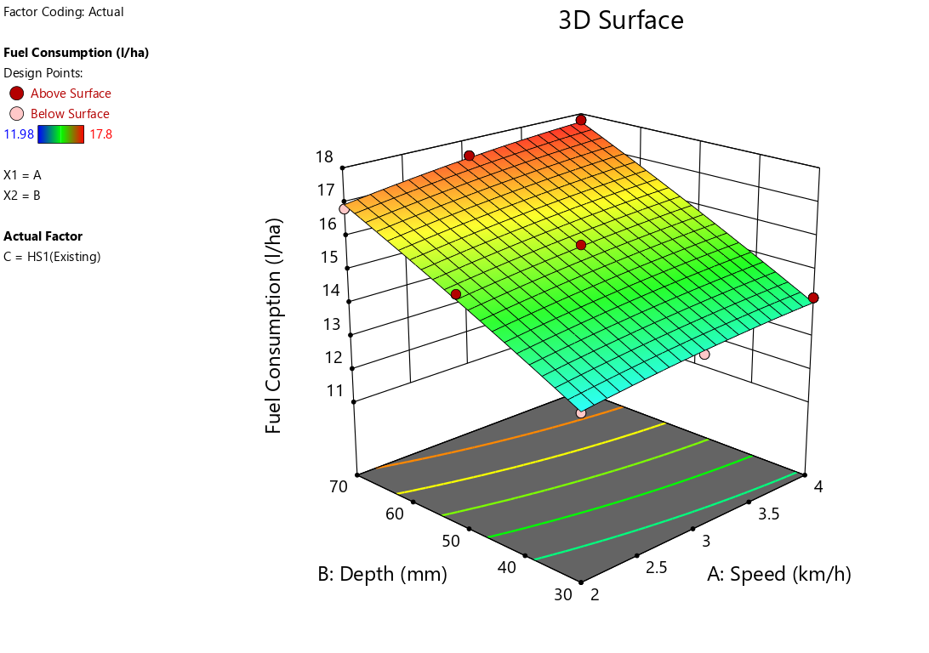 | 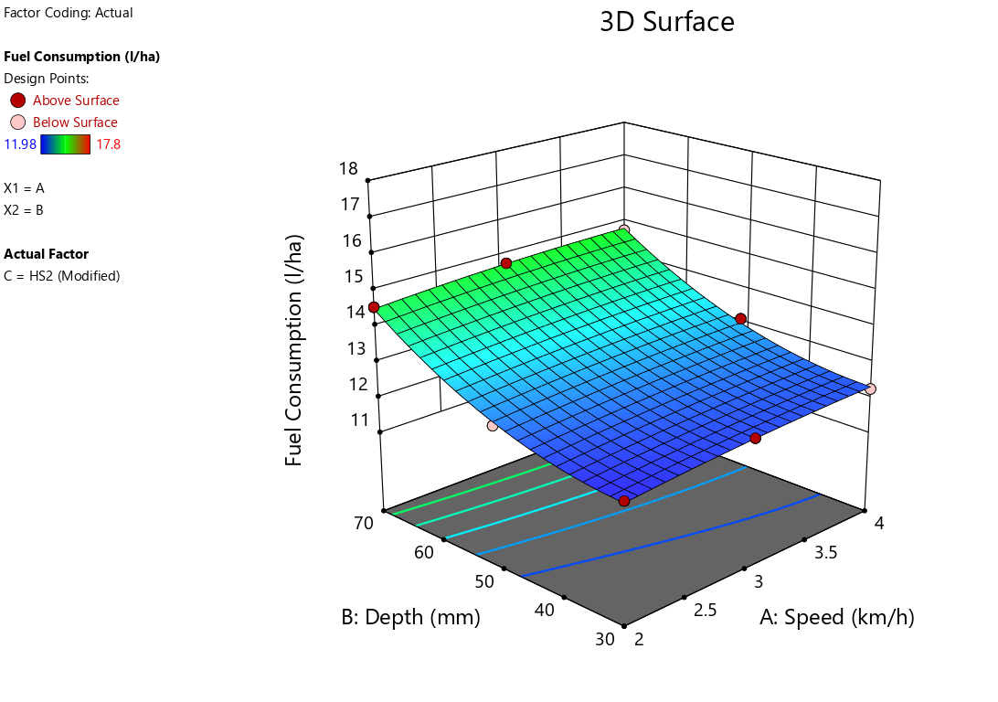
a | b
Fig. 6. Variation of fuel consumption with depth and speed of operation (a) HS1 (b) HS2

Plant population
The depth at which wheat is sown significantly impacts its successful germination. Ensuring an optimal sowing depth is crucial for seeds to reach the moisture required for effective germination. Plant population mostly depends on the germination of seed. Maximum plant population (131 plants/m²) was observed in the treatments where existing happy seeder was operated at a depth of 50 mm. Number of plant decreases when depth of operation escalated from 50 mm to 70 mm for each and every configuration (Fig. 7). Minimum plant population (79 plants/m²) were observed in the treatments where modified machine was operated at a depth and speed of 70 mm and 4 km/h respectively. Plant population in the plot where existing machine was operated was more in number than the modified one. Plant population of 103,131 and 91 was observed in the existing machine operated plot while operated at constant speed of 3 km/h and at different depth of 30, 50 and 70 mm respectively, whereas 98, 121 and 87 plants/m² was observed in the modified machine operated plots.
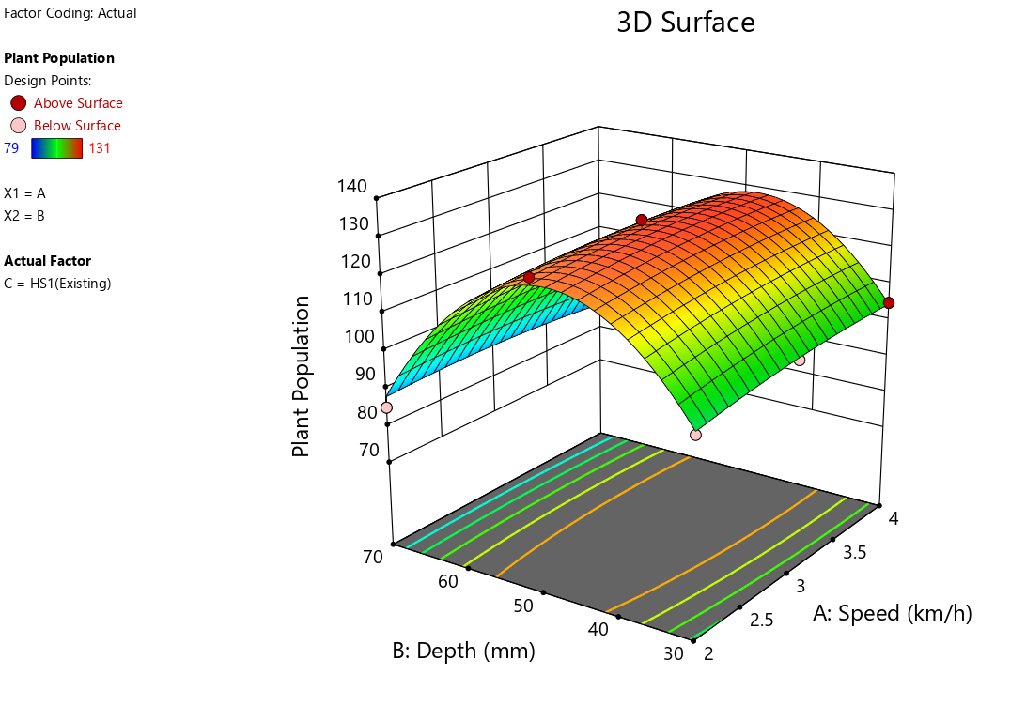 | 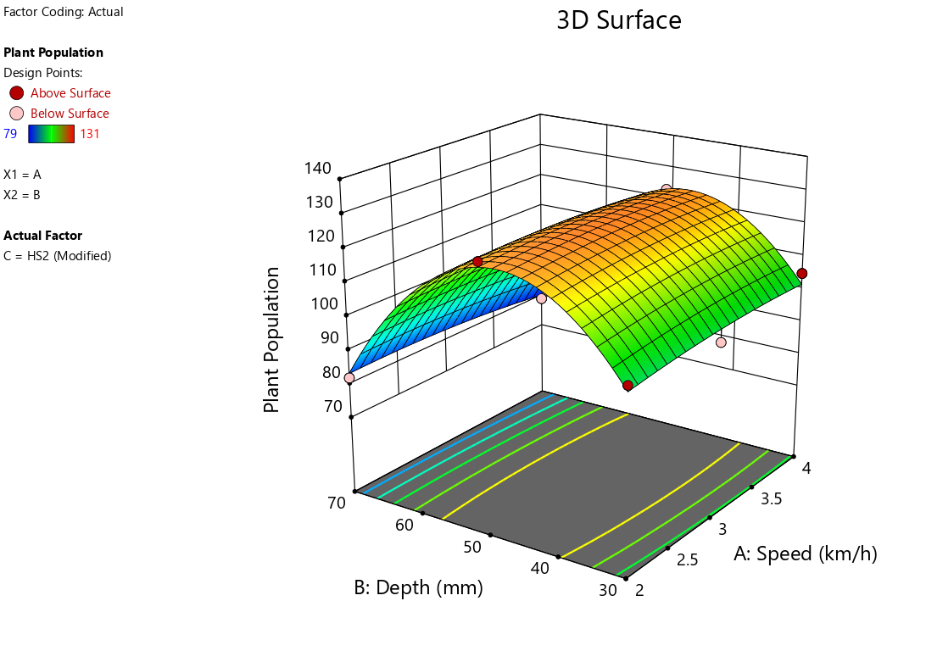
a | b
Fig. 7. Variation of plant population with depth and speed of operation (a) HS1 (b) HS2
Most satisfactory result was obtained at 50 mm seeding depth for both configuration (existing and modified). Studies shows that sowing wheat at shallower depth typically at 50 mm encourages higher germination rates compared to deeper sowing [25]. Higher depth operation hampers the germination due to poor aeration, soil compaction, excess moisture content, where poor soil cover during shallow depth of operation also disturbed the seed germination [26], [27]. Germination of wheat was drastically reduced at all the plots where both the machine was operated at 70 mm depth. Experiments have shown that reducing the forward speed of planting machinery can improve seed placement accuracy and, consequently, germination rates. Specifically, slower speeds enhance the likelihood that seeds will be sown at the proper depth, thus promoting better moisture absorption necessary for germination [28], [29].

Grain yield
Yield of wheat crop mostly depends on the plant population and then plant health. Maximum yield of 2889 kg/ha was registered from S2D2 plot where existing machine (HS1) was operated (Fig. 8). Negligible difference in grain yield was observed between the existing and modified machine operated plot. Minimum yield of 2385 kg/ha and 2443 kg/ha were obtained from the HS2 and HS1 operated plot while operating in the configuration of S1D3. Grain yield mostly depends on the germination of seed. Higher germination at 50 mm depth of operation resulted in most satisfactory grain yield as discussed earlier.
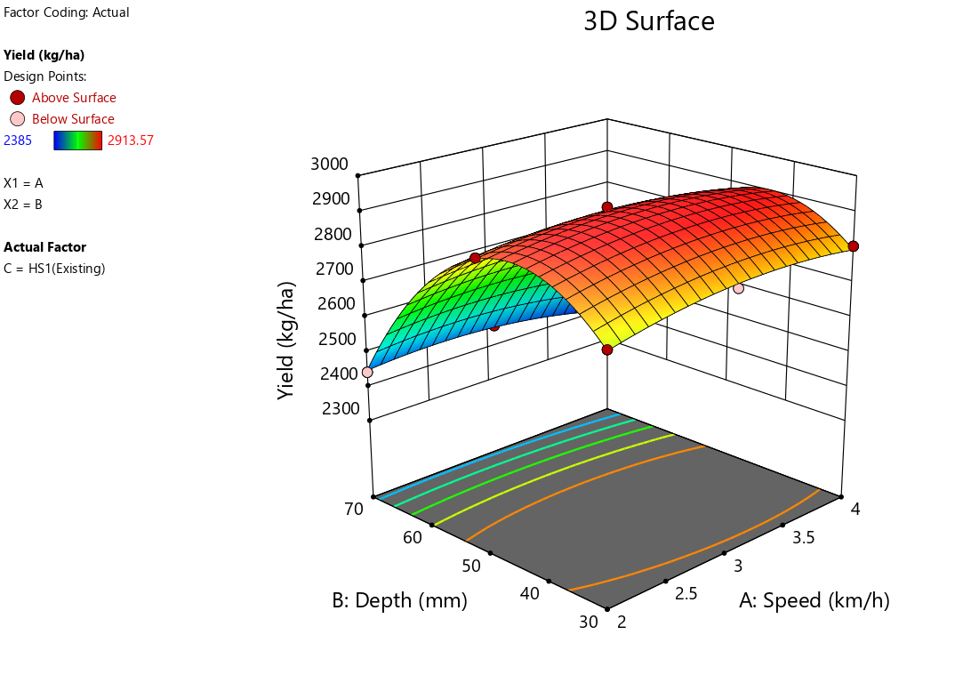 | 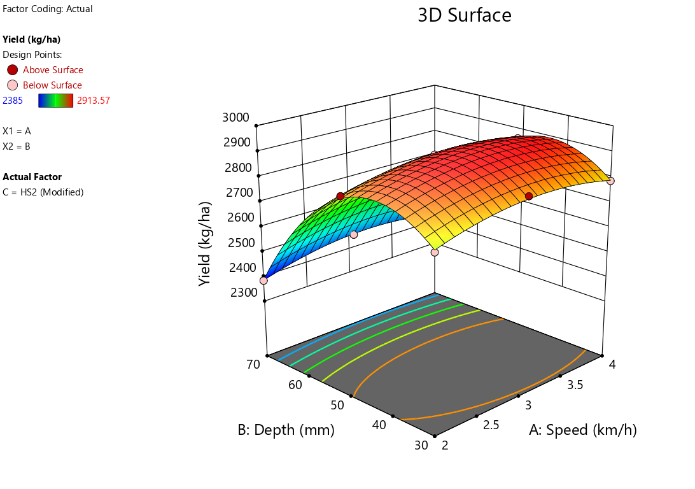
a | b
Fig. 8. Variation in grain yield with depth and speed of operation (a) HS1 (b) HS2
Grain yield of 2833, 2889 and 2861 kg/ha was recorded from the HS2 operated plot under the configuration of S1D2, S2D2 and S3D2, whereas HS1 machine operated plot results in slightly higher yield of 2875, 2914 and 2857 kg/ha, respectively. 15-16.1% lower yield was recorded from all the plot, where depth of operation was increased from 50-70 mm. Lower germination and plant population might be the reason behind the lower yielding [30], [31] also reported lower wheat yield at 80 mm sowing depth than 2- and 4-mm sowing depth. Whereas, higher sowing depth hinders the germination of wheat, sowing at 50 mm depth resulted in highest yield than 70, 90 mm depth of sowing [32]. There was very minor gap of yield between 30 mm and 50 mm depth of sowing irrespective of speed of operation.

Effective field capacity (EFC)
EFC of any machine depends on the actual working width of the machine and the speed of operation including wheel slip. Maximum effective field capacity was recorded at 4km/h operating speed by the HS2 at all the operating depth (Fig. 9). Uniform EFC of 0.438 ha/h was recorded while operating the modified machines in the configuration of S2D1 and S2D2. Existing machine (HS1) shows slightly lower EFC of 0.436 and 0.429 ha/h at that same operating condition. At 4 km/h speed and 30mm depth both the machine maintained an EFC of 0.52 ha/h, whereas at 50mm and 70 mm depth modified machine maintained slightly higher EFC of 0.523 and 0.520 ha/h than existing machine 0.51 and 0.50 ha/h respectively. Speed of operation increased EFC but depth of operation may vary the EFC of the implement. Higher depth resulted in high draft requirement and excessive slip percentage. Disc implement generally offer higher EFC than inverted-T implement due to the macro shape which encompasses the gross surface area, influences the soil cutting forces, and results in improved residue handling and movement through anchored stubbles [30], [31].
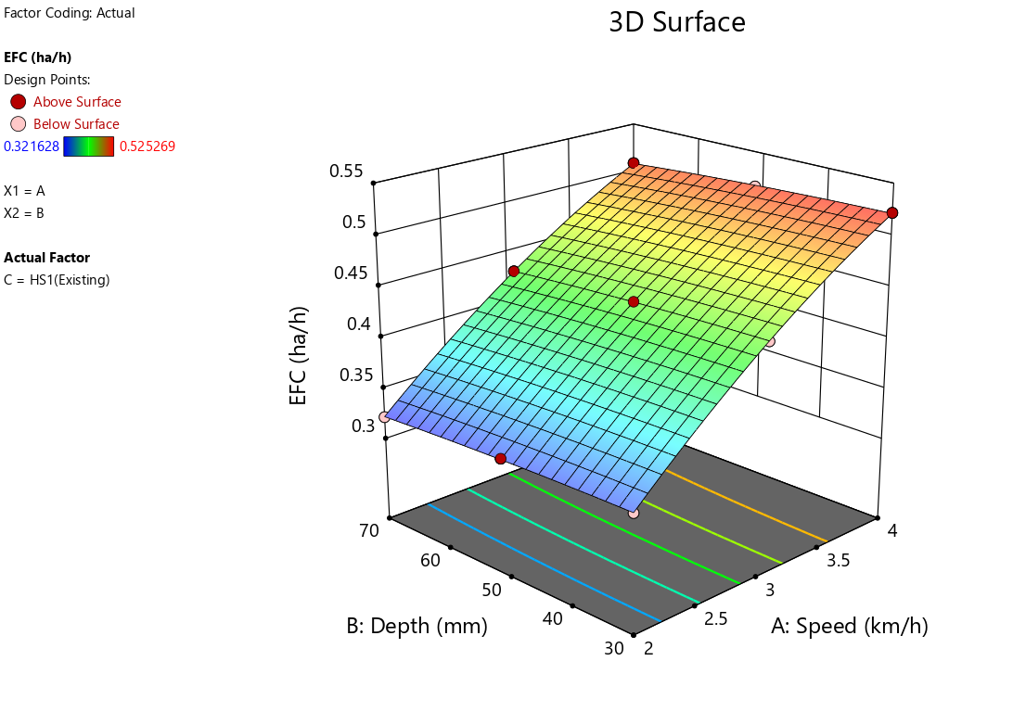 | 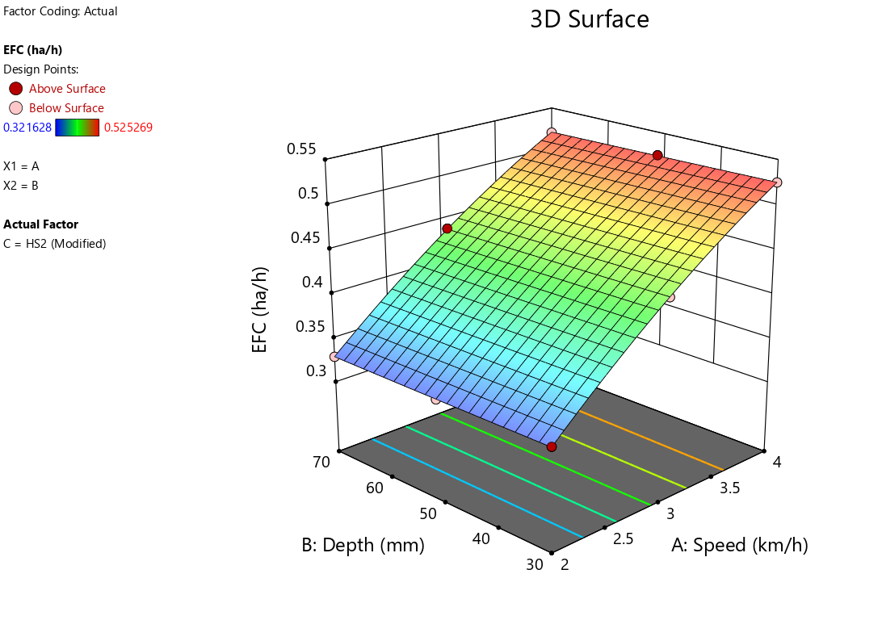
a | b
Fig. 9. Variation in EFC with depth and speed of operation of (a) HS1 (b) HS2
Negligible differences of EFC were observed between modified machine and existing machine at 30 mm operating depth. At 3 km/h operating speed modified machine exhibits higher EFC than existing machine at all the depths. At depth of 30 mm and 50 mm modified machine exhibits EFC of 0.438 ha/h, while existing machine shows slightly lower EFC of 0.436 ha/h and 0.429 ha/h respectively. Modified machine continuously outperformed the existing machine as speed of operation increased to 4 km/h. At 4 km/h speed and 30 mm depth both the machine maintained an EFC of 0.52 ha/h, whereas at 50 mm and 70 mm depth modified machine maintained slightly lower EFC of 0.52 and 0.50 ha/h respectively. Increment in speed of operation of modified machine from 2 km/h to 3 km/h and 3 km/h to 4km/h resulted in 20% and 19.40% increment of EFC at 30 mm depth of operation [33].
EFC depends on the length of field, speed of the machine and various time losses such as turning time, seed filling time and minor maintenance [34]. Thus, higher speed of operation increases the EFC, whereas higher depth of operation reduces the EFC of machine. It was evidenced in earlier researches that the soil contact with tools increases with increase in depth of operation, which results in higher slip and reduced speed of operation [35], [36].

RSM Optimization
One of the main objectives of this research was to comprehend the performance of the modified and existing machine at different operating conditions in terms of draft requirement, fuel consumption, plant population, yield, EFC. Accordingly, an ideal set of input data was required to get a suitable output. The constraints applied on the input parameter before optimizing the best possible solution is shown in Table 3. The model includes constraints to guarantee that the optimization process stays within rational boundaries. The RSM optimization yields the best feasible combinations of various input parameters that can be applied to suitable real-world scenarios. A total of 4 possible solution for 2 combinations of categoric factor levels (HS1 and HS2) were obtained from RSM optimization (Table 4). The best possible solution was found at operating speed and depth of 4 km/h and 42 mm by HS2 with a fuel consumption of 12.575 l/ha, draft of 3063 N, plant population of 122 plants/m², yield of 2895 kg/ha and EFC of 0.52 ha/h with a desirability of 0.905. Compared to the existing happy seeder (HS1), the HS2 consistently outperformed in efficiency and productivity, making it the most optimal choice for wheat cultivation.

Conclusions
The study established replacing the inverted-T type furrow opener (HS1) with a double-disc furrow opener (HS2) significantly improved the drilling, residue handling and implement performance. The modified happy seeder (HS2) reduced fuel consumption by 17.2%, alongside improvements in draft requirement, effective field capacity plant population, and foremostly grain yield. While, the implement with both furrow openers performed reasonably at 50 mm depth, response surface methodology (RSM) identified the optimum operating condition with HS2, at 4 km/h forward speed and 42 mm depth, endorsing with the best balance of performance indicators and a desirability of 0.905. The results highlight the modified happy seeder with double-disc furrow opener as an effective resolution to rice residue management and wheat establishment practice in combine-harvested paddy fields, while offering a cost-effective alternative and upholding sustainable crop management in the cereal-based system.
Table 3. Constraints for optimization of operational parameter
Name | Goal | Lower Limit |  | Upper Limit | Lower Weight | Upper Weight | Importance
A: Speed | is in range |  | 2 | 4 | 1 | 1 | 3
B: Depth | is in range | 30 |  | 70 | 1 | 1 | 3
C: Happy seeder | is in range | HS2 |  | HS1 | 1 | 1 | 3
FC | minimize | 11.98 |  | 17.8 | 1 | 1 | 4
Draft | minimize | 2325 |  | 7173 | 1 | 1 | 4
Plant Population | maximize | 79 |  | 131 | 1 | 1 | 4
Yield | maximize | 2385 |  | 2913.57 | 1 | 1 | 4
EFC | maximize | 0.32 |  | 0.53 | 1 | 1 | 4

Table 4. Solutions for 2 combinations of categoric factor levels of the RSM optimized data
Number | Speed | Depth | Happy seeder | Fuel Consumption (l/h) | Draft (N) | Plant Population (number of plants/m²) | Yield (kg/ha) | EFC (h/ha) | Desirability
1 | 4.000 | 42.029 | HS2 (Modified) | 12.56 | 3063.24 | 122.29 | 2894.93 | 0.52 | 0.90
2 | 3.813 | 38.780 | HS1(Existing) | 14.89 | 5076.13 | 122.99 | 2904.03 | 0.51 | 0.67
3 | 3.821 | 38.803 | HS1(Existing) | 14.89 | 5080.44 | 123.02 | 2903.78 | 0.51 | 0.67
4 | 3.805 | 38.816 | HS1(Existing) | 14.89 | 5072.81 | 123.04 | 2904.60 | 0.50 | 0.66

COMPETING INTERESTS DISCLAIMER:
Authors have declared that they have no known competing financial interests OR non-financial interests OR personal relationships that could have appeared to influence the work reported in this paper.

References
[1] S. Dhanda, A. Yadav, D. B. Yadav, and B. S. Chauhan, “Emerging Issues and Potential Opportunities in the Rice–Wheat Cropping System of North-Western India,” Feb. 22, 2022, Frontiers Media S.A. doi: 10.3389/fpls.2022.832683.
[2] H. S. Sidhu et al., “The Happy Seeder enables direct drilling of wheat into rice stubble,” Aust J Exp Agric, vol. 47, no. 7, pp. 844–854, 2007, doi: 10.1071/EA06225.
[3] R. P. Singh et al., “Economic assessment of the Happy Seeder for rice-wheat systems in Punjab, India,” in 52nd Annual Conference of the Australian Agricultural and Resource Economics Society (AARES 2008), 2008.
[4] A. Keil et al., “Changing agricultural stubble burning practices in the Indo-Gangetic plains: is the Happy Seeder a profitable alternative?,” Int J Agric Sustain, vol. 19, no. 2, pp. 128–151, 2021, doi: 10.1080/14735903.2020.1834277.
[5] S. T. Zaidi, “Rice Crop Residue burning and alternative measures by India: A Review,” Journal of Scientific Research, vol. 65, no. 02, pp. 132–137, 2021, doi: 10.37398/jsr.2021.650227.
[6] P. Singh, G. Singh, G. P. S. Sodhi, and S. Sharma, “Energy optimization in wheat establishment following rice residue management with Happy Seeder technology for reduced carbon footprints in north-western India,” Energy, vol. 230, Sep. 2021, doi: 10.1016/j.energy.2021.120680.
[7] P. Bhattacharyya et al., “Turn the wheel from waste to wealth: Economic and environmental gain of sustainable rice straw management practices over field burning in reference to India,” Jun. 25, 2021, Elsevier B.V. doi: 10.1016/j.scitotenv.2021.145896.
[8] P. Singh, G. Singh, and G. P. S. Sodhi, “Energy and carbon footprints of wheat establishment following different rice residue management strategies vis-à-vis conventional tillage coupled with rice residue burning in north-western India,” Energy, vol. 200, Jun. 2020, doi: 10.1016/j.energy.2020.117554.
[9] G. Singh, M. K. Gupta, S. Chaurasiya, V. S. Sharma, and D. Y. Pimenov, “Rice straw burning: a review on its global prevalence and the sustainable alternatives for its effective mitigation,” Jul. 01, 2021, Springer Science and Business Media Deutschland GmbH. doi: 10.1007/s11356-021-14163-3.
[10] P. Kumar and L. Joshi, “Pollution caused by agricultural waste burning and possible alternate uses of crop stubble: a case study of Punjab,” in Knowledge systems of societies for adaptation and mitigation of impacts of climate change, Springer, 2013, pp. 367–385.
[11] S. Kumar, D. K. Sharma, D. R. Singh, H. Biswas, K. V. Praveen, and V. Sharma, “Estimating loss of ecosystem services due to paddy straw burning in North-west India,” Int J Agric Sustain, vol. 17, no. 2, pp. 146–157, Mar. 2019, doi: 10.1080/14735903.2019.1581474.
[12] V. Saothongnoi, S. Amkha, K. Inubushi, and K. Smakgahn, “Effect of Rice Straw Incorporation on Soil Properties and Rice Yield,” 2014.
[13] H. S. Sidhu et al., “Development and evaluation of the Turbo Happy Seeder for sowing wheat into heavy rice residues in NW India,” Field Crops Res, vol. 184, pp. 201–212, Jul. 2015, doi: 10.1016/j.fcr.2015.07.025.
[14] N. BrarA, “Nitrogen management in wheat sown in rice straw as mulch in North West India,” Proceedings of the 19th World Congress of Soil, no. August, pp. 206–209, 2010.
[15] F. Ahmad, D. Weimin, D. Qishuo, M. Hussain, and K. Jabran, “Forces and straw cutting performance of double disc furrow opener in no-till paddy Soil,” PLoS One, vol. 10, no. 3, Mar. 2015, doi: 10.1371/journal.pone.0119648.
[16] B. S. Madhusudan et al., “Critical assessment of furrow openers and operational parameters for optimum performance under conservation tillage,” Sci Rep, vol. 14, no. 1, Dec. 2024, doi: 10.1038/s41598-024-70569-2.
[17] C. Sawant, A. Kumar, I. Mani, and J. K. Singh, “Soil bin studies on the selection of furrow opener for conservation agriculture.”
[18] R. K. Sahu and H. Raheman, “Draught Prediction of Agricultural Implements using Reference Tillage Tools in Sandy Clay Loam Soil,” Biosyst Eng, vol. 94, no. 2, pp. 275–284, Jun. 2006, doi: 10.1016/j.biosystemseng.2006.01.015.
[19] W. R. Gill and G. E. Vanden Berg, Soil dynamics in tillage and traction, no. 316. Agricultural Research Service, US Department of Agriculture, 1967.
[20] A. K. Srivastava, C. E. Goering, R. P. Rohrbach, and D. R. Buckmaster, “Engineering principles of agricultural machines,” 1993.
[21] H. Bernacki, J. Haman, C. Z. Kanafojski, and E. Wiszniewicz, “Agricultural machines, theory and construction,” (No Title), 1972.
[22] E. Haque, C. A. Meisner, I. Hossain, S. Justice, and K. Sayre, “Two-Wheel Tractor Operated Zero Till Seed Drill: A Viable Crop Establishment and Resource Conservation Option.”
[23] A. F. Kheiralla, A. Yahya, M. Zohadie, and W. Ishak, “Modelling of power and energy requirements for tillage implements operating in Serdang sandy clay loam, Malaysia,” Soil Tillage Res, vol. 78, no. 1, pp. 21–34, Jul. 2004, doi: 10.1016/j.still.2003.12.011.
[24] R. K. Sahu and H. Raheman, “Draught Prediction of Agricultural Implements using Reference Tillage Tools in Sandy Clay Loam Soil,” Biosyst Eng, vol. 94, no. 2, pp. 275–284, Jun. 2006, doi: 10.1016/j.biosystemseng.2006.01.015.
[25] U. K. Saddozai, M. S. Baloch, A. A. Alizai, and A. A. Khakwani, “WHEAT GENOTYPES POTENTIAL WITH LONGEST COLEOPTILE LENGTH SOWN AT DIFFERENT SOWING DEPTHS,” Pak J Bot, vol. 54, no. 4, pp. 1349–1358, 2022, doi: 10.30848/PJB2022-4(39).
[26] T. K. Das et al., “Conservation agriculture effects on crop and water productivity, profitability and soil organic carbon accumulation under a maize-wheat cropping system in the North-western Indo-Gangetic Plains,” Field Crops Res, vol. 215, no. October 2017, pp. 222–231, 2018, doi: 10.1016/j.fcr.2017.10.021.
[27] J. R. Lamichhane and E. Soltani, “Sowing and seedbed management methods to improve establishment and yield of maize, rice and wheat across drought-prone regions: A review,” J Agric Food Res, vol. 2, no. November, p. 100089, 2020, doi: 10.1016/j.jafr.2020.100089.
[28] M. Ahmad et al., “Effect of deep tillage on soil properties and crop (wheat) yield,” Soil & Environ, vol. 29, no. 2, pp. 177–180, 2010.
[29] S. Alwan, S. K. Alwan Alsharifi, N. Shtewy, and T. Al-Janabi, “The effect of sowing methods on the growth characteristics of wheat in Alhashemia, Iraq Corresponding author: 1*,” 2020.
[30] T. Rusu, P. I. Moraru, I. Bogdan, A. I. Pop, and M. L. Sopterean, “Effect of soil tillage system upon the soil properties, weed control, quality and quantity yield in some arable crops,” International Journal of Agricultural and Biosystems Engineering, vol. 5, no. 11, pp. 672–675, 2011.
[31] M. S. Alam, M. S. Sultana, M. B. Hossain, M. Salahin, and U. Roy, “Effect of Sowing Depth on the Yield of Spring Wheat,” J. Environ. Sci. & Natural Resources, vol. 7, no. 1, pp. 277–280, 2014.
[32] M. Yagmur and D. Kaydan, “The effects of different sowing depth on grain yield and some grain yield components in wheat (Triticum aestivum L.) cultivars under dryland conditions,” Afr J Biotechnol, vol. 8, no. 2, pp. 196–201, 2009.
[33] S. Bhunia et al., “Optimization of energy consumption using data envelopment analysis (DEA) in rice-wheat-green gram cropping system under conservation tillage practices,” Energy, vol. 236, Dec. 2021, doi: 10.1016/j.energy.2021.121499.
[34] T. Biswas et al., “The PROMETHEE-GAIA: A multi-criteria decision-making method for identifying best conservation agricultural practices,” Soil Tillage Res, vol. 245, Jan. 2025, doi: 10.1016/j.still.2024.106315.
[35] N. Kumar Patel Scholar et al., “Performance evaluation of turbo happy seeder: A review,” ~ 1390 ~ The Pharma Innovation Journal, no. 3, pp. 1390–1395, 2022.
[36] P. SINGH, B. S. GAUTAM, and R. K. YADAV, “Performance evaluation of happy seeder for sowing wheat crop in combined harvested,” International Journal of Agricultural Engineering, vol. 10, no. 2, pp. 643–646, 2017, doi: 10.15740/has/ijae/10.2/643-646.

