Efficacy of Botanicals and Bioagents against Rhizoctonia solani causing wet root rot of coriander.

.
ABSTRACT

A Present Lab study was conducted at Department of Plant Pathology, College of Agriculture, Latur, VNMKV, Parbhani, Maharashtra, India. during kharif season of 2023-24 to study Wet root rot of coriander Caused by Rhizoctonia solani of Coriander. Here, in vitro efficacy of Botanicals & Bioagents were assessed against Rhizoctonia solani causing wet root rot of coriander. Among eight aqueous plant extracts, Garlic (Allium sativum) was the most effective, achieving 100 % inhibition at both 10 % and 20 % concentrations. Mehendi (Lawsonia inermis) and Tulsi (Ocimum tenuiflorum) followed with 77.21 % and 45.40 % inhibition at 10 % and 95.55 % and 100 % at 20 %, respectively. Aloe vera (Aloe barbadensis) and Neem (Azadirachta indica) showed less inhibition, indicating ineffectiveness against R. solani. Biological agents also exhibited promising results. Trichoderma harzianum showed the highest inhibition (92.77 %) with mycelial growth reduced to 24.00 mm, followed by Trichoderma hamatum (89.89 %) and Trichoderma asperellum (87.40 %). Moderate inhibition was recorded for Aspergillus flavus (52.07 %) and Aspergillus niger (31.29 %), while Pseudomonas fluorescens and Bacillus subtilis were least effective, with 15.45% and 8.30 % inhibition, respectively.

Keywords: [Coriandrum sativum, Rhizoctonia solani, wet root rot, Botanical extracts, Bioagents]

1. INTRODUCTION
Coriander (Coriandrum sativum L.) is an important annual aromatic plant widely used across the globe. Since ancient times, it has been a key ingredient in various cuisines. It is commonly incorporated into soups, salads, seasonings and chutneys around the world (Jibat et al., 2019). A member of the Apiaceae (Umbelliferae) family, coriander is native to the Mediterranean Basin. Both its fruits and leaves are extensively utilized as essential herbal components (Bhuiyan et al., 2009). In addition to its culinary value, coriander is recognized for its extensive medicinal properties, particularly in treating gastrointestinal ailments such as flatulent colic, dyspepsia, diarrhea, abdominal cramps, vomiting and flu. It also exhibits various therapeutic effects including nerve-soothing, lipolytic, muscle relaxant, antirheumatic, anti-edema, anti-inflammatory, antibacterial, emmenagogue and antihypertensive activities (Chahal et al., 2017). Coriander is native to the Mediterranean and Middle Eastern regions and has been used for thousands of years in ancient Egypt and across Asia. Coriander is well known for its medicinal properties; its seed essential oil possesses carminative, antiseptic, bactericidal, fungicidal and muscle relaxant effects (Singh et al., 2007; Laribi et al., 2015). India is known for its diverse and rich traditional cuisine. Coriander stems, leaves and fruits possess a pleasant aroma, making them popular for adding flavor to continental curries and soups. The fruits are widely used as a condiment in the preparation of curry powders, pickling spices, sausages and seasonings. Additionally, they are used to enhance the flavor of pastries, biscuits, buns, cakes and even liquors; particularly gin (Gauhar et al., 2018). Rhizoctonia solani grows over wide range of _{P}H (2 to 11). Optimum _{P}H for different isolates ranging 5.6 to 8.5. In north India neutral to slightly alkaline soil favourable for R. solani. Optimum temperature for different isolates ranging 18 to 300C. In general, optimum temperature for winter crops 18 to 220C. For summer crop, 26 to 320C. (Parmeter 1970). It was (1904 Rolfs) found that poorly drained soils favour the development of R. solani. Heavy irrigation and water logging condition cause severe disease development (Schaal 1935). Increase in humidity leads to increase in severity of disease (Lewis and Papavizas 1977). Under greenhouse pot conditions, coriander was one of multiple hosts tested. It showed a disease incidence of 33.3 % when inoculated with R. solani. In a greenhouse study, Rhizoctonia solani caused 28.3 % pre-emergence damping-off, 41.7 % post-emergence damping-off and approximately 46.7 % root rot/wilt incidence in coriander (Coriandrum sativum), indicating high pathogenicity under controlled conditions (Abdelrhim et al., 2023). Coriander is affected by several pathogens causing diseases such as leaf blight, anthracnose, powdery mildew, rust, leaf spots, seed rot and grain mold (Rajan, 1990). Among these, wilting, damping-off and root rot are considered the most serious diseases, impacting coriander at all growth stages from seedling to maturity (Singh et al., 2007). Disease symptoms typically appear in scattered patches in fields.
2. material and methods
2.1 In Vitro Evaluation of Plant Extracts
The current study was conducted to assess the potential antifungal properties of extracts from various plant species against Rhizoctonia solani. water-based extracts of locally available higher plants were evaluated at concentrations of 10 % and 20 % using the poisoned food technique (Nene and Thapliyal, 1993), with PDA as the basal medium. Selected plant parts such as leaves, bulbs and cloves were thoroughly washed with distilled water, chopped into small pieces using a sterile knife, and then ground with an equal volume of distilled water (1:1 w/v) using a pestle and mortar. The resulting homogenate were filtered through a double layer of muslin cloth, followed by filtration through Whatman filter paper using a 100 ml glass volumetric flask and funnel. The clear filtrate obtained was considered the 100 % concentrated plant extract. To prepare the test media, appropriate volumes of the 100 % plant extract were mixed with autoclaved and cooled (40°C) PDA in 250 ml conical flasks to obtain 10 % and 20 % extract concentrations. These amended media was poured (20 ml per plate) into sterile 90 mm glass petri dishes and allowed to solidify at room temperature. Each phytoextract treatment were tested using two plates per concentration, replicated three times. Once solidified, all treatment plates were inoculated aseptically by placing a 5 mm disc from a 7-day-old, actively growing fungal culture in the center. Control plates containing plain PDA and inoculated with the fungal disc was serve as untreated controls. All plates were incubated at 28 ± 2°C for one week or until full mycelial growth covers the control plates.

Table 1: List of botanicals
Tr. No. | Treatments | Plant parts used | Tr. No. | Treatments | Plant parts used
T₁ | Lawsonia inermis  (Mehendi) | Leaves | T₅ | Bougainvillea glabra  (Paper flower) | Leaves
T₂ | Aloe barbadensis  (Aloe vera) | Leaves | T₆ | Allium sativum  (Garlic) | Clove
T₃ | Azadirachta indica  (Neem) | Leaves | T₇ | Allium cepa (Onion) | Leaves
T₄ | Lantana camera (Ghaneri) | Leaves | T₈ | Ocimum tenuiflorum  (Tulsi) | Bulb
 |  |  | T₉ | Control (Untreated)
2.2 In Vitro Evaluation of Bioagents
The most promising fungal and bacterial biocontrol agents were tested in vitro against the pathogens responsible for coriander root rot using the dual culture technique (Dennis and Webster, 1971) with PDA serving as the base medium. Cultures of both the test pathogens and biocontrol agents each seven days old and grown on their respective media was used for this evaluation.
Both the pathogen and biocontrol agents were aseptically placed at equal distances directly opposite each other on solidified PDA in Petri dishes which was then be incubated at 27 ± 2°C. Plates inoculated only with the pathogen was serve as the untreated control.
Table 2: List of Bioagents
Tr. No. | Treatments | Tr. No. | Treatments
T₁ | Trichoderma hamatum | T₅ | Aspergillus flavus
T₂ | Trichoderma harzianum | T₆ | Aspergillus niger
T₃ | Trichoderma koningii | T₇ | Pseudomonas fluorescens
T₄ | Trichoderma asperellum | T₈ | Bacillus subtilis
 |  | T₉ | Control (Untreated)
Observations on radial mycelial growth was recorded after seven days of incubation in all the replicated treatments. Per cent inhibition of the test pathogen was calculated by applying the formula given by Arora and Upadhay (1978) as follows,
C - T

Percent growth inhibition (I) =------------× 100
C
Where,
C = Growth (mm) of test fungus in untreated control plate.
T = Growth (mm) of test fungus in treated plates.
3. results and discussion

3.1 In vitro evaluation of Botanicals against Rhizoctonia solani.
Effect on radial mycelial growth inhibition
The results revealed that all the seven plant extracts tested, exhibited a wide range of mycelial growth inhibition of Rhizoctonia solani and it decreased drastically with increased in concentrations of tested plant extracts at 10 to 20 per cent.
At 10 percent concentration, radial mycelial growth of Rhizoctonia solani was ranged from 0 to 90 mm. However, significantly least mycelium growth of pathogen was observed in Allium sativum (0 mm), which was followed by Lawsonia inermis (20.5 mm), Ocimum tenuiflorum (49.13 mm), Allium cepa (64.16 mm) and maximum mycelial growth was observed in Aloe barbadensis, Azadirachta indica, Lantana camera, Bougainvillea glabra (90 mm). At 20 percent concentration, radial mycelial growth of Rhizoctonia solani was ranged from 0 to 90 mm. However, significantly least mycelium growth with Allium sativum (0 mm), followed by Ocimum tenuiflorum (0 mm) which was followed by Lawsonia inermis (04 mm), Bougainvillea glabra (34.83), Lantana camera (49.16). Allium cepa (64.16 mm). The maximum growth of pathogen was recorded in Aloe barbadensis (90 mm) and Azadirachta indica (90 mm).
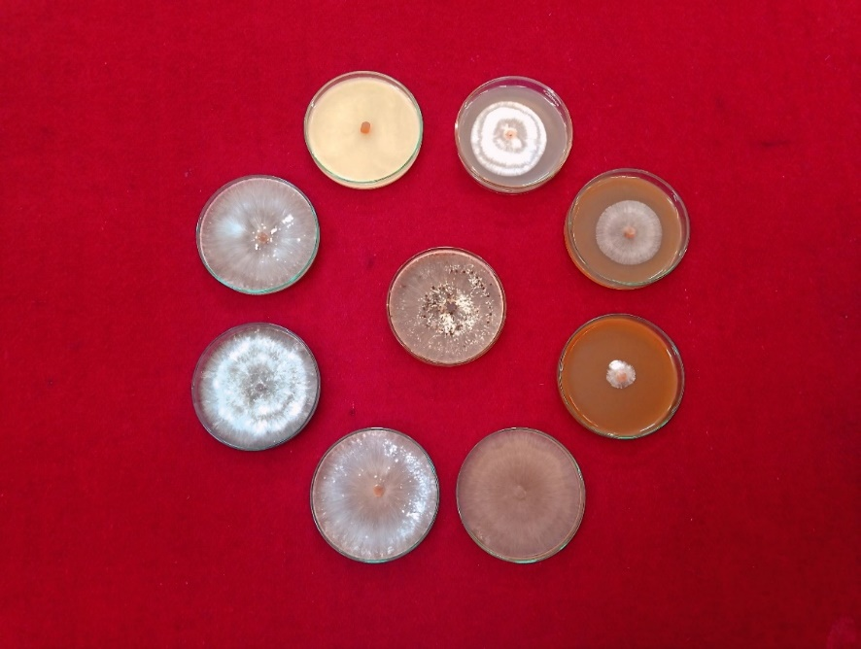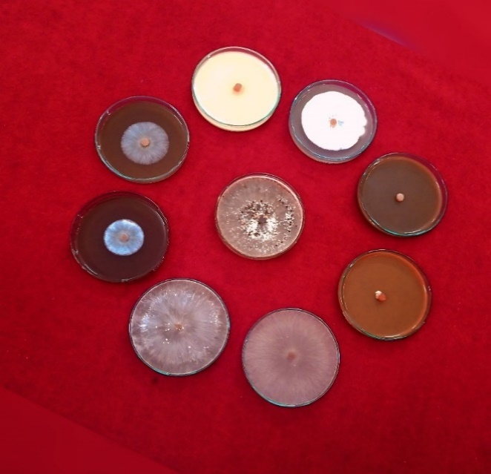
T₃
T₂
T₁
T₄
T₅
T₇
T₆
T₈
T₉
T₃
T₆
T₂
T₉
T₈
T₇
T₅
T₄
T₁
@10% @20%

Plate: 1 In vitro efficacy of Botanicals against Rhizoctonia solani by poisoned food technique

Effect on inhibition of mycelial growth
At 10 per cent concentration, mycelial growth inhibition of Rhizoctonia solani ranged from 0 to 100 percent as compared with control (0 %). However, the maximum growth inhibition of pathogen was recorded in Allium sativum (Garlic) i.e. 100 %, which was followed by Lawsonia inermis (Mehendi) i.e. 77.21 %, Ocimum tenuiflorum (Tulsi) i.e. 45.40 %, Allium cepa (Onion) i.e. 28.7 %. Least mycelial growth was recorded in Aloe barbadensis (Aloe vera) i.e. 0 %, Azadirachta indica (Neem) i.e. 0 %, Lantana camera (Ghaneri) i.e. 0 %, Bougainvillea glabra (Paper flower) i.e. 0 percent.At 20 per cent concentration, mycelial growth inhibition of Rhizoctonia solani ranged from 0 to100 percent as compared to control (0 %). However, it was significantly maximum in Allium sativum (Garlic) i.e. 100 % and Ocimum tenuiflorum (Tulsi) i.e. 100 %, which was followed by Lawsonia inermis (Mehendi) i.e. 95.55 %, Lantana camera (Ghaneri) i.e. 61.29 %, Bougainvillea glabra (Paper flower) i.e. 45.36 %, Allium cepa (Onion) i.e. 28.81 %. The least mycelial growth inhibition was recorded in Aloe barbadensis (Aloe vera) i.e. 0 % and Azadirachta indica (Neem) i.e. 0 percent.The results of the related study were consistent with earlier findings. For example, Yadav et al. (2021) reported that the clove extract of Allium sativum (garlic) was the most effective, showing the highest inhibition of fungal growth at 63.55 % and 68.70 % at 5 % and 10 % concentrations, respectively.

Table 3: In vitro evaluation of Botanicals against Rhizoctonia solani.
Tr. No. | Treatments | Colony Diameter (mm)*  at ppm |  | % Inhibition  at ppm
Tr. No. | Treatments | 10 % | 20% | 10 % | 20%
T₁ | Lawsonia inermis (Mehendi) | 20.50 | 04.00 | 77.21  (61.48)** | 95.55  (77.82)
T₂ | Aloe barbadensis (Aloe vera) | 90.00 | 90.00 | 00.00  (00.00) | 00.00  (00.00)
T₃ | Azadirachta indica (Neem) | 90.00 | 90.00 | 00.00  (00.00) | 00.00  (00.00)
T₄ | Lantana camera (Ghaneri) | 90.00 | 34.83 | 00.00  (00.00) | 61.29  (51.52)
T₅ | Bougainvillea glabra  (Paper flower) | 90.00 | 49.16 | 0.00  (00.00) | 45.36  (42.33)
T₆ | Allium sativum (Garlic) | 00.00 | 00.00 | 100.00  (90.00) | 100.00  (90.00)
T₇ | Allium cepa (Onion) | 64.16 | 64.06 | 28.7  (32.39) | 28.81  (32.46)
T₈ | Ocimum tenuiflorum (Tulsi) | 49.13 | 00.00 | 45.40  (42.36) | 100.00  (90.00)
T₉ | Control | 90.00 | 90.00 | 00.00  (00.00) | 00.00  (00.00)
 | S.E. ±  C.D. (P=0.01) | 0.44  1.81 | 0.36  1.50 | 0.49  2.01 | 0.41  1.67

*: Mean of three replications, **: Values in parenthesis are arcsin transformed values.

Fig. 1: In vitro evaluation of Bioagents against Rhizoctonia solani
The results on the mycelial growth and inhibition of Rhizoctonia solani, causing wet root rot in Coriander, were obtained using six fungal antagonists viz., Trichoderma hamatum, Trichoderma harzianum, Trichoderma koningii, Trichoderma asperellum, Aspergillus niger, Aspergillus flavus. Additionally, two bacterial antagonists, Pseudomonas fluorescens and Bacillus subtilis, were also tested.
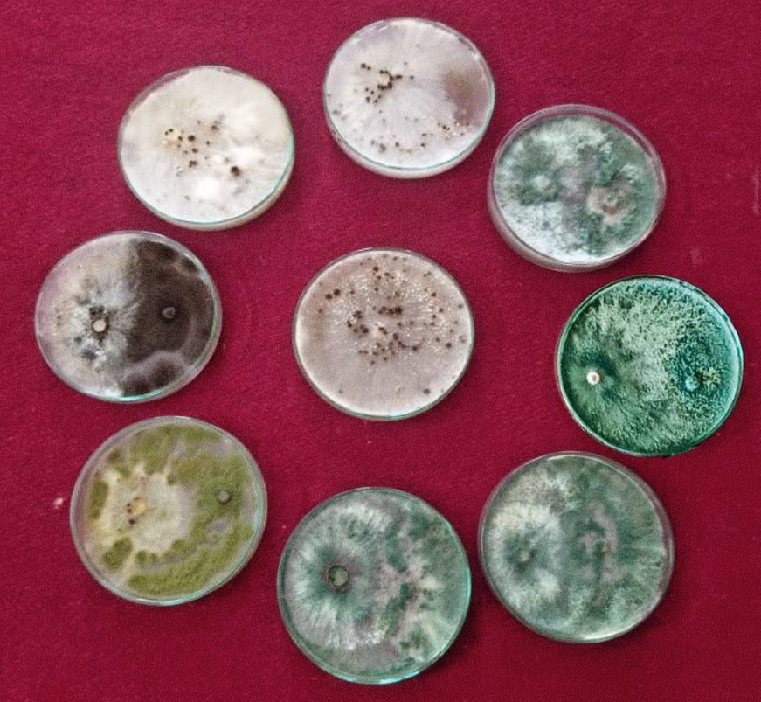
The results (Plate 2 Table 4 and Figure 1) demonstrated that all the bioagents tested exhibited fungistatic/antifungal activity against the test pathogen, significantly inhibiting its growth compared to the untreated control. Trichoderma harzianum showed the least linear mycelial growth (24 mm) of pathogen and was the most effective, achieving the highest mycelial growth inhibition (92.77 %). The second and third most effective antagonists were T. hamatum and T.
T₉
T₄
T₅
T₃
T₁
T₂
T₈
T₆
T₇
Plate 2: In vitro efficacy of bioagents against Rhizoctonia solani by dual culture technique

asperellum, with mycelial growth and inhibition of (8.5 mm and 89.89 %) and (11.33 mm and 87.40 %); respectively.These were followed by Trichoderma asperellum (14.36 mm and 84.03 %), Aspergillus flavus (42.46 mm and 52.07 %), Aspergillus niger (61.83 mm and 31.29 %). However, Pseudomonas fluorescens and Bacillus subtilis were the least effective, exhibiting the highest mycelial growth of R. solani and minimal inhibition, with growth values of (75.66 mm and 15.45 %) and (82.5 mm and 8.30 %); respectively.
The results of the such study were consistent with earlier findings and reporting. Trichoderma harzianum, T. asperellum and T. virens as effective agents against Rhizoctonia solani. Meena et al. (2018) also found that T. harzianum provided the greatest mycelial growth inhibition, followed by T. asperellum against Rhizoctonia solani causing foliar blight in mungbean.

Table 4: In vitro evaluation of Bioagents against Rhizoctonia solani
Tr. No. | Bioagents | *Colony Diameter (mm) | *% Inhibition
T₁ | Trichoderma hamatum | 08.50 | 89.89  ** (71.46)
T₂ | Trichoderma harzianum | 06.50 | 92.77  (74.40)
T₃ | Trichoderma koningii | 11.33 | 87.40  (69.20)
T₄ | Trichoderma asperellum | 14.36 | 84.03  (66.44)
T₅ | Aspergillus flavus | 42.46 | 52.07  (46.18)
T₆ | Aspergillus niger | 61.83 | 31.29  (34.01)
T₇ | Pseudomonas fluorescens | 75.66 | 15.45  (23.14)
T₈ | Bacillus subtilis | 82.50 | 08.30  (16.74)
T9 | Control | 90.00 | 00.00  (00.00)
 | S.E. ± | 0.35 | 0.50
 | C.D.(P=0.01) | 1.4 | 2.05

*: Mean of three replications. **: Values in parenthesis are arcsin transformed values.
Fig. 2: In vitro evaluation of Bioagents against Rhizoctonia solani
4. Conclusion
Eight aqueous plant extracts were tested for their effectiveness against Rhizoctonia solani at 10 % and 20 % concentrations. Results showed a wide range of mycelial growth inhibition, which increased significantly with higher concentration. At 10 %, Garlic (Allium sativum) showed 100 % inhibition but Aloe barbadensis (Aloe vera) and Azadirachta indica (Neem) were failed to control the growth of pathogen.
All tested bioagents exhibited significant antifungal activity against Rhizoctonia solani, with varying degrees of mycelial growth inhibition. Trichoderma harzianum was the most effective, showing 92.77 % inhibition with 24.00 mm mycelial growth. Pseudomonas fluorescens (15.45 %) and Bacillus subtilis (8.30 %) were the least effective, with the highest mycelial growth among treatments.

COMPETING INTERESTS DISCLAIMER:
Authors have declared that they have no known competing financial interests OR non-financial interests OR personal relationships that could have appeared to influence the work reported in this paper.

References
Abdelrhim, A.S., Abdellatif, Y.M.R., Hossain, M.A., Alamri, S., Pessarakli, M., Lessy, A.M.N. & Dawood, M.F.A. (2023). Comparative Study of Three Biological Control Agents and Two Conventional Fungicides against Coriander Damping-off and Root Rot Caused by Rhizoctonia solani. Plants. 12, 1694.
Arora, D.K. & Upadhyay, R.K. (1978). Effect of fungal staling growth substances on colony interaction. Plant Soil. 49, 685-690.
Bhuiyan, N., Begum, J. & Sultan, M. (2009). Chemical combination of leaf and seed essential oil of coriander (Coriandrum sativum L.). Bangladesh Journal of Pharmacology. 4, 150-153.
Chahal, K.K., Singh, R., Kumar, A. & Bhardwaj, U. (2017) Chemical composition and biological activity of Coriandrum sativum L. review of the Indian Journal of Natural Products and Resources. 8, 193-203.
Dennis, C. & Webstar, J. (1971). Antagonistic properties of species group of Trichoderma, production of volatile and non-volatile antibiotics. Transaction of the British Mycological Society. 57, 41-48.
Gauhar, T., Solanki, R.K., Kakani, R.K. & Choudhary, M. (2018). Study of genetic divergence in coriander (Coriandrum sativum L.). International Journal of Seed Spices. 8 (1), 56-59.
Jibat, M., Getachew, W. & Getu, A. (2019). Major Diseases of Coriander (Coriandrum sativum L.) in Different Growing areas of Ethiopia. International Journal of Research in Agriculture & Forestry. 6(12), pp 13-15.
Lewis, J.A. & Papivizas, G.C. (1977). Factors affecting Rhizoctonia solani infection of soybeans in the greenhouse. Plant Disease Reporter. 61 196-200.
Meena, R.L., Godara, S.L., Meena, A.K. & Meena, P.N. (2018). Evaluation of efficacy of different bioagents and fungicides against Rhizoctonia solani (Kuhn). International Journal of Current Microbiology and Applied Sciences. 7(9), 3694-3703.
Nene, Y.L. & Thapliyal, P.N. (1993). Evaluation of fungicides. In, Fungicides in Plant Disease Control (34 Edition). Oxford, IBH Publishing Co, New Delhi. 531- 532.
Parmeter, J.R. (1970). Rhizoctonia solani, biology and pathology (Berkeley, Los Angeles and London University of California Press).
Rajan, F.S., Vedamuthu, P.G.B., Khader, M.K. & Jeyarajan, R. (1990). Screening coriander lines against grain mould disease. South Indian Horticulture. 38, 168-169.
Rolfs, F.M. (1904). Potato failures. A second report. Colorado Agricultural Experiment Station Bulletin. 91 33 pp.
Schaal, L. A. (1935) Rhizoctoniosis of potatoes grown under irrigation. Phytopathology. 25 748-762 P.
Singh, R.K., Meena, S.S. & Vashishtha, B.B. (2007). Medicinal properties of seed spices. National Research Centre on Seed Spices (ICAR), Ajmer. p.19-22.
Yadav, V.K., Choudhary, V.P., Singh S.K., Maurya, M.K., Vishwakarma, S.V., Rajendra, P., Yadav, J. & Singh, A. (2021). The In vitro efficacy of botanicals against Rhizoctonia solani Kühn inciting sheath blight of rice. Pharma Innovation Journal. 10(8), 1144-1147.

