Original Research Article
Determinants of attitude of sugarcane growers towards sugarcane cultivation: Evidence from South Gujarat
ABSTRACT

Understanding the determinants of attitude of sugarcane growers towards sugarcane cultivation is vital for formulating effective developmental strategies. This study investigates the personal, social, economic, communication and psychological variables influencing the attitude of sugarcane growers towards sugarcane cultivation. Ex-post facto research design was adopted for the study. The present study was conducted in South Gujarat region of Gujarat state during the year 2023-25. Three districts namely, Bharuch, Tapi and Surat were purposively selected as they have maximum area under sugarcane cultivation in the South Gujarat. In the next step, multistage random sampling was employed. Two talukas from each district were selected randomly followed by, four villages were chosen randomly from each taluka. Finally, ten sugarcane growers were randomly selected from each village. Thus, the total sample size comprised 240 respondents. The data collected from the respondents were tabulated and analysed using Pearson’s correlation and stepwise regression analysis in IBM SPSS Statistics (Version 29). The results revealed that out of 25 independent variables, nine variables- education, experience in farming, extension contact, extension participation, mass media exposure, information seeking behaviour, use of ICT for farming, social media utilization and change proneness had positive and significant correlation with attitude towards sugarcane cultivation at one per cent level of significance whereas, social participation, credit orientation, scientific orientation, risk orientation and management orientation had positive and significant correlation with attitude towards sugarcane cultivation at five per cent level of significance. Further, the results of stepwise regression showed that social media utilization, mass media exposure, experience in farming, education, information seeking behaviour, credit orientation, extension participation, extension contact, use of ICT for farming and scientific orientation were accounting influence on attitude towards sugarcane cultivation. These ten independent variables together accounted 41.20 per cent variation in attitude towards sugarcane cultivation.

Keywords: Attitude, sugarcane cultivation, sugarcane growers, correlation, stepwise regression, South Gujarat

- INTRODUCTION

Sugarcane (Saccharum officinarum) is a crop of strategic importance in India, linking millions of sugarcane growers to the nation’s agro-industrial network and contributing substantially to economic growth of our nation and rural prosperity. It is an important commercial crop that contributes to about 7.00 per cent of the total value of agricultural output of the country (Anonymous, 2018) with 48.57 lakh hectare under cultivation, 399.25 million tonnes production and productivity of 82,205 kg/ha (Anonymous, 2022a). India has the largest area under sugarcane cultivation in the world and holds second position in terms of global sugarcane production (Anonymous, 2024). Gujarat is a prominent sugarcane producing state in India, with 2.23 lakh ha of area under cultivation, 17.44 million tonnes of production and 71.16t/ha of productivity (Anonymous, 2022b). In South Gujarat, sugarcane occupies a significant position due to its favourable agro climatic conditions, well established cooperative sugar mills and strong market linkages. Beyond its economic value, sugarcane cultivation also plays a vital role in employment generation and allied industries such as bio-energy, sugar and jaggery production.

However, the sustainability and profitability of sugarcane cultivation are not only influenced by physical and economic factors but also by the attitude of sugarcane growers towards sugarcane cultivation. According to Allport, (1935), attitude is the mental state of readiness, organized through experience exerting a directive and dynamic influence upon the individual response to all objects and situations with which it is related. It is a degree of positive or negative effect associated with some psychological object (Thurston, 1946). Attitude formation and attitude change are two important features at the core of social psychology (Srivastava and Rojhe, 2021). Attitudes are pivotal because it predict and shapes behaviour, especially when they are strongly embedded in an individual core values or are linked to social allegiances (Johnson et al. 2022). Attitude formation can be described as a function of prior beliefs and information (Young and Zeimer, 2024). Attitudes are formed as a result of personal experience, learning, social and cultural factors (Cherry, 2024). Some attitudes are mostly based on beliefs, while some are based on feelings, and behaviours but strong attitudes are important as we hold them with confidence, we do not change them very much, and we use them often to guide our actions (Jhangiani and Tarry, 2022). Attitude of an individual is shaped by a combination of several factors including personal, socio-economic, communication and psychological characteristics. Therefore, understanding these determinants is crucial for designing targeted extension strategies, policy interventions and support services that encourage a positive attitude towards sugarcane cultivation.

In this context, the present study seeks to ascertain the relationship between the profile of sugarcane growers and their attitude towards sugarcane cultivation. By providing empirical evidence, the findings aim to guide extension agencies, policy makers, researchers and other stakeholders in strengthening the engagement of sugarcane growers, improving adoption of recommended practices, and enhancing the overall productivity of sugarcane sector.

- OBJECTIVE

To ascertain the relationship of profile of sugarcane growers with their attitude toward sugarcane crop cultivation

- METHODOLOGY

The present study was conducted in South Gujarat region of Gujarat state during the year 2023-25 by employing Ex-post facto research design. Ex-post facto means what is done afterward and refers to those studies which investigate possible cause-and-effect relationships by observing an existing condition or state of affairs and searching back in the time of possible causal factors. Ex-post-facto research design is worthy to be applied when the independent variables have already acted upon (Kerlinger, 1976). Two sampling methods were adopted for the study. First, purposive sampling technique was used for the selection of districts. Bharuch, Surat and Tapi districts were purposively selected as these districts were having maximum area under sugarcane cultivation in South Gujarat. Second, the multistage random sampling technique was employed for the selection of talukas, villages and respondents. In first stage, two talukas from each selected district were selected randomly. In second stage, four villages from each taluka were selected randomly. In the final stage, 10 sugarcane growers were selected randomly from each village. Thus, the total sample size comprised 240 respondents. The schematic representation of sampling procedure is presented in Fig.1.

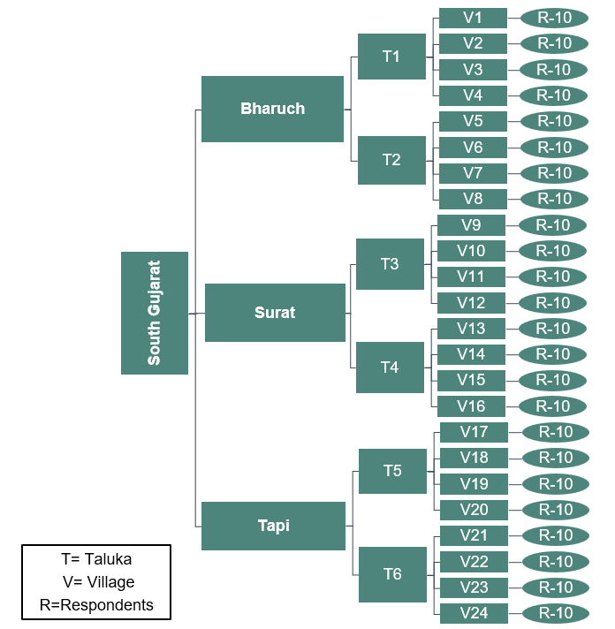
Fig.1. Schematic representation of sampling procedure

In light of the objectives of the study, attitude towards sugarcane cultivation was selected as the dependent variable and variables including age, education, experience in farming, family size, occupation other than farming, social participation, extension contact, extension participation, cosmopoliteness, group cohesiveness, annual income, area under sugarcane cultivation, farm resource possession, land holding, credit orientation, mass media exposure, information seeking behavior, use of ICT for farming, social media utilization, negotiation skills, scientific orientation, risk orientation, management orientation, change proneness and decision making ability were selected as independent variables. For measuring the dependent and independent variables appropriate measuring techniques/scales developed by other scientists were used. In the case of variables for which appropriate measuring tools are not available, were measured by pretested structured schedule. The tentative model depicted in Fig. 2 shows that 25 independent variables of the sugarcane growers might be having a relationship with their attitude towards sugarcane cultivation.

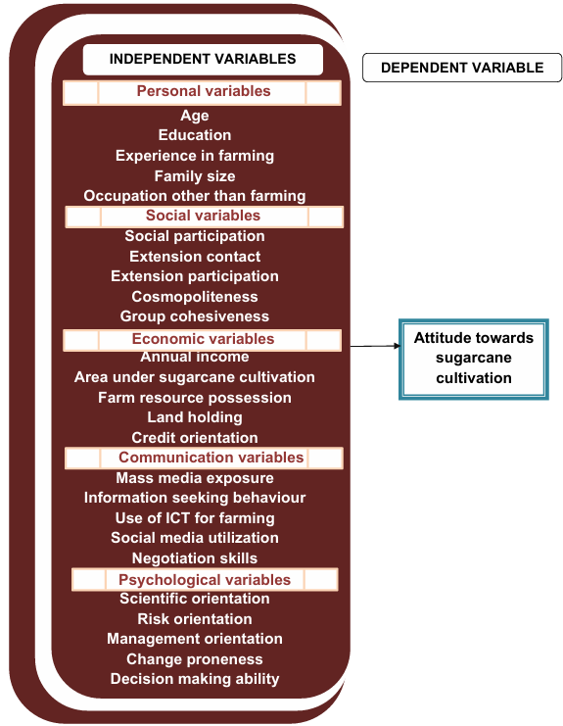
Fig. 2. Conceptual model showing the relationship of independent and dependent variables

The null hypothesis framed was as follows:
Null hypothesis(H₀): There is no relationship between the profile of sugarcane growers and their attitude towards sugarcane cultivation

A structured and pre-tested interview schedule was used to collect the data through personal interview method. The data collected were tabulated and analysed using appropriate statistical tools - Pearson’s correlation and stepwise regression analysis using IBM SPSS Statistics (Version 29). For visualisation of results, correlation heat map and model improvement graph of step wise regression were generated using Python (Version 3.13.3) in Jupyter Notebook.

- RESULTS AND DISCUSSION

4.1 Relationship between profile of sugarcane growers and their attitude towards sugarcane cultivation

The relationship between the profile of the sugarcane growers and their attitude towards sugarcane cultivation was examined by computing Pearson Correlation Coefficient. The results are presented in the Table 1. The correlation heat map shown in Fig. 3 provides a visual representation of strength and direction of these relationships and the empirical model shown in Fig. 4. summarizes significant and non-significant relationships between the independent variables and dependent variable.

Table 1: Relationship between the profile of sugarcane growers and their attitude towards sugarcane cultivation
(n=240)
Sr. No. | Independent Variables | Coefficient of correlation (r)
 | - Personal variables
1. | Age | -0.006 ^{NS}
2. | Education | 0.219**
3. | Experience in farming | 0.175**
4. | Family size | -0.002 ^{NS}
5. | Occupation other than farming | -0.006 ^{NS}
 | - Social variables
6. | Social participation | 0.162*
7. | Extension contact | 0.198**
8. | Extension participation | 0.203**
9. | Cosmopoliteness | 0.041 ^{NS}
10. | Group cohesiveness | -0.046 ^{NS}
 | - Economic variables
11. | Annual income | -0.003 ^{NS}
12. | Area under sugarcane cultivation | 0.053 ^{NS}
13. | Farm resource possession | 0.019 ^{NS}
14. | Land holding | 0.093 ^{NS}
15. | Credit orientation | 0.143*
 | - Communication variables
16. | Mass media exposure | 0.257**
17. | Information seeking behaviour | 0.185**
18. | Use of ICT for farming | 0.243**
19. | Social media utilization | 0.271**
20. | Negotiation skills | -0.027 ^{NS}
 | - Psychological variables
21. | Scientific orientation | 0.163*
22. | Risk orientation | 0.143*
23. | Management orientation | 0.134*
24. | Change proneness | 0.170**
25. | Decision making ability | -0.062 ^{NS}
**Significant at 0.01 level of probability *Significant at 0.05 level of probability
NS = Non significant

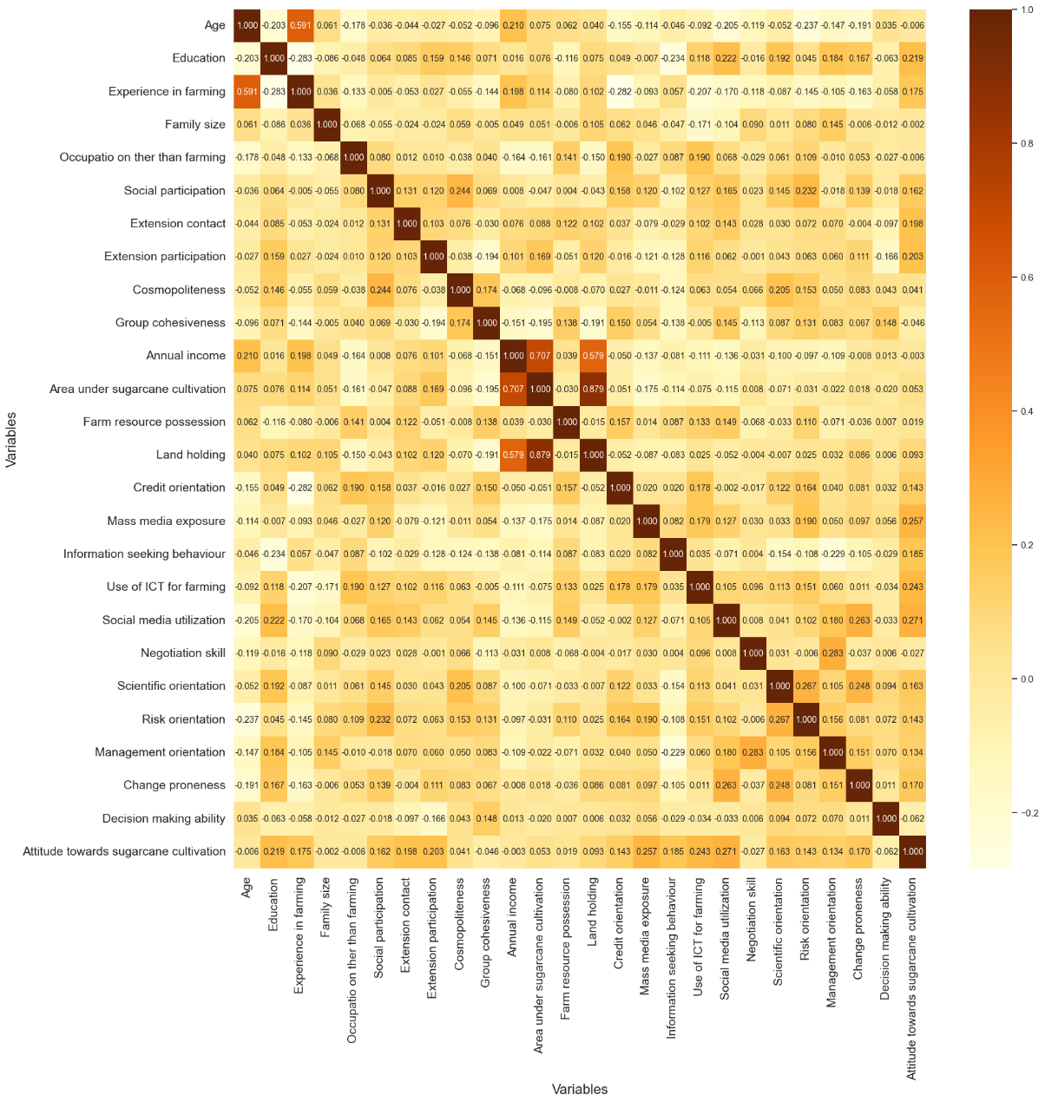
Fig.3. Correlation heat map showing relationship between profile of sugarcane growers with their attitude towards sugarcane cultivation
4.1.1 Personal variables

4.1.1.1 Age and attitude towards sugarcane cultivation

The data presented in Table 1, Fig.3 and Fig.4 reveals that age had non significant correlation with the attitude of growers towards sugarcane cultivation. Therefore, the null hypothesis (H₀): ‘There is no relationship between age and attitude towards sugarcane cultivation’ was accepted. It can be inferred from the above findings that age did not affect the attitude of sugarcane growers towards sugarcane cultivation. The probable reason might be that sugarcane cultivation is a common practice in their families and sugarcane growers of all age are involved in it from an early age. As a result, young, middle and old age growers had similar attitude towards sugarcane cultivation causing non significant relationship between age and attitude of respondents towards sugarcane cultivation. Similar findings were observed in the study conducted by Archana (2021).

4.1.1.2 Education and attitude towards sugarcane cultivation

The results presented in Table 1, Fig.3 and Fig.4 indicates that education had positive and significant correlation with the attitude towards sugarcane cultivation at one per cent level of significance. Hence, the null hypothesis (H₀): ‘There is no relationship between education and attitude towards sugarcane cultivation’ was rejected. This implies that highly educated sugarcane growers develop more favourable attitude towards sugarcane cultivation while, those with less education develop less favourable attitude towards sugarcane cultivation. This might be because educated sugarcane growers have higher awareness and better understanding of improved cultivation practices, government schemes and modern technologies. Hence, they may have good decision making ability and adopt new practices, which leads to more favourable attitude towards sugarcane cultivation. The results are in conformity with the findings of Archana (2021).

4.1.1.3 Experience in farming and attitude towards sugarcane cultivation

A careful observation of results depicted in Table 1, Fig.3 and Fig.4 indicates that experience in farming had positive and significant correlation with the attitude towards sugarcane cultivation at one per cent level of significance. The null hypothesis (H₀): ‘There is no relationship between experience in farming and attitude towards sugarcane cultivation’ was therefore, rejected. The positive and significant relationship between experience in farming and attitude towards sugarcane cultivation implies that sugarcane growers with more years of farming experience tend to have a more favourable attitude and vice versa. This might be because experienced growers might have gained practical knowledge and confidence over the years, which helps them understand the benefits and challenges of sugarcane cultivation better. Their familiarity with the crop and successful past experiences may lead to a more favourable attitude towards sugarcane cultivation.

4.1.1.4 Family size and attitude towards sugarcane cultivation

The data furnished in Table 1, Fig.3 and Fig.4 reveals that family size had non significant correlation with the attitude of growers towards sugarcane crop cultivation. The null hypothesis (H₀): ‘There is no relationship between family size and attitude towards sugarcane cultivation’ was hence, accepted. From this results, it can be inferred that size of family do not influence the attitude towards sugarcane cultivation. The probable reason might be that attitude depends more on individual knowledge, interest and experience rather than their family size.

4.1.1.5 Occupation other than farming and attitude towards sugarcane cultivation

It is evident from Table 1, Fig.3 and Fig.4 that occupation other than farming had non significant correlation with the attitude of sugarcane growers towards sugarcane cultivation. The null hypothesis (H₀): ‘There is no relationship between occupation other than farming and attitude towards sugarcane cultivation’ was accepted. The results implies that having a non farming occupation did not influence the attitude of sugarcane growers towards sugarcane cultivation. This might be due to the fact that even if the sugarcane growers are involved in other occupations, they still remain connected to sugarcane cultivation as it is their primary occupation and a traditional practice passed down through generations. Their interest and commitment remains unchanged, and therefore, their attitude towards sugarcane cultivation was not influenced with occupation other than farming.

4.1.2 Social variables

4.1.2.1 Social participation and attitude towards sugarcane cultivation
A careful examination of Table 1, Fig. 2 and Fig.3 states that social participation had positive and significant correlation with the attitude towards sugarcane cultivation at five per cent level of significance. Therefore, the null hypothesis (H₀): ‘There is no relationship between social participation and attitude towards sugarcane cultivation was rejected. The results indicates that as social participation of sugarcane grower increases, their attitude towards sugarcane cultivation become more favourable and vice versa. This might be due to the fact that involvement in social organizations gives them more opportunities to interact with others, exchange ideas, group activities and access to new information. As a result, higher social participation develops more favourable attitude towards sugarcane cultivation.

4.1.2.2 Extension contact and attitude towards sugarcane cultivation

From the results in Table 1, Fig.3 and Fig.4, it is clear that extension contact had positive and significant correlation with the attitude towards sugarcane cultivation at one per cent level of significance. The null hypothesis (H₀): ‘There is no relationship between extension contact and attitude towards sugarcane cultivation was hence, rejected. This indicates that higher the extension contact, more favourable is the attitude towards sugarcane cultivation and vice versa. The probable reason might be that sugarcane growers with more frequent extension contact may receive scientific recommendations and new information on improved cultivation practices. This might help them solve the problems faced in sugarcane cultivation and feel more confident. As a result, they develop more favourable attitude towards sugarcane cultivation. The results were similar to the findings of Archana (2021).

4.1.2.3 Extension participation and attitude towards sugarcane cultivation

The results presented in Table 1, Fig.3 and Fig.4 reveals that extension participation had positive and significant correlation with the attitude towards sugarcane cultivation at one
per cent level of significance. Hence, the null hypothesis (H₀): ‘There is no relationship between extension participation and attitude towards sugarcane cultivation was rejected. The results implies that sugarcane growers with high extension participation tend to develop more favourable attitude towards sugarcane cultivation and vice versa. The possible reason might be that sugarcane growers with high extension participation actively participate in training programmes, demonstrations, field visits, and other extension activities. Such participation increases their knowledge, improves their skills, and builds favourable attitude in adopting improved cultivation practices and technologies.

4.1.2.4 Cosmopoliteness and attitude towards sugarcane cultivation

The data furnished in Table 1, Fig.3 and Fig.4 reveals that cosmopoliteness had non significant correlation with the attitude of growers towards sugarcane cultivation. Hence, the null hypothesis (H₀): ‘There is no relationship between cosmopoliteness and attitude towards sugarcane cultivation was accepted. The findings suggest that cosmopoliteness does not affect the attitude towards sugarcane cultivation. The probable reason might be that sugarcane growers visit nearby towns may focus more on personal and non-agricultural activities, therefore growers do not gain much relevant information and motivation related to sugarcane cultivation. As a result, cosmopoliteness do not significantly affect their attitude towards cultivation.

4.1.2.5 Group cohesiveness and attitude towards sugarcane cultivation

The results presented in Table 1, Fig.3 and Fig.4 reveals that group cohesiveness had non significant correlation with the attitude of sugarcane growers towards sugarcane cultivation. Hence, the null hypothesis (H₀): ‘There is no relationship between group cohesiveness and attitude towards sugarcane cultivation was therefore, accepted. Therefore, it is evident that group cohesiveness of sugarcane growers does not influence their attitude towards sugarcane cultivation. The probable reason might be that even if sugarcane growers are close and united within groups, leading to collective learning, it does not necessarily influence how they feel about sugarcane cultivation. Their attitude may depend more on individual factors such as personal experience and education rather than group cohesiveness.

4.1.3 Economic variables

4.1.3.1 Annual income and attitude towards sugarcane cultivation

The data presented in Table 1, Fig.3 and Fig.4, reveals that annual income had non significant correlation with the attitude of sugarcane growers towards sugarcane cultivation. The null hypothesis (H₀): ‘There is no relationship between annual income and attitude towards sugarcane cultivation’ was hence, accepted. From the above results, it can be interpreted that annual income does not influence the attitude towards sugarcane cultivation. The possible reason for this results might be that most of the growers had low area under sugarcane cultivation and belonged to low and medium category of annual income, therefore there was less variation in annual income. As a result, annual income did not significantly influence their attitude towards sugarcane cultivation. Moreover, their attitude might be influenced more by their experience in farming, customs and traditional practices passed down through generations rather than their annual income.

4.1.3.2 Area under sugarcane cultivation and attitude towards sugarcane cultivation

It is evident from Table 1, Fig.3 and Fig.4, that area under sugarcane cultivation had non significant correlation with the attitude of sugarcane growers towards sugarcane cultivation. Therefore, the null hypothesis (H₀): ‘There is no relationship between area under sugarcane cultivation and attitude towards sugarcane cultivation’ was accepted. Therefore, the results indicates that attitude of sugarcane growers towards sugarcane cultivation is not influenced by their area under sugarcane cultivation. This might be that most of growers had low area under sugarcane cultivation. Hence, limited variation in area under sugarcane cultivation might be insufficient to affect their attitude towards sugarcane cultivation. Furthermore, their attitude towards sugarcane cultivation depends more on personal beliefs and experience.

4.1.3.3 Farm resource possession and attitude towards sugarcane cultivation

It is clear from Table 1, Fig.3 and Fig.4, that farm resource possession had non significant correlation with the attitude of growers towards sugarcane cultivation. The null hypothesis (H₀): ‘There is no relationship between farm resource possession and attitude towards sugarcane crop’ was accepted. The findings implies that farm resource possession has no influence on attitude towards sugarcane cultivation. This is because attitude of sugarcane growers towards sugarcane cultivation might be shaped more by their experience and commitment rather than the quantity of farm resources owned by them. Even growers with limited resources may have favourable attitude if they are motivated and interested in adopting better cultivation practices while growers with more farm resources may not necessarily have a favourable attitude. Therefore, farm resource possession did not had significant relationship with their attitude towards sugarcane cultivation.

4.1.3.4 Land holding and attitude towards sugarcane cultivation

The results presented in Table 1, Fig.3 and Fig.4, that land holding had non significant correlation with the attitude of sugarcane growers towards sugarcane cultivation. The null hypothesis (H₀): ‘There is no relationship between land holding and attitude towards sugarcane crop’ was accepted. It can be inferred from the above results that attitude of sugarcane cultivation is not influenced by land holding. The probable reason might be that most of sugarcane growers had small to semi medium land holdings, therefore, they might face similar challenges related to cultivation and resources. Moreover, all the growers may not use the total landholding only for sugarcane cultivation, which reduces the influence of size of land holdings on their attitude. Therefore, their attitude towards sugarcane cultivation might be shaped more by shared experiences and farming conditions rather than size of land holdings. This similarity in circumstances could result in non significant relationship. The findings of the study are in agreement with Archana (2021).

4.1.3.5 Credit orientation and attitude towards sugarcane cultivation

A careful observation of Table 1, Fig.3 and Fig.4 reveals that credit orientation had positive and significant correlation with the attitude towards sugarcane cultivation at five per cent level of significance. The null hypothesis (H₀): ‘There is no relationship between credit orientation and attitude towards sugarcane cultivation’ was hence, rejected. This indicates that sugarcane growers with high credit orientation tend to develop more favourable attitude towards sugarcane cultivation while, those with less credit orientation tend to have less favourable attitude. This might be due to the fact that growers with high credit orientation might become more aware of the benefits of accessing institutional credit and are active in seeking financial support for their farming activities. Credit oriented growers may invest more in improved inputs, technologies, and practices, leading to better results in cultivation. Therefore, the successful experience can, in turn, strengthen their favourable attitude towards sugarcane cultivation.

4.1.4 Communication variables

4.1.4.1 Mass media exposure and attitude towards sugarcane cultivation

The data presented in Table 1, Fig.3 and Fig.4 states that mass media exposure had positive and significant correlation with the attitude towards sugarcane cultivation at one per cent level of significance. The null hypothesis (H₀): ‘There is no relationship between mass media exposure and attitude towards sugarcane cultivation’ was therefore, rejected.
This finding implies that as the mass media exposure increases, their attitude towards sugarcane cultivation becomes more favourable, on the other hand, decrease in mass media exposure results in less favourable attitude towards sugarcane cultivation. The probable reason might be that mass media give growers more exposure to expert opinions, demonstration videos and real life success stories which might build favourable attitude towards sugarcane cultivation.

4.1.4.2 Information seeking behaviour and attitude towards sugarcane cultivation

The results presented in Table 1, Fig.3 and Fig.4 states that information seeking behaviour had positive and significant correlation with the attitude towards sugarcane cultivation at one per cent level of significance. Therefore, the null hypothesis (H₀): ‘There is no relationship between information seeking behaviour and attitude towards sugarcane cultivation’ was rejected. The result indicates that sugarcane growers with high information seeking behaviour tends to have more favourable attitude and vice versa. The possible reason could be that sugarcane growers who are interested in sugarcane cultivation seek information actively and gain new knowledge on modern cultivation practices. It is obvious that individuals who are interested in any aspect, object or any phenomena etc. have always positive attitude towards particular things. Moreover, success stories and expert advice which in turn helps them develop favourable attitude towards sugarcane cultivation.

4.1.4.3 Use of ICT for farming and attitude towards sugarcane cultivation

It is evident from Table 1, Fig.3 and Fig.4 that use of ICT for farming had positive and significant correlation with the attitude towards sugarcane cultivation at one per cent level of significance. Hence, the null hypothesis (H₀): ‘There is no relationship between use of ICT for farming and attitude towards sugarcane cultivation’ was rejected. This implies that sugarcane growers who use ICT tools more, tend to have a more favourable attitude towards sugarcane cultivation while, those who use ICT tools less develop less favourable attitude towards sugarcane cultivation. A probable reason is that ICT tools such as mobile applications, agricultural websites and SMS services enable quick and easy access to relevant information on best practices, pest and disease management, weather forecasts, market prices, and government schemes. This timely and accurate information empowers sugarcane growers to make better decisions, thereby developing a more favourable attitude towards sugarcane cultivation.

4.1.4.4 Social media utilization and attitude towards sugarcane cultivation

The results presented in Table 1, Fig.3 and Fig.4 indicates that social media utilization had positive and significant correlation with the attitude towards sugarcane cultivation at one per cent level of significance. The null hypothesis (H₀): ‘There is no relationship between social media utilization and attitude towards sugarcane cultivation’ was therefore, rejected. The findings indicates that an increase in social media utilization develops favourable attitude towards sugarcane cultivation whereas, lower social media utilization leads to less favourable attitude. The probable reason might be that social media platforms allow sugarcane growers to connect with agricultural experts, peer groups, and agricultural communities, where they can exchange knowledge and experiences. Access to success stories, demonstration videos, and real time advice through these platforms increases awareness and motivation, leading to a more favourable attitude towards sugarcane cultivation.

4.1.4.5 Negotiation skills and attitude towards sugarcane cultivation

From the data presented in Table 1, Fig.3 and Fig.4 indicates it is clear that negotiation skills had non significant correlation with attitude towards sugarcane cultivation. The null hypothesis (H₀): ‘There is no relationship between negotiation skills and attitude towards sugarcane cultivation’ was, therefore, accepted. The results suggests that attitude towards sugarcane cultivation is not influenced by the negotiation skills of sugarcane growers. The possible reason for the non significant relationship might be that negotiation skills are mostly used in buying inputs, marketing and selling agricultural produce rather than in the actual cultivation process.

4.1.5 Psychological variables

4.1.5.1 Scientific orientation and attitude towards sugarcane cultivation

The results presented in Table 1, Fig.3 and Fig.4 indicates that scientific orientation had positive and significant correlation with attitude towards sugarcane cultivation at five per cent level of significance. The null hypothesis (H₀): ‘There is no relationship between scientific orientation and attitude towards sugarcane cultivation’ was hence, rejected. This implies that the sugarcane growers with high scientific orientation have more favourable attitude towards sugarcane cultivation and vice versa. The possible reason for positive and significant relationship might be that scientifically oriented growers are more open to adopt new cultivation practices and technologies and often rely on research based information. This enables them to better understand the improved methods of sugarcane cultivation, leading to more favourable attitude towards sugarcane cultivation. The results were in consonance with results of Archana (2021).

4.1.5.2 Risk orientation and attitude towards sugarcane cultivation

The data presented in Table 1, Fig.3 and Fig.4 indicates that risk orientation had positive and significant correlation with attitude towards sugarcane cultivation at five per cent level of significance. The null hypothesis (H₀): ‘There is no relationship between risk orientation and attitude towards sugarcane cultivation’ was therefore, rejected. The positive and significant relationship between risk orientation and attitude towards sugarcane cultivation indicates that sugarcane growers who are willing to take more risk tend to have more favourable attitude towards sugarcane cultivation. On the other hand, those with low risk orientation tend to have less favourable attitude towards sugarcane cultivation. Sugarcane cultivation involves risk related to weather, market price and input costs. Sugarcane growers who are willing to take more risks might be more open to adopt new methods and investing in the crop, which help them develop a more favourable attitude towards sugarcane cultivation. The similar findings was reported by Archana (2021).

4.1.5.3 Management orientation and attitude towards sugarcane cultivation

The data furnished in Table 1, Fig.3 and Fig.4 indicates that management orientation had positive and significant correlation with attitude towards sugarcane cultivation at five per cent level of significance. Therefore, the null hypothesis (H₀): ‘There is no relationship between management orientation and attitude towards sugarcane cultivation was rejected. This implies that the growers with high management orientation have more favourable attitude towards sugarcane cultivation and vice versa. The probable reason could be that growers with good management orientation are better at planning, organizing, and using farm resources effectively. This helps them manage the various aspects of sugarcane cultivation more efficiently, which builds their confidence and leads to a more favourable attitude towards sugarcane cultivation. The results are in line with the findings of Archana (2021).

4.1.5.4 Change proneness and attitude towards sugarcane cultivation

It is clear from Table 1, Fig.3 and Fig.4 that change proneness had positive and significant correlation with attitude towards sugarcane cultivation at one per cent level of significance. Hence, the null hypothesis (H₀): ‘There is no relationship between change proneness and attitude towards sugarcane cultivation’ was rejected. The positive and significant relationship between change proneness and attitude towards sugarcane cultivation indicates that sugarcane growers with high change proneness tend to exhibit more favourable attitude towards sugarcane cultivation whereas, those with low change proneness tend to have less favourable attitude towards sugarcane cultivation. The possible reason might be that growers with high change proneness may try new ideas, and technologies in sugarcane cultivation. This also makes them more willing to adopt improved practices in sugarcane cultivation, which leads to a more favourable attitude towards sugarcane cultivation.

4.1.5.5 Decision making ability and attitude towards sugarcane cultivation

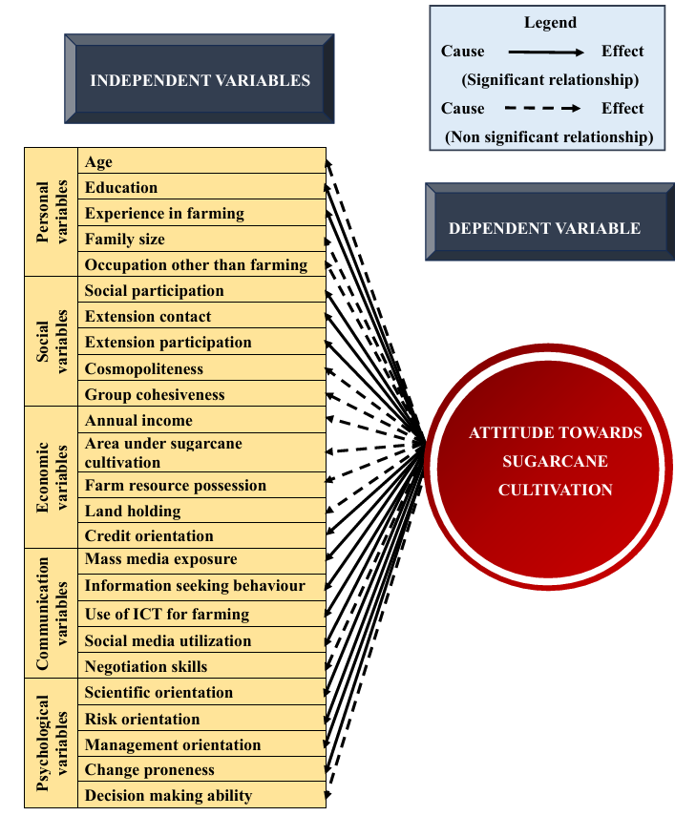
From the data presented in Table 1, Fig.3 and Fig.4 indicates it is clear that decision making ability had non significant correlation with attitude towards sugarcane cultivation. The null hypothesis (H₀): ‘There is no relationship between decision making ability and attitude towards sugarcane cultivation’ was therefore, accepted. The above findings implies that decision making ability of sugarcane growers does not influence their attitude towards sugarcane cultivation. Decision making ability varies depending on the situation and sugarcane growers might rely more on advice from experts, family and community rather than their own decision making skills regarding sugarcane cultivation. This reliance may reduce the influence of their own decision-making ability on their attitude towards sugarcane cultivation. Hence, decision making ability had non significant relationship with attitude towards sugarcane cultivation. The results are supported by the findings of Archana (2021).
Fig. 4. Empirical model showing relationship between the profile of sugarcane growers and their attitude towards sugarcane cultivation

4.2 Stepwise regression analysis of independent variables and attitude towards sugarcane cultivation

The results of stepwise regression analysis with 25 independent variables and attitude towards sugarcane cultivation are presented in Table 2. The Fig.2 shows how well the stepwise regression model explains the variation in the dependent variable (attitude towards sugarcane cultivation) as significant predictors are added step by step, with the increase in adjusted R² indicating improvement in model fit at each step.

Table 2: Stepwise multiple regression analysis of independent variables and attitude towards sugarcane growers
(n=240)
Sr. No. | Independent variables | Partial regression coefficient (b) | Standard error | Multiple Correlation Coefficient ‘R’ | Adjusted R²
 | (Constant) | -111.257 | 9.652 | 0.661 | 0.412
1. | Social media utilization (X₁₉) | 0.854** | 0.206 | 0.661 | 0.412
2. | Mass media exposure (X₁₆) | 0.768** | 0.161 | 0.661 | 0.412
3. | Experience in farming (X₃) | 0.663** | 0.094 | 0.661 | 0.412
4. | Education (X₂) | 2.604** | 0.567 | 0.661 | 0.412
5. | Information seeking behavior (X₁₇) | 0.663** | 0.130 | 0.661 | 0.412
6. | Credit orientation (X₁₅) | 0.434** | 0.121 | 0.661 | 0.412
7. | Extension participation (X₈) | 0.566** | 0.173 | 0.661 | 0.412
8. | Extension contact (X₇) | 0.903** | 0.302 | 0.661 | 0.412
9. | Use of ICT for farming (X₁₈) | 0.325** | 0.128 | 0.661 | 0.412
10 | Scientific orientation (X₂₁) | 0.357** | 0.152 | 0.661 | 0.412
**Significant at 0.01 level probability

The data presented in Table 2 reveals that out of 25 independent variables, ten variables namely viz. social media utilization (0.854**), mass media exposure (0.768**), experience in farming (0.663**), education (2.604**), information seeking behavior (0.663**), credit orientation (0.434**), extension participation (0.566**), extension contact (0.903**), use of ICT for farming (0.325**) and scientific orientation (0.357**) were accounting influence on attitude towards sugarcane cultivation.

These ten independent variables together accounted 41.20 per cent variation in attitude towards sugarcane cultivation.
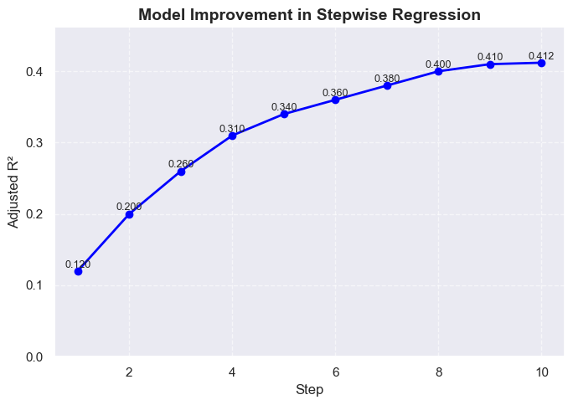
Fig.5. Improvement in Adjusted R² across stepwise regression stages

By following the model, result of stepwise regression analysis is as;
Y = a +b₁₉X₁₉+b₁₆X₁₆ + b₃X₃ + b₂X₂ + b₁₇X₁₇+b₁₅X₁₅+b₈X₈ + b₇X₇ + b₁₈X₁₈ + b₂₁X₂₁

Where
Y = Attitude towards sugarcane cultivation
a = the intercept i.e., -111.257
b₁₉ = Coefficient of partial regression of Y₁ on X₁₉ i.e. 0.854
b₁₆ = Coefficient of partial regression of Y₁ on X₁₆ i.e. 0.768
b₃ = Coefficient of partial regression of Y₁ on X₃ i.e. 0.633
b₂ = Coefficient of partial regression of Y₁ on X₂ i.e. 0.567
b₁₇ = Coefficient of partial regression of Y₁ on X₁₇ i.e. 0.130
b₁₅ = Coefficient of partial regression of Y₁ on X₁₅ i.e. 0.121
b₈ = Coefficient of partial regression of Y₁ on X₈ i.e. 0.722
b₇ = Coefficient of partial regression of Y₁ on X₇ i.e. 0.173
b₁₈ = Coefficient of partial regression of Y₁ on X₁₈ i.e. 0.302
b₂₁ = Coefficient of partial regression of Y₁ on X₂₁ i.e. 0.152
X₁₉ = Social media utilization
X₁₆ = Mass media exposure
X₃ = Experience in farming
X₂ = Education
X₁₇ = Information seeking behaviour
X₁₅ = Credit orientation
X₈ = Extension participation
X₇ = Extension contact
X₁₈ = Use of ICT for farming
X₂₁ = Scientific orientation

Therefore, the fitted equation would be as:
Y= -111.257+(0.854)X₁₉+(0.768)X₁₆+(0.663)X₃+(2.604)X₂+(0.663)X₁₇+(0.434)X₁₅+ (0.566)X₈+(0.903)X₇+(0.325)X₁₈+ (0.357)X₂₁

- CONCLUSION

From the findings of the study, it is evident that education, experience in farming, extension contact, extension participation, mass media exposure, information seeking behaviour, use of ICT for farming, social media utilization and change proneness had positive and significant relationship with attitude towards sugarcane cultivation at one per cent level of significance whereas, social participation, credit orientation, scientific orientation, risk orientation and management orientation had positive and significant relationship with attitude towards sugarcane cultivation at five per cent level of significance. Furthermore, the independent variables study namely, social media utilization, mass media exposure, experience in farming, education, information seeking behaviour, credit orientation, extension participation, extension contact, use of ICT for farming and scientific orientation significantly contributed to attitude towards sugarcane cultivation. Extension agencies, policymakers, and agricultural educators should focus on strengthening these determinants/attributes to foster more favourable attitude towards sugarcane cultivation, ultimately leading to better adoption of recommended practices and improved productivity.

DISCLAIMER (ARTIFICIAL INTELLIGENCE)

Author(s) hereby declare that no generative AI technologies such as Large Language Models (ChatGPT, COPILOT, etc.) and text-to-image generators have been used during the writing or editing of this manuscript.

REFERENCES

Allport, G. W. (1935). Attitudes, In : A Handbook of Social Psychology. (Murchison, C., Ed.), Clark University Press, Worcester, U.S.A, pp. 798–844.
Anonymous (2018). Status paper on sugarcane https://sugarcane.dac.gov.in/Mis/Docs/636988050947079153-d6011213-1f5c 47c5-8735-25157d55fe48SP_Sugarcane2017.pdf
Anonymous. (2022a). Annual report (2021-22), Department of Agriculture and Farmers Welfare, New Delhi, p. 05.
Anonymous. (2022b). State wise area of sugarcane in country during 2015-16 to 2021 22. https://sugarcane.dac.gov.in/.
Anonymous (2024). Sugarcane Production in India: Cultivation, Distribution & Importance. https://www.nextias.com/blog/sugarcane/
Archana, K. (2021). Prospects of sugarcane cultivation for jaggery - A critical analysis. Thesis Ph.D., Acharya N.G. Ranga Agricultural University, Guntur.
Cherry, K. (2024). Formation of an attitude and how it can be changed. https://www.verywellmind.com/attitudes-how-they-form-change-shape-behavior-2795897#citation-1
Jhangiani, R. & Tarry, H. (2022). Principles of Social Psychology (1st International H5P Ed.), Kwantlen Polytechnic University, BC campus.
Johnson, B., Martinez-Berman, L., & Curley, C. (2022). Formation of Attitudes: How People (Wittingly or Unwittingly) Develop Their Viewpoints. Oxford Research Encyclopedia of Psychology.
https://oxfordre.com/psychology/view/10.1093/acrefore/9780190236557.001.0001/acrefore-9780190236557-e-812
Kerlinger, F. N. (1976). Foundation of behavioural research, Surjeet Publication, New Delhi, India.
Srivastava, S., & Rojhe, K. C. (2021). Attitude formation and attitude change: A social psychological perspective. In B. Christiansen & H. C. Chandan (Eds.), Handbook of research on applied social psychology in multiculturalism. https://doi.org/10.4018/978-1-7998-6960-3.ch001
Thurstone, L. L. (1946). The Measurement of Attitude. American Journal of Sociology, 52(1): 39–50.
Young, C. & Ziemer, K. (2024). Attitude Formation at the Individual Level. In: Polls, Pollsters, and Public Opinion: A Guide for Decision-Makers. Methodological Tools in the Social Sciences. Cambridge University Press :25-37.

