Socio-economic attributes of the Mission Shakti Beneficiaries in Odisha

.
ABSTRACT
Even after decades of progressive policy and social reform, gender disparities persistently influence women's participation in economic activities across India. This study, titled “Entrepreneurial Intention of the Beneficiaries Working under the Mission Shakti Programme,” investigates the entrepreneurial intentions among women Self-Help Group (SHG) members in Subarnapur district, Odisha. Their socio-economic attributes were studied carefully, and their effect on entrepreneurial intentions was observed. An ex post facto research design was employed, and the study surveyed 160 beneficiaries from eight villages across two blocks, which were selected through random sampling. Data collection was facilitated through a structured interview schedule developed and validated through pilot testing and expert review. After analysis of the collected data on socio-economic attributes, it was found that majority of the Mission Shakti beneficiaries were middle-aged (31 to 50 years), OBC/SEBC, married, living in nuclear families up to four members, engaged in business as their major occupation, possessing marginal landholdings, and residing in pucca houses. A quarter of respondents (25.00%) were educated up to the undergraduate level, followed closely by 24.38 percent who had completed intermediate education. The family annual income distribution of the respondents showed that a considerable proportion (29.37%) earned between 2 to 3 lakh rupees annually, followed closely by (25.63%) who reported an income between 3 to 4 lakh rupees, and (22.50 %) who earned up to 1 lakh.

Keywords: gender disparities, entrepreneurial intention, socio-economic attributes

1. INTRODUCTION
In a traditionally patriarchal society, women have long been denied equal rights, restricting their potential and limiting their active participation in the development process. Mahatma Gandhi highlighted this reality by stating that the progress of a civilization is best measured by the status of its women, and he emphasized, “Woman is the companion of man, gifted with equal mental capacity.” This powerful assertion underscores the importance of empowering women to attain parity and progress. Despite more than five decades of independence, gender discrimination continues to persist in various forms across Indian society. To mitigate this, the concept of Self-Help Groups (SHGs) was introduced as a grassroots mechanism to bring women together into small groups, encouraging them to start micro-enterprises and build a collective fund through savings. An SHG generally consists of 10 to 20 members who contribute savings to a common fund, which is then used to meet emergency needs and offer collateral-free loans to group members. The concept was first introduced by Dr. Mohammad Yunus in Bangladesh in 1975, and later adopted in India by NABARD in 1986–87. The primary aim of SHGs was to empower rural women by engaging them in income-generating activities and enhancing their economic self-reliance. This not only aimed to improve women’s standard of living but also promoted gender parity through collective economic action (Mohanty, A. & Mishra, S.P., 2018). The word Shakti symbolizes feminine strength—an elemental energy that signifies the power of womanhood. Mission Shakti, a flagship initiative of the Government of Odisha, was launched on March 8, 2001, on the occasion of International Women’s Day, by the Hon’ble Chief Minister Shri Naveen Patnaik. It was envisioned as a platform to empower women across the state by engaging them in productive enterprises through the provision of financial support and market access. Initially targeting the formation of two lakh SHGs within two years, the programme expanded rapidly. By 2006–07, the number of SHGs had reached 2,48,689, increasing to 3,14,646 by 2017, and today, the programme supports more than six lakh SHGs across Odisha. To institutionalize and streamline its operations, the Mission Shakti Directorate was established in 2018 under the Department of Women and Child Development (Annual report book, 2022). The vision of Mission Shakti is to make Odisha a gender-neutral state by empowering women to participate equally in all spheres of life. The core objectives include social mobilization, financial inclusion, and livelihood enhancement. These are pursued through capacity building, credit linkage, and market promotion of SHG products, creating a robust ecosystem for women-led entrepreneurship in both rural and urban areas (Dash, 2024). Empowering women through entrepreneurship is a powerful strategy to break societal barriers and attain gender equality. The Government of India defines women entrepreneurs as those who own and control at least 51% of the capital and provide at least 51% of the employment generated by the enterprise (Government of India, 2006). Women currently represent around 10% of entrepreneurs in India, but their participation is growing rapidly. Recent trends show that women are initiating enterprises at nearly three times the rate of men. Traditionally restricted to household roles, modern Indian women are now venturing into diverse economic sectors. Many of these ventures initially stem from home-based skills such as making pickles, papads, and powders—a phenomenon commonly referred to as the “3 P’s” (Sharma, 2013). Entrepreneurial intention refers to the psychological state in which individuals aspire to establish a new business or create value within existing organizations. It provides a lens to understand why some individuals prefer self-employment over traditional jobs (Wu and Wu, 2008). Choo and Wong (2009) described it as the process of exploring and evaluating information conducive to starting a business, while Thompson (2009) defined it as a self-acknowledged determination to establish a business in the future. Entrepreneurial intention is shaped by a multitude of factors such as personality traits, locus of control, entrepreneurial attitude, previous exposure to entrepreneurship, educational background, family and institutional support, perceived feasibility, and self-efficacy. Understanding how these variables influence entrepreneurial intention is vital for developing effective support mechanisms for SHG members. Mission Shakti has been operational for over 24 years, engaging lakhs of women across Odisha in micro-enterprises and livelihood activities. Evaluating the entrepreneurial intention of these women is essential to understand their readiness, motivation, and potential to pursue entrepreneurial ventures. The insights from such an analysis can guide programme implementers in refining policies, improving infrastructure, and ensuring that beneficiaries receive adequate training, financial support, and market access.

2. methodology
The present study was conducted in the Subarnapur district of Odisha, also known as Sonepur, located in the western region of the state. From each of the eight selected villages, 20 beneficiaries of the Mission Shakti programme were randomly selected to serve as respondents for the study. Both purposive and random sampling techniques were followed to select the respondents for the study. The district was purposively selected based on its active and consistent implementation of the Mission Shakti programme since its inception. Situated in western Odisha, Subarnapur has developed a strong network of Women Self-Help Groups (WSHGs), which play a crucial role in promoting women’s empowerment and entrepreneurship. Out of the six administrative blocks in the Subarnapur district, two blocks, namely Birmaharajpur and Sonepur, were purposively selected for the study. The selection was made in consultation with the respective Mission Shakti block offices, based on the criteria of active participation, strong SHG engagement, and effective implementation of the Mission Shakti programme. This resulted in a total sample size of 160 beneficiaries (8 villages × 20 respondents). Of these, 80 respondents were drawn from the Sonepur block, and the remaining 80 respondents were from the Birmaharajpur block. From each of the two selected blocks, i.e., Birmaharajpur and Sonepur, four villages were randomly selected, resulting in a total of eight villages being chosen for the study. This multistage sampling approach ensured a representative distribution of respondents across different geographic areas within the district, thereby enhancing the reliability and validity of the findings.

3. results and discussion
3.1 SoCIO-ECONOMIC PROFILE
3.1.1 AGE
The age-wise distribution of the respondents in showed that a significant majority (61.25%) of the Mission Shakti beneficiaries belonged to the middle-aged category (30 to 50 years). This indicated that women in this age group were more actively engaged in self-help group (SHG) activities and were likely to possess a balanced combination of life experience, social engagement, and responsibility that fostered a favourable mindset toward entrepreneurship. About 24.37% of the respondents were from the younger age group (up to 30 years), while only 14.38% belonged to the older category (above 50 years). The lower participation of younger women might have reflected their ongoing education, early-stage family responsibilities, or limited exposure to entrepreneurial opportunities. In contrast, older women possibly faced constraints such as reduced better access to financial, educational, and social capital, which might reduce their reliance on group-based support systems like Mission Shakti. These findings suggested that the programme played a crucial role in empowering women from backward communities by enhancing their participation in entrepreneurial and income-generating activities.
3.1.2 CASTE
The caste-wise distribution of the respondents revealed that the majority of the beneficiaries under the Mission Shakti Programme belonged to the OBC/SEBC category, accounting for 58.75 percent of the sample. This was followed by 25.63 percent from the SC/ST category and 15.62 percent from the General category. The high representation of OBC/SEBC and SC/ST groups indicated that the programme had effectively reached the socially and economically disadvantaged sections of society, which aligns with its inclusive development objectives. The relatively lower participation of beneficiaries from the General category could be attributed to their comparatively better access to financial, educational, and social capital, which might reduce their reliance on group-based support systems like Mission Shakti. These findings suggested that the programme played a crucial role in empowering women from backward communities by enhancing their participation in entrepreneurial and income-generating activities.

3.1.3 EDUCATIONAL BACKGROUND
The educational background of the respondents showed a diverse distribution. A quarter of the respondents (25.00%) were educated up to the undergraduate level or above, followed closely by 24.38 percent who had completed intermediate education. High school education was attained by 20.00 percent of the respondents. A smaller proportion had education up to upper primary (10.00%) and primary level (9.38%), while 4.37 percent could only read and write without formal schooling. Notably, 6.87 percent of the respondents were illiterate. This distribution suggested that a majority of the Mission Shakti beneficiaries had at least completed high school or higher education, which could positively influence their awareness, decision-making ability, and confidence in pursuing entrepreneurial activities. However, the presence of illiterate and low-literacy individuals also indicated the need for simplified training materials and supportive capacity-building interventions tailored to their learning levels. The mix of educational qualifications among beneficiaries highlighted the importance of adopting differentiated communication and training strategies to ensure effective participation in entrepreneurship-related programmes.
3.1.4 MARITAL STATUS
The data on marital status revealed that a vast majority of the respondents (89.38%) were married, while only 10.62 percent were unmarried. This indicated that most of the women engaged under the Mission Shakti Programme were responsible for managing household duties alongside participating in self-help group activities. Married women might have perceived entrepreneurial activities as a means to contribute to family income and enhance financial security. Their involvement in group-based initiatives could also reflect a strong motivation to support their families and gain economic independence. The comparatively lower proportion of unmarried respondents could be due to younger women being more focused on education or family responsibilities before marriage, or due to limited exposure to such programmes at an early stage. The findings suggested that entrepreneurial support mechanisms within the Mission Shakti framework needed to consider the domestic responsibilities of married women and offer flexible, family-inclusive models to sustain their participation.

3.1.5 FAMILY TYPE
The analysis of family type revealed that a substantial majority of the respondents (81.25%) belonged to nuclear families, while only 18.75 percent lived in joint family setups. This indicated a predominant shift toward nuclear family structures among women beneficiaries under the Mission Shakti Programme. Women in nuclear families might have had more autonomy in decision-making, which could positively influence their entrepreneurial intention and willingness to participate in self-help group activities. Additionally, the reduced dependency on extended family approval might have enabled quicker adoption of income-generating ventures. In contrast, women in joint families might have experienced shared responsibilities, which could either provide additional support or pose constraints depending on the family dynamics. These findings highlighted the importance of considering family structure while designing entrepreneurship interventions, as women from nuclear families may require different forms of support compared to those from joint family settings.
3.1.6 FAMILY SIZE
The distribution of respondents based on family size indicated that the majority (76.25%) belonged to small families with up to four members. This was followed by 13.13 percent who had large families with seven or more members, and 10.62 percent who lived in medium-sized families comprising five to six members. The predominance of small family units suggested a growing trend toward nuclear households among the Mission Shakti beneficiaries. Women from smaller families might have experienced greater flexibility in time and decision-making, which could positively affect their entrepreneurial pursuits. On the other hand, those from larger families might have faced increased domestic responsibilities, which could either restrict their involvement in entrepreneurial activities or, in some cases, motivate them to contribute financially to meet household needs. These findings pointed to the necessity of tailoring entrepreneurial training and support services by considering the family size and associated time and resource constraints faced by women beneficiaries.

3.1.7 FAMILY ANNUAL INCOME
The family annual income distribution of the respondents showed that a considerable proportion (29.37%) earned between 2 to 3 lakh rupees annually. This was followed closely by 25.63 percent who reported an income between 3 to 4 lakh rupees, and 22.50 percent who earned up to 1 lakh. About 19.37 percent fell in the 1 to 2 lakh income bracket, while only 3.13 percent reported an income above 4 lakh rupees per year. The data suggested that a majority of the beneficiaries were concentrated in the lower to middle-income range, reflecting modest household earnings. This income level might have acted as both a motivator and a constraint for entrepreneurial activity. On one hand, the need to supplement family income could have driven interest in self-employment; on the other hand, limited financial resources might have restricted access to capital and risk-taking capacity. The low percentage of respondents in the higher income bracket further indicated that most women beneficiaries relied on Mission Shakti for income support and livelihood opportunities. These findings highlighted the importance of integrating financial support mechanisms such as micro-credit, subsidies, or revolving funds within entrepreneurship programmes for women from lower-income backgrounds.
3.1.8 FAMILY MAJOR OCCUPATION
The analysis of family major occupation revealed that the highest proportion of respondents (41.25%) belonged to families primarily engaged in business activities. This was followed by 24.37 percent whose families were involved in cultivation and 14.37 percent who depended on wage labour. About 13.13 percent of the respondents came from families following traditional caste-based occupations. Only a small proportion of respondents reported private jobs (3.13%) and government jobs (3.75%) as their family’s main source of livelihood. The dominance of business and cultivation as major occupations suggested that many families had a basic orientation toward self-employment or informal entrepreneurial ventures. This could have positively influenced the entrepreneurial intention of the women beneficiaries, as exposure to income-generating activities within the family often encourages similar attitudes. On the other hand, those from labour and caste occupation backgrounds might have seen entrepreneurship as a pathway to break away from generational dependence on low-income or low-status work. The findings indicated that entrepreneurial programmes under Mission Shakti should consider the occupational background of beneficiaries to design appropriate support systems, including skill development, credit facilitation, and market linkages.
3.1.9 LANDHOLDING
The analysis of landholding revealed that a significant majority of the respondents (68.13%) belonged to marginal landholding households with up to one hectare of land. This was followed by 26.25 percent who had small landholdings ranging from one to two hectares, and 5.63 percent who were in the medium category with holdings between two to four hectares. Notably, none of the respondents reported having large landholdings above four hectares. The predominance of marginal and small landholders indicated that most Mission Shakti beneficiaries came from economically modest agricultural backgrounds with limited access to land-based resources. This might have influenced their interest in non-farm and supplementary income activities, including entrepreneurship. The absence of large landholders in the sample also reflected the programme's targeted outreach to economically weaker sections. These findings suggested the need to design entrepreneurship interventions that required minimal land dependency and low investment, enabling women from land-scarce households to participate effectively and sustainably in income-generating ventures.

3.1.10 TYPE OF HOUSE
The data on the type of house revealed that a large majority of the respondents (76.88%) lived in pucca houses, while (23.13%) resided in semi-pucca structures. Notably, none of the respondents reported living in kutcha houses. The predominance of pucca houses indicated a relatively improved standard of living among the beneficiaries under the Mission Shakti Programme. This might have been the result of various housing and welfare schemes implemented by the government, such as the Pradhan Mantri Awas Yojana, or it could reflect the cumulative impact of income-generation activities carried out by the respondents and their families. The absence of kuccha houses also suggested a certain level of economic stability among the participants, which could be favourable for undertaking entrepreneurial activities. These findings highlighted the importance of leveraging existing household infrastructure and living conditions to promote home-based enterprises and micro-level entrepreneurship among women beneficiaries.
3.1.11 Association among socio-economic attributes
The Spearman’s Rank Correlation analysis was employed to assess the relationships among key socio-economic variables: age, education, family type, family size, family annual income, land holding, and type of house. Spearman’s correlation was chosen over Pearson's correlation due to the ordinal nature of many variables and the absence of a normal distribution in the data. Spearman’s method is a non-parametric technique that measures the strength and direction of monotonic relationships between ranked variables, making it suitable for socio-economic data that often violate the assumptions of parametric tests. The analysis revealed several significant associations. Age showed significant negative correlations with education (r = -0.452**), family annual income (r = -0.209**), land holding (r = -0.232**), and type of house (r = -0.291**). This indicates that younger respondents are generally more educated, come from higher-income families, possess larger land holdings, and live in better-quality houses. These results suggest that socio-economic conditions are improving among the younger generation. Education exhibited strong positive correlations with family annual income (r = 0.568**), land holding (r = 0.423**), and type of house (r = 0.503**), highlighting the influence of education in elevating the economic and living standards of individuals. A weak but significant negative correlation was observed between education and family type (r = -0.157*), suggesting that nuclear families are slightly better educated than joint families. Family type and family size had a highly significant positive correlation (r = 0.892**), which aligns with the understanding that joint families generally consist of more members. Both variables, however, were negatively associated with family annual income and type of house, indicating that larger and joint families tend to have lower income and reside in less permanent housing structures. Family size also negatively correlated with income (r = -0.234**) and type of house (r = -0.196*), implying that larger families may face financial pressure that affects their living conditions. Family annual income had positive correlations with land holding (r = 0.197*) and type of house (r = 0.380**), indicating that wealthier families are more likely to own land and live in better housing. Similarly, land holding positively correlated with type of house (r = 0.252**), suggesting that landowners typically reside in pucca or semi-pucca houses.
Table 1. Socio-economic attributes of the beneficiaries

Sl. No. | Category | Frequency | Percentage
AGE
i. | Young (Up to 30) | 39 | 24.37
ii. | Middle (31 to 50) | 98 | 61.25
iii. | Old (Above 50) | 23 | 14.38
CASTE
i. | ST/SC | 41 | 25.63
ii. | OBC/SEBC | 94 | 58.75
iii. | General | 25 | 15.62
EDUCATION
i. | Illiterate | 11 | 6.87
ii. | Read and write only | 7 | 4.37
iii. | Primary school (up to 4th) | 15 | 9.38
iv. | Upper primary (5th-7th) | 16 | 10.00
v. | High school | 32 | 20.00
vi. | Intermediate | 39 | 24.38
vii. | Undergraduate and above | 40 | 25.00
MARITAL STATUS
i. | Married | 143 | 89.38
ii. | Unmarried | 17 | 10.62
FAMILY TYPE
i. | Nuclear | 130 | 81.25
ii. | Joint | 30 | 18.75
FAMILY SIZE
i. | Small (Up to 4 Members) | 122 | 76.25
ii. | Medium (5-6 Members) | 17 | 10.62
iii. | Large (7 members & above) | 21 | 13.13
FAMILY ANNUAL INCOME
i. | Up to 1lakh | 36 | 22.50
ii. | 1 to 2lakh | 31 | 19.37
iii. | 2 to 3lakh | 47 | 29.37
iv. | 3 to 4lakh | 41 | 25.63
v. | Above 4lakh | 5 | 3.13
FAMILY ANNUAL INCOME
i. | Labour | 23 | 14.37
ii. | Caste occupation | 21 | 13.13
iii. | Cultivation | 39 | 24.37
iv. | Business | 66 | 41.25
v. | Private Job | 5 | 3.13
vi. | Govt. Job | 6 | 3.75
LAND HOLDING
i. | Marginal (up to 1 ha) | 109 | 68.12
ii. | Small (1-2 ha) | 42 | 26.25
iii. | Medium (2-4 ha) | 9 | 5.63
iv. | Large (more than 4 ha) | 0 | 0.00
TYPE OF HOUSE
i. | Kutcha | 0 | 0.00
ii. | Semi-pucca | 37 | 23.12
iii. | Pucca | 123 | 76.88

Table 2: Spearman's Rank Correlation
Sl. No. | Variable | Age | Education | Family Type | Family Size | Family Annual Income | Land Holding | Type of House
1 | Age | 1
2 | Education | -0.452** | 1
3 | Family Type | 0.030NS | -0.157* | 1
4 | Family Size | -0.056NS | -0.144NS | 0.892** | 1
5 | Family Annual Income | -0.209** | 0.568** | -0.204** | -0.234** | 1
6 | Land Holding | -0.232** | 0.423** | -0.068NS | 0.012NS | 0.197* | 1
7 | Type of House | -0.291** | 0.503** | -0.192* | -0.196* | 0.380** | 0.252** | 1

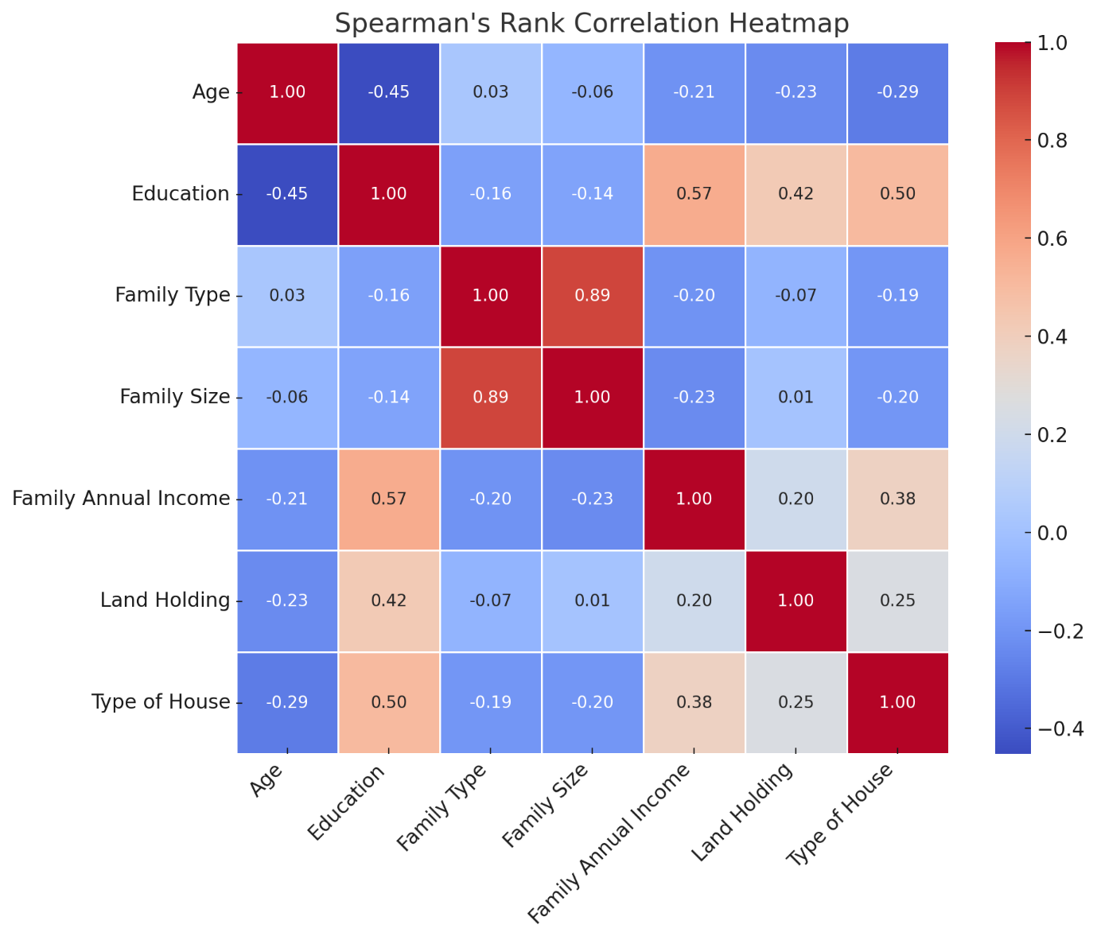

Figure 1: Spearman's rank correlation heatmap

4. Conclusion
The socio-economic and demographic profile of Mission Shakti beneficiaries reflects a diverse yet cohesive group of women driven by the need for financial independence and social empowerment. A majority are middle-aged (31–50 years), married, and belong to nuclear families, factors that seem to enhance decision-making and active participation in SHG activities. The programme has achieved inclusive outreach, with most beneficiaries from OBC/SEBC and sc/st communities, highlighting its role in empowering marginalized groups. The educational profile indicates that while many women have attained at least high school-level education, the presence of low-literacy participants calls for simplified and inclusive training approaches. Economic data reveal that most beneficiaries come from lower and middle-income households with small or marginal landholdings, necessitating low-investment, non-farm-based entrepreneurial strategies. Occupationally, the dominance of self-employment and informal work provides a conducive environment for entrepreneurship, though targeted support is essential for women from labour-intensive or caste-based backgrounds. Overall, Mission Shakti has emerged as a catalyst for women’s economic participation and empowerment. However, tailored interventions addressing age, family structure, literacy levels, and income constraints are essential to ensure sustained entrepreneurial growth and inclusive development

COMPETING INTERESTS DISCLAIMER:
Authors have declared that they have no known competing financial interests OR non-financial interests OR personal relationships that could have appeared to influence the work reported in this paper.

REFERENCES

Baindha, A., Berwal, R. K., Kumar, A., Sankhala, G., & Kumar, V. (2017). Socio-personal, communication and psychological profile affecting entrepreneurial behaviour of milk processors. International Journal of Veterinary Science and Animal Husbandry, 2(2), 39–43.
Bhagyasree, P. (2014). A study on capacity building and empowerment of self-help groups in Thane district of Maharashtra (Master’s thesis). Acharya N. G. Ranga Agricultural University, Hyderabad, India.
Chekame, A. S., Chauhan, J. K., Singh, R. J., & Das, D. (2019). Entrepreneurial behaviour of women self-help group members in Meghalaya. Indian Journal of Hill Farming, 32(1), 63–67.
Choo, S., & Wong, M. (2006). Entrepreneurial intention: triggers and barriers to new venture creations in Singapore. Singapore management review, 28(2), 47.
Dash, P. (n.d.). Mission Shakti: A silent revolution in Odisha. Government of Odisha. https://missionshakti.odisha.gov.in/
Ministry of Micro, Small and Medium Enterprises. (n.d.). Women entrepreneurs. Government of India. https://msme.gov.in/women-entrepreneurs
Prita, M. P. (2001). A study on the performance of self-help groups in Dharwad district (Master’s thesis). University of Agricultural Sciences, Dharwad, Karnataka, India.
Routray, S. (2024). Entrepreneurship for Women in Rural Odisha: Evolution Over the Past Five Years and Socioeconomic Relevance. In Breaking the Silos: Exploring the Multiple Perspectives of Positive Psychology (pp. 177-207). Singapore: Springer Nature Singapore.
Sain, K., & Mondal, A. (2017). An empirical study to examine the impact of self-help groups on the income of rural women. International Journal of Commerce and Management, 11, 162–170.
Sharma, P., & Varma, S.-K. (2008). Women empowerment through entrepreneurial activities of self-help groups. Indian Research Journal of Extension Education, 8(1), 46–51.
Thompson, E. R. (2009). Individual entrepreneurial intent: Construct clarification and development of an internationally reliable metric. Entrepreneurship Theory and Practice, 33(3), 669–694. https://doi.org/10.1111/j.1540-6520.2009.00321.x

