INFLUENCE OF GROWTH SUBSTRATE IN ROOTING ABILITY OF PYRETHRUM (CHRYSANTHEMUM CINERARIIFOLIUM) STEM CUTTINGS

Abstract
Pyrethrum (Chrysanthemum cinerariaefolium) has been a key cash crop in the world, especially for small holder farmers. Once the world’s top producer, Kenya’s output declined from 18,000 metric tons in the 1980s–90s due to policy and global market challenges but has recently rebounded, reaching 1,680 tons in 2023. Government interventions such as seedling distribution, agronomic training, and private sector involvement have increased the number of growers and acreage, with about 38,000 farmers now cultivating 9,500 acres. Pyrethrum is valued for its natural insecticidal properties and environmental safety, meeting global demand for sustainable pest control. The crop is mainly propagated vegetatively to preserve elite traits, with propagation success dependent on substrate, hormone use, and environmental conditions. In this study, an efficient protocol for the vegetative propagation of pyrethrum (Chrysanthemum cinerariifolium) was developed using stem cuttings. The study assessed the rooting performance of pyrethrum cuttings across different substrate types and plant growth regulator (PGR) formulations. This protocol is particularly valuable for disease screening, development of mapping populations, and seed multiplication in pyrethrum breeding programs. The experiment utilized a split plot randomized complete block design with four replications of 30 cuttings each per plot, tested across four substrate treatments, two hormone levels and 1 negative control with no hormone. After six weeks, rooting success was evaluated based on the number and length of roots, as well as the proportion of rooted versus non-rooted cuttings. Data were square root transformed and analyzed using ANOVA in Genstat, with treatment means compared using the least significant difference (LSD) test at the 5% significance level. Significant differences were observed both in substrate components and the PGR formulations. Results indicated that the coco peat: sand substrate produced the highest mean number of roots (13.29) and the greatest root length (5.41 cm). No roots developed in the negative control. The findings recommend the use of a coco peat: sand mixture combined with IBA powder at 0.6%, to maximize root development in pyrethrum cuttings, offering a reliable method for large-scale propagation.
Key words; Pyrethrum, Growth substrate, PGR, rooting

Introduction
Pyrethrum (Chrysanthemum cinerariaefolium) has been a major cash crop in several countries of the world. However, production declined sharply due to policies, market, and management challenges. In recent years, Kenya’s pyrethrum production has shown recovery after completely going down from the highest producer in the world, to no production at all. Production of dry pyrethrum flowers increased from 941.9 tonnes in 2022 to 1,680 tonnes in 2023, mainly due to government interventions such as seedling distribution, improved agronomic training, and better post-harvest handling. However, in 2024, production slightly declined to 1,634 tonnes, attributed to erratic weather, seedling distribution challenges, and reduced farmer participation (Economic Survey 2025). This revival has led to very high demand for planting material, that has led to the need to come up with fast means of providing clean planting materials to the farmers. The crop is valued for its natural insecticidal properties and its eco-friendly profile, natural pyrethrins degrade rapidly in the environment, reducing chemical residues and minimizing ecological impact (EurekAlert, 2024). The value of dry flowers increase with increase of pyrethrin extracts and there is significantly strong demand in the EU and US markets and still growing. The industry faces challenges such as policy inconsistencies, weather variability, and logistical setbacks. However, increasing global demand for natural insecticides and ongoing government support present significant opportunities for growth and export earnings. The renewed interest in pyrethrum is driven by the need for sustainable pest control solutions that address the environmental and health risks associated with synthetic pesticides. Integrating pyrethrum into agricultural systems supports the UN’s environmental conservation agenda while providing a valuable source of income for farmers. Pyrethrum is primarily propagated vegetatively, either by splitting established plants or by rooting stem cuttings. While seed propagation is possible, vegetative methods are preferred as they preserve the desirable genetic traits of elite mother plants, ensuring uniformity and vigor in new plantings. The success of vegetative propagation depends on several factors, including: Rooting hormone concentration; growth substrate; environmental conditions and cutting selection. Plant growth hormones particularly IBA has been found to effectively promote rooting in cuttings (Kontoh, 2016). This research study was conducted to evaluate the efficiency of different types of substrates in root initiation of pyrethrum (Chrysanthemum cinerariifolium) stem cuttings hence optimizing a propagation protocol for pyrethrum. These developments facilitate the breeding of high-pyrethrin-yielding varieties and support the expansion of sustainable pyrethrum production systems.

Materials and methods
Study Area
The study was conducted at the Department of Agriculture and Biotechnology of The University of Eldoret, Uasin Gishu County, Kenya. The latitude and longitude of this county are approximately: Latitude: 0° 31' 0" N (or 0.5167° N in decimal) Longitude: 35° 17' 0" E (or 35.2833° E), with an altitude ranging from about 1,800 to 2,200 meters above sea level. The county is characterized by a diversity of soil types, influenced by its plateau landscape, volcanic geology, and varying elevation. The dominant Soil types include: Ferralsols; Nitisols; Gleysols; Luvisols, Acrisols, Cambisols, and Regosols. The area features a subtropical highland climate, with moderate to cool temperatures year-round, ranges between 7°C and 29°C throughout the year. More specifically, the mean annual temperature is about 17.3°C (63.2°F), with average daily highs around 23.8°C (74.9°F) and lows around 11.5°C (52.7°F) The region receives an average annual rainfall of approximately 1,150 mm, with one long rainy season spanning from March to September, peaking in March and August. Relative humidity is moderate, and the climate supports both agricultural and urban activities (Uasin Gishu County Integrated Development Plan (CIDP), 2023–2027, (2023).

Plant Material
Stem cuttings were collected from mature Chrysanthemum cinerariifolium plants that had been established in the university field since September 2022 from tissue culture plants. The propagation material consisted of stems cuttings from average 4-month-old plants, randomly selected from mother plants exhibiting desirable traits such as disease resistance, high vigor, and uniform flowering. The stems from which the cuttings were made were harvested when they were at vegetative stage. Each cutting measured approximately 2–3 cm in length and was mainly from the youngest part of each stem from which the tip was cut off. These cuttings were cleaned with running water and dipped in 50% ethanol to sterilize from any pathogens.

Treatments
The experiment was set out as a split plot with the substrate type as the main plot, while the hormone treatment was the split plot. Four different growth substrates were used. The first was soil only, the second mix was sand: soil, with the third as manure: sand, and the last as cocopeat: sand with all mixtures at a ratio of 1:1. The mixtures were well blended together. The stem cuttings were treated using one of 2 growth hormones, either in powder or solution form, while the last one was left untreated with any growth hormone. To prepare the first growth hormone, Osho rootex rooting hormone was used with a concentration of 0.6% of IBA. Another set-up was prepared where IBA solution at a concentration of 4.5% (IBA powder was dissolved in pure ethanol and topped up with distilled water to obtain 4.5% of IBA). For the control treatment, no rooting hormone was used. Trays with cells were filled with each of the growth media substrate and compressed to create a compact substrate. The basal cuttings were dipped into 0.6% powder IBA. Another set of stem cuttings were soaked in IBA overnight to allow IBA solution absorption. All the treatments were replicated four times with 30 cuttings per plot. The cuttings were kept in a greenhouse with maintained temperatures of between 26-28⁰C with misting being done for 30 seconds after every 30 minutes, creating a humidity of 75-78%.
Experimental design
A split plot randomized complete block design was used with four replications comprising of 15 cuttings per plot where each of the 4 treatments were split into two IBA concentrations each in solution form and in powder form and a third split as cuttings with no hormone application, as shown in Table 1. The cuttings were first planted in plastic celled trays of 5 cm diameter each and 11 by 20 cells per tray.
After 6 weeks when the stem cuttings had established roots at their best, a transplant was carried out from the tray cells into pots to encourage more root growth.

Table 1: Description of substrate and PGR applied to Chrysanthemum cinerariifolium for rooting test
Soil types | Substrate | Four Split plot (hormone treatment of cuttings
T1 | Soil | IBA at 0.6% in powder form,  0.6% solution,  4.5% IBA powder  4.5% IBA solution, no hormone
T2 | Soil + sand
T3 | Manure+ sand | For each substrate
T4 | Coco peat+ sand

Data collection and statistical analysis
At six-week stage, the number of rooted cuttings, number of roots per cuttings, root length per cutting, number of dieback on stems cuttings and number of non-rooted cuttings was recorded. The plantlets which had not died were transplanted out in the pots which were 15 cm in diameter and depth of 10 cm. All data collected were square root transformed before being analyzed using Analysis of Variance (ANOVA) in statistical package. Differences between treatment means were separated using the least significant difference (LSD) test at 5% probability level.

Results and discussion
Six weeks after the establishment of the stem cuttings, data was collected on number of roots and the length of the roots, percentage of the die back, the rooted cuttings and the non-rooted cuttings as shown in Tables 2 and 3 and Figures 1 and 2 below. Getting to find out the best composition of rooting substrate for pyrethrum will help in preparing seedlings for farmers effectively and efficiently. Soil is the most common and first line choice of substrate. However, it is necessary to test other substrates and mixtures to optimize seedling preparation. In this study, there was significant differences in the rooting with the 4 different types of substrates. The addition or lack of it also brought up further differences that were significant. There was no rooting observed on the control plots, where no hormone was added, irrespective of the type of substrate used. This indicates that substrate alone will not lead to effective rooting of pyrethrum cuttings. There was a significant difference in the rooting percentage across all the treatments. Stem cuttings treated with 0.6% IBA in powder form gave the highest rooting percentage as compared to the stem cuttings dipped overnight in 4.5% IBA solution. This could be as a result of slow absorption of the IBA solution.

Effect of growth substrate and PGR form on survival and rooting ability of Chrysanthemum cinerariifolium
Different substrates allowed rooting differently. This could be due to the structure of the substrate, as support as well as providing rooting environment to the pyrethrum stem cuttings. It was observed that proper water and oxygen balance to the substrate was important to ensure provision of good growth conditions to the plant cuttings. This was deduced due to the fact that soil, which allows less aeration than sand and cocopeat, produced the lowest number of rooted cuttings. Good aeration is important in the supply of needed oxygen and carbon dioxide for physiological processes in root development to take place. This promotes sufficient nutrient uptake, transpiration, aeration thus encouraging root growth (Mabizela et al., 2017). Eight weeks after planting of the stem cuttings on the different substrates, cocopeat: sand gave the highest number of rooted cuttings (28.25) with the least number of non-rooted cuttings and dieback (3.50 and 3.00) respectively. This gives the indication that this combination allowed environment conditions for root growth and development. Cocopeat and sand both allow good aeration and nutrient exchange due to coarseness of their particle structures. Soil gave the highest number of stem cuttings that had a die back (12.500) (Table 2). This is an indication that soil would not make a good substrate for rooting of pyrethrum cuttings, and would therefore need to be blended with other substances to improve the conditions for growth and development of roots. It is possible that the compactness of the soil gave no provision of aeration causing stress on the stem cuttings hence the high rate of dieback. It is also possible that the root zone was not able to get nutrients efficiently due to the compactness of the soil particles. Compared with soil and sand mix, and soil and cocopeat mix, it shows that the conditions were better with the mixes, thus giving a higher number of the rooted stems (Table 2). It was observed that most of the non-rooted cuttings across all the treatments had developed callus at the basal part of the cutting. Callus is a mass of undifferentiated cells which occurs after wounding of a plant tissue enabling its healing (Jie Yu et al., 2017). Callus formation prevents the root growth due to its undifferentiated nature by impairing the vascular connection between the roots and shoots which is responsible for uptake of water and nutrients (Radmann et al., 2002, Arab et al., 2018). Callus grows when the tissue is under stress, thus it explains that the cuttings were in more stress when planted in soil than the soil mix with sand or cocopeat. Soil as a substrate for rooting of pyrethrum stem cuttings came out as the poorest. This could have been due to compaction and thus poor aeration and water availability to the weak cuttings.
It was observed that that the form of PGR as well as the concentration affected rooting and greatly influenced the rooting ability. Stem cuttings propagated after treating them with 4.5% IBA solution had less rooting effect as compared to the stem cuttings treated with 0.6% IBA powder. Even after soaking for 24 hours, this did not offer a better environment. The powder form was available to the cutting for longer than when soaked in solution for 24 hours. Even though at lower concentration, availability for a longer period allowed the IBA to regulate root development in a positive way. It could therefore lead to recommendation that IBA should be supplied in powder form for pyrethrum cuttings to root better.

Table 2: Effect of different substrates and PGR Form on rooting ability of Chrysanthemum cinerariifolium
Substrate | Rooted cuttings |  | Non rooted cuttings |  | Stem Die back
 | 0.6% IBA Powder | 4.5% IBA Solution | 0.6% IBA Powder | 4.5% IBA Solution | 0.6% IBA Powder | 4.5% IBA Solution
Soil | 9.00 b | 4.250 a | 13.50 c | 17.75 b | 12.500 c | 13.00 b
Soil: sand | 13.00 c | 8.750 b | 11.25 b | 13.75 a | 10.750 bc | 12.50 b
Manure: sand | 3.00 a | 4.250 a | 23.67 d | 17.75 b | 9.750 b | 13.00 b
Cocopeat: sand | 28.25 d | 16.000 c | 3.50 a | 11.50 a | 3.000 a | 8.00 a
Effect of growth substrate and PGR form on number and length of Chrysanthemum cinerariifolium
Both PGR form and type of growth substrate significantly influenced root number and length of pyrethrum stem cuttings. This shows that combination of the best substrate and the good PGR will lead to good root growth and development. The highest number of roots (13.294) were recorded in stem cuttings propagated on cocopeat: sand mix. This was also observed to be similar in ranking as the highest length of the roots (5.412) as shown in Table 3. This could have been caused by the fact that cocopeat has high aeration as compared to soil. Combined with sand, this further improved the coarseness of the substrate structure, and thus provided a condusive environment for root growth in number and length equivalent to favourable conditions for root development and growth. Manure: sand gave the least number and length of roots as in Table 3. This finding of manure not being a favourable substrate was also reported by Masay Adugna et al., (2015), where cuttings propagated on decomposed manure showed the lowest root growth. Manure may have showed poor properties due to composition of salts and soil acidity, that does not favour root development. High acidity retards root development. The richness of nutrient composition notwithstanding, manure and soil mix did not come out as a good substrate. This shows that for good growth, nutrient availability must be accompanied with conditions that favour uptake for effective and efficient utilization by the plant.
Table 3: Effect of growth substrate and PGR form on the number and length of roots of Chrysanthemum cinerariifolium
Substrate | No. of roots |  | Length of roots
 | 0.6% IBA Powder | 4.5% IBA Solution | 0.6% IBA Powder | 4.5% IBA Solution
Soil | 3.562 b | 2.812 a | 2.587 b | 2.431 a
Soil: sand | 7.875 c | 3.875 b | 3.150 c | 2.794 b
Manure: sand | 2.125 a | 3.867 b | 1.819 a | 2.640 ab
Cocopeat: sand | 13.294 d | 8.235 c | 5.412 d | 3.971 c

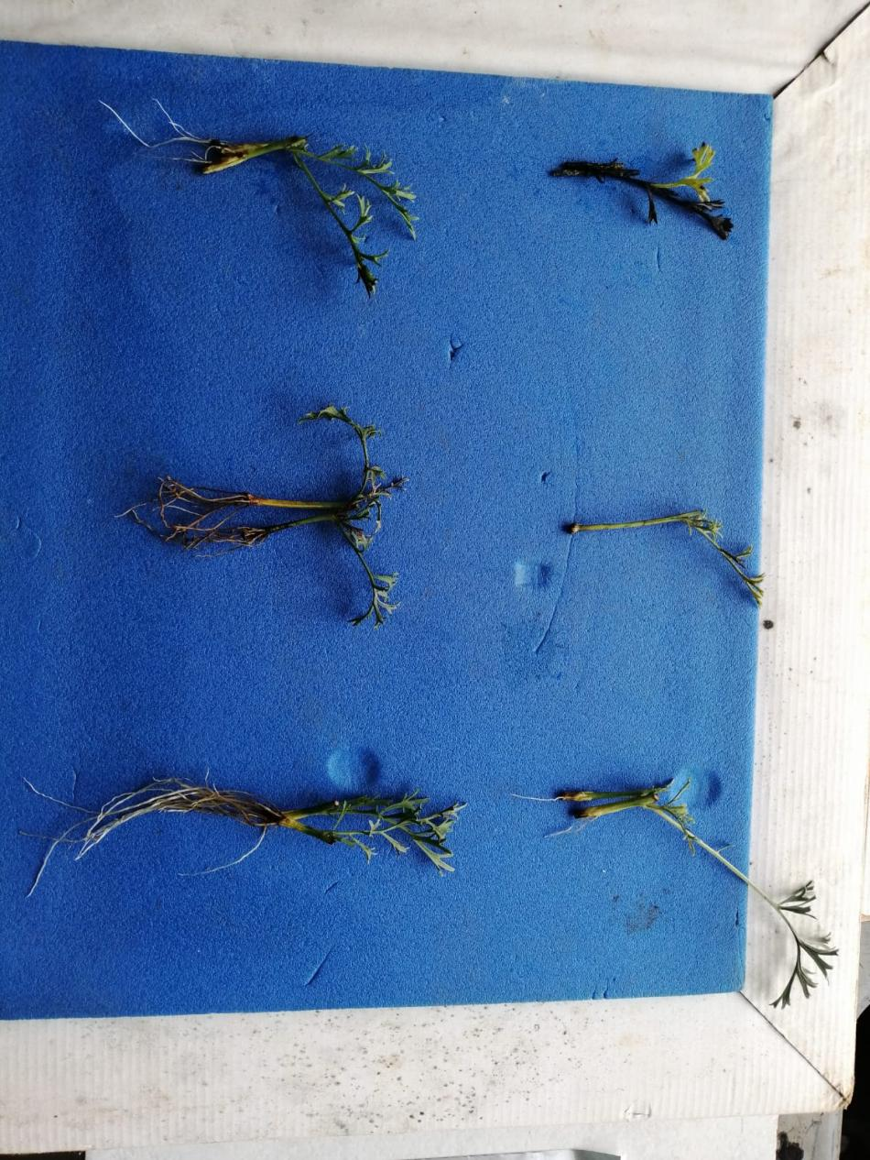
F
C
B
E
D
A
Figure 1: A) Dieback of the stem cuttings B) Non rooted cuttings which developed a callus at the base of the cutting C) Stem cuttings obtained from manure: sand D) Stem cuttings obtained from soil E) Stem cuttings obtained from soil: sand F) Stem cuttings obtained from cocopeat: sand

The pictures below show the stages of the micro propagation. From the initiation stage i, to the development of a whole plant, viii. 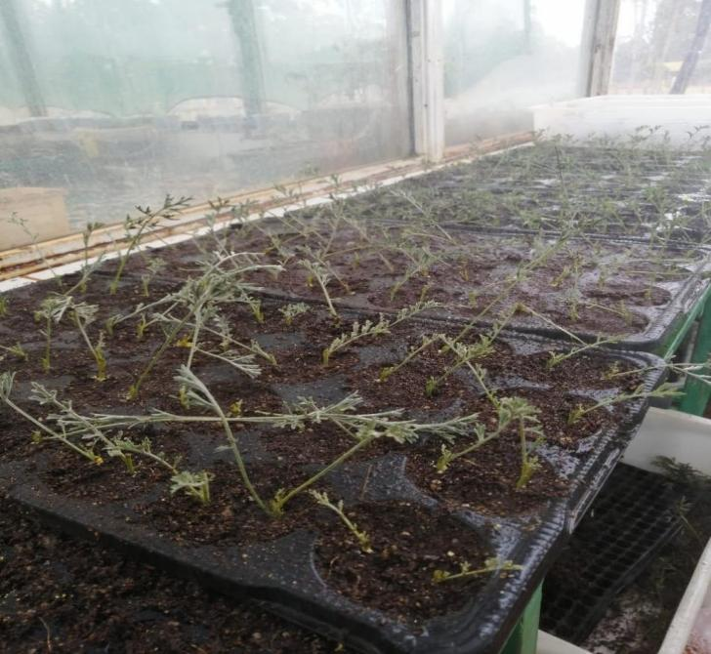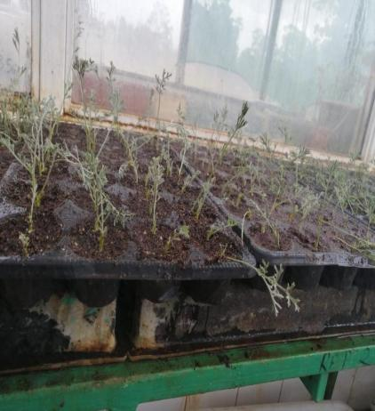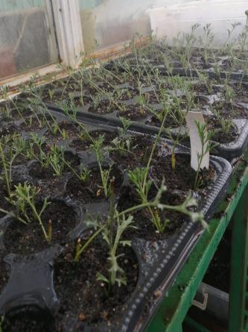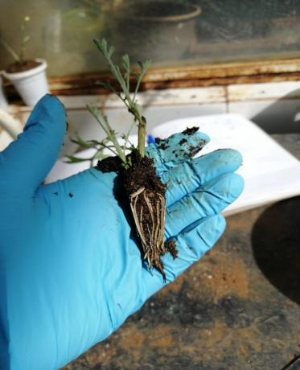 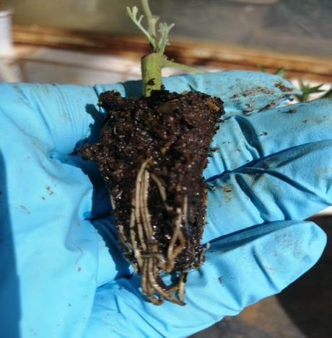 -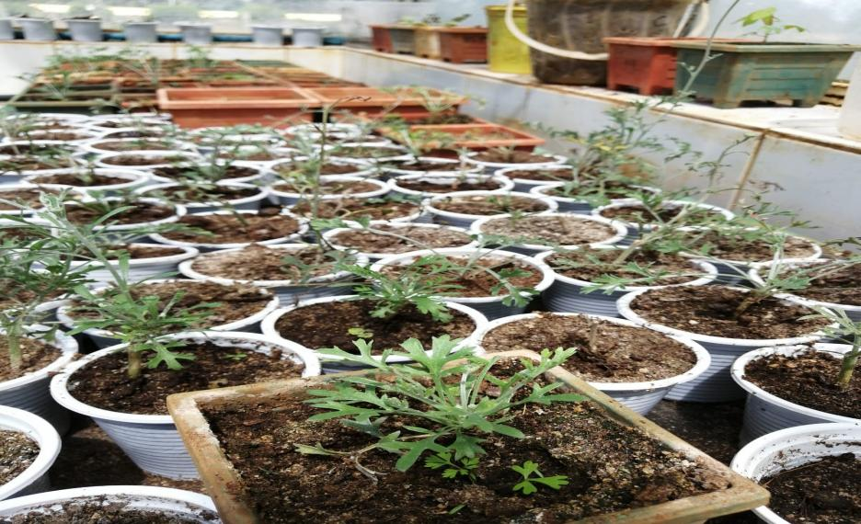
v
vi
iii
iv
i
ii
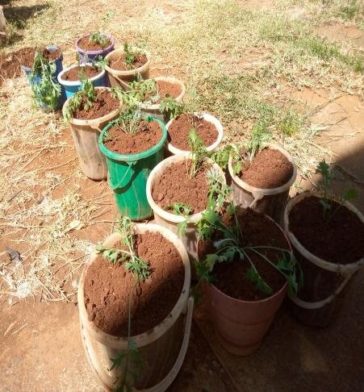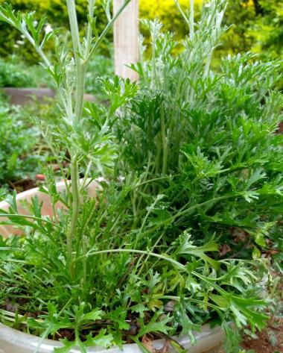
viii
viii
Fig. 2. Show the stages of the micro propagation. From the initiation stage i, to the development of a whole plant, viii

Conclusion and recommendation
The research study provides an optimized propagation protocol for pyrethrum (Chrysanthemum cinerariifolium) stem cuttings. Propagation with a combination of cocopeat: sand at ratio 1:1 and IBA powder at 0.6% was found to be the most effective to influence rooting. It is also recommended that the stem cuttings be maintained at optimum growth conditions of 26-28⁰C. Frequent misting of 30 seconds after 30 minutes is encouraged to create relative humidity of 75-80%. Frequent misting should be incorporated with good drainage system for aeration.
REFERENCES
EurekAlert! (2024): Review of pyrethrum’s historical and modern use, recent genetic and
biosynthetic pathway discoveries, and the crop’s role in sustainable agriculture and pest
management \
Kenya National Bureau of Statistic (KNBS), (2025). Economic Survey
Kenya National Bureau of Statistic (KNBS), (2024). National Agriculture Production Report.
Kenya Agriculture and Livestock Research Organization (KALRO),( 2024). Pyrethrum
Agronomics Practices.
Yu J, Liu W, Liu J, Qin P and Xu L (2017) Auxin Control of Root Organogenesis from
Callus in Tissue Culture. Front. Plant Sci. 8:1385. doi: 10.3389/fpls.2017.01385
Uasin Gishu County Integrated Development Plan (CIDP), 2023–2027, (2023) .

