Targeting SERPINE1 for Migraine Management: Computational Predictions and In-vitro Validation

Abstract
Migraine is a multifactorial neurovascular disorder involving aberrant neuronal excitability, vascular dysregulation, and neuroinflammation. Current therapies often provide incomplete relief and may cause adverse effects, highlighting the need for safer, multi-target interventions. This study explored the potential anti-migraine mechanisms of esculetin, a naturally occurring coumarin derivative with antioxidant, anti-inflammatory, and vasomodulatory properties. Network pharmacology identified SERPINE1, GSK3B, STAT1, IRAK1, and CA12 as hub targets linked to Toll-like receptor signaling, neuroinflammatory regulation, and vascular remodeling. Molecular docking ranked SERPINE1 (PAI-1, PDB: 4AQH) as the highest-affinity target (−7.50 kcal/mol) via dual hydrogen bonds and π–π stacking, followed by GSK3B and STAT1. Molecular dynamics simulations confirmed stable esculetin–SERPINE1 binding with consistent RMSD and persistent hydrogen bond occupancy, indicating sustained interaction under physiological conditions. In vitro assays using U-87 glioblastoma cells showed preserved viability (>85%) at 6.25–50 μM, while higher concentrations induced dose-dependent cytotoxicity (IC₅₀ ≈ 220 μM). DCFH-DA fluorescence revealed elevated ROS levels at IC₅₀, suggesting oxidative stress contributes to high-dose cytotoxicity. These findings suggest esculetin may act as a multi-target migraine modulator, particularly via SERPINE1 inhibition, with a dose-dependent shift from neuroprotection to oxidative stress induction. Further in vivo validation and BBB permeability studies are warranted to assess clinical translation.

Keywords: Esculetin, Migraine, SERPINE1, Molecular docking, Oxidative stress

1. INTRODUCTION
Migraine is one of the most prevalent and disabling neurological disorders worldwide, characterized by recurrent attacks of moderate to severe headache, often lasting 4–72 hours, and frequently accompanied by nausea, vomiting, photophobia, and phonophobia. Globally, it is estimated to affect over 1 billion individuals, with a lifetime prevalence of approximately 18% in women and 6% in men (1,2). Migraine ranks second among all causes of years lived with disability (YLDs), particularly affecting individuals in their most productive years (15–49 years). The socioeconomic burden is substantial, with direct healthcare costs and indirect productivity losses estimated to exceed $20 billion annually in the United States alone, and similar trends are observed in Europe and Asia (3).
The pathogenesis of migraine is complex and multifactorial, involving neurovascular dysregulation, cortical hyperexcitability, and inflammatory signaling within the trigeminovascular system. Two pivotal mechanisms-oxidative stress and neuroinflammation-are increasingly recognized as central to migraine initiation and persistence (4). Elevated levels of reactive oxygen species (ROS) lead to mitochondrial dysfunction, lipid peroxidation, and neuronal injury, which contribute to cortical spreading depression (CSD)-a wave of neuronal depolarization thought to underlie migraine aura. Concurrently, pro-inflammatory cytokines such as tumor necrosis factor-alpha (TNF-α), interleukin-1β (IL-1β), and interleukin-6 (IL-6) amplify trigeminal nerve activation and sensitize pain pathways (5). Another key mediator in migraine pathophysiology is calcitonin gene-related peptide (CGRP), a potent vasodilatory neuropeptide released from trigeminal afferents during migraine attacks. CGRP promotes neurogenic inflammation, plasma protein extravasation, and central pain transmission. Targeting the oxidative stress–CGRP–neuroinflammation axis is therefore a compelling therapeutic strategy for migraine (6).
Current pharmacological treatments-including triptans, nonsteroidal anti-inflammatory drugs (NSAIDs), and CGRP antagonists-have brought relief to many patients but remain inadequate for a significant subset (7). Triptans, while effective for acute attacks, are associated with vasoconstrictive effects and are contraindicated in patients with cardiovascular disease. NSAIDs carry risks of gastrointestinal bleeding, renal impairment, and rebound headaches with overuse (8). Although monoclonal antibodies targeting CGRP or its receptor have shown promise in prevention, their high cost, limited long-term safety data, and variability in patient response hinder widespread use. Furthermore, medication-overuse headaches remain a significant clinical challenge, reinforcing the need for novel, multi-targeted therapies with improved safety and tolerability (9).
Esculetin (6,7-dihydroxycoumarin), a naturally occurring coumarin derivative found in various medicinal plants, has attracted attention for its strong antioxidant, anti-inflammatory, and neuroprotective properties. It has been shown to scavenge free radicals, regulate inflammatory signaling, and protect neuronal cells from oxidative damage. Preclinical studies further suggest its neuroprotective potential in ischemic stroke, epilepsy, and neurodegenerative conditions (10). Esculetin can suppress pro-inflammatory mediators such as TNF-α and IL-6, regulate mitochondrial function, and modulate CGRP signaling, which may attenuate migraine-associated neurogenic inflammation and pain.
Moreover, esculetin may act on additional pain-related targets, including inhibition of cyclooxygenase (COX), lipoxygenase, and modulation of transient receptor potential (TRP) channels, which are involved in neuronal excitability and pain sensitization. Despite promising bioactivity, limitations such as low aqueous solubility and moderate metabolic stability may restrict its clinical application. Nanoparticle-based formulations and other delivery strategies are being explored to overcome these barriers and improve pharmacokinetics (11).
In this research work, we focus on esculetin, a furocoumarin derivative, as a potential anti-migraine agent. Using network pharmacology, we aim to predict its key molecular targets, pathways, and associated genes. We then employ molecular docking to assess binding affinity and molecular dynamics simulations to evaluate the stability of drug–target complexes. Finally, in vitro studies, including cell viability and ROS assay, will be performed to validate its antioxidant and neuroprotective potential, paving the way for its development as a novel therapeutic for migraine management.
2. Materials and methods
2.1. Screening of compounds and prediction of targets for Esculetin
The 3D chemical structure of esculetin was obtained from the PubChem database. Potential protein targets were predicted using SwissTargetPrediction, restricting the search to Homo sapiens. Targets with high probability scores were selected. All retrieved targets were standardized to their official gene names using the UniProtKB database (https://www.uniprot.org) (12).
2.2. Screening of migraine-related targets
Migraine-associated genes were collected from GeneCards and DisGeNET databases using the keyword “Migraine.” Duplicates were removed, and the combined dataset was exported in CSV format. Overlapping targets between migraine-related and esculetin-predicted targets were identified using Venny tool. A Venn diagram representing the intersection of these target sets was generated using Jvenn (http://jvenn.toulouse.inra.fr).
2.3. Construction of protein–protein interaction (PPI) networks
The intersecting targets were imported into the STRING database (https://string-db.org/) with the organism set to Homo sapiens and a minimum required interaction score of 0.900 (high confidence). Disconnected nodes were removed from the network. The PPI network data were downloaded in TSV format and imported into Cytoscape 3.7.2 for visualization. Topological analysis was performed using degree centrality (DC), closeness centrality (CC), and betweenness centrality (BC), with the cutoff value set to the median. The Molecular Complex Detection (MCODE) plugin was applied to identify significant clusters with the following parameters: degree cutoff = 2, node score cutoff = 0.2, k-core = 2, and max depth = 100 (13).
2.4. Construction of compound–target–pathway network
The esculetin–target–pathway interaction network was constructed using Cytoscape 3.7.2, integrating the identified targets and enriched pathways from KEGG analysis. The node size and color were adjusted according to their degree value to reflect network importance.

2.5. Molecular docking studies in Schrödinger
Docking was performed using the Schrödinger Maestro platform (Schrödinger Release 2024-1). The 3D structures of hub proteins were downloaded from the Protein Data Bank (PDB), selecting high-resolution crystal structures with co-crystallized ligands where available. Protein preparation was carried out using the Protein Preparation Wizard, which involved removal of crystallographic water molecules beyond 5 Å from the active site, addition of hydrogen atoms, optimization of side-chain orientations, and minimization using the OPLS4 force field.
The ligand structure of esculetin was prepared using LigPrep with default parameters, generating low-energy 3D conformations and assigning protonation states at physiological pH (7.0 ± 0.2) using Epik. The receptor grid was generated around the native ligand-binding site using the Receptor Grid Generation tool. Docking was carried out using Glide in extra precision (XP) mode to predict binding poses and interaction energies. Docking scores (GlideScore) and interaction fingerprints, including hydrogen bonds, π–π stacking, and hydrophobic contacts, were recorded for further analysis (14).
2.6. Molecular dynamics (MD) simulations in Schrödinger
MD simulations were performed using the Desmond module of Schrödinger to assess the stability of the top-ranked esculetin–target complexes. The docked complexes were placed in an orthorhombic simulation box solvated with the TIP3P water model, with a 10 Å buffer distance in all directions. Counterions (Na⁺ or Cl⁻) were added to neutralize the system, and an additional 0.15 M NaCl was introduced to mimic physiological ionic strength.
Energy minimization was performed using the OPLS4 force field to remove steric clashes. The system was equilibrated using the NVT ensemble for 1 ns at 300 K, followed by the NPT ensemble for 1 ns at 1 atm pressure using the Berendsen thermostat and barostat. Production runs were carried out for 100 ns, and trajectory data were recorded every 100 ps. Post-simulation analysis included root mean square deviation (RMSD), root mean square fluctuation (RMSF), radius of gyration (Rg), hydrogen bond occupancy, and protein–ligand contact maps to evaluate conformational stability and interaction persistence (15).
2.7 Cell Culture Maintenance
U-87 (MG) human brain glioblastoma epithelial cells were cultured in Dulbecco’s Modified Eagle Medium (DMEM) supplemented with 10% (v/v) heat-inactivated fetal bovine serum, 100 U/mL penicillin, and 100 μg/mL streptomycin. Cells were maintained at 37 °C in a humidified atmosphere containing 5% CO₂ and 95% air, and sub-cultured during the logarithmic growth phase.
2.7.1 MTT Assay for Anticancer Activity
The anticancer potential of the test sample was evaluated using the MTT assay. Briefly, U-87 (MG) cells were seeded in 96-well microplates at a density of 1 × 10⁴ cells/well and incubated for 48 h to reach 70–80% confluence. The cells were then treated with varying concentrations of the sample and incubated for 24 h under standard culture conditions. Morphological changes in both treated and untreated (control) cells were observed and photographed under a digital inverted microscope (20× magnification). Following treatment, cells were washed with phosphate-buffered saline (PBS, pH 7.4) and incubated with 20 μL of MTT solution (5 mg/mL in PBS) for 4 h at 37 °C in the dark. The resulting formazan crystals were solubilized in 100 μL of dimethyl sulfoxide (DMSO), and absorbance was measured at 570 nm using a spectrophotometer. Cell viability was calculated using the equation:
2.7.2 Reactive Oxygen Species (ROS) Analysis
Intracellular reactive oxygen species (ROS) generation in U-87 (MG) cells was assessed using the oxidative conversion of the non-fluorescent, cell-permeable probe dichloro-dihydro-fluorescein diacetate (DCFH-DA) into the fluorescent compound dichlorofluorescein (DCF). U-87 cells were seeded in 6-well plates at a density of 1 × 10⁵ cells/well and treated with the IC₅₀ concentration of the test sample for 24 h under standard culture conditions. Subsequently, the cells were incubated with 1 μL of DCFH-DA (1 mg/mL) for 20 min in the dark. The intracellular fluorescence of DCF was then visualized and documented using a fluorescence microscope.
3. Results
3.1. Identification of Common Targets between Esculetin and Migraine
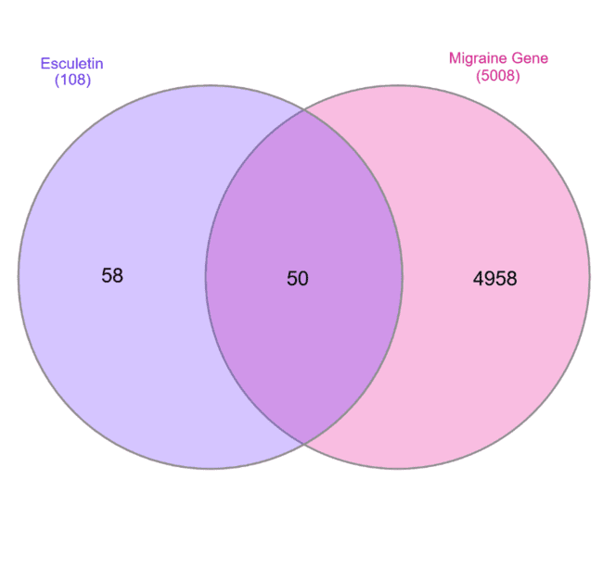
To elucidate the potential therapeutic mechanisms of esculetin in migraine, target prediction was performed using network pharmacology approaches. A total of 108 putative targets associated with esculetin were retrieved from target prediction databases. Simultaneously, 5,008 migraine-related genes were collected from GeneCards and DisGeNET databases. Intersection analysis using a Venn diagram revealed 50 overlapping targets between esculetin and migraine (Fig.1). These common targets were considered as the core set for subsequent protein–protein interaction (PPI) network construction, functional enrichment, and molecular docking analyses, as they may play a critical role in mediating the therapeutic effects of esculetin against migraine.

Figure 1. Venn diagram showing the overlap between esculetin-associated targets (blue) and migraine-related genes (pink). The intersection represents 50 shared targets potentially involved in esculetin’s anti-migraine activity.

3.1.2. Construction of the PPI Network for Common Targets
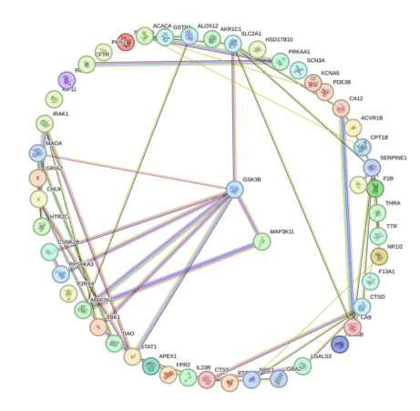
The 50 overlapping targets between esculetin and migraine (Fig.2) were subjected to protein–protein interaction (PPI) analysis using the STRING database (version 12.0), with the species set to Homo sapiens and a high-confidence interaction score threshold (≥ 0.900). The resulting network consisted of 50 nodes and 148 edges, indicating a significantly higher interaction density compared to a random network of similar size, thus highlighting functional connectivity among these targets. Nodes in the network represent proteins, and edges represent predicted functional associations derived from experimental data, co-expression profiles, curated databases, and text mining. The average node degree was 5.92, with SERPINE1, STAT1, TBK1, GSK3B, and SLC2A1 showing the highest connectivity, suggesting their central role in the biological mechanisms linking esculetin to migraine modulation.

Figure 2. Protein–protein interaction (PPI) network of the 50 common targets between esculetin and migraine constructed using the STRING database. Node size reflects degree centrality, while edge color denotes interaction evidence type: green (neighborhood), purple (experiments), blue (co-occurrence), yellow (text mining), and pink (curated databases).
3.1.3. Identification of Core Targets from the PPI Network
Following the intersection analysis, the 50 common targets were imported into the STRING database to generate a high-confidence protein–protein interaction (PPI) network (interaction score ≥ 0.900, species set to Homo sapiens). The network was visualized and analyzed using Cytoscape 3.9.1, and topological parameters — degree centrality (DC), betweenness centrality (BC), and closeness centrality (CC) — were calculated to identify key nodes. The Molecular Complex Detection (MCODE) algorithm was applied to filter functional modules. From this analysis, 10 hub genes were identified as potential core targets: GSK3B, CHUK, IRAK1, SERPINE1, SLC2A1, STAT1, TBK1, CTSD, CA9, and CA12 (Fig.3; Table 1). These genes exhibited the highest connectivity and centrality within the PPI network, suggesting a pivotal role in the pharmacological action of esculetin against migraine. Notably, SERPINE1 and STAT1 demonstrated the strongest network connectivity, indicating their potential as key regulatory nodes in disease modulation.
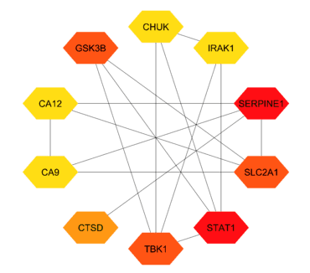

Figure 3. Top 10 hub genes identified from the PPI network analysis using Cytoscape. Node size reflects degree centrality, while node color indicates connectivity strength (yellow to red gradient from lower to higher).
3.1.4. KEGG Pathway Enrichment Analysis
To further elucidate the biological functions of the 50 common targets, KEGG pathway enrichment analysis was performed. The top 15 significantly enriched pathways (FDR < 0.05) are shown in (Fig.4). The most enriched pathway was the Toll-like receptor signaling pathway, followed by Measles and the IL-17 signaling pathway, each showing a high fold enrichment (> 75) and strong statistical significance (−log10FDR > 6).
Several enriched pathways were associated with immune and inflammatory responses, including Chagas disease, Yersinia infection, Toxoplasmosis, and Kaposi sarcoma-associated herpesvirus infection. Additionally, pathways related to viral infections (Hepatitis B, Hepatitis C, COVID-19) and metabolic regulation (Thyroid hormone signaling pathway, Lipid and atherosclerosis) were also prominent. These results suggest that the therapeutic effect of esculetin against migraine may involve modulation of immune-inflammatory pathways and viral infection-related mechanisms, highlighting the pleiotropic pharmacological potential of the identified targets.

Table 1. Top 10 hub genes identified from the PPI network analysis based on the degree centrality score.
Rank | Name | Score
1 | SERPINE1 | 10
1 | STAT1 | 10
3 | TBK1 | 8
3 | GSK3B | 8
3 | SLC2A1 | 8
6 | CTSD | 7
7 | CA12 | 6
7 | CA9 | 6
7 | CHUK | 6
7 | IRAK1 | 6

3.1.5. Involvement of Hub Genes in IL-17 and Toll-like Receptor Signaling Pathways
KEGG pathway mapping revealed that several hub genes, including TBK1 and GSK3B, are key regulators within immune-inflammatory signaling cascades. In the IL-17 signaling pathway (Fig.5), TBK1 is positioned downstream of TRAF6, linking receptor activation to NF-κB and MAPK signaling, ultimately promoting the transcription of inflammatory cytokines (IL-6, TNF-α), chemokines (CXCL1, CCL2), and tissue remodeling enzymes (MMP family). Additionally, GSK3B participates in modulating AP-1 and NF-κB transcriptional responses, influencing both pro-inflammatory and tissue repair processes. Parallel mapping to the Toll-like receptor signaling pathway indicated that GSK3B acts downstream of the PI3K/Akt and MAPK branches, functioning as a convergence point for TLR-mediated innate immune activation. TLR engagement leads to MyD88-dependent activation of TRAF6, which in turn triggers NF-κB and MAPK cascades-pathways also engaged by IL-17 signaling. This overlap suggests potential cross-talk between IL-17 and TLR pathways through shared intermediates such as TRAF6, TBK1, and GSK3B, amplifying inflammatory outputs. The integration of these findings implies that targeting GSK3B could modulate both IL-17 and TLR-driven immune responses, thereby exerting a broader anti-inflammatory effect relevant to migraine pathology.

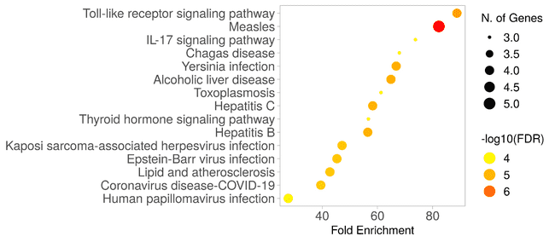

Figure 4. KEGG pathway enrichment analysis of the 50 common targets between esculetin and migraine. The x-axis represents fold enrichment, bubble size corresponds to the number of enriched genes, and bubble color reflects −log10(FDR), with deeper colors indicating higher significance.
3.1.6. Pathway Interconnections Highlighting Toll-like Receptor Signaling
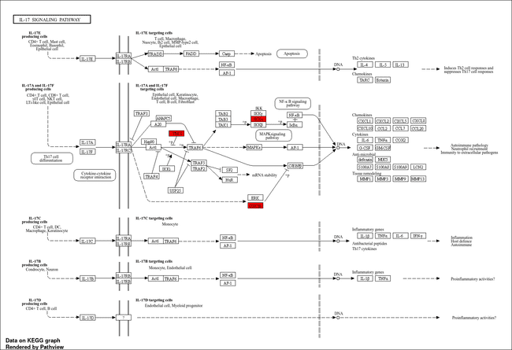
Pathway enrichment network analysis revealed a central positioning of the Toll-like receptor (TLR) signaling pathway within the interconnected biological processes (Fig.6). The TLR pathway demonstrated strong connectivity (yellow edges) with multiple immune-related and infectious disease pathways, including the IL-17 signaling pathway, measles, hepatitis B and C, COVID-19, Epstein–Barr virus infection, and Yersinia infection. The observed clustering underscores the pivotal role of TLR signaling as an upstream modulator of host defense responses, bridging innate immune activation with adaptive inflammatory cascades. Its direct linkage with the IL-17 pathway further supports mechanistic cross-talk between pattern recognition receptor signaling and cytokine-mediated inflammation. Given that GSK3B occupies a key regulatory position downstream of TLR activation—mediating NF-κB, MAPK, and AP-1 transcriptional outputs—its inhibition offers a strategic point of intervention capable of modulating multiple interconnected pathways simultaneously.

Figure 5. KEGG IL-17 signaling pathway highlighting the positions of TBK1 and GSK3B. Red boxes indicate targets identified in the present study.
3.2 Molecular Docking Analysis
Molecular docking of esculetin with the top hub gene–associated targets identified from the network pharmacology analysis (Table 2) revealed distinct interaction patterns, as illustrated in the 2D (Fig.7) and 3D (Fig.8) interaction diagrams. Among all evaluated proteins, SERPINE1 (PAI-1, PDB: 4AQH) exhibited the highest binding affinity (−7.50 kcal/mol). In the SERPINE1 complex, esculetin’s catechol moiety formed dual hydrogen bonds within the reactive center cleft, while the coumarin ring engaged in π–π stacking and hydrophobic interactions, stabilizing the ligand in a pose similar to known PAI-1 inhibitors. GSK3B (PDB: 1Q5K) demonstrated favorable hinge-region binding via hydrogen bonding and hydrophobic pocket occupancy, followed by STAT1 (PDB: 1YVL), which formed moderate polar and electrostatic contacts in a shallow groove. IRAK1-axis kinase (PDB: 4IM2) interactions were predominantly polar with limited hydrophobic stabilization, while CA12 (PDB: 6THA) binding involved rim hydrogen bonds without direct Zn²⁺ coordination, resulting in the lowest docking score. Overall, the affinity ranking was SERPINE1 > GSK3B ≈ STAT1 > IRAK1-axis > CA12, reinforcing SERPINE1 as the primary and structurally validated binding partner of esculetin, consistent with its hub role in the protein–protein interaction network.

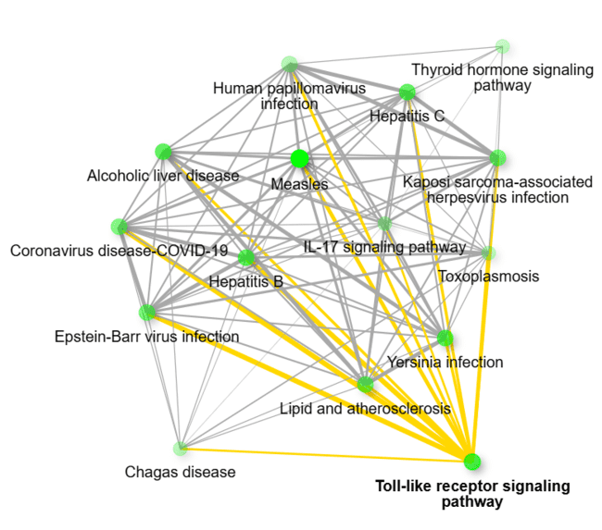

Figure 6. Pathway interconnection network showing the central role of Toll-like receptor signaling and its associations with immune, infectious, and inflammatory pathways. Yellow edges indicate strong functional connectivity.

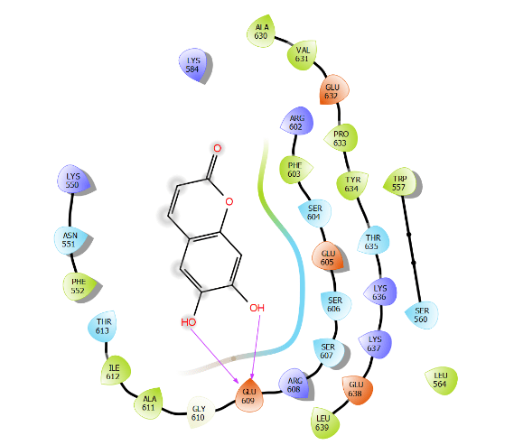
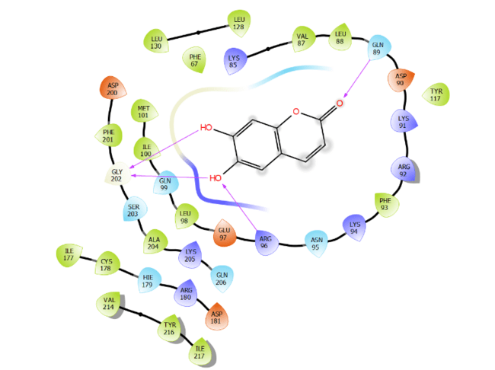

A B
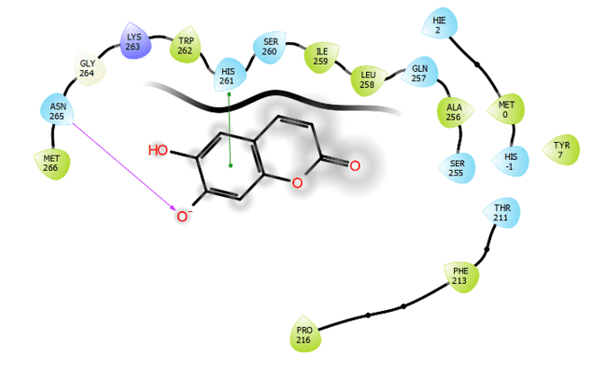
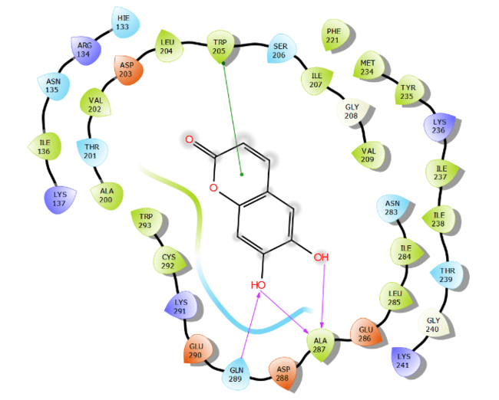

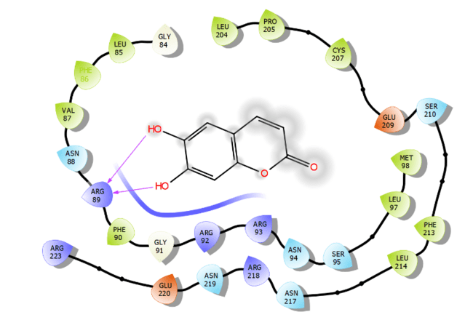
C D

E
Figure 7. 2D interaction diagrams of esculetin with top hub gene–associated targets: (A) 1Q5K (GSK3B), (B) 1YVL (STAT1), (C) 4AQH (SERPINE1), (D) 4IM2 (IRAK1), and (E) 6THA (CA12).

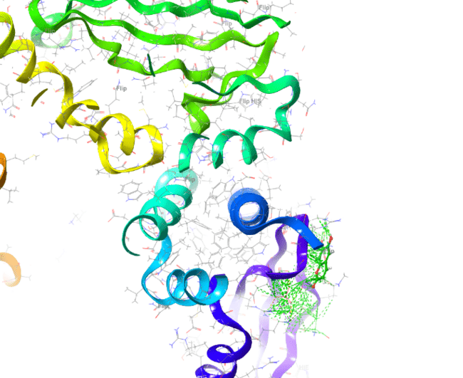
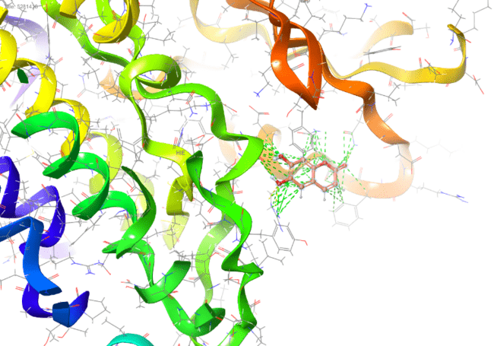

A B
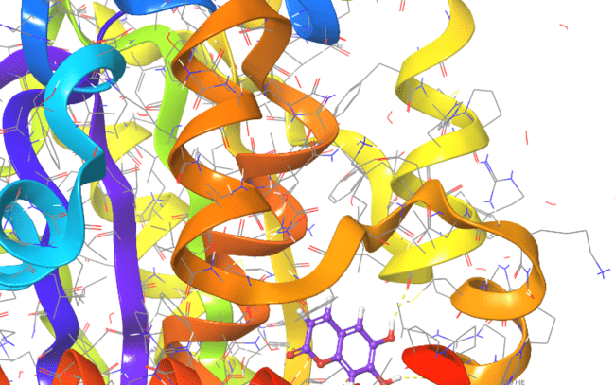
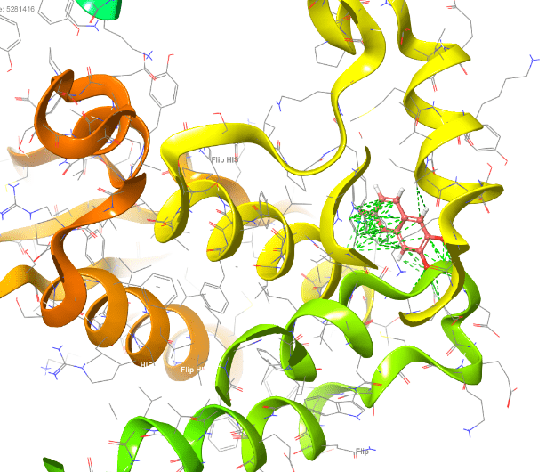

C D
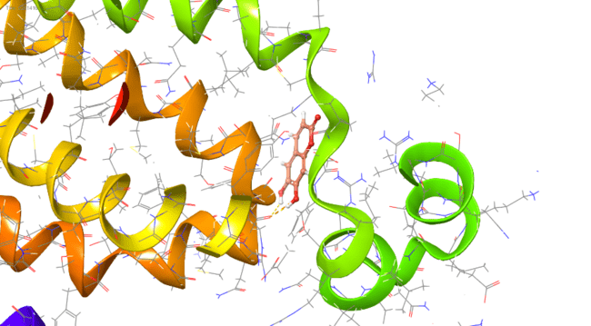

E
Figure 8. 3D binding poses of esculetin with target proteins, showing key interaction sites: (A) 1Q5K, (B) 1YVL, (C) 4AQH, (D) 4IM2, and (E) 6THA.

Table 2: Binding Affinities of Ligands with Target Proteins
Gene | PDB ID | Key Interacting Amino Acids | Binding Affinity (kcal/mol)
SERPINE1 | 4AQH | Tyr79, Glu84, His185, Arg118, Lys122 | -7.50
GSK3B | 1Q5K | Val135, Asp200, Lys85, Tyr134, Asp133 | -5.00
STAT1 | 1YVL | Lys567, Glu559, Arg602, Ser603 | < -3.00
IRAK1 | 4IM2 | Lys239, Asp340, Glu341, Arg342 | < -3.00
CA12 | 6THA | His64, Glu106, Thr199, His200 | < -3.00

3.3 Molecular Dynamic
3.3.1 Protein and ligand RMSD
The RMSD analysis over the 100 ns trajectory revealed that the protein backbone stabilized after approximately 20 ns, with fluctuations confined within ~2.0 Å for the remainder of the simulation. This plateau in RMSD is a hallmark of structural convergence, suggesting that the protein maintained its global fold without significant conformational drift. The ligand RMSD (Lig fit Prot), calculated after superimposing the complex on the protein backbone, also exhibited remarkable stability, remaining below ~2.5 Å for the majority of the simulation. Such low RMSD values for the ligand indicate that esculetin retained its binding orientation and did not undergo significant translational or rotational displacement from the initial docked pose as shown in (Fig.9). These findings align with the high docking affinity observed for SERPINE1, reinforcing the notion that esculetin forms a robust and persistent complex under physiological conditions. Stable RMSD values for both protein and ligand suggest that the system was well-equilibrated, thereby validating subsequent dynamic interaction analyses.
3.3.2 Protein RMSF
The per-residue RMSF profile highlighted localized flexibility within the protein, with the highest fluctuations (>2 Å) observed at the N-terminal and C-terminal regions, consistent with their inherent structural disorder and solvent exposure. Conversely, residues forming the core β-sheet scaffold and α-helices exhibited minimal fluctuation (<1.5 Å), indicative of a rigid, well-packed tertiary structure. Notably, residues constituting the esculetin-binding site displayed low mobility throughout the trajectory, confirming a stable microenvironment around the ligand as shown in (Fig.10). This rigidity is essential for preserving key intermolecular contacts over time, minimizing the entropic penalty for binding. The RMSF pattern also mirrors the conserved secondary structure arrangement, suggesting that ligand binding did not induce destabilizing local flexibility, which is often observed in weaker or transient complexes.

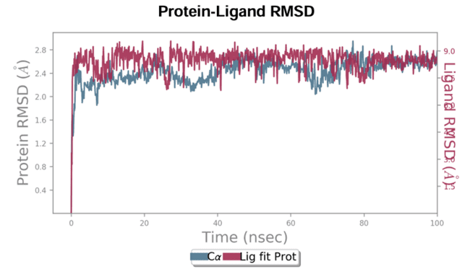

Figure 9: Time evolution of root mean square deviation (RMSD) for the protein backbone (left Y-axis, blue) and esculetin ligand (right Y-axis, red) over the 100 ns NPT simulation at 310 K. Protein RMSD stabilized after ~20 ns with fluctuations within 2 Å, indicating conformational stability. Ligand RMSD (Lig fit Prot) remained below 2.5 Å, confirming retention of the ligand within the binding pocket throughout the simulation.
3.3.3 Secondary structure element (SSE) analysis
The SSE profile remained highly conserved over the course of the 100 ns simulation, with α-helices and β-strands comprising approximately 20.38% and 31.34% of the protein structure, respectively. The preservation of SSE content indicates that esculetin binding does not perturb the global fold of the protein. This is particularly important for targets like SERPINE1, where structural integrity of β-strand-rich domains is critical for function and inhibitor binding. The time-resolved SSE map confirmed that the core structural elements adjacent to the ligand-binding cleft remained stable, further supporting the RMSD and RMSF observations. This stability suggests that esculetin binding reinforces rather than destabilizes the native protein architecture, a desirable trait for selective inhibition as shown in (Fig.11).
3.3.4 Ligand RMSF
Atom-wise RMSF analysis of esculetin revealed that the catechol moiety exhibited the lowest atomic fluctuations (<1.2 Å), reflecting its deep insertion and strong anchoring within the protein’s hydrogen bonding network. The coumarin ring also maintained low mobility, consistent with persistent π–π stacking interactions observed in docking. In contrast, peripheral atoms exposed to solvent displayed slightly higher RMSF values (~1.5–2 Å), likely due to increased rotational freedom and interaction with surrounding water molecules. The asymmetry in flexibility across the ligand indicates a stable pharmacophoric core, with mobility restricted to non-critical solvent-facing substituents as shown in (Fig.12). This dynamic profile complements the torsional stability analysis, supporting the idea that esculetin adopts a low-strain bound conformation.

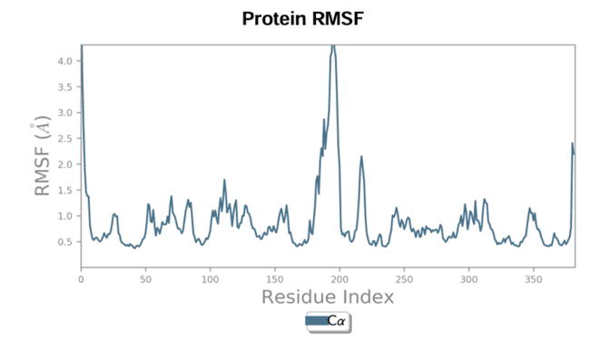

Figure 10: RMSF values plotted against residue index reveal local flexibility of the protein over the 100 ns trajectory. Terminal regions exhibited the highest fluctuations (>2 Å), whereas residues in secondary structure elements, particularly the binding site region, remained relatively stable (<1.5 Å), suggesting a rigid binding environment for esculetin.
3.3.5 Protein–ligand contact fractions
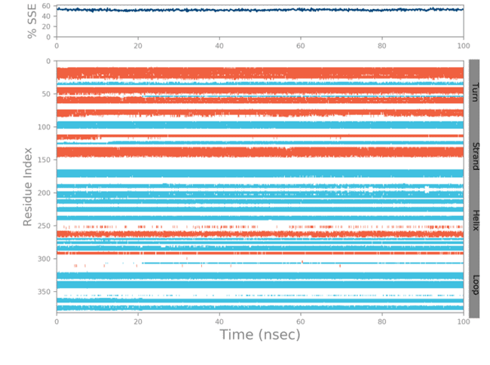
Interaction fraction analysis over the 100 ns trajectory demonstrated that hydrogen bonds and hydrophobic contacts were the predominant stabilizing forces in the esculetin–protein complex. Hydrogen bonds persisted for >70% of the simulation time, primarily involving residues lining the binding cleft, ensuring directional specificity in binding. Hydrophobic contacts provided complementary stabilization, particularly around the coumarin ring system, which engaged with non-polar side chains. Ionic interactions were transient, suggesting a supportive rather than primary role in complex stability as shown in (Fig.13). Water bridges, though less frequent, contributed to the adaptability of the hydrogen-bonding network, compensating for occasional direct hydrogen bond disruption. The predominance of hydrogen bonding aligns with the initial docking pose, where multiple polar interactions anchored esculetin in an energetically favorable orientation.

Figure 11: Distribution and temporal evolution of α-helices (red) and β-strands (yellow) across the protein structure over 100 ns. The overall SSE composition remained consistent (~20.38% helices, ~31.34% strands), indicating no major unfolding events and preservation of the global fold during ligand binding.
3.3.6 Interaction timeline
The interaction timeline clearly identified a cluster of residues maintaining persistent contacts with esculetin throughout the simulation as shown in (Fig.14). Several residues exhibited interaction multiplicity, forming more than one contact type (e.g., simultaneous hydrogen bonding and hydrophobic packing) within a single trajectory frame. This redundancy in interaction types is a hallmark of strong and resilient protein–ligand complexes, as it reduces the likelihood of complete contact loss during thermal fluctuations. The stability of these interactions across the entire simulation suggests that esculetin binding is not dependent on a single dominant contact but rather on a cooperative network of interactions, increasing binding robustness.
3.3.7 Frequent ligand–protein interactions
The 2D interaction schematic highlighted residues that interacted with esculetin for over 30% of the simulation, underscoring their importance in ligand stabilization. Persistent hydrogen bonds were observed with residues near the catechol hydroxyl groups, while hydrophobic interactions stabilized the coumarin core as shown in (Fig.15). Several water-mediated contacts bridged esculetin to residues at the pocket periphery, expanding the interaction network beyond direct contacts. Such water bridges often enhance ligand retention by providing flexible but persistent links between the ligand and protein surface. This pattern of multiple contact modes supports both the high docking affinity and the RMSD stability observed earlier.
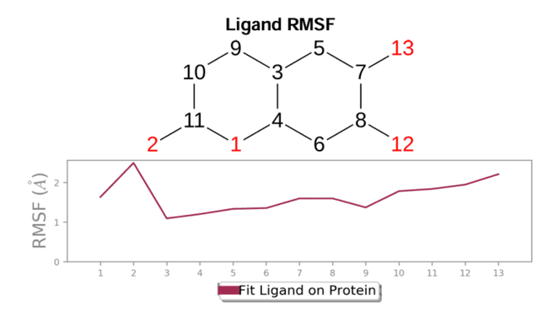

Figure 12: Atom-wise RMSF values for esculetin, mapped to the corresponding 2D structure. The catechol moiety atoms showed lower fluctuation (<1.2 Å), consistent with stable hydrogen bonding, while terminal hydrogens exhibited higher mobility due to solvent exposure.

3.3.8 Ligand torsional dynamics
Torsional angle analysis revealed that esculetin’s three rotatable bonds remained predominantly within low-energy conformations throughout the simulation. The absence of frequent high-energy torsional states indicates that the ligand experiences minimal conformational strain in the bound form, which can enhance both binding affinity and residence time. The catechol and coumarin moieties, connected via rigid linkages, contributed to the low torsional variability, while the limited flexibility of side groups allowed fine adjustment without compromising core stability. This torsional rigidity aligns with the low ligand RMSF values observed, indicating a consistent bound geometry over the 100 ns trajectory as shown in (Fig.16).
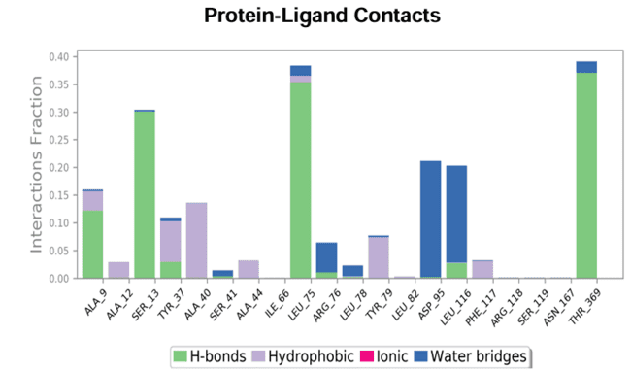

Figure 13: Normalized interaction fractions for hydrogen bonds, hydrophobic contacts, ionic interactions, and water bridges between esculetin and the protein. Hydrogen bonds and hydrophobic contacts were the predominant interaction types, with hydrogen bonding persisting for >70% of the trajectory, reinforcing stable binding.
3.3.9 Ligand physicochemical stability
Monitoring esculetin’s physicochemical properties over the 100 ns simulation revealed a stable RMSD trajectory, a consistent radius of gyration (~2.5 Å), and the maintenance of approximately one intramolecular hydrogen bond, suggesting minimal intramolecular rearrangement. MolSA and SASA values showed only minor fluctuations, indicating a stable solvent exposure profile, while the polar surface area (PSA) remained constant, consistent with persistent polar interactions with the protein and water molecules as shown in (Fig.17). Such stability in key descriptors implies that esculetin retains its bioactive conformation in the bound state, with no significant unfolding or collapse of its molecular surface.

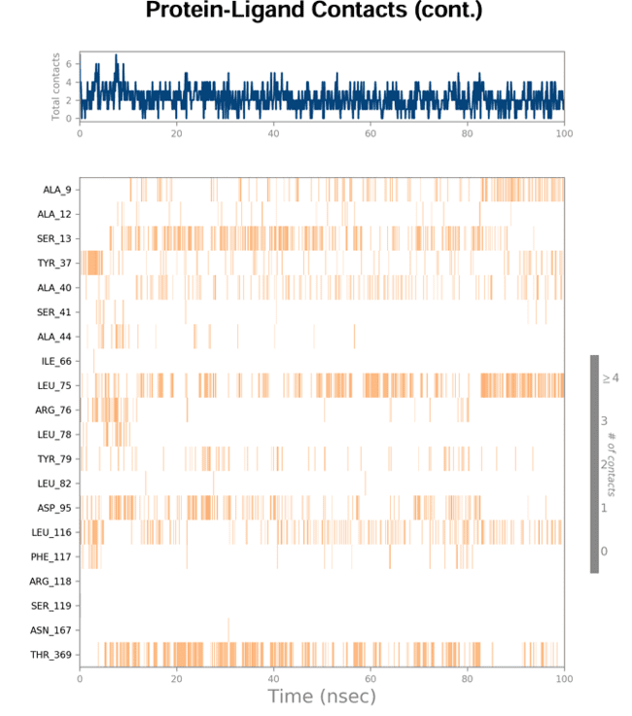

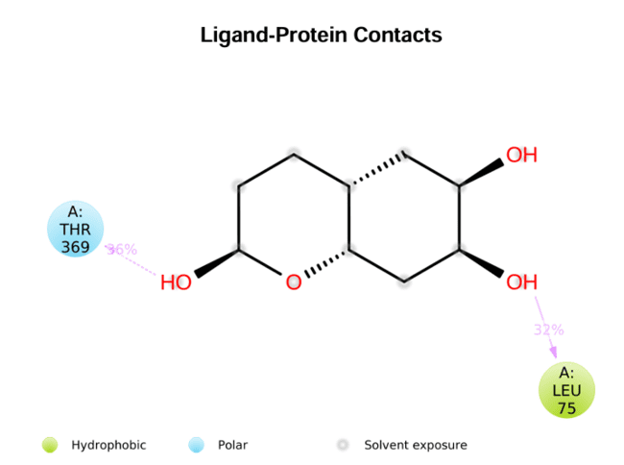
Figure 14: Temporal map showing the persistence and multiplicity of contacts between specific protein residues and esculetin over 100 ns. Darker shades represent higher contact frequency, highlighting key residues that maintain interactions throughout the simulation.

Figure 15: Two-dimensional interaction diagram depicting esculetin–protein contacts persisting for more than 30% of the simulation time. Hydrogen bonds (green dashed lines), hydrophobic interactions (orange), and water-mediated contacts (blue) are annotated with interacting residues.
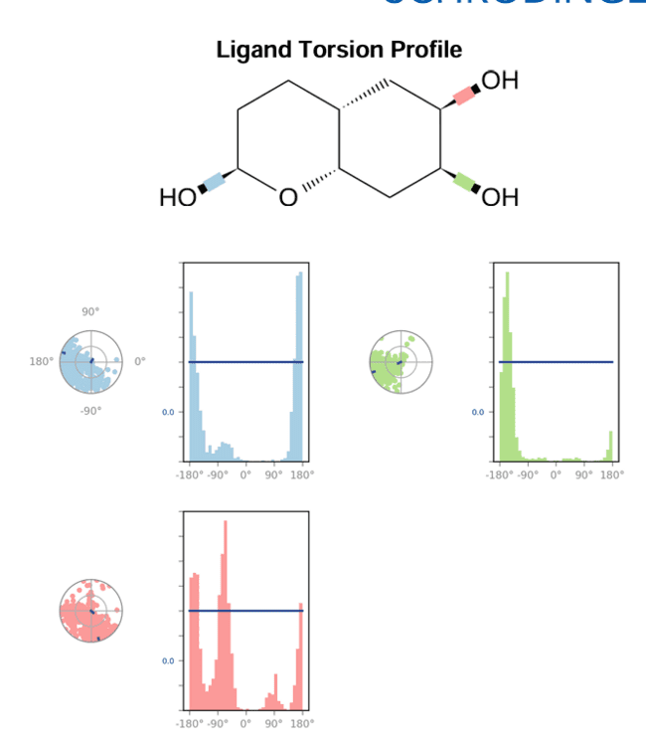

Figure 16: Radial and histogram plots for each rotatable bond (RB) in esculetin, color-coded according to the 2D structure. The torsional angles remained largely confined to low-energy conformations, indicating minimal strain in the bound state.
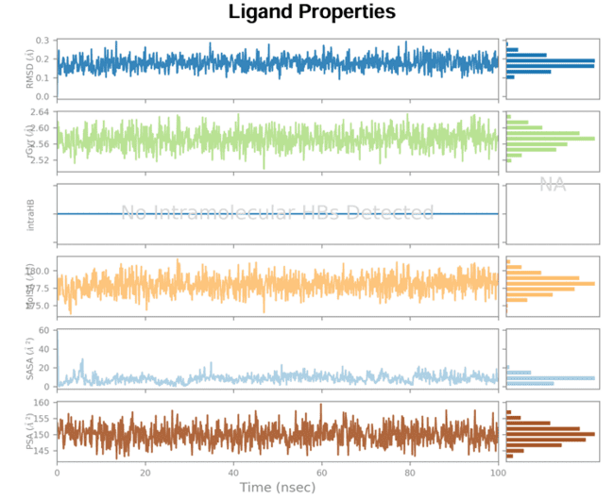

Figure 17: Plots showing RMSD, radius of gyration (rGyr), intramolecular hydrogen bonds (intraHB), molecular surface area (MolSA), solvent accessible surface area (SASA), and polar surface area (PSA) for esculetin over 100 ns. The stable trends across all parameters indicate conformational and solvation stability of the ligand in complex.
3.4 Neuroprotective Cell Viability Assay
The neuroprotective potential of esculetin was evaluated in U-87 glioblastoma cells using the MTT assay after 24 h exposure to varying concentrations (0–600 μM). As shown in Figure 18, lower concentrations (6.25–50 μM) maintained high cell viability (>85%), indicating minimal cytotoxicity and potential neuroprotective action. However, a gradual decline in viability was observed at higher concentrations, with a significant reduction beyond 100 μM, suggesting that excessive dosing may compromise cell survival. Nonlinear regression analysis determined an IC₅₀ value of approximately 220 μM. Morphological examination under phase-contrast microscopy revealed that control and low-dose treated cells retained normal spindle-like morphology and confluency, whereas cells exposed to higher concentrations exhibited rounding, shrinkage, and detachment, consistent with reduced viability. These results suggest that esculetin supports U-87 cell survival at low concentrations, but high doses may diminish its neuroprotective effect as shown in (Fig.18).
3.5 Reactive Oxygen Species (ROS) Assay
Intracellular ROS levels in U-87 glioblastoma cells were assessed using the DCFH-DA fluorescent probe in the absence of any external apoptotic inducer to evaluate the baseline oxidative stress status following esculetin treatment. As shown in (Fig.19), untreated control cells exhibited uniform, moderate green fluorescence, indicating basal ROS production typical of healthy proliferating cells. In contrast, cells treated with esculetin at its IC₅₀ concentration (220 μM) displayed a noticeably higher fluorescence intensity, suggesting an elevation in ROS generation. This observation implies that esculetin induces oxidative stress in U-87 cells even without additional oxidative or apoptotic stimuli. The increased ROS may contribute to the observed reduction in cell viability at higher esculetin concentrations, supporting the hypothesis that oxidative stress is a potential mechanism underlying its neuroprotective/cytotoxic dual behavior depending on dose.
3.6 Discussion and Conclusion
Migraine is a complex neurovascular disorder characterized by recurrent headaches and neurological disturbances, often linked to abnormal neuronal excitability, vascular dysfunction, and neuroinflammation. Current therapies are limited by incomplete efficacy and side effects, highlighting the need for novel, multi-target agents capable of modulating key pathogenic pathways. Esculetin, a naturally occurring coumarin derivative, has shown antioxidant, anti-inflammatory, and vasomodulatory effects, making it a promising candidate for further exploration in migraine-related mechanisms.
Network pharmacology analysis identified several hub genes closely associated with migraine pathogenesis, including SERPINE1, GSK3B, STAT1, IRAK1, and CA12. Pathway enrichment revealed strong associations with Toll-like receptor signaling, neuroinflammatory regulation, and vascular remodeling processes, suggesting that esculetin may exert therapeutic effects through simultaneous modulation of multiple molecular targets within these interconnected pathways.
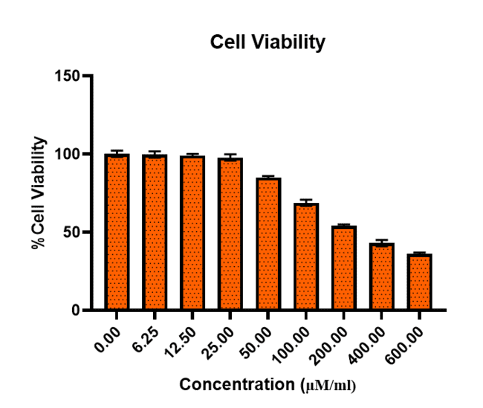
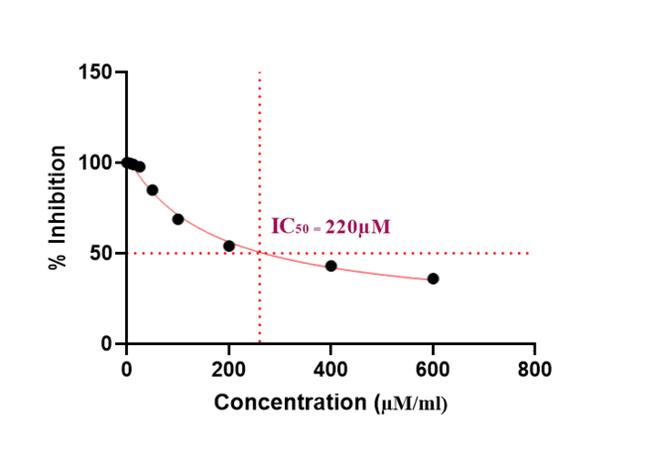

(A) (B)

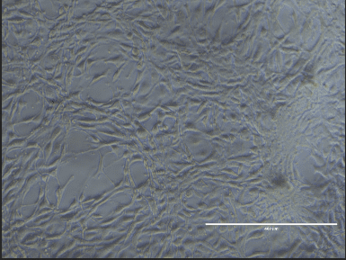
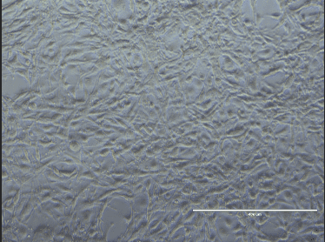
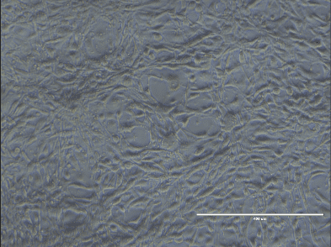

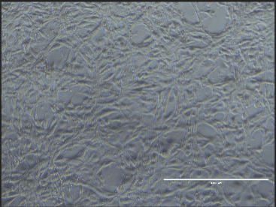
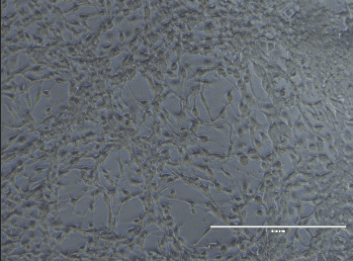

Control 6.25 µM/ml 12.5 µM/ml

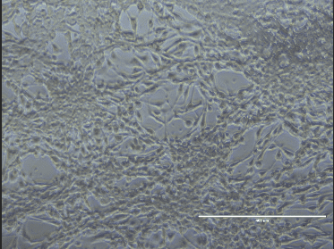

25 µM/ml 50 µM/ml 100 µM/ml
(C)
Figure 18. Dose-dependent effect of esculetin on viability of U-87 glioblastoma cells. (A) MTT assay showing percentage cell viability after 24 h treatment with indicated concentrations of esculetin. Data represent mean ± SD (n=3). (B) Dose–response curve for esculetin indicating an IC₅₀ of ~220 μM. (C) Representative phase-contrast images of U-87 cells following treatment for 24 h, illustrating preserved cell morphology at low concentrations and dose-dependent morphological deterioration at higher concentrations. Scale bar: 400 μm.

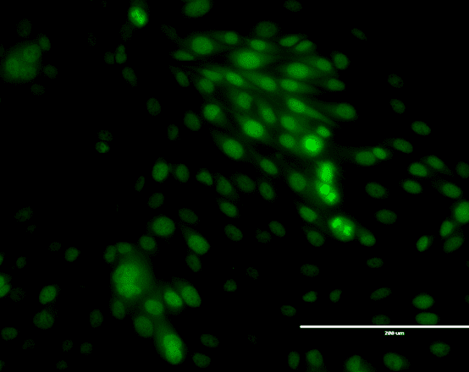
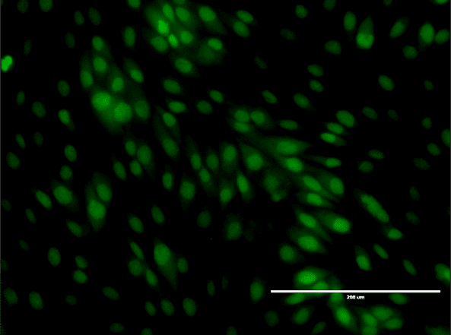

- (B)
Figure 19. Detection of intracellular ROS in U-87 cells using DCFH-DA assay without external apoptotic induction. Representative fluorescence microscopy images of (A) untreated control cells and (B) cells treated with esculetin at IC₅₀ concentration (220 μM) for 24 h. Green fluorescence corresponds to oxidized DCF, indicating intracellular ROS levels. Enhanced fluorescence in treated cells compared to control suggests esculetin-induced oxidative stress under basal conditions. Scale bar: 100 μm.
Molecular docking studies ranked SERPINE1 (PAI-1, PDB: 4AQH) as the top predicted binding partner of esculetin, with the highest affinity score, followed by GSK3B (PDB: 1Q5K) and STAT1. Esculetin’s catechol moiety formed stable hydrogen bonds within the SERPINE1 reactive center cleft, while the coumarin ring engaged in π–π stacking and hydrophobic interactions, closely mimicking known inhibitors. GSK3B interactions involved hinge-region hydrogen bonding and hydrophobic pocket occupation, consistent with kinase modulation. These computational findings positioned SERPINE1 as the primary therapeutic target.
Molecular dynamics simulations further validated the docking results by demonstrating stable root mean square deviation (RMSD) profiles and consistent hydrogen bond occupancy for the esculetin–SERPINE1 complex throughout the simulation period. This indicated a strong and persistent interaction, supporting the hypothesis that SERPINE1 inhibition by esculetin could be maintained under physiological conditions, potentially translating into functional modulation of fibrinolytic and vascular processes relevant to migraine.
In vitro assays using U-87 glioblastoma cells revealed that low esculetin concentrations (6.25–50 μM) preserved cell viability above 85%, whereas higher doses induced a dose-dependent decline, with an IC₅₀ of ~220 μM. Morphological changes at higher doses, including cell rounding and detachment, corresponded with reduced viability. ROS assays using the DCFH-DA probe showed that treatment at IC₅₀ significantly increased intracellular ROS levels compared to controls, suggesting that at elevated concentrations, esculetin shifts from a protective to a pro-oxidative state, potentially contributing to its cytotoxic effects.
While these findings indicate a promising multi-target mechanism of esculetin in migraine involving vascular, inflammatory, and oxidative stress pathways, several limitations remain. The in vitro model does not replicate the full neurovascular complexity of migraine, and pharmacokinetic factors such as blood–brain barrier penetration remain untested. Future studies should employ primary neuronal and trigeminovascular models, investigate target-specific knockdowns to confirm causality, and assess in vivo efficacy and safety to better define esculetin’s therapeutic potential in migraine management. Taken together, our findings highlight SERPINE1 as the primary molecular target and the Toll-like receptor signaling pathway as the key mechanistic axis through which esculetin may exert its anti-migraine effects.
Ethical Approval
Not applicable.
Consent for Publication
Not applicable.
Data Availability
This article contains no datasets generated or analyzed during the current study.
Declaration of Interest
The authors declare that they have no known competing financial interests or personal relationships that could have appeared to influence the work reported in this paper.

COMPETING INTERESTS DISCLAIMER:
Authors have declared that they have no known competing financial interests OR non-financial interests OR personal relationships that could have appeared to influence the work reported in this paper.

4. Reference
1. Pescador Ruschel MA, De Jesus O. Migraine Headache. In: StatPearls [Internet]. Treasure Island (FL): StatPearls Publishing; 2025 [cited 2025 Aug 19]. Available from: http://www.ncbi.nlm.nih.gov/books/NBK560787/
2. Eigenbrodt AK, Ashina H, Khan S, Diener HC, Mitsikostas DD, Sinclair AJ, et al. Diagnosis and management of migraine in ten steps. Nat Rev Neurol. 2021 Aug;17(8):501–14.
3. Steiner TJ, Stovner LJ, Jensen R, Uluduz D, Katsarava Z, on behalf of Lifting The Burden: the Global Campaign against Headache. Migraine remains second among the world’s causes of disability, and first among young women: findings from GBD2019. The Journal of Headache and Pain. 2020 Dec 2;21(1):137.
4. Goadsby PJ, Holland PR, Martins-Oliveira M, Hoffmann J, Schankin C, Akerman S. Pathophysiology of Migraine: A Disorder of Sensory Processing. Physiological Reviews. 2017 Apr;97(2):553–622.
5. Kursun O, Yemisci M, van den Maagdenberg AMJM, Karatas H. Migraine and neuroinflammation: the inflammasome perspective. The Journal of Headache and Pain. 2021 Jun 10;22(1):55.
6. Russo AF. Calcitonin Gene-Related Peptide (CGRP). Annu Rev Pharmacol Toxicol. 2015;55:533–52.
7. Pleș H, Florian IA, Timis TL, Covache-Busuioc RA, Glavan LA, Dumitrascu DI, et al. Migraine: Advances in the Pathogenesis and Treatment. Neurol Int. 2023 Aug 31;15(3):1052–105.
8. Nicolas S, Nicolas D. Triptans. In: StatPearls [Internet]. Treasure Island (FL): StatPearls Publishing; 2025 [cited 2025 Aug 19]. Available from: http://www.ncbi.nlm.nih.gov/books/NBK554507/
9. Alsaadi T, Kayed DM, Al-Madani A, Hassan AM, Terruzzi A, Krieger D, et al. Consensus-Based Recommendations on the Use of CGRP-Based Therapies for Migraine Prevention in the UAE. Neurol Ther. 2023 Oct 4;12(6):1845–65.
10. Di Stasi LC. Natural Coumarin Derivatives Activating Nrf2 Signaling Pathway as Lead Compounds for the Design and Synthesis of Intestinal Anti-Inflammatory Drugs. Pharmaceuticals (Basel). 2023 Mar 30;16(4):511.
11. Chehelgerdi M, Chehelgerdi M, Allela OQB, Pecho RDC, Jayasankar N, Rao DP, et al. Progressing nanotechnology to improve targeted cancer treatment: overcoming hurdles in its clinical implementation. Mol Cancer. 2023 Oct 9;22:169.
12. Hu S, Dan W, Liu J, Ha P, Zhou T, Guo X, et al. The Use of Traditional Chinese Medicine in Relieving EGFR-TKI-Associated Diarrhea Based on Network Pharmacology and Data Mining. Evid Based Complement Alternat Med. 2021 Apr 1;2021:5530898.
13. Shi S, Zhao S, Tian X, Liu F, Lu X, Zang H, et al. Molecular and metabolic mechanisms of bufalin against lung adenocarcinoma: New and comprehensive evidences from network pharmacology, metabolomics and molecular biology experiment. Computers in Biology and Medicine. 2023 May 1;157:106777.
14. Pandi S, Kulanthaivel L, Subbaraj GK, Rajaram S, Subramanian S. Screening of Potential Breast Cancer Inhibitors through Molecular Docking and Molecular Dynamics Simulation. Biomed Res Int. 2022 Jun 28;2022:3338549.
15. Halder SK, Sultana I, Shuvo MN, Shil A, Himel MK, Hasan MdA, et al. In Silico Identification and Analysis of Potentially Bioactive Antiviral Phytochemicals against SARS-CoV-2: A Molecular Docking and Dynamics Simulation Approach. Biomed Res Int. 2023 May 11;2023:5469258.

