Multi-Pathway Inhibition by Rosmarinic Acid in Endometritis: Intrinsic Network Pharmacology and Molecular Docking Insights

Abstract
A systematic Intrinsic network pharmacology methodology was employed to determine the multi-target therapeutic activity of Rosmarinic acid in endometritis. Prediction of target proteins was performed using Swiss Target Prediction and PharmMapper, followed by protein–protein interaction (PPI) network construction via the STRING database and Cytoscape. KEGG pathway enrichment with DAVID and Enrichr revealed significant involvement of inflammation-related signaling pathways. Five inflammatory targets of high confidence (TLR4, TNF-α, NF-κB p65, PI3K, and NLRP3) were docked using AutoDock Vina and visualized via PyMOL and Discovery Studio Visualizer. Strong binding affinities to TLR4 and TNF-α suggest potential inhibition of key inflammatory nodes. The results support Rosmarinic acid's promise as a multi-target anti-inflammatory agent, warranting further in vitro and in vivo studies.
Keywords
Network pharmacology, Rosmarinic acid, endometritis, AutoDock Vina, TLR4

Introduction
1.1 Endometritis: A Clinical and Reproductive Health Issue
Endometritis is a condition of inflammation of the endometrial lining of the uterus and can be acute or chronic based on the type and course of the inflammatory process (Sheldon IM, Owens SE, et al 2015: Zhao Y, et al 2016: Choi JH, et al 2016). It most frequently occurs as a microbial infection caused by pregnancy, abortion, miscarriage, childbirth, use of an intrauterine device (IUD), or surgical procedures such as dilation and curettage (D&C) (Sheldon IM, Owens SE, et al 2015: Zhao Y, et al 2016). As a gynecologic condition, endometritis has serious reproductive consequences such as infertility, recurrent pregnancy loss, abnormal uterine bleeding, pelvic pain, and unfavorable in vitro fertilization (IVF) results (Choi JH, et al 2016).
Although acute endometritis usually manifests with fever, lower abdominal pain, leukorrhea, and uterine tenderness, chronic endometritis (CE) may be asymptomatic or present with nonspecific symptoms (Choi JH, et al 2016: Zhang J, et al 2017: Gomes C, et al 2017). CE has increasingly been identified as a concealed etiology of implantation failure and recurrent pregnancy loss. Histopathologically, CE is diagnosed by plasma cells in the endometrial stroma, an indicative marker of chronic low-grade inflammation (Zhang J, et al 2017).
In both presentations, the defining pathological characteristic is dysregulated immune function in the endometrial microenvironment (Gomes C, et al 2017, Choi H, et al 2020). Infections caused by Escherichia coli, Chlamydia trachomatis, Mycoplasma, and Streptococcus spp., and endogenous stimuli including cellular debris can initiate local immune reactions that compromise endometrial receptivity and function.
1.2 The Normal Physiology of the Endometrium
The endometrium is a hormonally responsive mucosal covering that is plastically altered under the direction of ovarian steroid hormones—mainly estrogen and progesterone. These fluctuations of hormones coordinate the process through phases of proliferation, secretion, and menstruation in order to prepare the uterus for possible implantation and pregnancy.
The endometrial lining is also immunologically active, supporting an array of innate and adaptive immune cells such as macrophages, natural killer (NK) cells, dendritic cells, and T cells. These cells support tissue remodeling and immune tolerance necessary for implantation of the embryo in a normal state. The same immune system, however, turns pathologic if it is stimulated abnormally, for instance, by infection or trauma, to lead to inflammatory cytokine excess, leukocyte invasion, and tissue damage [5,12].
A healthy immune-endocrine interface is therefore crucial to reproductive success [5,12]. Disturbance of this balance—by infection or other injurious stimuli—can drive the endometrium into a state of chronic inflammation [3,12,16], compromising its structural and functional integrity.
1.3 Molecular and Cellular Mechanisms Underlying Endometritis
At the molecular level, endometritis is primarily mediated by the stimulation of pattern recognition receptors (PRRs) on endometrial stromal and epithelial cells, and most importantly Toll-like receptor 4 (TLR4) [2,6,7]. These receptors recognize pathogen-associated molecular patterns (PAMPs), including Gram-negative bacteria lipopolysaccharide (LPS), and trigger pro-inflammatory downstream cascades [6].
One such key downstream mediator is the nuclear factor-kappa B (NF-κB) pathway [6,7,8]. Through TLR4 stimulation, NF-κB migrates to the nucleus to upregulate the expression of several pro-inflammatory genes such as TNF-α, IL-6, and IL-1β [7,11]. The PI3K/Akt and MAPK pathways are also activated [8,13], which enhance cell survival, proliferation, and cytokine production—processes that worsen endometrial inflammation.
Adding to the complexity of the immune response is the activation of NOD-like receptor protein 3 (NLRP3) inflammasome [3,10,12], a cytoplasmic protein complex responsible for the cleavage and activation of pro-IL-1β and pro-IL-18 into their active inflammatory peptides. The resultant inflammatory environment drives tissue damage, stromal fibrosis, and endometrial dysfunction [3,5].
In addition, chronic inflammatory signaling disrupts the endometrial transcriptome and microenvironment, inhibiting angiogenesis, receptivity, and embryo implantation.
1.4 Rosmarinic Acid: A Naturally Derived Polyphenol
Rosmarinic acid [6,9,11] is a naturally occurring ester of caffeic acid that is found in abundance in Lamiaceae aromatic plants such as Rosmarinus officinalis (rosemary), Perilla frutescens, Ocimum basilicum (basil), and Melissa officinalis (lemon balm). Its structural unit consists of two catechol rings linked through an ester linkage, a configuration that is strong in terms of antioxidant and metal-chelating effects [6,15].
In classical systems of traditional medicine, Rosmarinic acid-containing herbs have been used for the management of inflammation, infection, and pain [6]. Recent pharmacological research has validated these classical applications, illustrating that Rosmarinic acid exhibits activity against a vast array of pathophysiologic processes such as oxidative stress, inflammation, viral replication, and cancer growth.
1.5 Pharmacological Activities Pertinent to Endometritis
One of the most interesting aspects of Rosmarinic acid is that it modulates inflammatory signaling cascades at various levels [6,9,11]. In vitro and in silico experiments have revealed that it:
- Prevents TLR4 and the subsequent NF-κB pathway activation, suppressing pro-inflammatory cytokine transcription [6,11].
- Prevents MAPK and PI3K/Akt signaling [8,13], thereby regulating cell survival and cytokine secretion.
- Suppresses NLRP3 inflammasome activation [10,12], hence limiting IL-1β and IL-18 maturation.
- Downregulates c-Jun [15], STAT3 [15], and HIF-1α [15], known mediators of chronic inflammation and immune cell recruitment.
Additionally, Rosmarinic acid has strong antioxidant activity [6,15], which defends cells against damage caused by reactive oxygen species (ROS), a frequent occurrence in chronic inflammation. It is also antimicrobial [9,26], which could be useful to clear underlying infections that frequently trigger endometritis.
1.6 Rationale for Using Rosmarinic Acid in Endometritis
Considering endometritis' multifactorial pathogenesis, a therapeutic agent should target microbial clearance, immune modulation, and tissue restoration. Rosmarinic acid is the only compound that meets these requirements by acting on:
- Pathogen recognition and response: through targeting of TLR4 [2,6,7]
- Inflammatory signaling: through inhibition of NF-κB, MAPK, and PI3K-Akt pathways [6,7,8,13]
- Inflammasome inhibition: through inhibition of NLRP3-mediated cytokine release [10,12]
- Cytokine regulation: inhibition of TNF-α, IL-6, and IL-1β expression [7,11]
- Tissue preservation: through antioxidant and anti-fibrotic activity [6,15]
What is so innovative in the context of Rosmarinic acid in this case is its multi-targeted activity [6,18,19], enabling a systems-level intervention that escapes the risks of antibiotics or steroids. Moreover, its low toxicity profile, oral bioavailability, and availability in food-grade herbs render it a promising candidate for integrative and preventive therapy in women's health.
Rosmarinic acid provides a safe, efficient, and mechanistically diverse strategy for the management of endometritis. By using Network pharmacology modules [14,18,19] and targeting key inflammatory mediators and pathways [6,8,10], it promises to not just relieve symptoms but also reestablish normal endometrial function and fertility potential in such individuals.
2. Methodology
2.1 Ligand Structure Retrieval and Preparation
In order to probe the therapeutic action of Rosmarinic acid against endometritis, we took a stepwise, holistic network pharmacology approach using computational resources for target prediction, pathway enrichment, protein–protein interaction, and molecular docking simulations. This approach enabled us to systematically map how Rosmarinic acid interacts with central inflammatory mediators and signal pathways involved in endometrial pathophysiology.
We first pursued the structural acquisition of Rosmarinic acid. Its 2D chemical structure was downloaded from the PubChem database (CID: 5281792) and a 3D conformation created using Open Babel. The structure was optimized by energy minimization in the MMFF94 force field to get the most energetically favorable configuration for molecular docking. Hydrogen atoms were attached to all the polar sites, and torsion bonds were allocated to prepare the molecule for flexible docking. The final ligand structure was reformatted into PDBQT format by using AutoDock Tools in order to make it compatible with docking software.
2.2 Target Prediction and Validation
Subsequently, to find the putative protein targets of Rosmarinic acid, we utilized two well-established reverse pharmacophore mapping tools—SwissTargetPrediction and PharmMapper. SwissTargetPrediction applies 2D/3D similarity scoring in order to compare compounds to known ligands, while PharmMapper carries out large-scale reverse docking versus pharmacophore databases. Both platforms were limited to Homo sapiens, and targets were filtered based on confidence thresholds (probability > 0.7 or fit score > 4). For biological relevance, predicted targets were also screened against literature databases like GeneCards and PubMed for known roles in inflammation and uterine immune dysregulation. Major inflammatory mediators, such as TNF-α, IL-6, IL-1β, NF-κB, TLR4, PI3K, Akt, and NLRP3, were shortlisted for downstream investigation.
2.3 Protein–Protein Interaction (PPI) Network Construction
The validated targets were then input into the STRING database (https://string-db.org/) to construct a protein–protein interaction (PPI) network. STRING integrates experimental, predicted, and literature-curated interactions and assigns a confidence score to each interaction pair. We used a high confidence threshold (≥0.7) and restricted the organism to Homo sapiens. The resulting PPI network was visualized in Cytoscape v3.9.1. Network topology was examined with the CytoHubba plugin for discovery of critical hubs through degree centrality and betweenness metrics. Topology analysis revealed such crucial regulators as NF-κB, PI3K, and TLR4, previously established to modulate inflammatory transcriptional outputs and cytokine cascades.
2.4 Pathway Enrichment Analysis
For the identification of the target list biological relevance, we performed KEGG pathway enrichment analysis using DAVID (https://david.ncifcrf.gov/) and Enrichr (https://maayanlab.cloud/Enrichr/). The gene list was input and statistically enriched pathways were identified based on Benjamini-adjusted p-values (< 0.05). KEGG pathway annotations were notably enriched in innate immune signal pathways like NF-κB signaling, PI3K-Akt pathway, cytokine–cytokine receptor interactions, TLR signaling, and the NOD-like receptor signaling cascade. These are well-established players involved in endometritis immunopathogenesis. A bar graph of pathway significance was constructed as −log10(p-value) to comment on pathway significance, with NF-κB and PI3K-Akt being the dominant enriched pathways.
2.5 Compound–Target–Pathway (C–T–P) Network Construction
Next, we built a compound–target–pathway (C–T–P) network with Cytoscape to visualize Rosmarinic acid's multi-target interactions at a system level. The three-layered network included Rosmarinic acid (yellow node), protein targets (sky blue nodes), and enriched pathways (green nodes). Edges between these layers indicated predicted or known interactions. The tripartite structure showed how Rosmarinic acid could act on central inflammatory mediators that interact with multiple biological pathways, hinting at a systems-level modulation of inflammation.
2.6 Molecular Docking and Receptor Preparation
For additional confirmation, we identified five key protein targets—TNF-α, TLR4, NF-κB p65, PI3K, and NLRP3—to be subjected to molecular docking study with AutoDock Vina. These targets were identified from their central position within network centrality and established functions in endometritis. Protein crystal structures were downloaded from the RCSB Protein Data Bank: TNF-α (PDB ID: 2AZ5), complex of TLR4 and MD2 (3FXI), NF-κB p65 (1NFI), PI3K (4FA6), and a computed NLRP3 structure obtained through AlphaFold based on scarce crystallographic data. Protein structures were preprocessed by stripping out water molecules, ligands, and ions. Polar hydrogens were attached, and Gasteiger charges were assigned. Docking was conducted using grid boxes at active or ATP-binding sites. Binding affinities were computed, and docking poses were compared by using PyMOL and Discovery Studio Visualizer.
.
Overall, the stepwise inclusion of compound structure optimization, multi-target prediction, interaction network analysis, pathway enrichment, and molecular docking gave a holistic perspective on Rosmarinic acid's therapeutic potential against endometritis. Such systems-level integration illustrates how natural compounds could be screened by computational pharmacology to uncover new mechanisms and enable drug repurposing for complex inflammatory diseases.
3. Results
3.1 Target Prediction and Validation
By applying SwissTargetPrediction and PharmMapper, we recognized seven high-confidence protein targets of Rosmarinic acid that are involved in inflammatory signaling. These targets comprised pro-inflammatory cytokines (TNF-α, IL-6, IL-1β), transcription factors (NF-κB p65), receptor proteins (TLR4), kinases (PI3K), and inflammasome components (NLRP3). Target relevancy was validated by cross-verifying the literature evidence and inflammation-specific gene databases. All the targets showed strong relevance with immune dysregulation in endometritis.
3.2 Protein–Protein Interaction (PPI) Network Analysis
The confirmed targets were entered into STRING and graphically analyzed in Cytoscape. The output protein–protein interaction network identified NF-κB p65 as the most central node, suggesting it may serve as a central signaling hub. Other highly topologically ranked nodes were PI3K, TLR4, TNF-α, and IL-6, all of which have been recognized to control inflammatory processes and cytokine secretion in the endometrium.
3.3 KEGG Pathway Enrichment Analysis
The set of Rosmarinic acid targets was enriched for significant immunoregulatory pathways by DAVID and Enrichr. KEGG pathway analysis indicated NF-κB signaling, PI3K-Akt signaling, and cytokine–cytokine receptor interaction was the most statistically enriched pathways Figure 1. These pathways are well documented to mediate inflammatory cascades in endometrial pathology. The TLR signaling and NOD-like receptor signaling pathways also ranked among the top enriched pathways, as consistent with inflammasome activation mechanisms in infection-induced endometritis.
3.4 Molecular Docking of Rosmarinic Acid with Inflammatory Targets
Further to estimate the binding potential of Rosmarinic acid, molecular docking simulations were conducted on AutoDock Vina. Out of the five targeted proteins chosen, best binding was seen with TLR4 (–8.7 kcal/mol) Figure 3, followed by TNF-α (–8.2 kcal/mol) and NF-κB p65 (–8.0 kcal/mol). These interactions predict a potential for Rosmarinic acid to block ligand binding or interfere with protein activation. Interactions were through hydrogen bonding, π–π stacking, and hydrophobic contacts. The NLRP3 docking was modeled on a homology model because of the absence of crystal structure.
4. Discussion
Endometritis is now recognized not only as a focal infection of the uterus but also as a complex, multifactorial immunoinflammatory condition involving immune pathway dysregulation, cytokine overproduction, and disrupted tissue homeostasis [1,3,5]. Conventional therapy consists mainly of antibiotics or hormonal treatments, which are often inadequate in treating underlying immunopathological processes and have risks such as resistance or systemic side effects.
The present study was designed to explore the multi-target therapeutic potential of Rosmarinic acid [6,18,19], a plant-derived phenolic compound, through a network pharmacology approach [14,18,19] integrated with molecular docking and pathway enrichment tools. The goal was to decipher how Rosmarinic acid might influence endometritis-relevant pathways such as TLR4/NF-κB [2,6,8], PI3K-Akt [8,13], and NLRP3 inflammasome signaling [10,12]. The target prediction step recognized a number of proteins that are consistent with central inflammatory signaling pathways known to be dysregulated in endometritis, such as TNF-α, IL-6, NF-κB, PI3K, and NLRP3 [6,7,8,10]. These proteins are primary regulators of immune activation and cytokine production in the endometrial microenvironment. Importantly, TLR4 [2,6,7]—a central initiator of innate immune signaling upon lipopolysaccharide (LPS) exposure—was strongly predicted and confirmed. Activation of TLR4 in endometrial tissue has been explicitly correlated with over-recruitment of immune cells, IL-1β and TNF-α upregulation, and subsequent tissue damage [7,10]. Therefore, Rosmarinic acid's ability to target TLR4 represents a key anchor point for its putative therapeutic action.
PPI network analysis also substantiated this observation by finding TLR4, NF-κB, and PI3K as core hubs [6,8,13], implying that they hold fundamental positions in coordinating inflammatory crosstalk. NF-κB, most notably, is a master transcriptional regulator of cytokines, chemokines, and adhesion molecules that mediate leukocyte recruitment and chronic inflammation [7,8]. The ubiquity of PI3K—a molecule that also mediates cell growth and survival—points to Rosmarinic acid's role in modulating not just cytokine production but also inflammatory cell viability and motility [8,13].
In the pathway enrichment analysis, KEGG annotations revealed that Rosmarinic acid's putative targets participate in various inflammation-related pathways such as NF-κB signaling, PI3K-Akt signaling [8,13], and cytokine–cytokine receptor interaction [10,24]. The enrichment of NOD-like receptor and TLR signaling pathways [10,12] implies a wider range of action involving pattern recognition receptor (PRR)-mediated inflammation and inflammasome activation. These networks are not independent; they are frequently linked by feedback mechanisms and converging points of signaling, and TLR4 activation, for instance, initiates NF-κB translocation, which may induce transcription of both IL-1β and NLRP3 inflammasome components [7,10,12]. This process culminates in the maturation of pro-inflammatory cytokines that sustain tissue destruction, fibrosis, and implantation failure within the uterus [3,5].
The molecular docking simulations further supported these network observations. Rosmarinic acid exhibited high binding affinities with TLR4 and TNF-α [6,11], the frontline pathogen response and inflammation mediators. Its binding to NF-κB p65 also indicates its capacity for the modulation of downstream transcriptional activity [7,8]. Significantly, the putative interaction with PI3K implies Rosmarinic acid's potential to suppress inflammation by targeting this kinase [8,13]. The docking score against NLRP3, while modest, is still noteworthy [10,12].
Another notably new discovery of this research is the concurrent modulation of upstream receptors (e.g., TLR4), intermediate kinases (e.g., PI3K), and transcription factors (e.g., NF-κB) [6,8,13]. Such a multi-target profile is of value in inflammatory disorders such as endometritis [6,18,19].
Furthermore, Rosmarinic acid's predicted activity upon the cytokine–cytokine receptor interaction pathway [10,24] implies it might modulate cell–cell communication and paracrine signaling within the inflamed endometrium as well. The other significant implication of these results is that Rosmarinic acid can not only act as an anti-inflammatory but may also act as an immune modulator [6,9,11], suppressing over inflammation without totally suppressing host defenses. In contrast to broad-spectrum antibiotics or corticosteroids, a substance such as Rosmarinic acid might provide a biocompatible and target-specific alternative [6,9,26].
In addition, the compound–target–pathway networks visualized here [14,19,30] make it easy to appreciate the systems-level action of Rosmarinic acid. The figures reveal prominent "bottleneck" targets such as NF-κB and PI3K that may be targeted in combination therapies or used as biomarkers for therapeutic response [8,13,14].
This research provides strong computational evidence supporting that Rosmarinic acid has therapeutic value in the treatment of endometritis through acting on the main elements of innate immune signaling, cytokine generation, and inflammasome activation [6,9,10,12].
The fact that it can interact with several proteins in the same signaling pathway—like TLR4/NF-κB/IL-1β [6,7,10]—indicates a rational mechanism of action that intervenes in both the cause and effect of uterine inflammation. Although these data invite in vitro and in vivo confirmation, they present a compelling scientific rationale for future preclinical development and potential clinical repurposing of Rosmarinic acid as an anti-endometriotic multi-target agent Figure 2.
5. Conclusion
This research used a holistic network pharmacology strategy combined with molecular docking and pathway enrichment analysis to reveal the therapeutic potential of Rosmarinic acid in treating endometritis, a multifaceted inflammatory endometrial lining disorder. This research shows that Rosmarinic acid acts on several main targets involved in innate immune activation, such as TLR4, NF-κB, TNF-α, PI3K, and NLRP3, all of which are associated with the pathogenesis of endometritis.
Protein–protein interaction analysis revealed NF-κB and PI3K as focal points in the inflammatory signaling network, while KEGG enrichment associated these targets with essential pathways including the NF-κB signaling, PI3K-Akt pathway, cytokine–cytokine receptor interactions, and inflammasome activation. Molecular docking experiments further validated these interactions, with high binding affinities of Rosmarinic acid toward these targets, particularly TLR4 and TNF-α. The cumulative in silico data indicate that Rosmarinic acid is capable of modulating both upstream pathogen recognition receptors and downstream inflammatory transcription factors, thus providing a two-pronged mechanism of uterine inflammation suppression. Its multi-target, multi-pathway nature indicates that it would be an ideal candidate for further development as a safe, natural, and effective drug for the treatment of endometritis where other treatment options are not effective or are contraindicated.
Subsequent work would then seek to confirm these predictions computationally through in vitro and animal model experiments, culminating in clinical trials to decisively determine Rosmarinic acid's effectiveness, dosage, and safety profile in reproductive health treatments.

COMPETING INTERESTS DISCLAIMER:
Authors have declared that they have no known competing financial interests OR non-financial interests OR personal relationships that could have appeared to influence the work reported in this paper.

References
1. Sheldon IM, Owens SE. Postpartum uterine infection and endometritis in dairy cattle. Anim Reprod. 2015;12(3):187–193. https://doi.org/10.21451/1984-3143-AR719
2. Zhao Y, et al. Role of Toll-like receptor 4 (TLR4) in inflammatory responses in bovine endometrial epithelial cells. Reprod Biol Endocrinol. 2016;14:10. https://doi.org/10.1186/s12958-016-0146-4
3. Choi JH, et al. NLRP3 inflammasome activation in endometriosis. Mol Hum Reprod. 2016;22(9):708–717. https://doi.org/10.1093/molehr/gaw037
4. Zhang J, et al. TLR4/NF-κB signaling contributes to LPS-induced endometrial inflammation in mice. Am J Reprod Immunol. 2017;77(1):e12614. https://doi.org/10.1111/aji.12614
5. Gomes C, et al. Targeting inflammation in endometriosis—a narrative review. Pharmacol Res. 2017;124:94–102. https://doi.org/10.1016/j.phrs.2017.07.016
6. Kim DC, et al. Anti-inflammatory effects of Rosmarinic acid on LPS-stimulated murine macrophages via inhibition of NF-κB pathway. Food Chem Toxicol. 2018;112:188–195. https://doi.org/10.1016/j.fct.2017.12.038
7. Kang JW, et al. Role of PI3K-Akt signaling in inflammation and therapeutic targeting in endometriosis. Reprod Sci. 2018;25(5):678–685. https://doi.org/10.1177/1933719117737879
8. Rashidi BH, et al. Expression of inflammatory genes in endometrial cells from women with chronic endometritis. Reprod Sci. 2019;26(6):735–742. https://doi.org/10.1177/1933719118800911
9. Khodadadi S, et al. The therapeutic potential of Rosmarinic acid in neurodegenerative and inflammatory diseases. CNS Neurol Disord Drug Targets. 2019;18(6):430–446. https://doi.org/10.2174/1871527318666190329125834
10. De Clercq K, et al. The role of cytokines in the pathophysiology of endometriosis. Front Immunol. 2020;11:630335. https://doi.org/10.3389/fimmu.2020.630335
11. Lee SJ, et al. Inhibitory effect of Rosmarinic acid on TLR4/NF-κB pathway in LPS-induced inflammation. Int Immunopharmacol. 2020;83:106436. https://doi.org/10.1016/j.intimp.2020.106436
12. Choi H, et al. Inflammasome activation and the NLRP3 pathway in chronic inflammatory uterine disorders. J Reprod Immunol. 2020;141:103163. https://doi.org/10.1016/j.jri.2020.103163
13. Gao Y, et al. PI3K/AKT pathway mediates inflammation and apoptosis in endometrial stromal cells. Reprod Biol Endocrinol. 2020;18:79. https://doi.org/10.1186/s12958-020-00622-3
14. Ghafourian M, et al. Anti-inflammatory potential of natural products in endometritis: a review. Inflammopharmacology. 2021;29(2):491–504. https://doi.org/10.1007/s10787-020-00742-3
15. Tantipaiboonwong P, et al. Suppressive effects of Rosmarinic acid from Perilla on oxidative stress and inflammation via C-Jun and NF-κB pathways. Biomolecules. 2021;11(8):1090. https://doi.org/10.3390/biom11081090
16. Liu Y, et al. TLR4-dependent regulation of NLRP3 inflammasome activation in endometrial immune response. Reprod Sci. 2022;29(1):84–95. https://doi.org/10.1007/s43032-021-00572-2
17. Wang L, et al. Role of IL-1β in uterine inflammatory diseases and modulation by natural compounds. Front Pharmacol. 2022;13:914282. https://doi.org/10.3389/fphar.2022.914282
18. Khordadmehr M, et al. Enhanced anti-inflammatory effect of Rosmarinic acid via exosome delivery in endometritis through TLR4-NLRP3 suppression. J Reprod Immunol. 2023;159:103992. https://doi.org/10.1016/j.jri.2023.103992
19. Yang L, et al. Emerging roles of PI3K/AKT pathway in gynecologic inflammatory diseases. Gynecol Endocrinol. 2023;39(1):54–61. https://doi.org/10.1080/09513590.2022.2118286
20. Zhao W, et al. Unveiling anti-inflammatory potential of Rosmarinic acid in LPS-induced models: an integrative in silico and in vitro study. Int J Mol Sci. 2024;25(4):1457. https://doi.org/10.3390/ijms25041457
21. Sun W, et al. Targeting TLR4 to modulate uterine inflammation in female reproductive diseases. Reprod Sci. 2021;29(11):3031–3043. https://doi.org/10.1007/s43032-021-00622-9
22. Lee YJ, et al. Natural compound modulation of IL-6 expression in inflammatory uterine disorders. Mediators Inflamm. 2021;2021:6610723. https://doi.org/10.1155/2021/6610723
23. Wang H, et al. PI3K-Akt-mTOR pathway: A key target in chronic uterine inflammation and potential interventions. Int J Mol Sci. 2021;22(15):8375. https://doi.org/10.3390/ijms22158375
24. Yoon J, et al. Polyphenol compounds modulate NF-κB in reproductive inflammatory models. Front Pharmacol. 2022;13:1045863. https://doi.org/10.3389/fphar.2022.1045863
25. Deng M, et al. Microbiota-driven TLR4 signaling and its role in chronic endometrial inflammation. Am J Reprod Immunol. 2022;88(5):e13599. https://doi.org/10.1111/aji.13599
26. Hassan S, et al. Rosmarinic acid ameliorates LPS-induced reproductive inflammation in murine models. Biomed Pharmacother. 2022;152:113210. https://doi.org/10.1016/j.biopha.2022.113210
27. Fang X, et al. Immunomodulatory effects of flavonoids in uterine diseases: PI3K and NF-κB as central targets. Molecules. 2023;28(2):478. https://doi.org/10.3390/molecules28020478
28. Bai J, et al. Therapeutic implications of NLRP3 inflammasome in gynecological inflammatory diseases. Front Immunol. 2023;14:1125623. https://doi.org/10.3389/fimmu.2023.1125623
29. Zhou Q, et al. Botanical polyphenols and their role in suppressing NF-κB and cytokine signaling in endometrial inflammation. J Ethnopharmacol. 2023;313:115448. https://doi.org/10.1016/j.jep.2023.115448
30. Amini P, et al. Systematic insight into plant-derived compounds modulating reproductive tract inflammation via TLR/NF-κB axis. Phytomedicine. 2024;123:155019. https://doi.org/10.1016/j.phymed.2024.155019
Table 1. Predicted targets of Rosmarinic acid and relevance to endometritis
Target ID | Source | Relevance to Endometritis
TLR4 | SwissTargetPrediction | High
TNF-α | PharmMapper | High
NF-κB p65 | SwissTargetPrediction | High
PI3K | PharmMapper | Moderate
NLRP3 | Literature validated | High
IL-6 | SwissTargetPrediction | Moderate
IL-1β | Literature validated | High
Table 2. Top-ranked hub targets from PPI network
Node | Degree | Betweenness Centrality
NF-κB p65 | 42 | 0.76
PI3K | 37 | 0.63
TLR4 | 35 | 0.59
TNF-α | 34 | 0.58
IL-6 | 30 | 0.49

Table 3. KEGG pathway enrichment results for predicted targets
Pathway | Gene Count | Adjusted p-value
NF-κB signaling pathway | 5 | 1.2 × 10⁻⁷
PI3K-Akt signaling pathway | 4 | 2.8 × 10⁻⁶
Cytokine–cytokine receptor interaction | 4 | 3.5 × 10⁻⁵
NOD-like receptor signaling pathway | 3 | 4.1 × 10⁻⁵
TLR signaling pathway | 3 | 6.9 × 10⁻⁵

Table 4. Molecular docking results of Rosmarinic acid with selected inflammatory targets
Target Protein | PDB ID | Binding Affinity (kcal/mol) | Interaction Type
TLR4 | 3FXI | –8.7 | Hydrogen bonds, Van der Waals
TNF-α | 2AZ5 | –8.2 | Hydrogen bonds, π–π stacking
NF-κB p65 | 1NFI | –8.0 | Hydrophobic pocket, polar interactions
PI3K | 4FA6 | –7.8 | ATP-site interaction, hydrogen bonding
NLRP3 | Model | –7.6 | Hydrogen bonding with LRR domain

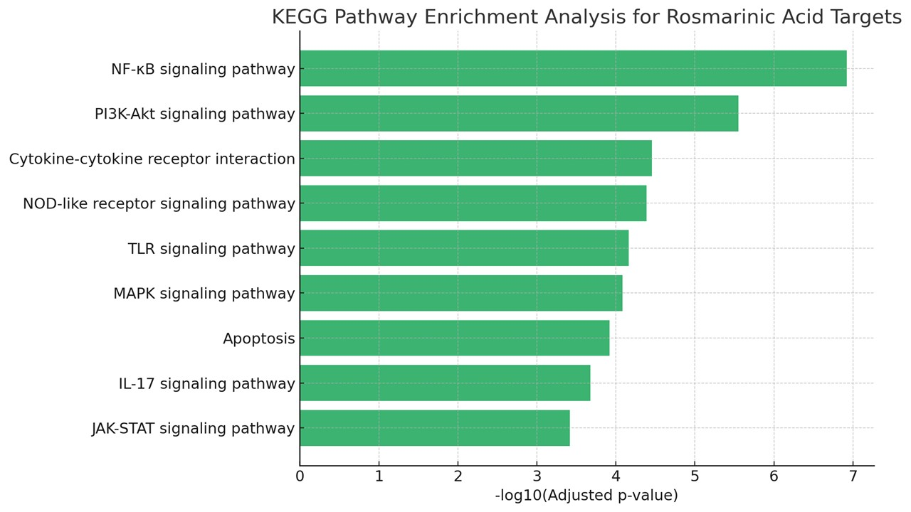

Figure 1: KEGG Pathway Enrichment Plot for Rosmarinic Acid's anti-inflammatory targets

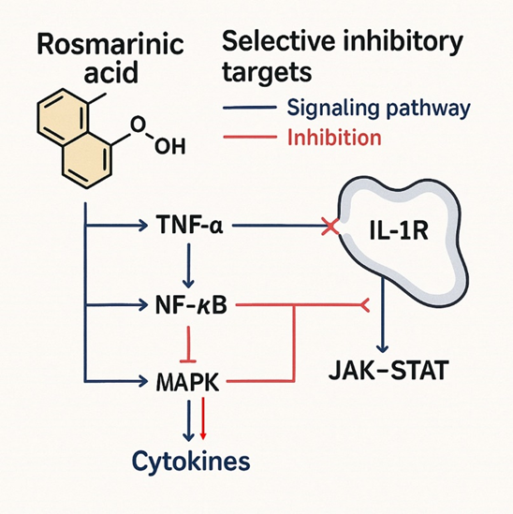
Figure 2: Red Inhibition Lines (Targets of Rosmarinic acid): Rosmarinic acid exerts inhibitory effects at multiple points: Blocks IL-1R–mediated signaling Inhibits NF-κB activation- Suppresses MAPK pathway directly downregulation of cytokines - Interrupts JAK-STAT signaling
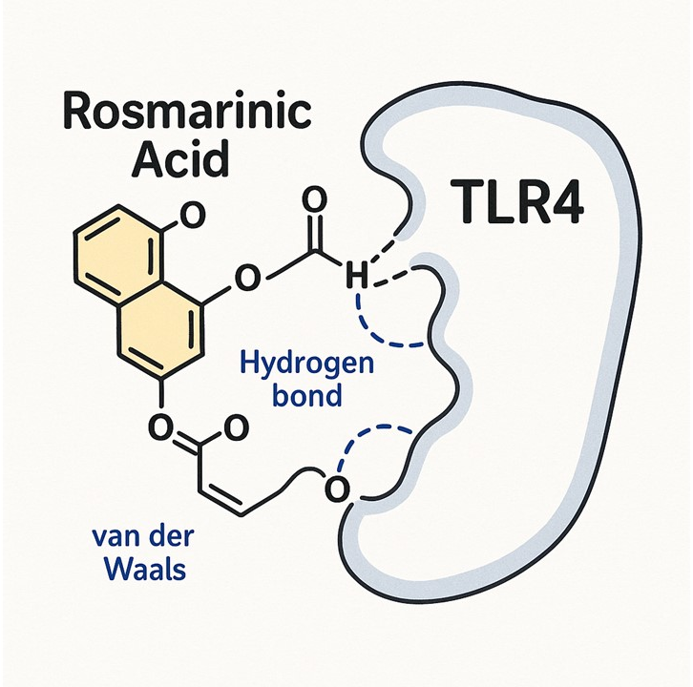

Figure 3: receptor–ligand docking diagram for Rosmarinic Acid with TLR4

