Systematic Review Article

Migraine and Genetic Causes in Saudi Arabia: Systematic Review and Meta-Analysis

.
ABSTRACT

Introduction
Migraine is a chronic neurological disorder marked by recurring headaches and aura symptoms, significantly impacting quality of life. While environmental factors contribute to its pathogenesis, genetics play a critical role, particularly in familial cases. In Saudi Arabia, rising migraine rates coincide with limited genetic research. This study aims to systematically evaluate local evidence on migraine-related genetic markers and research gaps.
Methodology
This systematic review and meta-analysis followed PRISMA and R-AMSTAR guidelines. We searched PubMed, Google Scholar, Embase, and MEDLINE (2005–2025) for studies on Genetic Cause of Migraines in KSA. Two independent reviewers screened titles, abstracts, and full texts, with data extracted into Excel; disagreements resolved with discussion.
Results
In this systematic review and meta-analysis, 19 studies were included, of which 3 (15.8%) identified genetic associations with migraine. The pooled migraine prevalence across Saudi studies was 3,643 out of 12,248 participants (39.8%, 95% CI: 28.4%–51.3%, I² = 99.6%, p < 0.001). Genetic subgroup analysis showed a higher migraine prevalence in studies reporting genetic associations (63.5%, 95% CI: 34.4%–92.7%) vs. non-genetic studies (35.6%, p = 0.0814). Family history subgroup analysis revealed significantly increased prevalence among those with a positive family history (62.0% vs. 31.5%, p = 0.0230). Gender-based analysis showed higher rates in female-dominant cohorts (49.4% vs. 32.3%, p = 0.1484). Genes associated with migraine included RETNLB, CYTB, ND5, and ATP1A2, all with risk-type associations, especially among migraine with aura cases. Three studies (15.8%) used whole-exome sequencing and validated findings through Sanger sequencing.
Conclusion
This study shows that there are emerging genetic landscape of migraine in Saudi Arabia, which reveals that there is associations of migraine with with nuclear and mitochondrial genes including RETNLB, CYTB, ND5, and ATP1A2. These findings support a potential hereditary basis, particularly in cases of migraine with aura, emphasizing the need for expanded genomic research in this population.

Keywords: Migraine, Genetic Susceptibility, Genetic Causes, Genetic Factors, Saudi Arabia, Mitochondrial DNA, Single Nucleotide Polymorphismsreliability.

1. INTRODUCTION:

Migraine is a condition which is the complex and chronic neurological disorder that significantly impacts the quality of life and functional capacity of the patient [1, 2]. It is characterized by the recurrent attacks of the moderate to severe headache which is often accompanied by the aura symptoms like the nausea, photophobia, and the phonophobia [3]. The migraine has evolved from being the perceived as a mere headache to recognized as the disabling neurovascular condition with the multifactorial etiology [4]. Globally, migraine ranks as the second leading cause of years lived with disability (YLDs) and is more prevalent among women, especially during their reproductive years [5]. There are many environmental and the lifestyle factors which play the crucial roles in the migraine pathogenesis and this mount the evidence points toward a strong genetic component which is particularly in the familial and the early-onset cases [6]. This genetic underpinning is increasingly being explored in the population-specific studies, yet it remains the understudied in the Middle Eastern populations, especially in Saudi Arabia.
The Kingdom of Saudi Arabia (KSA) like many countries has undergone a rapid urbanization and the lifestyle transition which has witnessed the notable rise in the migraine prevalence over the recent decades. The studies which are conducted across the various regions of the Saudi Arabia suggest that the migraine affects between the 2.6 and 32% of the adult population with the higher prevalence among the females healthcare workers, and the students [7]. However, despite this burden the research on the genetic susceptibility to migraine within the Saudi population remains fragmented and limited in the scope. Given the relatively homogenous gene pool due to the consanguinity [8] and the cultural practices in the Saudi Arabia, the population offers a unique opportunity to investigate hereditary factors influencing migraine susceptibility.
The international genome-wide association studies (GWAS) and the family linkage has identified the several gene loci and the gene variants which are associated with the migraine which include the mutations in the CACNA1A, ATP1A2, and SCN1A [9]. These genes are primarily implicated in the familial hemiplegic migraine. The polymorphisms in the genes related to the serotonin metabolism, the vascular regulation, and the inflammatory pathways such as the MTHFR, TRPM8, and the LRP1 have also been linked to the common forms of the migraine [10]. Whether these genetic variants similarly contribute to the migraine susceptibility among the Saudi population remains a critical unanswered question.
The paucity of the locally conducted genetic studies on the migraine lead to the several challenges which include the limited genetic research infrastructure, the insufficient funding, and the low public awareness of the genetic testing. Nevertheless, there a few pioneering studies in Saudi Arabia which have begun to investigate the association between the specific single nucleotide polymorphisms (SNPs) and migraine in various subpopulations. Although these studies are limited in the sample size and the geographic scope, they have been reported the associations between the migraine and the certain genetic variants, such as those in the MTHFR and the TNF-α genes [11]. However, the small sample sizes, the methodological inconsistencies, and lack of meta-analytic synthesis have limited the generalizability and translational value of these findings.
Given the migraine burden and emergence of the genetic evidence in the Saudi Arabia there is the need of a systematic review and meta-analysis which is essential to synthesize the existing data and provide evidence-based practice. This will clarify the genetic markers, inform clinical and the public health strategies, and support the personalized medicine, which improve the diagnosis and guide the targeted migraine therapies in the Saudi population. This study aim to review systematically and analyze the genetic studies on the migraine in Saudi Arabia, which identify the significant polymorphisms, assess the methodological quality, explore the heterogeneity, and highlights the research gaps to enhance the understanding of migraine's genetic basis in the Saudi population.

2. material and methods

Study Design and Reporting
This systematic review and meta-analysis was conducted in accordance with the Preferred Reporting Items for Systematic Reviews and Meta-Analyses (PRISMA) guidelines and the Revised Assessment of Multiple Systematic Reviews (R-AMSTAR) framework. The study protocol aimed to identify, appraise, and synthesize existing literature assessing genetic associations with migraine within the Saudi Arabian population.
Search Strategy and Criteria
An electronic literature search was performed from January 11, 2025 to April 15, 2025 across the following databases: PubMed, Google Scholar, and MEDLINE. The objective was to capture all relevant studies investigating genetic causes or polymorphisms associated with migraine in Saudi Arabia. The search strategy employed combinations of the following keywords and phrases: “Migraine,” “Genetics,” “Gene Polymorphism,” “Migraine Susceptibility,” “Familial Migraine,” “Mutation,” “GWAS,” and “Saudi Arabia.” Boolean operators (AND, OR) were applied to refine and optimize the search. Reference lists of included articles were also manually screened for additional eligible studies. Only studies published in English were considered.
Inclusion Criteria
Studies were included if they met the following criteria:
- Investigated genetic aspects of migraine, including gene polymorphisms or mutations.
- Conducted in Saudi Arabia or involving predominantly Saudi participants.
- Original research articles (case-control studies, cohort studies, cross-sectional studies, or case reports).
- Published in peer-reviewed journals.
- Provided full-text availability in English.
- Published between 2005 and 2024.
Exclusion Criteria
Studies were excluded if they:
- Were review articles, meta-analyses, editorials, expert opinions, or conference abstracts.
- Did not include genetic analyses or lacked a migraine-related genetic focus.
- Were animal studies or in vitro experiments without clinical correlation.
- Were not available in English.
- Were published before 2005.
Screening and Study Selection
All retrieved references were imported into EndNote for reference management, and duplicates were removed. Two independent reviewers (GS and BA) screened titles and abstracts to identify potentially eligible studies. Full texts of selected articles were then reviewed to confirm eligibility. Disagreements were resolved through discussion, and if consensus could not be reached, a senior reviewer (AA) made the final decision. A total of 19 studies were included in the final review (PRISMA flow diagram in Figure 1).
Assessment of Agreement
The inter-reviewer agreement was evaluated using the kappa (κ) statistic for screening. A priori classification was defined according to the following criteria: κ of 0.91-0.99 was considered almost perfect agreement; κ of 0.71–0.90 was considerable agreement; k of 0.61-0.70 was high agreement; κ of 0.41–0.60 was moderate agreement; κ of 0.21–0.40 was fair agreement and a κ or ICC value of 0.20 or less was classified as no agreement.
Data Abstraction
Data from the final set of twenty studies was abstracted independently by three authors into a standardized Microsoft Excel (Microsoft Corporation, Redmond, WA, USA) spreadsheet. Each article was thoroughly reviewed to extract key information on study demographics (including total sample size, sex distribution, mean or median age, and region within Saudi Arabia), migraine classification (episodic, chronic, or familial), and genetic parameters (such as gene polymorphisms studied, SNP identifiers, allelic distributions, and genotyping techniques used). Clinical context was noted, including diagnostic criteria for migraine (e.g., ICHD guidelines), presence of aura, comorbidities, and family history. Outcome data were collected on statistically significant associations between genetic variants and migraine risk, odds ratios, confidence intervals, and Hardy-Weinberg equilibrium status. Study characteristics—including design (case-control, cohort, or cross-sectional), publication year, sample source (e.g., hospital-based or population-based), and any relevant subgroup analyses—were also recorded. Discrepancies in data extraction were resolved through consensus discussions among the three reviewers, with unresolved disagreements referred to a senior author for final arbitration. Data accuracy was periodically verified by cross-checking with original full-text articles, and the Excel file served as the primary repository for all descriptive and outcome-related data used in this review.
Statistical Analysis
We performed statistical analyses using the inverse variance method to pool continuous outcomes, with random-effects models employed. Pooled effect sizes, along with 95% confidence intervals (CI), were calculated for Migraine Prevalence, genetic association, and gender and family association. Heterogeneity was assessed using the Q-statistic, I², and tau², with the restricted maximum-likelihood estimator applied to calculate tau². Subgroup analyses were conducted to compare between different groups. Sensitivity analyses were performed to evaluate the robustness of the findings. Publication bias was assessed visually with funnel plots. All analyses were conducted using specialized meta-analysis software, and a significance level of p < 0.05 was considered statistically significant.

3. results and discussion

Literature Search:
A total of 90,000 studies across Google Scholar, PubMed and MEDLINE were identified. Targeted narrowing of keywords removed 80,000 records. An additional 7,500 were excluded based on title screening, leaving 2,500 records to be fully screened. Of these, 1,032 were excluded for the wrong study design, and 1,468 were sought for retrieval. A total of 1,340 reports could not be retrieved, leaving 118 full-text articles assessed for eligibility. From these, 71 were excluded because the full articles were not available, while 28 did not report the outcomes of interest. Ultimately, nineteen studies met all the inclusion criteria and were included in the final review (Figure 1).
Figure 1: PRISMA flow diagram showing selection of included studies

Identification of studies via databases

Records removed on Narrow down Keywords:
(n = 80,000)
Records excluded Based on Title:
(n=7500)

Records identified from PubMed, Google Scholar and Medline:
(n=90,000)

Identification

Records screened
(n = 2500)
Records excluded wrong study design
(n = 1032)

Reports sought for retrieval
(n = 1468)
Reports not retrieved
(n = 1350)

Screening

Reports assessed for eligibility
(n = 118)
Reports excluded:
Full articles not available (n = 71)
Studies not reporting desired outcomes (n = 28)

Studies included in review
(n = 19)
Included

Quality Assessment of Included Studies
The methodological quality of this SRMA was assessed with using the Newcastle-Ottawa Scale for the Observational Studies. This assessment is conducted by the three independent reviewers, which ensure the robust evaluation of the process. In cases where discrepancies arose, consensus was reached among the reviewers through mutual discussion. If consensus could not be achieved the there is a senior reviewer who was involved to facilitate the conflict resolution, which ensure the impartiality and the accuracy in the evaluation process. Figure 2 shows the risk of bias assessment across all included studies based on the Newcastle-Ottawa Scale. The most studies demonstrated that there is a low risk for criteria such as the adequate case definition, the representativeness of the cases, and the ascertainment of the exposure, which indicate that there is a strong methodological quality in these domains. However, the high risk was the evident in the selection of the controls and the comparability for additional factors, which reflects that the weaknesses in how the control groups were chosen and the confounders were managed. Some uncertainty (yellow) was observed in non-response rate and ascertainment methods, pointing to reporting gaps. Moreover, the Figure 3 shows that the Newcastle-Ottawa Scale (NOS) risk of bias summary for the each included study. Thus, the most studies scored well on key domains such as adequate case definition, ascertainment of exposure, and consistent outcome assessment between groups. However, there are many studies which showed the high or unclear risk in the selection of the controls and the comparability criteria, which is particularly for the additional factor control. Studies like those by M.A. Al Qarni and M.A. Algarni had multiple high-risk ratings, while others like A.E. Mansour and M.A. Jumah demonstrated strong methodological quality.
Figure 2: Risk of bias graph: review authors' judgements about each risk of bias item presented as percentages across all included studies.
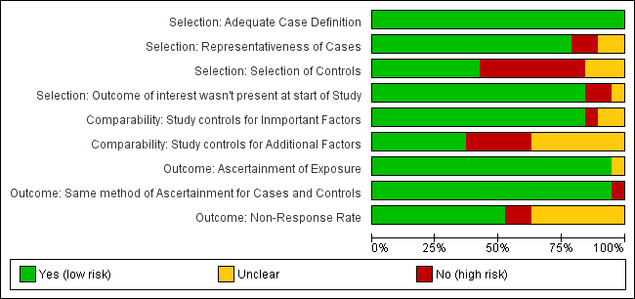

Figure 3: Risk of bias summary: review authors' judgements about each risk of bias item for each included study (Total Scores = 9)
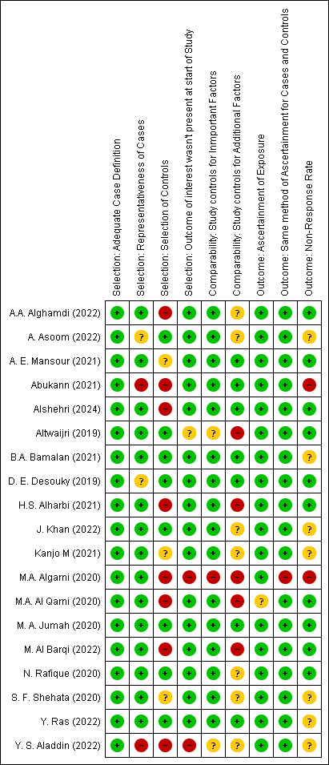

Characteristics of Included the Studies
A total of 19 studies were included in this SRMA, out of the which there are 4 (21.1%) studies which incorporated a control group, notably J. Khan (2022) [12], A. Asoom (2022) [13], B.A. Bamalan (2021) [16], and N. Rafique (2020) [29]. The remaining 15 studies (78.9%) lacked a control comparison group. In terms of design, case-control studies accounted for 3 (15.8%) of the included research [12, 13, 29], while cross-sectional and descriptive cross-sectional studies were predominant, making up 11 (57.9%) of the total [15–18, 20–22, 24–27, 30]. Only 1 study (5.3%) employed a retrospective cross-sectional design [28], and 1 (5.3%) was a case report [14]. One large-scale population-based study was also included [26].The total number of migraine patients across studies was 3,643 (24.8%), and the controls accounted for 3,220 (21.9%) of the total sample. The single largest study by the M. A. Jumah (2020) [26] has included the 2,329 participants, with the 1,010 (43.4%) who diagnosed with the migraine. Similarly, B.A. Bamalan (2021) [16] had a large cohort of 2,058 participants, among whom 765 (37.2%) had migraine and 1,293 served as controls. These studies spanned various cities and the regions in Saudi Arabia, with a few (e.g., Y. Ras (2022) [18]) incorporating data from multiple countries, including Syria. The geographic coverage has included the Dammam [12, 13, 29], Riyadh [14], Jeddah [16, 17, 22, 28], Eastern Region [19], Taif [20, 30], Makkah [21], Arar [23], Unaizah [24], and the Abha [25, 27] which reflect the strong national representation of our SRMA. Several studies involved large cohorts but did not report control group data or diagnostic detail, such as Alshehri (2024) [15] and A. E. Mansour (2021) [24], which limits comparative analysis (Table 1).
Author | Study  Design | Study  Period | Location  (City, Region) | Sample Size  (Total) | Migraine  Patients (n) | Control Group Present (Yes/No) | Controls (n)
J. Khan (2022) [12] | Case-control | 2021 | Dammam, Saudi Arabia | 40 | 20 | Yes | 20
A. Asoom (2022) [13] | Case-control | N/A | Dammam, Saudi Arabia | 40 | 20 | Yes | 20
Altwaijri (2019) [14] | Case report | N/A | Riyadh, Saudi Arabia | 3 | 3 | No | 0
Alshehri (2024) [15] | Cross-sectional survey | June 1, 2023 – August 31, 2023 | Nationwide (Saudi Arabia) | 1975 | N/A | No | N/A
B.A. Bamalan (2021) [16] | Descriptive cross-sectional study | April – June 2021 | Jeddah, Saudi Arabia | 2058 | 765 | Yes | 1293
Y. S. Aladdin (2022) [17] | Cross-sectional study | 2019 | Jeddah, Saudi Arabia | 410 | 165 | No | N/A
Y. Ras (2022) [18] | Cross-sectional | Not mentioned | Saudi Arabia, Syria | 620 | 102 | No | N/A
M. Al Barqi (2022) [19] | Cross-sectional | August 2021 – March 2022 | Eastern Region, Saudi Arabia | 877 | 117 | No | N/A
A.A. Alghamdi (2022) [20] | Cross-sectional | N/A | Taif City, Saudi Arabia | 75 | 23 | No | N/A
H.S. Alharbi (2021) [21] | Cross-sectional | March to May 2021 | Makkah, Saudi Arabia | 227 | 72 | No | N/A
Kanjo M (2021) [22] | Cross-sectional | June to September 2020 | Jeddah, Saudi Arabia | 313 | 224 | No | N/A
Abukann (2021) [23] | Descriptive cross-sectional | April 1st – July 31st, 2021 | Arar, Northern Saudi Arabia | 337 | 293 | No | N/A
A. E. Mansour (2021) [24] | Cross-sectional survey | N/A | Unaizah, Qassim, Saudi Arabia | 456 | N/A | No | N/A
S. F. Shehata (2020) [25] | Descriptive cross-sectional study | 2019 | Abha, Aseer Region, Saudi Arabia | 421 | 131 | No | N/A
M. A. Jumah (2020) [26] | Cross-sectional population-based study | N/A | Saudi Arabia (national-level study) | 2329 | 1,010 (43.4%) | No | N/A
M.A. Al Qarni (2020) [27] | Descriptive Cross-sectional survey | April 2018 – December 2018 | Abha, Aseer Region, Saudi Arabia | 1123 | 138 | No | N/A
M.A. Algarni (2020) [28] | Retrospective cross-sectional study | 2018–2019 | Jeddah, Saudi Arabia | 45 | 21 | No | N/A
N. Rafique (2020) [29] | Case-control study | March 2019 – March 2020 | Dammam, Saudi Arabia | 1990 | 103 | Yes | 1887
D. E. Desouky (2019) [30] | Cross-sectional study | Academic year 2016–2017 | Taif, Saudi Arabia | 1340 | 436 (32.5% of participants) | No | N/A
Table 1. Characteristics of Included Studies Investigating Genetic Associations with Migraine in Saudi Arabia

Clinical and Demographic Characteristics of Migraine Patients and Controls
Table 2 shows the clinical and the demographic characteristics of the migraine patients and the controls. The pooled mean age of migraine patients was 24.5 ± 4.1 years, ranging from 21.7 (Shehata, 2020) [25] to 32.4 years (Al Qarni, 2020) [27], with most studies reporting ages around 22 years among young Saudi females [12,13,21,24]. For the control group, only the Khan (2022) [12] and the Asoom (2022) [13] provided numeric values, both citing 21.86 ± 1.75 years as the control mean age. In terms of the gender distribution among the migraine patients, the complete data were available from the 13 studies. Across these, there is a total of 1,167 patients which were reported, which comprise of 239 males (20.5%) and the 928 females (79.5%). Among the included studies [12,13,15–18,20,21,23,27–30], several studies focused primarily on the females. J. Khan [12], A. Asoom [13], and N. Rafique [29] reported 100% female participation. In contrast, the study by the Alshehri [15] reported the highest male proportion at 64.2%. For the control group gender data, only the study by the Khan (2022) [12], Asoom (2022) [13], and the Rafique (2020) [29] has provided the complete information about the participants. Each of these included studies has reported that there is 0% male and 100% female participation among the controls. Several studies, including M. Al Barqi (2022) [19], Kanjo M (2021) [22], and M. A. Jumah (2020) [26], did not provide any gender or age-related data. Similarly, age data for control participants were limited to the two studies by Khan [12] and Asoom [13].

Table 2. Clinical and Demographic Characteristics of Migraine Patients and Controls
Author | Age  (Patients, Mean ± SD) | Age  (Controls, Mean ± SD) | Gender Distribution (Patients Male %) | Gender Distribution (Patients Female %) | Gender Distribution (Controls Male %) | Gender Distribution (Controls Female %)
J. Khan (2022) [12] | 22.10 ± 3.63 years | 21.86 ± 1.75 years | 0% | 100% | 0% | 100%
A. Asoom (2022) [13] | 22.10 ± 3.63 years | 21.86 ± 1.75 years | 0% | 100% | 0% | 100%
Altwaijri (2019) [14] | N/A | N/A | 0% | 100% | N/A | N/A
Alshehri (2024) [15] | 18–64 years (range) | N/A | 64.20% | 35.80% | N/A | N/A
B.A. Bamalan (2021) [16] | N/A | N/A | 18.9 | 81.1 | N/A | N/A
Y. S. Aladdin (2022) [17] | N/A | N/A | 0 | 100 | N/A | N/A
Y. Ras (2022) [18] | N/A | N/A | 20.6 | 79.4 | N/A | N/A
M. Al Barqi (2022) [19] | N/A | N/A | N/A | N/A | N/A | N/A
A.A. Alghamdi (2022) [20] | N/A | N/A | 0 | 100 | N/A | N/A
H.S. Alharbi (2021) [21] | 22.20 ± 2.67 | N/A | 26.1 | 73.9 | N/A | N/A
Kanjo M (2021) [22] | N/A | N/A | N/A | N/A | N/A | N/A
Abukann (2021) [23] | most participants were 18–24 years old: 55.5% | N/A | 19.30% | 80.70% | N/A | N/A
A. E. Mansour (2021) [24] | 22.14 ± 1.88 years | N/A | N/A | N/A | N/A | N/A
S. F. Shehata (2020) [25] | 21.7 ± 1.9 years | N/A | N/A | N/A | N/A | N/A
M. A. Jumah (2020) [26] | N/A | N/A | N/A | N/A | N/A | N/A
M.A. Al Qarni (2020) [27] | 32.4 ± 10 | N/A | 33.3 | 66.7 | N/A | N/A
M.A. Algarni (2020) [28] | N/A | N/A | 26.7 | 73.3 | N/A | N/A
N. Rafique (2020) [29] | N/A (age range 17–26) | N/A (age range 17–26) | 0 | 100 | 0 | 100
D. E. Desouky (2019) [30] | N/A | N/A | 0% (all female participants) | 100% | N/A | N/A

Genetic Factors and the Methodological Features of Migraine among KSA Population the Included Studies
Table 3 shows that the only three studies—J. Khan (2022) [12], A. Asoom (2022) [13], and Altwaijri (2019) [14]—investigated specific genetic markers in relation to migraine among individuals in Saudi Arabia, representing 15.8% of the total. All three studies used blood samples (3/3, 100%) as the biological material for genotyping. The primary genotyping technique in all genetic studies was whole-exome sequencing (WES), with Sanger sequencing used additionally for validation in the studies by Khan [12] and Altwaijri [14]. Each of these three studies reported that quality control measures were performed during genotyping procedures (3/3, 100%).
In terms of the type of genetic markers analyzed, J. Khan [12] explored single nucleotide variants (SNVs) and small insertions/deletions (indels), identifying associations with 12 genes including RETNLB, SCAI, ADH4, ESPL1, CPT2, FLG, PPP4R1, SERPINB5, ZNF66, ETAA1, EXO1, and CPA6. The allele specifically reported was rs5851607 in the RETNLB gene. Similarly, A. Asoom [13] investigated single nucleotide polymorphisms (SNPs) in mitochondrial DNA, with significant variants like rs1603225278 (CYTB gene) and rs386829281, and reported gene involvement of CYTB, ND5, ND4, COX2, COX1, ND3, COX3, ND2, and ND1. Altwaijri [14], on the other hand, focused on a single point mutation in the ATP1A2 gene (c.2450T>A; p.Ile817Asn) that was linked to familial hemiplegic migraine type 2. All three studies confirmed major genetic associations (3/3, 100%), and classified these associations as risk-associated rather than protective or neutral. Moreover, all genetic associations were reported in the context of migraine with aura, with J. Khan [12] and A. Asoom [13] explicitly noting "primarily with aura" and Altwaijri [14] specifying hemiplegic migraine with aura.
In contrast, the remaining 16 studies (84.2%)—including large-scale surveys like Alshehri (2024) [15], B.A. Bamalan (2021) [16], and M.A. Jumah (2020) [26]—did not investigate any genetic markers. These studies did not report the use of genotyping methods, quality control processes, or any allele-related findings. All fields related to genetic analysis were marked as not reported (N/R) or not applicable, and most of these studies clearly stated no genetic association found. Therefore, although migraine is a prevalent condition in Saudi Arabia, molecular genetic research in this context remains scarce and isolated to only a few pilot studies.
Table 3: Genetic Factors and the Methodological Features of Migraine among KSA Population the Included Studies
Author | Genetic Marker Type | Biological Sample Used | Genotyping  Method | Quality Control for Genotyping | Allele Names | Major Genetic Association Found | Specific Gene(s) Showing Association | Type of Association (Risk/Protective/Neutral) | Migraine Type Associated with Gene (e.g., with aura, without aura)
J. Khan (2022) [12] | Single nucleotide variants  (SNVs) and small insertions/deletions (indels) | Blood | Whole-exome sequencing; Sanger sequencing for validation | Yes | rs5851607 (RETNLB gene) | Yes | RETNLB, SCAI, ADH4, ESPL1, CPT2, FLG, PPP4R1, SERPINB5, ZNF66, ETAA1, EXO1, CPA6 | Risk | Primarily with aura
A. Asoom (2022) [13] | Single nucleotide polymorphisms (SNPs) in mitochondrial DNA | Blood | Whole-exome sequencing (WES) with mitochondrial DNA analysis | Yes | rs1603225278 (CYTB gene), rs386829281 | Yes | CYTB, ND5, ND4, COX2, COX1, ND3, COX3, ND2, ND1 | Risk | Primarily with aura
Altwaijri (2019) [14] | ATP1A2 gene mutation (c.2450T>A, p.Ile817Asn) | Blood | Whole-exome sequencing (WES) and Sanger sequencing | Yes | c.2450T>A | Yes | ATP1A2 | Risk | With aura (hemiplegic migraine)
Alshehri (2024) [15] | N/R | N/R | N/R | N/R | N/R | No | N/R | N/R | N/R
B.A. Bamalan (2021) [16] | N/R | N/R | N/R | N/R | N/R | No | N/R | N/R | N/R
Y. S. Aladdin (2022) [17] | N/R | N/R | N/R | N/R | N/R | No | N/R | N/R | N/R
Y. Ras (2022) [18] | N/R | N/R | N/R | N/R | N/R | No | N/R | N/R | N/R
M. Al Barqi (2022) [19] | N/R | N/R | N/R | N/R | N/R | N/R | N/R | N/R | N/R
A.A. Alghamdi (2022) [20] | N/R | N/R | N/R | N/R | N/R | N/R | N/R | N/R | N/R
H.S. Alharbi (2021) [21] | N/R | N/R | N/R | N/R | N/R | N/R | N/R | N/R | N/R
Kanjo M (2021) [22] | N/R | N/R | N/R | N/R | N/R | N/R | N/R | N/R | N/R
Abukann (2021) [23] | N/R | N/R | N/R | N/R | N/R | N/R | N/R | N/R | N/R
A. E. Mansour (2021) [24] | N/R | N/R | N/R | N/R | N/R | N/R | N/R | N/R | N/R
S. F. Shehata (2020) [25] | N/R | N/R | N/R | N/R | N/R | N/R | N/R | N/R | N/R
M. A. Jumah (2020) [26] | N/R | N/R | N/R | N/R | N/R | N/R | N/R | N/R | N/R
M.A. Al Qarni (2020) [27] | N/R | N/R | N/R | N/R | N/R | No | N/R | N/R | N/R
M.A. Algarni (2020) [28] | N/R | N/R | N/R | N/R | N/R | No | N/R | N/R | N/R
N. Rafique (2020) [29] | N/R | N/R | N/R | N/R | N/R | No | N/R | N/R | N/R
D. E. Desouky (2019) [30] | N/R | N/R | N/R | N/R | N/R | No | N/R | N/R | N/R

Environmental and other Additional genes related Risk Factors of migraine
Out of the 19 studies analyzed, 10 studies (52.6%) reported gender-specific associations in migraine occurrence. Studies by J. Khan (2022) [12], A. Asoom (2022) [13], and Altwaijri (2019) [14] exclusively focused on female participants. Other studies such as Alghamdi (2022) [20], Alharbi (2021) [21], Abukann (2021) [23], Mansour (2021) [24], Al Qarni (2020) [27], and Algarni (2020) [28] also described notable gender disparities. The study by the Detsouky (2019) [30], although the limited to the female participants but they did not compare the genders, and the Rafique (2020) [29] and Y. Ras (2022) [18] explicitly didnot reported the gender-specific findings.
The age-specific associations were the less frequently reported, which is mentioned in only 6 studies (31.6%). These include Alghamdi [20], Kanjo M [22], Abukann [23], and Algarni [28], who identified a higher migraine burden in younger populations, especially the 18–24 age group. Other studies, such as Alsoom [13] and Khan [12], did not stratify their genetic findings by age.
Only there are 3 studies (15.8%) which explicitly reported the data on the family history of the migraine. These were Khan (2022) [12] and Asoom (2022) [13], both indicating that 55% of participants had a positive family history, and Alharbi (2021) [21], reporting 53.6%. Additionally, the study by the Alshehri (2024) [15] found that 27.3% of the respondents believed that the genetics or the hereditary disease contributed to the migraine occurrence. Abukann (2021) [23] also documented the family history in the 27% of cases, though methodological details were limited.
When it comes to environmental risk factors, a strong majority—17 out of 19 studies (89.5%)—reported various external triggers for migraine. Common factors included sleep disturbances, stress, bright light, and dietary habits, as seen in Khan [12], Asoom [13], and Jumah [26]. Broader environmental and lifestyle-related variables like smoking, physical activity, and income level were assessed in studies such as Abukann [23]. Only Algarni (2020) [28] explicitly noted no environmental factors, and Altwaijri (2019) [14] did not investigate this domain.
Table 4: Environmental and other Additional genes related Risk Factors of migraine
Author | Gender-specific Associations Reported | Age-specific Associations Reported | Gene-Environment  Interaction Reported | Family History of Migraine Reported (Yes/No, %) | Environmental Factors Considered
J. Khan (2022) [12] | Yes; study focused exclusively on females | No | No | Yes, 55% | Yes (e.g., sleep disturbances, stress, bright light)
A. Asoom (2022) [13] | Yes; study focused exclusively on females | No | No | Yes, 55% | Yes (e.g., sleep disturbances, stress, bright light)
Altwaijri (2019) [14] | Yes; study focused exclusively on females | No | No | Yes, 100% | No
Alshehri (2024) [15] | No | No | No | Yes, 27.3% identified genetic disease as a cause | Yes
B.A. Bamalan (2021) [16] | N/A | N/A | N/A | N/A | Yes
Y. S. Aladdin (2022) [17] | N/A | N/A | N/A | N/A | Yes
Y. Ras (2022) [18] | No | No | No | N/A | Yes
M. Al Barqi (2022) [19] | No | No | N/A | N/A | Yes
A.A. Alghamdi (2022) [20] | Yes | Yes | N/A | N/A | Yes
H.S. Alharbi (2021) [21] | Yes | N/A | N/A | Yes (53.6%) | Yes
Kanjo M (2021) [22] | N/A | Yes | N/A | N/A | Yes
Abukann (2021) [23] | Yes (Females were more affected: 80.7%) | Yes (Younger age group 18–24 mostly affected) | N/A | Yes (27%) | Yes (Physical activity, smoking, income level)
A. E. Mansour (2021) [24] | Yes | N/A | N/A | N/A | Yes
S. F. Shehata (2020) [25] | N/A | N/A | N/A | N/A | Yes
M. A. Jumah (2020) [26] | N/A | N/A | N/A | N/A | Yes (e.g., stress, sleep disturbances)
M.A. Al Qarni (2020) [27] | Yes | No | No | N/A | Yes
M.A. Algarni (2020) [28] | Yes | Yes | No | N/A | No
N. Rafique (2020) [29] | No | No | No | N/A | Yes
D. E. Desouky (2019) [30] | No (study included only females) | No | No | N/A | Yes (stress/anxiety as triggers)

Summary of Genetic Associations and different Conclusions
Table 5 shows the summary of the key findings of the genetic associations and study conclusions across 19 included studies. Three studies—Khan (2022) [12], Asoom (2022) [13], and Altwaijri (2019) [14]—identified specific genetic variants linked to migraine, notably in mitochondrial and nuclear DNA, with risk associations predominantly among female patients. Environmental and psychiatric factors such as stress, sleep deprivation, and depression were commonly reported across observational studies (Alharbi [21], Desouky [30]). Quality of life impact, functional impairment, and photophobia were also recurrent themes. Limitations included small sample sizes, lack of control groups, reliance on self-reported questionnaires, and single-institution scope.
Table 5: Summary of Genetic Associations and different Conclusions
Author | Other Important  Clinical Findings | Conclusion | Study  Limitations
J. Khan (2022) [12] | Half of the significant genes were expressed in the temporal lobe. | Identified 17 functional variants in 12 genes associated with migraine risk among Saudi females. | Small sample size; pilot study, young females only.
A. Asoom (2022) [13] | 30 mitochondrial SNPs found; CYTB and ND5 genes most involved. | Mitochondial DNA variations linked to migraine pathophysiology in Saudi females. | Small sample size; only females included.
Altwaijri (2019) [14] | MRI: focal cortical swelling; EEG: unilateral slowing; no infection. | First report of ATP1A2 mutation linked to familial hemiplegic migraine in Saudi family. | Small sample; no control group.
Alshehri (2024) [15] | 27.3% identified genetic disease as migraine cause. | Moderate public knowledge on migraine; presence of misconceptions. | Self-reporting; no clinical validation.
B.A. Bamalan (2021) [16] | Photophobia most common (94.6%); lower QoL in patients. | Migraine in Jeddah highly affects quality of life. | Self-reported; online survey bias.
Y. S. Aladdin (2022) [17] | 7.8% cited caffeine; 2.2% cited chocolate as triggers. | Caffeine likely a hidden trigger for migraines in female students. | No control group; self-reported.
Y. Ras (2022) [18] | Depression significantly linked with migraine (OR = 2, P = 0.004). | Migraine among Arabs varies by environment and psychiatric links. | Questionnaire-only diagnosis.
M. Al Barqi (2022) [19] | 15.5% migraineurs unable to work during attacks. | Migraine and tension-type headaches cause high burden. | Lacks city-specific data.
A.A. Alghamdi (2022) [20] | QoL scores varied by age, education, work, chronic disease. | Migraine prevalent in elderly females in Taif. | Limited demographic data; small sample.
H.S. Alharbi (2021) [21] | Stress, sleep deprivation major triggers. | Migraine prevalent among medical students with academic stress. | Single-institution study.
Kanjo M (2021) [22] | Irregular sleep a key migraine trigger. | High migraine prevalence among Fakeeh College students. | Single institution; limited generalizability.
Abukann (2021) [23] | 41.2% severe HRQL impact; photophobia (51.9%), noise sensitivity (69.1%). | High primary headache (86.9%) prevalence; significant QoL impact. | Cross-sectional; convenience sampling.
A. E. Mansour (2021) [24] | Headaches limited work (59.2%); common symptoms: unilateral, pulsating. | Migraine severity influenced by gender and headache duration. | Not applicable.
S. F. Shehata (2020) [25] | Frequent evening/night headaches; blurred vision prodrome in 37.8%. | Majority experienced moderate-severe headaches tied to sleep, stress. | Not applicable.
M. A. Jumah (2020) [26] | Tension-type: 34.1%; chronic daily: 2.4%. | Migraine is the most common headache disorder in Saudi Arabia. | Not applicable.
M.A. Al Qarni (2020) [27] | Migraine linked with poor sleep, sinusitis, depression. | More common in females and poor sleepers. | Self-reported; no clinical diagnosis.
M.A. Algarni (2020) [28] | MRI mostly normal; CBC most used test (93.3%). | Chronic migraine most common; affects females 26-36. | Small sample; retrospective design.
N. Rafique (2020) [29] | Higher stress scores in migraineurs; sleep quality unaffected. | Stress strongly associated with migraine; sleep not significant. | Female students only.
D. E. Desouky (2019) [30] | Depression: 6.2%; stress/anxiety main trigger (86.6%). | Migraine common in female students with stress/anxiety triggers. | Cross-sectional; self-report bias.

Meta-Analysis
The meta analysis of this study shows that there is the pooled prevalence of the migraine across the studies which are conducted in the Saudi Arabia was 39.8% (95% CI: 28.4%–51.3%) which is based on the total of 12,248 observations and 3,643 migraine cases (Figure 4). The analysis of this study shows that there is very high heterogeneity across the studies (I² = 99.6%, p < 0.001) which indicate that there is the significant variability across the included studies. The subgroup analysis by the genetic association (Figure 5) shows that there is the higher pooled prevalence among the studies who are reporting the genetic associations with migraine at 63.5% (95% CI: 34.4%–92.7%) as compared to the 35.6% (95% CI: 23.7%–47.4%) in studies without such associations. Although the difference between the approached statistical significance (Q = 3.04, p = 0.0814) did not reach conventional thresholds.
Further, the subgroup analysis based on the family history (Figure 6) showed a significantly higher prevalence of migraine in individuals with a family history: 62.0% (95% CI: 37.9%–86.2%), compared to 31.5% (95% CI: 21.0%–41.9%) in those without with the statistically significant difference (Q = 5.17, p = 0.0230). Moreover, the gender-based subgroup analysis (Figure 7) shows that there is the higher prevalence among female predominant studies (49.4%, 95% CI: 30.0%–68.9%) as compared to the male-dominant or mixed populations (32.3%, 95% CI: 19.4%–45.1%) but this difference was not reached at the statistical significant values (p = 0.1484). Collectively, these findings support a potential genetic component in migraine susceptibility within the Saudi population, especially when coupled with family history.
Funnel Plot Showing Publication Bias
Figure 8 (Funnel plot) shows the potential evidence of the publication bias. There is an asymmetry, with the smaller studies which shows that there is more variability and the skewed distribution around the central effect estimate. This may indicate a tendency for smaller or less precise studies with negative or non-significant results to be underreported or unpublished. However, asymmetry can also result from factors like methodological heterogeneity or true heterogeneity in effect sizes. Therefore, further statistical tests (e.g., Egger’s test) are recommended to confirm the presence and extent of publication bias.
Figure 4: Pooled Prevalence of the Migraine in Saudi Population
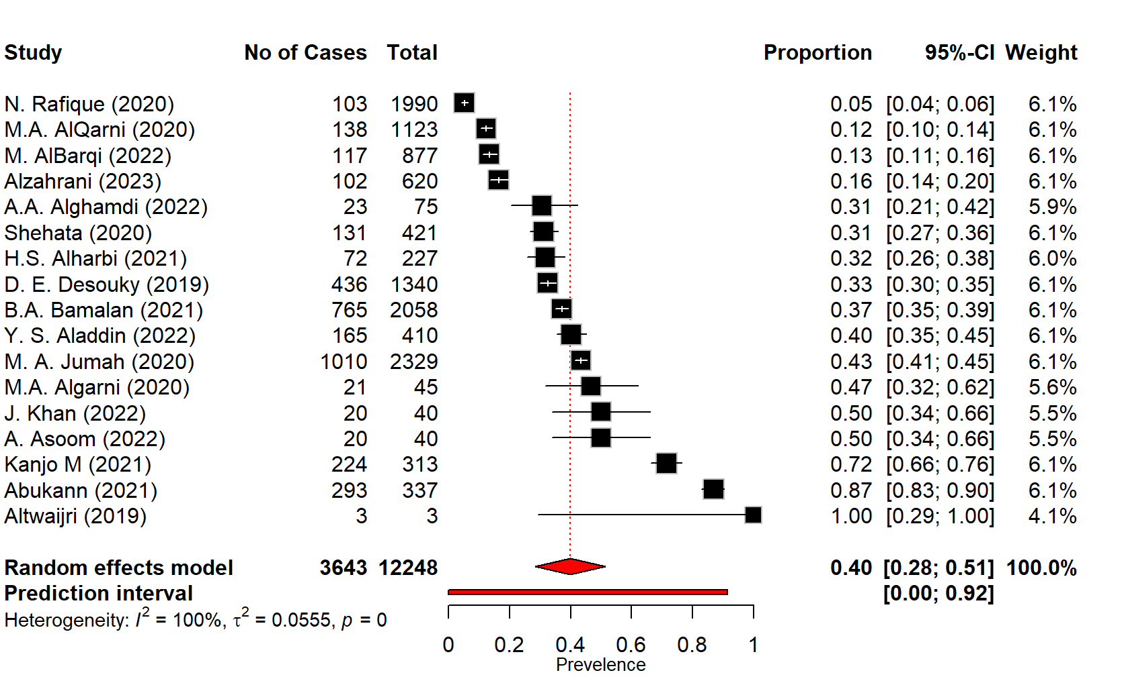
Figure 5: Subgroup analysis of Migraine by Genetic Association
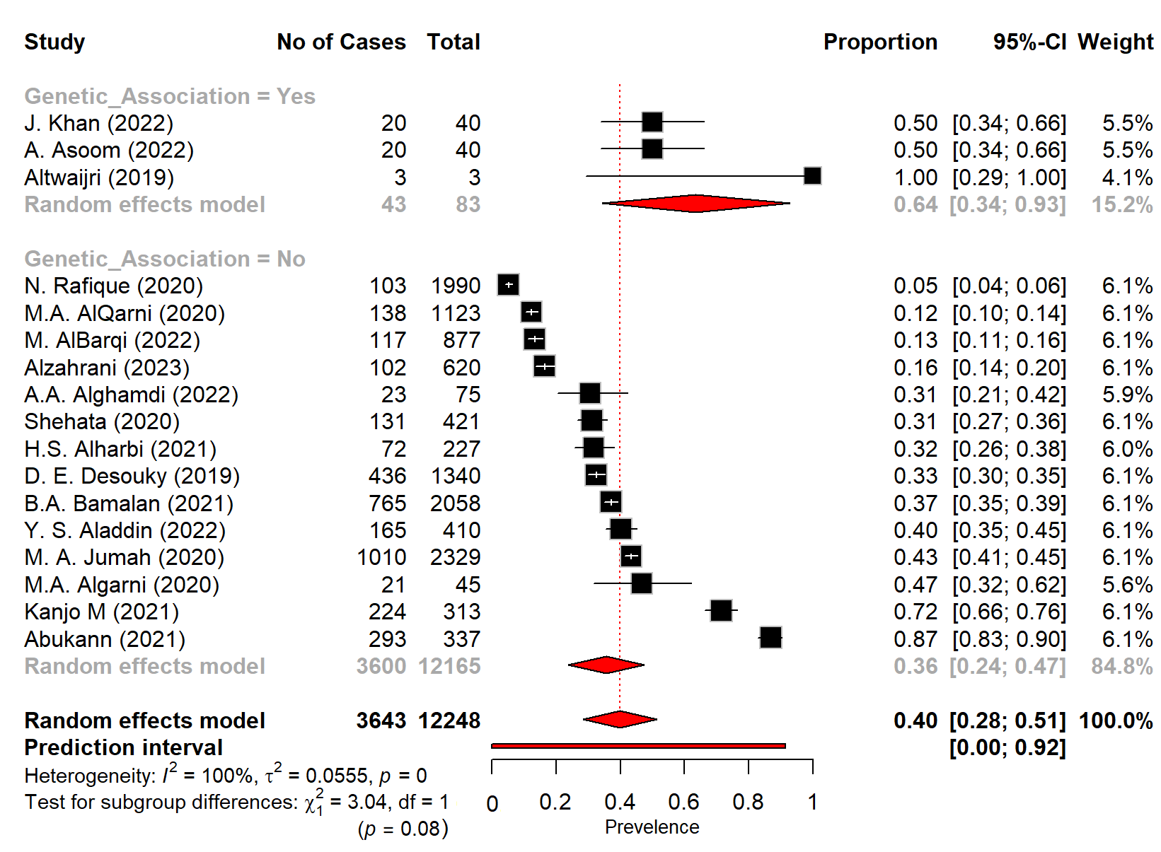
Figure 6: Subgroup analysis of Migraine by the Family History
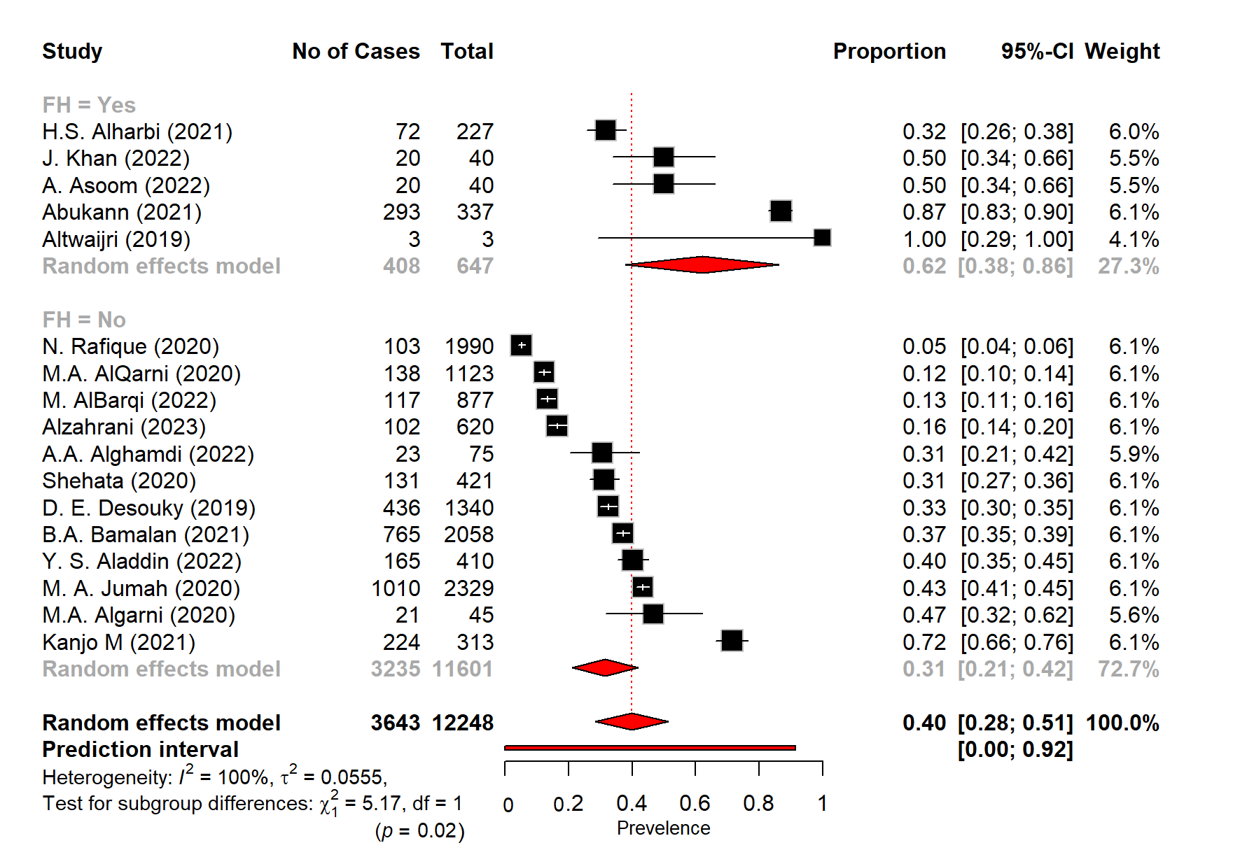

Figure 7: Subgroup analysis of Migraine by Gender (Female) Association
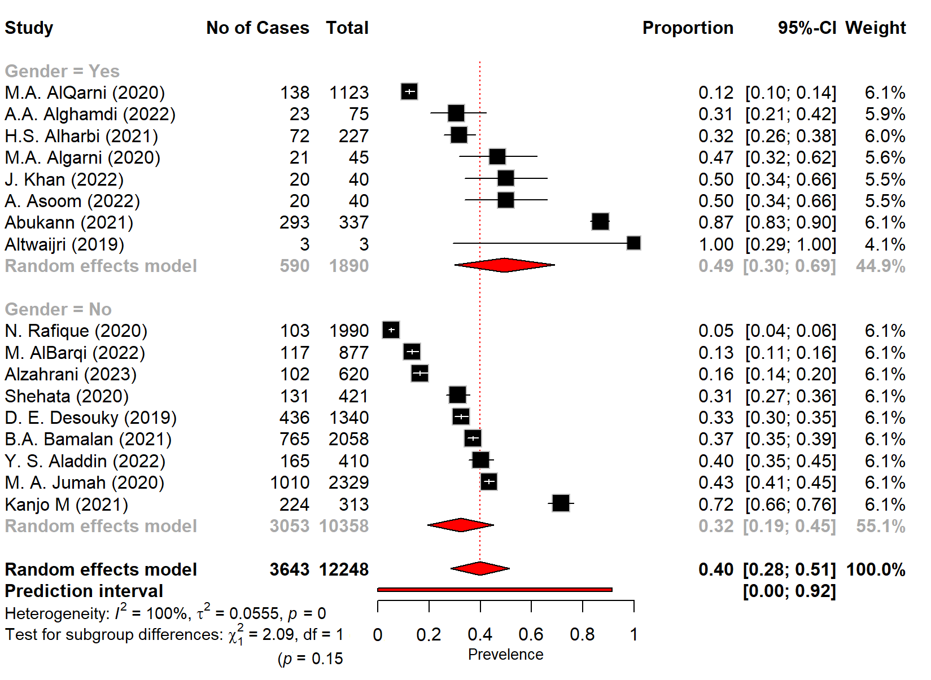
Figure 8: Funnel Plot showing Publication Bais
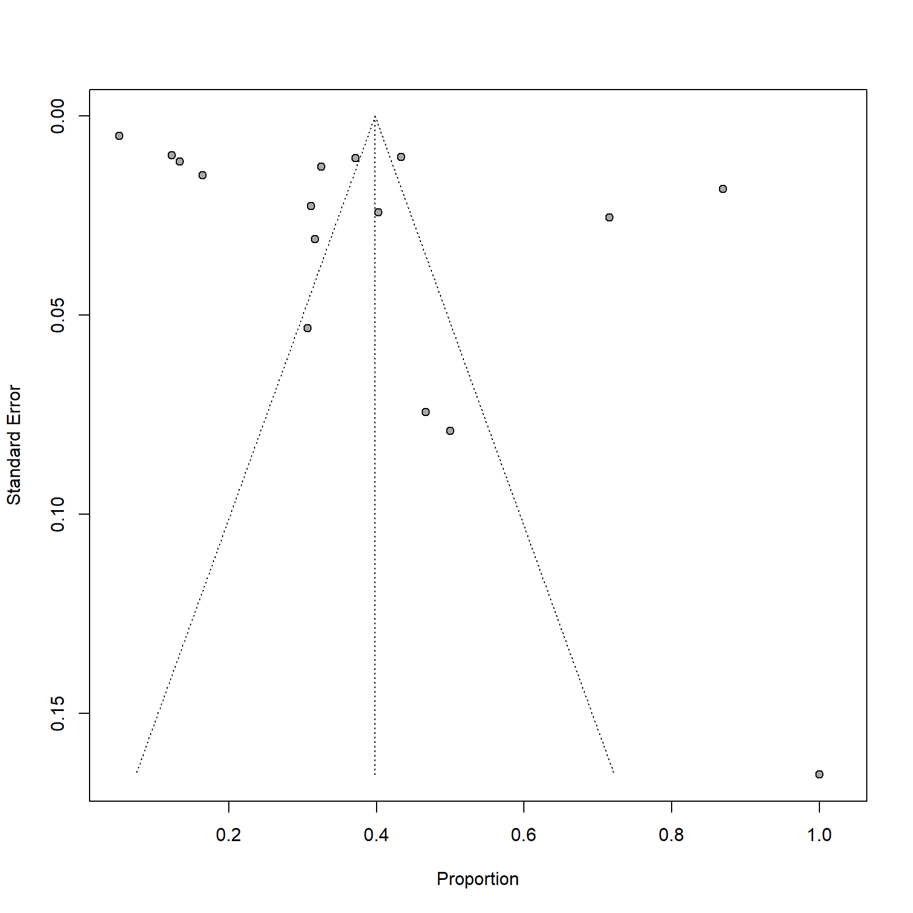
Discussion
Migraine is a complex neurological disorder which has significantly impairs the quality of life of the patient and it is influenced by the both environmental and the genetic factors [31]. In Saudi Arabia there is the rising rates of the migraine which is especially among the females and coincide with the rapid lifestyle changes. Despite these features the genetic research on the migraine in the region is very limited. While the global studies have been identified the several gene mutations linked to migraine, their role in the Saudi population is still unclear. This systematic review and meta-analysis aim to consolidate the local evidence which identify genetic markers and support the future precision medicine approaches in migraine care.
Notably, this study shows that the pooled prevalence estimate of migraine in Saudi Arabia was 39.8% (95% CI: 28.4% – 51.3%). This prevalence is notably higher than the other Arab countries where migraine prevalence is low which is typically in the ranges between 11% and 20% with an average of 11.6% (Metwally et al. (2020) [32]. A study by the Stovner et al. (2022) shows that there is the estimated global prevalence of the migraine is 14.0% (12.9–15.2) which is much lower than the prevalence calculated in our study [33]. Thus, these discrepancies may be attributed due to the methodological variations and the different characteristics of the included population. Moreover there is the high heterogeneity (I² = 99.6%, p < 0.001) across the included studies which suggested that the substantial variability in the sample selection, diagnostic criteria, and the study settings, which reinforce the need for the standardized migraine research protocols in the region.
The main findings of this SRMA which are explored by the three studies (15.8%) is the genetic basis of the migraine in the Saudi population which included the Khan (2022) [12], Asoom (2022) [13], and Altwaijri (2019) [14]. These studies reported the significant genetic associations which are particularly involve the nuclear and mitochondrial DNA markers in the migraine patients. Similarly, the study by the Amiri et al. (2021) shows that there are genetic factors of the migraine which include the mutations in the mitochondrial DNA (e.g., CYTB, ND genes), the nuclear genes (e.g., ATP1A2, CACNA1A), and the oxidative stress-related pathways, which highlights the energy metabolism and the mitochondrial dysfunction as key mechanisms in migraine pathology [31]. Moreover, the pooled prevalence among these studies was significantly higher at 63.5% (95% CI: 34.4% – 92.7%) than in studies without genetic association (35.6%, 95% CI: 23.7% – 47.4%). Notably, the subgroup difference did not achieve the statistical significance (p = 0.0814) but this observed trend suggests that there is the potential correlation between genetic susceptibility and migraine manifestation. These findings align with broader literature indicating that mutations in genes such as CACNA1A, ATP1A2, and SCN1A play a role in familial hemiplegic migraine (FHM), a rare but severe subtype of migraine with aura (Carreño et al., 2013) [34].
Notably, in this systematic review and meta-analysis (SRMA) there are several genes which were identified as being associated with migraine susceptibility in the Saudi population. J. Khan (2022) [12] shows that the RETNLB gene (rs5851607) and the additional associated genes which include the SCAI, ADH4, ESPL1, CPT2, FLG, PPP4R1, SERPINB5, ZNF66, ETAA1, EXO1, and CPA6 were identified in migraine patients. A study by Rainero et al. (2010) shows that the cluster headache or migraine is associated with the ADH4 gene or a linked locus [35]. Notably, this study shows the focused on the mitochondrial genes, which emphasize the gene variants which include the CYTB, ND5, ND4, COX2, COX1, ND3, COX3, ND2, and ND1, which underscore the relevance of mitochondrial dysfunction in migraine pathogenesis. Moreover, a mutation in the ATP1A2 gene (c.2450T>A; p.Ile817Asn) is linked to familial hemiplegic migraine. These findings are consistent with prior international studies, where genes such as CACNA1A, ATP1A2, and SCN1A have been frequently implicated in migraine with aura and hemiplegic subtypes, reinforcing a genetic component underlying this complex neurological disorder. However, Hiekkala et al. (2018) shows that the mutations in CACNA1A, ATP1A2 and SCN1A are not the major cause of hemiplegic migraine, which suggests that there are additional genetic factors which are contributing to the phenotype [36].
Interestingly, all the three genetic studies in our review focused exclusively on the female participants, which shows that there is a higher prevalence of migraine among women globally. This was corroborated in our gender subgroup analysis where female-predominant studies exhibited a higher pooled prevalence (49.4%, 95% CI: 30.0% – 68.9%) compared to others (32.3%, 95% CI: 19.4% – 45.1%), although this difference was not statistically significant (p = 0.1484). These findings are consistent with prior study by Pavlovic et al. (2017)that highlighted hormonal the influences and sex-linked genetic susceptibility as contributors to the female predominance in migraine disorders [37].
Moreover, the family history has emerged as another critical risk factor which further reinforce the genetic hypothesis of migraine. Subgroup analysis showed that individuals with a documented family history of migraine had a significantly higher prevalence (62.0%, 95% CI: 37.9% – 86.2%) compared to those without (31.5%, 95% CI: 21.0% – 41.9%), with a statistically significant difference (p = 0.0230). These findings are aligned with international cohort studies that suggest a two- to three-fold increase in migraine risk among first-degree relatives of affected individuals [38].
Beyond the genetics, the environmental and the lifestyle factors were frequently reported across 89.5% of included studies, with common triggers including stress, sleep deprivation, dietary habits, and sensory stimuli like bright light [39]. Thus, there is a gap in the local research, which shows that the genetic predisposition often interacts with the modifiable lifestyle factors to precipitate migraine attacks.
Implications and Future Direction
There is a clear genetic contribution to the migraine susceptibility in the Saudi population, which is particularly more common among females and the individuals with a positive family history. There is the need for the early identification, risk stratification, and the personalized treatment approaches. The future researches should focus on the large-scale, multicenter genetic studies, which should include the genome-wide association studies (GWAS) and the epigenetic analyses which should done to uncover the broader and population-specific genetic variants. The integration of the genetic screening into the clinical practice, alongside the environmental and the lifestyle assessments, may enhance the precision of medicine strategies and guide targeted therapies for migraine management within Saudi Arabia and similar high-prevalence regions.

4. Conclusion

This SRMA shows that there is the significant prevalence of the migraine in the Saudi Arabia and which suggests that there is a strong link between genetic susceptibility and the disease manifestation. This study identified that there are both nuclear and mitochondrial gene variants which are associated with the migraine, particularly among female patients and those with a family history. As the global evidence supports that the genes like CACNA1A, ATP1A2, and SCN1A in migraine with aura, local findings reveal additional variants such as the RETNLB, ADH4, ATP1A2, and mitochondrial genes like CYTB and ND5 in Saudi Population. The observed trends support the relevance of hereditary factors in the Saudi population. Environmental triggers remain prevalent, suggesting gene–environment interactions may influence migraine onset and progression.

References

1. AlHarbi, F.G. and M.A. AlAteeq, Quality of life of migraine patients followed in neurology clinics in Riyadh, Saudi Arabia. J Family Community Med, 2020. 27(1): p. 37-45.
2. Ruschel, M.A.P. and O. De Jesus, Migraine headache, in StatPearls [Internet]. 2024, StatPearls Publishing.
3. Migraine | National Institute of Neurological Disorders and Stroke.
4. Andreou, A.P. and L. Edvinsson, Mechanisms of migraine as a chronic evolutive condition. The Journal of Headache and Pain, 2019. 20(1): p. 117.
5. Steiner, T., et al., Migraine remains second among the world’s causes of disability, and first among young women: findings from GBD2019. The Journal of Headache and Pain, 2020. 21.
6. Pleș, H., et al., Migraine: Advances in the Pathogenesis and Treatment. Neurol Int, 2023. 15(3): p. 1052-1105.
7. Alsaadi, T., et al., Prevalence, Treatment, and Unmet Needs of Migraine in the Middle East: A Systematic Review. Pain and Therapy, 2025. 14(1): p. 145-183.
8. Dahbi, N., et al., Consanguinity, complex diseases and congenital disabilities in the Souss population (Southern Morocco): a cross-sectional survey. Egyptian Journal of Medical Human Genetics, 2024. 25(1): p. 27.
9. Hautakangas, H., et al., Genome-wide analysis of 102,084 migraine cases identifies 123 risk loci and subtype-specific risk alleles. Nature Genetics, 2022. 54(2): p. 152-160.
10. Schürks, M., Genetics of migraine in the age of genome-wide association studies. J Headache Pain, 2012. 13(1): p. 1-9.
11. An, X.-K., et al., Association of MTHFR C677T Polymorphism with Susceptibility to Migraine in the Chinese population. Neuroscience Letters, 2013. 549: p. 78-81.
12. Khan, J., et al. Whole-Exome Sequencing Reveals Migraine-Associated Novel Functional Variants in Arab Ancestry Females: A Pilot Study. Brain Sciences, 2022. 12, DOI: 10.3390/brainsci12111429.
13. Al Asoom, L., et al., A Pilot Mitochondrial Genome-Wide Association on Migraine Among Saudi Arabians. Int J Gen Med, 2022. 15: p. 6249-6258.
14. Altwaijri, W., et al., Familial Hemiplegic Migraine with Prolonged Coma and Hyperthermia: ATP1A2 Gene Mutation Case Report in a Single Saudi Family. Journal of Biochemical and Clinical Genetics, 2019. 2(1): p. 85-85.
15. Alshehri, F.S., et al., Understanding migraine in Saudi society: An assessment of public knowledge and attitudes: A cross-sectional study. PLoS One, 2024. 19(6): p. e0304840.
16. Bamalan, B.A., et al., Prevalence of migraine among the general population, and its effect on the quality of life in Jeddah, Saudi Arabia. Saudi Med J, 2021. 42(10): p. 1103-1108.
17. Aladdin, Y.S., et al., Migraine Prevalence and Analysis of Dietary Habits in Relation to Headache in the Female Population: A Single-Center Study From Jeddah, Saudi Arabia. Cureus, 2022. 14(5): p. e24848.
18. Ras, Y., et al., Migraine and Psychiatric Comorbidity among Arabs Living in Different Societal Environments: A Cross-sectional Study. Journal of Nature and Science of Medicine, 2022. 5.
19. AlBarqi, M., et al., Prevalence, frequency, and disability of migraine headaches and tension headaches among the general population in the Eastern Region of Saudi Arabia. J Med Life, 2022. 15(11): p. 1371-1378.
20. Alghamdi, A.A. and A.O. Aloufi, The Burden of Migraine among the Geriatric Population in Taif City, Saudi Arabia. 2022.
21. Alharbi, H., et al., Prevalence and risk factors of Migraine among medical students of Umm Al-Qura University, Makkah, Saudi Arabia. International Journal of Medicine in Developing Countries, 2021: p. 1.
22. Kanjo, M., et al., The prevalence of migraine headache among students of Fakeeh College in Jeddah, Saudi Arabia. Med Sci, 2021. 25(108): p. 320-27.
23. Abukanna, A.M.A., et al., Prevalence and impact of primary headache on quality of life in the general population of Arar, Northern Saudi Arabia. Med Sci, 2021. 25: p. 2431-9.
24. Mansour, A.E., et al., Prevalence of migraine among health college students at Qassim University, Saudi Arabia. International Journal of Medicine in Developing Countries, 2021. 5(2): p. 570-570.
25. Shehata, S.F., et al., Prevalence of primary headache among King Khalid University students in 2019. Middle East J Fam Med, 2020. 18: p. 57-65.
26. Al Jumah, M., et al., The prevalence of primary headache disorders in Saudi Arabia: a cross-sectional population-based study. J Headache Pain, 2020. 21(1): p. 11.
27. AlQarni, M.A., et al., Prevalence of migraine and non-migraine headache and its relation with other diseases in the adults of Aseer Region, Saudi Arabia. J Family Med Prim Care, 2020. 9(3): p. 1567-1572.
28. Al-Garni, M.A., et al., The burden of headache disorder at the neurology department in a tertiary hospital in Jeddah, Saudi Arabia. International Journal of Medicine in Developing Countries, 2020. 4(10): p. 1630-1630.
29. Rafique, N., et al., Prevalence of Migraine and its Relationship with Psychological Stress and Sleep Quality in Female University Students in Saudi Arabia. J Pain Res, 2020. 13: p. 2423-2430.
30. Desouky, D.E., H.A. Zaid, and A.A. Taha, Migraine, tension-type headache, and depression among Saudi female students in Taif University. J Egypt Public Health Assoc, 2019. 94(1): p. 7.
31. Amiri, P., et al., Migraine: A Review on Its History, Global Epidemiology, Risk Factors, and Comorbidities. Front Neurol, 2021. 12: p. 800605.
32. El-Metwally, A., et al., The Epidemiology of Migraine Headache in Arab Countries: A Systematic Review. The Scientific World Journal, 2020. 2020(1): p. 4790254.
33. Stovner, L.J., et al., The global prevalence of headache: an update, with analysis of the influences of methodological factors on prevalence estimates. The Journal of Headache and Pain, 2022. 23(1): p. 34.
34. Carreño, O., et al., Screening of CACNA1A and ATP1A2 genes in hemiplegic migraine: clinical, genetic, and functional studies. Mol Genet Genomic Med, 2013. 1(4): p. 206-22.
35. Rainero, I., et al., Cluster headache is associated with the alcohol dehydrogenase 4 (ADH4) gene. Headache, 2010. 50(1): p. 92-8.
36. Hiekkala, M.E., et al., The contribution of CACNA1A, ATP1A2 and SCN1A mutations in hemiplegic migraine: A clinical and genetic study in Finnish migraine families. Cephalalgia, 2018. 38(12): p. 1849-1863.
37. Pavlovic, J., et al., Sex-Related Influences in Migraine. Journal of Neuroscience Research, 2017. 95: p. 587-593.
38. Russell, M.B. and J. Olesen, Increased familial risk and evidence of genetic factor in migraine. Bmj, 1995. 311(7004): p. 541-4.
39. Kesserwani, H., Migraine Triggers: An Overview of the Pharmacology, Biochemistry, Atmospherics, and Their Effects on Neural Networks. Cureus, 2021. 13(4): p. e14243.

