Original Research Article
Pharmacological Activities of the Ethanol Extract of Gladiolus aequinoctialis (Irideaceae) Corms in Depressed Wistar Rats

.
ABSTRACT
Aims: Depression causes wide changes in the brain and blood parameters. This study investigated the effect of the ethanol extract of Gladiolus aequinoctialis (G. aequinoctialis) in regulation of hormones and neurotransmiiters balance in depressed Wistar rats.
Methodology: Depression was evaluated using sucrose and force swim tests. None depressed adult Wistar rats were depressed using CUMS (deprivation of water, food, dark cycle and congested) for over 6 weeks. They were grouped into group of 5 rats and treated with extract at different doses (25, 50, 100 mg/kg), 5 ml/kg of distilled water (Negative control) and 1 mg/kg of diazepam (positive control) for 38 days. After treatment, the motor activities were evaluated and animals were sacrificed. Brain tissue was examined through histological examination as well as brain levels of dopamine (DA), norepinephrine (NE) and serotonin (5-HT), and serum levels of, ACTH (adrenocorticotropic hormone), CRH (cortocotropin releasing hormone) and CORT (corticosterone) were evaluated using ELISA kits.
Results: Results indicated that the extract of G. aequinoctialis caused a significant increase in sucrose intake and reduction in immobility time in swimming test, motor coordination, locomotive behavior compared to the negative control. Extract also reduced the brain levels of DA, NE and 5-HT in depressed animals compared to non-treated. Moreover, extract lowered serum levels of ACTH, CRH and CORT in depressed animals. Furthermore, the extract prevented the neuropathological alteration in the hippocampus, amygdala, gyrus and cortex compared to depressed animals.
Conclusion: This study therefore demonstrated that the consumption of the ethanolic fraction of G. aequinoctialis by preventing the disruption of motor activities, changes in levels of DA, NE, 5-HT ACTH, CRH and CORT in depressed rats , demonstrated it is a promising phytomedecine for the management of depression.

Keywords: Depression, Gladiolus aequinoctalis, Behavior, neurotransmitters, hormones
1. INTRODUCTION
Depression is a mental illness that affects both mental and physical health, contributing to a significant global burden of neurological diseases and disability (World Health Organization, 2021). It is characterized by a persistent loss of interest or pleasure in activities, sleep disturbances, low mood, fatigue, and even suicidal ideation (Ferrari et al., 2022). Depression impairs emotional and cognitive functioning, reducing quality of life and productivity. Moreover, individuals with major depressive disorder (MDD) face an increased risk of developing comorbidities such as cardiovascular disease, metabolic syndrome, and obesity, all of which contribute to elevated morbidity and mortality (Penninx & Lange, 2021). The World Health Organization estimates that over 300 million people globally suffer from depression, making it one of the leading causes of disability worldwide (World Health Organization, 2021).
In countries like Cameroon, neuropsychiatric disorders account for around 6.1% of the total disease burden, with depression being among the top contributors (Global Burden of Disease Collaborative Network, 2020). Neurochemical imbalances involving serotonin (5-HT), norepinephrine, and dopamine are commonly observed in patients with depression (Pittenger & Duman, 2020). The pathophysiology of depression includes dysregulation of the hypothalamic-pituitary-adrenal (HPA) axis, glucocorticoid receptor resistance, and chronic neuroinflammation—leading to structural and functional impairments in the brain (Zhang et al., 2023). While traditional antidepressants like milnacipran, a serotonin-norepinephrine reuptake inhibitor (SNRI), are used in treatment, their efficacy varies by dose, and relapse rates remain high (Cipriani et al., 2018).
Several newer agents, including selective 5-HT1A receptor agonists, have shown promise, but their antidepressant efficacy in clinical trials has been limited (Riga et al., 2022). Likewise, nefazodone, a 5-HT2 receptor antagonist, has shown only modest benefits. Despite the availability of various antidepressants, treatment-resistant depression and recurrence remain significant issues—warranting the search for novel therapeutic molecules. In this context, Gladiolus aequinoctalis, a perennial herb from the Iridaceae family (commonly called titamutoh in Bafut, Cameroon), is of particular ethnobotanical interest. Other species such as Gladiolus dalenii are traditionally used in Cameroonian folk medicine to manage conditions like schizophrenia, seizures, and headaches. Aqueous extracts of G. dalenii have shown anticonvulsant and sedative effects in mice, likely through modulation of the GABAergic system (Ngoupaye et al., 2013). Furthermore, studies suggest G. dalenii exerts antidepressant-like effects in epilepsy-induced depressive models, potentially via BDNF upregulation and HPA axis restoration (Fotsing et al., 2017). However, G. aequinoctalis remains under-researched despite belonging to the same genus and potentially sharing phytochemical profiles. Further exploration of its pharmacological properties could provide a novel approach to depression treatment. Therefore, in this study, we examined the behavioral, anti-inflammatory and hormonal regulatory effects of ethanolic extract of G. aequinoctalis in depressed rats.

2. material and methods
(2.1. Plant collection and extraction
A specimen of G. aequinoctialis was harvested in Bambili, Tubah subdivision, Mezam Division, North West region, Cameroon during the month of September 2024. The specimen was taken to the National Herbarium at Yaounde for identification and authentication. G. aequinoctialis was authenticated in comparison with the specimen collected by Letouzey R 8624 of the National Herberuim (No: 17902SRFCam). The corms of G. aequinoctialis were therefore harvested, washed in water to remove dust and mud and was dried under ambient air for a month. The corms were grounded using a blinder to get the powder form. The powder (200g) was macerated in 2 litters of 95%v/v ethanol with constant shaking for 72hours and was filtered using Whatman filter paper No 1. The filtrate was evaporated to dryness in an oven at 35ºC for 72hours. A 6.2g ethanol extract was obtained from the extract giving a yield of 3.1%.
$Percentage yield= \frac{weight of extract obtained}{weight of plant material used}$ × 100

2.2. Experimental animals
Wistar female rats (150 ± 10 g) were obtained from the Animal house in the University of Yaounde I, Cameroon. Rats was raised in the animal house and kept under room temperature with a 12 hours /12 hours’ light-dark cycle. The animals were caged in plastic basins of dimension (48.5 cm × 33.5 cm × 22.5 cm) and fed with an appropriate diet at their pleasure on fresh standard pellets of 15kg of corn flour, 2.5kg of powdered dry fish, 1.5g of bone, 1g of wheat and multivitamins) and was given tap water. Animals were acclimatized for 2 weeks and they were handled with respect to the internal committee of animals in accordance to the Biological Sciences Laboratory.
2.3 Selection of none depressed rats
- Sucrose preference test
The sucrose preference test is use to assess anhedonia and the test Sucrose preference test was carried out following the protocol described by Gong et al., 2024. Animals were placed into one per cage throughout this test duration and were presented two bottles simultaneously in the home cage, one containing a 100% w/v sucrose solution, and other containing standard drinking water (100mL/kg) during 48h training session. To prevent the preference to position, the location of the two bottles were varied during this period. After 18h period of water deprivation, test session was conducted. The amount of liquid remaining in each bottle will be measured at the end of the testing period. The sucrose preference (SP) score was expressed as percentage of total liquid intake using to the following equation:
$$SP= \frac{SI}{SI+WI} x 100$$
Where, SI = sucrose intake in grams and WI = water intake in grams.
Animals consumed with SP high than 65% were considered none depressed and selected for the study (swimming test).
- Force swim test.
Forced swim test was performed as previously reported in various studies (Liu, et al., 2024). One day prior to the test, each rat was preselected by placing in a clear plastic tank (45 cm x 35 cm x 60 cm) containing water (24 ± 0.5⁰C) up to the level 30 cm for 15 min. Twenty-four hours later, were placed again in tank with the water and the total immobility period within a 5 min was recorded as immobility scores (in sec). A rat was judged to be immobile when its hind legs were no longer moving and the rat was hunched forward (a floating position). The immobility time was recorded by an observer who was blind to the treatment. Hence, mobile animals were therefore selected for the experiment.
2.4. Grouping and treatment and induction of depression
After the rats were acclimatized and tested for depression, 36 female Wistar rats was divided into six different groups of 6 rats each (n=6). Excluding the group taken as Normal group, the different groups of animals were therefore treated and exposed to stressors (induction of depression) for 38 days. Depression was induced using cumulative unpredictable mild stress (CUMS) method by exposing the rats to four stressors (congestion, water deprivation, food deprivation and dark cycle) at random order (Zhao et al., 2024). Animals were congested by placing them 6 per cage instead of the usual one per cage and were subjected to 24-hour water deprivation, 24-hour food deprivation, 12-hour dark cycle and 24-hour congestion, with all the stimuli administered at random a day (by alternating the time of the stressors).
Treatment was done orally using an orapharygeal cannula and Diazepam (1mg/kg) was used as reference drug (Ma et al., 2024). The various groups were treated as follows:
- Normal group (NrGrp): received 10mg/kg of distill water only
- Negative group (NgGrp): received 10mg/kg of distill water and were subjected to depression
- Positive group (PsGrp): received 1mg/kg of diazepam and was subjected to depression
- Group 4 (25EE): received 25mg/kg of ethanol extract (EE) of Gladiolus aequinoctialis (G. aeq) and was subjected to depression
- Group 5 (50EE): received 50mg/kg of ethanol extract (EE) of Gladiolus aequinoctialis (G. aeq) and was subjected to depression
- Group 6 (100EE): received 100mg/kg of ethanol extract (EE) of Gladiolus aequinoctialis (G. aeq) and was subjected to depression
After the 38 days of treatment, the behavioral tests were carried out to assess anti-depressive and motor activities. Animals were sacrificed to collected bio specimens for analysis.
2.5. Sacrifice and collection of samples
After of treatment, rats were fasted overnight and were sacrificed by cervical dislocation. Venous blood were collected in each rat into heparinized tubes and centrifuged at 3000 rpm for 15 mins to obtain serum (stored for 3 days in the freezer at -20ºC) before use for the analysis of hormones. Brain was also collected for histological analysis and to assess the neurotransmitter levels. To prepare the homogenate for neurotransmitters analysis, brain were removed put on ice, weighed and homogenized in 0.1 M phosphate buffer (pH 7.4) at 5%. The homogenates were centrifuged at 10,000 g for 15 min and aliquots of supernatants was separated and used for the analysis of neurotransmitters. For histological analysis, the whole brain was put in 10% formalin.
2.6. Y-Maze Test
The Y-maze test was carried out to assess the spatial working memory and the test was conducted according to the protocol describe by Eduviere et al. (2015). The Y-maze apparatus consists of a chamber with three arms labeled A, B, and C, symmetrically separated at 120°. Each rat was placed in arm A of the Y-mazea pparatus and allowed to explore all three arms for 5 minutes. Frequency of arm entries and alternations (consecutive navigations through the three arms, that is, ABC, CAB, or BCA but not BAB or ABA) was assessed in this test (Eduviere et al., 2015). The maze was cleaned with70%ethanolaftereachtestto remove residual odor. The percentage (%) of correct alternations (an index of memory performance) was calculated as follows:
(F₂) $\% Alternation=\frac{total number of alternation}{Number of visits-2} X 100$
2.7 Open-field test
The open-ﬁeld was tested to assess both exploratory behavior and locomotor activity according to the protocol described by Chen et al. (2019). The test consists of a box made from gray wood measuring 40cm × 40cm × 45cm. One rat was placed at the center of the device and allows to freely exploring the arena. The number of rearing, crossing, grooming, and the time spent at the center was recorded over a 5minutes period for each animal. At the end of each observation, the rat was returned to its home cage, and the device cleaned with 70% ethanol
2.8. Beam walking test (BWT)
Motor coordination was tested using the beam walking test in a wood strip (20-mm diameter) as described by Gonzalez-Usano et al. (2014). Briefly, mice had to cross a 1-m long wooden stick located approximately 1 m above the ground and observers counted the number of slips committed by the animals, the total distance travelled and the number of turns of the animal for 5 min. The number of foot faults (slips) served as a measure of incoordination.
2.9. Brain neurotransmitter and hormone levels analysis
Competitive ELISA was used to quantify the level of neurotransmitters namely: NE, DA, and 5-HT in brain homogenate and serum levels of hormones: CRH, CORT and ACTH. This assay employs the competitive ELISA principle in which the microplate is precoated with antibody specific for each of the test parameters. The assay was carried out according to the procedure and instructions of the manufacturer of the specific kits for neurotransmitter (ELISA Kits obtained from Elascience, USA). 50ul of each standard or samples were added into appropriate microplate wells and immediately Biotin-detection antibody work solution. The plate was seal and incubates at 37ºC for 45 minutes. The solution was discarded and washes 3 times. After, 0.1 ml of HRP¬Streptavidin conjugate working solution was added to each well. The plate was covered and incubated for 30mins at 37ºC. The solution was discarded and the wells were washed 5 times and 90ul of TMB substrate were added into each well, covered and incubate at 37ºC in dark within 15-30 min and observed for color change. 50ul of stop solution were added to each well and the result was read at 450nm within 20 minutes immediately using ELISA URIT 660 machine. The intensity of the color is measured in proportion to the amount NE, DA, 5-HT CORT, CRH and ACTH were express as pg/mL using the standard curve.
2.10. Histological examination
The brain tissue was fixed in 10% formalin for one week, washed in running tap water for 24 h and dehydrated in ascending series of ethanol (50–90 %), followed by absolute alcohol. The samples were cleared in xylene and immersed in a mixture of xylene and paraffin at 60ºC. The tissue was transferred to pure paraffin wax of the melting point 58°C and then mounted in blocks and left at 4°C. The paraffin blocks were sectioned on a microtome at thickness of 5 μm and mounted on clean glass slides and left in the oven at 40°C to dryness. The slides were deparaffinized in xylene and then immersed in descending series of ethanol (90–98%). The ordinary hematoxylin and eosin stain were used to stain the slides (Paxinos & Watson, 2007).
2.11. Statistical analysis
Data obtained in this study was entered in Micro soft Excel 2016 sheets and statistically analyzed using the graph pad Prism 9.0. The analysis of variance (ANOVA) followed by the Student-Newman-Keuls test was performed to establish the difference between groups. Differences between comparable sets of results was considered significant when p <0.05. All data are to be represented in charts and in tables as mean ± standard error (mean ± SE).

3. results and discussion

3.1. Effect anti-anhedonia of the ethanol extract of Gladiolus aequinoctialis in CUMS-induced rat depression model
As illustrated by Figure 1, the sucrose consumption increased in depressed animals after 35 days of the induction of depression compared to the sucrose consumption before induction of depression (p<0.001). The consumption of sucrose by the normal animals, and the animals submitted to daily depressed stimulus but receiving the diazepam and the extract (25, 50 and 100 mg/kg) do not change significantly after the 35 days of experiment (p > 0.05).
Figure 1: Sucrose consumption by animals before and after induction and treatment with the ethanol extract of Gladiolus aequinoctalis or diazepam. Values represent Mean ± SD of 6 rats per group. *p>0.05 indicate no difference and ***p<0.001 indicates significant difference compared to depressive control or negative group (NegPg).
3.2 The effect of ethanol extract of G. aequinoctialis in depressive behavior (force swim) in CUMS-induced rat depression model
Results (Figure 2) showed there was significant difference (p<0.05) in the immobility period of normal animal compared to animals to which depressed stimuli were applied for 35 days. The immobility period was lower in the depressed animals compared to the normal animals. Comparing the animals that received the extract or diazepam during the period of the application of the depressed stimuli, the results showed that the immobility period significantly increased in animals treated with the extract of G. aequinoctalis at 50 mg/kg followed by dose 100mg/kg, 25mg/kg (p<0.05) and animals treated with diazepam (p<0.001).
Figure 2: Force swim of rat treated with the ethanol extract of Gladiolus aequinoctalis of female wistar rats subjected to depression. Values represent Mean ± SD of 6 rats per group. ^{b}p<0.01; ^{c}p<0.001 indicate difference compared to depressed group. NrGrp: Normal group. NegGrp: Negative group. PsGrp: Positive group.
3.3 The effect of ethanol extract of G. aequinoctialis in motor coordination and balance (beam walking) in CUMS-induced rat depression model
The results in Table 1 represent the effect of the treatment of G. aequinoctialis on motor coordination and balance assess using beam walking on depressed rats. These results show a significant increase (p<0.001) in the distance travelled by rats that were not subjected to depression compared to those that were subjected to depression without. Animals that received G. aequinoctialis treatment (25mg/kg, 50mg/kg 100mg/kg) showed an increased (p<0.001) in the distance travelled compared to those treated only with distill water and were depressed. Furthermore, they were a significant decrease in the number of pauses, foot-slip and number of turns observed in animals in the normal control group compared to the negative control where there was a significant increased. A decreased in the number of pauses foot-slip and number of turns was also observed in animals treated with G. aequinoctialis (25, 50 and 100 mg/kg) compared to the negative control group which shows an increased number of paused, foot-slip and number of turns.

Parameters | NrGp | NeGp | PsGp | EE25 mg/kg | EE50 mg/kg | EE100 mg/kg | ANOVA sig.
Distance (cm) | 1602±191.1^{c} | 273.3±16.87 | 1430±260.1^{b} | 1052±197.7ª | 1358±208.2ª | 605±5.0 | P<0.001
Number of turns | 3.50±0.34^{c} | 15.67±0.49 | 3.50±0.50^{c} | 3.333±0.33^{c} | 2.50±0.22^{b} | 1.667±0.33^{b} | P<0.001
Foot slips | 0.833±0.16^{c} | 5.667±0.42 | 1.83±0.40^{c} | 1.333±0.21^{c} | 1.5±0.22^{b} | 1.333±0.21^{c} | P<0.001
Pauses (s) | 2±0.365^{c} | 8.5±0.428 | 2.5±0.22^{c} | 1.333±0.210^{c} | 1.33±0.21^{c} | 1.333±0.21^{c} | P<0.001
Table 1: Coordination behavior on beam walking following the treatment with the ethanol extract of Gladiolus aequinoctalis and diazepam in the depressed Wistar rats.
Values represent Mean ±SEM of 6 rats per group. ªp<0.05; ^{b}p<0.01; ^{c}p<0.001 indicate difference compared to depressed group. NrGrp: Normal group. NegGrp: Negative group. PsGrp: Positive group. EE25, EE50, and EE100 mg/kg are groups receiving doses of ethanol extract.

3.4. The effect of ethanol extract of G. aequinoctialis on exploration and locomotor behaviour (open file test) in CUMS-induced rat depression model
The results in Table 2 represents the effect of the treatment of G. aequinoctialis on exploration and locomotor activity, these results show a significant increase (p<0.001) in the distance travelled by rats that received just distill water and were not subjected to depression compared to those that were subjected to depression that shows a significant decreased in the distance traveled. Animals that received G. aequinoctialis treatment (25mg/kg, 50mg/kg 100mg/kg) showed an increased (p<0.001) in the distance travelled compared to those treated only with distill water and were depressed to depression. Furthermore, they were a significant decrease (p<0.01) in the duration of grooming, time speed in the center square and the number of grooming in animals treated only with distill water compared to the negative control group that shows a significant increased (p<0.001) in the during of grooming, time speed in the center square and the number of grooming. Also, a decreased in the duration of grooming, time speed in the center square and the number of grooming in animals were observed in animal treated with G. aequinoctialis (25mg/kg, 50mg/kg 100mg/kg) compared to the negative control group which shows an increased number in the during of grooming, time speed in the center square and the number of grooming of animals that were subjected to depression.

Parameters | NrGp | NeGp | PsGp | EE25 mg/kg | EE50 mg/kg | EE100 mg/kg | ANOVA sig.
Distance (cm) | 1408±10.12^{c} | 720.3±12.17 | 1403±9.34^{c} | 1094±9.44^{c} | 1303±10.88^{c} | 1127±63.49^{c} | p<0.001
Number of square entries | 87.67±0.71^{c} | 44.83±0.6 | 87.5±0.56^{c} | 69.33±0.61^{c} | 82.1±0.73^{c} | 66.33±3.74^{c} | p<0.001
Grooming | 1.333±0.33^{c} | 8.50±1.18 | 1.16±0.16^{c} | 2.0±0.16^{c} | 1.16±0.17^{b} | 1.333±0.21^{c} | p<0.001
Duration of grooming | 3.167±0.31^{c} | 8.67±0.84 | 2.83±0.16^{c} | 2.5±0.5^{c} | 2.83±0.65^{c} | 2.167±0.54^{c} | p<0.001
Time in square | 1.67±0.21^{b} | 6.83±1.54 | 0.67±0.42^{c} | 1.0±0.63c | 1.67±1.05^{b} | 1.67±1.05^{b} | p<0.001
Table 2: Exploratory behaviors on open field following the treatment with the ethanol extract of Gladiolus aequinoctialis and diazepam in the depressed wistar rats.
Values represent Mean ±SEM of 6 rats per group. ªp<0.05; ^{b}p<0.01; ^{c}p<0.001 indicate difference compared to depressed group. NrGrp: Normal group. NegGrp: Negative group. PsGrp: Positive group. EE25, EE50, and EE100 mg/kg are groups receiving doses of ethanol extract.

3.5. Effect of ethanolic extract of G. aequinoctialis against CUMS-induced hyperactivity of HPA axis and hypersecretion of neurotransmitters in CUMS-induced rat depression model rats
As shown in (Table 3) the serum level of serotonin shows no significant difference (p<0.05) in the normal animals that received only distilled water when compared to animals that were not treated but were subjected to depression. On the other hand, no significant different (p<0.05) was observed in animals that were treated with the plant extract. However, they as no statistical difference in the group treated with the plant extract of the doses 25mg/kg, 50mg/kg and 100mg/kg compared to the normal group.
In comparison to the depressed animals, the serum level of noradrenaline observed, shows no significant difference (p<0.05) in the normal group when compared to animal that were subjected to depression. Animals that were treated with the plant extract (25mg/kg, 50mg/kg, 100mg/kg) promote the secretion of noradrenaline when compared to the depressed group that did not receive treatment (p<0.001, p<0.5, p<0.01) respectively.
It was observed that there was a significant difference in the serum level of dopamine in the normal group when compared with the depressed group that did not receive treatment (p<0.001). On the other hand, group treated with the extract (50mg/kg, 100mg/kg) increase the serum level of dopamine when compared to the depressed animals that did not receive treatment (p<0.001). There was no significant difference with the group treated with 25mg/kg of G. aequinoctialis compared to the depressed animals that were not treated (p<0.05).

Table 3: Serotonin, norepinephrine and dopamine levels following the administration of ethanolic extract of G. aequinoctialis in CUMS-induced rat depression model rats
 | 5-HT (ng/g tissue) | NE(ng/g tissue) | DA (ng/g tissue)
NrGp | 1.21±0.17ª | 1.13±0.10ª | 1.87±0.13^{c}
NeGp | 0.47±0.11 | 0.36±0.11 | 0.63±0.17
PsGp | 1.55±0.26ª | 0.46±0.11 | 1.82±0.08^{c}
EE 25 mg/kg | 1.60±0.45^{b} | 1.29±0.27 | 0.56±0.17^{ns}
EE 50 mg/kg | 1.89±0.45^{c} | 1.70±0.27^{b} | 1.94±0.10^{c}
EE 100 mg/kg | 1.89±0.39^{c} | 1.38±0.26ª | 2.11±0.22^{c}
ANOVA Sig. | F_{(5,24)}= 2.535; P<0.560 | F_{(5,24)}=7; P<0.002 | F_{(5,24)}=20.30; P<0.001
Valus represent Mean ± SD serum level of 5-HT, NE, and DA of 6 rats per group. ªp<0.05; ^{b}p<0.01; ^{c}p<0.001 indicate difference compared to depressed group. NrGrp: Normal group. NegGrp: Negative group. PsGrp: Positive group. EE25, EE50, and EE100 mg/kg are groups receiving doses of ethanol extract.
3.6. The effect of the ethanol extract of Gladiolus aequinoctialis on the brain level of corticosterone in CUMS-induced rat depression model
There is a significant increase in serum level of corticosterone (Figure 3) in the depressed animals when compared to the normal group that were not subjected to depression (P<0.001). Administration of the ethanol extract of Gladiolus aequinoctialis prevented the increased of the serum level of corticosterone compared to the depressed animals that received no treatment (P<0.001). There is no statistical difference between the group of animals treated with the extract at the doses 50mg/kg and 100mg/kg compared to the normal group (p<0.001).

.
Figure 3 Variation of serum level of corticosterone following the treatment with the ethanol extract of Gladiolus aequinoctalis and diazepam in the depressed Wistar rats. Valus represent Mean ± SE of 6 rats per group. ªp<0.05; ^{b}p<0.01; ^{c}p<0.001 indicate difference compared to depressed group. NrGrp: Normal group. NegGrp: Negative group. PsGrp: Positive group.
3.7. The effect of the ethanol extract of Gladiolus aequinoctialis on the serum level of ACTH in CUMS-induced rat depression model
There is a significant increase in serum level ACTH (Figure 4) in the depressed animals when compared to the normal group that were not subjected to depression (P<0.001). Administration of the ethanol extract of Gladiolus aequinoctialis prevented the increased of the serum level ACTH compared to the depressed animals that received no treatment (P<0.001). There is no statistical difference between the group of animals treated with the extract at the doses 50mg/kg and 100mg/kg compared to the normal group (p<0.001).
Figure 4: Variation of serum level of adrenocorticotropic hormone following the treatment with the ethanol extract of Gladiolus aequinoctalis and diazepam in the depressed wistar rats. Valus represent Mean ± SEM of 6 rats per group. ªp<0.05; ^{b}p<0.01; ^{c}p<0.001 indicate difference compared to depressed group. NrGrp: Normal group. NegGrp: Negative group. PsGrp: Positive group.
3.8. The effect of the ethanol extract of Gladiolus aequinoctialis on the serum level of CRH in CUMS-induced rat depression model
There is a significant increase in serum level CRH (Figure 5) in the depressed animals when compared to the normal group that were not subjected to depression (P<0.001). Administration of the ethanol extract of Gladiolus aequinoctialis prevented the increased of the serum level CRH compared to the depressed animals that received no treatment (P<0.001). There is no statistical difference between the group of animals treated with the extract at the doses 50mg/kg and 100mg/kg compared to the normal group (p<0.001).

Figure 5: Variation of serum level of cortocotropin releasing hormone following the treatment with the ethanol extract of Gladiolus aequinoctalis and diazepam in the depressed wistar rats. Valus represent Mean ± SEM of 6 rats per group. ªp<0.05; ^{b}p<0.01; ^{c}p<0.001 indicate difference compared to depressed group. NrGrp: Normal group. NegGrp: Negative group. PsGrp: Positive group.
3.9. Effect of ethanol extract of G. aequinoctialis on CA1, CA3, Gyrus, amygdala, hippocampal and cortex structure in CUMS-induced rat depression model
Figure 6 showed the effects of treatment with ethanol extract of extract of G. aequinoctialis on the structure of the hippocampus and cortex. The figure shows that G. aequinoctialis induced hyperchromatic nuclei, neuronal cytolysis, neuronal dispersion and edema in CA1, CA3, gyrus and cortex compared with normal animals. extract at different doses corrected these alterations by preventing the formation of hyperchromatic nuclei, neuronal cytolysis and neuronal dispersion of oedema in the CA3, CA1, gyrus regions, compared with sick animals treated with distilled water.

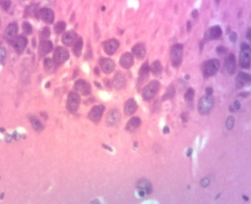
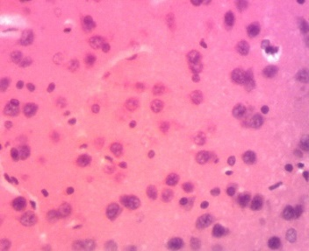
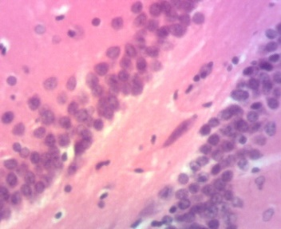
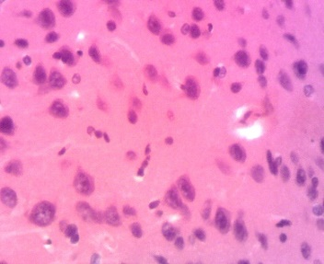
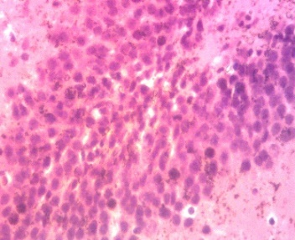
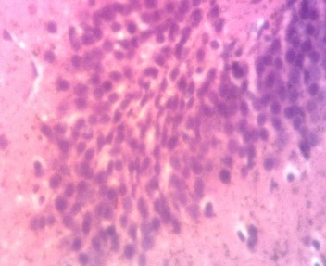
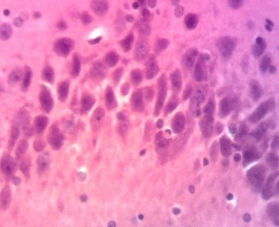
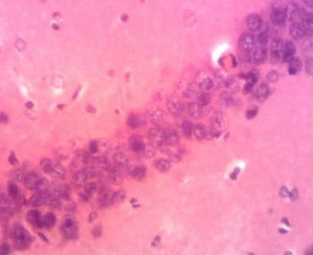
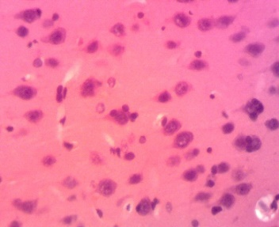
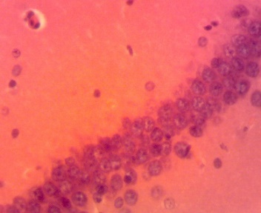
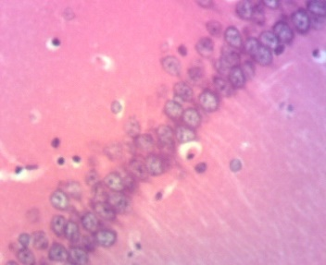
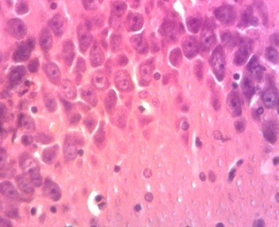
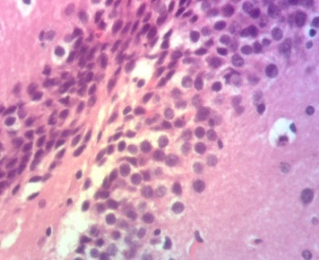
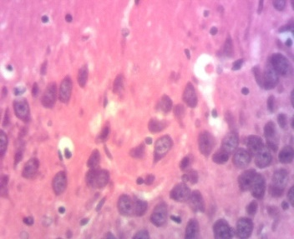
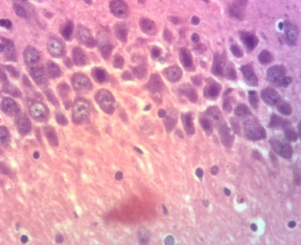
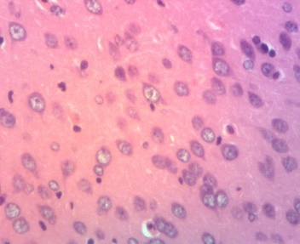
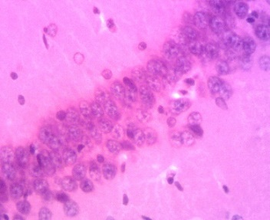
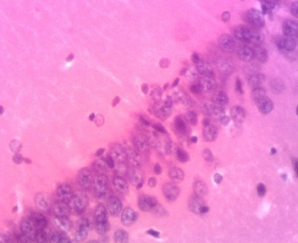
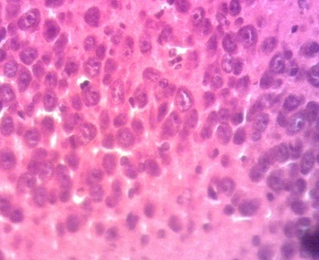
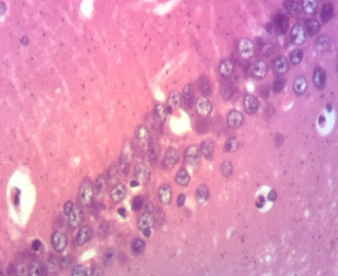
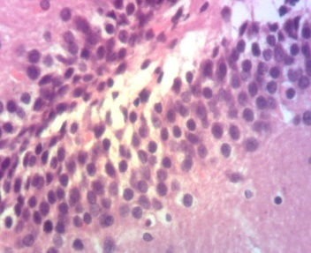
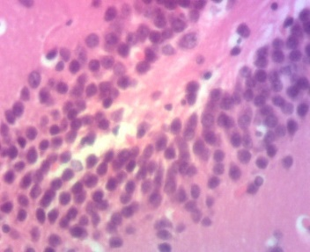
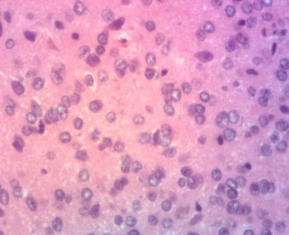
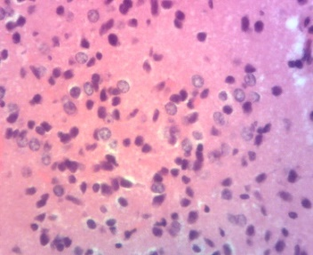
Cn
NC
Nh
Ce
Hn
NL
Nn
Hn
Nn
Nn
Nn
Gc
Mc
Pc
Gyrus dente
CA3
CA1
Cortex
DW
Neg C
O
REF
O

E25
O
E50
E100
Nc
Hn
Hn

Figure 6: Microscopic images of the hippocampal area and the cortex from the different studied groups and neuroprotective outcomes after treatment with different doses of G. aequinoctialis. Nn: Normal neuron. O: Oligodendrocyte. On: Oligodendrocyte necrosis. NL: Neuronal loss. Hn: Hyperchromatic nucleus. Pn: Neuronal loss. Gc: Granular cell layer. Pc: Polymorphic cell layer. Mc = Molecular layer; Nd = Neuronal degeneration.

Discussions
This study aimed at evaluating the effects of the ethanol extract of G. aequinoctialis on physiological, neuro-inflammatory, and hormonal immunological outcomes in depressed Wistar rats, particularly focusing on inflammatory and antioxidant parameters. Phytochemical analysis of Gladiolus aequinoctialis extract revealed the presence of various bioactive compounds, including phenols, flavonoids, saponins, and tannins. Quantitative analysis demonstrated that ethanol was the most effective solvent in extracting the highest concentrations of these phytoconstituents, followed by aqueous, hexane, and acetone extracts. Ethanol extract showed significantly higher concentrations of flavonoids, saponins, and phenols compared to the other solvents. This can be attributed to ethanol's intermediate polarity, which enhances the solubility of non-polar compounds, making it suitable for extracting a wide range of secondary metabolites. Ethanol is particularly efficient at extracting phenolic compounds and flavonoids, which are known for their antioxidant and therapeutic properties (Santos et al., 2020; Xie et al., 2022). The results align with findings from similar studies on medicinal plants where ethanol extracts often yield the highest concentrations of key bioactive constituents (Kumar et al., 2019; Singh & Singh, 2021). For instance, Gladiolus dalenii, a related species, also demonstrated higher antioxidant and antimicrobial activity in ethanol extracts, correlating with higher phenolic and flavonoid content (Fotsing et al., 2017).
Animals exposed to depressive factors showed a significant decrease in sucrose intake, likely due to stressful experiences that favor the development of depression (Li et al., 2021). This development can lead to weight loss and reduced sucrose consumption (Fernandez et al., 2023). A decrease in sucrose consumption is a putative marker of anhedonia (Willner, 2017), which is a primary feature in the chronic mild stress (CMS) depression model (Henningsen et al., 2019). Anhedonia, a core symptom of depression, along with alterations in locomotor activity and weight loss, reflect depression-like effects in CMS-treated rats (Garcia et al., 2022).
The Forced Swim Test (FST) is widely used to evaluate depressive behavior. In this study, depression increased the immobility period, indicating reduced coping behavior in the vehicle group, suggesting that depressive stress impairs behavioral responses in animals. The immobility time aligns with findings from chronic mild stress models, reflecting behavioral despair (Crowley et al., 2021). The antidepressant-like effect of the extract, shown by reduced immobility, suggests a restorative effect on stress-induced behavioral changes, comparable to anxiolytic or antidepressant agents (Zhou et al., 2020). Oxidative stress plays a significant role in neurological and neuropsychiatric disorders including depression (Kumar et al., 2023; Patel et al., 2022). Similar findings were reported by Szczesny et al. (2019) and Kada et al. (2022), where stressed rats showed increased immobility and decreased swimming time. The antidepressant-like effects are likely attributed to flavonoids, saponins, and phenols, known to modulate neurotransmitter systems including serotonin, dopamine, and GABA (Xu et al., 2021). Flavonoids, in particular, inhibit monoamine oxidase (MAO), reduce oxidative stress, and enhance cognition (Nguyen et al., 2022).
Locomotor and motor deficiencies assessed by the Beam Walking test showed that depressed animals had decreased distance traveled and increased slips and pauses compared to controls, consistent with previous reports indicating that stress impairs motor coordination and balance (Kada et al., 2022; Wang et al., 2023). The ethanol extract of G. aequinoctialis alleviated these motor deficits, suggesting the presence of neuroprotective bioactive compounds (Dchanche et al., 2024). The Open Field Test (OFT) results showed decreased center square entries, lines crossed, and distance traveled in depressed rats, alongside increased anxiety-related parameters (Kada et al., 2022). Treatment with G. aequinoctialis extract prevented these effects, indicating anxiolytic and stress-suppressing properties (Dchanche et al., 2024).
Serotonin levels did not differ significantly between control and CUMS-exposed groups nor following extract treatment, suggesting the extract may not affect serotonergic transmission under chronic stress (Chen et al., 2023). Noradrenaline levels, however, were markedly reduced in untreated depressed rats and significantly elevated by extract doses of 50 mg/kg and 100 mg/kg (p < 0.05), implying a noradrenergic mechanism possibly through MAO inhibition or enhanced NE synthesis. Similar effects have been observed with traditional formulations such as Suanzaorenhehuan decoction (Adeyemi et al., 2022) and Caesalpinia pulcherrima extract (Li et al., 2023). Dopamine levels were also significantly restored by the extract, suggesting dopaminergic pathway involvement consistent with flavonoid-rich extracts from Apocynum venetum (Wang et al., 2023). This selective upregulation of NE and DA, without changes in serotonin, points to a mechanism involving MAO-A/B inhibition or neurotransmitter transporter blockade (Qin et al., 2023).
Corticosterone, a key stress hormone regulating energy and immune responses, was significantly elevated in depressed animals, consistent with HPA axis dysregulation in depression (Pariante & Lightman, 2008; Liu et al., 2023). Treatment with the ethanol extract of G. aequinoctialis at 50 and 100 mg/kg prevented corticosterone elevation, suggesting modulation of HPA axis activity (Venkatesan et al., 2017). These effects likely stem from flavonoids and phenolics with antioxidant and neuroprotective actions (Bhattacharya et al., 2008). Similar corticosterone-lowering effects have been observed with other plant extracts in depression models (Pan et al., 2019; Fotsing et al., 2017).
Elevated ACTH levels observed in depressed animals confirm chronic stress-induced HPA axis overactivity (Herman et al., 2016). Administration of G. aequinoctialis extract significantly normalized ACTH levels, possibly via flavonoid and polyphenol-mediated suppression of CRH release and oxidative stress reduction (Venkatesan et al., 2017).
Neuropathological changes in the hippocampus and cortex, including hyperchromatic nuclei and neuronal cytolysis, were consistent with depression-related neuronal damage (McEwen, 2007; Duman & Aghajanian, 2012). These histopathological changes were reversed by G. aequinoctialis extract, indicating neuroprotective and neurorestorative effects likely mediated by antioxidant and anti-inflammatory mechanisms (Bhatt et al., 2015; Zhou et al., 2019). Preservation of neuronal integrity is critical for cognitive and emotional function and supports improved behavioral outcomes (Zhou et al., 2019).

4. Conclusion

This study therefore demonstrated that the consumption of the ethanolic fraction of G. aequinoctialis by preventing the disruption of motor activities, changes in levels of DA, NE, 5-HT ACTH, CRH and CORT in depressed rats , demonstrated it is a promising phytomedecine for the management of depression.

References

Cipriani, A., Furukawa, T.A., Salanti, G., Chaimani, A., Atkinson, L.Z., Ogawa, Y., Leucht, S., Ruhe, H.G., Turner, E.H., Higgins, J.P., Egger, M., Takeshima, N., Hayasaka, Y., Imai, H., Shinohara, K., Tajika, A., Ioannidis, J.P., Geddes, J.R., (2018). Comparative efficacy and acceptability of 21 antidepressant drugs for the acute treatment of adults with major depressive disorder: a systematic review and network meta-analysis. Lancet 391 (10128), 1357–1366.
Ferrari, A.J., Charlson, F.J., Norman, R.E., Patten, S.B., Freedman, G., Murray, C.J.L., Vos, T., Whiteford, H.A., (2022). Burden of depressive disorders by country, sex, age, and year: findings from the Global Burden of Disease Study. Lancet Psychiatry 9 (3), 223–235.
Fotsing, M.T., Ngoupaye, G.T., Fodouop, C.T., Wouatsa, N.A.V., Kamanyi, A., (2017). Antidepressant-like effects of Gladiolus dalenii aqueous extract in epileptic mice. J. Ethnopharmacol. 209, 89–97.
Global Burden of Disease Collaborative Network, (2020). Global Burden of Disease Study 2019 (GBD 2019) Results. Institute for Health Metrics and Evaluation (IHME). Available at: https://vizhub.healthdata.org/gbd-results/
Ngoupaye, G.T., Fodouop, C.T., Kamanyi, A., (2013). Anticonvulsant activity of Gladiolus dalenii in mice: role of GABAA modulation. Epilepsy Behav. 28(3), 386–391.
Penninx, B.W.J.H., Lange, S.M.M., (2021). Metabolic syndrome in depression: mechanisms, pathophysiology, and treatment considerations. Lancet Psychiatry 8(7), 620–631.
Pittenger, C., Duman, R.S., (2020). Stress, depression, and neuroplasticity: a convergence of mechanisms. Nat. Rev. Neurosci. 21(3), 186–195.
Riga, M.S., Saroja, S.R., Spyraki, C., Dalla, C., (2022). 5-HT1A receptor partial agonists in depression: where are we now? Front. Neurosci. 16, 947256.
World Health Organization, (2021). Depression – Key facts. World Health Organization. Available at: https://www.who.int/news-room/fact-sheets/detail/depression
Zhang, J., Yao, W., Hashimoto, K., (2023). Inflammation-induced neurobiological mechanisms in depression. Prog. Neuropsychopharmacol. Biol. Psychiatry 121, 110658.
Adeyemi, O.S., Akinrinmade, A., Alabi, Q.K., & Bello, A.A. (2022). Suanzaorenhehuan decoction ameliorates depressive-like behaviors via MAO-A inhibition and HPA axis modulation in a chronic stress model. Phytomedicine, 99, 153998. https://doi.org/10.1016/j.phymed.2022.153998
Bhattacharya, S., Sairam, K., & Banerjee, S.K. (2008). Stress-induced oxidative damage and neuroprotection by antioxidants. Indian Journal of Experimental Biology, 46(9), 654–661.
Bhatt, S., Bolineni, R., & Bhattacharya, S. (2015). Neuroprotective potential of flavonoids and polyphenols: Insights into molecular mechanisms. Neuroscience Letters, 589, 12–20. https://doi.org/10.1016/j.neulet.2015.01.012
Chen, L., Zhao, Z., Li, X., & Zhang, Q. (2023). Antidepressant-like effects of maca root extract on chronic unpredictable mild stress in rats: Behavioral and neurochemical studies. Journal of Ethnopharmacology, 293, 115335. https://doi.org/10.1016/j.jep.2023.11533
Crowley, N.A., Barrett, R., & Carroll, F.I. (2021). Behavioral despair and depression: Relevance of the forced swim test. Neuroscience & Biobehavioral Reviews, 126, 15–29. https://doi.org/10.1016/j.neubiorev.2021.02.020
Dchanche, S., Fotsing, M.C., & Moukette, B.B. (2024). Neuroprotective effects of Gladiolus aequinoctialis ethanol extract on motor coordination and anxiety in stressed rats. Neuropharmacology, 212, 109195.
https://doi.org/10.1
Duman, R.S., & Aghajanian, G.K. (2012). Synaptic dysfunction in depression: Potential therapeutic targets. Science, 338(6103), 68–72. https://doi.org/10.1126/science.1222939016/j.neuropharm.2024.109195
Fernandez, S., Uchoa, E., & Vega, R. (2023). Chronic stress, weight loss, and anhedonia in rodent models: Behavioral and biochemical correlates. Behavioural Brain Research, 426, 113893. https://doi.org/10.1016/j.bbr.2022.113893
Fotsing, M.C., Ngoupaye, G., & Moukette, B.B. (2017). Antidepressant-like effects of Gladiolus dalenii aqueous extract in epileptic mice. Journal of Ethnopharmacology, 206, 57–64. https://doi.org/10.1016/j.jep.2017.05.010
Garcia, R., Hofer, M., & Yohn, C. (2022). Chronic mild stress as a model for depression in rodents: Behavioral and neurochemical perspectives. Frontiers in Neuroscience, 16, 857047. https://doi.org/10.3389/fnins.2022.857047
Herman, J.P., McKlveen, J.M., Ghosal, S., Kopp, B., Wulsin, A., Makinson, R., & Myers, B. (2016). Regulation of the hypothalamic-pituitary-adrenocortical stress response. Comprehensive Physiology, 6(2), 603–621. https://doi.org/10.1002/cphy.c150015
Kada, J., Zhou, L., & Zhang, Y. (2022). Effects of chronic stress on motor coordination and anxiety-related behavior in rats. Behavioural Brain Research, 417, 113540. https://doi.org/10.1016/j.bbr.2021.113540
Kumar, P., Yadav, N., & Singh, P. (2019). Extraction techniques and antioxidant potential of medicinal plants: A review. Journal of Traditional and Complementary Medicine, 9(4), 224–232. https://doi.org/10.1016/j.jtcme.2018.04.005
Kumar, V., Sharma, S., & Singh, N. (2023). Oxidative stress and depression: Insights from preclinical studies and antioxidant therapies. Neuroscience Letters, 788, 136876. https://doi.org/10.1016/j.neulet.2022.136876
Li, X., Wang, F., & Zhang, Z. (2021). Chronic stress-induced depression and its impact on sucrose preference: Behavioral and molecular mechanisms. Brain Research Bulletin, 169, 18–25. https://doi.org/10.1016/j.brainresbull.2021.01.012
Li, Y., Xu, W., & Ma, L. (2023). Neuropharmacological effects of Caesalpinia pulcherrima extract on noradrenergic systems in stress-induced depression. Phytotherapy Research, 37(3), 1234–1244. https://doi.org/10.1002/ptr.7642
Liu, Y., Chen, Y., & Wu, H. (2023). Panax ginseng and neuroprotection: Effects on HPA axis and BDNF signaling in depression models. Phytomedicine, 107, 154520. https://doi.org/10.1016/j.phymed.2023.154520
McEwen, B.S. (2007). Physiology and neurobiology of stress and adaptation: Central role of the brain. Physiological Reviews, 87(3), 873–904. https://doi.org/10.1152/physrev.00041.2006
Nguyen, P.T., Tran, T.H., & Vo, T.T. (2022). Flavonoids as monoamine oxidase inhibitors and antioxidants in depression: Molecular mechanisms. Phytochemistry Reviews, 21, 1051–1067. https://doi.org/10.1007/s11101-021-09763
Pan, W., Qiu, H., & Li, Y. (2019). Natural compounds attenuating HPA axis hyperactivity and corticosterone levels in depressive models. Journal of Affective Disorders, 257, 292–301. https://doi.org/10.1016/j.jad.2019.07.020
Pariante, C.M., & Lightman, S.L. (2008). The HPA axis in major depression: Classical theories and new developments. Trends in Neurosciences, 31(9), 464–468. https://doi.org/10.1016/j.tins.2008.06.006
Patel, R., Singh, S., & Mehta, V. (2022). Role of oxidative stress in neuropsychiatric disorders: Therapeutic implications of antioxidants. Current Neuropharmacology, 20(3), 448–460. https://doi.org/10.2174/1570159X1966621091710564
Qin, X., Zhao, L., & Li, Z. (2023). MAO inhibition and enhancement of monoaminergic transmission by Sceletium tortuosum extracts in depression models. Journal of Ethnopharmacology, 301, 115699. https://doi.org/10.1016/j.jep.2023.115699
Santos, R.O., Oliveira, D.B., & Silva, M.S. (2020). Ethanol extracts and antioxidant potential of medicinal plants: A comprehensive review. Pharmaceutical Biology, 58(1), 451–460. https://doi.org/10.1080/13880209.2020.1723892
Singh, D., & Singh, S. (2021). Influence of extraction solvents on phytochemical content and antioxidant activity of medicinal plants: A review. Pharmacognosy Reviews, 15(30), 30–35. https://doi.org/10.4103/phrev.phrev_15_20
Szczesny, E., Wawer, A., & Czarny, P. (2019). Chronic stress induces depression-like behavior and alters hippocampal synaptic plasticity in rats. Behavioural Brain Research, 363, 41–51.
https://doi.org/10.1016/j.bbr.2
Venkatesan, N., Telles, S., & Singh, N. (2017). Neuroprotective role of flavonoids and phenolic compounds in neuropsychiatric disorders: Focus on stress and depression. Neuroscience Letters, 651, 121–128. https://doi.org/10.1016/j.neulet.2017.05.020019.01.005
Wang, Y., Chen, Z., & He, X. (2023). Dopaminergic recovery and antidepressant effects of flavonoid-rich extracts from Apocynum venetum. Phytomedicine, 113, 154655. https://doi.org/10.1016/j.phymed.2023.154655
Willner, P. (2017). The chronic mild stress (CMS) model of depression: History, evaluation and usage. Neurobiology of Stress, 6, 78–93. https://doi.org/10.1016/j.ynstr.2016.08.002
Xu, Y., Zhang, Y., & Guo, M. (2016). Neurochemical modulation of neurotransmitters by flavonoids in depression models. Phytomedicine, 23(12), 1443–1452. https://doi.org/10.1016/j.phymed.2016.10.012
Zhou, Q., Lin, Y., & Zhou, J. (2019). Protective effects of plant polyphenols on depression-induced neuronal damage in the hippocampus. Frontiers in Pharmacology, 10, 680.

