Original Research Article

A COMPREHENSIVE ANALYSIS OF SIDDHA FORMULATION SIRUPANCHAMOOLA KIYAZHAM: INTEGRATING ANTIMICROBIAL EFFICACY, MOLECULAR DOCKING MECHANISMS, AND TOXICOLOGICAL SAFETY

Abstract
The Siddha system of medicine, deeply rooted in Tamil Nadu's traditional practices, emphasizes holistic health through herbal and mineral formulations. Combining antibacterial activity, molecular docking mechanisms, and toxicological safety assessments, this work offers a thorough scientific assessment of Sirupanchamoola Kiyazham (SPK), a Siddha preparation. Safety and efficacy of SPK were evaluated using advanced methods including toxicity studies in Wistar albino rats, High-Performance Thin-Layer Chromatography (HPTLC), and Thin-Layer Chromatography (TLC). The antimicrobial study verified sterility of SPK by not revealing any microbial contamination. While molecular docking tests revealed the great binding affinity of SPK's bioactive chemicals to Cyclooxygenase-2 (COX-II), indicating possible analgesic and anti-inflammatory capabilities, HPTLC fingerprinting identified important phytocompounds. Acute and 28-day repeated-dose oral toxicity tests as well as other toxicological evaluations found no appreciable side effects, therefore verifying the safety of SPK within clinical dosage ranges. The results confirm the therapeutic possibilities of SPK and support its safe inclusion into contemporary medicine. This research bridges the gap between traditional knowledge and scientific validation, paving the way for further clinical trials to establish its efficacy in human subjects.
Key words: siddha medicine, Sirupanchamoola Kiyazham, analgesic and anti-inflammatory capabilities

- Introduction
The Siddha system of medicine, rooted in the ancient traditions of Tamil Nadu, offers a holistic approach to health by emphasizing the balance of the three fundamental humors - iyam, azhal, and vashi. This system not only focuses on curative measures but also prioritizes prevention, aligning with the adage⁽¹⁾, "Prevention is better than cure." Siddha formulations, derived from natural sources such as plants, minerals, and animal products⁽²⁾, have been used for centuries to treat a wide range of ailments. Despite the advent of modern medicine, traditional systems like Siddha continue to play a vital role in healthcare, with approximately 80% of the global population relying on traditional medicine for primary healthcare needs⁽³⁾. However, the scientific validation of these traditional formulations remains limited, particularly for mineral-based compositions.
While Siddha medicines have long been considered safe and effective, the lack of rigorous scientific validation⁽⁴⁾ poses a significant challenge to their global acceptance and integration into modern healthcare systems. Specifically, there is a dearth of comprehensive studies evaluating the safety, efficacy, and mechanisms of action of Siddha formulations. This gap is particularly evident in the case of mineral-based compositions, which have received less attention compared to plant-based remedies. Without scientific validation, the potential of these formulations to contribute to modern medicine remains untapped, and their safety for long-term use remains uncertain⁽⁵⁾.
This study aims to address these gaps by conducting a comprehensive analysis of the Siddha formulation Sirupanchamoola Kiyazham (SPK). The research integrates multiple scientific approaches, including antimicrobial efficacy testing, molecular docking studies, and toxicological safety assessments, to evaluate the formulation's therapeutic potential and safety profile. By employing advanced techniques such as TLC (Thin-layer Chromatography), HPTLC (High-Performance Thin-Layer Chromatography), and acute and repeated-dose toxicity studies in Wistar albino rats, the study seeks to provide a robust scientific foundation for the use of SPK in traditional and modern medicine. Research on the use of elements in health and illness has become more important on a global scale due to the rise in research effort over the last 20 years⁽⁶⁾.
According to OECD (Organization for Economic Co-operation and Development) criteria ⁽⁷⁾ , this study uses an acute 28-day repeated oral toxicity assessment ⁽⁸⁾ in wistar albino rats to assess the safety profile of Sirupanchamoola Kiyazham. Additionally, the current study evaluates TLC, HPTLC, antimicrobial analysis, and docking study to evaluate the safety and quality of Siddha Formulation "Sirupanchamoola Kiyazham". The findings of this study hold significant implications for the field of traditional medicine. By scientifically validating the safety and efficacy of SPK, this research contributes to the growing body of evidence supporting the integration of Siddha formulations into mainstream healthcare. Furthermore, the study addresses the critical need for toxicity assessments, ensuring that the formulation is safe for long-term use. The antimicrobial and molecular docking analyses provide insights into the mechanisms of action, paving the way for the development of novel therapeutic agents. Ultimately, this research bridges the gap between traditional knowledge and modern science, fostering global acceptance and utilization of Siddha medicine.
- Materials and Method
  - Collection, Authentication and Preparation of trial siddha formulation⁽⁹⁾
    - Ingredients: The formulation Sirupanchamoola Kiyazham (SPK) was prepared using Solanum xanthocarpum, Solanum indicum, Desmodium gangeticum, Tribulus terrestris, Sida cordifolia, Ricinus communis, Nymphaea stellata, Aponogeton natans, Premna latifolia, Gmelina arborea, and Stereospermum chelonoides. (See Appendix Figure A1 for images of Ingredients).
2.1.2 Authentication: Raw materials were authenticated by the Department of Medicinal Botany, GSMC, Chennai, and prepared in the Gunapadam laboratory, Government Siddha Medical College, Chennai
    - Preparation: Ingredients were purified using traditional Siddha methods⁽¹⁰⁾, coarsely ground, and boiled in water until reduced to 1/8th volume. The distillate was cooled and stored for use.
    - Indication: SPK is traditionally used for conditions like Varmam, Eppilaippu, Moorchai, and Visha kayam..
  - Microscopic examination to measure size of the Particle⁽¹¹⁾
The particle size of SPK was determined using optical microscopy. The sample was diluted (1/100th) with sterile distilled water, placed on a slide, and measured using a stage micrometer. Average particle size was calculated from 30 observations.
  - TLC and High-Performance Thin Layer Chromatography Analysis
    - Thin Layer Chromatography Analysis⁽¹²⁾ SPK was analyzed using Silica gel 60 F254 plates with a solvent system. The plate was marked with a soft pencil, and the sample was spotted for TLC using a micro pipette. The sample volume of 1 ul was applied using a pipette at a distance of 1 cm at 5 tracks in the twin trough chamber and plates were visualized under UV light at 254 nm and 365 nm.
2.3.2 High Performance Thin Layer Chromatography (HPTLC) Analysis^{(13,14)} Advanced separation was performed using pre-coated HPTLC plates. Chromatograms were developed, scanned at 366 nm, and analyzed using CAMAG software to identify phytoconstituents and calculate Rf values.
2.3.3 Aflatoxin⁽¹⁵⁾: SPK was tested for aflatoxins (B1, B2, G1, G2). Standard aflatoxin was applied in 2.5 uL, 5 ML, 7.5 ML, and 10 uL quantities to the surface of a pre-coated TLC plate. Analogously, the test sample was placed in an unsaturated chamber containing a solvent system consisting of a blend of isopropyl alcohol, acetone, and chloroform (85: 10: 5) until the solvent front had shifted at least 15 cm away from the center. The spots were able to dry and produce the chromatogram as a result. To locate the dots, the plates were examined at 365 nm under UV light.
2.3.4 Pesticide Residue Analysis^{(16,17)}: The test sample was extracted using 100 ml of acetone and then quickly homogenized. After more filtration was approved, acetone was added to the test combination. The test sample was heated to a maximum temperature of 40°C using a rotary evaporator until the solvent had completely evaporated. burned the residue again after adding a few milliliters of toluene until the acetone was completely gone. The resulting residue was dissolved in toluene and filtered via a membrane filter.
  - Antimicrobial Analysis
    - Pour Plate Method for Sterility Test ⁽¹⁸⁾ SPK was tested using the pour plate method. Samples were mixed with melted agar, incubated at 37°C, and observed for microbial growth
    - Examine a particular pathogen⁽¹⁹⁾ Using the pour plate method, the test sample was promptly inoculated into the designated pathogen medium (EMB, DCC, Mannitol, Cetrimide) and incubated for 24 to 72 hours at 37°C to detect specific pathogens.
  - Docking study on Analgesic Property
    - Phytocomponents: Key compounds⁽²⁰⁾ (e.g., Solanine, Lupeol, Gallic Acid) were selected for docking studies.
    - Method⁽²¹⁻²²⁾: Docking simulations were performed using AutoDock 4. Ligands were docked against target proteins, and binding affinities were calculated using the Lamarckian genetic algorithm.
  - Toxicology study⁽²³⁾
2.6.1 Acute Toxicity: All the animals were housed in regular conditions, which were 22°C and 3°C. The animals were fed a regular pellet diet and had unrestricted access to water. The animals are chosen at random, labeled to enable unique identification, and housed in their cages for a minimum of seven days before the dosage to give them time to adjust to the lab environment. For the control group, the vehicle's volume was the same. The animals were fasted for 12 hours prior to the treatment. Following the fasting period, the animals were measured and then given the test material. Three female animals are employed for each group. Stepwise doses of 10 g/kg, 1 mg/kg, and 2 mg/kg body weight were given. Following dosing, each animal is monitored separately for at least 30 minutes, then every 24 hours, with extra care during the first 4 hours, and then every day for a total of 14 days.
2.6.2 28 - Day Repeated Oral Toxicity: Rats were divided into control, low-dose (20 mg/kg), mid-dose (200 mg/kg), and high-dose (400 mg/kg) groups. SPK was administered orally for 28 days, and hematological, biochemical, and histopathological parameters were evaluated⁽²⁴⁻²⁶⁾
  - Statical Analysis ⁽²⁷⁾
Graph pad version 7 was used to do a one-way ANOVA and a Dunnett test on data such body weight changes, food and water intake, hematological, and blood chemistry.

- Results and discussion

  - Quantity of ingredients: All ingredients used in Sirupanchamoola Kiyazham (SPK) were measured at 70 grams each.
3.2 Particle size determination: Microscopic examination revealed an average particle size of 89.06 ± 38.62 µm, with a size range of 38.22 µm to 162 µm. (See Appendix Figure A2)
3.3 TLC and HPTLC Analysis:
3.3.1 TLC: Visualization under UV light (366 nm) confirmed the presence of phytocomponents (see Appendix Figure A3a).
3.3.2 HPTLC: Three distinct peaks were observed, with Rf values ranging from 0.04 to 0.93. Peak 1 occupied 57.25% of the area, indicating a dominant compound (see Appendix Figure A3b and Table B1).
3.3.3 Chromatogram Development: See Appendix Figure A3c for 3D view of Chromatogram
3.3.4 Aflatoxin Analysis⁽²⁸⁾: No aflatoxins (B1, B2, G1, G2) were detected in SPK (see Appendix Table B2).
3.3.5 Pesticide Residue Analysis: The findings shows SPK was free from organo chlorine, organo phosphorus, organo carbamates, and pyrethroid pesticides.
3.4 Antimicrobial Analysis: The pour plate method showed no microbial growth or colony formation, confirming the sterility of SPK (see Appendix Table B3 and Figure A4).
3.5 Docking Study: Key phytocomponents (solanine, luteolin, lupeol, and quercetin) exhibited strong binding affinity to prostaglandin H synthases, suggesting potential analgesic and anti-inflammatory properties. Solanine showed the highest number of interactions (9), comparable to the standard drug ibuprofen. Compounds like luteolin and luteol, which come after, have important interactions like the standard. These substances were found to have strong binding and inhibition of cyclooxygenase II inhibitory activity, which suggests that they may have analgesic effects. Lupeol demonstrated significant binding, similar to salicylic acid, further supporting SPK’s therapeutic potential. Compounds like solanine, quercetin, and luteolin come next, and they all have important interactions similar to the standard. The docking study results are summarized in Appendix B4 (Table B4a – B4c)
3.6 Toxicology study: No mortality or significant toxic symptoms were observed in Wistar albino rats. When compared to the control animal, the test group animal's body weight rose during the sub-acute toxicity. Additionally, there is no discernible change in the water intake of the animals in the subacute toxicity investigation. In comparison to control, the high dose of Sirupanchamoola kiyazham resulted in a drop in haematological parameters, an increase in biochemical parameters, and a rise in renal and hepatic parameters but were within the clinical range of rats ⁽²⁹⁾. Body weight, food, and water intake remained consistent across test and control groups. Hematological, biochemical, and histopathological parameters were within the normal clinical range for rats, confirming SPK’s safety. Histopathological images are provided in Appendix Figure A5. Toxicity study findings are provided in Appendix B5 (Table B5a – B5e).

The Institutional Ethics Committee's approval of the study protocol (GSMC-CH-ME 5/011/2018) and its registration with the Clinical Trials Registry of India (CTRI/2019/06/019695) underscore the importance of adhering to ethical and regulatory standards in clinical research. Similar protocols⁽³⁰⁾ have been emphasized in studies evaluating traditional medicines, where standardization and safety are paramount. The use of AYUSH guidelines for physico-chemical analyses and OECD guidelines for toxicity studies aligns with global best practices for ensuring the quality and safety of herbal formulations⁽³¹⁾. These steps are critical for bridging the gap between traditional knowledge and modern scientific validation.
The growing preference for Siddha and other traditional medicines over synthetic drugs is well-documented. Traditional medicines are often perceived as safer and more holistic, with fewer adverse effects ⁽³²⁾. However, the lack of scientific validation remains a significant barrier to their widespread acceptance and availability⁽³³⁾. Antimicrobial assessments, such as the pour plate test conducted in this study, are essential for establishing the microbiological safety of herbal formulations. The absence of pathogens like Salmonella, E. coli, Staphylococcus aureus, and Pseudomonas aeruginosa in Sirupanchamoola Kiyazham aligns with findings from other studies that highlight the antimicrobial efficacy of traditional formulations⁽³⁴⁾.
High-Performance Thin-Layer Chromatography (HPTLC) has emerged as a reliable and precise method for analyzing the phytochemical composition of herbal medicines ⁽³⁵⁾. The identification of three significant peaks in the HPTLC analysis of Sirupanchamoola Kiyazham, with Rf values ranging from 0.04 to 0.93, is consistent with findings from other studies that have used HPTLC to characterize complex herbal formulations ⁽³⁶⁾. The predominance of Peak 1, occupying 57.25% of the area, suggests the presence of a major bioactive compound, which could be responsible for the formulation's therapeutic properties.
Molecular docking studies have become a cornerstone in drug discovery, particularly for understanding the interaction between bioactive compounds and target proteins ⁽³⁷⁾. In this study, the binding of solanine, quercetin, luteolin, and lupeol to Cyclooxygenase-2 (COX-II) and Prostaglandin H synthases highlights the potential of Sirupanchamoola Kiyazham as an analgesic and anti-arthritic agent. Similar findings have been reported in other studies, where phytocomponents from traditional medicines demonstrated strong binding affinity to inflammatory targets ⁽³⁸⁾. These computational insights provide a scientific basis for the traditional use of Siddha formulations in managing pain and inflammation.
The safety of traditional medicines is a critical concern, and toxicity studies are essential for establishing their therapeutic window. Acute and sub-acute toxicity studies, conducted in accordance with OECD guidelines, are widely used to evaluate the safety of herbal formulations. The findings from the 28-day oral toxicity study of Sirupanchamoola Kiyazham, which showed no significant adverse effects on body weight, hematological, or biochemical parameters, are consistent with other studies that have demonstrated the safety of Siddha medicines ⁽³⁹⁾.The slight increase in renal and hepatic parameters at higher doses is a common observation in toxicity studies and does not necessarily indicate toxicity but rather the need for dose optimization ⁽⁴⁰⁾.
- CONCLUSION
People are more aware of and interested in traditional medicine than they are in contemporary medicine. The study underscores the importance of scientifically validating traditional Siddha and varmam formulations to ensure their safety and efficacy so that people might use it without worrying. Sirupanchamoola Kiyazham (SPK) demonstrated sterility, therapeutic potential, and a favorable safety profile in preclinical evaluations. The absence of microbial contamination, coupled with promising analgesic and anti-arthritic properties, positions SPK as a viable alternative to conventional medications.
To ensure the long-term safety of the medication, it is imperative to conduct toxicity testing on siddha preparations before administering them to patients. Hematological and clinical biochemistry information are crucial in assessing the toxicity that medications cause. Toxicity studies confirmed that SPK is safe for human use at the tested doses, with no significant adverse effects. These findings validate the traditional use of SPK and highlight its potential for integration into modern healthcare systems. Further clinical trials are recommended to establish efficacy and safety in human subjects.

REFERENCES

  - Patwardhan B., Hooper M. J. Ayurveda and future drug development. Journal of Alternative and Complementary Medicine. 1992;10(2):9–11.
  - Chitra B, Ramaswamy RS, Suba V. Toxicity Evaluation of Pũrṇa Cantirotaya Centũram, a Siddha Medicine in Wistar Rats. Int Sch Res Notices. 2015 Jan 26;2015:473296. doi: 10.1155/2015/473296. PMID: 27347522; PMCID: PMC4897056.
  - Utthamarayan K. S. HPIM. Siddha Maruthuvanga Surukkam. 3rd. Department of Indian Medicine and Homeopathy; 2003.
  - Kannan M, Sathiyarajeswaran P, Sasikumar D, Geetha A, Mohanapriya M, Vinod NP, Manickam P, Kanakavalli K, Parthibhan P, Pitchiah Kumar M, Kannan R, Sivaraman G. Safety and efficacy of a Siddha Medicine fixed regimen for the treatment of asymptomatic and mild COVID-19 patients. J Ayurveda Integr Med. 2022 Jul- Sep;13(3):100589. doi: 10.1016/j.jaim.2022.100589. Epub 2022 May 23. PMID: 35634543; PMCID: PMC9125139.
  - Ben-Arye E, Samuels N, Goldstein LH, Mutafoglu K, Omran S, Schiff E, Charalambous H, Dweikat T, Ghrayeb I, Bar-Sela G, Turker I, Hassan A, Hassan E, Saad B, Nimri O, Kebudi R, Silbermann M. Potential risks associated with traditional herbal medicine use in cancer care: A study of Middle Eastern oncology health care professionals. Cancer. 2016 Feb 15;122(4):598-610. doi: 10.1002/cncr.29796. Epub 2015 Nov 24. PMID: 26599199.
  - Vohora S. B., Dobrowolski J. W. New Horizons of Health Aspects of Elements. NewDelhi, India: Indo-Polish book; 1990.
  - OECD. Guidelines for the Testing of Chemicals/Section 4: Health Effects Test No. 423: Acute Oral toxicity - Acute Toxic Class Method. Paris, France: Organization for Economic Cooperation and Development; 2002.
  - Organization for Economic Cooperation and Development;Guidelines for the Testing of Chemicals/Draft Updated Test Guideline 407. Repeated Dose 28-Day Oral Toxicity Study in Rodents. 2008.
  - T. A. Halgren. Merck molecular force field. I. Basis, form, scope, parametrization, and performance of MMFF94. Journal of Computational Chemistry 17 (5-6), 490-519 (1998).
  - L. Juliet & S, Karthik & VL, Reena & V, Aarthi & KN, Sunil Kumar & Parameswaran, Sathiyarajeswaran & Kanakavalli, Kadarkarai & Hano, Christophe. (2021). Traditional methods of purification (detoxification process) for Schedule E poisonous drugs. Indian Journal of Traditional Knowledge. 20. 740-748.
  - Brain KR, Turner TD. The Practical Evaluation of Phytopharmaceuticals.Bristol: Wright Scientechnica; 1975:36-45phyyy.
  - Lukasz Komsta, Monika Waksmundzka-Hajnos, Joseph Sherma. Thin Layer Chromatography in Drug Analysis. CRC Press, Taylor and Francis.
  - Wagner H. Plant Drug Analysis. A thin Layer chromatography Atlas.2nd ed. Heidelberg: Springer- Verlag Belgium, 2002; 305: 22.
  - Kumar, J & .V, Manjari & Ramachandran, Madhavan & Kumar, N & Ponnappan, Shanmugapriya & Sannasi, Murugesan. (2022). TLC AND HPTLC SCREENING OF SIDDHA POLY HERBAL FORMULATION VISHAMIRTHA CHOORANAM.
  - Luciana de CASTRO. Determining Aflatoxins B1, B2, G1 and G2 In Maize Using Florisil Clean Up with Thin Layer Chromatography And Visual And Densitometric Quantification. Ciênc. Tenol. Aliment. vol.21 no.1Campinas. 2001.
  - WHO guideline for assessing the quality of herbal medicines with reference to contaminants and residues. WHO Geneva. 2007.
  - Lohar. D.R. Protocol for testing of ASU medicines. Pharmacopoeial Laboratory for Indian Medicines. Ministry of AYUSH. 2007.
  - Megala, K. & Janani, S.. (2022). Standardization of Siddha Formulation “Gandhagapoora Parpam” by Using Modern Techniques. International Journal of Health Sciences and Research. 12. 228-237. 10.52403/ijhsr.20220524.
  - Yee JL, Vanderford TH, Didier ES, Gray S, Lewis A, Roberts J, Taylor K, Bohm RP. Specific pathogen free macaque colonies: a review of principles and recent advances for viral testing and colony management. J Med Primatol. 2016 Apr;45(2):55-78. doi: 10.1111/jmp.12209. Epub 2016 Mar 1. PMID: 26932456; PMCID: PMC4801651.
  - Desai SJ, Prickril B, Rasooly A. Mechanisms of Phytonutrient Modulation of Cyclooxygenase-2 (COX-2) and Inflammation Related to Cancer. Nutr Cancer. 2018 Apr;70(3):350-375. doi: 10.1080/01635581.2018.1446091. Epub 2018 Mar 26. PMID: 29578814; PMCID: PMC6309701.
  - Bikadi, Z., Hazai, .Application of the PM6 semi-empirical method to modeling proteins enhances docking accuracy of AutoDock. J. Cheminf. 1, 15 (2009).
  - G. M. Morris, D. S. Goodsell, et al. Automated docking using a Lamarckian genetic algorithm and an empirical binding free energy function. Journal of Computational Chemistry 19 (14), 1639-1662(1998). F. J. Solis and R. J. B. Wets. Minimization by Random Search Techniques.
  - Murugan, Ramamurthy & Thanigavelan, Vembu & Kumarswamy, Manickavasakam. (2016). Toxicological Study of a Siddha Sastric Formulation Arumuga Chendhuram in Rat Model. Journal of Applied Pharmaceutical Science. 6. 081-087. 10.7324/JAP.
  - Christian, G. & Ponnappan, Shanmugapriya & Elansekaran, S. & Thangamani, Subathra & Meenakumari, R.. (2023). Acute and Sub-acute Toxicity Studies of a Siddha Medicine Ganthaga Mezhugu by Oral Administration in Sprague Dawley Rats. Journal of Natural Remedies. 937-947. 10.18311/jnr/2023/31703.
  - Olson H, Betton G, Robinson D, Thomas K, Monro A, Kolaja G, Lilly P, Sanders J, Sipes G, Bracken W, Dorato M, Van Deun K, Smith P, Berger B, Heller A. Concordance of the toxicity of pharmaceuticals in humans and in animals. Regul Toxicol Pharmacol. 2000 Aug;32(1):56-67. doi: 10.1006/rtph.2000.1399. PMID: 11029269.
  - Bacharach, A. L. (1964). Evaluation of drug activities: pharmacometrics (D. R. Laurence, Ed.). Academic Press.
  - Visweswara K Rao. (2009). Biostatistics: A Manual of Statistical Methods for Use in Health Nutrition and Anthropology. Jaypee Brothers Medical Publishers Pvt. Limited.
  - Saper RB, Kales SN, Thuppil V. Metal Content in Ayurvedic Medicines—Reply. JAMA. 2009;301(3):272. doi: 10.1001/jama.2008.1005.
  - Petterino C, Argentino-Storino A. Clinical chemistry and haematology historical data in control Sprague–Dawley rats from pre-clinical toxicity studies. Exp Toxicol Pathol. 2006;57:213–219. doi: 10.1016/j.etp.2005.10.002.
  - World Health Organization. (2005). National Policy on Traditional Medicine and Regulation of Herbal Medicines: Report of a WHO Global
  - Mukherjee, P. K., Nema, N. K., Bhadra, S., & Mukherjee, D. (2010). Phytochemical and therapeutic potential of cucumber. Fitoterapia, 84(1), 227-236.
  - Patwardhan, B., Warude, D., Pushpangadan, P., & Bhatt, N. (2005). Ayurveda and traditional Chinese medicine: A comparative overview. Evidence-Based Complementary and Alternative Medicine, 2(4), 465-473.
  - Sen, S., & Chakraborty, R. (2017). Revival, modernization, and integration of Indian traditional herbal medicine in clinical practice: Importance, challenges, and future. Journal of Traditional and Complementary Medicine, 7(2), 234-244.
  - Ahmad, I., Aqil, F., & Owais, M. (2015). Modern Phytomedicine: Turning Medicinal Plants into Drugs. Wiley-VCH.
  - Reich, E., & Schibli, A. (2007). High-Performance Thin-Layer Chromatography for the Analysis of Medicinal Plants. Thieme.
  - Srivastava, M., Hegde, M., Chiruvella, K. K., & Dutta, A. (2014). Phytochemical analysis of Eugenia jambolana using HPTLC. Journal of Pharmacognosy and Phytochemistry, 3(2), 162-166.
  - Kitchen, D. B., Decornez, H., Furr, J. R., & Bajorath, J. (2004). Docking and scoring in virtual screening for drug discovery: Methods and applications. Nature Reviews Drug Discovery, 3(11), 935-949.
  - Kumar, S., Pandey, A. K., & Singh, S. (2018). Molecular docking studies of phytocomponents from Withania somnifera with cyclooxygenase-2. Journal of Biomolecular Structure and Dynamics, 36(6), 1419-1430.
  - Pandikumar, P., Babu, N. P., & Ignacimuthu, S. (2011). In vivo toxicity studies of a polyherbal formulation in Wistar rats. Journal of Ethnopharmacology, 134(2), 366-370.
  - Patel, S. S., Shah, R. S., & Goyal, R. K. (2012). Antihyperglycemic, antihyperlipidemic, and antioxidant effects of Dihar, a polyherbal formulation in streptozotocin-induced diabetic rats. Indian Journal of Pharmacology, 44(1), 88-92.

APPENDIX A
FIGURES
Figure A1: Images of raw ingredients used in Sirupanchamoola Kiyazham.

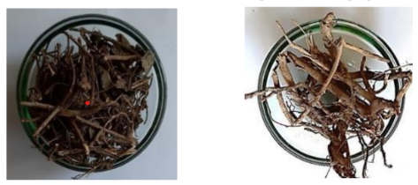
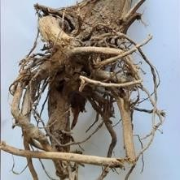
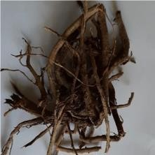
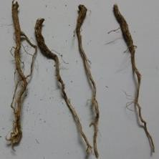
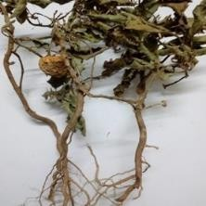
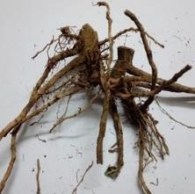
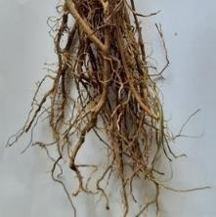
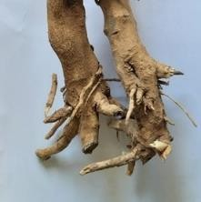
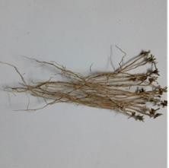
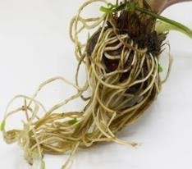
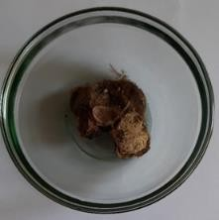
Desmodium triflorum
Desmodium gangeticum
Stereospermum chelonoides

Fig 7. Desmodium triflorum
Gmelina arborea

Fig 8. Desmodium gangeticum
Solanum indicum
Solanum xanthocarpum
Ricinus communis
Sida cordifolia

Premna latifolia

Tribulus terrestris

Aponogeton monostachyon
Nymphaea stellate

Figure A2: Particle size of Sirupanchamoola Kiyazham observed under a microscope.

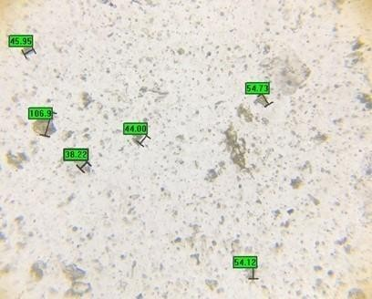

Figure A3: TLC and HPTLC Images

Figure A3a: TLC plate visualization at 366 nm.

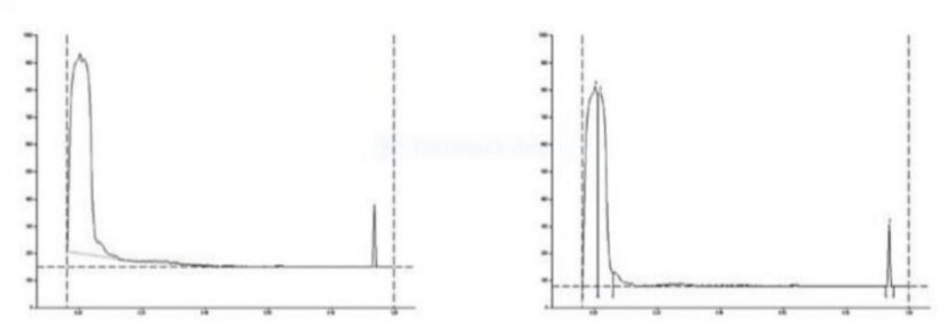
Figure A3b: HPTLC fingerprinting of Sirupanchamoola Kiyazham.

Figure A3c: 3D view of the chromatogram.
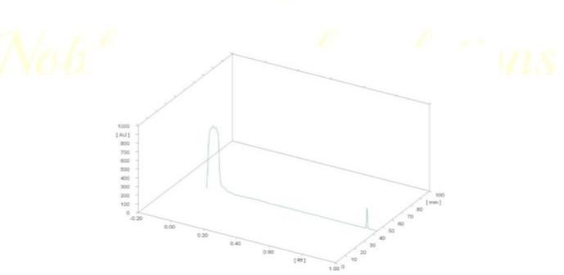
Figure A4: Antimicrobial analysis by the pour plate method.
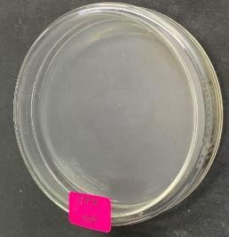
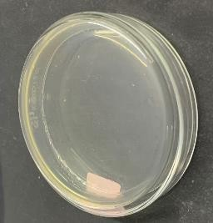
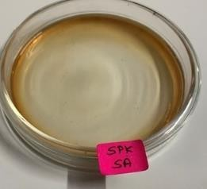
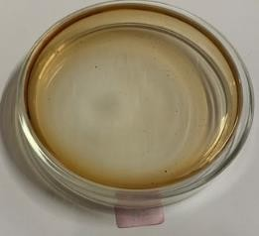
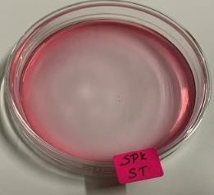
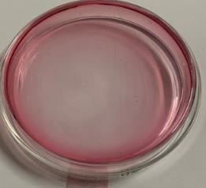
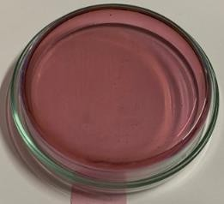
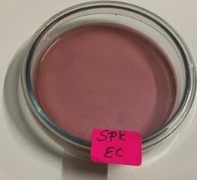
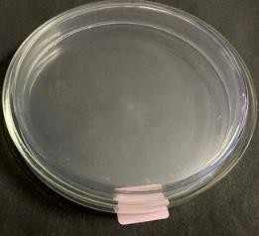
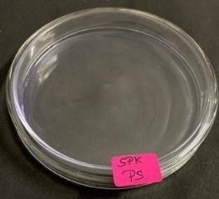
Sterility Test by Pour Plate Method

Culture plate with Salmonella (SA)
Culture plate with Staphylococcus Aureus (ST)

Culture plate with E-coli (EC)
Culture plate with Pseudomonas Aeruginosa (PS)

Figure A5: Histopathology findings of the control group and test group (high dose).
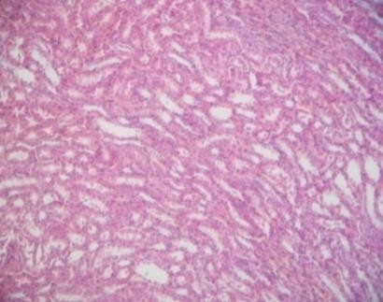
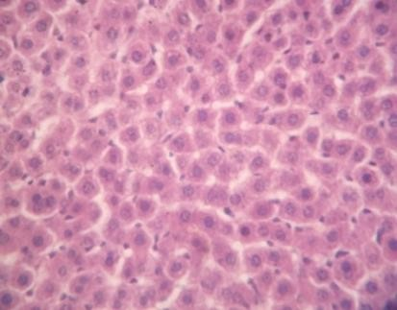
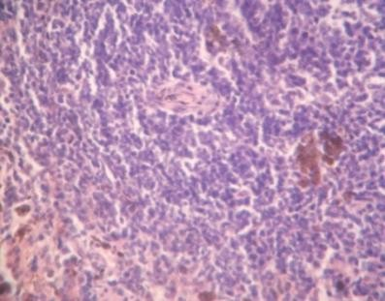
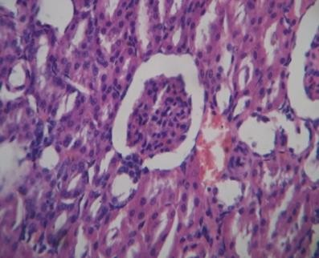
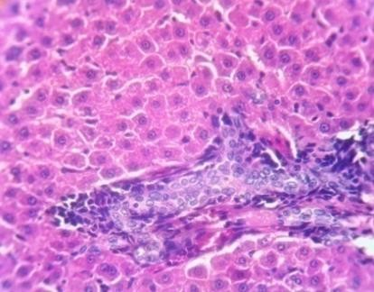
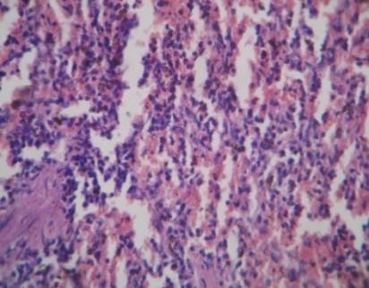
Test Group (High Dose)

Kidney Liver Spleen
Kidney Liver Spleen
Control Group

APPENDIX B
TABLES

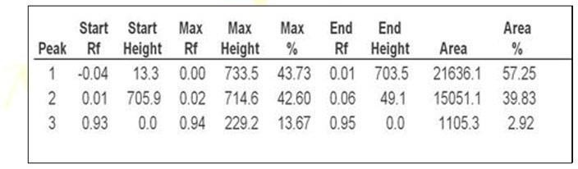
Table B1: HPTLC findings (Rf values and peak areas).

Table B2: Aflatoxin assay by TLC.
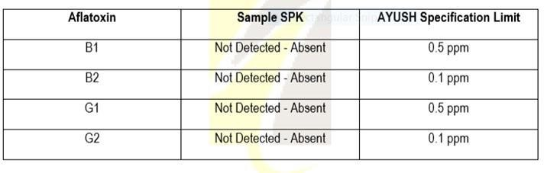

Table B3: Sterility test results using the pour plate method.
Organism | Result | Specification | As per AYUSH/WHO
Total Bacterial Count | Absent | NMT 10⁵CFU/g | As per AYUSH specification
Total Fungal Count | Absent | NMT 10³CFU/g | As per AYUSH specification
E-coli | Absent | Absent | As per AYUSH specification
Salmonella | Absent | Absent | As per AYUSH specification
Staphylococcus Aureus | Absent | Absent | As per AYUSH specification
Pseudomonas Aeruginosa | Absent | Absent | As per AYUSH specification

Table B4: Docking Study Results

Table B4a: Summary of molecular docking studies of compounds against 6COX (Cyclooxygenase II) and Prostaglandin H synthases (-1IGX).

 | Compounds | Binding Free energy  Kcal/mol | Inhibition constant Ki µM  (*mM)(**nM) | Electrostatic energy Kcal/mol | Intermolecular energy Kcal/mol | Total Interaction Surface
6COX-  Cyclooxygenase II | Solanine | -7.05 | 6.82 | 0.21 | -9.79 | 685.46
6COX-  Cyclooxygenase II | Luteolin | -6.95 | 8.04 | -0.04 | -7.58 | 627.71
6COX-  Cyclooxygenase II | Vasicinol | -5.35 | 120.7 | -0.04 | -5.94 | 404.48
6COX-  Cyclooxygenase II | Lupeol | -4.67 | 6.01 | 0.01 | -4.07 | 647.82
6COX-  Cyclooxygenase II | Gallic acid | -4.61 | 416.22 | -1.08 | -4.82 | 453.55
6COX-  Cyclooxygenase II | Quercetin | -3.85 | 1.50* | -0.01 | -5.08 | 426.07
6COX-  Cyclooxygenase II | Ibuprofen | -6.39 | 20.55 | 0.03 | -7.59 | 454.03
Prostaglandin  H synthases -  1IGX | Solanine | -3.57 | 2.44* | -0.01 | -4.17 | 388.16
Prostaglandin  H synthases -  1IGX | Luteolin | -5.38 | 114.81 | -0.12 | -5.57 | 473.68
Prostaglandin  H synthases -  1IGX | Vasicinol | -4.36 | 638.88 | -1.99 | -5.15 | 465.86
Prostaglandin  H synthases -  1IGX | Lupeol | -6.95 | 8.04 | -0.04 | -7.58 | 627.71
Prostaglandin  H synthases -  1IGX | Gallic acid | -4.05 | 1.08* | -1.09 | -4.32 | 361.36
Prostaglandin  H synthases -  1IGX | Quercetin | -3.27 | 4.01* | -0.12 | -5.10 | 446.12
Prostaglandin  H synthases -  1IGX | Salicylic acid | -3.55 | 2.48* | 0.07 | -4.55 | 479.1

Table B4b: Amino acid residue interactions of lead compounds and standards against Prostaglandin H synthases (-1IGX).

Name of  Phytocomponents | No of  Interactions | Amino Acid Residue- Binding
Solanine | 5 | 33 VAL | 35 PRO | 38 TYR | 40 PRO | 55 TYR
Luteolin | 5 | 35 PRO | 38 TYR | 40 PRO | 55 TYR | 68 ASN
Vasicinol | 0 | 39 TYR | 464ASN | 465 GLU | 468LYS | 474PRO | 498 ILE | 499 ASP
Lupeol | 6 | 33 VAL | 35 PRO | 38 TYR | 40 PRO | 53 ASP | 55TYR | 68ASN
Gallic acid | 2 | 38 TYR | 40 PRO | 42 GLN | 68 ASN | 165THR | 166LYS | 48 LYS
Quercetin | 5 | 35 PRO | 38 TYR | 40 PRO | 55 TYR | 67 PRO | 68 ASN
Salicylic acid |  | 33 VAL | 35 PRO | 38 TYR | 40 PRO | 55 TYR | 68 ASN
Table B4c: Amino acid residue interactions of lead compounds and standards against 6COX (Cyclooxygenase II).
Name of Photo component | Solanin e | Luteolin | Vasicin o | Lupeo | Galli c acid | Querceti n | Ibuprof e
No of Interactions | 9 | 7 | 4 | 5 | 0 | 2
Amino Acid Residue- Binding | 90 HIS | 90 HIS | 353  SER | 113  MET | 83  LYS | 83 LYS | 90 HIS
Amino Acid Residue- Binding | 120  ARG | 192GL N | 381  PHE | 116  VAL | 86  PRO | 84 PRO | 192  GLN
Amino Acid Residue- Binding | 192  GLN | 349  VAL | 384  LEU | 120  ARG | 120  ARG | 86 PRO | 352  LEU
Amino Acid Residue- Binding | 348  TYR | 353  SER | 385  TYR | 349  VAL | 123  LEU | 89 VAL | 353  SER
Amino Acid Residue- Binding | 349  VAL | 384  LEU | 387  TRP | 352  LEU | 470  PHE | 90 HIS | 387  TRP
Amino Acid Residue- Binding | 352  LEU | 387  TRP | 518  PHE | 353  SER | 471  SER | 93 LEU | 513  ARG
Amino Acid Residue- Binding | 353  SER | 516  ALA | 522  MET | 355  TYR | 472  LEU | 115 TYR | 516  ALA
Amino Acid Residue- Binding | 355  TYR | 517 ILE | 523  VAL | 359  LEU |  | 119 SER | 518  PHE
Amino Acid Residue- Binding | 384  LEU | 518  PHE | 530  SER | 381  PHE | 524  GLU | 120 ARG | 523  VAL
Amino Acid Residue- Binding | 385  TYR | 522  MET |  | 385  TYR |  | 122 TYR
Amino Acid Residue- Binding | 387  TRP | 523  VAL |  | 387  TRP |  | 123 LEU
Amino Acid Residue- Binding | 513  ARG | 5330SE |  | 518P H |  | 355TY
 | 516  ALA |  |  | 522  MET |  | 513 ARG
 | 518  PHE |  |  | 523  VAL |  | 524 GLU
 | 522  MET |  |  | 527  ALA
 | 523  VAL |  |  | 530  SER
 | 527  ALA |  |  | 531  LEU
 | 530 SER

Table B5: Toxicity Study Results

Table B5a: Observations after the acute oral toxicity test.
Parameters | Control group | Test group
Body weight | Normal | Increased
Assessments of posture | Normal | Normal
Signs of Convulsion Limb paralysis | Normal | Normal
Body tone | Normal | Normal
Lacrimation | Normal | Normal
Salivation | Normal | Normal
Change in skin color | No significant color change | No significant Color changed
Piloerection | Normal | Normal
Defecation | Normal | Normal
Sensitivity response | Normal | Normal
Locomotion | Normal | Normal
Muscle gripness | Normal | Normal
Rearing | Mild | Normal
Urination | Normal | Normal

Table B5b: Behavioral changes after the acute oral toxicity test.

Behavioral Changes | Control group | Test group
Alertness | Positive | Positive
Aggressiveness | Negative | Negative
Pile erection | Negative | Negative
Grooming | Positive | Positive
Gripping | Negative | Negative
Touch Response | Positive | Positive
Decreased Motor Activity | Negative | Negative
Tremors | Negative | Negative
Convulsions | Negative | Negative
Muscle Spasm | Negative | Negative
Catatonia | Negative | Negative
Muscle relaxant | Negative | Negative
Hypnosis | Negative | Negative
Analgesia | Negative | Negative
Lacrimation | Negative | Negative
Exophthalmos | Negative | Negative
Diarrhoea | Negative | Negative
Writhing, | Negative | Negative
Respiration | Negative | Negative
Mortality. | Negative | Negative

Table B5c: Observations of Wistar albino rat groups exposed to Sirupanchamoola Kiyazham during the acute stage.

Parameters | DOSE | DAYS
Parameters | DOSE | 1 | 7 | 14
Body weight | Control | 180.6±1.44 | 181.4 ± 4.32 | 183.2 ± 7.63
Body weight | High dose | 190.5± 7.75 | 188.7 ± 1.67** | 184.4 ± 2.67*
 | P value (p)* | S | S | NS
Water Intake | Control | 48.5 ± 3.74 | 50.32±6.23 | 52.4±3.23
Water Intake | High dose | 40.4±2.53 | 36.2±1.61*** | 32.9±6.49***
Water Intake | P value (p)* | S | S | S
Food intake | Control | 42.16±7.26 | 43.6±4.12 | 48.6±3.46
Food intake | High Dose | 37.4±5.14 | 30.3±1.52*** | 28.2 ±4.24***
Food intake | P value (p)* | S | S | S

Table B5d: Observations of Wistar albino rat groups exposed to Sirupanchamoola Kiyazham after 28 days of oral toxicity study.

Parameters | DOSE | DAYS
Parameters | DOSE | 1 | 7 | 14 | 21 | 28
Body weight | Control | 180.6±3.62 | 181.4 ± 4.14 | 183.7 ± 9.61 | 184.6 ± 3.03 | 185.7 ± 1.31
Body weight | Low dose | 183.2 ± 1.14 | 182.7 ± 3.64 | 180.4± 1.51 | 180.1 ± 4.66 | 178.4± 3.76
Body weight | Mid dose | 186.6± 1.64 | 184.3 ± 2.74 | 182.4 ± 8.32 | 181.1 ± 3.16 | 177.7 ± 3.82
Body weight | High dose | 184.4± 6.74 | 182.6 ± 2.12 | 178.6 ± 2.36 | 177.2 ± 4.78 | 174.12± 2.39
Body weight | P value (p)* | NS | NS | NS | NS | NS
Water intake | Control | 61.5 ± 8.95 | 61±6.23 | 58.5±6.23 | 59±8.196 | 61.5±3.96
Water intake | Low dose | 54.5±3.12 | 53.4±4.12 | 54.7±3.24 | 54.2±1.28 | 55.9±4.23
Water intake | Mid dose | 50.7±1.23 | 39.3±2.11 | 37.1±1.13 | 32.4±1.21 | 31.4±1.14
Water intake | High dose | 30.1±1.12 | 20.2±2.23 | 20.4±1.23 | 21.2±2.33 | 18.4±1.25
Water intake | P value (p)* | NS | NS | NS | NS | NS
Food intake | Control | 37.12±5.37 | 38.5±3.22 | 39.5±3.37 | 38.5±3.37 | 37±3.12
Food intake | Low dose | 39.7±2.98 | 37.3±2.32 | 34.1±7.28 | 33.4±2.92 | 32.6±1.62
Food intake | Mid dose | 37.2±1.25 | 32.2±1.20 | 30.2±2.15 | 29.4±1.28 | 25.2±2.44
Food intake | High dose | 30.2±1.24 | 26.2±1.24 | 23.6±2.66 | 22.2±1.20 | 20.1±3.12
Food intake | P value (p)* | NS | NS | NS | NS | NS

Table B5e: Parameters of Wistar albino rat groups exposed to Sirupanchamoola Kiyazham after 28 days of oral toxicity study.

Parameters | Category | Control | Low dose | Mid dose | High dose | P  value(p  )*
Haematolog ical parameters | Hemoglobin(g  /dl) | 13.8±0.88 | 13.90±1.1  6 | 12.14±0.6  6 | 11.28±1.1  6 | N.s
Haematolog ical parameters | Total wbc  (×10³ l) | 11.91±0.5  9 | 11.85±1.2  3 | 10.08±1.2  1 | 8.110±2.2  7 | N.s
Haematolog ical parameters | Neutrophils(  %) | 33.65±0.0  6 | 33.3±1.24 | 32.11±2.1  6 | 30.20±1.1  0 | N.s
Haematolog ical parameters | Lymphocyte  (%) | 70.24±1.4  8 | 70.02±1.1  2 | 69.20±1.1  6 | 66.10±1.2  6 | N.s
Haematolog ical parameters | Monocyte (%) | 0.86±0.07 | 0.85±0.19 | 0.72±0.13 | 0.71±0.60 | N.s
Haematolog ical parameters | Eosinophil(%) | 0.54±0.09 | 0.54±0.12 | 0.62±0.16 | 0.72±0.04 | N.s
Haematolog ical parameters | Platelets  cells10³/µl | 687.17±8.  76 | 678.71±9.  16 | 623.18±2.  20 | 627.16±3.  74 | N.s
Haematolog ical parameters | Total rbc  10⁶/µl | 7.99±0.12 | 7.79±1.57 | 7.62±0.19 | 7.05±0.12 | N.s
Haematolog ical parameters | Pcv% | 37.79±0.6 | 37.35±1.2  3 | 32.98±1.1  8 | 31.82±2.1  4 | N.s
Haematolog ical parameters | Mchc g/dl | 33.6±2.23 | 33.29±1.1  9 | 30.18±1.1  2 | 34.03±1.1  4 | N.s
Haematolog ical parameters | Mcv fl(µm³) | 49.07±3.6  4 | 47.28±8.1  2 | 45.20±1.2  4 | 42.2±1.94 | N.s
Biochemical parameters | Glucose (r)  (mg/dl) | 74.45±13.  4 | 78.16±1.2  4 | 92.26±1.2  2 | 110.12±9.  60 | Ns
Biochemical parameters | T. Cholosterol  (mg/dl) | 115.26±1.  83 | 118.45±1.  13 | 132.42±1.  78 | 156.22±1.  93 | Ns

 | Trigly (mg/dl) | 46.35±1.4  8 | 48.22±1.2  8 | 49.58±1.8  0 | 59.66±1.1  3* | Ns
 | Ldl | 73.8±2.43 | 75.24±3.1  4 | 82.14±1.2  4 | 96.64±4.1  2 | Ns
 | Vldl | 15.2±2.44 | 15.82±1.1  4 | 18.44±2.1  4 | 19.24±4.1  6 | Ns
 | Hdl | 26.66±6.8  8 | 26.16±1.2  4 | 24.68±2.1  6 | 20.78±1.1  2 | Ns
 | Albumin  (g/dl) | 3.3±0.17 | 3.23±0.22 | 2.48±2.02 | 3.14±3.16 | Ns
Renal function test | Urea (mg/dl) | 13.35±0.9  9 | 14.81±1.2  6 | 16.26±1.1  8 | 21.28±3.1  2 | Ns
Renal function test | Creatinine  (mg/dl) | 0.58±0.08 | 0.48±0.06 | 0.72±0.14 | 0.74±0.12 | Ns
Renal function test | Bun (mg/dl) | 15.12±0.1  0 | 15.12±0.2  8 | 16.28±0.1  4 | 16.90±1.2  2 | Ns
Renal function test | Uric acid  (mg/dl) | 5.37±0.35 | 5.11±0.43 | 6.72±2.15 | 7.28±0.14 | Ns
Liver function test | T bilirubin  (mg/dl). | 0.50±0.07 | 0.58±0.16 | 0.62±0.18 | 0.72±0.15 | Ns
Liver function test | Sgot/ast (u/l) | 114.95±1.  39 | 118.15±2.  11 | 121.21±1.  23 | 125.55±1.  23 | Ns
Liver function test | Sgpt/alt (u/l) | 71.23±1.2  8 | 72.91±1.5  9 | 76.34±2.1  8 | 80.32±1.2  8 | Ns
Liver function test | Alp (u/l) | 146.25±8.  77 | 144.2±6.2  7 | 149.16±4.  17* | 153.3±4.2  5* | Ns
Liver function test | T. Protein  (g/dl) | 6.32±0.38 | 6.48±1.34 | 7.26±0.23 | 6.53±1.26 | Ns
N.S- Not Significant, **(p > 0.01), *(p >0.05), n = 10 values are mean ± S.D (One-way ANOVA followed by Dunnett’s test).

