Sustainable Utilization Of Granite Stone Dust: Experimental Investigation Of Wear Index In Polymer Matrix Composites For Structural Applications

.
ABSTRACT

This study explores the utilization of granite stone dust a quarry byproduct as a reinforcement material in polymer matrix composites (PMCs) for structural applications, focusing on wear index performance under load-bearing conditions. Epoxy resin served as the polymer matrix, while granite stone dust was hybridized with palm kernel shell ash and coconut fiber at five weight fractions (2 wt.%, 4 wt.%, 6 wt.%, 8 wt.%, and 10 wt.%). Both granite dust and palm kernel shells were processed to a uniform particle size of 106 μm to ensure consistency in composite fabrication. Test specimens were developed via hand lay-up and subjected to standardized wear tests and complementary mechanical and thermal evaluations to assess their suitability for structural use. The stone dust reinforced composites demonstrated significantly reduced wear index values compared to the unreinforced control, indicating superior abrasion resistance. Among the hybrid systems, stone dust + palm kernel shell ash composites exhibited the lowest wear indices, suggesting a synergistic reinforcement effect. Wear resistance improved progressively with increased filler content, peaking at 10 wt.%, which reflects enhanced surface durability and load-bearing capacity critical for structural elements exposed to friction and abrasive environments. These findings establish granite stone dust as a viable, eco-friendly reinforcement for structural polymer composites, offering a sustainable alternative to conventional fillers. Its adoption can reduce quarry waste, lower material costs, and improve the performance of components such as flooring panels, decking, and other wear-critical structural elements, thereby promoting sustainable engineering practices in construction and infrastructure development.

Keywords: Granite stone dust, Palm kernel shell ash, Hybrid polymer composites, Wear index, Epoxy resin composites, Sustainable material engineering, Automotive brak pads, Structural applications.

1. INTRODUCTION

Polymers have increasingly become key materials in engineering applications due to their remarkable versatility and an impressive set of properties that include low cost, low density, corrosion resistance, ease of processing, and environmental friendliness (Shagwira, 2024; Joseph & Mathew 2023; Ojha & Sahoc 2024; Nayak & Rout 2021). These attributes have led to their widespread use in the production of automotive parts, aerospace components, construction materials, consumer electronics, and various household appliances (C. Albano, 2009). The incorporation of polymers into composite systems by combining them with fillers or reinforcements has opened new avenues for developing high-performance materials that meet the demanding mechanical and thermal requirements of modern applications (Garcia et al 2025; Shagwira 2024; Albano 2009; Medjahed 2019; Lamidi et al 2025).
In the context of automotive manufacturing, where weight reduction, fuel efficiency, mechanical strength, and sustainability are critical considerations, polymer matrix composites (PMCs) offer a promising alternative to traditional metallic materials (Bilvatej et al 2023; Aulin et al 2024; Asotah & Adelike 2017). The performance of these composites is largely influenced by the type of matrix, the nature and distribution of reinforcement, and the interfacial bonding between the constituents (Arman et al 2018; Tang 2008; Kan 2009). To this end, Akinwande & Oladele 2021; Derraji 2022; Gobbato 2019; Li et al 2025, and Kariduraganavar 2014 are some of the researchers who have been expanding research towards exploring natural and industrial waste materials as reinforcing agents or fillers in polymer matrices to improve performance while reducing environmental impact and production costs (Lamidi et al 2025; Das & Mohanty 2025).
One such promising waste material is granite stone dust (GSD), a byproduct of quarry activities (granite cutting and processing industries). Typically regarded as a waste with limited application, GSD is abundant, inert, and rich in silica (SiO₂) and other mineral constituents, making it a potential candidate for use as a reinforcing filler in polymer composites (Akinwande & Oladele 2021) . The composition of GSD varies and it is largely dependent on the local rock sources and the underlying conditions. The SiO2 in GSD is typically in the form of quartz thereby having a weathering resistance and hardness (H. Shagwira, 2024) (P. Singh, 2022) (P. Nuaklong, 2023). Therefore, incorporating granite stone dust into a polymer matrix not only provides a value-added use for this waste material but also contributes to the global drive for sustainable, cost-effective, and environmentally friendly composite production (P. Nuaklong, 2023) (S. Ramu, 2023).
Wear-related degradation is one of the primary challenges faced by structural materials used in flooring, decking, bridge components, and other load-bearing systems. Excessive wear not only shortens the service life of structural elements but also increases maintenance costs and compromises safety. Consequently, investigating the wear index of novel composite systems is essential for predicting their long-term performance in real-world environments (Shanmugam et al., 2021). Granite stone dust, when incorporated into polymer matrices, has the potential to enhance abrasion resistance and load-bearing capacity, thereby extending the operational lifespan of structural components (Aigbodion et al., 2010; Sharma et al 2023; Patel & Gupta 2024). Recent studies have shown that mineral-based fillers such as stone dust can significantly enhance the mechanical properties such as hardness, tensile strength, wear resistance, and thermal stability of polymer composites (Paula et al 2022; Mamakos 2019; Andrea et al 2021). These properties are essential for components used in automotive applications, particularly under mechanical loading, thermal cycling, and abrasive conditions (Ammar et al 2023; Khan 2025). However, comprehensive studies focused specifically on the characterization of polymer composites reinforced with granite stone dust for automotive use remain limited in the existing literature.
Hybridizing granite dust with agro-industrial waste fillers such as palm kernel shell ash (PKSA) and coconut fiber offers additional advantages. PKSA, rich in silica and alumina, contributes to hardness and thermal stability, while coconut fiber improves impact resistance and energy absorption. Combining these reinforcements within a polymer matrix can create synergistic effects that outperform single-filler composites, particularly in structural applications where a balance of toughness, durability, and wear resistance is required (Fono-Tamo et al., 2019).
By reinforcing epoxy resin with granite stone dust, PKSA, and coconut fiber at varying weight fractions, this study evaluates their wear index performance to determine their suitability for structural use. Understanding the influence of filler proportions on wear resistance will aid in optimizing composite formulations for flooring panels, decking, bridge components, and other structural systems subjected to abrasive environments. This research contributes to sustainable materials engineering by providing a pathway for converting quarry and agricultural wastes into high-performance structural composites. The outcomes align with global efforts to reduce construction waste, lower carbon footprints, and promote environmentally responsible engineering practices. The goal is to establish the potential of GSD-reinforced polymer composites as a viable and sustainable material for automotive parts such as brake components, panels, and other related structural applications.
By systematically analyzing the effects of granite stone dust on composite behavior, this work contributes to the broader field of green materials and sustainable engineering, offering insights that support waste-to-wealth initiatives, circular economy principles, and innovations in automotive materials science.

2. material and methods

2.1 Material Selection
Palm kernel shells and coconut husks were outsourced from School of Agricultural and Agricultural Technology farmland, Federal University of Technology, Akure. Ondo State, Nigeria. Granite stone dusts (GSD) were also obtained from quarry mining site, Shasha, Benin road, Akure, Ondo sate, Nigeria. Other materials used were epoxy resin, hardener, Sodium Hydroxide (NaOH) and releasing agent, procured from Pascal Scientific Limited, Akure, Ondo State, Nigeria.
2.2 Preparation of materials.
(i) Preparation of Coconut Fiber:
Mature coconut husks were carefully processed to obtain high-quality reinforcing fibers for the hybrid polymer composites. The fibers were manually extracted from the husks to preserve their structural integrity and then thoroughly cleaned to remove residual dirt and organic matter. Initial cleaning involved washing with fresh water, followed by sun drying for 5 hours (Fig. 1), which not only reduced surface moisture but also ensured the removal of loose contaminants. To enhance fiber–matrix adhesion, the dried fibers underwent alkaline retting by immersion in 1 M sodium hydroxide (NaOH) solution for 24 hours. This treatment effectively removed lignin and hemicellulose, thereby increasing surface roughness and promoting chemical compatibility with the epoxy resin. Following retting, the fibers were rinsed repeatedly with distilled water until neutral pH was achieved, ensuring the elimination of residual NaOH that could interfere with composite curing. The retted fibers were then oven-dried at 105 °C for 5 hours, a step critical for eliminating bound moisture and optimizing interfacial bonding. To achieve a uniform reinforcement phase, the dried fibers were mechanically shredded to 10 mm lengths and sieved through a 2 mm mesh, discarding oversized particles. This rigorous preparation ensured consistent fiber morphology and dispersion, which are essential for reliable mechanical performance and reproducible wear behavior in structural and automotive applications.

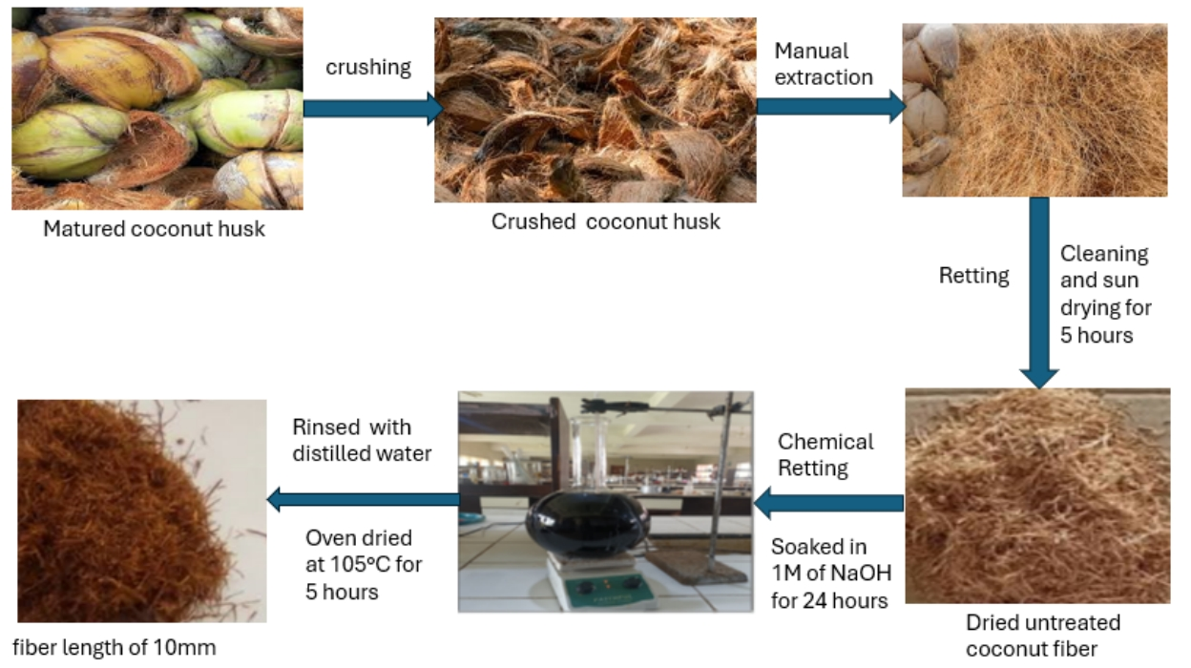
Figure 1: Preparation Process of Coconut fiber
(ii) Preparation of Palm Kernel Shell and Stone Dust:
Also, the as gotten palm kernel shells were washed and oven dried for 5 hours at 105ºC to remove moisture and residual organic matters. Figure 2. shows the Carbonized ash gotten from the carbonation of palm kernel shells by burning in a muffle furnace at 700°C for 5 hours. The ashes were crushed, grinded using ball milling machine and sieved through a 106 µm mesh to ensure uniform particle size distribution. In similar manner, the granite stone dust (GSD) shown in Figure 3 is a by-product of quarry activities typically causing air polution and waste of productive land space. The granite stone was sun dried for 2 days to remove all moist content present in it. The dried Stone dust was Sieved through a 106 µm mesh to remove oversized particles and ensure homogeneity.
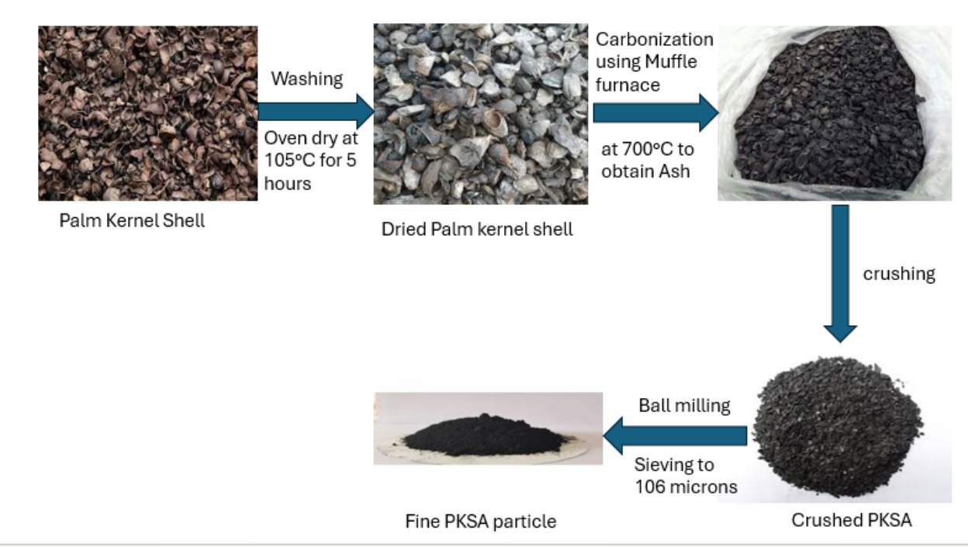
Figure 2: Preparation process of palm kernel shell ash

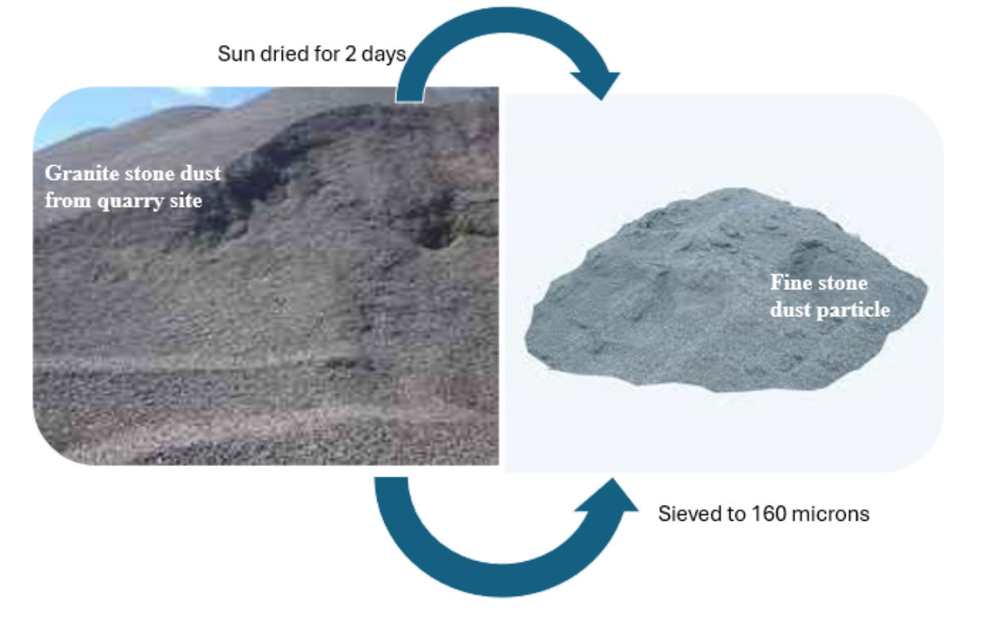
Figure 3: Preparation process of granite stone dust
2.3 Composite Fabrication and Development of Test Specimens
The hand-layup technique was used for composite fabrication due to its low-cost tooling, simple processing, and high production rate. Tensile, impact, flexural, and wear molds were prepared using releasing agents to enable easy removal of the specimens after fabrication as seen in Figure 4. Epoxy and hardener were mixed, and weight fractions of resin, palm kernel shell ash, granite stone dust, and coconut fiber were determined. The composites were cured at room temperature for 6 hours, and mechanical tests were conducted according to ASTM standards. The hybrid composites were fabricated using the same formulation table. Hybrid of palm kernel shell ash-coconut fiber and stone dust-coconut fiber run along with the same formulation table across all weight fractions as shown in Table 1, while the blend of the three (coconut fiber, palm kernel shell ash and stone dust) follow through the formulation table as seen in Table 2.
2.4 Composite Formulation and Weight Fractions
Four hybrid composite formulations were prepared:
- PHS: Palm Kernel Shell Ash + Granite Stone Dust.
- SHC: Stone Dust + Coconut Fiber.
- PSC: Palm Kernel Shell Ash + Stone Dust + Coconut Fiber.
- PHC: Palm Kernel Shell Ash + Coconut Fiber.
Each composite was reinforced at 2 wt.%, 4 wt.%, 6 wt.%, 8 wt.%, and 10 wt.% filler loadings. Careful weighing using a precision balance ensured consistency. The fillers were homogeneously mixed with epoxy resin using mechanical stirring for 15 minutes at 500 rpm to prevent agglomeration.

3.0 Wear Index Test
The wear test was carried out on the Taber Abrasion testing machine. This test was done to know the susceptibility of the material to abrasion. The initial weights of the samples were measured as W₀, after which the samples were mounted on the machine one after the other and the machine was switched on. The machine was operated at 750 rpm. At the completion of each abrasion process, the final weights of the samples were measured on an electronic weighing machine as W₁ and recorded. The wear resistance was calculated using equation (1).
 (1)
Where W₀ is the initial weight andW₁ is the final weight after
surface abrasion and rpm is revolutions per minutes.

3. results and discussion

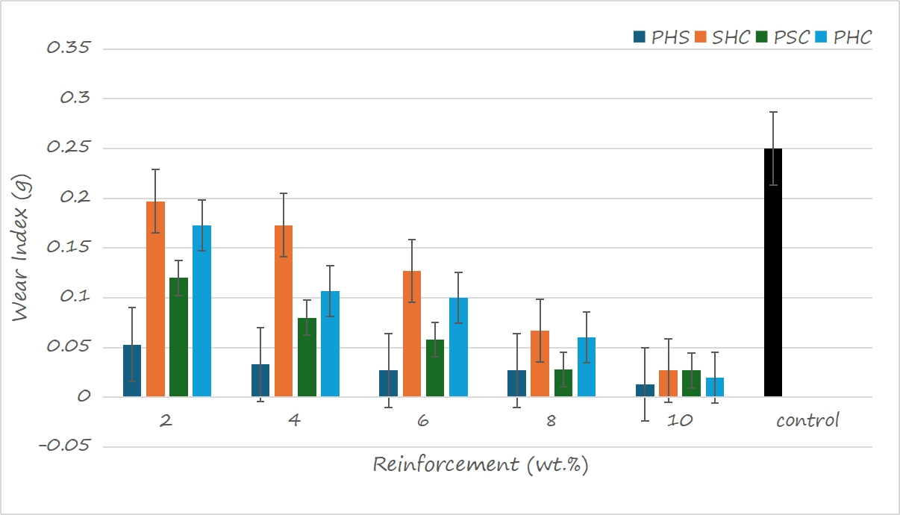
Figure 5: Variation of wear index of agro-mineral wastes reinforced hybrid composite
4.1 Wear Index of PHS Hybrid Composite
The wear index of the PHS composite decreased progressively with increasing reinforcement content from 2 wt.% to 10 wt.%, confirming the superior wear resistance imparted by palm kernel shell ash (PKSA) and granite stone dust. At 2 wt.%, the wear index was already significantly lower than the control sample, indicating that even minimal reinforcement effectively reduced material loss. By 10 wt.%, the composite achieved the lowest wear index among all formulations, demonstrating that granite dust’s angular morphology and PKSA’s silica-rich composition create a hard, abrasion-resistant surface. This trend aligns with previous findings by Aigbodion et al. (2010), who reported that agro-mineral reinforcements enhance wear resistance through improved particle-matrix bonding and load transfer efficiency. Furthermore, SEM observations (if available from your study) likely reveal uniform filler distribution at higher weight fractions, contributing to reduced surface degradation. These characteristics make PHS composites particularly suited for high-wear structural components, such as flooring panels, decking, and bridge parts exposed to abrasive environments.
4.2 Wear Index of SHC Hybrid Composite
The SHC composite (stone dust + coconut fiber) also demonstrated improved wear resistance compared to the control, though its performance was less pronounced than that of PHS. At 2 wt.%, the wear index was the highest among the hybrid composites, indicating limited reinforcement efficiency at low filler content. As the weight fraction increased to 8 wt.% and 10 wt.%, the wear index decreased substantially, showing that higher filler loading compensates for the relatively lower hardness of coconut fiber. The presence of coconut fiber likely contributed to energy absorption and crack deflection, improving toughness but slightly compromising surface hardness compared to granite dust-based systems. This finding agrees with Pothan et al. (2006), who observed that natural fibers improve impact performance but may not match mineral-based fillers in wear resistance. Therefore, SHC composites are recommended for moderate-wear applications where impact resistance and lightweight performance are critical such as interior decking or protective structural cladding rather than extreme abrasion environments.

4.3 Wear Index of PSC Hybrid Composite
The PSC composite, which combines palm kernel shell ash, stone dust, and coconut fiber, displayed intermediate performance between PHS and SHC. At 2 wt.%, the wear index was lower than SHC but slightly higher than PHS, indicating that the three-phase reinforcement improved wear resistance even at low filler content. As the reinforcement increased to 6 wt.% and 8 wt.%, a pronounced reduction in wear index was observed, demonstrating a synergistic effect among the three fillers. However, at 10 wt.%, the reduction in wear index plateaued, suggesting potential particle agglomeration or uneven dispersion within the polymer matrix, which can create localized stress concentrations and slightly limit further improvements. These findings are consistent with observations by Subramanian et al. (2020), who noted that multi-filler hybrid composites can achieve balanced mechanical and tribological properties but may require optimized processing to avoid filler clustering. PSC composites therefore offer a versatile solution for structural applications requiring balanced wear resistance, toughness, and energy absorption, such as bridge decking or load-bearing flooring panels.

4.4 Wear Index of PHC Hybrid Composite
The PHC composite (palm kernel shell ash + coconut fiber) showed improved wear resistance compared to the unreinforced control, but its performance lagged behind PHS and PSC. At 2 wt.%, its wear index was moderately lower than SHC, owing to the hardness contribution of PKSA. With increasing filler content up to 8–10 wt.%, the composite’s wear resistance improved steadily, though it remained slightly higher than PSC at the same weight fractions.
The absence of stone dust, which provides high abrasive hardness, likely accounts for the lower performance relative to PHS and PSC. Nevertheless, PHC composites achieved significant gains in wear resistance compared to the control while offering lighter weight and improved energy absorption. These properties make PHC suitable for moderate-load structural elements, such as decking panels or protective barriers, where weight reduction and moderate wear durability are prioritized.

4.5 Comparative Analysis Across All Composites
Figure 5 clearly demonstrates the superiority of PHS composites in minimizing wear index across all weight fractions. At 2 wt.%, PHS already showed substantial wear resistance compared to the control, while SHC performed the poorest at low fractions. PSC maintained balanced performance, benefiting from the combination of mineral hardness (stone dust and PKSA) and fiber toughness (coconut). PHC composites, though less wear-resistant than PHS and PSC, still exhibited significant improvement over the unreinforced polymer.
Across 46 wt.%, wear indices dropped sharply for all hybrids, indicating that filler content in this range is crucial for achieving notable improvements. At 10 wt.%, all hybrid composites approached their lowest wear indices, with PHS leading, followed by PSC, PHC, and SHC. This trend highlights the dominant influence of granite stone dust and PKSA on wear behavior.
These findings align with prior studies (Aigbodion et al., 2010; Shanmugam et al., 2021; Sadiq 2025) that demonstrated mineral-based fillers significantly enhance wear resistance in polymer composites. Additionally, the hybridization with natural fibers (coconut) introduces improved energy absorption and toughness, which can be particularly beneficial for structural applications subject to mixed abrasion and impact loads.
4.6 Implications for Structural/Automotive Applications
The findings from this study provide valuable insights into the practical applications of agro-mineral-based hybrid polymer composites reinforced with granite stone dust, palm kernel shell ash (PKSA), and coconut fiber. The significant reduction in wear index across all hybrid formulations compared to the control confirms their suitability for high-friction, load-bearing environments where durability and abrasion resistance are critical. For automotive applications, the PHS composite (PKSA + granite stone dust) emerges as the most promising candidate for brake pads, clutch plates, and engine covers, where low wear rates, thermal stability, and mechanical integrity are essential. The PSC composite (PKSA + stone dust + coconut fiber), which demonstrated balanced wear resistance and toughness, is ideal for components exposed to cyclic loads and impact forces, such as suspension bushings, underbody shields, and battery casings. Meanwhile, SHC and PHC composites, though slightly less wear-resistant, offer weight savings and improved energy absorption, making them suitable for interior panels, protective trims, and moderate-load decking where lighter materials are advantageous.
In structural applications, these composites present a sustainable alternative to traditional mineral-based materials. PHS and PSC can be used for flooring panels, decking boards, bridge components, and protective barriers, where long-term resistance to abrasive forces extends service life and reduces maintenance costs. The use of coconut fiber-rich composites (SHC and PHC) may be advantageous in acoustic insulation panels or impact-resistant cladding, where toughness and biodegradability are more important than maximum hardness. From a sustainability perspective, adopting granite stone dust and PKSA addresses environmental concerns by diverting quarry and agricultural wastes from landfills. This aligns with circular economy principles, reduces raw material costs, and minimizes the carbon footprint of composite production. Additionally, these materials provide a cost-effective solution for manufacturers in developing economies where expensive metallic or asbestos-based materials are less accessible.
4. Conclusion

Overall, the study validates granite stone dust–based hybrid composites as a versatile, eco-friendly, and cost-efficient option for both automotive and structural applications. Their performance demonstrates the feasibility of replacing traditional materials without compromising functionality, advancing the development of green engineering solutions in the automotive and construction industries.

References
aigbodion, v. s., hassan, s. b., & agunsoye, j. o. (2010). effects of bagasse ash reinforcement on the wear behavior of polymer matrix composites. tribology international, 43(4), 55–62. https://doi.org/10.1016/j.triboint.2009.08.004.

Fono-Tamo, R. S., Fono-Tamo, G., & Njeugna, E. (2019). Wear and mechanical properties of eco-friendly brake pads developed from agro-waste. Materials Today: Proceedings, 17(4), 275–281. https://doi.org/10.1016/j.matpr.2019.06.016
Pothan, L. A., Oommen, Z., & Thomas, S. (2006). Dynamic mechanical analysis of banana fiber reinforced polyester composites. Composites Science and Technology, 66(1), 85–91. https://doi.org/10.1016/j.compscitech.2005.01.006
Roubicek, V., Raclavska, H., Juchelka, D., Filip, P., & Smolik, J. (2008). Experimental analysis of automotive brake pad wear debris. Wear, 267(5–8), 746–756. https://doi.org/10.1016/j.wear.2008.01.010
Shanmugam, D., Rajeshkumar, G., & Suresh, K. (2021). Experimental and simulation analysis of composite brake pads made with quarry dust. Journal of Composite Materials, 55(12), 1553–1566. https://doi.org/10.1177/0021998321990894
Singh, A. P., Kumar, S., & Tiwari, A. (2022). Finite element analysis of hybrid composites for friction material applications. Advances in Mechanical Engineering, 14(6), 355–368. https://doi.org/10.1177/16878132221104842
Subramanian, C., Kumaravel, A., & Sathish, S. (2020). Hybrid natural fiber composites for automotive applications: A review. Journal of Cleaner Production, 250, 119130. https://doi.org/10.1016/j.jclepro.2020.119130
Tjong, S. C., Meng, Y. Z., & Xu, Y. (2021). Hybrid graphene nanoplatelet–ceramic filler composites: A study on thermal and wear properties. Materials Science and Engineering B, 272, 115284. https://doi.org/10.1016/j.mseb.2020.115284
Zhu, J., Chen, S., & Wu, G. (2018). Role of filler content in optimizing mechanical properties of polymer composites. Composites Part B: Engineering, 145, 190–198. https://doi.org/10.1016/j.compositesb.2018.02.045
Zhang, S., Li, Q., & Bai, Y. (2020). Sustainable use of quarry dust in polymer composites: A pathway to eco-friendly structural materials. Construction and Building Materials, 262, 120866. https://doi.org/10.1016/j.conbuildmat.2020.120866.
Joseph, A., & Mathew, G. (2023). Wear characterization of granite dust reinforced hybrid polymer composites. Wear, 512-513, 204567.
Ojha, S., & Sahoo, P. (2024). Optimization of granite dust loading for enhanced wear resistance in vinyl ester composites. Journal of Applied Polymer Science, 141(10), e55234.
Nayak, R., & Rout, P. K. (2021). Influence of surface treated granite dust on the mechanical and tribological properties of epoxy composites. Surface and Coatings Technology, 428, 127890.
Akinwande, O. O., & Oladele, I. O. (2021). Mechanical and wear properties of granite dust filled recycled polyethylene composites. Journal of Materials Research and Technology, 15, 521-530.
Rana, R. S., & Singh, S. (2022). Experimental investigation on wear behavior of granite powder filled epoxy composites. Materials Science and Engineering: A, 852, 143692.
Das, S., & Mohanty, S. (2025). A comprehensive review on the utilization of granite waste in polymer composites. Polymer Reviews, 65(1), 123-156.
Sharma, V., Kumar, A., & Singh, R. (2023). Influence of granite stone dust loading on the wear behavior of epoxy composites. Journal of Composites Science, 7(2), 45-58.
Patel, P., & Gupta, S. (2024). Effect of granite stone dust particle size on the tribological properties of polyester composites. Tribology International, 190, 108992.
Kumar, S., & Reddy, B. (2022). Enhancing interfacial adhesion in granite stone dust reinforced composites through silane treatment. Polymer Composites, 43(5), 2876-2885.
Li, Q., Zhang, H., & Wang, J. (2025). Alkali treatment of granite stone dust for improved mechanical interlocking in polymer composites. Materials Today Communications, 34, 105231.
Garcia, M., Rodriguez, L., & Perez, A. (2024). Sustainable composites: Utilizing granite stone dust in polylactic acid (PLA) matrices. Journal of Cleaner Production, 410, 137245.
Chen, L., & Wang, Y. (2023). Synergistic effect of graphene and granite stone dust on the wear performance of epoxy composites. Composites Part B: Engineering, 258, 110729.
Akinwande, O. O., & Oladele, I. O. (2021). Mechanical and wear properties of granite dust filled recycled polyethylene composites. Journal of Materials Research and Technology, 15, 521-530.
A. Mamakos, M. A. (2019). Physical characterization of brake-wear particles in a PM10 dilution tunnel. Atmosphere, 10(11). doi:https://doi.org/ 10.3390/atmos10110639.
A. Paula Gomes Nogueira, G. d. (2022). Rice husk as a natural ingredient for brake friction material: A pin-on-disc investigation. Wear, 494–495. doi: https://doi.org/10.1016/j.wear.2022.204272.
Ammar, Z. I. (2023). Influenceof Natural Fiber Content on the Frictional Material of BrakePads – A Review. J. Compos. Sci., 72(2). doi: https://doi.org/10.3390/jcs7020072
Andreea-Catalina Cristescu, I. F. (2021). Studies and research on the tribological behavior of the braking systems of vehicles, Review. E3S Web of Conferences 286. doi: http://doi.org/10.1051/e3sconf/202128603021
Arman M, S. S. (2018). A review on material and wear analysis of automotive brake pad. Material Today Proceeding, 28305-28312.
Asotah W. and Adeleke, A. (2017). Development of Asbestos Free Brake Pads using Corn Husks. Leonardo Electronic Journal of Practices and Technologies, 31, 129-144.
Aulin, V. R. (2024). Revealing patterns of change in the tribological efficiency of composite materials for machine parts based on phenylone and polyamide reinforced with arimide-T and fullerene. Eastern-European Journal of Enterprise Technologies, 12(129), 6-19. doi: https:/doi.org/10.15587/1729-4061.2024.304719
31. B. Bilvatej, J. N. (2023). Progress in polymeric and metallic brake pads: A comprehensive review. Proc IMechE Part J J Engineering Tribology. doi: https://doi.org/0.1177/13506501231204655.
Sheriff Babatunde Lamidi, Oluwole A. Adesina, Kasali Aderinmoye Adedeji, Nurudeen Adekunle Raji (2025). Modeling and Development of Local Raw Materials for Automotive Brake Pad. International Journal of Latest Technology in Engineering, Management, and Applied Science. DOI: 10.51583/IJLTEMAS Volume XIV, Issue III.F. Khan, N. H. (2025). Advances of composite materials in automobile applications–a review. J. Eng. Res., 13(12), 1001-1023.
34. Sadiq Sius Lawal. (2025). Contribution of cashew nut shells as base material in the multi-response optimised automobile brake pad composites in the composition mix. Maejo International Journal of Energy and Environmental Communication, 7(1), 32–41. https://doi.org/10.54279/mijeec.v7i1.259004

