Recovery of silver from waste electronic printed circuit boards of cell phone and television using Organic acid

ABSTRACT
The study was aimed to recover silver from waste printed circuit boards of cell phone and television using two different organic acids. The metallic parts of the waste printed circuit boards of cell phone and television were separated and then washed with sodium hydroxide, dried, pulverized to 75µm and then characterized using SEM-EDX and XRD. The leaching experiment was carried out with different concentrations of oxalic and malic acids, different time intervals and temperatures. Leaching efficiency was determined by the analysis of the leached solution with atomic absorption spectrophotometer. The SEM result shows a magnified view of material's surface and also presence of metal particles in the PCB samples of cell phone and a rough, irregular surface with a combination of smooth and textured areas for waste PCB of television. The EDX result recorded a weight concentration of 1.06 and 3.51%wt for cell phone and television respectively. More so, oxalic acid recorded the highest yield of (83.47%) at 30 °C being the optimum temperature. The optimum leaching time was 2hr with 73.85% efficiency while optimum concentration was 4 M. The kinetic study shows both acids fit the pseudo-first order model reasonably well, with malic acid giving a better correlation. For television PCB, oxalic acid shows an excellent fit of (R² ≈ 0.90). Considering the Rate constants (K1), the study reveals that malic acid dissolves Ag faster from waste PCB of cell phone. The work also shows that the extraction of Ag from television with oxalic acid is Spontaneous at all tested temperatures.
Keywords: Printed circuit board; acid leaching; base metal; e- waste; kinetics
INTRODUCTION
The waste from electrical and electronic equipment (E-waste) is becoming the fastest growing waste stream due to its increasing demand and shorter life cycles (Arshadi and Mousavi 2014). E-waste has an annual growth rate of 3–5% (Tuncuk et al. 2012). Among the E-waste, the printed circuit boards (PCBs) are the main carriers of valuable and hazardous metals. It contains base metals such as copper (Cu), lead (Pb), nickel (Ni), tin (Sn), and zinc (Zn). It also contains valuable metals such as silver (Ag), gold (Au), and palladium (Pd). E waste is generally very complex and may have a variation in composition (Cayumil et al. 2014). This makes the metal leaching process complicated. At present, E-waste is inadequately disposed of in landfills or burnt openly. This produces dioxins and furans and generates harmful waste residues/ runoff that contaminate the soil, water, and air (Cayumil et al. 2014; Askari et al. 2014). Leaching of metals from E-waste is of particular importance not only for sustainability in waste management but also for meeting an ever-increasing demand for these metals and conservation of rapidly depleting natural resources (Nwagbara and Onuegbu 2025; Arshadi and Mousavi 2014;Askari et al.2014).
The industrial treatment plants for leaching of metals from E-waste are based on pyrometallurgical and hydrometallurgical processes. The pyrometallurgy needs special equipment for high temperature operation and produces dusty and toxic gases pollutants. Meanwhile, the consumption of chemical reagents is large, which increases the cost compared to the other methods. Hydrometallurgy has exhibited many advantages, including high leaching efficiency, good operating environment, and continuous and automated process. However, it is not possible for a single hydrometallurgy approach to completely recover all metals without the collaborative application of other technologies. Two basic processes such as physical and chemical pretreatments has to be employed to the WPCBs just before leaching of the metals (Li et al., 2018). In physical pretreatment, the connected electronic components are evacuated, followed by the dismantling of WPCBs (Debnath et al., 2018; Nwagbara and Onuegbu 2025; Lee et al., 2012; Verma et al., 2017). Metallic and nonmetallic parts are isolated based on physical properties (Kumari et al., 2016; Rao et al., 2021; Xing and Lee, 2019). Chemical treatment is the subsequent step for the recovery of the metals from WPCBs. In this procedure, acids are utilized to dissolve the base metals, for example, Cu, Pb and Sn in solution, leaving metals in the residual solid ( Zhang et al., 2012) . Leaching of metals is the final step in metal recovery from WPCBs. In this process, WPCBs residue is dissolved in leaching agents such as organic acids, cyanide, thiourea and thiosulphate (Baláž et al., 1996; Jeffrey et al., 2003; Syed, 2016). The leaching reactions are based on the complexing tendency of the metals with these leaching agents. Chemical leaching is the most effective and profitable method of metal recovery. Nitric acid (HNO₃) is often used in silver and leaching of other metals because of its strong reactivity and its affordable price (Click et al 2024). Organic acids are considered mild acids that cause little or no pollution to the environment, unlike inorganic acids. Due to environmental regulations for waste disposal, it is appealing to create effective green leaching methods for metal extraction using organic acids (Lisińska et al 2021, Pathak et al 2022). The principal sources of silver are sulfide ores (e.g. argentite, acan- thite, prousite, pyrargyrite, cerargyrite, pearceite, polybasite, stephan- ite etc.) present in the earth’s crust. It is commonly found in association with ores of gold, copper, zinc and lead. Silver is commonly extracted by preparing sulfide ores. It is mainly recovered while refining other elements such as lead and zinc (Eisele et al., 1983; Hoffmann, 2012).
The leaching of silver with organic acids is scarcely reported in the literature compared to inorganic acid leaching. This study aimed to mainly recover silver from used cellphone and television printed circuit boards with malic and oxalic acids. This research is anticipated to offer theoretical and technical support for extensive cellphone and television PCB module recycling.
The process of oxalic and malic acid leaching of silver was thoroughly optimized and evaluated. Hence, the need to characterize e-waste for their elemental composition is highly essential, to ensure appropriate handling and management of these toxic and precious waste streams. In this study, electronic wastes in the form of PCBs of used cell phone and television were characterized for their elemental composition to find out the possibility of extracting silver as one of the recyclable elements present therein for reuse.
2.0 MATERIALS AND METHODS
2.1 Materials collection: Waste PCBs of Televisions and cell phones were collected randomly from different electronics repairer’s workshops and selected homes. They were then taken to the Materials and energy technology lab in Projects Development institute (PRODA) Enugu Nigeria for further analysis.
2.2 Sample Preparation: Cables and plastic materials attached to the circuit board matrix were manually removed from the board. Dismantling products such as plastic film, ferrous scraps and paper pieces were separated. Metal components were removed from the printed circuit board by the use of hot air gun. The detached metals, after size reduction, were washed in distilled water and allowed to drain. Size reduction of the waste PCBs was done to liberate metals from other polymer contents and to increase the efficiency of extraction of metals through the metal – acid contact. They were subsequently dried at 30⁰C immersed and stirred in 1M sodium hydroxide solution with mild agitation (100 rpm) at 60⁰C for 4 hours. The treated and dried metals were crushed to powdered form of 75µm using laboratory jaw crusher, this was sieved for uniform size and then characterized using SEM-EDX and XRD.
2.3 Leaching with Organic Acids: During the leaching experiments, five different concentrations of the acids were prepared (1M, 2M, 3M, 4M and 5M) and measured 10 ml each and 1g of the sample into Erlenmeyer three neck glass reactor). Heat was provided by a hot plate with a magnetic stirrer. The temperature of the medium was monitored by a thermometer in the three neck glass reactor. The media leaching time (2hrs, 3hrs, 4hrs, 5hrs and 6hrs) with heat at various temperatures of 30⁰C, 40⁰C, 50⁰C, 60⁰C and 70⁰C. were varied. Constant pulp density used was 25g/1. The leaching operation conditions were made equal to facilitate comparison of the leaching efficiency of each different leaching reagent. The extractants obtained were filtered using what man filter paper and the filtrate analyzed using AAS (Atomic Absorption Spectroscopy) to determine the total amount of metals after the process variation of Parameters. To establish leaching efficiency (Nwagbara and Onuegbu 2025) extraction efficiency was calculated as
$$Ex Eff=\frac{C_{m} x 10000}{P x Y_{m}}$$
Where Cm = Concentration of metals in the leached solution in grams per litter (g/L); P= Pulp density of the sample in percentage (%; i.e., 25g/1000 mL); and Ym = Metal content in the original sample (%; 1%= 10,000 g/L).
The probable chemical reactions involved in the dissolution process are given in the equations below:
C₂H₂O₄ + 2AgNO₃ 2Ag + 2CO₂ + 2HNO₃
Balanced ionic equation:
C₂O₄²⁻ + 2Ag⁺ 2Ag + 2CO₂
C₄H₆O₅ + 2AgNO₃ Ag₂C₄H₄O₅ + 2HNO₃
Balanced ionic equation:
C₄H₆O₅ + 2Ag⁺ Ag₂C₄H₄O₅ + 2H⁺

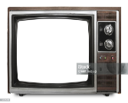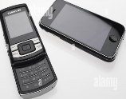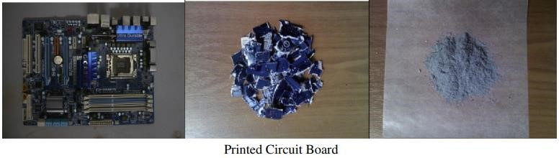
A B C D
Figure 1 Television (A), Cell phone (B), Waste PCB (C), Crushed PBC (D)

results and discussion

3.1 Characterization of the PCB Samples: Various characterization techniques were used for the evaluation of the physicochemical properties of the PCBs. Surface morphology of the PCB samples were studied using Scanning electron microscopy (SEM) analysis as shown in Figure 5. The bright spots in the image (A) shows a magnified view of material's surface and also presence of metal particles in the PCB samples. The image (B) shows a rough, irregular surface with a combination of smooth and textured areas. The lighter regions suggest areas with higher electron backscatter, possibly indicating a denser or different material composition, while the darker areas may represent voids, cracks, or less dense material. The prominent curved feature could be a cross-section of a fiber, wire, or layered material, showing its internal texture or coating. The roughness along the edges might indicate wear, fracture, or a natural grain structure. Along with morphological analysis, the quantitative determination of metal ions and elemental composition of the PCB samples were also performed by Energy Dispersive X-ray (EDX) analysis as shown in tables 1 and 2. X-ray diffraction (XRD) analysis performed. XRD could not detect any silver as shown in the XRD pattern. This can possibly be due to the fact that the crystalline phase is below 1-2 wt%, poorly crystalline or the peaks overlapped each other. The absence of clear peaks doesn’t mean silver was not present but it was detected by EDX with significant concentration.
3.2 Effect of Reaction Time: Reaction time was varied for a wide range from 2h to 6h respectively to investigate the effect of time on the extraction of Ag from waste PCBs of cell phone and television. It was observed that for both malic and oxalic acid, the silver yield decreased as leaching time increased (from 2 hours to 6 hours). This means the highest silver recovery occurred at short contact times (2 h), consistent with (Öncel et al. (2005) while prolonged leaching reduced efficiency. Leaching of silver from cell phone PCB with Oxalic acid consistently outperforms malic acid in silver extraction from cell phones (Han et al., 2023; Muñoz et al., 2015). However, both acids show a steady decline with time, suggesting possible re-adsorption, precipitation, or passivation of surface sites that hinders longer extraction. Silver extraction from television shows lower yields than in cell phone reflecting differences in silver content or matrix composition of the boards. Again, oxalic acid shows nearly double the efficiency of malic acid. Decline with time is present but less steep compared to cell phones. Cell phones release silver more readily than televisions, possibly due to higher initial silver concentration or more favorable bonding matrix. Prolonged leaching reduces efficiency, likely due to secondary reactions (precipitation of silver oxalate/malate or surface passivation) (Petter et al., 2014; Ghosh et al., 2015). For practical recovery, short leaching times (2 h) with oxalic acid give the highest yield as observed from this work.
3.3 Effect of Concentration: To investigate the effect of acid concentration on the leaching of silver from waste PCBs of television and cell phone, experiments were carried out with different acid concentrations of malic and oxalic acid such as 1M, 2M 3M, 4M, and 5M. Both acids showed increasing efficiency with concentration up to a point (4 M), after which the trend slightly declined. Oxalic acid consistently outperformed Malic acid across all concentrations and for both waste types. For cell phone PCBs, leaching with malic acid, efficiency increased steadily from 10.57% to 43.19%, peaking at 5 M (Xiang et al., 2010). Oxalic acid started higher and increased faster from 17.16% to 57.33% at 4 M), but then slightly drops to 55.11% at 5 M. Malic acid shows gradual improvement with concentration but did not reach the same efficiency as Oxalic. Oxalic acid is more effective at moderate concentrations (3–4 M), beyond which efficiency slightly decreased, suggesting possible precipitation or complex formation at higher acid strengths. Similar to cell phones, Oxalic acid is much more effective, but optimum efficiency is at 4 M. Efficiency drop at 5 M suggests acid strength beyond optimum may hinder leaching. The decrease in leaching yield with the increase in the concentration also may be attributed to the relatively low solubility of oxalic acid in water. Indeed, oxalic acid concentrations higher than 4 M produced saturated solutions, which were not conducive to acidolysis. The acid concentration was already at its maximum in a saturated solution and further acid additions will not actively dissolve in the solution. This can lead to a reduction in the effective concentration of acid available for the acidolysis reaction (Klein et al 2020). Cell phone PCBs generally leach more silver than television PCBs under the same conditions. This indicates cell phone boards may contain more easily leachable silver phases (or finer grain structures, less encapsulation) compared to televisions.
3.4 Temperature effect: Additional tests were performed by varying the temperatures from 30 to 70 °C at a constant experimental conditions. Results of the leaching reaction show noticeable effects that increase in solution temperature affected the reaction. Both acids (malic and oxalic) show decreasing efficiency as temperature increased. Oxalic acid is consistently more effective than malic acid at all temperatures for both waste types. For cell Phone PCBs, malic acid recorded the highest yield at 30 °C (63.77%) it then dropped steadily to 48.61% at 70 °C. More so, oxalic acid recorded a very high initial yield at 30 °C (83.47%) and gradually decline to 57.18% at 70 °C. Efficiency loss is more pronounced but still much higher than malic. Lower temperatures are more favorable. (Flores et al., 2025; Nicol, et al., 2020) Oxalic acid performs best at 30 °C, achieving the maximum yield observed in all conditions. Higher temperatures may cause silver complex instability, side reactions, or reduced acid effectiveness.
Looking at Television PCBs Similar to cell phones, efficiency dropped as temperature rises. Oxalic is still far more effective, nearly doubling malic acid’s performance at every temperature (Kastanaki et al., Krishnamoorthy et al., 2021). Comparing Cell Phone with Television. Cell phone PCBs consistently yield higher recovery than television PCBs under the same conditions. This indicates silver in cell phones is more accessible and soluble, while in televisions it may be more embedded in alloys or oxides. Temperature increase reduces silver recovery — contrary to some leaching systems where higher temperature enhances kinetics. Remember, temperature was varied at constant concentration of 3 M. This is high and could be the reason further increase in temperature decreased the efficiency. (Antonijevi´et al., 2004; Dimitrijevi´ et al., 1997). The differences observed between temperatures, concentrations, and times are statistically significant. Lower temperature (30 °C) is optimal for silver recovery. Recovery improves with acid concentration up to 4 M. Shorter leaching time (2 h) is optimal; prolonged leaching reduces yield. Efficiency ranking, Temperature has the largest effect (nearly 18% drop from 30 to 70 °C), followed by concentration (rise from 10 to 38%), then time (peak at 2 h, decline afterward). Best condition for silver recovery: Around 30 °C, 4 M acid, 2 h leaching time from this research work.

Figure 2. Effect of acid concentration on silver leached from waste printed circuit boards of cellphone and television
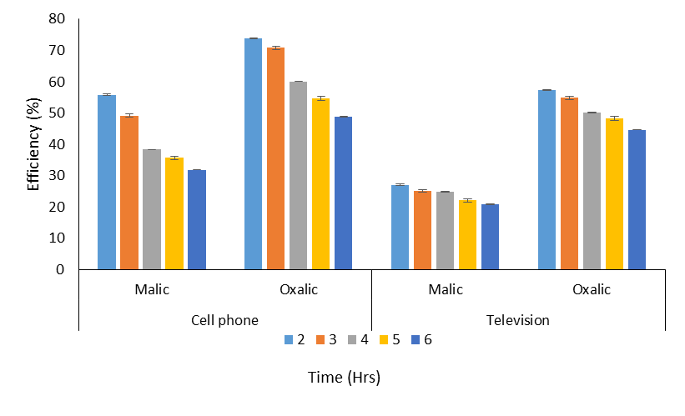
Figure 3 Effect of leaching time on silver leached from waste printed circuit boards of cellphone and television

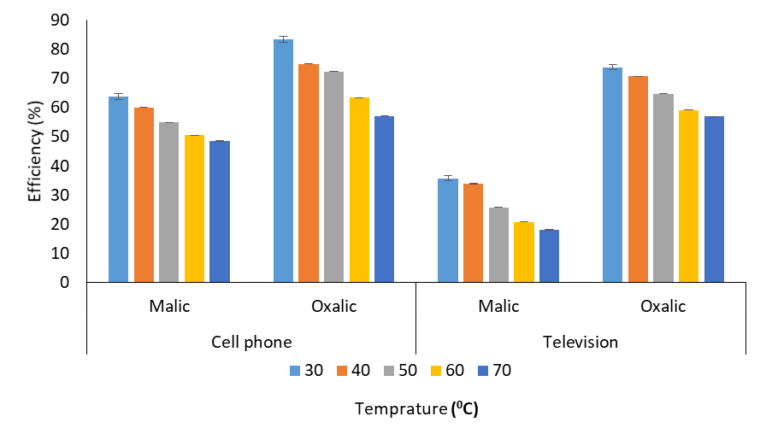
Figure 4. Effect of leaching temperature on silver leached from waste printed circuit boards of cellphone and television

Element Number | Element symbol | Element name | Atomic conc. | Weight conc.
50 | Sn | Tin | 17.77 | 43.56
29 | Cu | Copper | 16.68 | 21.89
6 | C | Carbon | 39.94 | 9.91
47 | Ag | Silver | 1.58 | 3.51
41 | Nb | Niobium | 1.45 | 2.79
26 | Fe | Iron | 2.38 | 2.74
14 | Si | Silicon | 3.86 | 2.24
20 | Ca | Calcium | 2.63 | 2.18
19 | K | Potassium | 2.38 | 1.92
13 | Al | Aluminium | 3.22 | 1.79
22 | Ti | Titanium | 1.73 | 1.71
39 | Y | Yttrium | 0.89 | 1.64
24 | Cr | Chromium | 1.52 | 1.63
16 | S | Sulfur | 1.95 | 1.29
15 | P | Phosphorus | 1.21 | 0.78
12 | Mg | Magnesium | 0.81 | 0.41

Table 1. SEM \ EDX Result for television

Element Number | Element Symbol | Element Name | Atomic Conc | Weight Conc
29 | Cu | Copper | 49.14 | 52.34
30 | Zn | Zinc | 22.56 | 24.73
28 | Ni | Nickel | 15.10 | 14.86
50 | Sn | Tin | 0.71 | 1.41
11 | Na | Sodium | 3.12 | 1.20
47 | Ag | Silver | 0.59 | 1.06
6 | C | Carbon | 4.08 | 0.82
41 | Nb | Niobium | 0.35 | 0.54
22 | Ti | Titanium | 0.67 | 0.50
39 | Y | Yttrium | 0.34 | 0.50
19 | K | Potassium | 0.71 | 0.47
24 | Cr | Chromium | 0.38 | 0.33
17 | Cl | Chlorine | 0.48 | 0.28
20 | Ca | Calcium | 0.42 | 0.28
14 | Si | Silicon | 0.59 | 0.28
16 | S | Sulfur | 0.26 | 0.14
13 | Al | Aluminum | 0.27 | 0.12
12 | Mg | Magnesium | 0.23 | 0.09

Table 2. SEM \ EDX Result for cell phone

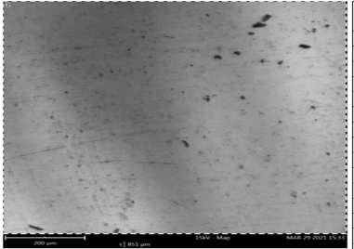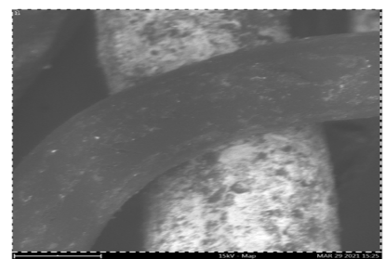
A B
Figure 5. SEM images of (A) Cellphone and (B) Television PCB samples
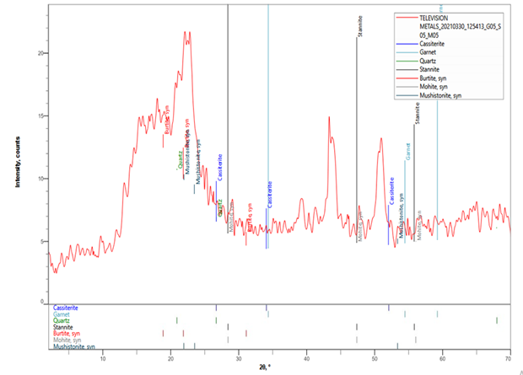
Figure 6. X-Ray diffraction (XRD) spectrum of waste PCB of Television
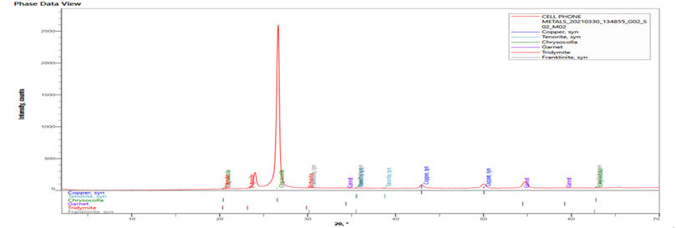
Figure 7. X-Ray diffraction (XRD) spectrum of waste PCB of Cellphone

 | Cell phone |  | Television
 | Malic acid | Oxalic acid | Malic acid | Oxalic acid
Intercept | 0.5065 | 0.3867 | 0.6101 | 0.4302
Slope | -5.3824 | -4.5728 | -4.8361 | -3.815
R² | 0.8569 | 0.7877 | 0.71 | 0.8991
K1 | 0.05382 | 0.04573 | 0.04836 | 0.03815
Qe | 1.65947 | 1.47211 | 1.84062 | 1.53757
Table 3. Pseudo First Order for Silver Leaching from Waste PCB of Cell Phone and Television

Figure 8. Pseudo First Order Kinetics for Ag (Cell phone) recovery

Figure 9. Pseudo First Order Kinetics for Ag (television) recovery

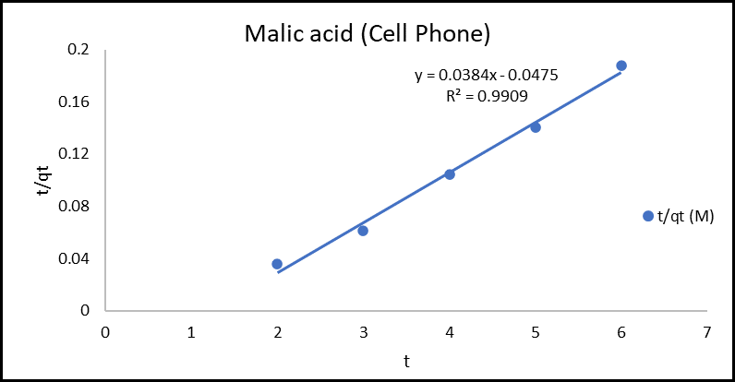

Figure 10. Pseudo Second Order Kinetics for Ag (Cell phone) Recovery with Malic Acid

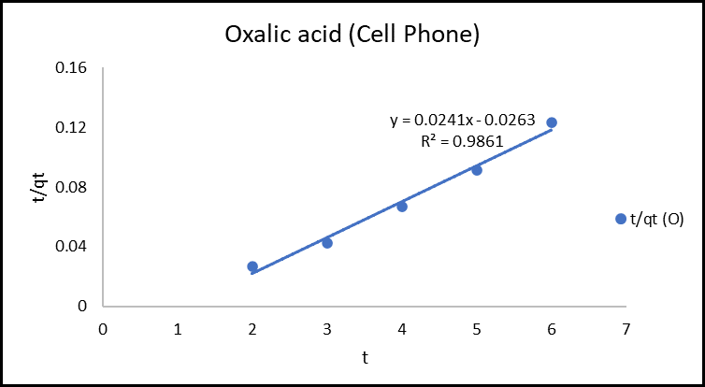
Figure 11. Pseudo Second Order Kinetics for Ag (Cell phone) Recovery with Oxalic Acid

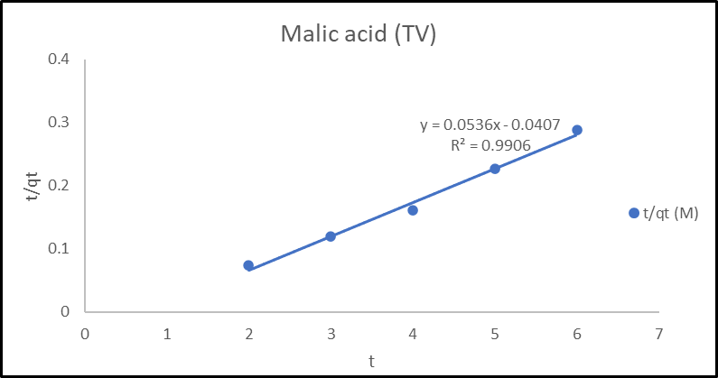
Figure 12. Pseudo Second Order Kinetics for Ag (Television) Recovery with Malic Acid

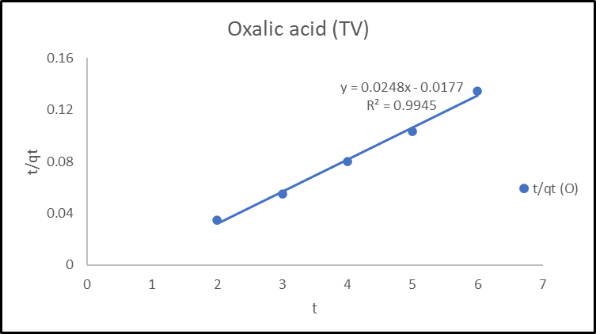

Figure 13. Pseudo Second Order Kinetics for Ag (Television) Recovery with Oxalic Acid

Figure 14. Thermodynamics of Ag leaching (cell phone)

Figure 15 Thermodynamics of Ag leaching (television)
3.5 Kinetics study
The influence of time on the leaching of silver from waste printed circuit boards of cell phone and television was investigated over a leaching time ranging from 2 to 6 hours, with the results illustrated in Figure 8 and 9. The study shows that the leaching process exhibited a time dependent behavior, with the leaching efficiency progressively decreasing using malic and oxalic acid. At 2 hours, malic acid has 55.86% efficiency while Oxalic acid has 73.85% (significantly higher). At 6 hours, malic acid has 31.92% efficiency while oxalic acid has 48.79% efficiency in silver extraction from cell phones. However, both acids show a steady decline with prolonged leaching time. The leaching kinetics of (Ag) using organic acids was modeled as a pseudo-first-order reaction with the equation; ln(Qe − Qt) = ln(Qe)−kt
Where: Qe​: represents the predicted maximum silver yield (mg/g or %) under pseudo-first-order conditions: Qt​: Amount of (Ag) leached at time t (same units as Qe​). k: Pseudo-first-order rate constant (typically in min−1 assuming time is in minutes). t: Time. Qe−Qt represents the amount of (Ag) still available to be leached at time t.
The analysis of the plots of all the kinetic curves, however, did not give a straight line, passing through the origin. This result differs with that of a similar report (Alafara et al, 2012). Both acids fit the pseudo-first order model reasonably well, with malic acid giving a better correlation. For television PCB, oxalic acid shows an excellent fit (R² ≈ 0.90) hence it has the best kinetic fit, while malic acid is weaker. This means oxalic acid leaching of TV boards follow pseudo-first-order kinetics more closely than malic acid. Considering the Rate constants (K1) for cell phone PCB, malic acid dissolves Ag faster from cell phone PCBs showing the fastest leaching rate as shown in table 3. The study shows that malic acid provides a higher dissolution rate for TV PCB. Malic acid consistently shows higher reaction rates (K1) than oxalic acid and also higher Ag recovery capacity and potential for both PCB types. The pseudo-second-order kinetic model assumes that the rate-limiting step is proportional to the square of the number of unoccupied sites on the leaching surface (Gindaba and Demsash, 2025). The linear form of the Pseudo-second-order kinetic model is given by equation 1;
$$\frac{t}{q_{t}}= \frac{1}{k_{2}q_{e}^{2 }}+ \frac{1}{q_{e}}t 1$$
t is the time, qt is the adsorption capacity at time t, qe is the equilibrium adsorption capacity, and k₂ is the rate constant.
The R² values for malic and oxalic acid (0.9861 and 0.9945) are very close to 1, showing that the pseudo-second-order kinetic model fits the experimental data extremely well. This suggests that the leaching kinetics are strongly controlled by chemisorption involving valence forces (electron sharing/exchange between silver and leaching agents). (Chen et al., 2024)
The pseudo-second-order model confirms that silver leaching from waste PCBs follows chemisorption-dominated kinetics. Oxalic acid achieves higher silver recovery capacity, while malic acid shows faster reaction rates in televisions. Thus, oxalic acid is more efficient overall, but process selection could depend on whether the goal is maximum recovery (oxalic) or faster kinetics (malic in TV PCBs).

3.6 Thermodynamics study of leaching process.Thermodynamics studies were performed to investigate the temperature effect on the leaching process. Thermodynamic parameters such as Gibbs free energy change (ΔG°), Enthalpy change (ΔH°), and Entropy change (ΔS°) were calculated using the Gibbs and the Van’t Hoff equation $lnKc=\frac{-ΔH}{RT}+\frac{ΔS}{R}$ a curve of lnK and 1/t was plotted as shown in fig 10 and 11. The Gibbs free energy (ΔG°) demonstrates the spontaneity of the leaching process and a higher positive value reflects a less dynamically favourable leaching (Din et al., 2014). Oxalic acid consistently shows better thermodynamic predictability across both waste types. Cell phone leaching shows malic acid (R² = 0.92) as very good fit and reliable thermodynamic. Also oxalic acid (R² = 0.85) shows good fit. Leaching for television also shows malic acid (R² = 0.78) as weaker fit, and oxalic acid (R² = 0.90) strong fit and reliable.
Enthalpy (ΔH, kJ/mol) for Cell phone has malic acid as almost weakly endothermic and oxalic acid slightly exothermic. Also television PCB has malic acid as mildly endothermic and oxalic acid as essentially weakly exothermic. Entropy (ΔS, kJ/mol•K) is seen constant at +0.004 for all systems showing disorder increases during leaching, this is consistent with solid Ag dissolving into ions in solution. (Zhu et al., 2019). Dissolution increases disorder.
ΔG values were reported at multiple temperatures (303–343 K). Leaching with malic acid from cell phone shows ΔG more negative above ~323 K this suggests that the leaching process is spontaneous at higher temperature. Also extraction of Ag from cell phone using oxalic acid follows same pattern as malic acid shows ΔG as positive at low temperature and negative at higher temperature. ΔG is more favorable and efficient at high temperatures. Extraction of Ag from television with oxalic acid shows ΔG = –1.09 → –2.03 → –2.47 kJ/mol (always negative). Spontaneous at all tested temperatures. The leaching process shows oxalic > malic, television > cell phone.
Conclusion
As end-of-life electronic products are not only hazardous to health, but also can generate income, the disposal of e-waste along with other house hold waste should be discourage making recovery of metals from e-waste potentially more economical. Failure to recover these metals results in both economic losses and the depletion of valuable resources. The mineralogical characterization and leaching kinetics of silver from waste PCBs of cell phone and television were successfully investigated. The SEM result shows a magnified view of material's surface, irregular surface with a combination of smooth and textured areas. The leaching experiment showed oxalic acid consistently outperformed malic acid in silver extraction. However, both acids show a steady decline with time. Oxalic acid recorded the highest yield of (83.47%) at 30 °C being the optimum temperature. The optimum leaching time was 2hr with 73.85% efficiency.
The kinetic study revealed both acids fit for pseudo-first order model reasonably well, with malic acid giving a better correlation. For television PCB, oxalic acid shows an excellent fit of (R² ≈ 0.90)

REFERENCES
Alafara, A. B. and Folahan, A., 2012. "A study of dissolution kinetics of a Nigerian galena ore in hydrochloric acid." Journal of Saudi Chemical Society, vol. 16, pp. 377-386.
Antonijevi´ M.M, Dimitrijevi´ M , Jankovi ´Z, Leaching of pyrite with hydrogen peroxide in sulphuric acid, Hydrometallurgy 46 (1) (1997) 71–83, https://doi. org/10.1016/S0304-386X(96)00096-5.
Antonijevi´ M.M., Jankovi´ Z.D, Dimitrijevi´ M.D, Kinetics of chalcopyrite dissolution by hydrogen peroxide in sulphuric acid, Hydrometallurgy 71 (3–4) (2004) 329–334.
Arshadi, M., Amiri, M.J. and Mousavi, S. (2014) Kinetic, Equilibrium and Thermodynamic Investigations of Ni(II), Cd(II), Cu(II) and Co(II) Adsorption on Barley Straw Ash. Water Resources and Industry, 6, 1-17.
https://doi.org/10.1016/j.wri.2014.06.001
Arshadi, M., Mousavi, S.M., 2015. Enhancement of simultaneous gold and copper extraction from computer printed circuit boards using Bacillus megaterium. Bioresour. Technol. 175, 315–324.
Baláž , P., Ficeriová, J., Š epelák, V., Kammel, R., 1996. Thiourea leaching of sil- ver from mechanically activated tetrahedrite. Hydrometallurgy 43, 367–377. doi: 10.1016/0304-386x(96)00015-1
Birloaga, I., Coman, V., Kopacek, B., Vegliò, F., 2014. An advanced study on the hydrometallurgical processing of waste computer printed circuit boards to extract their valuable content of metals. Waste Manage. 34, 2581–2586.
Birloaga, I., Coman, V., Kopacek, B., & Vegliò, F. (2013). An advanced study on the hydrometallurgical processing of waste computer printed circuit boards to extract their valuable content of metals. Waste Management, 33(4), 935–941. https://doi.org/10.1016/j.wasman.2012.11.011
Cayumil R, Ikram-Ul- Haq M, Khanna R, Saini R., Mukherjee P.S., Mishra B.K, Sahajwalla V. (2014) High temperature investigations on optimising the recovery of copper from waste printed circuit boards https://doi.org/10.1016/j.wasman.2017.01.001
Cayumil, R., et al. Concentration of precious metals during their recovery from electronic waste. Waste Management (2015), http://dx.doi.org/10.1016/j.wasman.2015.12.004
Chen, W.; Zhao, D.; Li, H. Environmentally friendly leaching strategies for critical metals from e-waste: a comparative review of organic acids vs mineral acids. J. Mater. Cycles Waste Manag. 2024, 26, 317–332. DOI: 10.1007/s10163-024-01944-4.
Chen, S., Qin, C., Wang, T., Chen, F., Li, X., Hou, H., & Zhou, M. (2019). Study on the adsorption of dyestuffs with different properties by sludge-rice husk biochar: Adsorption capacity, isotherm, kinetic, thermodynamics and mechanism. Journal of Molecular Liquids, 285, 62–74. https://doi.org/10.1016/j.molliq.2019.04.03 5
Click, N.; Teknetzi, I.; Adcock, R.; Tao, M.; Ebin, B. Silver Cementation Mechanism for Leaching Silicon Solar Cells in Nitric Acid. Sol. Energy 2024, 283, 113009. [CrossRef]
Duan, H., Hou, K., Li, J., Zhu, X., 2011. Examining the technology acceptance for dis mantling of waste printed circuit boards in light of recycling and environmental concerns. J. Environ. Manag. 92, 392–399. http://dx.doi.org/10.1016/j.jenvman. 2010.10.057.
Eisele, J.A., Colombo, A.F., Mcclelland, G.E., 1983. Recovery of gold and silver from ores by hydrometailurgical processing. Sep. Sci. Technol. 18, 1081–1094. doi: 10.1080/01496398308059918 .
Jeffrey, M.I., Breuer, P.L., Chu, C.K., 2003. The importance of controlling oxygen addi- tion during the thiosulfate leaching of gold ores. Int. J. Miner. Process. 72, 323–330. doi: 10.1016/S0301-7516(03)00108-X .
Gattinoni, C., & Michaelides, A. (2015). Oxalate chemistry at surfaces: Reactivity, bonding, and redox properties. Chemical Reviews, 115(2), 1066–1102. https://doi.org/10.1021/cr500249p
Ghosh, B., Ghosh, M. K., Parhi, P., Mukherjee, P. S., & Mishra, B. K. (2015). Waste printed circuit boards recycling: An extensive assessment of current status. Journal of Cleaner Production, 94, 5–19. https://doi.org/10.1016/j.jclepro.2015.02.024
Gindaba, G.T. and Demsash, H.D., 2025. Statistical analysis and optimization of mercury removal from aqueous solution onto green synthesized magnetite nanoparticle using central composite design. Biomass Conversion and Biorefinery, 15(3), pp.4657-4676.
Guo, J.; Cao, B.; Guo, J.; Xu, Z. A plate produced by nonmetallic materials of pulverized waste printed circuit boards. Environ. Sci. Technol. 2008, 42, 5267–5271.
Han, X., Niu, X., Zhao, Y., & Song, Q. (2023). Advances in recycling waste printed circuit boards by hydrometallurgy: A review. Journal of Hazardous Materials, 441, 129880. https://doi.org/10.1016/j.jhazmat.2022.129880
Hoffmann, J.E., 2012. The hydrometallurgical extraction and recovery of high-purity silver. Metall. Mater. Trans. B Process Metall. Mater. Process. Sci. 43, 431–439. doi: 10.1007/s11663-011-9624-0 .
Huang, K.; Guo, J.; Xu, Z. Recycling of waste printed circuit boards: A review of current technologies and treatment status in China. J. Hazard. Mater. 2009, 164, 399–408.
Huang, J., Chen, M., Chen, H., Chen, S., Sun, Q., 2014. Leaching behavior of copper from waste printed circuit boards with Brønsted acidic ionic liquid. Waste Manage. 34, 483–488.
Hischier, R.; Wäger, P.; Gauglhofer, J. Does WEEE recycling make sense from an environmental perspective?: The environmental impacts of the Swiss take-back and recycling systems for waste electrical and electronic equipment (WEEE). Environ. Impact Assess. Rev. 2005, 25, 525–539.
Işıldar, A., van de Vossenberg, J., Rene, E. R., van Hullebusch, E. D., & Lens, P. N. L. (2017). Two-step bioleaching of copper and gold from discarded printed circuit boards (PCB). Waste Management, 60, 458–465. https://doi.org/10.1016/j.wasman.2016.12.010

Jing-ying, L., Xiu-li, X., Wen-quan, L., 2012. Thiourea leaching gold and silver from the printed circuit boards of waste mobile phones. Waste Manage. 32, 1209 1212.
Joda, N., Rashchi, F., 2012. Recovery of ultra fine grained silver and copper from PC board scraps. Sep. Purif. Technol. 92, 36–42. http://dx.doi.org/10.1016/j.seppur. 2012.03.022.
Klein, D. Organic Chemistry, 4th ed.; Wiley: Hoboken, NJ, USA, 2020.
Kang, H.-Y.; Schoenung, J.M. Electronic waste recycling: A review of U.S. infrastructure and technology options. Resour. Conserv. Recycl. 2005, 45, 368–400.
Kastanaki, E., et al. “Organic Acid-Assisted Hydrothermal Leaching of Silver from Silicon PV Panels.” Applied Sciences 15, 6383 (2025). — Compares organic acids (including oxalic and maleic/malic family analogs) for Ag mobilization in another Ag-bearing tech waste; provides cross-system evidence and notes where some acids underperform at room temp.
Krishnamoorthy, S., et al. “Recovery of valuable metals from waste printed circuit boards using organic acids produced by Aspergillus niveus.” IET Nanobiotechnology 15 (2021): 81–91. — Bio/organic acids (citric, itaconic, oxalic) mobilize metals from WPCBs; notes oxalic’s role in forming oxalates that influence recoveries.
Kumar, A., Holuszko, M., & Espinosa, D. C. R. (2017). E-waste: An overview on generation, collection, legislation and recycling practices. Resources, Conservation and Recycling, 122, 32–42. https://doi.org/10.1016/j.resconrec.2017.01.018
Lee, Jaeryeong, Kim, Y., Lee, Jae chun, 2012. Disassembly and physical separation of electric/electronic components layered in printed circuit boards (PCB). J. Hazard. Mater. 241–242. doi: 10.1016/j.jhazmat.2012.09.053 , 387–394 .
Lee, J.-C.; Song, H.T.; Yoo, J.-M. Present status of the recycling of waste electrical and electronic equipment in Korea. Resour. Conserv. Recycl. 2007, 50, 380–397.
Lisi´nska, M.; Gajda, B.; Saternus, M.; Brozová, S.; Wojtal, T.; Rzelewska-Piekut, M. The Effect of Organic Acids as Leaching Agents for Hydrometallurgical Recovery of Metals from PCBs. Metalurgija 2022, 61, 609–612.
Lisińska, M., Tkacz, K., & Franus, W. (2021). Recovery of metals from waste printed circuit boards by organic acid leaching. Materials, 14(19), 5806. https://doi.org/10.3390/ma14195806
Maria R. Lee, Tsung and Teng Chen( 2012).Revealing research themes and trends in knowledge management: From 1995 to 2010 Knowledge-Based Systems.Volume 28, April 2012, Pages 47–58 DOI: 10.1016/j.knosys.2011.11.016
Min Lee ,Eric J Shiroma, Felipe Lobelo, Peter Katzmarz Physical Activity Series Working GroupEffect of physical inactivity on major non-communicable diseases worldwide: an analysis of burden of disease and life expectancy.July 2012,380(9838):219-29 DOI: 10.1016/S0140-6736(12)61031-9
Mishra, D., Rhee, Y. H., & Ahn, J. G. (2008). Selective recovery of precious metals (Ag, Au, Pd and Pt) from acidic leach liquor of waste PCBs using weak organic acids. Hydrometallurgy, 94(1–4), 144–149. https://doi.org/10.1016/j.hydromet.2008.05.018
Muñoz Hernández, R. A., Garcia, A. L., & Nava, J. L. (2015). Dissolution of silver with thiourea and potassium oxalate solutions. Hydrometallurgy, 157, 109–115. https://doi.org/10.1016/j.hydromet.2015.08.005
Muskan Jain, Depak Kumar, Jyoti Chaudhary, Sudesh Kumar, Sheetal Sharma, Ajay Singh Verma, Review on E-waste management and its impact on the environment and society, Waste Management Bulletin, Volume 1, Issue 3, 2023, Pages 34-44, ISSN 2949-7507, https://doi.org/10.1016/j.wmb.2023.06.004.
(https://www.sciencedirect.com/science/article/pii/S2949750723000135)
Nicol, M. J., et al. “The role and use of hydrogen peroxide as an oxidant in hydrometallurgy.” Hydrometallurgy 197 (2020): 105498. — Notes that temperatures ~60–70 °C negatively affect leaching because H₂O₂ decomposes more rapidly; mechanistic support for the temperature-drop trend.
Ogunniyi, I. O., Vermaak, M. K. G., & Groot, D. R. (2009). Chemical composition and liberation characterization of printed circuit board comminution fines for beneficiation investigations. Waste Management, 29(7), 2140–2146. https://doi.org/10.1016/j.wasman.2009.02.010
Öncel, M.S., Ince, M., Bayramo ǧlu, M., 2005. Leaching of silver from solid waste using ultrasound assisted thiourea method. Ultrason. Sonochem. 12, 237–242. doi: 10.1016/j.ultsonch.2003.10.007
Petter, P. M. H., Veit, H. M., & Bernardes, A. M. (2014). Evaluation of gold and silver leaching from printed circuit board of mobile phones. Waste Management, 34(2), 475–482. https://doi.org/10.1016/j.wasman.2013.10.035
Quinet, P., Proost, J., Van Lierde, A., 2005. Recovery of precious metals from electronic scrap by hydrometallurgical processing routes. Miner. Metall. Proc. 22 (1), 17–22.
.Rao, M.D., Shahin, C., Jha, R., 2021a. Materials today: proceedings optimization of leaching of copper to enhance the recovery of gold from liberated metallic layers of WPCBs. Mater. Today Proc. 1–4. doi: 10.1016/j.matpr.2021.01.052 .
Roohallah Saberi Riseh, Mozhgan Gholizadeh Vazvani , Mohadeseh Hassanisaadi ,Vijay Kumar Thakur},{Agricultural wastes: A practical and potential source for the isolation and preparation of cellulose and application in agriculture and different industries}, Journal {Industrial Crops and Products}, volume = {208}, pages {117904}, {2024},issn {0926-6690},doi {https://doi.org/10.1016/j.indcrop.2023.117904}, url
Tuncuk, A., Stazi, V., Akcil, A., et al., 2012. Aqueous metal recovery techniques from e scrap: hydrometallurgy in recycling. Miner. Eng. 25, 28–37. http://dx.doi.org/10. 1016/j.mineng.2011.09.019.
Verma, A., (2017) Optimization of Different Reaction Conditions for the Bio-Inspired Synthesis of Silver Nanoparticles Using Aqueous Extract of Solanum nigrum Leaves. Journal of Nanomaterials & Molecular Nanotechnology, 6, 2-8. https://doi.org/10.4172/2324-8777.1000214
Wang, X., Gaustad, G., 2012. Prioritizing material recovery for end-of-life printed circuit boards. Waste Manage. 32 (10), 1903–1913.
Xu, H., Li, J., & Wang, J. (2018). Organic acid leaching of valuable metals from waste printed circuit boards: A review. Journal of Cleaner Production, 197, 1247–1263. https://doi.org/10.1016/j.jclepro.2018.06.266
Xiang, Y., Wu, P., Zhu, N., Zhang, T., & Wu, J. (2010). Leaching of metals from printed circuit boards using organic acids. Journal of Hazardous Materials, 177(1-3), 911–918. https://doi.org/10.1016/j.jhazmat.2010.01.003
Zhu, G., Cheng, G., Wang, P., Li, W., Wang, Y., & Fan, J. (2019). Water compatible imprinted polymer prepared in water for selective solid phase extraction and determination of ciprofloxacin in real samples. Talanta, 200, 307–315. https://doi.org/10.1016/j.talanta.2019.03.07 0

