A STUDY ON THE THERMOGRAVIETRIC AND DIFFERENTIAL THERMAL ANALYSIS OF A BIO BASED SILICA NANO COMPOSITE MATERIAL

Abstract
The thermal response of ethanol extract of Dacryodes edulis (DE), precipitated amorphous silica (PAS), and their hybrid (DE/PAS) was evaluated by thermogravimetric/differential thermal analysis (TGA/DTA) between 0–950 °C. Three major thermal events were observed: initial weight loss at ~30–200 °C (physically adsorbed water/volatiles), major decomposition at 300–500 °C (polymer chain degradation, silanol condensation, endothermic peaks), and residual stability beyond 500 °C. Residual mass values were ~15% (DE), ~12% (PAS), and ~10% (DE/PAS). Major weight loss occurred at 350–450 °C (DE), 370–480 °C (PAS), and 380–500 °C (DE/PAS), with peak decomposition temperatures at 400 °C, 420 °C, and 430 °C respectively. The weakest DTA peak intensity in DE/PAS indicated a more controlled degradation process and superior thermal stability. FTIR analysis revealed functional groups (aromatic ester, alkyl aryl ether, O–H, C=C, C=O, anhydride, N=C=S, C≡C, C–H), while TEM confirmed spherical nanoparticles (~20–50 nm) before and after hybridization. The enhanced stability of DE/PAS is attributed to strong covalent interactions between electron-rich groups in DE and Si–O–Si bonds in PAS, conferring improved mechanical strength and thermal resistance.
Keywords: organic/inorganic hybrids, nanocomposites, TGA/DTA, Dacryodes edulis, precipitated amorphous silica, thermal stability

Introduction

Background
Organic/inorganic nanocomposites are increasingly employed across diverse fields including optoelectronics, energy storage, catalysis, biomedical applications, sensors, coatings, and membranes. Their unique properties arise from the synergistic combination of organic and inorganic phases, resulting in enhanced performance, multifunctionality, and superior thermal and mechanical stability [1,2].
Precipitated amorphous silica (PAS) is a versatile inorganic material characterized by its high surface area, fine particle size, and hygroscopic nature. These attributes make PAS suitable as a filler, reinforcement agent, and additive in coatings, plastics, rubber, pharmaceuticals, food, and beverages [3-4, 21].
Conversely, plant-derived materials such as extracts from leaves and bark have shown promise as eco-friendly corrosion inhibitors. Their protective effect is attributed to the presence of electron-rich functional groups (e.g., O–H, C=O, C=C) that form covalent bonds with metallic substrates, creating protective layers against corrosion [5,6]. However, the use of plant materials alone is limited by poor thermal stability, mechanical weakness, and void formation due to swelling.[6-7]
Dacryodes edulis (African/bush pear), an indigenous fruit tree from West and Central Africa, is rich in phytochemicals such as flavonoids, alkaloids, and tannins. FTIR studies of its ethanol extract confirm the presence of aromatic esters, alkyl aryl ethers, O–H, C=C, C=O, anhydrides, N=C=S, C≡C, and C–H groups [7-8]. These functional groups can form strong covalent interactions with Si–O–Si networks in PAS, potentially improving the stability and mechanical performance of composites [34-35, 37]
The synthesis of organic/inorganic hybrids enables the integration of plant extracts with PAS, addressing limitations of organic systems while enhancing coating performance. Such hybrids are especially important as environmentally friendly alternatives to toxic anticorrosive additives such as hexavalent chromium, which pose significant health hazards. Beyond environmental safety, these hybrids improve adhesion, mechanical strength, and anti-sagging behaviour in coatings [9–12,20].
Thermal characterization techniques such as thermogravimetric analysis (TGA) and differential thermal analysis (DTA) are vital for assessing the stability of organic/inorganic composites. TGA measures weight loss as a function of temperature, while DTA identifies endothermic and exothermic transitions, providing insights into phase changes, degradation, and chemical reactions [13–17, 38]. These tools are crucial for optimizing processing conditions (e.g., curing, drying) and predicting coating performance and durability
Previous research demonstrates the stabilizing effect of nanoparticles in hybrid matrices. Nicolás et al. (2024) reported enhanced stability in nano-bioactive glass (nBG) loaded hybrids compared to TEOS-based systems, with degradation peaks shifting to higher temperatures [18]. Chen et al. (2019) observed a 20% increase in thermal stability for hydrolyzed tetraethoxy silane (HTEOS) hybrid coatings compared to pure SE coatings [19]. Similarly, Sharif et al. (2012) showed improved stability in polyurethane–fattyamide/TEOS hybrids, with higher O–Si–O content directly correlated with greater resistance to thermal degradation
This study investigates the thermal behaviour of ethanol extract of D. edulis (DE), PAS, and their hybrid (DE/PAS) using TGA/DTA in nitrogen atmosphere. FTIR was employed to identify functional groups, while TEM and SEM were used to confirm particle size (20–50 nm) and morphology before and after hybridization. The analysis highlights the enhanced thermal stability of the hybrid material, attributed to covalent bonding between the electron-rich organic groups of DE and the Si–O–Si network of PAS. It also demonstrates the potential of DE/PAS hybrids as sustainable, thermally stable alternatives in coating technology, combining renewable bio-sources with inorganic reinforcement to achieve superior performance.

Materials and Methods

Preparation of Plant Extract
Fresh leaves of Dacryodes edulis were collected from Ubomiri, Mbaitoli Local Government Area, Imo State, Nigeria (Latitude 5.6500° N, Longitude 7.0333° E). The leaves were thoroughly washed with distilled water, air-dried at room temperature, and ground into fine powder. Approximately 100 g of the powdered sample was soaked in 1000 mL of 99% ethanol in an airtight container and allowed to stand for 48 h. The mixture was then filtered, and the solvent was removed under reduced pressure using a rotary evaporator, yielding the concentrated ethanolic extract [23-27].

Synthesis of Precipitated Amorphous Silica (PAS)
PAS was synthesized via acid neutralization of sodium silicate solution. Briefly, 250 g of analytical grade sodium silicate (Na₂SiO₃) was dissolved in 750 mL of distilled water to obtain a 25% solution, followed by moderate heating until a homogeneous solution was achieved. A dilute solution of tetraoxosulphate (VI) acid (H₂SO₄; 1:10 with water) was prepared separately. The acid was added gradually to the sodium silicate solution containing 0.1 g of polyvinylpyrrolidone (PVP) while stirring with a high-energy disperser. The rate of acid addition was controlled by temperature: faster addition at 40–60 °C and slower addition at 60–80 °C.
The pH was monitored throughout, decreasing from ~11 to 7.5 as precipitation occurred. The reaction mixture was maintained at ~80 °C with vigorous stirring to prevent coagulation. The precipitate was aged for 1 h, cooled to room temperature, and separated by vacuum filtration. The silica cake was washed repeatedly with distilled water until the filtrate pH matched that of distilled water (6.5). The recovered material was oven-dried at 40 °C and ground to obtain nano-sized PAS powder.[3, 22]

Hybridization of Organic and Inorganic Components
The hybrid material was prepared by incorporating the ethanolic extract of D. edulis onto PAS via ultrasonication, followed by thorough mixing to ensure uniform dispersion. The resulting bio-based organic/inorganic hybrid was stored in airtight containers for subsequent analyses.[9]
Results and discussion

FTIR Examination [28-31]
The FTIR spectrum of the ethanol extract of Dacryodes edulis leaves (Fig. 1) displayed several absorption bands corresponding to characteristic functional groups. Peaks at 757.2 cm⁻¹ and 855.1 cm⁻¹ were attributed to cis- and ortho-disubstituted alkenes and benzene rings, while the band at 2687.7 cm⁻¹ indicated O–H stretching typical of carboxylic acids. A strong peak at 1281.1 cm⁻¹ corresponded to aromatic esters and alkyl aryl ethers, whereas the band at 1606.7 cm⁻¹ was assigned to C=C stretching, consistent with α,β-unsaturated ketones and β-lactams, and also overlapping with anhydride C=O stretching. Additional anhydride-related bands were observed at 1882.2 cm⁻¹ and 2037.5 cm⁻¹. The sharp peak at 2144.5 cm⁻¹ was ascribed to N=C=S stretching of isothiocyanates, while the absorption at 2532.7 cm⁻¹ suggested C≡C stretching of alkynes. A broad band at 3069.6 cm⁻¹ indicated C–H stretching of alkanes.
These findings reveal the presence of aromatic esters, alkyl aryl ethers, hydroxyl, carbonyl, anhydride, isothiocyanate, alkyne, and alkane groups, suggesting that the extract is rich in carboxylic acids, phenols, and carbonyl compounds. This aligns with previous phytochemical studies on Dacryodes edulis, which reported abundant flavonoids, alkaloids, tannins, phenols, and carboxylic acids (Agiriga et al., 2019; Udo et al., 2016). Such functional groups are known to act as electron-donating or electron-deficient moieties, enabling strong interactions with inorganic phases (e.g., Si–O–Si bonds) in hybrid nanocomposites, thereby contributing to improved thermal and mechanical stability.
Fig 1: FTIR spectra on the ethanol extract of Dacryodes edulis (DE

TEM Analysis
Transmission electron microscopy (TEM) micrographs of PAS and the hybrid DE/PAS (Figs. 2–3) revealed predominantly spherical, smooth-surfaced nanoparticles with average particle sizes of ~20 nm and ~50 nm at higher (×1000) and lower (×500) magnifications, respectively, confirming nanoscale dimensions. In PAS (Figs. 2a–b), localized dark patches were observed, which can be attributed to regions of higher electron density, possibly due to the presence of heavy elements or grain boundaries with disordered atomic arrangements. In contrast, the DE/PAS hybrid (Figs. 3a–b) exhibited relatively lighter regions, consistent with a predominance of low electron density organic phases (carbon-rich matrix). The reduced contrast and more homogeneous morphology in the hybrid material suggest successful grafting of PAS onto the organic extract. This hybridization is likely facilitated by strong covalent interactions between electron-rich functional groups in Dacryodes edulis extract (e.g., –OH, –C=O) and Si–O–Si bonds in PAS, resulting in a more integrated organic–inorganic nanocomposite.
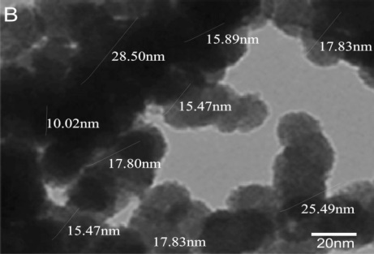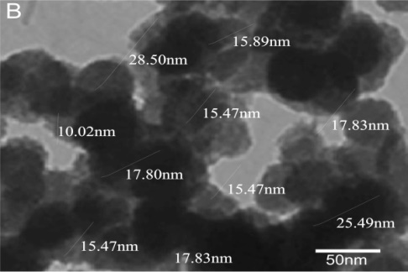
Fig 2a:TEM image on PAS Fig. 2b TEM image on PAS
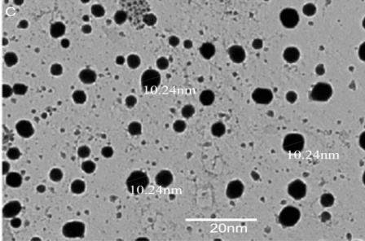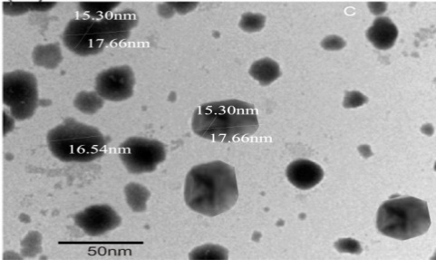
Fig 3a TEM image on DE/PAS Fig 3b TEM image on

Thermal Analysis (TGA/DTA) [36]
The TGA/DTA profile of DE (Fig. 4) shows three distinct thermal events. An initial weight loss (~5–10%) between 100–300 °C corresponds to evaporation of residual moisture and low-molecular-weight volatiles. A major decomposition (~70%) occurred between 300–500 °C, accompanied by a strong endothermic peak in the DTA curve, attributable to polymer chain degradation, organic component breakdown, and phase transitions. Above 500 °C, the curve plateaued, leaving a residual mass of ~10%, likely due to char or thermally stable inorganic fractions.
Similarly, the PAS sample (Fig. 5) displayed an initial moderate mass loss (~5–10%) at 30–150 °C, attributed to physically adsorbed water and volatile species. The major weight loss (~70–80%) occurred at 150–500 °C with a corresponding DTA endothermic peak, associated with the removal of strongly bound water and condensation of silanol groups (dehydration/dehydroxylation). Beyond 500 °C, the mass loss slowed, with a final residue of ~10–20% up to 950 °C, representing the thermally stable silica framework.
The TGA/DTA profile of DE/PAS (Fig. 6) exhibited an initial weight loss (~5–10%) between 30–200 °C, attributed to the evaporation of physically adsorbed water and low molecular weight volatiles. A major decomposition occurred at 300–500 °C, with ~70–80% mass loss and a corresponding endothermic peak (~430 °C), reflecting polymer degradation and removal of chemically bound water from silanol groups. Beyond 500 °C, a stable residue of ~10–20% was recorded, associated with inorganic reinforcement such as the silica framework.
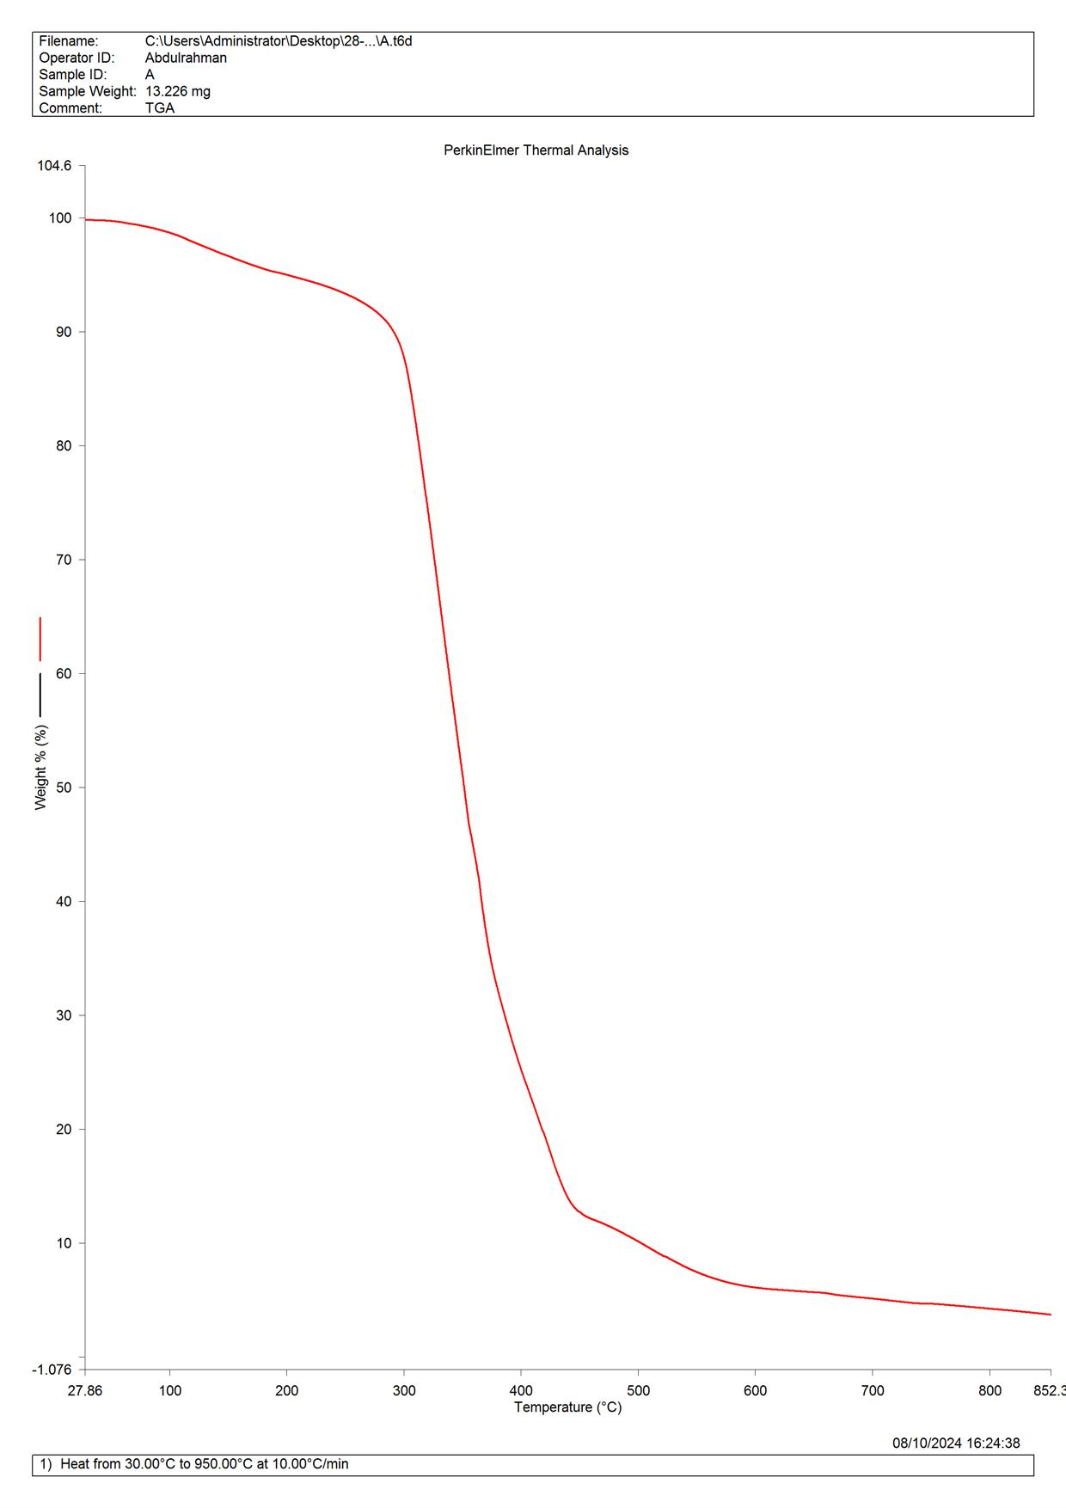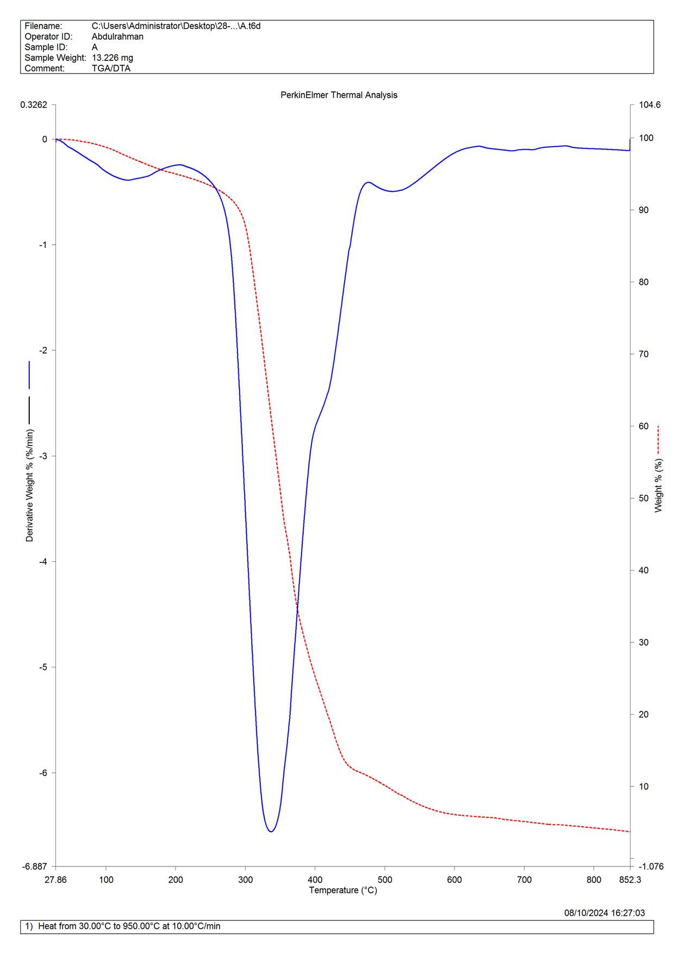
Fig 4a TGA plot on DE Fig 4b TGA/DTA plot on DE
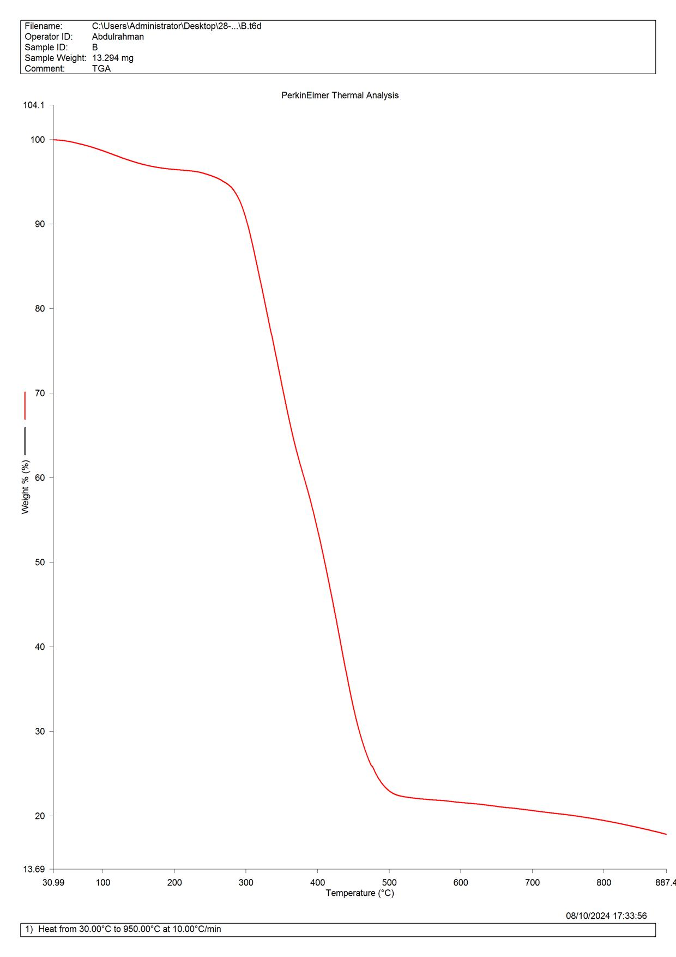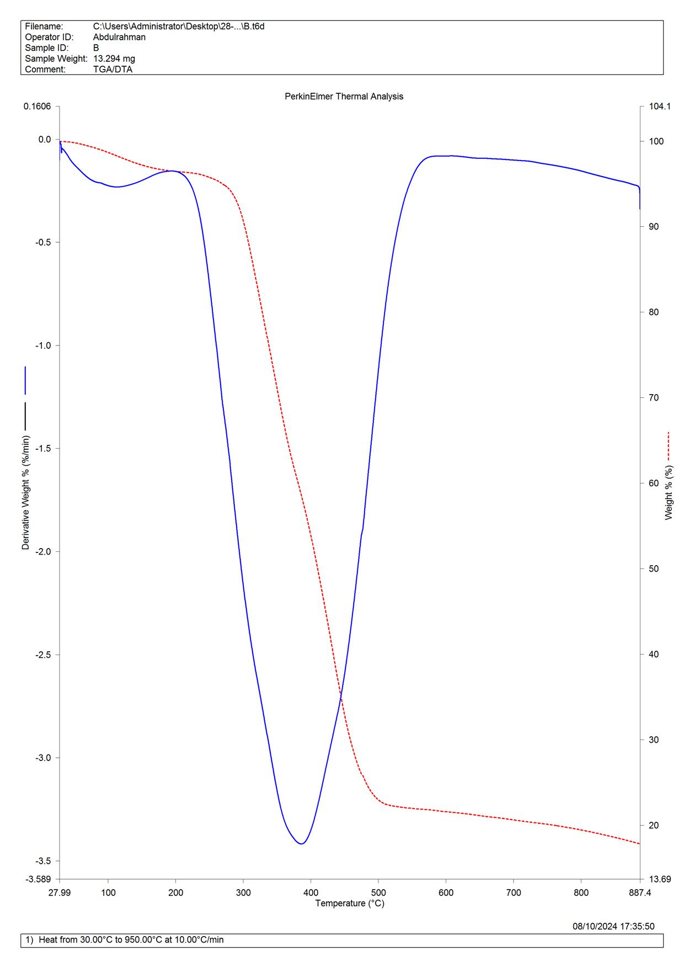
Fig 5a:TGA plot on PAS Fig 5b: TGA/DTA plot on PAS
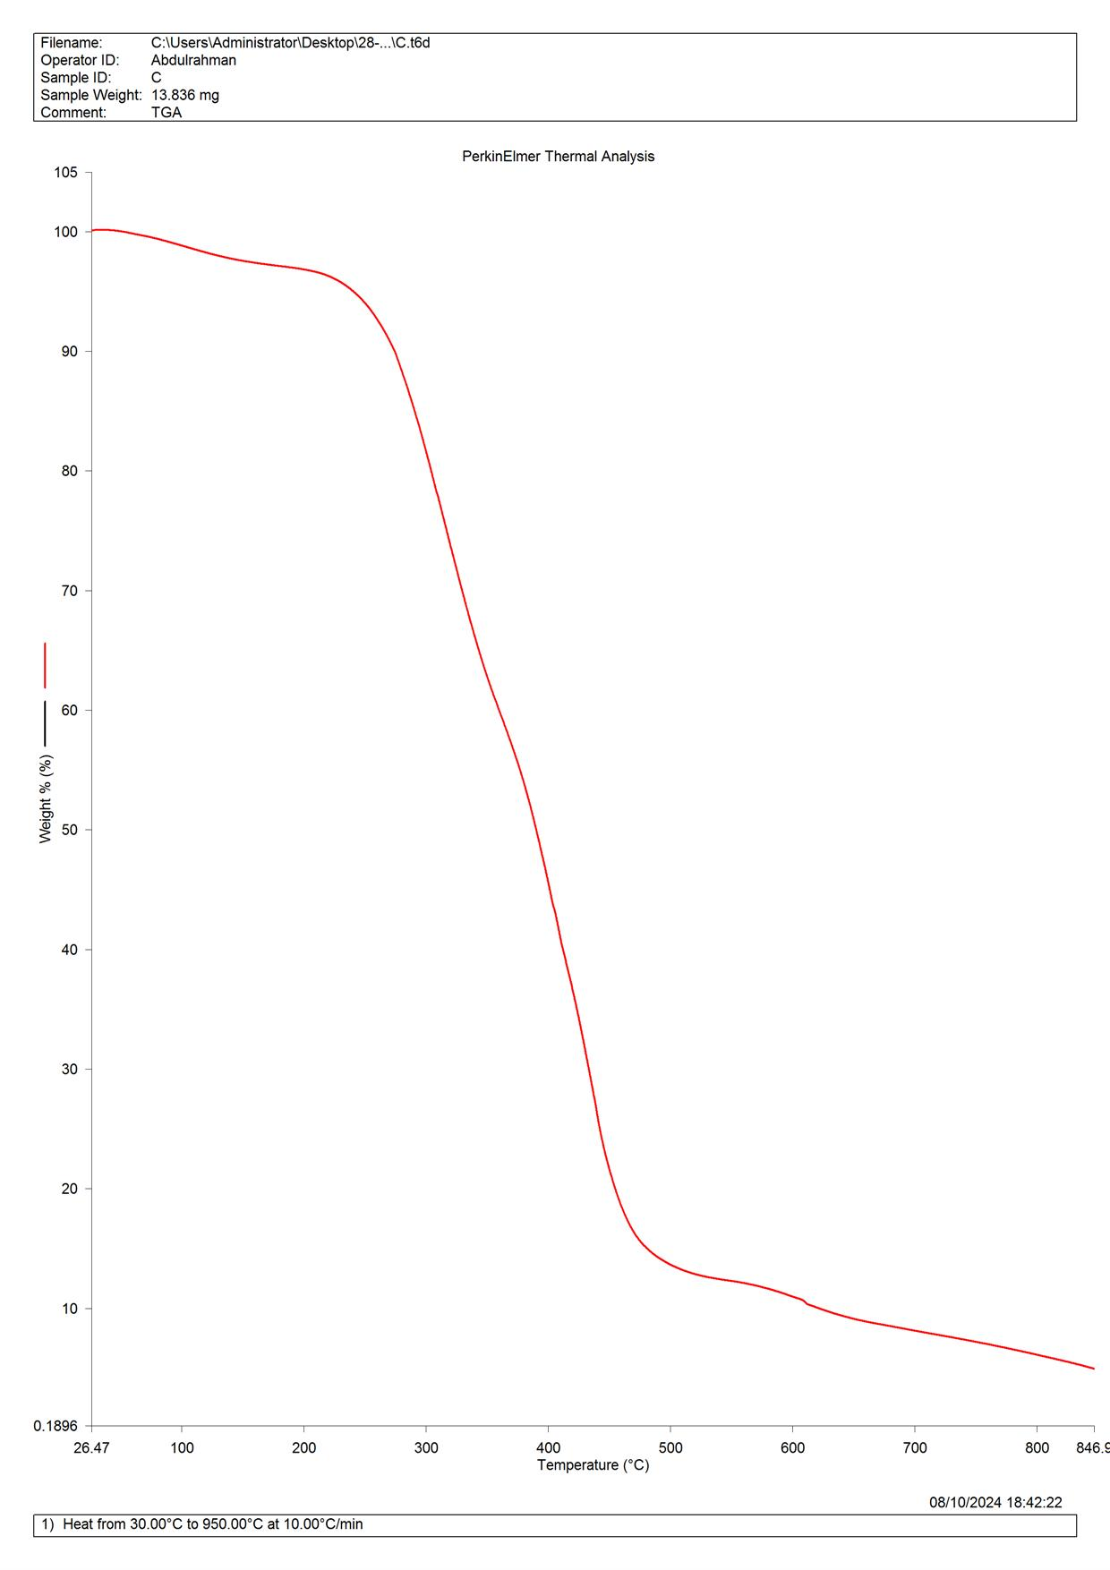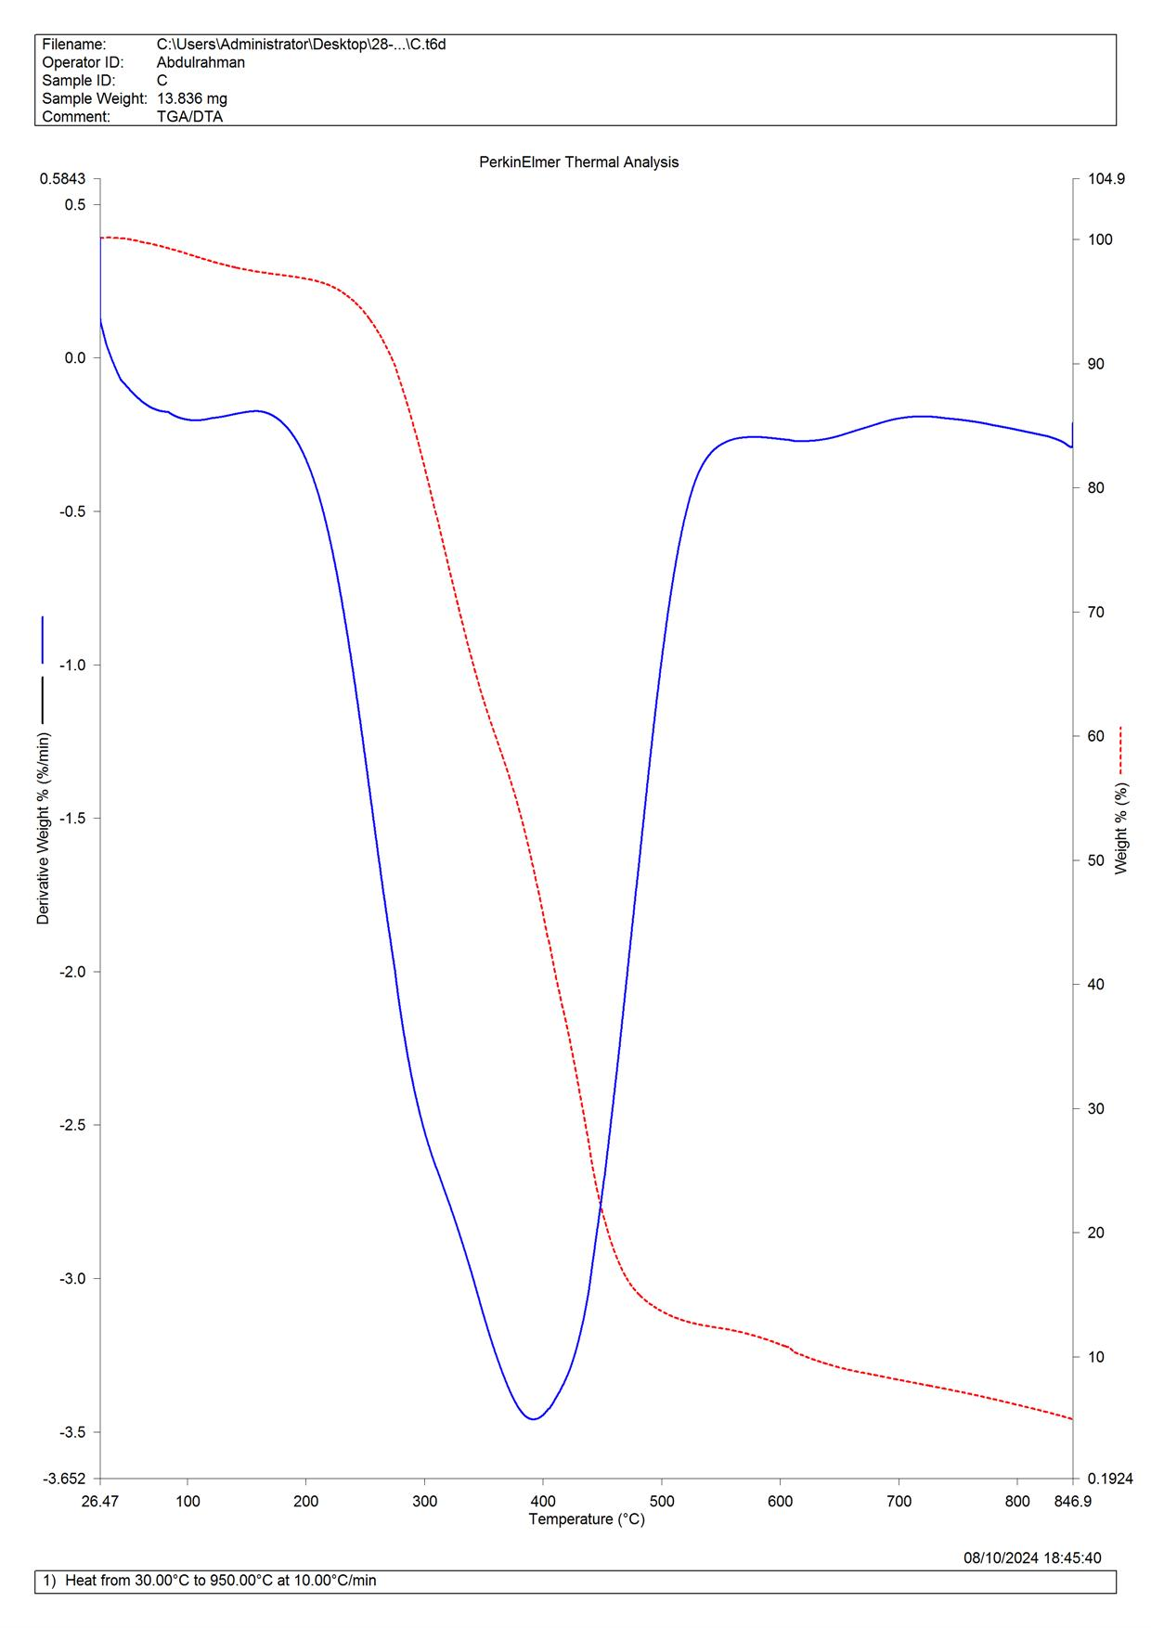
Fig 6a: TGA plot on DE/PAS Fig 6b: TGA/DTA plot on DE/PAS
Comparison of DE, PAS, and DE/PAS showed all materials were thermally stable up to ~300 °C, with major weight loss (~70–80%) occurring between 300–500 °C and final residues of 10–20% above 600 °C. DE degraded most rapidly (350–450 °C) with the strongest DTA peak, while PAS showed decomposition at 370–480 °C. The hybrid DE/PAS demonstrated the highest thermal stability, with delayed decomposition (~350–500 °C), weakest DTA peak, and controlled degradation behaviour.
Table 1 Comparison of the three plots
Features | DE | PAS | DE /PAS
Initial decomposition temperature | ~320°C | ~340°C | ~350°C
Major weight loss range | 350-450°C | 370-480°C | 380-500°C
Residual mass (~950°C) | ~15% | ~12% | ~10%
DTA peak temperature | ~400°C | ~420°C | ~430°C
Peak intensity (DTA Curve) | Strongest | Moderate | Weakest
The enhanced stability of DE/PAS is attributed to crosslinking between functional groups in DE (aromatic esters, ethers, O–H, C=O, C=C, etc.) and silanol (Si–OH) groups on PAS, forming strong covalent Si–O–Si linkages. This crosslinking improves mechanical integrity and thermal resistance. SEM micrographs further confirmed surface modification and grafting of DE onto PAS. Similar improvements in hybrid systems have been reported in previous studies (Sharma et al., 2017; Zhang et al., 2009; Krispyna et al., 2017; Subramanian et al., 2017).

Conclusion
The thermal performance of bio-based silica nanocomposites combining Dacryodes edulis extract (DE) and precipitated amorphous silica (PAS) demonstrated that the DE/PAS hybrid offers substantially enhanced thermal stability. The hybrid’s degradation onset (~350 °C) occurs at higher temperatures compared to PAS (~340 °C) and DE (~320 °C), with a delayed and more controlled weight loss within 300–500 °C, and a subdued DTA peak (~430 °C). In contrast, DE exhibited the most abrupt decomposition and strongest DTA response, signaling rapid organic breakdown. These observations align with findings from organic–inorganic hybrid coatings, where covalent linkage between phases (as in Class II systems) markedly improves thermal resistance and modulus through enhanced interfacial bonding.[45]
SEM analysis confirmed a rough, grafted surface indicating robust interfacial bonding—consistent with improved mechanical strength and adhesion reported in other functional hybrid coating systems
Because of its elevated thermal resistance and controlled degradation, the DE/PAS hybrid holds strong potential as an eco-friendly additive in high-performance coatings—offering anti-sagging, scratch resistance, and corrosion protection, while avoiding hazardous additives like chromium. This aligns with growing literature emphasizing the need for sustainable bio-based functional additives in coatings with multifunctional properties[43-45].
Beyond coatings, these findings pave the way for broader applications of bio-based hybrids in fields such as water purification, heavy metal sequestration, energy storage, and biomedical systems—areas increasingly explored in recent research on sustainable hybrid nanocomposites [42-43]
Conflict of interest
Non applicable
Ethical guidelines
Non applicable
References
- Sánchez, C., Julián, B., Belleville, P., & Popall, M. (2005). Applications of hybrid organic–inorganic
nanocomposites. Journal of Materials Chemistry, 15(35–36), 3559–3592. https://doi.org/10.1039/B509097K
- Kickelbick, G. (2007). Hybrid Materials: Synthesis, Characterization, and Applications. Wiley-VCH. https://doi.org/10.1002/9783527610485
- Barkalow, R.H. (1990). Precipitated silica: properties and applications. Journal of Coatings Technology, 62(785), 63–72. https://doi.org/10.1007/BF02695813
- Braun, D., Cherdron, H., & Kern, W. (2013). Polymer Synthesis: Theory and Practice. Springer. https://doi.org/10.1007/978-3-642-38557-3
- Raja, P.B., & Sethuraman, M.G. (2008). Natural products as corrosion inhibitors for metals in corrosive media – A review. Materials Letters, 62(1), 113–116. https://doi.org/10.1016/j.matlet.2007.04.079
- Rani, B.E.A., & Basu, B.B.J. (2012). Green inhibitors for corrosion protection of metals and alloys: An overview. International Journal of Corrosion, 2012, 1–15. https://doi.org/10.1155/2012/380217
- Agiriga, A.N., Umerie, S.C., & Onwuka, G.I. (2019). Phytochemical and nutritional composition of Dacryodes edulis. Journal of Food Science and Nutrition, 7(2), 456–463. https://doi.org/10.1002/fsn3.932
- Udo, I.U., & Udofia, U.S. (2016). Characterization of Dacryodes edulis extracts: potential industrial and medicinal applications. International Journal of Current Research in Biosciences and Plant Biology, 3(5), 56–64. https://doi.org/10.20546/ijcrbp.2016.305.007
- Sharif, M., et al. (2012). Organic–inorganic hybrid materials based on polyurethane fatty amide and TEOS: Improved thermal stability. Progress in Organic Coatings, 75(1–2), 45–52. https://doi.org/10.1016/j.porgcoat.2012.03.017
- Rohanizadeh, R., et al. (2008). Bioactive hybrid coatings for metals. Journal of Materials Science: Materials in Medicine, 19(10), 3385–3393. https://doi.org/10.1007/s10856-008-3490-8
- Zheludkevich, M.L., et al. (2005). Sol–gel coatings for corrosion protection of metals. Journal of Materials Chemistry, 15(48), 5099–5111. https://doi.org/10.1039/B510313B
- Soliman, Y.S., et al. (2013). Organic–inorganic hybrid coatings as corrosion protective layers. Surface and Coatings Technology, 235, 449–456. https://doi.org/10.1016/j.surfcoat.2013.07.007
- Vyazovkin, S., et al. (2011). ICTAC Kinetics Committee recommendations for performing kinetic computations on thermal analysis data. Thermochimica Acta, 520(1–2), 1–19. https://doi.org/10.1016/j.tca.2011.03.034
- Wendlandt, W.W. (1986). Thermal Analysis. Wiley-Interscience.
- Chen, X., et al. (2019). Enhanced thermal stability of organic/inorganic hybrid coatings. Progress in Organic Coatings, 132, 465–472. https://doi.org/10.1016/j.porgcoat.2019.04.030
- Sánchez, C. & Soler-Illia, G. (2000). Designed hybrid organic-inorganic nanocomposites: strategies, synthesis, and applications. Chemistry of Materials, 12(11), 3050–3053. https://doi.org/10.1021/cm000757h
- Khabaz, F., et al. (2018). Application of TGA/DTA in nanocomposite coatings characterization. Thermal Analysis and Calorimetry, 133(2), 759–772. https://doi.org/10.1007/s10973-018-7391-7
- Nicolás, E., et al. (2024). Enhanced thermal stability of nBG-loaded hybrid matrices. Materials Today Communications, 38, 107232. https://doi.org/10.1016/j.mtcomm.2024.107232
- Chen, X., et al. (2019). Thermal stability improvement of hybrid coatings with hydrolyzed TEOS. ACS Applied Materials & Interfaces, 11(34), 30912–30922. https://doi.org/10.1021/acsami.9b09441
- Kickelbick, G. (2015). Introduction to Hybrid Materials. Wiley-VCH. https://doi.org/10.1002/9783527684479
- Degussa AG. (1993). Precipitated Silica: Properties and Applications. Technical Bulletin Pigments.
- Musić S., Filipović-Vinceković, N. & Sekovanić L. (2011) . Precipitation of amorphous sio₂ particles and their properties Brazilian Journal of Chemical Engineering, 1(28), 89 – 94. https://doi.org/10.1590/S0104-66322011000100011
- Oguzie, E, E., Onuoha, G. N., Ejike E. N. (2007). Effect of Gongrenema latifolum extract on Aluminium corrosion in acidic and Alkaline media. Pigment and Resin Technology (36), 44 – 49. https://doi.org/10.1108/03699420710718751 .24 Omogbehin, A. S.,
- Momoh, S. A., & Yahaya H. (2010). Inhibitory action of Nicotiana tobacum extract in the corrosion of mild steel in HCL . Pacific Journal of science and Technology, 11(2), 455-462. (ISSN: 1545-0740). http://www.sciencepub.net/nature
- Udo, I. E., Gloria, O., Michael, H. (2016). Physiochemical characteristics of the exudate of Dacryodes edulis. J. Appl. Sci. Manage. 20 (1), 209 – 201. https://doi.org/10.4314/jasem.v20i1.25
- Omogbehin, A. S., Momoh, S. A., & Yahaya H. (2010). Inhibitory action of Nicotiana tobacum extract in the corrosion of mild steel in HCL . Pacific Journal of science and Technology, 11(2), 455-462. (ISSN: 1545-0740). http://www.sciencepub.net/nature27
- Oguzie, E, E., 27] Onuoha, G. N., Ejike E. N. (2007). Effect of Gongrenema latifolum extract on Aluminium corrosion in acidic and Alkaline media. Pigment and Resin Technology (36), 44 – 49. https://doi.org/10.1108/03699420710718751
28. Omogbehin, A. S., Momoh, S. A., & Yahaya H. (2010). Inhibitory action of Nicotiana tobacum extract in the corrosion of mild steel in HCL . Pacific Journal of science and Technology, 11(2), 455-462. (ISSN: 1545-0740). http://www.sciencepub.net/nature
29. Stuart, B. (2004). Infrared Spectroscopy: Fundamentals and Applications. Wiley. https://doi.org/10.1002/0470011149
30. Coates, J. (2006). Interpretation of Infrared Spectra: A Practical Approach. In Meyers, R.A. (Ed.),
31 Encyclopedia of Analytical Chemistry. Wiley. https://doi.org/10.1002/9780470027318.a5606
32. Silverstein, R.M., Webster, F.X., Kiemle, D.J., & Bryce, D.L. (2014). Spectrometric Identification of Organic Compounds (8th ed.). Wiley.
33. Pavia, D.L., Lampman, G.M., Kriz, G.S., & Vyvyan, J.A. (2015). Introduction to Spectroscopy (5th ed.). Cengage Learning
34. Agiriga, A.N., Edori, O.S., & Ujowundu, F.N. (2019). Phytochemical screening and antioxidant properties of Dacryodes edulis leaves. International Journal of Biochemistry Research & Review, 28(3), 1–8. https://doi.org/10.9734/ijbcrr/2019/v28i330142
35. Udo, I.F., Etim, E.I., & Nta, A.I. (2016). Phytochemical and proximate composition of Dacryodes edulis leaves. International Journal of Scientific and Research Publications, 6(9), 204–209.
36. Oguzie, E. E., Enenebeaku, C. K., Akalezi, C. O., Okoro, S. C., Ayuk, A. A., & Ejike, E. N. (2010). Adsorption and corrosion-inhibiting effect of Dacryodes edulis extract on low-carbon-steel corrosion in acidic media. Journal of Colloid and Interface Science, 349(1), 283–292. https://doi.org/10.1016/j.jcis.2010.05.027
37. Reader, C. J., & Nargiello, M. (2021). The use of engineered silica to enhance coatings. CoatingsTech Magazine.
38. [Anonymous]. (2013). Thermal stability and abrasion resistance of polyacrylate/nano-silica hybrid coatings. Iranian .Polymer Journal, 22, 465–471. https://doi.org/10.1007/s13726-013-0146-2 38]
39. Musa, M. A., et al. (2015). Use of natural gums as green corrosion inhibitors: an overview. International Journal of Industrial Chemistry, 6, 29–41. https://doi.org/10.1007/s40090-015-0040-1 39]
40. Encyclopedia reference: Thermogravimetric analysis overview. Wikipedia. Wikipedia
Nicolás, E., et al. (2024). Enhanced thermal stability of nBG-loaded hybrid matrices. Materials Today Communications, 38, 107232. https://doi.org/10.1016/j.mtcomm.2024.107232
41. Sharif, M., et al. (2012). Organic–inorganic hybrid materials based on polyurethane fatty amide and TEOS: Improved thermal stability. Progress in Organic Coatings, 75(1–2), 45–52. https://doi.org/10.1016/j.porgcoat.2012.03.017
42. Khalid, S., Chaudhary, M. N., Nazir, R., Ahmad, S. R., Hussain, N., Ayub, Y., & Ibrar, M. (2023). Biochar supported metallo-inorganic nanocomposite: A green approach for decontamination of heavy metals from water. PLoS ONE, 18(9), e0289069. https://doi.org/10.1371/journal.pone.0289069
43. Damiri, F., Andra, S., Kommineni, N., Balu, S. K., Bulusu, R., Boseila, A. A., ... & Cavalu, S. (2022). Recent advances in adsorptive nanocomposite membranes for heavy metal ion removal from contaminated water: A comprehensive review. Materials, 15(15), 5392. https://doi.org/10.3390/ma15155392
44. Kundu, P. P., & De, P. (1998). Influence of organic–inorganic interaction on thermal behavior of epoxy–silica composites. Journal of Applied Polymer Science, 70(13), 2639–2647. https://doi.org/10.1002/(SICI)1097-4628(19981014)70:13<2639::AID-APP15>3.0.CO;2-H
45. Korhonen, J. T., & Argyropoulos, D. S. (2023). Recent advances in bio-based functional additives for polymers. Progress in Materials Science, 139, 101186. https://doi.org/10.1016/j.pmatsci.2023.101186

