Dynamic changes of Forest Cover in Goalpara Forest Range: A Study on Notified Forest Areas (NFA’s) in Goalpara District

ABSTRACT:
The assessment of changes in forest cover is critical to the sustainable management of forest resources, particularly in notified forest areas (NFAs). These habitats provide vital habitat for several terrestrial creatures, including the huge Asian elephant that lives in the study area. In recent decades, several forest-related issues have arisen in the Goalpara, including encroachment, agricultural land expansion, and confrontations between humans and elephants.
To better understand the dynamics of forest cover alterations and their underlying causes, land use and land cover (LULC) pattern analysis has been carried out using Landsat imagery. Furthermore, GIS software has been used to analyze spatio-temporal changes in forest cover over a 30-year period, specifically the years 1993, 2003, 2013, and 2023. Additionally, future forest cover mappings were generated using the QGIS Molusce Plugin, with a focus on estimations for the year 2033.
The key findings of this study indicate that the total forest cover area of the range has been determined as 6663.74 ha (66.52%) in 1993, 6991.09 ha (69.79%) in 2003, 6308.69 ha (62.98%) in 2013, 5955.96 ha (59.45%) in 2023, and is projected to reach 4662.41 ha (53.55%) in 2033. The significant alterations in land use and land cover (LULC) classes include a decrease in Dense Forest (DF) by 1176.9 ha (-11.7%), an overall decrease in Open Forest (OF) by 497.2 ha (-5%), together with an increase in built-up area (BU) by 1977.7 ha (19.7%) and Agricultural Plantation (AP) by 458.1 ha (4.6%). Meanwhile, Moderate Forest (MF) experienced an increase of 238.9 ha (2.4%). The decline in DF and OF can usually be attributed to changes in the area, particularly the increase in non-forest regions. These areas, typically located near forest edges, are rapidly diminishing due to encroachment by human settlements.
Keywords: Forest cover dynamic, NFAs, satellite data and LULC, Goalpara forest range

- INTRODUCTION:
The forest is recognized as an essential component of the global terrestrial ecosystem, encompassing around 31% of the Earth's land surface (FAO, 2010; Xia, H., et al., 2023). Forest cover is recognized as a vital indicator of environmental conditions (Keenan, RJ, et al., 2015), providing numerous benefits to human beings, such as fresh water and the regulation of water flow (Ssentongo A.A. et al., 2017). Forests provide unparalleled species richness and diversity compared to any other terrestrial environment (Medhi and Kar, 2016). Forests are an indispensable component of our environment; they preserve environmental and ecological balance through energy exchange, carbon cycling, and climate change (Yuan et al., 2020), ensuring that ecosystems remain balanced on both regional and global scales among humans, plants, animals, and other abiotic components (Liu et al., 2020). The global forest cover serves as a crucial indicator of the planet's health, playing a vital role in sustaining life on Earth (Pan, Y., et al., 2011; www.worldwildlife.org).
Monitoring of forest cover on both global and regional levels has facilitated the identification of suitable locations for the establishment of protected areas aimed at biodiversity conservation, where biodiversity is significantly under-protected (Myers et al., 2000; Ghosh-Harihar et al., 2019). This is because protected areas serve as the only shelter for numerous species that inhabit underneath them. The India State of Forest Report (ISFR, 2019) reveals an increase in forest cover by 3,97,600 ha from 2017 to 2019. However, in contrast, the northeastern region of India, including Assam, Mizoram, Nagaland, and Manipur, has faced a loss of 387,700 hectares of forest cover from 2013 to 2023. The total recorded forest area in Assam is reported to be 26,83,200 ha, which constitutes 34.21% of the total geographical area, which is a combined area of 17,864 ha that has been identified as Reserved Forest, while 8,968 ha was categorized as Unclassed Forest (ISFR, 2019). The Goalpara district spans a recorded forest area of 36,430.83 ha, which is split into 103 No’s, in which there are 56 reserved forests (RF) and 47 protected reserved forests (PRF). The notified forest areas include 5,278.64 ha of reserved forest and 2,743.50 ha of protected reserved forest, with reports indicating that these areas have already undergone human encroachment (Pathak, Bhaskar, et al., 2025). Nonetheless, earlier investigations indicate that the district is experiencing a decline in forest cover at a rate of 0.64% annually (Deka, Sangeta, et al., 2019). The decrease in forest area was significant, dropping from 38,900 ha in 1999 (21.33%) to 33,700 ha in 2011 (18.48%). (Rabha K. Bipul, 2016).
Despite the growing recognition of the importance of forest ecosystems, global deforestation rates have remained disturbingly elevated in recent decades (FAO, 2010). Even so, just like as a result of illegal cutting, overgrazing, clearing land for agricultural expansion, and wildfires, the world's forests continue to diminish annually, leading to a reduction in overall forest cover area (FRA, 2020). A comprehensive assessment possesses significant importance as resources change across different locations and times due to human activities, which leads to deteriorating forest ecosystems and ecological stability. Remote sensing serves as a powerful method for evaluating spatio-temporal patterns in land cover and forest cover changes (Mahato, R., et al., 2021). This procedure provides extensive information regarding land cover usage across local, regional, and global scales, while aerial photographs over time can be costly and not readily accessible to all (Baumann et al., 2012).

- OBJECTIVE:
The major objectives of present study are:
- To assess the spatio-temporal analysis of forest cover change in the study area and
- To quantify the land use and land cover change as well as the forest cover area within the National Forest Areas (RF/PRF’s) under the Goalpara forest range
3. DATABASE AND METHODOLOGY:
3.1 STUDY REGION:
The Goalpara forest division consists of four forest ranges: Rangjuli, Krishnai Central, Goalpara Sadar, and Lakhipur Forest Range. It encompasses a total of 103 no’s of notified forest areas (NFAs) and is situated in the western part of Assam. The Goalpara Sadar Range, also known as the Goalpara Range, is situated in the northwestern part of the district, close to Goalpara town, which serves as the district's administrative headquarters. It is bordered to the east by the Krishnai forest range, while the Dhubri and Bongaigaon districts and the Brahmaputra River lie to the west. To the south, it is adjacent to the Lakhipur forest range, and to the north and west, it is bordered by the Brahmaputra River. The area is situated between the latitudes of 26°02'42'' N and 26°12'6'' N and the longitudes of 90°22'47'' E to 90°45'50'' E, encompassing a total geographical extent of 37148.31 ha. The study area consists of 18 NFAs, which include ten (10) RFs and eight (08) PRFs (DFO, Goalpara, 2023), encompassing a total geographical area of 10,017 ha, representing 5.49% of the district's total geographical area. The largest NFAs include Rakshini PRF at 2589.63 ha, followed by Dohikata RF at 1362.49 ha, Bagulamari PRF at 1220.76 ha, and Nolonga RF at 1055.87 ha, as illustrated in table 3/fig 1.
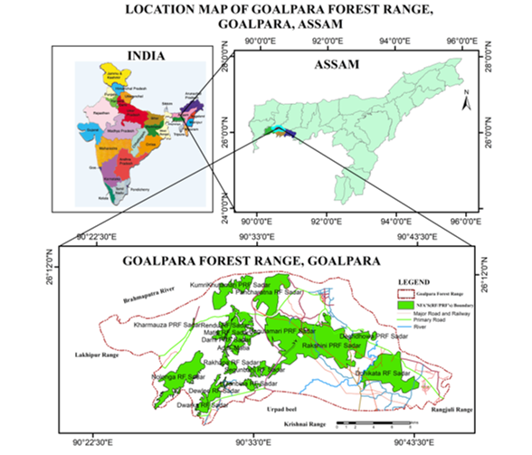
Figure 1: Depicting the location map of the Goalpara forest range along with the corresponding NFA’s (RF/PRF’s), located in Goalpara, Assam.

3.2 SATELLITE DATA:
The thorough quantitative evaluation relies on satellite data and field research. The satellite data were obtained from USGS Earth Explorer (https://earthexplorer.usgs.gov/). Utilizing data regularities and consistency, Landsat satellite imagery was employed to evaluate spatio-temporal changes in forest cover and land use/land cover for the years 1993 (January), 2003 (January), 2013 (December), and 2023 (January) (figure 2). Additionally, the imagery underwent preprocessing, including radiometric correction, mosaicking, and subsetting, utilizing Erdas Imagine 2015 software.

3.3 LAND USE-LANDCOVER (LULC) CLASSIFICATION:
LULC was prepared using a supervised classification algorithm, which is one of the most commonly utilized methods for image classification (Garedew, E., et al., 2009; Munsi, et al., 2010). The LULC classification utilized eight distinct classes: water bodies (WB), low-lying area (LL), barren land (BL), built-up area (BU), cropland (CL), agricultural plantation (AP), dense forest (DF), moderate forest (MF), and open forest (OF).
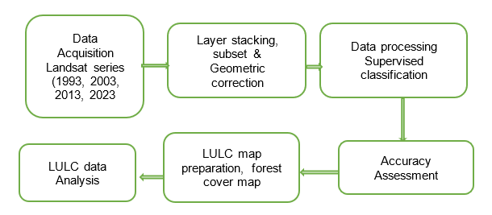

Figure 2: Flow chart of methodology

  - FOREST COVER CHANGE ANALYSIS:
To assess changes in forest cover, forest categories were derived from land use and land cover classifications, which include agriculture plantation (AP), dense forest (DF), moderate forest (MF), and open forest (OF). Additionally, to illustrate changes in forest areas within the boundaries of the NFA, union geoprocessing tools were utilized in ArcGIS software v-10.3 ( https://desktop.arcgis.com ).

4. RESULT AND DISCUSSION:
4.1. Forest Cover Analysis:
4.1.1. Overall Forest Cover Change in Goalpara forest range:
The total forest cover in the Goalpara forest range has been recorded as 36.65% (13,615.7 ha) in 1993, 37.22% (13,825.15 ha) in 2003, 36.38% (13,513.34 ha) in 2013, 35.35% (13,130.9 ha) in 2023, and 31.46% (11,686.86 ha) in 2033 (table 1). We conducted an analysis of decadal variations in the forest cover area to assess the intensity of changes in forest cover across different periods. During the period from 1993 to 2003, there was an increase in forest cover of 209.34 hectares (+0.56). However, thereafter this period of time, forest cover has been on a continuous decline, with a decrease of 311.81 ha (-0.84%) from 2003 to 2013 and an additional decrease of 382.42 ha (-1.03%) from 2013 to 2023. The predictive estimation for the period of 2023-2033 indicates a significant declining rate of -3.89% (1444.05 ha). Moreover, it has been noted that from 1993 to 2023, the study area has experienced a loss of approximately 484.87 ha (-1.31%). It has been observed that forest cover outside the NFA's has increased, which was caused by the rise in agricultural plantations in the Char area and the expansion of rubber plantations in local villages (figure 3).
Table 1: Forest cover and Non-forest area of Goalpara forest range, Goalpara
Year | 1993 |  | 2003 |  | 2013 |  | 2023 |  | 2033(Predictive)
Change | ha | % | ha | % | ha | % | ha | % | ha | %
Forest Cover | 13615.79 | 36.65 | 13825.15 | 37.22 | 13513.34 | 36.38 | 13130.91 | 35.35 | 11686.86 | 31.46
Non-Forest | 23532.53 | 63.35 | 23306.69 | 62.74 | 23680.35 | 63.75 | 24017.53 | 64.65 | 25507.42 | 68.66
Session | 1993-2003 |  | 2003-2013 |  | 2013-2023 |  | 1993-2023 |  | 2023-2033(Predictive)
Forest Cover | 209.36 | 0.56 | -311.81 | -0.84 | -382.42 | -1.03 | -484.87 | -1.31 | -1444.05 | -3.89

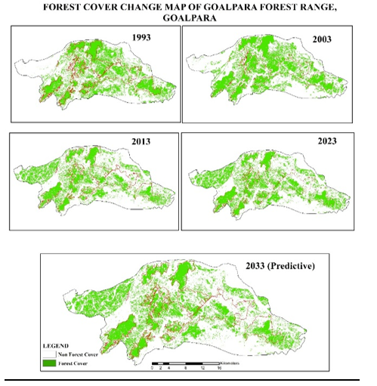

Figure 3: Showing the forest cover map of the Goalpara forest area boundary from 1993 to 2033 (predictive).
4.1.2. Forest Cover Change within NFA’s in Goalpara forest range:
The forest cover within NFA has experienced significant changes over the 30-year period from 1993 to 2023, as illustrated in figure 5 and table 2. During this time period, the area of forest cover has consistently decreased, while the non-forest area has increased. The total forest cover area of the range was recorded as 6663.74 ha (66.52%) in 1993, 6991.09 ha (69.79%) in 2003, 6308.69 ha (62.98%) in 2013, 5955.96 ha (59.45%) in 2023, and is projected to be 4662.41 ha (53.55%) in 2033. The most significant decrease in forest cover recorded between 2003 and 2013 was 682.39 ha (-6.81%), followed by a reduction of 352.74 ha (-3.52%) from 2013 to 2023. In contrast, a positive change of 327.35 ha (3.27%) was observed during the period from 1993 to 2003. There has been a total forest cover loss of 707.78 ha (-7.07%) in the study area from 1993 to 2023, resulting in an annual forest loss of 23.59 ha (-0.25%). The predictive modelling results for 2033 indicate a continuous decline in forest area, amounting to 5,363.32 ha (53.55%), alongside a loss of 591 ha (-5.91%) from previous decades. Consequently, the non-forest area has expanded from 3353.88 ha (33.48%) in 1993 to 4062.39 ha (40.55%) in 2023.
Table 2: Forest cover and non-forest cover area of NFAs under Goalpara range

Year | 1993 |  | 2003 |  | 2013 |  | 2023 |  | 2033
Area | ha | % | ha | % | ha | % | ha | % | ha | %
Forest cover | 6663.74 | 66.52 | 6991.09 | 69.79 | 6308.69 | 62.98 | 5955.96 | 59.45 | 5364.32 | 53.55
Non-Forest | 3353.88 | 33.48 | 3026.52 | 30.21 | 3717.45 | 37.11 | 4062.39 | 40.55 | 4662.41 | 46.54
Session | 1993-2003 |  | 2003-13 |  | 2013-23 |  | 1993-23 |  | 2023-33
Change | ha | % | ha | % | ha | % | ha | % | ha | %
Forest cover | 327.35 | 3.27 | -682.39 | -6.81 | -352.74 | -3.52 | -1299.41 | -12.97 | -944.37 | -5.91
Non- Forest | -327.36 | -3.27 | 690.93 | 6.90 | 344.93 | 3.44 | 708.51 | 7.07 | 600.02 | 5.99

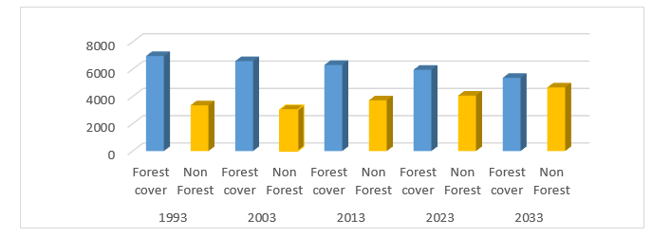
Figure 4: Illustrating Forest and Non-forest area NFA’s under Goalpara range

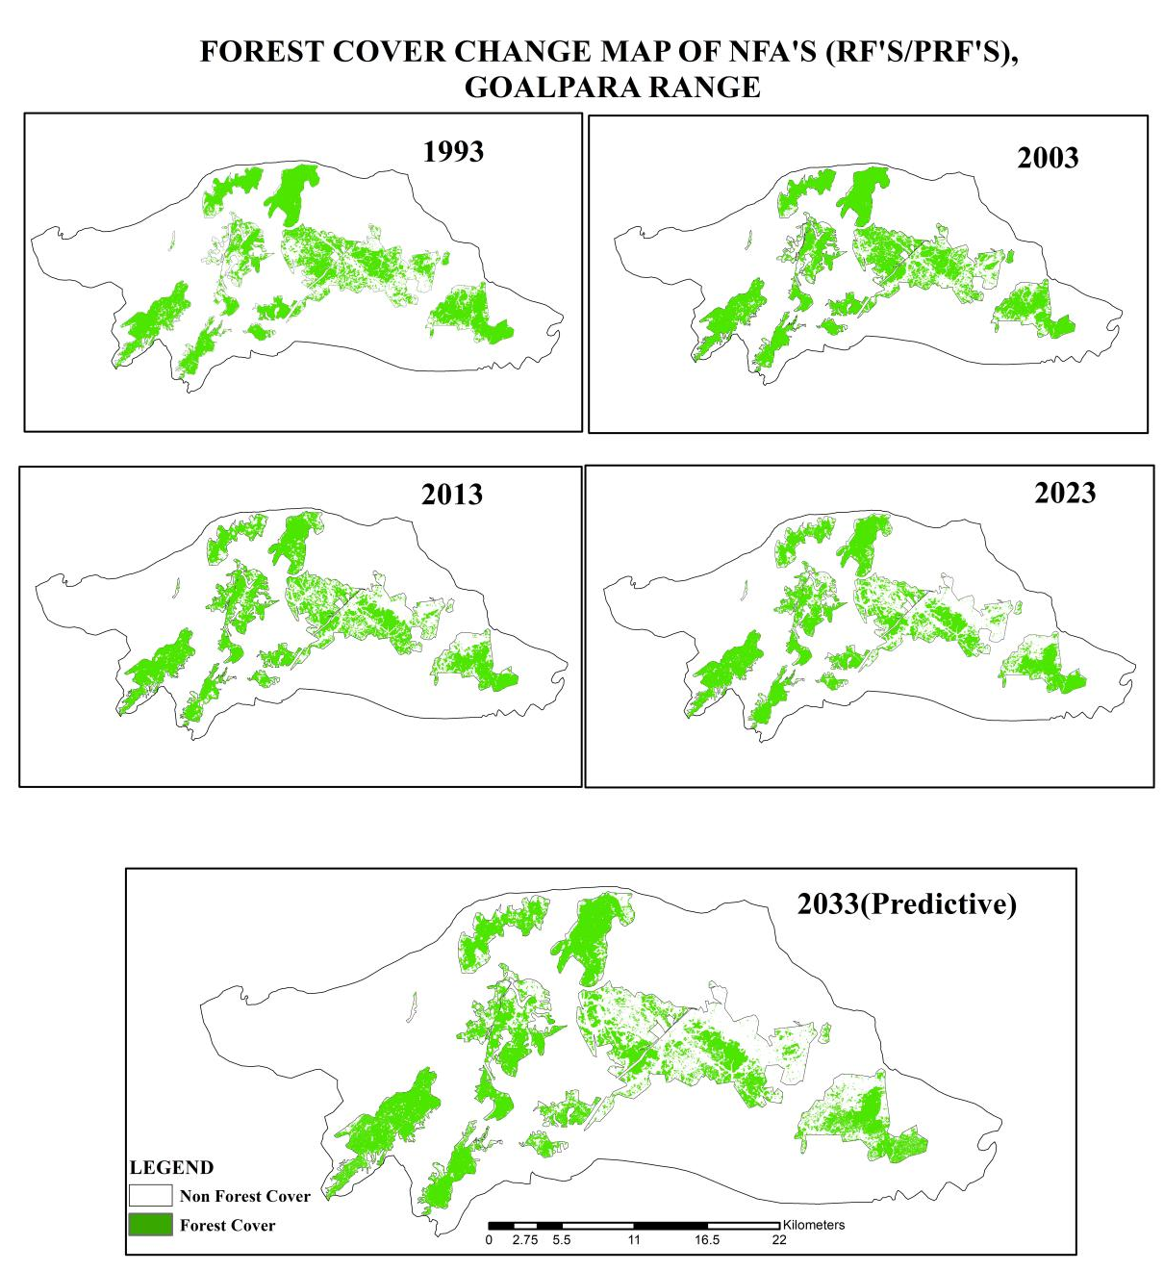
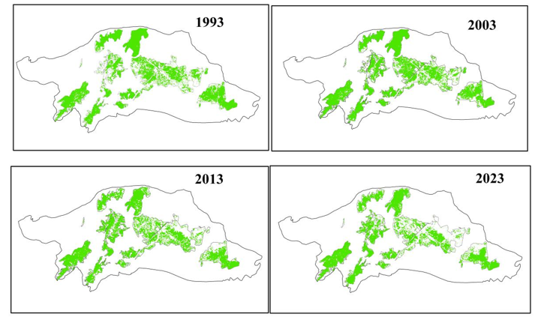
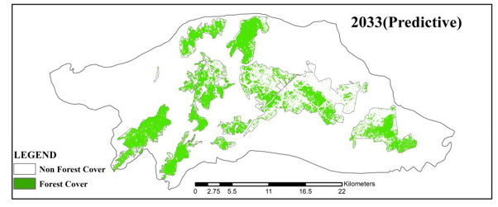
Figure 5: Illustrating Forest and Non-forest Area NFAs under Goalpara Range
4.1.3. FOREST COVER CHANGE IN NFA’S IN GOALPARA FOREST RANGE:
The distribution of changes in forest cover within the boundaries of the NFA in the study area has been found to be highly dynamic. Observations indicate that the forest area varies both spatially and temporally over different time periods (table 4). The analysis reveals significant alterations in forest cover.

Forest cover changes within NFA’s 1993-2003:
Throughout this time period, the overall forest area has increased by 273.6 hectares (1.55%). While spatially some areas of the NFA have experienced significant forest loss, such as Segunbahi RF with a decrease of 55 ha (-23%), Bagulamari PRF losing 145 ha (-11%), and Kumrikhutamari PRF down by 58 ha (-9.5%), there are also instances of forest area gains in other NFAs. Notably, Dewlee PRF has increased by 4.6 ha (17.9%), Rakhapa RF has gained 31.7 ha (+15.9%), Matia RF has expanded by 130.9 ha (+15.4%), and Rendu RF has grown by 27 ha (+14.4%).
Forest cover changes within NFA’s 2003-2013:
Overall forest area in NFAs in the time interval has been observed to decrease by a total of 679.2 ha (-6.2%) as compared to the previous year (2003). The major losses of forest cover within forest area boundaries are Deghdhowa PRF 10.8 ha (-34.3%), Ganbina RF 41 ha (32.1%), Dewlee RF 39 ha (-16%), and Bugulamari PRF 143.4 ha (-11%), respectively, while forest cover gains are found only in Rendu RF 38.2 ha (+20.4%), Segunbhahi RF 9.6 ha (4%), and Nolonga RF 37.2 ha (3.5%).
Forest cover changes within NFA’s 2013-2023:
During this time period, it is evident that the forest area has decreased by 80 hectares, representing a decline of 3.4% compared to previous years. Significant alterations in forest area have been observed in Rendu RF 35ha (-18.9%), Kharmuza PRF 2ha (-12%), Additional Matia 3.7ha (-13.3%), and Buglamari PRF 126 ha (-10.4%). Conversely, forest area increases have been noted in Deghdhowa PRF 6.1ha (19.4%), Delwee 31ha (13%), and Kumrikhutamari PRF 65.6 ha (+10.7%).

Forest cover changes within NFA’s 2023-2033(Predictive):
The predictive mapping for the year 2033 indicates that forest area will decrease by up to 4973.1 ha (53%), reflecting a loss of 974.1 ha (-6.3%) compared to 2023. Within the NFA’s Rendu RF, there is a significant decrease of 20.8% over an area of 39.1 ha, while Dewlee RF has seen a reduction of 20.1% across 49 ha. Segunbahi RF follows with a decline of 20% over 48.2 ha. In contrast, Additional Matia has experienced an increase of 3.8 ha, representing a growth of 13.7%, which is the only area showing a positive change of 3.8 ha (+13.7%).
The assessment indicates a decline in forest cover area over the past three decades, resulting in a total loss of -1299.41 ha (-12.97%). The most significant amount of forest decline was observed between 2003 and 2013, with a rate of -6.2%. This trend is projected to persist, with an anticipated decline of -6.3% per decade through 2033. It has been observed that among the NFAs, six have already lost more than 50% of their forest cover since 1993, while seven others have experienced a loss of 30-50% in forest cover, and ten NFAs have lost less than 30% of their forest cover. The rate of forest cover loss in the Goalpara forest range exhibits spatial variation based on location. This is attributed to changes in land use and land cover patterns, which directly influence forest cover changes within specific forest boundaries, as illustrated in figure 7.
Table 3: Forest cover change area in specific NFA’s area under Goalpara forest range
Name of the RF/PRF's | Year | 1993 |  | 2003 |  | 2013 |  | 2023 |  | 2033
Name of the RF/PRF's | Total Area  (ha) | Forest cover  (ha) | % | Forest cover  (ha) | % | Forest cover  (ha) | % | Forest cover  (ha) | % | Forest cover  (ha) | %
Addl_Matia | 27.7 | 17.4 | 62.6 | 17.3 | 62.4 | 12.1 | 43.5 | 10.4 | 37.3 | 14.2 | 51.1
Bagulamari PRF | 1220.8 | 918.6 | 75.2 | 772.8 | 63.3 | 629.4 | 51.6 | 503.0 | 41.2 | 423.8 | 34.7
Darni PRF | 199.7 | 33.4 | 16.7 | 42.7 | 21.4 | 132.3 | 66.2 | 131.0 | 65.6 | 108.6 | 54.4
Deghdhowa PRF | 31.4 | 19.0 | 60.5 | 18.1 | 57.7 | 7.4 | 23.4 | 13.4 | 42.8 | 12.9 | 41.1
Dewlee RF | 245.0 | 220.3 | 89.9 | 233.7 | 95.4 | 194.0 | 79.2 | 225.9 | 92.2 | 176.6 | 72.1
Dewlee_addn PRF | 25.6 | 16.2 | 63.4 | 20.8 | 81.2 | 18.8 | 73.2 | 18.2 | 71.1 | 13.2 | 51.5
Dohikata RF | 1362.5 | 1053.6 | 77.3 | 972.3 | 71.4 | 838.2 | 61.5 | 830.9 | 61.0 | 683.5 | 50.2
Dwarka RF | 185.4 | 138.9 | 74.9 | 160.0 | 86.3 | 141.7 | 76.4 | 151.4 | 81.7 | 150.0 | 80.9
Ganbina RF | 128.3 | 115.3 | 89.9 | 122.7 | 95.6 | 81.5 | 63.5 | 91.9 | 71.6 | 74.9 | 58.4
Kharmauza PRF | 16.8 | 5.5 | 33.0 | 6.2 | 37.0 | 5.3 | 31.5 | 3.3 | 19.5 | 1.9 | 11.0
Kumrikhutamari PRF | 611.4 | 508.7 | 83.2 | 450.5 | 73.7 | 363.8 | 59.5 | 429.4 | 70.2 | 362.4 | 59.3
Matia RF | 850.1 | 439.5 | 51.7 | 570.4 | 67.1 | 479.7 | 56.4 | 515.7 | 60.7 | 431.4 | 50.8
Nolonga RF | 1055.9 | 918.7 | 87.0 | 899.0 | 85.1 | 936.1 | 88.7 | 960.4 | 91.0 | 801.2 | 75.9
Pancharatna RF | 838.8 | 820.6 | 97.8 | 820.0 | 97.8 | 706.6 | 84.2 | 709.8 | 84.6 | 678.1 | 80.8
Rakhapa RF | 199.1 | 136.5 | 68.6 | 168.2 | 84.5 | 170.3 | 85.5 | 174.2 | 87.5 | 154.2 | 77.5
Rakshini PRF | 2589.6 | 1337.0 | 51.6 | 1198.7 | 46.3 | 1010.1 | 39.0 | 915.7 | 35.4 | 710.8 | 27.4
Rendu RF | 187.6 | 62.8 | 33.5 | 89.8 | 47.9 | 128.0 | 68.2 | 92.5 | 49.3 | 53.5 | 28.5
Segunbahi RF | 241.3 | 216.4 | 89.7 | 160.9 | 66.7 | 170.5 | 70.7 | 170.2 | 70.5 | 122.0 | 50.6
Total Area | 10017 | 6978.4 | 67.0 | 6706 | 68.9 | 6025.6 | 62.4 | 5965.3 | 59.4 | 4973.1 | 53.1

4.2 LULC change analysis:
4.2.1 LULC change trend analysis within NFA’s:
The patterns of land use and land cover significantly influence the transformation of forested areas. The Goalpara district exhibits a highly dynamic pattern of land use and land cover change over time, influenced by demographic shifts and the expansion of urban areas. The dynamic changes in land use and land cover within forested areas have resulted in forest degradation, as illustrated in figures 6-7 and table 4. Various land use and land cover types have been identified in the NFA’s areas, with the primary cause of forest cover loss being the expansion of built-up areas. In the LULC category, agricultural plantation, dense forest, moderate forest, and open forest are classified as forest land, whereas BL, BU, LL, WB, and CL are categorized as non-forest land. The forest categories are highly dynamic, as illustrated in Figure 6 and Table 4. The analysis of LULC change over time in the study area is presented as follows:
Changes of LULC during 1993-2003:
During this time, important changes in land use and land cover patterns were distinctly categorized into forest types (i.e., DF, MF, OF, and AP) and non-forest types (i.e., BU, LL, WB, CL, and BL). Significant increases have been observed in the areas of DF at 325.7 ha (3.3%), BU at 609.3 ha (6.1%), and BL at 316.3 ha (3.2%). Conversely, there have been decreases in the classes of CL at 524 ha (-5.2%), OF at 215.3 ha (-2.1%), LL at 256.7 ha (-2.6%), and AP at 211.4 ha (-2.1%).
Changes of LULC during 2003-2013:
The land use and land cover pattern is distinctly categorized into forest types, including DF, MF, OF, and AP, as well as non-forest types, which comprise BU, LL, WB, CL, and BL. Significant increases have been identified in the following areas: OF 524.4 ha (3.3%), BU 889.6 ha (8.9%), AP 332.9 ha (3.3%), and CL 203.2 ha (2%). Conversely, decreases were observed in the classes of DF 1019.9 ha (-10.2%), BL 711.6 ha (-7.1%), MF 165.9 ha (-1.7%), OF 215.3 ha (-2.1%), and LL 256.7 ha (-2.6%).
Changes of LULC during 2013-2023:
The land use and land cover pattern is distinctly categorized into forest types (including DF, MF, OF, and AP) and non-forest types (such as BU, LL, WB, CL, and BL). Significant increases have been observed in the following areas: OF 524.4 ha (3.3%), BU 478.9 ha (4.8%), MF 453.6 ha (4.5%), AP 336.7 ha (3.4%), LL 305.7 ha (3.1%), and CL 203.2 ha (2%). Conversely, decreases were noted in the classes of DF 482.6 ha (-4.8%), MF 453.6 ha (4.5%), and OF 804.6 ha (-8.0%).
Changes of LULC during 1993-2023:
Throughout the extensive 30-year period from 1993 to 2023, the forest cover category exhibited a decline in OF by 806.2 ha (-5.0%) and in DF by 482.6 ha (-11.7%). Conversely, the AP experienced an increase of 336.7 ha (4.6%), while MF rose by 453.6 ha (2.4%). On the other hand, BU alone has experienced a constant increase in the non-forest category, expanding by 478.9 ha (19.7%). In contrast, other non-forest lands are exhibiting a decline, such as BL with a decrease of 4.9% and CL with a decrease of 5.4%, among others. The alterations in the forest category of land use and land cover classes indicate a significant decline in dense forest areas, typically located near the forest edge, primarily due to encroachment by human settlements (Figure 6). It has also been observed that the core areas of NFA have been declining, while MF areas have seen a slight increase. This trend indicates a transition from core forest land to forest degradation. The area of agricultural land has been on the rise due to the conversion of isolated hills and fragmented forest land into various monoculture activities, including rubber plantations and banana cultivation.
Table 4: LULC change area in different category within the NFA’s under Goalpara forest range from 1993-2023
Class | 1993 |  | 2003 |  | 2013 |  | 2023 |  | 1993-2003 |  | 2003-2013 |  | 2013-2023 |  | 1993-2023
Class | ha | % | ha | % | ha | % | ha | % | ha | % | ha | % | ha | % | ha | %
AP | 449.2 | 4.5 | 237.8 | 2.4 | 570.7 | 5.7 | 907.4 | 9.1 | -211.4 | -2.1 | 332.9 | 3.3 | 336.7 | 3.4 | 336.7 | 4.6
BL | 1215.0 | 12.1 | 1531.2 | 15.3 | 819.7 | 8.2 | 727.0 | 7.3 | 316.3 | 3.2 | -711.6 | -7.1 | -92.7 | -0.9 | -92.7 | -4.9
BU | 368.8 | 3.7 | 978.1 | 9.8 | 1867.7 | 18.6 | 2346.6 | 23.4 | 609.3 | 6.1 | 889.6 | 8.9 | 478.9 | 4.8 | 478.9 | 19.7
CL | 791.3 | 7.9 | 267.3 | 2.7 | 470.4 | 4.7 | 254.6 | 2.5 | -524.0 | -5.2 | 203.2 | 2.0 | -215.9 | -2.2 | -215.9 | -5.4
DF | 1965.2 | 19.6 | 2290.9 | 22.9 | 1270.9 | 12.7 | 788.3 | 7.9 | 325.7 | 3.3 | -1019.9 | -10.2 | -482.6 | -4.8 | -482.6 | -11.7
LL | 737.2 | 7.4 | 480.5 | 4.8 | 426.6 | 4.3 | 732.3 | 7.3 | -256.7 | -2.6 | -53.9 | -0.5 | 305.7 | 3.1 | 305.7 | 0.0
MF | 1550.8 | 15.5 | 1502.0 | 15.0 | 1336.1 | 13.3 | 1789.7 | 17.9 | -48.8 | -0.5 | -165.9 | -1.7 | 453.6 | 4.5 | 453.6 | 2.4
OF | 2889.0 | 28.8 | 2673.7 | 26.7 | 3198.0 | 31.9 | 2391.8 | 23.9 | -215.3 | -2.1 | 524.4 | 5.2 | -806.2 | -8.0 | -806.2 | -5.0
WB | 50.3 | 0.5 | 55.6 | 0.6 | 56.8 | 0.6 | 79.4 | 0.8 | 5.4 | 0.1 | 1.2 | 0.0 | 22.6 | 0.2 | 22.6 | 0.3
Total | 10017 | 100 | 10017 | 100 | 10017 | 100 | 10017 | 100

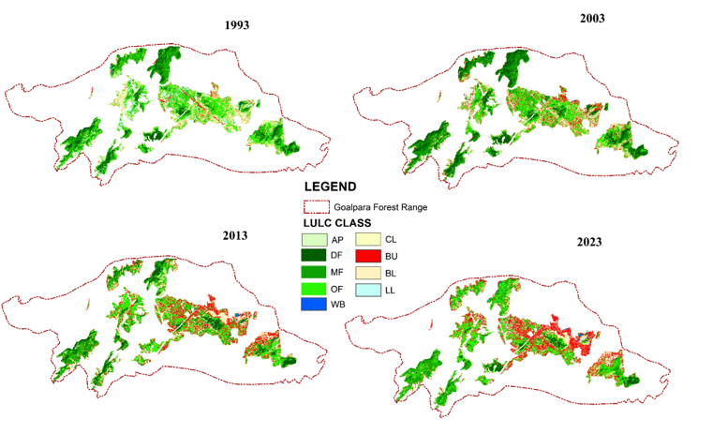
Figure 6: Showing the LULC change map of within NFA’s under Goalpara forest range

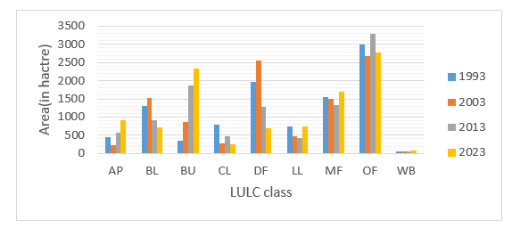
Figure 7: LULC area of NFA’s of in under Goalpara forest range

4.2.2. Accuracy assessment:
Accuracy assessment performed post-classification for validation of classified image. In table 6 shown the whole accuracy table of four different time periods (i.e. 1993, 2003, 2013, and 2023). Based on User Accuracy (UA), Producer Accuracy (PA), Omission Accuracy (OA), and Commission Accuracy (CA) accuracy the overall accuracy and kappa coefficient have been calculated (table 5). The overall accuracy and Kappa coefficient was found 88.4%, 0.84 in 1993, 95%, 0.84 in 2003, 88.4%, 0.85, in 2013 and its 88.4%, 0.84 in 2023 respectively. The highest overall accuracy was found 95% in the year 2013 and maximum value of Kappa value found 0.85 in the 2023. The average overall accuracy of whole classified LULC is found 89.75%.
Table 5: Validation of LULC result
CLASS | 1993 |  |  |  | 2003 |  |  |  | 2013 |  |  |  | 2023
CLASS | UA% | PA% | OA% | CA% | UA% | PA% | OA% | CA% | UA% | PA% | OA% | CA% | UA% | PA% | OA% | CA%
CL | 96.4 | 91.6 | 3.5 | 3.66 | 82.5 | 77.2 | 18.7 | 17.4 | 90.6 | 95.7 | 4.23 | 8 | 93.3 | 89.7 | 10.2 | 7.14
BU | 91.7 | 97.8 | 8.2 | 8.98 | 93.3 | 83.3 | 6.67 | 6.67 | 79.3 | 92 | 8 | 20.6 | 80 | 48 | 52 | 20
BU | 87.2 | 95.7 | 12.7 | 14.6 | 90.4 | 100 | 0 | 2.21 | 88.6 | 92.8 | 7.14 | 11.3 | 95.9 | 95.1 | 4.88 | 4.1
LL | 95.6 | 81.4 | 4.3 | 4.54 | 79.0 | 40 | 20.9 | 20.9 | 100 | 95.6 | 4.35 | 0 | 65 | 83.8 | 16.1 | 35
AP | 62.5 | 29.4 | 37.5 | 60 | 62.5 | 87.5 | 33.3 | 37.5 | 83.3 | 33.3 | 66.6 | 16.6 | 80.8 | 100 | 0 | 19.1
DF | 75 | 42.8 | 25 | 33.3 | 84.8 | 66.6 | 9.46 | 15.1 | 68 | 94. | 2.4 | 32 | 95.4 | 70 | 30 | 4.55
MF | 66.6 | 66.6 | 33.3 | 50 | 90.7 | 87.5 | 14.2 | 9.3 | 100 | 97.6 | 4.35 | 0 | 85.7 | 96 | 4 | 14.2
OF | 58.6 | 77.2 | 41.3 | 70.5 | 94.8 | 81.2 | 11.2 | 5.17 | 95.6 | 95.6 | 4.35 | 4.35 | 81.2 | 81.2 | 18. | 18.7
WB | 80 | 50 | 20 | 25 | 75 | 75 | 76.9 | 25 | 75 | 62.5 | 37.5 | 25 | 90.9 | 71.4 | 28.5 | 9.09
Overall Accuracy | 88.4 |  |  |  | 87.2 |  |  |  | 95 |  |  |  | 88.4
Kappa Statistics | 0.84 |  |  |  | 0.84 |  |  |  | 0.84 |  |  |  | 0.85

5. Conclusion:
Forest cover exhibits significant dynamism, undergoing changes over time alongside alterations in land use and land cover within the landscape. The current micro-level assessment indicates a decline in forest cover areas within NFA’s, attributed to factors such as population growth, urban expansion, and the increase in agricultural land. The study area reveals that small isolated forest lands of NFA are being encroached upon by human settlements, and this trend is likely to persist unless effective measures are implemented. Consequently, issues such as forest fragmentation, deforestation, and human-elephant conflict are expected to escalate.

References:
- Xia, H., Li, H., & Prishchepov, A. V. (2023). Assessing forest conservation outcomes of a nature reserve in a subtropical forest ecosystem: effectiveness, spillover effects, and insights for spatial conservation prioritization. Biological Conservation, 285, 110254. https://doi.org/10.1016/j.biocon.2023.110254
- Keenan RJ,Reams GA, AchardF, deFreitasJV, GraingerA, Lindquist E. Dynamics of global forest area: Results from the FAO Global Forest Resources Assessment 2015.For Ecol Manage.2015; 352:9–20. https://doi.org/10.1016/j.foreco.2015.06.014

- A.A.Ssentongo1, D. Darkey, and J.Mutyaba, Detecting Forest Cover and Ecosystem Service Change Using Integrated Approach of Remotely Sensed Derived Indices in the Central Districts of Uganda, South African Journal of Geomatics, Vol. 7. No. 1, AARSE 2017 Special Edition, January 2017, DOI: http://dx.doi.org/10.4314/sajg.v7i1.4

- Medhi and Kar., 2016, Depletion of Forest Cover and Encroachment in Gonbina Reserved Forest in the Goalpara District of Assam, India, Space and Culture, India 2016, DOI: 10.20896/saci.v4i1.187b

- Hossain, A. K. M. A., &Easson, G. (2015). Potential Impacts of the Growth of a Mega City in Southeast Asia, a Case Study on the City of Dhaka, Bangladesh. In W.-Y. Chen, T. Suzuki, & M. Lackner (Eds.), Handbook of Climate Change Mitigation and Adaptation (pp. 1–24). Springer New York. doi: https://doi.org/10.1007/978-1-4614-6431-0_68-1.
- Liu, X., Liang, S., Ma, H., Li, B., Zhang, Y., Li, Y., He, T., Zhang, G., Xu, J., Xiong, C., Ma, R., Wu, W., & Teng, J. (2024). Landsat-observed changes in forest cover and attribution analysis over Northern China from 1996‒2020. GIScience & Remote Sensing, 61(1). https://doi.org/10.1080/15481603.2023.2300214

- Pan, Yude; Birdsey, Richard A.; Fang, Jingyun; Houghton, Richard; Kauppi, Pekka E.; Kurz, Werner A.; Phillips, Oliver L.; Shvidenko, Anatoly; Lewis, Simon L.; Canadell, Josep G.; Ciais, Philippe; Jackson, Robert B.; Pacala, Stephen W.; McGuire, A. David; Piao, Shilong; Rautiainen, Aapo; Sitch, Stephen; Hayes, Daniel. 2011. A large and persistent carbon sink in the world's forests. Science. 333: 988-993.

- https://www.worldwildlife.org accessed 27 August, 2025
- Myers, N., Mittermeier, R., Mittermeier, C. et al. Biodiversity hotspots for conservation priorities. Nature 403, 853–858 (2000). https://doi.org/10.1038/35002501
- Ghosh-Harihar, M., An, R., Athreya, R., Borthakur, U., Chanchani, P., Chetry, D., Datta, A., Harihar, A., Karanth, K. K., Mariyam, D., Mohan, D., Onial, M., Ramakrishnan, U., Robin, V., Saxena, A., Shahabuddin, G., Thatte, P., Vijay, V., Wacker, K., . . . Price, T. D. (2019). Protected areas and biodiversity conservation in India. Biological Conservation, 237, 114–124. https://doi.org/10.1016/j.biocon.2019.06.024

- FSI – 2019. State of forest report, Assam. Forest Survey of India, Ministry of Environment and Forests, Dehradun, pp. 23–33

- Pathak, Bhaskar., Kalita Chandra Jogen., Bhuyan., Robin., 2025, Studies on the Anthropogenic impact on leafy vegetables of forest coverage area of Goalpara district, Assam, India. (2025). International Journal of Environmental Sciences, 11(5s), 443-457. https://doi.org/10.64252/x9x1dw85

- Deka, Sangeta, et al., 2019, Land Use Dynamics on Ecosystem Service Value Implications of Land Use Dynamics on Ecosystem Service Value: A Case Study from Goalpara District of Assam, Northeast India, International Journal of Plant And Environment VL - 5, Doi - 10.18811/ijpen.v5i04.7

- Rabha, K. Bipul, Actual Picture of JFM System: Field Study from Goalpara District of Assam, International Journal of Research in Humanities and Social Studies, Volume 3, Issue 7, July 2016, PP 1-6 ISSN 2394-6288 (Print) & ISSN 2394-6296 (Online)
- FAO (2010), Global forest resource assessment 2010. Rome: Food and Agriculture Organisation of the United Nations.
- https://www.fao.org/interactive/forest-resources-assessment/2020/en/
- Mahato, R., Nimasow, G., Nimasow, O.D. et al. Assessing the tropical forest cover change in northern parts of Sonitpur and Udalguri District of Assam, India. Sci Rep 11, 11170 (2021). https://doi.org/10.1038/s41598-021-90595-8
- Baumann, M., Ozdogan, M., Wolter, P., Krylov, A., Vladimirova, N., &Radeloff, V. (2014). Landsat remote sensing of forest windfall disturbance. Remote Sensing of Environment, 143, 171-179. http://dx.doi.org/10.1016/j.rse.2013.12.020

- Garedew, E., Sandewall, M., Söderberg, U., & Campbell, B. M. (2009). Land-use and land-cover dynamics in the central rift valley of Ethiopia. Environmental management, 44(4), 683-694.
- Munsi, M., Malaviya, S., Oinam, G., & Joshi, P. K. (2010). A landscape approach for quantifying land-use and land-cover change (1976–2006) in middle Himalaya. Regional Environmental Change, 10(2), 145-155.
- https://desktop.arcgis.com/en/arcmap/latest/tools/analysis-toolbox/union.htm

