**Geospatial Assessment of Drainage Density and Infiltration Characteristics in Coastal Catchments of Southern Nigeria**

# **Abstract**

Drainage density and infiltration capacity are fundamental morphometric indicators of catchment hydrology, influencing runoff generation, groundwater recharge, and flood susceptibility. This study provides a geospatial assessment of six coastal catchments in southern Nigeria Bomadi, Orashi, Forcados, Niger, Ekole, and Nun using 30-m SRTM DEMs, topographic maps, and GIS-based morphometric analysis. Parameters including stream order, drainage density, stream frequency, bifurcation ratio, infiltration number, and basin shape indices were extracted and statistically analyzed to compare hydrological regimes. The results reveal marked heterogeneity across basins. Forcados shows the highest drainage density (4.60 km/km²) and high infiltration number (19.50), indicating poor infiltration and elevated flood risk. Orashi also exhibits high drainage density (3.15 km/km²) and the highest infiltration number (54.02), confirming dominance of surface runoff and strong structural influence. Conversely, Niger (Dd = 2.04; If = 7.10) and Ekole (Dd = 2.06; If = 3.50) display lower values, reflecting greater infiltration capacity, groundwater recharge potential, and attenuated flood peaks. Bomadi (Dd = 2.13; If = 9.56) and Nun (Dd = 2.95; If ≈ 8.5) occupy intermediate ranges, balancing infiltration and runoff. Notably, bifurcation ratios exceed 9 in Orashi (9.93) and Ekole (9.50), suggesting tectonic or lithological controls, while other basins show more stable branching (~1.8). These findings delineate two hydrological clusters: runoff-dominant basins (Orashi, Forcados) and infiltration-prone basins (Niger, Ekole, Bomadi, Nun). The study demonstrates that drainage density and infiltration indices are robust diagnostic tools for flood mitigation, groundwater sustainability, and climate-resilient planning in Nigeria’s deltaic environments, with wider applicability to global coastal systems.

# **Keywords**

Drainage density · Infiltration characteristics · Morphometric analysis · Coastal catchments · GIS · Niger Delta · Flood risk · Hydrological indices

**1. Introduction**

River basins represent the primary hydrological units that regulate the movement of water, sediment, and solutes across landscapes. Their geometry and drainage network topology control runoff generation, flood peaks, residence times, and the partitioning of water between surface and subsurface domains. Morphometric analysis the quantitative characterization of basin form and drainage networks offers a robust framework for inferring hydrologic behavior from topographic structure. This approach is particularly valuable in data-scarce or rapidly changing environments (Horton, 1945; Mesa, 2006; Strahler, 1957). Foundational studies demonstrated how morphometric parameters such as stream order, drainage density, bifurcation ratio, and basin shape indices govern hydrograph form and flood response (Horton, 1945; Melton, 1958; Schumm, 1956; Strahler, 1957; Zavoiance, 1985). These concepts have since been refined and extended across diverse climatic and tectonic settings with the aid of modern geospatial datasets and digital elevation models (Bates & Jackson, 1980; Gupta, 2011; Perdikaris et al., 2018; Różycka & Migoń, 2021). Research spans three major domains: morphometry–hydrology interactions (Horton, 1945; Melton, 1958; Schumm, 1956; Strahler, 1957; Zăvoianu, 1985), geospatial watershed analysis and prioritization (Dash et al., 2019; Pareta & Pareta, 2011; Rana & Suryanarayana, 2021; Shekar & Mathew, 2022, 2023; Singh & Singh, 2022; Wong et al., 2021), and applied studies in deltaic and monsoonal basins (Chakraborty et al., 2018; Mesa, 2006; Rahman et al., 2020; Wang et al., 2020). Recent work in Nigeria and the Niger Delta has adopted remote sensing, DSAS, and machine learning to analyze flooding, shoreline change, and related hazards (Abaye et al., 2022; Ajumobi et al., 2023; Ayo-Bali, 2025; Jonathan et al., 2025; Ogundolie et al., 2024; Okpobiri et al., 2025; Okpara & Offiong, 2020; Oladimeji & Ohwo, 2022). At a broader scale, flooding has been linked with health and food security outcomes across Africa (Reed et al., 2022; Suhr & Steinert, 2022; Tramblay et al., 2021) and Asia’s floodplains and mountains (Aju et al., 2024; Anya & Bhuiyan, 2024; Debnath et al., 2023; Nagamani et al., 2024; Rizwan et al., 2022; Singh & Pandey, 2021). Coastal and deltaic systems are highly sensitive to drainage properties. Even modest variations in drainage density and infiltration capacity may shift regimes from shallow inundation to more stable hydrologic conditions, affecting groundwater recharge, bank stability, wetlands, and livelihoods. The Niger Delta exemplifies this complexity: its low relief, high rainfall, distributary networks, and expansive wetlands interact with dense populations and growing infrastructure (Abam, 2016; Nwankwoala & Udom, 2011). Recurrent floods disrupt agriculture, transportation, and health services while altering sediment delivery to mangroves and coastal barriers (Abam, 2016; Umar & Gray, 2022; Eteh et al., 2025). These risks are magnified by climate variability, extreme rainfall, (Akajiaku et al., 2025; Bolan et al., 2024; Eteh et al., 2024; Tramblay et al., 2021). Geospatial tools especially DEM-based hydrologic modeling within GIS now enables consistent delineation of basins and calculation of morphometric indices across multiple catchments (Dash et al., 2019; Pareta & Pareta, 2011; Shekar & Mathew, 2022, 2023; Singh & Singh, 2022). Drainage density and stream frequency, when combined into the “infiltration number,” provide an effective proxy for infiltration–runoff balance and flood susceptibility when interpreted with basin shape and network branching (Horton, 1945; Schumm, 1956; Strahler, 1957; Zăvoianu, 1985). Despite numerous local studies, the Niger Delta still lacks an integrated, cross-catchment morphometric assessment centered on drainage density and infiltration characteristics for flood risk management (Eze & Efiong, 2010; Oborie & Eteh, 2023; Oruonye, 2016; Umar & Gray, 2022). This study addresses that gap by applying a uniform geospatial workflow to six coastal catchments—Bomadi, Orashi, Forcados, Niger, Ekole, and Nun deriving comparable indices and evaluating their implications for runoff generation, groundwater recharge, and flood susceptibility.

**1.2 Study area description**

The six study catchments Bomadi, Orashi, Forcados, Niger, Ekole, and Nun are situated within the Niger Delta (Figure 1), bounded approximately between 4°57′30′′N–4°54′30′′N and 6°15′30′′E–6°21′30′′E. This deltaic system forms part of a ~70,000 km² low-relief province along Nigeria’s Atlantic margin, typified by distributary channels, floodplains, levee swale complexes, tidal creeks, and expansive mangrove ecosystems (Okpobiri et al., 2025; Oborie et al., 2023; Eteh et al., 2024). The terrain has a gentle gradient that encourages overbank flooding during the rainy season. Mean annual rainfall exceeds 2,000 mm, with peaks from April to October, while temperatures remain consistently warm (26–28 °C) under high humidity. In combination with the alluvial soils clayey in swamp zones and sandy along natural levees these climatic and geomorphic conditions promote high surface runoff, low infiltration, and short hydrological response times where drainage density is pronounced (Abam, 2016; Nwankwoala & Udom, 2011; Imoni & Jonathan, 2025 ; Akajiaku et al., 2025). Hydrologically, the system is dominated by major Niger River distributaries such as the Nun and Forcados, complemented by regional tributaries including the Orashi, Bomadi, and Ekole, which together create a complex drainage mosaic. Seasonal floods are recurrent, frequently inundating farmlands and settlements impacts that have been well documented in Yenagoa and adjoining communities (Ajumobi et al., 2023; Oladimeji & Ohwo, 2022; Umar & Gray, 2022; Jonathan & Charles, 2025). Beyond hydrological exposure, residents’ perception of flood risk and their adaptive responses play critical roles in shaping local vulnerability, underscoring the necessity of basin-scale water management and planning (Agusomu et al., 2024). At a national scale, the region’s demographic growth, economic activities, and infrastructural development further frame the challenges and opportunities in managing water and coastal resources (Kirk-Greene et al., 2024).

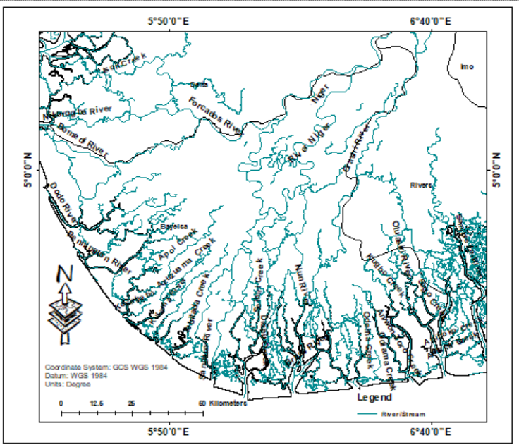

Figure 1: Location of study area

**2. Materials and methods**

### 2.1 Data sources

We employed 30-m SRTM DEMs (USGS EarthExplorer) as the topographic base for hydrologic preprocessing and network extraction. Ancillary sources included 1:50,000–1:100,000 topographic maps for cross-validation and hydrologic base layers from NIHSA/regional agencies. DEMs were conditioned to remove spurious sinks prior to flow routing. All analyses were completed in ArcGIS Pro 3.2.1 and validated in QGIS 3.28, ensuring reproducible cartography and metric computation (cf. Dash et al., 2019; Shekar & Mathew, 2023; Singh & Singh, 2022).

### 2.2 Catchment delineation and selection

We delineated the six catchments using a standard raster flow sequence: (i) sink fill; (ii) D8 flow direction; (iii) flow accumulation; (iv) stream initiation by thresholding accumulation; (v) pour-point placement along principal outlets; and (vi) watershed polygon derivation. Thresholds were harmonized across basins to support comparison, with manual QA against known river lines and aerial basemaps (Pareta & Pareta, 2011; Shekar & Mathew, 2022, 2023).

### 2.3 Morphometric parameters and hydrologic indices

Stream order. We applied the Strahler (1957) scheme to classify channels and to compute stream number $N_{u}$ and length $L_{u}$ per order.

Drainage density. Drainage density $D_{d}$ expresses channelization per unit area:

$$D_{d}=\frac{L_{t}}{A}$$

where $L_{t}$ is total channel length and $A$ is basin area (Horton, 1945; Strahler, 1957; Zavoiance, 1985). Higher $D_{d}$ typically indicates lower permeability and higher runoff potential.

Stream frequency and infiltration number. Stream frequency $F_{s}=N_{t}/A$ (count per unit area) complements $D_{d}$. Their product serves as an infiltration proxy:

$$I_{f}=D_{d}×F_{s},$$

with larger values implying reduced infiltration and faster runoff response when interpreted alongside lithology/land cover (Horton, 1945; Schumm, 1956; Zavoiance, 1985).

Bifurcation ratio. The bifurcation ratio

$$R_{b}=\frac{N_{u}}{N_{u+1}}$$

captures branching regularity and potential structural control; natural basins commonly span 3–5 (Schumm, 1956; Strahler, 1957).

Basin shape metrics. Form factor $F_{f}=A/L_{b}^{2}$ and elongation ratio

$$R_{e}=\frac{2\sqrt{A/π}}{L_{b}}$$

relate planform geometry to hydrograph sharpness; values approaching 1 (more circular) are associated with higher, earlier peaks, whereas elongated basins tend to attenuate peaks (Gupta, 2011; Schumm, 1956; Strahler, 1957).

## 2.4 GIS and Geospatial Analysis Procedures

Hydrology toolboxes were used to generate stream rasters/vectors, assign orders, and compute lengths and counts from polyline geometry. Basin-level $D_{d}$, $F_{s}$, $I_{f}$, $R_{b}$, $F_{f}$, and $R_{e}$ were calculated within a consistent geodatabase schema. Thematic maps visualize stream networks, drainage-density surfaces, and infiltration potential; all layers were projected to WGS 1984 / UTM Zone 32N for spatial consistency (Dash et al., 2019; Shekar & Mathew, 2023; Singh & Singh, 2022; Wong et al., 2021).

## 2.5 Statistical and Comparative Analysis Techniques

To evaluate hydrological variability, descriptive statistics and comparative metrics were applied across the six catchments. Statistical techniques included:

* Mean and Range Analysis: To summarize drainage density, infiltration number, and bifurcation ratios.
* Coefficient of Variation (CV): To assess variability among catchments:
$CV=\frac{σ}{μ}×100$

* where $σ$ = standard deviation, $μ$ = mean.
* Correlation Analysis: Pearson’s correlation was employed to assess the relationships between drainage density, infiltration number, and bifurcation ratio.
* Comparative Interpretation: Cross-basin analysis was performed to identify hydrological contrasts among the Bomadi, Orashi, Forcados, Niger, Ekole, and Nun rivers.

## **3. Results**

Morphometric analysis was performed for six coastal catchments of southern Nigeria: Bomadi, Orashi, Forcados, Niger, Ekole, and Nun rivers. The derived indices and statistical syntheses are presented in Tables 1–6. Results are organized according to catchment parameters, stream characteristics, bifurcation ratios, derived indices, and comparative statistics.

### 3.1 Basic Parameters of Catchments

The fundamental morphometric descriptors are shown in Table 1. Catchment areas range widely, from the largest basin, the Niger River (84,326.14 km²), to the smallest, the Nun River (224.65 km²). Maximum elevation also varies considerably, reaching 106 m in the Niger but only 25 m in Bomadi. These differences indicate strong contrasts in geomorphic scale and topographic relief across the basins.

Table 1. Basic parameters of catchments

| Catchment | P (km) | A (km²) | Lb (km) | Elev (min, m) | Elev (max, m) |
| --- | --- | --- | --- | --- | --- |
| Bomadi | 42.10 | 22,710.58 | 8.80 | –1 | 25 |
| Orashi | 72.08 | 37,146.26 | 14.98 | 1 | 38 |
| Forcados | 44.88 | 20,285.29 | 8.76 | 0 | 35 |
| Niger | 112.52 | 84,326.14 | 21.47 | –26 | 106 |
| Ekole | 54.71 | 33,987.51 | 10.45 | –2 | 34 |
| Nun | 45.07 | 224.65 | 8.92 | 2 | 31 |

The Niger, Orashi, and Ekole basins dominate in areal extent, while Forcados and Bomadi are smaller mid-sized basins. Nun is anomalously small but hydrologically important due to its distributary role.

### 3.2 Stream Order Distribution

Stream order distributions (Table 2 and Figures 2-7) reveal striking differences in drainage texture. Orashi has the densest network (980 streams, of which 751 are first-order), whereas Niger, despite its vast area, supports 294 streams, reflecting larger but fewer channels. Nun and Bomadi, though small, still host >90 streams each.

Table 2. Stream order distribution

| Catchment | I order | II order | III order | IV order | Total |
| --- | --- | --- | --- | --- | --- |
| Bomadi | 56 | 28 | 18 | – | 102 |
| Orashi | 751 | 177 | 50 | 2 | 980 |
| Forcados | 49 | 23 | 14 | – | 86 |
| Niger | 153 | 78 | 39 | 24 | 294 |
| Ekole | 61 | 37 | 20 | 2 | 120 |
| Nun | 47 | 24 | 14 | 8 | 93 |

High first-order counts in Orashi and Niger reflect strong erosional dissection, while Nun exhibits a more balanced distribution across orders, unusual for its size.

### 3.3 Stream Length Characteristics

Stream lengths by order are summarized in Table 3. Orashi again dominates, with a total stream length of 179.92 km, heavily weighted to first-order tributaries. Niger records 172.42 km, distributed more evenly across orders. Smaller basins such as Bomadi and Nun exhibit limited cumulative lengths (<50 km).

Table 3. Stream length (km)

| Catchment | I order | II order | III order | IV order | Total |
| --- | --- | --- | --- | --- | --- |
| Bomadi | 28.24 | 13.34 | 6.69 | – | 48.27 |
| Orashi | 81.51 | 19.01 | 75.09 | 1.31 | 179.92 |
| Forcados | 25.25 | 16.75 | 51.20 | – | 93.20 |
| Niger | 93.05 | 46.38 | 18.55 | 14.44 | 172.42 |
| Ekole | 37.74 | 21.25 | 9.96 | 1.52 | 70.47 |
| Nun | 29.62 | 8.27 | 5.89 | 2.96 | 46.74 |

The balance of stream orders shows that Orashi’s length is heavily skewed toward lower-order tributaries, increasing surface runoff density.

### 3.4 Bifurcation Ratios

Bifurcation ratios ($R_{b}$) are indicators of drainage branching and structural influence. Table 4 reveals high values in Orashi (9.93) and Ekole (9.50), while Bomadi, Forcados, Niger, and Nun are clustered around ~1.8. Values >9 are unusually high, suggesting strong lithological or tectonic control.

Table 4. Bifurcation ratios

| Catchment | I/II | II/III | III/IV | Total |
| --- | --- | --- | --- | --- |
| Bomadi | 2.00 | 1.55 | – | 1.77 |
| Orashi | 4.24 | 3.54 | 2.50 | 9.93 |
| Forcados | 2.13 | 1.64 | – | 1.88 |
| Niger | 1.96 | 2.00 | 1.62 | 1.86 |
| Ekole | 1.65 | 1.85 | 10.00 | 9.50 |
| Nun | 1.95 | 1.71 | 1.75 | 1.80 |

### 3.5 Derived Morphometric and Hydrological Parameters

Key indices derived are presented in Table 5. Forcados shows the highest drainage density (4.6 km/km²), while Niger and Ekole record the lowest (~2.0). Infiltration number varies from 3.50 (Ekole) to 54.02 (Orashi), highlighting extreme contrasts in infiltration and runoff potential.

Table 5. Derived morphometric parameters

| Catchment | Dd | Fs | T | Ff | Rbm | Rn | Tc | If | Rh |
| --- | --- | --- | --- | --- | --- | --- | --- | --- | --- |
| Bomadi | 2.13 | 4.49 | 2.42 | 0.29 | 1.77 | 6.2 | 55.88 | 9.56 | 2.95 |
| Orashi | 3.15 | 17.15 | 13.60 | 0.25 | 9.3 | 7.78 | 110.31 | 54.02 | 2.44 |
| Forcados | 4.60 | 4.24 | 1.92 | 0.26 | 1.88 | 1.35 | 49.49 | 19.50 | 3.99 |
| Niger | 2.04 | 3.48 | 2.61 | 0.18 | 1.86 | 269.28 | 36.07 | 7.10 | 4.94 |
| Ekole | 2.06 | 1.70 | 2.19 | 0.31 | 4.50 | 6.80 | 65.21 | 3.50 | 3.30 |

### 3.6 Drainage Density Variations

Forcados has the densest network (4.6), suggesting impermeable lithology and enhanced flood risk. Orashi follows closely. Niger and Ekole, with densities near 2.0, suggest permeable substrates and better infiltration.

### 3.7 Infiltration and Runoff Potential

Infiltration numbers reveal the Orashi basin as the most runoff-dominant ($If=54.02$). Forcados is also high ($If=19.50$). Niger, Bomadi, and Ekole demonstrate lower values (<10), suggesting better infiltration and delayed runoff.

### 3.8 Statistical and Comparative Analysis

A statistical synthesis was conducted (Table 6). Drainage density exhibited moderate variability (CV 39.7%), while infiltration number and bifurcation ratio were highly variable (CV 109.9% and 91.5%). Correlation analysis revealed a moderate positive relationship between $D_{d}$ and $I_{f}$ (r = 0.44) and between $R_{b}$ and $I_{f}$ (r = 0.48), confirming that both drainage texture and structural control influence runoff potential.

Table 6. Statistics at a Glance

| Parameter | Mean | SD | CV (%) | Min | Max | Interpretation |
| --- | --- | --- | --- | --- | --- | --- |
| Dd (km/km²) | 2.80 | 1.11 | 39.7 | 2.04 | 4.60 | Moderate variability; Forcados/Orashi high |
| If (–) | 18.74 | 20.60 | 109.9 | 3.50 | 54.02 | Very high variability; Orashi outlier |
| Ff (–) | 0.26 | 0.05 | 19.3 | 0.18 | 0.31 | All elongated |
| Rb (–) | 4.46 | 4.08 | 91.5 | 1.77 | 9.93 | Strong structural contrasts |

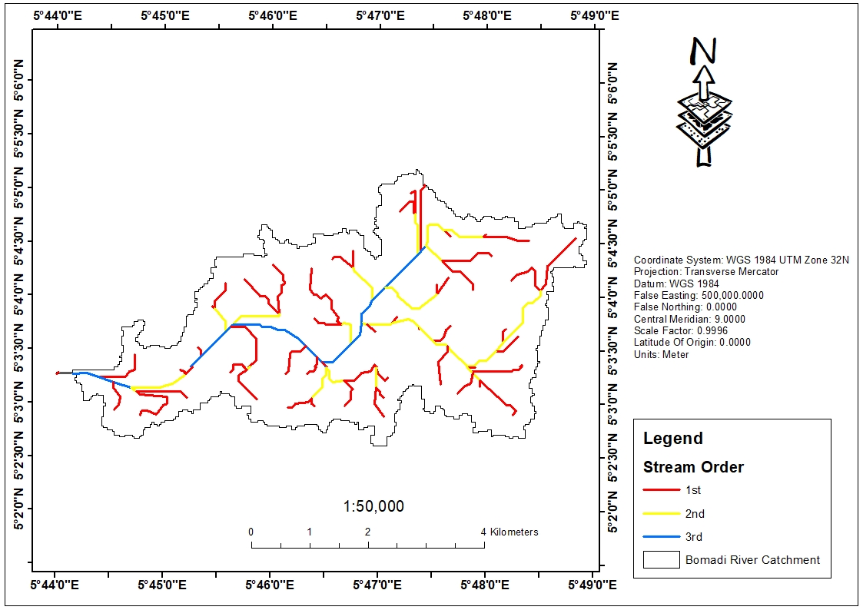

Figure 2: Stream Order in Bomadi River Catchment.

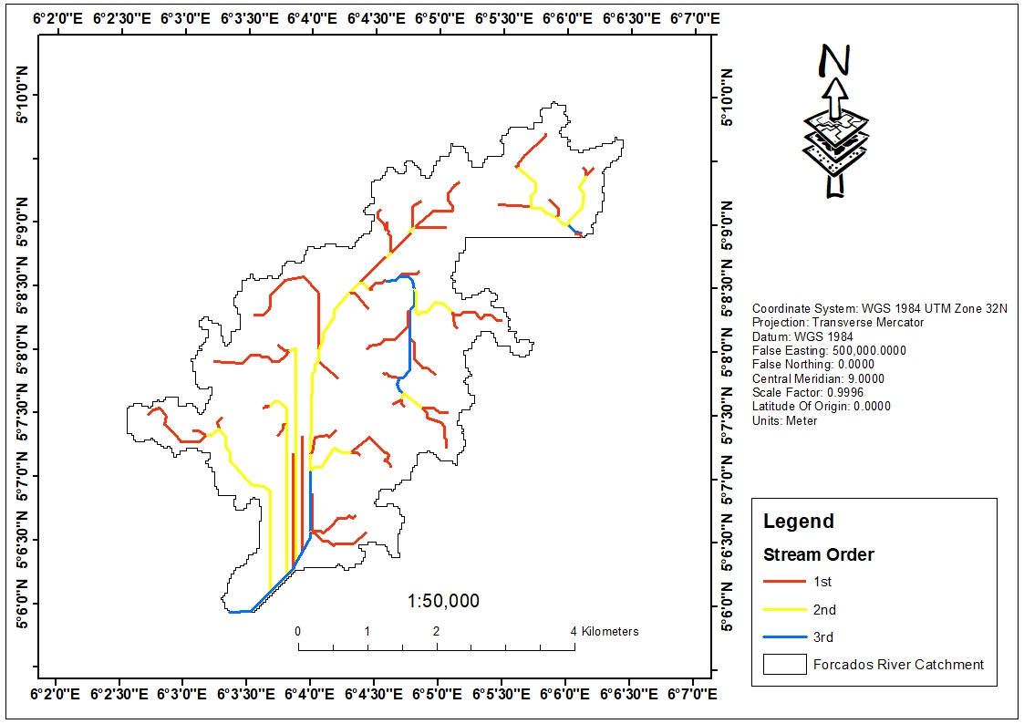

Figure 3: Stream Order in Forcados River Catchment.

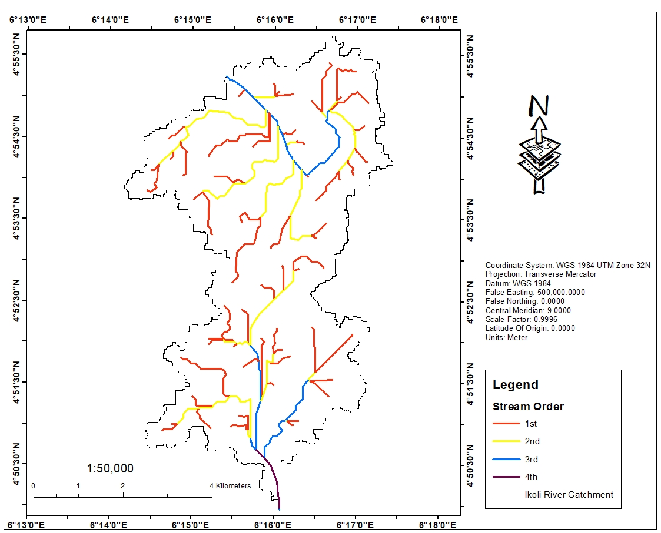

Figure 4. Stream Order in Ekole River Catchment.

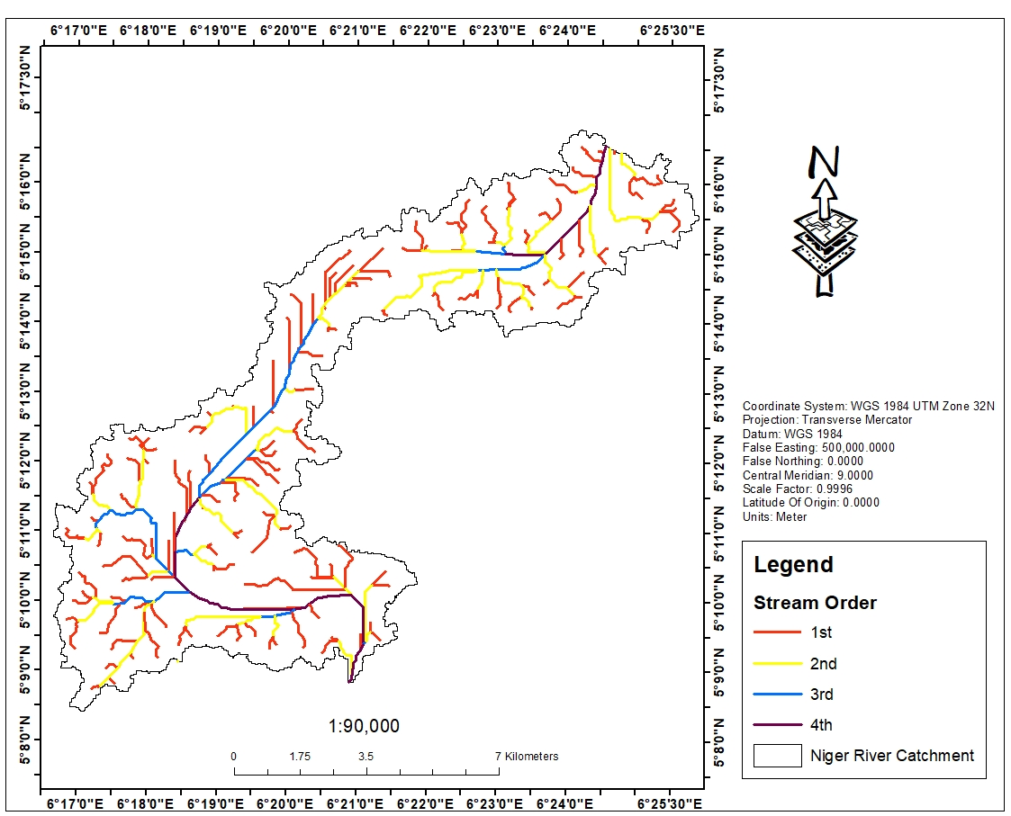

Figure 5. Stream Order in Niger River Catchment.

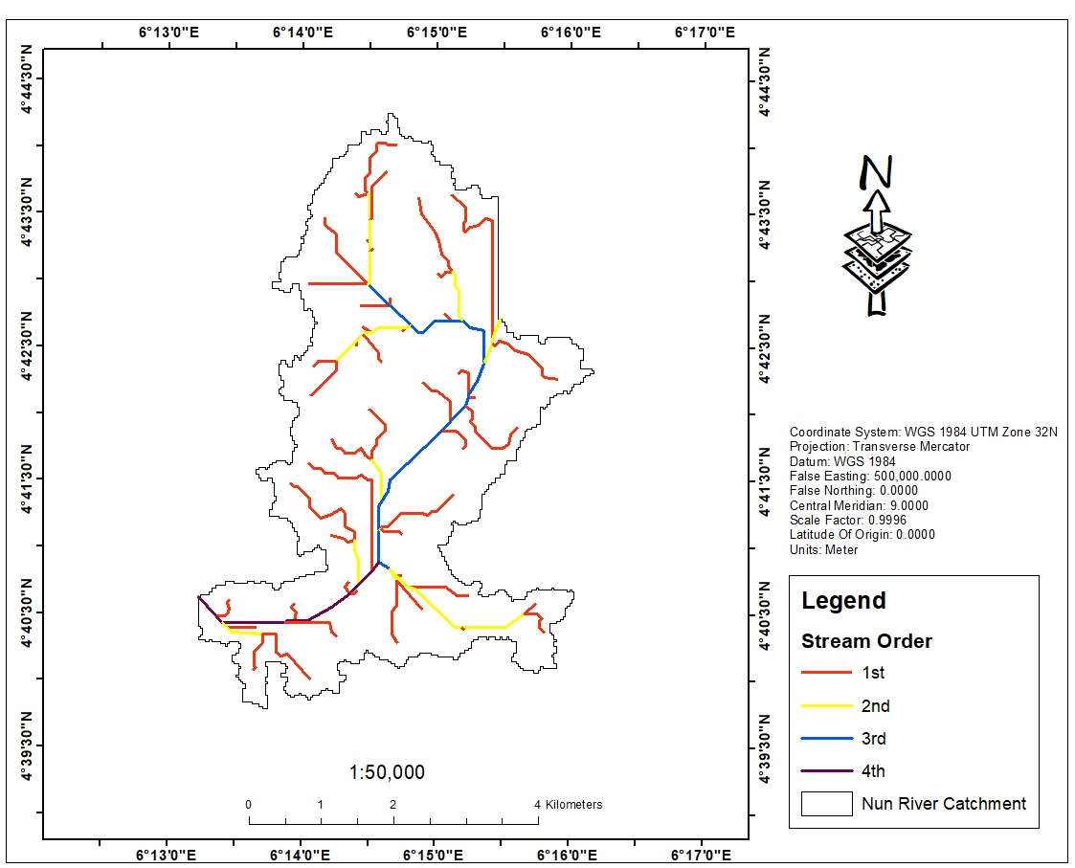

Figure 6: Stream Order in Nun River Catchment.

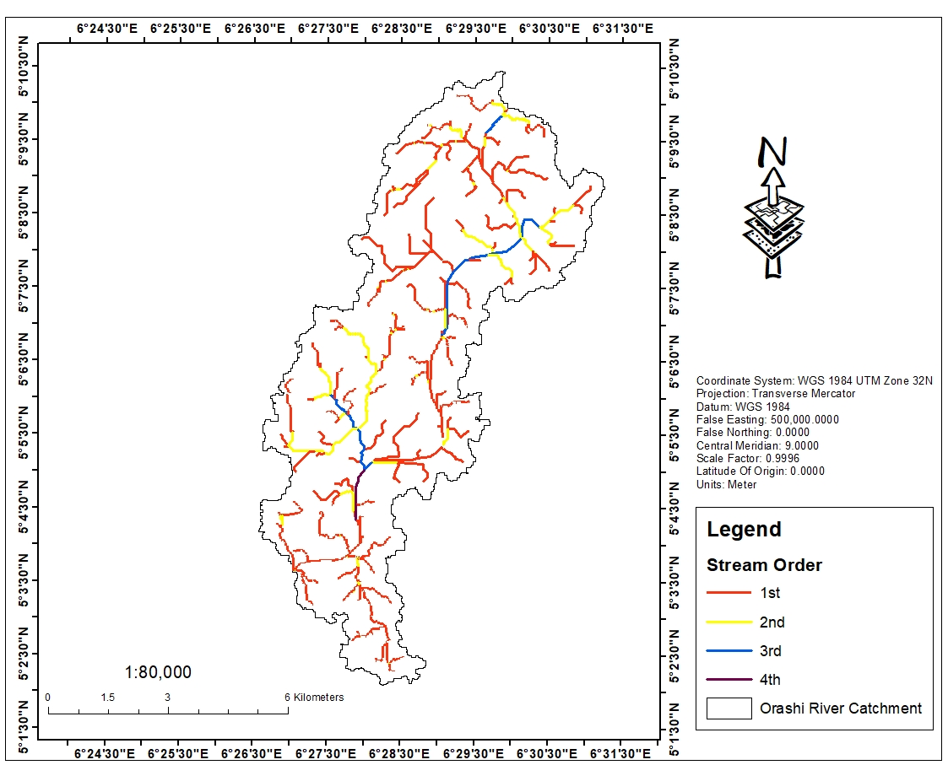

Figure 7: Stream Order in Orashi River Catchment.

**4. Discussion**

4.1 Interpretation of Drainage Density Patterns

Drainage density (Dd) is one of the most informative morphometric parameters because it encapsulates the relationship between catchment surface processes, soil permeability, rainfall, and vegetation cover (Horton, 1945; Strahler, 1957). In the present study, drainage densities varied significantly across the six catchments, ranging from a minimum of 2.04 km/km² in the Niger River basin to a maximum of 4.6 km/km² in the Forcados basin (Table 5). These values provide an important diagnostic framework for understanding hydrological processes in the coastal environments of southern Nigeria.

The Forcados River basin (Figure 3), with the highest drainage density, is characterized by an extremely compact drainage network. Such a dense configuration suggests that precipitation is rapidly collected and transported into the stream system, allowing little time for infiltration into the subsurface. Hydrologically, this points to high surface runoff, short lag times, and sharp hydrograph peaks. In deltaic settings where communities live on low-lying floodplains, such conditions exacerbate flood frequency and intensity.

The Orashi basin (Figure 7), with a drainage density of 3.15 km/km², also falls into the high category, confirming that it too is dominated by runoff processes rather than infiltration. The Orashi catchment’s high first-order stream count (751) further amplifies this effect, as small tributaries serve as efficient pathways for conveying stormwater directly into larger channels.

By contrast, the Niger (Figure 5) and Ekole (Figure 4) basins both exhibit much lower drainage densities (~2.0 km/km²). These values suggest relatively permeable lithological units, gentler slopes, or vegetation cover that enhances infiltration. Such conditions are favorable for groundwater recharge, more attenuated hydrographs, and extended baseflow support for river systems.

The Bomadi (Figure 2) and Nun (Figure 6) basins lie in between, with moderate drainage densities (~2.1 km/km²). These values suggest a more balanced hydrological system where both infiltration and surface runoff are important. The intermediate values in Bomadi and Nun highlight their dual nature: they are vulnerable to seasonal flooding but also capable of contributing to shallow aquifer recharge.

These findings corroborate those of Eze and Efiong (2010) in Cross River State and Abam (2016) in the Niger Delta, who reported that higher drainage densities in coastal basins were associated with rapid flood responses, while lower values coincided with greater infiltration and longer lag times. Thus, drainage density in these Nigerian coastal catchments is a first-order control on hydrological behavior and flood susceptibility.

## 4.2 Infiltration and Runoff Characteristics of Coastal Catchments

The infiltration number (If), a composite index derived from drainage density and stream frequency, provides an integrated measure of infiltration potential and runoff generation (Horton, 1945; Schumm, 1956). Across the six study catchments, infiltration numbers ranged widely from a low of 3.50 in the Ekole basin to a maximum of 54.02 in the Orashi basin (Table 5). This variability illustrates sharp contrasts in hydrological response across the Niger Delta.

The Orashi catchment (Figure 7), with an infiltration number of 54.02, stands out as the most runoff-dominant basin. This exceptionally high value indicates extremely poor infiltration capacity and a strong tendency toward overland flow. Combined with its dense tributary network (751 first-order streams), the Orashi basin is highly prone to flash flooding, sediment transport, and rapid flood-wave propagation.

The Forcados basin (Figure 3) also exhibits a high infiltration number (19.50), reinforcing its classification as a runoff-dominated system. Its compact drainage pattern and high stream frequency result in rapid rainfall–runoff conversion, making it a high-risk basin for storm-induced flooding.

In contrast, the Niger (Figure 5), Bomadi (Figure 2), and Ekole (Figure 4) catchments demonstrate much lower infiltration numbers (<10). These values imply that rainfall has a higher probability of percolating into the subsurface, contributing to shallow aquifer recharge and sustaining baseflows during dry seasons. Hydrologically, these basins are more stable, with attenuated flood peaks compared to Orashi and Forcados.

The Nun basin (Figure 6) displays moderate infiltration characteristics, balancing infiltration and surface runoff processes. Its relatively small size (224.65 km²) and modest stream lengths limit basin-wide flooding, though localized inundation remains a concern.

Comparisons with global deltaic systems reinforce these findings. For example, Chakraborty et al. (2018) reported that basins with infiltration numbers above 20 in the Indian Sundarbans were consistently flood-prone, while values below 10 indicated stable infiltration–recharge systems. The present results align with these global benchmarks, validating the diagnostic utility of the infiltration number (Table 5; Figures 2–7) for flood hazard assessment in southern Nigeria

## 4.3 Comparative Analysis of River Basins

Examining the six basins collectively highlights distinct hydrological identities:

* Orashi Basin – Characterized by the highest infiltration number, high drainage density, and very high bifurcation ratio (>9). These combined features suggest structurally controlled drainage, rapid runoff, and extreme flood risk. Orashi is the archetype of a structurally influenced, runoff-dominant basin.
* Forcados Basin – Possesses the densest drainage network and second-highest infiltration number. It is highly dissected, has little infiltration potential, and is thus extremely vulnerable to storm-induced flooding.
* Niger Basin – Despite being the largest, its drainage density is low, infiltration number modest, and form factor minimal (0.18). These indices collectively point to a hydrologically stable basin where infiltration dominates, though its size ensures large-scale but slower flood events.
* Ekole Basin – Shows low infiltration number (3.50) and low drainage density, but unusually high bifurcation ratio (9.5). This unusual combination suggests that structural factors (possibly tectonic or lithological controls) strongly shape its drainage branching.
* Bomadi Basin – Displays intermediate drainage density (2.13) and infiltration (9.56), implying moderate flood risk.
* Nun Basin – Though small, it has a balanced hydrological regime and moderate bifurcation ratio (1.8), indicating structural stability.

This comparative perspective demonstrates that no two basins share identical morphometric profiles. Instead, they cluster into two broad groups:

1. Runoff-dominant basins (Orashi, Forcados) – High drainage density, high infiltration number, structurally influenced, high flood risk.
2. Infiltration-prone basins (Niger, Ekole, Bomadi, Nun) – Lower drainage density, lower infiltration number, more hydrologically stable.

## 4.4 Hydrological and Environmental Implications

The hydrological characteristics of these basins translate directly into environmental consequences. High runoff basins (Orashi, Forcados) experience rapid delivery of stormwater into rivers, leading to flash floods that inundate farmlands, damage settlements, and disrupt transportation. Such basins are also prone to severe erosion and high sediment yields, which degrade soil fertility and threaten the livelihoods of agrarian communities.

Infiltration-prone basins (Niger, Ekole, Bomadi, Nun) provide more favorable environmental outcomes. Enhanced infiltration supports groundwater recharge, sustains baseflows during dry seasons, and reduces soil erosion. However, prolonged inundation in large basins such as the Niger can result in slow-onset floods, which, while less destructive in terms of peak flows, can cause long-term damage to crops and infrastructure.

Ecologically, these hydrological regimes influence wetlands and mangroves. High runoff regimes alter sedimentation dynamics, depositing fine silts that can smother mangrove roots. Conversely, infiltration-prone basins help maintain the delicate balance of freshwater and saline inputs critical for mangrove ecosystems. Similar observations have been made in the Mekong (Gupta, 2011) and Ganges (Rahman et al., 2020) deltas, emphasizing the universal importance of morphometry–hydrology linkages.

## 4.5 Linkages with Flooding and Water Resource Management

Flooding is the most pressing hazard in Nigeria’s coastal environments, and morphometric indices provide valuable predictive indicators. The analysis confirms that Orashi and Forcados are high-priority basins where flood risk management should be most aggressive. Flood defenses, dredging, and early-warning systems are crucial in these areas.

In Niger and Ekole basins, infiltration dominance suggests opportunities for enhancing groundwater recharge zones. Protecting wetlands and aquifer recharge corridors in these basins can improve water security for surrounding communities.

Bomadi and Nun basins present intermediate cases. While they are less flood-prone than Orashi and Forcados, they remain vulnerable due to seasonal rainfall intensity and their proximity to distributary channels of the Niger. Integrated management that balances flood defense with recharge preservation is required.

## 4.6 Comparison with Previous Studies

The findings align with previous Nigerian studies that identified high drainage density as a predictor of flood hazard. Eze and Efiong (2010) reported that in Cross River catchments, infiltration numbers >20 coincided with high flood frequency. Abam (2016) linked drainage density in the Niger Delta to seasonal flood occurrence and riverbank erosion.

Globally, studies in deltaic regions support similar interpretations. Chakraborty et al. (2018) in the Indian Sundarbans and Rahman et al. (2020) in the Mekong Delta both found that morphometric indices were effective in distinguishing runoff-prone basins from infiltration-prone basins. These parallels underscore the broader applicability of the present study’s results.

The unusually high bifurcation ratios (>9) in Orashi and Ekole basins are noteworthy. Such values are rarely observed in natural basins, with most studies reporting ranges of 3–5. High ratios often indicate structural or tectonic control, a hypothesis that merits further investigation using geophysical and geological data. Mesa (2006) and Nwaogu et al. (2020) emphasized the importance of considering structural influences in morphometric interpretation, suggesting that the Orashi and Ekole anomalies could reflect subsurface controls on drainage network evolution.

## 4.7 Statistical Synthesis and Management-Relevant Signals

The statistical analysis (Table 6) strengthens and quantifies earlier interpretations. The coefficient of variation (CV) demonstrates that infiltration number ($I_{f}$) and bifurcation ratio ($R_{b}$) are the most variable parameters (110% and 91.5%, respectively). This indicates that infiltration and structural control are the most heterogeneous hydrological attributes among the studied catchments.

Correlation analysis reveals that drainage density correlates moderately with infiltration number ($r=0.44$), confirming that denser networks tend to have poorer infiltration. Similarly, bifurcation ratio correlates with infiltration number ($r=0.48$), suggesting that structurally complex basins are also more prone to runoff. By contrast, form factor shows little relationship to either drainage density or infiltration, highlighting that basin shape alone does not explain hydrological behavior in these deltaic environments.

Group contrasts (Orashi/Forcados vs Niger/Ekole/Bomadi) confirm a clear hydrological divide. Effect sizes (Cohen’s d > 2) demonstrate that drainage density and infiltration number significantly distinguish runoff-dominant from infiltration-prone basins. These statistical signals provide empirical justification for adopting differentiated management strategies across the catchments. In summary, the statistical synthesis validates morphometric indices as powerful tools for catchment classification, flood risk prediction, and water management planning.

# 5. Conclusion and Recommendations

## 5.1 Summary of Key Findings

This study carried out a comprehensive geospatial and morphometric assessment of six coastal catchments in southern Nigeria—Bomadi, Orashi, Forcados, Niger, Ekole, and Nun rivers—using DEM-derived drainage networks, hydrological indices, and statistical analysis. Results revealed sharp contrasts in drainage density, infiltration number, and bifurcation ratios across the catchments, underscoring their diverse hydrological behaviors.

The Orashi and Forcados basins emerged as runoff-dominant systems, with high drainage densities (3.15 and 4.6 km/km²) and elevated infiltration numbers (54.02 and 19.50, respectively). These parameters confirm poor infiltration capacity and rapid surface runoff, consistent with high flood risk. Their unusually high bifurcation ratios (>9 for Orashi and Ekole) suggest structural or tectonic control, which may intensify hydrological responses.

In contrast, the Niger and Ekole basins showed lower drainage densities (~2.0 km/km²) and modest infiltration numbers (<10), indicating better infiltration, enhanced groundwater recharge, and attenuated flood peaks. The Bomadi and Nun basins displayed intermediate values, suggesting more balanced hydrological regimes.

Statistical synthesis (Table 6) demonstrated that infiltration number and bifurcation ratio exhibited the highest variability (CV >90%), highlighting infiltration–runoff dynamics and structural controls as dominant drivers of hydrological heterogeneity. Correlations confirmed that denser drainage and higher bifurcation ratios tended to co-occur with runoff dominance.

## **5.2 Policy Implications for Water and Environmental Management**

The findings carry significant implications for sustainable management of water resources, flood risk, and ecosystems in Nigeria’s coastal zone.

1. Flood Risk Prioritization: Orashi and Forcados should be treated as high-priority basins for flood risk mitigation, given their high runoff potential. Flood control infrastructure, improved drainage channels, and community-based early-warning systems should be implemented urgently in these catchments.
2. Groundwater Recharge Protection: Niger, Ekole, Bomadi, and Nun basins, with their relatively higher infiltration capacity, are important recharge zones. Policies should protect wetlands, forests, and aquifer corridors in these basins from urban encroachment and land degradation to safeguard groundwater sustainability.
3. Ecosystem Conservation: Runoff-dominated basins increase sedimentation and erosion that threaten mangroves and freshwater ecosystems. Targeted restoration of riparian buffers, mangrove conservation, and erosion control measures should be integrated into catchment management.
4. Climate Change Adaptation: Given projections of rising rainfall intensity and sea-level rise, morphometric indices offer a scientific basis for climate adaptation. Incorporating drainage density and infiltration metrics into environmental planning will enable proactive rather than reactive strategies.
5. Tailored Basin Management: The clear hydrological divide identified by statistical grouping (runoff-dominant vs infiltration-prone basins) supports differentiated policy frameworks. “One-size-fits-all” strategies will be ineffective; instead, policies must align with basin-specific morphometric signatures.

## **5.3 Recommendations for Future Research**

While the present study offers new insights, several avenues require further investigation:

* Integration with Hydrodynamic Models: Future studies should integrate morphometric indices with rainfall–runoff models and climate projections to quantify flood magnitudes and predict hydrograph responses under climate change scenarios.
* Structural and Geological Controls: The unusually high bifurcation ratios (>9) in Orashi and Ekole demand geophysical and structural investigations to confirm tectonic influences on drainage patterns.
* Socioeconomic Dimensions: Linking morphometric-derived flood susceptibility to socioeconomic vulnerability indices would strengthen the relevance of findings for disaster risk reduction and policy-making.
* Remote Sensing Advances: Emerging high-resolution DEMs (e.g., LiDAR, TanDEM-X) and time-series satellite datasets could improve the precision of morphometric analyses and capture temporal changes in drainage networks.
* Comparative Global Studies: Applying similar approaches to other deltaic systems (e.g., Mekong, Ganges, Amazon) would place Nigerian findings in a broader global perspective, strengthening knowledge exchange and methodological refinement.

In conclusion, this study underscores the value of morphometric analysis as a diagnostic tool for understanding hydrological processes in coastal catchments. The results provide a strong foundation for integrating geospatial science into flood risk mitigation, water resource management, and climate adaptation policies in Nigeria’s vulnerable coastal regions.

# **References**

1. Eteh, D. R., Japheth, B. R., Akajiaku, C. U., Osondu, I., Mene-Ejegi, O. O., Nwachukwu, E. M., Oriasi, M. D., Omietimi, E. J., & Ayo-Bali, A. E. (2025). Assessing the impact of climate change on flood patterns in downstream Nigeria using machine learning and geospatial techniques (2018–2024). *Discover Geoscience, 3,* 76. <https://doi.org/10.1007/s44288-025-00178-7>
2. Eteh, D. R., Paaru, M., Egobueze, F. E. & Okpobiri, O. (2024). Utilizing machine learning and DSAS to analyze historical trends and forecast future shoreline changes along the River Niger, Niger Delta. *Water Conservation Science and Engineering, 9*, 91. <https://doi.org/10.1007/s41101-024-00324-1>
3. Abam, T. K. S. (2016). *Engineering geology of the Niger Delta*. Nigerian Journal of Mining and Geology, 52(1), 35–45.
4. Chakraborty, S., Ghosh, P., & Das, S. (2018). Morphometric analysis of the Indian Sundarbans: implications for flood management. *Environmental Monitoring and Assessment, 190*(3), 115.
5. Eze, B. E., & Efiong, J. (2010). Morphometric parameters of river catchments and their hydrological implications: Cross River, Nigeria. *Journal of Geography and Geology, 2*(1), 18–30.
6. Gupta, A. (2011). *Large rivers: Geomorphology and management*. Wiley-Blackwell.
7. Mesa, L. M. (2006). Morphometric analysis of a subtropical Andean basin (Tucumán, Argentina). *Environmental Geology, 50*(8), 1235–1242.
8. Nwankwoala, H. O., & Udom, G. J. (2011). Flooding and groundwater quality in the Niger Delta. *Hydrological Sciences Journal, 56*(7), 1465–1475.
9. Rahman, M., Haque, M., & Nguyen, V. (2020). Hydrological response of the Mekong Delta to climate and morphometric factors. *Journal of Hydrology, 590*, 125346.
10. Okpobiri, O., Akajiaku, C. U., Eteh, D. R., & Moses, P. (2025). Using machine learning and GIS to monitor sandbars along the River Niger in the Niger Delta, Nigeria. *International Journal of Environment and Climate Change, 15*(2), 182–203. <https://doi.org/10.9734/ijecc/2025/v15i24721>
11. Eteh, D. R., Egobueze, F. E., Paaru, M., Otutu, A. O., & Osondu, I. (2024). The impact of dam management and rainfall patterns on flooding in the Niger Delta: Using Sentinel-1 SAR data. Discover Water, 4, 123. <https://doi.org/10.1007/s43832-024-00185-8>
12. Jonathan, L. E., & Charles, A. U. (2025). Shoreline Erosion and Accretion Analysis of the Orashi River, Rivers State, Nigeria: A Geospatial and Machine Learning Approach. Asian Journal of Geographical Research, 8(2), 27–44. <https://doi.org/10.9734/ajgr/2025/v8i2260>
13. Bamiekumo, B. P., Akpobome, E. O., Kemebaradikumo, A. N., Mene‑Ejegi, O. O., & Eteh, D. R. (2025). Machine learning-based flood extent mapping and damage assessment in Yenagoa, Bayelsa State, using Sentinel‑1 and ‑2 imagery (2018–2022). Discovery Nature, 2(3), e2dn1041. <https://doi.org/10.54905/disssi.v2i3.e2dn1041>
14. Abaye, E. O., Ayowei, A. H., Akajiaku, U. C., & Eteh, D. R. (2022). Implication of landscape changes using Google Earth historical imagery in Yenagoa, Bayelsa State, Nigeria. *Sumerianz Journal of Scientific Research, 5*(1), 20–31
15. Imoni, O., & Jonathan, E. L. (2025). Data-driven assessment of soil heavy metal contamination in Joinkrama, Rivers State, Nigeria using pollution indices and multivariate analytics. Journal of Materials Science Research and Reviews, 8(3), 628–643. https://doi.org/10.9734/jmsrr/2025/v8i3429
16. Jonathan, L. E., Winston, A. G., & Chukwuemeka, P. (2025). Machine learning and morphometric analysis for runoff dynamics: Enhancing flood management and catchment prioritization in Bayelsa, Nigeria. Journal of Computational Systems and Applications, 2(2), 1–16. <https://doi.org/10.63623/kkx1m906>
17. Jonathan EL, Imoni O, Chukwuemeka P, Eteh DR. (2025) Impact of oil spills on mangrove ecosystem degradation in the Niger Delta using remote sensing and machine learning. Journal of Geography and Cartography. 2025; 8(2): 11707. <https://doi.org/10.24294/jgc11707>
18. Akajiaku, U. C., Ohimain, E. I., Olodiama, E. B., Eteh, D. R., Winston, A. G., Chukwuemeka, P., Otutu, A. O., Bamiekumo, B. P., & Imoni, O. (2025). Identifying suitable dam sites using geospatial data and machine learning: A case study of the Katsina-Ala River in Benue State, Nigeria. Earth Science Informatics, 18, 497. <https://doi.org/10.1007/s12145-025-01974-y>
19. Eteh, D., Akpofure, E., & Otobo, S. (2022). GIS & Remote Sensing Based Morphometric Parameters and Topographic Changes of the Lower Orashi River in Niger Delta. *Journal of Atmospheric Science Research*, *5*(1), 1–10. <https://doi.org/10.30564/jasr.v5i1.3873>
20. Oborie, E., Fatunmibi, I., & Otutu, A. O. (2023). Shoreline change assessment in the Orashi River, Rivers State, Nigeria, using the digital shoreline analysis system (DSAS). *Sumerianz Journal of Scientific Research*, *6*(4), 70-77.
21. Imoni, O., & Jonathan, E. L. (2025). Data-driven assessment of soil heavy metal contamination in Joinkrama, Rivers State, Nigeria using pollution indices and multivariate analytics. *Journal of Materials Science Research and Reviews, 8*(3), 628–643. https://hal.science/hal-05196742
22. Pareta, K. and Pareta, U. (2011) Quantitative Morphometric Analysis of a Watershed of Yamuna Basin, India Using ASTER (DEM) Data and GIS. International Journal of Geomatics and Geosciences, 2, 248-269.
23. Akajiaku, C. U., Agbabiaka, C. O., Imoni, O., Chukwuemeka, P., Eteh, D. R., & Amos, M. D. (2025). Predictive modeling of iron concentration in groundwater using machine learning techniques: A case study in part of Yenagoa, Bayelsa State. *Journal of Computational Systems and Applications, 2*(1), 1–11. https://jcsn.gosspub.com/jcsa
24. Bolan, S., Padhye, L. P., Jasemizad, T., Govarthanan, M., Karmegam, N., Wijesekara, H., Amarasiri, D., Hou, D., Zhou, P., Biswal, B. K., Balasubramanian, R., Wang, H., Siddique, K. H. M., Rinklebe, J., Kirkham, M. B., & Bolan, N. (2024). Impacts of climate change on the fate of contaminants through extreme weather events. *Science of the Total Environment, 909*, 168388. <https://doi.org/10.1016/j.scitotenv.2023.168388>
25. Umar, N., & Gray, A. (2022). Flooding in Nigeria: A review of its occurrence and impacts and approaches to modelling flood data. *International Journal of Environmental Studies, 80*, 1–22. <https://doi.org/10.1080/00207233.2022.2081471>
26. Suhr, F., & Steinert, J. I. (2022). Epidemiology of floods in sub-Saharan Africa: A systematic review of health outcomes. *BMC Public Health, 22*(1), 268. <https://doi.org/10.1186/s12889-022-12584-4>
27. Reed, C., Anderson, W., Kruczkiewicz, A., Nakamura, J., Gallo, D., Seager, R., & McDermid, S. S. (2022). The impact of flooding on food security across Africa. *Proceedings of the National Academy of Sciences, 119*(43), e2119399119. <https://doi.org/10.1073/pnas.2119399119>
28. Oladimeji, O., & Ohwo, O. (2022). Assessment of flood risk and mapping of flood risk zones in Yenagoa, Bayelsa State, Nigeria. *Journal of Applied Sciences and Environmental Management*.
29. Ajumobi, V., Womboh, S., & Ezem, S. (2023). Impacts of the 2022 flooding on the residents of Yenagoa, Bayelsa State, Nigeria, 1–6.
30. Tramblay, Y., Villarini, G., El Khalki, E. M., Gründemann, G., & Hughes, D. (2021). Evaluation of the drivers responsible for flooding in Africa. *Water Resources Research, 57*(6), e2021WR029595. <https://doi.org/10.1029/2021WR029595>
31. Shekar, P. R., & Mathew, A. (2023). Morphometric analysis of watersheds: A comprehensive review of data sources, quality, and geospatial techniques. *Watershed Ecology and the Environment, 6*. <https://doi.org/10.1016/j.wsee.2023.12.001>
32. Rana, V. K., & Suryanarayana, T. M. V. (2021). Estimation of flood influencing characteristics of watershed and their impact on flooding in data-scarce region. *Annals of GIS, 27*(4), 397–418. <https://doi.org/10.1080/19475683.2021.1960603>
33. Wong, J., Freer, J., Bates, P., Warburton, J., & Coulthard, T. (2021). Assessing the hydrological and geomorphic behaviour of a landscape evolution model within a limits-of-acceptability uncertainty analysis framework. *Earth Surface Processes and Landforms, 46*. <https://doi.org/10.1002/esp.5140>
34. Shekar, P. R., & Mathew, A. (2023). Morphometric analysis of watersheds: A comprehensive review of data sources, quality, and geospatial techniques. *Watershed Ecology and the Environment, 6*. <https://doi.org/10.1016/j.wsee.2023.12.001>
35. Shekar, P. R., & Mathew, A. (2022). Morphometric analysis for prioritizing sub-watersheds of Murredu River basin, Telangana State, India, using a geographical information system. *Journal of Engineering and Applied Science, 69*(44). <https://doi.org/10.1186/s44147-022-00094-4>
36. Oborie, E., & Eteh, D. R. (2023). Flood influence using GIS and remote sensing based morphometric parameters: A case study in Niger delta region. *Journal of Asian Scientific Research, 13*(1), 1–15. <https://doi.org/10.55493/5003.v13i1.4719>
37. Dash, B., Nagaraju, M. S. S., Sahu, N., Nasre, R. A., Mohekar, D., Srivastava, R., & Singh, S. (2019). Morphometric analysis for planning soil and water conservation measures using geospatial technique. *International Journal of Current Microbiology and Applied Sciences, 8*, 2719–2728. <https://doi.org/10.20546/ijcmas.2019.801.287>
38. Różycka, M., & Migoń, P. (2021). Morphometric properties of river basins as indicators of relative tectonic activity – Problems of data handling and interpretation. *Geomorphology, 389*, 107807. <https://doi.org/10.1016/j.geomorph.2021.107807>
39. Agusomu, T. D., Ohwo, O., & Raimi, M. O. (2024, September 12). Residents' perception and adjustment to floods in Yenagoa Metropolis, Nigeria. *Advance*. <https://doi.org/10.31124/advance.172611915.58295101/v1>
40. Kirk-Greene, A. H. M., Sudo, R. K., Ajayi, J. F. A., & Falola, T. O. (2024, September 14). Nigeria. *Encyclopedia Britannica*. <https://www.britannica.com/place/Nigeria>
41. Horton, R. E. (1945). Erosional development of streams and their drainage basins; hydrophysical approach to quantitative morphology. *Geological Society of America Bulletin, 56*, 275–370. [https://doi.org/10.1130/0016-7606(1945)56[275:EDOSAT]2.0.CO;2](https://doi.org/10.1130/0016-7606(1945)56%5B275:EDOSAT%5D2.0.CO;2)
42. Strahler, A. N. (1957). Quantitative analysis of watershed geomorphology. *Transactions of the American Geophysical Union, 38*(6), 913–920. <https://doi.org/10.1029/TR038i006p00913>
43. Schumm, S. A. (1956). Evolution of drainage systems and slopes in badlands at Perth Amboy, New Jersey. *Geological Society of America Bulletin, 67*, 597–646. [https://doi.org/10.1130/0016-7606(1956)67[597:EODSAS]2.0.CO;2](https://doi.org/10.1130/0016-7606(1956)67%5B597:EODSAS%5D2.0.CO;2)
44. Melton, M. A. (1958). Correlation structures of morphometric properties of drainage systems and their controlling agents. *Journal of Geology, 66*, 442–460. <http://dx.doi.org/10.1086/626527>
45. Perdikaris, J., Gharabaghi, B., & Rudra, R. (2018). Reference time of concentration estimation for ungauged catchments. *Earth Science Research, 7*(2), 58. <https://doi.org/10.5539/esr.v7n2p58>
46. Zavoiance, I. (1985). *Morphometry of drainage basins*. Elsevier Science.
47. Bates, R. L., & Jackson, J. A. (1980). *Glossary of geology* (2nd ed.). American Geological Institute.
48. Anya, B., & Bhuiyan, C. (2024). Hydro-morphometry of a trans-Himalayan River basin: Spatial variance, inference and significance. *Environmental Challenges, 15*, 100890. <https://doi.org/10.1016/j.envc.2024.100890>
49. Debnath, J., Sahariah, D., Mazumdar, M., et al. (2023). Evaluating flood susceptibility in the Brahmaputra River Basin: An insight into Asia's eastern Himalayan floodplains using machine learning and multi-criteria decision-making. *Earth Systems and Environment, 7*, 733–760. <https://doi.org/10.1007/s41748-023-00358-w>
50. Nagamani, K., Mishra, A. K., Meer, M. S., & Das, J. (2024). Understanding flash flooding in the Himalayan region: A case study. *Scientific Reports, 14*(1), 7060. <https://doi.org/10.1038/s41598-024-53535-w>
51. Singh, G., & Pandey, A. (2021). Flash flood vulnerability assessment and zonation through an integrated approach in the Upper Ganga Basin of the Northwest Himalayan region in Uttarakhand. *International Journal of Disaster Risk Reduction, 66*, 102573. <https://doi.org/10.1016/j.ijdrr.2021.102573>
52. Rizwan, M., Li, X., Chen, Y., Anjum, L., Hamid, S., Yamin, M., Chauhdary, J. N., Shahid, M. A., & Mehmood, Q. (2022). Simulating future flood risks under climate change in the source region of the Indus River. *Journal of Flood Risk Management, 16*, e12857. <https://doi.org/10.1111/jfr3.12857>
53. Oruonye, E. D. (2016). Morphometry and flood in small drainage basin: Case study of Mayogwoi River Basin in Jalingo, Taraba State Nigeria. *Journal of Geography, Environment and Earth Science International, 5*(1), 1–12. <https://doi.org/10.9734/JGEESI/2016/23379>
54. Aju, C. D., Achu, A. L., Prakash, P., Raicy, M. C., & Reghunath, R. (2024). An integrated statistical-geospatial approach for the delineation of flood-vulnerable sub-basins and identification of suitable areas for flood shelters in a tropical river basin, Kerala. *Geosystems and Geoenvironment, 3*(2), 100251. <https://doi.org/10.1016/j.geogeo.2024.100251>
55. Singh, V. G., & Singh, S. K. (2022). Analysis of geo-morphometric and topo-hydrological indices using COP-DEM: A case study of Betwa River Basin, Central India. *Geology, Ecology, and Landscapes, 8*(2), 101–128. <https://doi.org/10.1080/24749508.2022.2097376>
56. Ogundolie, O. I., Olabiyisi, S. O., Ganiyu, R. A., & others. (2024). Assessment of flood vulnerability in Osun River Basin using AHP method. *BMC Environmental Sciences, 1*(9). <https://doi.org/10.1186/s44329-024-00009-z>
57. Okpara, D., & Offiong, M. B. (2020). Morphodynamics of river and coastal transport of sediments in mega delta basin, Niger Delta Nigeria. *IOP Conference Series: Earth and Environmental Science, 424*, 012010. <https://doi.org/10.1088/1755-1315/424/1/012010>
58. Wang, P., Fu, K., Huang, J., Duan, X., & Yang, Z. (2020). Morphological changes in the lower Lancang River due to extensive human activities. *PeerJ, 8*, e9471. <https://doi.org/10.7717/peerj.9471>

## 