Modeling land use land cover change along with the underlying drivers in Taita Taveta County between the years 2000-2022

.
ABSTRACT

Aims: Due to a variety of natural occurrence and socioeconomic activities, the earth's surface is undergoing speedy changes in land-use and land-cover (LULC). This study's main objective was to render a quantitative understanding of the alteration in land cover and use in Taita Taveta County between 2000 and 2022, as well as a projection for the year 2030 and thereafter analyze the driving forces.
Study design: Remote sensing and GIS for LUCCC and SPSS for the driving forces.
Place and Duration of Study:Taita Taveta County,Kenya for a period between December 2020 and august 2023
Methodology: Landsat images for the year 2000, 2010 and 2022 were used in modelling LULCC. Imageries were digitized through the polygon-making function of the software QGIS and classified with correct labels by the identified class. ArcGIS desktop software was used for mapping to evaluate the LULC changes and Support Vector Machine (SVM) and machine learning Spectral Angle Mapper (SAM) algorithms were used in classifying the images. Accuracy assessments were conducted for each reference year with overall accuracies of more than 87.5% and Kappa coefficients greater than 0.89 calculated.SPSS was used for the analysis of livelihood of the residents.
Results: From the analysis there was increase in built up area from 17.93% to 39.59%, crop land5.17% to 9.03%, bush land 30.96 to 43.19% and bare land 14.75% to 18.95% insignificant reduction in water bodies was noted 34.02% to 33.93%where there was reduction in forest cover 4.12% to 2.77% for the year 2000 to 2022.It was observed that there was in drastic reduction in the area covered by grass for the year 2000 to 2010 which was approximately 59.405 to 35.69% but an increase for the year 2020 was noted to 44.21% The main activities majorly associated with the changes included population growth, urban development, deforestation over grazing and mining activities.

Keywords: Land use, Land cover, livehood,remote sensing ,satellite imagery

1. INTRODUCTION

The land cover and land use in the County of Taita Taveta have changed significantly in the past. In an attempt to maintain their agricultural productivity and meet their daily quotas, farmers have spread their farms into natural habitats as a result of the high population and lack of available land. A growing population has forced people to clear land for settlement and improvements so they can carry out daily tasks like farming and animal husbandry, which has led to the rapid deforestation of the majority of the natural cover. These factors all play a part in land modifications, which have put the region's biodiversity at risk. Urbanization in Taita Taveta County is a result of both rural-urban migration and urban growth and expansion. To make room for urbanization and agricultural growth, the majority of the lands that were once range lands, grasslands, shrub-lands, and forests have been cleared.

Urban and regional planners, the research community, policy developers, and decision makers will all benefit greatly from the study's substantial information on the factors influencing changes in land use and land cover, which will inform policies and strategic development. Additionally, the study will provide monitoring tools to help guide future decisions, particularly those pertaining to the sustainability of the county's natural resources. The study will also provide information on changes in land use and land cover to planners at the County and National Governments, as well as provide a basis for further research
The study was conducted in Taita Taveta County and focused on examining alterations in land use and land cover (LULC) on significant elements such as forest cover, bare land, water bodies, bush-lands, grasslands, croplands, and urban areas from 2000 to 2022, with projections through 2030. Remote sensing techniques and geographic information systems were utilized to facilitate data collection and analysis.
The land cover is undergoing swift changes, primarily concerning alterations in land use and land cover. This rapid transformation has raised global concerns, making it a focal point for numerous researchers. Land refers to areas where human activities occur; thus, land use pertains to the utilization of land resources by individuals (Ellis, et al., 2007). The purpose for which land is used varies, encompassing crop production, housing, recreation, mining, processing, and the biophysical characteristics of the land itself (Hayes, et al., 2002).
Land use affects land transformation (Haghla Parveen1, 2018). It is not a requirement that a change in one will necessarily cause a change in the other. However, the majority of land use modifications are initiated by a variety of social factors that subsequently lead to changes in land cover. These factors impact biodiversity, water and radiation balances, and other processes that collectively contribute to alterations in the climate and biosphere (Riebsame et al. 1994).
Ongoing training and awareness initiatives are being implemented for both national and county governments regarding the driving forces and methods to enhance the changes that have already taken place and to avert additional changes. Local residents are receiving training on appropriate agricultural and economic practices to promote sustainable changes over the years.

2. material and methods

2.1 Study Area
Taita Taveta County is situated between 37 º 36" east and 30 º 14" east longitude and 2 º 46" south and 4 º 10" south latitude (GoK, 2013) in the coastal region and approximately 200km Northwest of Mombasa and 360km Southeast of Nairobi,Kenya’s Capital City . The county is approximately 17,084.1km2 with 10,649.9 km2 (62.3 per cent) covered by the Tsavo East and Tsavo West National Parks. The County borders Kitui, and Tana River Counties in the north; Kilifi and Kwale Counties in the East; Kajiado County in the north-west and the Republic of Tanzania to the south.

Figure 1: Map of Taita Taveta County
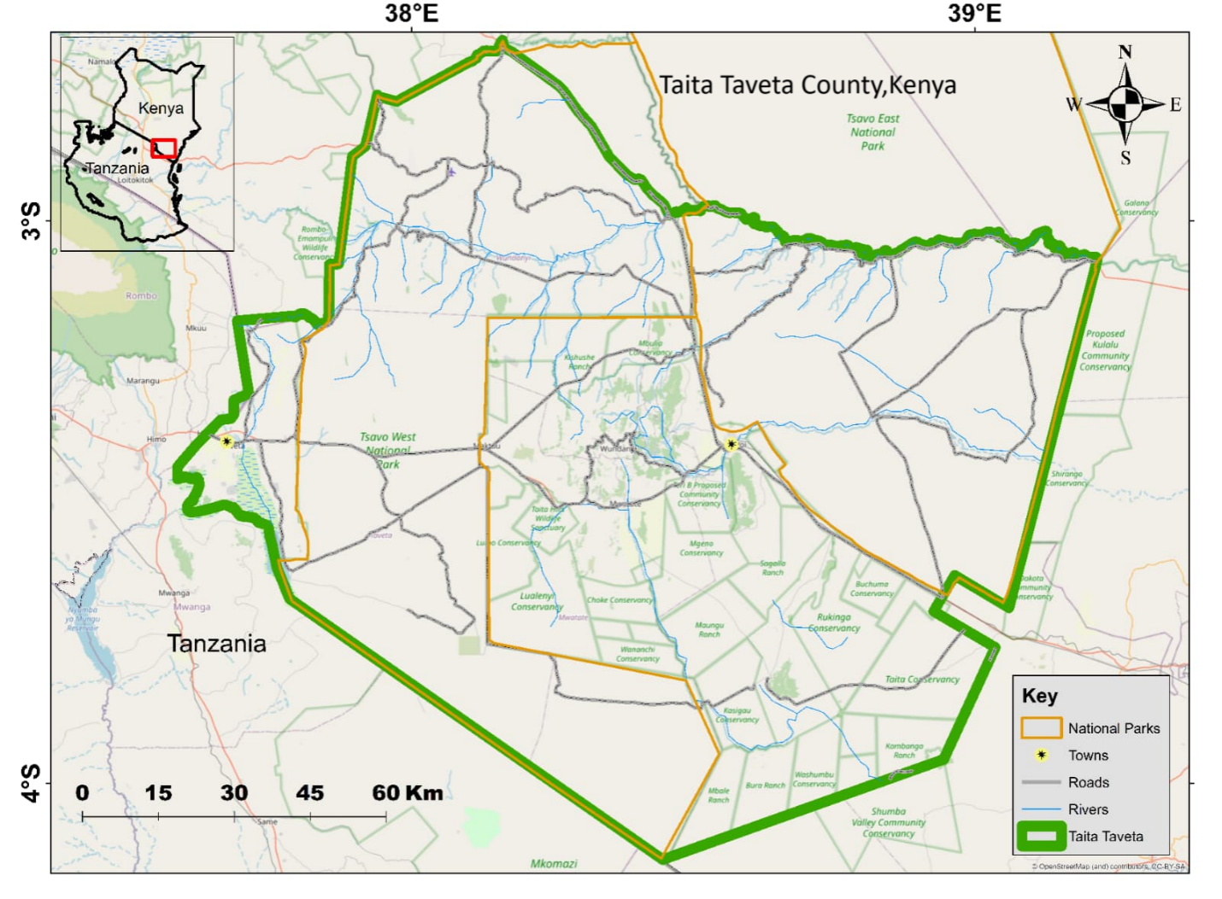

2.2 Data collection
The statistical package for the social sciences (SPSS 2002) was used to analyze the socioeconomic data that was gathered through the survey. Temporal Landsat images from 2000 to 2022 were obtained for the Land Use and Land Cover study from the USGS's Earth Explorer and GLOVIS archives. Three images for the years 2000, 2010, and 2022 were produced using Landsat 7 tiles. The photos were filtered to preserve imagery with less than 20% cloud cover because of the cloud cover in the study area. To avoid misinterpretation of the building and sand percentage coverage, the cloud was masked using Arc GIS 10.5's Mask tool. The dates of acquisition for the images used are displayed in Table 1. A multi-spectral image was created for each scene by stacking the panchromatic bands that were downloaded for that scene.

Table 1: Satellite images

Year | Day and Month | Scene/Tile | Pixel Resolution | Producer
2000 | 11TH FEB  11TH FEB  4TH FEB  3RD FEB | 167062  167063  166063  166062 | 30M | USGS
2010 | 1ST MARCH  17TH MARCH  22ND JAN  22ND JAN | 167062  167063  166062  166063 | 30M | USGS
2022 | 19TH MARCH  19TH MARCH  12TH FEB  12TH FEB | 166062  166063  167062  167063 | 30M | USGS

2.3 Image Preprocessing
The first image processing task was to identify the seven land cover classes as shown in table 2. During sampling and ground truth, the number of classes was established by combining the downloaded images' surface reflectance or spectral features.

Table 2: Land Use Land Cover Classes
No. | Habitat Class | Description
1. | Forest Cover | Any dense clustering of tall (~15-m or greater) dense vegetation, normally with a closed or dense canopy
2. | Bushland | Mosaic of small clusters of vegetation or individual plants scattered on an open landscape with visible ground or rock; scrubby patches in closed forests which are unmistakably lower than trees; examples: sparse to open cover of shrubs and bushes and clumps of grasses, savannas with extremely open grasses, trees or other vegetation
3. | Grassland | Open spaces with even-heighted grasses with minimal to no tall growth
4. | Cropland | Human planted/plotted grains, grasses, and crops not up to tree level
5. | Built up | Man-made structures; extensive road and rail networks; huge homogeneous impermeable surfaces such as parking facilities, office towers and residential dwellings
6. | Bare | Areas of rock or soil with very sparse to no vegetation for the entire year

2.4 Image Classification
Each image was analyzed alongside its metadata data to detect different classes on the image. Imageries were digitized through the polygon-making function of the software QGIS and classified with correct labels by the identified class.
For building a classification model, spectra samples were taken out from the images. The model construction strategy was to take a representative example of all individual classes within the images. For this purpose, 20-30 individual sample polygons per class of all recognizable classes present in the image are utilized. This was accomplished through digitizing these polygons in QGIS Desktop using Landsat images and Google Earth Images.
After developing the model, Support Vector Machine (SVM) and machine learning Spectral Angle Mapper (SAM) algorithms were used in classifying the images. Support Vector Machine (SVM) possesses an ability to process large numbers of continuous and categorical variables. Moreover, this algorithm can be utilized even with small training data sets and high‐dimensional data, a feature this project was well suited to. SVM classification was conducted with the help of Dzetsaka Plugin in QGIS. The resultant model obtained during this step was then validated in accuracy with the r. Kappa tool in QGIS.

2.5 Accuracy Assessment
The accuracy test was conducted to evaluate the accuracy level of the thematic map yielded by the four classification methods. This accuracy test was based on the development of a confusion matrix and three universal parameters from the said matrix, namely the overall accuracy (OA), the producer's accuracy (PA), and the user's accuracy (UA).
OA is presented as the proportion of the amount of data used as a validation sample and is clearly defined against classes defined. UA is interpreted as the mean correctness probability (%) that an object is classified and, on the mean, characterizing the quality of classification of each class in the scene. UA is the mean correctness probability (%) that an object of a classified imagery, characterizing the classes in the scene. The Kappa statistic value was also obtained from each classification results.

2.6 Post-Classification Processing
After the accuracy assessment was completed, the classification results were "cleaned" to make them ready for end-user use. Following Lillesand and Kiefer's (2010) recommendation, statistical filtering was used to remove "salt and pepper appearance" and improve the cartographic appearance of the resulting land cover types. Majority filter was applied with a kernel window of 21 pixels (3 x 3 window). Once this was done the outputs were ready for map production and comparison to detecting change.

2.6 Land Cover Modeling Procedure
Geosos-FLUS software was used to project LULC for the year 2030 based on classified satellite imagery. GeoSOS-FLUS has the capability to utilize an artificial neural network (ANN) algorithm to get the conversion probability of different land use types within the study area through the initial stage of land use data and other driving factors such as natural effects and human activities. The output of the neural network will be a value that indicates the chance or probability of the first land use type in the grid cell. A high value means a grid cell has a high chance of conversion to the destination land use type.
Possible underlying drivers of LULCC
The third objective of this study was to identify the key drivers of the land use land cover change in Taita Taveta County. To achieve this, 250 questionnaires were issued to residents of the four sub counties: Voi, Wundanyi, Mwatate and Taveta in Taita Taveta County. The sampling calculator was utilized in the determination of the number of samples to utilize. Purposive sampling was done to get data from respondents and key informants in areas with changes and who have been the resident from 2010. Standard questionnaires were administered to locals in each of the identified LULC categories. Key informants included Forest department, mining, meteorological, agriculture and urban planning departments. SPSS (statistical package for the social sciences) was used for the analysis of the collected data.

RESULTS AND DISCUSSION

3.1 Land use land cover change
It can be ascertained from table 2 that varied LULC classes changed year by year from the year 2000 to the year 2022.It is predicted that, if all other factors remain the same, there will be a change in 2030. Some categories have increased in area coverage and others decreased. It can be considered that there are changes from one LULC class to another class. It was the primary purpose of this study to quantify land use land cover changes and have a projection of the same. It was essential to estimate the change detection matrices of 2000 to 2022 and a projection of the same for 2030.
From table 2 the whole land area is about 17km square and in the year 2000 the largest proportion was covered with grassland which was about 59% of the whole area which has decreased to 43% over the years and an estimation of the same indicates by 2030 it will decline to 42%.

Built-up area occupies approximately 0.6% of the county and have increased over time spanning an area of approximately 39km2 and expected to increase to 53.2 km2 by 2030. This is due to urbanization and increase in human population over the years.
Waterbodies have remained relatively unchanged since the year 2000 as the extent of land covered by water that encompassed lake Challa, lake Jipe, Mzima springs and other perennial and seasonal rivers covered a sum of approximately 35km2, owing to prolonged droughts accelerated by deforestation at the catchments a slight change was detected reducing by 0.4%.

Deforestation has taken place years and 2% of the forests were cut down between 2000 and 2022 with a 1% projected decrease by 2030. Crop land cultivation has resulted in cutting of trees and thus practice agricultural farming in the areas that were covered by the forests. Cutting down trees from the forests has resulted in regeneration of bushes from the areas which were initially under trees and the primary activity being carried out such is agriculture because of fertile land and favorable climatic conditions near the forested areas. Cutting down the trees has resulted in increase in area under bushes from 30% to 43% of land.

Table 3 :Area transition between the year 2000,2010,2022 ans 2030
Year | 2000 |  | 2010 |  | 2022 |  | 2030
Feature | Km2 | % | Km2 | % | Km2 | % | Km2 | %
Forest | 704.44 | 4.12 | 632.60 | 3.70 | 473.36 | 2.77 | 446.16 | 2.60
Bushland | 5309.62 | 30.96 | 9205.37 | 53.68 | 7457.06 | 43.49 | 7584.26 | 44.28
Grassland | 10195.52 | 59.40 | 6129.73 | 35.69 | 7591.34 | 44.21 | 7365.52 | 42.95
Cropland | 883.49 | 5.17 | 1136.16 | 6.66 | 1545.55 | 9.03 | 1650.23 | 9.62
Builtup | 17.93 | 0.06 | 19.37 | 0.06 | 39.59 | 0.20 | 53.2 | 0.20
Bare | 14.75 | 0.09 | 2.51 | 0.01 | 18.95 | 0.11 | 25.07 | 0.15
Water | 34.02 | 0.20 | 34.02 | 0.20 | 33.93 | 0.20 | 33.93 | 0.20
Total | 17159.77 | 100 | 17159.77 | 100 | 17159.77 | 100 | 17159.77 | 100

3.2 Land use Land cover Maps
Figure 2 :Land Use Land Cover 2000
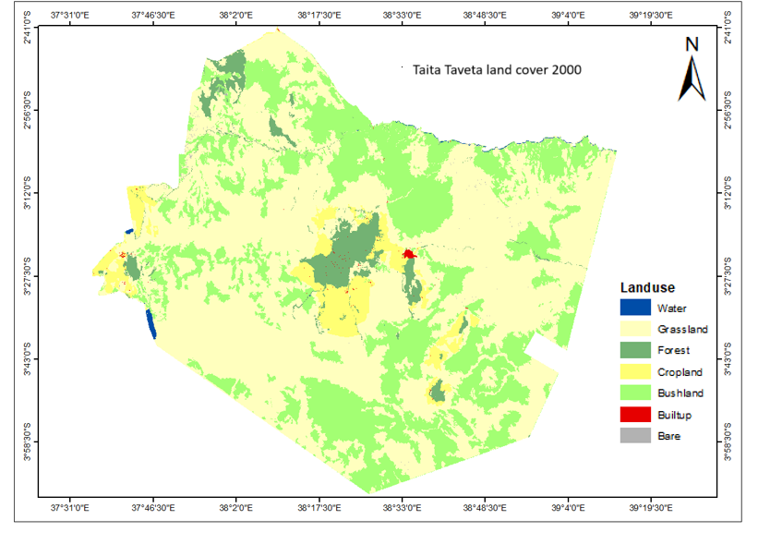

Figure 3: BarGraph of LULC ,2000
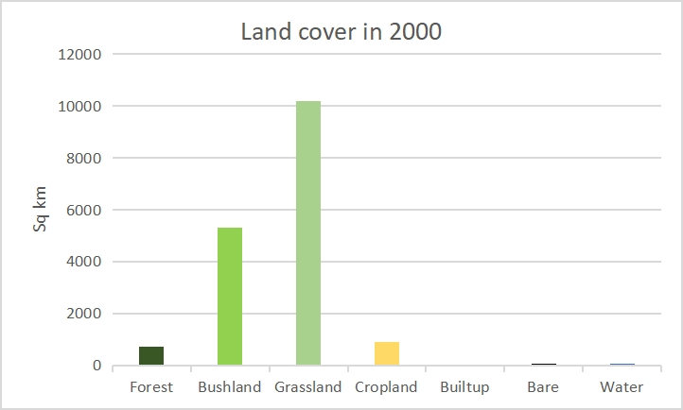

Figure 4 : Land Use Land Cover , 2010

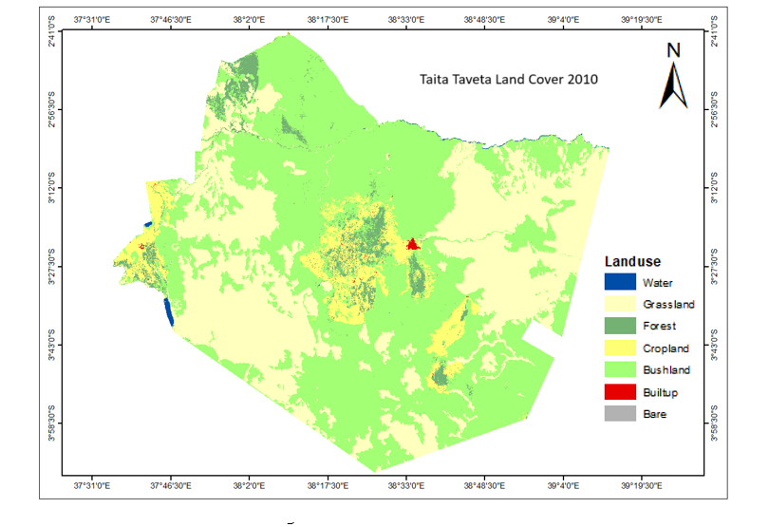
Figure 5 : Bar Graph of LULC ,2010
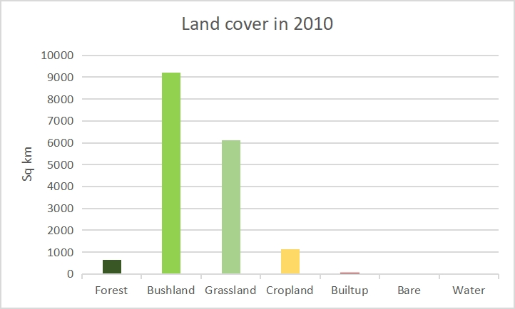

Figure 6 : Land Use Land Cover ,2022

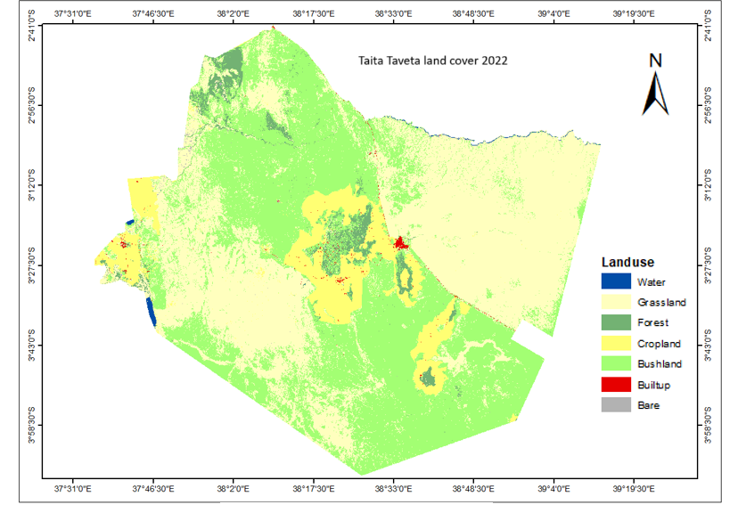
Figure 7 : Bar Graph of LULC, 2022
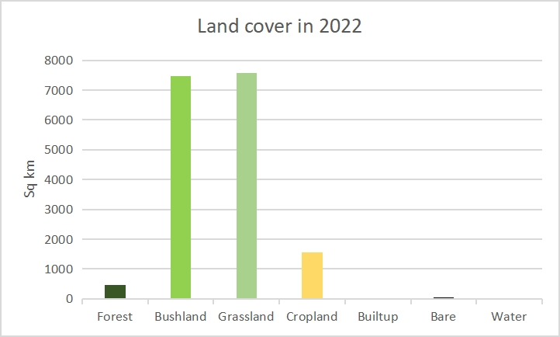
Figure 8 : Land Use Land Cover, 2030
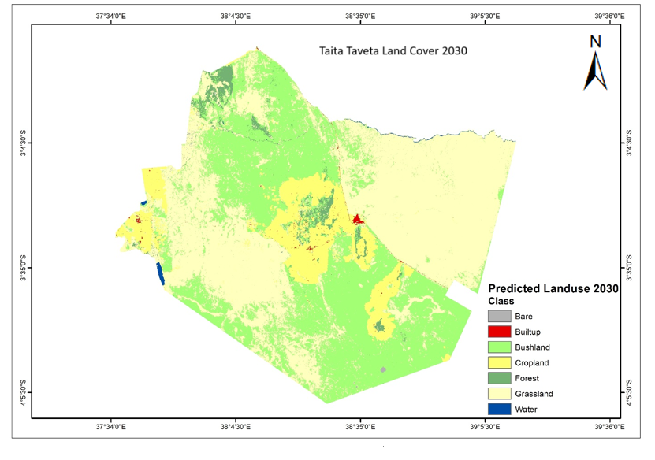
Figure 9: Bar Graph for LUCC,2030
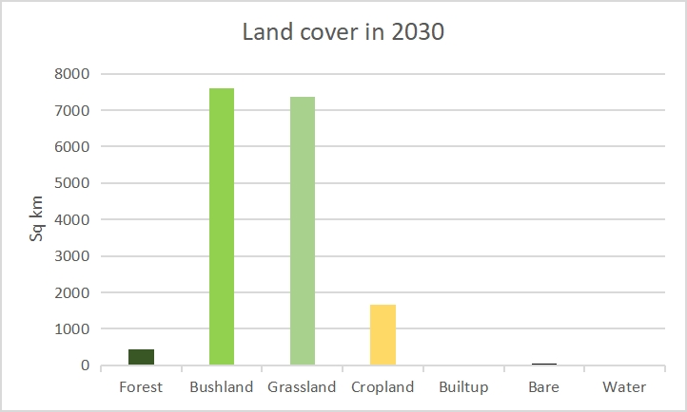
Change detection matricies

Table 4: Change matrix for the year 2000 to 2010

Table 5:Change matrix for the year 2010 to 2022

Table 6: Change matrix for the year 2000 to 2022

Results from questionnaires
The main drivers of LULC changes were mining, deforestation, and social economic activity. The results of the spatial analysis that was conducted provide validation for the changes that the local population underwent. According to the respondents, land subdivision and inheritance practices have resulted in a reduction in the amount of arable land. The department of agriculture also reported that the county's extension services delivery has increased, which has led to an increase in staffing and development partner support. 30% of farmers received training, twenty percent received better planting materials, and seventy percent of farmers' capacity was based on the adoption of livestock innovations and technologies, which raised crop and livestock production's productivity, commercialization, and competitiveness (CIDP 2023-27). As a result, more crops were produced to feed the growing metropolitan areas. Seventy percent of those surveyed had relocated to the present area of residence.

According to the mining department, government cooperation with miners has resulted in the rehabilitation of a few mined areas, increasing the amount of grassland, which is consistent with our findings. Additionally, over the past 2 years, a program run by SNV Netherlands that focuses primarily on fodder production has made a substantial contribution to grass coverage. The department of urban planning claims that the rise in built-up areas is a result of both migration and population growth, which is also supported by the respondents' statements. The towns' surrounding residential areas, including Voi, Wundanyi, Mwatate, and Taveta, are flourishing. There has been 1,195. 5 km of graded roads, 100km of graveled roads, and 100km of newly constructed roads (CIDP 2018–22), as a result of this people have begun to settle and construct in rural areas. In order to guarantee better quality, it was also stated that the government intended to build new roads while renovating and improving existing ones.

According to a forest department official, deforestation has occurred over time. Because of farming and settlements, trees were being cut down. Five Community Forest Associations were formed in order to facilitate appropriate and sustainable management of forest resources; four of these associations currently possess Forest Management Plans, while one does not. They confirmed that squatters have encroached on several forests in spite of the efforts. These forests are Goye, Macha, Iyale, and Mwandongo.The clearing of forest has also lead to increase in bushland.

According to the department of mining, Taita Taveta County is the leading producer of minerals in Kenya. Mining department officer stated that sand harvesting is additional mining activity in the county mainly undertaken in major dry rivers such as Voi River.Because more land has been cleared for mining operations, there is now more bare land and bush land as a result of these activities.

4. Conclusion
The results clearly demonstrated that Land Use and Land Cover Change (LULCC) has taken place in Taita Taveta County, exhibiting varying degrees of area alterations from one Land Use and Land Cover (LULC) category to another during the specified study periods. Over the years, there has been a noticeable decline in forest cover, signifying a distinct transition to alternative land cover types. Specifically, forest cover diminished by 1.6 % from 2000 to 2022. This reduction has been attributed to local residents who cleared the forest for both settlement and agricultural purposes. The transformation of forested areas into cropland and urban developments serves as a clear testament to this trend. Consequently, as other land cover classes were converted to bush-land, the area occupied by bushes saw an increase of 14.7 %. Deforestation stands out as the main land cover category driving the growth of bush-land. Nevertheless, between 2000 and 2010, grassland experienced a growth of 7.3 %, followed by a decline of 24 % from 2010 to 2022. The area dedicated to crop production has risen by 4.5% over time. This increase has been accompanied by the conversion of various land cover classes into cropland. The rise in population, advancements in agricultural technology, and farmer training have all been linked to the expansion of cropland. Bare land has seen a slight increase of 0.08%, primarily due to mining operations and overgrazing. The area designated for water has shown negligible change, with a reduction of 0.09 hectares from 2010 to 2022, while it remained stable from 2000 to 2010.

References

- Agarwal C, Green GM, Grove JM, Evans TP, Schweik CM (2002) A Review and Assessment of Land-Use Change Models: Dynamics of Space, Time
and Human Choice. Center for the Study of Institutions, Population, and Environmental Change, USDA Forest Service Northeastern Forest ResearchStation, USA, pp: 1-62.
- Allen, J.C. and Barnes, D.F. 1985. The Causes of Deforestation in Developing Countries.
Annals of the Association of American Geographers 75: 163-84.
- Alemu, B., Garedew, E., Eshetu, Z., and Kassa, H. (2015). Land Use and Land
Cover Changes and Associated Driving Forces in North Western Lowlands of
Ethiopia. Int. Res. J. Agric. Sci. Soil Sci. 5(1):28-44
- Anyona, S., &Rop, B. (2015, May).Environmental Impacts of Artisanal and Small-scale Mining in TaitaTaveta County.In Proceedings of Sustainable Research and Innovation Conference (pp. 228-241).
- Aplin, P., Atkinson, P. M., & Curran, P. J. (1997).Fine spatial resolution satellite
sensors for the next decade.International Journal of Remote Sensing, 18 (18), 3873-3881
- Bai ZG, Dent DL, Olsson L and Schaepman ME 2008. Global assessment of land degradation and improvement. 1. Identification by remote sensing. Report 2008/01, ISRIC – World Soil D’Odorico, P., & Ravi, S. (2016).Land degradation and environmental change.Biological and Environmental Hazards, Risks, and Disasters. Netherlands: Elsevier, 219-227.
- Briassoulis, H. (2000). Analysis of Land-use Change: Theoretical and Modeling
Approaches. The web book of regional science. West Virginia University, Regional
Research Institute, Morgantown,
- Campbell, J. B. (2002). Introduction to remote sensing.Taylor and Francis.
- Campbell. D.J., Lusch, D.P., Smucker, T. and Wangui, E.E. (2003). Root causes of land use change in the Loitoktok area, Kajiado county, Kenya LUCID Working paper series No.19
- Cheruto MC, Kauti MK, Kisangau PD, Kariuki P (2016) Assessment of Land Use and Land Cover Change Using GIS and Remote Sensing
Techniques: A Case Study of Taita Taveta County, Kenya. J Remote Sensing & GIS 5: 175. doi: 10.4175/2469-4134.1000175
- Clark, B., &Pellikka, P. (2007, July).Mapping land cover change in the Taita Hills, Kenya, utilizing multi-scale segmentation and object-oriented classification of SPOT imagery. In 2007 IEEE International Geoscience and Remote Sensing Symposium (pp. 1918-1921). IEEE.
- Coppin, P., Jonckheere, I., Nackaerts, K., Muys, B., and Lambin, E. (2004). Digital
change detection methods in ecosystem monitoring: a review. International Journal
of Remote Sensing, 25(9):1565–1596
- Ellis, E., & Pontius, R. (2007). Land-use and land-cover change. Encyclopedia of earth, 1, 1-4.
- Erle, E., & Pontius, R. (2007).Land-use and land-cover change. Encyclopaedia of Earth.(Eds.). Cutler J. Cleveland(Washington, DC: Environmental Information Coalition, National Council for Science and the Environment). LastRetrieved January, 19, 2008.
- Food and Agriculture Organization (FAO) (2009).Forest resources assessment 1990. A survey of tropical forest cover and study of change processes. United Nations Food and Agriculture Organization, Rome
- FAO. 2022. The State of the World’s Land and Water Resources for Food and Agriculture – Systems at breaking point. Main report. Rome. https://doi.org/10.4060/cb9910en

- Geoghegan, Jacqueline, Sergio Cortina Villar, Peter Klepeis, Pedro Macario Mendoza,
Yelena Ogneva-Himmelberger, Rinku Roy Chowdhury, B. L. Turner II, and
Colin Vance. 2001. Modeling Tropical Deforestation in the Southern Yucatan
- Government of Kenya/Ministry of Environment and Natural Resources, 2016
- Government of Kenya/Ministry of Environment and Natural ResourcesTechnical Report on the National Assessment of Forest and Landscape Restoration Opportunities in Kenya(2016)
- Mwichabe, S. (1996).Nomadic Pastoralism and Environmental Legislation in Kenya.KENGO/UNEP.
- Hayes, Daniel J., Steven A. Sader, and Norman B. Schwartz. 2002. Analyzing a Forest
Conversion History Datatbase to Explore the Spatial and Temporal
Characteristics of Land Cover Change in Guatemala’s Maya Biosphere Reserve.
Landscape Ecology. 17: 299:314.
- Hinton, J. C. (1996). GIS and remote sensing integration for environmental applications. International Journal of Geographical Information Systems, 10(7), 877-890.
- Hua W, Chen H, Sun S, et al. Assessing climatic impacts of future land use and land cover change
projected with the CanESM2 model [J]. International Journal of Climatology, 2015,
35(12):3661-3675
- Kamande LM (2008). An evaluation of the contribution of human-wildlife conflicts to poverty in Taveta division, Taita-Taveta County, Kenya.MSc thesis, Kenyatta University, Kenya.
- Kiage, L. M., Liu, K. B., Walker, N. D., Lam, N., & Huh, O. K. (2007). Recent land-cover/use change associated with land degradation in the Lake Baringo catchment, Kenya, East Africa: evidence from Landsat TM and ETM+. International Journal of Remote Sensing,28(19), 4285–4309.
- J. Rogan and D. M. Chen, “Remote Sensing Technology for Mapping and Monitoring Land-Cover and Land-Use Change,” Progress in Planning, Vol. 61, No. 4, 2004, pp. 301-325.
- Maeda, E. E., Clark, B., Pellikka, P., Siljander, M., &Vi, P. T. (2010, May). Driving forces of land-use change in the Taita Hills, Kenya. In 13th AGILE international conference on geographic information science (pp. 2-5)
- Masek, J. G., Lindsay, F. E. and Goward, S. N.2000.Dynamics of urban growth in the Washington DC metropolitan area, 1973–1996, from Landsat observations..International Journal of Remote Sensing, 21: 3473–3486.
- Meyer, W. B., Meyer, W. B., & BL Turner, I. I. (Eds.). (1994). Changes in land use and land cover: a global perspective (Vol. 4). Cambridge University Press.
- Muia, V. K., &Ndunda, E. (2013).Evaluating the impact of direct anthropogenic activities on land degradation in arid and semi-arid regions in Kenya. Nairobi, Kenya: Kenyatta University.
- Okembo, C., Lemmen, C., Kuria, D., & Zevenbergen, J. (2022). Developing an adapted land administration domain model profile for Kenya. Land use policy, 117, 106087.

- Peninsular Region: Comparing Survey and Satellite Data. Agriculture, Ecosystems and Environment. 85(1-3): 25-46
- Petit C, Scudder T, Lambin E (2001). Quantifying processes of landcover change by remote sensing: resettlements and rapid land-cover changes in south-eastern Zambia. Int. J. Remote Sens. 22:3435- 3456.
- Republic of Kenya (2009).Kenya National Bureau of Statistics (KNBS).Kenya Population and Housing Census, Nairobi, Kenya.
- Schowengerdt, R. A. (2006). Remote sensing: models and methods for image processing. Elsevier.
- Shaghla Parveen, Jasmeen Basheer and Bushra Praveen.2018.A Literature Review On Land Use Land Cover Changes.ISSN: 2320-5407
- Singh, A. K. (2003). Modeling land use land cover changes using cellular automata in a
geo-spatial environment. Unpublished thesis.Enschede, The Netherlands: ITC.
- TaitaTaveta County Government. (2013).County integrated development plan.
- Riebsame, W. E., Meyer, W. B., & Turner, B. L. (1994).Modeling land use and cover as part of globalenvironmental change. Climatic change, 28(1-2), 45-64
- (Shaghla Parveen, 2018).A Literature Review On Land Use Land Cover Changes.ISSN: 2320-5407
- Stabile, M. (2012).Deconstructing the complexity of land use and cover classification and
land change modeling.Unpublished thesis. New South Wales, Australia: Faculty of
Agriculture, Food and Natural Resources, The University of Sydney.
- Stocking, M. (1996). Soil erosion: Breaking new ground. In: The lie of the land: Challenging
received wisdom on the African environment, (Leach, M. and Mears, R. eds). African
issues.Villiers Publications. UK. 240 pp
- Turner, B.L., Skole, D., Sanderson, S. Fischer, G., Fresco, L. and Leemans, R. (1995).LandUse and Land-Cover Change Science/Research Plan. HDP Report Series No. 7.
http://www.ihdp.uni-bonn.de/html/publications/reports/report07/luccsp.htm. Accessed,
May 10, 2004
- T. Ramachandra and U. Kumar, “Geographic Resources Decision Support System for Land Use, Land Cover Dynamics Analysis,” Proceedings of the FOSS/GRASS Users Conference, Bangkok, September 2004.
- UNEP (United Nations Environmental Programme)(2009). Turning the Land Degradation Tide.World Desertification Report. UNEP, Nairobi
- UNDP, H. (2015). Human Development Report 2015 Technical notes.
- Verburg, P. H., Schot, P. P., Dijst, M. J., &Veldkamp, A. (2004). Land use change modelling: current practice and research priorities. GeoJournal, 61(4), 309-324.
- Wekesa, C., Kirui, B. K., Maranga, E. K., & Muturi, G. M. (2019). The fate of Taita Hills forest fragments: Evaluation of forest cover change between 1973 and 2016 using Landsat magery.

- Zollo, N. J. (2019). A Study on Artisanal and Small-Scale Gemstones Mining in TaitaTaveta County, Kenya (Doctoral dissertation, University of Ghana).

Definitions, Acronyms, Abbreviations
CIDP-County Integrated Development Plan
LULCC -Land Use Land Cover Changes
LULC-Land Use Land Cover
NGOs- Non-Governmental Organizations
OA-overall accuracy (OA)
PA- producer's accuracy (PA)
GIS-Geographic Information System
QGIS-Quantum Geographic Information System

