Review Article

The role of microalgae in carbon and nitrogen transformation in wastewater

Abstract
Excessive carbon emissions and nitrogen pollution in aquatic environments pose significant threats to global sustainability, contributing to climate change and eutrophication. Microalgae have emerged as a promising bioremediation tool due to their ability to efficiently assimilate carbon and transform nitrogen compounds in wastewater. Their application enables simultaneous nutrient recovery and environmental remediation, offering a sustainable, low-energy, and cost-effective approach to mitigate pollution and promote circular nutrient management. Therefore, this review explores carbon transformation by microalgae, including photosynthesis, biomass conversion for renewable energy, and wastewater treatment. It also examines microalgal application methods, such as open raceway ponds, closed photobioreactors, and other relevant cultivation systems. In addition, nitrogen transformation processes are addressed, including ammonia removal, nitrite and nitrate conversion, nitrogen capture for eutrophication control, and the factors influencing these transformations. This review further highlights the cellular and biochemical pathways underlying carbon sequestration and nitrogen transformation in microalgae. Finally, prospective strategies are proposed for optimizing microalgal applications for carbon capture and nitrogen conversion to enhance environmental sustainability.

Keywords: Microalgae, Wastewater treatment, Carbon transformation, Nitrogen transformation, Circular bioeconomy

Introduction
Microalgae have emerged as a promising solution for sustainable wastewater management because of their ability to transform two key elements in wastewater carbon and nitrogen (Torres-Franco et al., 2021). These tiny photosynthetic organisms use sunlight to turn carbon dioxide (CO₂) and nutrients into biomass, offering an eco-friendly method for nutrient recovery and carbon sequestration (Viswanaathan et al., 2022). This process not only helps reduce greenhouse gas emissions but also enables the production of valuable bio-products, supporting the circular bioeconomy One of the main roles of microalgae in wastewater treatment is carbon transformation, Through photosynthesis, microalgae capture CO2 from the atmosphere or dissolved inorganic carbon from wastewater and convert it into organic matter stored in their biomass (Priya et al., 2023). And it also reduces the carbon footprint of wastewater treatment plants and provides a renewable source of raw materials for bioenergy production. For example, microalgal biomass can be turned into biohydrogen, biogas, biodiesel, and other biofuels, contributing to energy recovery and resource sustainability. Additionally, microalgae can utilize organic carbon in wastewater, further improving carbon neutrality by lowering the overall chemical oxygen demand (COD) (Srimongkol and Sangtanoo 2022, de Lima Barizão et al. 2023). Apart from carbon sequestration, microalgae also play a key role in nitrogen transformation, which is crucial for maintaining water quality and preventing eutrophication. These microorganisms can absorb various forms of nitrogen such as ammonia, nitrates, and nitrites often found in high concentrations in wastewater (Omar et al., 2024), Paul and Banerjee 2022) for instance, Innovative algae-bacteria symbiosis systems have been highlighted as promising solutions, offering efficient ammonia-nitrogen removal with low energy consumption while simultaneously enhancing CO₂ sequestration (C. Y. Chen et al., 2025). This ability makes microalgae effective in reducing nitrogen loads, preventing harmful algal blooms, and avoiding oxygen depletion in natural water bodies. When paired with bacterial consortia, microalgae can further boost nitrogen removal by combining processes like nitrification and denitrification, where ammonia is ultimately converted into harmless nitrogen gas (Z. Wang et al., 2024). Although large-scale implementation of microalgae-based wastewater treatment faces some challenges, it offers a transformative approach to the circular bioeconomy by turning waste into valuable resources while reducing pollution (Sarker & Kaparaju, 2024). The Ongoing innovations, such as using granular activated carbon (GAC) to control bacterial contamination and developing membrane photobioreactors (MPBRs) for better nutrient recovery, are gradually overcoming these obstacles (Goh et al., 2022). Microalgae provide a versatile and sustainable approach to wastewater treatment, with the potential to reduce environmental impacts and transform waste into valuable products. By optimizing cultivation conditions and addressing technical challenges, microalgae-based systems could play a pivotal role in promoting a sustainable, circular bioeconomy (Sarker & Kaparaju, 2024).
This paper aims to evaluate the capacity of different microalgae species (e.g., Nannochloropsis sp., Chlorella vulgaris) to remove ammonia, nitrate, and nitrite from wastewater under varying environmental conditions. It will also compare the performance of open ponds, photobioreactors (PBRs), and hybrid systems in terms of biomass productivity, contamination control, and operational costs for large-scale wastewater treatment., The paper will analyze the impact of critical factors such as light intensity, temperature, pH, and nutrient ratios on microalgae carbon fixation and nitrogen assimilation to identify the optimal operational conditions. Finally, it will explore advancements in AI-driven monitoring, electro flocculation harvesting, and genetic engineering to improve microalgae-based wastewater treatment efficiency and economic feasibility. The paper will also assess the feasibility of converting microalgae biomass into biofuels (such as biodiesel and biogas) and high-value products (like animal feed and bioplastics) to enhance the circular bioeconomy of wastewater treatment systems.

Carbon Transformation by Microalga
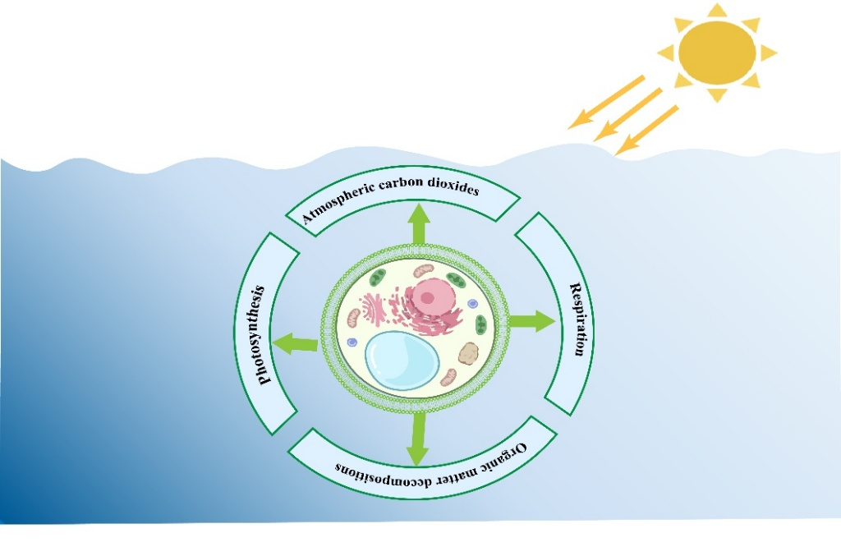
Microalgae are great at converting carbon dioxide (CO₂) into biomass through photosynthesis (Mao et al., 202) For instance, identified a species of Chlorella vulgaris with a maximum CO₂ absorption rate of 0.412 g/L·day and a maximum volume utilization of 8.125 L/day, demonstrating the capacity to remove up to 39% of CO₂ from thermal power plant exhaust gases (Politaeva et al., 2023). This is important for fighting climate change because microalgae capture CO₂ from the air or industrial emissions and turn it into organic compounds, helping to lower greenhouse gas levels (Dahai et al., 2024). How efficiently they do this depends on various environmental and physiological factors. Light, for example, is the main energy source for photosynthesis, and both its intensity and quality can really impact how well microalgae fix CO₂. When the light conditions are just right, they boost the activity of photosynthetic pigments and enzymes, which in turn increases the rate at which they absorb carbon (Yamaoka et al., 2025). This relationship is illustrated in Fig. 1, which shows how environmental inputs such as light and CO₂ are integrated within microalgal cells light captured by photoreceptors generates cellular energy, while CO₂ is concentrated via the carbon concentrating mechanism (CCM); together, these processes channel fixed carbon into storage molecules such as triacylglycerol’s and starch, directly linking environmental conditions to biomass accumulation and CO₂ sequestration efficiency.
Figure 1 Schematic representation of carbon transformation by microalga.

However, excessive light can lead to photo inhibition, damaging the photosynthetic apparatus and reducing efficiency. Therefore, maintaining appropriate light intensity and quality is crucial for maximizing CO₂ fixation in microalgal cultures (Didaran et al., 2024). For example, Photo inhibition is a significant and complex phenomenon involving light-induced damage to the photosynthetic machinery, primarily affecting the Photosystem II complex and resulting in decreased photosynthetic productivity (Bhutta et al., 2023). Temperature profoundly affects microalgal metabolism and CO₂ fixation. Each microalgal species has an optimal temperature range for growth and photosynthesis (Priyadharsini et al., 2022). For instance, Chlorella vulgaris exhibits optimal growth between 25°C and 30°C, with growth rates declining significantly outside this range. Elevated temperatures can impair enzyme function, particularly that of ribulose-1,5-bisphosphate carboxylase/oxygenase (Rubisco), leading to reduced photosynthetic efficiency (Wijewardene et al., 2021, Moore et al. 2021). Equally, low temperatures can slow metabolic processes, limiting CO₂ uptake and biomass production. Therefore, maintaining species-specific optimal temperatures is essential for efficient carbon fixation (Yu et al., 2024). The pH of the culture medium influences enzyme activity, nutrient availability, and the overall metabolic processes of microalgae(Hofmann et al., 2025). For example, the most microalgal species thrive in a neutral to slightly alkaline pH range (7.0–8.5). Deviations from this range can inhibit enzyme activity and nutrient uptake, thereby reducing CO₂ fixation efficiency(Ruiz-Ruiz et al., 2024). Moreover, pH fluctuations can affect the solubility and availability of inorganic carbon species, such as bicarbonate and carbonate ions, which are utilized by microalgae during photosynthesis. Then, maintaining an optimal pH range is critical for maximizing carbon assimilation (Latagan et al., 2025).
Nutrients, particularly nitrogen and phosphorus, are essential for microalgal growth and CO₂ fixation. Nitrogen is a key component of amino acids, proteins, and nucleic acids, while phosphorus is vital for energy transfer and nucleic acid synthesis (Maltsev et al., 2023). Deficiencies in these nutrients can limit cell division and photosynthetic capacity, thereby reducing CO₂ uptake. Conversely, optimal nutrient concentrations support robust growth and high biomass productivity, enhancing carbon sequestration potential. Therefore, careful management of nutrient levels is necessary to sustain efficient CO₂ fixation in microalgal cultures (Elbasiouny et al., 2022) For instance, in Scenedesmus sp. LX1, nitrogen and phosphorus half-saturation constants were reported at 12.1 mg/L and 0.27 mg/L, respectively; concentrations below these thresholds led to marked declines in growth rate (from 2.21 × 10⁶ to <1.0 × 10⁶ cells mL⁻¹ day⁻¹) despite an increase in lipid content under severe limitation (up to 53% of biomass) (Xin et al., 2010). This highpoint is the importance of maintaining optimal nutrient concentrations to sustain biomass productivity and maximize carbon sequestration potential.

Carbon sequestration via Photosynthesis
Photosynthesis is a vital process in which autotrophic organisms, including plants, algae, and microalgae, convert carbon dioxide (CO₂) and water into glucose and oxygen using sunlight (Häder, 2022) for example, in an experimental study, Chlorella vulgaris cultured under continuous illumination absorbed 0.412 g CO₂ L⁻¹·day⁻¹, equivalent to the utilization of 8.125 L of CO₂ per day from flue gas streams, converting it into biomass through photosynthesis (Politaeva et al., 2023). This measurable CO₂ uptake directly demonstrates the process in which autotrophic microalgae transform carbon dioxide and water into organic matter and release oxygen using sunlight. This process not only sustains life by producing oxygen and organic matter but also acts as a powerful mechanism for carbon sequestration capturing and storing atmospheric CO₂ long-term (Murphy, 2024). Among photosynthetic organisms, microalgae play a particularly significant role in carbon reduction due to their high photosynthetic efficiency, rapid growth rates, and ability to thrive in diverse aquatic environments (Politaeva et al., 2023). Microalgae absorb CO₂ during photosynthesis using the Calvin cycle, following the general reaction.
6CO₂+6H₂O+light energy→C₆H₁₂O₆+6O_{2.} --------------- Equation 2.1
This mechanism is depicted in Fig. 2, which illustrates how microalgae take up inorganic carbon in the form of dissolved CO₂ and bicarbonate (HCO₃⁻), actively transport these molecules into the cell, and utilize carbonic anhydrase (CA) to catalyze their interconversion, thereby ensuring a steady intracellular CO₂ supply for the Calvin cycle and subsequent biomas.
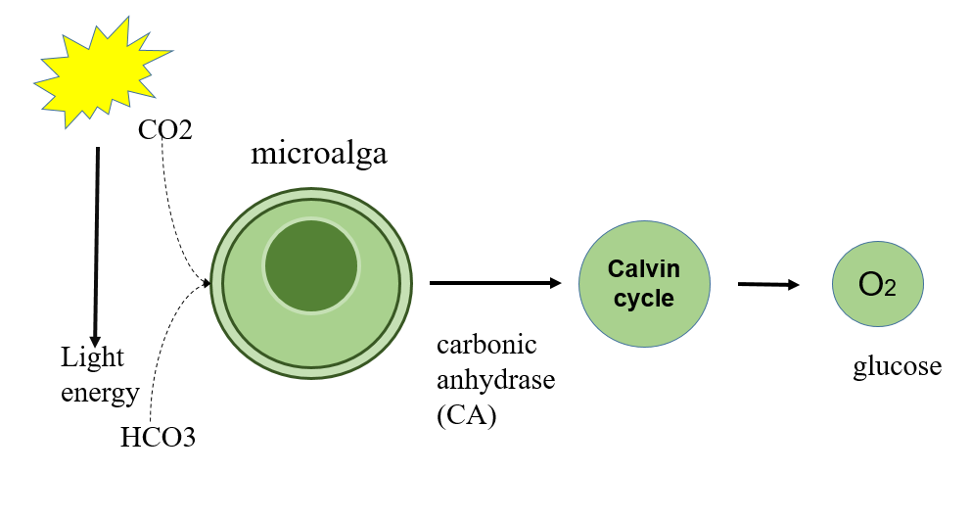
Unlike terrestrial plants, microalgae can fix more CO₂ per unit area because they have simpler structures, a higher surface-area-to-volume ratio, and faster biomass productivity(Kim et al., 2025). This concept is illustrated in Fig.3, which presents a microalgae-based biorefinery framework where sunlight, wastewater nutrients, and CO₂ or flue gas drive rapid microalgal growth, and the resulting biomass is harvested and converted into biofuels, fertilizers, animal feed, nutraceuticals, and other high-value products, thereby coupling efficient CO₂ fixation with resource recovery and sustainable product generation (Toplicean & Datcu, 2024).
Figure 2. The simplified scheme for the Photosynthesis and Carbon Sequestration

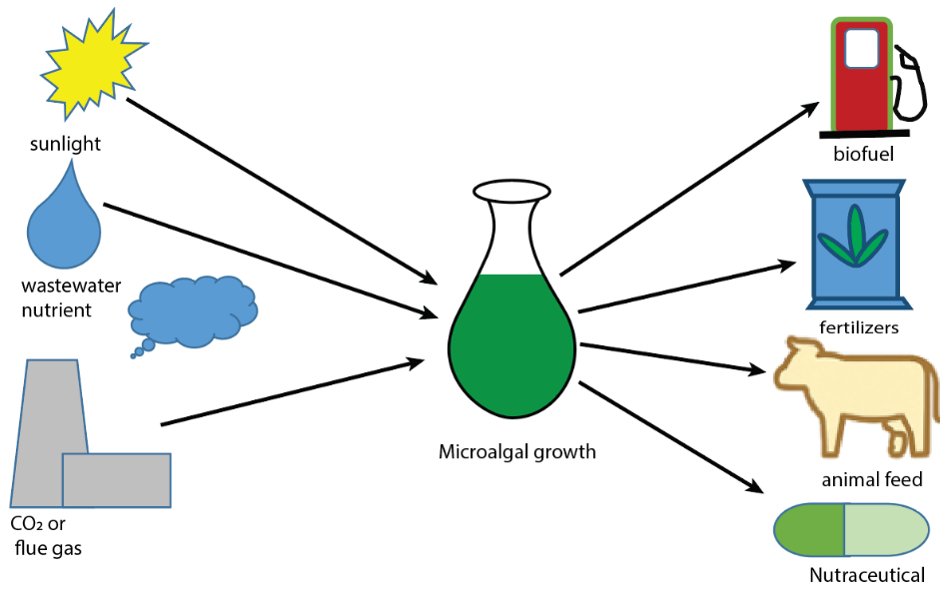
Figure 3. microalgae-based biorefnery framework for carbon sequestration
Many species can double their biomass in a matter of hours under optimal conditions. Additionally, microalgae can grow in wastewater, saline water, or even flue gas enriched environments, making them effective in industrial carbon capture systems (Iglina et al., 2022). For example, Chlorella sp. GD cultivated in aquaculture wastewater aerated with boiler flue gas containing ~8% CO₂ achieved a biomass productivity of 0.892 g L⁻¹·day⁻¹ and CO₂ fixation efficiencies of 30–53%, depending on aeration rate (Kuo et al., 2016). Through their biomass, which can be harvested and converted into biofuels, fertilizers, or bioplastics, microalgae offer a dual benefit: they sequester carbon and produce valuable byproducts (Balan et al., 2023). Moreover, when integrated into wastewater treatment systems or photo bioreactors, microalgae help reduce CO₂ emissions by utilizing carbon from organic waste and emissions streams. The biomass can be stored or reused in a manner that delays or prevents the re-release of carbon into the atmosphere, making microalgae a promising solution in mitigating climate change (Das et al., 2025) for example, Chlorella sorokiniana grown in mixed swine and municipal wastewater (1:3 ratio) with 5% CO₂ aeration achieved a biomass concentration of 1.22 g L⁻¹, removed 88% of total nitrogen, and accumulated lipids accounting for 17% of its biomass over 10 day (Yao et al., 2015). As global carbon emissions continue to rise, leveraging the photosynthetic capacity of microalgae offers a sustainable, scalable, and eco-friendly approach to reducing atmospheric CO₂ concentrations while supporting a circular bioeconomy (Sarker & Kaparaju, 2024).

Medium of microalgae application for carbon transformation
Microalgae can be applied in several engineered systems to transform and reduce atmospheric and anthropogenic carbon dioxide (CO₂) through photosynthesis and biomass production (Awewomom et al., 2024). These application methods vary in scale, design, and efficiency, but all aim to enhance carbon capture, fixation, and conversion into valuable bio-products. The most common methods include open pond systems, closed photobioreactors (PBRs), algal turf scrubbers, and hybrid systems (Ahmad & Abdullah, 2025).

Open Raceway Ponds (ORPs)
Open raceway ponds are the simplest and most widely adopted system for large-scale microalgal cultivation. They consist of shallow basins where microalgae grow in nutrient-rich water under natural sunlight. To enhance productivity, CO₂ is often bubbled into the ponds, which the algae absorb through photosynthesis, converting it into organic carbon stored in their biomass. Despite being cost-effective, open ponds face several limitations, including susceptibility to contamination, high evaporation rates, and reduced productivity caused by fluctuations in light and temperature (Yahaya et al., 2025) for instance, In well-managed open raceway ponds, areal biomass productivity typically reaches only 20–25 g m⁻²·day⁻¹ during short periods, whereas long-term productivity in large commercial operations rarely exceeds 12–13 g m⁻²·day⁻¹ (Cunha et al., 2020). This process is illustrated in Figure 6, which demonstrates how wastewater and flue gases can be utilized in open raceway ponds for microalgal growth, with harvested biomass converted into biofuels and treated water reused for irrigation. For enhancement of carbon capturing and sequestration, Open raceway ponds This process, however, is subject to environmental limitations, requiring optimization to achieve long-term, efficient use of resources.

Close Photobioreactors (PBRs)
Photobioreactor which are enclosed systems that provide more controlled environments for micro algal cultivation said by (Penloglou et al., 2024). They can be designed in various configurations (e.g., tubular, flat-panel, column) to optimize light exposure, gas exchange, and nutrient delivery. Photobioreactor significantly increase carbon fixation rates due to enhanced photosynthetic efficiency and protection from external contaminants. CO₂ can be directly injected into the system often from industrial flue gas making photorbioreactor ideal for carbon capture and utilization (CCU)(Keet et al., 2024) For instance, a flat-plate photobioreactor cultivating Chlorella vulgaris achieved impressive CO₂ fixation rates between 1.30 and 1.78 g CO₂ per liter per day when aerated with 15% CO₂ (v/v), far exceeding typical rates in open pond systems (Y. Li et al., 2018). These findings demonstrate the strong potential of Photobioreactors in enhancing carbon capture and sequestration efficiency, especially when integrated with emission sources.

Algal turf scrubbers
Algal turf scrubbers (ATS) involve growing filamentous algae on inclined screens over which wastewater or CO₂-rich water flows. These systems can simultaneously remove nutrients and carbon while allowing for easy biomass harvesting. ATS systems are increasingly being integrated into wastewater treatment plants and carbon-emitting industries said by (Alam et al., 2022).
In hybrid systems, microalgae cultivation is combined with other biological or chemical processes for example, integrating algae with bacteria for nutrient recycling or using microalgae in anaerobic digesters post-harvest to recover energy(Farooq, 2021). These applications not only transform carbon into biomass and bioenergy but also close the carbon loop by minimizing emissions.
Overall, selecting the appropriate microalgae application method depends on the source of CO₂, land availability, operational costs, water resources, and the intended use of the biomass. When optimized, these systems contribute significantly to climate change mitigation, industrial decarbonization, and bioeconomy development (Ali et al., 2025) For example, microalgae cultivation systems can fix 1.6 to 2 tons of CO₂ per hectare per year, while yielding 127 to 300 tons of biomass per hectare annually demonstrating both high-efficiency carbon capture and substantial biomass output suitable for bioenergy and bioproducts (Kadam et al., 2024)review (Ashour et al., 2024).

Microalgae biomass for renewable energy
Microalgae absorb carbon dioxide (CO₂) from the atmosphere or industrial emissions during photosynthesis and convert it into organic biomass (Politaeva et al., 2023). This biomass, when harvested, can be processed into renewable biofuels such as biodiesel, bioethanol, or biogas (Pilarski et al., 2021). The carbon-neutrality of this system lies in the fact that the CO₂ released during fuel combustion is equal to the CO₂ previously fixed by the microalgae, creating a closed carbon loop (Tropea, 2022).
This means that for every mole (44 grams) of CO₂ fixed, a portion of organic carbon (as glucose or other biomass) is formed. If this biomass is converted to energy (e.g., through combustion or fermentation), the same amount of CO₂ is released (Mahmood et al., 2023): As illustrated in Fig. 4 (Mahmood et al., 2023), this pathway highlights how sunlight-driven photosynthesis in microalgae facilitates CO₂ fixation, leading to biomass accumulation that can be processed into biofuels and other valuable products. Additionally, the biomass productivity (P) in terms of carbon fixation can be estimated proved by (Pilarski et al., 2021).
P_{CO2}​​=μ⋅X⋅Y_{CO2}​/X ------------------------- Equation 2.2
Where:
μ = specific growth rate of microalgae (day⁻¹), X = biomass concentration (g/L), Y_{CO2}​/X​ = yield coefficient (g CO₂ fixed / g biomass produced).
This equation helps quantify how much CO₂ is biologically captured during microalgae cultivation, enabling scale-up for real-world carbon capture systems.

Cellular and Biochemical Pathways of Carbon Sequestration in Microalgae
Inside a microalgal cell, carbon sequestration begins with the capture of inorganic carbon from the surrounding environment. In water, carbon dioxide exists both as dissolved CO₂ and as bicarbonate (HCO₃⁻), with bicarbonate often more abundant at higher ph. Microalgae take up CO₂ by diffusion across membranes, while bicarbonate enters through specific transporters located on the plasma membrane and chloroplast envelope (Kupriyanova et al., 2023). The enzyme carbonic anhydrase plays a key role by interconverting CO₂ and HCO₃⁻, ensuring a steady supply. Many microalgae also employ carbon-concentrating mechanisms (CCMs), which accumulate bicarbonate and then convert it to CO₂ in the chloroplast, creating a high concentration of CO₂ around RuBisCO and improving the efficiency of carbon fixation (Prasad et al., 2021).
Once inside the chloroplast, the inorganic carbon is directed toward RuBisCO, the central enzyme of the Calvin–Benson–Bassham (CBB) cycle (Meloni et al., 2023). In many species, bicarbonate is concentrated near the pyrenoid, a specialized compartment filled with RuBisCO. Carbonic anhydrase located in the pyrenoid converts bicarbonate into CO₂, saturating RuBisCO and reducing photorespiration. The structure of the pyrenoid, often surrounded by starch sheaths and thylakoids, helps retain CO₂ and minimize losses, ensuring efficient fixation (An et al., 2023).
The energy needed to power this process comes from the light reactions of photosynthesis. In photosystem II, water molecules are split, releasing oxygen and sending electrons through an electron transport chain (Schmidt-Rohr, 2021) for instance, The energy needed to power this process comes from the light reactions of photosynthesis. As described by (Shapovalov et al., 2021) structural studies of Photosystems I and II demonstrate that water oxidation at the Mn₄CaO₅ cluster in PS-II produces O₂, H⁺, and e⁻, providing the reducing power necessary for photosynthetic energy conversion. This builds a proton gradient that drives ATP synthase to produce ATP. Meanwhile, photosystem I transfers electrons to NADP⁺, reducing it to NADPH. Together, ATP and NADPH provide the energy and reducing power for the Calvin cycle (Henri, 2022).
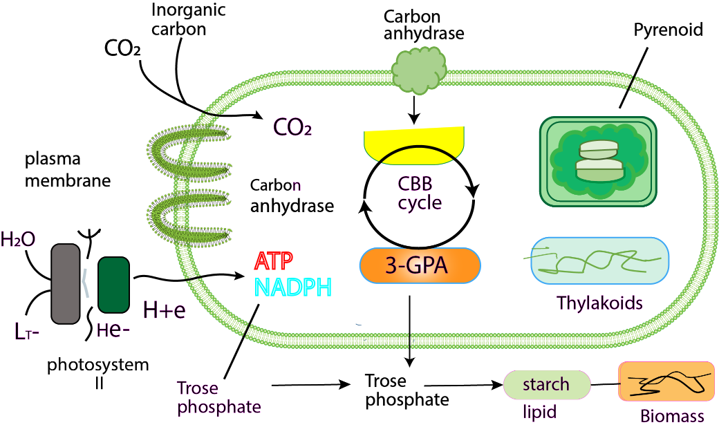
In the CBB cycle, RuBisCO incorporates CO₂ into ribulose-1,5-bisphosphate (RuBP), forming two molecules of 3-phosphoglycerate (3-PGA). These are phosphorylated using ATP and then reduced by NADPH to form triose phosphates. As shown in Figure 4 illustrates these pathways, showing how inorganic carbon enters the cell, is converted by carbonic anhydrase, fixed by RuBisCO in the pyrenoid, and processed through the CBB cycle with ATP and NADPH from photosynthesis, ultimately leading to starch, lipid, and biomass formation. Some of these triose phosphates are recycled to regenerate RuBP, while others are diverted to build biomass (Meloni et al., 2023). This step represents the heart of carbon sequestration, where inorganic carbon is converted into organic molecules.
Figure 4. cellular and biochemical pathways of carbon sequestration in microalgae
The fixed carbon is partitioned into different storage and functional forms. In the chloroplast, triose phosphates can be stored as starch granules, while in other algae, carbon is stored as chrysolaminarin. Alternatively, they may be converted into lipids: triose phosphates are transformed into pyruvate, then into acetyl-CoA, which feeds fatty acid synthesis(Q. Chen et al., 2022). These fatty acids are assembled into triacylglycerols (TAGs) and stored in lipid droplets. Under nutrient stress, such as nitrogen limitation, microalgae often divert more carbon into lipids, a form well-suited for long-term storage and biofuel production. Carbon is also incorporated into proteins and pigments, and in some cases, secreted as extracellular polymeric substances (EPS), which contribute to environmental carbon pools (Jenkinson, 2023).
The efficiency of carbon sequestration is safeguarded by several mechanisms. The CCM maintains high CO₂ levels around RuBisCO to suppress photorespiration. Microalgae can adjust transporter activity, carbonic anhydrase expression, and pyrenoid architecture in response to low external CO₂, tuning their carbon capture system (Prasad et al., 2021). Environmental conditions such as light, temperature, and nutrient availability further influence how carbon is allocated among starch, lipids, and other cellular components.
Ultimately, carbon fixed by microalgae contributes to long-term sequestration when biomass is harvested, mineralized, or buried. In engineered systems, this means carbon can be locked into algal biomass for biofuels or bioproducts, while in natural ecosystems, some carbon sinks into sediments (Sarwer et al., 2022). Certain groups, like coccolithophores, even fix carbon into calcium carbonate minerals, storing it in geologic form.

Microalgae-driven nitrogen regulation and conversion processes in water systems
The use of microalgae for nitrogen transformation involves different methods designed to maximize the removal and conversion of nitrogen compounds, like ammonium (NH₄⁺), nitrate (NO₃⁻), and nitrite (NO₂⁻), from wastewater or nutrient-rich environments (Salbitani & Carfagna, 2021) For instance, a study demonstrated that a microalgae-bacteria consortium achieved enhanced nitrogen removal from wastewater without the need for aeration or external organic carbon, highlighting the potential of microalgae in nitrogen transformation processes. (Zheng et al., 2025). These methods aim to either turn reactive nitrogen into microalgal biomass or convert it into safer, less harmful forms, which helps with pollution control and resource recovery.

Eutrophication Control for Nitrogen Capturing
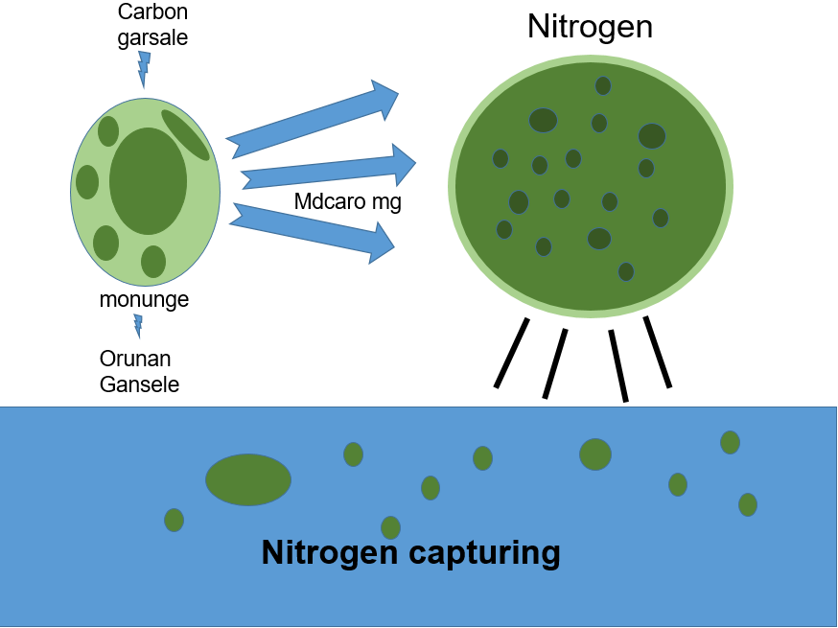
Eutrophication can occur in any freshwater or marine (saltwater) body of water, including lakes, rivers, reservoirs, estuaries, and coastal waters. Eutrophication is a major environmental problem caused by the excessive accumulation of nutrients, particularly nitrogen and phosphorus, in water bodies. This nutrient overload trigger microalgae blooms, oxygen depletion, and a serious decline in aquatic ecosystems (Lan et al., 2024). One promising biological solution is the use of use microalgae which simultaneously influence both the nitrogen and carbon cycles. As shown in Figure 9, microalgae absorb carbon dioxide through photosynthesis, fixing it into organic biomass. similarly, they assimilate nitrogen compounds such as ammonium, nitrate, and nitrite, incorporating them into their cellular structure (Salbitani & Carfagna, 2021) for example, (Rani & Maróti, 2021), reported that Chlorella sp. and Chlamydomonas sp. removed up to 100% of nitrate from synthetic wastewater within 3 days, with Chlamydomonas sp. achieving 34.6% nitrate removal even at high concentrations (50 mm) over 6 days. This demonstrates their potential in reducing nitrogen pollution and producing valuable biomass.
Figure 5. Eutrophication Controlfor Nitrogen Capturing

By linking these cycles, microalgae not only reduce nitrogen pollution but also regulate carbon flows in aquatic systems. If harvested, their biomass represents a sustainable removal of both nitrogen and carbon, while unharvested cells may undergo respiration or decomposition, releasing CO₂ and CH₄ back into the system, or contribute to long-term carbon sequestration through sedimentation. Unlike chemical treatments that provide only short-term relief, microalgae offer a sustainable approach: they transform excess nutrients into valuable biomass while helping to restore balance in both the nitrogen and carbon cycles (Sarker & Kaparaju, 2024). Microalgae can be grown in controlled systems, like wastewater treatment ponds, wetlands, or photobioreactors, where they help remove nitrogen before the water is released into natural ecosystems (Sátiro et al., 2025). Some algae strains, with their high nitrogen uptake rates, are even specially chosen for cleaning nitrogen-polluted waters.

Wastewater Treatment Plant
Microalgae are becoming an increasingly popular addition to wastewater treatment plants (WWTPs) as a sustainable alternative or even a supplement to traditional treatment methods. Typically, in conventional WWTPs, nitrogen and phosphorus removal depends on energy-heavy processes like activated sludge systems, nitrification-denitrification, and chemical precipitation. But when microalgae are integrated into the system, they offer a more biological, low-energy, and eco-friendly way to remove nutrients, especially nitrogen compounds such as ammonium (NH₄⁺), nitrate (NO₃⁻), and nitrite (NO₂⁻) (Omar et al., 2024) For example, pilot-scale high-rate algal ponds treating real wastewater achieved average removal efficiencies of 90% for ammonium (NH₄⁺), 70% for chemical oxygen demand (COD), and 50% for phosphate (PO₄³⁻) demonstrating effective nitrogen transformation and energy savings versus activated sludge systems (Velásquez-Orta et al., 2024).
In these microalgae-assisted WWTPs, the nutrient-rich wastewater not only provides a growth medium but also acts as a source of carbon and nitrogen for the algae’s photosynthesis and biomass production (Selvasembian et al., 2024). As the algae grow, they absorb nitrogen and phosphorus directly from the wastewater, significantly reducing the concentration of pollutants(Mathew et al., 2022). Plus, during the day, the microalgae produce oxygen through photosynthesis, which heterotrophic bacteria in the system can use to break down organic matter. This reduces the need for external aeration, helping to cut operational costs For example, in a bioreactor using Chlorella vulgaris immobilized in alginate beads alongside Pseudomonas putida, glucose removal efficiency improved from 50% in 12 hours (without aeration) to 100% in just 6 hours when photosynthetic aeration was at play (Praveen & Loh, 2015).

Open Ponds
Open ponds, especially high-rate algal ponds (HRAPs) and raceway ponds, are some of the most commonly used and cost-effective systems for growing microalgae in wastewater treatment (Arbib et al., 2022) For example, a 2024 meta-analysis of pilot-scale HRAPs revealed that these systems can remove up to 90% of ammonium (NH₄⁺), 70% of chemical oxygen demand (COD), and 50% of phosphate (PO₄³⁻), while enabling resilient biomass production under real-world outdoor conditions (Velásquez-Orta et al., 2024). These systems are essentially shallow, open-air basins that are mixed either naturally or mechanically, ensuring that light, nutrients, and algae cells are evenly distributed. The main goal of these ponds is to harness the photosynthetic activity of microalgae, enabling them to absorb sunlight and nutrients particularly nitrogen (such as ammonium, nitrate, and nitrite) from wastewater (Zamfirescu et al., 2024) for example, a 2021 study reported that In one pilot-scale study using outdoor open raceway ponds fed with municipal wastewater, a mixed microalgal consortium significantly outperformed monocultures in both biomass productivity and nutrient uptake, demonstrating the effectiveness of pond design in maximizing nutrient uptake, especially nitrogen species (e.g., ammonium, nitrate, nitrite)(Lage et al., 2021).
The primary role of these open ponds in wastewater treatment is to remove nitrogen and phosphorus compounds while producing valuable algal biomass said by (Liu & Hong, 2021). In nitrogen-rich wastewater, microalgae quickly absorb inorganic nitrogen and convert it into proteins and other cellular materials (Omar et al., 2024). This process helps reduce nutrient levels that can cause eutrophication, while also creating biomass that can be harvested for use in bioenergy, fertilizers, or animal feed.
A typical raceway pond is a closed-loop, oval-shaped channel with paddle wheels that keep the water and algae in constant motion. The depth is usually kept between 20 and 30 cm to allow maximum light penetration, since light is a key factor for algae growth reported by (J. Wang et al., 2015) Carbon dioxide (CO₂) can be supplied either naturally through atmospheric diffusion or artificially by bubbling, especially when treating high-strength wastewater or trying to boost growth rates for biomass production (Lage et al., 2018) For example, integrating 10% CO₂ bubbling into a funnel-shaped spoiler–improved column photobioreactor resulted in an 18.2% increase in biomass, a 13.95% boost in CO₂ fixation rate, and enhanced removal of COD, total phosphorus, and ammonium compared to conventional setups (Ji et al., 2025).
Open ponds offer several advantages, including low construction and operational costs, simple design, and scalability. They also provide a dual function of treatment and biomass generation, with the added benefit of being able to operate efficiently in warm, sunny climates. However, these systems face challenges such as evaporation losses, temperature and light fluctuations, and the risk of contamination from other microorganisms. Meanwhile, they tend to have lower biomass productivity compared to closed systems. Despite these limitations, open pond systems remain a viable and widely implemented method for large-scale nitrogen transformation and carbon capture using microalgae. They are particularly suitable for developing regions and municipalities aiming to reduce treatment costs while aligning with green infrastructure and sustainability goals(Cousins & Hill, 2021).

Microalgae Reactor
Microalgae reactors, also called photobioreactors (PBRs), are controlled systems designed to maximize microalgae growth and nutrient transformation. As illustrated in Fig.10, wastewater is introduced into the reactor, where microalgae use light to drive photosynthesis, enabling the uptake of nitrogen and phosphorus compounds Unlike open pond setups, PBRs offer more control over factors like light intensity, temperature, CO₂ supply, and mixing, which make them highly effective for nitrogen removal, carbon capture, and biomass production, particularly in wastewater treatment (Poblete et al., 2022) For instance, a membrane photobioreactor culturing Chlorella sorokiniana removed 13.5 mg NH₄⁺-N per gram per day and 18.1 mg PO₄³⁻-P per gram per day, significantly outperforming non-membrane systems (NPBR) under the same conditions (Zou et al., 2022).
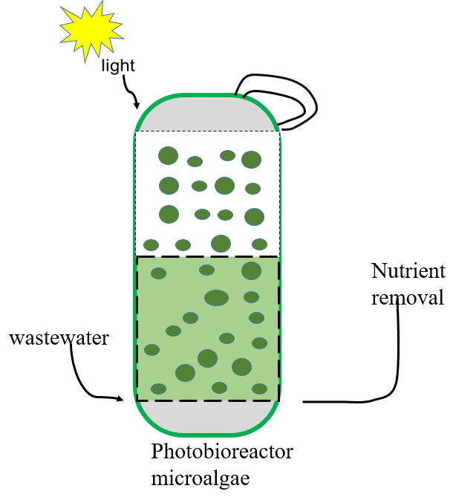
Figure 6. Schematic representation of Microalgae Reactor
There are several types of photobioreactors configuration, such as tubular, flat-panel, column, and airlift designs, each optimized for different environmental conditions and treatment goals (Carone, 2024). Regardless of the design, all systems rely on a steady light source, natural or artificial, to sustain photosynthesis, allowing microalgae to absorb ammonium (NH₄⁺), nitrate (NO₃⁻), and nitrite (NO₂⁻). This process ultimately lowers the nutrient load in wastewater while producing valuable biomass (Arnaldo et al., 2024).
In microalgae reactors, CO₂ is often injected from pure sources or captured flue gas to boost algal growth and carbon transformation (Iglina et al., 2022). The closed-loop system helps minimize gas loss and contamination, while automated controls ensure precise monitoring of key factors like pH, oxygen levels, nutrient concentrations, and growth rates(Dsouza et al., 2021). As a result, these reactors offer much better nitrogen and carbon removal efficiency than open systems, making them ideal for situations where consistent effluent quality is a top priority (Omar et al., 2024).
Some reactors even support algal-bacterial consortia, where the symbiotic relationship between algae and bacteria boosts both organic matter degradation and nutrient cycling. The oxygen produced by the algae helps fuel aerobic bacterial processes, while the bacteria release CO₂ and mineral nutrients that promote further algal growth(X. Wang & Hong, 2022) While microalgae reactors come with a higher initial investment and require more technical expertise than open ponds, their compact size, scalability, and ability to perform well in different climates make them a great fit for urban wastewater treatment plants, industrial sites, and facilities focused on high-value biomass production. In short, microalgae reactors offer a highly efficient, advanced treatment technology that not only removes nitrogen and carbon but also generates valuable biomass. Integrating them into wastewater treatment systems aligns with sustainable development goals and supports a practical approach to green, circular resource recovery reported by (Satiro et al., 2024).

Cellular and Biochemical Pathways of Nitrogen Transformation by Microalgae

Ammonia removal
Ammonia removal in wastewater treatment primarily occurs through direct uptake by microalgae during photosynthesis. In the presence of sunlight, ammonia serves as a readily available nitrogen source that is assimilated into amino acids and other nitrogen-containing biomolecules (Edward & Edward, 2025) For example, (W. R. L. Song et al., 2024) reported that Chlorella vulgaris cultured in synthetic aquaculture wastewater achieved an ammonium nitrogen removal efficiency of 83.7%, demonstrating the effective incorporation of ammonia into cellular components. This mechanism is illustrated in Figure 7, which depicts how ammonium (NH₄⁺) is absorbed by microalgae and assimilated into amino acids and proteins via pathways such as GS-GOGAT, thereby supporting efficient nitrogen removal in wastewater treatment.

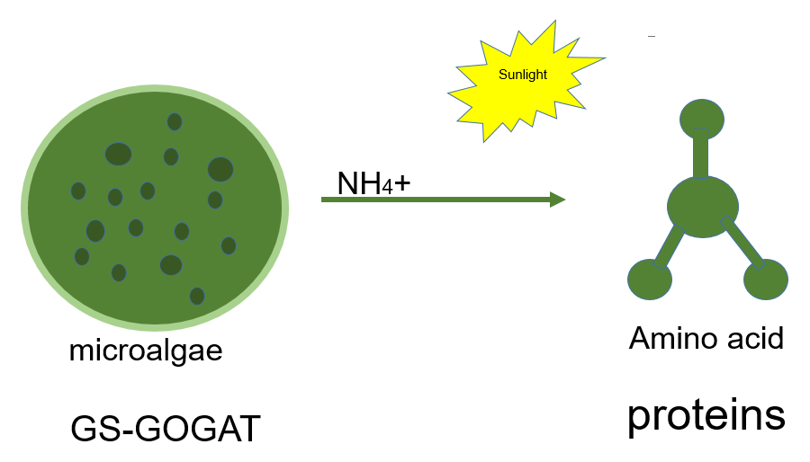
Figure 7. Ammonia Removal

Nitrite and nitrate removal
Nitrite and nitrate removal in wastewater treatment follows a similar biological pathway to ammonia assimilation, whereby microalgae absorb these compounds and reduce them to ammonium before incorporating them into cellular biomass (Salbitani & Carfagna, 2021), Unlike nitrifying bacteria, which oxidize ammonia to nitrite and nitrate, microalgae preferentially utilize reduced forms such as ammonium but retain the metabolic capacity to taking up and convert nitrate and nitrite when necessary. This process is mediated by enzymes including nitrate reductase (NR) and nitrite reductase (NiR), which facilitate the stepwise reduction of nitrate (NO₃⁻) to nitrite (NO₂⁻) and subsequently to ammonium (NH₄⁺)(Omar et al., 2024). The pathway is illustrating in figure 8, which depicts the enzymatic reduction steps and the assimilation of ammonium into amino acids via the GS-GOGAT cycle.
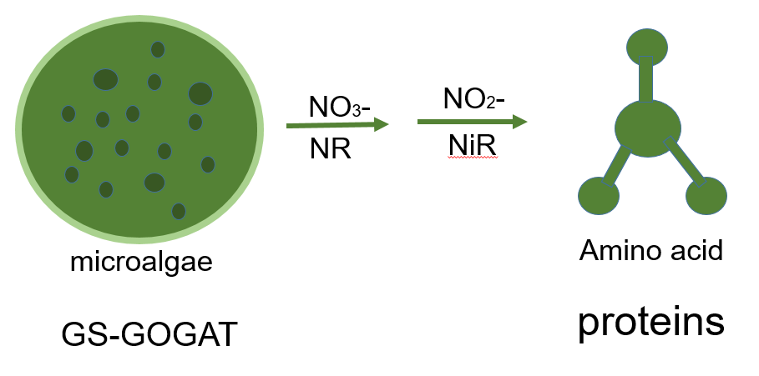
Figure 8. Nitrite and Nitrate Removal

Furthermore, when microalgae are cultivated in mixed algal-bacterial systems, synergistic interactions enhance nitrogen removal. For instance, bacteria can convert organic nitrogen to ammonia, which is then absorbed by the algae. Likewise, microalgae produce oxygen during photosynthesis, supporting aerobic bacterial nitrification, while algae themselves consume the end products (NO₃⁻ and NO₂⁻) for assimilation (Nedaei & Shokrkar, 2025).
This integrated approach not only leads to the effective reduction of nitrogen pollutants but also results in the production of valuable algal biomass, which can be used for biofertilizers, bioenergy, or animal feed. Therefore, microalgae offer an environmentally friendly and cost-effective alternative to conventional nitrogen removal processes in wastewater treatment systems (Renganathan et al., 2024).

Nitrogen transformation pathways metabolism
Nitrogen transformation and the associated nitrogen pathways in microalgae cells are essential processes for their growth, metabolism, and overall physiological function. These discussed pathways enable microalgae to utilize various forms of nitrogen, including ammonium (NH₄⁺), nitrate (NO₃⁻), and atmospheric nitrogen (N₂), depending on the species and environmental conditions (Salbitani & Carfagna, 2021) For instance, that Chlorella sorokiniana NCU-7 exhibited strong ammonium tolerance, adaptability to nitrogen deprivation, and efficient NH₄⁺-N removal from wastewater, while sustaining high algal yields and metabolic flexibility (H. Song et al., 2024). Ammonium is a preferred nitrogen source and is assimilated through the Glutamine Synthetase-Glutamate Synthase (GS-GOGAT) cycle. In this cycle, ammonium is first incorporated into glutamine by glutamine synthetase (GS), and then glutamate is synthesized via the action of glutamate synthase (GOGAT). This process is crucial for producing amino acids and supporting cellular functions (Fan et al., 2025). Nitrate, another common nitrogen source, is first absorbed by the microalgal cell and then reduced to nitrite by the enzyme nitrate reductase (NR). Nitrite is subsequently reduced to ammonium by nitrite reductase (NiR), which is then incorporated into organic molecules through the GS-GOGAT cycle (Tejada-Jimenez et al., 2019). In certain nitrogen-fixing species, such as cyanobacteria, atmospheric nitrogen (N₂) is converted into ammonium through a process known as biological nitrogen fixation, which is catalyzed by the nitrogenase enzyme complex. This process requires significant energy input and is primarily carried out under anaerobic conditions (Uddin & Wright, 2023). The regulation of these nitrogen assimilation pathways is tightly controlled by transcriptional mechanisms, post-translational modifications, and feedback inhibition to ensure that nitrogen is utilized efficiently(Wei et al., 2021). For example, high levels of ammonium can inhibit further ammonium uptake and the activity of enzymes like GS, while nitrogen-responsive transcription factors adjust gene expression based on nitrogen availability (Kunwar et al., 2025). Nitrogen is crucial for the synthesis of amino acids, proteins, and nucleic acids, and is also a key component of chlorophyll, which is essential for photosynthesis (L. H. Chen et al., 2024). Environmental factors such as light, temperature, pH, and oxygen levels also influence nitrogen assimilation, with light and temperature affecting enzyme activities and nitrogen fixation rates (Lu et al., 2023). Overall, nitrogen metabolism in microalgae is a complex, highly regulated process that is central to their growth and ecological success (X. Li et al., 2024).

Conclusion
Microalgae have emerged as a promising and eco-friendly solution to address critical environmental challenges, including carbon emissions, nutrient pollution, and sustainable energy production. Through photosynthesis, microalgae efficiently capture and convert carbon dioxide into organic biomass, contributing significantly to carbon sequestration and climate change mitigation. Their capacity to assimilate nitrogenous compounds, such as ammonium, nitrate, and nitrite, makes them highly effective in wastewater treatment applications, improving effluent quality and mitigating the risks of eutrophication. Various cultivation systems, such as open ponds, photobioreactors, and algal-bacterial consortia, offer flexible and scalable solutions for enhancing both carbon and nitrogen transformation. However, the success of these systems depends on several key factors, including light intensity, pH, nutrient availability, temperature, and strain selection. Furthermore, the harvested microalgal biomass can be utilized for renewable energy production, biofertilizers, and value-added bioproducts, reinforcing the principles of a circular bioeconomy. the application of microalgae in carbon and nitrogen management holds immense potential for creating integrated environmental solutions. With ongoing research, technological advancements, and policy support, microalgae-based systems can play a pivotal role in achieving global sustainability goals, including clean water, clean energy, and climate action.

Future Perspective
The application of microalgae for carbon and nitrogen transformation presents a significant opportunity to address pressing environmental and energy challenges. As the demand for sustainable solutions grows, future research should focus on optimizing large-scale cultivation systems, enhancing strain selection through genetic engineering and synthetic biology, and integrating artificial intelligence and automation for real-time monitoring and control.
In carbon capture, microalgae offer a unique advantage by utilizing CO₂ from flue gases and industrial emissions. Advancing carbon-negative technologies, such as bioenergy with carbon capture and storage (BECCS), could play a crucial role in meeting climate targets under the Paris Agreement. Similarly, in wastewater treatment, developing hybrid systems combining microalgae with bacterial consortia, membranes, or constructed wetlands could improve nutrient removal efficiency while recovering valuable resources. Further exploration into valorizing microalgae biomass for high-value products like biofuels, pharmaceuticals, bioplastics, and animal feed could enhance the economic viability of these systems and attract private investment. Policy support, public-private partnerships, and regulatory frameworks will be vital to scale microalgae technologies from experimental phases to commercial applications. In the long term, integrating microalgae into smart cities, zero-waste infrastructure, and climate-resilient agriculture could revolutionize global management of carbon, water, and nutrient cycles. With interdisciplinary collaboration and strategic investment, microalgae have the potential to become a key pillar in building a sustainable, low-carbon, and circular bioeconomy for future generations.

References
Ahmad, I., & Abdullah, N. (2025). Nature-based technologies for wastewater treatment and bioenergy production. Nature-Based Technologies for Wastewater Treatment and Bioenergy Production, 1–281. https://doi.org/10.2166/9781789064100
Alam, M. A., Wan, C., Tran, D. T., Mofijur, M., Ahmed, S. F., Mehmood, M. A., Shaik, F., Vo, D. V. N., & Xu, J. (2022). Microalgae binary culture for higher biomass production, nutrients recycling, and efficient harvesting: a review. Environmental Chemistry Letters, 20(2), 1153–1168. https://doi.org/10.1007/s10311-021-01363-z
Ali, S. S., Al-Tohamy, R., Al-Zahrani, M., Schagerl, M., Kornaros, M., & Sun, J. (2025). Advancements and challenges in microalgal protein production: A sustainable alternative to conventional protein sources. Microbial Cell Factories, 24(1), 1–23. https://doi.org/10.1186/s12934-025-02685-1
An, Y., Wang, D., Du, J., Wang, X., & Xiao, J. (2023). Pyrenoid: Organelle with efficient CO2-Concentrating mechanism in algae. Journal of Plant Physiology, 287(June), 154044. https://doi.org/10.1016/j.jplph.2023.154044
Arbib, Z., Marín, D., Cano, R., Saúco, C., Fernandez, M., Lara, E., & Rogalla, F. (2022). Large-scale demonstration of microalgae-based wastewater biorefineries. Integrated Wastewater Management and Valorization Using Algal Cultures, 215–234. https://doi.org/10.1016/B978-0-323-85859-5.00007-5
Arnaldo, M. D. G., Gamage, N. D., Jaffrenou, A., Rabesaotra, V., Mossion, A., Wielgosz-Collin, G., & Méléder, V. (2024). Comparison of different small-scale cultivation methods towards the valorization of a marine benthic diatom strain for lipid production. Algal Research, 77(June 2023). https://doi.org/10.1016/j.algal.2023.103327
Ashour, M., Mansour, A. T., Alkhamis, Y. A., & Elshobary, M. (2024). Usage of Chlorella and diverse microalgae for CO2 capture - towards a bioenergy revolution. Frontiers in Bioengineering and Biotechnology, 12(August), 1–20. https://doi.org/10.3389/fbioe.2024.1387519
Awewomom, J., Dzeble, F., Takyi, Y. D., Ashie, W. B., Ettey, E. N. Y. O., Afua, P. E., Sackey, L. N. A., Opoku, F., & Akoto, O. (2024). Addressing global environmental pollution using environmental control techniques: a focus on environmental policy and preventive environmental management. Discover Environment, 2(1). https://doi.org/10.1007/s44274-024-00033-5
Balan, V., Pierson, J., Husain, H., Kumar, S., Saffron, C., & Kumar, V. (2023). Potential of using microalgae to sequester carbon dioxide and processing to bioproducts. Green Chemistry, 25(20), 7934–7951. https://doi.org/10.1039/d3gc02286b
Bhutta, M. A., Bibi, A., Ahmad, N. H., Kanwal, S., Amjad, Z., ur Rehman, H., Farooq, U., Khalid, M. N., & Nayab, S. F. (2023). Molecular Mechanisms of Photoinhibition in Plants: A Review. Sarhad Journal of Agriculture, 39(2), 340–345. https://doi.org/10.17582/journal.sja/2023/39.2.340.345
Carone, M. (2024). Next-Generation Microalgae Cultivation : Innovative flat panel photobioreactor with tailored light regulation and hybrid modelling approach.
Chen, C. Y., Chang, Y. H., Leong, Y. K., & Chang, J. S. (2025). Application of algae-bacteria symbiosis system for ammonia nitrogen wastewater treatment. Journal of Bioscience and Bioengineering. https://doi.org/10.1016/j.jbiosc.2025.06.011
Chen, L. H., Xu, M., Cheng, Z., & Yang, L. T. (2024). Effects of Nitrogen Deficiency on the Photosynthesis, Chlorophyll a Fluorescence, Antioxidant System, and Sulfur Compounds in Oryza sativa. International Journal of Molecular Sciences, 25(19). https://doi.org/10.3390/ijms251910409
Chen, Q., Yu, X., Liu, S., Luo, S., Chen, X., Xu, N., & Sun, X. (2022). Identification, Characteristics and Function of Phosphoglucomutase (PGM) in the Agar Biosynthesis and Carbon Flux in the Agarophyte Gracilariopsis lemaneiformis (Rhodophyta). Marine Drugs, 20(7). https://doi.org/10.3390/md20070442
Cousins, J. J., & Hill, D. T. (2021). Green infrastructure, stormwater, and the financialization of municipal environmental governance. Journal of Environmental Policy and Planning, 23(5), 581–598. https://doi.org/10.1080/1523908X.2021.1893164
Cunha, P., Pereira, H., Costa, M., Pereira, J., Silva, J. T., Fernandes, N., Varela, J., Silva, J., & Simões, M. (2020). Nannochloropsis oceanica cultivation in pilot-scale raceway ponds-from design to cultivation. Applied Sciences (Switzerland), 10(5). https://doi.org/10.3390/app10051725
Das, S., Beegum, S., Acharya, B. S., & Panday, D. (2025). Soil Carbon Sequestration: A Mechanistic Perspective on Limitations and Future Possibilities. Sustainability (Switzerland), 17(13). https://doi.org/10.3390/su17136015
de Lima Barizão, A. C., de Oliveira Gomes, L. E., Brandão, L. L., Sampaio, I. C. F., de Moura, I. V. L., Gonçalves, R. F., de Oliveira, J. P., & Cassini, S. T. (2023). Microalgae as tertiary wastewater treatment: Energy production, carbon neutrality, and high-value products. Algal Research, 72(March). https://doi.org/10.1016/j.algal.2023.103113
Didaran, F., Kordrostami, M., Ghasemi-Soloklui, A. A., Pashkovskiy, P., Kreslavski, V., Kuznetsov, V., & Allakhverdiev, S. I. (2024). The mechanisms of photoinhibition and repair in plants under high light conditions and interplay with abiotic stressors. Journal of Photochemistry and Photobiology B: Biology, 259(7), 113004. https://doi.org/10.1016/j.jphotobiol.2024.113004
Dsouza, A., Price, G. W., Dixon, M., & Graham, T. (2021). A conceptual framework for incorporation of composting in closed-loop urban controlled environment agriculture. Sustainability (Switzerland), 13(5), 1–28. https://doi.org/10.3390/su13052471
Edward, I. E. S., & Edward, D. S. (2025). Leveraging the blue economy for emission reduction in industries: a comprehensive review of recent studies. Environmental Science and Pollution Research, 32(20), 12147–12166. https://doi.org/10.1007/s11356-025-36454-9
Elbasiouny, H., El-Ramady, H., Elbehiry, F., Rajput, V. D., Minkina, T., & Mandzhieva, S. (2022). Plant Nutrition under Climate Change and Soil Carbon Sequestration. Sustainability (Switzerland), 14(2), 1–20. https://doi.org/10.3390/su14020914
Fan, X., Lu, C., Khan, Z., Li, Z., Duan, S., Shen, H., & Fu, Y. (2025). Mixed Ammonium-Nitrate Nutrition Regulates Enzymes, Gene Expression, and Metabolic Pathways to Improve Nitrogen Uptake, Partitioning, and Utilization Efficiency in Rice. Plants, 14(4). https://doi.org/10.3390/plants14040611
Farooq, W. (2021). Sustainable production of microalgae biomass for biofuel and chemicals through recycling of water and nutrient within the biorefinery context: A review. GCB Bioenergy, 13(6), 914–940. https://doi.org/10.1111/gcbb.12822
Goh, P. S., Ahmad, N. A., Lim, J. W., Liang, Y. Y., Kang, H. S., Ismail, A. F., & Arthanareeswaran, G. (2022). Microalgae-Enabled Wastewater Remediation and Nutrient Recovery through Membrane Photobioreactors: Recent Achievements and Future Perspective. Membranes, 12(11). https://doi.org/10.3390/membranes12111094
Henri, J. (2022). Structures et interactions des enzymes du cycle de Calvin-Benson-Bassham.
Hofmann, T. A., Atkinson, W., Fan, M., Simkin, A. J., Jindal, P., & Lawson, T. (2025). Impact of climate-driven changes in temperature on stomatal anatomy and physiology. Philosophical Transactions of the Royal Society of London. Series B, Biological Sciences, 380(1927), 20240244. https://doi.org/10.1098/rstb.2024.0244
Iglina, T., Iglin, P., & Pashchenko, D. (2022). Industrial CO2 Capture by Algae: A Review and Recent Advances. Sustainability (Switzerland), 14(7). https://doi.org/10.3390/su14073801
Jenkinson, I. R. (2023). Plankton Genes and Extracellular Organic Substances in the Ocean. Journal of Marine Science and Engineering, 11(4), 1–27. https://doi.org/10.3390/jmse11040783
Ji, Y., Zhang, H., Wang, P., Lin, G., Yang, H., & Cheng, H. X. (2025). Promotion of Microalgal Growth, CO2 Fixation, and Pollutant Removal in Piggery Effluent by a Column Photobioreactor with Funnel-Shaped Spoilers. Sustainability (Switzerland), 17(10), 1–17. https://doi.org/10.3390/su17104511
Kadam, D., Kadam, A., Koksel, F., & Aluko, R. E. (2024). file:///C:/Users/thinkpad/OneDrive/Documents/WeChat Files/wxid_dh8ocfdjy45k22/FileStorage/Temp/Copy/Scientifica - 2024 - Songserm - Light Influences the Growth Pigment Synthesis Photosynthesis Capacity and Antioxidant.pdf. Sustainable Food Proteins, 2(4), 183–214. https://doi.org/10.1002/sfp2.1036
Keet, G., Du Toit, J. P., & Pott, R. W. M. C. (2024). PBRs significantly increase carbon fixation rates due to enhanced photosynthetic efficiency and protection from external contaminants. World Journal of Microbiology and Biotechnology, 40(3), 1–19. https://doi.org/10.1007/s11274-024-03909-z
Kim, K. H., Parrow, M. W., & Kheirkhah Sangdeh, P. (2025). Microalgae-integrated building enclosures: a nature-based solution for carbon sequestration. Frontiers in Built Environment, 11(May), 1–9. https://doi.org/10.3389/fbuil.2025.1574582
Kunwar, U. B., Manzoor, N., Wen, J., & Pandit, N. R. (2025). Integrating Agronomic and Molecular Advancements to Enhance Nitrogen Use Efficiency (NUE) and Promote Sustainable Rice Production. Nitrogen (Switzerland), 6(2), 1–30. https://doi.org/10.3390/nitrogen6020034
Kuo, C. M., Jian, J. F., Lin, T. H., Chang, Y. Bin, Wan, X. H., Lai, J. T., Chang, J. S., & Lin, C. S. (2016). Simultaneous microalgal biomass production and CO2 fixation by cultivating Chlorella sp. GD with aquaculture wastewater and boiler flue gas. Bioresource Technology, 221(75), 241–250. https://doi.org/10.1016/j.biortech.2016.09.014
Kupriyanova, E. V., Pronina, N. A., & Los, D. A. (2023). Adapting from Low to High: An Update to CO2-Concentrating Mechanisms of Cyanobacteria and Microalgae. Plants, 12(7). https://doi.org/10.3390/plants12071569
Lage, S., Gojkovic, Z., Funk, C., & Gentili, F. G. (2018). Algal biomass from wastewater and flue gases as a source of bioenergy. Energies, 11(3), 1–30. https://doi.org/10.3390/en11030664
Lage, S., Toffolo, A., & Gentili, F. G. (2021). Microalgal growth, nitrogen uptake and storage, and dissolved oxygen production in a polyculture based-open pond fed with municipal wastewater in northern Sweden. Chemosphere, 276, 130122. https://doi.org/10.1016/j.chemosphere.2021.130122
Lan, J., Liu, P., Hu, X., & Zhu, S. (2024). Harmful Algal Blooms in Eutrophic Marine Environments: Causes, Monitoring, and Treatment. Water (Switzerland), 16(17), 1–64. https://doi.org/10.3390/w16172525
Latagan, M. J. D., Nagarajan, D., Chen, J. H., Huang, W. M., Chen, C. Y., Pacquiao, M. R., de Luna, M. D. G., Rollon, A. P., & Chang, J. S. (2025). Bioprospecting microalgal strains cultivated using bicarbonate under a pH-regulated regime for enhanced carbon capture and utilization. Algal Research, 89(April), 104064. https://doi.org/10.1016/j.algal.2025.104064
Li, X., Li, S., Xie, P., Chen, X., Chu, Y., Chang, H., Sun, J., Li, Q., Ren, N., & Ho, S. H. (2024). Advanced wastewater treatment with microalgae-indigenous bacterial interactions. Environmental Science and Ecotechnology, 20, 100374. https://doi.org/10.1016/j.ese.2023.100374
Li, Y., Li, R., Fu, H., & Gao, Y. (2018). Influence of Ventilation Modes on Carbon Dioxide Fixation of Chlorella vulgaris in a Flat-Plate Photobioreactor. 7(6), 275–282. https://doi.org/10.11648/j.earth.20180706.14
Liu, X. ya, & Hong, Y. (2021). Microalgae-Based Wastewater Treatment and Recovery with Biomass and Value-Added Products: a Brief Review. Current Pollution Reports, 7(2), 227–245. https://doi.org/10.1007/s40726-021-00184-6
Lu, S., Li, Y., Liu, X., Cheng, G., Yuan, Z., & Wu, F. (2023). Influence of Light Irradiation on Nitrification in Microalgal–Bacterial Systems for Treating Wastewater. Processes, 11(12). https://doi.org/10.3390/pr11123453
Mahmood, T., Hussain, N., Shahbaz, A., Mulla, S. I., Iqbal, H. M. N., & Bilal, M. (2023). Sustainable production of biofuels from the algae-derived biomass. Bioprocess and Biosystems Engineering, 46(8), 1077–1097. https://doi.org/10.1007/s00449-022-02796-8
Maltsev, Y., Kulikovskiy, M., & Maltseva, S. (2023). Nitrogen and phosphorus stress as a tool to induce lipid production in microalgae. Microbial Cell Factories, 22(1), 1–22. https://doi.org/10.1186/s12934-023-02244-6
Mathew, M. M., Khatana, K., Vats, V., Dhanker, R., Kumar, R., Dahms, H. U., & Hwang, J. S. (2022). Biological Approaches Integrating Algae and Bacteria for the Degradation of Wastewater Contaminants—A Review. Frontiers in Microbiology, 12(2). https://doi.org/10.3389/fmicb.2021.801051
Meloni, M., Gurrieri, L., Fermani, S., Velie, L., Sparla, F., Crozet, P., Henri, J., & Zaffagnini, M. (2023). Ribulose-1,5-bisphosphate regeneration in the Calvin-Benson-Bassham cycle: Focus on the last three enzymatic steps that allow the formation of Rubisco substrate. Frontiers in Plant Science, 14(2), 1–13. https://doi.org/10.3389/fpls.2023.1130430
Moore, C. E., Meacham-Hensold, K., Lemonnier, P., Slattery, R. A., Benjamin, C., Bernacchi, C. J., Lawson, T., & Cavanagh, A. P. (2021). The effect of increasing temperature on crop photosynthesis: From enzymes to ecosystems. Journal of Experimental Botany, 72(8), 2822–2844. https://doi.org/10.1093/jxb/erab090
Murphy, D. J. (2024). Biological Carbon Sequestration: From Deep History to the Present Day. Earth (Switzerland), 5(2), 195–213. https://doi.org/10.3390/earth5020010
Nedaei, L., & Shokrkar, H. (2025). Investigating the removal of pollutants from wastewater using microalgae. Chemical Review and Letters, 8(2), 426–440. https://doi.org/10.22034/crl.2025.490720.1482
Omar, A., Almomani, F., Qiblawey, H., & Rasool, K. (2024). Advances in Nitrogen-Rich Wastewater Treatment: A Comprehensive Review of Modern Technologies. Sustainability (Switzerland) , 16(5), 1–37. https://doi.org/10.3390/su16052112
Paul, D., & Banerjee, A. (2022). Technologies for Biological and Bioelectrochemical Removal of Inorganic Nitrogen from Wastewater: A Review. Nitrogen (Switzerland), 3(2), 298–313. https://doi.org/10.3390/nitrogen3020020
Penloglou, G., Pavlou, A., & Kiparissides, C. (2024). Recent Advancements in Photo-Bioreactors for Microalgae Cultivation: A Brief Overview. Processes, 12(6). https://doi.org/10.3390/pr12061104
Pilarski, K., Pilarska, A. A., Boniecki, P., Niedbała, G., Witaszek, K., Piekutowska, M., Idzior-Haufa, M., & Wawrzyniak, A. (2021). Degree of biomass conversion in the integrated production of bioethanol and biogas. Energies, 14(22). https://doi.org/10.3390/en14227763
Poblete, I. B. S., Araujo, O. de Q. F., & de Medeiros, J. L. (2022). Sewage-Water Treatment and Sewage-Sludge Management with Power Production as Bioenergy with Carbon Capture System: A Review. Processes, 10(4). https://doi.org/10.3390/pr10040788
Politaeva, N., Ilin, I., Velmozhina, K., & Shinkevich, P. (2023). Carbon Dioxide Utilization Using Chlorella Microalgae. Environments - MDPI, 10(7). https://doi.org/10.3390/environments10070109
Prasad, R., Gupta, S. K., Shabnam, N., Oliveira, C. Y. B., Nema, A. K., Ansari, F. A., & Bux, F. (2021). Role of microalgae in global co2 sequestration: Physiological mechanism, recent development, challenges, and future prospective. Sustainability (Switzerland), 13(23). https://doi.org/10.3390/su132313061
Praveen, P., & Loh, K. C. (2015). Photosynthetic aeration in biological wastewater treatment using immobilized microalgae-bacteria symbiosis. Applied Microbiology and Biotechnology, 99(23), 10345–10354. https://doi.org/10.1007/s00253-015-6896-3
Priya, A. K., Alagumalai, A., Balaji, D., & Song, H. (2023). Bio-based agricultural products: a sustainable alternative to agrochemicals for promoting a circular economy. RSC Sustainability, 1(4), 746–762. https://doi.org/10.1039/d3su00075c
Priyadharsini, P., Nirmala, N., Dawn, S. S., Baskaran, A., SundarRajan, P., Gopinath, K. P., & Arun, J. (2022). Genetic improvement of microalgae for enhanced carbon dioxide sequestration and enriched biomass productivity: Review on CO2 bio-fixation p athways modifications. Algal Research, 66(8), 102810. https://doi.org/10.1016/j.algal.2022.102810
Rani, V., & Maróti, G. (2021). Assessment of nitrate removal capacity of two selected eukaryotic green microalgae. Cells, 10(9). https://doi.org/10.3390/cells10092490
Renganathan, P., Gaysina, L. A., Holguín-Peña, R. J., Sainz-Hernández, J. C., Ortega-García, J., & Rueda-Puente, E. O. (2024). Phycoremediated Microalgae and Cyanobacteria Biomass as Biofertilizer for Sustainable Agriculture: A Holistic Biorefinery Approach to Promote Circular Bioeconomy. Biomass (Switzerland), 4(4), 1047–1077. https://doi.org/10.3390/biomass4040059
Ruiz-Ruiz, P., Gómez-Borraz, T. L., Saldivar, A., Hernández, S., Morales-Ibarría, M., & Revah, S. (2024). Diluted methane mitigation by a co-culture of alkaliphilic methanotrophs and the microalgae Scenedesmus obtusiusculus towards carbon neutrality. Biochemical Engineering Journal, 203(December 2023). https://doi.org/10.1016/j.bej.2023.109211
Salbitani, G., & Carfagna, S. (2021). Ammonium utilization in microalgae: A sustainable method for wastewater treatment. Sustainability (Switzerland), 13(2), 1–17. https://doi.org/10.3390/su13020956
Sarker, N. K., & Kaparaju, P. (2024). Microalgal Bioeconomy: A Green Economy Approach Towards Achieving Sustainable Development Goals. In Sustainability (Switzerland) (Vol. 16, Issue 24). https://doi.org/10.3390/su162411218
Sarwer, A., Hamed, S. M., Osman, A. I., Jamil, F., Al-Muhtaseb, A. H., Alhajeri, N. S., & Rooney, D. W. (2022). Algal biomass valorization for biofuel production and carbon sequestration: a review. In Environmental Chemistry Letters (Vol. 20, Issue 5). Springer International Publishing. https://doi.org/10.1007/s10311-022-01458-1
Satiro, J., dos Santos Neto, A. G., Marinho, T., Sales, M., Marinho, I., Kato, M. T., Simões, R., Albuquerque, A., & Florencio, L. (2024). The Role of the Microalgae–Bacteria Consortium in Biomass Formation and Its Application in Wastewater Treatment Systems: A Comprehensive Review. Applied Sciences (Switzerland), 14(14). https://doi.org/10.3390/app14146083
Sátiro, J., Marchiori, L., Morais, M. V., Marinho, T., Florencio, L., Gomes, A., Muñoz, R., Albuquerque, A., & Simões, R. (2025). Integrating photobioreactors and constructed wetlands for paper pulp industry wastewater treatment: A nature-based system approach. Journal of Water Process Engineering, 71(1). https://doi.org/10.1016/j.jwpe.2025.107237
Schmidt-Rohr, K. (2021). O2 and other high-energy molecules in photosynthesis: Why plants need two photosystems. Life, 11(11). https://doi.org/10.3390/life11111191
Selvasembian, R., Mal, J., Das, S., Verma, D. K., & Anastopoulos, I. (2024). Emerging Trends in Microbial Electrochemical Technologies for Sustainable Mitigation of Water Resources Contamination: Microbial Electrochemical Technologies in Wastewater Treatment. In Emerging Trends in Microbial Electrochemical Technologies for Sustainable Mitigation of Water Resources Contamination: Microbial Electrochemical Technologies in Wastewater Treatment. https://doi.org/10.1007/978-3-031-74636-9
Shapovalov, Y., Tokpayev, R., Khavaza, T., & Nauryzbayev, M. (2021). Generation of hydrogen and oxygen from water by solar energy conversion. Sustainability (Switzerland), 13(24). https://doi.org/10.3390/su132413941
Song, H., Li, J., Su, Q., Li, H., Guo, X., Shao, S., Fan, L., Xu, P., Zhou, W., & Qian, J. (2024). Insight into the mechanism of nitrogen sufficiency conversion strategy for microalgae-based ammonium-rich wastewater treatment. Chemosphere, 349(December). https://doi.org/10.1016/j.chemosphere.2023.140904
Song, W. R. L., Keong, Y. S., Yusoff, F. M., Ping, T. J., & Rahman, N. A. (2024). Potential of culturing microalgae Chlorella vulgaris and Nannochloropsis oculata with aquaculture wastewater for simultaneous aquafeed production and wastewater remediation. Blue Biotechnology, 1(1), 1–12. https://doi.org/10.1186/s44315-024-00020-8
Srimongkol, P., & Sangtanoo, P. (2022). Microalgae-based wastewater treatment for developing economic and environmental sustainability : Current status and future prospects. September, 1–18. https://doi.org/10.3389/fbioe.2022.904046
Tejada-Jimenez, M., Llamas, A., Galván, A., & Fernández, E. (2019). Role of nitrate reductase in NO production in photosynthetic eukaryotes. Plants, 8(3). https://doi.org/10.3390/plants8030056
Toplicean, I. M., & Datcu, A. D. (2024). An Overview on Bioeconomy in Agricultural Sector, Biomass Production, Recycling Methods, and Circular Economy Considerations. Agriculture (Switzerland), 14(7). https://doi.org/10.3390/agriculture14071143
Torres-Franco, A., Passos, F., Figueredo, C., Mota, C., & Muñoz, R. (2021). Current advances in microalgae-based treatment of high-strength wastewaters: challenges and opportunities to enhance wastewater treatment performance. In Reviews in Environmental Science and Biotechnology (Vol. 20, Issue 1). https://doi.org/10.1007/s11157-020-09556-8
Tropea, A. (2022). Biofuels Production and Processing Technology. Fermentation, 8(7), 4–9. https://doi.org/10.3390/fermentation8070319
Uddin, M. M., & Wright, M. M. (2023). Anaerobic digestion fundamentals, challenges, and technological advances. Physical Sciences Reviews, 8(9), 2819–2837. https://doi.org/10.1515/psr-2021-0068
Velásquez-Orta, S. B., Yáñez-Noguez, I., Ramírez, I. M., & Ledesma, M. T. O. (2024). Pilot-scale microalgae cultivation and wastewater treatment using high-rate ponds: a meta-analysis. Environmental Science and Pollution Research, 31(34), 46994–47021. https://doi.org/10.1007/s11356-024-34000-7
Viswanaathan, S., Perumal, P. K., & Sundaram, S. (2022). Integrated Approach for Carbon Sequestration and Wastewater Treatment Using Algal – Bacterial Consortia : Opportunities and Challenges.
Wang, J., Liu, J., & Liu, T. (2015). The difference in effective light penetration may explain the superiority in photosynthetic efficiency of attached cultivation over the conventional open pond for microalgae John Sheehan. Biotechnology for Biofuels, 8(1), 1–12. https://doi.org/10.1186/s13068-015-0240-0
Wang, X., & Hong, Y. (2022). Microalgae Biofilm and Bacteria Symbiosis in Nutrient Removal and Carbon Fixation from Wastewater: a Review. Current Pollution Reports, 8(2), 128–146. https://doi.org/10.1007/s40726-022-00214-x
Wang, Z., Hu, G., & Hong, Y. (2024). Strong Alliance of Microalgae and Bacteria: The State-of-the-Art Review and Future Prospects of Utilizing Microalgae-Bacteria Consortia for Comprehensive Treatment of Swine Wastewater. Current Pollution Reports, 10(4), 744–764. https://doi.org/10.1007/s40726-024-00325-7
Wei, L., You, W., Xu, Z., & Zhang, W. (2021). Transcriptomic survey reveals multiple adaptation mechanisms in response to nitrogen deprivation in marine Porphyridium cruentum. PLoS ONE, 16(11 November), 1–21. https://doi.org/10.1371/journal.pone.0259833
Wijewardene, I., Shen, G., & Zhang, H. (2021). Enhancing crop yield by using Rubisco activase to improve photosynthesis under elevated temperatures. Stress Biology, 1(1), 1–20. https://doi.org/10.1007/s44154-021-00002-5
Xin, L., Hong-ying, H., Ke, G., & Ying-xue, S. (2010). Effects of different nitrogen and phosphorus concentrations on the growth, nutrient uptake, and lipid accumulation of a freshwater microalga Scenedesmus sp. Bioresource Technology, 101(14), 5494–5500. https://doi.org/10.1016/j.biortech.2010.02.016
Yahaya, E., Yeo, W. S., Nandong, J., & Ngu, J. C. Y. (2025). CO2 fed microalgae cultivation in photobioreactor: review on challenges and possible solutions. Environmental Technology Reviews, 14(1), 540–564. https://doi.org/10.1080/21622515.2025.2508945
Yao, L., Shi, J., & Miao, X. (2015). Mixed wastewater coupled with CO2 for microalgae culturing and nutrient removal. PLoS ONE, 10(9), 1–16. https://doi.org/10.1371/journal.pone.0139117
Yu, B. S., Pyo, S., Lee, J., & Han, K. (2024). Microalgae: a multifaceted catalyst for sustainable solutions in renewable energy, food security, and environmental management. Microbial Cell Factories, 23(1). https://doi.org/10.1186/s12934-024-02588-7
Zamfirescu, A. V., Stancu, M. M., Ardelean, I. I., & Moisescu, C. (2024). Harnessing Oxygenic Photosynthetic Microorganisms for Sustainable Wastewater Treatment Systems: A Comprehensive Review. Water (Switzerland), 16(21). https://doi.org/10.3390/w16213094
Zheng, X., Liu, R., Li, K., Sun, J., Wang, K., Shao, Y., Hu, Z., Zhu, J., Pan, Z., & Nakhla, G. (2025). Microalgae-bacteria symbiosis enhanced nitrogen removal from wastewater in an inversed fluidized bed bioreactor: performance and microflora. Frontiers in Microbiology, 16(April), 1–12. https://doi.org/10.3389/fmicb.2025.1591974
Zou, H., Rutta, N. C., Chen, S., Zhang, M., Lin, H., & Liao, B. (2022). Membrane Photobioreactor Applied for Municipal Wastewater Treatment at a High Solids Retention Time: Effects of Microalgae Decay on Treatment Performance and Biomass Properties. Membranes, 12(6). https://doi.org/10.3390/membranes12060564

