Review Article

Redirecting Flow: A Behaviourally-Informed Urban Mobility Blueprint for Dehradun’s Congestion Crisis

Abstract
Dehradun, a fast-urbanising hill city, is witnessing critical levels of vehicular traffic congestion, particularly during peak school and office hours. This report presents a strategically layered, behaviourally informed urban mobility plan to reduce congestion sustainably. Drawing on globally validated behavioural models (Behavioural Urbanism, COM-B, EAST), criminological frameworks (CPTED, SCP, Defensible Space), and national-international precedents, this proposal leverages a hybrid of digital nudges, infrastructural adaptation, and social norm activation to drive sustainable modal transition.
Peak hour congestion is attempted to be solved from a Geographical perspective with the help of Transport Science, large scale network maps tying up with the previously mentioned Behaviour Science principles. Case studies of congestion hotspots are analysed with ground level solutions often involving changes in appearance of infrastructure and its presentation rather than changes in infrastructure capacity.
These solutions aim to be affordable, easy to implement and bring drastic change in how transportation is viewed in the hill city. Hotspot analysis is followed by a cost feasibility assessment, list of potential funding sources, implementation risk analysis and implementation roadmap. Lastly, areas for future research are specified.
Keywords
Behavioural urbanism, CPTED, SCP, defensible space, behavioural economics,
economical-tactical urbanism, sustainable congestion management
Introduction
The state of Uttaranchal (now Uttarakhand) separated from Uttar Pradesh in the year 2000 when three new states (Uttaranchal, Chhattisgarh and Jharkhand) were carved out based on the different cultures they had to their previous counterparts. With the Himalayan region separating from the Northern Plains, Uttaranchal gained Dehradun as its capital. A small town located on the foothills, Dehradun lies at a mere elevation of 450 metres compared to the mighty Himalayas which peak as high as 8 kilometres in Nepal and Tibet.
Since its inauguration as the state’s capital, the hill city has witnessed an urban area growth of nearly 200% increasing its urban land use (Figure 1) from 746 hectares to 1,463 hectares (Municipal Development and Development Authority, 2023). Much of this growth in urban land use and population has been haphazard, leading to congested roads, encroachment of footpaths, narrow alleyways with no room for vehicular movement and long traffic jams in the city’s central business district. The only arteries of the city are the State and National Highways which cut through the megalopolis and are crucial to movement within and through Dehradun.
A concoction of mismanagement, unplanned growth and large-scale immigration to the once calm and relaxed small town has led to a shift from pedestrian to vehicular transport. Dehradun presents a case of extremely high ownership of private transport means, most notably two-wheelers such as scooters and motorbikes. Most residences and commercial zones have developed without adequate parking spaces or consideration for vehicular storage contributing further to the crisis. A boiling point is reaching, where traffic jams may stretch throughout the city corridors, in notable intersections like Ghantaghar and Rispana Pul leading to a complete standstill which can only be solved through targeted behavioural nudges, reform in the attitude towards public transport and realising that the impending disaster can be averted through simple interventions.
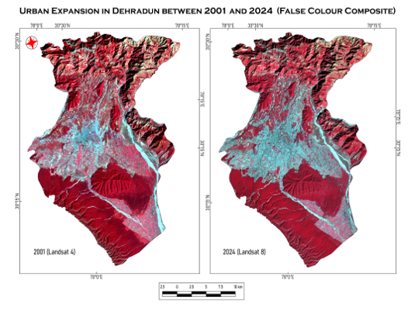
Figure (1): LULC Comparison Maps of Dehradun City (2001-2024)
This paper shall attempt to describe and then recommend strategies to solve said problems using popular and widely recognised theories of Spatial Criminology [such as Situational Crime Prevention, Crime Prevention through Environmental Design, Capability (C)-Opportunity (O)-Motivation (M) = Behaviour (B)], Behavioural Urbanism [such as Residential Density, New Urbanism], Behavioural Economics [such as Loss Aversion and Nudges] amongst others.
The focus will be on identifying key areas of congestion complications, developing targeted solutions and also general frameworks that can be applied to any part of the city.
Literature Review
Designing behaviourally informed mobility interventions requires grounding in both theoretical models and context-specific empirical studies. This review synthesises key literature and policy documents that collectively frame Dehradun’s traffic congestion as not merely an infrastructural issue, but a systemic behavioural challenge. Drawing on criminological, urban design, and behavioural economics literature, along with national-level policy documents and localised city assessments, this section anchors the proposed strategies in robust scholarly and applied evidence.
Clarke’s (1995) pioneering framework on Situational Crime Prevention (SCP) establishes the foundation for regulating space and human behaviour through environmental cues and structural deterrents. Originally used in criminology, the SCP model is aptly repurposed here to address informal transport behaviour—such as illegal auto stops and vendor encroachments—through access control, rule-setting, and spatial structuring. Clarke’s emphasis on manipulating situational variables rather than changing intrinsic motivations directly supports the use of low-cost nudges and micro-zoning strategies in urban mobility planning.
Complementing Clarke’s structural orientation, Crowe’s (2000) Crime Prevention Through Environmental Design (CPTED) extends the behavioural lens to spatial aesthetics and safety perceptions. Crowe illustrates how built environments can be proactively designed to influence pro-social behaviours, reduce fear, and improve usability. For Dehradun, CPTED principles like natural surveillance, territorial reinforcement, and lighting design directly inform the deployment of safe bus shelters, walkable zones, and calm areas near schools and hospitals. This integration of environmental psychology with behavioural economics reinforces the role of design in behaviour modulation.
The COM-B model introduced by Michie et al. (2011) serves as the principal theoretical scaffold for behavioural diagnosis in this report. By dissecting behaviour into Capability, Opportunity, and Motivation, the model enables a granular understanding of why Dehradun’s commuters continue to prefer private transport. The model’s multidimensional scope captures issues ranging from poor public transit literacy (capability) to unsafe commuting environments (opportunity) and status-related motivations (motivation). The COM-B model’s versatility allows for precise identification of behavioural bottlenecks and tailored intervention design.
Space, Time, Crime by Chataway (2020) provides the crux of all the spatial criminology principles used in our methodology and later implicitly in targeted implementation programmes. It goes into depth about CPTED, SCP as well as Defensible spaces and how it can be implemented in manners of civil offences such as traffic violations.
The MDDA’s Dehradun Master Plan 2041 (2023) contextualises these behavioural models within the city’s infrastructural and demographic realities. It reveals the disproportionate growth of private vehicles vis-à-vis public infrastructure and recognises the fragmentation of traffic control across departments. While the plan is rich in spatial data, it lacks behavioural diagnostics—thereby validating the need for this report’s behaviour-first orientation. The Master Plan’s zoning priorities, pedestrianisation goals, and mobility corridor proposals offer infrastructural scaffolding onto which behavioural strategies can be layered.
The Dehradun Traffic Crisis report by the SDC Foundation (2023) delivers critical street-level insights into how the city’s mobility crisis plays out daily for different user groups. Using grounded interviews, photographic audits, and congestion timelines, it documents pedestrian neglect, traffic indiscipline, and infrastructural disrepair. This localised diagnosis helps calibrate behavioural interventions like Switch Day campaigns and reward-based modal shifts to the city's unique commuter psyche.
IIT Roorkee’s (2024) pilot study on safer streets for children in Dehradun offers direct validation for many interventions proposed in this report. Its focus on child-friendly design, school drop zone staggering, and ambient zone demarcation provides both a methodological precedent and outcome metrics. Their use of real-time observational audits and student-parent feedback mechanisms aligns with this report’s commitment to co-design and iterative validation.
Oxford University Press’ book on Behavioural Economics (Baddeley, 2017) proves to be a great introductory literature to common terms for Behavioural Economics such as ‘Nudges, Heuristics, Loss Aversion, Bounded Rationality, Prospect Theory amongst others. The terms are used in the paper wherever interventions are spoken off and behavioural science is applied.
The road network analysis of Dehradun city from the Journal of the Indian Society of Remote Sensing (Nijagunappa et al, 2007) tries to use network analysis to find out path of least resistance between points of interest in Dehradun while also characterising the city’s road density. The study provides a base for identifying areas of importance in this paper as well as indicates areas for further research using spatial and quantitative data.
New Urbanism, tools for behavioural change and urban design are specified by Zali’s (2019) paper which makes us aware of changing functions and demands of the city since World War II and how New Urbanism comes up as a good alternative to improve material quality of life while keeping ecology in mind. Planned mixed-use development with sustainable measures if applied to Dehradun can result in massive changes to its transportation problems and rising ownership of private vehicles.
The Dehradun Air Action Plan (CPCB, 2022) serves as the environmental rationale for congestion reduction. While it does not engage with behavioural theory directly, its identification of transport as a major pollution source aligns with modal shift goals. The inclusion of AQI dashboards and pollution alerts echoes the salience and time-based nudges proposed in the EAST framework.
Finally, the Inter-Traffic Global Case Study (2024) situates Dehradun’s challenges within a global urban learning framework. It documents how cities like Mexico City, Perth, and Moscow have leveraged vending regulation, smart kiosks, and congestion dashboards to drive measurable efficiency gains. These cities’ success in behavioural design and participatory urbanism supports the feasibility and relevance of the proposed interventions.
Together, these academic and policy references not only provide a multidisciplinary foundation for Dehradun’s behavioural mobility reset but also reinforce the replicability, contextual sensitivity, and impact potential of the proposed strategies.
Data Collection
To understand the crux of the problems daily commuters face during peak and off-peak hours in Dehradun, several telephonic interviews and questionnaires were used to collect primary data from residents of the city. In total, about 25 interviews and oral questionnaire surveys were conducted whose inputs have been used to determine the areas with the direst conditions and used to create targeted solutions for them (mentioned later).
Geography of Dehradun
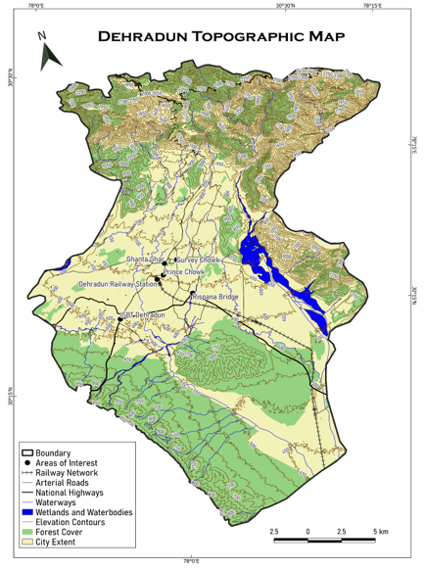
Figure (2): Topographic Map of Dehradun City
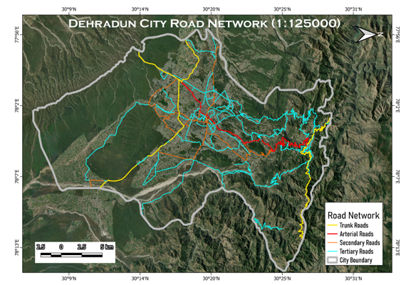
Figure (3): Dehradun’s road-network superimposed on its geographical landscape
Dehradun (also called as Dehra Doon) is a city with a population of 23.2 lakhs (2025 projection) consisting of a male majority. The city lies enveloped inside the Doon valley which itself is sandwiched between Himadri and Shivaliks of the Himalayan ranges. This valley also acts as a watershed between Yamuna and Ganga. The elevation of the hill city ranges from 410 metres in Clement Town in the South to about 700 metres (Figure 2 and 3) in Malsi in the North (Melbourne School of Design, 2024). The Langha Range, Ashkrodi, Nagal Jwalapur and Lachhiwala Range lie South to the city while Rajaji National Park is found to its South East. To the North lies Mussoorie and the Himadri Himalayan range and while to the east is the Song river. The city is found between latitudes 30°01' N and 31°2'N and longitudes 77°34' E and 78°18'E. Dehradun’s geomorphological and meteorological characteristics make it prone to a number of natural hazards. The area is frequented by earthquakes, landslides, floods and hailstorms.
The climatic conditions of the city mirror a humid subtropical classification (given by Koppen). However, elevation differences give way to moderate variations in temperature and intensity of heat. The Urban Heat Island effect along with naturally hotter summers due to climate change lead to temperatures as high as 40 degrees Celsius in summers and may also fall below 0 degree Celsius in winters. Monsoons witness high amounts of rainfall anywhere between 300-600 mm with around 20 rainy days (Government of Uttarakhand, 2025). An old canal network (Singh, 2020) also once existed in the city which contributed to its ecology and microclimate but was demolished in the process of urbanisation.
Agriculture comprises Lychee and paddy farming while mineral deposits include Magnesite, Limestone and Gypsum (MDDA, 2023). The soil profile of the region varies greatly according to elevation but primarily consists of rich Podzol and Peaty soil.
Methodology and Theory Framework
This study employs the COM-B behavioural diagnostic framework, which conceptualises behaviour (B) as a function of the dynamic interplay between Capability (C), Opportunity (O), and Motivation (M) (Michie et al., 2011). Applied to the context of Dehradun’s urban mobility crisis, the framework enables a granular examination of commuter behaviour within a layered socio-technical system. Capability constraints are evident in the limited cognitive and physical ability of residents to navigate public transportation—stemming from inadequate awareness, inaccessible informational systems, and insufficient exposure to shared mobility experiences. Opportunity, both physical and social, is restricted by pervasive environmental impediments such as sidewalk encroachments, the absence of functional bus shelters, and a lack of formalised vendor zones—factors that collectively suppress non-motorised transport. Furthermore, the social fabric lacks normative reinforcement for shared transit, eroding the social opportunity component. Motivation remains deeply tethered to behavioural inertia, shaped by comfort-seeking biases, the aspirational status attached to private vehicle ownership, and entrenched perceptions of insecurity within public transport ecosystems. Together, these deficits across all three COM-B domains help explain the prevailing resistance to modal shift and underscore the need for behaviourally targeted mobility interventions.
Complementing the diagnostic rigour of the COM-B model, the EAST framework—developed by the UK Behavioural Insights Team—offers a pragmatic set of design heuristics grounded in behavioural economics: interventions should be Easy, Attractive, Social, and Timely. Within the context of urban mobility reform in Dehradun, this framework provides an operational lens to translate behavioural insights into deployable interventions. The principle of Ease is addressed through infrastructure simplifications such as floating bus stops, QR-coded route maps, and intuitive POP kiosks—each calibrated to minimise cognitive and procedural friction in the adoption of public and shared transport. Attractiveness is engineered through the aesthetic activation of mobility spaces—colour-coded pedestrian zones, illuminated art-based signage, and strategically placed vendor pods that link rewards with pro-social commuting choices. Social influence is harnessed via community-driven mechanisms including Commute Clubs, peer-endorsed “Eco Traveller” designations, and visible Green Vendor Badges, all of which foster behavioural contagion through normative reinforcement. Lastly, Timeliness is achieved through the deployment of real-time congestion dashboards and temporally aligned prompts—such as school-entry nudges—that deliver behaviourally salient information at critical decision-making junctures. Together, the EAST principles serve not merely as design tools, but as catalytic levers for embedding behavioural change within the spatial, social, and temporal rhythms of urban commuting.
Apart from the previously stated measures, the paper also builds upon ideas of Behavioural Urbanism, a multi-disciplinary science concerned with psychological urban planning and environmental studies (Lockton, 2011). The field also intersects with some theories of Behavioural Economics (which we shall see in a bit). Primarily theories of Behavioural Urbanism used here include Residential and Employment Density where proper planning of traffic flow and creation of public transport to ease pressure on roads can be possible only up to an extent owing to the residential or commercial density of the area. Planned housing and limited capacity aids in environmental design. Spatial pattern of employment also influences Network Analysis. Complementing planning density is Accessibility and Neighbourhood design wherein closeness of areas, walkability, road width, density, amenities available, target audience are considered. A great example of such neighbourhood design is a ban on operation of four wheelers in some neighbourhoods and colonies which drastically reduces people’s incentive of buying them and may switch to areas of less congestion/use public transport more.
Rooted in Behavioural Urbanism are also traditional urban planning methods which emerged after sub-urbanisation of USA, most notably New Urbanism and Compact cities which was an urban design movement that promoted environmentally friendly habits by having cities with high densities, controlled rents, short distances to all amenities, creating walkable neighbourhoods containing a wide range of housing and job types. Focus was on mixed-land use planning, incorporation of community centres, parks, walking and cycling paths. Behavioural nudges in a car-centric city like Dehradun can move people towards adopting New Urbanism and compaction of the land area. (Viale, 2025)
Coming to Behavioural Economics, the borrowed theories include encouragement of a behaviour or pattern, sometimes it becomes necessary to make the behaviour opposite to it uncomfortable or discouraged through Comfort of material prospects/services Example: Using rumble strips and assigning low-priority to private vehicles to encourage car-pooling, walking or public transport. Default Options–The concept of people being too lazy to change the status-quo. Example: A voluntary cess included in parking charges for maintenance of public transport services which is opted in by-default. And finally, Loss Aversion–referring to people’s tendency to prefer avoiding losses more strongly than acquiring equivalent gains. In the context of reducing traffic congestion, this principle can be leveraged to nudge drivers toward behaviours that reduce overall congestion. (Behavioural economics: A very short introduction, 2017)
The intervention strategy is further anchored in the principles of nudge theory and choice architecture, as articulated by Thaler and Sunstein (2008), wherein subtle modifications to the decision-making environment can systematically guide behaviour without restricting individual autonomy. These behavioural levers are embedded within the spatial and temporal fabric of Dehradun’s urban mobility design. Default settings—such as pre-assigned school gate drop-off times and opt-in carpooling shuttles—strategically steer commuters toward congestion-reducing behaviours by minimising decision effort. Salience cues, including vividly painted pedestrian trails, high-contrast transit signage, and real-time bus countdowns, elevate the visibility and perceived ease of sustainable choices. Employing behavioural framing and loss aversion, congestion dashboards that display time penalties (e.g., “+12 minutes if you drive”) exploit cognitive biases to dissuade private vehicle use. Gamification mechanisms, such as point-based reward systems for walking or cycling, are integrated into local economic loops involving vendors and schools, thus linking mobility behaviour with tangible community incentives. Finally, commitment devices—including public pledges and visual progress trackers like “X days without car use”—leverage consistency bias and collective accountability to catalyse long-term habit formation. Collectively, these tools constitute a nuanced choice architecture that recalibrates behavioural defaults in favour of sustainable, socially reinforced commuting patterns.
The behavioural design methodology advanced in this study draws empirical validation from a series of globally recognised precedents that exemplify the efficacy of low-cost, non-coercive mobility interventions. In Copenhagen, the transformation of Strøget Street into a car-free pedestrian corridor yielded a 35% reduction in traffic-related injuries, affirming the safety dividends of human-centric spatial reallocation. Shimla’s “One-Minute Pause” zones, introduced at strategic choke points, demonstrated how temporal nudges alone can modulate traffic flow—reducing downstream congestion by up to 18% (Shimla Municipal Corporation, 2019). Mexico City’s Terminal de Autobuses implemented behavioural flow redesign and vendor regulation, achieving a 23% gain in terminal movement efficiency by alleviating micro-level spatial conflict. Meanwhile, Seoul’s Smart Commute Zones, under the aegis of the Korea Transport Institute (KOTI, 2021), institutionalised time-staggered school and office timings—leading to a 21% decrease in peak-hour congestion. These international examples provide robust precedent-based scaffolding for the interventions proposed in Dehradun, reinforcing the premise that behavioural and spatial reengineering, when synergised, can generate substantial impact without requiring large-scale infrastructural overhaul.
Adding to Behaviouralism is Spatial Criminology or Geographies of Crime theories, most notably Defensible spaces or Crime Prevention Through Environmental Design proposed by Oscar Newman and C. Ray Jeffery respectively in the 1970s and inspired by the earlier works of Jane Jacobs on Urban expansion and collapse, specifically in the United States of America. Newman’s work came out at a time of rising crime rates and the lack of effectiveness in policing especially in inner cities. The theories proposed by Newman were based on the ideas of how the public housing areas had been poorly designed failing to differentiate between private and public ownership space. This lack of separation motivated the offender to access residences unrecognised. The goal of using Defensible Space in Urban Planning, specifically behaviourally motivated urban planning is to view unplanned spaces or congestion as the crime one seeks to reduce. Newman’s principles included the concepts of Territoriality; where, by introducing ownership of space, locals are more likely to involve themselves in community policing and proactively stop encroachment of footpaths, roads and keep the area clean. Access control which aims at restriction of movement by installing gates in neighbourhoods, designated entry of EVs, cycling-only zones, pedestrian-priority zones help cut down congestion and reduce pollution metrics. Symbolic barriers can also include signage, boards and notices promoting use of buses, designing the city to limit private vehicle ownership. Natural Surveillance whereby design promotes security through open-concept autos, buses with larger windows, panic-buttons, and a special helpline for women. Rewards for reporting crimes on all public transports will enhance women's safety and increase their footfall in public transport. Image, which specifically refers to retrofitting neighbourhoods with footpaths, paved roads, street lighting and access to small or large forms of public transport regardless of economic condition of the area to improve the perception of said space. And lastly, Milieu which calls attention to provision of social infrastructure and implementing these behaviour-based ideas in areas of absolute dilapidation to improve welfare which contribute to improving other measures such as women choosing walking instead of hiring a taxi for short distances.
All five of the principles of Defensible Space touched on here contributed to Jeffery’s work on CPTED. Apart from the principles discussed earlier, CPTED includes target hardening which prevents residents from committing civil offences contributing to the problems of traffic congestion. Stricter licensing of street vendors, weekly anti-encroachment drives, increasing garbage pickup to keep cleanliness, stricter traffic laws, larger fines, increasing number of traffic policemen, fixing existing red lights etc. (Chataway et al., 2020)
While Defensible Space and CPTED talk about improving the environment to reduce opportunity of crime (or in this case, traffic congestion), Situational Crime Prevention put forward by Ronald V. Clarke and Patricia Mayhew expand on circumstantial opportunities which leads to offenders committing crimes. As very beautifully written in the book ‘Space, Crime, Time’ by Kim Lersch “SCP techniques are designed to reduce the opportunity for criminal acts by either increasing the amount of effort or by increasing the level of risk of apprehension or reducing potential reward.” In the sense of urban planning, SCP principles simply do not let opportunity of mismanagement arise by increasing perceived effort of crimes where monthly cleanliness drives, weekly encroachment drives, increasing taxes on large vehicle ownership, convenient and prominent bus routes with larger fleets to dissuade private vehicle usage. Bollard instalment, dividers, and road barriers to prevent illegal U-turns and wrong-way driving, make important commercial and tourist zones inaccessible to private vehicles during peak hours, restrict non-BS6 vehicles, divert heavy traffic to outside the city etc. Increase in perceived risks of crime via enrolling greater numbers of traffic policemen, traffic cameras in important areas, stricter licensing for vendors, clearly marked intersections, zebra crossings and improved street lighting for better visibility, use of automatic plate recognition software for challan etc. Reducing perceived rewards of crime and provocations along with removal of excuses which encompass closing off shortcuts and cuts via barricades or making them one-way to reduce traffic congestion, banning on-street parking and use of shuttles in high congestion zones, mandating passes for using private vehicles in key areas (only during off-peak hours), disbanding informal street parking and cracking down on illegal parking services, immediate e-challans for traffic violations, using real time electronic signs to make people aware of congestion in areas and places to avoid, staggering school and office timings, redesigning intersections like Clock Tower, ISBT, creating mobile apps for parking throughout the city (exists but lacks implementation), creating clear boards denoting no parking zones, directions to parking etc.
Concluding the framework with one last theory of Economics is Pigouvian taxes. A Pigouvian tax is a cess on any market activity that generates negative externalities (Santora, 2017) (i.e., external costs incurred by third parties that are not included in the market price). The tax is set by the government to correct an undesirable or inefficient market outcome and does so by being set equal to the external marginal cost of the negative externalities. In the case of Dehradun, a congestion tax in the inner-city area via the use of GPS enabled tags or monthly subscription passes for private vehicles can increase relative cost of using private over public transport nudging people to avoid it, especially for short distances in the main congestion areas. (Hu & Ley, 2025)

Results and Discussion
With over 1.8 million registered vehicles for a population of one million (RTO Dehradun, 2023), Dehradun’s vehicle-per-capita rate surpasses national urban averages. Traffic delays in core nodes like Ghanta Ghar and Survey Chowk reach up to 30 minutes during peak hours (IIT-R, 2023). The Dehradun Master Plan 2041 identifies 65% of total traffic as private vehicle trips (MDDA, 2023), exacerbated by infrastructural bottlenecks (shown in Figure 4 below), vendor encroachments, and erratic traffic behaviour.
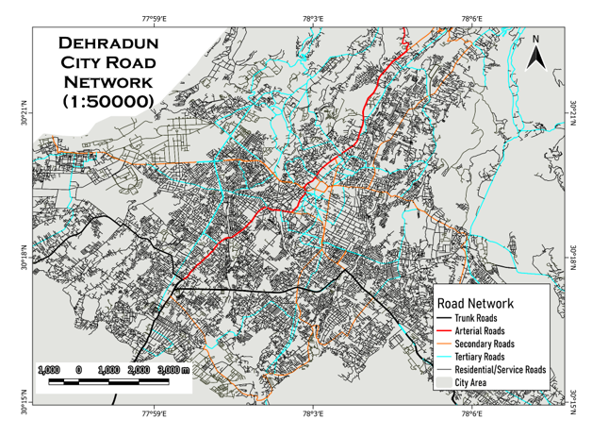
Figure (4): Dehradun’s Road network, showcasing the apparent lack of enough arterial and trunk roads needed for high intensity movement of vehicles
Despite the implementation of progressive infrastructural reforms—including the induction of electric bus fleets, interactive bus stop interfaces, and broader Smart Mobility initiatives—Dehradun’s commuters continue to exhibit a pronounced resistance toward public and shared transit systems. This behavioural inertia stems from a constellation of psychosocial factors: entrenched comfort biases, the habitual preference for personal convenience, status signalling associated with private vehicle ownership, and the absence of salient environmental safety cues. In response, this study proposes the strategic deployment of Safe, Smart, and Sustainable School Commute Zones (S³CZs), informed by the dual frameworks of Crime Prevention Through Environmental Design (CPTED) and Situational Crime Prevention (SCP). These S³CZs, situated around educational institutions and dense residential clusters, function as micro-urban mobility laboratories—designed to incubate and evaluate behaviourally intelligent interventions that recalibrate commuter norms, ease congestion, and embed long-term modal shifts within the everyday mobility culture of the city.
PROPOSED BEHAVIOURAL INTERVENTIONS FOR DEHRADUN’S URBAN MOBILITY
This multi-level intervention framework is designed to shift commuter behaviour by embedding principles of CPTED (Crime Prevention Through Environmental Design), SCP (Situational Crime Prevention), behavioural urbanism and behavioural economics into the everyday commute. The goal is to rewire commuting norms, reduce private vehicle reliance, and create safe, inclusive, and low-emission mobility ecosystems across Dehradun. At the core are Green Commute Zones and No-Honk, No-Pass Quiet Zones, spatially demarcated within 500-metre radii of schools and office clusters. These areas become motor-restricted during peak hours, encouraging modal shift toward walking, e-rickshaws, and public transit via strategically placed physical and symbolic deterrents—bollards, green signage, and painted curbs. Tactile design features such as planters, vertical gardens, and sound-absorbing murals contribute to ambient calm, while student-led peer enforcement (e.g., “Noise-Free Hero” tokens) reinforces civic participation and behavioural visibility. These spaces exemplify low-cost tactical urbanism layered with behavioural insight and community ownership.
In parallel, the “Switch Day” Mobility Campaign institutionalises weekly car-free days in educational and municipal institutions. Through the use of social proof, school gamification, peer pledging, and leaderboard displays (e.g., “Greenest Department of the Month”), the intervention generates sustained behavioural momentum while normalising low-emission commuting. The campaign’s incentive structure—badges, merchant discounts, and public recognition—taps into commitment devices and habit formation principles.
To complement habit-building with immediate behavioural reinforcement, the Eco-Travel Incentive Program (ETIP) introduces a QR-code-based rewards system. Commuters earn “Green Points” by walking, cycling, or using public transport, which are redeemable for tangible benefits like e-rickshaw rides and café discounts. Drawing on operant conditioning and present bias, ETIP offers visible, short-term gains that make sustainable behaviour both attractive and habitual.
Transforming spatial awareness into real-time decisions, Smart Congestion Visualisation Boards are proposed at critical junctions (e.g., Prince Chowk, Rajpur Road). These digital dashboards display real-time traffic status with behaviourally framed prompts such as “Take Rajpur Road now: Save 14 mins.” By leveraging salience and time-framing nudges, they redirect traffic flows and reduce bottlenecks, particularly during peak commuting windows.
Taking a page from Economics and the New York City case study, a potential way to shift people to public transport and walking is a Congestion Tax applied in the central areas of the city (ISBT, Railway Station, Clock Tower etc.) FAST-TAGS or a card-based system will be used to charge a fee to enter the CBD of the city during rush hours (07:00-11:00 and 16:00-20:00) much like how it is in lower Manhattan (Walker, 2018) for cars entering from Brooklyn and New Jersey City (Hu & Ley, 2025).
The physical transit environment itself undergoes a perceptual overhaul through Floating Transit Shelters—bus stops redesigned as inclusive, aesthetic, and functional micro-hubs. Drawing inspiration from Bogotá’s TransMilenio and Seoul’s Smart Shelter system, these shelters include ambient lighting, public art, and interactive elements, enhancing both usability and safety. The design aligns with the EAST framework—Easy, Attractive, Social, Timely—making public transport aspirational rather than utilitarian. Similarly, Interactive Passenger Orientation Pods (POPs) are deployed at high-footfall nodes like ISBT and Ghanta Ghar. These AI-lite kiosks provide icon-based directions, route planning, and grievance redressal in multiple languages, improving wayfinding confidence for first-time, low-literacy, or digitally underserved users.
Further, Calm Zones for Urban Mobility are introduced within 200 metres of sensitive areas such as schools and hospitals. Inspired by Zurich’s “Shared Space” design and Jaipur’s “Silent School Zones,” these environments integrate ambient soundscapes, silent-horn signages, LED-lit footpaths, and speed-calming measures to reduce aggressive driving and reinforce spatial respect. This creates an emotionally and behaviourally calibrated zone of safety, especially for children, women, and elderly commuters.
Moreover, the initiative includes Apps and Gamified Bus Stop Experiences, such as digital applications for coordinated school van pickups and community murals or puzzle installations at bus stops. These reduce the psychological burden of waiting and reposition public transport as a socially engaging and status-neutral mode of travel. Low-cost and community-designed, these spaces build affinity through interaction, especially among younger commuters.
To institutionalise visible behavioural signals, Walk Leaders—modelled after Australia’s walking school bus programs—guide younger students along clearly demarcated safe walking routes. Visual cues such as zebra art, colourful footprints, and reflective signage reinforce safety and build student-led authority bias. Recognition systems (e.g., “Safe Route Hero” walls) reward participation, ensuring continuity and pride in active commuting.
Finally, the initiative introduces Micro Traffic-Free Zones for Last-Mile Delivery in markets such as Paltan Bazaar and Astley Hall. By restricting motor vehicle entry during peak hours and promoting cargo cycles or e-trolleys, these zones address the behavioural inertia of delivery systems while displaying real-time emissions savings. Simultaneously, Rent-Free Ride & Return Cycles—city-branded bicycles borrowable by students—build early identification with sustainable transport while nudging intermodal habits through station placements at bus stops rather than school gates.
Together, this multi-layered behavioural strategy demonstrates a coherent integration of urban form, cognitive science, and social learning. It not only disrupts the habitual dominance of private motor vehicles but also reconstructs Dehradun’s mobility ecosystem into one that is inclusive, participatory, and future-ready.

HOTSPOT SPECIFIC INTERVENTIONS
Ghanta Ghar (Clock Tower) Intersection
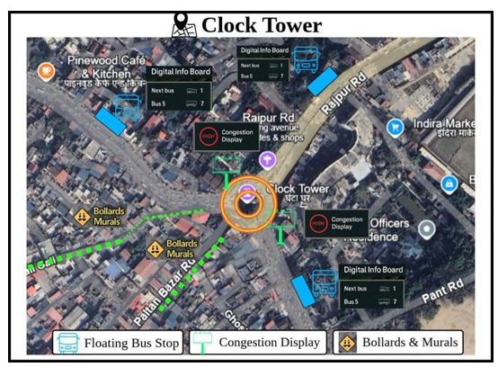
Figure (5): Clock Tower (Ghanta Ghar) interventions
Central Dehradun landmark—Ghanta Ghar is a radial convergence of six major roads (Paltan Bazaar, Rajpur Road, Chakrata Road, Ashley Hall, etc.). Surrounded by dense commercial markets (Paltan Bazaar, Kanwali Road), pedestrian traffic, street vendors, and public transport stops. Historically congested and highly pedestrianized yet dominated by private vehicles and two-wheelers. No clear zoning for pedestrians, deliveries, or autos to chaotic multimodal friction.
Challenges: The urban corridor experiences critical mobility dysfunction characterized by pedestrian spill over onto roadways due to inadequate sidewalk infrastructure and pervasive street obstructions. Systematic unauthorized parking, particularly of two-wheelers and delivery vehicles, compounds spatial constraints while heterogeneous traffic flows—encompassing auto-rickshaws, tempos, and private vehicles—operate without regulatory oversight. The absence of public transport incentivization mechanisms, coupled with pedestrian safety deficits, perpetuates car-centric mobility patterns and undermines sustainable urban transportation objectives (refer to Figure 5 and Table 1 for the corresponding visual and tabular syntheses of behaviourally informed interventions tailored to the Clock Tower node).
BEHAVIORALLY INFORMED INTERVENTIONS
Radial Pedestrian Priority Ring | A 150-meter radial pedestrian-priority zone around Clock Tower will restrict vehicle access during peak hours (9-11 AM, 5-8 PM) and incorporate CPTED elements including decorative bollards, string lighting, murals, ambient music, and plantings.
Digital Delivery Coordination Zone | Two delivery hubs near Ashley Hall and Paltan Bazaar will feature QR-coded lockers where riders must park and load/unload, eliminating mid-road halts through Situational Crime Prevention principles. Participating vendors receive "Smart Bazaar Vendor" badges and enhanced app visibility as behavioural incentives for compliance.
Smart Walking Trails with Social Nudges | Painted pedestrian trails will connect Ghanta Ghar to key landmarks including Paltan Bazaar, Gandhi Park, and Survey Chowk, incorporating directional arrows, temporal indicators ("4 min walk to Café Central"), and motivational signage. These wayfinding elements utilize temporal discounting and self-image nudges to encourage walking by reducing perceived travel time and reinforcing positive pedestrian identity.
Quite Core: Audio-Visual Campaign | Ambient interventions including calm music and LED displays ("Welcome to the Calm Clock Zone") will be deployed alongside real-time noise monitoring through volunteers or smart poles displaying daily "Noise Scores." Weekly rewards of free advertising banners for vendors during low-noise periods create compliance incentives, ensuring that calm environments enhance perceived order and reduce deviant behaviours.
Auto Ring with Token Entry | A circular loop system around Ghanta Ghar will limit auto-rickshaw presence through digital queue management, allowing only a fixed number of vehicles within the ring at any time. Entry tokens and real-time queue status displayed on digital boards at feeder roads (Rajpur Road, Chakrata Road) manage availability without complete bans, to control congestion while maintaining transport accessibility.
Table (1): Behaviourally Informed Interventions for Ghanta Ghar (Clock Tower) Intersection
Global Case Parallel: Copenhagen’s Strøget pedestrian mall reduced foot injuries and traffic incidents by 35% within 18 months.

ISBT Dehradun
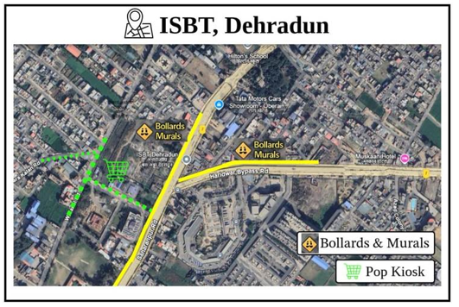
Figure (6): ISBT Dehradun interventions
Dehradun’s primary bus transit hub, connecting Uttarakhand to Delhi, Punjab, Himachal, and other states. Heavy footfall of interstate passengers, autos, taxis, private pick-up vehicles, and street vendors. Multiple entry-exit points; unregulated flow of shared autos and taxis causes severe traffic snarls. Surrounding areas have unplanned street layouts, leading to bottlenecks and confusion for first-time users.
Challenges: The transportation hub lacks designated pick-up and drop-off zones, resulting in chaotic traffic patterns as autos and taxis park haphazardly along roadsides, obstructing vehicular access. Inadequate wayfinding signage and orientation systems strand unfamiliar passengers, prompting informal boarding practices, while poor lighting and crowded conditions create safety concerns that particularly compromise nighttime accessibility and user confidence (refer to Figure 6 and Table 2 for the corresponding visual and tabular syntheses of behaviourally informed interventions tailored to ISBT Dehradun).

BEHAVIORALLY INFORMED INTERVENTIONS
Designated Pick-Up Bays | Colour-coded zones should be designated for taxis, e-rickshaws, and private cars, with each zone subject to digital timing limits to ensure efficient turnover and prevent prolonged occupancy.
Vendor Circle Regulation | Vending activities need to be formalized through licensed modular pods that incorporate integrated waste control systems to ensure organized commercial operations and environmental compliance.
Passenger Orientation Pods | Entry kiosk can be installed featuring a live city map, integrated booking portal, and comprehensive fare guidance system to assist passengers with navigation and transportation planning.
Auto Token Queue | Pre-authorized e-rickshaw orders will be displayed on LED screens positioned at the gate to provide real-time visibility of scheduled pickups.
Table (2): Behaviourally informed interventions for ISBT Dehradun
Parallel: Mexico City’s Terminal de Autobuses employs vending demarcation and real-time boarding alerts, improving efficiency by 23%.

Rispana Bridge Corridor
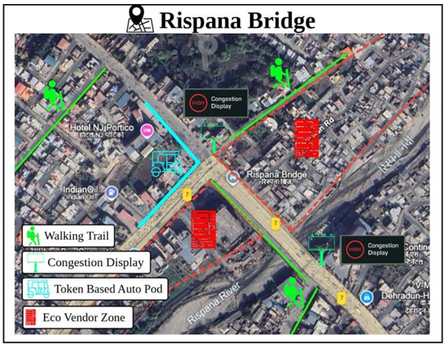
Figure (7): Rispana Bridge interventions
It is a critical junction connecting Haridwar Road with inner city areas like Nehru Colony and Dharampur. Key Landmarks: Proximity to Hotel JSR Continental and NJ Portico, indicating commercial activity. Traffic Patterns: High vehicular density due to mixed traffic—private vehicles, shared autos, buses, and pedestrians.
Challenges: The Rispana Bridge experiences capacity constraints due to its narrow width, creating peak-hour bottlenecks exacerbated by the absence of pedestrian infrastructure that intensifies vehicle-pedestrian conflicts. Street vendor encroachments and unauthorized parking further reduce available road space, while inadequate and poorly maintained public transport facilities discourage modal shift toward sustainable transportation options (refer to Figure 7 and Table 3 for the corresponding visual and tabular syntheses of behaviourally informed interventions tailored to the Rispana Bridge Corridor).

BEHAVIORALLY INFORMED INTERVENTIONS
Time segregated access zones | Peak-hour restrictions to be implemented for private vehicles, with access limited exclusively to school buses and e-bikes during specified high-traffic periods.
Floating Bus Platforms | Designated stopping points to be positioned near NJ Portico and JSR Continental to facilitate timed vehicle halts at these strategic locations.
Walk and Save Zones | A QR-coded sidewalk zone can be established to track and reward pedestrian movement through digital incentive systems.
Vendor Reallocation | A defined vending island can be established at a designated distance from the curb side to organize commercial activities and maintain traffic flow.
Table (3): Behaviourally informed interventions for Rispana Bridge Corridor
Parallel Model: Shimla’s “One-Minute Traffic Plan” introduced pause zones before choke points, easing downstream flow by 18%.

Dharampur and Survey Chowk Corridor
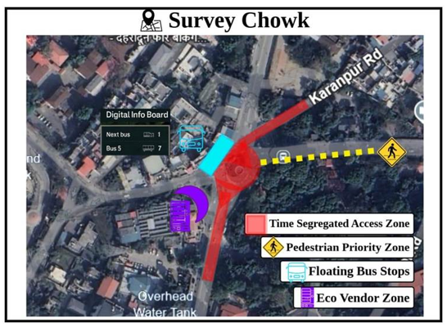
Figure (8): Survey Chowk interventions
Dharampur is one of Dehradun’s most saturated intersections—where Haridwar Road, EC Road, and Rajpur Road traffic converges. Surrounded by schools, hospitals (e.g., Drona Hospital), coaching centres, and residential zones, it experiences chaotic peak-hour movement. High density of autos, e-rickshaws, private two-wheelers, and informal roadside parking. Major feeder point to Survey Chowk and arterial road to ISBT.
Challenges: The area experiences traffic disruption from illegal U-turns and road-blocking drop-offs, while the absence of spatial separation between autos, vendors, and pedestrians creates operational chaos. Inadequate walkable infrastructure forces pedestrian spill over into vehicle lanes, and poor waiting conditions at transport facilities result in minimal public transport adoption (refer to Figure 8 and Table 4 for the corresponding visual and tabular syntheses of behaviourally informed interventions tailored to the Survey Chowk precinct).

BEHAVIORALLY INFORMED INTERVENTIONS
Auto Dispatch Pods | RFID-based queue stands will be implemented with rotational entry systems to manage orderly vehicle access and prevent congestion.
Staggered School Entry & Drop off System | Schools can be assigned different gate timings, with colour-coded entry boards installed to guide parents to appropriate pickup and drop-off zones based on their designated time slots.
Congestion Display Poles | Dynamic route time estimators can be installed to display real-time travel information alongside nudge messages such as "Take Rajpur Rd. = -7 mins" to encourage optimal route selection.
Vendor Compliance Badges | Monthly clean-vendor ratings can be implemented and linked to sales incentive coupons to reward vendors who maintain hygiene and cleanliness standards.
Green Points Transit Card | A Dharampur Pilot program can be launched where each bus ride, walk-to-school trip, or e-rickshaw journey tracked via QR codes earns "Green Points" that are redeemable at partner cafés, libraries, and tuition centres. This system encourages sustained behavioural shift toward sustainable transportation modes through gamified incentives.
Table (4): Behaviourally informed interventions for Dharampur and Survey Chowk Corridor
Benchmark: Seoul’s “Smart Commute Zones” synchronised school/office timings and reduced congestion by 21%.

Patel Nagar and Prince Chowk Intersection
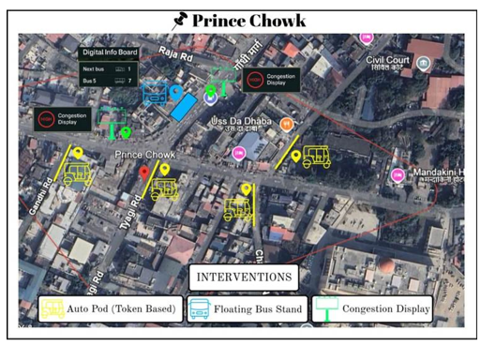
Figure (9): Prince Chowk interventions
It is a dense residential-commercial mixed-use area, lying adjacent to the Dehradun Railway Station and arterial roads like Haridwar Road and Prince Chowk. It acts as a key link between the inner city and ISBT/Railway Station, with significant through-traffic. Streets are narrow, choked with informal vending, roadside parking, and multiple small commercial shops. Low public transport uptake, with preference for personal two-wheelers and informal autos.
Challenges: The area suffers from excessive vehicular volume on constrained streets, compounded by random stops and encroachments that create persistent congestion. Residents avoid walking or cycling due to safety concerns, footpath encroachments, and environmental pollution, while local businesses resist vehicle restrictions fearing reduced visibility and customer access. The absence of real-time travel feedback leaves road users unaware of delays until they encounter traffic bottlenecks (refer to Figure 9 and Table 5 for the corresponding visual and tabular syntheses of behaviourally informed interventions tailored to the Patel Nagar and Prince Chowk intersection).
BEHAVIORALLY INFORMED INTERVENTIONS
Smart One-Way Loops | A circular flow system can be introduced to eliminate cross-directional halts and improve overall traffic movement efficiency.
Divider Wall Art by Local Schools | Behavioural nudges should be implemented to promote lane discipline and encourage walking among road users.
Live Entry Boards | Alert systems to be deployed to notify commuters to avoid entry during congestion periods, displaying messages such as "Next Window in 12 mins" to indicate optimal travel times.
Neighbourhood Guardian Groups | Residents and vendors must ensure rule compliance by displaying visible ID tags that indicate their participation in the traffic management system.
LOCAL GUARDIAN APP & FEEDBACK LOOP Residents and shopkeepers can report violations (e.g., illegal halts, honking) via a lightweight app. Monthly performance stats shown publicly: “Patel Nagar Quietest Street This Month: Street No. 6!”
Table (5): Behaviourally informed interventions for Patel Nagar and Prince Chowk Intersection
EQUITY AND INCLUSION COMMITMENTS
Equity and inclusion are not ancillary considerations but foundational imperatives in the architecture of behaviourally intelligent urban mobility systems. The suite of proposed interventions for Dehradun transcends mere optimisation of traffic flow; it is anchored in the principle that every demographic—irrespective of age, gender, physical ability, or digital literacy—must be afforded equitable participation in the evolving urban transport ecosystem. In a city marked by socio-spatial stratification and uneven infrastructural access, this commitment to inclusion is not only ethically vital but structurally transformative. By embedding universal design within behavioural frameworks, the initiative ensures that the most marginalised commuter segments are not peripheral beneficiaries but active co-creators of sustainable mobility futures.
Gendered Mobility and Safe Access for Women
Recognising the systemic mobility challenges faced by women, the intervention framework introduces targeted design features to enhance both the perceived and actual safety of female commuters. These include strategically placed, well-lit floating bus stops; designated women-only ride options during high-demand hours; and “Calm Zones” near educational and commercial districts, equipped with ambient lighting and sensory-scaping. Surveillance-enabled POP kiosks provide an added layer of visible safety infrastructure. Together, these spatial and behavioural interventions address deterrents such as fear, threat perception, and lack of agency—barriers that have long constrained women’s independent urban movement.
Child-Centric Commute Ecosystems
Children, particularly school-goers, are positioned at the centre of the initiative's behavioural design logic. Interventions such as colourfully painted walking trails, illustrated and signposted drop-off zones, and structured “Buddy Travel Groups” not only enhance physical safety but also nurture autonomous mobility cultures. Positive reinforcement systems—including QR-coded reward programmes and badge-based recognition within schools—embed behavioural change early in life, while simultaneously reducing traffic volatility in school zones. This pedagogical approach to mobility instils civic values and ecological consciousness at formative stages.
Street Vendors as Spatial Stakeholders
Often relegated to the margins of formal urban planning, street vendors are reconceptualised here as legitimate spatial actors within the mobility ecosystem. Regulated vending pods, equipped with QR-enabled payment systems and embedded within formal traffic zones, create economic opportunity while reducing informal sprawl. The “Clean Vendor” badge programme further reinforces hygiene norms and civic pride, transforming vendors from congestion contributors to visible agents of order and behavioural signalling.
Inclusive Design for the Elderly and Persons with Disabilities (PwDs)
Mobility equity is further advanced through infrastructural adaptations for elderly citizens and persons with disabilities. High-contrast signage, tactile paving, icon-driven POP kiosks, and strategically placed rest benches create a navigable and inclusive transport environment. These elements respond to both sensory and physical impairments, enabling fuller participation in public and non-motorised transport systems without reliance on others. This infrastructural empathy not only fosters inclusion but models’ best practice for age-friendly and disability-sensitive urban planning.
Addressing the Digitally Underserved
In recognition of the city’s digital divide, the initiative incorporates alternative access mechanisms for communities lacking smartphones or digital literacy. Multilingual visual signage, audio-enabled kiosks, and analogue reward systems (e.g., physical punch cards) ensure that behavioural incentives and information systems remain universally accessible. This emphasis on parity in access safeguards against the exclusionary effects of techno-centric urbanism and reinforces the project’s foundational commitment to behavioural justice.
In sum, by giving centrality to equity and inclusion within a behaviourally informed design strategy, the Dehradun mobility initiative envisions a transport ecosystem that does not merely move people, but affirms their right to move with dignity, safety, and agency. Through deliberate engagement with historically underserved groups, the city sets a precedent for participatory, pluralistic, and psychologically attuned urban transformation.
STAKEHOLDERS INVOLVED
Implementing behaviourally intelligent mobility interventions in Dehradun demands a coordinated, multi-stakeholder ecosystem. The Municipal Corporation of Dehradun (MCD) and Uttarakhand Transport Corporation (UTC) anchor policy, infrastructure, and operational oversight, while the Traffic Police enforce adaptive regulatory measures. Academic partners, notably IIT Roorkee, contribute empirical diagnostics, behavioural modelling, and spatial analytics. Private mobility operators and logistics providers drive technological deployment and service innovation. Civil society actors—including resident welfare associations, women’s collectives, vendor unions, and commuter advocacy groups—facilitate co-design, community buy-in, and sustained adoption. This interdependent governance model ensures interventions are technically sound, socially legitimate, and contextually embedded for long-term scalability (refer Figure 10 for stakeholder mapping).
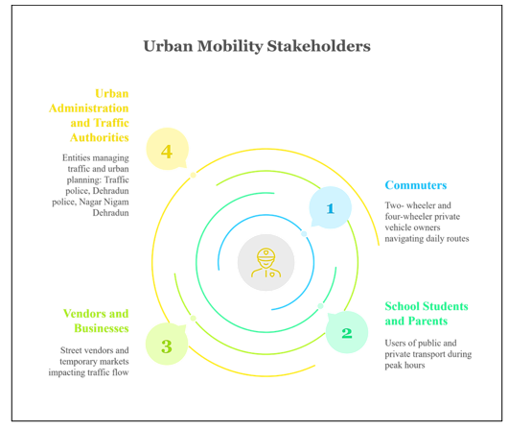
Figure (10): Stakeholders in Dehradun’s urban renewal
COST FEASIBILITY AND RISK MITIGATION
Ensuring cost-efficiency without compromising on behavioural impact is central to the proposed intervention framework. The estimated total implementation budget is capped at ₹5 crores for all five zones over a 12-month period, making it viable under most urban mobility innovation grants and Smart City initiatives. The modular nature of the interventions allows phased deployment with built-in feedback loops to ensure that resource allocation remains adaptive and cost-justified (refer Table 6 for estimated budget breakdown).

ESTIMATED BUDGET BREAKDOWN
Components | Approx. Cost (in ₹)
Behavioural signage, murals, and painted pedestrian paths | 80 lakhs
POP kiosks and digital feedback dashboards | 1 crore
Floating bus shelters with CPTED-compliant upgrades | 1.25 crores
QR-based reward and gamification systems | 60 lakhs
Community workshops, outreach campaigns, school programs | 50 lakhs
Monitoring, evaluation, and third-party validation tools | 35 lakhs
Contingency and maintenance reserves | 50 lakhs
Table (6): Estimated Budget Breakdown
High Impact and Low-Cost Tools:
High-impact, low-cost interventions include community co-created murals to reduce visual clutter and define behavioural zones, solar-powered lighting and bollards for enhanced safety with minimal operational expenses, QR and SMS-based reward systems that bypass app download requirements, and vendor regulation through collapsible bamboo pods within designated painted boundaries.
Potential Funding Sources:
- Smart Cities Mission (MoHUA)
- 15th Finance Commission Urban Mobility Grants
- CSR contributions from logistics, e-mobility, and real estate sectors
- Academic partnerships for data collection and low-cost behavioural lab testing, e.g., IIT-R, NID (refer Figure 11 for sources of funds for pilot projects and implementation of initial behavioural reforms)
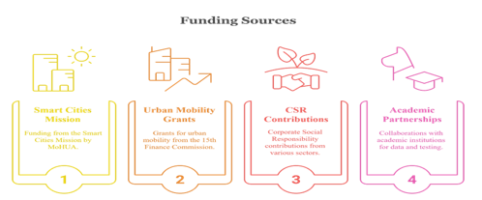
Figure (11): Sources of funds for pilot projects and implementation of initial behavioural reforms
IDENTIFIED RISKS AND MITIGATION STRATEGIES
RISK | IMPACT | MITIGATION STRATEGY
Digital Divide | Reduced participation in QR or app-based nudges | Provide paper-based reward cards and voice-enabled kiosks for non-smartphone users
Stakeholder Resistance | Lack of buy-in from auto unions or vendors | Incentivise participation through badge schemes, revenue assurance, and participation in governance boards
Maintenance and Vandalism | Damage to murals, signage, or kiosks | Use weatherproof paint, clear community ownership, and street guardian volunteer groups
Pilot Fatigue | Early enthusiasm drops off | Refresh campaigns quarterly with new reward themes and community events
Table (7): Identified Risks, Impacts and Mitigation Strategies
This financial model ensures that Dehradun’s congestion problem is addressed not through capital-intensive construction but through intelligent, behaviourally guided urban design—with long-term benefits outweighing initial deployment costs (Table 7 shows the identified risks, impacts and mitigation strategies).
IMPELEMENTATION ROADMAP
The success of behaviourally driven mobility reforms depends on a well-orchestrated and time-bound implementation roadmap that balances immediate interventions with long-term structural integration. This roadmap adopts a four-phase approach over a 12-month period—designed to pilot, validate, and scale sustainable mobility behaviours across Dehradun’s five most congested zones. Each phase involves key stakeholders such as municipal authorities, schools, civil society partners, local vendors, and transport unions to ensure deep-rooted behavioural adoption (see Table 8 for the Phased Implementation Roadmap and Figure 12 for its visual representation).
PHASE | MONTHS | MILESTONES & ACTIVITIES
Planning | 1-3 | Surveys, community co-design, vendor mapping
Pilot | 4-6 | 2-zone deployment of floating stops, auto tokens, congestion boards
Expansion | 7-9 | Scale to all 5 hotspots; launch app dashboard & kiosk network
Evaluation | 10-12 | Traffic volume tracking, AQI analytics, commuter feedback survey
Table (8): Phased Implementation Roadmap for Behavioural Mobility Interventions in Dehradun
A. PHASE 1: Planning (1-3 Months)
The focus lies on community engagement, baseline surveys, spatial audits, and vendor mapping in the targeted zones. Detailed co-design workshops will be conducted to tailor interventions using real commuter insights, especially from students, women, and elderly users.
B. PHASE 2: Piloting (4-6 Months)
Will involve live deployment of behavioural prototypes in two priority zones (e.g., Rispana and ISBT), including tokenized auto dispatch, floating bus shelters, congestion signage, QR-reward systems, and school drop-time staggering. A lean monitoring team will collect data on usage, feedback, and observable shifts.
C. PHASE 3: Expansion (7-9 Months)
Validated solutions will be rolled out across all five hotspots. This includes full activation of POP kiosks, Eco-Travel dashboards, clean vending pods, and the Switch Day ecosystem. Communication campaigns, pledge drives, and gamified challenges will reinforce uptake.
D.PHASE 4: Evaluation (10-12 Months)
Citywide traffic flow will be assessed using GIS tools, AQI sensors, and transport surveys. Feedback loops will inform continuous improvement and guide potential integration into Dehradun’s Smart Mobility and Sustainable Transport Policy framework. Partnerships with academic institutions such as IIT-R and behavioural consultants will support outcome validation and publication of learnings for replication in other cities.
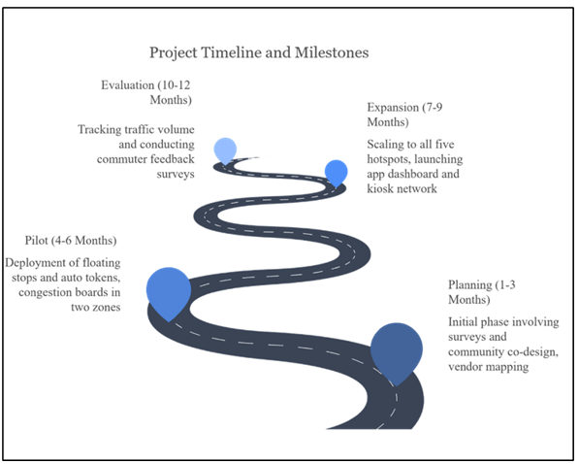
Figure (12): Implementation Road map
IMPACT AND EVALUATION METRICS
Measuring the success of behavioural interventions requires a robust, multidimensional framework that captures both direct and indirect impacts. This report adopts a hybrid evaluation approach combining quantitative indicators (traffic volume, AQI levels, transport mode share) with qualitative feedback mechanisms (surveys, interviews, perception audits). The goal is not only to assess modal shifts and congestion reduction but also to evaluate changes in commuter perception, safety, and stakeholder compliance.
Key metrics are drawn from comparable global case studies and adapted for Dehradun's context (refer Table 9). For instance, Copenhagen’s pedestrian reforms and Seoul’s time-staggering programs have shown success by measuring footfall shifts, modal elasticity, and safety perception—metrics mirrored here. Indicators will be collected through traffic sensors, GIS mapping, air quality monitors, and mobile app data.
Impact Metric | Target Outcome
Modal Shift (Public/Shared Transit) | Increase by 25% in targeted hotspots
Private Vehicle Use (School Hours) | Decrease by at least 30% through time-gated entry and nudges
Air Quality Index (AQI) | Improve by ≥10 points in pilot corridors
Women’s Safety Index | Enhance perceived safety by 40% (via surveys and feedback)
Vendor Compliance Index | 90% stall adherence to vending zones and cleanliness norms
Floating Bus Stop Usage | ≥15% increase in ridership within 6 months
Reward Program Participation | At least 5,000 active Green Commuter users by end of pilot
Community Satisfaction Score | Target 80%+ positive feedback in quarterly surveys
Table (9): Measurable Success Criteria for Dehradun’s Behavioural Urban Mobility Framework
Evaluation phases will be aligned with the implementation roadmap, enabling iterative refinement and public reporting. Key learnings will be disseminated through open data dashboards, allowing replicability in similar urban contexts such as Shimla and Nainital.
Calculations:
Copenhagen’s pedestrian reforms and Seoul’s time-staggering programs have shown success by measuring footfall shifts, modal elasticity, and safety perception—metrics mirrored here. To estimate and track behavioural shifts, we propose the following calculations:
- Modal Shift Rate (%) = (post-intervention public/shared transit users − Baseline users) / Baseline users × 100
Example: If baseline public/shared use is 20%, and post-intervention it becomes 25%, the modal shift = (25−20)/20 × 100 = 25%
- Reduction in Private Vehicle Use (Peak Hours) = (Baseline vehicle count − post-intervention count) / Baseline count × 100
- AQI Improvement = (pre-AQI average − post-AQI average) points (target ≥10 points)
- Women’s Safety Index Improvement (%) = (post-survey safety score − Baseline score) / Baseline score × 100
Example: If baseline perception score is 50/100 and improves to 70/100 → (70−50)/50 × 100 = 40%
- Reward Program Engagement = Total unique app scans × average daily participation rate over pilot duration
- Vendor Compliance Rate (%) = (Number of vendors inside designated pods / Total active vendors) × 100
Additional calculation methods for key metrics include:
- Floating Bus Stop Usage Rate (%) = (Monthly post-intervention ridership at floating stops − Baseline ridership) / Baseline ridership × 100
Example: If baseline ridership is 1,000/month and post-intervention it is 1,150 → (1,150 − 1,000)/1,000 × 100 = 15% increase
- Reward Program Participation Growth (%) = (Final number of active users − Initial user base) / Initial user base × 100
Example: From 500 initial users to 5,000 by end of pilot → (5,000 − 500)/500 × 100 = 900% growth
- Community Satisfaction Score (%) = (Positive feedback responses / Total feedback responses) × 100
Example: 640 out of 800 respondents gave a positive rating → 640/800 × 100 = 80% satisfaction rate

Conclusion
This study advances a nuanced, behaviourally informed framework for addressing Dehradun’s persistent urban mobility challenges, situating the analysis within the intersection of criminological design principles and contemporary behavioural science models. The findings underscore that infrastructural upgrades, while necessary, are insufficient in the absence of interventions that directly engage commuter psychology, socio-cultural norms, and environmental cues. Through a dual approach—city-wide behavioural nudges and hotspot-specific micro-interventions—this work demonstrates how strategically designed “pressure points” can recalibrate individual mobility choices toward safer, lower-emission, and more inclusive modes.
The proposed interventions—from Green Commute Zones to interactive transit nodes—are not conceived as isolated pilot schemes but as scalable prototypes for an adaptive, resilient mobility ecosystem. Crucially, the integration of equity and inclusion safeguards ensures that such transformations do not exacerbate existing socio-spatial inequalities but rather empower marginalised commuter groups, from schoolchildren and women to street vendors and persons with disabilities. The evaluation metrics outlined herein provide a replicable framework for measuring tangible shifts in travel patterns, congestion levels, and perceived safety, enabling continuous feedback loops for policy refinement.
By anchoring behavioural interventions within local context yet validating them against global precedents, this research contributes to the evolving discourse on human-centric urban transport policy. The synthesis of cost-effective tactical urbanism, participatory governance, and evidence-led behavioural design offers a pragmatic yet visionary pathway for Dehradun to emerge as a benchmark in sustainable mobility transition. In its broader implications, the study affirms that the future of urban transport planning lies not merely in engineering roadways but in reshaping the cognitive, emotional, and social landscapes through which citizens navigate their cities.
Policy Implications
For policymakers, the evidence presented herein mandates an urgent shift from infrastructure-heavy, vehicle-centric planning to agile, behaviourally embedded interventions integrated into the Smart Mobility framework. Legislative provisions should enable tactical urbanism pilots, incentivise modal shifts through fiscal levers, and institutionalise participatory design processes that centre diverse commuter voices. If embedded within the city’s statutory transport policy, these interventions could not only mitigate congestion and emissions but also reframe Dehradun’s urban identity as a model of inclusive, sustainable mobility for emerging Indian cities.
Also, Dehradun needs a metro-rail. Urgently.
Future Research Recommendations
The paper gravitates towards a more qualitative than quantitative/mixed-methods approach while investigating causes and possible solutions of traffic blockage. Case studies, qualitative theories and existing literature is used to advance the research and fill the gap of tackling vehicular traffic. However, quantitative approaches and data such as volume/capacity ratio of roads, road density, average speeds amongst others which can be used to provide a more empirical analysis of the problems in urban planning. At a more technical level, network analysis using a node-link model, topology and algorithms to find paths of least possible resistance such as by Dijkstra can be applied to identify new possible bus routes, cycling paths, plans for metro routes etc.
In an ideal case, more primary data from residents of Dehradun who travel every day, interaction with local bodies and quantitative data together would produce the most comprehensive and iron-clad measures to solve all urban planning issues the hill-city faces.

References

- Clarke, R. V. (1995). Situational crime prevention. In M. Tonry & D. Farrington (Eds.), Building a safer society: Strategic approaches to crime prevention (Vol. 19, pp. 91–150). University of Chicago Press.
- Crowe, T. D. (2000). Crime prevention through environmental design: Applications of architectural design and space management concepts (2nd ed.). Butterworth-Heinemann.
- Intertraffic. (2024). Global case studies: Moscow, Perth, Mexico City. https://www.intertraffic.com/news/traffic-management/three-smart-cities-in-traffic-management-perth-mexico-city-moscow
- Michie, S., van Stralen, M. M., & West, R. (2011). The behaviour change wheel: A new method for characterising and designing behaviour change interventions. Implementation Science, 6(1), 42. https://doi.org/10.1186/1748-5908-6-42
- Municipal Development and Development Authority (MDDA). (2023). Dehradun Master Plan 2041. http://mddaonline.in/wp-content/uploads/2023/04/Dehradun-Master-Plan-2.0A.pdf
- SDC Foundation. (2023). Dehradun’s traffic crisis: A daily commute. https://www.sdcuk.in/dehraduns-traffic-crisis-a-daily-commute/
- Times of India. (2024, May 20). IIT-R completes study for safer, happier streets for Doon kids. https://timesofindia.indiatimes.com/city/dehradun/iit-r-completes-study-for-safer-happier-streets-for-doon-kids/articleshow/109658124.cms
- Central Pollution Control Board. (2022). Dehradun air action plan. https://cpcb.nic.in/Actionplan/Dehradun.pdf
- GeoFabrik. (2018). Geofabrik Download Server. Geofabrik Download Server. https://download.geofabrik.de/asia/india/central-zone.html
- Urban Behaviours Ideathon. (2025). Home | Cities Ideathon. Cities Ideathon. https://cityideathon.abcd.guide/
- Dehradun's Traffic Crisis: A Daily Commute - Social Development for Communities (SDC) Foundation. (2024, October 2). Social Development for Communities (SDC) Foundation. https://www.sdcuk.in/dehraduns-traffic-crisis-a-daily-commute/
- Doon Today. (n.d.). Vikrams Routes of Dehradun - Doon Today-All About Dehradun. Doon Today-All About Dehradun - Dehradun Directory. https://doontoday.com/transportation-in-dehradun/vikrams-routes-of-dehradun/
- Euttaranchal. (2025). Dehradun Electric Bus Service - Doon Electric Buses Timings Routes Schedule. eUttaranchal - Uttarakhand Tourism, Hotels, News, Culture of Uttarakhand. https://www.euttaranchal.com/tourism/electric-buses-dehradun.php
- Lockton, Dan. (2011). Architecture, urbanism, design and behaviour: a brief review.
- Viale R (2025) Behavioral city. Front. Built Environ. 10:1501853. doi:10.3389/fbuil.2024.1501853
- Mussoorie-Dehradun Development Authority. (2023). Dehradun Master Plan - 2041 (Draft). Town and Country Planning Department, Uttarakhand. http://mddaonline.in/wp-content/uploads/2023/04/Dehradun-Master-Plan-2.0A.pdf
- ZALI, N., ABIZADEH, S., & BAGHERINIA, A. (2019). New Urbanism and Urban Design, Tools for Changing Behavioral Patterns of the Citizens. International Journal of Natural and Engineering Sciences, 7(1), 31–36
- Nijagunappa, R & Shekhar, Sulochana & B, Gurugnanam & Raju, PLN & De, Prabir. (2007). Road network analysis of Dehradun City using high resolution satellite data and GIS. Journal of the Indian Society of Remote Sensing. 35. 267-274. 10.1007/BF03013494.
- Social Development for Communities Foundation. (2023). Public Transport in Dehradun. Social Development for Communities Foundation. https://www.sdcuk.in/wp-content/uploads/2024/01/SDC-Foundation-Report-on-Public-Transport-in-Dehradun.pdf
- Chataway, M., Hart, T., & Lersch, K. M. (2020). Space, Time, and Crime. Carolina Academic Press.
- Korea Transport Institute (KOTI). (2021). Smart commute zones in Seoul: Behavioural interventions for congestion control. KOTI Reports.
- Shimla Municipal Corporation. (2019). Urban transport initiatives: The ‘One-Minute Pause’ experiment. Urban Mobility Progress Reports.
- Thaler, R. H., & Sunstein, C. R. (2008). Nudge: Improving decisions about health, wealth, and happiness. Yale University Press.
- Melbourne School of Design. (2024). Dehradun | SDG Symposium | Melbourne School of Design. https://msd.unimelb.edu.au/sdg-cities/cities/dehradun-uttarakhand-india
- Baddeley, Michelle, 2017. "Behavioural Economics: A Very Short Introduction," OUP Catalogue, Oxford University Press, number 9780198754992, Decembrie
- Galvin, S. S. (2021). Becoming Organic: Nature and Agriculture in the Indian Himalaya. United Kingdom: Yale University Press.
- Melbourne School of Design. (n.d.). Dehradun | SDG Symposium | Melbourne School of Design. https://msd.unimelb.edu.au/sdg-cities/cities/dehradun-uttarakhand-india
- Singh, K. (2020). How 'City of Canals' lost its tag | Dehradun News - The Times of India. The Times of India. https://timesofindia.indiatimes.com/city/dehradun/how-city-of-canals-lost-its-tag/articleshow/74446926.cms
- Government of Uttarakhand. (2025). Climate. District Dehradun. https://dehradun.nic.in/climate/
- Hu, W., & Ley, A. (2025). Welcome to the Congestion Zone: New York Toll Program Is Set to Begin. The New York Times. https://www.nytimes.com/2025/01/04/nyregion/congestion-pricing-nyc.html
- The Economist. (2024). Congestion pricing in New York gets the go-ahead after all. Maybe. https://www.economist.com/united-states/2024/11/21/congestion-pricing-in-new-york-gets-the-go-ahead-after-all-maybe
- NYC congestion pricing start date set for June 30. See a map of the zone and how much it will cost. (2024). CBS News | Breaking news, top stories & today's latest headlines. https://www.cbsnews.com/newyork/news/nyc-congestion-pricing-start-date/
- Santora, M. (2017). Open-Road Tolls Could Pave the Way for Manhattan Congestion Pricing. The New York Times. https://www.nytimes.com/2017/08/25/nyregion/new-york-open-road-tolls-congestion-pricing.html
- Walker, A. (2018). New York drivers spent an average of 91 hours in traffic last year. Curbed NY. https://ny.curbed.com/2018/2/6/16979696/new-york-city-traffic-congestion-second-worst
- Hu, W., & Ley, A. (2025). New York City Welcomes Congestion Pricing With Fanfare and Complaints. The New York Times. https://www.nytimes.com/2025/01/05/nyregion/nyc-congestion-pricing-tolls.html
- Government of Uttarakhand. (2023). Routes. UTC Online. https://www.utconline.uk.gov.in/route.aspx
- ASRTU. (2024). Association of State Road Transport Undertakings. Association of State Road Transport Undertakings. https://www.asrtu.org/

